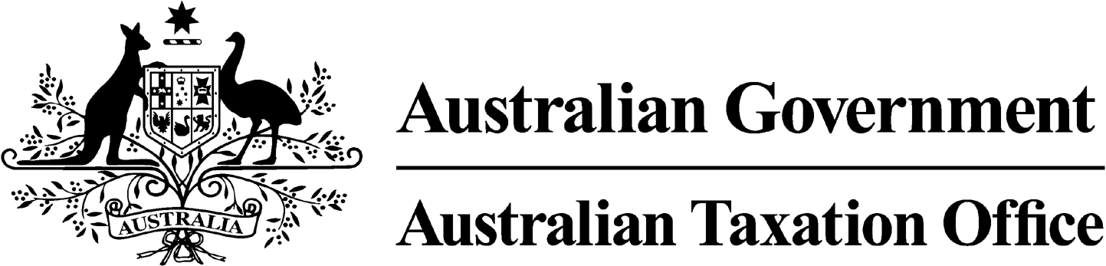
NOTICE OF REVOCATION OF DISQUALIFICATION – Shane Simmons -
31 October 2025
Superannuation Industry (Supervision) Act 1993
To:

Shane Simmons

River Heads Queensland 4655

I, Ben Kelly, a delegate of the Commissioner of Taxation, give you notice as required by subsection 126A(6) of the Superannuation Industry (Supervision) Act 1993 (SISA), that I have made a decision under subsection 126A(5) of the SISA to revoke the disqualification notice issued to you on 24 August 2022.

The revocation of the disqualification order takes effect on the day on which this notice is made.

Dated: 31 October 2025

Ben Kelly
Deputy Commissioner of Taxation

Per Diptie Achal

Note 1:
Under subsection 126A(7) of the SISA, details of this revocation of disqualification notice will be published as a Notifiable Instrument in the Federal Register of Legislation.

