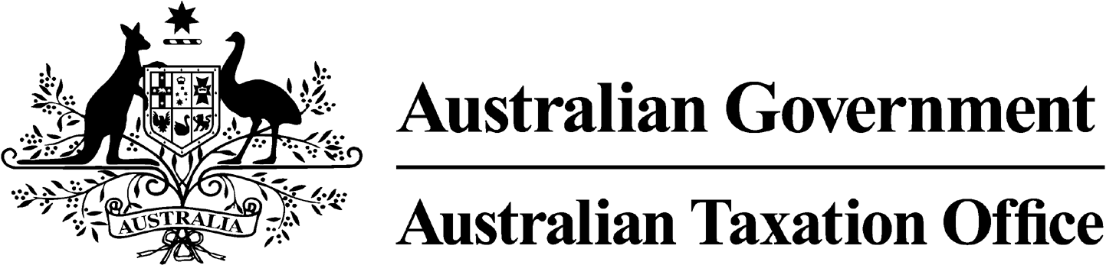

**NOTICE OF CONFIRMATION OF DISQUALIFICATION – AMIT KUMAR -**

**12 June 2025**

*Superannuation Industry (Supervision) Act 1993*

To:

AMIT KUMAR

HORNSBY HEIGHTS NSW 2077

I, Andrew Orme, a delegate of the Commissioner of Taxation, give you notice as required by subsection 344(6) of the *Superannuation Industry (Supervision) Act 1993 (SISA)*, that I have confirmed your disqualification under subsection 344(4) of the SISA.

I’ve confirmed your disqualification as I’m satisfied that the corporate trustee of one or more superannuation entities has contravened the SISA on one or more occasions, and at the time of the contraventions you were a responsible officer of the corporate trustee and the nature of the contraventions provides grounds for disqualifying you.

The confirmation of disqualification takes effect on the day on which it is made.

Dated: 12 June 2025

**Andrew Orme**

Deputy Commissioner of Taxation

Per Manisha Karre

**Note 1:**

Under subsection 126A(7) of the SISA, details of this disqualification notice will be published as a notifiable instrument in the Federal Register of Legislation.

**Note 2:**

Under section 126K of the SISA, it is an offence for a disqualified person, who knows that he or she is a disqualified person, to be, or act as a:

* trustee, investment manager or custodian of a superannuation entity
* responsible officer or a body corporate that is a trustee, investment manager or custodian, of a superannuation entity.

The maximum penalty for committing this offence is two years jail.

**Note 3:**

Under subsubsection 344(8) of the SISA, if you are affected by this decision and are not satisfied with it, you can apply to the Administrative Review Tribunal to review the decision within 28 days of the Commissioner giving notification of this decision.