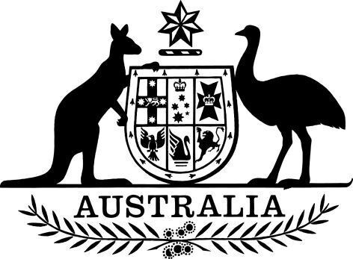

**Takeovers Panel – President and Members – Appointments and Reappointments (No. 1) 2025**

I, the Honourable Sam Mostyn AC, Governor-General of the Commonwealth of Australia, acting with the advice of the Federal Executive Council, and under subsection 172(2) and section 173 of the *Australian Securities and Investments Commission Act 2001*:

1. reappoint Alex Cartel as a member and the President of the Takeovers Panel, on a part-time basis, for a period of three years beginning on 8 March 2025;
2. reappoint Kelvin Barry, Michael Borsky, Constantine Boulougouris, James Burchnall, Alberto Colla, Bruce Cowley, Chelsey Drake, Marissa Freund, Timothy Longstaff, John McGlue, Bruce McLennan, Deborah Page and Philippa Stone as members of the Takeovers Panel, each on a part-time basis and each for a period of three years beginning on 8 March 2025; and
3. appoint Kellie Benda, Costas Condoleon, Toni Anne Dwyer and Susan Forrester as members of the Takeovers Panel, each on a part-time basis and each for a period of three years beginning 8 March 2025.

Dated 6 March 2025

Sam Mostyn AC

Governor‑General

By Her Excellency’s Command

Dr Jim Chalmers

Treasurer