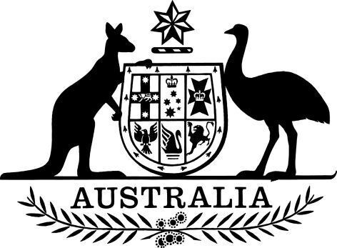

**Productivity Commission – Commissioner – Appointment (No. 1) 2025**

I, the Honourable Sam Mostyn AC, Governor-General of the Commonwealth of Australia, acting with the advice of the Federal Executive Council, and under subsection 24(1) of the *Productivity Commission Act 1998*, appoint Angela Jackson as a Commissioner of the Productivity Commission, on a full-time basis, for a period of five years beginning on 28 April 2025.

Dated 6 March 2025

Sam Mostyn AC

Governor‑General

By Her Excellency’s Command

Dr Jim Chalmers

Treasurer