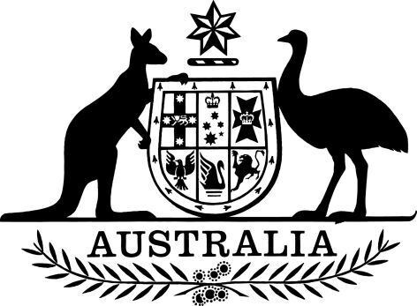

**Commonwealth Grants Commission – Chairperson – Reappointment (No. 1) 2025**

I, the Honourable Sam Mostyn AC, Governor-General of the Commonwealth of Australia, acting with the advice of the Federal Executive Council, and under subsection 8(2) of the *Commonwealth Grants Commission Act 1973*, reappoint Michael Callaghan as the Chairperson of the Commonwealth Grants Commission, on a part-time basis, for a period of five years beginning on 25 June 2025.

Dated 6 March 2025

Sam Mostyn AC

Governor‑General

By Her Excellency’s Command

Dr Jim Chalmers

Treasurer