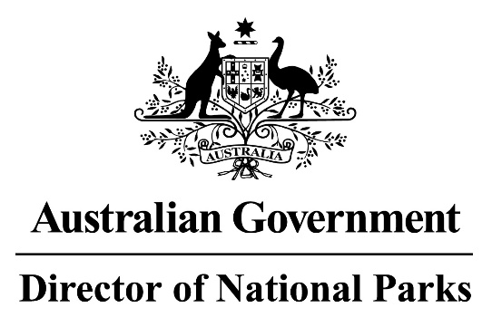

*Environment Protection and Biodiversity Conservation Regulations 2000*

Sub-regulation 12.34 (3)

**SOUTH-EAST MARINE PARKS**

**DETERMINATION OF REQUIRED FISHING PRACTICES**

**STOWING AND SECURING FISHING GEAR DURING TRANSIT AND CAGE TOWING THROUGH UNAUTHORISED AREAS**

I, RONALD (RICKY) ARCHER, Director of National Parks acting pursuant to sub-regulation 12.34(3) of the *Environment Protection and Biodiversity Conservation Regulations 2000* HEREBY DETERMINE that for each of the Marine Parks listed in the Schedule to this determination, the following commercial fishing practices are to be followed:

1. Transit, including transit by a vessel engaged in cage towing, is prohibited in the Macquarie Island Marine Park Sanctuary Zone (Ia); and
2. Transit by a fishing vessel through the listed Marine Parks in which:
   1. commercial fishing operations are not authorised; or,
   2. the use of a particular gear type (which is on board) is not authorised;

must be:

* 1. at a speed greater than 5 knots (unless engaged in cage towing); and
  2. with all fishing gear, or the particular fishing gear, kept stowed and secured.

 AND I HEREBY REVOKE the previous determinations relating to:

1. Stowing and securing of fishing gear during transit through unapproved areas, notified in the *Gazette*(F2023N00193) and published on 30 June 2023.
2. Prohibition of Commercial Fishing Practices in the National Park Zone and Sanctuary Zone of the Macquarie Island Marine Park, notified in the *Gazette*(F2023N00194) and published on 30 June 2023.
3. Prohibiting the use of vessels engaged in cage towing, notified in the *Gazette* (F2023N00192) and published on 30 June 2023.

In this determination:

**Cage towing** means a vessel towing a cage that is suitable for caging fish.

**Stowed and secured** means all fishing equipment, including nets and lines, are on-board the vessel, and not in contact with the water.

**Transit** means the en-route passage of a vessel through a marine park, whereby the transit is in a straight direction as fast as reasonably practical, and the vessel does not stop for any reason other than in response to an emergency or to undertake an activity authorised by law or permit.

This determination commences on 17 February 2025 and remains in effect until it is revoked or amended.

Ronald (Ricky) Archer

Director of National Parks

Date: 17 February 2025

**SCHEDULE**

**LISTED MARINE PARKS\***

Apollo Marine Park

Beagle Marine Park

Boags Marine Park

East Gippsland Marine Park

Flinders Marine Park

Franklin Marine Park

Freycinet Marine Park

Huon Marine Park

Murray Marine Park

Macquarie Island Marine Park

Nelson Marine Park

South Tasman Rise Marine Park

Tasman Fracture Marine Park

Zeehan Marine Park