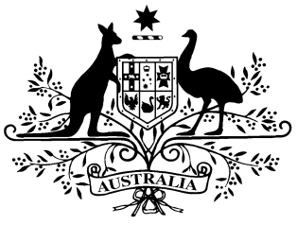

PB 147 of 2024

National Health (February 2025 First New Brand statutory price reduction) (Exercise of Ministerial discretion) Determination 2024
National Health Act 1953
I, Eden Simon, Acting Assistant Secretary, Pricing and PBS Policy Branch, Technology Assessment and Access Division, Department of Health and Aged Care, delegate of the Minister for Health and Aged Care, make the following determination.
Dated 19 December 2024

EDEN SIMON
Acting Assistant Secretary
Pricing and PBS Policy Branch
Technology Assessment and Access Division
Department of Health and Aged Care

1 Name of Instrument
(1) This instrument is the National Health (February 2025 First New Brand statutory price reduction) (Exercise of Ministerial discretion) Determination 2024.
(2) This instrument may also be cited as PB 147 of 2024.
2 Commencement
This instrument commences on 1 February 2025.
3 Definitions

Note: A number of expressions used in this instrument are defined in Part VII the Act.

In this instrument:

Act means the National Health Act 1953.
4 Authority

This instrument is made under subsection 99ACB(6A) of the Act.
5 Brand of pharmaceutical item subject to a lower price reduction than would otherwise apply

(1) I determine under subsection 99ACB(6A) of the Act that, for the purposes of subsection 99ACB(5), the maximum agreed price of the brand of pharmaceutical item specified in item 1 in the table in Part 1 of the Schedule that comes into force on 1 February 2025 is to be worked out using a reduction of 10%.
Note: Subsection 99ACB(6A) enables the Minister to determine that limit on the maximum agreed price of a new brand of an existing pharmaceutical item is to be calculated using a lower percentage, including zero %, than would otherwise be the case.
Schedule
Part 1 — Brands of pharmaceutical items with approved ex-manufacturer price reduced by a lower percentage than would otherwise apply

Column 1 | Column 2
Item | Brand of pharmaceutical item
 | Drug | Form | Manner of administration | Brand
1 | Paclitaxel, nanoparticle albumin-bound | Powder for I.V. injection containing 100 mg paclitaxel | Injection | nab-PACLITAXEL JUNO

