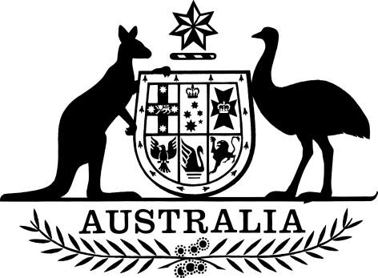

PB 123 of 2025
National Health (Pharmaceutical benefits – early supply) Amendment Instrument 2025 (No. 10)

National Health Act 1953
I, REBECCA RICHARDSON, Assistant Secretary, PBS Listing, Pricing and Policy Branch, Technology Assessment and Access Division, Department of Health, Disability and Ageing, delegate of the Minister for Health and Ageing, make this Instrument under subsection 84AAA(2) of the National Health Act 1953.
Dated 29 October 2025
REBECCA RICHARDSON
Assistant Secretary
PBS Listing, Pricing and Policy Branch
Technology Assessment and Access Division
Contents
1. Name 1
2. Commencement 1
3. Authority 1
4. Schedules 1
Schedule 1—Amendments 2
National Health (Pharmaceutical benefits—early supply) Instrument 2015 (PB 120 of 2015) 2

1. Name

(1) This instrument is the National Health (Pharmaceutical benefits – early supply) Amendment Instrument 2025 (No. 10).

(2) This instrument may also be cited as PB 123 of 2025.

2. Commencement

(1) Each provision of this instrument specified in column 1 of the table commences, or is taken to have commenced, in accordance with column 2 of the table. Any other statement in column 2 has effect according to its terms.
Commencement information
Column 1 | Column 2 | Column 3
Provisions | Commencement | Date/Details
1. The whole of this instrument | 1 November 2025 | 1 November 2025
Note: This table relates only to the provisions of this instrument as originally made. It will not be amended to deal with any later amendments of this instrument.

(2) Any information in column 3 of the table is not part of this instrument. Information may be inserted in this column, or information in it may be edited, in any published version of this instrument.

3. Authority

This instrument is made under subsection 84AAA(2) of the National Health Act 1953.

4. Schedules

Each instrument that is specified in a Schedule to this instrument is amended or repealed as set out in the applicable items in the Schedule concerned, and any other item in a Schedule to this instrument has effect according to its terms.

Schedule 1—Amendments
National Health (Pharmaceutical benefits—early supply) Instrument 2015 (PB 120 of 2015)
[1] Schedule 1, entry for Brexpiprazole
insert as first entry:
 | Tablet 500 micrograms | 20 | 30 | 0
[2] Schedule 1, entry for Clopidogrel
substitute:
Clopidogrel | Tablet 75 mg (as besilate) | 20 | 28 | 5
 | Tablet 75 mg (as bisulfate) (Aurobindo, USA) (S19A) | 20 | 28 | 5
 | Tablet 75 mg (as bisulfate) (Novadoz, USA) (S19A) | 20 | 28 | 5
 | Tablet 75 mg (as hydrogen sulfate) | 20 | 28 | 5
 | Tablet 75 mg (as hydrogen sulfate) (S19A) | 20 | 28 | 5
[3] Schedule 1, after entry for Dutasteride with tamsulosin
insert:
Elafibranor | Tablet 80 mg | 20 | 30 | 5
[4] Schedule 1, entry for Estradiol with norethisterone
(a) omit:
 | Transdermal patches containing 510 micrograms estradiol (as hemihydrate) with 4.8 mg norethisterone acetate, 8 (S19A) | 20 | 1 | 5
(b) omit:
 | Transdermal patches containing 620 micrograms estradiol (as hemihydrate) with 2.7 mg norethisterone acetate, 8 (S19A) | 20 | 1 | 5
[5] Schedule 1, entry for Ethosuximide
omit:
 | Capsule 250 mg (s19A) | 20 | 200 | 2
[6] Schedule 1, after entry for Etonogestrel
insert:
Etonogestrel with ethinylestradiol | Vaginal ring containing etonogestrel 11.7 mg with ethinylestradiol 2.7 mg | 20 | 3 | 3
[7] Schedule 1, entry for Siponimod
omit:
 | Tablet 250 micrograms (as hemifumarate) | 20 | 120 | 5
[8] Schedule 2, omit entry for Betaxolol
[9] Schedule 2, entry for Clopidogrel
substitute:
Clopidogrel | Tablet 75 mg (as besilate) | 50 | 56 | 5
 | Tablet 75 mg (as bisulfate) (Aurobindo, USA) (S19A) | 50 | 56 | 5
 | Tablet 75 mg (as bisulfate) (Novadoz, USA) (S19A) | 50 | 56 | 5
 | Tablet 75 mg (as hydrogen sulfate) | 50 | 56 | 5
 | Tablet 75 mg (as hydrogen sulfate) (S19A) | 50 | 56 | 5
[10] Schedule 2, entry for Estradiol with norethisterone
(a) omit:
 | Transdermal patches containing 510 micrograms estradiol (as hemihydrate) with 4.8 mg norethisterone acetate, 8 (S19A) | 50 | 2 | 5
(b) omit:
 | Transdermal patches containing 620 micrograms estradiol (as hemihydrate) with 2.7 mg norethisterone acetate, 8 (S19A) | 50 | 2 | 5

