

Woomera Prohibited Area (Suspension of Standing Permission in the Woomera Prohibited Area for 27 October 2025 to 16 November 2025) Instrument 2025
I, Elizabeth O’Brien, Director Woomera Prohibited Area Coordination Office, delegate of the Minister for Defence, make the following instrument under subsection 11(3) of the Woomera Prohibited Area Rule 2014.
Dated 21 October 2025
Elizabeth O’Brien
Director Woomera Prohibited Area Coordination Office
Department of Defence

1 Name
This instrument is the Woomera Prohibited Area (Suspension of Standing Permission in the Woomera Prohibited Area for 27 October 2025 to
16 November 2025) Instrument 2025.

2 Commencement
This instrument commences on the day after it is registered.

3 Authority
This instrument is made under subsection 11(3) of the Woomera Prohibited Area Rule 2014.

4 Definitions
In this instrument:
Rule means the Woomera Prohibited Area Rule 2014.
Woomera Prohibited Area means the area prescribed by section 5 of the Rule.

5 Suspension of Standing Permission
(1) For the purpose of subsection 11(3) of the Rule, this section suspends standing permission in the Woomera Prohibited Area for the period between 27 October 2025 and 16 November 2025.
(2) The standing permission for the Tarcoola to Darwin railway line access route is suspended between the two closure points marked on the map in Schedule 1 as:
(a) ‘North Closure Point -29.53264, 134.54429’; and
(b) ‘South Closure Point -30.09861, 134.53523’.
(3) The standing permission for the Stuart Highway access route is suspended between the two access control points marked on the map in Schedule 2 as:
(a) ‘North Access Control Point -29.69107, 135.13308’; and
(b) ‘South Access Control Point -30.15898, 135.19511’.

6 Repeal
This instrument is repealed on 17 November 2025.

Schedule 1—Map of the Tarcoola to Darwin Railway Line Access Route

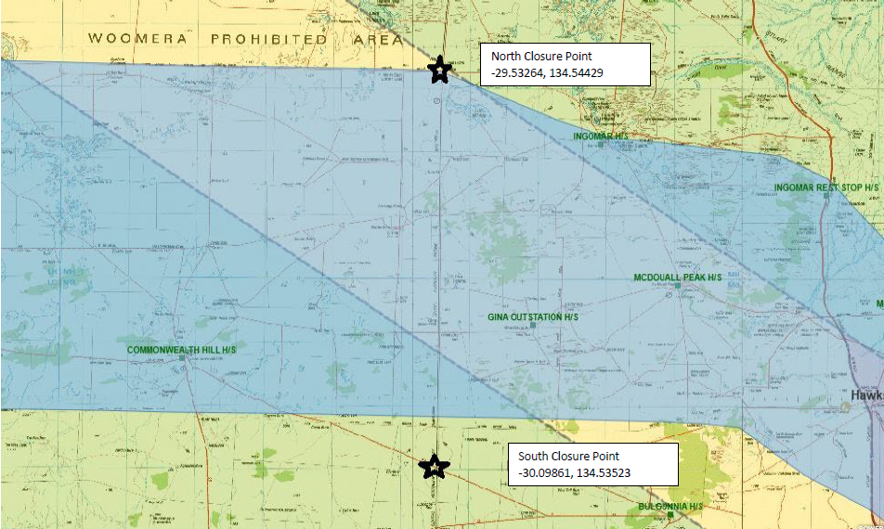

Schedule 2—Map of the Stuart Highway Access Route

