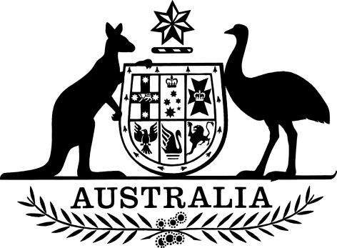

PB 107 of 2025

National Health (Prescriber Bag Supplies) Amendment (October Update) Determination 2025

National Health Act 1953

I, REBECCA RICHARDSON, Assistant Secretary, PBS Listing, Pricing and Policy Branch, Technology Assessment and Access Division, Department of Health, Disability and Ageing, delegate of the Minister for Health and Ageing, make this Instrument under sections 93, 93AA and 93AB of the *National Health Act 1953*.

Dated 29 September 2025

**REBECCA RICHARDSON**  
Assistant Secretary  
PBS Listing, Pricing and Policy Branch  
Technology Assessment and Access Division

Contents

1. Name 1

2. Commencement 1

3. Authority 1

4. Schedules 1

Schedule 1—Amendments 2

*National Health (Prescriber Bag Supplies) Determination 2024 (PB 29 of 2024)* 2

1. Name

(1) This Instrument is the *National Health (Prescriber Bag Supplies) Amendment (October Update) Determination 2025.*

(2) This Instrument may also be cited as PB 107 of 2025.

2. Commencement

(1) Each provision of this instrument specified in column 1 of the table commences, or is taken to have commenced, in accordance with column 2 of the table. Any other statement in column 2 has effect according to its terms.

|  |  |  |
| --- | --- | --- |
| **Commencement information** | |  |
| **Column 1** | **Column 2** | **Column 3** |
| **Provisions** | **Commencement** | **Date/Details** |
| 1. The whole of this instrument | 1 October 2025 | 1 October 2025 |

Note: This table relates only to the provisions of this instrument as originally made. It will not be amended to deal with any later amendments of this instrument.

(2) Any information in column 3 of the table is not part of this instrument. Information may be inserted in this column, or information in it may be edited, in any published version of this instrument.

3. Authority

This instrument is made under sections 93, 93AA and 93AB of the *National Health Act 1953*.

4. Schedules

Each instrument that is specified in a Schedule to this instrument is amended or repealed as set out in the applicable items in the Schedule concerned, and any other item in a Schedule to this instrument has effect according to its terms.

Schedule 1—Amendments

*National Health (Prescriber Bag Supplies) Determination 2024 (PB 29 of 2024)*

[1] Schedule 1, entry for Methoxyflurane

omit from the column headed “Prescriber Bag Supplier”: MP substitute: MP, NP

[2] Schedule 1, entry for Phytomenadione

omit from the column headed “Prescriber Bag Supplier”: MP substitute: MP, NP