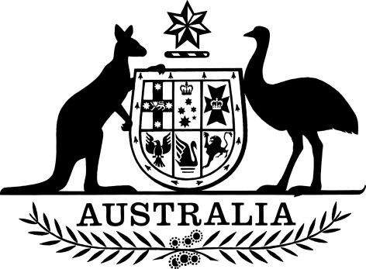

PB 106 of 2025

National Health (Commonwealth Price and Conditions for Commonwealth Payments for Supply of Pharmaceutical Benefits) Amendment Determination 2025 (No. 9)

National Health Act 1953

I, REBECCA RICHARDSON, Assistant Secretary, PBS Listing, Pricing and Policy Branch, Technology Assessment and Access Division, Department of Health, Disability and Ageing, delegate of the Minister for Health and Ageing, make this Instrument under subsection 98C(1) of the *National Health Act 1953*.

Dated 29 September 2025

**REBECCA RICHARDSON**  
Assistant Secretary  
PBS Listing, Pricing and Policy Branch  
Technology Assessment and Access Division

Contents

1. Name 1

2. Commencement 1

3. Authority 1

4. Schedules 1

Schedule 1—Amendments 2

*National Health (Commonwealth Price and Conditions for Commonwealth Payments for Supply of Pharmaceutical Benefits) Determination 2019 (PB 114 of 2019)* 2

1. Name

(1) This instrument is the *National Health (Commonwealth Price and Conditions for Commonwealth Payments for Supply of Pharmaceutical Benefits) Amendment Determination 2025 (No. 9)*.

(2) This instrument may also be cited as PB 106 of 2025.

2. Commencement

(1) Each provision of this instrument specified in column 1 of the table commences, or is taken to have commenced, in accordance with column 2 of the table. Any other statement in column 2 has effect according to its terms.

|  |  |  |
| --- | --- | --- |
| **Commencement information** | |  |
| **Column 1** | **Column 2** | **Column 3** |
| **Provisions** | **Commencement** | **Date/Details** |
| 1. The whole of this instrument | 1 October 2025 | 1 October 2025 |

Note: This table relates only to the provisions of this instrument as originally made. It will not be amended to deal with any later amendments of this instrument.

(2) Any information in column 3 of the table is not part of this instrument. Information may be inserted in this column, or information in it may be edited, in any published version of this instrument.

3. Authority

This instrument is made under subsection 98C(1) of the *National Health Act 1953*.

4. Schedules

Each instrument that is specified in a Schedule to this instrument is amended or repealed as set out in the applicable items in the Schedule concerned, and any other item in a Schedule to this instrument has effect according to its terms.

Schedule 1—Amendments

*National Health (Commonwealth Price and Conditions for Commonwealth Payments for Supply of Pharmaceutical Benefits) Determination 2019 (PB 114 of 2019)*

[1] Schedule 3, entries for Morphine

omit:

|  |  |
| --- | --- |
| Morphine | Oral solution containing morphine sulfate 10 mg per 5 mL in 100 mL bottle, 1 mL (S19A) |
| Morphine | Oral solution containing morphine sulfate 10 mg per 5 mL in 300 mL bottle, 1 mL (S19A) |

[2] Schedule 4, after entry for Lumacaftor with ivacaftor in the form Sachet containing granules, lumacaftor 150 mg and ivacaftor 188 mg

insert:

|  |  |
| --- | --- |
| Lumasiran | Solution for subcutaneous injection 94.5 mg (as sodium) in 0.5 mL |

[3] Schedule 4, entries for Paracetamol

omit:

|  |  |
| --- | --- |
| Paracetamol | Oral liquid 120 mg per 5 mL, 100 mL |

[4] Schedule 4, entries for Timolol

(a) omit:

|  |  |
| --- | --- |
| Timolol | Eye drops 5 mg (as maleate) per mL, 5 mL (S19A) |

(b) omit:

|  |  |
| --- | --- |
| Timolol | Eye drops (gellan gum solution) 5 mg (as maleate) per mL, 2.5 mL ‑ (Timoptol‑LA) (S19A) |