

Federal Circuit and Family Court of Australia (Family Law) Amendment (2025 Measures No. 1) Rules 2025

We, Judges of the Federal Circuit and Family Court of Australia (Division 1), make the following Rules of Court.

Dated 2 June 2025

Alstergren CJ   
McClelland DCJ  
Aldridge J  
Austin J  
Bennett J  
O'Brien J  
Baumann J  
Sutherland J  
Williams J  
Tyson J  
Wilson J  
Mead J  
Hartnett J  
Altobelli J  
Howard J  
Jarrett J

Campton J  
  
Christie J  
Schonell J  
McNab J  
Smith J  
Carter J  
Berry J  
Cohen J  
Curran J  
Jones J  
Boyle J  
Anderson J   
Behrens J   
Simpson J   
Stewart J   
Parker J

Judges of the Federal Circuit and Family Court of Australia (Division 1)

Contents

1 Name 1

2 Commencement 1

3 Authority 1

4 Schedules 1

Schedule 1—Amendments 2

Federal Circuit and Family Court of Australia (Family Law) Rules 2021 2

1 Name

These Rules are the *Federal Circuit and Family Court of Australia (Family Law) Amendment (2025 Measures No. 1) Rules 2025*.

2 Commencement

(1) Each provision of these Rules specified in column 1 of the table commences, or is taken to have commenced, in accordance with column 2 of the table. Any other statement in column 2 has effect according to its terms.

| Commencement information | | |
| --- | --- | --- |
| Column 1 | Column 2 | Column 3 |
| Provisions | Commencement | Date/Details |
| 1. The whole of these Rules | 10 June 2025. | 10 June 2025 |

Note: This table relates only to the provisions of these Rules as originally made. It will not be amended to deal with any later amendments of these Rules.

(2) Any information in column 3 of the table is not part of these Rules. Information may be inserted in this column, or information in it may be edited, in any published version of these Rules.

3 Authority

These Rules are made under Chapter 3 of the *Federal Circuit and Family Court of Australia Act 2021*.

4 Schedules

Each instrument that is specified in a Schedule to these Rules is amended or repealed as set out in the applicable items in the Schedule concerned, and any other item in a Schedule to these Rules has effect according to its terms.

Schedule 1—Amendments

Federal Circuit and Family Court of Australia (Family Law) Rules 2021

1 Subrule 1.04(1)

Omit “section 67 of the Federal Circuit and Family Court Act”, substitute “section 95 of the Family Law Act”.

2 Subrule 1.04(1) (note 1)

Omit “Note 1”, substitute “Note”.

3 Subrule 1.04(1) (note 1)

Omit “subsection 67(3) of the Federal Circuit and Family Court Act”, substitute “subsection 95(3) of the Family Law Act”.

4 Subrule 1.04(1) (note 2)

Repeal the note.

5 Subrule 1.04(2) (note)

Repeal the note, substitute:

Note: See subsection 96(1) of the Family Law Act.

6 Subrule 1.04(3) (note)

Repeal the note, substitute:

Note: See subsection 96(2) of the Family Law Act.

7 Subrule 1.05(1) (definition of *arbitration*)

Omit “section 10L”, substitute “subsection 10L(1)”.

8 Subrule 1.05(1)

Insert:

***ART*** means the Administrative Review Tribunal.

***ART Act*** means the *Administrative Review Tribunal Act 2024*.

***ART Registrar*** means any of the following:

(a) the Principal Registrar (within the meaning of the ART Act);

(b) a person who has been appointed as a registrar under section 237 of the ART Act;

(c) a person to whom functions or powers have been delegated under subsection 280(1) of the ART Act.

9 Subrule 1.05(1) (paragraph (b) of the definition of *child support proceeding*)

Omit “section 44AAA of the *Administrative Appeals Tribunal Act 1975*”, substitute “section 99 of the Registration Act”.

10 Subrule 1.05(1) (definition of *child welfare record*)

Omit “regulation 12CBA”, substitute “section 53”.

11 Subrule 1.05(1) (definition of *Family Law Regulations*)

Omit “*1984*”, substitute “*2024*”.

12 Subrule 1.05(1) (definition of *financial orders*)

Repeal the definition.

13 Subrule 1.05(1)

Insert:

***financial or property orders*** includes orders in relation to any of the following:

(a) maintenance;

(b) a Child Support Application under section 116, 123 or 129 of the Assessment Act;

(c) contribution to child bearing expenses;

(d) property.

***financial or property proceeding*** means a proceeding (other than an appeal) involving an application:

(a) relating to financial or property matters of a marriage (within the meaning of subsection 71B(7) of the Family Law Act); or

(b) relating to financial or property matters of a de facto relationship (within the meaning of subsection 90RI(7) of the Family Law Act); or

(c) relating to child bearing expenses (see section 67B of the Family Law Act);

and includes, for the purposes of Part 6.1 of these Rules, a proceeding (other than an appeal) involving an application for the enforcement of a financial obligation.

14 Subrule 1.05(1) (definition of *financial proceeding*)

Repeal the definition.

15 Subrule 1.05(1) (definition of *litigation guardian*)

Omit “next friend, guardian ad litem”, substitute “litigation supporter, litigation representative, next friend, guardian *ad litem*, case guardian”.

16 Subrule 1.05(1)

Insert:

***party to a financial or property proceeding*** includes a payee and any other respondent to an enforcement application.

17 Subrule 1.05(1)

Repeal the following definitions:

(a) definition of ***party to a financial proceeding***;

(b) definition of ***property proceeding***.

18 Subrule 1.05(1)

Insert:

***protected confidence*** has the meaning given by section 102BA of the Family Law Act.

***protected confider*** has the meaning given by section 102BA of the Family Law Act.

19 Rule 1.06 (table item 2, column headed “Power”, paragraph (h))

After “financial”, insert “or property”.

20 Subparagraph 1.10(2)(f)(ii)

Omit “regulation 21M”, substitute “section 68”.

21 Rule 1.12 (heading)

After “**financial**”, insert “**or property**”.

22 Subrule 1.12(1)

After “financial”, insert “or property”.

23 Subrule 1.12(2)

Omit “79(10)”, substitute “79AA(10)”.

24 Subrule 1.12(3)

Omit “90SM(10)”, substitute “90SMA(10)”.

25 Paragraph 1.12(4)(a)

Omit “79(10) or 90SM(1)”, substitute “79AA(10) or 90SMA(10)”.

26 Subrule 1.12(6)

Before “property”, insert “financial or”.

27 Paragraph 1.13(1)(b)

Repeal the paragraph.

28 Paragraph 1.13(1)(d)

Repeal the paragraph, substitute:

(d) an application under:

(i) Subdivision B or C of Division 9 of Part 7 of the Family Law Regulations; or

(ii) Division 4 or 5 of Part 10 of the Family Law Regulations.

29 Paragraph 1.13(4)(d)

Omit “Administrative Appeals Tribunal”, substitute “ART”.

30 Subparagraph 1.13(4)(d)(i)

Repeal the subparagraph, substitute:

(i) an ART Registrar; and

31 Rule 1.26 (heading)

After “**law**”, insert “**or other matters**”.

32 Subrule 1.26(1) (note)

Omit “(Division 2)”.

33 At the end of rule 1.26

Add:

(3) A referral by an arbitrator of a matter to the court under paragraph 31(b) or 32(1)(b) of the Family Law Regulations must be made by written notice to the Registry Manager.

Note: Section 31 of the Family Law Regulations is about suspension of arbitration for failure to comply with directions. Section 32 of the Family Law Regulations is about termination of arbitration where a party does not have the ability to take part in the arbitration.

(4) A referral by an arbitrator of a matter to the court under paragraph 32(1)(b) of the Family Law Regulations must be made within 7 days after the arbitration is terminated.

34 Rule 1.27

Repeal the rule, substitute:

1.27 Application for orders in relation to arbitration

A party to an arbitration, or an arbitrator, seeking orders under section 13F of the Family Law Act in relation to an arbitration must file:

(a) an application in accordance with the approved form; and

(b) a statement signed by the party or the arbitrator briefly stating the facts relied on in support of the application.

35 Rule 1.28

Omit “67P(4)(b)”, substitute “36(4)(b)”.

36 Before subrule 1.29(1)

Insert:

(1) An application to register an arbitration award must include the award and the arbitrator’s reasons.

37 Subrule 1.29(1)

Renumber as subrule (2).

38 Subrule 1.29(1)

Omit “subregulation 67Q(2)”, substitute “subsection 37(3)”.

39 Subrule 1.29(2)

Renumber as subrule (3).

40 Paragraph 1.30(2)(b)

After “affidavit”, insert “or written statement”.

41 Subrule 1.30(3)

Omit “response and affidavit must be filed and served”, substitute “respondent must file and serve the documents referred to in subrule (2)”.

42 Subrule 2.01(6) (before the table)

Insert:

(7) Unless the court otherwise directs, a party to a proceeding (other than an appeal) filed in the court must file any subsequent proceeding or application between the parties using the same court file number.

43 Rule 2.03 (note)

Omit “paragraph 69ZQ(1)(aa)”, substitute “paragraphs 102NH(1)(a) and (b)”.

44 Subrule 2.10(2)

After “financial”, insert “or property”.

45 Subrule 2.23(6) (note)

Omit “Regulation 2.11(3)”, substitute “Subsection 2.11(3)”.

46 Subrule 2.24(1) (note)

Repeal the note, substitute:

Note: A person who starts a proceeding by making an application for an order under Part VII of the Family Law Act must file:

(a) a certificate given to the person by a family dispute resolution practitioner; or

(b) if an exemption from having to file a certificate is sought—an affidavit (see subsection 60I(7) of the Family Law Act and rule 4.02 of these Rules).

47 Paragraph 2.49(1)(a)

Omit “Part IIAB”, substitute “Division 2 of Part 10”.

48 Paragraph 2.49(1)(b)

Omit “Part IIAC”, substitute “Division 3 of Part 10”.

49 Paragraph 2.49(5)(a)

Omit “Attorney‑General’s Department”, substitute “Department of Foreign Affairs and Trade”.

50 Subrule 3.07(2) (paragraph (a) of the note)

Omit “79(10)”, substitute “79AA(10)”.

51 Subrule 3.07(2) (paragraph (b) of the note)

Omit “90SM(10)”, substitute “90SMA(10)”.

52 Rule 3.13 (at the end of note 2)

Add “to the extent they are capable of complying with the duty”.

53 Rule 3.14

Repeal the rule, substitute:

3.14 Who may be a litigation guardian

A person may be a litigation guardian in a proceeding if the person:

(a) in the case of an individual—is an adult; and

(b) in any case:

(i) has no interest in the proceeding adverse to the interest of the person needing the litigation guardian; and

(ii) can fairly and competently conduct the proceeding for the person needing the litigation guardian.

Note: A reference to a person includes a body politic or corporate as well as an individual (see subsection 2C(1) of the *Acts Interpretation Act 1901*).

54 Subrule 3.15(4)

Repeal the subrule, substitute:

(4) The court may, on the filing of an affidavit, remove a litigation guardian at the written request of the litigation guardian.

55 Subrule 3.19(1)

Before “property”, insert “financial or”.

56 Rule 3.19 (note 2)

Omit “79(1A), 79(8), 79A(1C), 90SM(2), 90SM(8),”, substitute “79AA(1A), 79AA(8), 79A(1C), 90SMA(2), 90SMA(8),”.

57 Rule 3.20 (paragraph (a) of the definition of *relevant proceeding*)

After “79A,”, insert “79AA,”.

58 Rule 3.20 (paragraph (a) of the definition of *relevant proceeding*)

After “90SM”, insert “, 90SMA”.

59 Paragraph 4.01(2)(e)

Repeal the paragraph, substitute:

(e) the proceeding involves a child born under a surrogacy arrangement and either:

(i) there is no respondent seeking different orders to the orders sought by the applicant; or

(ii) all parties consent to the orders sought; or

(f) the court is satisfied that, in the circumstances, it was not appropriate for a party to comply with the pre‑action procedures.

60 Subrule 4.01(3)

Omit “paragraph (2)(e)”, substitute “paragraph (2)(f)”.

61 Paragraph 4.01(3)(b)

Before “property”, insert “financial or”.

62 Rule 4.01 (note 1)

After “financial”, insert “or property”.

63 Rule 4.01 (note 2)

Omit “Subsections 60I(7) to (12) of the Family Law Act provide”, substitute “Section 60I of the Family Law Act provides”.

64 Paragraph 4.02(1)(b)

Omit “if no certificate is required because paragraphs 60I(9)(b), (c), (d), (e) or (f) of the Family Law Act applies”, substitute “if an exemption from having to file a certificate is sought under subsection 60I(8A) of the Family Law Act”.

65 Paragraph 4.02(1)(b)

Omit “exception claimed”, substitute “exemption sought”.

66 At the end of subrule 4.04(1)

Add:

Note: See also subsection 60I(7) of the Family Law Act, which sets out a requirement that must be met before the court will accept for filing an application for an order under Part VII of that Act.

67 Subrule 4.06(1) (note)

Omit “paragraph 117(2A)(f)”, substitute “paragraph 114UB(3)(f)”.

68 Division 4.2.2 (heading)

Before “**property**”, insert “**financial or**”.

69 Subrule 4.11(1)

Before “property”, insert “financial or”.

70 Rule 4.11 (note 1)

Omit “paragraph 117(2A)(f)”, substitute “paragraph 114UB(3)(f)”.

71 Chapter 6

Omit:

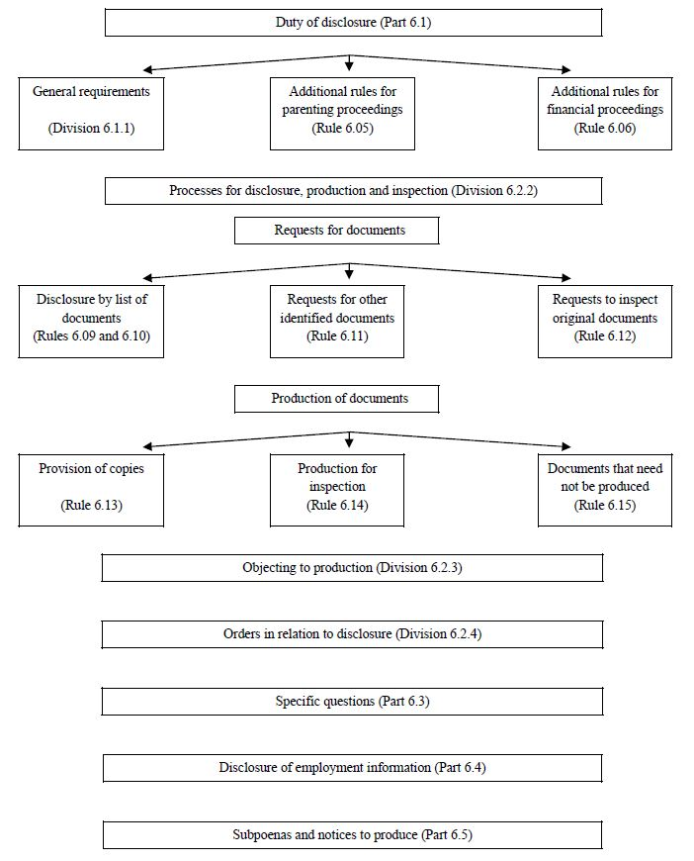

substitute:

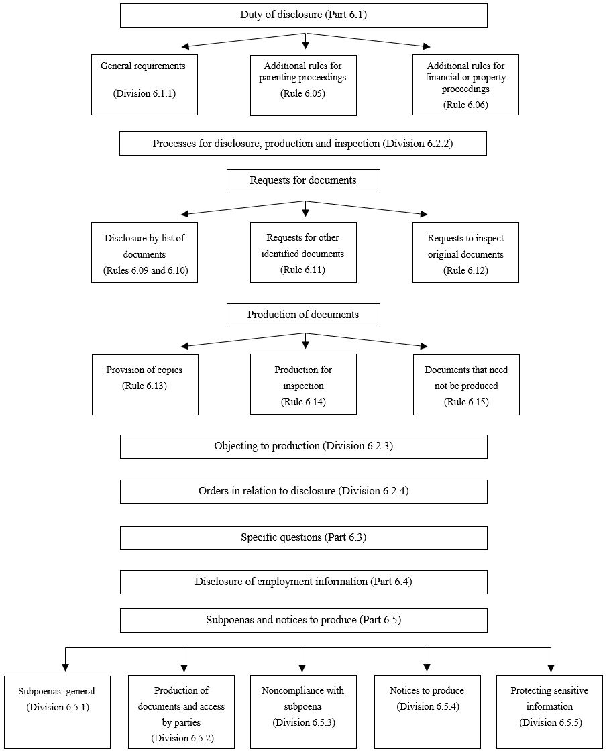

72 Subrule 6.01(1) (note)

Omit “financial proceedings.”, substitute “financial or property proceedings. For the duty of disclosure in proceedings relating to financial or property matters, see subsections 71B(1) and 90RI(1) of the Family Law Act.”.

73 Subrule 6.01(2) (at the end of the note)

Add “For the duty of disclosure while preparing for a proceeding relating to financial or property matters, see subsections 71B(5) and 90RI(5) of the Family Law Act.”.

74 At the end of subrule 6.01(3)

Add:

to the extent they are capable of complying with the duty.

Note: For financial or property proceedings, see subsections 71B(3) and 90RI(3) of the Family Law Act.

75 At the end of subrule 6.01(4)

Add:

Note: For financial or property proceedings, see subsections 71B(4) and 90RI(4) of the Family Law Act.

76 Subparagraph 6.02(1)(a)(i)

After “read”, insert “section 71B or 90RI of the Family Law Act (as applicable) and”.

77 Rule 6.03 (note)

Omit “Note”, substitute “Note 1”.

78 At the end of rule 6.03

Add:

Note 2: A document, or part of a document, must not be disclosed if the court has made an order under subsection 102BD(1) of the Family Law Act in relation to the document or part of the document.

79 Subrule 6.04(1)

Omit “A person who inspects or copies”, substitute “Unless the court gives permission, a person who inspects, copies or receives”.

80 Paragraph 6.04(1)(b)

Omit “without the court’s permission”.

81 At the end of rule 6.04

Add:

Note: For permission to use a document or information in proceedings for another purpose, see rule 15.26.

82 At the end of rule 6.05

Add:

Note: A document, or part of a document, must not be disclosed if the court has made an order under subsection 102BD(1) of the Family Law Act in relation to the document or part of the document.

83 Rule 6.06 (heading)

After “**financial**”, insert “**or property**”.

84 Subrule 6.06(1)

Repeal the subrule.

85 Subrule 6.06(2)

Renumber as subrule (1).

86 Subrule 6.06(2)

Omit “Subrules (3) to (9) do not apply to a party to a”, substitute “Subrules (2) to (8) do not apply to a party to a financial or”.

87 Subrule 6.06(3)

Renumber as subrule (2).

88 Subrule 6.06(3)

Omit “Without limiting subrule (1), a party to a financial”, substitute “A party to a financial or property”.

89 Subrule 6.06(4)

Renumber as subrule (3).

90 Subrule 6.06(4)

Omit “(3)(g)”, substitute “(2)(g)”.

91 Subrule 6.06(5)

Renumber as subrule (4).

92 Subrule 6.06(5)

Omit “starting, or filing a response or reply to, a financial”, substitute “to a marriage or de facto relationship starting, or filing a response or reply to, a financial or property”.

93 Paragraph 6.06(5)(b)

Repeal the paragraph, substitute:

(b) a financial questionnaire in accordance with the approved form, unless the party is required by these Rules to file an affidavit.

94 Subrule 6.06(6)

Renumber as subrule (5).

95 Subrule 6.06(7)

Renumber as subrule (6).

96 Subrule 6.06(7)

Omit “subrule (6)”, substitute “subrule (5)”.

97 Subrule 6.06(8)

Renumber as subrule (7).

98 Subrule 6.06(8)

Omit “Without limiting subrule (1), unless”, substitute “Unless”.

99 Subrule 6.06(9)

Renumber as subrule (8).

100 Subrule 6.06(9)

Omit “Without limiting subrule (1), a”, substitute “A”.

101 Subrule 6.06(10)

Renumber as subrule (9).

102 At the end of rule 6.07

Add:

Note: This Part also does not apply to child support and child maintenance proceedings (see rule 1.13).

103 At the end of rule 6.15

Add:

(3) Despite the duties of disclosure and the disclosure procedures in this Part, if an order has been made by the court that production of a document, or part of a document, would disclose:

(a) a protected confidence; or

(b) the contents of a document recording or relating to a protected confidence;

the document, or part of the document, must not be produced.

104 At the end of rule 6.21

Add:

Note: This Part does not apply to child support and child maintenance proceedings (see rule 1.13).

105 At the end of rule 6.23

Add:

Note: A party may object to answering a specific question on the basis that it would disclose a protected confidence or the contents of a document recording or relating to a protected confidence (see sections 102BC and 102BD of the Family Law Act).

106 Rule 6.25 (heading)

After “**financial**”, insert “**or property**”.

107 Subrule 6.25(1)

After “financial”, insert “or property”.

108 After subrule 6.27(2)

Insert:

(2A) A party or an independent children’s lawyer must not request the issue of a subpoena for production of a document if the court has made an order that production of the document, or part of the document, would disclose:

(a) a protected confidence; or

(b) the contents of a document recording or relating to a protected confidence.

Note: See section 102BD of the Family Law Act.

109 Subrules 6.27(3) and (4)

Omit “and (2)”, substitute “to (2A)”.

110 Subrule 6.36(2)

Omit “A person who inspects or copies”, substitute “Unless the court gives permission, a person who inspects, copies or receives a copy of”.

111 Paragraph 6.36(2)(b)

Omit “without the court’s permission”.

112 At the end of rule 6.36

Note: For permission to use a document or information in proceedings for another purpose, see rule 15.26.

113 Subrule 6.38(2)

Repeal the subrule, substitute:

(2) If an issuing party seeks the production of:

(a) a person’s medical records; or

(b) another document recording or relating to a protected confidence made by the person;

the person may, before the day stated in the subpoena for production, notify the Registry Manager in writing that the person wants to inspect the records for the purpose of determining whether to object to the inspection or copying of the document by any other party.

114 Paragraphs 6.38(3)(a) and (b)

After “medical records”, insert “or other document”.

115 Subrule 6.39(1)

Omit “If”, substitute “Subject to subrule (4), if”.

116 At the end of rule 6.39

Add:

(4) If an order has been made by the court that production of a document, or part of a document, would disclose:

(a) a protected confidence; or

(b) the contents of a document recording or relating to a protected confidence;

the document, or part of the document, must not be produced.

Note: See section 102BD of the Family Law Act.

117 At the end of rule 6.41

Add:

Note 3: A person does not need to comply with a subpoena to produce a document or part of a document if an order has been made, under section 102BD of the Family Law Act, that it not be produced.

118 At the end of Part 6.5

Add:

Division 6.5.5—Protecting sensitive information

6.43 Applications relating to protected confidences

(1) Subject to subrules (2) and (3), a person may apply to the court for an order under section 102BD of the Family Law Act that a document or a part of a document:

(a) not be produced; or

(b) not be inspected; or

(c) not be copied;

by filing an application for an interlocutory order and an affidavit stating the facts relied on in support of the orders sought.

Note 1: See rule 2.01 for when an application for an interlocutory order may be included in an application for final orders.

Note 2: See rules 5.02 to 5.08 for the requirements for filing and responding to applications for interlocutory orders, including the limit on the length of affidavits.

Note 3: For the persons who may make an application for an order under section 102BD of the Family Law Act, see subsection 102BD(3) of that Act.

(2) If:

(a) a person is required by a subpoena to produce a document, or part of a document, that may disclose:

(i) a protected confidence; or

(ii) the contents of a document recording or relating to a protected confidence; and

(b) the protected confider does not consent to the disclosure;

an objection to the production of the document must be made in accordance with rule 6.38.

(3) If:

(a) an interested person is given a copy of a subpoena to produce a document, or part of a document, that may disclose:

(i) a protected confidence; or

(ii) the contents of a document recording or relating to a protected confidence; and

(b) the protected confider does not consent to the disclosure;

an objection to the inspection or copying of the document must be made in accordance with rule 6.38.

119 Rule 7.23 (note)

Omit “subsection 117(2)”, substitute “subsection 114UB(2)”.

120 Part 8.2 (note to the Part heading)

Omit “(see section 69ZT”, substitute “, or in property or other non‑child‑related proceedings, by consent or order of the court (see section 102NL”.

121 Subrule 8.18(1)

Omit “section 69ZT”, substitute “section 102NL”.

122 Subrule 8.18(1) (note)

Omit “Section 69ZT”, substitute “Section 102NL”.

123 Subrule 8.18(1) (note)

After “child related proceedings”, insert “, or to property or other non‑child‑related proceedings,”.

124 Subrule 10.06(1)

Before “property”, insert “financial or”.

125 Chapter 11

Omit:

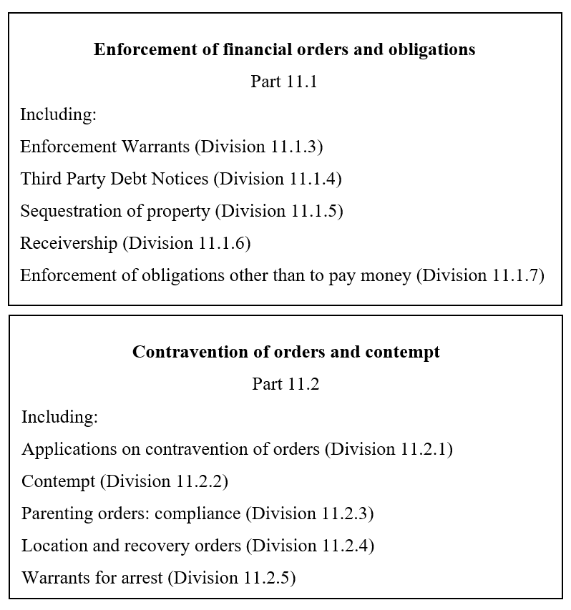

substitute:

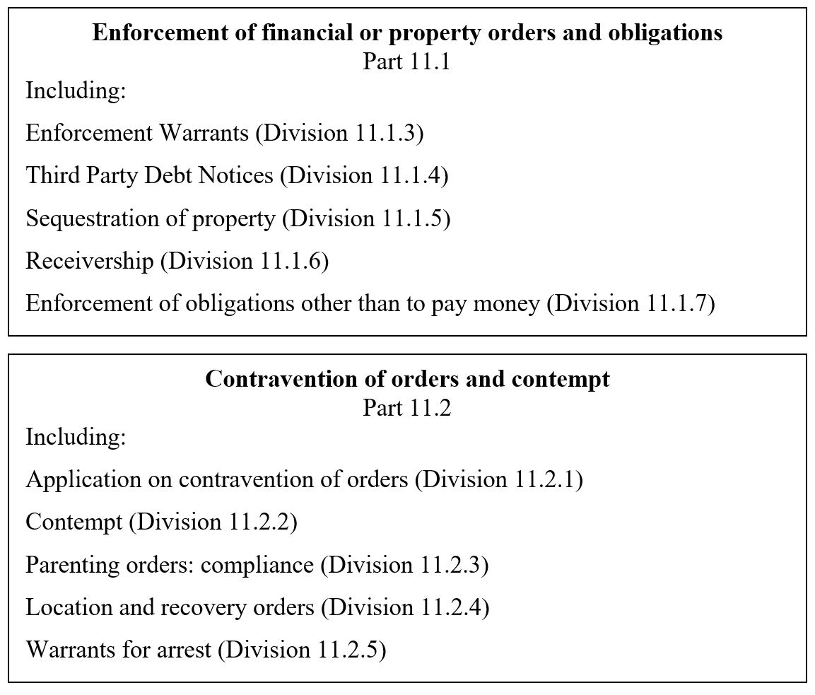

126 Part 11.1 (heading)

After “**financial**”, insert “**or property**”.

127 Rule 11.63 (paragraph (b) of note 2)

Omit “regulation 17”, substitute “section 75”.

128 Subrule 11.64(1) (table item 4, column headed “Kind of application”)

Before “property”, insert “financial or”.

129 Rule 11.75 (note)

Omit “subsection 67N(3)”, substitute “section 67N”.

130 Subrule 12.05(1)

Before “property”, insert “financial or”.

131 Subrule 12.06(6)

After “financial”, insert “or property”.

132 At the end of subrule 12.13(3)

Add:

Note: See subsection 114UB(4) of the Family Law Act.

133 Subrule 12.13(5) (note 1)

Omit “Section 117(1)”, substitute “Subsection 114UB(1)”.

134 Subrule 12.13(5) (note 1)

Omit “Section 117(2)”, substitute “Subsection 114UB(2)”.

135 Subrule 12.13(5) (note 1)

Omit “subsections 117(2A), (4), (4A), (5) and (6)”, substitute “subsection 114UB(3) and sections 114UC and 114UD”.

136 At the end of subrule 12.17(1)

Add:

Note: See subsection 114UB(5) of the Family Law Act.

137 At the end of subrule 12.17(2)

Add:

Note: See subsection 114UB(6) of the Family Law Act.

138 Chapter 13

Omit:

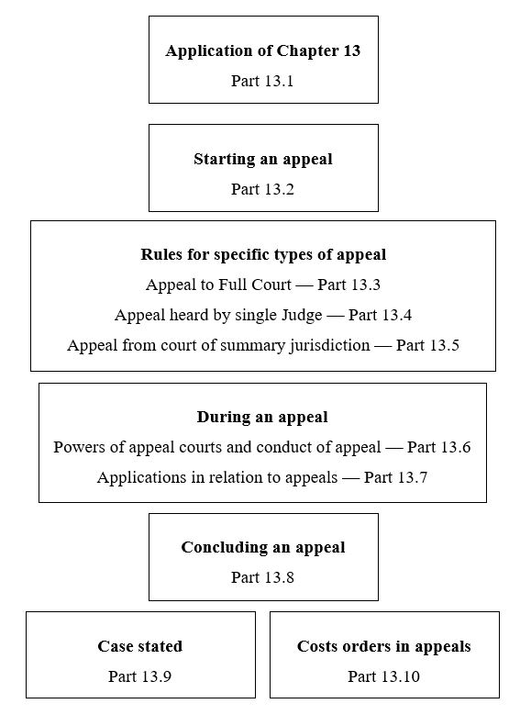substitute:

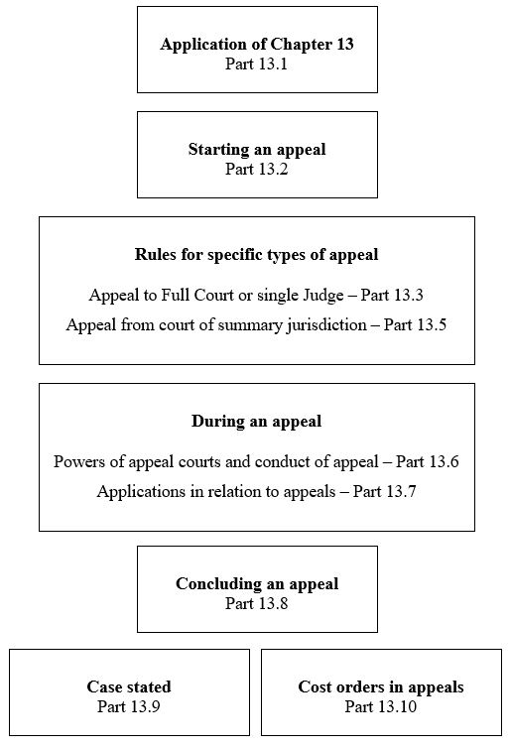

139 Paragraph 13.01(2)(a)

Repeal the paragraph, substitute:

(a) an appeal to the Federal Circuit and Family Court (Division 2) under the Assessment Act or Registration Act; or

140 Subrule 13.02(1) (paragraph (a) of note 1)

Omit “*2012*”, substitute “*2022*”.

141 After subrule 13.03(2) (before the notes)

Insert:

(3) If a person makes an application, under subrule 15.06(1), for an extension of time to appeal by filing an Application in an Appeal and affidavit in support, the proposed Notice of Appeal must be annexed to the application.

142 Rule 13.03 (note 2)

Repeal the note, substitute:

Note 2: See also rules 13.36 and 15.06.

143 Part 13.3 (at the end of the heading)

Add “**or single Judge**”.

144 Paragraph 13.15(b)

Repeal the paragraph, substitute:

(b) an appeal to the Federal Circuit and Family Court (Division 1) from an order of:

(i) the Federal Circuit and Family Court (Division 2); or

(ii) a Family Law Magistrate of Western Australia;

whether the jurisdiction of the court in relation to the appeal is to be exercised by a single Judge or a Full Court.

145 Rule 13.15 (note)

Repeal the note, substitute:

Note: An appeal from an order of the Federal Circuit and Family Court (Division 2) or a Family Law Magistrate of Western Australia is to be heard by a single Judge of the Federal Circuit and Family Court (Division 1) unless the Chief Justice decides that the appeal is to be heard by a Full Court (see subsection 32(1) of the Federal Circuit and Family Court Act). There is no right to appeal against this decision.

146 At the end of rule 13.18

Add:

(3) The Appeal Judicial Registrar or other Judicial Registrar conducting a procedural hearing may make procedural orders in chambers, in the absence of the parties, on the documents filed.

147 Part 13.4

Repeal the Part.

148 Rule 13.36

Omit “together with”, substitute “and, except as provided by subrule 13.40(3),”.

149 After subrule 13.40(2)

Insert:

(3) An application under subrule (1) does not need to be supported by an affidavit.

150 Rule 14.04 (note 1)

After “Federal Circuit and Family Court Act”, insert “and section 60I of the Family Law Act”.

151 Rule 15.08 (note 2)

Omit “regulation 17”, substitute “section 75”.

152 Rule 15.14 (at the end of the heading)

Add “**and other documents produced to the court**”.

153 Subrule 15.14(5) (not including the note)

Repeal the subrule, substitute:

(5) If other documents are produced to the court, the court may:

(a) if the document is the original document—return it to the person who produced the document; or

(b) if the document is not the original document—destroy the document in an appropriate way;

not earlier than 42 days after the final determination of the application or appeal (if any).

(6) Subrules (4) and (5) do not apply to a document produced by a person as required by a subpoena for production.

154 Paragraph 15.15(2)(b)

Repeal the paragraph, substitute:

(b) an Application for Divorce if:

(i) the application was made jointly by the parties; and

(ii) both applicants have requested the court to determine the proceedings in the absence of the parties; or

(ba) an Application for Divorce if:

(i) the application was made by one party to the marriage; and

(ii) the applicant has requested the court to determine the proceedings in the absence of the parties; and

(iii) the respondent has not requested to attend the hearing; or

155 At the end of Part 15.6

Add:

15.26 Use of documents or information obtained in proceedings

(1) The court may grant permission for a person to use a document or information obtained in proceedings for another purpose, including in proceedings before another court or tribunal, if the person can satisfy the court that special circumstances exist to permit the person to use the document or information for that other purpose.

(2) In this rule:

***document*** includes, but is not limited to, the following:

(a) a document filed in a proceeding in accordance with these Rules or an order;

(b) a document produced in accordance with a disclosure obligation or a subpoena;

(c) a document admitted into evidence in a proceeding;

(d) a document provided to the court in accordance with section 67ZBD or 67ZBE of the Family Law Act;

(e) a family report or single expert report;

(f) reasons for judgment whether anonymised or not.

Note 1: For restrictions on the use of a document produced in compliance with the duty of disclosure, see rule 6.04.

Note 2: For restrictions on the use of a document produced in compliance with a subpoena for production, see rule 6.36.

Note 3: Nothing in this rule limits the ability of a person to use a document for another purpose if the use is authorised by other legislation, for example, the Assessment Act.

156 Schedule 1 (note 2 to Schedule heading)

After “for financial”, insert “or property”.

157 Schedule 1 (note 2 to Schedule heading)

Omit “both financial”, substitute “financial or property matters and”.

158 Part 1 of Schedule 1 (heading)

After “**financial**”, insert “**or property**”.

159 Paragraph 1(4)(f) of Part 1 of Schedule 1

Omit “section 67 of the *Federal Circuit and Family Court of Australia Act 2021*”, substitute “section 95 of the *Family Law Act 1975*”.

160 Subclause 4(1) of Part 1 of Schedule 1

Omit “to a proceeding”, substitute “preparing for a financial or property proceeding”.

161 Paragraph 4(4)(a) of Part 1 of Schedule 1

After “financial”, insert “or property”.

162 Paragraph 4(4)(a) of Part 1 of Schedule 1

Omit “subrule 6.06(8)”, substitute “subrule 6.06(7)”.

163 Paragraph 4(4)(b) of Part 1 of Schedule 1

Omit “rule 6.06(9)”, substitute “subrule 6.06(8)”.

164 Paragraph 1(4)(f) of Part 2 of Schedule 1

Omit “section 67 of the *Federal Circuit and Family Court of Australia Act 2021*”, substitute “section 95 of the *Family Law Act 1975*”.

165 Paragraph 1(9)(b) of Part 2 of Schedule 1

Repeal the paragraph, substitute:

(b) the applicant must file a certificate given to the applicant by a family dispute resolution practitioner under subsection 60I(8) of the *Family Law Act 1975*, unless an exemption from having to file a certificate is sought under subsection 60I(8A) of that Act.

166 At the end of clause 4 of Part 2 of Schedule 1

Add:

(7) In complying with the duty of disclosure when preparing for proceedings, a party is not required to disclose a document, or part of a document, if the party reasonably asserts that it would disclose a protected confidence that is likely to cause harm to the protected confider or a child.

167 Schedule 3

Repeal the Schedule, substitute:

Schedule 3—Scale of costs in family law and child support matters

Note: See rules 12.17, 12.18, 12.20 to 12.26, 12.30, 12.47 and 12.48.

Part 1A—Application of this Schedule

1 Application of this Schedule

This Schedule, as substituted by the *Federal Circuit and Family Court of Australia (Family Law) Amendment (2025 Measures No. 1)* *Rules 2025*, applies to work done or services performed on or after 10 June 2025.

Part 1—Costs allowable for lawyer’s work done and services performed

| Costs—lawyer’s work | | |
| --- | --- | --- |
| Item | Matter for which charge may be made | Amount (including GST) |
| 101 | Drafting a document (other than a letter) | $25.59 per 100 words |
| 102 | Producing a document (other than a letter) in printed form | $8.73 per 100 words |
| 103 | Drafting and producing a letter (including a fax or an email) | $29.38 per 100 words |
| 104 | Reading a document | $11.97 per 100 words |
| 105 | Scanning a document (if reading is not necessary) | $4.69 per 100 words |
| 106 | For a document or letter referred to in item 101, 102, 103, 104 or 105 containing more than 3,000 words | The amount allowed by the Registrar |
| 107 | Photocopy or other reproduction of a document | $1.00 per page |
| 108 | Time reasonably spent by a lawyer on work requiring the skill of a lawyer (other than work to which any other item in this Part applies) | $300.31 per hour |
| 109 | Time reasonably spent by a lawyer, or by a clerk of a lawyer, on work (other than work to which any other item in this Part applies) | $194.69 per hour |

Note: See rule 12.23 in relation to item 104.

Part 2—Costs allowable for counsel’s work done and services performed

| Costs—counsel’s work | | | |
| --- | --- | --- | --- |
| Item | Matter for which charge may be made | Amount (including GST)  Senior counsel | Amount (including GST)  Junior counsel |
| 201 | Chamber work (including preparing or settling any necessary document, opinion, advice or evidence, and any reading fee (if allowed)) | $577.56–$990.16 per hour | $344.80–$491.78 per hour |
| 202 | Attendance at a conference (including a court‑appointed conference), if necessary | $577.56–$990.16 per hour | $344.80–$491.78 per hour |
| 203 | Attendance of less than 3 hours (for example, a procedural hearing or a summary hearing) | $577.56–$4,125.49 | $308.47–$1,445.54 |
| 204 | A hearing or trial taking at least 3 hours but not more than 1 day | $1,072.62–$8,251.78 | $1,022.74–$2,364.14 |
| 205 | Other hearings or trials | $2,722.95–$8,251.78 per day | $2,437.43–$3,582.68 per day |
| 206 | Reserved judgment | $577.56–$990.16 per hour | $344.80–$491.78 per hour |

Part 3—Basic composite amount for undefended divorce

| Costs—undefended divorce | | |
| --- | --- | --- |
| Item | Matter for which charge may be made | Amount (including GST) |
| 301 | If the lawyer employed another lawyer to attend at court for the applicant and there is a child of the marriage under 18 | $1,268.45 |
| 302 | If the lawyer employed another lawyer to attend at court for the applicant and there is no child of the marriage under 18 | $943.73 |
| 303 | If the lawyer did not employ another lawyer to attend at court for the applicant and there is a child of the marriage under 18 | $1,190.87 |
| 304 | If the lawyer did not employ another lawyer to attend at court for the applicant and there is no child of the marriage under 18 | $891.09 |
| 305 | If the lawyer did not attend at court for the hearing under section 98A of the Act | $766.71 |

Part 4—Basic composite amount for request for Enforcement Warrant or Third Party Debt Notice

| Costs—Enforcement Warrant or Third Party Debt Notice | | |
| --- | --- | --- |
| Item | Matter for which charge may be made | Amount (including GST) |
| 401 | An Enforcement Warrant under rule 11.15 | $766.71 |
| 402 | A Third Party Debt Notice under rule 11.34 | $766.71 |

168 Clause 1 of Schedule 4 (definition of *Family Law Regulations*)

Omit “*1984*”, substitute “*2024*”.

169 Clause 2 of Schedule 4 (table item 1.2)

Repeal the item.

170 Clause 2 of Schedule 4 (table item 1.3)

Renumber as item 1.2.

171 Clause 2 of Schedule 4 (table item 1.4)

Renumber as item 1.3.

172 Clause 2 of Schedule 4 (table item 1.5)

Renumber as item 1.4.

173 Clause 2 of Schedule 4 (table item 1.6)

Renumber as item 1.5.

174 Clause 2 of Schedule 4 (table item 3.7, column 1)

Omit “subsection 69ZR(1)”, substitute “subsection 102NJ(1)”.

175 Clause 2 of Schedule 4 (table item 3.8, column 1)

Omit “Paragraph 69ZR(1)(c)”, substitute “Paragraph 102NJ(1)(c)”.

176 Clause 2 of Schedule 4 (cell at table item 4.2, column 1)

Repeal the cell, substitute:

|  |
| --- |
| Section 79 FLA  Section 79AA FLA  Section 90SM FLA  Section 90SMA FLA  but only if the order is an interim order |

177 Clause 2 of Schedule 4 (cell at table item 4.3, column 1)

Repeal the cell, substitute:

|  |
| --- |
| Section 79 FLA  Section 79AA FLA  Section 90SM FLA  Section 90SMA FLA  but only if the order is made in undefended proceedings |

178 Clause 2 of Schedule 4 (cell at table item 4.4, column 1)

Repeal the cell, substitute:

|  |
| --- |
| Section 79 FLA  Section 79AA FLA  Section 90SM FLA  Section 90SMA FLA  but only if the order is made with the consent of all the parties to the proceedings |

179 Clause 2 of Schedule 4 (cell at table item 4.4A, column 1)

Repeal the cell, substitute:

|  |
| --- |
| Section 79 FLA  Section 79AA FLA  Section 90SM FLA  Section 90SMA FLA  but only if the gross value of the property pool, inclusive of superannuation, is less than $2 million |

180 Clause 2 of Schedule 4 (table item 4.5, column 1)

Omit “Paragraphs 79(9)(c) and 90SM(9)(c)”, substitute “Paragraphs 79AA(9)(c) and 90SMA(9)(c)”.

181 Clause 2 of Schedule 4 (table item 10.5, column 2)

After “financial”, insert “or property”.

182 Clause 2 of Schedule 4 (table items 12.1, 12.2 and 12.3, column 1)

Omit “Subsection 117(2) FLA”, substitute “Subsection 114UB(2) FLA”.

183 Clause 2 of Schedule 4 (table item 12.4, column 2)

Omit “section 117”, substitute “section 114UB”.

184 Clause 2 of Schedule 4 (table item 13.6)

Repeal the item.

185 Clause 2 of Schedule 4 (table item 14.1, column 1)

Omit “Subsection 68(3) FCFCOA Act”, substitute “Subsection 96(3) FLA”.

186 Clause 2 of Schedule 4 (after table item 15.2)

Insert:

|  |  |  |  |  |
| --- | --- | --- | --- | --- |
| 15.3 | Rule 15.26 | To give permission for a person to use a document or information obtained in proceedings for another purpose | ✓ |  |

187 Clause 2 of Schedule 4 (table item 21.4)

Repeal the item, substitute:

|  |  |  |  |  |
| --- | --- | --- | --- | --- |
| 21.4 | Subsection 60I(8A) FLA | To grant the applicant for a Part VII order in relation to a child an exemption from filing a section 60I certificate | ✓ | ✓ |

188 Clause 2 of Schedule 4 (table item 21.5)

Repeal the item.

189 Clause 2 of Schedule 4 (after table item 24.4)

Insert:

|  |  |  |  |  |
| --- | --- | --- | --- | --- |
| 24.5 | Section 102BC FLA | To make an order directing that evidence not be adduced on the basis that it would disclose a protected confidence or the contents of a document recording or relating to a protected confidence | ✓  but only in relation to a proceeding to be heard and determined by a Senior Judicial Registrar |  |
| 24.6 | Section 102BD FLA | To make an order directing that a document or part of a document not be produced, or not be inspected, or not be copied on the basis that it would disclose a protected confidence or the contents of a document recording or relating to a protected confidence | ✓ | ✓ |

190 Clause 2 of Schedule 4 (table item 38.1, column 1)

Omit “Subregulation 4(1)”, substitute “Subsection 15(1)”.

191 Clause 2 of Schedule 4 (table item 38.2, column 1)

Omit “Regulation 5”, substitute “Section 16”.

192 Clause 2 of Schedule 4 (table item 38.3, column 1)

Omit “Paragraph 6(1)(a)”, substitute “Paragraph 17(a)”.

193 Clause 2 of Schedule 4 (table item 38.4)

Repeal the item, substitute:

|  |  |  |  |  |
| --- | --- | --- | --- | --- |
| 38.4 | Subsection 72(3) | To register an overseas child order | ✓ | ✓ |