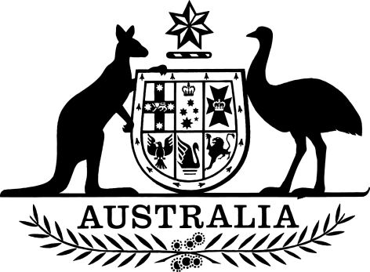

Environment Protection and Biodiversity Conservation (Norfolk Island Region Threatened Species Recovery Plan) Instrument 2025
I, Tanya Plibersek, the Minister for the Environment and Water, make the Norfolk Island Region Threatened Species Recovery Plan in the following instrument.
Dated 13.2.25
Tanya Plibersek
Minister for the Environment and Water

1 Name
This instrument is the Environment Protection and Biodiversity Conservation (Norfolk Island Region Threatened Species Recovery Plan) Instrument 2025.

2 Commencement
This instrument commences on the day after it is registered.

3 Authority
This instrument is made under subsection 269A(2) of the Environment Protection and Biodiversity Conservation Act 1999.

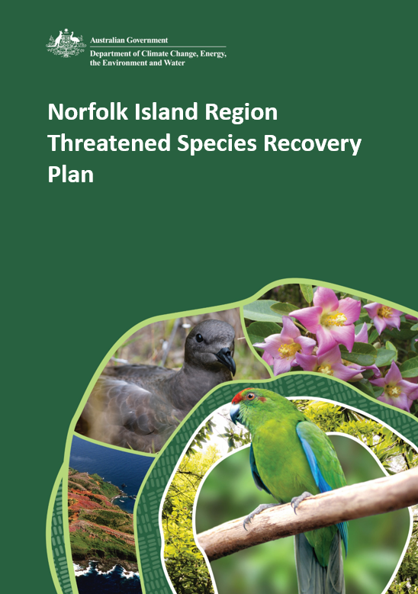

© Commonwealth of Australia 2025
Ownership of intellectual property rights
Unless otherwise noted, copyright (and any other intellectual property rights) in this publication is owned by the Commonwealth of Australia.
Creative Commons licence
All material in this publication is licensed under a Creative Commons Attribution 4.0 International Licence except content supplied by third parties, logos and the Commonwealth Coat of Arms.
Inquiries about the licence and any use of this document should be emailed to copyright@dcceew.gov.au.

Cataloguing data
Citation details: Commonwealth of Australia (2025) Norfolk Island Region Threatened Species Recovery Plan. Department of Climate Change, Energy, the Environment and Water, Canberra.
This publication is available at SPRAT EPBC Act Recovery Plans.
Department of Climate Change, Energy, the Environment and Water
GPO Box 3090 Canberra ACT 2601
Telephone 1800 803 772
Web dcceew.gov.au
Disclaimer
The Australian Government acting through the Department of Climate Change, Energy, the Environment and Water has exercised due care and skill in preparing and compiling the information and data in this publication. Notwithstanding, the Department of Climate Change, Energy, the Environment and Water, its employees and advisers disclaim all liability, including liability for negligence and for any loss, damage, injury, expense or cost incurred by any person as a result of accessing, using or relying on any of the information or data in this publication to the maximum extent permitted by law.
This Recovery Plan has been developed with the involvement and cooperation of a range of stakeholders, but individual stakeholders have not necessarily committed to undertaking specific actions. The achievement of targets and the provision of funds may be subject to budgetary and other constraints and may also be constrained by the need to address other conservation priorities. Approved recovery actions may be subject to modification due to changes in knowledge and changes in conservation status.
Acknowledgement of Country
We acknowledge the Traditional Custodians of Australia and their continuing connection to land and sea, waters, environment and community. We pay our respects to the Traditional Custodians of the lands we live and work on, their culture, and their Elders past and present.

Contributions
Lead authors and editors: Nicholas Macgregor, Margarita Goumas, Jess Williams, Erik Doerr, Samuel Merson, Carla Miles, Alyssa Roggero, Lil Blake, Melinda Wilson, Allie Andersen, Grace Wall, Lydia Ayto.
Contributors: Keith Broome, Rhonda Butcher, Nicholas Carlile, James Castles, Joel Christian, Margaret Christian, Rohan Clarke, Department of Infrastructure, Transport, Regional Development, Communications and the Arts, Eloise Dowd, Daniel Gautschi, Simon Gorta, Nigel Greenup, Frances Greeshaw, Luke Halpin, Marc Hockings, Ben Hoffman, Isabel Hyman, Salit Kark, Lilli King, Peter Latch, Juliana Lazzari, Glynn Maynard, Kevin Mills, Penny Olsen, Luis Ortiz-Catedral, Tara Patel, Julie Quinn, Philip Reid, Libby Rumpff, Bec Rush, Mitch Ryan, Mark Scott, Flossy Sperring, Hannah Taylor, James Tweed, Gillian Walker, James Watson, Chuanji Yong, Heidi Zimmer.
We also acknowledge the members of Threatened Species Scientific Committee who provided insightful and valuable feedback during the preparation of this plan, and we thank them for their contributions.
This plan represents the combined efforts of many people, including those who have directly contributed to the content of the plan and those who have built the knowledge and understanding on which the plan relies.
Image credits
Cover: Kermadec petrel (credit: Stuart Cohen); White oak flowers (credit: Parks Australia); Phillip Island aerial image (credit: Norfolk Island Tourism); Norfolk Island green parrot (credit: Parks Australia).
Page iv: Norfolk Island landscape (credit: Norfolk Island Tourism).

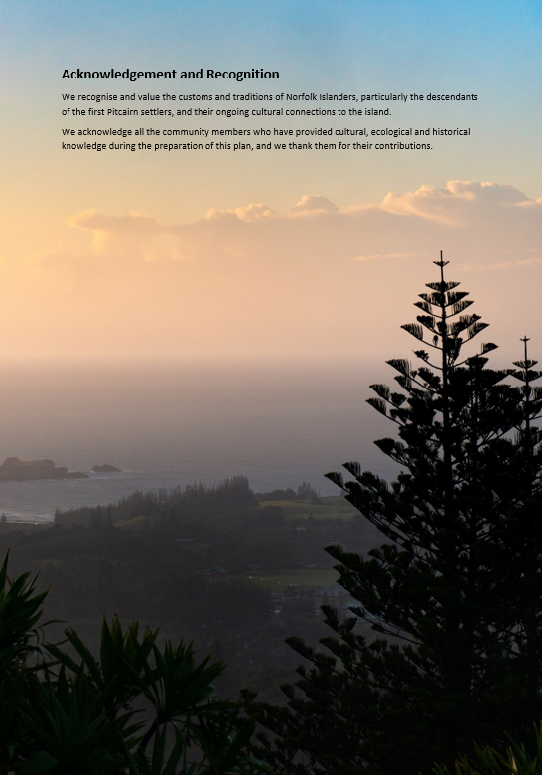

Contents
Summary 1
Purpose 1
Summary of targets 1
Summary of recommended management and monitoring 6
Summary of the costing framework 7
Part 1—Context 9
1.1 Introduction 9
1.2 The Norfolk Island Group 17
Part 2—Pressures and risks 66
2.1 Pressures 66
2.2 Risk assessment 79
Part 3—Review of past planning and management 85
3.1 Review of implementation of the previous recovery plan 85
3.2 Analysis of the adequacy of current management 96
Part 4—Management planning 99
4.1 Conceptual framework for management planning 99
4.2 Ten-year species targets 103
4.3 Ten-year management targets 107
4.4 Direct management programs 109
4.5 Supporting management actions 119
4.6 Adaptive management 122
4.7 Research 127
Part 5—Implementation 130
5.1 Governance and responsibilities 130
5.2 Interaction with other plans, policies, and strategies 142
5.3 Costs of implementation 144
5.4 Implementation timeframe 151
Part 6—Species profiles 152
6.1 Invertebrates 155
6.2 Reptiles 172
6.3 Land birds 180
6.4 Seabirds 202
6.5 Flora 239
Part 7—Appendices 389
Appendix A: Conceptual models 390
Glossary 395
References 397

Tables
Table 1 Ten-year targets for animal species 2
Table 2 Ten-year targets for plant species 3
Table 3 Ten-year management targets 5
Table 4 Listed threatened species covered by the recovery plan 11
Table 5 Soils of Norfolk Island 20
Table 6 EPBC listed threatened molluscs of the Norfolk Island Group 24
Table 7 EPBC listed threatened reptiles of the Norfolk Island Group 27
Table 8 Endemic and/or EPBC listed avian fauna of the Norfolk Island Group 29
Table 9 Distribution of EPBC listed threatened fauna (excluding species presumed to be extinct) on the Norfolk Island Group across tenure types 42
Table 10 Threatened and/or endemic plants of the Norfolk Island Group 43
Table 11 Distribution of EPBC listed plant species of the Norfolk Island Group across tenure types 47
Table 12 Description of the native plant communities found on Norfolk Island and a summary of the threatened plant species that may occur within them 52
Table 13 Plant communities of Phillip Island 54
Table 14 Area of native plant communities (remnant and non-remnant) on Norfolk Island predicted for 1750 and estimated for 2020, and percentage remaining in 2020 58
Table 15 Distribution of remnant plant communities present in 2020 on Norfolk Island across tenure types 59
Table 16 Sites of significant native vegetation in the Norfolk Island Group, including in the national park, public reserves and other locations 61
Table 17 Key threatening processes listed under the EPBC Act relevant to Norfolk Island Group 76
Table 18 Potential weed species of concern in the Norfolk Island Group 77
Table 19 Risk matrix used to assess risks to species 80
Table 20 Summary of severity of risk posed by each pressure to each species 81
Table 21 Species population estimates and trends from 2010 to 2023 90
Table 22 Summary of actions completed 94
Table 23 Management programs assessed 96
Table 24 IUCN status definitions 97
Table 25 IUCN rules for assigning status 97
Table 26 Listed threatened fauna species and their 2034 targets 103
Table 27 Listed threatened plant species and their 2034 targets 105
Table 28 Management targets and the pressures they address 107
Table 29 Management programs and associated targets and actions to achieve 2034 targets for threatened species 110
Table 30 The importance of each management program for each species 115
Table 31 Summary of roles in delivering the plan—direct management 140
Table 32 Summary of roles in delivering the plan—supporting management, research and monitoring 141
Table 33 Core and contingent management programs, and their locations of implementation, for which costs have been estimated 146
Table 34 Estimated cost of management programs over five years for Norfolk Island National Park, public reserves and other land 148
Table 35 Five-year present value cost of management programs by activity category and area 150

Figures
Figure 1 Sequence of management programs and targets over the life of the plan 2
Figure 2 Photos of the native plant communities on Norfolk Island 51
Figure 3 Predicted response after 10 years under 2021 management levels 98
Figure 4 Simplified conceptual model of the pressures, drivers, and management that influence the state of threatened species on the Norfolk Island Group 99
Figure 5 The hierarchy of outcomes relevant to this ten-year plan 102
Figure 6 Illustration of the major steps of the adaptive management cycle and its links to the Norfolk Island Region Threatened Species Recovery Plan 122
Figure 7 An example of a chain of linked indicators, representing the monitoring of a sequence of results towards a final target for a threatened species 123
Figure 8 Schematic overview of a possible integrated monitoring program to comprehensively track results across major management programs 124
Figure 9 A conceptual overview of evaluation across sets of linked resource, management, pressure and value indicators, and some of the management decisions that might be considered under different scenarios 125
Figure 10 Conceptual model of factors and interactions influencing forest birds on Norfolk Island..390
Figure 11 Conceptual model of factors and interactions influencing native plant communities and threatened plant species on Norfolk Island 391
Figure 12 Conceptual model of factors and interactions influencing threatened snails on Norfolk Island 392
Figure 13 Conceptual model of factors and interactions influencing native plant communities and threatened plant species on Phillip Island 393
Figure 14 Conceptual model of factors and interactions influencing threatened animals on Phillip Island 394

Maps
Map 1 Terrestrial areas of the Norfolk Island Group covered in the plan, including location of protected areas 10
Map 2 Soil map of Norfolk Island 19
Map 3 A Map showing the known locations of threatened molluscs on the Norfolk Island Group 35
Map 4 A map showing the distribution of threatened reptiles on the Norfolk Island Group 36
Map 5 Primary distribution of the Norfolk Island green parrot 37
Map 6 Range movements of the Norfolk Island morepork on Norfolk Island 38
Map 7 Distribution of the Norfolk Island golden whistler 39
Map 8 Distribution of the Norfolk Island robin 40
Map 9 Distribution of the Kermadec petrel in the Norfolk Island Group 41
Map 10 Number of threatened plant species in each park and reserve in the Norfolk Island Group 46
Map 11 Norfolk Island native plant communities present in 1750 56
Map 12 Norfolk Island native plant communities present in 2020 57

Summary

Purpose
The purpose of the Norfolk Island Region Threatened Species Recovery Plan (‘the plan’) is to provide the management and supporting actions necessary to stop the decline and support the recovery of terrestrial threatened species in the Norfolk Island Group. By taking a regional approach, this plan seeks to identify and support integrated solutions for the threatened species in the Norfolk Island Group and contribute to conservation of overall biodiversity on the islands. The plan covers all land tenures across the Norfolk Island Group including Norfolk Island, Phillip Island, Nepean Island and surrounding rock stacks (Map 1) but does not address the Norfolk Marine Park, which is managed under the Temperate East Marine Parks Network Management Plan 2018 (Director of National Parks 2018). The plan replaces the previous Norfolk Island Region Threatened Species Recovery Plan (Director of National Parks 2010).
The plan serves as a formal recovery plan for a specific subset of the threatened species in the Norfolk Island Group, comprising 46 plant species, five bird species and two reptile species (Table 1). It also includes actions for five endemic snails that are listed under the Environment Protection and Biodiversity Conservation Act 1999 (EPBC Act), but which do not require a recovery plan.
Successful implementation of the plan requires coordination by a recovery team made up of agencies with responsibility for land management and other stakeholders, with strong participation by the Norfolk Island community.

Summary of targets
The plan contains a detailed conceptual framework for management planning based on a hierarchy of outcomes. A long-term vision and goals provide a direction of travel, recognising that the plan is one part of an ongoing process to restore the Norfolk Island Group’s biodiversity and ecosystems. Within that context, the plan focuses on a sequence of specific aims for the next ten years, based on delivery of management actions (grouped into management programs), leading to achievement of management targets, in turn leading to achievement of recovery targets for the species (Figure 1). Targets have been set to be sufficiently ambitious to support achieving the vision for 2050 while being achievable within a decade if sufficient resources are available.
Details of each of those three levels of targets are summarised below (with full details in Part 4—Management planning). They are presented in the reverse of the order in Figure 1, on the basis that planning starts with defining desired outcomes and works back to identify relevant intermediate targets and required actions.
Figure 1 Sequence of management programs and targets over the life of the plan
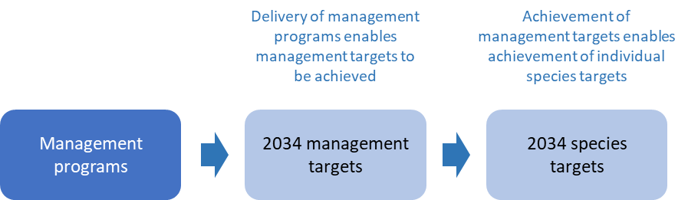

Ten-year species targets
Summary tables of animal and plant species targets are below. For full details, see Table 26 and Table 27.
Table 1 Ten-year targets for animal species
Species | Common name | Target
Advena campbellii | Campbell’s keeled glass-snail | Maintain at least three viable populations on Norfolk Island
Mathewsoconcha grayi (Advena grayi) | Gray’s glass-snail | At least one large stable population on Phillip Island
Mathewsoconcha phillipii (Advena phillipii) | Phillip Island glass-snail | n/a, presumed extinct
Mathewsoconcha suteri (Advena suteri) | Suter’s striped glass-snail | Maintain at least two viable populations on Norfolk Island
Quintalia stoddartii (Advena stoddartii) | Stoddart’s glass-snail | n/a, presumed extinct
Christinus guentheri | Lord Howe Island gecko | Maintain numbers and range
Oligosoma lichenigerum | Lord Howe Island skink | Area of occupancy increased by at least 10%
Cyanoramphus cookii | Norfolk Island green parrot | The population has increased to 1000 individuals, including 150 to 200 breeding pairs, and the breeding range has extended to the south of the island
Ninox novaeseelandiae undulata | Norfolk Island morepork | The population size has increased by at least 30% from 2023, and breeding is occurring both inside and outside of the national park
Pachycephala pectoralis xanthoprocta | Norfolk Island golden whistler | The population is at least 2000 individuals and distributed across Norfolk Island
Petroica multicolor | Norfolk Island robin | The population is at least 1500 individuals, and the distribution extends outside the national park and its fringes to other areas of the island (such as other reserves and more southern parts of the island)
Pterodroma neglecta neglecta | Kermadec petrel | There are at least 100 breeding pairs on Phillip Island with ongoing high breeding success
Table 2 Ten-year targets for plant species
Species | Common name | Target ª
Abutilon julianae | Norfolk Island abutilon | 1000
Achyranthes arborescens | Chaff tree, soft-wood | 1000
Achyranthes margaretarum | Phillip Island chaffy tree | 500
Anthosachne kingiana kingiana | Phillip Island wheat grass | 100 groups of plants
Blechnum norfolkianum | Norfolk Island water-fern | 1000
Boehmeria australis australis | Tree nettle, nettletree | 1000
Calystegia affinis | A creeper | 100 groups of plants
Clematis dubia | Clematis | 500
Coprosma baueri | Coastal coprosma | 1500
Coprosma pilosa | Mountain coprosma | 1000
Cordyline obtecta | Ti | 3000
Dendrobium brachypus | Norfolk Island orchid | No decline
Dysoxylum bijugum | Sharkwood | 2000
Elatostema montanum | Mountain procris | 100
Euphorbia norfolkiana | Norfolk Island euphorbia | 1000
Euphorbia obliqua | A herb | 2000
Hibiscus insularis | Phillip Island hibiscus | 1000
Hypolepis dicksonioides | Downy ground-fern, brake fern, ground fern | 750
Ileostylus micranthus | Mistletoe | 750
Lastreopsis calantha | Shield-fern | 250
Marattia salicina (Ptisana salicina) | King fern, para, potato fern | 250
Melicope littoralis | Shade tree | 1000
Melicytus latifolius | Norfolk Island mahoe | 500
Melicytus ramiflorus subsp. oblongifolius | Whiteywood | 1000
Meryta angustifolia | Narrow-leaved meryta | 1000
Meryta latifolia | Broad-leaved meryta | 1000
Muehlenbeckia australis | Shrubby creeper, pohuehue | 250
Myoporum obscurum | Popwood | 1000
Myrsine ralstoniae | Beech | 3000
Pennantia endlicheri | Pennantia | 1000
Phreatia limenophylax | Norfolk Island phreatia | Established in a second location
Phreatia paleata | White lace orchid | No decline
Pittosporum bracteolatum | Oleander | 3000
Planchonella costata | Bastard ironwood | 1000
Polyphlebium endlicherianum | Middle filmy fern | 250
Pteris kingiana | King’s brakefern | 500
Pteris zahlbruckneriana | Netted brakefern | 250
Senecio australis | A daisy | 3000
Senecio evansianus | A daisy | 250
Senecio hooglandii | A daisy | 750
Streblus pendulinus | Siah’s backbone | 1000
Taeniophyllum norfolkianum | Minute orchid, ribbon-root orchid | No decline
Tmesipteris norfolkensis | Hanging fork-fern | 1000
Ungeria floribunda | Bastard oak | 1000
Wikstroemia australis | Kurrajong | 1000
Zehneria baueriana | Native cucumber, giant cucumber | 300 groups of plants
ª Target figures refer to number of individuals, unless otherwise stated.

Ten-year management targets
A summary table of management targets is below. For full details, see Table 28.
Table 3 Ten-year management targets
2034 management target | Pressures addressed ª
No new potentially damaging exotic fauna, flora or pathogens establish on islands within the Norfolk Island Group | Impacts of potential new invasive species including pathogens
At least a 50% decrease in activity and/or density of rats in the national park with no negative side effects on native species | Predation by rodents
An 80% reduction of feral chickens in the national park relative to 2023 levels | Predation or damage by chickens
Free-roaming cats detected on less than 50% of the island | Predation by cats
Numbers of rosellas in the national park reduced by 50% | Lack of available nest sites
Swamphen activity on Phillip Island maintained at or reduced below current levels | Predation by swamphens
Argentine ants eradicated from Norfolk Island | Predation by Argentine ants
Minimise spread of Phytophthora cinnamomi beyond baseline distributions within the park and across the island  Plant dieback caused by P. cinnamomi is reduced to the point where intervention is no longer necessary | Infection by pathogens already present
Extent of high-quality native vegetation is increased (for detailed targets for restoration of native vegetation, refer to Table 28) | Loss, degradation and fragmentation of native vegetation  Competition from weeds/change of habitat due to weed invasion
Fire risk to protected areas and other areas of native vegetation is minimised, and any outbreaks in or threatening these areas are swiftly suppressed  Increased awareness and vigilance to prevent unplanned ignitions and to report and stop them rapidly when detected | Increased fire risk as a result of climate change
Limited availability of suitable nest sites overcome such that, for each hollow-nesting species, there is an increase of at least 20% in the number of breeding attempts in managed nest sites | Lack of available nest sites
Insurance captive breeding or nursery populations established and appropriately managed, if required  All threatened plant species protected in seed banks  New wild populations established if required | Problems caused by small populations  Other in-situ pressures
Any incursion of a significant invasive species on Phillip Island is swiftly eradicated | Impacts of potential new invasive species
ª See risk assessment at Section 2.2

Summary of recommended management and monitoring
A coordinated suite of management programs will be required to achieve the objectives of the plan, including:
- biosecurity
- integrated invasive animal control:
- control of rodents
- control of feral chickens
- control of free-roaming cats
- control of crimson rosellas
- control of swamphens
- eradication of Argentine ants
- control of Phytophthora cinnamomi
- restoration of native vegetation
- fire management
- provision of nest sites for native threatened birds
- population management.
See Table 3 for a summary and Table 29 for full details of these management programs.
Direct management must be supported by a range of supporting actions, including coordination, policy and legislation, and community engagement and communication.
It is essential that management is informed by a comprehensive and integrated program of monitoring and evaluation. Section 4.6 (Adaptive management) provides a framework for developing a monitoring plan with the ability to track results across chains of linked indicators, representing a sequence of results towards a final goal, specifically regarding: (1) investment of resources, (2) delivered management actions, (3) state of pressures (relating to management targets) and (4) populations of threatened species (relating to species targets). Regular evaluation across these chains of indicators will enable progress to be tracked and appropriate adaptive adjustments to be made to management, ecological monitoring, and research elements of the recovery plan.

Summary of the costing framework
The plan applies a systematic costing framework to estimate the budget that would be required to achieve the targets of the plan and help secure the long-term future of the unique biodiversity of the Norfolk Island Group. Costs were estimated for all core and contingency management programs. For each program, the underlying activities required to achieve the management target over a five-year period were identified, using a standardised framework of categories of activity and different cost components. Structured models were used to estimate the costs of each management program, including simulating a range of cost estimates to account for uncertain variables such as travel and labour costs. Contingency costs for eradicating invasive species from Phillip Island if those species arrived on the island from Norfolk Island were estimated by considering the per eradication event cost and the probability of occurrence over the five years.
Costs were estimated separately for three management areas: Norfolk Island National Park, public reserves, and other land. Table 33 summarises the management programs and locations to which they apply.
Estimates of total costs over five years (best estimates with ranges to incorporate uncertainty in cost predictions) are:
- Norfolk Island National Park: $54,217,963 (range: $39,235,600 to $82,376,763)
- public reserves: $16,551,581 (range: $11,922,670 to $25,470,962)
- other land: $13,884,341 (range: $9,534,594 to $21,314,373).
Approximately 64% of costs would be associated with management in the national park, 20% with management in public reserves and 16% with management on other land (Table 34). This reflects the size of the park relative to public reserves, and the wider ranging and/or more ambitious management targets that have been set for the park in comparison with other types of land.
Of the different programs, restoration of native vegetation was estimated to be the most resource intensive, representing over 50% of the total budget. Rodent control was the next most expensive ongoing program, at 15% of the total.
The bulk of costs identified are for on-ground management (78.5% of the total), but resources will also be required for other actions, including planning and coordination, monitoring, research, education and training.
The cost figures are estimates of what it would cost to fully implement the plan. They do not indicate the budget that will be available; nor do they represent a commitment by any organisation to provide any element of the budget. Relevant organisations should use this plan to prioritise actions to protect species and enhance their recovery.

Structure of the plan
This plan is presented in seven parts.
Part 1 presents the purpose and scope, the legislative context, and a description of the Norfolk Island Group, including an introduction to the threatened species addressed in this plan.
Part 2 outlines the past, current and likely future pressures on threatened species and biodiversity in the Norfolk Island Group and presents an assessment of risks associated with those pressures.
Part 3 presents the results of a review of the previous recovery plan and an analysis of the adequacy of management that was being undertaken in 2021 when development of the new plan began.
Part 4 covers the logic and conceptual underpinning of the plan, management planning, including the species and management targets for the next ten years, and the management programs and actions to be implemented to achieve those targets.
Part 5 covers implementation, including governance, and a summary of the methods and results of an analysis to estimate the costs of delivering the plan.
Part 6 contains detailed species profiles for each of the threatened species, including a summary of the actions outlined in this plan to guide their management. Profiles are also included for some of the region’s most significant seabirds, some of which are listed as marine and/or migratory under the EPBC Act.
Part 7 provides additional information in Appendices.

Part 1—Context

Introduction

Purpose and scope
The Norfolk Island Group contains many threatened species in a relatively small and isolated geographic area. Many of the threatened species in the Norfolk Island Group are affected by common pressures and have overlapping requirements. To take a more strategic and integrated approach to threatened species recovery and threat abatement for the Norfolk Island Group, a regional recovery plan is more appropriate than separate plans for individual species. This allows for more integration of regional scale threat abatement activities, and many of the management actions proposed have been devised to deliver benefit to multiple species.
The recovery plan replaces the previous Norfolk Island Region Threatened Species Recovery Plan (Director of National Parks 2010). The overall objective of the previous recovery plan was to secure and improve the conservation status of Norfolk Island threatened species through an integrated program of habitat protection and improvement, threat abatement, and public awareness and involvement. The previous plan covered 58 threatened species, serving as a formal recovery plan for 53 of these. The plan also provided conservation actions for five endemic snails that are listed under the EPBC Act, but which do not require a recovery plan (there is an additional conservation advice in place for each of the five species).
The purpose of this recovery plan is to outline the management and recovery actions necessary to stop the decline and support the recovery of terrestrial threatened species on Norfolk Island. This plan aims to maximise the likelihood of threatened species surviving long term in the wild and is intended as the next phase of a longer pathway towards the conservation of biodiversity on Norfolk Island. By taking a regional approach, this plan seeks to identify and support integrated solutions for the group of threatened species, ecosystems, and general biodiversity in the Norfolk Island Group. However, within that broad scope it is essential to identify and address the management and recovery requirements of the individual species and to identify the priority actions to be delivered in different places. This balance is reflected in the targets that have been established.
The plan covers all land tenures across the Norfolk Island Group including Norfolk Island, Phillip Island, Nepean Island and surrounding rock stacks (Map 1) but does not address the Norfolk Marine Park (which is managed under the Temperate East Marine Parks Network Management Plan 2018 (Director of National Parks 2018). However, there are important ecological interactions between seabirds and other primarily land-dwelling species with the surrounding marine environment. Where necessary, these interactions are acknowledged, and the Norfolk Marine Park is discussed briefly in section 5.1.
Map 1 Terrestrial areas of the Norfolk Island Group covered in the plan, including location of protected areas
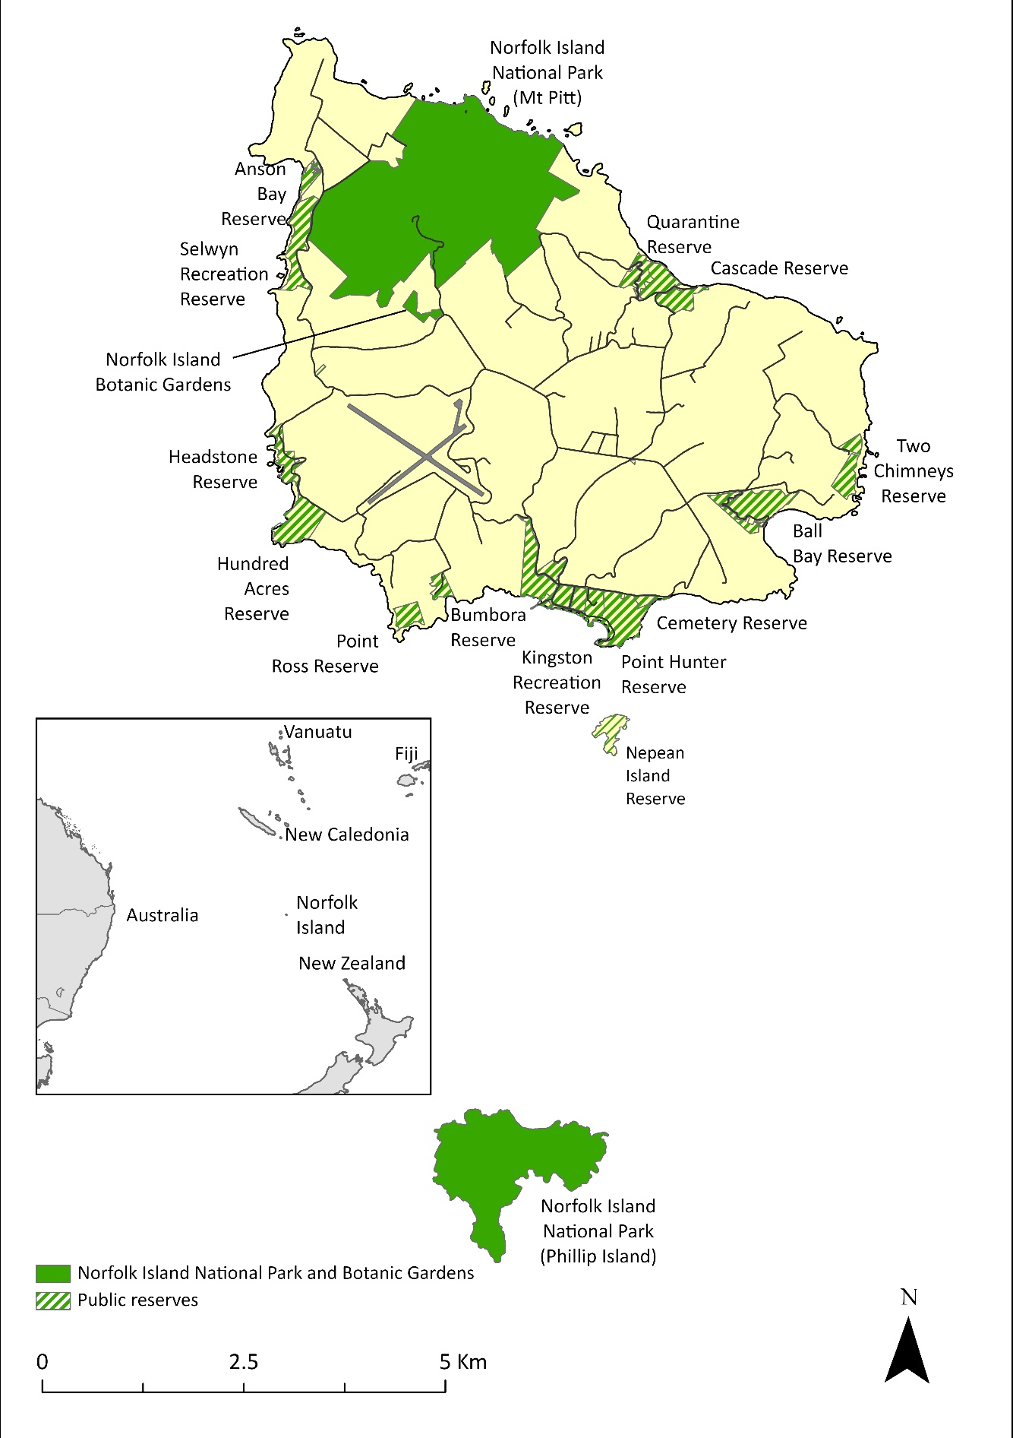
The plan covers all land tenures across the Norfolk Island Group including Norfolk Island, Phillip Island, Nepean Island and surrounding rock stacks, but does not address the Norfolk Marine Park.
The plan is formally made for 53 threatened species in the Norfolk Island Group that are listed under the Environment Protection and Biodiversity Conservation Act 1999 (EPBC Act), but more broadly addresses the full suite of threatened species, comprising 46 plant species, five species of land snails, five bird species and two reptile species (Table 4). This plan is consistent with, or will not conflict with, any other recovery plans for species that are in force under the EPBC Act. This plan will serve as a formal recovery plan under the EPBC Act for all species listed in Table 4 with the exception of the five molluscs, which do not formally require a recovery plan under the EPBC Act and have a conservation advice in place. The five snail species all occur in areas currently managed as national parks or public reserves, and the approved conservation advices are considered sufficient for providing direction to implement priority actions and manage key threats.
Note that for taxonomic names of the threatened species covered by this plan, all scientific names used are those for the species as they are currently accepted by the Australian Plant Census (APC) for flora and the Australian Faunal Directory (AFD) for fauna. Where species have been listed under the EPBC Act under previous names, the listed name appears first in tables, with the APC/AFD name in brackets, and any further information provided in table notes.
Table 4 Listed threatened species covered by the recovery plan
Species type | Species | Common name | EPBC Act status | Range
Molluscs | Advena campbellii | Campbell’s keeled glass-snail | Critically Endangered | Endemic
 | Mathewsoconcha grayi (Advena grayi) ª | Gray’s glass-snail | Critically Endangered | Endemic
 | Mathewsoconcha phillipii (Advena phillipii) ª | Phillip Island glass-snail | Critically Endangered | Endemic
 | Mathewsoconcha suteri (Advena suteri) ª | Suter’s striped glass-snail | Critically Endangered | Endemic
 | Quintalia stoddartii (Advena stoddartii) ª | Stoddart’s glass-snail | Critically Endangered | Endemic
Reptiles | Christinus guentheri | Lord Howe Island gecko | Vulnerable | Norfolk Island, Lord Howe Island
 | Oligosoma lichenigerum | Lord Howe Island skink | Vulnerable | Norfolk Island, Lord Howe Island
Birds | Cyanoramphus cookii | Norfolk Island green parrot | Endangered | Endemic
 | Ninox novaeseelandiae undulata | Norfolk Island morepork | Endangered | Endemic (hybrid population)
 | Pachycephala pectoralis xanthoprocta | Norfolk Island golden whistler, tamey | Vulnerable | Endemic
 | Petroica multicolor | Norfolk Island robin | Vulnerable | Endemic
 | Pterodroma neglecta neglecta | Kermadec petrel (western) | Vulnerable | South Pacific
Vascular plants | Abutilon julianae | Norfolk Island abutilon | Critically Endangered | Endemic
 | Achyranthes arborescens | Chaff tree, soft-wood | Critically Endangered | Endemic
 | Achyranthes margaretarum | Phillip Island chaffy tree | Critically Endangered | Endemic (Phillip Island only)
 | Anthosachne kingiana kingiana | Phillip Island wheat grass | Critically Endangered | Norfolk Island, Lord Howe Island
 | Blechnum norfolkianum | Norfolk Island water-fern | Endangered | Norfolk Island, Kermadec Island, Vanuatu, Samoa, Society Island
 | Boehmeria australis australis | Tree nettle, nettletree | Critically Endangered | Endemic
 | Calystegia affinis | A creeper | Critically Endangered | Norfolk Island, Lord Howe Island
 | Clematis dubia | Clematis | Critically Endangered | Endemic
 | Coprosma baueri | Coastal coprosma | Endangered | Endemic
 | Coprosma pilosa | Mountain coprosma | Endangered | Endemic
 | Cordyline obtecta | Ti | Vulnerable | Norfolk Island, New Zealand
 | Dendrobium brachypus | Norfolk Island orchid | Endangered | Endemic
 | Dysoxylum bijugum | Sharkwood | Vulnerable | Norfolk Island, New Caledonia, southern Vanuatu
 | Elatostema montanum | Mountain procris | Critically Endangered | Endemic
 | Euphorbia norfolkiana | Norfolk Island euphorbia | Critically Endangered | Endemic
 | Euphorbia obliqua | A herb | Vulnerable | Norfolk Island, New Caledonia, Vanuatu
 | Hibiscus insularis | Phillip Island hibiscus | Critically Endangered | Endemic (Phillip Island only)
 | Hypolepis dicksonioides | Downy ground-fern, brake fern, ground fern | Vulnerable | Norfolk Island, Kermadec Island, New Zealand, Samoa, Society Island, Marquesas
 | Ileostylus micranthus | Mistletoe | Vulnerable | Norfolk Island, New Zealand
 | Lastreopsis calantha (Parapolystichum calanthum) ^{b} | Shield-fern | Endangered | Endemic
 | Marattia salicina (Ptisana salicina) ^{c} | King fern, para, potato fern | Endangered | Norfolk Island, New Zealand
 | Melicope littoralis | Shade tree | Vulnerable | Endemic
 | Melicytus latifolius | Norfolk Island mahoe | Critically Endangered | Endemic
 | Melicytus ramiflorus subsp. oblongifolius | Whiteywood | Vulnerable | Endemic
 | Meryta angustifolia | Narrow-leaved meryta | Vulnerable | Endemic
 | Meryta latifolia | Broad-leaved meryta | Critically Endangered | Endemic
 | Muehlenbeckia australis | Shrubby creeper, pohuehue | Endangered | Norfolk Island, New Zealand
 | Myoporum obscurum | Popwood | Critically Endangered | Endemic
 | Myrsine ralstoniae | Beech | Vulnerable | Endemic
 | Pennantia endlicheri | Pennantia | Endangered | Endemic
 | Phreatia limenophylax | Norfolk Island phreatia | Critically Endangered | Endemic
 | Phreatia paleata | White lace orchid | Endangered | Norfolk Island, New Caledonia, New Guinea, Solomon Island, Vanuatu
 | Pittosporum bracteolatum | Oleander | Vulnerable | Endemic
 | Planchonella costata | Bastard ironwood | Endangered | Norfolk Island, New Zealand
 | Polyphlebium endlicherianum | Middle filmy fern | Endangered | Norfolk Island, Queensland, New Zealand, Fiji, Vanuatu, Samoa, Tahiti
 | Pteris kingiana | King’s brakefern | Endangered | Endemic
 | Pteris zahlbruckneriana | Netted brakefern | Endangered | Endemic
 | Senecio australis | A daisy | Vulnerable | Endemic ^{d}
 | Senecio evansianus | A daisy | Endangered | Endemic
 | Senecio hooglandii | A daisy | Vulnerable | Endemic
 | Streblus pendulinus | Siah’s backbone | Endangered | Endemic
 | Taeniophyllum norfolkianum ^{e} | Minute orchid, ribbon-root orchid | Vulnerable | Endemic
 | Tmesipteris norfolkensis | Hanging fork-fern | Vulnerable | Endemic
 | Ungeria floribunda | Bastard oak | Vulnerable | Endemic
 | Wikstroemia australis | Kurrajong | Critically Endangered | Endemic
 | Zehneria baueriana | Native cucumber, giant cucumber | Endangered | Norfolk Island, New Caledonia
ª Hyman et al. (2023) have completed a revised taxonomy of the Norfolk Island microcystid snails and concluded that the three genera, Advena, Mathewsoconcha and Quintalia, should be combined into the single genus Advena. However, these recommendations are yet to be adopted by the Australian Faunal Directory.
^{b} Listed under the EPBC Act as Lastreopsis calantha. The Australian Plant Census (APC) accepts Lastreopsis calantha and recognises Parapolystichum calanthum as a synonym.
^{c} Listed under the EPBC Act as Marattia salicina. The APC accepts the name Ptisana salicina and recognises Marattia salicina as a synonym.
^{d} Considered endemic at time of listing; however, it has been recorded in New Zealand. The New Zealand Plant Conservation Network describes its status as “Non-resident Native—Vagrant”, which is defined as “Taxa whose occurrences, though natural, are sporadic and typically transitory, or migrants with fewer than 15 individuals visiting New Zealand per annum.”
^{e} Considered endemic at time of listing, but also now reported from New Zealand (Renner & Beadel 2011).
Except where they are also listed as threatened, recovery plans are not required for species listed as migratory or marine under the EPBC Act. A Wildlife Conservation Plan for Seabirds (Commonwealth of Australia 2022) has been prepared to guide the management actions necessary to support listed marine and migratory seabirds. Section 1.2.6 provides an overview of the region’s seabirds and identifies those which are listed as migratory and/or marine. Section 6.4 also contains profiles for these species (including details of actions to guide their management).
The plan does not fully address some locally significant species such as the white-necked petrel (Pterodroma cervicalis), the providence petrel (P. solandri) and slender-billed white-eye (Zosterops tenuirostris) that are not currently listed under the EPBC Act. However, some information on these species is included, and recovery actions identified in the plan (such as managing predators and restoring native vegetation) are likely to benefit non-listed species irrespective of conservation status.
The plan is intended to work in a complementary way with other existing plans to support the management of common pressures and the conservation of species, their habitats and the wider ecosystems of Norfolk Island. Such plans include the Norfolk Island Marine Park Plan, the Norfolk Island National Park and Norfolk Island Botanic Garden Management Plan, and the Wildlife Conservation Plan for Seabirds, among others. Interactions with other plans are discussed in more detail in Section 5.2.

Legislative and administrative context
Norfolk Island is an external Territory of Australia administered by the Australian Government through the Department of Infrastructure, Transport, Regional Development, Communications and the Arts (DITRDCA). The Australian Government is responsible for the delivery of national and state-type services to Norfolk Island. Norfolk Island Regional Council is responsible for local government functions on Norfolk Island and may deliver some state-type functions under agreements with DITRDCA.
The EPBC Act has been in force on Norfolk Island since 1999. The Act is the Australian Government’s central piece of environmental legislation. It provides a legal framework to protect and manage nationally and internationally important flora, fauna, ecological communities, and heritage places—defined in the EPBC Act as Matters of National Environmental Significance (MNES). MNES on Norfolk Island include:
- World Heritage properties
- nationally threatened species and ecological communities
- migratory species
- Commonwealth marine areas.
The EPBC Act requires that an action that will have, or is likely to have, a significant impact on MNES must be referred to the Minister for the Environment for a decision on whether assessment and approval is required under the EPBC Act. The EPBC act also requires that an approved Conservation Advice be in place for entities listed as threatened. The Minister for the Environment decides whether a Recovery Plan is also required for threatened species.
Management of threatened species on Norfolk Island requires the input, contribution and coordination of multiple organisations. The relevant organisations and their role and responsibilities in relation to terrestrial threatened species are described in Section 5.1.
The Australian Government’s Threatened Species Action Plan 2022–2032 sets targets and objectives for threatened species recovery and conservation over ten years (DCCEEW 2022b). Under the Action Plan, Norfolk Island has been identified as one of 20 priority places and the Norfolk Island green parrot (Cyanoramphus cookii) as one of 110 priority species.

International obligations
There are 32 bird species that occur in the Norfolk Island Group that are subject to one or more of the bilateral migratory bird agreements with Japan (Japan Australia Migratory Bird Agreement [JAMBA]), China (China Australia Migratory Bird Agreement [CAMBA]) and the Republic of Korea (Republic of Korea Migratory Bird Agreement [ROKMBA]). Of those species, two are listed threatened species (Table 8). This plan provides recovery guidance for those two species, which complements guidance for these species provided in the Wildlife Conservation Plan for Seabirds (Commonwealth of Australia 2022).

Preparation of the Norfolk Island Region Threatened Species Recovery Plan
The development of the Norfolk Island Region Threatened Species Recovery Plan (‘the plan’) has been coordinated by Parks Australia with assistance from many contributors. The Norfolk Island Region Recovery Plan Steering Committee (consisting of representatives from Parks Australia, Norfolk Island Regional Council and DITRDCA) reviewed the previous plan and guided development of the new plan.
This plan builds on the previous recovery plan but with substantial revision and additional material. A review of the previous plan (see Part 3) showed there had been progress in restoring native vegetation, reducing the impacts of introduced flora and fauna, and increasing some populations, with 53% of the listed threatened species recording increases in population size since the commencement of the 2010 recovery plan (see Table 21). Most of these increases can be attributed to recovery actions—for example, efforts to protect the Norfolk Island green parrot and Kermadec petrel (Pterodroma neglecta neglecta) from predation, and extensive propagation and planting of threatened plants.
Some recovery objectives of the previous recovery plan were not met due to limited progress in implementing the identified actions. Delivery was hampered by several factors, including ambitious objectives that required more than one decade to achieve. The review made a series of recommendations, including having measurable targets, comprehensive and robust estimates of costs, a clear and logical framework for monitoring and evaluation, and a clear outline of roles and responsibilities. Those recommendations have been addressed in this new plan which has benefited not only from the review but from new information produced by research on the islands in recent years, analyses conducted specifically to support development of the plan, and insights from experiences in other places in the south-west Pacific.
An expert workshop involving 32 specialists from Norfolk Island, Australia and New Zealand was held in July 2021 to determine targets and priority actions for the threatened species included in this plan. A decision support tool developed by Parks Australia and the National Environmental Research Program Environmental Decisions Hub (Di Fonzo et al. 2017) was used to help guide resource allocation for threatened species management. Many of the workshop participants, along with other experts, subsequently contributed to an assessment of risks to individual species and/or to development of the text of the plan.
Meetings were held with the Norfolk Island Flora & Fauna Society and the community in August 2021 and May 2023 and with the Norfolk Island National Park Advisory Committee in September 2021.
Further workshops were held in 2022 with Parks Australia and Norfolk Island Regional Council staff, focusing on indicators of management effectiveness and on estimating the costs of implementing the plan. More accurate and detailed costs of management programs were determined using a local and regional-scale conservation budgeting framework and tool previously used to develop cost estimates of threatened species recovery across Australia (Yong et al. 2023). That cost analysis was led by Chuanji Yong.
This plan was made available for public comment during 2023. Relevant comments in submissions received were considered and addressed in the final drafting phase.

The Norfolk Island Group

Regional overview
The Norfolk Island Group is founded on a seamount of volcanic origin in the South Pacific Ocean (29°02’S, 167°57’E), between New Caledonia, Lord Howe Island and New Zealand, at the intersection of tropical and temperate oceanic island environments. The Group consists of the main island of Norfolk Island, the small uninhabited Nepean and Phillip Islands, and numerous rocky islets dotted about the Norfolk Island coastline. The island is predominantly bounded by precipitous cliffs of basalt and tuff. The plateau averages around 100 m above sea level with two peaks in the north over 300 m. Norfolk Island is approximately 1,450 km from Brisbane and 1,100 km from Auckland. The nearest islands to Norfolk Island are New Caledonia (767 km to the north) and Lord Howe Island (896 km to the southwest). The islands of the Norfolk Group are truly oceanic. Few oceanic islands occur in the Pacific Ocean between latitude 25°S and 35°S, and the islands are an important link between tropical and temperate environments.
Norfolk Island has a land area of 3,455 hectares (ha) of which approximately 75% is held privately as freehold or leasehold. The remainder is a combination of Commonwealth Crown land or Council-owned land, designated for a range of public uses, including conservation. Currently, 650 ha of the Island Group are managed as national park. This includes the Mt Pitt section of Norfolk Island, the Norfolk Island Botanic Garden and all of Phillip Island. An additional 237 ha are protected in a network of 18 public reserves, most of which are located along the coastline.

Geology and geomorphology
Norfolk and Phillip Islands are small remnants of a large volcano that developed on the Norfolk Ridge. The volcanic landmass of which they are a small part was created during several eruptions between 3.1 and 2.3 million years ago (Jones & McDougall 1973). Nepean Island, located between Norfolk and Phillip Islands, is not volcanic in origin and is composed of calcarenite (a form of limestone). It was formed from windblown sand dunes during the last two ice ages (Jones & McDougal 1973; NIP & FS 2003).
One of the two main volcanic vents was in the vicinity of Mt Bates (318 m above sea level) and Mt Pitt (316 m above sea level), which now stand as the two highest peaks on the main island. The other significant geological feature is the southern plateau, formed from horizontal sheets of basalt, which occupies most of the main island and is dissected by deep narrow valleys (Jones & McDougall 1973). There is a smaller plateau in the north-west near Duncombe Bay. The fourth physical region is the coastal lowland around Kingston, comprising the land formed by infilling behind the calcarenite barrier (Abell & Falkland 1991). Precipitous cliffs surround the island and most of the valleys hang over the cliffs, suggesting that wave action has been the most important force in shaping the features of the landscape.
Surface water is restricted on Norfolk Island, with no lakes and few wetlands. The three permanently flowing streams on the southern side of the island are relatively small compared to the valleys they occupy, suggesting that they were largely eroded during a wetter period. These three streams are the only creek lines that drain down to sea level. The northern portion of the island has only sparse and intermittent creek lines.
Groundwater flow systems are localised, following the major drainage basins, with vertical drainage through the weathered volcanics leaking into the underlying agglomerate and basalt aquifers, which are generally hydraulically interconnected (Petheram et al. 2020). Recharge occurs across the elevated portions of the island, including the southern and northern plateaus. A high-level water table with hydraulic potential occurs under the southern plateau at a height of over 100 m above sea level (Petheram et al. 2020).
On Phillip Island there are three (possibly four) volcanic vents. At 280 m, Jacky Jacky is the highest point on Phillip Island with steep cliffs fringing the perimeter. There are no permanent streams on the island. The tuff and ash beds are very friable and sensitive to erosion. There has been severe erosion on Phillip Island as a result of vegetation destruction by introduced goats (Capra aegagrus hircus), pigs (Sus scrofa) and rabbits (Oryctolagus cuniculus); in some places at least two metres of topsoil was lost (Melville 1969; see also section 1.2.7). Some of the valleys on Phillip Island have formed within living memory, and soil washed from the island colours the sea red following rain.

Soils
Clay-rich soils, produced by normal weathering of basalt rock, cover much of Norfolk Island (Abell & Taylor 1981). These soils are nutrient rich, well structured, friable and highly permeable. They do not hold moisture well, so native vegetation is susceptible to stress during long dry periods. The soils are also prone to mass movement such as soil creep, slumps and landslips in areas where vegetation cover has been reduced (Petheram et al. 2020).
CSIRO identified 11 soils on Norfolk Island during surveys in 1954 (Stephens and Hutton 1954). Petheram et al. (2020) also describe the Norfolk Island soils with additional hydrological context—see Map 2 and Table 5 for the soils mapped in these studies and their properties.
A digital soil attributes modelling exercise was undertaken as part of the Norfolk Island Water Resource Assessment (Petheram et al. 2020), mapping attributes relevant to ground and surface water such as permeability, water holding capacity, drainage, clay content, and soil thickness. These data are available from the CSIRO data access portal.
Map 2 Soil map of Norfolk Island
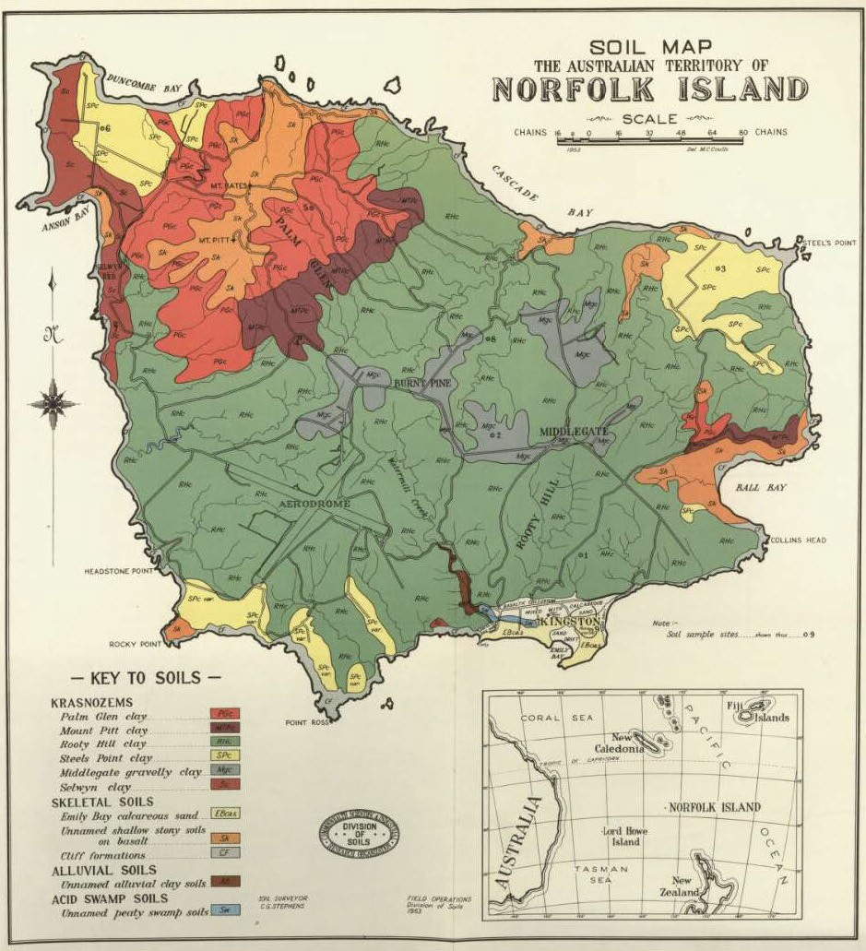
Source: Stephens and Hutton 1954.

Table 5 Soils of Norfolk Island
Soil group | Soil type | 1954 description of topography and drainage | 2020 description of soil | Parent material
Krasnozems / Ferrosols | Palm Glen clay (Red Ferrosol) | Steep to moderate slopes, located on the upper and middle slopes of Mt Pitt and Mt Bates and along Stockyard Road to the north-west of Ball Bay. Unrestricted drainage. | Very deep, rapidly drained, highly permeable, Red Ferrosol with an acid to neutral strongly structured brown or dark light clay surface. | Basalt
 | Mt Pitt clay (Red Ferrosol) | Moderate slopes, located on the middle and lower slopes of Mt Pitt and Mt Bates and north of Ball Bay. Unrestricted drainage. Generally, has been cleared for pasture and horticulture. | Moderately deep to deep, well drained, moderately permeable, Red Ferrosol with a neutral dark or brown light clay surface. | Basalt
 | Rooty Hill clay (Red Ferrosol) | Steep to moderate convex slopes and ridge tops, located on the dissected slopes and spurs of the eastern and central part of the island. Unrestricted drainage. Is largely under pasture. | Highly variable in depth, well-drained, moderately permeable, Red Ferrosol with a neutral brown, dark or brownish red light clay surface. | Basalt
 | Steel’s Point clay (Brown Ferrosol) | Gently undulating to flat, occurs extensively near Steel’s Point and near Duncombe Bay and Rocky Point. Unrestricted drainage. Regarded as the most fertile arable soil on Norfolk Island. | Very deep, well drained, moderately permeable, Brown Ferrosol with a neutral to moderately alkaline dark light clay surface. | Likely tuff
 | Middlegate clay (Red Ferrosol) | Gently undulating drainage divide, occupying the least dissected central portion of the island in the Middlegate and Burnt Pine areas. Unrestricted drainage. Largely under pasture and horticulture. | Very deep, well drained, moderately permeable Red Ferrosol with a neutral dark light clay surface. | Basalt
 | Selwyn clay (Brown Ferrosol) | Gently undulating areas on cliff tops, on the west coast of the island. Unrestricted drainage. Associated with petrel burrows. Of high fertility but occurring in exposed areas. | Deep to very deep, well drained, moderately permeable, Brown Ferrosol with a neutral dark light clay surface. | Basalt
Skeletal soils | Emily Bay calcareous sand (Calcarosol) | Undulating, confined to the Kingston area, wind deposited from the adjacent fringing reef. Unrestricted drainage. | Highly permeable, strongly alkaline Calcarosol with a pale sand surface and a hard cemented calcareous pan at depth. | Calcarenite
 | Unnamed shallow stony soils | Steep slopes, on upper portion of Mt Pitt and Mt Bates. Unrestricted drainage. | Undescribed in this study. | Basalt
 | Cliff formation | Very steep slopes. Excessive drainage. | Undescribed in this study. | Basalt and tuff
Alluvial soils | Unnamed alluvial soils | Gently sloping to flat, occurs in some of the valleys such as Watermill Creek. Unrestricted drainage. | Very deep, moderately well drained, highly permeable, with neutral to alkaline brown, red or dark light clay surface. | Basaltic alluvium
Acid swamp soils | Unnamed swamp soils | Valley floors with restricted drainage, located in Kingston. | Not located during this survey—area has been filled with sediment and man-made materials. | Basaltic alluvium
Sources: Stephens & Hutton 1954; Petheram et al. 2020.

Climate
The sub-tropical climate of Norfolk Island is moderated by the surrounding sea and is primarily affected by a belt of high-pressure systems that oscillate over the island. Annual and diurnal temperature ranges are small. The average daily minimum temperature ranges from 13°C to 15°C in winter and between 18°C and 20°C in summer. Average daily maximum temperatures range from 18°C to 19° C in winter and between 23°C and 25°C in summer. Annual average rainfall is 1,312 millimetres, peaking from May to August. Prevailing winds are primarily east to south-easterly during summer and autumn, swinging to the south or south-west in mid-winter, and returning to south in spring. Tropical cyclones occasionally have an influence in the early part of the year (Bureau of Meteorology 2021).

Human history
Excavations on Norfolk Island have revealed evidence of a small Polynesian village (Anderson 1996) which pre-dates European settlement. Two Polynesian adzes (stone axes) and stone flakes were discovered during a dig on Norfolk Island in 2022, which provide strong evidence for a Polynesian settlement on the island during the 13th and 15th centuries CE (Anderson & White 2001; Australian Museum 2022). The presence of Polynesians on Norfolk Island prior to European settlement is further supported by the presence of a banana grove, Polynesian rats (Rattus exulans) and stone axes found elsewhere on the island (Norfolk Island Conservation Society 1988; Gilmour & Helman 1989a, 1989b).
The island was first settled by Europeans in 1788, at which time it was uninhabited. The aim of the initial European settlement of the island was to clear land for the cultivation of native flax, as well as grains and vegetables to support the new colony at Port Jackson. The island had two periods of operation as a penal colony: firstly from 1788 until 1814, after which it remained uninhabited for 10 years, and again from 1825 until 1855.
At the time of settlement, Norfolk Island was covered with dense forest, which now largely remains only on the highest land (Green 1994), while Phillip Island was mostly covered with white oak (Lagunaria patersonia)/low forest (Mills 2009b). Since settlement, land use has had a very significant impact on vegetation. Accounts by early settlers describe the vegetation on Norfolk Island as very dense with complete canopy excluding light, very little growth on the forest floor and abundant towering emergent pines (Hoare 1969). The early penal colonies and free settlers progressively cleared much of the natural vegetation for agriculture and timber export during the first 75 years of settlement. They also stocked Phillip Island with pigs, goats and rabbits to provide a food source, and these animals were left behind when the settlements folded.
During its time as a penal colony, most of the island, apart from the two mountains and the land to the north, was cleared for crops or pasture (Benson 1980). Following the removal of convicts in 1855, the island supported a smaller agricultural community. Only about 100 ha were under cultivation, and much of the island was neglected and invaded by weeds (Gilmour & Helman 1989a, 1989b). In 1856, the inhabitants of Pitcairn Island were relocated to Norfolk Island. These settlers cultivated the land that had been cleared by the penal colony, and agriculture became the economic base of the island. Trade with Australia in several crops developed, with farmers transitioning from one crop to another as markets changed. Whaling was also an important commercial activity, carried out periodically for over a century from about 1850.
By the mid-1920s, previously cleared land again supported Norfolk Island pines, but dense stands occurred only in areas too steep to support grazing (Benson 1980). Introduced weeds invaded the remnant rainforest to the north of the mountains, and very little of the original vegetation was left in its virgin state (Benson 1980). Following wartime construction of the airfield, the economy of the island changed, and tourism became the dominant industry on Norfolk Island.

Native species
Norfolk Island has 58 threatened species listed under the EPBC Act comprising 46 plants, five birds, two reptiles and five endemic land snails (two of which are likely extinct). An additional six bird species are known to have become extinct in historical times, along with two endemic plant species. Alongside the threatened species are many other terrestrial species including birds, invertebrates and plants.

Fauna
Norfolk Island has 12 fauna species that are listed under the EPBC Act as threatened, comprising four land birds, one seabird, two reptiles and five endemic land snails (Table 4). Six species of land birds, endemic to the island, are listed as extinct under the EPBC Act, while another species that has become extinct since European settlement, the Norfolk Island ground dove (Gallicolumba norfolciensis), is not listed under the Act. There are a further 22 species of birds occurring on Norfolk Island that are listed as migratory or marine under the EPBC Act (Table 8). There are 32 species relevant to Norfolk Island National Park and Botanic Garden that relate to one or more of the bilateral migratory bird agreements with Japan (JAMBA), China (CAMBA) and the Republic of Korea (ROKAMBA). Of those species, two are listed threatened species and discussed in this plan.

Invertebrate fauna
Norfolk Island’s invertebrate fauna — like that of many islands around the world — is relatively depauperate, with many groups having few or no species present. However, it is richer than would be expected given the island group’s small size and isolation. The invertebrate fauna of Norfolk Island remains poorly understood.
Previous invertebrate work has primarily been in the form of taxonomic publications or biosecurity surveys. The Norfolk Island Quarantine Survey 2012–2014 focused on agricultural plant pests and parasites of domestic animals, significantly improving the understanding of these groups (Maynard et al. 2018). The report documented more than 1,190 species of invertebrates, many of which had not been recorded from the island previously.
Comparatively little is known about native invertebrate fauna on Norfolk Island, and it is likely many invertebrates remain undescribed. There is currently a significant volume of work underway to improve knowledge of the island’s native invertebrates, particularly the snails and insects, as well as additional work on agricultural and horticultural pests. The following section provides details on groups of invertebrates for which significant survey work has been conducted.

Land snails
A major component of the biota of Pacific islands is land snails, which are recognised for their high levels of diversity and endemism (Cowie 2001). Many of these snails are now threatened with extinction (Ponder 1997). The Norfolk Island Group once supported many species of land snails, some of which are only known from fossil deposits and many of which were endemic. The non-marine molluscan fauna for Norfolk Island consists of 68 terrestrial species and one freshwater species and is almost entirely endemic (Smith 1992; Ponder 1997).
Currently, there are differences between the listing of Norfolk Island mollusc species under the EPBC Act and on the IUCN Red List. Five species are listed as Critically Endangered under the EPBC Act (Table 6): Campbell’s keeled glass-snail (Advena campbellii), Gray’s glass-snail (A. grayi), Phillip Island glass-snail (A. phillipii), Suter’s striped glass-snail (A. suteri) and Stoddart’s glass-snail (A. stoddartii). In comparison, twenty species appear on the IUCN Red List: six species are listed as extinct, including the only recorded freshwater mollusc (Posticobia norfolkensis), four species are considered Endangered, eight species are considered Vulnerable, and two species are data deficient. The same threats that have resulted in the extinction of several birds and plants—environmental degradation and the introduction of feral animals—have probably affected the terrestrial snail fauna as well (Ponder 1997). Surveys in 2020 resulted in the rediscovery of one species, Allenoconcha quintalia (previously known as Nancibella quintalia), which was last collected in 1889 and was listed as Extinct by the IUCN (Hyman & Köhler 2020). There is a need to reassess the listings of other endemic snail species and evaluate whether additional species should be listed under the EPBC Act.
Of the five EPBC listed threatened molluscs, only three are known to persist. Campbell’s keeled glass-snail occurs within the Mt Pitt section of the Norfolk Island National Park, Gray’s glass-snail occurs on Phillip Island, and Suter’s striped glass-snail is currently only found within Hundred Acres Reserve (Map 3). More detailed individual species information is included in Part 6.
Taxonomy of the species previously classified in the genera Advena, Mathewsoconcha and Quintalia was revised in 2023, bringing all five Critically Endangered species into the single genus, Advena (Hyman et al. 2023).
Table 6 EPBC listed threatened molluscs of the Norfolk Island Group
Species ª | Common name | EPBC Act status | Known status | Relevant Commonwealth plans
Advena campbellii | Campbell’s keeled glass-snail | Critically Endangered | Extant | Conservation Advice (DEWHA 2008a), Threat abatement plan to reduce the impacts of exotic rodents on biodiversity on Australian offshore islands of less than 100,000 hectares (Commonwealth of Australia 2009)
Mathewsoconcha grayi (Advena grayi) | Gray’s glass-snail | Critically Endangered | Extant | Conservation Advice (DEWHA 2008b), Threat abatement plan to reduce the impacts of exotic rodents on biodiversity on Australian offshore islands of less than 100,000 hectares (Commonwealth of Australia 2009)
Mathewsoconcha phillipii (Advena phillipii) | Phillip Island glass-snail | Critically Endangered | Presumed extinct | Conservation Advice (DEWHA 2008c), Threat abatement plan to reduce the impacts of exotic rodents on biodiversity on Australian offshore islands of less than 100,000 hectares (Commonwealth of Australia 2009)
Mathewsoconcha suteri (Advena suteri) | Suter’s striped glass-snail | Critically Endangered | Extant | Conservation Advice (DEWHA 2008d), Threat abatement plan to reduce the impacts of exotic rodents on biodiversity on Australian offshore islands of less than 100,000 hectares (Commonwealth of Australia 2009)
Quintalia stoddartii (Advena stoddartii) | Stoddart’s glass-snail | Critically Endangered | Presumed extinct | Conservation Advice (DEWHA 2008e), Threat abatement plan to reduce the impacts of exotic rodents on biodiversity on Australian offshore islands of less than 100,000 hectares (Commonwealth of Australia 2009)
ª Hyman et al. (2023) have completed a revised taxonomy of the Norfolk Island microcystid snails and concluded that the three genera, Advena, Mathewsoconcha and Quintalia, should be combined into the single genus Advena. As these species have been listed under the EPBC Act under previous names, the listed name appears first, with the revised names in brackets.

Orthoptera (grasshoppers, crickets and katydids)
A total of 20 orthopterans are known from the Norfolk Island Group, 11 of which are endemic. The cricket Nesitathra philipensis is believed to be endemic to Phillip Island where it lives among seabird colonies. Many of Norfolk Island’s orthopterans share close affinities with those of Lord Howe Island, with many species on both islands classified within the same genera. The crickets and katydids are among the largest and most abundant indigenous herbivores and several species can be commonly found feeding on the foliage of forest trees and shrubs at night. The chorus formed by the calls of many of the cricket and katydid species, particularly at dusk, is a distinct feature of Norfolk Island’s forest ecosystems (Rentz 1988).

Lepidoptera (moths and butterflies)
At least 263 species of lepidopterans from 29 families have been recorded on Norfolk and Phillip Islands. Of these, more than 40 are believed to be endemic, including Nesiotica cladara (which belongs to an endemic genus) and two endemic subspecies of butterfly both derived from New Caledonia (Holloway 1977). Numerous pest species are known to be present that have either been introduced or established naturally (Edwards 1985; Maynard et al. 2018).

Coleoptera (beetles)
The coleopteran fauna of Norfolk and Phillip Islands is depauperate, typical of oceanic islands. At least 304 species in 46 families have been identified, of which at least 65 species are considered endemic (Weir 1985). There have been 57 species found on Phillip Island including five endemic species (Weir 1985).
The ground beetles (Carabidae) are the most well-studied of all beetle families present on the island, though most endemic species remain poorly known. A total of 16 species are known from the island, seven of which are known to be endemic (Moore 1985; Giachino 2005).
The endemic stag beetle (Lamprima aenea) is listed as Vulnerable on the IUCN Redlist and is currently Norfolk Island’s only endemic insect species to have a threat status (IUCN 2022).

Hymenoptera (bees, wasps and ants)
The Norfolk Island Group contains a depauperate hymenopteran fauna. There are 219 species recorded from Norfolk Island or Phillip Island including nine endemic species (Naumann 1984, Smithers 1998). Many of the Hymenoptera are associated with low flowering herbs and annuals that are abundant in some parts of Phillip Island but excluded by introduced grasses on Norfolk Island (Naumann 1984).
Fifteen species of ants are known from Norfolk Island including the endemic species, Oligomyrmex norfolkensis, Tetramorium antipodum and Iridomyrmex phillipensis, the latter of which is currently only known from Phillip Island (Taylor & Brown 1985, Smithers 1998, Heterick & Shattuck, 2011). Several of the ant species are cosmopolitan or introduced and most of the others can be attributed to the Australian element of the Norfolk fauna, although some are found on Lord Howe Island or in New Zealand (Holloway 1977). The invasive Argentine ant (Linepithema humile) was first reported on Norfolk Island in 2005 (Davis 2008).

Other insects
Most groups of insects on Norfolk Island are poorly known, with substantial further work required to understand the full diversity. An order of insects that has received substantial recent attention is the thrips (order: Thysanoptera). When a catalogue of the island’s insects was compiled in 1998 (Smithers 1998), only three species of thrips were recorded from the island, two of which were endemic. Following extensive survey work from 2012–2014, Mound and Wells (2015) increased this total to 66 species, at least 12 of which are endemic. Significant work has also been undertaken on bark lice (order: Psocodea), with at least 11 known endemic species (Smithers et al. 1999).
The true flies (order: Diptera) have received relatively little attention, with future surveys likely to document many species as-yet unrecorded from the island, likely including numerous undescribed endemic species.

Myriapoda (centipedes and millipedes)
The endemic centipede, Cormocephalus coynei, was recorded on Phillip Island in 1792 but was not formally described until much later (Halpin et al. 2021a). It is restricted to Phillip and Nepean Islands, found in litter, soil and under bark (Koch 1984), and can grow to almost one foot (30.5cm; Halpin et al. 2021a). The species has a highly varied diet including crickets, seabird chicks, geckos and skinks, and even fish dropped by black noddies (Anous minuta; Halpin et al. 2021a).
Beyond the charismatic C. coynei, relatively little is known of Norfolk’s myriapod fauna. Only a handful of species have ever been documented from the island (Johns 1967).

Freshwater invertebrates
The small freshwater crab, Amarinus lacustris, is known to occur on Norfolk Island but it is not common or widespread (McCormack & Coughran 2009). Specimens of this elusive species have been collected at two locations on Norfolk Island—Bumboras Creek and Kingston. Anecdotal information suggests that land crabs (Geograpsus greyii) were well known in the past on Norfolk Island, but they were not detected in 2009 (McCormack & Coughran 2009). Local advice suggests the land crabs are in the order of 60–70mm carapace width with a hairy, purple appearance and that they live within 1km of the ocean under logs in the forests. In 2019, a sighting of this land crab was recorded on Philip Island.
The same 2009 study found one endemic species of shrimp (Paratya norfolkensis), and a population of freshwater amphipods. Paratya norfolkensis is listed as Critically Endangered on the IUCN Red List. Two species of freshwater snails were found to be plentiful in the streams. Although not identified to species level, it appears that representatives of both the families Planorbidae and Lymnaeidae were collected.

Reptiles
Two native land reptiles occur in the Norfolk Island Group: the Lord Howe Island gecko (Christinus guentheri) and the Lord Howe Island skink (Oligosoma lichenigerum), which are both listed as Vulnerable under the EPBC Act (Table 7). These species are restricted to the Norfolk and Lord Howe Island groups. Neither is now found on Norfolk Island, but both species occur on Phillip Island. The gecko also occurs on Nepean Island and the small rocky islets (Map 4)—Moo-oo Stone, Bird Rock and Green Pool Stone (Cogger 2004). See the individual species entries for the threatened reptiles in Part 6 for more detailed information.
The introduced Asian house gecko (Hemidactylus frenatus) has been recorded at three sites on Norfolk Island, primarily in the Burnt Pine township (in buildings). This species has been implicated in the decline of native gecko species in other parts of its introduced range (Hoskin 2011).
Table 7 EPBC listed threatened reptiles of the Norfolk Island Group
Species | Common name | EPBC Act status | Relevant Commonwealth plans
Christinus guentheri | Lord Howe Island gecko | Vulnerable | Lord Howe Island Biodiversity Management Plan (DECC NSW 2007), Threat abatement plan to reduce the impacts of exotic rodents on biodiversity on Australian offshore islands of less than 100,000 hectares (Commonwealth of Australia 2009), Threat abatement plan for predation by feral cats (Commonwealth of Australia 2015a)
Oligosoma lichenigerum | Lord Howe Island skink | Vulnerable | Lord Howe Island Biodiversity Management Plan (DECC NSW 2007), Threat abatement plan to reduce the impacts of exotic rodents on biodiversity on Australian offshore islands of less than 100,000 hectares (Commonwealth of Australia 2009), Threat abatement plan for predation by feral cats (Commonwealth of Australia 2015a)

Birds
The fauna of the Norfolk Island Group is notable for its endemic land birds and large numbers of seabirds, which are the most visible and most well studied terrestrial fauna element. More than 150 species of birds have been recorded on Norfolk Island and adjacent islands (Hermes et al. 1986; Christian 2005; M Christian 2024, pers comm 12 January). Of these, 32 species are resident breeding land or freshwater birds, 13 are current regular breeding seabirds, and the remainder are non-breeding migrants or vagrants (Schodde et al. 1983; Christian 2005; N Carlile 2024, pers comm 12 January). Many of the breeding land and freshwater birds were deliberately introduced or arrived on the island independently following European settlement.

Land birds
Of the 14 species and subspecies of land birds endemic to Norfolk Island, only seven are extant (Table 8). Seven are presumed extinct, though only six are listed as Extinct under the EPBC Act (the Norfolk Island ground dove is known to be extinct but is listed as migratory). Four of the seven extant species are listed under the EPBC Act.
The decline of the land birds occurred during two distinct periods. During the first period (between settlement and approximately 1900), the Norfolk Island subspecies of the New Zealand pigeon (Hemiphaga novaeseelandiae spadicea), the Norfolk Island ground dove (Gallicolumba norfolciensis), the Norfolk Island kaka (Nestor productus), and the Norfolk Island subspecies of the Tasman starling (Aplonis fusca fusca) became extinct (Schodde et al. 1983).
In the second period of decline (post-1940s), the long-tailed triller (Lalage leucopyga leucopyga) and the grey-headed blackbird or island thrush (Turdus poliocephalus poliocephalus) disappeared (Schodde et al. 1983; Dutson 2013). There were serious declines in the populations of the Norfolk Island morepork (Ninox novaeseelandiae undulata) (Olsen 1996; Olsen et al. 1989) and the Norfolk Island green parrot (Cyanoramphus cookii) (Hicks & Greenwood 1989; Hill 2002; Ortiz-Catedral et al. 2018). Populations of more common land birds such as the Norfolk Island robin (Petroica multicolor) and the slender-billed white-eye (Zosterops tenuirostris) also declined over this period.
The post-1940s period of species decline coincided with many changes to the Norfolk Island environment. These were: the introduction of the black rat (Rattus rattus) in the mid-1940s; modification to the environment through clearing, grazing and forestry activities (Smithers & Disney 1969); the replacement of native vegetation by introduced weed species such as guava, olive and lantana (Smithers & Disney 1969); the introduction or self-introduction of several non-native birds (Schodde et al. 1983); a rapid increase in the tourist population; and increasing use of agricultural poisons such as organochlorides and dieldrin (Olsen 1996). The most recent extinction of a land bird from Norfolk Island was the white-breasted white-eye (Zosterops albogularis), which was last seen in 2004.
Currently, the Mt Pitt section of Norfolk Island National Park is the stronghold for the Norfolk Island green parrot, but there is growing anecdotal evidence that its range has increased substantially, and the species is now regularly seen in areas well outside of the national park boundary (Map 5).
The Norfolk Island morepork is distributed across the national park with a higher density on the southern slopes of Mt Pitt and Mt Bates, and more sparsely distributed across the rest of Norfolk Island (Map 6).
The Norfolk Island golden whistler and the Norfolk Island robin are both endemic threatened forest birds whose ranges include the Mt Pitt section of the Norfolk Island National Park plus some adjacent and nearby forested areas (Map 7 and Map 8). The Norfolk Island golden whistler is more widespread across these areas than the Norfolk Island robin despite having specialised habitat requitements. See the individual species entries in Part 6 for more detailed information on each of the above-mentioned threatened bird species.

Seabirds
Of the 14 breeding seabirds, all are listed as marine species, four are listed as migratory species and one (the Kermadec petrel) is listed as Vulnerable under the EPBC Act (Table 8). There are two additional seabirds that may breed on the Norfolk Island Group, but this is unconfirmed: the Australasian gannet (Morus serrator; listed as Marine) and the Tasman white-bellied storm-petrel (Fregetta grallaria grallaria; listed as Marine and Vulnerable).
At the time of the first European settlement, Norfolk Island supported large populations of breeding seabirds, dominated by the wedge-tailed shearwater (Ardenna pacifica) nesting in the summer and the providence petrel (Pterodroma solandri) nesting in the winter. Food and supplies for the settlement were in short supply and thousands of birds from the large colony of providence petrels nesting around the peaks of Mt Pitt and Mt Bates were eaten, contributing (along with the activities of introduced feral pigs) to the elimination of the breeding colony. The species now breeds largely on Lord Howe Island and Phillip Island.
Today, ground nesting seabirds in the Norfolk Island Group are largely restricted to Phillip Island, Nepean Island and rock stacks surrounding Norfolk Island. This is due to predation by rats and feral and free-roaming cats (Felis catus), degradation of breeding sites through clearing and introduction of weeds, and disturbance by humans and domestic animals. The absence of mammalian predators and permanent inhabitants on these islands are critical for the survival of these colonies.
The Kermadec petrel breeds on islands across the Pacific Ocean as far east as Easter Island. In the Norfolk Island Group, a small population breeds on Phillip Island. See Map 5 and the Kermadec petrel species profile in Part 6 for more detailed information.
Table 8 Endemic and/or EPBC listed avian fauna of the Norfolk Island Group
EPBC listed threatened species that are still extant are in bold. Extinct species are noted as such in the EPBC Act status column. Range refers to the area of occurrence and not the breeding range of the species.
Type of bird | Species ª | Common name | EPBC Act status | Range | Relevant Commonwealth plans (excluding recovery plan)
Land birds ^{b} | Aplonis fusca | Tasman starling | Extinct, Migratory | Norfolk Island, Lord Howe Island | N/A
 | Chrysococcyx lucidus (Chalcites lucidus) | Shining bronze-cuckoo | Marine | Australasia | -
 | Cyanoramphus cookii | Norfolk Island green parrot | Endangered, Migratory (JAMBA) | Endemic | Conservation Advice (TSSC 2016a), Threat abatement plan to reduce the impacts of exotic rodents on biodiversity on Australian offshore islands of less than 100,000 hectares (Commonwealth of Australia 2009), Threat abatement plan for predation by feral cats (Commonwealth of Australia 2015a)
 | Eudynamys taitensis | Long-tailed cuckoo | Marine | Australasia | -
 | Falco cenchroides | Nankeen kestrel | Marine | Australasia | -
 | Gallicolumba norfolciensis | Norfolk Island ground dove | Migratory ^{c} | Endemic | -
 | Gerygone modesta | Norfolk Island gerygone | Not listed | Endemic | -
 | Hemiphaga novaeseelandiae spadicea | New Zealand pigeon (Norfolk Island race) | Extinct, Migratory | Endemic | N/A
 | Hirundo neoxena | Welcome swallow | Marine | Australasia | -
 | Lalage leucopyga leucopyga | Norfolk Island long-tailed triller | Extinct, Migratory | Endemic | N/A
 | Nestor productus | Norfolk Island kaka | Extinct, Migratory | Endemic | N/A
 | Ninox novaeseelandiae undulata | Norfolk Island morepork, Norfolk Island boobook | Endangered, Migratory (JAMBA) | Endemic | Conservation Advice (2016b), Threat abatement plan to reduce the impacts of exotic rodents on biodiversity on Australian offshore islands of less than 100,000 hectares (Commonwealth of Australia 2009), Threat abatement plan for predation by feral cats (Commonwealth of Australia 2015a)
 | Pachycephala pectoralis xanthoprocta | Golden whistler (Norfolk Island) | Vulnerable | Endemic | Threat abatement plan to reduce the impacts of exotic rodents on biodiversity on Australian offshore islands of less than 100,000 hectares (Commonwealth of Australia 2009), Threat abatement plan for predation by feral cats (Commonwealth of Australia 2015a)
 | Petroica multicolor | Norfolk Island robin | Vulnerable | Endemic | Threat abatement plan to reduce the impacts of exotic rodents on biodiversity on Australian offshore islands of less than 100,000 hectares (Commonwealth of Australia 2009), Threat abatement plan for predation by feral cats (Commonwealth of Australia 2015a)
 | Porphyrio porphyrio (Porphyrio melanotus) | Purple swamphen (‘tarla bird’ or ‘taalaberd’) | Marine | Australasia | -
 | Porzana tabuensis | Spotless crake | Marine | Australasia | -
 | Rallus philippensis (Hypotaenidia philippensis) | Buff-banded rail | Marine | Australasia | -
 | Rhipidura albiscapa pelzelni | Norfolk Island grey fantail | Not listed | Endemic | -
 | Todiramphus sanctus | Sacred kingfisher, nuffka | Marine | Norfolk Island, Lord Howe Island, New Zealand | -
 | Turdus poliocephalus poliocephalus | Grey-headed blackbird, Island thrush | Extinct, Migratory | Endemic | N/A
 | Zosterops albogularis | White-breasted white-eye, white-chested white-eye, grinnell | Extinct, Migratory (JAMBA) | Endemic | N/A
 | Zosterops lateralis | Silvereye | Marine | Australasia | -
 | Zosterops tenuirostris | Slender-billed white-eye | Not listed | Endemic | -
Breeding seabirds | Procelsterna cerulea (Anous albivittus albivittus) | Grey ternlet (western Pacific) | Marine | Australia, New Zealand | -
 | Anous minutus | Black noddy | Marine | Widespread | Marine bioregional plan for the Temperate East Marine Region (DSEWPaC 2012d), Threat abatement plan for predation by feral cats (Commonwealth of Australia 2015a), Wildlife Conservation Plan for Seabirds (Commonwealth of Australia 2020)
 | Anous stolidus | Brown noddy, common noddy | Marine, Migratory (JAMBA, CAMBA) | Widespread | Marine bioregional plan for the North Marine Region (DSEWPaC 2012a), Marine bioregional plan for the Temperate East Marine Region (DSEWPaC 2012d), Marine bioregional plan for the South-west Marine Region (DSEWPaC 2012c), Threat abatement plan for predation by feral cats (Commonwealth of Australia 2015a), Wildlife Conservation Plan for Seabirds (Commonwealth of Australia 2020)
 | Fregetta grallaria grallaria | Tasman white-bellied storm-petrel | Vulnerable, Marine | Norfolk, Lord Howe, New Zealand, Pacific | Lord Howe Island Biodiversity Management Plan (DECC NSW 2007), Threat abatement plan to reduce the impacts of exotic rodents on biodiversity on Australian offshore islands of less than 100,000 hectares (Commonwealth of Australia 2009), Marine bioregional plan for the Temperate East Marine Region (DSEWPaC 2012d)
 | Gygis alba | White tern | Marine | Widespread | Marine bioregional plan for the Temperate East Marine Region (DSEWPaC 2012d), Threat abatement plan for predation by feral cats (Commonwealth of Australia 2015a), Wildlife Conservation Plan for Seabirds (Commonwealth of Australia 2020)
 | Morus serrator | Australasian gannet | Marine | Australasia | Wildlife Conservation Plan for Seabirds (Commonwealth of Australia 2020)
 | Phaethon rubricauda | Red-tailed tropicbird | Marine, Migratory | Indo-pacific | Marine bioregional plan for the Temperate East Marine Region (DSEWPaC 2012d), Threat abatement plan for predation by feral cats (Commonwealth of Australia 2015a), Wildlife Conservation Plan for Seabirds (Commonwealth of Australia 2020)
 | Pterodroma cervicalis | White-necked petrel | Marine | Trans-equatorial | Marine bioregional plan for the Temperate East Marine Region (DSEWPaC 2012d), Wildlife Conservation Plan for Seabirds (Commonwealth of Australia 2020)
 | Pterodroma neglecta neglecta | Kermadec petrel (western) | Vulnerable, Marine | Norfolk Island, Lord Howe Island, Pacific | Lord Howe Island Biodiversity Management Plan (DECC NSW 2007), Threat abatement plan to reduce the impacts of exotic rodents on biodiversity on Australian offshore islands of less than 100,000 hectares (Commonwealth of Australia 2009), Marine bioregional plan for the Temperate East Marine Region (DSEWPaC 2012d)
 | Pterodroma nigripennis | Black-winged petrel | Marine | Norfolk, Lord Howe, New Zealand, Pacific | Threat abatement plan to reduce the impacts of exotic rodents on biodiversity on Australian offshore islands of less than 100,000 hectares (Commonwealth of Australia 2009), Marine bioregional plan for the Temperate East Marine Region (DSEWPaC 2012d), Threat abatement plan for predation by feral cats (Commonwealth of Australia 2015a), Wildlife Conservation Plan for Seabirds (Commonwealth of Australia 2020)
 | Pterodroma solandri | Providence petrel | Marine, Migratory (JAMBA) | Norfolk, Lord Howe, Pacific | Threat abatement plan to reduce the impacts of exotic rodents on biodiversity on Australian offshore islands of less than 100,000 hectares (Commonwealth of Australia 2009), Marine bioregional plan for the Temperate East Marine Region (DSEWPaC 2012d), Wildlife Conservation Plan for Seabirds (Commonwealth of Australia 2020)
 | Puffinus assimilis | Little shearwater | Marine | Widespread | Threat abatement plan to reduce the impacts of exotic rodents on biodiversity on Australian offshore islands of less than 100,000 hectares (Commonwealth of Australia 2009), Marine bioregional plan for the Temperate East Marine Region (DSEWPaC 2012d), Marine bioregional plan for the South-west Marine Region (DSEWPaC 2012c), Threat abatement plan for predation by feral cats (Commonwealth of Australia 2015a), Threat Abatement Plan for the impacts of marine debris on the vertebrate wildlife of Australia's coasts and oceans (Commonwealth of Australia 2018a), Wildlife Conservation Plan for Seabirds (Commonwealth of Australia 2020)
 | Puffinus carneipes (Ardenna carneipes) | Flesh-footed shearwater | Marine, Migratory (JAMBA, ROKAMBA) | Trans-equatorial | Threat abatement plan to reduce the impacts of exotic rodents on biodiversity on Australian offshore islands of less than 100,000 hectares (Commonwealth of Australia 2009), Marine bioregional plan for the Temperate East Marine Region (DSEWPaC 2012d), Marine bioregional plan for the South-west Marine Region (DSEWPaC 2012c), Threat Abatement Plan for the incidental catch (or bycatch) of seabirds during oceanic longline fishing operations (Commonwealth of Australia 2018b), Threat Abatement Plan for the impacts of marine debris on the vertebrate wildlife of Australia's coasts and oceans (Commonwealth of Australia 2018a), Wildlife Conservation Plan for Seabirds (Commonwealth of Australia 2020)
 | Puffinus pacificus (Ardenna pacifica) | Wedge-tailed shearwater | Marine, Migratory (JAMBA) | Widespread | Marine bioregional plan for the Temperate East Marine Region (DSEWPaC 2012d), Marine bioregional plan for the North-west Marine Region (DSEWPaC 2012b), Marine bioregional plan for the South-west Marine Region (DSEWPaC 2012c), Threat abatement plan for predation by feral cats (Commonwealth of Australia 2015a), Threat Abatement Plan for the incidental catch (or bycatch) of seabirds during oceanic longline fishing operations (Commonwealth of Australia 2018b), Threat Abatement Plan for the impacts of marine debris on the vertebrate wildlife of Australia's coasts and oceans (Commonwealth of Australia 2018a), Wildlife Conservation Plan for Seabirds (Commonwealth of Australia 2020)
 | Sterna fuscata (Onychoprion fuscata) | Sooty tern, whalebird | Marine | Widespread | Threat abatement plan to reduce the impacts of exotic rodents on biodiversity on Australian offshore islands of less than 100,000 hectares (Commonwealth of Australia 2009), Marine bioregional plan for the Temperate East Marine Region (DSEWPaC 2012d), Marine bioregional plan for the South-west Marine Region (DSEWPaC 2012c), Threat abatement plan for predation by feral cats (Commonwealth of Australia 2015a)
 | Sula dactylatra | Masked booby | Marine, Migratory (JAMBA, ROKAMBA | Widespread | Threat abatement plan to reduce the impacts of exotic rodents on biodiversity on Australian offshore islands of less than 100,000 hectares (Commonwealth of Australia 2009), Marine bioregional plan for the Temperate East Marine Region (DSEWPaC 2012d), Threat abatement plan for predation by feral cats (Commonwealth of Australia 2015a)
Other marine and/or migratory birds | Ardea alba | Great egret | Marine (JAMBA, CAMBA) | Widespread | -
 | Arenaria interpres | Ruddy turnstone | Marine, Migratory (JAMBA, CAMBA, ROCKAMBA) | Global | Marine bioregional plan for the North-west Marine Region (DSEWPaC 2012b), Wildlife Conservation Plan for Migratory Shorebirds (Commonwealth of Australia 2015b)
 | Bubulcus coromandus | Eastern cattle egret | Marine (JAMBA, CAMBA) | Widespread | -
 | Circus approximans | Swamp harrier | Marine | Australasian | -
 | Fregata minor | Great frigatebird | Marine, Migratory (JAMBA, CAMBA) | Widespread | Marine bioregional plan for the North-west Marine Region (DSEWPaC 2012b), Wildlife Conservation Plan for Seabirds (Commonwealth of Australia 2020)
 | Limosa lapponica | Bar-tailed godwit | Marine, Migratory (JAMBA, CAMBA, ROKAMBA) | Global | Marine bioregional plan for the North-west Marine Region (DSEWPaC 2012b), Wildlife Conservation Plan for Migratory Shorebirds (Commonwealth of Australia 2015b)
 | Numenius phaeopus | Whimbrel | Marine, Migratory (JAMBA, CAMBA, ROKAMBA) | Global | Marine bioregional plan for the North-west Marine Region (DSEWPaC 2012b), Wildlife Conservation Plan for Migratory Shorebirds (Commonwealth of Australia 2015b)
 | Pluvialis fulva | Pacific golden plover | Marine, Migratory (JAMBA, CAMBA, ROKAMBA) | Global | Marine bioregional plan for the North-west Marine Region (DSEWPaC 2012b), Wildlife Conservation Plan for Migratory Shorebirds (Commonwealth of Australia 2015b)
 | Todiramphus sanctus | Sacred kingfisher (NI/Tasman) | Marine | Australasia | -
 | Tringa incana | Wandering tattler | Marine, Migratory (JAMBA) | Global | Wildlife Conservation Plan for Migratory Shorebirds (Commonwealth of Australia 2015b)
ª Scientific names used are those that are currently accepted by the Australian Plant Census (APC) for flora and the Australian Faunal Directory (AFD) for fauna. Where species have been listed under the EPBC Act under previous names, the listed name appears first in tables, with the APC/AFD name in brackets.
^{b} Excludes non-breeding visitors and vagrants.
^{c} Known to be extinct but is only listed as Migratory, not extinct under the EPBC Act. The species name is not recognised by the AFD.

Mammals
The only native land mammals that have been recorded on Norfolk Island are the Eastern free-tail bat (Mormopterus norfolkensis) and Gould's wattled bat (Chalinolobus gouldii), although it is likely that the former was described from Norfolk Island in error and never occurred there (Hoye et al. 2008). Anecdotal sightings of the latter were reported around the time the last recovery plan was prepared (Director of National Parks 2010) and more recently, but scientific surveys are required to confirm the species’ potential presence.
As in many other island ecosystems, introduced mammals have been responsible for significant environmental degradation. The Polynesian rat was introduced by early Polynesian visitors prior to European arrival. The black rat was possibly introduced from a shipwreck in 1942, but it could have been introduced any time since European settlement. There is a strong likelihood that the house mouse (Mus musculus) and the feral cat were introduced during early settlement on the island (Wilson 2002).

Fish
In most creek systems, McCormack & Coughran (2009) found one species of eel (Anguilla sp.) and large numbers of small exotic pest fish species, mostly Gambusia holbrooki (Gambusia, mosquito fish) and Poecilia reticulata (guppies).

Distribution of threatened fauna
Map 3–9 present the known distribution of threatened fauna on the Norfolk Island Group. Table 9 summarises the distribution of threatened fauna by proportion across tenure types, dividing land into the Norfolk Island National Park, public reserves, and other land.
Map 3 Known locations of threatened molluscs on the Norfolk Island Group
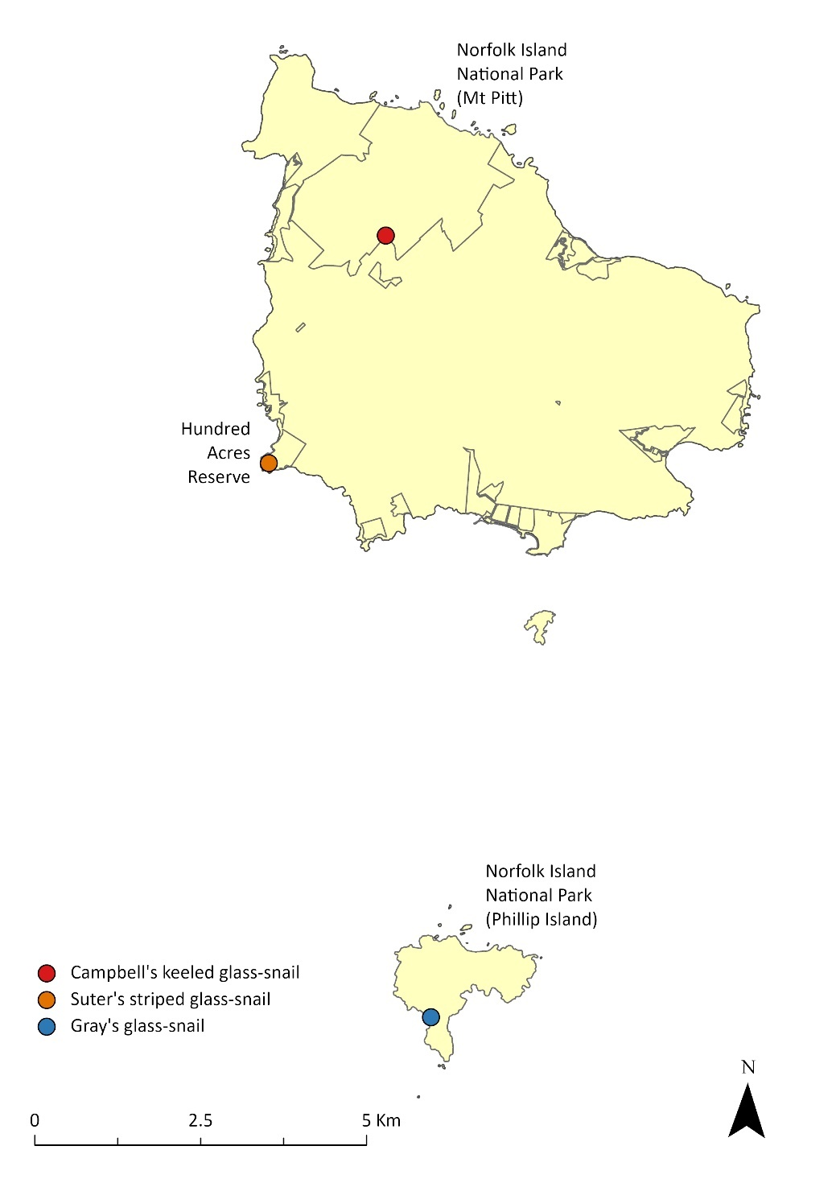
Campbell’s keeled glass-snail (Advena campbellii) occurs in the Mt Pitt section of the national park, Suter’s striped glass-snail (A. suteri) occurs in Hundred Acres Reserve, and Gray’s glass-snail (A. greyi) occurs on Phillip Island.
Source: Hyman & Kohler 2020; Tweed 2023.
Map 4 Distribution of threatened reptiles on the Norfolk Island Group
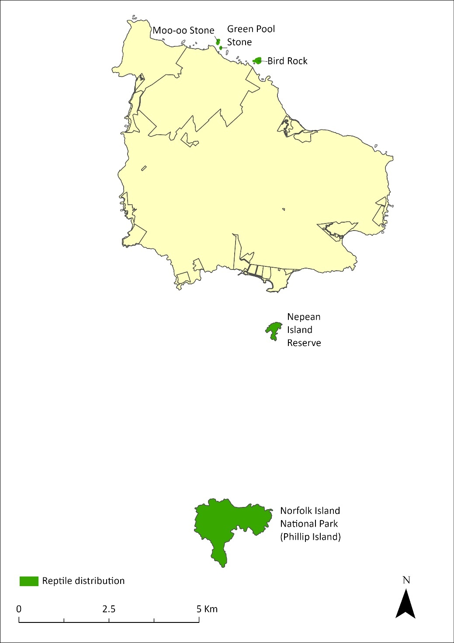
The Lord Howe Island skink (Oligosoma lichenigerum) occurs only on Phillip Island. The Lord Howe Island gecko (Christinus guentheri) has been found on Nepean and Phillip Islands and on three small rocky islets—Moo-oo Stone, Bird Rock and Green Pool Stone.
Source: Cogger et al. 2006.
Map 5 Primary distribution of the Norfolk Island green parrot
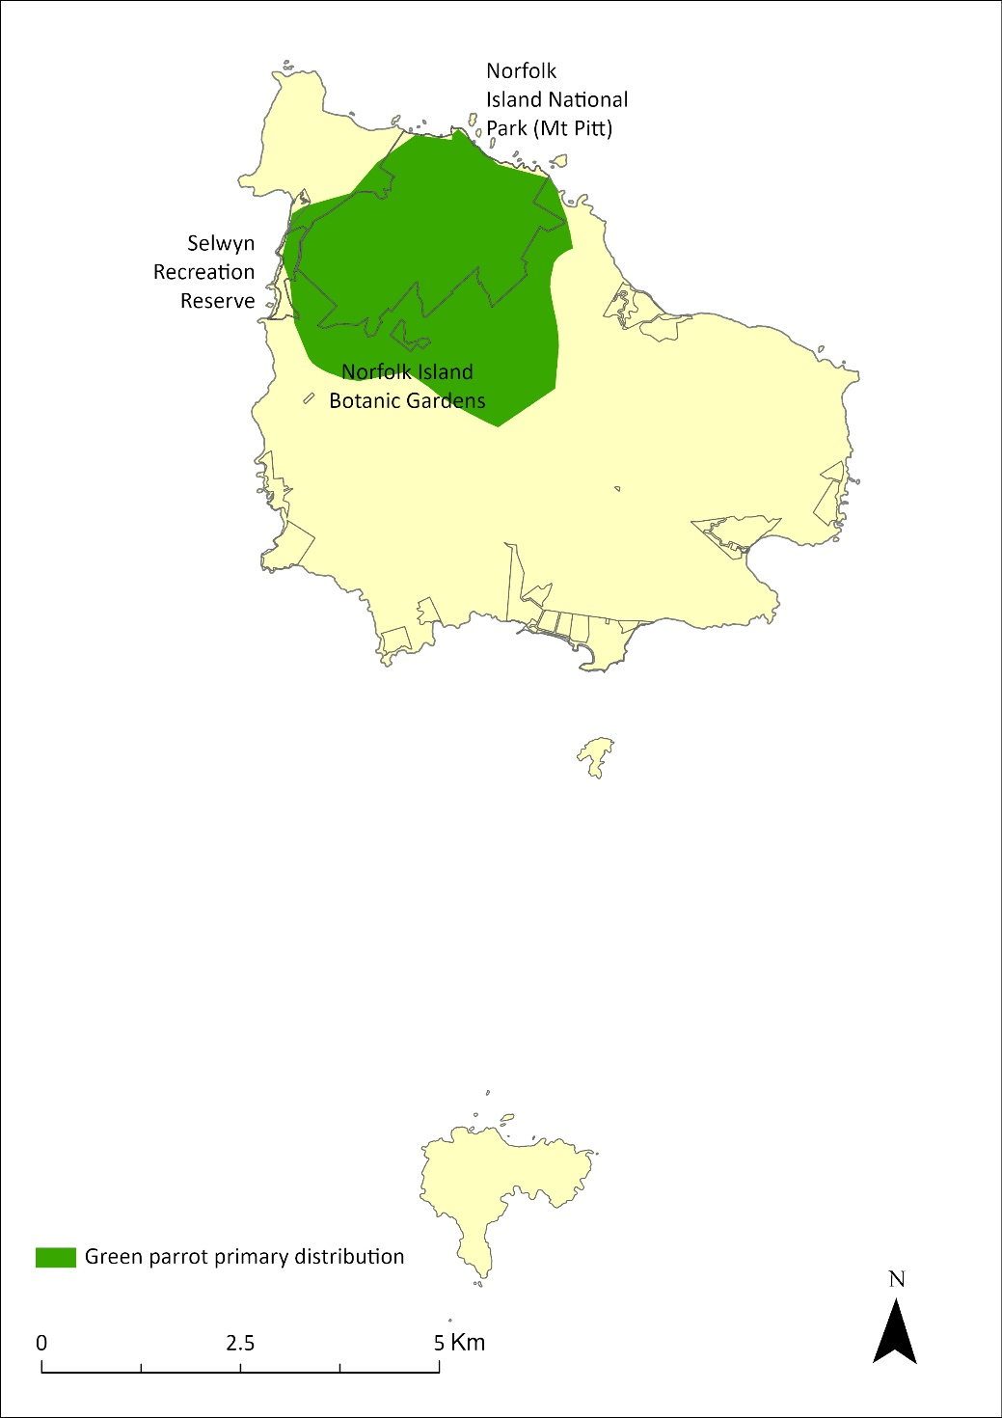
The stronghold for the Norfolk Island green parrot is within the shaded area. However, its range extends across Norfolk Island.
Source: Macgregor et al. 2021.
Map 6 Range movements of the Norfolk Island morepork on Norfolk Island
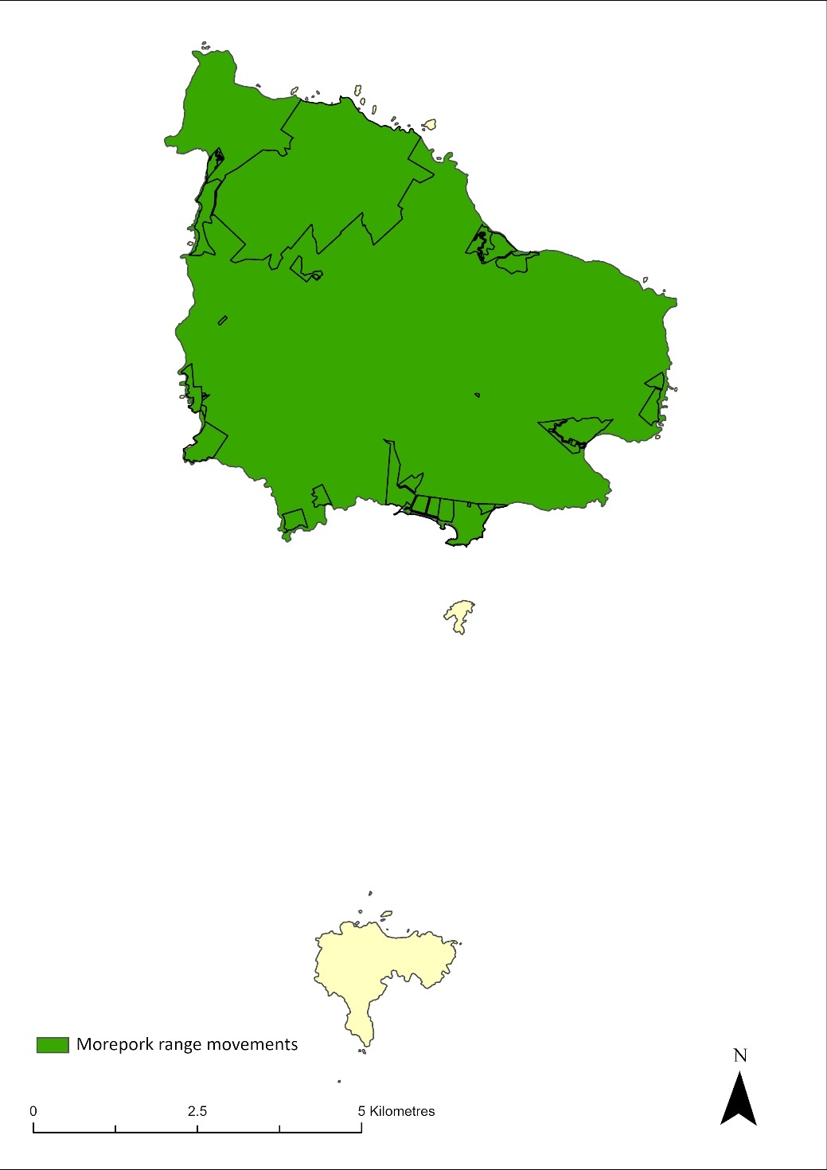
Source: Sperring et al. 2021a.
Map 7 Distribution of the Norfolk Island golden whistler
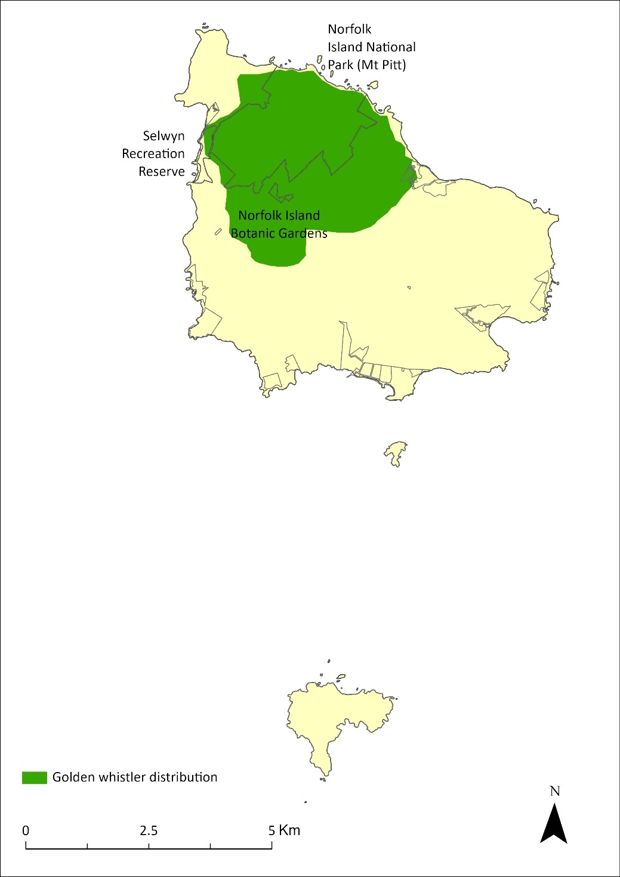
Source: Nance et al. 2021b.
Map 8 Distribution of the Norfolk Island robin
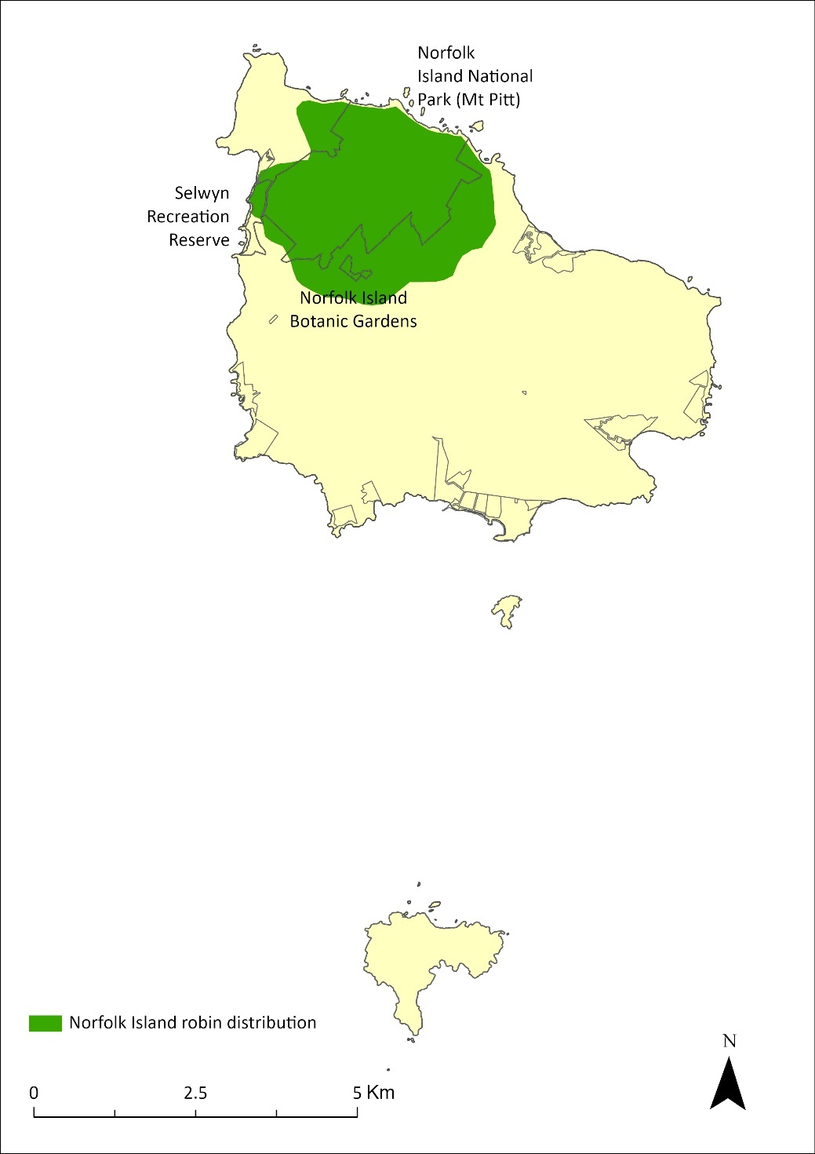
Source: Nance et al. 2021c.
Map 9 Distribution of the Kermadec petrel in the Norfolk Island Group
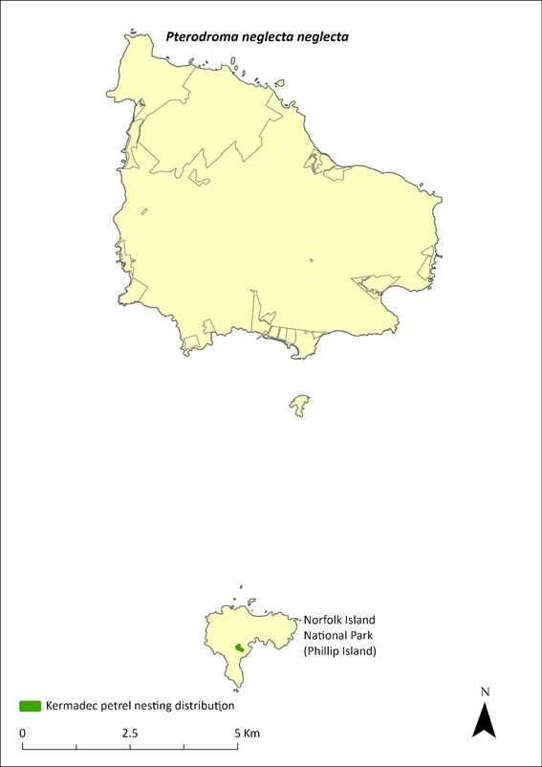
Source: Carlile and O’Dwyer 2023.
Table 9 Distribution of EPBC listed threatened fauna (excluding species presumed to be extinct) on the Norfolk Island Group across tenure types
Fauna type | Species | Common name | Distribution / range (ha) | % in national park | % in public reserves | % in other land
Molluscs | Advena campbellii | Campbell’s keeled glass-snail | 1.3 | 90% | 0% | 10%
 | Mathewsoconcha grayi (Advena grayi) | Gray’s glass-snail | 0.93 | 100% | 0% | 0%
 | Mathewsoconcha suteri (Advena suteri) | Suter’s striped glass-snail | 0.7 | 0% | 100% | 0%
Reptiles | Christinus guentheri | Lord Howe Island gecko | 306 | 93% | 5% | 2%
 | Oligosoma lichenigerum | Lord Howe Island skink | 286 | 100% | 0% | 0%
Birds | Cyanoramphus cookii | Norfolk Island green parrot | 944 | 52% | 1% | 47%
 | Ninox novaeseelandiae undulata | Norfolk Island morepork | 5357 | 9% | 4% | 86%
 | Pachycephala pectoralis xanthoprocta | Norfolk Island golden whistler | 1149 | 42% | 1% | 57%
 | Petroica multicolor | Norfolk Island robin | 837 | 59% | 1% | 40%
 | Pterodroma neglecta neglecta | Kermadec petrel (western) | 0.11 | 100% | 0% | 0%

Flora
There are 182 recognised native vascular plant species in the Norfolk Island Group (of which about 25% are endemic) and at least a further 430 naturalised species (Mills 2009a; Maynard et al. 2018). Two monotypic endemic genera occur: the rainforest tree Ungeria floribunda, which is listed as Vulnerable, and Streblorrhiza speciosa (Phillip Island glory pea) a presumed extinct but previously endemic vine on Phillip Island (Green 1994).
Forty-six plant species on Norfolk Island are listed as threatened species under the EPBC Act (Table 10). Of these, 30 species are endemic to Norfolk Island and Phillip Island, and two are endemic to Phillip Island only. An additional two species are endemic to the Norfolk Island and Lord Howe Island Groups, and another is found in north-east Queensland as well as on Norfolk Island. The remaining twelve species have their only Australian distribution on the Norfolk Island Group, but also occur in New Zealand or other Pacific islands. There are also 13 plant species that are endemic to Norfolk Island and Phillip Island that are not listed under the EPBC Act (Table 10). See Map 10 for an illustration of the number of threatened plant species occurring within each park and reserve in the Norfolk Island Group. For distribution of individual plant species see the species profiles in Part 6.
Norfolk Island has a relatively diverse and prolific lichen assemblage (Elix et al. 1992) with 190 taxa recorded (ABRS 2017). The areas of subtropical rainforest within the Norfolk Island National Park are the major habitat for lichens, and the higher, moister ridges support the greatest diversity of bryophytes on the island. Invasion of forested areas by woody weeds, particularly red guava (Psidium cattleyanum cattleyanum) and African olive (Olea europaea cuspidata), represents the major threat to lichen species; these two woody species and lantana (Lantana camara) are also a threat to the bryophytes (Elix & Streimann 1985).
Table 10 Threatened and/or endemic plants of the Norfolk Island Group
Species type | Species | Common name | EPBC Act status | Range | Relevant Commonwealth plans (excluding recovery plan)
Listed species | Abutilon julianae | Norfolk Island abutilon | Critically Endangered | Endemic | -
 | Achyranthes arborescens | Chaff tree, soft-wood | Critically Endangered | Endemic | -
 | Achyranthes margaretarum | Phillip Island chaffy tree | Critically Endangered | Endemic (Phillip Island only) | -
 | Anthosachne kingiana kingiana | Phillip Island wheat grass | Critically Endangered | Norfolk Island, Lord Howe Island | Lord Howe Island Biodiversity Management Plan (DECC NSW 2007)
 | Blechnum norfolkianum | Norfolk Island water-fern | Endangered | Norfolk Island, Kermadec Island, Vanuatu, Samoa, Society Island | -
 | Boehmeria australis australis | Tree nettle, nettletree | Critically Endangered | Endemic | -
 | Calystegia affinis | A creeper | Critically Endangered | Norfolk Island, Lord Howe Island | Lord Howe Island Biodiversity Management Plan (DECC NSW 2007)
 | Clematis dubia | Clematis | Critically Endangered | Endemic | -
 | Coprosma baueri | Coastal coprosma | Endangered | Endemic | -
 | Coprosma pilosa | Mountain coprosma | Endangered | Endemic | -
 | Cordyline obtecta | Ti | Vulnerable | Norfolk Island, New Zealand | -
 | Dendrobium brachypus | Norfolk Island orchid | Endangered | Endemic | -
 | Dysoxylum bijugum | Sharkwood | Vulnerable | Norfolk Island, New Caledonia, southern Vanuatu | -
 | Elatostema montanum | Mountain procris | Critically Endangered | Endemic | -
 | Euphorbia norfolkiana | Norfolk Island euphorbia | Critically Endangered | Endemic | -
 | Euphorbia obliqua | A herb | Vulnerable | Norfolk Island, New Caledonia, Vanuatu | -
 | Hibiscus insularis | Phillip Island hibiscus | Critically Endangered | Endemic (Phillip Island only) | -
 | Hypolepis dicksonioides | Downy ground-fern, brake fern, ground fern | Vulnerable | Norfolk Island, Kermadec Island, New Zealand, Samoa, Society Island, Marquesas | -
 | Ileostylus micranthus | Mistletoe | Vulnerable | Norfolk Island, New Zealand | -
 | Lastreopsis calantha (Parapolystichum calanthum) | Shield-fern | Endangered | Endemic | -
 | Marattia salicina (Ptisana salicina) | King fern, para, potato fern | Endangered | Norfolk Island, New Zealand | -
 | Melicope littoralis | Shade tree | Vulnerable | Endemic | -
 | Melicytus latifolius | Norfolk Island mahoe | Critically Endangered | Endemic | -
 | Melicytus ramiflorus subsp. oblongifolius | Whiteywood | Vulnerable | Endemic | -
 | Meryta angustifolia | Narrow-leaved meryta | Vulnerable | Endemic | -
 | Meryta latifolia | Broad-leaved meryta | Critically Endangered | Endemic | -
 | Muehlenbeckia australis | Shrubby creeper, pohuehue | Endangered | Norfolk Island, New Zealand | -
 | Myoporum obscurum | Popwood | Critically Endangered | Endemic | -
 | Myrsine ralstoniae | Beech | Vulnerable | Endemic | -
 | Pennantia endlicheri | Pennantia | Endangered | Endemic | -
 | Phreatia limenophylax | Norfolk Island phreatia | Critically Endangered | Endemic | -
 | Phreatia paleata | White lace orchid | Endangered | Norfolk Island, New Caledonia, New Guinea, Solomon Island, Vanuatu | -
 | Pittosporum bracteolatum | Oleander | Vulnerable | Endemic | -
 | Planchonella costata | Bastard ironwood | Endangered | Norfolk Island, New Zealand | -
 | Polyphlebium endlicherianum | Middle filmy fern | Endangered | Norfolk Island, Queensland, New Zealand, Fiji, Vanuatu, Samoa, Tahiti | Conservation Advice (DCCEEW 2024)
 | Pteris kingiana | King’s brakefern | Endangered | Endemic | -
 | Pteris zahlbruckneriana | Netted brakefern | Endangered | Endemic | -
 | Senecio australis | A daisy | Vulnerable | Endemic ª | -
 | Senecio evansianus | A daisy | Endangered | Endemic | -
 | Senecio hooglandii | A daisy | Vulnerable | Endemic | -
 | Streblus pendulinus | Siah’s backbone | Endangered | Endemic | Conservation Advice (TSSC 2016c)
 | Taeniophyllum norfolkianum ^{b} | Minute orchid, ribbon-root orchid | Vulnerable | Endemic | -
 | Tmesipteris norfolkensis | Hanging fork-fern | Vulnerable | Endemic | -
 | Ungeria floribunda | Bastard oak | Vulnerable | Endemic | -
 | Wikstroemia australis | Kurrajong | Critically Endangered | Endemic | -
 | Zehneria baueriana | Native cucumber, giant cucumber | Endangered | Norfolk Island, New Caledonia | -
Non-listed endemics | Alyxia gynopogon | Evergreen | None | Endemic | Not listed
 | Araucaria heterophylla | Norfolk Island pine | None | Endemic | Not listed
 | Asplenium dimorphum | Two-frond fern, lace fern | None | Endemic | Not listed
 | Capparis nobilis | Devil’s guts | None | Endemic | Not listed
 | Carex neesiana | A tufted perennial | None | Endemic | Not listed
 | Cyathea australis norfolkensis | Rough treefern, farn | None | Endemic | Not listed
 | Sphaeropteris excelsa | Norfolk Island treefern, farn | None | Endemic | Not listed
 | Dendrobium macropus | Norfolk Island orchid | None | Endemic | Not listed
 | Dianella intermedia | A herb | None | Endemic | Not listed
 | Freycinetia baueriana | Mountain rush, palm-lily, screw palm | None | Endemic | Not listed
 | Korthalsella disticha | Mistletoe | None | Endemic | Not listed
 | Melodinus baueri | Big creeper | None | Endemic | Not listed
 | Streblorrhiza speciosa | Phillip Island glory pea | None | Endemic | Not listed
ª Considered endemic at time of listing; however, it has been recorded in New Zealand. The New Zealand Plant Conservation Network describes its status as “Non-resident Native—Vagrant”, which is defined as “Taxa whose occurrences, though natural, are sporadic and typically transitory, or migrants with fewer than 15 individuals visiting New Zealand per annum.”
^{b} Considered endemic at time of listing, but also now reported from New Zealand (Renner & Beadel 2011).

Distribution of threatened flora
Map 10 presents spatial data for known populations of threatened flora on the Norfolk Island Group, showing number of species occurring in the park and reserves.
Table 11 summarises the distribution of each threatened flora species by proportion across tenure types, dividing land into the Norfolk Island National Park, public reserves, and other land.
Map 10 Number of threatened plant species in each park and reserve in the Norfolk Island Group
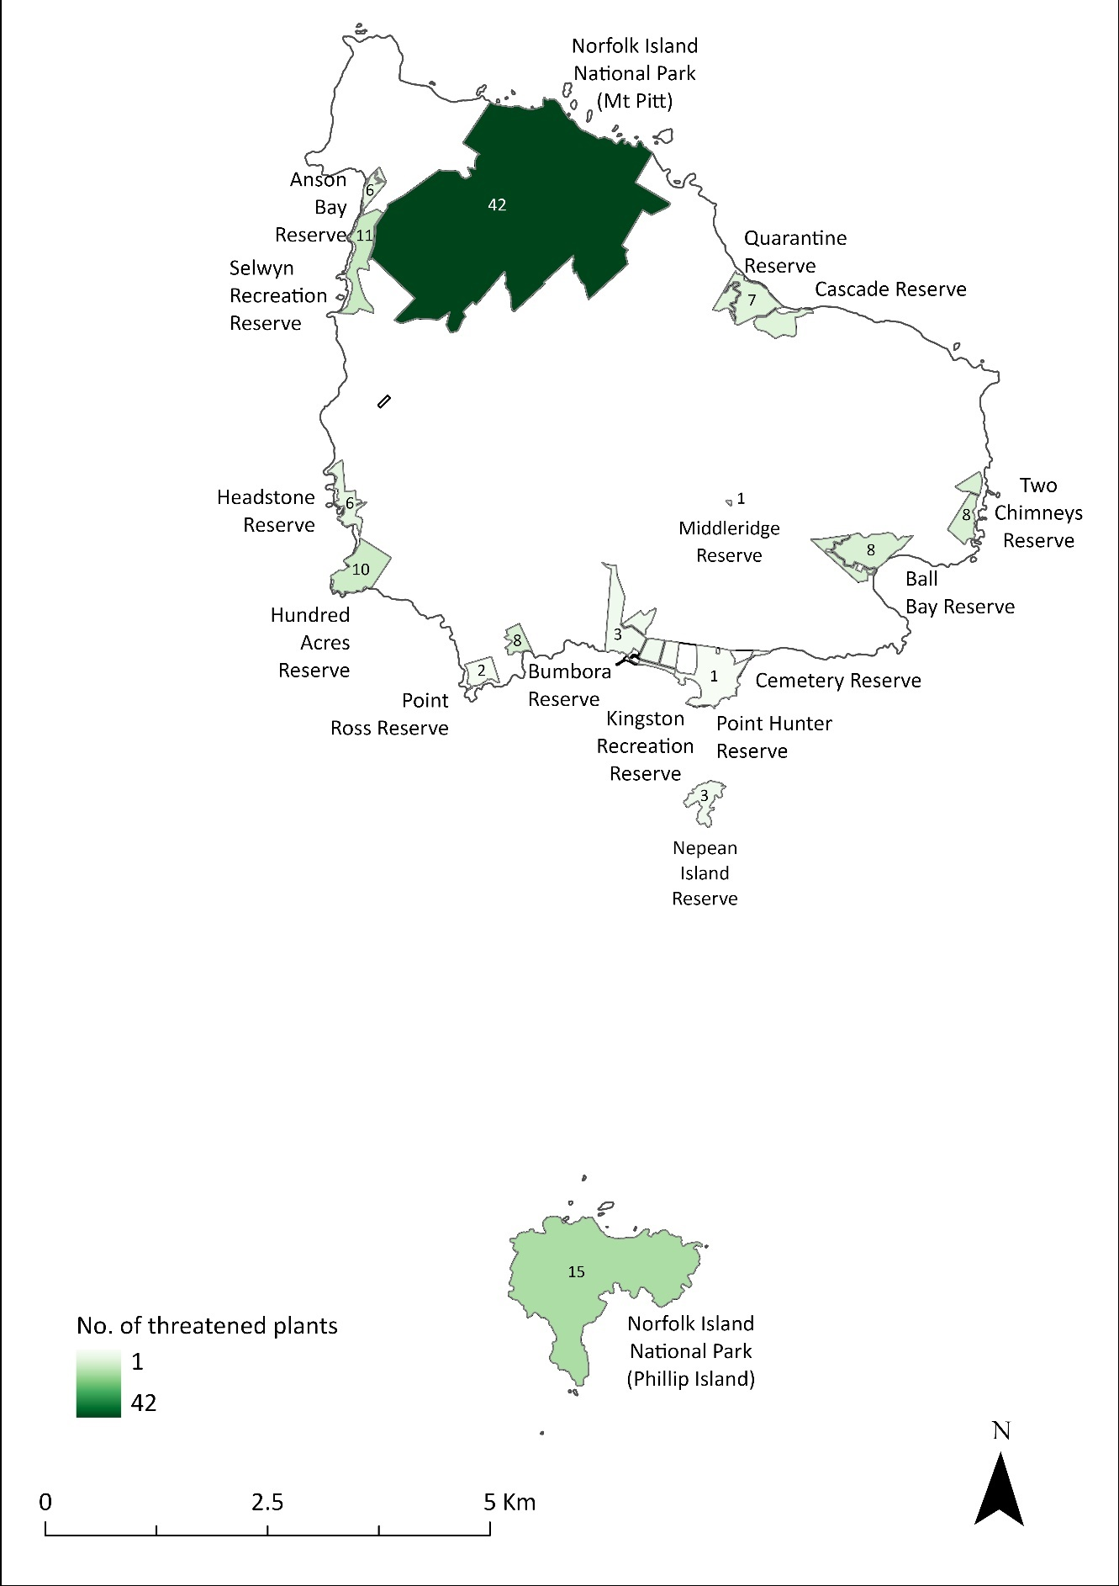
Spatial data for threatened species locations outside of reserves is not available. For distribution of individual plant species, see Table 11 and Part 6.
Table 11 Distribution of EPBC listed plant species of the Norfolk Island Group across tenure types
Species | Common name | % of population in national park | % of population in reserves | Prevalence on other land
Abutilon julianae | Norfolk Island abutilon | >95% | 0% | Unknown, but common recent planting ª
Achyranthes arborescens | Chaff tree, soft-wood | >95% | 1% | May occur in remnant viny hardwood forest outside of the park and reserves, north of Mission Road; common recent planting
Achyranthes margaretarum | Phillip Island chaffy tree | 100% | 0% | Unknown
Anthosachne kingiana kingiana | Phillip Island wheat grass | 100% | 0% | n/a
Blechnum norfolkianum | Norfolk Island water-fern | 100% | 0% | Unknown
Boehmeria australis australis | Tree nettle, nettletree | >95% | 0% | Unknown, but common recent planting
Calystegia affinis | A creeper | 100% | 0% | Unknown
Clematis dubia | Clematis | 100% | 0% | Unknown
Coprosma baueri | Coastal coprosma | >90% | 6% | May occur in remnant vegetation outside of the park and reserves; common recent planting
Coprosma pilosa | Mountain coprosma | >95% | 0% | Unknown, but common recent planting
Cordyline obtecta | Ti | >80% | >15% | Unknown, but common recent planting
Dendrobium brachypus | Norfolk Island orchid | 100% | 0% | Unknown
Dysoxylum bijugum | Sharkwood | >95% | 1% | Has been recorded in Mission Road rainforest fragments.
Elatostema montanum | Mountain procris | 100% | 0% | Unknown
Euphorbia norfolkiana | Norfolk Island euphorbia | >85% | >10% | May occur in remnant vegetation outside of the park and reserves; common recent planting
Euphorbia obliqua | A herb | 0% | >95% | Unknown
Hibiscus insularis | Phillip Island hibiscus | >95% | 0% | Common in private gardens including many recent plantings
Hypolepis dicksonioides | Downy ground-fern, brake fern, ground fern | 99% | 1% | Unknown
Ileostylus micranthus | Mistletoe | 100% | 0% | Unknown
Lastreopsis calantha (Parapolystichum calanthum) ^{b} | Shield-fern | 100% | 0% | Unknown
Marattia salicina (Ptisana salicina) ^{c} | King fern, para, potato fern | 100% | 0% | Unknown
Melicope littoralis | Shade tree | 100% | 0% | Unknown
Melicytus latifolius | Norfolk Island mahoe | >95% | 0% | Has been recorded in the in the Mission Road area
Melicytus ramiflorus subsp. oblongifolius | Whiteywood | 99% | 1% | Remnant vegetation, where the species may occur, exists outside of the park and reserves
eryta angustifolia | Narrow-leaved meryta | >95% | 0% | Has been recorded in the Mission Road rainforest remnants; common recent planting
Meryta latifolia | Broad-leaved meryta | >25% | >70% | Has been recorded in the in the Mission Road rainforest remnants; common recent planting
Muehlenbeckia australis | Shrubby creeper, pohuehue | 100% | 0% | Unknown
Myoporum obscurum | Popwood | >90% | 4% | Unknown, but common recent planting
Myrsine ralstoniae | Beech | >30% | >65% | May occur in remnant vegetation outside of the park and reserves; common recent planting
Pennantia endlicheri | Pennantia | >95% | 0% | Unknown, but common recent planting
Phreatia limenophylax | Norfolk Island phreatia | 100% | 0% | Unknown
Phreatia paleata | White lace orchid | 100% | 0% | Unknown
Pittosporum bracteolatum | Oleander | >80% | >15% | Occurs in the Mission Road rainforest remnants; common recent planting
Planchonella costata | Bastard ironwood | >95% | <1% | Unknown, but common recent planting
Polyphlebium endlicherianum | Middle filmy fern | 100% | 0% | Unknown
Pteris kingiana | King’s brakefern | 19% | 81% | Unknown
Pteris zahlbruckneriana | Netted brakefern | 100% | 0% | Unknown
Senecio australis | A daisy | 34% | 66% | Remnant vegetation, where the species may occur, exists outside of the park and reserves
Senecio evansianus | A daisy | Unknown | Unknown | Unknown
Senecio hooglandii | A daisy | >95% | 0% | Has been recorded on Nepean Island
Streblus pendulinus | Siah’s backbone | 95% | 5% | Unknown
Taeniophyllum norfolkianum ^{d} | Minute orchid, ribbon-root orchid | 100% | 0% | Unknown
Tmesipteris norfolkensis | Hanging fork-fern | 100% | 0% | Unknown
Ungeria floribunda | Bastard oak | >95% | 0% | Has been known from private land
Wikstroemia australis | Kurrajong | >95% | 0% | Occurs on private land; also a common recent planting
Zehneria baueriana | Native cucumber, giant cucumber | >95% | 0% | Has been recorded from the Mission Road area
Note: Proportion of the estimated population in each area is given for known populations in the national park and public reserves. Suitable habitat may exist in remnant plant communities outside of the parks and reserves for some species (as noted), but data on species occurrence and/or numbers in these areas is limited.
ª All species noted as “common recent plantings” are ones that have been sold in significant numbers (hundreds of individual plants) by the Norfolk Island National Park Nursery for planting on private lands and gardens. Such plantings are unlikely to contribute to a species’ breeding population for some years.
^{b}Listed under the EPBC Act as Lastreopsis calantha. The Australian Plant Census (APC) accepts Lastreopsis calantha and recognises Parapolystichum calanthum as a synonym.
^{c} Listed under the EPBC Act as Marattia salicina. The APC accepts the name Ptisana salicina and recognises Marattia salicina as a synonym.
d Considered endemic at time of listing, but also now reported from New Zealand (Renner & Beadel 2011).).

Plant communities
The distribution of plant species and communities on Norfolk Island is influenced by altitude, aspect, topography and proximity to the sea. Resulting patterns of precipitation (rainfall, fog and mist) influence plant distributions, and there is a significant difference between the mountains and the southern part of the island, which is drier.
A detailed study of the distribution of the natural vegetation on Norfolk Island—both as it is currently known and as it is best understood to have existed in 1750 (Figure 2) —identified 14 plant communities, each of which supports assemblages of threatened plant species (Table 12): eight forest communities and six non-tree communities (Invasive Species Council & TierraMar 2021). This work built upon previous investigations of the vegetation (Gilmour & Helman 1989a, 1989b; Mills 2007a). In 1750 the vegetation on the island was primarily dense subtropical rainforest, with the endemic Norfolk Island pine (Araucaria heterophylla) particularly abundant on the lower elevations and along the coast. The extent of all native plant communities has been substantially reduced since European settlement (Map 11 and Map 12).
The largest remnant of native forest today occurs in the Mt Pitt section of the national park, spreading down the slopes of the mountain and into the valleys between Mt Pitt and Mt Bates. There are also smaller remnant forest patches in lower areas on the island. Moist palm valley forest and moist upland hardwood forest occur largely in the national park, while most of the coastal non-tree communities occur in public reserves and on private land. Many parts of the island are now covered by non-remnant vegetation including large patches of woody weeds, pastures and exotic gardens. Some of this non-remnant vegetation may be significantly disturbed but still contain native plant assemblages. Such patches may have high conservation potential if restored.
At the time of European settlement, Phillip Island probably supported six plant communities including moo-oo (Cyperus lucidus) sedgeland, shrub thickets on exposed areas and forest in the valleys, with emergent pines throughout (Cogger 2004; Mills 2009b); however, there is no record of the exact communities that originally existed (see Table 13). Phillip Island was severely eroded by grazing by goats, pigs and rabbits, which were introduced by the early British colonists. These introduced mammals almost completely removed the native vegetation, which was followed by the loss of virtually all topsoil on the island. Pigs and goats were eradicated in the early 1900s, while the last rabbit was eradicated in 1986 (Mills 2009b). There has since been a significant regeneration of vegetation on the island, particularly in the gullies where accumulated eroded soil and runoff have provided suitable conditions for plant growth (Cogger 2004; Mills 2009b). Some native plant communities are developing well, such as the moo-oo sedgeland, although the forest community of the valleys is likely to take the longest to reach stability (Mills 2009b). Research in 2008 found that the vegetation on Phillip Island was a mixture of 42 native species and 60 exotic weed species (Mills 2009b).
Figure 2 Photos of the native plant communities on Norfolk Island
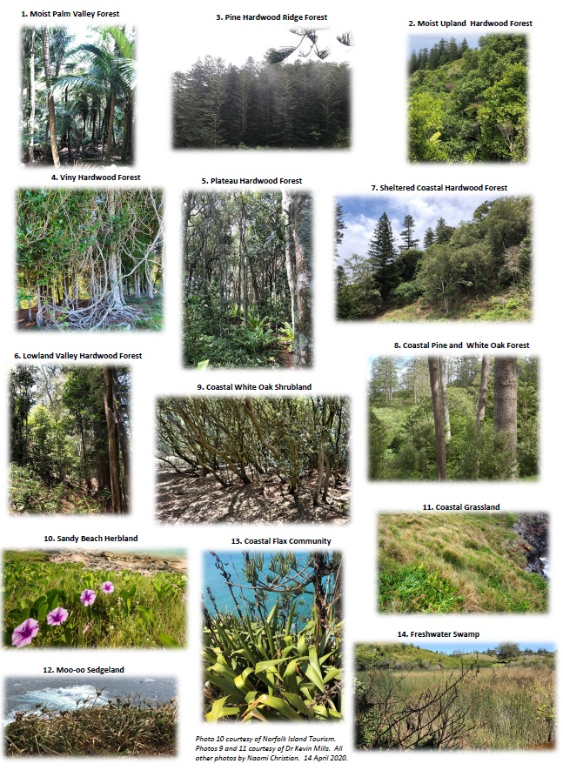
Table 12 Description of the native plant communities found on Norfolk Island and the threatened plant species that may occur within them
Community | Description | Common plant species | Threatened plant species
Moist palm valley forest | Thick nee-ow palm and tree fern forest mostly in mountain valleys. | - Rhopalostlyis baueri (nee-ow palm)  - Cyathea brownii (smooth treefern)  - Alsophila australis norfolkensis (rough treefern) | - Blechnum norfolkiana  - Elatostema montanum  - Pennantia endlicheri  - Phreatia limenophylax
Moist upland hardwood forest | Thick hardwood rainforest mostly in the national park. | - Nestegis apetala (ironwood) | - Coprosma pilosa  - Cordyline obtecta  - Dysoxylon bijugum  - Lastreopsis calantha  - Melicope littoralis  - Melicytus latifolius  - Meryta angustifolia  - Myrsine ralstoniae  - Pennantia endlicheri  - Pittosporum bracteolatum  - Ungeria floribunda  - Wikstroemia australis
Pine hardwood ridge forest | Tall pine forest on ridges, mostly on drier ridges in national park. | - Araucaria heterophylla (Norfolk pine)  - Nestegis apetala (ironwood) | - Coprosma pilosa  - Cordyline obtecta  - Dysoxylon bijugum  - Meryta angustifolia  - Myrsine ralstoniae  - Pennantia endlicheri  - Pittosporum bracteolatum  - Ungeria floribunda  - Wikstroemia australis
Viny hardwood forest | Thick rainforest with lots of Samson’s sinew in the Mission Road area. | - Celtis paniculata (whitewood)  - Callerya australis (Samson’s sinew)  - Baloghia inophylla (bloodwood) | - Achyranthes arborescens  - Melicytus ramiflorus subsp. oblongifolius  - Meryta latifolia  - Myrsine ralstoniae  - Pittosporum bracteolatum  - Planchonella costata
Plateau hardwood forest | Mixed hardwood forest found on flat areas at Steeles Point and Anson Bay. | - Elaeodendron curtipendula (maple)  - Lagunaria patersonia (white oak)  - Nestegis apetala (ironwood)  - Baloghia inophylla (bloodwood) | - Dysoxylon bijugum  - Myrsine ralstoniae  - Melicytus latifolius
Lowland valley hardwood forest | Valley forest once more common in lowland areas. Includes hardwoods and tree ferns that can be seen in many lowland valleys. | - Nestegis apetala (Ironwood)  - Lagunaria patersonia (white oak)  - Baloghia inophylla (Bloodwood)  - Cyathea brownii (smooth treefern)  - Araucaria heterophylla (Norfolk pine) | - Cordyline obtecta  - Myrsine ralstoniae
Sheltered coastal forest | Thick forest that only occurs close to the coast in areas protected from wind and salt. Small pockets left at Bumboras, Ball Bay and Selwyn Reserve. | - Baloghia inophylla (bloodwood)  - Lagunaria patersonia (white oak)  - Nestegis apetala (ironwood)  - Elaeodendron curtipendulum (maple) | - Meryta latifolia  - Myrsine ralstoniae  - Pteris kingiana  - Streblus brunonianus
Coastal pine and white oak forest | Hardy open forest of Norfolk pines and white oaks that can be seen at Hundred Acres. | - Araucaria heterophylla (Norfolk pine)  - Lagunaria patersonia (white oak) | - Coprosma baueri  - Euphorbia norfolkiana  - Myrsine ralstoniae  - Senecio australis
Coastal white oak shrubland | Stunted, low growing white oaks and melky trees such as those near Cemetery Bay, Ball Bay and Hundred Acres. | - Lagunaria patersonia (white oak)  - Excoecaria agallocha (melkytree) | - Senecio australis  - Coprosma baueri
Sandy beach herbland | Low growing, non-woody plants growing in sand at Slaughter Bay, Anson Bay, and Cemetery Bay. | - Sporobolus virginicus (salt couch)  - Ipomoea pes-caprae (goat’s foot)  - Wollastonia biflora (mile-a-minute)  - Ficinia nodosa (club rush) | - Euphorbia obliqua
Coastal grassland | Thick, salt tolerant grasses and sedges growing in sandy coastal areas. | - Sporobolus virginicus (salt couch)  - Carpobrotus glaucescens (pigface)  - Achyranthes aspera (coastal achyranthes) | - Senecio australis
Moo-oo sedgeland | Thick cover of moo-oo on exposed northern coastal cliffs, for example near Gun Club (Anson Bay area). | - Cyperus lucidus (moo-oo)  - Achyranthes aspera (coastal achyranthes)  - Carpobrotus glaucescens (pigface)
Coastal flax community | Uncommon areas of native flax, found on sheltered southern cliffs/slopes at Ball Bay, Garnet Point and Beefsteak. | - Phormium tenax (flax)  - Achyranthe saspera (coastal achyranthes)  - Dianella intermedia (native dianella)  - Asplenium difforme (coastal two-frond) | - Coprosma baueri
Freshwater swamp | Muddy areas and creeksides with native drain flax, bullrushes, and swamp lillies, for example at Kingston. Probably more widespread in the past. | - Eleocharis acuta (common spike rush)  - Crinum pedunculatum (crinum)  - Typha orientalis (drain flax)  - Juncus continuus (bull rush)
The native plant communities listed in Table 12 are all remnant communities in which the main native canopy is intact. Non-remnant vegetation may have been significantly disturbed (for example, by weed invasion and clearing), but may still resemble one of the native plant communities and potentially be suitable for restoration. Non-remnant vegetation also includes plantations of native species such as pine plantations.
Source: Invasive Species Council & TierraMar 2021.
Table 13 Plant communities of Phillip Island
Community | Key species | Proposed pre-European occurrence | 2008 occurrence
Pine hardwood subtropical forest | - Araucaria heterophylla (Norfolk pine)  - Lagunaria patersonia (white oak)  - Celtis paniculata (whitewood)  - Capparis nobilis | Valley floors and adjacent lower slopes | There are only a handful of remnant rainforest trees remaining on the island other than Araucaria heterophylla and Lagunaria patersonia
White oak forest / low forest | - Lagunaria patersonia (white oak)  - Phormium tenax (flax) | Covered much of the island, on most slopes | White oak is regenerating across the island
Exposed cliff edge shrubland | - Coprosma baueri (coastal coprosma)  - Phormium tenax (flax)  - Lagunaria patersonia (white oak) | Near high cliffs in the south-western and western parts of the island | On the cliff edges on the highest parts of the island
Moo-oo headland sedgeland | - Cyperus lucidus (moo-oo)  - Achyranthes aspera (chaff flower)  - Carpobrotus glaucescens (pigface) | Dominated large parts of the island, particularly exposed headlands and slopes around the island and the high ridges | Extensive areas across much of the eastern parts of the island
Salt couch foreshore grassland | - Sporobolus virginicus (salt couch)  - Lobelia anceps (native lobelia)  - Wollastonia biflora (mile-a-minute) | Foreshores around the island where there is gentle topography | At the rear of rock platforms almost at sea level and in the mouths of some of the valleys and on West End
Pigface herbland | - Carpobrotus glaucescens (pigface)  - Achyranthes aspera (chaff flower) | Cliffs and cliff edges overlooking the sea | Grows extensively on the cliffs and around the fringes of the island
Non-native olive low forest / shrubland | - Olea europaea cuspidata (African olive) | None | Extensive stands on the western part of the island
Non-native red-leg grass grassland | - Bothriochloa macra (red-leg grass) | None | A large patch above Owen’s Camp, and scattered small areas across the island
Non-native paspalum grassland | - Paspalum dilatatum | None | Extensive on the valley floors and some adjacent slopes.
The first six plant communities described have been postulated by Mills (2009b) for pre-European Phillip Island. Remnants and/or regrowth of these communities can be found on Phillip Island today.
Source: Mills 2009b.

Distribution of plant communities
The distribution of plant communities existing in 1750 and present in 2020 are shown in Map 11 and Map 12. Table 14 summarises the area of native plant communities (remnant and non-remnant) on Norfolk Island predicted for 1750 and estimated for 2020. Table 15 summarises the current distribution of remnant plant communities by proportion across tenure types, dividing land into the Norfolk Island National Park, public reserves, and other land.
Map 11 Norfolk Island native plant communities present in 1750
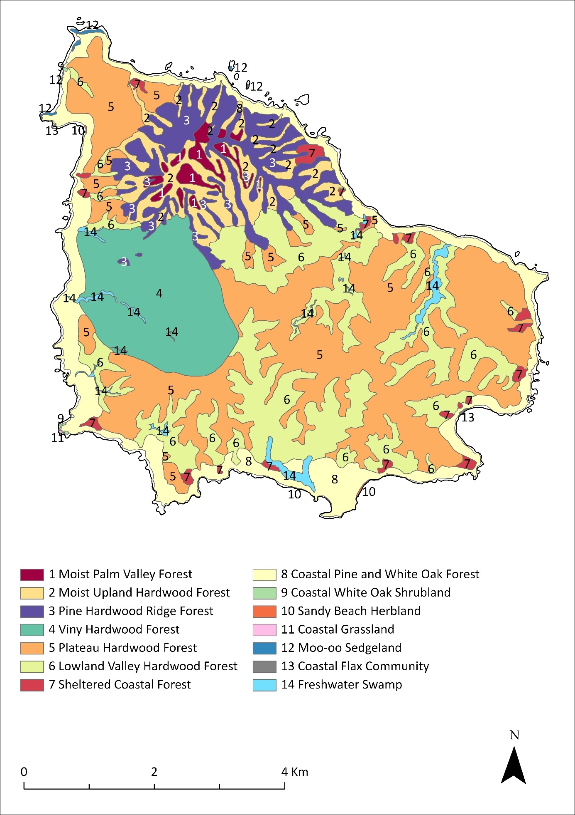
Source: Christian & Mills 2021.
Map 12 Norfolk Island native plant communities present in 2020
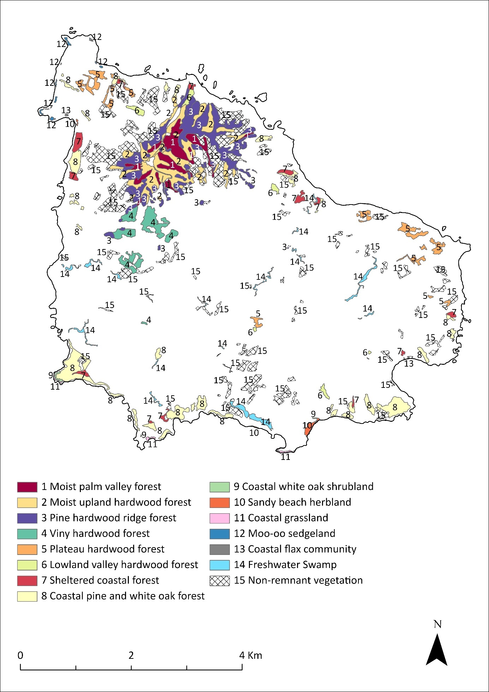
Source: Christian & Mills 2021.
Table 14 Area of native plant communities (remnant and non-remnant) on Norfolk Island predicted for 1750 and estimated for 2020, and percentage remaining in 2020
Plant community | 1750 area (ha) | 2020 area (ha) | Area in 2020 as a percentage of area in 1750
Moist palm valley forest | 52.7 | 42.2 | 80%
Moist upland hardwood forest | 223.5 | 80.1 | 36%
Pine hardwood ridge forest | 288.6 | 105 | 36%
Viny hardwood forest | 417.9 | 33.7 | 8%
Plateau hardwood forest | 1715.6 | 30.8 | 2%
Lowland valley hardwood forest | 793.6 | 8.8 | 1%
Sheltered coastal forest | 49.3 | 18.1 | 37%
Coastal pine and white oak forest | 452.2 | 80.2 | 18%
Coastal white oak shrubland | 1.1 | 1.0 | 91%
Sandy beach herbland | 1.0 | 2.7 | 270%
Coastal grassland | 0.2 | 1.6 | 800%
Moo-oo sedgeland | 4.4 | 2.3 | 52%
Coastal flax community | 0.5 | 0.4 | 80%
Freshwater swamp | 44.6 | 17.7 | 40%
Non-remnant native vegetation ª | 0 | 183.2 | 0%
Total remnant native vegetation | 4045.1 | 423.1 | 10%
Source: Christian & Mills 2021.
ª Non-remnant vegetation may have been significantly disturbed (for example by weed invasion and clearing) but may still resemble one of the native plant communities and potentially be suitable for restoration.
Table 15 Distribution of remnant plant communities present in 2020 on Norfolk Island across tenure types
Plant community | Distribution / range (ha) | % in national park | % in public reserves | % in other land
Moist palm valley forest | 42.2 | >99% | 0% | <1%
Moist upland hardwood forest | 80.1 | 95% | 0% | 5%
Pine hardwood ridge forest | 105 | 93% | 0% | 7%
Viny hardwood forest | 33.7 | 18% | 1% | 81%
Plateau hardwood forest | 30.8 | 0% | 0% | 100%
Lowland valley hardwood forest | 8.8 | 36% | 2% | 62%
Sheltered coastal forest | 18.1 | 5% | 54% | 41%
Coastal pine and white oak forest | 80.2 | 3% | 37% | 60%
Coastal white oak shrubland | 1.0 | 0% | 78% | 22%
Sandy beach herbland | 2.7 | 0% | 89% | 11%
Coastal grassland | 1.6 | 0% | 62% | 38%
Moo-oo sedgeland | 2.3 | 0% | 0% | 100%
Coastal flax community | 0.4 | 0% | 1% | 99%
Freshwater swamp | 17.7 | 0% | 38% | 62%

Habitat critical to survival of threatened species
The EPBC Act specifies that a recovery plan must describe to the extent practicable, and with spatial information, areas of habitat that are critical to the survival of the species or ecological communities, and what must be done to stop the decline and support the survival of a threatened species or community, including actions to protect and restore habitat. Habitat is a species-specific concept; it refers to the resources and conditions present in an area and not to a specific vegetation type or land cover (Hall et al. 1997; Kirk et al. 2018). Habitat is the sum of the specific resources needed for a species to occupy an area, and to survive and reproduce there (Hall et al. 1997; Kirk et al. 2018).
All the native plant communities on Norfolk Island provide habitat for threatened plant species (Table 12). The remaining areas of moist palm valley forest, moist upland hardwood forest, pine-hardwood ridge forest, viny hardwood forest and sheltered coastal forest in and around the Mt Pitt section of the national park support the core parts of the populations of the Norfolk Island green parrot, Norfolk Island golden whistler, Norfolk Island robin and Campbell’s keeled glass-snail, as well as the greatest density of Norfolk Island morepork territories (TSSC 2016a; TSSC 2016b). Pine/oak vegetation supports the remaining population of Suter’s striped glass-snail. Gray’s glass-snail has been found in flax on slopes on Phillip Island. Some species also occur in areas of non-native vegetation. For example, the Norfolk Island morepork, green parrot and robin are found in both native and weed-infested forests (Garnet & Crowley 2000; TSSC 2016a; TSSC 2016b). For more information on habitat requirements of individual species, see Part 6.
The extent of native vegetation on the islands has been greatly reduced since European settlement (Map 11 and Map 12; Table 13 and Table 14). The remaining fragments of natural or near-natural native vegetation are largely contained within the network of Australian Government and Norfolk Island Regional Council protected areas, together with small parcels of privately owned land (Table 16 and Map 12). All vegetation in these areas represents habitat critical for the survival of the taxa in areas covered by this plan.
In view of the restricted ranges of all listed species to which the plan applies (both in absolute terms and relative to their original ranges), all sites known to currently support any threatened species, or containing remnant native vegetation, should be viewed as critical for the group of threatened species collectively. However, these areas alone may not be sufficient. Areas of the island that have vegetation retaining some native elements, or which otherwise provide opportunities for restoration of vegetation, are likely to be important in supporting recovery (refer to the species profiles in Part 6 for more detailed information about the range and habitat requirements of individual species).
Table 16 Sites of significant native vegetation in the Norfolk Island Group, including in the national park, public reserves and other locations
Property | EPBC listed flora | EPBC listed fauna ª | Property description
Anson Bay Reserve ^{b c} | - Cordyline obtecta  - Dysoxylum bijugum  - Meryta latifolia  - Myrsine ralstoniae  - Pteris kingiana  - Senecio australis | - White tern  - Wedge-tailed shearwater  - Red-tailed tropicbird  - Norfolk Island golden whistler | The reserve includes coastal cliffs, steep slopes and Anson Bay beach. Coastal vegetation is found on the cliffs, with good quality pine and white oak forest in the south and beach vegetation behind the beach in the north (Coastal Pine and White Oak Forest and Sandy Beach Herbland).  The reserve contains some of the most intact coastal forest left on Norfolk Island at the far southern end of the reserve, which also extends into the adjoining Selwyn Reserve and private land.  The coastal cliffs provide important breeding habitat for seabirds.
Anson Point Nesting Ground ^{c d} | - None | - Wedge-tailed shearwater | Anson Point supports a large colony of wedge-tailed shearwaters. There is little native forest cover and the dominant vegetation is kikuyu (Cenchrus clandestinus) grasslands.
Ball Bay Reserve (including what was formerly known as Bucks Point Reserve ^{b c}) | - Cordyline obtecta  - Euphorbia norfolkiana  - Melicytus ramiflorus subsp. oblongifolius  - Muehlenbeckia australis  - Myrsine ralstoniae  - Pteris kingiana  - Senecio australis  - Streblus pendulinus | - White tern | Lowland valley hardwood forest and sheltered coastal forest. The reserve incorporates small areas of coastal forest and valuable habitat for many threatened species and nesting seabirds. However, much of the forest is infested with woody weeds.  In the western end of the reserve is a small gully containing a population of Critically Endangered Euphorbia norfolkiana (Norfolk Island euphorbia). The reserve also supports the only known population of the native fern Dicranopteris linearis on the island.
Bloody Bridge/ Collins Head (Gannet Point) | - Pittosporum bracteolatum  - Pteris kingiana | - Black noddy  - White tern | The southern section contains a good example of pine/oak coastal forest and is an important nesting location for black noddy and white tern. The understorey of this coastal forest is much less weedy than at many other locations and there is regeneration of pines where they are protected from cattle grazing.
Bumbora Reserve and adjoining areas ^{b c} (Creswell Bay area) | - Cordyline obtecta  - Euphorbia norfolkiana  - Hypolepis dicksonioides  - Meryta latifolia  - Myoporum obscurum e  - Myrsine ralstoniae  - Pteris kingiana  - Senecio australis | - White tern | The reserve is one of three known populations of the Norfolk Island euphorbia. The southern section of the Reserve has good quality Norfolk Island pine forest with an understorey of white oak and native flax. Most of the area is coastal pine and white oak forest and sheltered coastal forest.
Cascade Reserve ^{c f} (including 10ha of Quarantine Reserve) | - Cordyline obtecta  - Myoporum obscurum e  - Myrsine ralstoniae  - Pittosporum bracteolatum e  - Pteris kingiana  - Senecio australis  - Streblus pendulinus | - None | Remnants of sheltered coastal forest and coastal pine and white oak forest, some of which is not grazed and relatively weed-free. Cascade Creek is one of the few permanent streams on the island.
North of Cascade | - Blechnum norfolkianum  - Boehmeria australis australis  - Clematis dubia  - Polyphlebium endlicherianum  - Melicope littoralis  - Melicytus ramiflorus subsp. oblongifolius  - Meryta angustifolia  - Meryta latifolia  - Parapolystichum calanthum  - Pennantia endlicheri  - Pteris kingiana  - Pteris zahlbruckneriana  - Streblus pendulinus  - Ungeria floribunda | - Black noddy  - Norfolk Island green parrot  - Norfolk Island robin  - White tern | Coastal blocks in this area are important nesting areas for the black noddy and white tern. There are several remnants that contain listed plant species that are not well represented in the national park. The valleys between Red Road and JE Road, although weed infested, contain some of the best populations of ferns, particularly filmy ferns.
Cemetery Reserve | - Euphorbia obliqua | - None | Some coastal vegetation along the fence lines and outside the cemetery boundary.
Duncombe Bay area and private land adjoining Anson Bay Reserve and Selwyn Reserve | Similar to species listed for Anson Bay Reserve and Selwyn Reserve, plus:  - Melicope littoralis  - Melicytus latifolius  - Meryta angustifolia  - Muehlenbeckia australis  - Ungeria floribunda | - White tern | The forest in Selwyn and Anson Bay Reserves and surrounding private land represents one of the best quality coastal forests remaining on the island (and one of the few areas with intact sandy beach herbland).  The area south of Anson Beach is an important white tern nesting area.
Hundred Acres Reserve ^{b c} | - Achyranthes arborescens e  - Cordyline obtecta  - Melicytus ramiflorus subsp. oblongifolius  - Meryta latifolia  - Myoporum obscurum  - Myrsine ralstoniae  - Pittosporum bracteolatum  - Planchonella costata  - Pteris kingiana  - Senecio australis | - Suter’s striped glass-snail  - Norfolk Island golden whistler  - Norfolk Island green parrot  - Red-tailed tropicbird  - Wedge-tailed shearwater  - Black noddy  - White tern | The largest area of pine/oak forest (coastal pine and white oak forest, coastal white oak shrubland, sheltered coastal forest) existing on the island, regenerated due to protection from grazing. It is one of the few areas outside of the national park to include pristine native forest with high species diversity.  The black noddy colony is the largest remaining on the Island and is the only one within a protected area. The reserve also contains the largest wedge-tailed shearwater breeding area on the Island.
Kingston Common Reserve | - Coprosma baueri  - Cordyline obtecta  - Euphorbia obliqua  - Meryta latifolia  - Myrsine ralstoniae | - None | Primarily mown and/or grazed exotic grassland.
Mission Road North area | - Achyranthes arborescens  - Boehmeria australis australis  - Polyphlebium endlicherianum  - Melicope littoralis  - Melicytus latifolius  - Melicytus ramiflorus subsp. oblongifolius  - Meryta angustifolia  - Meryta latifolia  - Parapolystichum calanthum  - Pennantia endlicheri  - Planchonella costata  - Streblus pendulinus  - Zehneria baueriana | - Norfolk Island green parrot  - Norfolk Island robin  - White tern | Contains a significant remnant of viny sub-tropical rainforest which is poorly represented in the national park. Most remnants are contiguous with forest in the national park or botanic garden. Some areas were fenced and weeded by Parks Australia in 1994-95, while other areas have had cattle excluded for many years. There are good populations of several listed plant species and habitat for endemic land birds (in particular the Norfolk Island green parrot and Norfolk Island robin) and white terns. Parts of this area provide corridors of contiguous canopy linking the national park and the botanic garden to each other and to various other remnants.
Mission Road South area | - Meryta angustifolia  - Meryta latifolia | - White tern | A few small remnants of viny forest and pine/hardwood forest.
Mt Pitt Rd to Selwyn Pine Rd | - Blechnum norfolkianum  - Parapolystichum calanthum  - Muehlenbeckia australis  - Melicytus ramiflorus subsp. oblongifolius  - Meryta angustifolia  - Meryta latifolia  - Pennantia endlicheri  - Streblus pendulinus | - Norfolk Island green parrot  - White tern | Several areas of pine over hardwood forest, mainly on the south-west slopes of the ridges. Most patches are contiguous with adjacent areas and with forest in the national park.
Nepean Island Reserve ^{c g} | - Euphorbia obliqua  - Senecio australis  - Senecio hooglandii | - Black noddy  - Brown noddy  - Grey ternlet  - Masked booby  - Red-tailed tropicbird  - Wedge-tailed shearwater  - Lord Howe Island gecko | The seasonal and sometimes permanent habitat for significant populations of breeding seabirds. An important rookery for masked boobies, a refuge for the Lord Howe Island gecko, and a valuable rat-free habitat. The island provides habitat for rare plants including Senecio hooglandii and Euphorbia obliqua.  The original open forest was cleared during the first settlement, and the native flora now largely consists of coastal herbs and forbs.
Norfolk Island National Park (Mt Pitt Section) | All species except:  - Euphorbia obliqua  - Senecio evansianus  - Senecio hoogliandii  - Anthosachne kingiana kingiana | All species except:  - Kermadec petrel  - Suter’s striped glass-snail (and the 2 presumed extinct snails)  - Lord Howe Island gecko  - Lord Howe Island skink | The Mt Pitt section contains most of the surviving rainforest and palm forest on the island, holds most of the Norfolk Island robin population and is a core area for other forest bird species.
Norfolk Island National Park (Phillip Island) | - Abutilon julianae  - Achyranthes margaretarum  - Anthosachne kingiana kingiana (possibly extinct)  - Coprosma baueri  - Cordyline obtecta e  - Dysoxylum bijugum e  - Euphorbia norfolkiana e  - Hibiscus insularis  - Hypolepis dicksonioides  - Meryta latifolia e  - Muehlenbeckia australis  - Pteris kingiana  - Senecio australis  - Senecio hooglandii  - Zehneria baueriana | - Kermadec petrel  - Lorde Howe Island gecko  - Lorde Howe Island skink | Phillip Island is a valuable rodent-free area and supports significant populations of breeding seabirds, as well as the Lord Howe Island gecko, the Lord Howe Island skink, and a number of threatened plant species. Since the eradication of feral grazers (goats, pigs and rabbits) there has been significant regeneration of vegetation on the island, though weeds are abundant in that vegetation. See Table 15 for information about the native plant communities on the island.
Point Hunter Reserve | - Euphorbia obliqua | - None | Coastal dune vegetation near foreshore. This area supports probably the largest Euphorbia obliqua population on Norfolk Island.
Point Ross Reserve ^{b c} | - Myrsine ralstoniae  - Pteris kingiana | - Red-tailed tropicbird  - Wedge-tailed shearwater  - White tern | Provides important habitat for a variety of sea and land birds as well as for remnant and regenerating native vegetation (some coastal white oak shrubland). Also contains significant coastal grassland/herbland, primarily on the sea cliffs.
Selwyn Reserve ^{c g} | - Achyranthes arborescens  - Coprosma bauer  - Cordyline obtecta  - Dysoxylum bijugum  - Meryta latifolia  - Myoporum obscurum  - Myrsine ralstoniae  - Pittosporum bracteolatum  - Pteris kingiana  - Senecio australis  - Streblus pendulinus | - White tern  - Wedge-tailed shearwater  - Red-tailed tropicbird  - Norfolk Island golden whistler  - Norfolk Island robin  - Norfolk Island green parrot | Selwyn Reserve contains several native vegetation types including coastal cliff communities and some rainforest in the gully (sheltered coastal forest and coastal pine and white oak forest). The reserve provides important habitat for a variety of sea and land birds as well as for native vegetation.  Threatened flora common in the reserve include Senecio australis, Coprosma baueri, Meryta latifolia and Pteris kingiana.  The Norfolk Island golden whistler and Norfolk Island robin are common in the remnant forest and older plantation areas in the northern section.
Steels Point | - Melicytus latifolius | - None | Remnant patches of forest including some areas that are protected from grazing.
Two Chimneys Reserve ^{b c} | - Coprosma baueri  - Cordyline obtecta e  - Dysoxylum bijugum e  - Meryta latifolia e  - Myoporum obscurum e  - Myrsine ralstoniae  - Pittosporum bracteolatum  - Senecio australis | - Black noddy  - Red-tailed tropicbird  - Wedge-tailed shearwater  - White tern | The reserve has remnant coastal pine and white oak forest and sheltered coastal forest, with significant recent regeneration of pines since stock grazing was removed.  In 2019, Norfolk Island Regional Council and Parks Australia installed nest boxes to increase nesting sites for the Norfolk Island morepork in Two Chimneys, Ball Bay and Bumbora Reserves.
ª Listed under EPBC Act as threatened and/or migratory and/or marine.
^{b} Place removed from the Commonwealth Heritage List (ownership transferred to NIRC).
^{c} Listed on the Norfolk Island Heritage List for its natural values.
^{d} Indicative Place on the Commonwealth Heritage List (formal nomination has not been made).
^{e} Planted.
^{f} Nominated Place on the Commonwealth Heritage List.
^{g} Listed on the Commonwealth Heritage List for its natural values.
Sources: Gilmour & Helman 1989a, 1989b; Norfolk Island Conservation Society 1988; Mills 2007b. Reserve Plans of Management (NIRC 2020a-r); Australian Heritage Database (DCCEEW n.d.).

Part 2—Pressures and risks

Pressures

Current and past pressures
Oceanic islands contribute only 6.7% of the world’s land surface area but collectively support approximately 20% of Earth’s known biodiversity (Tershy et al. 2015; Fernandez-Palacios et al. 2021). The isolated nature of islands makes them particularly susceptible to threatening processes, and 75% of the known extinctions since the global European expansion have occurred on islands (Fernandez-Palacios et al. 2021). Tallied taxonomically, 94% of birds, 90% of reptiles, 54% of mammals and 68% of vascular plants known to have gone extinct once inhabited islands (Fernandez-Palacios et al. 2021). The major threatening processes on oceanic islands are anthropogenic: habitat fragmentation and loss, invasive species, and introduced pathogens (Borges et al. 2020). After habitat loss, invasive species are the main cause of ecological disintegration globally and are likely the main cause of ongoing extinctions in island ecosystems (Tershy et al. 2015; Munstermann et al. 2022).
Typical of small oceanic islands, the Norfolk Island Group has suffered significant species loss due to the impacts of human habitation and the introduction of exotic species. Since European settlement six species of endemic land birds have become extinct, and several species of land snails, at least one plant species and one endemic land bird are presumed extinct. Some seabird species which were once abundant on Norfolk Island now only occur in small numbers on Phillip Island.
While pressures are considered individually by the plan, it is unlikely that a pressure is ever acting in isolation. The ecological changes observed are most frequently a reaction to multiple pressures acting in combination and having an additive, synergistic or antagonistic effect. Many pressures are ongoing and have long-term effects, and cumulative impacts occur if pressures are acting simultaneously or in the same location at a different time. The compounding effects of pressures erode ecosystem resilience, and it is this cumulative impact that has led to most of the decline in threatened species observed (Kearney et al. 2023). While it is unlikely that managing a single pressure will improve the trajectory of threatened species, it is important to understand each pressure individually and establish appropriate pressure-specific management actions and targets.
The pressures identified in this section apply to the Norfolk Island Group as a whole and multiple populations of taxa covered by the plan. Note that ‘pressures’ and ‘threats’ are used interchangeably with the same meaning in this plan.

Predation by invasive vertebrates
There are several introduced vertebrate species that pose significant threats to the native species of Norfolk Island. These include rodents, free-roaming cats and feral chickens (Gallus gallus) as well as species native to mainland Australia such as the purple swamphen (Porphyrio porphyrio) and the nankeen kestrel (Falco cenchroides).

Predation by rodents
There are three introduced rodent species on Norfolk Island: the black rat (Rattus rattus), the Polynesian rat (R. exulans) and the house mouse (Mus musculus).
Predation by the black rat has been identified as a specific threat to the Norfolk Island golden whistler, the Norfolk Island robin, the Norfolk Island green parrot, most nesting seabirds including the Kermadec petrel, reptiles, land snails and other invertebrate species (Hicks & Preece 1991; Olsen 1997; Hill 2002; Cogger 2004; Commonwealth of Australia 2005; TSSC 2016a; Brown et al. 2020; Garnett & Baker 2021). Rats are also a threat to some plant species (including Achyranthes arborescens, Melicope littoralis, Meryta latifolia and Ungeria floribunda) through consumption of seeds and fruits, which restricts regeneration (Invasive Species Compendium 2022b).
The Polynesian rat has a negative impact on the breeding productivity of petrels and shearwaters on islands in New Zealand (Pierce 2002) and probably caused the decline of the Lord Howe Island gecko and Lord Howe Island skink on Norfolk Island (Smith et al. 2001). The house mouse is also present on Norfolk Island and eats a range of fruits, seeds and invertebrates. While the impact on biodiversity is unknown, it is likely to adversely affect native flora and invertebrates.

Predation by cats
Feral and free-roaming cats have been identified as a threat to the Norfolk Island green parrot, Norfolk Island golden whistler, Norfolk Island robin, most nesting seabirds, and the Lord Howe Island gecko and Lord Howe Island skink (Olsen 1997; Hill 2002; Cogger 2004; Commonwealth of Australia 2005; TSSC 2016a; Brown et al. 2020; Garnett & Baker 2021).

Predation by other species
The activity of feral chickens represents a threat to many invertebrates, including threatened land snails and flora. Their scratching to uncover food disturbs the leaf litter and soil profiles, causing the micro-environment associated with the litter to become warmer and drier. This change has an impact on nutrient cycling by disrupting invertebrates and fungal species, which has flow on effects for the broader native ecosystem (Christian 2005). Feral chickens also consume snails and damage and remove seedlings, affecting the regeneration of native plant species (Christian 2005).
The purple swamphen—locally known as the ‘tarla bird’ or ‘taalaberd’—was first recorded on Norfolk Island in 1888 and occurs in marsh areas where there is cover nearby (Schodde et al. 1983). There was probably no suitable habitat for the swamphen on the islands prior to European settlement (Smithers & Disney 1969). This species has established on Phillip Island where it is a significant predator of eggs and chicks of terns and petrels, with predation rates on Kermadec petrel nests prior to control efforts measured at 40% (Carlile & O’Dwyer 2018). Other seabird species such as black-winged petrels and sooty terns are also heavily impacted (Carlile & O’Dwyer 2018).
The nankeen kestrel was first recorded on the island in 1969. Through much of the 1970s, kestrels were regarded as rare non-breeding visitors. The first breeding pair was reported in 1978 (Schodde et al. 1983) and by 1990 there were at least five breeding pairs (Bell 1990). They are now common and widespread across the island (M Christian 2024, pers comm 12 January). Kestrels have been reported feeding on Norfolk Island robin, Norfolk Island golden whistler, white tern (Gygis alba), grey ternlet (Anous albivittus albivittus) and sooty tern (Onychoprion fuscata) (Garnet & Crowley 2000; S Gorta 2024, pers comm 11 January). The significance of this predation is not well understood, but they are known to prefer open areas such as cleared fields.

Other impacts of introduced vertebrates
In addition to the invasive vertebrate predators, several other introduced vertebrate species negatively impact Norfolk Island’s native species either through competition or by degrading habitat.

Competition
Introduced birds such as the crimson rosella (Platycercus elegans; known locally as the red parrot) and the European starling (Sturnus vulgaris) compete for nest hollows with the Norfolk Island green parrot and the Norfolk Island morepork (Hill 2002; TSSC 2016a; TSSC 2016b). Rosellas fill hollows with nesting material such that the sites cannot be used by the native species (Hermes et al. 1986). The common blackbird (Turdus merula) and song thrush (T. philomelos) have also been suggested as potential threats to the whistler and robin; however, there is little evidence to support the claim (Robinson 1988). Additionally, an increase in the population of California quail (Callipepla californica) on Norfolk Island—a possible result of successful rat control given that rats are a significant predator of the species—may impact biodiversity (Rasheed et al. 2018); however, this potential impact is currently not well understood.
The Asian house gecko, which occurs on Norfolk Island, is a potential threat to the Lord Howe Island gecko if it becomes established on Phillip Island or the other outlying islands. This widely distributed species is commensal with humans and has been implicated in the decline of native gecko species elsewhere in its introduced range (Cole et al. 2005; Csurhes & Markula 2009).

Grazing by domestic herbivores
Since European settlement there has been extensive loss of vegetation cover and diversity on Norfolk Island through cattle (Bos taurus) grazing (Neuweger et al. 2001). Cattle grazing has documented impacts on plant species such as Achyranthes arborescens, Boehmeria australis australis, Elatostema montanum, Ptisana salicina, Meryta latifolia and Streblus pendulinus (Sykes & Atkinson 1998). In areas outside the national park and in some public reserves, the loss of native forest to livestock grazing has been followed by little or no regeneration of native plant species. Grazing, trampling and soil compaction by cattle continue to be significant threats to remnant and regenerating native vegetation and to the health of ecosystems, particularly in riparian areas. Additionally, cattle are vectors for the spread of seeds from introduced plants and mechanical transmission of plant pathogens. Grazing by farmed cattle and goats may pose a threat to some of the few remaining patches of lowland forest on Norfolk Island.
Almost all the native vegetation on Phillip Island was lost to grazing by goats, pigs and rabbits, and as a result the island’s topsoil has been severely eroded (Hyder Consulting 2008). Since the eradication of these feral herbivores, there has been significant regeneration of vegetation, particularly in gullies where soil pockets and collected precipitation provide good conditions for plant growth. Habitat loss, soil compaction and erosion caused by grazing and burrowing rabbits all contributed to the decline of native reptiles (Cogger et al. 1993) and the suppression of plant species such as Anthosachne kingiana kingiana on Phillip Island (Sykes & Atkinson 1988).

Introduced invertebrate species
The Argentine ant (Linepithema humile) is one of the world’s worst invasive species, having spread from its native habitat in South America to establish populations on six continents and many oceanic islands (Suarez et al. 2001). The threat abatement plan to reduce the impacts of tramp ants on biodiversity in Australia and its territories (DEH 2006) identified the Argentine ant as one of six national priority species.
The Argentine ant was identified on Norfolk Island in 2005, and an eradication program commenced in 2008. Work to date has found Argentine ant infestations in 16 spatially discrete areas covering approximately 460 ha of the island’s 3,455 ha. Approximately 45% of the infested areas have undergone treatment to date. No specific data on the impacts of the Argentine ant on Norfolk Island’s biota or agriculture have been documented, but the potential impacts of this globally-dispersed invasive species are well known (such as interfering with pollination and seed dispersal, outcompeting native invertebrates and damaging crops). Because of their aggressive nature and need for protein-based food sources, Argentine ants may pose a significant threat to the majority of the island’s vertebrates and invertebrates. At particular risk are ground-nesting seabirds and endangered species such as the Norfolk Island green parrot, Norfolk Island robin and slender-billed white-eye (Hoffman 2020).
Other introduced invertebrates also pose a threat to certain listed species. European honeybees (Apis mellifera) have occupied wild nest sites of the Norfolk Island green parrot (Hill 2002). The Asian paper wasp (Polistes chinensis antennalis) also occurs on Norfolk Island, although its impact on threatened species is unknown. The American cockroach (Periplaneta americana) is believed to have caused the extinction of an endemic cricket (Tathra sp.1) on Norfolk Island; the cricket is now found only on Phillip Island and would be at risk if the cockroach established there and was not subsequently controlled by the island’s lizards and centipede (Rentz 1988). The European wasp (Vespula germanica) has invaded and been eliminated from the island at least once (in 1982; Naumann 1984) and could impact native species if it re-established.

Introduced plants
Competition from exotic weeds is a threat to all plant species covered by the plan, and most native plant communities are affected to some degree. Of the 612 species of vascular plants on Norfolk Island, 430 are established non-native species (Invasive Species Council and Island Conservation 2017). These non-native species have been introduced either accidentally as seeds or deliberately for cultivation (Maynard et al. 2018). Of these introduced species more than 65 are invasive (Invasive Species Compendium 2022a) and have contributed to changes in the composition and structure of vegetation, affecting the survival and reproduction of native plant species and some animals. For example, weed invasion has resulted in changes to the forest structure and a decline in the quality of habitat for Campbell's keeled glass-snail and Suter's striped glass-snail (TSSC 2009a,d). There are several particularly widespread and problematic invasive species (Davidson et al. 1994; Invasive Species Compendium 2022b; J Christian 2024, pers comm 11 January), including red guava (Psidium cattleyanum var. cattleyanum), African olive (Olea europaea cuspidata), broad-leaf pepper tree (Schinus terebinthifolius) and lantana (Lantana camara). Native plant species with restricted distributions or specific habitat requirements, such as ferns on stream banks, are particularly at risk of being out competed by invasive weeds.
Knowledge of aquatic weeds is currently data deficient. Of the 38 wetland plants on the island, 27 are introduced (Mills 2012a). Most of these are found in the Kingston Common, Lower Watermill Creek and dam, and Lower Cascade Creek. One of the worst wetland weeds is water hyacinth (Eichhornia crassipes), which is highly abundant (to the point of choking) in Kingston and several other wetland areas.
Details of the principal terrestrial weed species affecting the islands are given below. CSIRO have produced probability maps and GIS layers for the distribution of red guava and African olive, which are available via the CSIRO Data Access Portal (Levick and Johnson 2023).

Red guava/porpay (Psidium cattleyanum var. cattleyanum)
Red guava is native to Brazil and has been present on Norfolk Island for over 150 years, where it poses a significant threat to native vegetation (Sykes & Atkinson 1988; Lowe et al. 2000). The plant produces an edible fruit and establishes in dense bush thickets with wide ranging root systems that restrict the growth of surrounding native plants. These thickets form rapidly, reduce light penetration to the understorey and produce numerous seeds which are then widely dispersed by birds and cattle (Director of National Parks 2008). Fruit dropped from the plants also negatively impact the environment by altering the chemical composition of downstream soil as they degrade, affecting the germination of native plant species (Christian 1999; Lowe et al. 2000). Areas infested with red guava tend to have lower surface soil moisture, and where dense stands occur along creek gullies there is little sign of regeneration of native ferns (Davidson et al. 1994). The impact is amplified in times of low rainfall when competition for moisture is more intense. A high abundance of woody weed species like the red guava can result in mortality of mature Norfolk Island pines due to competition for moisture (Parks Australia, unpublished data).
Red guava is present throughout much of the Mt Pitt section of the national park and across Norfolk Island, though not on Phillip Island. Extensive woody weed removal in the national park over the past decade has considerably reduced its cover (Parks Australia, unpublished data), suggesting that it is possible to control the impact of this weed.

African olive (Olea europaea cuspidata)
African olive is native to Mediterranean regions in North Africa but has become a widespread invasive species in Hawaii, New Zealand and eastern Australia (Starr et al. 2003; Cuneo & Leishman 2006). It is believed to have been introduced to Norfolk Island by the Melanesian Mission to provide wind breaks (R Ward 2024, pers comm 11 January) and on Phillip Island following the removal of rabbits. As native vegetation was cleared on Norfolk Island, African olive established as a major weed, and it is the main weed species found on Phillip Island. Plants occur as isolated individuals, scattered clumps or impenetrable thickets. African olive threatens species such as the Phillip Island hibiscus (Hibiscus insularis) (Director of National Parks 2008).
As with red guava, areas infested with African olive tend to have lower surface soil moisture (Davidson et al. 1994) and the impact of the weed is amplified during times of low rainfall, when competition for moisture is more intense. This can result in the mortality of native species such as the Norfolk Island pine (Parks Australia, unpublished data). Additionally, African olives likely exert an allelopathic effect on co-occurring species, inhibiting native plant germination and growth. The removal of African olive leads to demonstrable improvement in the survival and recruitment of emergent native species (Director of National Parks 2008), suggesting that it is possible to reduce the impact of this weed.
Despite being an invasive weed, African olive provides a year-round source of food for some species such as the Norfolk Island green parrot. It also helps mitigate soil loss and provides essential nesting sites for the threatened Kermadec petrel on Phillip Island.

Broad-leaf pepper tree (Schinus terebinthifolius)
Broad-leaf (or broad-leaved) pepper tree (also known locally on Norfolk Island as Hawaiian holly) is native to South America. It is known to invade grassy paddocks and is a pioneer species, quickly colonising disturbed sites. Broad-leaf pepper tree also invades undisturbed natural environments and can displace native species. It is a problem weed in some parts of eastern Australia, Hawaii, Florida, New Caledonia, Fiji, Tahiti and Mauritius (PIER 2002).
Broad-leaf pepper tree was introduced to Norfolk Island in the 1920s when a resident planted some berries collected in Hawaii (Ziesing 1997). It is a low growing evergreen tree that shades out other plants and prevents the re-establishment of other species due to the release of allelopathic substances (Dawkins and Esiobu 2016). The fruits have been implicated in bird intoxication and death and its prolific flowers can cause allergic reactions (Director of National Parks 2008).

Lantana (Lantana camara)
Lantana is listed as a Weed of National Significance in Australia and continues to have serious impacts. It is an aggressive woody weed of open areas and suppresses regeneration of native species through blocking light and allelopathy (Director of National Parks 2008). Lantana was introduced to Norfolk Island in 1905 as an ornamental horticultural species and is now widespread probably due to birds dispersing the seeds. It is found on Phillip Island in low abundance but could be eradicated with targeted weed control and monitoring to detect new populations (Mills 2009b).

William Taylor (Ageratina riparia)
Also known as mist flower, this weed species was introduced to Norfolk Island as a garden plant. It grows to one metre high with white flower heads and spreads widely, shading out small native plants. It is found in areas open to the wind and with full sunlight. The weed dominates the understorey in some parts of the national park (Director of National Parks 2008) and is also found on Phillip Island (Mills 2009b; J Christian 2024, pers comm 11 January).

Kikuyu (Cenchrus clandestinus)
Kikuyu is an exotic grass introduced to Norfolk Island for pasture. The species was used to stabilise open areas, roadsides and rehabilitation areas in the national park (Director of National Parks 2008). Kikuyu severely restricts regeneration of native plant species, particularly in the national park and public reserves, as it forms a thick sward that is almost impossible for seedlings to penetrate.
Competition from kikuyu and other imported grasses such as buffalo grass (Stenotaphrum secundatum) and couch grass (Cynodon dactylon) may prevent the re-establishment of pines and other species (Benson 1980). The thick sward and deep runners of kikuyu have the potential to degrade the habitat for ground nesting seabirds such as wedge-tailed shearwaters and other burrowing petrels. The grass constricts burrow entries and has been reported to strangle birds on Lord Howe Island (DECC NSW 2007). Kikuyu is not a major weed on Phillip Island, but abundance and impact require close monitoring (Director of National Parks 2010; J Christian 2024, pers comm 11 January).

Madeira vine (Anredera cordifolia)
Madeira vine is becoming a significant threat on Norfolk Island in both public reserves and on private land. The species is a fleshy climber with stems that can climb high into the canopy, and it typically invades the margins of rainforests, smothering small trees and shrubs. The presence of underground and aerial tubers makes this species difficult to control.

Wild tobacco (Solanum mauritianum)
Introduced to Norfolk Island in about 1855, this is a fast-growing tree that can occupy habitats for rare, shade-intolerant species such as chaff tree (Achyranthes arborescens) and nettle tree (Boehmeria australis australis) (Sykes & Atkinson 1988). As wild tobacco prefers open areas it is generally considered to be less of a threat in forested national parks than shade-tolerant species such as red guava and African olive (Director of National Parks 2008). It is often found in parts of the valley bottoms in association with the native species bleeding heart (Homalanthus populifolius). Wild tobacco fruits and seeds are consumed by the Norfolk Island green parrot (Simmonds 2019).

Morning glory (Ipomoea cairica)
Morning glory is a perennial vine that rapidly invades open areas created by tree falls or abrupt woody weed removal (Director of National Parks 2008). This vine has a cosmopolitan global distribution and its native status on Norfolk Island is disputed. It was recorded in a drawing from 1790, and it may have been introduced by Polynesians as a medicinal plant. On Norfolk Island it is regarded as invasive and is generally removed during weed control activities. Morning glory has been found to threaten burrow-nesting seabird species with entanglement if left unmanaged (Carlile et al. 2015).

Formosan lily (Lilium formosanum)
Formosan lily is a vigorous, shade-tolerant, herbaceous species that escaped from cultivation. It produces large numbers of seeds and is difficult to remove once established. It often grows in disturbed sites in a range of locations such as native forests, pine plantations, guava and olive thickets, kikuyu pasture and domestic gardens (Director of National Parks 2008). Formosan lily has not yet invaded Phillip Island (Mills 2009b; R Ward 2024, pers comm 11 January).

Pathogens
There are known pathogens on Norfolk Island which affect either native flora or fauna, and there is the ongoing threat that new pathogens will be introduced to which natives will be particularly susceptible. Psittacine circoviral disease (PCD), or beak and feather disease, is listed under the EPBC Act as a key threatening process to endangered parrots. PCD occurs in the Norfolk Island green parrot population, however, studies by Taronga Zoo indicate that, while carriers of the virus, the species remains unaffected unless subjected to stress (Hill 2002). A survey of the virus in 2016 found a 0.05% prevalence among Norfolk Island green parrots (L Ortiz-Catedral 2024, pers comm 11 January), but PCD is still considered a threat to the Norfolk Island green parrot due to its small population size (TSSC 2016a).
Root and butt rot (Phellinus noxius) has been associated with the death of mature Norfolk Island pines and may pose a threat to other native plant species. The fungus naturally occurs in rainforests globally, but its impacts are exacerbated by low levels of soil phosphorus, highlighting the link between seabirds and the island’s ecosystems (NIRC 2021).
There is an ongoing and significant risk of introducing extremely dangerous plant pathogens (and serious invertebrate pests) on both legally and illegally imported plant material in the future. Surveys conducted in 2021 by Australian Government scientists confirmed the presence of the root disease Phytophthora cinnamomi on the island. This pathogen is a potentially major risk for threatened tree and shrub species.

Loss and fragmentation of native vegetation
Clearing has caused large-scale loss and fragmentation of native vegetation and dramatically changed land cover in the Norfolk Island Group (Map 11 and Map 12). Direct loss of habitat from land clearing has been implicated in the declines of the Lord Howe Island gecko and Lord Howe Island skink (Cogger et al. 1993). The clearing of remnant forest for the airport may also have contributed to the extinction of the Norfolk Island triller (Lalage leucopyga leucopyga) and the restriction of several other bird species to the national park and immediate surrounding area, including the Norfolk Island robin and Norfolk Island golden whistler (Garnett & Crowley 2000).
Although clearing has largely ceased, past clearing has a considerable legacy effect on native species and their habitats. Most of the native plant communities are now within the national park. However, significant areas of native forest outside the national park and other reserves could be vulnerable to clearing, which would impact localised threatened species. These remnant patches are important as they provide habitat for native species outside protected areas and, if supported by significant revegetation efforts, have the potential to create a network of native forest patches connected by corridors across the island.

Loss of biotic vectors
The loss of large colonies of nesting seabirds on Mt Pitt and Mt Bates has resulted in a change in the nutrients available to remaining native vegetation in these areas. In turn, this may have negatively affected the survival of many plant species and forest dynamics generally. Loss of some other bird species such as the wood pigeon (Hemiphaga novaeseelandiae) may have affected seed dispersal of some native plants.

Offshore human activities
Human activities in offshore environments have the potential to negatively impact threatened seabirds. Two types of activities have been recognised as key threatening processes under the EPBC Act: incidental catch (or bycatch) of seabirds during oceanic longline fishing operations (ESSS 1995); and injury and fatality to vertebrate marine life caused by ingestion of, or entanglement in, harmful marine debris (TSSC 2003). However, based on current evidence, neither of these processes are likely to have a significant impact on threatened species in the Norfolk Island Group. For example, none of the seabirds currently breeding in the island group have been found in bycatch from longlines, and these species have ecological characteristics that make it unlikely they would be impacted, such as night foraging and size of prey they target (N Carlile 2024, pers comm 12 January). Similarly, there is no evidence to suggest that ingestion of human debris (such as plastic) by Norfolk Island Group seabirds is occurring to any degree, much less at levels significant enough to cause injury or fatality (N Carlile 2024, pers comm 12 January). Furthermore, none of Norfolk Island’s threatened seabirds are known to forage in at-sea areas of high plastic concentrations in either their breeding or non-breeding periods (Clark et al. 2023).
The development of offshore wind farm turbine infrastructure may present an emerging threat to Norfolk Island seabirds. At least four seabird species breeding within the Norfolk Group (wedge-tailed shearwaters, providence petrel, sooty tern and flesh-footed shearwater) are known to forage in the coastal areas of eastern Australia, potentially in proximity to proposed offshore wind farms (N Carlile 2024, pers comm 12 January).

Climate change
The impacts of a changing climate caused by anthropogenic emissions of greenhouse gases are a current and increasing threat to global biodiversity, with many impacts irreversible and expected to continue over the coming centuries and millennia (IPCC 2021). As a result, climate change has been acknowledged as one of the key drivers of species extinction (IPBES 2019).
Current climate change projections for Norfolk Island include a 1.3°C increase in temperature (10th to 90th percentile range, 1.1°C to 1.7°C) and a 6% decrease in rainfall (10th to 90th percentile range, -13% to +4%) by 2050 (CSIRO, Managers of World Heritage Properties in Australia and Indigenous Reference Group 2021). More general regional climate change projections can be drawn from those for nearby Lord Howe Island, which project increased frequency and severity of storm events, increase in drought events, drier winter and spring conditions, more intense marine heatwaves by mid-century (1.5–4°C warmer with 240–320 more total annual marine heatwave days) and regional sea level change by 2046–65 of 0.2–0.4 m (Erwin et al. 2015; Bindoff et al. 2019; Oliver et al. 2019; CSIRO 2020). Drying trends observed on Norfolk Island are likely due to the extension of the poleward shift in the subtropical ridge, which has influenced the decreased rainfall trend in south-eastern Australia (Cai 2011). The predicted impact of climate change on specific ecosystems is uncertain, but it is likely that climate change will have a profound influence on the distribution of vegetation, invertebrates and seabirds (Hughes 2003; Dunlop & Brown 2008; Director of National Parks 2011). This is likely to be exacerbated by ongoing reduction of tree cover, of which more than 60% has been lost.
Possible impacts of climate change on Norfolk Island include:
- decreased annual rainfall, changes in seasonal rainfall patterns, and long runs of dry years impacting on the hydrology of Norfolk Island, including groundwater recharge and streamflow (CSIRO 2020)
- drying conditions and lower soil moisture balances affecting species requiring constant damp conditions to survive, such as snails, skinks, and some native flora
- changes to cloud formation reducing the frequency with which the forest is immersed in cloud, reducing available water and causing the forest to dry out, impacting both forest productivity and threatened species which thrive in cool moist mountain areas (McJannet et.al. 2023)
- increased erosion and runoff due to increased intensity and frequency of storm events (particularly on Phillip Island until higher vegetation cover is achieved)
- hotter, drier conditions resulting in stress and mortality in plants and an increased fire risk, which is a particular risk for many fire-sensitive plants and wet rainforest ecosystems; there is a particularly high fire risk in the forestry area (part of the Mt Pitt section of the park) where introduced Eucalyptus trees are adjacent to native forest
- increased sea surface temperatures and marine heatwaves which may impact regional marine communities and may have implications for top predators such as seabirds (Hyder Consulting 2008)
- increased flooding, coastal erosion and saltwater intrusion in low lying areas (mostly Kingston) from more frequent and higher-level storm surges (Watkins Consulting 1999) in combination with sea level rise
- extreme weather events such as cyclones which may result in damage to forest ecosystems on Norfolk Island
Finally, many other pressures are likely to be exacerbated by climate change, further magnifying these direct impacts of climate change. For example, some invasive species are likely to be better adapted to increasingly warm and/or dry conditions than endemic species, increasing the ability of the former to outcompete the latter.
Endemic species with restricted distributions and limited population size are particularly susceptible to all of these impacts.

Pressures resulting from small population size
Many of Norfolk Island’s native species face pressures due to their small population sizes. Small, isolated populations are susceptible to genetic drift and inbreeding depression, both of which reduce the genetic diversity of a species (Frankham et al. 2014). Small populations are vulnerable to negative impacts of demographic stochasticity resulting from random fluctuations in reproductive rates, mortality processes and sex ratios. They are also more susceptible to the impact of environmental stochasticity, including the sort of normal climatic variation that produces ‘good’ and ‘bad’ years, as well as natural disasters such as fires, floods and storms.
Both plant and animal species will be affected by this class of threats in inverse proportion to their population sizes (or more accurately, to their effective population sizes). Thus, species such as the Norfolk Island morepork (current population size (N) = 25 individuals), Suter’s striped glass-snail (N = 50 individuals), mountain procris (N = 26 individuals) and netted brakefern (N = 35 individuals) are likely to be particularly susceptible to genetic drift and inbreeding depression.

Key threatening processes
Nine key threatening processes listed under the EPBC Act are potentially relevant to the Norfolk Island Group. Table 17 indicates which of these processes have a threat abatement plan in place. Threat abatement plans are statutory documents aimed at lessening the impact of a key threatening process. All management actions implemented under this plan should align with the relevant threat abatement plans, including updated plans as they are released. Where appropriate, actions from the relevant threat abatement plans have been incorporated into management actions in this plan.
Table 17 Key threatening processes listed under the EPBC Act relevant to Norfolk Island Group
Key threatening process | Threat abatement plan (TAP)
Land clearance | No TAP
Loss of terrestrial climatic habitat caused by anthropogenic emissions of greenhouse gases | No TAP
Predation by exotic rats on Australian offshore islands of less than 1000 km² (100,000 ha) | Commonwealth of Australia (2009)  Threat abatement plan to reduce the impacts of exotic rodents on biodiversity on Australian offshore islands of less than 100 000 hectares
Predation by feral cats | Commonwealth of Australia (2015a)  Threat abatement plan for predation by feral cats
Psittacine Circoviral (beak and feather) disease affecting endangered psittacine species | 2016 Non-statutory threat abatement advice  Threat Abatement Advice for the key threatening process ‘Psittacine Circoviral (beak and feather) Disease affecting endangered psittacine species’
Incidental catch (or bycatch) of seabirds during oceanic longline fishing operations | Commonwealth of Australia (2018b)  Threat abatement plan for the incidental catch (or bycatch) of seabirds during oceanic longline fishing operations
Injury and fatality to vertebrate marine life caused by ingestion of, or entanglement in, harmful marine debris | Commonwealth of Australia (2018a)  Threat abatement plan for the impacts of marine debris on the vertebrate wildlife of Australia’s coasts and oceans
Fire regimes that cause declines in biodiversity | No TAP
Novel biota and their impact on biodiversity | 2013 Non-statutory threat abatement guidelines  Threat abatement guidelines for key threatening process 'Novel biota and their impact on biodiversity'

Future pressures

Potential invasive species
There are a range of invasive species not currently known to exist on Norfolk Island but present on other Pacific islands, mainland Australia and/or New Zealand that pose a major threat to listed species if introduced. Several tramp ant species such as red imported fire ants (Solenopsis invicta) and yellow crazy ants (Anoplolepis gracilipes) have the potential to radically alter the ecology of oceanic islands (O’Dowd et al. 2003). Yellow crazy ants have been intercepted on several occasions arriving on cargo from Yamba in New South Wales (though this cargo route ceased in 2013). Vertebrates such as the brown tree snake (Boiga irregularis) can also have serious impacts on island ecology (Rodda et al. 2002; Cogger et al. 2006).
The potential of accidentally introducing cane toads (Rhinella marina) also represents a significant biosecurity risk to the fauna of the Norfolk Island Group. Cane toads are poisonous in all their life stages and are linked to a marked decline in native species wherever they are introduced (Hayes et al. 2009; Shine 2010).

Potential weed species
A number of plant species have the potential to become invasive weeds on Norfolk Island. A list of those of most concern is provided in Table 18.
Table 18 Potential weed species of concern in the Norfolk Island Group
Common name | Scientific name | Notes on impacts
Asparagus | Asparagus aethiopicus | Asparagus weeds are highly invasive climbing plants that can smother native vegetation.
Bitou bush | Chrysanthemoides monilifera | Bitou bush is a perennial shrub which was originally planted to revegetate coastal dunes in NSW and QLD following mining. It out-competes and often eliminates the native flora which would otherwise grow on these dunes. The species is currently localised to one property on Norfolk Island where it has been present for an estimated 10 years, but it has the potential to spread under the right conditions.
Cascade curse | Polygala myrtifolia | Cascade curse (or Milkwort) is a shrub that is a serious bushland weed in mainland Australia, particularly in coastal habitats. It grows rapidly, outcompeting natives such as the coastal wattle.
Cassia | Senna septemtrionalis | Cassia is a tall sprawling shrub with bright yellow flowers. It invades bushland and outcompetes other plants. It has become a serious invasive weed on Raoul Island in the Kermadec Group, which is at a similar latitude to the Norfolk Island Group.
Coffee | Coffea arabica | Coffee naturalised in some gully bottoms in the national park and botanic garden dating back to the 1800s. It is regarded as an environmental weed in mainland Australia and considered to be particularly invasive because it will grow under intact forest canopies.
Cotoneaster | Cotoneaster acrophylls | Cotoneaster is a large evergreen shrub with red berries. It is a garden escapee that forms dense thickets in bushland around towns.
Duranta | Duranta erecta | Duranta is regarded as an environmental weed on mainland Australia. This species invades moist or wet sites in native bushland areas and is also regarded as a ‘sleeper weed’ in parts of Australia (plants that appear benign for many years, but which may suddenly spread rapidly following certain natural events).
Honeysuckle | Lonicera japonica | Japanese honeysuckle is an aggressive scrambling shrub. It has become a serious weed in moist gullies, forests and bushland.
Mysore thorn | Biancaea decapetala | Mysore thorn is an aggressively prickly shrub that forms dense thickets. It invades environmental areas, creek banks, roadsides, pastures and bushlands. It has become a serious invasive weed on Raoul Island in the Kermadec Group, which is at a similar latitude to the Norfolk Island Group.
Rose apple | Syzygium jambos | Rose apple has been known to spread on oceanic islands, where it is a concern due to its perceived high impact on biodiversity.
Umbrella tree | Schefflera actinophylla | Umbrella tree escaped from cultivation, with the first record of it wild on Norfolk Island in de Lange et al. (2005). It is considered an environmental weed in mainland Australia as well as Christmas Island due to the roots being particularly invasive.
Sources: Green 1994; Ziesing 1997; Invasive Species Council & TierraMar 2021.

Introduction of pathogens
Introduction of new pathogens represents a major ongoing threat to the biodiversity of the Norfolk Island Group. Island birds have often evolved in the absence of diseases common in continental avian faunas, and the introduction of disease to island birds can be disastrous. An example is the arrival of avian malaria to Hawaii via the accidental introduction of a new species of mosquito. This event caused the extirpation of almost the entire endemic bird fauna below 600 m altitude and was probably the main cause of the total extinction of several bird species (Hay 1986). The range of many surviving species was severely reduced and fragmented, markedly increasing their ongoing risk of extinction (Hay 1986).
Psittacine circoviral disease is already present on Norfolk Island (see Section 2.1). The introduction of such diseases can be disastrous and can be difficult to eliminate due to persistence in feral populations of exotic species, which are likely to have greater resistance to them (Hill 2002).
Globally, all wild bird species are believed to be at risk of impacts from high pathogenicity avian influenza (HPAI). As of November 2024, the highly pathogenic strain of avian flu (H5N1) has impacted wild bird and mammal populations across the globe, apart from Australia and the South Pacific. While H5N1 has not yet been recorded on Norfolk Island, the bird fauna are considered particularly vulnerable, due to their isolation, the presence of endemic species found nowhere else, and the high risk of disease transmission associated with group-nesting seabirds.
In addition to these diseases, there is also significant risk of introducing dangerous plant pathogens on both legally and illegally imported plant material, including seeds, fruit, vegetables, whole plants, plant parts and potting mixes.

Risk assessment

Assessment of risks
An assessment of the risks associated with the pressures outlined in Section 2.1 informed the identification and prioritisation of conservation actions in this plan.
Risks were assessed in relation to the following pressures:
- loss and fragmentation of native vegetation through past land clearing
- loss and fragmentation of native vegetation through current or future land clearing
- degradation of native vegetation through past grazing or loss of nutrients
- degradation of native vegetation through current or future grazing
- lack of available nest sites
- predation by rodents
- predation by cats
- predation or damage by chickens
- predation by swamphens
- predation by Argentine ant
- competition from/change of habitat because of weed invasion
- infection by pathogens already present
- impacts of potential new invasive species including pathogens
- changes to vegetation, increased fire risk and/or direct physiological stress as a result of climatic changes
- problems caused by small populations, including lack of genetic diversity.
To obtain a risk rating, likelihood of exposure to the pressure and the consequence were estimated using a risk matrix (Table 19).
In this assessment, each threatened species was considered individually. A small number of additional species were included—the Norfolk Island stag beetle (listed on the IUCN Red List of Threatened Species though not under the EPBC Act), the slender-billed white-eye and several priority seabirds: white-necked petrel, providence petrel and sooty tern.
The assessment was done by scientists and conservation practitioners with expertise in the different species, with results combined. Risks were assessed for the current distributions of the threatened species and the relevant pressure. In addition, there was a separate assessment of risks posed to some species currently restricted to Phillip Island, assuming they were to recolonise or be reintroduced to Norfolk Island. A summary of results is presented in Table 20 with more detailed information in Part 6.
Table 19 Risk matrix used to assess risks to species
Likelihood of exposure | Negligible consequence | Minor consequence | Moderate consequence | Major consequence | Extreme consequence
Almost certain (91–100%) | Negligible risk | Medium risk | High risk | Extreme risk | Extreme risk
Likely (51–90%) | Negligible risk | Medium risk | Medium risk | High risk | Extreme risk
Possible (26–50%) | Negligible risk | Low risk | Medium risk | High risk | High risk
Unlikely (11–25%) | Negligible risk | Low risk | Low risk | Medium risk | Medium risk
Rare (0–10%) | Negligible risk | Negligible risk | Negligible risk | Low risk | Medium risk
For this assessment, exposure was defined as the likelihood of the pressure acting on the species in some way, either directly (for example, through competition or predation) or indirectly (for example, through reducing the availability of a food source).
Likelihood of exposure categories (adapted from the national standard for risk management AS/NZS 4360:2004) are:
- Almost certain—expected to occur in most circumstances
- Likely—will probably occur in most circumstances
- Possible—could occur
- Unlikely—could occur but not expected
- Rare—occurs only in exceptional circumstances.
Consequence categories are:
- Negligible—the pressure does not act on the species, no long-term effect on individuals or populations
- Minor—individuals may be adversely affected but no effect at population level
- Moderate—population recovery is stable or declining
- Major—population decline is ongoing
- Extreme—population trajectory is towards extinction.
In assessing consequence, it was assumed that all pressures other than the one under consideration were being managed sufficiently to not be affecting the species.

Table 20 Summary of severity of risk posed by each pressure to each species
Species type | Species | Past vegetation loss | Current vegetation loss | Past vegetation degradation | Current vegetation degradation | Lack of nest sites | Rodent predation | Cat predation | Predation or damage by chickens | Swamp-hen predation | Argentine ant predation | Weeds | Present pathogens | Potential new invasives | Climate change | Small  populations
Fauna | Campbell’s keeled glass-snail | Extreme | Medium | High | Low | n/a | Extreme | Negligible | High | Negligible | Negligible | Low | Low | Low | Medium | Medium
 | Suter’s striped glass-snail | Extreme | Medium | High | Medium | n/a | Extreme | Negligible | Extreme | Negligible | Negligible | Medium | Low | Low | Medium | Medium
 | Gray’s glass-snail | Extreme | Medium | High | Low | n/a | Medium | Negligible | Low | Negligible | Negligible | Medium | Low | Low | Medium | Medium
 | Norfolk Island stag beetle | Extreme | High | Medium | Low | n/a | Extreme | Negligible | High | Negligible | Medium | Low | Low | Low | High | High
 | Lord Howe Island Gecko | Medium | Negligible | Negligible | Negligible | n/a | Negligible | Negligible | Negligible | Negligible | Low | Negligible | Negligible | Medium | Medium | Negligible
 | Lord Howe Island Skink | High | Negligible | High | Negligible | n/a | Negligible | Negligible | Negligible | Negligible | Low | Negligible | Negligible | Medium | Extreme | Medium
 | Norfolk Island golden whistler | High | Low | Medium | Medium | Negligible | High | Medium | Negligible | Negligible | High | Medium | Negligible | Negligible–Medium | Low | Low
 | Norfolk Island robin | Extreme | Low | Negligible | Negligible | Negligible | Extreme | High | Negligible | Low | High | Medium | Negligible | Negligible–Medium | Low | Low
 | Slender-billed white-eye | Extreme | Low | Negligible | Negligible | Negligible | Extreme | High | Negligible | Low | High | Medium | Negligible | Negligible–Medium | Low | Low
 | Norfolk Island morepork | Extreme | Extreme | High | High | High | Low | Low | Negligible | Negligible | Medium | Medium | Negligible | Negligible | Medium | Extreme
 | Norfolk Island green parrot | High | Low | High | Medium | High | Extreme | Extreme | Negligible | Negligible | Medium | Medium | Medium | Medium | High | High
 | Kermadec petrel | Extreme | Negligible | High | Negligible | Negligible | Medium | Medium | Negligible | Extreme | High | Low | Negligible | Unknown | High | Medium
 | Kermadec petrel Exp. Range ª | Low | Negligible | Negligible | Negligible | Negligible | Extreme | Extreme | Negligible | High | High | Low | Negligible | Unknown | High | Medium
 | White-necked petrel | Extreme | Negligible | High | Negligible | Negligible | High | High | Negligible | Medium | High | Low | Negligible | Unknown | High | Medium
 | White-necked petrel Exp. Range ª | Low | Negligible | High | Negligible | Low | Extreme | Extreme | Negligible | Medium | High | Low | Negligible | Unknown | High | Medium
 | Providence petrel | Extreme | Negligible | Extreme | Negligible | Low | Low | Medium | Negligible | Negligible | High | Low | Negligible | Unknown | High | Negligible
 | Providence petrel Exp. Range ª | High | Negligible | Medium | Low | Negligible | Low | Extreme | Negligible | Negligible | High | Negligible | Negligible | Unknown | High | Low
 | Sooty tern | High | Low | High | Negligible | Negligible | Low | Negligible | Unknown | Extreme | High | Low | Negligible | Unknown | High | Low
Trees and shrubs | Abutilon julianae | Extreme | Negligible | Extreme | Medium | n/a | Low | Negligible | Medium | Negligible | Low | High | Negligible | Low | Medium | High
 | Achyranthes arborescens | Extreme | Negligible | High | Negligible | n/a | Medium | Negligible | Medium | Negligible | Low | High | Medium | High | Extreme | Extreme
 | Achyranthes margaretarum | Extreme | Negligible | Extreme | Negligible | n/a | Unknown | Negligible | Medium | Negligible | Low | High | Medium | Medium | Extreme | Extreme
 | Boehmeria australis australis | Extreme | Negligible | Extreme | Medium | n/a | Medium | Negligible | Medium | Negligible | Low | High | Medium | Low | Medium | Extreme
 | Coprosma baueri | Extreme | Negligible | Extreme | Medium | n/a | High | Negligible | Medium | Negligible | Low | Medium | Medium | Low | Medium | High
 | Coprosma pilosa | Extreme | Negligible | Extreme | Medium | n/a | High | Negligible | Medium | Negligible | Low | Medium | Medium | Low | Extreme | Extreme
 | Cordyline obtecta | Extreme | Negligible | Extreme | Medium | n/a | Medium | Negligible | Negligible | Negligible | Low | Medium | Medium | Low | Low | Low
 | Dysoxylum bijugum | Extreme | Negligible | Extreme | Medium | n/a | Medium | Negligible | Negligible | Negligible | Low | Low | Medium | Low | Low | Negligible
 | Euphorbia norfolkiana | Extreme | Negligible | Extreme | Medium | n/a | Extreme | Negligible | Medium | Negligible | Low | Medium | Medium | Low | High | Extreme
 | Hibiscus insularis | Extreme | Negligible | Extreme | Medium | n/a | Medium | Negligible | Medium | Negligible | Low | Low | Medium | Low | Low | High
 | Melicope littoralis | Extreme | Negligible | Extreme | Medium | n/a | Medium | Negligible | Negligible | Negligible | Low | High | Medium | Low | Medium | High
 | Melicytus latifolius | Extreme | Negligible | Extreme | Medium | n/a | High | Negligible | Medium | Negligible | Low | Extreme | Medium | Low | Medium | Extreme
 | Melicytus ramiflorus subsp. oblongifolius | Extreme | Negligible | Extreme | Medium | n/a | Medium | Negligible | Negligible | Negligible | Low | High | Medium | Low | Medium | Medium
 | Meryta angustifolia | Extreme | Negligible | Extreme | Medium | n/a | Extreme | Negligible | Negligible | Negligible | Low | Medium | Medium | Low | Medium | Medium
 | Meryta latifolia | Extreme | Negligible | Extreme | Medium | n/a | Extreme | Negligible | Medium | Negligible | Low | Medium | Medium | Low | Medium | Extreme
 | Myoporum obscurum | Extreme | Negligible | Extreme | Medium | n/a | Low | Negligible | Medium | Negligible | Low | High | Medium | Low | Medium | Extreme
 | Myrsine ralstoniae | Extreme | Negligible | Extreme | Medium | n/a | High | Negligible | Negligible | Negligible | Low | Medium | Medium | Low | Low | Low
 | Pennantia endlicheri | Extreme | Negligible | Extreme | Medium | n/a | High | Negligible | Medium | Negligible | Low | Extreme | Medium | Low | Medium | High
 | Pittosporum bracteolatum | Extreme | Negligible | Extreme | Medium | n/a | High | Negligible | Negligible | Negligible | Low | Medium | Medium | Low | Medium | Low
 | Planchonella costata | Extreme | Negligible | Extreme | Medium | n/a | Low | Negligible | Medium | Negligible | Low | High | Medium | Low | Medium | High
 | Streblus pendulinus | Extreme | Negligible | Extreme | Medium | n/a | Extreme | Negligible | Medium | Negligible | Low | Medium | Medium | Low | Medium | High
 | Ungeria floribunda | Extreme | Negligible | Extreme | Medium | n/a | Extreme | Negligible | Negligible | Negligible | Low | Medium | Medium | Low | Medium | Medium
 | Wikstroemia australis | Extreme | Negligible | Extreme | Medium | n/a | Extreme | Negligible | Medium | Negligible | Low | Medium | Medium | Low | Medium | Medium
Herbs and grasses | Anthosachne kingiana kingiana | Extreme | Negligible | Extreme | Medium | n/a | Negligible | Negligible | Negligible | Negligible | Negligible | Extreme | Negligible | Low | Medium | Extreme
 | Elatostema montanum | Extreme | Negligible | Extreme | Medium | n/a | Negligible | Negligible | Negligible | Negligible | Negligible | Low | Negligible | Low | Extreme | High
 | Euphorbia obliqua | Extreme | Negligible | Extreme | Medium | n/a | Negligible | Negligible | Negligible | Negligible | Negligible | Low | Negligible | Low | Medium | Medium
 | Senecio australis | Extreme | Negligible | Extreme | Medium | n/a | Negligible | Negligible | Negligible | Negligible | Negligible | Low | Negligible | Low | Medium | Medium
 | Senecio evansianus | Extreme | Negligible | Extreme | Medium | n/a | Negligible | Negligible | Negligible | Negligible | Negligible | High | Negligible | Low | High | Extreme
 | Senecio hooglandii | Extreme | Negligible | Extreme | Medium | n/a | Medium | Negligible | Negligible | Negligible | Negligible | High | Negligible | Low | Medium | Medium
Vines | Calystegia affinis | Extreme | Negligible | Extreme | Medium | n/a | Extreme | Negligible | Negligible | Negligible | Negligible | Extreme | Negligible | Low | Medium | Extreme
 | Clematis dubia | Extreme | Negligible | Extreme | Medium | n/a | Medium | Negligible | Negligible | Negligible | Negligible | Medium | Negligible | Low | Medium | Extreme
 | Ileostylus micranthus | Extreme | Negligible | Extreme | Medium | n/a | Low | Negligible | Negligible | Negligible | Negligible | Low | Negligible | Low | Low | High
 | Muehlenbeckia australis | Extreme | Negligible | Extreme | Medium | n/a | Low | Negligible | Negligible | Negligible | Negligible | Medium | Negligible | Low | Medium | Medium
 | Zehneria bauerian | Extreme | Negligible | Extreme | Medium | n/a | Negligible | Negligible | Negligible | Negligible | Negligible | Medium | Negligible | Low | Medium | Medium
Ferns | Blechnum norfolkianum | Extreme | Negligible | Extreme | Medium | n/a | Negligible | Negligible | Negligible | Negligible | Negligible | Medium | Negligible | Low | High | High
 | Hypolepis dicksonioides | Extreme | Negligible | Extreme | Medium | n/a | Negligible | Negligible | Negligible | Negligible | Negligible | Medium | Negligible | Low | Medium | Extreme
 | Lastreopsis calantha | Extreme | Negligible | Extreme | Medium | n/a | Negligible | Negligible | Negligible | Negligible | Negligible | Medium | Negligible | Low | Medium | Low
 | Marattia salicina | Extreme | Negligible | Extreme | Medium | n/a | Negligible | Negligible | Negligible | Negligible | Negligible | High | Negligible | Low | Medium | Extreme
 | Polyphlebium endlicherianum | Extreme | Negligible | Extreme | Medium | n/a | Negligible | Negligible | Negligible | Negligible | Negligible | Low | Negligible | Low | High | Medium
 | Pteris kingiana | Extreme | Negligible | Extreme | Medium | n/a | Negligible | Negligible | Negligible | Negligible | Negligible | Medium | Negligible | Low | Medium | Medium
 | Pteris zahlbruckneriana | Extreme | Negligible | Extreme | Medium | n/a | Negligible | Negligible | Negligible | Negligible | Negligible | Medium | Negligible | Low | Medium | Medium
 | Tmesipteris norfolkensis | Extreme | Negligible | Extreme | Medium | n/a | Negligible | Negligible | Negligible | Negligible | Negligible | Low | Negligible | Low | Medium | Medium
Orchids | Dendrobium brachypus | Medium | Negligible | Medium | Low | n/a | High | Negligible | Negligible | Negligible | Negligible | Medium | Low | Low | High | High
 | Phreatia limenophylax | Medium | Negligible | Medium | Medium | n/a | Negligible | Negligible | Negligible | Negligible | Negligible | Medium | Low | Low | High | High
 | Phreatia paleata | Medium | Negligible | Medium | Low | n/a | High | Negligible | Negligible | Negligible | Negligible | Medium | Low | Low | High | Medium
 | Taeniophyllum norfolkianum | Medium | Negligible | Medium | Low | n/a | Negligible | Negligible | Negligible | Negligible | Negligible | Medium | Medium | Low | High | Medium
ª Exp. Range Expected severity of risk posed to species should its range expand to include the main island.

Part 3—Review of past planning and management

Review of implementation of the previous recovery plan
As a starting point for development of the new plan, a review of the previous recovery plan for the Norfolk Island Region was undertaken by and on behalf of the Norfolk Island Region Recovery Plan Steering Committee. The review assessed progress in meeting objectives and delivering actions of the previous plan, and developed a series of conclusions and recommendations to be considered when drafting the new plan.

Progress in meeting objectives
The overall goal of the previous Norfolk Island Region Threatened Species Recovery Plan (Director of National Parks 2010) was to secure and improve the conservation status of the Norfolk Island Region’s threatened species through an integrated program of habitat protection and improvement, threat abatement, and public awareness and involvement. The plan had eight objectives, and during the ten years the plan was in force, a variety of management activities relevant to those objectives were undertaken.

Objective 1: To reduce the impact of existing weeds on biodiversity

Management actions
- Weed control was conducted in the Norfolk Island National Park and in public reserves, complemented by planting native species, to restore native vegetation.
- Weed control and planting on Phillip Island was conducted with a focus on improving the condition of native vegetation and reducing the spread of aggressive weeds such as African olive.
- Some private landowners conducted effective weed control on their own land.

Outcome
From a spatial perspective, the area managed represented only a small proportion of the total area affected by weeds. Removal of weeds from some areas in the national park and public reserves is one of the factors that has contributed to observed increases in many threatened plant species, though the direct impact of this management action is difficult to quantify as it cannot clearly be uncoupled from the impact of other management actions. Experimental testing of the impact of weed removal plots compared with unmanaged plots on Norfolk Island has shown that red guava supresses recruitment of native plant species, and its removal allows for forest regeneration (Dann et al. 2023).

Objective 2: To improve the condition and extent of native vegetation and vegetation remnants

Management actions
- Restoration activities were undertaken to revegetate denuded areas and areas cleared of weeds with native vegetation.
- The Norfolk Island National Park’s nursery complex was significantly upgraded and expanded, enabling a much-increased level of native plant propagation.
- Plants from the nursery were planted in the national park, in public reserves, and as part of restoration work on other public land, with excess stock made available to the public for planting on private land. Between December 2018 and September 2021, 11,000 plants (mostly threatened species) were planted in the national park and public reserves, at the Kingston and Arthur Vale Historic Site, and on private land.

Outcome
Assessing progress towards this objective is challenging as specific baseline data and indicators were not identified. However, the weeding and planting activities outlined will certainly have improved the condition of vegetation in some areas.

Objective 3: To reduce the impact of introduced fauna on biodiversity

Management actions
- In 2014, the existing rat-baiting grid was doubled in area to include the eucalypt forest (old forestry area) and the northern coast of the national park, thus covering nearly all of the Mt Pitt section of the park.
- Research into rat foraging behaviour and trials with non-toxic methods of trapping were conducted.
- Trapping of feral cats (which had already been occurring in the national park) was intensified and became widespread in other areas of public and private land.
- Information was developed and provided to the public to encourage responsible cat management, and de-sexing and microchipping of domestic cats was subsidised.
- Management of introduced bird species was implemented: crimson rosellas were managed in the Mt Pitt section of the park and in some public reserves, and feral chickens were managed in the national park, public reserves and on some private land.
- Control of swamphens was initiated on Phillip Island in 2019.

Monitoring undertaken
- Surveys of free-roaming cats were conducted annually across the island from 2018–2020 to monitor range and activity, estimate the population size, and assess effectiveness of trapping.
- Rat activity was surveyed quarterly using a network of tracking tunnels and chew cards, building on a smaller set of tunnels used previously.
- The population of crimson rosellas was estimated on one occasion through a survey in 2018 (Skirrow 2018).
- Surveys to develop preliminary indices of swamphen activity on Phillip Island were conducted in 2019.
- No extensive surveys of chickens or weeds were undertaken.

Outcome
For some native animals, the management of invasive species (in some cases in conjunction with other management) led to a clear positive outcome. The most notable example was an increase in the rate of fledging of seabirds on Phillip Island in 2020 and 2021 following the commencement of control of swamphens. Control of cats and crimson rosellas on Norfolk Island, together with provision of protected nest sites, contributed to a substantial increase in the population of Norfolk Island green parrots.
For some other species, the benefits of feral animal control were not as large as expected. Most populations of threatened passerine birds are believed to have been stable or in decline over the last decade. As rats are thought to be one of the greatest threats to these species, the lack of positive population trends suggests that rat control efforts may not have been sufficient to significantly reduce predation impacts.

Objective 4: To prevent the accidental introduction of exotic fauna, flora or pathogens

Management actions
- Under the Biosecurity Act 2015, Australian border control arrangements were extended to cover Norfolk Island, and the movement of vessels, goods and people into Norfolk Island is now managed like international movements (previously, Norfolk Island was responsible for its own biosecurity and operated outside of the Commonwealth Quarantine Act 1908).
- All vessels and goods that are brought onto Norfolk Island must comply with the Biosecurity Act 2015. Norfolk Island also has its own goods determination that prescribes goods that are prohibited from being brought onto the island (amendments to this determination are made as required).
- The Norfolk Island Quarantine Survey 2012–2014 (NIQS) was undertaken to provide baseline data on species present on the island which are considered exotic for both Norfolk Island and mainland Australia. This baseline has informed risk analysis and decisions on border control arrangements.
- NIQS also identified and implemented measures to enhance quarantine capabilities, including provision of a laboratory, heat treatment facilities, training and a quarantine detector dog.

Outcome
Results from the NQIS 2012–2014 were used to inform the Norfolk Island Pest and Disease Survey 2021–2023. This survey filled important knowledge gaps, including information on the marine environment. The NQIS 2012–2014 revealed that several biosecurity risks had been introduced to Norfolk Island, and, more recently, myrtle rust (a fungal disease) and palm seed borer (a pest beetle) have been introduced. This suggests that more needs to be done to reduce the risk of future accidental introductions.

Objective 5: To recover flora and fauna species listed under the EPBC Act through specific actions
All actions undertaken contributed to this objective; some specific actions are listed.

Management actions—flora
- In 2018, a dedicated threatened flora program was initiated by Parks Australia that involved seed collections, propagation trials and raising seedlings in the Norfolk Island National Park nursery, as well as reducing the impact of weed species and predation by rodents and chickens, to improve juvenile recruitment and competitive advantage.
- The translocation of nursery-grown plants into suitable locations in the park was conducted (see Objective 2 in section 3.1.1), with the aim of increasing numbers in existing populations as well as establishing them in additional locations.
- Nursery-grown plants were provided to the Department of Infrastructure, Transport, Regional Development, Communications and the Arts (DITRDCA), the Norfolk Island Regional Council (NIRC) and the Norfolk Island community to enable vegetation restoration across the island, with over 2000 plants disseminated for community plantings.
- Some plant species endemic to Phillip Island were established on Norfolk Island.

Management actions—fauna
- Around 70 protected nests for Norfolk Island green parrots were maintained in the national park.
- A network of nest boxes for the Norfolk Island morepork was also maintained in the national park, with boxes raised to higher, more suitable positions and new boxes added following a review in 2019. A smaller number of boxes were also placed in public reserves.
- On Phillip Island, nesting shelters were installed for white-necked petrels and Kermadec petrels, with a high level of use by breeding pairs of the two species.
- An attempt was made to translocate Norfolk Island green parrot chicks from Norfolk Island to Phillip Island in 2017; though it was unsuccessful, much was learned to inform potential future attempts to establish an insurance population of the species.
- A captive breeding program for Campbell’s keeled glass-snail and Suter’s striped glass-snail was initiated, with the aim of breeding snails at Taronga Zoo (NSW) and establishing new populations with captive-bred founders in a fenced and managed area on the island.

Monitoring undertaken
Surveys of many threatened species were undertaken during the life of the plan, either by continuing existing monitoring programs or through establishing new programs (particularly in the later years). However, there were some gaps—for example, no reptile surveys were undertaken.

Molluscs
- The Australian Museum conducted surveys within the national park for Campbell’s keeled glass-snail in 2020 (Hyman & Köhler 2020) and for Gray’s glass-snail in 2023, with systematic monitoring of the Campbell’s keeled glass-snail population occurring every three months since November 2021. There was also periodic monitoring of the population of Suter’s striped glass-snail by NIRC.

Reptiles
- Reptiles were not surveyed during the life of the plan.

Birds
- Targeted ongoing monitoring of Norfolk Island green parrot nests was undertaken monthly during the breeding season. Annual surveys of the population were conducted by researchers from Massey University between 2013 and 2018 (Skirrow 2018). A research project from 2021 provided further information about the population, including on use of protected nests (Gautschi et al. 2022).
- Island-wide surveys of the Norfolk Island morepork were undertaken in 2019–2020 as part of a PhD project. Monthly nest box monitoring in the national park occurred during breeding season and chicks were banded for ongoing monitoring.
- The Norfolk Island golden whistler and the Norfolk Island robin were surveyed island-wide in 2019 (Nance et al. 2021a,b; and 2023). Annual nest monitoring was also undertaken from 2018–‍2020 (Nance et al. 2023).
- Regular surveys of the Kermadec petrel were undertaken every 2–3 months from 2017 (Carlile and O’Dwyer 2023).

Plants
- Targeted surveys for orchids were conducted in 2022 (Zimmer et al. 2023).
- A number of threatened plant species in the national park were monitored by park staff through annual transect counts and targeted searches.
- A number of surveys were conducted by an expert botanist in the national park and public reserves (Mills 2012a,b; Mills 2017a,b,c,d,e,f,g).

Outcome
Of the 58 listed threatened species in the Norfolk Island Group, 27 (47%) increased in population size since the commencement of the 2010 recovery plan (Table 21). The majority (25) of those species were plants. There were increases in populations of 12 of the 15 Critically Endangered plants, 7 of the 16 Endangered plants and 6 of the 15 Vulnerable plant species. Notable examples of species recovery through this program include Wikstroemia australis (kurrajong) increasing from 155 to 629 individuals, Boehmeria australis australis (Norfolk Island nettle) increasing from 259 to 591 individuals, and Hibiscus insularis (Phillip Island hibiscus) increasing from 100 to 300 individuals. Increases have also been seen in two threatened bird species: the Norfolk Island green parrot (from an estimated 240 in 2010 to an estimated 438 in 2021) and the Kermadec petrel (from 100 to 150).
Apparent decreases occurred in two bird species, the Norfolk Island morepork (from 40 to approximately 25), and the Norfolk Island robin (from an estimated 800 to an estimated 750). Decreases occurred in two plant species, the Phillip Island chaffy tree (from 20 to 14) and Phillip Island wheat grass (from 50 to 5).
It should be noted that the conservation status of many flora species has not been reassessed since listing in 2003 and needs to be reviewed—there may be additional species that warrant listing in (or possibly removal from) the EPBC Act and consideration in future conservation plans.
Trends could not be estimated for the threatened snails as robust baseline data was not available; however, recent monitoring has provided baseline data for Advena campbellii and A. suteri, and an initial survey of the recently rediscovered A. grayi was conducted in March 2023. The other two snails are presumed extinct.
For the remaining two reptiles and 15 plant species, recent population estimates are not available, so trends over the plan period cannot be determined.
Table 21 Species population estimates and trends from 2010 to 2023
Species type | Species | Common name | EPBC Act status | Estimated population (2010) ª | Estimated population (2023) ª | Trend | Confidence in trend
Molluscs | Advena campbellii | Campbell’s keeled glass-snail | Critically Endangered | Presumed extinct | 500 | Unknown | n/a
 | Mathewsoconcha grayi (Advena grayi) | Gray’s glass-snail | Critically Endangered | Unknown | 5,000 | Unknown | n/a
 | Mathewsoconcha phillipii (Advena phillipii) | Phillip Island glass-snail | Critically Endangered | Presumed extinct | Presumed extinct | n/a | n/a
 | Mathewsoconcha suteri (Advena suteri) | Suter’s striped glass-snail | Critically Endangered | Unknown | 350 | Unknown | n/a
 | Quintalia stoddartii (Advena stoddartii) | Stoddart’s glass-snail | Critically Endangered | Presumed extinct | Presumed extinct | n/a | n/a
Reptiles | Christinus guentheri | Lord Howe Island gecko | Vulnerable | 176000 | 176000 | Stable | Medium
 | Oligosoma lichenigerum | Lord Howe Island skink | Vulnerable | Unknown | 7000 | Stable ^{b} | Low
Birds | Cyanoramphus cookii | Norfolk Island green parrot | Endangered | 240 | 438 (270–606) | Increase | Medium
 | Ninox novaeseelandiae undulata | Norfolk Island morepork, boobook owl | Endangered | 40 | 25 (20–30) | Decrease | Medium
 | Pachycephala pectoralis xanthoprocta | Norfolk Island golden whistler, tamey | Vulnerable | 2300 | 1671 (1372–1970) | Stable or decrease | Low
 | Petroica multicolor | Norfolk Island robin | Vulnerable | 800 | 750 (700–800) | Decrease | Medium
 | Pterodroma neglecta neglecta | Kermadec petrel (western) | Vulnerable | 100 | 150 | Increase | High
Flora | Abutilon julianae | Norfolk Island abutilon | Critically Endangered | 43 | 227 | Increase | Medium
 | Achyranthes arborescens | Chaff tree, soft-wood | Critically Endangered | 109 | 391 | Increase | Medium
 | Achyranthes margaretarum | Phillip Island chaffy tree | Critically Endangered | 20 | 14 | Decrease | High
 | Anthosachne kingiana kingiana | Phillip Island wheat grass | Critically Endangered | 50 | 5 | Decrease | High
 | Blechnum norfolkianum | Norfolk Island water-fern | Endangered | 708 | 708 | Stable | Medium
 | Boehmeria australis australis | Tree nettle, nettletree | Critically Endangered | 259 | 591 | Increase | Medium
 | Calystegia affinis | A creeper | Critically Endangered | 13 | 28 | Increase | Medium
 | Clematis dubia | Clematis | Critically Endangered | 53 | 303 | Increase | High
 | Coprosma baueri | Coastal coprosma | Endangered | 446 | 708 | Increase | Medium
 | Coprosma pilosa | Mountain coprosma | Endangered | 338 | 420 | Increase | Medium
 | Cordyline obtecta | Ti | Vulnerable | 818 | 1863 | Increase | Medium
 | Dendrobium brachypus | Norfolk Island orchid | Endangered | 200 | 20 (5-50) | Unclear | Low
 | Dysoxylum bijugum | Sharkwood | Vulnerable | 870 | 940 | Stable | Medium
 | Elatostema montanum | Mountain procris | Critically Endangered | 11 | 26 | Increase | Low
 | Euphorbia norfolkiana | Norfolk Island euphorbia | Critically Endangered | 104 | 388 | Increase | High
 | Euphorbia obliqua | A herb | Vulnerable | 530 | 814 | Increase | Low
 | Hibiscus insularis | Phillip Island hibiscus | Critically Endangered | 100 | 350 | Increase | High
 | Hypolepis dicksonioides | Downy ground-fern, brake fern, ground fern | Vulnerable | 500 | 506 | Stable | Medium
 | Ileostylus micranthus | Mistletoe | Vulnerable | 500 | 500 | Unclear | Low
 | Lastreopsis calantha | Shield-fern | Endangered | 148 | 148 | Stable | Medium
 | Marattia salicina (Ptisana salicina) | King fern, para, potato fern | Endangered | 44 | 160 | Increase | High
 | Melicope littoralis | Shade tree | Vulnerable | 273 | 305 | Stable | Low
 | Melicytus latifolius | Norfolk Island mahoe | Critically Endangered | 16 | 148 | Increase | High
 | Melicytus ramiflorus subsp. oblongifolius | Whiteywood | Vulnerable | 436 | 570 | Increase | Medium
 | Meryta angustifolia | A tree | Vulnerable | 479 | 494 | Stable | Medium
 | Meryta latifolia | Broad-leaved meryta | Critically Endangered | 110 | 395 | Increase | Medium
 | Muehlenbeckia australis | Shrubby creeper, pohuehue | Endangered | 100 | 100 | Stable | Medium
 | Myoporum obscurum | Popwood | Critically Endangered | 30 | 417 | Increase | High
 | Myrsine ralstoniae | Beech | Vulnerable | 562 | 1789 | Increase | Medium
 | Pennantia endlicheri | Pennantia | Endangered | 680 | 791 | Increase | Medium
 | Phreatia limenophylax | Norfolk Island phreatia | Critically Endangered | 5 | 20 (5-50) | Unclear | Low
 | Phreatia paleata | White lace orchid | Endangered | 27 | 80 (20-300) | Unclear | Low
 | Pittosporum bracteolatum | Oleander | Vulnerable | 921 | 1349 | Increase | Medium
 | Planchonella costata | Bastard ironwood | Endangered | 176 | 251 | Increase | Medium
 | Polyphlebium endlicherianum | Middle filmy fern | Endangered | 200 | 200 | Unclear | Low
 | Pteris kingiana | King’s brakefern | Endangered | 93 | 483 | Increase | Medium
 | Pteris zahlbruckneriana | Netted brakefern | Endangered | 35 | 35 | Unclear | Low
 | Senecio australis | A daisy | Vulnerable | 500 | 1454 | Increase | Low
 | Senecio evansianus | A daisy | Endangered | 200 | 200 | Unclear | Low
 | Senecio hooglandii | A daisy | Vulnerable | 550 | 550 | Unclear | Low
 | Streblus pendulinus | Siah’s backbone | Endangered | 187 | 259 | Increase | Medium
 | Taeniophyllum norfolkianum | Minute orchid, ribbon-root orchid | Vulnerable | 500 | 500 (100-1000) | Unclear | Low
 | Tmesipteris norfolkensis | Hanging fork-fern | Vulnerable | 500 | 500 | Unclear | Low
 | Ungeria floribunda | Bastard oak | Vulnerable | 502 | 502 | Stable | Medium
 | Wikstroemia australis | Kurrajong | Critically Endangered | 155 | 629 | Increase | High
 | Zehneria baueriana | Native cucumber, giant cucumber | Endangered | 180 | 180 | Stable | Medium
ª For non-endemic species, population sizes refer only to numbers in the Norfolk Island Group. For flora species, population estimates in 2010 are derived from surveys undertaken in the national park and public reserves; there may be uncounted individuals on private land. Flora species population estimates for 2021 include plants produced in the nursery and planted across the island. These include both mature seeding plants and established plants that have not yet reached maturity. Confidence in the figures and trends for plant species are generally reported as ‘high’ where systematic surveys have been undertaken. For plant species where systematic surveys have not been conducted, figures reported are based on expert opinion, and often include additional plantings and monitoring of their survivorship.
^{b} Based on comparison with estimation population in 1978 and 2005 (Cogger et al. 1979, 2006)

Objective 6: To engage the Norfolk Island community in implementing the recovery plan

Management actions
- The Norfolk Landcare Group undertook a range of rehabilitation projects (comprising plantings and woody weed control) in various public reserves including Cascade Reserve and Headstone Reserve.
- Significant rehabilitation works were undertaken at Bombora Reserve by the Boardriders Club, a school group, and a private individual.
- The Norfolk Island Flora & Fauna Society conducted weeding and plantings in various public reserves.
- A Norfolk Island Conservation Volunteers group was formed in 2020 to assist in the management of invasive environmental weeds under the auspices of Norfolk Island Flora & Fauna Society, supported by NIRC and the national park.
- A public meeting was held during an expert workshop on the Norfolk Island morepork in 2019, and a community forum convened in 2022 to explore views on potential conservation interventions for the species.
- Two packages of educational materials on cat management were produced and delivered to all residents of the island. The first of these focused on the history of cat control on the island, early results from camera surveys, ways the community can contribute, and a list of further resources. The second package explained the analysis used to estimate density of free-roaming cats, the results, and how control work was keeping the population in check.
- A guide to propagating Norfolk Island’s native plants and seeds (Dann et al. 2021) was published with the aim of improving seed-based conservation and restoration efforts on the island.

Outcome
These activities reached and engaged a large proportion of the community on Norfolk Island, and the work of the different community groups made a significant contribution to conservation. However, there remains a significant opportunity to expand on work with the community and engage landowners and members of the public in conservation activities.

Objective 7: To identify, monitor and manage the consequences of climate change on biodiversity

Management actions
- A climate change strategy was produced for Norfolk Island National Park and Botanic Garden early in the life of the 2010 plan (Director of National Parks 2011) which identified potential impacts and recommended a series of actions.

Outcome
At the time of writing the 2010 plan, climate change (and potential impacts such as fire) appears to have been regarded largely as a future threat. As a result, actions to address climate change impacts were not prioritised during implementation of the plan. As it is now a current threat, much more research, planning and management remains to be done.

Objective 8: To assess the appropriateness of reintroducing locally extinct fauna after rodents have been controlled or locally eradicated

Management actions
- Information was collated on candidate species that could be considered.

Outcome
There has been little progress against this objective beyond collating information. Detailed assessments of feasibility and appropriateness remain to be completed. A strategy is also required to identify the role of Phillip Island in re-establishing populations. The objective in the 2010 plan focused on fauna, but flora must also be included when considering reintroductions and insurance populations.

Progress in delivering recovery actions
A review of individual actions listed in the 2010 plan revealed that 60% of actions had been initiated; most were part completed or underway and ongoing. A large proportion of actions (40%) had not been started (Table 22). The main reasons identified for actions not being achieved were that actions were too ambitious to be completed in the time available or had insufficient resources.
Table 22 Summary of actions completed
Status | Proportion
Completed | 13.3%
Part completed | 13.3%
Underway and ongoing | 33.3%
Not started | 40%
Some of the actions that had not been started related to provision of advice and incentives to the public. For example, advice and support in undertaking weed control had not been provided to landholders, and there had not been any financial incentives for private landholders to restore native vegetation. However, detailed guidance was provided on cultivation of native plants.
Another gap was in the delivery of actions relating to strategies and plans. Norfolk Island National Park had not developed or reviewed weed control strategies, there was a lack of a coordinated strategy behind the management of invasive birds, and a biosecurity plan for Phillip Island and Nepean Island was still to be finalised. Nevertheless, some important progress had been made in this area, notably the completion by NIRC of a pest management strategy and a strategic review and update of Plans of Management for public reserves. A climate change strategy was produced for Norfolk Island National Park and Botanic Garden in 2011 (Director of National Parks 2011).

Conclusions
The 2010 recovery plan was an important document that set a relevant direction for and helped to facilitate conservation on the islands, and a great deal was achieved during the decade that it was in force. It fell short of achieving some objectives simply because they were too ambitious to complete in one decade. There were also some additional contributing factors that limited effectiveness of delivery, including:
- insufficiently detailed cost estimates that in hindsight were underestimated
- insufficient resources, possibly caused at least partly by a limited range of funding sources available for conservation on the island
- insufficient systematic monitoring (though monitoring of many threatened species and some pressures increased in the later years of the plan)
- lack of a framework to enable the evaluation of management program effectiveness
- lack of a clear process for regular evaluation, review, and improvement (particularly across organisations and land tenures) while the plan was active
- unclear delegation of responsibilities and possibly insufficient coordination among agencies in provision of information to the public (though this improved greatly in the later years of the plan)
- insufficient links and translation to operational plans, which limited the usefulness of the plan as a document to inform management.

Recommendations
Reflecting on the conclusions presented above, the review identified several ways in which a new plan could improve on the 2010 plan (in addition to considering new knowledge and information gained over the last decade). Major recommendations were to:
- Ensure a logical hierarchy of SMART (Doran 1981) targets is included in the new plan to provide a strong base to inform the development of detailed operational plans, and for evaluating progress.
- Promote, and provide a framework for, regular review and evaluation.
- Identify and implement improved methods for estimating costs.
- Ensure that roles and responsibilities are clear among stakeholders and a strong partnership approach underpins the new plan.
- Identify and apply lessons learned from elsewhere (such as on Lord Howe Island and New Zealand).
- Ensure climate change is adequately addressed as a significant current threat.
- Ensure private land conservation is supported during the implementation of the new plan.
- Write the recovery plan in a way that helps inform the development of detailed implementation plans to i) improve coordination between agencies, ii) ensure an integrated approach across management programs and iii) enable recovery plan targets to be linked much more strongly to operational plans of the different land management organisations.
These recommendations have been addressed fully in this new plan.

Analysis of the adequacy of current management
Following the review of the previous plan, an analysis was undertaken of the adequacy of the major management programs that were being implemented in Norfolk Island National Park and Norfolk Island reserves at the time (Director of National Parks 2021).
A decision support tool (Di Fonzo et al. 2017) was applied to assess the outcomes of five management programs (Table 23).
Table 23 Management programs assessed
Program | 2021 level
Rodent control | Baiting half the rodent network once per month in Norfolk Island National Park (NINP).  Norfolk Island Regional Council (NIRC) baiting and monitoring in public reserves (60 days/yr).
Cat control | 15 days of control each month in the park.  Subsidised de-sexing clinic.  150 days/yr trapping, monitoring, euthanising by NIRC.
Weed management | 7ha in the park each year and 120 days/year of control of mainly roadside weeds by NIRC.
Restoration of native vegetation | Growing of plants, revegetation (including site preparation), fencing to exclude livestock.  Nursery manager working three days per week.  Over 3000 plantings and restoration sites maintained as best as possible.  Limited resources spent on this action outside the park apart from action by community groups and private landholders.
Management of invasive birds and nesting sites for threatened native birds | Approximately 1500 chickens per year controlled.  Three volunteer trips to Phillip Island per year to control swamphens, with approximately 4.5 hours per week of culling on Norfolk Island.  Each year, approximately 6 nest boxes placed and up to 5 repaired.
The decision support tool uses an expert elicitation approach and requires assessors to estimate the likely outcome for a species—in terms of a rate of population change and/or the resulting number of mature individuals in the population—under the scenario of each program (Table 23) being implemented, and a scenario of no management.
A total of 14 people with direct experience in research and/or management of Norfolk Island threatened species took part as assessors in the expert elicitation process. Not all species were assessed by all assessors. The time horizon considered in assessments was set to 10 years. Because of the large number of threatened plant species to be considered, these were grouped by growth form and threat status. Fauna species were assessed individually.
For each combination of scenario (no management vs management) and species (or species group), assessors provided best-case and worst-case estimates for each value, as well as a confidence rating. With this information, the tool calculates the cost-effectiveness of the suite of candidate management actions. The tool assumes two things: 1) all species under consideration are equally important; and 2) the goal is to minimise the number of extinctions over the long term.
The tool uses ‘expected extant years’ as the measure of benefit. The IUCN status definitions used are listed in Table 24.
Table 24 IUCN status definitions
IUCN status | Probability of extinction | Expected extant years (Di Fonzo et al. 2017)
Critically Endangered | 50% chance over 10 years | 15 years
Endangered | 20% chance over 20 years | 90 years
Vulnerable | 10% chance over 100 years | 950 years
The IUCN rules for assigning status used are listed in Table 25. For detailed methods and discussion on why these criteria were selected see Di Fonzo et al. (2017).
Table 25 IUCN rules for assigning status
Rule | Critically Endangered | Endangered | Vulnerable
A. Decline in population size in the past 10 years, or 3 generations (whichever is longer) | ≥80% | ≥50% | ≥30%
D. Population size of mature individuals | <50 | <250 | <1,000
Across the suite of threatened flora and fauna species, all management actions assessed were believed to have some benefit. However, outcomes were variable across species (Figure 3). Some animal species (including the Norfolk Island green parrot and Norfolk Island scarlet robin) and some plants (including Critically Endangered and Endangered trees and shrubs, Vulnerable vines, ferns and Vulnerable orchids) were assessed as likely to benefit greatly from continuation, at the same intensity, of the management programs being implemented in 2021. For many other species, or species groups, there was a predicted smaller increase. For a few species, including the Norfolk Island morepork and Critically Endangered orchids, while current management might be an essential foundation it was not by itself predicted to lead to any notable improvement in population status.
There were some clear conclusions from this analysis:
- Existing programs should be continued. Continuation of existing management is expected to greatly benefit some threatened plants and animals and provide a foundation for conservation of others.
- The level of management intensity in 2021 was insufficient for many species, and efforts need to be increased.
- Existing management, even at an enhanced level, will not be enough to help all species, particularly those like the Norfolk Island morepork and some orchids that have extremely small populations. Additional actions will be required to address risks to those species.
These results have been used to inform the selection of management actions and targets stated in this plan (Part 4—Management planning).

Figure 3 Predicted response after 10 years under 2021 management levels
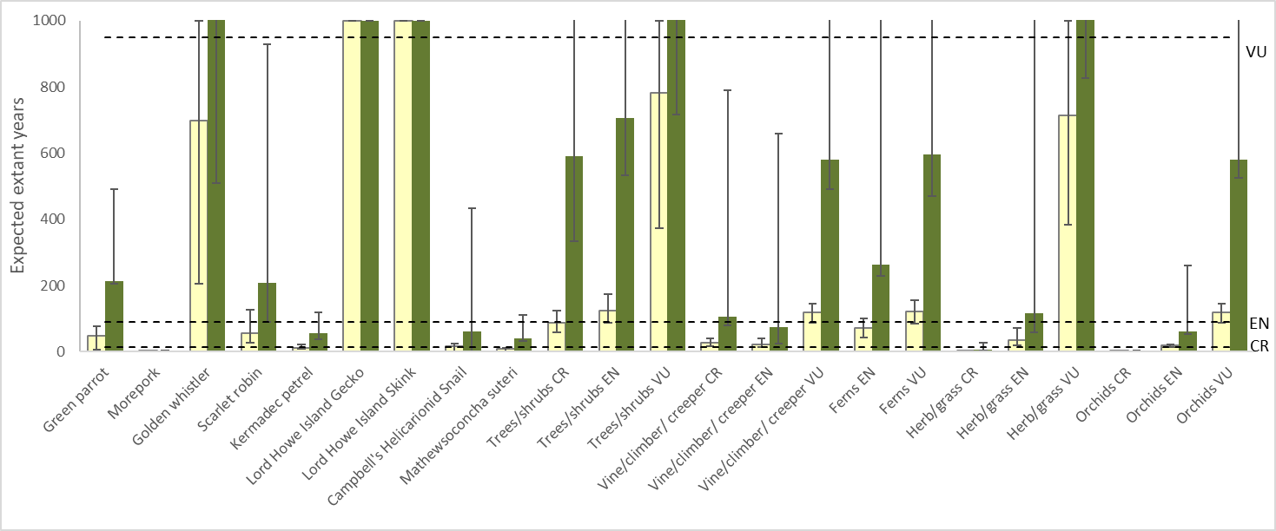
EPBC Act listing categories shown: CR = Critically Endangered, EN = Endangered, and VU = Vulnerable
Response over 10 years for each individual species (or plant group) without management action (yellow bars, on the left of each column entry) and with all programs being implemented at the 2021 level (green bars, on the right of each column entry). The dotted lines indicate the threshold for a species to move between EPBC Act listing categories. The three snail species presumed extinct at the time of the analysis (Advena grayi was rediscovered subsequently) are not included in this chart, as their status was not predicted to change with management. It should be noted that there was an implicit assumption that, even under a scenario of no management, biosecurity on Phillip Island would remain sufficient to prevent non-native predators being introduced from Norfolk Island; as a result, the outcomes of the two scenarios in terms of threat status were similar for the two species of reptile (however, there was an additional benefit of management that is not shown in the graph as the bars are clipped at 1000 years).

Part 4—Management planning

Conceptual framework for management planning

Conceptual models
This plan is underpinned by a high-level conceptual model (Figure 4) that outlines the threats to threatened species (and biodiversity more generally on Norfolk Island), the drivers of those threats, and the management that could be implemented to mitigate them. As described in Section 2.1, the 58 threatened species are impacted by a range of pressures, mostly relating to interactions with invasive species and effects of land use practices, which are exacerbated by climate change impacts such as reduced rainfall and higher risk of fires. Some threatened species populations are vulnerable to reduced genetic diversity that is inherent to many isolated small island populations.
Figure 4 Simplified conceptual model of the pressures, drivers, and management that influence the state of threatened species on the Norfolk Island Group
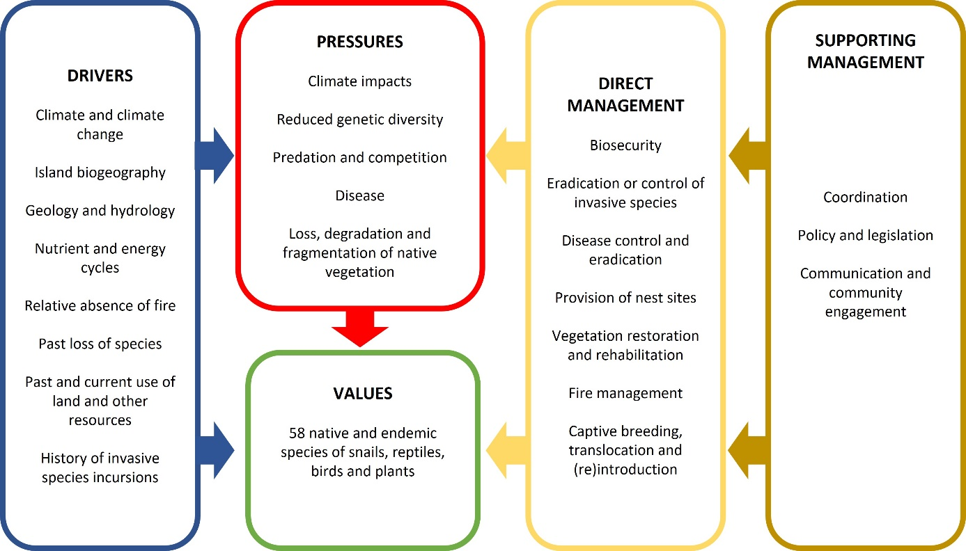
Building on this simple model, more detailed conceptual models have been developed focusing on the factors that influence individual species or groups of species (Appendix A: Conceptual models—Figure 10 to Figure 14). Conceptual models are a valuable planning tool in conservation as they allow the identification of specific relationships (which might involve the interaction of several factors) that influence threatened species or other values to be conserved, and of the ways that management might affect those relationships. In this case, the models highlight that a range of pressures impact threatened species in the Norfolk Island Group. These pressures often interact with one another and may cause cascading and compounding effects that impact multiple threatened species. One such major pressure confirmed by these models is the reduction in the extent and condition of Norfolk Island’s forests and Phillip Island’s native vegetation, which is driven by a variety of factors (such as past clearing and grazing, species loss, and weed invasion) and interacts with other significant pressures including the effects of feral animals and a changing climate. These models highlight the importance of restoration of native vegetation as a central component of future conservation efforts, but also the necessity of managing other pressures such as controlling feral animal species like rats, which exert a pressure on many threatened flora and fauna.

Hierarchy of outcomes
A hierarchy of outcomes (see also Figure 5) provides long-term reference points for the plan as well as outcomes to be achieved during the life of the plan:
- A Vision for restoration of the island’s biodiversity and ecosystems provides the broad context:
By 2050, the Norfolk Island Group will have resilient ecosystems that hold self-sustaining populations of all native species.
While achieving that vision is beyond both the timespan and scope of this ten-year species recovery plan (it will require more than a decade and conservation efforts that go beyond recovery of terrestrial threatened species), it provides a broad reference point for the plan.
- Contributing to the realisation of that vision is a series of more specific long-term goals:
Native species
  - By 2045, populations of all native species are secure and self-sustaining, and species currently restricted to Phillip Island (that previously occurred on Norfolk Island) are back in the wild on Norfolk Island.
Plant communities
  - By 2045, native vegetation has been re-established across the islands with a range and area of coverage sufficient for all 14 native plant communities on Norfolk Island (Table 13) and all six native plant communities on Phillip Island (Table 15) to be well represented, self-sustaining, and present in sufficient amounts and appropriate locations and configurations to provide habitat to support native species.
Invasive species
  - By 2040, all invasive species in the Norfolk Island Group have been eradicated or controlled to sustainable levels required to achieve other goals.
These long-term goals align closely with the scope of this recovery plan, but their achievement is likely beyond the ten-year timespan of the current plan. They represent the outcomes to which subsequent recovery plans should aspire, provide specific reference points for the current plan, and highlight that the next decade is a step in a longer journey.
With the two higher levels of the hierarchy providing context, several further levels of shorter-term goals (Figure 5) set the ambition for the ten-year timeframe of the current plan, with the aim of making significant progress towards achieving the long-term goals and realising the overall vision.
- Ten-year targets for species populations (hereafter, species targets) have been set for individual species or groups of species. These targets are generally in relation to population size and/or distribution of a species.
- Ten-year targets for management of pressures (the presence of a negative factor or absence of a positive factor) that are impeding recovery of species (hereafter, management targets).
- These targets inform identification of specific actions to be implemented, which are grouped into management programs.
Targets for threatened species are presented in section 4.2. Management targets are outlined in section 4.3. Management programs and major constituent actions are presented in section 4.4. Supporting management actions that underpin the direct management programs are detailed in section 4.5.

Figure 5 The hierarchy of outcomes relevant to this ten-year plan
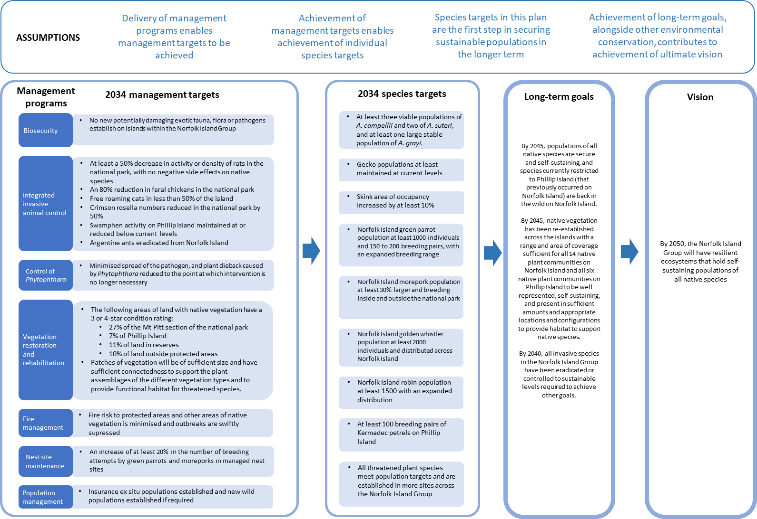
Management targets (allocated to management programs) and species targets in the plan (in the first two columns) contribute to the achievement of long-term goals and the long-term vision (in the third and fourth columns), which are beyond the life of the plan.

Ten-year species targets

Threatened fauna

Targets
By 2034, threatened fauna species populations meet target levels stated in Table 26.
These targets were developed through discussion with local conservation managers and other experts and informed by current literature, action plans and population survey results.
Table 26 Listed threatened fauna species and their 2034 targets
Species | Common name | EPBC Act status | Estimated population (2023) | Target
Advena campbellii | Campbell’s keeled glass-snail | Critically Endangered | 500 (3 populations) | At least three viable populations maintained on Norfolk Island
Mathewsoconcha grayi (Advena grayi) | Gray’s glass-snail | Critically Endangered | 5,000 (1 population) | At least one large population on Phillip Island
Mathewsoconcha phillipii (Advena phillipii) | Phillip Island glass-snail | Critically Endangered | Presumed extinct | n/a
Mathewsoconcha suteri (Advena suteri) | Suter’s striped glass-snail | Critically Endangered | 350 (1 population) | Current population maintained and at least one additional viable population established on Norfolk Island
Quintalia stoddartii (Advena stoddartii) | Stoddart’s glass-snail | Critically Endangered | Presumed extinct | n/a
Christinus guentheri | Lord Howe Island gecko | Vulnerable | 176,000 | Maintained numbers and range
Oligosoma lichenigerum | Lord Howe Island skink | Vulnerable | 7,000 | Area of occupancy increased by at least 10%
Cyanoramphus cookii | Norfolk Island green parrot | Endangered | 438  (270–606) | The population has increased to 1000 individuals, including 150 to 200 breeding pairs, and the breeding range has extended to the south of the island
Ninox novaeseelandiae undulata | Norfolk Island morepork | Endangered | 25  (20–40) | The population size has increased by at least 30% from 2023, and breeding is occurring both inside and outside of the national park
Pachycephala pectoralis xanthoprocta | Golden whistler | Vulnerable | 1,671  (1,372–1,970) | The population is at least 2000 individuals and distributed across Norfolk Island
Petroica multicolor | Norfolk Island robin | Vulnerable | 750  (700–800) | The population is at least 1500 individuals, and the distribution extends outside the national park and its fringes to other areas of the island (such as public reserves and more southern parts of the island)
Pterodroma neglecta neglecta | Kermadec petrel | Vulnerable | 150 on Phillip Island  (50 breeding pairs) | There are at least 100 breeding pairs on Phillip Island with maintained high breeding success

Threatened plants

Targets
By 2034, threatened plant species populations meet target levels stated in Table 27 and most species are established in a larger number of sites across the Norfolk Island Group.
Population sizes in 2023 are derived from surveys undertaken in the national park and public reserves; there may be uncounted individuals on private land. These population estimates inform targets that were determined through extensive consultation with local conservation managers and other experts. Targets set for 2034 include planted individual and groups of plants that survive in the ground for at least one year.
Table 27 Listed threatened plant species and their 2034 targets
Species | Common name | EPBC Act status | Estimated population (2023) | Target
Abutilon julianae | Norfolk Island abutilon | Critically Endangered | 227 | 1000
Achyranthes arborescens | Chaff tree, soft-wood | Critically Endangered | 391 | 1000
Achyranthes margaretarum | Phillip Island chaffy tree | Critically Endangered | 14 | 500
Anthosachne kingiana kingiana | Phillip Island wheat grass | Critically Endangered | 5 groups of plants | 100 groups of plants
Blechnum norfolkianum | Norfolk Island water-fern | Endangered | 708 | 1000
Boehmeria australis australis | Tree nettle, nettletree | Critically Endangered | 591 | 1000
Calystegia affinis | A creeper | Critically Endangered | 28 groups of plants | 100 groups of plants
Clematis dubia | Clematis | Critically Endangered | 303 | 500
Coprosma baueri | Coastal coprosma | Endangered | 708 | 1500
Coprosma pilosa | Mountain coprosma | Endangered | 420 | 1000
Cordyline obtecta | Ti | Vulnerable | 1863 | 3000
Dendrobium brachypus | Norfolk Island orchid | Endangered | 200 | No decline
Dysoxylum bijugum | Sharkwood | Vulnerable | 940 | 2000
Elatostema montanum | Mountain procris | Critically Endangered | 26 | 100
Euphorbia norfolkiana | Norfolk Island euphorbia | Critically Endangered | 388 | 1000
Euphorbia obliqua | A herb | Vulnerable | 814 | 1500
Hibiscus insularis | Phillip Island hibiscus | Critically Endangered | 350 | 1000
Hypolepis dicksonioides | Downy ground-fern, brake fern, ground fern | Vulnerable | 506 | 750
Ileostylus micranthus | Mistletoe | Vulnerable | 500 | 750
Lastreopsis calantha | Shield-fern | Endangered | 148 | 250
Marattia salicina (Ptisana salicina) | King fern, para, potato fern | Endangered | 160 | 250
Melicope littoralis | Shade tree | Vulnerable | 305 | 1000
Melicytus latifolius | Norfolk Island mahoe | Critically Endangered | 148 | 500
Melicytus ramiflorus subsp. oblongifolius | Whiteywood | Vulnerable | 570 | 1000
Meryta angustifolia | Narrow-leaved meryta | Vulnerable | 494 | 1000
Meryta latifolia | Broad-leaved meryta | Critically Endangered | 395 | 1000
Muehlenbeckia australis | Shrubby creeper, pohuehue | Endangered | 100 | 250
Myoporum obscurum | Popwood | Critically Endangered | 417 | 1000
Myrsine ralstoniae | Beech | Vulnerable | 1789 | 3000
Pennantia endlicheri | Pennantia | Endangered | 791 | 1000
Phreatia limenophylax | Norfolk Island phreatia | Critically Endangered | 5 | Established in a second location
Phreatia paleata | White lace orchid | Endangered | 27 | No decline
Pittosporum bracteolatum | Oleander | Vulnerable | 1349 | 3000
Planchonella costata | Bastard ironwood | Endangered | 251 | 1000
Polyphlebium endlicherianum | Middle filmy fern | Endangered | 200 | 250
Pteris kingiana | King’s brakefern | Endangered | 483 | 500
Pteris zahlbruckneriana | Netted brakefern | Endangered | 35 | 250
Senecio australis | A daisy | Vulnerable | 1454 | 3000
Senecio evansianus | A daisy | Endangered | 200 | 250
Senecio hooglandii | A daisy | Vulnerable | 550 | 750
Streblus pendulinus | Siah’s backbone | Endangered | 259 | 1000
Taeniophyllum norfolkianum | Minute orchid, ribbon-root orchid | Vulnerable | 500 | No decline
Tmesipteris norfolkensis | Hanging fork-fern | Vulnerable | 500 | 1000
Ungeria floribunda | Bastard oak | Vulnerable | 502 | 1000
Wikstroemia australis | Kurrajong | Critically Endangered | 629 | 1000
Zehneria baueriana | Native cucumber, giant cucumber | Endangered | 180 groups of plants | 300 groups of plants

Ten-year management targets
To achieve targets for individual threatened species, pressures preventing the recovery of the species need to be managed. A series of management targets to address those pressures were developed through consultation with local conservation managers and other experts (Table 28). For information on which threatened species are supported by each of these management actions, see Table 30.
These are broad targets for each pressure overall; more detailed spatial planning and area-based subsidiary targets will be needed in many cases.
Table 28 Management targets and the pressures they address
2034 management target | Pressures addressed ª
No new potentially damaging exotic fauna, flora or pathogens establish on islands within the Norfolk Island Group | Impacts of potential new invasive species, including pathogens
At least a 50% decrease in activity and/or density of rats in the national park with no negative side effects on native species | Predation by rodents
An 80% reduction of feral chickens in the national park relative to 2023 levels | Predation or damage by chickens
Free-roaming cats detected on less than 50% of the island | Predation by cats
Numbers of rosellas in the national park reduced by 50% | Lack of available nest sites
Swamphen activity on Phillip Island maintained at or reduced below current levels | Predation by swamphens
Argentine ants eradicated from Norfolk Island | Predation by Argentine ants
Minimised spread of Phytophthora cinnamomi beyond baseline distributions within the park and across the island  Plant dieback caused by P. cinnamomi is reduced to the point where intervention is no longer necessary | Infection by pathogens already present
Extent of high-quality native vegetation increased:  - At least 27% of the Mt Pitt section of the national park has native vegetation in good or recovering condition ^{b}  - at least 7% of Phillip Island has native vegetation in good or recovering condition ^{b}  - at least 11% of land in public reserves has native vegetation in good or recovering condition ^{b}  - Outside of the park and reserves, at least 10% of land has native vegetation in good or recovering condition. This will include restoration of a substantial amount of the three forest types that have been most reduced from their original range: viny hardwood forest, plateau hardwood forest, and lowland valley hardwood forest ^{b}  - Patches of vegetation will as far as possible be of sufficient size and have sufficient connectedness to support the plant assemblages that are characteristic of the different vegetation types and to provide functional habitat networks for threatened species | Loss, degradation and fragmentation of native vegetation  Competition from/change of habitat because of weed invasion
Fire risk to protected areas and other areas of native vegetation is minimised, and any outbreaks in or threatening these areas are swiftly suppressed  Increased awareness and vigilance to prevent unplanned ignitions and to report and stop them rapidly when detected | Increased fire risk as a result of climate change
Limited availability of suitable nest sites overcome such that, for each hollow-nesting species, there is an increase of at least 20% in the number of breeding attempts in managed nest sites | Lack of available nest sites
Insurance captive breeding or nursery populations established and appropriately managed, if required  All threatened plant species protected in seed banks  New wild populations established if required | Problems caused by small populations  Other in-situ pressures
Any incursion of a significant invasive species on Phillip Island is swiftly eradicated | Impacts of potential new invasive species
ª See risk assessment in section 2.2.
^{b} Good condition will be defined in a framework for monitoring vegetation condition with indicators and metrics appropriate to the native plant communities of the Norfolk Island Group, informed by the National Restoration Standards (SERA 2017). This framework will take into consideration factors such as presence of weeds, structure (e.g. presence of expected forest strata), evidence of plant recruitment, and species composition. Recovering condition will be defined as any area undergoing restoration management (for example, weeding and planting) and believed to be on the desired trajectory towards good condition.

Direct management programs
To achieve the management targets in section 4.3, a range of threat abatement and restoration actions must be implemented. These group into management programs.
Some are core management programs that require ongoing delivery:
- biosecurity
- integrated invasive animal control:
- control of rodents
- control of feral chickens
- control of free-roaming cats
- control of crimson rosellas
- control of swamphens
- eradication of Argentine ants
- control of Phytophthora cinnamomi
- restoration of native vegetation
- fire management
- provision of nest sites for native threatened birds
- population management.
In addition, there is a need to be prepared to implement contingency programs to eradicate any incursions onto Phillip Island of significant invasive species from the main island, if such incursions occurred.
Management programs, their associated management targets, and actions to be implemented are summarised in Table 29. Delivery of actions in management programs, achievement of management targets (section 4.3), and achievement of species targets (section 4.2) represent a sequence of important and measurable results on the path to species recovery. This sequence forms a basis for targeted and effective monitoring, evaluation and improvement (see section 4.6).

Table 29 Management programs and associated actions to achieve 2034 targets for threatened species
Category | Management program | Actions
Biosecurity | Biosecurity | - Develop and implement a comprehensive biosecurity plan (quarantine, surveillance and incursion preparedness) for Phillip Island.  - Review and implement relevant findings and recommendations from the Norfolk Island Quarantine Survey 2012–2014 (Maynard et al. 2018), DITRDCA’s Norfolk Island Plant Pest and Disease Survey (Martoni et al. 2023) and the Norfolk Island: Protecting an Ocean Jewel report (Invasive Species Council and Island Conservation 2017).  - Install boot scrub stations and develop associated interpretive information/signage for locals, tourists, and contractors.
Integrated invasive animal control | Control of rodents | - Develop and implement a comprehensive rodent control plan to deliver effective targeted control of rodents using appropriate methods, including trials of new methods.  - Explore the possibility of making rodent baits locally (solving issues surrounding bait importation).  - Introduce technologies such as thermal surveys to supplement existing monitoring methods.  - Establish experimental fenced areas excluding rats and cats.
 | Control of feral chickens | - Develop and implement a comprehensive invasive bird control program that enables effective targeted control of chickens.
 | Control of free-roaming cats | - Develop and implement a comprehensive island-wide cat management action plan, enabling effective targeted control of cats using appropriate methods, including trials of new techniques.  - Coordinate development and delivery of cat and rodent control plans.  - Identify and implement a strategy for improved domestic cat management which includes effecting legislative change regarding domestic cats.  - Establish a domestic animal pound that charges to retrieve roaming cats that have been caught.  - Establish an experimental fenced area excluding rats and cats.
 | Control of crimson rosellas | - Develop and implement a comprehensive invasive bird control program that includes a strategic island-wide approach to rosella culling.
 | Control of swamphens | - Develop and implement a comprehensive invasive bird control program that includes, at a minimum, maintaining the swamphen shooting regime on Phillip Island (at 2020–21 levels or higher) and monthly control works focused on the source population on Norfolk Island.
 | Eradication of Argentine ants | - Continue to implement the Argentine ant Eradication Strategy Norfolk Island 2021–2026 (Hoffman 2020).
Pathogen control | Control of Phytophthora cinnamomi | - Maintain hygiene stations in the national park and educate people on importance of minimising the movement of soil and infected equipment.  - Research effects on native species.  - Develop and implement a comprehensive management plan for the island.  - Undertake surveys to confirm distribution of Phytophthora spp. if necessary.
Restoration of native vegetation | Restoration of native vegetation | This management program addresses the need to conserve and enhance the habitat critical for survival of the threatened species under this plan. It includes specific actions to propagate and plant threatened plant species.  Actions to restore native plant communities:  - Develop and implement a strategic plan for restoration of native vegetation, following the principles of the National Restoration Standards (SERA 2017), with targets for different areas and communities. The strategic plan should aim for a comprehensive, adequate, functionally connected, resilient and representative network of sites, and provide information on species population viability and ecological thresholds.  - The practical management required will include the following coordinated activities:  - Protection of all existing native vegetation  - Seed collection  - Propagation (including expansion of nursery facilities on both Norfolk and Phillip Islands)  - Revegetation (including through establishment of new areas of native forest in areas currently dominated by non-native species or native plantations)  - Management of weeds  - Management of grazing (exclusion of livestock from conservation/restoration areas)  - Conversion of the forestry area of the national park to native forest.  Actions to benefit specific species:  - Snails: expansion of suitable native vegetation to benefit threatened snails, removal of weeds (especially red guava) from important areas to provide suitable pH and moisture levels, and experimental addition of woody debris to increase the number of shelter sites.  - Forest birds: restoration of native forest outside the park, with patches of appropriate size, composition, and physical connectedness, to enable passerine birds to expand their range and support a greater density of Norfolk Island morepork territories.  - Forest birds: protection of old hollow-bearing trees for Norfolk Island moreporks and Norfolk Island green parrots.  - Seabirds: restoration of native vegetation on Phillip Island that takes into consideration the use by seabirds of African olive as nest sites, and the need for seabirds to have clear flight paths to nesting sites.  - Plants: continued inclusion in restoration plantings of threatened plant species cultivated at the nursery.
Fire management | Fire management | - Implementation of community programs to increase awareness, precaution, vigilance, and reporting of ignitions.  - Maintenance of access tracks.  - Fuel reduction (forestry area).  - Conversion of Eucalyptus plantation to native forest.  - Suppression of fire outbreaks.
Provision of nest sites for native threatened birds | Provision of nest sites for native threatened birds | - Upgrades to and maintenance of artificial or protected natural nest sites appropriate to each species.  - Improvement in the placement, and potentially the number and spatial configuration, of nest sites for Norfolk Island moreporks and Norfolk Island green parrots, particularly outside the national park.  - Removal and replacement of decrepit structures for seabirds on Phillip Island.
Population management | Population management (potentially including seed banking, ex situ cultivation and captive breeding, translocation and (re)introduction) | Snail species:  - Continue the captive breeding program for Campbell’s keeled glass-snail (Advena campbellii).  - Return the species to appropriate facilities on Norfolk Island.  - If appropriate, expand the captive breeding program to other snail species.  Reptiles:  - Develop captive breeding protocols for the species.  - Identify other islands where the Norfolk Island reptiles could be translocated to provide insurance populations.  Norfolk Island robin:  - Identify sites and assess feasibility of translocation, with the aim of establishing a population in at least one new site on Norfolk Island by 2027.  Norfolk Island golden whistler:  - Trial translocation from Norfolk Island to Phillip Island following those of other non-threatened passerines (dependent on results of feasibility studies).  Norfolk Island morepork:  - If genetic rescue is required, introduce additional individuals from an appropriate source population.  Norfolk Island green parrot:  - Explore options for translocation of the Norfolk Island green parrot to other islands to create insurance populations.  Threatened plants:  - Increase representation of the species in seedbanks and botanic gardens collections.  - Secure genetically representative ex situ seed collections, particularly for those plant species that are not predicted to respond to broader management actions.  - Increase cultivation of epiphytic orchids when improved techniques have been developed.  General:  - Explore options for utilising zoos, botanic gardens, and other conservation organisations (for example, the Australian Native Plants Society) to assist with ex situ conservation on and off the island and with education.  - Assess the appropriateness and feasibility of reintroducing locally extinct fauna (or related species that would fill the same ecological niches) following the control or eradication of rats. Candidate projects include:  - reintroducing reptiles from Phillip Island to Norfolk Island.  - introducing close relatives of bird taxa that have been lost from the Norfolk Island Group.
Contingency programs (post-border biosecurity measures on Phillip Island) | Invasive species eradication | - Implement appropriate control methods at the level of intensity required to achieve eradication.

Level of importance of each management program to each species
The expected importance to each threatened species of each management program outlined in Table 29 is summarised in Table 30. Refer also to risk assessment results in section 2.2 and the conceptual models of factors influencing species in Appendix A: Conceptual models.

Table 30 The importance of each management program for each species
Species type | Species | Biosecurity | Rodent control | Cat control | Chicken control | Swamphen control | Argentine ant eradication | Pathogen control | Re-vegetation ª | Weed control ª | Fire management | Provision of nest sites | Population management ^{b}
Fauna | Campbell’s keeled glass-snail | Moderate | Critical | Negligible | High | Negligible | Low | Low | Critical | Moderate | Moderate | n/a | High
 | Suter’s striped glass-snail | Moderate | Critical | Negligible | Critical | Negligible | Low | Low | Critical | Moderate | Moderate | n/a | High
 | Gray’s glass-snail | Moderate | Negligible | Negligible | Low | Unknown | Negligible | Low | Critical | Moderate | Negligible | n/a | Moderate
 | Norfolk Island stag beetle | High | Critical | Negligible | High | Negligible | Moderate | Low | Critical | Low | High | n/a | High
 | Lord Howe Island gecko | Moderate | Negligible | Negligible | Negligible | Negligible | Low | Negligible | Moderate | Negligible | Negligible | n/a | Negligible
 | Lord Howe Island skink | High | Negligible | Negligible | Negligible | Negligible | Low | Negligible | High | Negligible | Negligible | n/a | Moderate
 | Norfolk Island golden whistler | High | High | Moderate | Negligible | Negligible | High | Negligible | High | Moderate | Low | Negligible | Moderate
 | Norfolk Island robin | Moderate | Critical | High | Negligible | Negligible | High | Negligible | High | Moderate | Moderate | Negligible | High
 | Norfolk Island morepork | Moderate | Low | Low | Negligible | Negligible | Moderate | Negligible | Critical | Moderate | High | Critical | Critical
 | Norfolk Island green parrot | Moderate | Critical | Critical | Negligible | Negligible | Moderate | Moderate | High | Moderate | High | High | High
 | Kermadec petrel | Moderate | Negligible | Moderate | Negligible | Critical | High | Negligible | Moderate | Low | Negligible | Negligible | Negligible
 | Kermadec petrel (Exp. Range) ^{c} | High | Critical | Critical | Negligible | High | High | Negligible | Low | Low | Moderate | Negligible | Negligible
 | White-necked petrel | Moderate | Negligible | High | Negligible | Low | High | Negligible | Critical | Low | Negligible | Negligible | Negligible
 | White-necked petrel (Exp. Range) ^{c} | High | Critical | Critical | Negligible | Low | High | Negligible | Low | Low | Moderate | Low | Negligible
 | Providence petrel | Moderate | Negligible | Moderate | Negligible | Negligible | High | Negligible | Critical | Low | Negligible | Low | Negligible
 | Providence petrel (Exp. Range) ^{c} | High | Low | Critical | Negligible | Negligible | High | Negligible | High | Negligible | Moderate | Negligible | Low
 | Sooty tern | Moderate | Low | Negligible | Unknown | Critical | High | Negligible | High | Low | Negligible | Negligible | Negligible
Trees and shrubs | Abutilon julianae | High | Low | Negligible | Moderate | Negligible | Low | Negligible | Critical | High | Moderate | n/a | High
 | Achyranthes arborescens | Moderate | Moderate | Negligible | Moderate | Negligible | Low | Moderate | Critical | High | Critical | n/a | Critical
 | Achyranthes margaretarum | Moderate | Unknown | Negligible | Moderate | Negligible | Low | Moderate | Critical | High | Low | n/a | Critical
 | Boehmeria australis australis | Moderate | Moderate | Negligible | Moderate | Negligible | Low | Moderate | Critical | High | Moderate | n/a | Critical
 | Coprosma baueri | Moderate | High | Negligible | Moderate | Negligible | Low | Moderate | Critical | Moderate | Moderate | n/a | High
 | Coprosma pilosa | Moderate | High | Negligible | Moderate | Negligible | Low | Moderate | Critical | Moderate | Critical | n/a | Critical
 | Cordyline obtecta | Moderate | Moderate | Negligible | Negligible | Negligible | Low | Moderate | Critical | Moderate | Moderate | n/a | Low
 | Dysoxylum bijugum | Moderate | Moderate | Negligible | Negligible | Negligible | Low | Moderate | Critical | Low | Moderate | n/a | Moderate
 | Euphorbia norfolkiana | Moderate | Critical | Negligible | Moderate | Negligible | Low | Moderate | Critical | Moderate | High | n/a | Critical
 | Hibiscus insularis | Moderate | Moderate | Negligible | Moderate | Negligible | Low | Moderate | Critical | Low | Low | n/a | Critical
 | Melicope littoralis | Moderate | Moderate | Negligible | Negligible | Negligible | Low | Moderate | Critical | High | Moderate | n/a | High
 | Melicytus latifolius | Moderate | High | Negligible | Moderate | Negligible | Low | Moderate | Critical | Critical | Moderate | n/a | Critical
 | Melicytus ramiflorus subsp. oblongifolius | Moderate | Moderate | Negligible | Negligible | Negligible | Low | Moderate | Critical | High | Moderate | n/a | Moderate
 | Meryta angustifolia | Moderate | Critical | Negligible | Negligible | Negligible | Low | Moderate | Critical | Moderate | Moderate | n/a | Moderate
 | Meryta latifolia | Moderate | Critical | Negligible | Moderate | Negligible | Low | Moderate | Critical | Moderate | Moderate | n/a | Critical
 | Myoporum obscurum | Moderate | Moderate | Negligible | Moderate | Negligible | Low | Moderate | Critical | High | Moderate | n/a | Critical
 | Myrsine ralstoniae | Moderate | High | Negligible | Negligible | Negligible | Low | Moderate | Critical | Moderate | Low | n/a | Low
 | Pennantia endlicheri | Moderate | High | Negligible | Moderate | Negligible | Low | Moderate | Critical | Critical | Moderate | n/a | High
 | Pittosporum bracteolatum | Moderate | High | Negligible | Negligible | Negligible | Low | Moderate | Critical | Moderate | Moderate | n/a | Low
 | Planchonella costata | Moderate | Low | Negligible | Moderate | Negligible | Low | Moderate | Critical | High | Moderate | n/a | High
 | Streblus pendulinus | Moderate | Critical | Negligible | Moderate | Negligible | Low | Moderate | Critical | Moderate | Moderate | n/a | High
 | Ungeria floribunda | Moderate | Critical | Negligible | Negligible | Negligible | Low | Moderate | Critical | Moderate | Moderate | n/a | Critical
 | Wikstroemia australis | Moderate | Critical | Negligible | Moderate | Negligible | Low | Moderate | Critical | Moderate | Moderate | n/a | Critical
Herbs and grasses | Anthosachne kingiana kingiana | Moderate | Negligible | Negligible | Negligible | Negligible | Negligible | Negligible | Critical | Critical | Moderate | n/a | Critical
 | Elatostema montanum | Moderate | Negligible | Negligible | Negligible | Negligible | Negligible | Negligible | Critical | Low | Critical | n/a | Critical
 | Euphorbia obliqua | Moderate | Negligible | Negligible | Negligible | Negligible | Negligible | Negligible | Critical | Low | Moderate | n/a | Moderate
 | Senecio australis | Moderate | Negligible | Negligible | Negligible | Negligible | Negligible | Negligible | Critical | Low | Moderate | n/a | Moderate
 | Senecio evansianus | Moderate | Negligible | Negligible | Negligible | Negligible | Negligible | Negligible | Critical | High | High | n/a | Critical
 | Senecio hooglandii | Moderate | Moderate | Negligible | Negligible | Negligible | Negligible | Negligible | Critical | High | Moderate | n/a | Moderate
 | Calystegia affinis | Moderate | Critical | Negligible | Negligible | Negligible | Negligible | Negligible | Critical | Critical | Moderate | n/a | Critical
 | Clematis dubia | Moderate | Moderate | Negligible | Negligible | Negligible | Negligible | Negligible | Critical | Moderate | Moderate | n/a | Critical
 | Ileostylus micranthus | Moderate | Low | Negligible | Low | Negligible | Low | Low | Critical | Low | Low | n/a | Low
 | Muehlenbeckia australis | Moderate | Low | Negligible | Negligible | Negligible | Negligible | Negligible | Critical | Moderate | Moderate | n/a | Moderate
 | Zehneria bauerian | Moderate | Negligible | Negligible | Negligible | Negligible | Negligible | Negligible | Critical | Moderate | Moderate | n/a | Moderate
Ferns | Blechnum norfolkianum | Moderate | Negligible | Negligible | Negligible | Negligible | Negligible | Negligible | Critical | Moderate | Low | n/a | High
 | Hypolepis dicksonioides | Moderate | Negligible | Negligible | Negligible | Negligible | Negligible | Negligible | Critical | Moderate | Low | n/a | Critical
 | Lastreopsis calantha | Moderate | Negligible | Negligible | Negligible | Negligible | Negligible | Negligible | Critical | Moderate | Low | n/a | Low
 | Marattia salicina | Moderate | Negligible | Negligible | Negligible | Negligible | Negligible | Negligible | Critical | High | Low | n/a | Critical
 | Polyphlebium endlicherianum | Moderate | Negligible | Negligible | Negligible | Negligible | Negligible | Negligible | Critical | Low | Low | n/a | Moderate
 | Pteris kingiana | Moderate | Negligible | Negligible | Negligible | Negligible | Negligible | Negligible | Critical | Moderate | Low | n/a | Moderate
 | Pteris zahlbruckneriana | Moderate | Negligible | Negligible | Negligible | Negligible | Negligible | Negligible | Critical | Moderate | Low | n/a | Moderate
 | Tmesipteris norfolkensis | Moderate | Negligible | Negligible | Negligible | Negligible | Negligible | Negligible | Critical | Low | Low | n/a | Moderate
Orchids | Dendrobium brachypus | Moderate | High | Negligible | Negligible | Negligible | Negligible | Low | Moderate | Moderate | High | n/a | Critical
 | Phreatia limenophylax | Moderate | Negligible | Negligible | Negligible | Negligible | Negligible | Low | Moderate | Moderate | High | n/a | Critical
 | Phreatia paleata | Moderate | High | Negligible | Negligible | Negligible | Negligible | Low | Moderate | Moderate | High | n/a | Critical
 | Taeniophyllum norfolkianum | Moderate | Negligible | Negligible | Negligible | Negligible | Negligible | Moderate | Moderate | Moderate | High | n/a | Critical
ª The management program 'restoration of native vegetation' has been divided here into its two major components: revegetation and weed control.
^{b} Population management may include captive breeding/propagation, seed banking and conservation translocations.
^{c} Exp. Range—The importance of each management program to the species should their range expand to include the main island.
Notes: biosecurity is deemed to be of high importance to animal species restricted to Phillip Island, reflecting the known invasive predators present on Norfolk Island; biosecurity for other species was assessed as being of moderate importance. Rodent and cat control is scored as being of negligible importance for Phillip Island populations, as the essential task of keeping those species off Phillip Island is considered under biosecurity, and control of the two predators on Norfolk Island (short of eradication) is not expected to significantly reduce the risk of invasion of Phillip Island. Eradication of Argentine ants, however, was deemed to be of high importance to some Phillip Island species, as eradication from Norfolk Island would significantly reduce the risk of invasion of Phillip Island.

Supporting management actions
The actions described support the direct management actions outlined in section 4.3. They are not optional or less important actions, but rather have a crucial role in underpinning effective management on the ground.

Coordination
A recovery team will be responsible for coordinating the implementation of this plan. This team should have representation from the agencies with primary responsibility for land management and from other stakeholder groups, and ideally this group should have a dedicated member of staff to provide a central point of contact and coordination for all supporting actions. Coordination, governance and responsibilities are discussed further in section 5.1.

Actions
- Establish a management group to coordinate planning, management and monitoring that includes representatives of the main land managing agencies, representatives from the Norfolk Island community, and experts in relevant aspects of threatened species ecology and management methods.
- Develop a detailed Communication and Engagement Plan outlining the approach, plan and timeline for communication, engagement, and outreach activities with stakeholder groups.
- Undertake effective monitoring, evaluation and reporting to relevant stakeholders of the results of the progress in implementing the plan and the effectiveness of different management approaches (section 4.3).

Policy and legislation
Policy, legislation and funding must be improved to successfully implement recovery actions for threatened species in the Norfolk Island Group.

Actions
- Develop stronger legislative protection (including enforcement) for native vegetation/habitat, such as limiting tree removals, stronger offset conditions, and the use of conservation covenants. Greater protection is required for mature trees (particularly Norfolk Island pines), which take 200–300 years to reach the stage where they provide significant environmental benefits, including hollows for birds and water recharge.
- Communicate responsibilities for native vegetation protection on private land to ensure that these responsibilities are understood by the community.
- Develop and implement improved regulation and enforcement of restrictions on the importation of all cats or particular breeds, pending outcomes of community consultation. Additionally, undertake further consultation with the community to determine the level of support for greater regulations around domestic cat ownership, including for example: registration, vaccination, microchipping and desexing, feral adoption bans, curfews, fines for cats that are found straying from home, and pet exclusion zones.
- Advocate for the Norfolk Island Group to become or join a designated Natural Resource Management Region (NRM) of Australia to enable eligibility for national funding programs, including the National Landcare Program. Such funding could support private land initiatives and Norfolk Island community work on public land (as occurred in the past).
- Update climate change vulnerability assessment and adaptation planning for the islands.
- Review threatened species listings for plants, snails and other groups such as terrestrial arthropods, and submit listing nominations if required.

Community engagement
A high level of community support and engagement will be essential for the plan to be achieved.

Actions
- Develop or support a citizen science and broader volunteer program on Norfolk Island linked to a coordinated Conservation Management Network, to encourage community involvement in research, monitoring and management.
- Continue the community-based Norfolk Island morepork monitoring project.
- Develop an education campaign to encourage community understanding and appreciation of Norfolk Island’s endemic and threatened species. This could include: field guides, opportunities to be involved in surveys, school programs, and live exhibits at the visitor centre or botanic garden (such as threatened snails and reptiles).
- Share information and continue community education about the importance of management practices for control of rodents, free-roaming cats, feral chickens, swamphens and crimson rosellas, and their impact on native species.
- Continue community education and incentives for best practice in domestic cat ownership.
- Explore community values and aspirations for the future environment and biodiversity of the islands, including attitudes to potential conservation interventions and priority locations for action.
- Support the community to manage native vegetation and promote the restoration of native vegetation through the development of field guides, planting guides for threatened plant species, educational material (including the importance of preventing garden escapees), and field days.
- Provide financial incentives for private landholders to manage natural areas for conservation (for example, by weeding, fencing native vegetation from livestock, and/or undertaking revegetation).
- Provide financial support for commercial and private fruit growers to protect their crops from increasing Norfolk Island green parrot numbers.
- Determine if carbon-offsetting programs to support restoration of native vegetation are appropriate for Norfolk Island and undertake community consultation on potential programs.
- Create a platform for data, knowledge and information sharing and collaboration amongst managers, local community members, researchers and other experts. Utilise (and if possible, expand upon) existing platforms for knowledge sharing.

Adaptive management
Adaptive management is an iterative decision-making process which, in simple terms, can be described as learning by doing and adapting based on what is learned. This process acknowledges that uncertainty often exists in conservation management and seeks to progressively reduce that uncertainty and improve decision making through a continuous cycle of planning, action, monitoring, research (including experimental management), evaluation and adjustment (Figure 6). There are multiple possible ‘loops’ of adjustment that can be made depending on the results of evaluation, from refining management actions and survey design to wholesale reassessment of conceptual plans.
Figure 6 Illustration of the major steps of the adaptive management cycle and its links to the Norfolk Island Region Threatened Species Recovery Plan
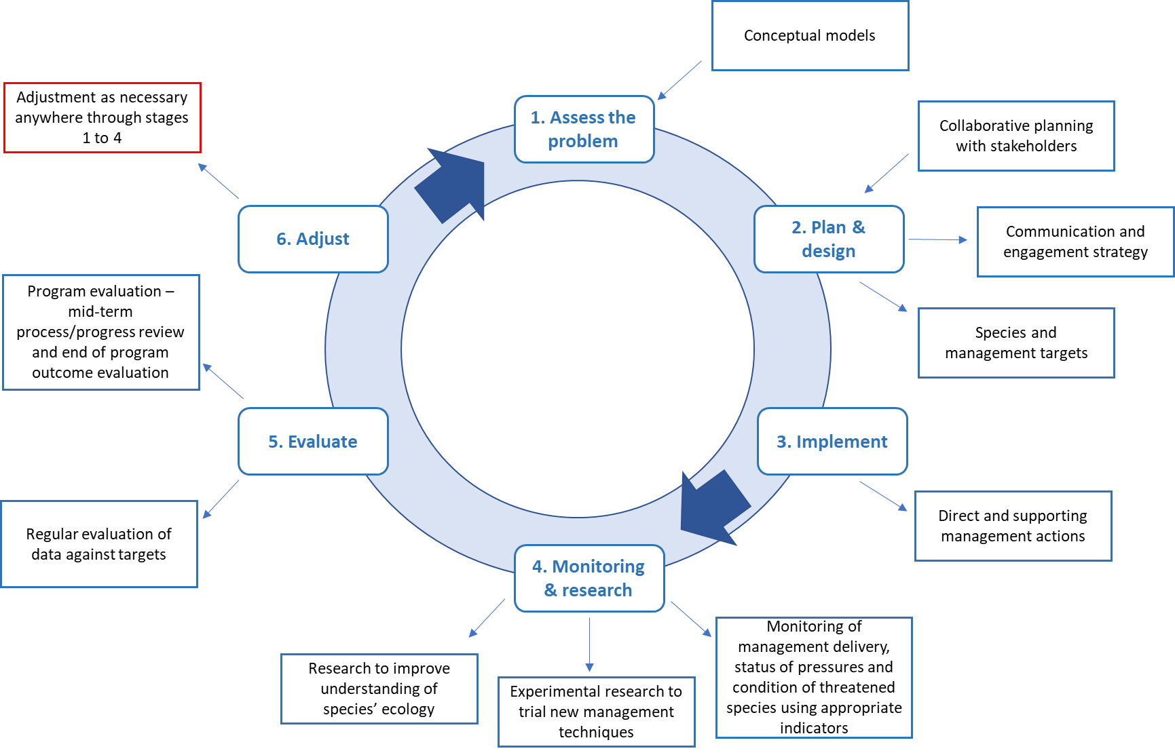
In the development of any actions to recover Norfolk Island’s threatened species, stakeholders and specialists should undertake planning sessions to understand the system in which they work and assess the problems they are seeking to address. Conceptual models and associated results chains are tools that can support this process and inform the development of robust management programs, threatened species recovery targets and key performance indicators.
Effective monitoring and evaluation of the management actions in this plan will be fundamental to achieving the targets. Clear and timely reporting will help to ensure that the recommendations resulting from evaluation can be used to inform future delivery of actions.
As part of the adaptive management approach, research will be closely integrated with delivery of management. Experimental research is needed to test the effectiveness of different management approaches. Research is also needed to improve our understanding of Norfolk Island’s ecosystems and biodiversity in general and to determine the status of some currently unlisted endemic species.

Monitoring
Adaptive management requires well-targeted and informative monitoring, which must be seen as an integral part of management. To support effective evaluation and improvement (see section 4.6.2), monitoring will be needed across chains of linked indicators. Typically, these chains will include four elements (Figure 7):
- A measure of resources expended
- An indicator of management outputs (relating to delivery of direct actions outlined in section 4.4)
- One or more indicators of pressures (relating to management targets outlined in section 4.3)
- One or more indicators of species populations (relating to targets outlined in section 4.2)
Figure 7 An example of a chain of linked indicators, representing the monitoring of a sequence of results towards a final target for a threatened species
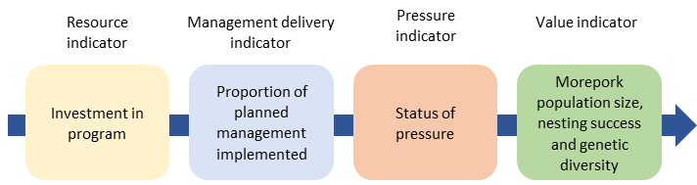
Choice of indicators should take into consideration:
- Relevance:
  - Information content in relation to the variable of interest (such as threatened species population, threat, or management action)
  - Specificity to the variable
  - Sensitivity to changes over time
- Measurability:
  - Feasibility of measurement
  - Confidence in accuracy and precision
The inclusion of pressure indicators (providing information on a pressure that is impeding recovery of one or more species) and ‘value’ indicators (providing direct information about populations of threatened species) is essential—it is vital to go beyond simply measuring actions delivered and include measurement of desired outcomes. Monitoring across all management programs, with coordinated and consistent methods across different sites and land tenures, will provide a comprehensive and integrated picture of trends in threatened species as well as the factors that are expected to influence those species (Figure 8).

Actions
- Complete the design of a comprehensive and integrated monitoring plan, covering all the major management programs and including finalisation of appropriate resource, management, pressure and threatened species indicators, with associated protocols for survey methods, frequency of data collection, and survey locations.
- Where appropriate, the monitoring plan should be consistent with existing national standards for evaluating outcomes, such as the National standards for the practice of ecological restoration in Australia (SERA 2017).
- Implement the monitoring plan, including prompt analysis and interpretation of data collected to inform evaluation.
Figure 8 Schematic overview of a possible integrated monitoring program to comprehensively track results across major management programs
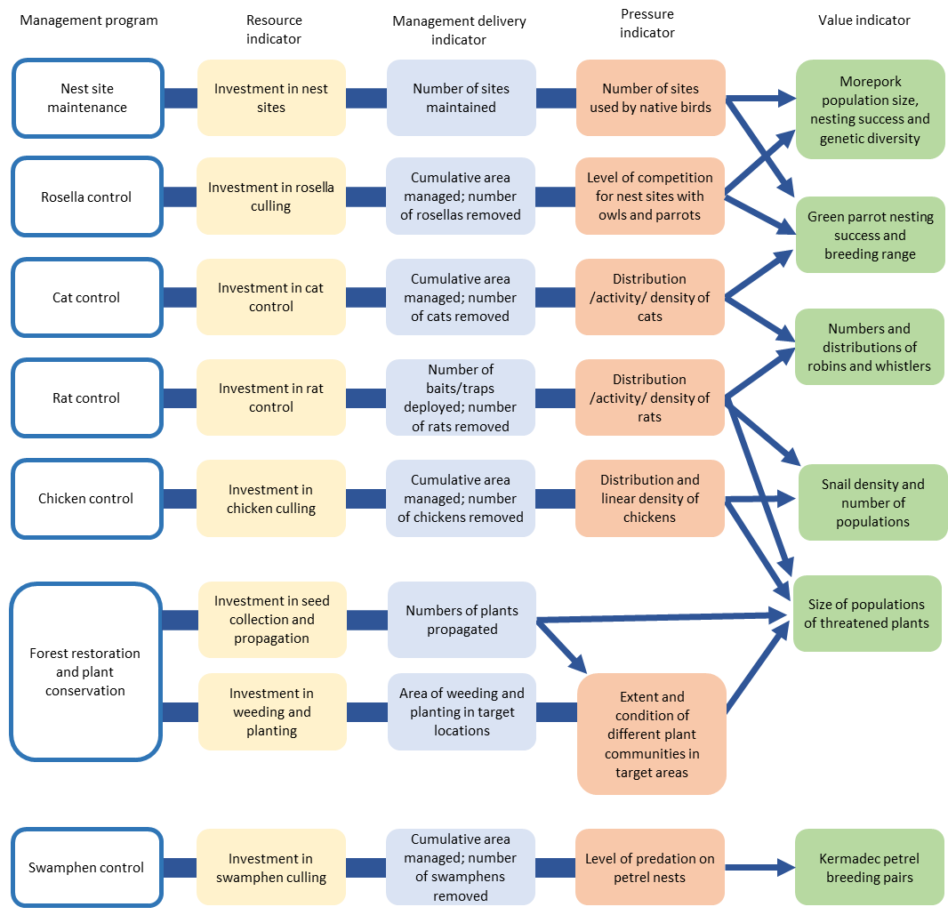
Text in boxes indicates broad indicators that may require further refinement, including considering possible sub-indicators stratified spatially or by other relevant covariates. Many management indicators can be divided into two levels – the immediate management output (e.g. number of traps operated) and its direct result (number of animals removed). While presented as linear chains, there are interactions and feedback loops between these management programs (see Appendix A: Conceptual models).

Evaluation and reporting
As part of adaptive management, evaluation and reporting will utilise outputs from the monitoring and research activities to inform future reviews and updates of the plan. An integrated evaluation of the plan will be developed and implemented to track and evaluate trends in relevant indicators of (1) investment of resources, (2) delivered management actions, (3) state of pressures (relating to management targets) and (4) populations of threatened species. Interpretation of some management indicators, especially those relating to direct results, may be meaningful only in the context of the pressure indicators they relate to – for example removal of a given number of rats would be interpreted differently depending on whether rat density was estimated to be high or low.
Regular evaluation across these chains of indicators will enable adaptive adjustments to the management, ecological monitoring and research elements of the recovery plan to be made as the plan is delivered. Changes in the different indicators should be evaluated in relation to each other to help determine whether delivery of the plan is on track and, if not, where problems may lie (Figure 9).
Figure 9 A conceptual overview of evaluation across sets of linked resource, management, pressure and value indicators, and some of the management decisions that might be considered under different scenarios
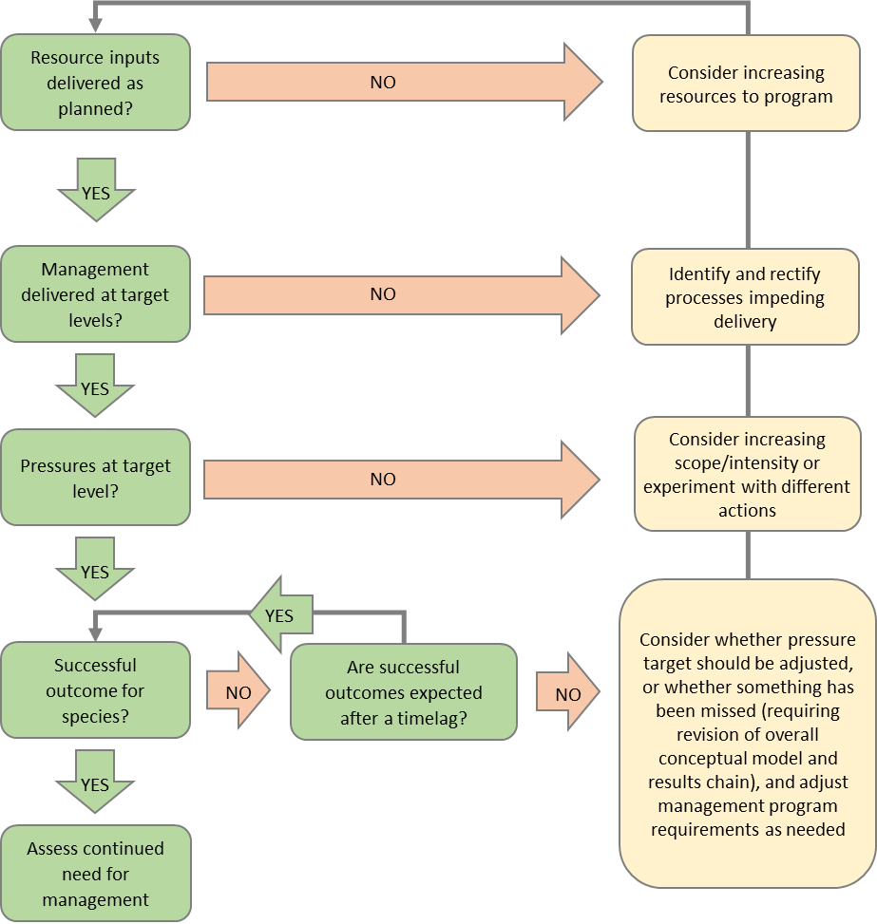
Evaluating results across chains of indicators in this way will also enable testing of assumptions and improved understanding of relationships—for example, the number of feral cats on Norfolk Island will have density-dependent impacts on a number of threatened species, but reducing the cat population will not necessarily benefit those threatened species if it leads to an increase in the population sizes of the introduced rodent species.
The effectiveness of the management actions implemented as part of the plan should be evaluated regularly. Feedback from these evaluations will be used to adjust actions as necessary. Simple evaluations (including, at least, tracking of resource and management indicators) should be undertaken annually. More in-depth evaluation (possibly conducted independently) including evaluation of all indicators should occur after five years and nine years. The results of evaluation should be reported as appropriate to organisations involved in delivery of the plan, to community members and to external stakeholders (this should be reflected in the Communication and Engagement Strategy; see also section 5.1). The management group that is formed to coordinate implementation of the plan should coordinate annual reporting, following Best Practice Guidelines for Recovery Team Governance (DoEE 2017).

Research
Monitoring and evaluation require the support of an integrated research program to address critical knowledge gaps and test experimental management approaches. The development and implementation of a research program would benefit from the establishment of a hub bringing together interested researchers and key stakeholders, building on the strong networks that already exist. Ideally, this would be supported by a research coordinator role, and by establishment of a dedicated field research station (which could also contribute to community engagement and communication).
Further work is needed to develop a comprehensive and prioritised research plan, and some of the topics that should be considered are detailed below.

Cross-cutting research
- Research to inform monitoring of pressures and native species and evaluate the effectiveness of management actions.
- Research into the sensitivity of all threatened species to projected climate change, an assessment of overall biodiversity vulnerability to climate change, and identification of potential refuge locations.
- Research to inform possible translocations and climate change interventions, including assessment of feasibility and risk, identification and surveys of source and destination sites, and associated monitoring.
- Research to support reviews of threatened species listings for multiple taxa, including under-studied groups such as freshwater biota.

Research to support control of invasive animal species
- Research into rat density, activity and movement in and between different areas, including further research into arboreal activity.
- Research into cat diet, genetics, movement and impacts on threatened species.
- Research into relationships between rodent control and cat numbers, cumulative impacts on threatened species, and likely changes in impacts if numbers of one or multiple predators were reduced.
- Investigation of the impact that rodent control may have on the Norfolk Island morepork population.
- Research on how to abate species-specific pressures on threatened animals.

Research to support restoration of native vegetation and conservation of native flora
- Experimental restoration of vegetation on Phillip Island, to adaptively improve restoration techniques and to benefit from the research opportunities offered by this case study of island restoration and ecosystem re-assembly.
- Research into the connections between landform, microclimate and plant survival to identify potential priority areas for restoration, and possible experimental management to enhance the qualities of those areas (for example, to maximise moisture retention).
- Research to inform ex situ actions for those plant species that may not respond to more general environmental management (such as Critically Endangered herbs, grasses and orchids), for example: propagation and establishment techniques for threatened orchids, including seed germination and mycorrhizal fungal relationships.
- Research into habitat requirements of range-restricted plant species (such as some orchids).
- Research to fill knowledge gaps for priority threatened plant species including on life history parameters, reproductive strategies, genetic diversity, pollination ecology, and potential importance of mycorrhizal fungal relationships.
- Research into sustainable and cost-effective ways of removing woody weeds rapidly from large areas of forest and promoting restoration of native forest while minimising negative consequences such as erosion, loss of habitat for threatened species and reinvasion by weeds.
- Research to understand which plant species (native and exotic) can host Phytophthora cinnamomi and which native species are susceptible to disease and dieback.
- Research on how to abate species-specific pressures on threatened plants.

Research to support conservation of native fauna
- Continuation of research on the ecology, population size, genetics and range movements (as required) of priority bird species, including the Norfolk Island morepork, Norfolk Island green parrot, and various sea birds.
- Research into phylogenetic relationships and ecological gaps in avian assemblages in the Norfolk Island Group and assessment of the potential to (re)introduce species that have been lost, or close relatives such as the long-tailed triller (Lalage leucopyga), New Zealand kākā (Nestor meridionalis) and New Zealand pigeon (Hemiphaga novaeseelandiae).
- Research into the potential impact of offshore human activities (such as wind farms), including comprehensive research on seabird species which have not already been subjects of tracking studies.
- Investigation of the movement and micro-habitat requirements of snail species, including assessment of the potential impacts of climate change and identification of areas of the islands (in their current state or with enhanced management) with the potential to provide refuges.
- Research into the Lord Howe Island gecko and Lord Howe Island skink distributions, population dynamics, ecological requirements and vulnerability to threats.
- Further research to inform the provision of suitable nest sites for Norfolk Island green parrots and Norfolk Island moreporks.

Social research
- Research into community aspirations and values in relation to the natural environment of Norfolk Island, attitudes towards possible conservation interventions, and factors that facilitate or hinder community engagement in conservation.

Part 5—Implementation

Governance and responsibilities

Governance
For the plan to be successfully delivered in full, coordinated planning, management and monitoring is required across different areas and land tenures in the Norfolk Island Group. This will require the establishment of a recovery team that will be responsible for implementing the plan and that includes representatives of the land management agencies, representatives from the Norfolk Island community, and experts in relevant aspects of threatened species ecology and management methods. The members of the group should bring complementary skills to ensure all ecological, administrative and social aspects of the plan are collectively covered. It could also form the nucleus of a wider conservation management network on the island.
This group should be constituted as a formal recovery team and cover many or all of the typical functions of a recovery team (DoEE 2017), including:
- development of strategies to support the plan
- oversight of delivery of management actions, and coordination among groups/individuals implementing management (for example, to enable coordinated management of invasive species across land tenures)
- oversight of monitoring and ensuring alignment of methods
- evaluation at appropriate stages of progress in implementing the plan and advising on adjustment/reprioritisation of operations as required
- reporting to internal and external stakeholders, including the Norfolk Island community
- coordination of community involvement and citizen science
- identification of potential partnerships that could be explored to address knowledge gaps or secure additional resources for management
- assistance in coordination of research and development of a research hub
Clear terms of reference should be established for the group in accordance with the Commonwealth Terms of Reference guide (DoEE 2017), covering for example:
- role, purpose and objectives
- representation, knowledge and skills
- responsibilities of members
- intended reporting and communication
- decision making processes
- structure including formation and duties of working groups
- operational arrangements
It is suggested that the group meet at least every six months and evaluate progress on an annual basis, following the approach outlined in section 4.6.2. The results of annual evaluation should be reported among partners and to the community as a minimum. More extensive reports following in-depth evaluation should be made at appropriate points.
For the group to be maximally effective, a dedicated coordinator position should be funded. This staff member would both coordinate and provide secretariat support for the activities of the group and act as a project officer to lead individual elements of work (particularly relating to policy on the island) and coordinate community engagement, citizen science and related activities.

Relevant organisations and groups
The following parties have an important role in implementing and/or supporting the plan:
- Australian Government—Director of National Parks
- Australian Government—Department of Climate Change, Energy, the Environment and Water
- Australian Government—Department of Infrastructure, Transport, Regional Development Communications and the Arts (DITRDCA)
- Australian Government—Department of Agriculture, Fisheries and Forestry (DAFF)
- Norfolk Island Regional Council (NIRC)
- Norfolk Island National Park Advisory Committee (NINPAC)
- private landholders and leaseholders
- community organisations such as the Norfolk Island Flora & Fauna Society and Friends of Norfolk Island National Park
- other community members
Other organisations such as the Lord Howe Island Board and the NSW Department of Planning and Environment may be able to provide advice during the plan’s implementation and finer scale operational planning.
Other Commonwealth, State or Regional agencies may have roles if there are any changes in governance arrangements for the Norfolk Island Group within the life of this plan.
The roles of each agency or group and how they can support implementation of recovery actions are outlined in section 5.1.

Director of National Parks

Legislative context
The Director is a corporation-sole under the EPBC Act and a corporate Commonwealth entity for the purposes of the Public Governance, Performance and Accountability Act 2013. The corporation is constituted by the person appointed by the Governor-General to the office that is also called the Director of National Parks. The functions of the Director include the administration, management and control of the Norfolk Island National Park and Botanic Garden. The Director is supported by Parks Australia, a division of the Department of Climate Change, Energy, the Environment and Water (DCCEEW).
The Mt Pitt section of the park and the botanic garden were established under the Norfolk Island National Park and Norfolk Island Botanic Garden Act 1984 (Norfolk Island) and subsequently also proclaimed under the National Parks and Wildlife Conservation Act 1975 (Commonwealth NPWC Act) in 1986 following a request of the Norfolk Island Legislative Assembly. The Phillip Island section of the park was proclaimed under the NPWC Act in 1996. The NPWC Act was replaced by the EPBC Act in July 2000. The park and the botanic garden continue as Commonwealth reserves under the EPBC Act pursuant to the Environmental Reform (Consequential Provisions) Act 1999.
The national park and botanic garden are managed in accordance with the Norfolk Island National Park and Norfolk Island Botanic Garden Management Plan 2020 (Director of National Parks 2020). One of the primary objectives of the management plan is to identify, conserve and protect the natural and cultural values of the park and botanic garden while providing for appropriate use. The Norfolk Island National Park Advisory Committee (NINPAC) advises the Park Manager on implementation of the management plan.
The Director of National Parks is also responsible for management of the Norfolk Marine Park under the EPBC Act and in accordance with the Australian Marine Parks Temperate East Network Management Plan prepared under the Act (Director of National Parks 2018).

Priority values and areas for management under this plan
Norfolk Island National Park covers 650 ha in two sections. The Mount Pitt Section on Norfolk Island itself covers 460 ha. The other section comprises 190 ha of neighbouring Phillip Island. The Norfolk Island Botanic Garden covers 5.5 ha and is located near the Mount Pitt Section of the park.
Phillip Island is included on the Commonwealth Heritage List established under the EPBC Act in recognition of its significant natural heritage. Norfolk Island National Park is listed on the Norfolk Island Heritage Register for its significant natural heritage (Table 16).

Norfolk Island National Park—Mount Pitt Section
The national park and botanic garden protect most of the remaining subtropical rainforest that originally covered Norfolk Island prior to settlement. This includes areas of remnant lower altitude rainforest that are characterised by abundant vines.
The Mt Pitt section of the national park is a primary focus for the direct management actions described in the plan. This section is a stronghold for many threatened species and contains most of the island’s remaining native vegetation. The management actions include:
- maintenance of fences and cattle grids to exclude grazing from the park
- intensive control of invasive species, including experimental trials of new techniques
- provision of nest sites for the Norfolk Island green parrot and Norfolk Island morepork
- weeding and restoration of existing forest areas
- creation of fenced areas for reintroduced threatened snails
- gradual restoration of the old forestry area, which has unique lowland topography not found in the Conservation Zone of the national park

Norfolk Island National Park—Phillip Island
Phillip Island, although long devoid of its original vegetation, is an important seabird nesting site and a refuge for several threatened species lost from Norfolk Island itself. The gradual recovery of vegetation on Phillip Island following the eradication of pigs, goats and rabbits in 1986 provides an example of ecosystem redevelopment with great conservation and scientific value. Additionally, Phillip Island remains a refuge for several endemic invertebrates that are now believed to be extinct on Norfolk Island.
Phillip Island supports the only populations of several species covered by this plan and, being free of rats and cats, offers great potential as an ‘island ark’ for the conservation of additional species. Management priorities include:
- maintaining biosecurity to prevent invasive species from establishing
- maintaining control of swamphens to protect the island’s important seabird colonies
- maintaining nest sites for seabirds
- continued restoration of native vegetation, with opportunities to take an experimental approach and study the ecosystem as it develops under a long-term vision for restoration of the island
- potential introductions of species from Norfolk Island such as the Norfolk Island golden whistler, fantail and gerygone

Norfolk Marine Park
The Norfolk Marine Park is beyond the scope of this plan but is included here for completeness in outlining the management responsibilities of the Director of National Parks. The Norfolk Marine Park surrounds Norfolk Island, including Nepean Island Reserve and Phillip Island. The Marine Park spans 700 km in a north to south direction, covering an area of 188,444 sq km and a depth range of 5,000 m up to the high-water mark. The Marine Park was proclaimed under the EPBC Act on 14 December 2013 and renamed Norfolk Marine Park on 9 October 2017. The Norfolk Marine Park is assigned IUCN category IV and includes three zones assigned under this plan: national park Zone (II), Habitat Protection Zone (IV) and Special Purpose Zone (Norfolk) (VI).
The park is recognised primarily for its conservation and commercial values. A series of prominent pinnacles and seamounts that protrude from the Norfolk Ridge act as biodiversity hotspots, attracting an abundance of fish species to the dense coral and sponge habitats. Norfolk Marine Park is also recognised for its cultural values, with several important archaeological sites within the park boundaries relating to its Polynesian heritage. The Park contains over 20 known shipwrecks listed under the Historic Shipwrecks Act 1976 including the HMS Sirius, a flagship of the First Fleet that was wrecked on the coral reef off Slaughter Bay in 1790.

Department of Infrastructure, Transport, Regional Development, Communications and the Arts (DITRDCA)

Legislative context
DITRDCA is responsible for the management of Commonwealth land outside the national park and botanic garden and the protection of Commonwealth Heritage values. Under the EPBC Act, Commonwealth agencies have responsibilities for the protection of Commonwealth Heritage values and must implement recovery plans to the extent to which they apply in Commonwealth areas. Management requirements are set out under the EPBC Act and Environment Protection Biodiversity Conservation Regulations 2000. Commonwealth agencies that own or lease a Commonwealth Heritage place are required to manage the place in accordance with the Commonwealth management principles.
In 2004, several places on Norfolk Island that were previously on the Commonwealth’s Register of National Estate were added to the Commonwealth Heritage List (CHL), including Selwyn Reserve, Nepean Island Reserve and Kingston and Arthur’s Vale Historic Area (KAVHA). Cascade Reserve was listed in 2022. Many of these places are also on the Norfolk Island Heritage Register 2002 (Heritage Act 2002 (NI)) and are public reserves under the Public Reserves Act 1997 (NI).
In 2010 KAVHA was also added to the World Heritage List. In addition to KAVHA’s National and Commonwealth Heritage listings, the Australian Government’s obligations under the Convention Concerning the Protection of the World Cultural and Natural Heritage are also implemented through the EPBC Act.
DITRDCA has overall responsibility for the management of KAVHA. The Department’s management of the site is supported by the Department’s Commonwealth Heritage Manager and guided by the KAVHA Advisory Committee. The KAVHA Community Advisory Group also provides input on conservation and tourism activities in KAVHA. NIRC provides services at the site under an agreement with the Australian Government.
The majority of land within the KAVHA site is owned by the Commonwealth. Crown leases within the KAVHA are comprised of rural residential, rural and special purpose leases. The Commonwealth Heritage Listed area excludes all private freehold land areas as the listing can only apply to Commonwealth land.
The KAVHA Heritage Management Plan (Jean Rice Architect et al. 2016) establishes strategic principles of conservation and protection of the outstanding universal value, Commonwealth Heritage values and other heritage values of KAVHA. It also supports the Australian Government to meet its statutory obligations under the EPBC Act. A new Kingston Site Master Plan was released in 2023.
On behalf of the Commonwealth, DITRDCA is responsible for management of the islets, the vast majority of Norfolk Island’s cliff faces and areas outside of the cadastral boundaries, among other sites including the school and hospital.

Kingston and Arthur’s Value Historic Area (KAVHA)
The site covers approximately 250 ha, of which 78 ha are within public reserves. The public reserves within KAVHA include:
- Cemetery Reserve
- Government House Reserve
- Kingston Common Reserve
- Kingston Recreation Reserve
- Point Hunter Reserve
- War Memorial Reserve.
Day to day management of the KAVHA reserves is vested in the Conservator for Public Reserves.
Remnant natural vegetation, key flora species, migratory birds, land snails and crustaceans within KAVHA are listed as key attributes forming the protected heritage values. A number of threatened species have been recorded within the KAVHA reserves. Point Hunter Reserve supports what is likely the largest population of Euphorbia obliqua (a prostrate perennial herb) on Norfolk Island. The wetland and freshwater marsh in the lower reaches of Watermill and Town Creeks also contribute to the biodiversity of the area.
The KAVHA Heritage Management Plan outlines policies for the natural environment, including conservation, water, biodiversity, climate change, waste management, weed control, introduced species management, land management and community awareness (Jean Rice Architect et al. 2016).
Priority management actions for the KAVHA area include:
- pest and weed control
- restoration of native vegetation and ecological rehabilitation
- wetland and drainage channel management, including water quality
- grazing management

Norfolk Island Regional Council

Legislative context
Norfolk Island Regional Council (NIRC) has responsibilities for all eighteen public reserves, both council and Commonwealth-owned, including the preparation and implementation of Plans of Management. The reserves, formerly proclaimed under the Commons and Public Reserves Ordinance Act 1936 (NI), are now proclaimed under the Public Reserves Act 1997 (NI) (The Act). The Act also requires the appointment of a Conservator of Public Reserves who is responsible for the management of all public reserves. Management is to be conducted in accordance with the Act and the Plan of Management for each reserve. This applies to both council and Commonwealth-owned public land. The Manager of Environment & Planning at NIRC has been appointed the Conservator.
NIRC performs a direct management role for those public reserves that are council-owned. Council also authorises controlled activities in all reserves in its capacity as Conservator of Public Reserves, regardless of land ownership. NIRC is supported in its role by the Reserves and Conservation Advisory Committee, under the Local Government Act 1993 (NSW) (NI).
The Norfolk Island Plan 2002 sets the development and land management of Norfolk Island in accordance with the provision of the Planning Act 2002. There are many other Norfolk Island Acts and associated Regulations relevant to the environment and natural areas including the Bores and Wells Act 1996, Environment Act 1990, Noxious Weeds Act 1916, Norfolk Island Heritage Act 2002, Subdivision Act 2002, Waste Management Act 2003, Stock Diseases Act 1936, Migratory Birds Act 1980, Animals (Importation) Act 1983, and the Trees Act 1997, which aims to promote the conservation of the natural environment including the regulation of tree removals.

Priority values and areas for management under this plan
An important component of the Norfolk Island protected areas system is a network of 18 public reserves totalling 237 ha or 6.5% of the Territory. Most are located around the coast, and many are of value for nature conservation (Mosley 2001).
Phillip Island, Nepean Island Reserve and Selwyn Reserve are included on the Commonwealth Heritage List established under the EPBC Act in recognition of their significant natural heritage. Norfolk Island National Park and 10 of the public reserves are also listed on the Norfolk Island Heritage Register for their significant natural heritage (see Table 16).

Public reserves managed by NIRC
Norfolk Island’s public reserve network holds significant natural values, including the only known population of Suter’s striped glass-snail (Advena suteri) and a variety of native plant communities. Many of these reserves contain habitat not found on other land tenures across the region. Areas of particular importance are Ball Bay Reserve, Bumbora Reserve, the part of Cascade Reserve referred to as Quarantine Reserve, Hundred Acres Reserve, Anson Bay, Anson Point Nesting Ground, Point Ross Reserve, and Two Chimneys Reserve; however, all reserves have important conservation potential (Table 16).
Most actions included in this plan are applicable to the reserves. Priorities include:
- native vegetation restoration and weeding
- pest animal control
- grazing management
- supporting community volunteerism and positive nature-based recreation
- maintaining existing Norfolk Island morepork nest boxes and expanding the network of nest sites for both the Norfolk Island morepork and the Norfolk Island green parrot
NIRC’s Environment Strategy 2018–2023 (2018) was developed to support the achievement of outcomes of Strategic Direction 1 of the Norfolk Island Community Strategic Plan 2016–2026, specifically ‘An Environmentally Sustainable Community’ (Norfolk Island Regional Council 2016). This document provides guidance to NIRC on key environmental issues and actions, developed in consultation with the community and with shared accountability with Parks Australia for some actions.
Plans of management for the public reserves managed by NIRC detail specific values, threats and management strategies.

Other Commonwealth Government agencies

Legislative context
Under the Biosecurity Act 2015, the DAFF is responsible for regulating the importation of goods into Norfolk Island and protecting Norfolk Island’s unique biosecurity status.
DITRDCA is responsible for state-type biosecurity functions and, in partnership with NIRC through a Service Delivery Agreement, administers several programs which support the management of biosecurity on Norfolk Island. These include targeted pest eradication programs and biosecurity surveys. DITRDCA also provides funding to and collaborates with Parks Australia and NIRC to manage invasive pest animal and plant species.
Other Australian Government agencies are responsible for parcels of Commonwealth land under their respective jurisdictions, including the Bureau of Meteorology and Australian Border Force (Department of Home Affairs).

Private landholders, community organisations and community members
The Norfolk Island community has a strong connection to the history and management of the islands of the Norfolk Island Group and will play an important role in the delivery of this plan.
Private land covers about three quarters of the island and offers great potential to support the conservation of core threatened species populations in the park and reserves. Appropriately managed private land may allow threatened species to increase their ranges and population sizes.
Self-funded and initiated biodiversity conservation works on private land are currently conducted by several private landholders. Works include habitat restoration through weeding and revegetation with locally native plants from the national park’s nursery and pest animal control. Historically, funding has been available to private landholders conducting biodiversity conservation works on their land through a locally administered trust fund. With approximately 75% of the island privately owned, there remains a significant gap in support for landholders to manage land for conservation outcomes.
Providing support and incentives to private landholders to preserve valuable environmental areas is included as a priority action in NIRC’s Environment Strategy 2018–2023. This includes the restoration of high value conservation areas, restoring and maintaining vegetation communities that represent habitat for threatened species and considering reintroduction of native species lost from parts of Norfolk Island.

Priority values and areas for management under this plan

Private land
Areas of private land that contain significant habitat for listed species (such as the Mission Road rainforest remnants) are of particular importance. However, significant contributions from many other areas of private land will be essential to long-term conservation success. Priority management actions include:
- expansion of native vegetation, using a diversity of native plants (including from the national park nursery and privately propagated plants)
- control of woody weeds
- restoration of gullies, which are important areas for a range of native species and may become even more important in a changing climate
- control of pest species in buffer zones adjacent to the park or reserves or other areas supporting important populations of threatened species
- administering regulation and appropriate offsetting of protected tree removal

Public reserves
While no longer in existence, the previous Norfolk Landcare undertook a range of rehabilitation projects (comprising plantings and woody weed control) in various public reserves including Cascade Reserve, Quarantine Reserve and Headstone Reserve. Significant works were undertaken at Bumbora Reserve by the Boardriders Club, a school group, and a private individual. The Norfolk Island Flora & Fauna Society has conducted weeding and plantings in various reserves. A Norfolk Island Conservation Volunteers group was formed in 2020 to assist in the management of invasive environmental weeds under the auspices of Norfolk Island Flora & Fauna Society, supported by NIRC and the national park. In a short amount of time, the group has removed a large area of coral berry (Rivina humilis) and other weeds.

Responsibilities for implementation of this plan
The EPBC Act provides for the listing of threatened species and ecological communities, the making of recovery plans for these entities, and protection for these in areas of Commonwealth responsibility. The development of recovery plans for making under the EPBC Act is facilitated by DCCEEW in collaboration with partners and other stakeholders.
Commonwealth agencies will use this plan to prioritise actions to protect species and enhance their recovery, and that relevant activities will be undertaken according to agency priorities. The Director of National Parks has responsibility for managing Norfolk Island National Park and Botanic Garden in accordance with the management plan for that park and garden. DITRDCA’s obligations under the EPBC Act apply to the land it owns or leases on Norfolk Island.
While not legally bound by the scope of this recovery plan, NIRC has a responsibility to manage the environment on public land, regulate environmental impacts and support the community in protecting and restoring the island’s biodiversity. This includes supporting the outcomes of this recovery plan.
A recovery plan does not place obligations on any individual private landholder on Norfolk Island. However, the successful implementation of the plan will require close consultation with and involvement of all landowners, managers, and members of the Norfolk Island community, engaging the community in natural resource and conservation management by fostering positive land conservation, citizen science initiatives and volunteer opportunities. There is a growing appetite amongst the Norfolk Island community to contribute to improved environmental outcomes, and opportunities should be sought to enable the community to take the lead.
A partnership approach between the relevant Australian Government agencies, NIRC, community groups and private landholders is crucial to implementing the necessary cross-tenure outcomes outlined in this plan. As noted in section 5.1.1, a coordination group/recovery team should be formed to provide overall coordination and governance of the plan. Roles in delivering the plan are summarised in Table 31 and Table 32.

Table 31 Summary of roles in delivering the plan—direct management
Organisation/ group | Biosecurity | Argentine ant eradication | Pest animal control | Provision of nest sites | Restoration of vegetation | Weed management | Grazing management | Fire management | Translocation and captive breeding
Director of National Parks | Phillip Island | National park (Mt Pitt) | National park | National park (Mt Pitt) | National park | National park | National park (Mt Pitt) | National park (Mt Pitt) | National park
DITRDCA | Island-wide (state government services) | Joint DITRDCA/NIRC | Commonwealthowned assets | Commonwealth owned assets | Commonwealthowned assets | Commonwealthowned assets | n/a | Commonwealthowned assets | n/a
NIRC | Public reserves | Island-wide | Public reserves | Public reserves | Public reserves | Public reserves and roadsides | Public reserves, council owned land and roadsides | Public reserves | Public reserves
DAFF | Borders (import and export) | n/a | n/a | n/a | n/a | n/a | n/a | n/a | n/a
Other govt agencies | Island-wide | Island-wide | n/a | n/a | n/a | n/a | n/a | n/a | n/a
Community organisations | n/a | n/a | n/a | n/a | Island-wide | Island-wide | Island-wide (Norfolk Island Cattle Association) | n/a | n/a
Private landowners | n/a | n/a | Private land | Private land | Private land | Private land | Private land | n/a | n/a
Research institutions | n/a | n/a | n/a | n/a | n/a | n/a | n/a | n/a | Island-wide
Primary roles for each organisation/group in delivery of direct management under this plan are outlined. The columns correspond to management programs in section 4.1, but ‘restoration of native vegetation’ has been separated into constituent activities of seed collection and propagation, restoration of vegetation, weed management, and grazing management. Each organisation may also provide support to other agencies beyond these primary roles and areas of responsibility. Roles indicated here refer to technical leadership, oversight and delivery, and not necessarily to the provision of funding.
Table 32 Summary of roles in delivering the plan—supporting management, research and monitoring
Organisation/ group | Coordination (whole Plan) | Policy and legislation | Community engagement | Monitoring | Evaluation | Research
Director of National Parks | n/a | National park | National park | National park | National park | National park
DCCEEW | n/a | Threatened Species Action Plan priorities | n/a | n/a | n/a | n/a
DITRDCA | n/a | Commonwealth assets | Commonwealth assets | Commonwealth assets | n/a | Island-wide
NIRC | n/a | Island-wide; Reserve plans | Island-wide | Public reserves/ island-wide | Public reserves/ island-wide | Island-wide
DAFF | n/a | n/a | n/a | n/a | n/a | n/a
Other govt agencies | n/a | n/a | n/a | n/a | n/a | n/a
Community organisations | n/a | n/a | Island-wide | Island-wide | n/a | n/a
Private landowners | n/a | n/a | Private land | Private land | n/a | Private land
Research institutions | n/a | n/a | n/a | Island-wide | n/a | Island-wide
Recovery team for the Plan | Island-wide | Island-wide | Island-wide | Island-wide | Island-wide | Island-wide
Primary roles for each organisation/group in delivery of supporting management under this plan are outlined. Each organisation may also provide support to other agencies beyond these primary roles and areas of responsibility. Roles indicated here refer to technical leadership, oversight and delivery, and not necessarily to the provision of funding.

Interaction with other plans, policies, and strategies
A range of planning instruments, management plans, policies and programs are already in existence that support management of Norfolk Island’s natural environment. The plan refers to many of these directly or has the potential to interact with them and, in most instances, does not intend to restate relevant actions or information contained in them. The plan does, however, seek to identify common approaches and actions between these existing plans and programs to provide an integrated and efficient approach to the management of the biodiversity in the planning area. The synthesis of documents will identify opportunities for linkages and interactions at multiple levels but may also indicate areas of conflicting management goals or actions.
As a document to guide the recovery of a large number of threatened species, many endemic to the Norfolk Island Group, this plan makes an important contribution to meeting the Australian government’s commitment in the Nature Positive Plan to work towards no further extinctions of native plants and animals (DCCEEW 2022a).
The plan’s synthesis of integrated and relevant actions will inform identification of priorities for support under the Australian Government’s Threatened Species Action Plan 2022–2032 (hereafter TSAP), which lists Norfolk Island as a priority place. There are numerous links between targets in this plan and targets in the TSAP. For example:
- The target of an increase in the population size and breeding range of the Norfolk Island green parrot (a priority species under the TSAP) corresponds to the TSAP target 1: All priority species are on track for an improved trajectory.
- Nursery propagation and banking of seed of threatened Norfolk Island plants supports the TSAP target 13: At least 80% of nationally listed threatened plant species are secured in insurance collections by 2027.
- Some actions in the plan will make species populations less vulnerable to the effects of a changing climate, linking to TSAP target 7: Impacts of climate change on priority species and places are identified and actions are underway to strengthen resilience and adaptive capacity.
- The target to reduce the free-roaming cat population supports TSAP target 9: Feral cats and foxes are managed across all priority places where they are a key threat to condition, using best practice methods for the location.
- Management to respond to invasions on Phillip Island or respond to fires links to TSAP target 17: Emergency response management and planning for critical biodiversity assets improves across all jurisdictions.
- More generally, the targets in the plan, and indicators that will be developed to measure them, will inform how condition of Norfolk Island (as a priority place under the TSAP) is defined and how actions are prioritised.
This recovery plan also has links to the following existing plans and strategies:
- Norfolk Island Community Strategic Plan 2016–2026: Our Plan for the Future (NIRC 2016)
- The Norfolk Island Environment Strategy 2018–2023 (NIRC 2018a)
- Norfolk Island Regional Council Pest Management Plan 2021–2026 (NIRC 2021)
- Norfolk Island National Park and Norfolk Island Botanic Garden Management Plan 2020 (Director of National Parks 2020)
- Plans of Management for Reserves (NIRC 2020a-r)
- Norfolk Island Heritage and Culture Strategy 2017–2020 (NIRC 2017)
- Norfolk Island Regional Council’s annual Operational Plan
- Kingston and Arthur’s Vale Historic Area (KAVHA) Heritage Management Plan (Jean Rice Architect et al. 2016)
- Norfolk Island Plan 2002 (NIRC, as amended 2016)
- Norfolk Island Regional Council Asset Management Policy (NIRC 2018b)
- Lord Howe Island Biodiversity Management Plan (DECC NSW 2007)
- Australian Heritage Database (DCCEEW) and Norfolk Island Heritage Register 2002 (NIRC 2003)
- All relevant Threat Abatement Plans made under the EPBC Act (see Table 17).

Social and economic impacts
The overall economic impact of the plan is expected to be positive. Tourism is the major industry on Norfolk Island, and nature conservation already makes an important contribution to supporting it, with most tourists visiting the national park and some travelling to the island specifically for its wildlife. Enhancing populations of threatened species and the overall biodiversity of the Norfolk Island Group is likely to provide additional opportunities for nature-based tourism, though these will need to be carefully managed to avoid unintended impacts on the environment. Delivery of the actions in the plan may also create opportunities for direct employment through fieldwork activities and possibly through local construction of equipment and other infrastructure.
Options for funding or subsidising protection of orchards from Norfolk Island green parrots should be explored, as should programs to provide financial incentives for maintaining and restoring native vegetation. Any decisions about regulation of management of land and animals should be undertaken in consultation with the community, with appropriate advice and support provided. As noted in section 4.7, it will be important to undertake more detailed social and economic research as part of delivering the plan, to identify barriers to and opportunities for achieving sustainable outcomes for biodiversity and people. Appropriate actions should be developed and implemented as the plan is delivered, as part of the ongoing process of evaluation and adaptive management.

Costs of implementation
This section summarises the methods and results of analysis to assess what it might cost to fully implement this plan. It does not indicate the budget that will be available, and it does not constitute a commitment by any organisation to provide any element of the budget.

Development of cost models

Overview
For effective regional conservation planning, there is a need to develop improved, consistent approaches to development of cost models that are applicable across broad landscapes, with clear documentation of assumptions and calculations to enable comparisons across places, actions, and contexts.
An important part of developing this new plan was therefore to develop thorough and systematic cost estimates. This was done by applying a broad-scale systematic costing framework (Yong et al. 2023) to a fine-scale setting for the core components of the plan. This provided a detailed bottom-up five-year budget that is transparent and can be used for planning and prioritisation.
The budget to achieve the targets of the recovery plan was estimated with bottom-up cost models and included the core management programs and actions (together with a series of contingency costs to address potential biosecurity issues on Phillip Island). Knowledge of conservation practitioners on Norfolk Island and published literature was used to parameterise each model, estimating the implementation cost of each program across management areas. The methods used were adapted from those of Yong et al. (2023) and involved a four-step process to estimate the costs of each management program. While the targets outlined earlier in the plan have a ten-year horizon, the timeframe for estimating costs was five years.
The first step was to define each management program (hereafter, MP) and its target, based on section 4.3 of this plan, followed by relevant assumptions, required activities, and cost components. The underlying activities required to achieve the MP target over a five-year period were identified, using a standardised framework of categories of action. Each activity was assigned to one of six categories: general management (including planning and preparation); on-ground management; communication, education and policy; monitoring; research; or training. Within each activity a consistent structure was used to define four specific cost components: labour, travel within site, consumables and equipment.
The second step was estimating the management costs for the management programs by generating structured models to estimate the cost of each MP as a function of relevant activities (spatial and non-spatial). To capture the uncertainty in underlying variables, a Monte-Carlo analysis was used to simulate a range of cost estimates, taking into consideration a range of uncertain variables that were common to many programs, including travel and accommodation costs, labour costs and discount rates.
The third step was to model the contingency costs for eradicating invasive species (rodents, weeds, Phytophthora cinnamomi, house gecko and Argentine ant) from Phillip Island if those species arrived on the island from Norfolk Island. This was done by considering the per eradication event cost and the probability of occurrence over the five years.
The management areas considered were the Mt. Pitt section of Norfolk Island National Park (hereafter, Mt Pitt; 3.6 km²), the Phillip Island section of Norfolk Island National Park (hereafter, Phillip Island; 1.9 km²), the collective of council and Commonwealth reserves (hereafter, reserves; 2.37 km²), and all the other land in the Norfolk Island Group external to the aforementioned protected areas (hereafter, other land; 27.13 km²). Actions within management programs were defined based on Parks Australia’s management of Mt Pitt and Phillip Island. These actions could be extended to the reserves with reasonable confidence as all the protected areas share relatively similar contexts. For a small number of management programs, costs were further extrapolated to other land in the Norfolk Island Group. These estimates are more uncertain and might reflect true management costs less accurately, as assumptions about vegetation condition, invasive species densities and required activities based on the protected areas may not be valid for private land. A separate exercise to estimate costs for private land more thoroughly should be undertaken.
This section presents the scope of the cost models, the cost modelling approach, and the estimate of the budget required to achieve the targets of the plan for each management area.

Scope
Management programs for which costs were estimated, and the locations to which they apply, are summarised in Table 33. These correspond to the programs in sections 4.3 and 4.5, with some differences:
- Maintenance of cattle fences around native vegetation in protected areas was considered separately from broader restoration activities.
- Creation of predator-proof sanctuaries—an action under both the rodent control and cat control programs in section 4.3—was costed separately.
- The budget includes biosecurity for Phillip Island (which focuses on protection of biodiversity) only. It does not include biosecurity for the Norfolk Island Group overall, which is a broad activity that goes well beyond conservation of biodiversity. It is assumed that the current level of biosecurity for the Norfolk Island Group will be maintained independent of this plan.
- Programs for eradicating incursions of invasive species on Phillip Island were costed individually and separately from the program of ongoing biosecurity management for that island. Those eradication programs on Phillip Island are termed ‘contingent programs’, distinct from the ‘core programs’ that represent the direct management programs outlined in section 4.3.
- Most supporting management actions (as outlined in section 4.5) were incorporated into the programs of direct management to which they relate (for example, communication and policy work on cat management was included under the cat management program). The exception was the cost of a dedicated position to coordinate overall delivery of the plan and the work of the recovery team to undertake some policy and communication projects.
It was out of scope to prioritise management actions for funding and provide a staged approach to expenditure across the 10 years the plan is active. Prioritising how funding will be spent on management actions will be done as part of the implementation phase, informed by analysis underway at the time of writing the plan, and reassessed regularly as it is likely that management priorities will change over the life of the plan.
Table 33 Estimated costs and locations of core and contingent management programs
Type of program | Program name | Mt Pitt | Phillip Island | Reserves | Other land
Core program | Rodent control | Yes | N/A | Yes | Yes ª
 | Control of free-roaming cats | Yes | N/A | Yes | No
 | Feral chicken control | Yes | N/A | Yes | No ^{b}
 | Crimson rosella control | Yes | N/A | Yes | No ª
 | Swamphen control | Yes | Yes | Yes | No ª
 | Provision of nest sites for threatened birds | Yes | N/A | Yes | No ª
 | Restoration of native vegetation | Yes | Yes | Yes | Yes
 | Fire management | Yes ^{c} | No | No | No
 | Fencing—cattle fences | Yes ^{d} | N/A | Yes ª | No
 | Fencing—predator proof sanctuaries | Yes ^{e} | N/A | Yes | No
 | Phillip Island: biosecurity | N/A | Yes | N/A | N/A
 | Translocations ^{f} | Yes | Yes | Yes | N/A
Contingent program | Phillip Island—Rodent eradication | N/A | Yes | N/A | N/A
 | Phillip Island—Weed eradication | N/A | Yes | N/A | N/A
 | Phillip Island—House gecko eradication | N/A | Yes | N/A | N/A
 | Phillip Island—Argentine ant eradication | N/A | Yes | N/A | N/A
 | Phillip Island—Phytophthora cinnamomi eradication | N/A | Yes | N/A | N/A
The management areas considered were the Mt. Pitt section of Norfolk Island National Park (Mt Pitt; 3.6 km²), the Phillip Island section of Norfolk Island National Park (Phillip Island; 1.9 km²), the collective of council and Commonwealth reserves (reserves; 2.37 km²), and all the other land in the Norfolk Island Group external to the protected areas (other land; 27.13 km²). ‘Yes’ indicates that a program is relevant in a particular area and has been costed. ‘No’ indicates that a program has not been costed. ‘N/A’ indicates that a management program is not applicable in that area.
ª Costs of rodent control outside protected areas was specifically and only for the northern area of Norfolk Island outside the national park boundary from Selwyn reserve north including Anson Bay.
^{b} A small amount of these actions takes places on ‘other land’; however, it is implemented as an extension of management focused on either Mt Pitt or Phillip Island and has been included in costs for those areas.
^{c} Fire management is specifically for the Eucalyptus forest within the Mt Pitt section of the national park.
^{d} Cattle fencing was costed for the perimeters of relevant protected areas. For the national park, costs are for maintenance of the fence around the Mt Pitt section of the park; for reserves, costs were estimated for a combined perimeter of 10km based on information from Norfolk Island Regional Council.
^{e} Predator proof fencing was costed for an area with a perimeter equivalent to that of the forestry area in the Mt Pitt section of the national park.
^{f} Translocation costs were attributed to the destination of translocation within the Norfolk Island Group, or to the source area within the Norfolk Island Group if the translocation would involve creating an insurance population outside the Norfolk Island Group.

Budget estimates
The results of the analysis indicate that a significant budget would be needed to fully deliver the activities required to achieve the targets of the plan. There is a large amount of variation around that estimate, illustrating the effect that fluctuations in variable costs might have. Approximately 64% of costs would be associated with management in the national park, 20% with management in reserves and 16% with management on other land (Table 34). This reflects the size of the park relative to reserves, and the wider ranging and/or more ambitious management targets (especially for restoration of vegetation) that have been set for the park in comparison with other types of land. It is also influenced by the fact that all research costs were assigned to the park.
More than 99% of costs would be for the ‘core’ management programs. Contingency management programs represent a very small part of the budget but have a wide range of possible costs due to the inherent uncertainty of occurrence of invasion or fire events that might require management.
Of the different programs, restoration of native vegetation was estimated to be by far the most resource-intensive, representing over 50% of the total budget. Rodent control was the next most expensive ongoing program, at 15% of the total. Translocations were also a major component (approximately 13%), but it should be noted that this was an aggregate cost for nine independent translocation projects, each of which would be relatively inexpensive in the context of the total budget.
Across the programs, the bulk of funds would be for on-ground management (78.5% of the total), followed by research (10.5%), with all other activity categories requiring some budget (Table 35).

Table 34 Estimated cost of management programs over five years for Norfolk Island National Park, public reserves and other land
Management program type | Program name | Norfolk Island National Park 5-year present value | Norfolk Island National Park range | Public reserves 5-year present value | Public reserves range | Other land 5-year present value | Other land range
Core management program | Rodent control | $5,577,767 | $3,803,335 to $8,612,725) | $2,456,567 | $1,599,527 to $3,969,152 | $4,451,020 | $2,865,737 to $7,138,565
 | Control of free-roaming cats | $2,502,177 | $1,898,626 to $3,597,111 | $2,049,920 | $1,568,485 to $3,020,115 | n/a | n/a
 | Feral chicken control | $877,998 | $569,232 to $1,425,131) | $253,284 | $157,619 to $428,348 | n/a | n/a
 | Crimson rosella control | $466,425 | $302,085 to $763,857 | $207,541 | $128,908 to $351,992 | n/a | n/a
 | Provision of nest sites for threatened birds | $2,204,448 | $1,708,445 to $3,017,368 | $239,620 | $149,767 to $399,673 | n/a | n/a
 | Restoration of native vegetation | $18,029,178 | $13,008,176 to $26,785,527 | $9,391,592 | $6,819,767 to $14,073,612 | $9,433,321 | $6,668,857 to $14,175,808
 | Fire management | $1,294,150 | $977,774 to $1,921,068 | n/a | n/a | n/a | n/a
 | Fencing—predator proof sanctuaries | $752,724 | $588,572 to $1,054,926 | n/a | n/a | n/a | n/a
 | Fencing—cattle fences | $207,870 | $153,473 to $299,629 | $163,440 | $120,927 to $240,250 | n/a | n/a
 | Translocation programs | $9,313,750 | $6,591,773 to $14,550,490 | $1,789,618 | $1,377,669 to $2,987,820 | n/a | n/a
 | Phillip Island—Restoration of native vegetation | $8,668,703 | $6,609,720 to $12,380,052 | n/a | n/a | n/a | n/a
 | Phillip Island—Swamphen control | $3,770,058 | $2,666,585 to $5,500,824 | n/a | n/a | n/a | n/a
 | Phillip Island—Biosecurity | $460,420 | $357,804 to $707,148 | n/a | n/a | n/a | n/a
 | Total management costs | $54,125,667 | $39,235,600 to $80,615,855 | $16,551,581 | $11,922,670 to $25,470,962 | $13,884,341 | $9,534,594 to $21,314,373
Contingency management program | Phillip Island—Rodent eradication | $68,945 | $0 to $1,476,228 | n/a | n/a | n/a | n/a
 | Phillip Island—Crimson rosella eradication | $3,152 | $0 to $59,188 | n/a | n/a | n/a | n/a
 | Phillip Island—House gecko eradication | $2,082 | $0 to $49,232 | n/a | n/a | n/a | n/a
 | Phillip Island—Argentine ant eradication | $2,509 | $0 to $47,098 | n/a | n/a | n/a | n/a
 | Phillip Island—Phytophthora cinnamomi eradication | $1,654 | $0 to $27,227 | n/a | n/a | n/a | n/a
 | Eucalypt Forestry Area—Fire suppression (small) | $1,651 | $0 to $4,999 | n/a | n/a | n/a | n/a
 | Eucalypt Forestry Area—Fire suppression (moderate) | $12,303 | $0 to $96,937 | n/a | n/a | n/a | n/a
 | Total contingency costs | $92,296 | $0 to $1,760,908 | n/a | n/a | n/a | n/a
Total core and contingency | Total management and contingency costs | $54,217,963 | $39,235,600 to $82,376,763 | $16,551,581 | $11,922,670 to $25,470,962 | $13,884,341 | $9,534,594 to $21,314,373

Table 35 Five-year present value cost of management programs by activity category and area
Activity category | Norfolk Island National Park | Public reserves | Other land
General management (such as planning and coordination) | $2,473,707 | $548,672 | $297,647
Communication, education and policy | $1,100,634 | $311,124 | $127,976
Research | $8,308,448 | $607,674 | n/a
Training | $332,760 | n/a | n/a
On-ground management | $38,754,411 | $14,515,850 | $13,221,407
Monitoring | $3,248,004 | $568,260 | $237,312
Total 5-year present value cost | $54,217,963 | $16,551,581 | $13,884,341

Implementation timeframe
During the first year of the plan significant work will be needed to set up coordination and governance arrangements, including: the coordination group/recovery team; a plan for monitoring, evaluation of management effectiveness and reporting; and a citizen science and volunteer program.
There will be a need to prioritise activities, taking into consideration available resources and any new information. Priorities should be regularly reviewed and revised over the life of the plan.
In the first two years of the plan, a series of operational and strategic plans for delivery of management programs should be developed, including any research that is needed to inform these strategies. Work should also begin on investigating potential legislative changes (for example, to better protect native vegetation).
Once operational, most management programs will require ongoing action and be regularly reviewed and adjusted. The intensity of some programs may need to be increased over the 10 years of the program based on the results of evaluation in the initial years.
The timing of species-specific interventions (such as possible captive breeding and translocations) will be dependent on feasibility studies and decision analysis, and on data still to be collected and decisions yet to be taken.

Part 6—Species profiles
While this recovery plan is made for a specific subset of listed threatened species in the Norfolk Island Group, profiles have been included for each of the threatened species, as well as the region’s most significant seabirds, some of which are listed as marine and/or migratory under the EPBC Act. Distribution maps are included for the extant listed threatened species only, and only cover their Norfolk Island Group range. Risks assessments have been undertaken for the threatened species and a small number of additional species: the Norfolk Island stag beetle (listed on the IUCN red list though not under the EPBC Act), the slender-billed white eye and several priority seabirds (white-necked petrel, providence petrel and sooty tern).
6.1 Invertebrates 155
Advena campbellii—Campbell’s keeled glass-snail 155
Advena grayi—Gray’s glass-snail 159
Advena phillipii—Phillip Island glass-snail 162
Advena stoddartii—Stoddart’s glass-snail 164
Advena suteri—Suter’s striped glass-snail 166
Lamprima aenea—Norfolk Island stag beetle/Norfolk Island Christmas beetle 170
6.2 Reptiles 172
Christinus guentheri—Lord Howe Island gecko 172
Oligosoma lichenigerum—Lord Howe Island skink 176
6.3 Land birds 180
Cyanoramphus cookii—Norfolk Island green parrot 180
Ninox novaeseelandiae undulata—Norfolk Island morepork 185
Pachycephala pectoralis xanthroprocta—Norfolk Island golden whistler (tamey) 190
Petroica multicolor—Norfolk Island robin 194
Zosterops albogularis—white-breasted white-eye, grinnell 198
Zosterops tenuirostris—slender-billed white-eye 200
6.4 Seabirds 202
Anous albivittus albivittus—Tasman grey noddy, grey ternlet (western pacific) 202
Anous minutus—black noddy 204
Anous stolidus—common noddy 206
Ardenna carneipes—flesh-footed shearwater 207
Ardenna pacifica—wedge-tailed shearwater, ghost bird 209
Fregetta grallaria grallaria—Tasman white-bellied storm-petrel 211
Gygis alba—white tern 212
Morus serrator—Australasian gannet 213
Onychoprion fuscata—sooty tern, whale bird 215
Phaethon rubricauda—red-tailed tropicbird 218
Pterodroma cervicalis—white-necked petrel 220
Pterodroma neglecta neglecta—Kermadec petrel (western) 224
Pterodroma nigripennis—black-winged petrel 229
Pterodroma solandri—providence petrel 231
Puffinus assimilis—little shearwater 235
Sula dactylatra—masked booby 237
6.5 Flora 239
Abutilon julianae—Norfolk Island abutilon 239
Achyranthes arborescens—chaff tree, soft-wood 242
Achyranthes margaretarum—Phillip Island chaffy tree 246
Anthosachne kingiana kingiana—Phillip Island wheat-grass 249
Blechnum norfolkianum—Norfolk Island water-fern 253
Boehmeria australis australis—tree nettle, nettletree 257
Calystegia affinis—a creeper 260
Clematis dubia—clematis 263
Coprosma baueri—coastal coprosma 266
Coprosma pilosa—mountain coprosma 270
Cordyline obtecta—Ti 273
Dendrobium brachypus—Norfolk Island orchid 276
Dysoxylum bijugum—sharkwood 279
Elatostema montanum—mountain procris 282
Euphorbia norfolkiana—Norfolk Island euphorbia 285
Euphorbia obliqua—a herb 289
Hibiscus insularis—Phillip Island hibiscus 292
Hypolepis dicksonioides—downy ground fern, brake fern 295
Ileostylus micranthus—mistletoe 298
Lastreopsis calantha—shield-fern 301
Marattia salicina (Ptisana salicina)—king fern, para, potato fern 304
Melicope littoralis—shade tree 307
Melicytus latifolius—Norfolk Island mahoe 310
Melicytus ramiflorus subsp. oblongifolius—whiteywood 313
Meryta angustifolia—Narrow-leaved Meryta 316
Meryta latifolia—broad-leaved meryta 319
Muehlenbeckia australis—shrubby creeper, pohuehue 323
Myoporum obscurum—popwood 326
Myrsine ralstoniae—beech 330
Pennantia endlicheri—pennantia 333
Phreatia limenophylax—Norfolk Island phreatia 337
Phreatia paleata—White lace orchid 340
Pittosporum bracteolatum—oleander 343
Planchonella costata—bastard ironwood 346
Polyphlebium endlicherianum—middle filmy fern 349
Pteris kingiana—King’s brakefern 352
Pteris zahlbruckneriana—netted brakefern 356
Senecio australis—a daisy 359
Senecio evansianus—a daisy 363
Senecio hooglandii—a daisy 366
Streblus pendulinus—Siah’s backbone 369
Taeniophyllum norfolkianum—minute orchid, ribbon-root orchid 373
Tmesipteris norfolkensis—hanging fork-fern 376
Ungeria floribunda—bastard oak 379
Wikstroemia australis—kurrajong 382
Zehneria baueriana—native cucumber, giant cucumber 386

Invertebrates

Advena campbellii—Campbell’s keeled glass-snail

Conservation significance
Endemic to the Norfolk Island Group.
EPBC Act Listing Status: Critically Endangered
Non-statutory Listing Status: Listed as Extinct on the IUCN Red List (IUCN 2020)
Approved Conservation Advice: 19/12/2008 (DEWHA 2008a).

Description
A small land snail, which usually has a bi-coloured shell with an elevated fawn spire and a black round base. Typical specimen is about 17 mm in diameter and 11 mm high.

Distribution
Campbell’s keeled glass-snail (Advena campbellii) was once common on Phillip Island and pre-European fossil records suggest it was once abundant in the Emily Bay-Cemetery Bay area of Norfolk Island (Varman 1991; Neuweger et al. 2001).
Its range contraction and rarity suggested it may be close to extinction, with the species only being recorded in the national park and botanic garden by 2008 (DEWHA 2008).
In surveys undertaken in March 2020 (Hyman & Kohler 2020), Campbell’s keeled glass-snail was observed east of Mt Pitt Road and near the national park boundary, both inside and outside the park. Twenty-one living specimens and over 40 empty shells were observed over a 1.5 person-hour search in an area approximately 10 x 60 m. In subsequent surveys in October 2020 and May 2021 the population size had increased, as had the size of the area in which they were found. The current estimated population size is 500 individuals, based on a count of 197 live specimens in May 2022 and 137 live specimens in November 2022, distributed over 1.3 ha and three populations. The distribution is shown in Map 13.

Ecology
Live bearing and the largest of the native land snails.

Habitat
It is known to live under leaf litter, logs and rocks; particularly common under fallen palm fronds (Smith 1992, Hyman & Kohler 2020).

Threats
Major threats include habitat loss, fragmentation and degradation by land clearing and stock grazing, as well as the introduction of feral animals (notably rats) and invasive weeds. Predation by rodents and feral chickens remains a significant threat. Many empty shells found in the 2020 survey showed clear signs of rodent predation, and there were also signs of feral chickens in the area. Drying conditions and lower soil moisture balances due to climate change are also a threat.
Map 13 Distribution of Advena campbellii
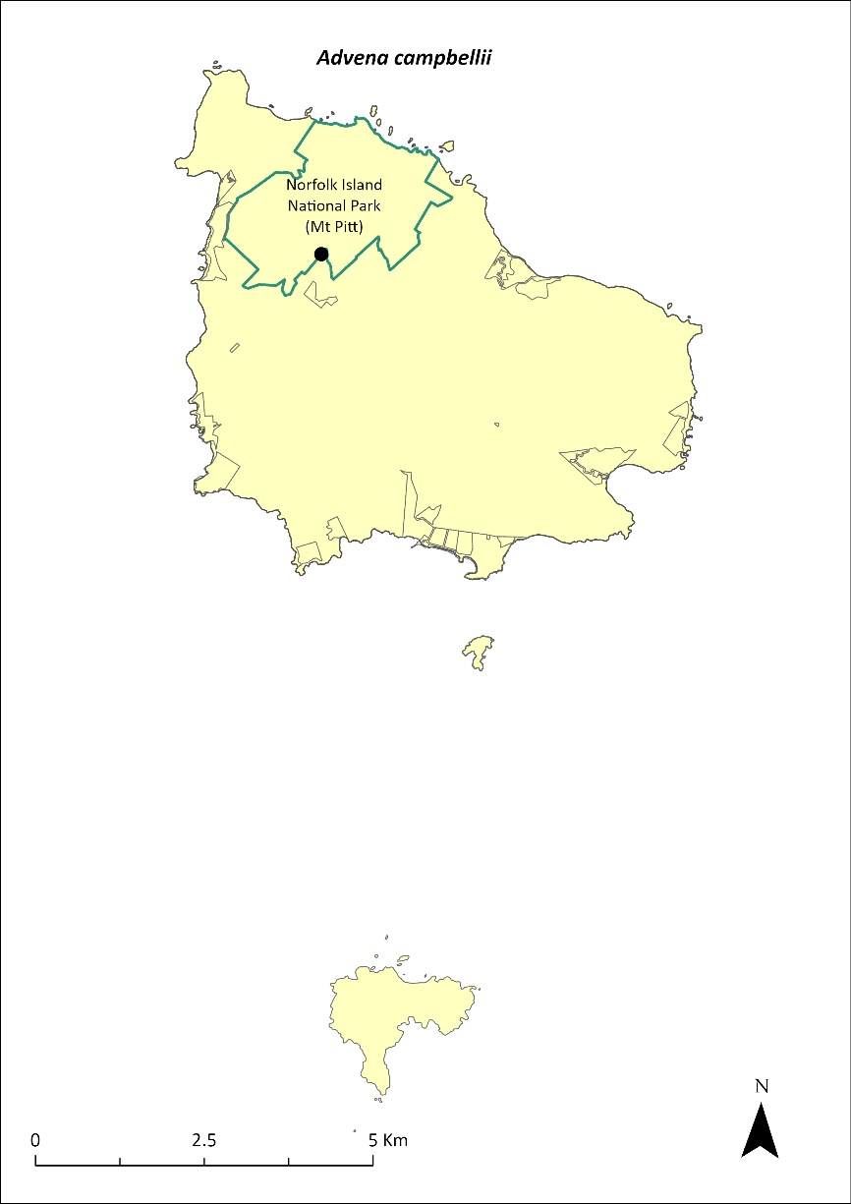
Green outlines indicate reserves within which the species occurs. Points show recorded locations (Hyman & Kohler 2020).

Impact on other species
None known.

Risk assessment
The risk assessment is shown in Table 36.
Table 36 Risk assessment for Advena campbellii
Risk | Likelihood of exposure | Consequence | Threat rating
1. Loss and fragmentation of native vegetation through past land clearing | Almost certain (91–100%) | Major | Extreme
2. Loss and fragmentation of native vegetation through current or future land clearing | Unlikely (11–25%) | Major | Medium
3. Degradation of native vegetation through past grazing or loss of nutrients | Almost certain (91–100%) | Moderate | High
4. Degradation of native vegetation through current or future grazing | Unlikely (11–25%) | Moderate | Low
6. Predation by rodents | Almost certain (91–100%) | Extreme | Extreme
7. Predation by cats | Rare (0–10%) | Negligible | Negligible
8. Predation or damage by chickens | Likely (51–90%) | Major | High
9. Predation by swamphens | Rare (0–10%) | Negligible | Negligible
10. Predation by Argentine ant | Rare (0–10%) | Negligible | Negligible
11. Competition from/change of habitat because of weed invasion | Possible (26–50%) | Minor | Low
12. Infection by pathogens already present | Unlikely (11–25%) | Minor | Low
13. Impacts of potential new invasive species or pathogens | Unlikely (11–25%) | Moderate | Low
14. Changes to vegetation, increased fire risk and/or direct physiological stress as a result of climatic changes | Likely (51–90%) | Moderate | Medium
15. Problems caused by small populations, including lack of genetic diversity | Likely (51–90%) | Moderate | Medium

Management actions
Restore native vegetation, control introduced weeds and feral animals (primarily rodents and chickens). Reduce predation pressure by targeting control of rodents in areas where there are known snail populations. Remove weeds (especially red guava) from important areas for snails to restore suitable pH and moisture levels. Conduct further surveys to determine the full extent of existing populations.
Continue the captive breeding program at Taronga Zoo and return the species to appropriate managed sites on Norfolk Island (ensuring exclusion of rodents and chickens).

Recovery target
The recovery target is shown in Table 37.
Table 37 Recovery target for Advena campbellii
EPBC Act status | Estimated population (2023) | Where known populations occur | 2034 target
Critically Endangered | 500 (3 populations) | 90% in national park  10% outside the park and reserves | At least three viable populations maintained on Norfolk Island

Relevant literature
DEWHA (Department of the Environment, Water, Heritage and the Arts) (2008a) Approved Conservation Advice for Advena campbellii campbellii. Department of the Environment, Water, Heritage and the Arts, Canberra.
Hyman I & Köhler F (2020) Report on survey of land snails on Norfolk Island. Australian Museum, Sydney.
Hyman I (2005) Taxonomy, systematic, and evolutionary trends in Helicarionida (Mollusca, Pulmonata). PhD Thesis, University of Sydney.
Hyman IT, Caiza J & Köhler F (2023) Systematic revision of the microcystid land snails endemic to Norfolk Island (Gastropoda: Stylommatophora) based on comparative morpho-anatomy and mitochondrial phylogenetics. Invertebrate Systematics 37(5–6), 334–443.
Iredale T (1945) The land mollusca of Norfolk Island. Australian Zoologist 11, 46–71.
IUCN (2020) 2020 IUCN Red List of Threatened Species. Accessed 23 January 2024.
Neuweger D, White P & Ponder WF (2001) Land snails from Norfolk Island sites. Records of the Australian Museum Supplement 27, 115–122.
Ponder WF (1997) Conservation status, threats and habitat requirements of Australian terrestrial and freshwater mollusca. Memoirs of the Museum of Victoria 56, 421–430.
Smith BJ (1992) Non-marine Mollusca, in WWK Houston (ed) Zoological Catalogue of Australia Volume 8. Australian Government Publishing Service, Canberra.
Varman RVJP (1991) Conchological Survey 1983-90: Manuscript of Land Mollusca Fossiliferous and Present Day. Unpublished manuscript.

Advena grayi—Gray’s glass-snail

Conservation significance
Endemic to the Norfolk Island Group.
EPBC Act Listing Status: Critically Endangered (listed as Mathewsoconcha grayi ms).
Approved Conservation Advice: 19/12/2008 (DEWHA 2008b).

Description
This species has a similar shell to Advena suteri but the spire is slightly higher and the shell distinctly larger and more inflated. Typical specimen is 15 mm in diameter and 11 mm in height (Hyman 2005). There is no peripheral band.

Distribution
Fossils of this species were found on Nepean Island, and it was common in sub-fossil deposits on Norfolk Island but was not located in native forests during surveys between 1983 and 1990 (Varman 1991). The only previous non-fossil material for this species came from two specimens collected on Phillip Island in 1982 (TSSC 2009b).
The species was thought to be extinct on both Norfolk Island and Phillip Island but was recently rediscovered surviving in flax on slopes on Phillip Island. Based on a survey in March 2023, the estimated (conservative approximated) population size is 5,000, with one population over an area of 0.93ha. The population may be very weather dependant and go through boom-and-bust cycles.
The distribution is shown in Map 14.

Ecology
Live-bearing.

Habitat
Litter and woodland (Smith 1992).

Threats
Major threats include habitat loss, fragmentation and degradation by land clearing and stock grazing, as well as the introduction of feral animals (notably rats) and invasive weeds. Predation by rodents and feral chickens remains a significant threat. Drying conditions and lower soil moisture balances due to climate change are also a threat.

Impact on other species
None known.
Map 14 Distribution of Advena grayi
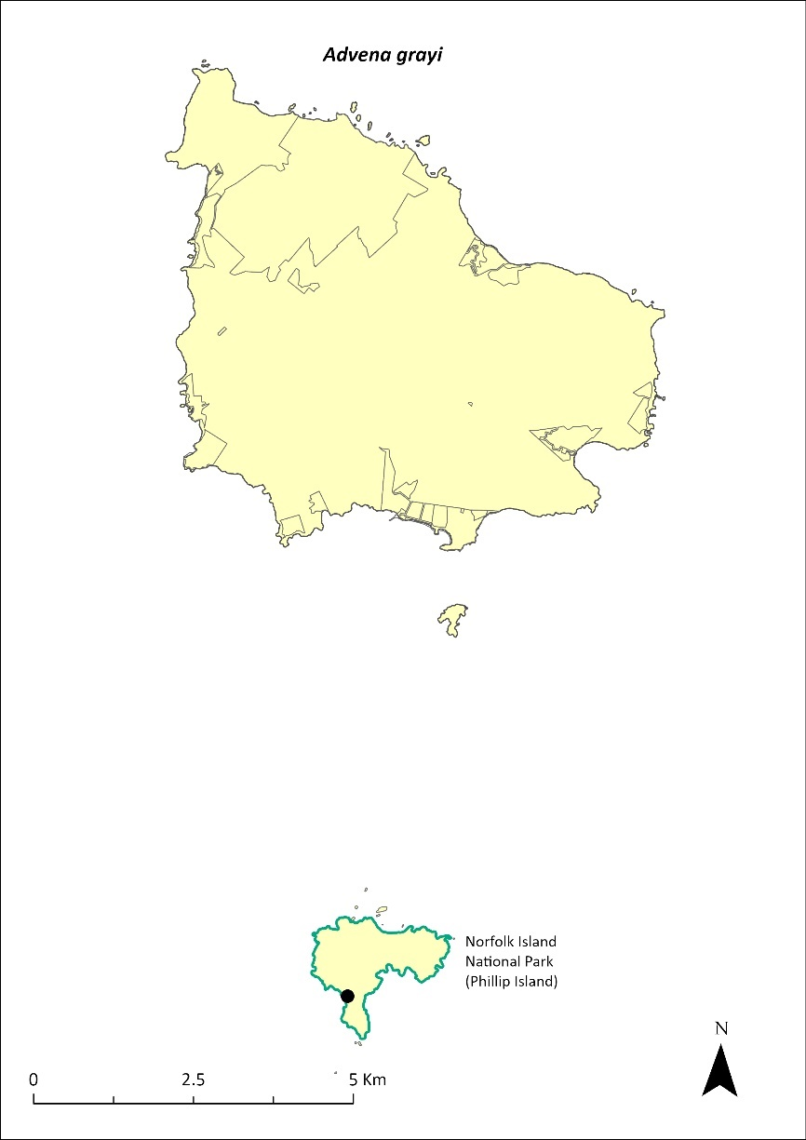
Green outlines indicate reserves within which the species occurs. Points show recorded locations (Tweed 2023).

Risk assessment
The risk assessment is shown in Table 38.
Table 38 Risk assessment for Advena grayi
Risk | Likelihood of exposure | Consequence | Threat rating
1. Loss and fragmentation of native vegetation through past land clearing | Almost certain (91–100%) | Major | Extreme
2. Loss and fragmentation of native vegetation through current or future land clearing | Unlikely (11–25%) | Major | Medium
3. Degradation of native vegetation through past grazing or loss of nutrients | Almost certain (91–100%) | Moderate | High
4. Degradation of native vegetation through current or future grazing | Unlikely (11–25%) | Moderate | Low
6. Predation by rodents | Rare (0–10%) | Extreme | Medium
7. Predation by cats | Rare (0–10%) | Negligible | Negligible
8. Predation or damage by chickens | Rare (0–10%) | Major | Low
9. Predation by swamphens | Rare (0–10%) | Negligible | Negligible
10. Predation by Argentine ant | Rare (0–10%) | Negligible | Negligible
11. Competition from/change of habitat because of weed invasion | Almost certain (91–100%) | Minor | Medium
12. Infection by pathogens already present | Unlikely (11–25%) | Minor | Low
13. Impacts of potential new invasive species or pathogens | Unlikely (11–25%) | Moderate | Low
14. Changes to vegetation, increased fire risk and/or direct physiological stress as a result of climatic changes | Likely (51–90%) | Moderate | Medium
15. Problems caused by small populations, including lack of genetic diversity | Possible (26–50%) | Moderate | Medium

Management actions
Restore native forest habitat, control introduced weeds and predators (rodents, chickens), survey to determine the extent of existing populations and consider captive breeding.

Recovery target
The recovery target is shown in Table 39.
Table 39 Recovery target for Advena grayi
EPBC Act status | Estimated population (2023) | Where known populations occur | 2034 target
Critically Endangered | 5,000 (1 population) | 100% within the national park | At least one large population on Phillip Island

Relevant literature
DEWHA (Department of the Environment, Water, Heritage and the Arts) (2008b) Approved Conservation Advice for Mathewsoconcha grayi ms (a snail). Department of the Environment, Water, Heritage and the Arts, Canberra.
Hyman I (2005) Taxonomy, systematic, and evolutionary trends in Helicarionida (Mollusca, Pulmonata). PhD Thesis, University of Sydney.
Hyman IT, Caiza J & Köhler F (2023) Systematic revision of the microcystid land snails endemic to Norfolk Island (Gastropoda: Stylommatophora) based on comparative morpho-anatomy and mitochondrial phylogenetics. Invertebrate Systematics 37(5–6), 334–443.
Smith BJ (1992) Non-marine Mollusca, in WWK Houston (ed) Zoological Catalogue of Australia Volume 8. Australian Government Publishing Service, Canberra.
TSSC (Threatened Species Scientific Committee) (2009b) Commonwealth Listing Advice on Mathewsoconcha grayi ms. Department of the Environment, Water, Heritage and the Arts, Canberra.
Tweed J (2023) Phillip Island Survey March 2023. Unpublished data.
Varman RVJP (1991) Conchological Survey 1983-90: Manuscript of Land Mollusca Fossiliferous and Present Day. Unpublished manuscript.

Advena phillipii—Phillip Island glass-snail

Conservation significance
Endemic to the Norfolk Island Group.
EPBC Act Listing Status: Critically Endangered (listed as Mathewsoconcha phillipii).
Approved Conservation Advice: 19/12/2008 (DEWHA 2008c).

Description
Very similar to Advena grayi but has a slightly larger shell, the spire is shorter and there is a white narrow peripheral band. Typical specimen is 16 mm in diameter and 12 mm in height (Hyman 2005).

Distribution
This species is known from non-fossil material only from two official specimens collected from Phillip Island in 1908 (TSSC 2009c). Fossils of this species were collected from the Cemetery Bay area of Norfolk Island (Varman 1991). It is likely extinct on Norfolk Island and restricted to Phillip Island where, because of the previous destruction of the vegetation by rabbits, it is unlikely to be anything other than very rare.

Ecology
Live-bearing.

Habitat
Saxicoline, under rocks (Smith 1992).

Threats
Major threats include habitat loss, fragmentation and degradation by land clearing and stock grazing, as well as the introduction of feral animals (notably rats) and invasive weeds. Drying conditions and lower soil moisture balances due to climate change remain a threat to endemic snails in the Norfolk Island Group.

Impact on other species
None known.

Risk assessment
Not undertaken as species is presumed extinct.

Management actions
Restore native forest habitat, control introduced weeds and predators (chickens, rodents), survey to determine the presence of any existing populations and if found to be extant, consider captive breeding.

Recovery target
Not applicable as species is presumed extinct.

Relevant literature
DEWHA (Department of the Environment, Water, Heritage and the Arts) (2008c) Approved Conservation Advice for Mathewsoconcha phillipii (Phillip Island Helicarinoid Snail). Department of the Environment, Water, Heritage and the Arts, Canberra.
Hyman I (2005) Taxonomy, systematic, and evolutionary trends in Helicarionida (Mollusca, Pulmonata). PhD Thesis, University of Sydney.
Hyman IT, Caiza J & Köhler F (2023) Systematic revision of the microcystid land snails endemic to Norfolk Island (Gastropoda: Stylommatophora) based on comparative morpho-anatomy and mitochondrial phylogenetics. Invertebrate Systematics 37(5–6), 334–443.
Iredale T (1945) The land mollusca of Norfolk Island. Australian Zoologist 11, 46–71.
Ponder WF (1997) Conservation status, threats and habitat requirements of Australian terrestrial and freshwater mollusca. Memoirs of the Museum of Victoria 56, 421–430.
Smith BJ (1992) Non-marine Mollusca, in WWK Houston (ed) Zoological Catalogue of Australia Volume 8. Australian Government Publishing Service, Canberra.
TSSC (Threatened Species Scientific Committee) (2009c) Commonwealth Listing Advice on Mathewsoconcha phillipii. Department of the Environment, Water, Heritage and the Arts, Canberra.
Varman RVJP (1991) Conchological Survey 1983-90: Manuscript of Land Mollusca Fossiliferous and Present Day. Unpublished manuscript.

Advena stoddartii—Stoddart’s glass-snail

Conservation significance
Endemic to the Norfolk Island Group.
EPBC Act Listing Status: Critically Endangered (listed as Quintalia stoddartii).
Non-statutory Listing Status: Listed as Extinct on the IUCN Red List (IUCN 2020).
Approved Conservation Advice: 19/12/2008 (DEWHA 2008e).

Description
The species has an imperforate, depressed conical shell with dimensions of at least 14mm diameter and 8mm height.

Distribution
Early records and sub-fossil material suggest this species once occurred on all three islands. In the early 1900s this species made up as much as 9% of total snail specimens collected on Norfolk Island. However, recent surveys have failed to locate this species; it was last collected at Ball Bay and Duncombe Bay in 1945, and is likely extinct on Norfolk Island.
No museum-held specimens from Phillip Island exist apart from the type material that was collected in 1834 (Hyman 2005). A specimen that is currently held in a private collection was collected from Phillip Island in the 1990s, indicating that this species may have survived. While no specimens were found in a single recent targeted survey, the lack of sampling from Phillip Island provides hope that it may still be extant there.

Ecology
Live-bearing.

Habitat
Saxicoline, under rocks (Smith 1992).

Threats
Major threats include habitat loss, fragmentation and degradation by land clearing and stock grazing, as well as the introduction of feral animals (notably rats) and invasive weeds. Drying conditions and lower soil moisture balances due to climate change remain a threat to endemic snails in the Norfolk Island Group.

Impact on other species
None known.

Risk assessment
Not undertaken as species is presumed extinct.

Management actions
Restore native forest habitat, control introduced weeds and predators (chickens, rodents), survey to determine the presence of any existing populations and if found to be extant, consider captive breeding.

Recovery target
Not applicable as species is presumed extinct.

Relevant literature
DEWHA (Department of the Environment, Water, Heritage and the Arts) (2008e) Approved Conservation Advice for Quintalia stoddartii (Stoddart's Helicarionid Land Snail). Department of the Environment, Water, Heritage and the Arts, Canberra.
Hyman I (2005) Taxonomy, systematic, and evolutionary trends in Helicarionida (Mollusca, Pulmonata). PhD Thesis, University of Sydney.
Hyman IT, Caiza J & Köhler F (2023) Systematic revision of the microcystid land snails endemic to Norfolk Island (Gastropoda: Stylommatophora) based on comparative morpho-anatomy and mitochondrial phylogenetics. Invertebrate Systematics 37(5–6), 334–443.
Iredale T (1945) The land mollusca of Norfolk Island. Australian Zoologist 11, 46–71.
IUCN (2020) 2020 IUCN Red List of Threatened Species. Accessed 24 January 2024.
Ponder WF (1997) Conservation status, threats and habitat requirements of Australian terrestrial and freshwater mollusca. Memoirs of the Museum of Victoria 56, 421–430.
Smith BJ (1992) Non-marine Mollusca, in WWK Houston (ed) Zoological Catalogue of Australia Volume 8. Australian Government Publishing Service, Canberra.
TSSC (Threatened Species Scientific Committee) (2009e) Commonwealth Listing Advice on Quintalia stoddartii. Department of the Environment, Water, Heritage and the Arts, Canberra.

Advena suteri—Suter’s striped glass-snail

Conservation significance
Endemic to the Norfolk Island Group.
EPBC Act Listing Status: Critically Endangered (listed as Mathewsoconcha suteri).
Approved Conservation Advice: 19/12/2008 (DEWHA 2008d).

Description
Suter’s striped glass-snail (Advena suteri) has an orange-brown to fawn shell with a narrow white peripheral band, a depressed spire, and is 9 to 10 mm in diameter and 6 to 6.5 mm high.

Distribution
Archaeological deposits suggest this species was once common but by 1914 it was considered rare (Iredale 1945; Varman 1991). More recent records suggested it was restricted to isolated localities including Norfolk Island National Park in the area around Mt Pitt and Hundred Acres Reserve (TSSC 2009d). By the late 1990s it had appeared to be extinct in the national park (Varman 2015, 2016).
In March 2020, Suter’s striped glass-snail was observed in Hundred Acre Reserve where more than 50 freshly dead shells were observed, but in a period of approximately 6 person-hours of searching, only a single live specimen was found. None of the dead shells were rodent-predated, but the whole area was extremely dry and it is likely that there had been a recent high mortality rate linked to the dry weather (Hyman and Kohler 2020). In May 2021, after more favourable weather, approximately 18 person-hours of searching revealed 52 live specimens, indicating that the population was recovering from the dry period. Based on 2022 surveys, the population size has now grown to 350 individuals over an area of 0.7ha.
The distribution is shown in Map 15.

Ecology
Live-bearing.

Habitat
Litter and woodland (Smith 1992), living under logs.

Threats
Major threats include habitat loss, fragmentation and degradation by land clearing and stock grazing, as well as the introduction of feral animals (notably rats) and invasive weeds. Drying conditions and lower soil moisture balances due to climate change are also a threat.

Impact on other species
None known.
Map 15 Distribution of Advena suteri
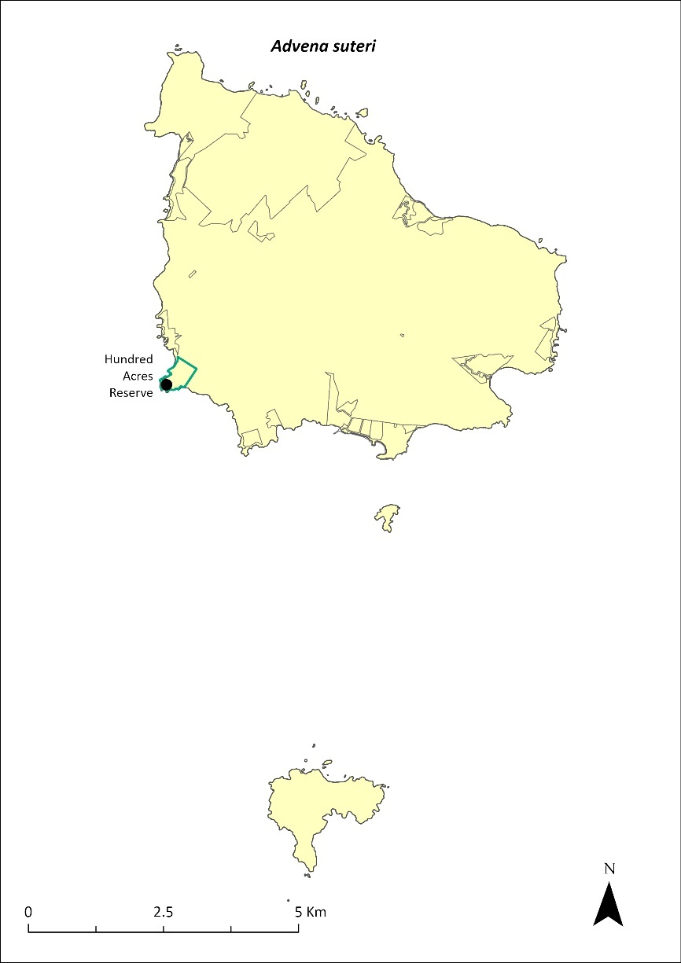
Green outlines indicate reserves within which the species occurs. Points show recorded locations (Hyman & Kohler 2020).

Risk assessment
The risk assessment is shown in Table 40.
Table 40 Risk assessment for Advena suteri
Risk | Likelihood of exposure | Consequence | Threat rating
1. Loss and fragmentation of native vegetation through past land clearing | Almost certain (91–100%) | Major | Extreme
2. Loss and fragmentation of native vegetation through current or future land clearing | Unlikely (11–25%) | Major | Medium
3. Degradation of native vegetation through past grazing or loss of nutrients | Almost certain (91–100%) | Moderate | High
4. Degradation of native vegetation through current or future grazing | Possible (26–50%) | Moderate | Medium
6. Predation by rodents | Likely (51–90%) | Extreme | Extreme
7. Predation by cats | Rare (0–10%) | Negligible | Negligible
8. Predation or damage by chickens | Almost certain (91–100%) | Major | Extreme
9. Predation by swamphens | Rare (0–10%) | Negligible | Negligible
10. Predation by Argentine ant | Rare (0–10%) | Negligible | Negligible
11. Competition from/change of habitat because of weed invasion | Almost certain (91–100%) | Minor | Medium
12. Infection by pathogens already present | Unlikely (11–25%) | Minor | Low
13. Impacts of potential new invasive species or pathogens | Unlikely (11–25%) | Moderate | Low
14. Changes to vegetation, increased fire risk and/or direct physiological stress as a result of climatic changes | Likely (51–90%) | Moderate | Medium
15. Problems caused by small populations, including lack of genetic diversity | Likely (51–90%) | Moderate | Medium

Management actions
Restore native vegetation, control introduced weeds and animals (chickens, rodents). Target control of rodents in areas where there are known snail populations to reduce predation pressure. Remove weeds (especially red guava) from important areas for snails to restore suitable pH and moisture levels. Expansion of suitable native vegetation and experimental addition of woody debris to increase the number of shelter sites for the species. Conduct further surveys to determine the full extent of existing populations.
If warranted, reinitiate captive breeding and return individuals to appropriate managed sites on Norfolk Island (ensuring exclusion of rodents and chickens).

Recovery target
The recovery target is shown in Table 41.
Table 41 Recovery target for Advena suteri
EPBC Act status | Estimated population (2023) | Where known populations occur | 2034 target
Critically Endangered | 350 (1 population) | 100% within public reserves | Current population maintained and at least one additional viable population established on Norfolk Island

Relevant literature
DEWHA (Department of the Environment, Water, Heritage and the Arts) (2008d). Approved Conservation Advice for Mathewsoconcha suteri (a snail). Department of the Environment, Water, Heritage and the Arts, Canberra. Accessed 1 February 2024.
Hyman I (2005) Taxonomy, systematic, and evolutionary trends in Helicarionida (Mollusca, Pulmonata). PhD Thesis, University of Sydney.
Hyman I & Köhler F (2020) Report on survey of land snails on Norfolk Island. Australian Museum, Sydney.
Hyman IT, Caiza J & Köhler F (2023) Systematic revision of the microcystid land snails endemic to Norfolk Island (Gastropoda: Stylommatophora) based on comparative morpho-anatomy and mitochondrial phylogenetics. Invertebrate Systematics 37(5–6), 334–443.
Iredale T (1945) The land mollusca of Norfolk Island. Australian Zoologist 11, 46–71.
Ponder WF (1997) Conservation status, threats and habitat requirements of Australian terrestrial and freshwater mollusca. Memoirs of the Museum of Victoria 56, 421–430.
Smith BJ (1992) Non-marine Mollusca, in WWK Houston (ed) Zoological Catalogue of Australia Volume 8. Australian Government Publishing Service, Canberra.
TSSC (Threatened Species Scientific Committee) (2009d) Commonwealth Listing Advice on Mathewsoconcha suteri. Department of the Environment, Water, Heritage and the Arts, Canberra.
Varman RVJ (2015) Norfolk Island Snail Species Collections made between January and March 2015. Unpublished report.
Varman RVJ (2016) Norfolk Island Snail Species Collections made between January and March 2016. Unpublished report.
Varman RVJP (1991) Conchological Survey 1983-90: Manuscript of Land Mollusca Fossiliferous and Present Day. Unpublished manuscript.

Lamprima aenea—Norfolk Island stag beetle/Norfolk Island Christmas beetle

Conservation significance
Endemic to the Norfolk Island Group.
EPBC Act Listing Status: not listed.
Non-statutory Listing Status: Listed as vulnerable on the IUCN Red List (IUCN 2020).

Description
A large metallic-coloured beetle. Males are typically a bright metallic green with large jaws used for fighting other males and typically measure 26–30 mm long. Females are typically smaller (23–27 mm) and have a bronzish tinge (Reid et al. 2018).

Distribution
Very little is known about the distribution of the Norfolk Island stag beetle (Lamprima aenea). During a recent revision of the genus Lamprima, Reid et al. (2018) reported only 10 specimens amongst the material they examined, only one of which had a specified collection location. However, given the widespread distribution of Lord Howe stag beetle (L. insularis) on Lord Howe Island (Reid et al. 2018), it seems likely that the Norfolk Island stag beetle would have been found across the entirety of Norfolk Island, and possibly on Phillip Island prior to its habitat degradation from the impact of introduced species.
Recent records have all been from within the Mt Pitt section of Norfolk Island National Park, though some unconfirmed records suggest it may also still occur in other areas of the island (J Tweed 2024. pers comm 17 January).

Ecology
Little is known of the specific ecology of the Norfolk Island stag beetle; however, it is assumed that the ecology is like that of its close relative the Lord Howe stag beetle on Lord Howe Island (Reid et al. 2018). The larvae develop in rotting wood infected by white-rot fungi and are unlikely to be reliant on a single host tree species.

Habitat
Native forest. Dependent on dead wood for reproduction.

Threats
Major threats include habitat loss, fragmentation and degradation by land clearing and stock grazing, as well as the introduction of feral animals (notably rats and chickens) and invasive weeds. Elytra (modified forewing) showing evidence of rodent predation have been collected, and remains of other large beetle species are frequently found within rat nests in rotting logs within the national park (J Tweed 2024. pers comm 17 January). Drying conditions and lower soil moisture balances due to climate change are also a threat, particularly in its early developmental stages which rely on moist decaying wood. Poaching is also a serious threat to the species as rare stag beetles are highly prized by collectors.

Impact on other species
None known.

Risk assessment
The risk assessment is shown in Table 42.
Table 42 Risk assessment for Lamprima aenea
Risk | Likelihood of exposure | Consequence | Threat rating
1. Loss and fragmentation of native vegetation through past land clearing | Almost certain (91–100%) | Major | Extreme
2. Loss and fragmentation of native vegetation through current or future land clearing | Possible (26–50%) | Major | High
3. Degradation of native vegetation through past grazing or loss of nutrients | Almost certain (91–100%) | Moderate | Medium
4. Degradation of native vegetation through current or future grazing | Unlikely (11–25%) | Moderate | Low
6. Predation by rodents | Almost certain (91–100%) | Extreme | Extreme
7. Predation by cats | Rare (0–10%) | Negligible | Negligible
8. Predation by chickens | Likely (51–90%) | Moderate | High
9. Predation by swamphens | Rare (0–10%) | Negligible | Negligible
10. Predation by Argentine ant | Possible (26–50%) | Moderate | Medium
11. Competition from/change of habitat because of weed invasion | Possible (26–50%) | Minor | Low
12. Infection by pathogens already present | Unlikely (11–25%) | Minor | Low
13. Impacts of potential new invasive species or pathogens | Unlikely (11–25%) | Minor | Low
14. Changes to vegetation, increased fire risk and/or direct physiological stress as a result of climatic changes | Likely (51–90%) | Major | High
15. Problems caused by small populations, including lack of genetic diversity | Likely (51–90%) | Major | High

Management actions
Restore native vegetation, control introduced weeds and feral animals (rodents, chickens, Argentine ants). Ensure rodent control targets all three known rodent species. Remove and replace red guava and other weeds with native vegetation to provide suitable food plants for larvae. Ensure wind falls and felled trees are left to rot naturally (not burnt or mulched) to provide habitat for reproduction. Conduct further surveys to determine the distribution of the species and improve the understanding of its ecology. Vigilance is required to ensure poachers do not impact the species.

Relevant literature
IUCN (2020) 2020 IUCN Red List of Threatened Species. Accessed 24 January 2024.
Reid AM, Smith K and Beatson M (2018) Revision of the genus Lamprima Latreille, 1804 (Coleoptera: Lucanidae). Zootaxa 4446: 151–202.
Tweed J (2024) Personal communication by email, 17 January. University of Queensland.

Reptiles

Christinus guentheri—Lord Howe Island gecko

Conservation significance
Endemic to the Norfolk Island Group and the Lord Howe Island Group.
EPBC Act Listing Status: Vulnerable.
State Listing Status: Listed as vulnerable under the Biodiversity Conservation Act 2016 (NSW).
Non-statutory Listing Status: Listed as Vulnerable under The Action Plan for Australian Lizards and Snakes 2017 (Chapple et al. 2019).
For further information on the species outside of the Norfolk Island Group, see the species profile on SPRAT.

Distribution
The Lord Howe Island gecko (Christinus guentheri) was described from Norfolk Island and Lord Howe Island in 1885. On the Lord Howe Island complex this species was abundant on the main island until the 1930s, after which it declined dramatically. It is now found only in small numbers in few locations, but it has remained common on some of the other islands of the group, occurring on most vegetated rocky outcrops in the Lord Howe complex.
On the Norfolk Island Group, this species has been found on Nepean and Phillip Islands and on three small rocky islets—Moo-oo Stone, Bird Rock and Green Pool Stone, each about 100 m from the northern cliffs of Norfolk Island. It almost certainly occurs on other rocky islets but it has not been found on the main island and probably became extinct there prior to European settlement (Cogger et al. 2006). Early European reports expressed surprise at the absence of reptiles on the main island; however, remains of this species have been identified on the main island from deposits dating back to 6,500 BP (Cogger et al. 1979).
Cogger et al. (1979) suggested that a conservative estimate for the population on Phillip Island would be 100,000 individuals. The subsequent removal of rabbits and recovery of vegetation on Phillip Island has provided additional suitable habitat for this species. A 2005 survey suggested this species was likely more abundant on Phillip Island than in 1978, with a population estimate of between 99,000 and 176,000 (Cogger et al. 2006). The growth in range and abundance was considered due to revegetation and expanded habitat.
The distribution within the Norfolk Island Group is shown in Map 16.
Map 16 Distribution of Christinus guentheri
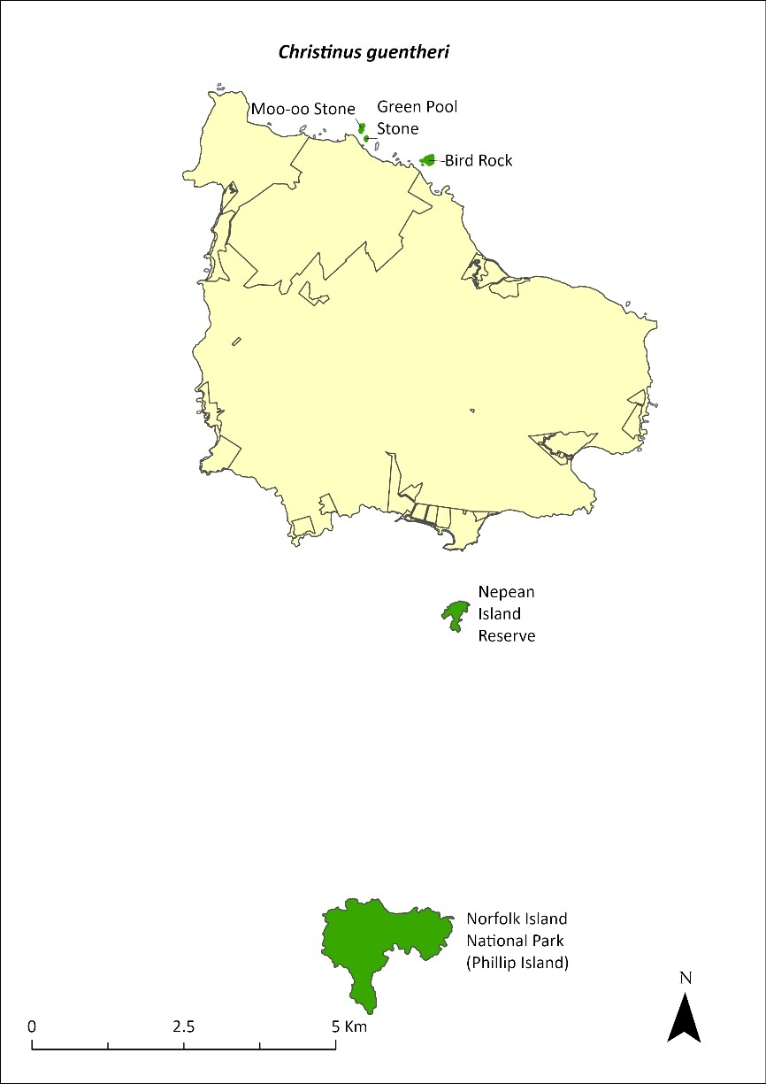
Green shading indicates the islands on which the species has been recorded (Cogger et al. 2006).

Ecology
A nocturnal species that shelters under rocks, in splits in trees, and under man-made shelter during the day. It feeds on beetles, spiders, moths, ants and other insects among the leaf litter; it also hunts in trees and feeds on the nectar of some flowers. It uses rock boulders and rock crevices for shelter and egg-deposition sites. Lays a clutch of 1–3 eggs, and incubation is about 80 to 90 days. Females probably have multiple clutches as gravid females have been reported in November and in March. It forms a significant portion of the prey for the Phillip Island centipede (Cormocephalus coynei; Halpin et al. 2021b), but predation is unlikely to be impacting overall population levels.

Habitat
The species occurs in a range of habitats including primary forest, secondary regrowth forest and lightly grassed or bare rocky islands that are exposed to extreme climatic and physical conditions (Cogger et al. 2006). It has been observed at night on both shrubs and trees but especially on flowering white oak (Lagunaria patersonia) and Phillip Island hibiscus (Hibiscus insularis), where it feeds on the nectar (Cogger et al. 2006). It can also be found on Norfolk Island pine (Araucaria heterophylla) and on the weed species African olive (Olea europaea cuspidata), but it is largely absent from all but the edges of the dense groves of immature olives. Most geckos make only relatively short journeys onto bare ground from the cover of edge vegetation or rock screes.

Threats
The presence of rats and cats on Norfolk Island probably prevents this species from establishing there. The main threats are the introduction of predators (such as rats and cats) or competitors such as the Asian house gecko (Hemidactylus frenatus) to Phillip and Nepean Islands, and degradation and loss of habitat on those islands.

Impact on other species
None known.

Risk assessment
The risk assessment is shown in Table 43.
Table 43 Risk assessment for Christinus guentheri
Risk | Likelihood of exposure | Consequence | Threat rating
1. Loss and fragmentation of native vegetation through past land clearing | Almost certain (91–100%) | Minor | Medium
2. Loss and fragmentation of native vegetation through current or future land clearing | Rare (0–10%) | Negligible | Negligible
3. Degradation of native vegetation through past grazing or loss of nutrients | Almost certain (91–100%) | Negligible | Negligible
4. Degradation of native vegetation through current or future grazing | Rare (0–10%) | Negligible | Negligible
6. Predation by rodents | Rare (0–10%) | Negligible | Negligible
7. Predation by cats | Rare (0–10%) | Minor | Negligible
8. Predation or damage by chickens | Rare (0–10%) | Negligible | Negligible
9. Predation by swamphens | Possible (26–50%) | Negligible | Negligible
10. Predation by Argentine ant | Rare (0–10%) | Major | Low
11. Competition from/change of habitat because of weed invasion | Almost certain (91–100%) | Negligible | Negligible
12. Infection by pathogens already present | Rare (0–10%) | Negligible | Negligible
13. Impacts of potential new invasive species or pathogens ª | Rare (0–10%) | Extreme | Medium
14. Changes to vegetation, increased fire risk and/or direct physiological stress as a result of climatic changes | Almost certain (91–100%) | Minor | Medium
15. Problems caused by small populations, including lack of genetic diversity | Rare (0–10%) | Minor | Negligible
ª Assessment is of risk of potential new species reaching Phillip Island.

Management actions
Continue weed control and habitat restoration work on Phillip Island, particularly removal of African olive and re-establishing stands of white oak; and establish effective quarantine protocols for Phillip Island. If rats and cats can be controlled on Norfolk Island, it may be possible to re-establish a population there. Develop captive breeding protocols for the species so that the necessary procedures are in place if a translocation to another island is required in the future. Identify other islands where the Norfolk Island reptiles could be translocated to provide an insurance population.

The Lord Howe Island Biodiversity Management Plan covers the recovery needs of this species across its range outside of Norfolk Island. Possible future actions (such as captive breeding and translocation) may need to be undertaken in collaboration with the NSW Government as appropriate.

Recovery target
The recovery target is shown in Table 44.
Table 44 Recovery target for Christinus guentheri
EPBC Act status | Estimated population (2023) | Where known populations occur | 2034 target
Vulnerable | 176,000 | 93% in the national park  5% in public reserves  2% in other lands | Maintained numbers and range

Relevant literature
Chapple D, Tingley R, Mitchell N, Macdonald S, Keogh JS, Shea G, Bowles P, Cox N & Woinarski J (2019) The Action Plan for Australian Lizards and Snakes 2017. CSIRO Publishing, Melbourne.
Cogger HG, Cameron EE & Sadlier RA (1979) The terrestrial reptiles of islands in the Norfolk Island complex. Unpublished report to the Australian National Parks and Wildlife Service, Canberra.
Cogger HG, Muir G & Shea G (2006) A survey of the terrestrial reptiles of Norfolk Island March 2005: Report 4. Assessment of the suitability of potential gecko re-introduction sites on Norfolk’s main island and a review of threatening processes and recovery actions proposed in the draft Recovery Plan. Unpublished report to the Department of the Environment and Heritage, Canberra.
Halpin LR, Terrington DI, Jones HP, Mott R, Wong WW, Dow DC, Carlile N & Clarke RH (2021) Arthropod predation of vertebrates structures trophic dynamics in island ecosystems. The American Naturalist 198(4), 540–550.

Oligosoma lichenigerum—Lord Howe Island skink

Conservation significance
Endemic to the Norfolk Island Group and the Lord Howe Island Group.
EPBC Act Listing Status: Vulnerable
State Listing Status: Listed as Vulnerable under the Biodiversity Conservation Act 2016 (NSW).
Non-statutory Listing Status: Listed as Vulnerable under The Action Plan for Australian Lizards and Snakes 2017 (Chapple et al. 2019)
For further information on the species outside of the Norfolk Island Group, see the species profile on SPRAT.

Distribution
The Lord Howe Island skink (Oligosoma lichenigerum) was described in 1874 from Lord Howe Island and was first recorded on the Norfolk Island complex in 1978 (Cogger et al. 1993). On the Lord Howe Island Group this species is as widely distributed as the Lord Howe Island gecko (Christinus guentheri).
On the Norfolk Island Group this species has only been found on Phillip Island, despite considerable search effort on Nepean Island and on many of the small rocky islets (Cogger et al. 1979). The species is not as abundant as the Lord Howe Island gecko; for example, 10 specimens were encountered on Fisherman’s Hut Rock on Phillip Island in 1979, during which time 285 geckos were also found (Cogger et al. 1979).
The population on Phillip Island is estimated to be large and secure, and the increase in suitable habitat since the removal of rabbits in 1986 suggests that they were at least as abundant in 2005 as they were in 1978 (Cogger et al. 2006). The distribution of the species is shown in Map 17.

Ecology
Knowledge of the biology, ecology and conservation status of this species is fragmentary and based on few individual records. It is a nocturnal species that shelters under rocks, in splits in trees, and in holes in rocks during the day. It feeds on beetles, spiders, moths, ants and other insects among the leaf litter.

Habitat
This species ranges across a variety of habitats from bare cliffs and eroded slopes to the narrow and heavily wooded gullies of Long Valley (Cogger et al. 1993). Greater densities of skinks occur where the vegetation has formed dense root mats in which they could hide and forage, sometimes of grasses but especially of Moo-oo (Cyperus lucidus) and native flax (Phormium tenax).
Map 17 Distribution of Oligosoma lichenigerum
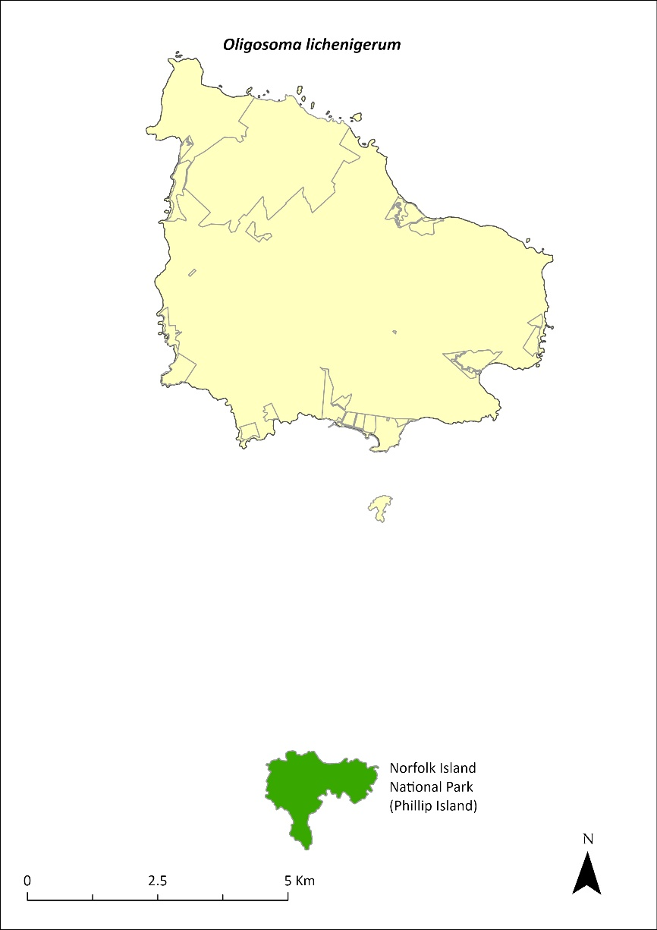
Green shading indicates the islands on which the species has been recorded (Cogger et al. 2006).

Threats
The presence of rats and cats on Norfolk Island probably prevents this species from establishing there. The main threats are the introduction of predators (such as rats and cats) or potential competitors to Phillip Island, and degradation and loss of habitat on the island. Drying conditions and lower soil moisture balances due to climate change are also a threat.

Impact on other species
None known.

Risk assessment
The risk assessment is shown in Table 45.
Table 45 Risk assessment for Oligosoma lichenigerum
Risk | Likelihood of exposure | Consequence | Threat rating
1. Loss and fragmentation of native vegetation through past land clearing | Almost certain (91–100%) | Moderate | High
2. Loss and fragmentation of native vegetation through current or future land clearing | Rare (0–10%) | Moderate | Negligible
3. Degradation of native vegetation through past grazing or loss of nutrients | Almost certain (91–100%) | Moderate | High
4. Degradation of native vegetation through current or future grazing | Rare (0–10%) | Moderate | Negligible
6. Predation by rodents | Rare (0–10%) | Negligible | Negligible
7. Predation by cats | Rare (0–10%) | Minor | Negligible
8. Predation or damage by chickens | Rare (0–10%) | Negligible | Negligible
9. Predation by swamphens | Possible (26–50%) | Negligible | Negligible
10. Predation by Argentine ant | Rare (0–10%) | Major | Low
11. Competition from/change of habitat because of weed invasion | Almost certain (91–100%) | Negligible | Negligible
12. Infection by pathogens already present | Rare (0–10%) | Negligible | Negligible
13. Impacts of potential new invasive species or pathogens ª | Rare (0–10%) | Extreme | Medium
14. Changes to vegetation, increased fire risk and/or direct physiological stress as a result of climatic changes | Almost certain (91–100%) | Major | Extreme
15. Problems caused by small populations, including lack of genetic diversity | Possible (26–50%) | Moderate | Medium
ª Assessment is of risk of potential new species reaching Phillip Island.

Management actions
Continue weed control and habitat restoration work on Phillip Island, and establish effective quarantine protocols. If rats and cats can be controlled on Norfolk Island, it may be possible to establish a population there. Develop captive breeding protocols for the species so that the necessary procedures are in place if a translocation to another island is required in the future. Identify other islands where the Norfolk Island reptiles could be translocated to provide an insurance population.

The Lord Howe Island Biodiversity Management Plan covers the recovery needs of this species across its range outside of Norfolk Island. Possible future actions (such as captive breeding and translocation) may need to be undertaken in collaboration with the NSW Government as appropriate.

Recovery target
The recovery target is shown in Table 46.
Table 46 Recovery target for Oligosoma lichenigerum
EPBC Act status | Estimated population (2023) | Where known populations occur | 2034 target
Vulnerable | 7,000 | 100% within the national park | Increase in area of occupancy by at least 10%

Relevant literature
Chapple D, Tingley R, Mitchell N, Macdonald S, Keogh JS, Shea G, Bowles P, Cox N & Woinarski J (2019) The Action Plan for Australian Lizards and Snakes 2017. CSIRO Publishing, Melbourne.
Cogger HG, Cameron EE & Sadlier RA (1979) The terrestrial reptiles of islands in the Norfolk Island complex. Unpublished report to the Australian National Parks and Wildlife Service, Canberra.
Cogger HG, Cameron EE, Sadlier RA & Eggler P (1993) The Action Plan for Australian Reptiles. Australian Nature Conservation Agency, Canberra.
Cogger HG, Muir G & Shea G (2006) A survey of the terrestrial reptiles of Norfolk Island March 2005: Report 4. Assessment of the suitability of potential gecko re-introduction sites on Norfolk’s main island and a review of threatening processes and recovery actions proposed in the draft Recovery Plan. Unpublished report to the Department of the Environment and Heritage, Canberra.

Land birds

Cyanoramphus cookii—Norfolk Island green parrot

Conservation significance
Endemic to Norfolk Island.
EPBC Act Listing Status: Endangered.
Non-statutory Listing Status: Described as Critically Endangered in the Action Plan for Australian Birds 2020 (Garnett & Baker 2021).
Approved Conservation Advice: 15/07/2016 (TSSC 2016a).

Distribution and abundance
The Norfolk Island green parrot was a common forest bird when Norfolk Island was discovered in the late 1700s; however, by the late 1970s, fewer than 50 individuals remained and the population was restricted to the national park (Schodde et al. 1983; Hermes et al. 1986; Hill 2002).
In 1983, the Government Conservator commenced a captive breeding program, which was followed by sustained rat and cat control as well as artificial nest construction (Hicks & Greenwood 1989). Over 15 years, between 1987 and 2002, approximately 250 chicks fledged successfully, and sightings became common. However, following a period of no active management between 2007 and 2013, a survey indicated the population had declined to between 42 and 96 individuals, of which only 10 were confirmed adult females (Ortiz-Catedral 2013). As a result of renewed efforts to provide rat- and cat-proof nests and intensify control of rats and cats, nest success increased substantially (Ortiz-Catedral et al. 2018) and the population increased to an estimated 438 (SE ± 168) in 2017 (Skirrow 2019). However, it should be noted that there are large confidence intervals around this estimate, and while there certainly appears to have been population growth, the rate of increase and current population size are not clear (Macgregor et al. 2021).
The Mt Pitt section of Norfolk Island National Park remains a stronghold for the species, but there is growing anecdotal evidence that its range has increased substantially, and Norfolk Island green parrots are now regularly seen in areas well outside of the national park boundary.
The distribution is shown in Map 18.
Map 18 Distribution of Cyanoramphus cookii
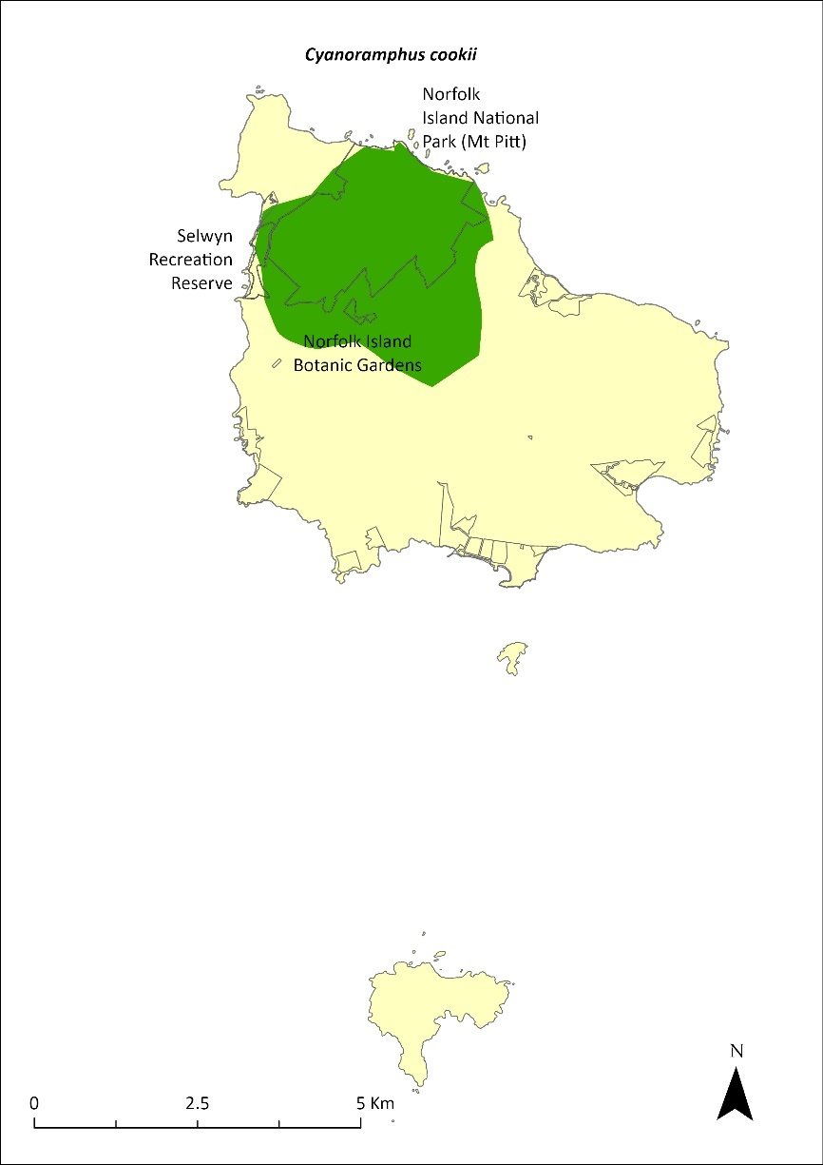
The stronghold for the Norfolk Island green parrot is within the shaded area; however, its range extends across Norfolk Island (Director of National Parks 2010, NIRC 2020).

Ecology
Breeds in all months of the year. Hicks and Greenwood (1990) reported a peak between December to March; more recent data from 2013–20 indicate a peak from January to June (Director of National Parks unpublished). Average clutch size is six eggs (1–8; Hicks & Greenwood 1989; Director of National Parks unpublished), and individual pairs can successfully fledge young up to four times in a single year (Hill 2002). Similar to other Cyanoramphus species, females incubate the eggs and undertake most of the chick feeding, while males provide food for nesting females (Greene 2003; Ortiz-Catedral et al. 2009).
Nests in hollows of living trees often within two metres of the ground or at ground level among tree roots. Adults return to the same nest site each season but will also use other sites within their territory.
Diet is a variety of seeds, fruits, flowers, pollen, sori, sprout rhizomes and bark, taken from at least 30 native and introduced plant species.
Active foraging is mostly at heights of 2–7 metres, although the parrots also feed on the ground, especially in winter (Waldman 2016). They have some overlapping dietary preferences with the crimson rosella, although there are seasonal differences (Simmonds 2019).

Habitat
The breeding range is thought to be largely restricted to the Mt Pitt section of the national park, though successful nesting has been recorded outside the park (D Gautschi 2024. pers comm 12 January). The species forages in the park and adjacent forested areas and orchards.

Threats
The main factors responsible for the decline of the species were clearance of vegetation for agriculture, particularly trees with suitable nesting hollows, and predation from introduced predators. Change in forest structure due to weed invasion is likely to also have reduced the area of suitable habitat available to the species (Garnett et al. 2011; TSSC 2016a). Predation of eggs and chicks by rats and cats, a shortage of suitable predator-free nest sites, and nest hollow competition from introduced crimson rosellas (which have a population three times that of the Norfolk Island green parrot (TSSC 2016a; Skirrow 2019)) are the main factors limiting population recovery (Macgregor et al. 2021), while disease may be a significant cause of mortality in certain circumstances (Hill 2002). The purple swamphen, a self-introduced species that arrived on the Norfolk Island Group before 1888, may prevent re-establishment on Phillip Island (Heinsohn 2019).

Impact on other species
None known.

Risk assessment
The risk assessment is shown in Table 47.
Table 47 Risk assessment for Cyanoramphus cookii
Risk | Likelihood of exposure | Consequence | Threat rating
1. Loss and fragmentation of native vegetation through past land clearing | Almost certain (91–100%) | Moderate | High
2. Loss and fragmentation of native vegetation through current or future land clearing | Unlikely (11–25%) | Minor | Low
3. Degradation of native vegetation through past grazing or loss of nutrients | Almost certain (91–100%) | Moderate | High
4. Degradation of native vegetation through current or future grazing | Likely (51–90%) | Minor | Medium
5. Lack of available nest sites | Almost certain (91–100%) | Moderate | High
6. Predation by rodents | Almost certain (91–100%) | Major | Extreme
7. Predation by cats | Almost certain (91–100%) | Major | Extreme
8. Predation or damage by chickens | Rare (0–10%) | Negligible | Negligible
9. Predation by swamphens | Rare (0–10%) | Moderate | Negligible
10. Predation by Argentine ant | Likely (51–90%) | Moderate | Medium
11. Competition from/change of habitat because of weed invasion | Possible (26–50%) | Negligible | Negligible
12. Infection by pathogens already present | Likely (51–90%) | Moderate | Medium
13. Impacts of potential new invasive species or pathogens | Possible (26–50%) | Moderate | Medium
14. Changes to vegetation, increased fire risk and/or direct physiological stress as a result of climatic changes | Likely (51–90%) | Major | High
15. Problems caused by small populations, including lack of genetic diversity | Almost certain (91–100%) | Moderate | High

Management actions
Control predators and competitors, particularly feral cats, black rats and rosellas (TSSC 2016). Implement targeted control of cats and rats to reduce predation on the Norfolk Island green parrot. Provide and maintain suitable rat proof nest sites, and optimise the number, placement and spatial configuration of these nest sites, particularly outside the national park (TSSC 2016). Continue weed control and forest rehabilitation work (particularly Nestegis dominant forest) and protect old hollow-bearing trees (TSSC 2016). Control purple swamphens on Phillip Island to facilitate re-establishment of Norfolk Island green parrots. Develop approaches to help the Norfolk Island community manage the species’ impacts on orchards as the population continues to expand beyond the park. Explore options for translocation of the species to other islands to create insurance populations.

Recovery target
The recovery target is shown in Table 48.
Table 48 Recovery target for Cyanoramphus cookii
EPBC Act status | Estimated population (2023) | Where known populations occur | 2034 target
Endangered | 438  (270–606) | 52% in the national park  1% in public reserves  47% in other lands | The population has increased to 1000 individuals, including 150 to 200 breeding pairs, and the breeding range has extended to the south of the island

Relevant literature
Garnett ST & Baker GB (2021) The Action Plan for Australian Birds 2020. CSIRO Publishing, Melbourne.
Garnett ST, Szabo J & Dutson G (2011) The Action Plan for Australian Birds 2010. CSIRO Publishing, Melbourne.
Gautschi D (2024) personal communication by email, 12 January. Australian National University.
Greene TC (2003) Breeding biology of red-crowned parakeets (Cyanoramphus novaezelandiae novaezelandiae) on Little Barrier Island, Hauraki Gulf, New Zealand. Notornis 50, 83–99.
Heinsohn R (2019) Review of the translocation of Norfolk Island Green Parrots from Norfolk Island to Phillip Island. Report to the Director of National Parks, Canberra.
Hermes N, Evans O & Evans B (1986) Norfolk Island birds: a review 1985. Notornis 33, 141–149.
Hicks J & Greenwood D (1990) Rescuing Norfolk Island’s Parrot. Birds International 2, 35–47.
Hicks J & Preece M (1991) Green Parrot. 1991 Recovery Plan. Unpublished report to the Australian National Parks and Wildlife Service.
Hill R (2002) Recovery Plan for the Norfolk Island Green Parrot Cyanoramphus novaeseelandiae cookii. Environment Australia, Canberra.
Macgregor NA, Wilson M, Brown SM, Goumas M, Heinsohn R, Clarke RH, Ortiz-Catedral L, Greenup N, Christian M, Greenwood D, Ward R & Garnett ST (2021) Norfolk Island Green Parrot Cyanoramphus novaezelandiae cookii, in ST Garnett & GB Baker (eds), The Action Plan for Australian Birds 2020. CSIRO Publishing, Melbourne. pp. 432-435.
Ortiz-Catedral L (2013) The Population and Status of Green Parrot (Tasman Parakeet) Cyanoramphus cookii on Norfolk Island. Unpublished report to the Director of National Parks.
Ortiz-Catedral L, Kearvell JC, Hauber ME & Brunton DH (2009) Breeding biology of the critically endangered Malherbe’s parakeet on Maud Island, New Zealand, following the release of captive-bred individuals. Australian Journal of Zoology 57, 433–439.
Ortiz-Catedral L, Nias R, Fitzsimons J, Vine S & Christian M (2018) Back from the brink–again: the decline and recovery of the Norfolk Island green parrot, in S Garnett, P Latch, D Lindenmayer & J Woinarski (eds), Recovering Australian Threatened Species: A Book of Hope. CSIRO Publishing.
Schodde R, Fullagar P & Hermes N (1983) A review of Norfolk Island birds past and present (Special Publication No. 8). Australian National Parks and Wildlife Service, Canberra.
Simmonds SA (2019) Habitat use by Tasman Parakeets (Cyanoramphus cookii) and Crimson Rosellas (Platycercus elegans) on Norfolk Island, South Pacific. MSc Thesis, Massey University, Auckland.
Skirrow MJ (2019) Estimating the population size of two critically endangered South Pacific parakeets: the Tasman Parakeet and Malherbe's Parakeet. MSc Thesis, Massey University, Auckland.
Smithers CN & Disney HJ (1969) The distribution of terrestrial and freshwater birds on Norfolk Island. Australian Zoologist 15, 127–140.
Threatened Species Scientific Committee (TSCC) (2016a) Conservation Advice Cyanoramphus cookii Norfolk Island green parrot. Department of the Environment, Canberra.
Waldmann A (2016) Foraging ecology of the world's only population of the critically endangered Tasman parakeet (Cyanoramphus cookii) on Norfolk Island. MSc Thesis, Massey University, Auckland.

Ninox novaeseelandiae undulata—Norfolk Island morepork

Conservation significance
Endemic to Norfolk Island.
EPBC Act Listing Status: Endangered.
Non-statutory Listing Status: Described as Critically Endangered in the Action Plan for Australian Birds 2020 (Garnett & Baker 2021).
Approved Conservation Advice: 15/07/2016 (TSSC 2016b).

Distribution and abundance
The Norfolk Island morepork (or boobook owl) was first recorded by King in 1788–90. Since 1909 the owl had been recorded as occurring largely in the gullies surrounding Mt Pitt (Smithers & Disney 1969; Olsen et al. 1989). A reasonable population remained in 1912–13 but by 1968 the owl was considered extremely rare and was heard only occasionally (Turner et al. 1968; Smithers & Disney 1969). By 1986 the population had declined to a single female, and the genetically pure form of the species is now extinct (TSSC 2016b).
Two males from the closely related New Zealand subspecies were introduced in 1987. In 1989 the Norfolk female and one of the New Zealand males raised their first chicks. They also produced chicks in 1990 but those were the last chicks produced by the Norfolk female, and she was last recorded in October 1995. There has been subsequent second and third generation breeding with 45 ‘hybrid’ offspring banded up to December 2007. The current population is entirely descended from that single breeding pair: the last female Norfolk Island morepork Ninox n. undulata and one of the introduced males N. n. novaeseelandiae (Olsen et al. 1989).
Successful breeding was observed in every year from 1993 to 2007. Subsequently, a single successful breeding event was observed between 2008 and 2018 (successful breeding in 2011 only). In 2016, there were estimated to be 32 individuals (Wilson 2016); estimates from more recent surveys reported a population of 20–30 (Sperring et al. 2021a). After the establishment of new nest boxes, one nest found in 2019 produced two fledglings, while a single nest found in 2020 (believed to be from the same pair and in a box near the location of the successful nest in 2019) had eggs that did not hatch (Sperring et al. 2021b). Although surveys in 2019–2021 detected just two previously banded birds of the 12 captured, indicating that undetected breeding has occurred at some point, the population possibly consists of ageing birds that are not reproducing at a sufficient rate to maintain the population. In December 2023, a nest with two new chicks was discovered and was being monitored.
The population is now fairly evenly distributed across the entire national park with a higher density on the southern slopes of Mt Pitt and Mt Bates. Tracking data from spring 2019 and 2020 showed that the average territory size for owls living mostly within the national park was 48 hectares while the average size for owls outside of the park was 128 hectares. Territory sizes during winter are similar to those in spring, though one owl tracked during winter, and displaying behaviour suggestive of searching for a mate, ranged over an area of 389 hectares. Because owls occupy small territories in the national park, the population density is much higher there; owls are distributed more sparsely across the rest of the island (Sperring et al. 2021b).
Whilst Norfolk Island moreporks have previously been heard on Phillip Island, they are not currently known to occupy the island (M Wilson 2024. pers comm 12 January). All recent breeding has taken place in Norfolk Island National Park (Sperring 2021a,b).
The distribution is shown in Map 19.
Map 19 Range movements of the Norfolk Island morepork on Norfolk Island
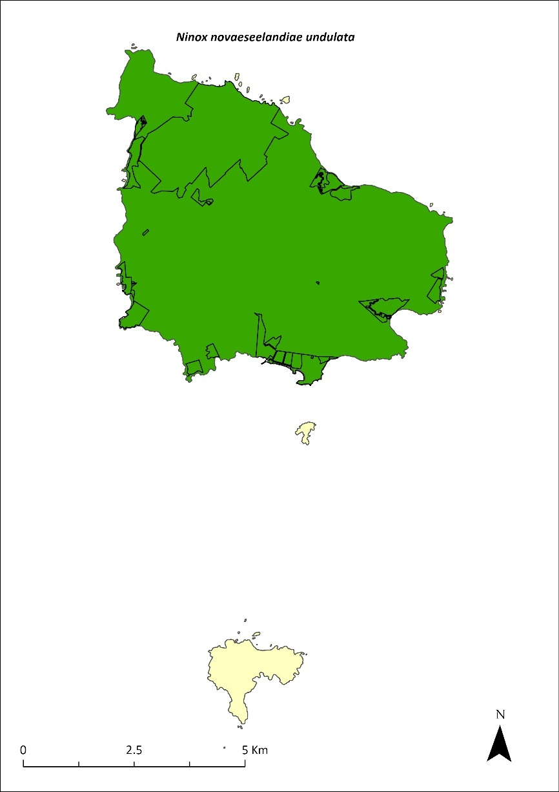
Source: Sperring et al. 2021.

Ecology
Breeds September to January. Clutch size can be up to three eggs, but two eggs per clutch is more common.
Nests in tree hollows. All nests of the hybrid population have been in artificial nest boxes, although breeding is suspected to have occurred in natural hollows.
Feed primarily on insects, in particular orthopterans and coleopterans, as well as rodents, passerines (including the Norfolk Island robin and slender billed white-eye) and white terns (Olsen 1996; Sperring et al. 2001b).

Habitat
Norfolk Island moreporks prefer native woody vegetation, red guava (Psidium cattleyanum) or Eucalyptus plantation to open land and other woody weeds. They also prefer canopy height above 10 m (Sperring, unpublished data), mostly roosting high in the canopy. They are most commonly found in native trees (particularly ironwood and bloodwood) but have also been seen roosting in guava, olive and banana plantations.

Threats
The decline of the Norfolk Island morepork was probably caused by a combination of unrelated environmental, demographic and genetic forces acting on a naturally small population. The main factors were likely to have been: the loss of approximately 30 individuals from the population for a natural history collection in 1913; the loss of suitable habitat and nesting hollows caused by land clearing and selective logging of large trees; and competition for hollows from introduced species such as crimson rosellas and European starlings (TSSC 2016b). Current major threats include inbreeding depression, lack of suitable nesting sites, and competition from introduced species (TSSC 2016b). Low habitat suitability across the island is also likely to reduce the carrying capacity of the island putting pressure on the population to maintain genetic diversity (Sperring et al. 2021a). Secondary poisoning from rodent and chicken baiting is also a threat (likely cause of death of two chicks in 2012 (Debus 2012) and near death of one likely poisoned adult in 2021 (Sperring et al. 2021b). Predation of eggs and chicks by rats, cats and Argentine ants is also a possible threat. Weed invasion by red guava (Psidium cattleyanum), African olive (Olea europaea), wild tobacco (Solanum mauritianum) and lantana (Lantana camara) and the resulting change in forest structure is also likely to affect owls’ ability to hunt (Wilson 2016).

Impact on other species
None known.

Risk assessment
The risk assessment is shown in Table 49.
Table 49 Risk assessment for Ninox novaeseelandiae undulata
Risk | Likelihood of exposure | Consequence | Threat rating
1. Loss and fragmentation of native vegetation through past land clearing | Almost certain (91–100%) | Major | Extreme
2. Loss and fragmentation of native vegetation through current or future land clearing | Almost certain (91–100%) | Major | Extreme
3. Degradation of native vegetation through past grazing or loss of nutrients | Likely (51–90%) | Major | High
4. Degradation of native vegetation through current or future grazing | Likely (51–90%) | Major | High
5. Lack of available nest sites | Possible (26–50%) | Major | High
6. Predation by rodents | Unlikely (11–25%) | Minor | Low
7. Predation by cats | Unlikely (11–25%) | Minor | Low
8. Predation or damage by chickens | Rare (0–10%) | Negligible | Negligible
9. Predation by swamphens | Rare (0–10%) | Negligible | Negligible
10. Predation by Argentine ant | Likely (51–90%) | Minor | Medium
11. Competition from/change of habitat because of weed invasion | Possible (26–50%) | Moderate | Medium
12. Infection by pathogens already present | Rare (0–10%) | Negligible | Negligible
13. Impacts of potential new invasive species or pathogens | Rare (0–10%) | Minor | Negligible
14. Changes to vegetation, increased fire risk and/or direct physiological stress as a result of climatic changes | Likely (51–90%) | Minor | Medium
15. Problems caused by small populations, including lack of genetic diversity | Almost certain (91–100%) | Extreme | Extreme
16. Secondary poisoning | Likely (51–90%) | Moderate | Medium

Management actions
Maintain suitable nest boxes (particularly in appropriate locations) to improve the breeding success of individuals within the population (TSSC 2016b). Restore habitat outside of the national park to increase the carrying capacity of the island and reduce the pressure of maintaining genetic diversity (TSSC 2016b). Protect old hollow bearing trees. Maintain crimson rosella control program to minimise competition for nest boxes (TSSC 2016b). Genetic rescue through the introduction of individuals from New Zealand or Australia may be required in future. Prevention or serious reduction in the use of second-generation rodent and chicken baits outside of the national park is also likely to assist the population.

Recovery target
The recovery target is shown in Table 50.
Table 50 Recovery target for Ninox novaeseelandiae undulata
EPBC Act status | Estimated population (2023) | Where known populations occur | 2034 target
Endangered | 25 (20–40) | 9% in the national park  1% in public reserves  86% in other land | The population size has increased by at least 30% from 2023, breeding is occurring both inside and outside of the national park.

Relevant literature
Debus SJS (2012) Norfolk Island Boobook chick deaths. Boobook 30, 6.
Garnett ST & Baker GB (2021) The Action Plan for Australian Birds 2020. CSIRO Publishing, Melbourne.
Olsen P (1996) Re-establishment of an endangered subspecies: the Norfolk Island Boobook. Bird Conservation International 6, 63–70.
Olsen P (1997) Recovery Plan for the Norfolk Island Boobook Owl Ninox novaeseelandiae undulata. Environment Australia, Canberra.
Olsen PD (1986) Status and conservation of the Norfolk Island Boobook Owl Ninox novaeseelandiae undulata. Unpublished report to the Australian National Parks and Wildlife Service.
Olsen PD, Mooney NJ & Olsen J (1989) Status and conservation of the Norfolk Island Boobook Ninox novaeseelandiae undulata, in BU Meyburg & RD Chancellor (eds), Raptors in the Modern World. WWGBP, Berlin. pp. 123–129.
Schodde R, Fullagar P & Hermes N (1983) A review of Norfolk Island birds past and present (Special Publication No. 8). Australian National Parks and Wildlife Service, Canberra.
Smithers CN & Disney HJ (1969) The distribution of terrestrial and freshwater birds on Norfolk Island. Australian Zoologist 15, 127–140.
Sperring F, Webster W, Isaac B, Clarke R, Gautschi D, Heinsohn R, Olsen P, Weeks A, Macgregor N, Wilson M & Greenup N (2021b) Ecology, genetics, and conservation management of the Norfolk Island morepork and green parrot. Interim report to the NESP Threatened Species Recovery Hub, Brisbane.
Sperring VF, Brown SM, Macgregor NA, Olsen P, Clarke RH, Wilson M, Greenup N, Weeks A, Ward R, Greenwood D, Christian M & Garnett ST (2021a) Norfolk Island Morepork Ninox novaeseelandiae undulata, in ST Garnett & GB Baker (eds), The Action Plan for Australian Birds 2020. CSIRO Publishing, Melbourne. pp. 360-363.
TSSC (Threatened Species Scientific Committee) (2016b). Conservation Advice Ninox novaeseelandiae undulata Norfolk Island boobook owl. Department of the Environment, Canberra.
Turner JS, Smithers CN & Hoogland RD (1968) The Conservation of Norfolk Island. Australian Conservation Foundation, Melbourne.
Wilson M (2016) Owl Survey Report, December 2016. Director of National Parks, Canberra.
Wilson M (2024) personal communication by email, 12 January, Parks Australia (Norfolk Island National Park).

Pachycephala pectoralis xanthroprocta—Norfolk Island golden whistler (tamey)

Conservation significance
Endemic to Norfolk Island.
EPBC Act Listing Status: Vulnerable.
Non-statutory Listing Status: Described as least concern in the Action Plan for Australian Birds 2020 (Garnett & Baker 2021).

Distribution and abundance
This subspecies was originally distributed throughout Norfolk Island (and probably Phillip Island) but experienced range contraction from the 1960s (Schodde et al. 1983) and became largely restricted to the Mt Pitt section of the national park and nearby forested areas by the late 1980s (Bell 1990).
There were about 1,000 breeding birds in 1987, with some evidence of a decrease in numbers outside the park between 1987 and 1996 (Robinson 1988, 1997).
Dutson (2013) estimated the population size at 1400–3650 mature individuals in 2009. The most recent estimate is 1372–1970 individuals in 2019 (Nance et al. 2021a). The population is thought to have been broadly stable since 2009; however, the confidence in that trend is low. There have been records from many sites outside the boundaries of the park over the last decade (Nance et al. 2021a).
The distribution is shown in Map 20.

Ecology
Breeds September to November, nest with one egg in December, young present in February. Nests in small trees or in hanging masses of vines.
Diet poorly known but consists of insects and some fruit. Often ventures onto the ground to forage in leaf litter.

Habitat
The Norfolk Island golden whistlers occur in all vegetation types within the national park, including rainforest, palm forest and pine forest, but are most abundant in palm forest (Robinson 1988, 1997; Major 1989). Outside the park, they sometimes occur in remnant forest on agricultural land. The subspecies generally inhabits the shrubby understorey (Robinson 1988).
Map 20 Distribution of Pachycephala pectoralis xanthroprocta
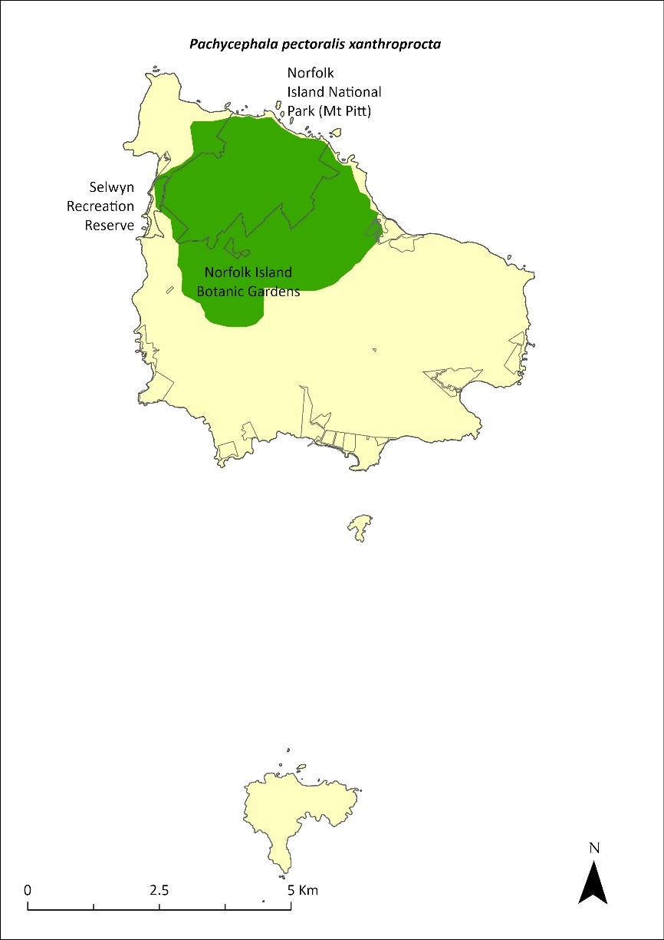
The shaded area indicates the approximate current range of the golden whistler (Director of National Parks 2010, NIRC 2020).

Threats
The main threats to the remaining population of Norfolk Island golden whistlers is predation from black rats and Argentine ants, with predation by cats a likely additional pressure. Whistlers may be more vulnerable to rat predation in disturbed environments (Nance et al. 2021a). The limited extent of native vegetation outside protected areas represents a barrier to the species recolonising its former range.

Impact on other species
None known.

Risk assessment
The risk assessment is shown in Table 51.
Table 51 Risk assessment for Pachycephala pectoralis xanthroprocta
Risk | Likelihood of exposure | Consequence | Threat rating
1. Loss and fragmentation of native vegetation through past land clearing | Almost certain (91–100%) | Moderate | High
2. Loss and fragmentation of native vegetation through current or future land clearing | Unlikely (11–25%) | Moderate | Low
3. Degradation of native vegetation through past grazing or loss of nutrients | Almost certain (91–100%) | Minor | Medium
4. Degradation of native vegetation through current or future grazing | Almost certain (91–100%) | Minor | Medium
5. Lack of available nest sites | Rare (0–10%) | Minor | Negligible
6. Predation by rodents | Almost certain (91–100%) | Moderate | High
7. Predation by cats | Likely (51–90%) | Moderate | Medium
8. Predation or damage by chickens | Rare (0–10%) | Negligible | Negligible
9. Predation by swamphens | Rare (0–10%) | Negligible | Negligible
10. Predation by Argentine ant | Almost certain (91–100%) | Moderate | High
11. Competition from/change of habitat because of weed invasion | Almost certain (91–100%) | Minor | Medium
12. Infection by pathogens already present | Rare (0–10%) | Negligible | Negligible
14. Changes to vegetation, increased fire risk and/or direct physiological stress as a result of climatic changes | Possible (26–50%) | Minor | Low
15. Problems caused by small populations, including lack of genetic diversity | Unlikely (11–25%) | Minor | Low

Management actions
Control the main predators, black rats and feral cats, with targeted control of rodents in natural areas to protect Norfolk Island golden whistler nests (predation by rats has a strong influence on fledging rates). Restore native forest inside the national park, but also outside the park, with patches of appropriate size, composition, and physical connectedness, to enable passerine birds to expand their range.

Recovery target
The recovery target is shown in Table 52.
Table 52 Recovery target for Pachycephala pectoralis xanthroprocta
EPBC Act status | Estimated population (2023) | Where known populations occur | 2034 target
Vulnerable | 1,671  (1,372–1,970) | 42% in the national park  1% in public reserves  57% in other lands | The population is at least 2000 individuals and distributed across Norfolk Island

Relevant literature
Bell BD (1990) The status and management of the White-breasted White-eye and other birds of Norfolk Island. Unpublished report to the Australian Nature Conservation Agency.
Commonwealth of Australia (2005) National Recovery Plan for the Norfolk Island Scarlet Robin Petroica multicolor multicolor and the Norfolk Island Golden Whistler Pachycephala pectoralis xanthroprocta. Department of the Environment and Heritage.
Dutson G (2013) Population densities and conservation status of Norfolk Island forest birds. Bird Conservation International 23, 271–282.
Garnett ST & Baker GB (2021) The Action Plan for Australian Birds 2020. CSIRO Publishing, Melbourne.
Garnett ST & Crowley GM (2000) The Action Plan for Australian Birds. Environment Australia.
Major R (1989) Reproductive output and recruitment of the Norfolk Island Scarlet Robin (Petroica multicolor multicolor) Phase II. Report to the Australian National Parks and Wildlife Service, Canberra.
Nance AH, Mitchell W, Wilson M, Brown SM, Clarke RH, Macgregor NA, Ward R & Garnett ST (2021a) Norfolk Island Golden Whistler Pachycephala pectoralis xanthoprocta, in ST Garnett & GB Baker (eds), The Action Plan for Australian Birds 2020. CSIRO Publishing, Melbourne. pp. 709-710.
Robinson D (1988) Ecology and Management of the Scarlet Robin, White-breasted White-eye, and Long-billed White-eye of Norfolk Island. Consultants’ report to the Australian National Parks and Wildlife Service, Canberra.
Robinson D (1997) An evaluation of the status of the Norfolk Island Robin following rat-control and weed-control works in the Norfolk Island National Park. Report to Environment Australia, Canberra.
Schodde R, Fullagar P & Hermes N (1983) A review of Norfolk Island birds past and present (Special Publication No. 8). Australian National Parks and Wildlife Service, Canberra.

Petroica multicolor—Norfolk Island robin

Conservation significance
Endemic to Norfolk Island.
EPBC Act Listing Status: Vulnerable.
Non-statutory Listing Status: Described as Endangered in the Action Plan for Australian Birds 2020 (Garnett & Baker 2021).

Distribution and abundance
The endemic Norfolk Island robin was once common and widespread over Norfolk Island (and probably also on Phillip Island), but its range has contracted significantly since about 1960 (Schodde et al. 1983; Robinson 1988). The remaining population is almost entirely confined to Norfolk Island National Park and a few adjacent forested areas including some private properties and Selwyn Reserve (Robinson 1988, 1997; Major 1989; Bell 1990; M Christian 2024. pers comm 12 January).
There was little change in the density of birds inside the national park from 1987 to 1996, and the population appeared likely to remain stable if predator control continued (Robinson 1997).
There were estimated to be 750 mature Norfolk Island robins in the park in 2018 (about 375 pairs; Dawlings & Clarke unpublished report cited in Nance et al. 2021b) compared with 520 pairs (1040 individuals) in 1987 and 380–440 pairs (760–880 individuals) in 1996 (Robinson 1988).
Other important sites outside the park include the valleys between Prince Phillip Drive and Mt Pitt Road, between Douglas Drive and the park boundary, and valleys near Duncombe Bay (Commonwealth of Australia 2005). Occasional sightings elsewhere on the island since 2017 (for example a private rehabilitation site above Bloody Bridge) probably represent dispersing individuals (Nance et al. 2021b).
The distribution is shown in Map 21.

Ecology
Breeding season is late September to March. The species can breed in the first year of life and produce two eggs per season. On average each pair produces one fledgling per year (Major 1989). Nests placed near the top of the subcanopy or in upright fork or horizontal branch of tree.
Feeds on invertebrates, mainly insects, foraging on the ground in deep litter where a dense understorey has an open ground layer (Robinson 1988) or using low horizontal branches from which to pounce on prey.
Map 21 Distribution of Petroica multicolor
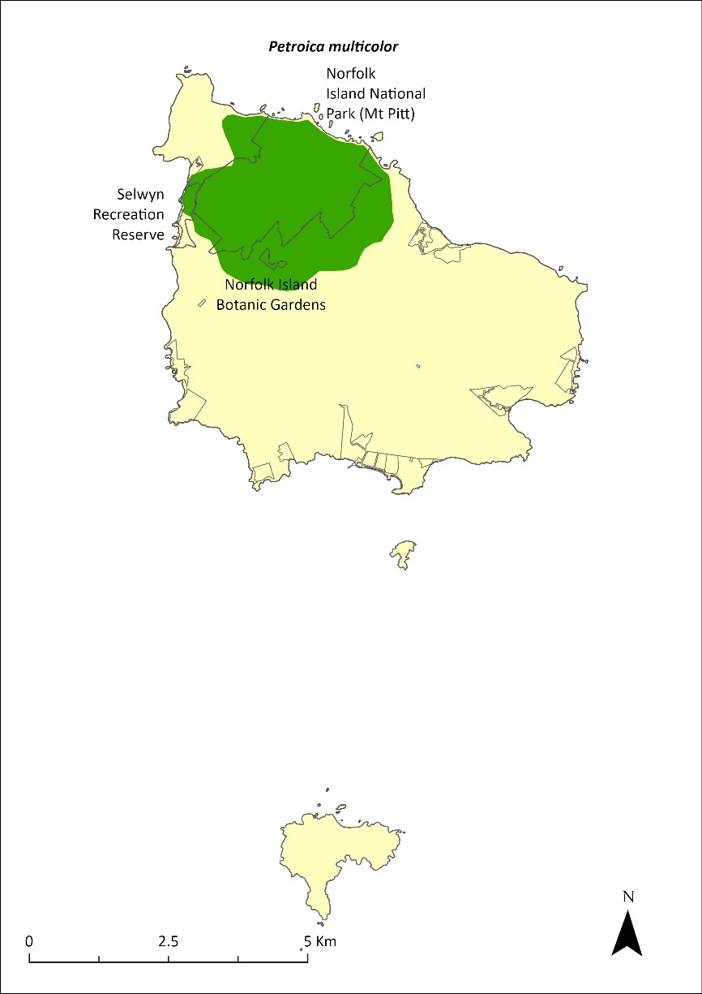
The shaded area indicates the approximate current range of the Norfolk Island robin (Director of National Parks 2010, NIRC 2020.

Habitat
Mainly inhabits the cooler and damper native rainforest with lower densities in habitats dominated by Norfolk Island palm (Rhopalostylis baueri), African olive (Olea europaea cuspidata) or eucalypt plantations (Robinson 1988, 1997; Major 1989). The species generally prefers areas such as gullies with a deep moist litter layer, dense shrub layer 1–10 m tall to provide shelter and nests, and an open shaded layer near ground level to provide visibility for foraging (Robinson 1988, 1997).

Threats
The primary threat to survival of the population is predation from black rats. In a study in which nests were observed with remote cameras, rats preyed on 75% of nests and reduced nest success to 17%. In unbaited areas, rodent density was twice as high (8.1/ha cf 4.2/ha) and robin nest survival approximately 20 times lower (1.6% cf. 36.4%) than in baited areas (Dawlings and Clarke unpublished reported in Nance et al. 2021b). Population viability modelling suggests decline to extinction within six years in the absence of rat baiting (based on observed nest survival rates in unbaited areas; Nance et al. 2021b). Predation by cats and Argentine ants are also a threat. The invasive red guava (Psidium cattleyanum) is likely to increase rat populations by providing unlimited food supply for rats 3–4 months of the year (Nance et al. 2021b). A possible trend towards drier conditions in a changing climate (Bureau of Meteorology 2019) could affect the forest habitat of the Norfolk Island robin and the abundance of invertebrates they rely on for food (Nance et al. 2021b)

Impact on other species
None known.

Risk assessment
The risk assessment is shown in Table 53.
Table 53 Risk assessment for Petroica multicolor
Risk | Likelihood of exposure | Consequence | Threat rating
1. Loss and fragmentation of native vegetation through past land clearing | Almost certain (91–100%) | Major | Extreme
2. Loss and fragmentation of native vegetation through current or future land clearing | Unlikely (11–25%) | Moderate | Low
3. Degradation of native vegetation through past grazing or loss of nutrients | Almost certain (91–100%) | Negligible | Negligible
4. Degradation of native vegetation through current or future grazing | Almost certain (91–100%) | Negligible | Negligible
5. Lack of available nest sites | Rare (0–10%) | Minor | Negligible
6. Predation by rodents | Almost certain (91–100%) | Major | Extreme
7. Predation by cats | Likely (51–90%) | Major | High
8. Predation or damage by chickens | Rare (0–10%) | Negligible | Negligible
9. Predation by swamphens | Rare (0–10%) | Negligible | Negligible
10. Predation by Argentine ant | Almost certain (91–100%) | Moderate | High
11. Competition from/change of habitat because of weed invasion | Almost certain (91–100%) | Minor | Medium
12. Infection by pathogens already present | Rare (0–10%) | Negligible | Negligible

Management actions
Implement targeted control of rats and cats in natural areas to reduce predation on the Norfolk Island robin. Restore native forest inside the national park, but also outside the park, with patches of appropriate size, composition, and physical connectedness, to enable passerine birds to expand their range. Conduct weed management (particularly red guava) with planting of native vegetation to avoid habitat becoming unsuitable and to allow ground feeding.

Recovery target
The recovery target is shown in Table 54.
Table 54 Recovery target for Petroica multicolor
EPBC Act status | Estimated population (2023) | Where known populations occur | 2034 target
Vulnerable | 750 (700–800) | 59% in the national park  1% in public reserves  40% in other land | The population is at least 1500 individuals and the distribution extends outside the national park and its fringes to other areas of the island (such as other reserves and more southern parts of the island)

Relevant literature
Bell BD (1990) The status and management of the White-breasted White-eye and other birds of Norfolk Island. Unpublished report to the Australian Nature Conservation Agency.
Bureau of Meteorology (2019) Temperature and rainfall changes at remote Australian Islands and Antarctic sites. Accessed 24 January 2024.
Christian M (2024) personal communication by email, 12 January.
Commonwealth of Australia (2005) National Recovery Plan for the Norfolk Island Scarlet Robin Petroica multicolor multicolor and the Norfolk Island Golden Whistler Pachycephala pectoralis xanthroprocta. Department of the Environment and Heritage, Canberra.
Garnett ST & Baker GB (2021) The Action Plan for Australian Birds 2020. CSIRO Publishing, Melbourne.
Major R (1989) Reproductive output and recruitment of the Norfolk Island Scarlet Robin (Petroica multicolor multicolor) Phase II. Report to the Australian National Parks and Wildlife Service, Canberra.
Nance AH, Mitchell W, Clarke RH, Wilson M, Brown SM, Macgregor NA, Dutson G & Garnett ST (2021b) Norfolk Island Robin Petroica multicolor, in ST Garnett & GB Baker (eds), The Action Plan for Australian Birds 2020. CSIRO Publishing, Melbourne. pp. 741-744.
Robinson D (1988) Ecology and Management of the Scarlet Robin, White-breasted White-eye, and Long-billed White-eye of Norfolk Island. Consultants’ report to the Australian National Parks and Wildlife Service, Canberra.
Robinson D (1997) An evaluation of the status of the Norfolk Island Robin following rat-control and weed-control works in the Norfolk Island National Park. Report to Environment Australia, Canberra.
Schodde R, Fullagar P & Hermes N (1983) A review of Norfolk Island birds past and present (Special Publication No. 8). Australian National Parks and Wildlife Service, Canberra.

Zosterops albogularis—white-breasted white-eye, grinnell

Conservation significance
Endemic to Norfolk Island.
EPBC Act Listing Status: Extinct
Non-statutory Listing Status: Classified as extinct in the Action Plan for Australian Birds 2020 (Garnett & Baker 2021).

Distribution and abundance
Early records suggest the white-breasted white-eye (Zosterops albogularis) was common and widespread on the island before the end of the 1800s, after which the population declined dramatically to an estimate of fewer than 50 birds by 1962 (Schodde et al. 1983). By the 1970s the population had further declined and there have only been scattered sightings over the last two decades including two in 1991, four in 1994 and one in 2000 (Garnett & Crowley 2000).
The last reported confirmed sighting was in 2004 (Christian 2005). While the Action Plan for Australian Birds 2010 (Garnett et al. 2011) assessed the species as Critically Endangered, the more recent assessment is that there was a high probability that the species was already extinct in 2010 and that persistence a decade later is not possible (Clarke et al. 2021).

Ecology
The species was a tree-creeper feeding on small insects in the canopy.

Habitat
The species occurred mainly in native forest that was free of weeds, though there were earlier records of nesting in orchards and red guava. The last sightings were in the national park.

Threats
The decline of this species was probably due primarily to predation by black rats, with additional pressure from clearing of habitat and competition from the self-introduced Australian silvereye (Z. lateralis; Clarke et al. 2021).

Impact on other species
None known.

Management actions
Actions to support other passerines would provide some benefit to this species; however, the species is no longer thought to persist on the island.

Relevant literature
Bell BD (1990) The status and management of the White-breasted White-eye and other birds of Norfolk Island. Unpublished report to the Australian Nature Conservation Agency.
Christian M (2005) Norfolk Island…the birds. Green Eyes Publications, Norfolk Island.
Clarke RH, Dutson G, Olsen P & Garnett ST (2021) White-chested White-eye Zosterops albogularis, in ST Garnett & GB Baker (eds), The Action Plan for Australian Birds 2020. CSIRO Publishing, Melbourne. pp. 762–763.
Garnett ST & Baker GB (2021) The Action Plan for Australian Birds 2020. CSIRO Publishing, Melbourne.
Garnett ST & Crowley GM (2000) The Action Plan for Australian Birds. Environment Australia.
Garnett ST, Szabo J & Dutson G (2011) The Action Plan for Australian Birds 2010. CSIRO Publishing, Melbourne.
Robinson D (1988) Ecology and Management of the Scarlet Robin, White-breasted White-eye, and Long-billed White-eye of Norfolk Island. Consultants’ report to the Australian National Parks and Wildlife Service, Canberra.
Schodde R, Fullagar P & Hermes N (1983) A review of Norfolk Island birds past and present (Special Publication No. 8). Australian National Parks and Wildlife Service, Canberra.

Zosterops tenuirostris—slender-billed white-eye

Conservation significance
Endemic to Norfolk Island.
EPBC Act Listing Status: None.
Non-statutory Listing Status: Described as Vulnerable in the Action Plan for Australian Birds 2020 (Garnett & Baker 2021).

Distribution and abundance
A moderately abundant species originally derived from the Australian silvereye (Zosterops lateralis). A survey in 2009 estimated there were 4030 individuals (95% CI 2550–6360) in the national park (Dutson 2013). A later survey in 2016 confirmed there to be little change (Director of National Parks unpublished).
This species has gradually disappeared from all parts of the island that have been extensively cleared, a decline that has probably been exacerbated by the arrival of the black rat (Robinson 1997). It is now largely confined to the national park, with birds observed outside of the national park thought to be dispersing individuals.

Ecology
Slender-billed white-eyes forage in small groups and appear to have a different ecological niche to the self-introduced silvereye (Robinson 1988). They have a long down-curved bill and use it to probe fissures in bark for insects. They also eat fruit, including introduced species such as the red guava, with the white-eye likely to disperse its seeds.

Habitat
Slender-billed white-eyes occur primarily in rainforest, rainforest remnants, and tall secondary forest, avoiding lower thickets and garden and forest edges (Schodde et al. 1983).

Threats
The main threat to the species is predation from black rats. Predation by cats and degradation and loss of habitat are additional threats (Nance et al. 2021c). This species has probably managed to survive due to its habit of fast movement and remote nest construction on slender branches which do not support the weight of feral animal predators (Director of National Parks 2010).

Impact on other species
None known.

Management actions
Survey to monitor for any signs of further population decline. Assess the need for listing as a threatened species. Undertake targeted predator control of black rats and feral cats. Restore native forest inside and outside the national park, including management to reduce size of areas dominated by red guava.

Relevant literature
Christian M (2005) Norfolk Island … the birds. Green Eyes Publications, Norfolk Island.
Dutson G (2013) Population densities and conservation status of Norfolk Island forest birds. Bird Conservation International 23, 271–282.
Garnett ST & Baker GB (2021) The Action Plan for Australian Birds 2020. CSIRO Publishing, Melbourne.
Garnett ST & Crowley GM (2000) The Action Plan for Australian Birds. Environment Australia.
Nance AH, Mitchell W, Clarke R, Wilson M, Brown SM, Macgregor NA, Dutson G & Garnett ST (2021c) Slender-billed White-eye Zosterops tenuirostris, in ST Garnett & GB Baker (eds), The Action Plan for Australian Birds 2020. CSIRO Publishing, Melbourne. pp. 763-765.
Robinson D (1988) Ecology and Management of the Scarlet Robin, White-breasted White-eye, and Long-billed White-eye of Norfolk Island. Consultants’ report to the Australian National Parks and Wildlife Service, Canberra.
Robinson D (1997) An evaluation of the status of the Norfolk Island Robin following rat-control and weed-control works in the Norfolk Island National Park. Report to Environment Australia, Canberra.
Schodde R, Fullagar P & Hermes N (1983) A review of Norfolk Island birds past and present (Special Publication No. 8). Australian National Parks and Wildlife Service, Canberra.

Seabirds

Anous albivittus albivittus—Tasman grey noddy, grey ternlet (western pacific)

Conservation significance
EPBC Act Listing Status: Not listed.
State Listing Status: Listed as Vulnerable under the Biodiversity Conservation Act 2016 (New South Wales).
Non-statutory Listing Status: Described as near threatened in the Action Plan for Australian Birds 2010 (Garnett et al. 2011).

Distribution
Widespread throughout the subtropical and tropical zones of the Indian and West Pacific Oceans. It breeds on the Norfolk Island Group and in Australia on Ashmore Reef, Rowley Shoals, Cocos Keeling Islands, Christmas Island, islands of the Great Barrier Reef and islands of the Lord Howe Island.
A widespread coastal summer breeding species, this species is well established on the Norfolk Island Group and occurs on all three islands. Numbers appear to have been stable, particularly on Phillip Island where there are no predators (Schodde et al. 1983). Phillip Island supports one of the largest breeding populations in Australia. 100–1000 pairs were estimated during 2006 (Priddel et al. 2010) and <1000 pairs in 2017–18 (Carlile & O’Dwyer 2018).

Ecology
Nest selection occurs in November with eggs laid through December, and eggs hatch up until early February, after 45 days of incubation. Usually a single egg is laid and only one chick is ever brooded, with fledging at 85 days. Nest consists of a scrape on the ground on an inaccessible ledge or under shrubs usually near the tops of coastal sea cliffs or steep hills.
Diet consists of squid and fish taken from far offshore.

Habitat
Marine, pelagic mainly in subtropical and tropical waters.

Threats
The main threat to this species is the reduction in the quality of foraging areas due to climate-related shifts in oceanic resources. On Norfolk Island, other threats include interference by people and predation by cats and rats where ternlets nest above the cliff edge or in accessible areas (such as Hundred Acres Reserve and Rocky Point Reserve). Most of the population is not under threat as they nest below the cliff edge. On Phillip Island, additional threats include reforestation, which could render the internal parts of the island unavailable for nesting, and predation of unattended nestlings by purple swamphens.

Impact on other species
None known.

Management actions
Protect nesting areas on Norfolk Island from disturbance by rats and cats. Continue the control of purple swamphens on Phillip Island. Retain status of pest-free Phillip Island through detection monitoring for introduced vertebrates and invertebrates.

Relevant literature
Carlile N & O’Dwyer T (2018) NI2016–26 Report to the Director national parks and Manager Norfolk Island National Park. Office of Environment and Heritage NSW.
Christian M (2005) Norfolk Island … the birds. Green Eyes Publications, Norfolk Island.
Garnett ST & Crowley GM (2000) The Action Plan for Australian Birds. Environment Australia.
Garnett ST, Szabo J & Dutson G (2011) The Action Plan for Australian Birds 2010. CSIRO Publishing, Melbourne.
Priddel D, Carlile N, Evans O, Evans B & McCoy H (2010) A review of the seabirds of Phillip Island in the Norfolk Island Group. Notornis 57, 113–127.
Schodde R, Fullagar P & Hermes N (1983) A review of Norfolk Island birds past and present (Special Publication No. 8). Australian National Parks and Wildlife Service, Canberra.

Anous minutus—black noddy

Conservation significance
Secure, widespread
EPBC Act Listing Status: Marine

Distribution
Widespread over subtropical and tropical seas worldwide, breeding on various islands. It breeds on the Norfolk Island Group and in Australia on the islands of the Great Barrier Reef, north-west Australia, and Lord Howe Island.
The black noddy (Anous minutus) is the most common of the three noddy species present in the Norfolk Island region. It is a spring and summer breeding species that is well established on Norfolk and Phillip Islands. Large rookeries occur in the tall pines of Hundred Acre Reserve, Titerack Valley (in the national park at the end of McLaughlan’s Lane), above Bloody Bridge and in white oak (Lagunaria patersonia) and Norfolk Island pines on Phillip Island (Christian 2005). In 1977 the breeding population on Phillip Island was estimated at between 1,000 and 10,000 breeding pairs (Fullagar 1978). The number of rookeries has fallen over the past few decades, and 100–1000 pairs were estimated in 2010 (Priddel et al. 2010).

Ecology
Breeding season is from October to March. The black noddy lays one egg and shares incubation for 36 days. Hatching to fledging spans approximately 50 days. Nests built of leaves and twigs cemented with excreta in Norfolk Island pines or white oaks.
Diet consists mainly of fish. Forages typically in flocks, swooping and snatching prey at the surface.

Habitat
Exclusively pelagic mainly in tropical and subtropical waters. Often feeds at sea in groups.

Threats
Main threats to the black noddy are reduction in quality of foraging areas through climate related shifts in oceanic resources, and on Norfolk Island, degradation and loss of habitat in pine forest through cattle grazing, weed invasion and development pressure. Other threats include predation from cats and possibly introduced ants.

Impact on other species
None known.

Management actions
Protect nesting areas and control feral predators around nesting areas on Norfolk Island.
Encourage protection of pine forest habitat through covenants on private land. Depleted colonies in the park should be restored through enhancing pine forest habitat in the north-east corner of the park and The Chord area.
Retain status of pest-free Phillip Island through detection monitoring for introduced vertebrates and invertebrates.

Relevant literature
Christian M (2005) Norfolk Island … the birds. Green Eyes Publications, Norfolk Island.
Fullagar PJ (1978) Norfolk Island birds. Unpublished report to RAOU Congress, Norfolk Island.
Priddel D, Carlile N, Evans O, Evans B & McCoy H (2010) A review of the seabirds of Phillip Island in the Norfolk Island Group. Notornis 57, 113–127.
Schodde R, Fullagar P & Hermes N (1983) A review of Norfolk Island birds past and present (Special Publication No. 8). Australian National Parks and Wildlife Service, Canberra.

Anous stolidus—common noddy

Conservation significance
Secure, widespread.
EPBC Act Listing Status: Marine, Migratory.

Distribution
Widespread over subtropical and tropical seas worldwide, breeding on various islands. It breeds on the Norfolk Island Group and in Australia on the islands of the Great Barrier Reef, north-west Australia, and Lord Howe Island.
The common noddy is a common spring and summer breeding species that gathers on the islands to nest, then disperses out to sea. It nests in small groups on the ground or amongst rocks on Phillip Island. Estimates of breeding population on Phillip Island range from >1000 pairs in 1977 (Fullagar 1978) to a few hundred in 1978–79 (Tarburton 1981; Schodde et al. 1983) and several hundred pairs in 1985 (Hermes et al. 1986).

Ecology
Breeds on Phillip Island in spring and early summer (October to December–January). On Norfolk Island, each pair raises a single brood each year. The single egg can be replaced if lost and is incubated for 35 days. Hatching to fledging spans 50 days. Nests in a depression on the ground or in rocks. Feeds mainly on fish, foraging typically in flocks and swooping to take prey from the sea surface.

Habitat
Marine, pelagic mainly in tropical or subtropical waters.

Threats
The main threat to the black noddy is the reduction in the quality of foraging areas through climate-related shifts in oceanic resources. As a ground nesting species, the presence of cats on Norfolk Island probably excludes it from breeding there. This species is largely secure in Australasia, but predation from cats and disturbance from humans have adversely affected some populations.

Impact on other species
None known.

Management actions
Protect and enhance nesting areas through revegetation efforts. Retain status of pest-free Phillip Island through detection monitoring for introduced vertebrates and invertebrates.

Relevant literature
Christian M (2005) Norfolk Island … the birds. Green Eyes Publications, Norfolk Island.
Fullagar PJ (1978) Norfolk Island birds. Unpublished report to RAOU Congress, Norfolk Island.
Hermes N, Evans O & Evans B (1986) Norfolk Island birds: a review 1985. Notornis 33, 141–149.
Schodde R, Fullagar P & Hermes N (1983) A review of Norfolk Island birds past and present (Special Publication No. 8). Australian National Parks and Wildlife Service, Canberra.
Tarburton MK (1981) Seabirds nesting on Norfolk Island. Notornis 28, 209–211.

Ardenna carneipes—flesh-footed shearwater

Conservation significance
EPBC Act Listing Status: Marine, Migratory (listed marine under the EPBC Act as Puffinus carneipes).
State Listing Status: Listed as Vulnerable under the Biodiversity Conservation Act 2016 (NSW).
Non-statutory Listing Status: Listed as Near Threatened in The Action Plan for Australian Birds 2020 (Garnett & Baker 2021).

Distribution
A widespread species across the southern Indian Ocean and south-eastern Pacific Ocean; breeding and non-breeding visitor to the coastal and pelagic waters of southern Australia.
Priddel et al. (2010) estimated the population of flesh-footed shearwater on Phillip Island to be 1–10 pairs. Breeding here was confirmed in 2011 when a fledgling was intercepted at the known breeding site below Red Knoll (Carlile 2011).

Ecology
Breeds late August to May. Eggs are incubated for less than 60 days, and young fledge approximately three months after hatching. Nests in a deep burrow.
Diet consists of small fish and squid. Food captured by diving and pursuit plunging to 10 m and by surface seizing.

Habitat
Breeding may occur on islands within the Australasian region and Indian Ocean. Nests are made in burrows on gentle to steep slopes where burrowing is not restricted by dense vegetation, deep litter or bare rock. Nesting colonies require clear, elevated places to allow sufficient space for take-off.

Threats
The main threat to the flesh-footed shearwater is the reduction in the quality of foraging areas through climate-related shifts in oceanic resources. The species is also threatened by degradation and loss of breeding habitat. Offshore windfarms along the east coast of Australia may represent an emerging threat due to turbine strike.

Impact on other species
None known.

Management actions
Retain status of pest-free Phillip Island through detection monitoring for introduced vertebrates and invertebrates. Protect nesting areas and conduct surveillance camera monitoring of known burrows between December and May annually to detect continued breeding below Red Knoll.

Relevant literature
Carlile N (2011) Observations of seabirds on Phillip Island 8–12 May 2011. Unpublished report.
Christian M (2005) Norfolk Island … the birds. Green Eyes Publications, Norfolk Island.
Garnett ST & Baker GB (2021) The Action Plan for Australian Birds 2020. CSIRO Publishing, Melbourne.
Garnett ST, Szabo J & Dutson G (2011) The Action Plan for Australian Birds 2010. CSIRO Publishing, Melbourne.
Priddel D, Carlile N, Evans O, Evans B & McCoy H (2010) A review of the seabirds of Phillip Island in the Norfolk Island Group. Notornis 57, 113–127.

Ardenna pacifica—wedge-tailed shearwater, ghost bird

Conservation significance
EPBC Act Listing Status: Marine, migratory (listed marine under the EPBC Act as Puffinus pacificus)
Non-statutory Listing Status: Listed as Least Concern in the Action Plan for Australian Birds 2010 (Garnett et al. 2011)

Distribution
This species is the most common and widespread shearwater in the south-west Pacific and Indian Oceans with many breeding localities. It is a common breeding summer migrant to the Norfolk Island Group where it breeds on all three islands (Schodde et al. 1983) with a total breeding population of several hundreds of thousands of birds (Tarburton 1981). The Phillip Island population was estimated in 2006 as between 1,000–10,000 pairs (Priddel et al. 2010). Black rats have caused populations to decline on some Pacific islands (such as Midway), and feral cats severely damage shearwater colonies (Fitzherbert & Peter 1988).

Ecology
Summer breeder returning to Norfolk Island in October and departing in May. Incubation is 53 days of their single egg and hatching to fledging takes approximately three months. On Norfolk Island the nests are in crowded colonies often concentrated among tussocks of kikuyu (Cenchrus clandestinus). On Phillip Island they are amongst other burrowing species in deeper soils. The nest is at the end of a burrow that can be 1–2 m long.
Diet consists of squid, fish and crustaceans, caught by lunge-diving to two metres.

Habitat
Marine, pelagic mainly in tropical and subtropical waters. Feeds at sea during the day; rafts of birds can often be seen just offshore before they return to the breeding colonies at dusk.

Threats
The main threats to the wedge-tailed shearwater are the reduction in the quality of foraging areas through climate-related shifts in oceanic resources, predation from cats, and degradation and loss of breeding habitat, particularly through weed invasion from kikuyu. Adults and fledglings can get entangled in kikuyu runners. Offshore windfarms along the east coast of Australia may represent an emerging threat due to turbine strike.

Impact on other species
In limited areas on Phillip Island, when adults return to breed, they will evict unfledged providence petrel (Pterodroma solandri) chicks from their burrows.

Management actions
Protect nesting areas through appropriate weed management.

Relevant literature
Christian M (2005) Norfolk Island … the birds. Green Eyes Publications, Norfolk Island.
Garnett ST, Szabo J & Dutson G (2011) The Action Plan for Australian Birds 2010. CSIRO Publishing, Melbourne.
Fitzherbert K & Peter J (1988) Status and movement of Australian migratory birds Vol 1. Procellariiformes Part II. Royal Australasian Ornithologists Union.
Priddel D, Carlile N, Evans O, Evans B & McCoy H (2010) A review of the seabirds of Phillip Island in the Norfolk Island Group. Notornis 57, 113–127.
Schodde R, Fullagar P & Hermes N (1983) A review of Norfolk Island birds past and present (Special Publication No. 8). Australian National Parks and Wildlife Service, Canberra.
Tarburton MK (1981) Seabirds nesting on Norfolk Island. Notornis 28, 209–211.

Fregetta grallaria grallaria—Tasman white-bellied storm-petrel

Conservation significance
EPBC Act Listing Status: Vulnerable, Marine
Non-statutory Listing Status: Described as Vulnerable in the Action Plan for Australian Birds 2020 (Garnett and Baker 2021).

Distribution and abundance
Breeding has been recorded on islands and islets off the east coast of New South Wales (such as Muttonbird Island), Ball’s Pyramid in the Lord Howe Island group, and Macauley and Curtis Islands in the Kermadec Island Group. It is also thought to breed on Phillip Island in the Norfolk Island Group. Fewer than 100 pairs are thought to nest on islands off the New South Wales coast, and fewer than 700 in the Kermadec Islands. Numbers on Ball’s Pyramid are unknown (Garnett and Baker 2021.) It migrates between its breeding locations and its non-breeding grounds in the Tasman Sea, Coral Sea and central Pacific Ocean.

Ecology
Breeds late summer to autumn. Eggs are laid from January to March, and young fledge in May. Nests in crevices between large volcanic rocks and in burrows excavated in banks. Clutches consist of a single egg, which is incubated by both parents for approximately 37 days.
Forages both at day and at night on small crustaceans and squid, usually far from shore, by skimming low over the ocean and plucking prey from beneath the surface of the water.

Habitat
Marine, highly pelagic across sub-tropical and tropical waters in the Tasman Sea, Coral Sea and the central Pacific Ocean, and rarely approaches land except to return to colonies.

Threats
The main known threats are predation from invasive species, particular the black rat. It is thought the population on Lord Howe Island was extirpated by black rats after they arrived in 1918.

Impact on other species
None known.

Management actions
Maintain biosecurity measures on breeding islands and islets, particularly to prevent the arrival of rats or cats. Confirm rodent eradication on Lord Howe Island and encourage chances of re-establishment of the species there (Garnett and Baker 2021).

Relevant literature
Garnett ST & Baker GB (2021) The Action Plan for Australian Birds 2020. CSIRO Publishing, Melbourne.

Gygis alba—white tern

Conservation significance
EPBC Act Listing Status: Marine
Non-statutory Listing Status: Described as vulnerable in the Action Plan for Australian Birds (Garnett & Crowley 2000).

Distribution and abundance
This species breeds on tropical and subtropical islands throughout the Pacific, Indian, and South Atlantic oceans. Within Australasian waters it breeds on Norfolk Island, Lord Howe Island and the in the Cocos Keeling group. On Norfolk Island, white oak (Lagunaria patersonia) and Norfolk Island pine (Araucaria heterophylla) are the favoured nest trees (Schodde et al. 1983). The north-west coast of the island supports large rookeries as does the valley behind Bloody Bridge (Christian 2005). There are about 2,000 to 2,500 breeding pairs on Norfolk Island and this species has persisted despite predation from nankeen kestrels (Falco cenchoides) and marsh harriers (Circus approximans) (Garnett & Crowley 2000).

Ecology
A spring/summer breeder with egg laying beginning in October. One egg is laid. No nest is built. The single egg is laid in a notch or depression on the horizontal branch of a tree. Its diet consists mainly of small fish and squid. Feeds mainly by surface seizing and often feeds in small groups. At sea tracking reveals that little time is spent on the ocean surface annually (Carlile & O’Dwyer 2022).

Habitat
Marine, pelagic mostly in tropical and subtropical waters. The Lord Howe population shows significant non-breeding movements into the Coral Sea (Carlile & O’Dwyer 2022).

Threats
The main threats are predation from cats, degradation and loss of habitat and increased frequencies of intense storms resulting in nest failure.

Impact on other species
None known.

Management actions
Protection of nesting areas, and regular monitoring of the population to detect significant changes. Restore remnant coastal pine/oak forests in the national park and in coastal reserves.

Relevant literature
Carlile N & O’Dwyer T (2022) At-sea movements of the White Tern Gygis alba in waters off Eastern Australia. Marine Ornithology 50, 157–164.
Christian M (2005) Norfolk Island …the birds. Green Eyes Publications, Norfolk Island.
Garnett ST & Crowley GM (2000) The Action Plan for Australian Birds. Environment Australia.
Schodde R, Fullagar P & Hermes N (1983) A review of Norfolk Island birds past and present (Special Publication No. 8). Australian National Parks and Wildlife Service, Canberra.

Morus serrator—Australasian gannet

Conservation significance
EPBC Act Listing Status: Marine.
Non-statutory Listing Status: Described as least concern by the Action Plan for Australian Birds 2010 (Garnett et al. 2011).

Distribution
The species is largely found in temperate waters with breeding colonies on rocky islands off Victoria, Tasmania and the North Island of New Zealand.
From the 1960s to the 2000s, the Australasian gannet was a rare summer breeding species in the Norfolk Island Group. The species was first recorded nesting on Nepean Island in 1961, then shifted to Phillip Island, with up to four pairs reported (Tarburton 1981). In 2005, only three pairs were known to nest on Phillip Island (Christian 2005). By 2006, two pairs were present (Priddel et al. 2010) and since 2011 no breeding has been observed (N Carlile 2024. pers comm 12 January). Recently, the species has been recorded on one of the offshore stacks north of Norfolk Island (M Christian 2024. pers comm 12 January), with possible breeding not yet investigated.

Ecology
Breeding: formerly bred on Phillip Island in summer.
Nesting: Nest colonially on mounds of guano mixed with seaweed or earth built on rocks.
Foraging: Feeds on small fish and cephalopods.

Habitat
A marine pelagic species whose non-breeding range extends from the seas off southern Australia to northern Queensland and the Lord Howe and the Norfolk Island Groups. Juveniles may remain near breeding colonies throughout the year although most non-breeding birds disperse.

Threats
The main threats to the Australasian gannet include changes in the marine environment, entanglement in long-line fishing gear, and competition from the fishing industry for oceanic resources. Both on Phillip Island and on Nepean Island, breeding birds are free from predation from introduced rats and cats.

Impact on other species
None known.

Management actions
None required until re-nesting is detected.

Relevant literature
Carlile N (2024) Personal communication by email, 12 January.
Christian M (2005) Norfolk Island … the birds. Green Eyes Publications, Norfolk Island.
Christian M (2024) Personal communication by email, 12 January.
Garnett ST & Crowley GM (2000) The Action Plan for Australian Birds. Environment Australia, Canberra.
Garnett ST, Szabo J & Dutson G (2011) The Action Plan for Australian Birds 2010. CSIRO Publishing, Melbourne.
Priddel D, Carlile N, Evans O, Evans B & McCoy H (2010) A review of the seabirds of Phillip Island in the Norfolk Island Group. Notornis 57, 113–127.
Tarburton MK (1981) Seabirds nesting on Norfolk Island. Notornis 28, 209–211.

Onychoprion fuscata—sooty tern, whale bird

Conservation significance
EPBC Act Listing Status: Marine (listed marine under the EPBC Act as Sterna fuscata)
State Listing Status: Listed as Vulnerable under the Biodiversity Conservation Act 2016 (NSW).

Distribution
A wide distribution over tropical and subtropical seas, breeding on numerous islands (including islands of the Great Barrier Reef) in north-west Australia and the south-west Pacific (including the Lord Howe and Norfolk Island Groups). Preliminary findings from tracking of sooty terns on Phillip Island indicate that during the breeding season the species forages within approximately 600 km of Phillip Island (Gorta unpublished data 2023). In the non-breeding season, which began as early as mid-January 2023 in the 2022–23 season, sooty terns largely migrated into the South and West Pacific (Gorta unpublished data 2023).
Known on Norfolk Island as the whale bird, this is an abundant summer breeding species that nests on Phillip and Nepean Islands and on the north coast of the main island (Schodde et al. 1983). There were an estimated 80,000 to 140,000 birds breeding in the Norfolk Island Group (Blakers et al. 1984) including about 20,000 on Phillip Island and several hundred on Nepean Island (Fullagar 1978). In 2006 the population here was estimated to be between 1000–10,000 pairs (Priddel et al. 2010). Breeding was significantly reduced on Phillip Island by 2016 (fewer than 1,000 pairs) and only recommenced in larger numbers following purple swamphen control in 2019 (Carlile & O’Dwyer 2023). Preliminary results from surveys during the 2022–23 breeding season indicate the current breeding population on Phillip Island numbers from 6,000-8,000 pairs (Gorta unpublished data 2023).
In 1908, 10,000 to 15,000 eggs were harvested from Nepean Island several times a week (Schodde et al. 1983). This species is subject to a limited annual open season for the harvesting of eggs.

Ecology
Present around Norfolk Island from August, this species is a spring/summer breeder with most pairs starting to nest in November, but the laying season is prolonged by the harvesting of eggs by islanders. A single egg is laid, which can be replaced after roughly 2 weeks. Incubation lasts around 28 days and hatching to fledging spans approximately 50 days. Nest is a shallow scrape in sand or soft soil. Will nest in open areas, but often partially or completely underneath shrubby vegetation on Phillip Island.
Forages nocturnally and diurnally by swooping to snatch pelagic squid, crustaceans and fish at the ocean surface.

Habitat
Marine, pelagic in tropical and subtropical waters, breeding on islands.

Threats
The main threat to the sooty tern is the reduction in the quality of foraging areas through climate related shifts in oceanic resources. Additional threats include predation by rats and cats on Norfolk Island and predation of nests by swamphens on Phillip Island. Loss of habitat to significant revegetation can limit areas of breeding. Offshore windfarms along the east coast of Australia may represent an emerging threat due to turbine strike.

Impact on other species
None known.

Risk assessment
The risk assessment is shown in Table 55.
Table 55 Risk assessment for Onychoprion fuscata
Risk | Likelihood of exposure | Consequence | Threat rating
1. Loss and fragmentation of native vegetation through past land clearing | Likely (51–90%) | Major | High
2. Loss and fragmentation of native vegetation through current or future land clearing | Unlikely (11–25%) | Minor | Low
3. Degradation of native vegetation through past grazing or loss of nutrients | Likely (51–90%) | Major | High
4. Degradation of native vegetation through current or future grazing | Unlikely (11–25%) | Negligible | Negligible
5. Lack of available nest sites | Rare (0–10%) | Negligible | Negligible
6. Predation by rodents | Possible (26–50%) | Minor | Low
7. Predation by cats | Unlikely (11–25%) | Negligible | Negligible
8. Predation or damage by chickens | Rare (0–10%) | Unknown | Unknown
9. Predation by swamphens | Almost certain (91–100%) | Major | Extreme
10. Predation by Argentine ant | Possible (26–50%) | Major | High
11. Competition from/change of habitat because of weed invasion | Unlikely (11–25%) | Minor | Low
12. Infection by pathogens already present | Unlikely (11–25%) | Negligible | Negligible
13. Impacts of potential new invasive species or pathogens | Possible (26–50%) | Unknown | Unknown
14. Changes to vegetation, increased fire risk and/or direct physiological stress as a result of climatic changes | Likely (51–90%) | Major | High
15. Problems caused by small populations, including lack of genetic diversity | Unlikely (11–25%) | Minor | Low

Management actions
Continue control of swamphens on Phillip Island and experiment with new control approaches. Protect nesting areas from woody weed invasion. Retain status of pest-free Phillip Island through detection monitoring for introduced vertebrates and invertebrates. Use drone mapping of colony extent on Phillip Island annually in December as a proxy to detect significant changes in populations.

Relevant literature
Blakers M, Davies SJJJF & Reilly PM (1984) An atlas of Australian birds. Royal Australasian Ornithologists Union, Melbourne University Press, Melbourne.
Carlile N & O’Dwyer T (2023) Conservation of the surface-nesting Kermadec Petrel Pterodroma neglecta neglecta in the South Pacific: Clarifying breeding ecology and the threat of avian ground predators. Bird Conservation International 33, e44, 1–9.
Christian M (2005) Norfolk Island … the birds. Green Eyes Publications, Norfolk Island.
Feare CJ (1976) The breeding of the Sooty Tern Sterna fuscata in the Seychelles and the effects of experimental removal of its eggs. Journal of Zoology 179(3), 317–360.
Fullagar PJ (1978) Norfolk Island birds. Unpublished report to RAOU Congress, Norfolk Island.
O'Neill L (2006) The breeding and feeding ecology of the Sooty Tern Sterna fuscata on Lord Howe Island. PhD Thesis, Charles Sturt University, Albury, NSW.
Priddel D, Carlile N, Evans O, Evans B & McCoy H (2010) A review of the seabirds of Phillip Island in the Norfolk Island Group. Notornis 57, 113–127.
Schodde R, Fullagar P & Hermes N (1983) A review of Norfolk Island birds past and present (Special Publication No. 8). Australian National Parks and Wildlife Service, Canberra.

Phaethon rubricauda—red-tailed tropicbird

Conservation significance
EPBC Act Listing Status: Marine, Migratory.
State Listing Status: Listed as Vulnerable under the Biodiversity Conservation Act 2016 (New South Wales).
Non-statutory Listing Status: Described as near threatened in the Action Plan for Australian Birds 2010 (Garnett et al. 2011).

Distribution
Widespread throughout the subtropical and tropical zones of the Indian and West Pacific Oceans. In Australia it breeds on Ashmore Reef, Rowley Shoals, Cocos-Keeling Islands, Christmas Island, islands of the Great Barrier Reef and islands of the Lord Howe Island and Norfolk Island Group.
A widespread coastal summer breeding species, this species is well established on the Norfolk Island Group and occurs on all three islands. Numbers were apparently stable, particularly on Phillip Island where there are no predators (Schodde et al. 1983). Phillip Island supports one of the largest breeding populations in Australia. 100–1000 pairs were estimated during 2006 (Priddel et al. 2010) and <1000 pairs in 2017–18 (Carlile & O’Dwyer 2018).

Ecology
Nest selection occurs in November with eggs laid through December, and eggs hatch into early February after 45 days of incubation. Usually a single egg is laid and only one chick is ever brooded, with fledging at 85 days. Nest consists of a scrape on the ground on an inaccessible ledge or under shrubs usually near the tops of coastal sea cliffs or steep hills or on plateaus.
Diet consists of squid and fish taken far from shore.

Habitat
Marine, pelagic mainly in subtropical and tropical waters.

Threats
The main threat to the red-tailed tropicbird is reduction in the quality of foraging areas through climate-related shifts in oceanic resources. On Norfolk Island, threats include interference by people and predation by cats and rats where tropicbirds nest above the cliff edge or in accessible areas (such as Hundred Acres Reserve and Rocky Point Reserve). Most of the population is not under threat as they nest below the cliff edge. On Phillip Island complete reforestation would render the internal parts of the island unavailable for nesting and increase predation of unattended nestlings by purple swamphen.

Impact on other species
Excludes Kermadec petrel from nest sites on Phillip Island, which has led to failed nesting attempts for the petrel (Carlile & O’Dwyer 2023).

Management actions
Protect nesting areas on Norfolk Island from disturbance by rats and cats. Continue the control of swamphens on Phillip Island. Retain status of pest-free Phillip Island through detection monitoring for introduced vertebrates and invertebrates.

Relevant literature
Carlile N & O’Dwyer T (2018) NI2016–26 Report to the Director national parks and Manager Norfolk Island National Park. Office of Environment and Heritage NSW.
Christian M (2005) Norfolk Island … the birds. Green Eyes Publications, Norfolk Island.
Garnett ST & Crowley GM (2000) The Action Plan for Australian Birds. Environment Australia, Canberra.
Garnett ST, Szabo J & Dutson G (2011) The Action Plan for Australian Birds 2010. CSIRO Publishing, Melbourne.
Priddel D, Carlile N, Evans O, Evans B & McCoy H (2010) A review of the seabirds of Phillip Island in the Norfolk Island Group. Notornis 57, 113–127.
Schodde R, Fullagar P & Hermes N (1983) A review of Norfolk Island birds past and present (Special Publication No. 8). Australian National Parks and Wildlife Service, Canberra.

Pterodroma cervicalis—white-necked petrel

Conservation significance
EPBC Act Listing Status: Marine.
Non-statutory Listing Status: The Australian breeding population is described as Endangered in the Action Plan for Australian Birds 2020 (Garnett & Baker 2021).

Distribution
Before 1991, the white-necked petrel (Pterodroma cervicalis) was only known to breed at Macauley Island (Tennyson et al. 1989) and Raoul Island (Iredale 1910) in the Kermadec Group, with the latter population going extinct after the establishment of rodents there. A pair were found breeding on Phillip Island in 1992 (Priddel et al. 2010). This increased to about 10 breeding birds in 1995 (Garnett & Crowley 2000). There were two colonies each consisting of 10–12 breeding pairs on Phillip Island in 2010 (Director of National Parks 2010), 10–100 pairs in 2006 (Priddel et al. 2010) and 44 pairs in 2017–18 (Carlile & O’Dwyer 2018). Prior to purple swamphen management their population likely suffered from predation of eggs and chicks by that species (Halpin et al. 2021).

Ecology
Breeds in summer, arriving in late November and departing the island the following May. Incubation period is unknown but hatching to fledging spans over three months. Nests in burrows or on the surface under natural and artificial cover.
Feeds on small squid and crustaceans taken from the open ocean (Halpin et al. 2022). Not known to frequent at-sea areas of high plastic concentrations in breeding or non-breeding periods (Clarke et al. 2023).

Habitat
Marine pelagic species that migrates to the North Pacific when not breeding.

Threats
The main threats to the white-necked petrel are reduction in the quality of foraging areas through climate-related shifts in oceanic resources, predation of chicks by purple swamphens, human disturbance of nests, and degradation and loss of breeding habitat.

Impact on other species
None known.

Risk assessment
The risk assessment is shown in Table 56 and Table 57.
Table 56 Risk assessment for Pterodroma cervicalis (current range, Phillip Island)
Risk | Likelihood of exposure | Consequence | Threat rating
1. Loss and fragmentation of native vegetation through past land clearing | Almost certain (91–100%) | Extreme | Extreme
2. Loss and fragmentation of native vegetation through current or future land clearing | Unlikely (11–25%) | Negligible | Negligible
3. Degradation of native vegetation through past grazing or loss of nutrients | Likely (51–90%) | Major | High
4. Degradation of native vegetation through current or future grazing | Unlikely (11–25%) | Negligible | Negligible
5. Lack of available nest sites | Unlikely (11–25%) | Negligible | Negligible
6. Predation by rodents | Possible (26–50%) | Extreme | High
7. Predation by cats | Possible (26–50%) | Extreme | High
8. Predation or damage by chickens | Unlikely (11–25%) | Negligible | Negligible
9. Predation by swamphens | Likely (51–90%) | Moderate | Medium
10. Predation by Argentine ant | Likely (51–90%) | Major | High
11. Competition from/change of habitat because of weed invasion | Unlikely (11–25%) | Minor | Low
12. Infection by pathogens already present | Unlikely (11–25%) | Negligible | Negligible
13. Impacts of potential new invasive species or pathogens | Possible (26–50%) | Unknown | Unknown
14. Changes to vegetation, increased fire risk and/or direct physiological stress as a result of climatic changes | Likely (51–90%) | Major | High
15. Problems caused by small populations, including lack of genetic diversity | Likely (51–90%) | Moderate | Medium
Table 57 Risk assessment for Pterodroma cervicalis (if range expanded to include Norfolk Island)
Risk | Likelihood of exposure | Consequence | Threat rating
1. Loss and fragmentation of native vegetation through past land clearing | Unlikely (11–25%) | Minor | Low
2. Loss and fragmentation of native vegetation through current or future land clearing | Unlikely (11–25%) | Negligible | Negligible
3. Degradation of native vegetation through past grazing or loss of nutrients | Likely (51–90%) | Major | High
4. Degradation of native vegetation through current or future grazing | Unlikely (11–25%) | Negligible | Negligible
5. Lack of available nest sites | Possible (26–50%) | Minor | Low
6. Predation by rodents | Almost certain (91–100%) | Extreme | Extreme
7. Predation by cats | Almost certain (91–100%) | Extreme | Extreme
8. Predation or damage by chickens | Unlikely (11–25%) | Negligible | Negligible
9. Predation by swamphens | Likely (51–90%) | Moderate | Medium
10. Predation by Argentine ant | Likely (51–90%) | Major | High
11. Competition from/change of habitat because of weed invasion | Unlikely (11–25%) | Minor | Low
12. Infection by pathogens already present | Unlikely (11–25%) | Negligible | Negligible
13. Impacts of potential new invasive species or pathogens | Possible (26–50%) | Unknown | Unknown
14. Changes to vegetation, increased fire risk and/or direct physiological stress as a result of climatic changes | Likely (51–90%) | Major | High
15. Problems caused by small populations, including lack of genetic diversity | Likely (51–90%) | Moderate | Medium

Management actions
Continue control of swamphens on Phillip Island. Retain status of pest-free Phillip Island through detection monitoring for introduced vertebrates and invertebrates. Maintain existing artificial breeding structures where standing camps have been removed and construct additional artificial breeding structures to improve breeding success. Protect natural nesting areas including appropriate weed control and revegetation.
Conduct annual monitoring of a subset (≥ 30) of known nesting sites (both natural and artificial) to provide a measure of breeding success. Nesting sites should be monitored in mid-January for birds incubating eggs and again rechecked in mid-April for fledglings. Near-fledged birds should be banded with Australian Bird and Bat Banding Scheme (ABBBS) bands. Nest surveys should be undertaken every three years for five days in January with a minimum of three nights of four-hour searches, to provide an estimate of population size and colony expansion.

Relevant literature
Carlile N & O’Dwyer T (2018) NI2016–26 Report to the Director national parks and Manager Norfolk Island National Park. Office of Environment and Heritage NSW.
Christian M (2005) Norfolk Island … the birds. Green Eyes Publications, Norfolk Island.
Clark BL, Carneiro APB, Pearmain EJ et al. (2023) Global assessment of marine plastic exposure risk for oceanic birds. Nature Communications 14, 3665.
Director of National Parks (2010) Norfolk Island Region Threatened Species Recovery Plan. Department of the Environment, Water, Heritage and the Arts, Canberra.
Garnett ST & Baker GB (2021) The Action Plan for Australian Birds 2020. CSIRO Publishing, Melbourne.
Garnett ST & Crowley GM (2000) The Action Plan for Australian Birds. Environment Australia, Canberra.
Halpin LR, Carlile N, Baker GB & Garnett ST (2021) White-necked Petrel Pterodroma cervicalis cervicalis, in ST Garnett & GB Baker (eds), The Action Plan for Australian Birds 2020. CSIRO Publishing, Melbourne. pp. 177-179.
Halpin LR, Mott R, Clay TA, Humphries GRW, Chatwin TA, Carlile N & Clarke RH (2022) Predicting the foraging habitats of sympatrically breeding gadfly petrels in the South Pacific Ocean. Frontiers in Marine Science 9, 853104.
Iredale T (1910) Bird life on the Kermadec Islands. Emu 10, 2–16.
Priddel D, Carlile N, Evans O, Evans B & McCoy H (2010) A review of the seabirds of Phillip Island in the Norfolk Island Group. Notornis 57, 113–127.
Schodde R, Fullagar P & Hermes N (1983) A review of Norfolk Island birds past and present (Special Publication No. 8). Australian National Parks and Wildlife Service, Canberra.
Tennyson AJD, Taylor GA & Scofield RP (1989) Another visit to Macauley Island. Ornithological Society of New Zealand News 52, 4–5. Supplement to Notornis 36.

Pterodroma neglecta neglecta—Kermadec petrel (western)

Conservation significance
EPBC Act Listing Status: Vulnerable
State Listing Status: Listed as Vulnerable under the Biodiversity Conservation Act 2016 (NSW)
Non-statutory Listing Status: The Australian breeding population is described as Vulnerable in the Action Plan for Australian Birds 2020 (a downlisting of one level since 2010 based on new information rather than a genuine sufficient change in population), with the population visiting Australian territory rated as being of ‘least concern’ (Garnett & Baker 2021).
For further information on the species outside of the Norfolk Island Group, see the species profile on SPRAT.

Distribution
The western subspecies of the Kermadec petrel breeds on islands across the Pacific Ocean as far east as Easter Island, with hybrids on Round Island near Mauritius in the Indian Ocean; however, its current breeding range is smaller than it once was. It nests on the ground so is particularly vulnerable to predation (Merton 1970)—on Raoul Island in the Kermadec Group it is estimated that 250,000 pairs were destroyed by rats between 1910 and 1970. In the Australian region, small numbers of pairs nest on Phillip Island and Ball’s Pyramid to the south of Lord Howe Island. Black rats caused its extinction from Lord Howe Island (Fullagar & Disney 1975) where it was formally probably widespread before the arrival of pigs in 1788. Rats probably prevent it from colonising Norfolk Island (Garnett & Crowley 2000).
The latest estimate of the population on Phillip Island is 20–25 breeding pairs in 2017–18 (Carlile & O’Dwyer 2018) and over 50 pairs in 2019 (Carlile et al. 2021). The small population on Phillip Island remains the most accessible internationally for the study of this species.
The Norfolk Island Group distribution of nesting Kermadec petrels is shown in Map 22.

Ecology
Breeding occurs on Phillip Island in all months of the year with peaks in numbers in spring and summer (Carlile et al. 2021). A single egg is incubated for 50 days, and fledging takes another 96 days (Carlile and O’Dwyer 2023). Nests among rocks and vegetation, under stands of wind-swept African olive (Olea europaea cuspidata) and under clumps of New Zealand flax (Phormium tenax).
Forages far out to sea and feeds on small squid and crustaceans (Halpin et al. 2022). Not known to frequent at-sea areas of high plastic concentrations in breeding or non-breeding periods (Clarke et al. 2023).

Habitat
Marine, pelagic in waters 15-25 degrees C. Breeds on high islands among rocks and vegetation. On Phillip Island, breeding habitat occurs on sloping terrain 182–228 m above the shoreline and up to 85 m from the coast in small sub-colonies under low scrubby woodland (Carlile and O’Dwyer 2023).
Map 22 Distribution of Pterodroma neglecta neglecta within the Norfolk Island Group
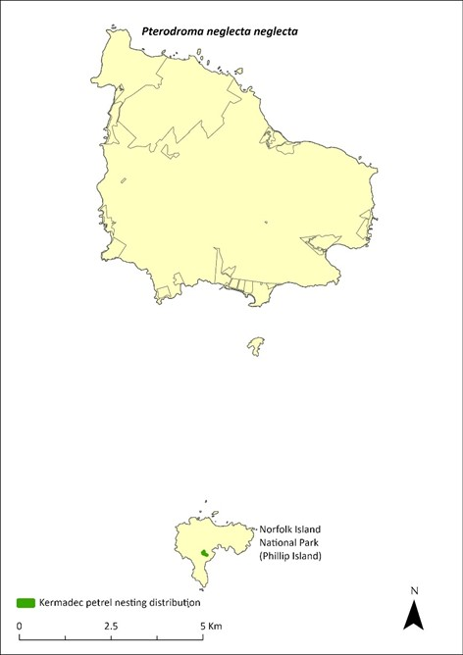
Green shading indicates locations where the species has been recorded breeding. Source: Carlile and O’Dwyer 2023.

Threats
Kermadec petrels are prone to nest predation because they nest on the surface of the ground. Purple swamphens prey on eggs and chicks on Phillip Island and are the major immediate threat to the population. Rats and cats have reduced or eliminated Kermadec petrel populations on other islands, and the accidental introduction of either species to Phillip Island would present an extreme threat. Other threats include degradation of breeding habitat, which could occur through revegetation activities either removing excessive African olive or failing to maintain open areas without shrubs near current nesting sites, and the reduction in the quality of foraging areas through climate-related shifts in oceanic resources.

Impact on other species
None known.

Risk assessment
The risk assessment is shown in Table 58 and Table 59.
Table 58 Risk assessment for Pterodroma neglecta neglecta (current range, Phillip Island)
Risk | Likelihood of exposure | Consequence | Threat rating
1. Loss and fragmentation of native vegetation through past land clearing | Almost certain (91–100%) | Extreme | Extreme
2. Loss and fragmentation of native vegetation through current or future land clearing | Unlikely (11–25%) | Negligible | Negligible
3. Degradation of native vegetation through past grazing or loss of nutrients | Likely (51–90%) | Major | High
4. Degradation of native vegetation through current or future grazing | Unlikely (11–25%) | Negligible | Negligible
5. Lack of available nest sites | Unlikely (11–25%) | Negligible | Negligible
6. Predation by rodents | Possible (26–50%) | Extreme | High
7. Predation by cats | Unlikely (11–25%) | Extreme | Medium
8. Predation or damage by chickens | Rare (0–10%) | n/a | n/a
9. Predation by swamphens | Likely (51–90%) | Extreme | Extreme
10. Predation by Argentine ant | Likely (51–90%) | Major | High
11. Competition from/change of habitat because of weed invasion | Unlikely (11–25%) | Minor | Low
12. Infection by pathogens already present | Unlikely (11–25%) | Negligible | Negligible
13. Impacts of potential new invasive species or pathogens | Possible (26–50%) | Unknown | Unknown
14. Changes to vegetation, increased fire risk and/or direct physiological stress as a result of climatic changes | Likely (51–90%) | Major | High
15. Problems caused by small populations, including lack of genetic diversity | Likely (51–90%) | Moderate | Medium
Table 59 Risk assessment for Pterodroma neglecta neglecta (if range expanded to include Norfolk Island)
Risk | Likelihood of exposure | Consequence | Threat rating
1. Loss and fragmentation of native vegetation through past land clearing | Unlikely (11–25%) | Minor | Low
2. Loss and fragmentation of native vegetation through current or future land clearing | Unlikely (11–25%) | Negligible | Negligible
3. Degradation of native vegetation through past grazing or loss of nutrients | Unlikely (11–25%) | Negligible | Negligible
4. Degradation of native vegetation through current or future grazing | Unlikely (11–25%) | Negligible | Negligible
5. Lack of available nest sites | Unlikely (11–25%) | Negligible | Negligible
6. Predation by rodents | Almost certain (91–100%) | Extreme | Extreme
7. Predation by cats | Almost certain (91–100%) | Extreme | Extreme
8. Predation or damage by chickens | Rare (0–10%) | Negligible | Negligible
9. Predation by swamphens | Likely (51–90%) | Major | High
10. Predation by Argentine ant | Likely (51–90%) | Major | High
11. Competition from/change of habitat because of weed invasion | Unlikely (11–25%) | Minor | Low
12. Infection by pathogens already present | Unlikely (11–25%) | Negligible | Negligible
13. Impacts of potential new invasive species or pathogens | Possible (26–50%) | Unknown | Unknown
14. Changes to vegetation, increased fire risk and/or direct physiological stress as a result of climatic changes | Likely (51–90%) | Major | High
15. Problems caused by small populations, including lack of genetic diversity | Likely (51–90%) | Moderate | Medium

Management actions
Continue control of swamphens on Phillip Island, including maintaining the shooting regime on Phillip Island that was implemented in 2020–21 to reduce nest predation. Protect nesting areas through appropriate weed control and revegetation. Undertake removal and replacement of decrepit nesting structures for seabirds on Phillip Island. Retain status of pest-free Phillip Island through implementation of comprehensive biosecurity procedures (quarantine, surveillance and incursion readiness and response).
Conduct annual monitoring of a subset (≥ 30) of known nesting sites during four targeted site visits annually to provide a measure of breeding success. Every three years, conduct bi-monthly nest monitoring, over a minimum of three nights of four-hour search sessions, to provide an estimate of population size and colony expansion. Near-fledged birds should be banded with ABBBS bands.
The Lord Howe Island Biodiversity Management Plan covers the recovery needs of this species on the Lord Howe Island group. Possible future actions may need to be undertaken in collaboration with the NSW Government as appropriate.

Recovery target
The recovery target is shown in Table 60.
Table 60 Recovery target for Pterodroma neglecta neglecta
EPBC Act status | Estimated population (2023) | Where known populations occur | 2034 target
Vulnerable | 150 on Phillip Island  (50 breeding pairs) | 100% within the national park | There are at least 100 breeding pairs on Phillip Island with maintained high breeding success

Relevant literature
Carlile N & O’Dwyer T (2018) NI2016–26 Report to the Director national parks and Manager Norfolk Island National Park. Office of Environment and Heritage NSW.
Carlile N & O’Dwyer T (2023) Conservation of the surface-nesting Kermadec Petrel Pterodroma neglecta neglecta in the South Pacific: Clarifying breeding ecology and the threat of avian ground predators. Bird Conservation International 33, e44, 1–9.
Carlile N, O'Dwyer T, Wilson M, Clarke RH, Brown SM, Baker GB & Garnett ST (2021) Western Kermadec petrel Pterodroma neglecta neglecta, in ST Garnett & GB Baker (eds), The Action Plan for Australian Birds 2020. CSIRO Publishing, Melbourne. pp. 169-172.
Christian M (2005) Norfolk Island … the birds. Green Eyes Publications, Norfolk Island.
Clark BL, Carneiro APB, Pearmain EJ et al. (2023) Global assessment of marine plastic exposure risk for oceanic birds. Nature Communications 14, 3665.
Fullagar PJ & Disney HJ (1975) The birds of Lord Howe Island: a report on the rare and endangered species. ICBP Bulletin 12, 187–202.
Garnett ST & Baker GB (2021) The Action Plan for Australian Birds 2020. CSIRO Publishing, Melbourne.
Garnett ST & Crowley GM (2000) The Action Plan for Australian Birds. Environment Australia, Canberra.
Halpin LR, Mott R, Clay TA, Humphries GRW, Chatwin TA, Carlile N & Clarke RH (2022) Predicting the foraging habitats of sympatrically breeding gadfly petrels in the South Pacific Ocean. Frontiers in Marine Science 9, 853104.
Merton DV (1970) Kermadec Island expedition reports: a general account of bird life. Notornis 17, 147–199.
Schodde R, Fullagar P & Hermes N (1983) A review of Norfolk Island birds past and present (Special Publication No. 8). Australian National Parks and Wildlife Service, Canberra.

Pterodroma nigripennis—black-winged petrel

Conservation significance
EPBC Act Listing Status: Marine
Non-statutory Listing Status: Listed as Vulnerable under the Biodiversity Conservation Act 2016 (NSW).
Non-statutory Listing Status: Described as least concern in the Action Plan for Australian Birds 2010 (Garnett et al. 2011).

Distribution
The black-winged petrel (Pterodroma nigripennis) species has a wide oceanic range in the Tasman Sea and in the subtropical and tropical regions of the Central Pacific Ocean. It breeds on Lord Howe Island, the Norfolk Island Group, Kermadec Island Group, Three Kings Group, the Chatham Islands and the Austral Group. In the Norfolk Island Group, it is an uncommon breeding summer migrant that is present from late November to early March, primarily breeding on Phillip Island (Schodde et al. 1983). The species has attempted to breed on Norfolk Island, but mortality has been high probably due to predation from feral cats and rats (Schodde et al. 1983). Between 1978-79, there were between 50 and 100 pairs breeding on Phillip Island (Tarburten 1981); in 1985, several hundred birds (Hermes et al. 1986); in 2006, 1000-10,000 pairs (Priddel et al. 2010); and in 2017–18, 18,000 pairs (Carlile & O’Dwyer 2018).

Ecology
A summer breeder. A single egg is laid and incubated for 45 days, with fledging occurring after an additional 85 days. Recent breeding success increased from 47% in 2017 to 64% in 2021, an increase likely due to the control of purple swamphen numbers on Phillip Island since 2019 (O’Dwyer et al. 2023). Excavates burrows under rocks or vegetation to nest, in upper valleys and shallow soil under cliff faces.
Foraging: feeds on small fish, squid and crustaceans, which are captured by surface seizing and dipping (Halpin et al. 2022). Not known to frequent at-sea areas of high plastic concentrations in breeding or non-breeding periods (Clarke et al. 2023).

Habitat
Migratory and highly pelagic; migrates to the Central Pacific when not breeding.

Threats
The main threats to the black-winged petrel are the reduction in the quality of foraging areas through climate related shifts in oceanic resources, and predation from rats and cats on Norfolk Island. On Phillip Island, other threats include predation of nests by purple swamphens and the degradation and loss of breeding habitat. The Phillip Island centipede (Cormocephalus coynei) is known to reduce fledgling numbers annually (Halpin et al. 2021) but is unlikely to be impacting recruitment into the population.

Impact on other species
None known.

Management actions
Continue control of swamphens on Phillip Island. Protect and enhance nesting areas through revegetation efforts on Phillip Island. Retain status of pest-free Phillip Island through detection monitoring for introduced vertebrates and invertebrates. Protect potential nesting sites on Norfolk Island from feral cats and rats to allow re-establishment of colonies there.

Relevant literature
Carlile N & O’Dwyer T (2018) NI2016–26 Report to the Director national parks and Manager Norfolk Island National Park. Office of Environment and Heritage NSW.
Carlile N, Halpin LR, O’Dwyer T, O’Neill L (2023) Changing fortunes of the Black-winged Petrel Pterodroma nigripennis following the Lord Howe Island Rodent Eradication Project - interactions with other recovering species. Bird Conservation International 33: e18.
Christian M (2005) Norfolk Island … the birds. Green Eyes Publications, Norfolk Island.
Clark BL, Carneiro APB, Pearmain EJ et al. (2023) Global assessment of marine plastic exposure risk for oceanic birds. Nature Communications 14, 3665.
Garnett ST, Szabo J & Dutson G (2011) The Action Plan for Australian Birds 2010. CSIRO Publishing, Melbourne.
Halpin LR, Mott R, Clay TA, Humphries GRW, Chatwin TA, Carlile N & Clarke RH (2022) Predicting the foraging habitats of sympatrically breeding gadfly petrels in the South Pacific Ocean. Frontiers in Marine Science 9, 853104.
Halpin LR, Terrington DI, Jones HP, Mott R, Wong WW, Dow DC, Carlile N & Clarke RH (2021) Arthropod predation of vertebrates structures trophic dynamics in island ecosystems. The American Naturalist 198(4), 540-550.
Hermes N, Evans O & Evans B (1986) Norfolk Island birds: a review 1985. Notornis 33, 141–149.
O’Dwyer T, Carlile N, O’Neill L & Halpin LR (2023) Changing fortunes of the Black-winged Petrel Pterodroma nigripennis following the Lord Howe Island Rodent Eradication Project - interactions with other recovering species. Bird Conservation International 33: e18.
Priddel D, Carlile N, Evans O, Evans B & McCoy H (2010) A review of the seabirds of Phillip Island in the Norfolk Island Group. Notornis 57, 113–127.
Schodde R, Fullagar P & Hermes N (1983) A review of Norfolk Island birds past and present (Special Publication No. 8). Australian National Parks and Wildlife Service, Canberra.
Tarburton MK (1981) Seabirds nesting on Norfolk Island. Notornis 28, 209–211.

Pterodroma solandri—providence petrel

Conservation significance
EPBC Act Listing Status: Marine.
State Listing Status: Listed as Vulnerable under the Biodiversity Conservation Act 2016 (NSW).
Non-statutory Listing Status: Described as least concern in the Action Plan for Australian Birds 2020 (Garnett & Baker 2021).

Distribution
The providence petrel (Pterodroma solandri) was discovered on Norfolk Island in 1788 and was considered common, with large breeding colonies on Mt Pitt and Mt Bates. The birds were an important source of food for the early settlers and more than 170,000 birds were harvested between April and July 1790 (Medway 2002). By 1796 the population had dropped to about 15,000 and by 1800 the species was extirpated from Norfolk Island (Lindsey 1986).
The providence petrel returned over 150 years later to Phillip Island in 1985 (Hermes et al. 1986). Genetic studies on the providence petrel have shown that there is high gene flow between the populations on Lord Howe and Phillip Islands, suggesting that the Phillip Island population is the result of recent colonisation from Lord Howe, rather than a relict population from the extinct Norfolk Island population (Davidson 2008; Carlile 2011; Lombal et al. 2016).
In May 2011, 35 birds were counted in the air at one time and 252 extant burrows documented along ridge-lines and above Cow Bay on Phillip Island (Carlile 2011). In the early 2000s, 32,000 breeding pairs were estimated to be present on Lord Howe Island (Bester 2003), which remains the principal location of breeding for this species. Feral cats have likely prevented this species re-establishing on Norfolk Island.

Ecology
Breeding occurs on Phillip Island from February to November, with egg-laying occurring in May. Adults share incubation for 55 days and feeding of young over the following three months. Nests in a chamber at the end of a burrow.
Diet consists of squid, fish and crustaceans. While feeding chicks, adults make foraging trips of 1 to 14 days and return to feed chicks in the late afternoon and through the night.

Habitat
Marine, pelagic in waters 15-25 C. Breeds on the upper slopes along and below ridgelines on Phillip Island.

Threats
The main threats to the providence petrel are the reduction in the quality of foraging areas through climate-related shifts in oceanic resources, and some competition with wedge-tailed shearwaters (Ardenna pacifica) at restricted burrow sites where both species are present. Erosion in exposed areas continue to degrade some breeding areas, leading to a loss of habitat (Priddel et al. 2010). Offshore windfarms along the east coast of Australia may represent an emerging threat due to turbine strike.

Impact on other species
None known.

Risk assessment
The risk assessment is shown in Table 61 and Table 62.
Table 61 Risk assessment for Pterodroma solandri (current range, Phillip Island)
Risk | Likelihood of exposure | Consequence | Threat rating
1. Loss and fragmentation of native vegetation through past land clearing | Almost certain (91–100%) | Extreme | Extreme
2. Loss and fragmentation of native vegetation through current or future land clearing | Unlikely (11–25%) | Negligible | Negligible
3. Degradation of native vegetation through past grazing or loss of nutrients | Almost certain (91–100%) | Major | Extreme
4. Degradation of native vegetation through current or future grazing | Unlikely (11–25%) | Negligible | Negligible
5. Lack of available nest sites | Unlikely (11–25%) | Minor | Low
6. Predation by rodents | Possible (26–50%) | Minor | Low
7. Predation by cats | Unlikely (11–25%) | Major | Medium
8. Predation or damage by chickens | Rare (0–10%) | Negligible | Negligible
9. Predation by swamphens | Unlikely (11–25%) | Negligible | Negligible
10. Predation by Argentine ant | Likely (51–90%) | Major | High
11. Competition from/change of habitat because of weed invasion | Unlikely (11–25%) | Minor | Low
12. Infection by pathogens already present | Unlikely (11–25%) | Negligible | Negligible
13. Impacts of potential new invasive species or pathogens | Possible (26–50%) | Unknown | Unknown
14. Changes to vegetation, increased fire risk and/or direct physiological stress as a result of climatic changes | Likely (51–90%) | Major | High
15. Problems caused by small populations, including lack of genetic diversity | Unlikely (11–25%) | Negligible | Negligible
Table 62 Risk assessment for Pterodroma solandri (if range expanded to include Norfolk Island)
Risk | Likelihood of exposure | Consequence | Threat rating
1. Loss and fragmentation of native vegetation through past land clearing | Possible (26–50%) | Major | High
2. Loss and fragmentation of native vegetation through current or future land clearing | Unlikely (11–25%) | Negligible | Negligible
3. Degradation of native vegetation through past grazing or loss of nutrients | Possible (26–50%) | Moderate | Medium
4. Degradation of native vegetation through current or future grazing | Unlikely (11–25%) | Minor | Low
5. Lack of available nest sites | Unlikely (11–25%) | Negligible | Negligible
6. Predation by rodents | Possible (26–50%) | Minor | Low
7. Predation by cats | Almost certain (91–100%) | Extreme | Extreme
8. Predation or damage by chickens | Rare (0–10%) | Minor | Negligible
9. Predation by swamphens | Unlikely (11–25%) | Negligible | Negligible
10. Predation by Argentine ant | Likely (51–90%) | Major | High
11. Competition from/change of habitat because of weed invasion | Unlikely (11–25%) | Negligible | Negligible
12. Infection by pathogens already present | Unlikely (11–25%) | Negligible | Negligible
13. Impacts of potential new invasive species or pathogens | Possible (26–50%) | Unknown | Unknown
14. Changes to vegetation, increased fire risk and/or direct physiological stress as a result of climatic changes | Likely (51–90%) | Major | High
15. Problems caused by small populations, including lack of genetic diversity | Unlikely (11–25%) | Minor | Low

Management actions
Protect and enhance nesting areas through revegetation efforts on Phillip Island. Retain status of pest-free Phillip Island through detection monitoring for introduced vertebrates and invertebrates. As Phillip Island represents a significant second world population, regular monitoring is required to detect significant changes. Every three years, a survey of breeding burrows on Phillip Island should be undertaken in late May. From this, a subset of individual burrows (≥ 50) that are observable via visual inspection or using a burrow-scope and that contain a bird on an egg should be identified. These selected sites should be resurveyed in early October for the presence of a fledgling and to determine breeding success. The presence or absence of active wedge-tailed shearwater burrows nearby should be noted at this time to provide a possible indication of pre-fledging losses caused by intraspecific competition for nesting sites. Assess the potential for management of cat numbers within national park boundaries on Norfolk Island to make feasible the re-establishment of a colony on Mt Bates.

Relevant literature
Bester A (2003) The breeding, foraging ecology and conservation of the Providence Petrel Pterodroma solandri on Lord Howe Island, Australia. PhD Thesis, Charles Sturt University, Albury, NSW.
Binder D, Priddel D, Carlile N, & Kingsford RT (2013) Emergence, growth, ageing and provisioning of Providence Petrel (Pterodroma solandri) chicks: implications for translocation. Emu 113: 33–44.
Carlile N (2011) Observations of seabirds on Phillip Island 8–12 May 2011. Unpublished report.
Christian M (2005) Norfolk Island … the birds. Green Eyes Publications, Norfolk Island.
Davidson P (2008) Collection of Blood Samples from Providence Petrel Pterodroma solandri on Phillip Island, Norfolk Island Group 12–14 June 2008. Unpublished report.
Garnett ST & Baker GB (2021) The Action Plan for Australian Birds 2020. CSIRO Publishing, Melbourne.
Hermes N, Evans O & Evans B (1986) Norfolk Island birds: a review 1985. Notornis 33, 141–149.
Lindsey TR (1986) The Seabirds of Australia: the national photographic index of Australian Wildlife. Angus and Robertson, North Ryde, NSW.
Lombal AJ, Wenner TJ, Carlile N, Austin JJ, Woehler E, Priddel D & Burridge CP (2016) Population genetic and behavioral variation of the two remaining colonies of Providence petrel (Pterodroma solandri). Conservation Genetics 18, 117–129.
Medway DG (2002) History and causes of the extirpation of the Providence petrel (Pterodrma solandri) on Norfolk Island. Notornis 49 (4), 246–258.
Priddel D & Carlile N (2007) Conservation and Restoration of seabird populations within the Norfolk Island Group. NSW Department of Environment and Conservation. Unpublished report.
Priddel D, Carlile N, Evans O, Evans B & McCoy H (2010) A review of the seabirds of Phillip Island in the Norfolk Island Group. Notornis 57, 113–127.

Puffinus assimilis—little shearwater

Conservation significance
EPBC Act Listing Status: Marine.
State Listing Status: Listed as Vulnerable under the Biodiversity Conservation Act 2016 (NSW).
Non-statutory Listing Status: Described as Least Concern in the Action Plan for Australian Birds 2020 (Garnett & Baker 2021).

Distribution
The little shearwater (Puffinus assimilis) is a widespread species of the subtropical Atlantic, Indian and Pacific Oceans. Breeds on islands of the Lord Howe Group, the Kermadec Islands, the Norfolk Group, and islands off the West Australian coast.
Withing the Norfolk Island Group, the little shearwater breeds on Phillip and Nepean Islands and has been reported from Anson Point in the mid-1970s. Predation by feral cats and rats has apparently eliminated colonies from the main island. On Phillip Island, Priddel et al. (2010) estimated the population to be 100–1000 pairs.

Ecology
A winter breeder present in the Norfolk Island Group from April (Priddel et al. 2010) and breeding between July and early December (Schodde et al. 1983). Nests in a narrow burrow. A single egg is laid and incubated for 55 days, with fledging occurring after an additional 72 days.
Diet consists of small fish, squid and krill, which is captured by surface diving, pursuit plunging, and by surface seizing.

Habitat
Marine, pelagic, breeds on subtropical and subantarctic islands; digs burrows in soft soil under mats of succulents, in grassland, under low shrubs, among loose rocks in upper valleys, and shallow soil under cliff faces.

Threats
The main threats to the little shearwater are the reduction in the quality of foraging areas through climate-related shifts in oceanic resources, and predation from rats, cats and kestrels on Norfolk Island. On Phillip Island, additional threats include predation of nests by purple swamphens and degradation and loss of breeding habitat.

Impact on other species
None known.

Management actions
Continue control of swamphens on Phillip Island. Protect and enhance nesting areas through revegetation efforts on Phillip Island. Retain status of pest-free Phillip and Nepean islands through detection monitoring for introduced vertebrates and invertebrates.

Relevant literature
Garnett ST & Baker GB (2021) The Action Plan for Australian Birds 2020. CSIRO Publishing, Melbourne.
Priddel D, Carlile N, Evans O, Evans B & McCoy H (2010) A review of the seabirds of Phillip Island in the Norfolk Island Group. Notornis 57, 113–127.
Schodde R, Fullagar P & Hermes N (1983) A review of Norfolk Island birds past and present (Special Publication No. 8). Australian National Parks and Wildlife Service, Canberra.

Sula dactylatra—masked booby

Conservation significance
EPBC Act Listing Status: Marine, migratory.
State Listing Status: Listed as Vulnerable under the Biodiversity Conservation Act 2016 (NSW).
Non-statutory Listing Status: Described as Least Concern in the Action Plan for Australian Birds 2020 (Garnett & Baker 2021).

Distribution
The masked booby (Sula dactylatra) is widely distributed throughout the tropical and subtropical seas of the world. In Australia it breeds on islands off north-east and north-west Australia.
In the Norfolk Island Group, the species nests regularly on Nepean and Phillip islands. Boobies have attempted to nest on rocky islets off the coast and began establishing a colony at Rocky Point on the main island, which persisted for a few years before some birds were killed and the colony dispersed. Long-term banding of this species has suggested a marked decline (Christian 2005). Coyne et al. (2015) estimated substantial variation in the number of pairs on Nepean Island each year between 1978 to 1995 (ranging from 140 pairs to 1090 pairs). Numbers banded between 1978–1984 were higher than between 1996–2007, suggesting a decline in the breeding population size over that period (Coyne et al. 2015). In 2006 the population on Phillip Island was estimated to exceeded 300 breeding pairs, based on previous years of fledgling banding (Priddel et al. 2010).
In recent years, a growing population has formed on the northern cliffs of Fisherman’s Lane (on Norfolk Island) as a result of targeted and coordinated pest animal control by private landholders.

Ecology
Has a protracted breeding season from August to February with the main egg-laying period occurring in October. Incubation is 45 days, and the period from hatching to fledging spans 120 days. Out of a clutch of two eggs only one fledgling is raised. Lost eggs will be replaced.Nests on the ground in high open areas.
Diet consists of squid and fish.

Habitat
Marine, pelagic mainly in tropical and subtropical waters. Breeds on high open areas so it can take off into the wind.

Threats
The main threat to the masked booby is reduction in the quality of foraging areas through climate-related shifts in oceanic resources. Predation from cats and disturbance from humans, rats and dogs limit breeding on Norfolk Island.

Impact on other species
None known.

Management actions
Protect nesting areas. Every three years, carry out a census of breeding pairs (by drone counts in early November) to detect significant changes. Retain status of pest-free Phillip Island through detection monitoring for introduced vertebrates and invertebrates.

Relevant literature
Christian M (2005) Norfolk Island … the birds. Green Eyes Publications, Norfolk Island.
Coyne P, Evans B, Evans O & McCoy H (2015) The Tasman Masked Booby Sula dactylatra tasmani of Nepean and Phillip Islands in the Norfolk Island Group. Corella 39 (3), 60–66.
Garnett ST & Baker GB (2021) The Action Plan for Australian Birds 2020. CSIRO Publishing, Melbourne.
Priddel D, Carlile N, Evans O, Evans B & McCoy H (2010) A review of the seabirds of Phillip Island in the Norfolk Island Group. Notornis 57, 113–127.
Schodde R, Fullagar P & Hermes N (1983) A review of Norfolk Island birds past and present (Special Publication No. 8). Australian National Parks and Wildlife Service, Canberra.
Tarburton MK (1981) Seabirds nesting on Norfolk Island. Notornis 28, 209–211.

Flora

Abutilon julianae—Norfolk Island abutilon
Family MALVACEAE

Conservation significance
Endemic to Norfolk Island Group
EPBC Act Listing Status: Critically Endangered

Description
A subshrub to about 1m tall with young stems covered with dense stellate hairs. Leaves with petiole 2–8 cm long; the blade of the leaf is heart shaped, hairy on the underside and almost hairless on top; solitary yellow flowers.

Distribution and abundance
Originally occurred on Norfolk Island and on Phillip Island but was lost from Norfolk Island. Rediscovered on Phillip Island after the eradication of rabbits in the 1980s (Mills 2012b). By 1988, there were about 100 small-to-medium plants and 12 medium-to-large plants known, mostly occurring over the inaccessible southern part of Phillip Island. There were three main patches: one of about 100 plants, another with 18 plants and one with about 10 plants (Sykes & Atkinson 1988).
Mills (2009b) counted 43 plants on Phillip Island (in cliff edge shrubland and pigface herbland) including mature plants and seedlings, but suggested the population was greater than this figure implies.
Abutilon julianae has now been extensively planted on Norfolk Island in the national park in open areas, and the population is increasing with increased management intervention and use of the species in rehabilitation works. The population estimate in 2021 was 227 individuals. Propagation and planting have occurred through the Norfolk Island National Park threatened flora program.
The distribution is shown in Map 23.

Ecology
Little known.

Habitat
Grows in open situations among grasses; probably previously restricted to exposed coastal sites.

Threats
Major current threats include weed invasion and competition, as well as predation by chickens. Phytophthora cinnamomi is potentially a major risk.
Map 23 Distribution of Abutilon julianae
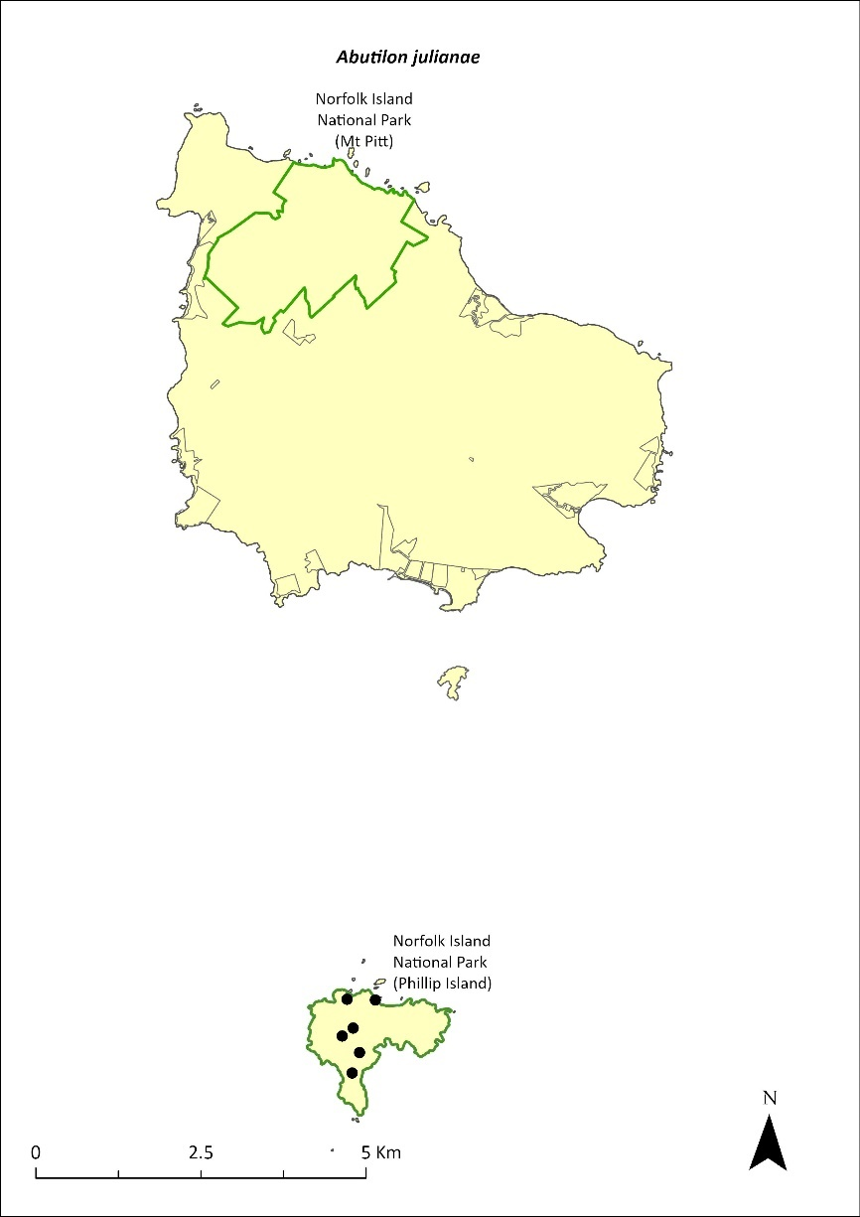
Green outlines indicate reserves within which the species can be found. Points show recorded locations (Mills 2009b).

Impact on other species
None known.

Risk assessment
Risk assessment undertaken for Critically Endangered trees/shrubs as a grouping. The risk assessment is shown in Table 63.
Table 63 Risk assessment for Critically Endangered trees/shrubs as a grouping
Risk | Likelihood of exposure | Consequence | Threat rating
1. Loss and fragmentation of native vegetation through past land clearing | Almost certain (91–100%) | Extreme | Extreme
2. Loss and fragmentation of native vegetation through current or future land clearing | Rare (0–10%) | Negligible | Negligible
3. Degradation of native vegetation through past grazing or loss of nutrients | Almost certain (91–100%) | Extreme | Extreme
4. Degradation of native vegetation through current or future grazing | Possible (26–50%) | Moderate | Medium
6. Predation by rodents | Possible (26–50%) | Minor | Low
7. Predation by cats | Rare (0–10%) | Negligible | Negligible
8. Predation or damage by chickens | Likely (51–90%) | Moderate | Medium
9. Predation by swamphens | Rare (0–10%) | Negligible | Negligible
10. Predation by Argentine ant | Possible (26–50%) | Minor | Low
11. Competition from/change of habitat because of weed invasion | Likely (51–90%) | Major | High
12. Infection by pathogens already present | Rare (0–10%) | Negligible | Negligible
13. Impacts of potential new invasive species or pathogens | Unlikely (11–25%) | Minor | Low
14. Changes to vegetation, increased fire risk and/or direct physiological stress as a result of climatic changes | Possible (26–50%) | Moderate | Medium
15. Problems caused by small populations, including lack of genetic diversity | Almost certain (91–100%) | Moderate | High

Management actions
Continue re-establishing a wild population on Norfolk Island by raising plants from seeds and planting out established plants in suitable habitat with protection from invasive herbivores; undertake regular monitoring to identify factors affecting their survival. Implement targeted weed control and maintenance and ongoing rat and chicken control. Exclude grazing from areas known to contain A. julianae.

Recovery target
The recovery target is shown in Table 64.
Table 64 Recovery target for Abutilon julianae
EPBC Act status | Estimated population (2023) | Where known populations occur | 2034 target
Critically Endangered | 227 | >95% within the national park | 1000

Relevant literature
Mills K (2009b) The Vegetation of Phillip Island, Norfolk Island Group. Envirofund 2007/2008. Kevin Mills & Associates, Jamberoo, NSW.
Mills K (2012b) The Flora of Norfolk Island. Report 14. The Endangered Plants in the national park: Field Survey and Review. Kevin Mills & Associates, Jamberoo, NSW.
Orchard A (ed) (1994) Flora of Australia. Vol. 49. Oceanic Islands 1. Australian Government Publishing Service, Canberra.
Sykes W & Atkinson I (1988) Rare and Endangered Plants of Norfolk Island. Unpublished report to the Australian National Parks and Wildlife Service, Norfolk Island.

Achyranthes arborescens—chaff tree, soft-wood
Family AMARANTHACEAE

Conservation significance
Endemic to Norfolk Island.
EPBC Act Listing Status: Critically Endangered.

Description
Soft-wooded trees to 9m tall.

Distribution and abundance
Occurs in in viny hardwood forest, in valleys extending southwards and south-east from Mt Pitt and Mt Bates, with 99% of the natural population in Norfolk Island National Park (Sykes & Atkinson 1988).
Only 55 individuals were located in 1988 (Sykes & Atkinson 1988) and the species had declined further by 1989, particularly in Filmy Fern Gully (Gilmour & Helman 1989b).
The total number of mature individuals in 2003 was 57 and the population was severely fragmented, with none of the four subpopulations containing more than 40 individuals (TSSC 2003d). Outside the national park it occurs in moist valleys, with three mature trees and some natural regeneration identified.
Propagation and planting in the national park, particularly in the valleys, greatly increased the population of the species. 109 plants were recorded in 2012 ranging from seedlings to trees, and mainly growing on valley floors where the species had been planted (Mills 2012b). A few individuals have also been planted in Hundred Acres Reserve and Selwyn Reserve.
The population estimate in 2021 was 391 individuals. Propagation has occurred through the Norfolk Island National Park threatened flora program.
The distribution is shown in Map 24.

Ecology
Requires canopy gaps to successfully establish. Established seedlings on valley floors can be washed away by heavy rain.

Habitat
Achyranthes arborescens can grow in the shade of Norfolk palm (Rhopalostylis baueri), occasionally on ridges but most commonly in gullies on valley floors or lower valley sides.

Threats
Weed invasion and competition, especially in suitable canopy gaps that are filled rapidly by wild tobacco (Solanum mauritianum) and vines such as coastal morning glory (Ipomoea cairica), which smothers young and adult plants (Sykes & Atkinson 1988). A. arborescens is also threatened by cattle grazing and predation of seeds by rats. Phytophthora cinnamomi is potentially a major risk.
Map 24 Distribution of Achyranthes arborescens
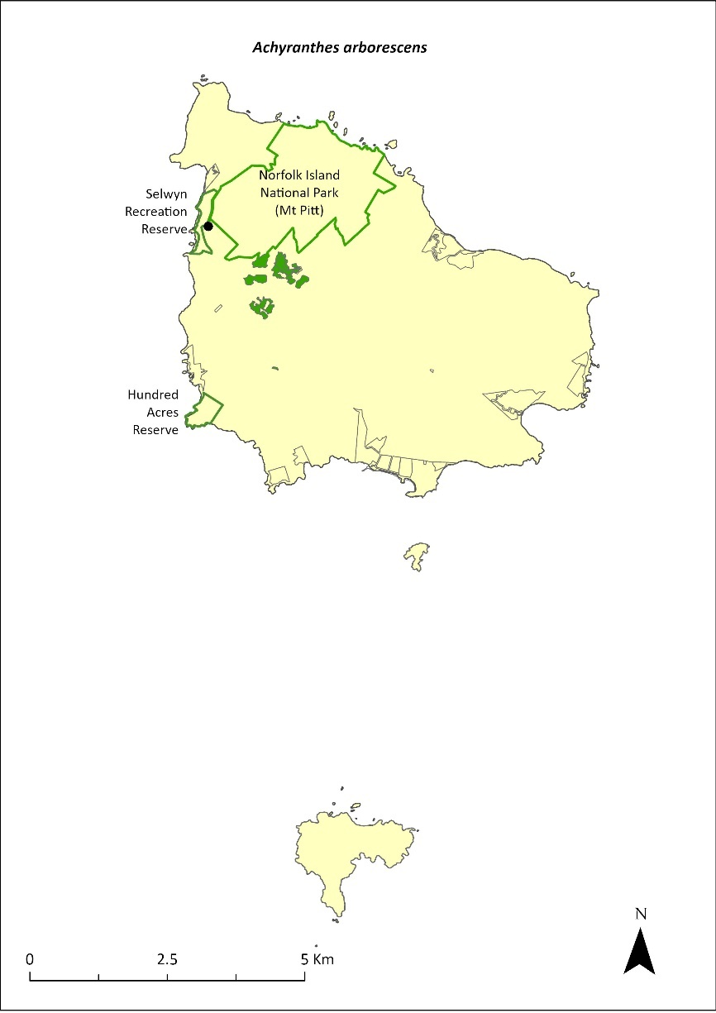
Green outlines indicate reserves within which the species occurs. Green shading shows plant communities within which the species may occur (Christian & Mills 2021). Points show recorded locations (Mills 2017d).

Impact on other species
None known.

Risk assessment
Risk assessment undertaken for Critically Endangered trees/shrubs as a grouping. The risk assessment is shown in Table 65.
Table 65 Risk assessment for Critically Endangered trees/shrubs as a grouping
Risk | Likelihood of exposure | Consequence | Threat rating
1. Loss and fragmentation of native vegetation through past land clearing | Almost certain (91–100%) | Extreme | Extreme
2. Loss and fragmentation of native vegetation through current or future land clearing | Rare (0–10%) | Negligible | Negligible
3. Degradation of native vegetation through past grazing or loss of nutrients | Likely (51–90%) | Major | High
4. Degradation of native vegetation through current or future grazing | Rare (0–10%) | Minor | Negligible
6. Predation by rodents | Likely (51–90%) | Moderate | Medium
7. Predation by cats | Rare (0–10%) | Negligible | Negligible
8. Predation or damage by chickens | Likely (51–90%) | Moderate | Medium
9. Predation by swamphens | Rare (0–10%) | Negligible | Negligible
10. Predation by Argentine ant | Possible (26–50%) | Minor | Low
11. Competition from/change of habitat because of weed invasion | Likely (51–90%) | Major | High
12. Infection by pathogens already present | Possible (26–50%) | Moderate | Medium
13. Impacts of potential new invasive species or pathogens | Possible (26–50%) | Major | High
14. Changes to vegetation, increased fire risk and/or direct physiological stress as a result of climatic changes | Almost certain (91–100%) | Major | Extreme
15. Problems caused by small populations, including lack of genetic diversity | Almost certain (91–100%) | Major | Extreme

Management actions
Continue propagation and planting within canopy breaks following weed control. The species is difficult to propagate from seed but propagates well from cuttings. Remove introduced species such as wild tobacco and coastal morning glory in proximity to established plants to promote natural regeneration (Sykes & Atkinson 1988). Manage or exclude grazing in areas know to contain A. arborescens. Carry out rodent and chicken control.

Recovery target
The recovery target is shown in Table 66.
Table 66 Recovery target for Achyranthes arborescens
EPBC Act status | Estimated population (2023) | Where known populations occur | 2034 target
Critically Endangered | 391 | >95% within the national park  1% in the reserves | 1000

Relevant literature
Christian NE & Mills K (2021) Vegetation Mapping of Norfolk Island 2021. Unpublished data.
Gilmour PM & Helman CE (1989b) The Vegetation of Norfolk Island National Park. Report to the Australian National Parks and Wildlife Service, Norfolk Island.
Invasive Species Council & TierraMar (2021) The Native Plant Communities of Norfolk Island. Invasive Species Council, Katoomba, NSW.
Orchard A (ed) (1994) Flora of Australia. Vol. 49. Oceanic Islands 1. Australian Government Publishing Service, Canberra.
Mills K (2012b) The Flora of Norfolk Island. Report 14. The Endangered Plants in the national park: Field Survey and Review. Kevin Mills & Associates, Jamberoo, NSW.
Mills K (2017d) Survey of public reserves on Norfolk Island for threatened plant species: 6. Anson Bay Reserve and Selwyn Reserve. Prepared for Norfolk Island Regional Council.
Sykes W & Atkinson I (1988) Rare and Endangered Plants of Norfolk Island. Unpublished report to the Australian National Parks and Wildlife Service, Norfolk Island.
TSSC (Threatened Species Scientific Committee) (2003d) Commonwealth Listing Advice—Critically Endangered Achyranthes arborescens (Chaff Tree, Soft-wood).

Achyranthes margaretarum—Phillip Island chaffy tree
Family AMARANTHACEAE

Conservation significance
Endemic to Phillip Island.
EPBC Act Listing Status: Critically Endangered.

Description
A compact shrub to 2–3 m high with maroon flowers.

Distribution and abundance
A single 2 m tall Achyranthes margaretarum specimen was discovered on Phillip Island in the late 1980s following the removal of rabbits. Although this specimen died in the early 1990s it left numerous seedlings, of which ten or so survived to maturity (de Lange & Murray 2001). By March 1999 the wild population stood at 10 adult specimens together with numerous saplings and seedlings. These wild occurrences were further supplemented by the successful translocation of 10 additional seedlings to other parts of the island (de Lange & Murray 2001).
Mills (2009b) noted that plants were naturally regenerating on Phillip Island, but the population was quite small; 22 plants were found, ranging in size from seedlings to shrubs, seven of which were over one metre tall. It is now found in the upper section of Long Valley at Owen’s Camp on Phillip Island (Mills 2009b; M Wilson 2024. pers comm 12 January). Counts in 2021 showed a decline in the population to 14.
A. margaretarum has been established back on Norfolk Island in revegetation plantings within the national park.
The distribution is shown in Map 25.

Ecology
Reaches sexual maturity within two years from seed germination (de Lange & Murray 2001).

Habitat
Found growing at 180 m above sea level, in association with Norfolk Island flax (Phormium tenax), under a dense canopy of white oak (Lagunaria patersonia). The plants show a preference for canopy gaps where flax growth is less dense (de Lange & Murray 2001).

Threats
Prior to feral animal eradication on Phillip Island, A. margaretarum was threatened by grazing from pigs, goats and rabbits. The loss of vegetation and high levels of erosion from that grazing now reduces the ability of the species to recolonise the island. The weed species bleeding heart (Homolanthus populifolius) and wild tobacco (Solanum mauritianum) compete with A. margaretarum and may threaten its establishment in high-light areas. The species is also threatened by small population size, which can lead to low genetic diversity and an increased risk of extinction through natural events such as cyclones, slips and drought. Phytophthora cinnamomi is potentially a major risk.
Map 25 Distribution of Achyranthes margaretarum
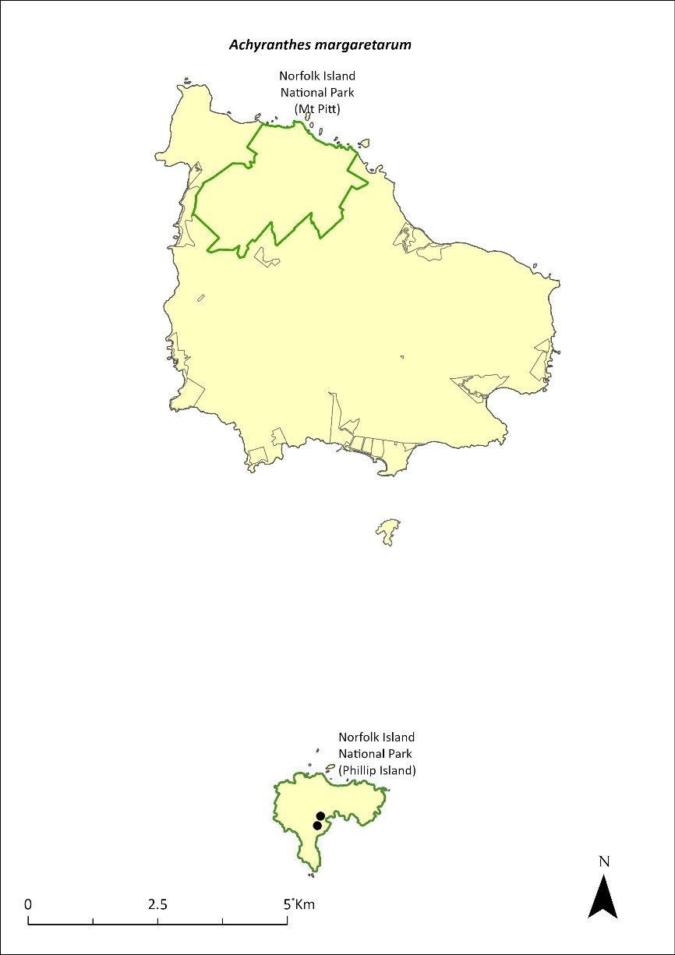
Green outlines indicate reserves within which the species occurs. Points show recorded locations (Mills 2009b).

Impact on other species
None known.

Risk assessment
Risk assessment undertaken for Critically Endangered trees/shrubs as a grouping. The risk assessment is shown in Table 67.
Table 67 Risk assessment for Critically Endangered trees/shrubs as a grouping
Risk | Likelihood of exposure | Consequence | Threat rating
1. Loss and fragmentation of native vegetation through past land clearing | Almost certain (91–100%) | Extreme | Extreme
2. Loss and fragmentation of native vegetation through current or future land clearing | Rare (0–10%) | Negligible | Negligible
3. Degradation of native vegetation through past grazing or loss of nutrients | Almost certain (91–100%) | Major | Extreme
4. Degradation of native vegetation through current or future grazing | Rare (0–10%) | Minor | Negligible
6. Predation by rodents | Rare (0–10%) | Unknown | Unknown
7. Predation by cats | Rare (0–10%) | Negligible | Negligible
8. Predation or damage by chickens | Likely (51–90%) | Moderate | Medium
9. Predation by swamphens | Rare (0–10%) | Negligible | Negligible
10. Predation by Argentine ant | Possible (26–50%) | Minor | Low
11. Competition from/change of habitat because of weed invasion | Likely (51–90%) | Major | High
12. Infection by pathogens already present | Possible (26–50%) | Moderate | Medium
13. Impacts of potential new invasive species or pathogens | Possible (26–50%) | Moderate | Medium
14. Changes to vegetation, increased fire risk and/or direct physiological stress as a result of climatic changes | Almost certain (91–100%) | Major | Extreme
15. Problems caused by small populations, including lack of genetic diversity | Almost certain (91–100%) | Extreme | Extreme

Management actions
Undertake propagation in the Phillip Island nursery and continue planting at Phillip Island (though plantings on Norfolk Island may act as an insurance population). Continue habitat restoration, including targeted weed control, at Phillip Island to provide suitable habitat for the species.

Recovery target
The recovery target is shown in Table 68.
Table 68 Recovery target for Achyranthes margaretarum
EPBC Act status | Estimated population (2023) | Where known populations occur | 2034 target
Critically Endangered | 14 | 100% within the national park | 500

Relevant literature
de Lange PJ & Murray BG (2001) A new Achyranthes (Amaranthaceae) from Phillip Island, Norfolk Island Group, South Pacific Ocean. New Zealand Journal of Botany 39, 1–8.
Mills K (2009b) The Vegetation of Phillip Island, Norfolk Island Group. Envirofund 2007/2008. Kevin Mills & Associates, Jamberoo, NSW.
Wilson M (2024) Personal communication by email, 12 January 2024, Parks Australia (Norfolk Island National Park).

Anthosachne kingiana kingiana—Phillip Island wheat-grass
Family POACEAE

Conservation significance
Endemic to Norfolk Island and Lord Howe Island.
EPBC Act Listing Status: Critically Endangered.
For further information on the species outside of the Norfolk Island Group, see the species profile on SPRAT.

Description
A tufted perennial grass growing 30–100 cm tall with glaucous leaves.
This species is cryptic unless containing flowering heads and difficult to find. It is easily confused with Elymus spp.

Distribution and abundance
A very rare grass found only on Phillip Island, Anthosachne kingiana kingiana was rediscovered in 1987 following the removal of rabbits. Several small patches were found growing on north facing slopes towards the upper part of the island (Sykes & Atkinson 1988).
A. kingiana kingiana has not been recorded on Norfolk Island since 1963 (DEH 2003). It was previously reported from Second Sands and Point Ross (Connor 1990; Mills 2009b). Occurrences of the species on Norfolk Island are likely to be through artificial propagation and translocation (DEH 2003).
There were fewer than 50 mature individuals in 2003 (TSSC 2003a). Two small populations were found by Mills (2009b) above the dykes area and on the cliff edge on the southern side of Stony Valley on Phillip Island. The estimated population in 2021 was five individuals.
The distribution within the Norfolk Island Group is shown in Map 26.

Ecology
Little known.

Habitat
Grows on the north-facing slopes of Phillip Island in high areas, among tall herbs and subshrubs, often in association with a herb community dominated by pigface (Carpobrotus glaucescens).

Threats
Prior to feral animal eradication on Phillip Island, the major threat to the species was grazing from pigs, goats and rabbits. The loss of vegetation and high levels of erosion from that grazing now reduces the ability of the species to recolonise the island.
Current threats are the small population size and restricted distribution (Phillip Island) and as a result, an increased risk of extinction through natural events such as cyclones, slips and drought. Weed invasion and competition is also a threat. Grazing by herbivores may be a threat if propagated on Norfolk Island.
Map 26 Distribution of Anthosachne kingiana kingiana
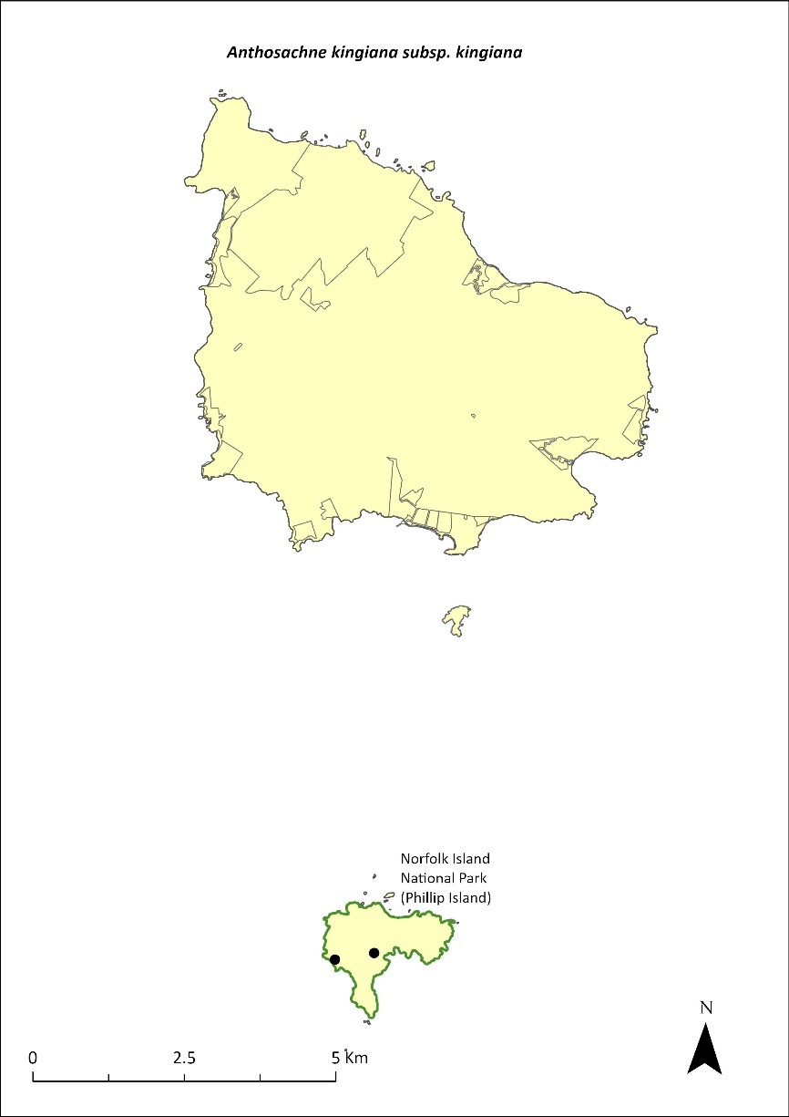
Green outlines indicate reserves within which the species occurs. Points show recorded locations (Mills 2009b).

Impact on other species
Little known.

Risk assessment
Risk assessment undertaken for Critically Endangered herbs/grasses as a grouping. The risk assessment is shown in Table 69.
Table 69 Risk assessment for Critically Endangered herbs/grasses as a grouping
Risk | Likelihood of exposure | Consequence | Threat rating
1. Loss and fragmentation of native vegetation through past land clearing | Almost certain (91–100%) | Extreme | Extreme
2. Loss and fragmentation of native vegetation through current or future land clearing | Rare (0–10%) | Negligible | Negligible
3. Degradation of native vegetation through past grazing or loss of nutrients | Almost certain (91–100%) | Extreme | Extreme
4. Degradation of native vegetation through current or future grazing | Possible (26–50%) | Moderate | Medium
6. Predation by rodents | Rare (0–10%) | Negligible | Negligible
7. Predation by cats | Rare (0–10%) | Negligible | Negligible
8. Predation or damage by chickens | Rare (0–10%) | Negligible | Negligible
9. Predation by swamphens | Rare (0–10%) | Negligible | Negligible
10. Predation by Argentine ant | Rare (0–10%) | Negligible | Negligible
11. Competition from/change of habitat because of weed invasion | Almost certain (91–100%) | Major | Extreme
12. Infection by pathogens already present | Rare (0–10%) | Negligible | Negligible
13. Impacts of potential new invasive species or pathogens | Unlikely (11–25%) | Minor | Low
14. Changes to vegetation, increased fire risk and/or direct physiological stress as a result of climatic changes | Possible (26–50%) | Moderate | Medium
15. Problems caused by small populations, including lack of genetic diversity | Almost certain (91–100%) | Major | Extreme

Management actions
Undertake surveys to search for individuals and conduct research to better understand the ecology of the species. Map distribution and determine conditions for successful germination. Monitor populations during late spring. Propagate on Phillip Island for use in rehabilitation work. Propagate on Norfolk Island and use to establish further populations in coastal habitat. Exclude grazing from any new populations established on Norfolk Island. Implement targeted weed control and maintenance.
The Lord Howe Island Biodiversity Management Plan covers the recovery needs of this species on the Lord Howe Island group. Possible future actions may need to be undertaken in collaboration with the NSW Government as appropriate.

Recovery target
The recovery target is shown in Table 70.
Table 70 Recovery target for Anthosachne kingiana kingiana
EPBC Act status | Estimated population (2023) | Where known populations occur | 2034 target
Critically Endangered | 5 groups of plants | 100% within the national park | 100 groups of plants

Relevant literature
Connor HE (1990) Elymus (Gramineae) on Norfolk Island. Kew Bulletin 45, 680.
Department of the Environment and Heritage (DEH) (2003) What the Environment Protection and Biodiversity Conservation Act 1999 (EPBC Act) means for Norfolk Island. Department of the Environment and Heritage, Canberra.
Mills K (2009b) The Vegetation of Phillip Island, Norfolk Island Group. Envirofund 2007/2008. Kevin Mills & Associates, Jamberoo, NSW.
Orchard A (ed) (1994) Flora of Australia. Vol. 49. Oceanic Islands 1. Australian Government Publishing Service, Canberra.
Sykes W & Atkinson I (1988) Rare and Endangered Plants of Norfolk Island. Unpublished report to the Australian National Parks and Wildlife Service, Norfolk Island.
TSSC (Threatened Species Scientific Committee) (2003a) Commonwealth Listing Advice for Norfolk Island Flora – 11 Critically Endangered Species.

Blechnum norfolkianum—Norfolk Island water-fern
Family BLECHNACEAE

Conservation significance
Found on Norfolk Island and on other Pacific Islands.
EPBC Act Listing Status: Endangered.

Description
A medium-sized terrestrial fern with fronds growing to between 30 and 80cm long and a short erect rhizome (underground stem).

Distribution and abundance
Australian distribution is restricted to Norfolk Island but also occurs in the Kermadec Islands, Vanuatu, Samoa and the Society Islands (TSSC 2003c). It is listed in New Zealand as “at risk—sparse” because it exists as widely scattered, small subpopulations or has restricted ranges (de Lange et al. 2004).
The total number of plants recorded in 2012 in Norfolk Island National Park was 708, including small plants to mature individuals (Mills 2012b). Plants ranged from small ferns to plants over one metre in height, although most specimens were under 50 cm tall. There were marked differences between populations in the moister, southern valleys and the drier valleys on the northern side of the mountains. The number of plants counted in the wetter valleys averaged 22 plants per 100 metres of transect, while in the drier valleys the figure was 0.4 plants per 100 metres (Mills 2012b). The population is considered to have remained stable since 2012.
The distribution is shown in Map 27.

Ecology
The species is found in damp and shady places mostly occurring in the south-facing valleys of the Mt Pitt section of the national park (Sykes & Atkinson 1988), particularly on the upper slopes of Mt Bates.

Habitat
The species occupies moist palm valley forest along the watercourses in the national park, particularly those on the moister, southern side of the mountains (Mills 2012b).

Threats
Drought/dry conditions due to climate change. Changes to hydrology within the national park (Braggins 1996). Weed invasion and competition.

Impact on other species
None known.
Map 27 Distribution of Blechnum norfolkianum
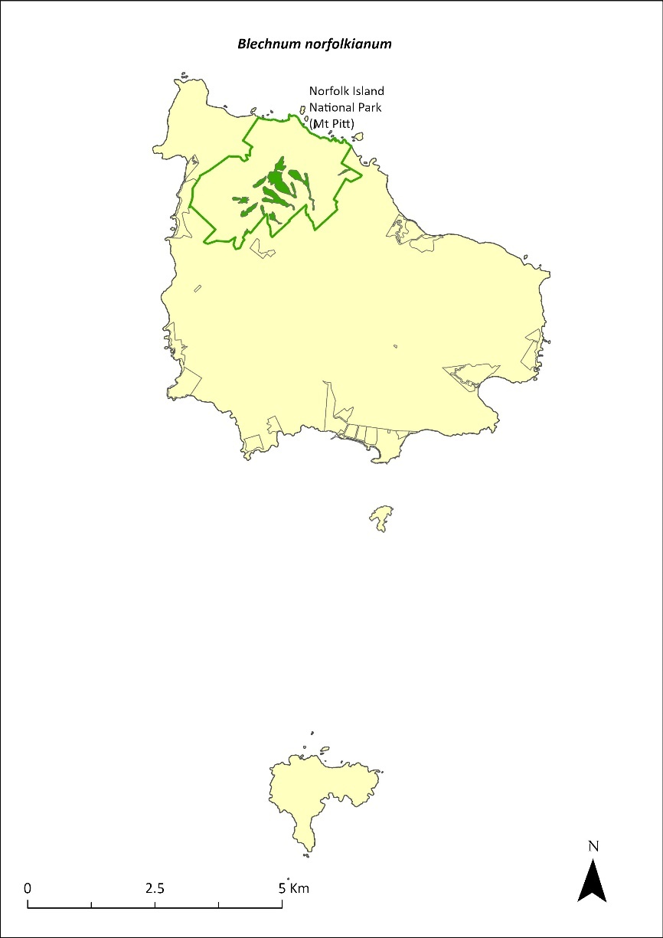
Green outlines indicate reserves within which the species occurs. Green shading shows plant communities within which the species may occur (Christian & Mills 2021).

Risk assessment
Risk assessment undertaken for Endangered ferns as a grouping. The risk assessment is shown in Table 71.
Table 71 Risk assessment for Endangered ferns as a grouping
Risk | Likelihood of exposure | Consequence | Threat rating
1. Loss and fragmentation of native vegetation through past land clearing | Almost certain (91–100%) | Extreme | Extreme
2. Loss and fragmentation of native vegetation through current or future land clearing | Rare (0–10%) | Negligible | Negligible
3. Degradation of native vegetation through past grazing or loss of nutrients | Almost certain (91–100%) | Extreme | Extreme
4. Degradation of native vegetation through current or future grazing | Possible (26–50%) | Moderate | Medium
6. Predation by rodents | Rare (0–10%) | Negligible | Negligible
7. Predation by cats | Rare (0–10%) | Negligible | Negligible
8. Predation or damage by chickens | Rare (0–10%) | Negligible | Negligible
9. Predation by swamphens | Rare (0–10%) | Negligible | Negligible
10. Predation by Argentine ant | Rare (0–10%) | Negligible | Negligible
11. Competition from/change of habitat because of weed invasion | Possible (26–50%) | Moderate | Medium
12. Infection by pathogens already present | Rare (0–10%) | Negligible | Negligible
13. Impacts of potential new invasive species or pathogens | Unlikely (11–25%) | Minor | Low
14. Changes to vegetation, increased fire risk and/or direct physiological stress as a result of climatic changes | Likely (51–90%) | Major | High
15. Problems caused by small populations, including lack of genetic diversity | Possible (26–50%) | Major | High

Management actions
Implement targeted weed control and maintenance. Implement revegetation/habitat restoration. Investigate potential for ex situ conservation (germplasm storage, propagation, replanting, representation in botanic gardens collections).

Recovery target
The recovery target is shown in Table 72.
Table 72 Recovery target for Blechnum norfolkianum
EPBC Act status | Estimated population (2023) | Where known populations occur | 2034 target
Critically Endangered | 5 | 100% within the national park | 100 groups of plants

Relevant literature
Braggins JE (1996) Report on the conservation status of the ferns of Norfolk Island. Unpublished report to the Australian Nature Conservation Agency.
Christian NE & Mills K (2021) Vegetation Mapping of Norfolk Island 2021. Unpublished data.
de Lange PJ, Johnson PN, Norton DA, Hitchmough R, Heenan PB, Courteney SP, Molloy B.P.J, Ogle C.C & Rance BD (2004) Threatened and uncommon plants of New Zealand. New Zealand Journal of Botany 42, 45–76.
Invasive Species Council & TierraMar (2021) The Native Plant Communities of Norfolk Island. Invasive Species Council, Katoomba, NSW.
Orchard A (ed) (1994) Flora of Australia. Vol. 49. Oceanic Islands 1. Australian Government Publishing Service, Canberra.
Mills K (2012b) The Flora of Norfolk Island. Report 14. The Endangered Plants in the national park: Field Survey and Review. Kevin Mills & Associates, Jamberoo, NSW.
Sykes W & Atkinson I (1988) Rare and Endangered Plants of Norfolk Island. Unpublished report to the Australian National Parks and Wildlife Service, Norfolk Island.
TSSC (Threatened Species Scientific Committee) (2003c) Commonwealth Listing Advice for Norfolk Island Flora – 16 Endangered Species.

Boehmeria australis australis—tree nettle, nettletree
Family URTICACEAE

Conservation significance
Endemic to Norfolk Island
EPBC Act Listing Status: Critically Endangered

Description
A small tree or large spreading shrub to 5m tall; monoecious (male and female flowers separate but found on the same tree).

Distribution and abundance
Found in the valleys east of Mt Bates and Mt Pitt, with only 16 individuals sighted during surveys in 1988 (Sykes & Atkinson 1988). Later surveys suggested Boehmeria australis australis was less rare than indicated with small numbers recorded at several sites on the northern side of Mt Bates, and about 30 individuals found in a protected forest remnant on private land (Gilmour & Helman 1989a).
By 2003 there were 33 mature individuals (TSSC 2003a), with a few healthy trees occurring in the north-east corner of the national park. Mills (2012b) noted that regeneration from planted specimens and natural recruitment had increased the population of B. australis australis significantly since 2003 and found a total of 259 plants in the national park, ranging from seedlings to mature plants.
The population has since increased to 591 individuals through propagation and planting as part of the Norfolk Island National Park threatened flora program.
The distribution is shown in Map 28.

Ecology
B. australis australis is a rapidly growing species with a short life span that is adapted to colonising extensive open sites where the ground has been exposed.

Habitat
Grows in an open sheltered habitat on the margins of rainforest remnants (Sykes & Atkinson 1988, Gilmour & Helman 1989a).

Threats
Weed invasion and competition from weeds such as Lantana (Lantana camara), William Taylor (Ageratina riparia), kikuyu grass (Cenchrus clandestinus) and wild tobacco (Solanum mauritianum). The species is also threatened by grazing in areas outside of the national park and attack by phytophagous insects (Sykes & Atkinson 1988). Phytophthora cinnamomi is potentially a major risk.
Map 28 Distribution of Boehmeria australis australis
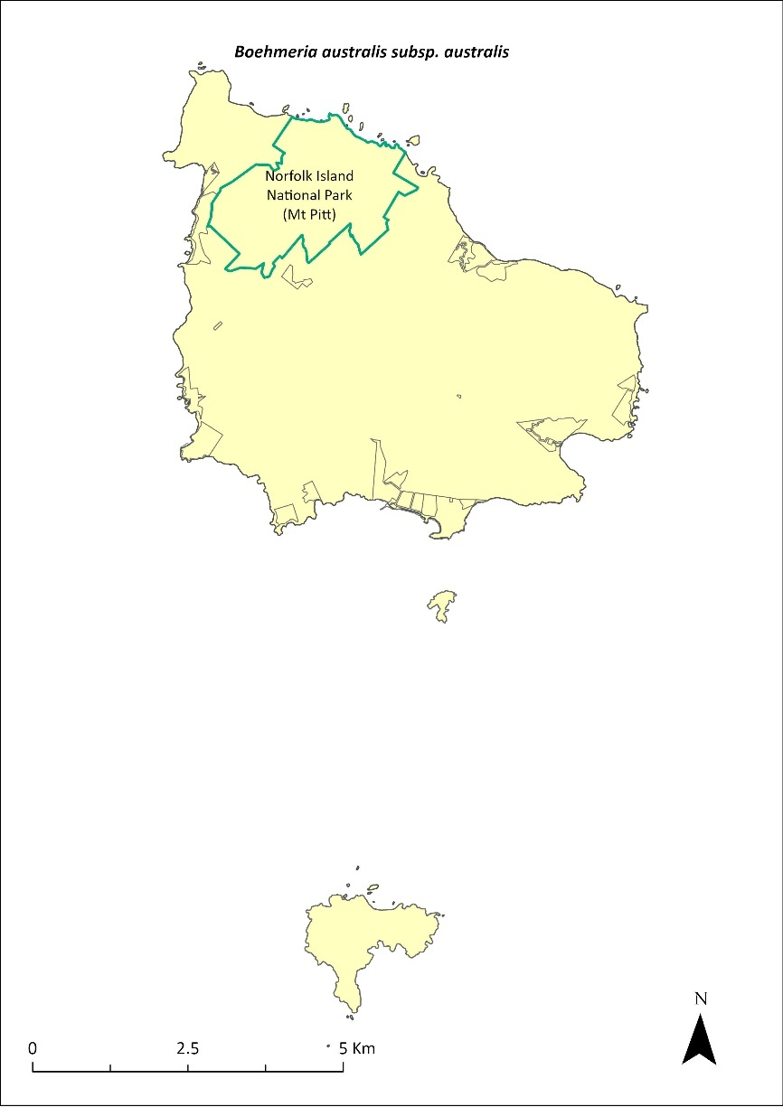
Green outlines indicate reserves within which the species occurs.

Impact on other species
None known.

Risk assessment
Risk assessment undertaken for Critically Endangered trees/shrubs as a grouping. The risk assessment is shown in Table 73.
Table 73 Risk assessment for Critically Endangered trees/shrubs as a grouping
Risk | Likelihood of exposure | Consequence | Threat rating
1. Loss and fragmentation of native vegetation through past land clearing | Almost certain (91–100%) | Extreme | Extreme
2. Loss and fragmentation of native vegetation through current or future land clearing | Rare (0–10%) | Negligible | Negligible
3. Degradation of native vegetation through past grazing or loss of nutrients | Almost certain (91–100%) | Extreme | Extreme
4. Degradation of native vegetation through current or future grazing | Possible (26–50%) | Moderate | Medium
6. Predation by rodents | Likely (51–90%) | Minor | Medium
7. Predation by cats | Rare (0–10%) | Negligible | Negligible
8. Predation or damage by chickens | Likely (51–90%) | Moderate | Medium
9. Predation by swamphens | Rare (0–10%) | Negligible | Negligible
10. Predation by Argentine ant | Possible (26–50%) | Minor | Low
11. Competition from/change of habitat because of weed invasion | Likely (51–90%) | Major | High
12. Infection by pathogens already present | Possible (26–50%) | Moderate | Medium
13. Impacts of potential new invasive species or pathogens | Unlikely (11–25%) | Minor | Low
14. Changes to vegetation, increased fire risk and/or direct physiological stress as a result of climatic changes | Possible (26–50%) | Moderate | Medium
15. Problems caused by small populations, including lack of genetic diversity | Almost certain (91–100%) | Major | Extreme

Management actions
Implement targeted weed control and maintenance to promote natural regeneration around mature plants of B. australis australis just before seed drop (summer and autumn; Sykes & Atkinson 1988). Establish populations through propagation and planting in suitable gully habitats in the public reserves; manage or exclude cattle grazing.

Recovery target
The recovery target is shown in Table 74.
Table 74 Recovery target for Boehmeria australis australis
EPBC Act status | Estimated population (2023) | Where known populations occur | 2034 target
Critically Endangered | 591 | >95% within national park | 1000

Relevant literature
Gilmour PM & Helman CE (1989a) A Survey of Quality Plant Communities of Norfolk Island Outside the national park. Report to the Australian National Parks and Wildlife Service, Norfolk Island.
Orchard A (ed) (1994) Flora of Australia. Vol. 49. Oceanic Islands 1. Australian Government Publishing Service, Canberra.
Mills K (2012b) The Flora of Norfolk Island. Report 14. The Endangered Plants in the national park: Field Survey and Review. Kevin Mills & Associates, Jamberoo, NSW.
Sykes W & Atkinson I (1988) Rare and Endangered Plants of Norfolk Island. Unpublished report to the Australian National Parks and Wildlife Service, Norfolk Island.
TSSC (Threatened Species Scientific Committee) (2003a) Commonwealth Listing Advice for Norfolk Island Flora – 11 Critically Endangered Species.

Calystegia affinis—a creeper
Family CONVOLVULACEAE

Conservation significance
Found only on Norfolk Island and Lord Howe Island.
EPBC Act Listing Status: Critically Endangered
State Listing Status: listed as Critically Endangered under the Biodiversity Conservation Act 2016 (NSW)
For further information on the species outside of the Norfolk Island Group, see the species profile on SPRAT.

Description
A thin stemmed climbing or creeping vine with sparse leaves.

Distribution and abundance
On Norfolk Island, 95% of the natural population of Calystegia affinis is found in the open higher parts of Mt Pitt and Mt Bates, though it occasionally comes up from dormant seed when forest or scrub is cleared (Sykes & Atkinson 1988). In 2003 the Norfolk Island population consisted of about 45 mature individuals (TSSC 2003a). In 2012, 13 plants were counted across five transects (Mills 2012b). The plants were all on the higher parts of Mount Pitt and Mount Bates, except for one plant near the Red Stone Link Track. The population estimate in 2021 was 28 individuals.
C. affinis is also found on Lord Howe Island but it is very rare, known from only four locations with possibly only one plant at each location, sprawling over an area of some square metres.
The distribution within the Norfolk Island Group is shown in Map 29.

Ecology
Stems take root when touching the soil. The species grows prolifically in the sun under cultivation.

Habitat
Found on the open higher parts of mountain tops on Norfolk and Lord Howe Islands.

Threats
The primary threats to the species are weed invasion and competition, and habitat clearing and modification through track maintenance.

Impacts on Other Species
Can climb vigorously over other plants in cultivation.
Map 29 Distribution of Calystegia affinis
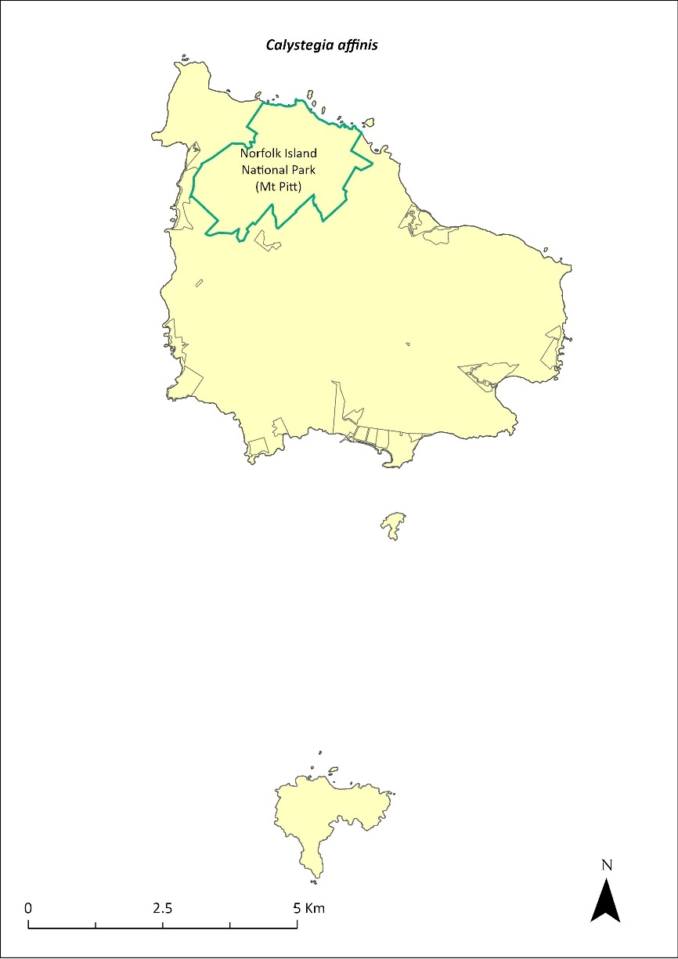
Green outlines indicate reserves within which the species occurs.

Risk assessment
Risk assessment undertaken for Critically Endangered vines/climbers as a grouping. The risk assessment is shown in Table 75.
Table 75 Risk assessment for Critically Endangered vines/climbers as a grouping
Risk | Likelihood of exposure | Consequence | Threat rating
1. Loss and fragmentation of native vegetation through past land clearing | Almost certain (91–100%) | Extreme | Extreme
2. Loss and fragmentation of native vegetation through current or future land clearing | Rare (0–10%) | Negligible | Negligible
3. Degradation of native vegetation through past grazing or loss of nutrients | Almost certain (91–100%) | Extreme | Extreme
4. Degradation of native vegetation through current or future grazing | Possible (26–50%) | Moderate | Medium
6. Predation by rodents | Almost certain (91–100%) | Major | Extreme
7. Predation by cats | Rare (0–10%) | Negligible | Negligible
8. Predation or damage by chickens | Rare (0–10%) | Negligible | Negligible
9. Predation by swamphens | Rare (0–10%) | Negligible | Negligible
10. Predation by Argentine ant | Rare (0–10%) | Negligible | Negligible
11. Competition from/change of habitat because of weed invasion | Almost certain (91–100%) | Major | Extreme
12. Infection by pathogens already present | Rare (0–10%) | Negligible | Negligible
13. Impacts of potential new invasive species or pathogens | Unlikely (11–25%) | Minor | Low
14. Changes to vegetation, increased fire risk and/or direct physiological stress as a result of climatic changes | Possible (26–50%) | Moderate | Medium
15. Problems caused by small populations, including lack of genetic diversity | Almost certain (91–100%) | Extreme | Extreme

Management actions
Undertake propagation and planting within suitable shaded areas. Undertake targeted weed control and maintenance.
The Lord Howe Island Biodiversity Management Plan covers the recovery needs of this species on the Lord Howe Island group. Possible future actions may need to be undertaken in collaboration with the NSW Government as appropriate.

Recovery target
The recovery target is shown in Table 76.
Table 76 Recovery target for Calystegia affinis
EPBC Act status | Estimated population (2023) | Where known populations occur | 2034 target
Critically Endangered | 28 groups of plants | 100% in the national park | 100 groups of plants

Relevant literature
Mills K (2012b) The Flora of Norfolk Island. Report 14. The Endangered Plants in the national park: Field Survey and Review. Kevin Mills & Associates, Jamberoo, NSW.
Sykes W & Atkinson I (1988) Rare and Endangered Plants of Norfolk Island. Unpublished report to the Australian National Parks and Wildlife Service, Norfolk Island.
TSSC (Threatened Species Scientific Committee) (2003a) Commonwealth Listing Advice for Norfolk Island Flora – 11 Critically Endangered Species.

Clematis dubia—clematis
Family RANUNCULACEAE

Conservation significance
Endemic to Norfolk Island.
EPBC Act Listing Status: Critically Endangered.

Description
A woody vigorous climber with hairy white flowers.

Distribution and abundance
Sykes and Atkinson (1988) note this vine was once common in the Mt Pitt and Mt Bates area but was not seen during surveys that year. In 2003 the natural population was confined to Norfolk Island National Park where there were 15 mature individuals recorded (TSSC 2003a).
Mills (2012b) found 53 plants but recorded only 3 as large plants. Seedlings were regularly found along transects. The species was also found on private land.
The population estimate has since increased to 303 individuals in 2021 through propagation and planting as part of the Norfolk Island National Park threatened flora program.
The distribution is shown in Map 30.

Ecology
This species will grow in light gaps and seeds rarely (every 4 to 5 years).

Habitat
This species grows on the forest margins and in clearings.

Threats
Weed invasion and competition.

Impact on other species
None known.
Map 30 Distribution of Clematis dubia
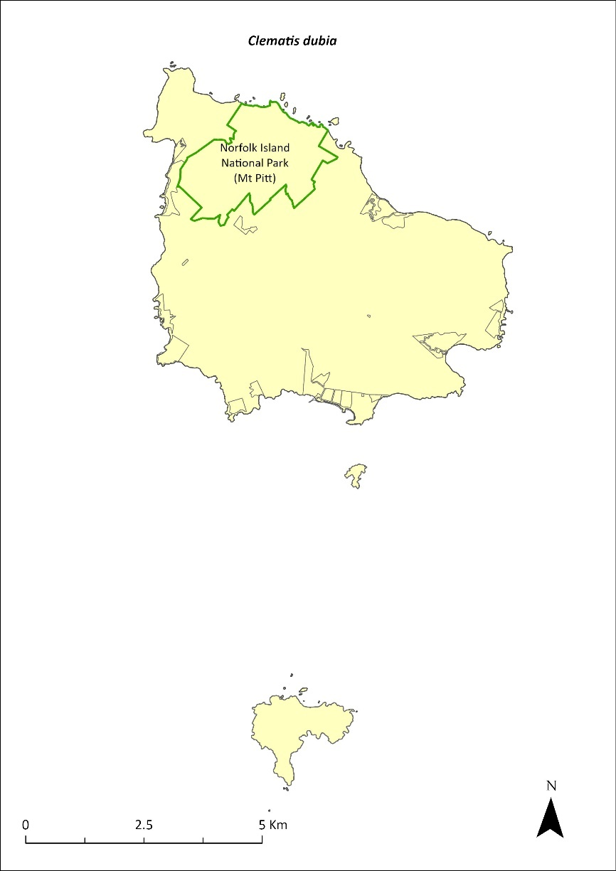
Green outlines indicate reserves within which the species occurs.

Risk assessment
Risk assessment undertaken for Critically Endangered vines/climbers as a grouping. The risk assessment is shown in Table 77.
Table 77 Risk assessment for Critically Endangered vines/climbers as a grouping
Risk | Likelihood of exposure | Consequence | Threat rating
1. Loss and fragmentation of native vegetation through past land clearing | Almost certain (91–100%) | Extreme | Extreme
2. Loss and fragmentation of native vegetation through current or future land clearing | Rare (0–10%) | Negligible | Negligible
3. Degradation of native vegetation through past grazing or loss of nutrients | Almost certain (91–100%) | Extreme | Extreme
4. Degradation of native vegetation through current or future grazing | Possible (26–50%) | Moderate | Medium
6. Predation by rodents | Unlikely (11–25%) | Major | Medium
7. Predation by cats | Rare (0–10%) | Negligible | Negligible
8. Predation or damage by chickens | Rare (0–10%) | Negligible | Negligible
9. Predation by swamphens | Rare (0–10%) | Negligible | Negligible
10. Predation by Argentine ant | Rare (0–10%) | Negligible | Negligible
11. Competition from/change of habitat because of weed invasion | Likely (51–90%) | Moderate | Medium
12. Infection by pathogens already present | Rare (0–10%) | Negligible | Negligible
13. Impacts of potential new invasive species or pathogens | Unlikely (11–25%) | Minor | Low
14. Changes to vegetation, increased fire risk and/or direct physiological stress as a result of climatic changes | Possible (26–50%) | Moderate | Medium
15. Problems caused by small populations, including lack of genetic diversity | Almost certain (91–100%) | Extreme | Extreme

Management actions
Continue propagation (from seeds and cuttings) and plantings within suitable areas. Undertake targeted weed control and maintenance around known plants. Undertake revegetation/habitat restoration.

Recovery target
The recovery target is shown in Table 78.
Table 78 Recovery target for Clematis dubia
EPBC Act status | Estimated population (2023) | Where known populations occur | 2034 target
Critically Endangered | 303 | 100% within the national park | 500

Relevant literature
Mills K (2012b) The Flora of Norfolk Island. Report 14. The Endangered Plants in the national park: Field Survey and Review. Kevin Mills & Associates, Jamberoo, NSW.
Sykes W & Atkinson I (1988) Rare and Endangered Plants of Norfolk Island. Unpublished report to the Australian National Parks and Wildlife Service, Norfolk Island.
TSSC (Threatened Species Scientific Committee) (2003a) Commonwealth Listing Advice for Norfolk Island Flora – 11 Critically Endangered Species.

Coprosma baueri—coastal coprosma
Family RUBIACEAE

Conservation significance
Endemic to Norfolk Island and Phillip Island.
EPBC Act Listing Status: Endangered.

Description
A shrub or small tree with light green glossy leaves, small green flowers and orange egg-shaped fruit.

Distribution and abundance
Historical records suggest Coprosoma baueri may have always been rare (Gilmour & Helman 1989b). It occurs along the sea cliffs and slopes of Norfolk Island and on the higher parts of Phillip Island in cliff edge shrubland (Mills 2009b).
There were 228 mature individuals present in 2003 (TSSC 2003c).
In 2008 Mills (2009b) recorded 446 plants on Phillip Island. Surveys of the reserves in 2017 recorded five plants in Headstone Reserve, seven plants in Kingston Common, two plants in Two Chimneys Reserve, and 31 in Selwyn Reserve (Mills 2017c, d and g).
The population had increased to 708 individuals in 2021. Propagation and planting have occurred through the Norfolk Island National Park threatened flora program.
The distribution is shown in Map 31.

Ecology
Dioecious with wind-pollinated flowers and bird-dispersed seeds. The species can grow in areas affected by salt spray.

Habitat
Grows within coastal pine and white oak forest, coastal white oak shrubland, and coastal flax communities (Invasive Species Council & TierraMar 2021), as well as on cliffs and other locations on the coast. The species can be extensively chewed by insects. On Phillip Island, it grows mainly on the coastal cliffs, and the healthiest plants exist in areas of loose soil fertilised by wedge-tailed shearwaters (Ardenna pacifica) nesting on the cliffs (Sykes & Atkinson 1988).

Threats
C. baueri is threatened by drought on Phillip Island and by its small population size, which leads to an increased risk of extinction through natural events such as cyclones, slips and drought. Weed invasion and competition is also a threat. Possible hybridisation could occur with the introduced species C. repens (Sykes & Atkinson 1988). Phytophthora cinnamomi is potentially a major risk.
Map 31 Distribution of Coprosma baueri
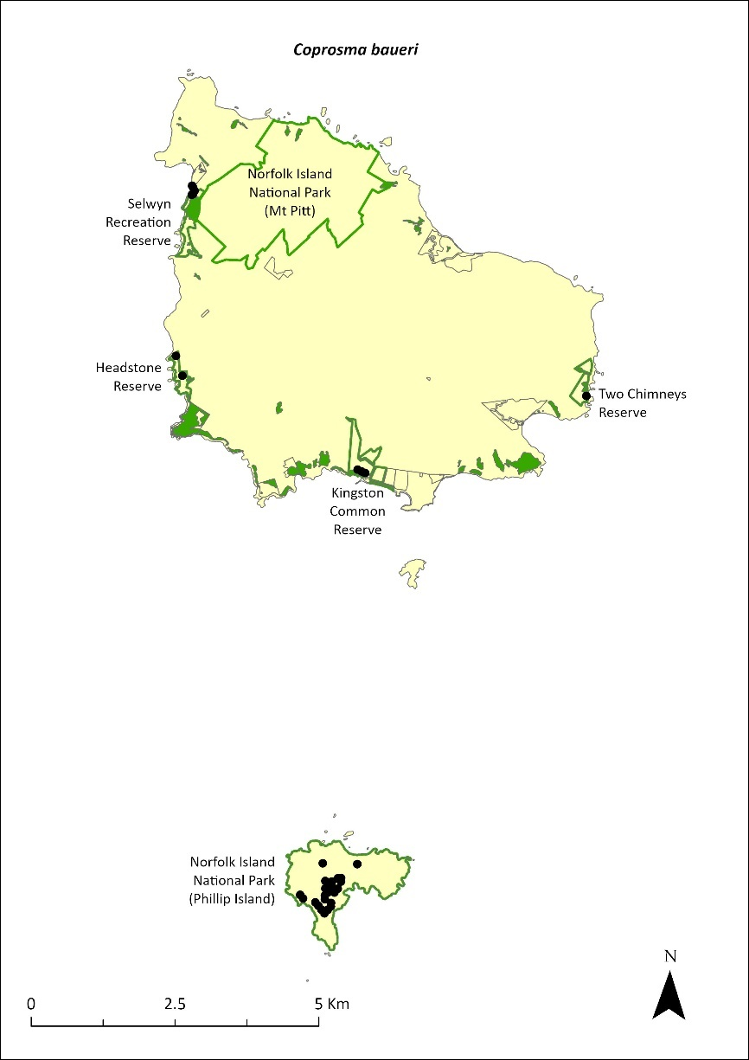
Green outlines indicate reserves within which the species occurs. Green shading shows plant communities within which the species may occur (Christian & Mills 2021). Points show recorded locations (Mills2009b and Mills 2017c d and g).

Impact on other species
None known.

Risk assessment
Risk assessment undertaken for Endangered trees/shrubs as a grouping. The risk assessment is shown in Table 79.
Table 79 Risk assessment for Endangered trees/shrubs as a grouping
Risk | Likelihood of exposure | Consequence | Threat rating
1. Loss and fragmentation of native vegetation through past land clearing | Almost certain (91–100%) | Extreme | Extreme
2. Loss and fragmentation of native vegetation through current or future land clearing | Rare (0–10%) | Negligible | Negligible
3. Degradation of native vegetation through past grazing or loss of nutrients | Almost certain (91–100%) | Extreme | Extreme
4. Degradation of native vegetation through current or future grazing | Possible (26–50%) | Moderate | Medium
6. Predation by rodents | Almost certain (91–100%) | Moderate | High
7. Predation by cats | Rare (0–10%) | Negligible | Negligible
8. Predation or damage by chickens | Likely (51–90%) | Moderate | Medium
9. Predation by swamphens | Rare (0–10%) | Negligible | Negligible
10. Predation by Argentine ant | Possible (26–50%) | Minor | Low
11. Competition from/change of habitat because of weed invasion | Possible (26–50%) | Moderate | Medium
12. Infection by pathogens already present | Possible (26–50%) | Moderate | Medium
13. Impacts of potential new invasive species or pathogens | Unlikely (11–25%) | Minor | Low
14. Changes to vegetation, increased fire risk and/or direct physiological stress as a result of climatic changes | Possible (26–50%) | Moderate | Medium
15. Problems caused by small populations, including lack of genetic diversity | Likely (51–90%) | Major | High

Management actions
Continue propagation and planting within suitable areas. Undertake targeted weed control and maintenance around existing plants. Undertake revegetation/habitat restoration. Support conservation of wedge-tailed shearwaters to promote C. baueri regeneration, as these birds help to maintain a nutrient-rich open habitat through their burrowing habit (Sykes & Atkinson 1988).

Recovery target
The recovery target is shown in Table 80.
Table 80 Recovery target for Coprosma baueri
EPBC Act status | Estimated population (2023) | Where known populations occur | 2034 target
Endangered | 708 | >90% within the national park  6% occurs within the reserves | 1500

Relevant literature
Christian NE & Mills K (2021) Vegetation Mapping of Norfolk Island 2021. Unpublished data.
Gilmour PM & Helman CE (1989b) The Vegetation of Norfolk Island National Park. Report to the Australian National Parks and Wildlife Service, Norfolk Island.
Invasive Species Council & TierraMar (2021) The Native Plant Communities of Norfolk Island. Invasive Species Council, Katoomba, NSW.
Mills K (2009b) The Vegetation of Phillip Island, Norfolk Island Group. Envirofund 2007/2008. Kevin Mills & Associates, Jamberoo, NSW.
Mills K (2017c) Survey of public reserves on Norfolk Island for threatened plant species: 1. The Kingston Reserves. Prepared for Norfolk Island Regional Council.
Mills K (2017d) Survey of public reserves on Norfolk Island for threatened plant species: 6. Anson Bay Reserve and Selwyn Reserve. Prepared for Norfolk Island Regional Council.
Mills K (2017g) Survey of public reserves on Norfolk Island for threatened plant species: 5. Two Chimneys Reserve. Prepared for Norfolk Island Regional Council.
Orchard A (ed) (1994) Flora of Australia. Vol. 49. Oceanic Islands 1. Australian Government Publishing Service, Canberra.
Sykes W & Atkinson I (1988) Rare and Endangered Plants of Norfolk Island. Unpublished report to the Australian National Parks and Wildlife Service, Norfolk Island.
TSSC (Threatened Species Scientific Committee) (2003c) Commonwealth Listing Advice for Norfolk Island Flora – 16 Endangered Species.

Coprosma pilosa—mountain coprosma
Family RUBIACEAE

Conservation significance
Endemic to Norfolk Island.
EPBC Act Listing Status: Endangered.

Description
Shrub or small tree to 6m tall with small green flowers, dark green hairy leaves and cone shaped dark bluish-purple fruit.

Distribution and abundance
The entire population of Coprosoma pilosa is found within the higher sections of Norfolk Island National Park and began to regenerate naturally following removal of cattle from the national park.
There were 260 individuals in 1995 (Anderson & Cochrane 1995) and 187 mature individuals in 2003 (TSSC 2003c). Mills (2012b) recorded 338 plants (ranging from small seedlings to mature trees) in the higher parts of the mountains in the national park. The population estimate in 2021 was 420 individuals.
The distribution is shown in Map 32.

Ecology
This species only seeds occasionally. Dioecious, with wind-pollinated flowers and bird-dispersed seeds.

Habitat
Occurs within moist upland hardwood forest and pine-hardwood ridge forest (Invasive Species Council & TierraMar 2021) and is almost entirely restricted to the higher parts of the mountains in the national park. Can be found down to about 180 metres, with very few growing at lower altitudes (Mills 2012b).

Threats
C. pilosa is threatened by its small population size/limited distribution and subsequent increased risk of extinction through natural events such as cyclones, slips and drought. Weed invasion and competition is also a threat. The epiphytic mistletoe (Ileostylus micranthus) favours C. pilosa as its host, and heavy infestations can kill the host plant. Changes in the climate of the mountain tops may threaten the species. Phytophthora cinnamomi is potentially a major risk.

Impact on other species
None known.
Map 32 Distribution of Coprosma pilosa
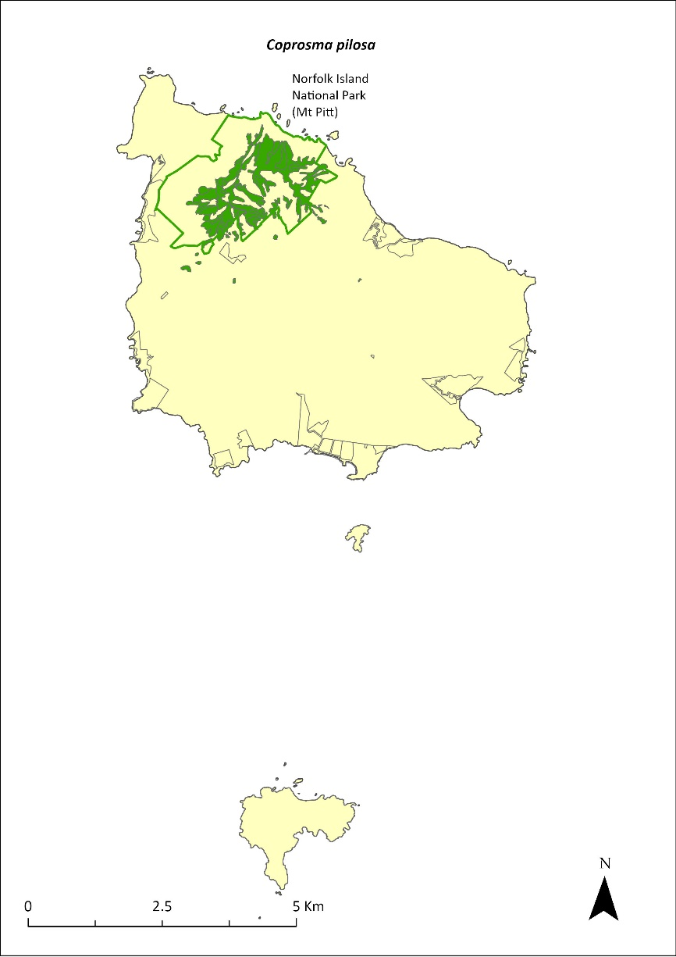
Green outlines indicate reserves within which the species occurs. Green shading shows plant communities within which the species may occur (Christian & Mills 2021).

Risk assessment
Risk assessment undertaken for Endangered trees/shrubs as a grouping. The risk assessment is shown in Table 81.
Table 81 Risk assessment for Endangered trees/shrubs as a grouping
Risk | Likelihood of exposure | Consequence | Threat rating
1. Loss and fragmentation of native vegetation through past land clearing | Almost certain (91–100%) | Extreme | Extreme
2. Loss and fragmentation of native vegetation through current or future land clearing | Rare (0–10%) | Negligible | Negligible
3. Degradation of native vegetation through past grazing or loss of nutrients | Almost certain (91–100%) | Extreme | Extreme
4. Degradation of native vegetation through current or future grazing | Possible (26–50%) | Moderate | Medium
6. Predation by rodents | Almost certain (91–100%) | Moderate | High
7. Predation by cats | Rare (0–10%) | Negligible | Negligible
8. Predation or damage by chickens | Likely (51–90%) | Moderate | Medium
9. Predation by swamphens | Rare (0–10%) | Negligible | Negligible
10. Predation by Argentine ant | Possible (26–50%) | Minor | Low
11. Competition from/change of habitat because of weed invasion | Possible (26–50%) | Moderate | Medium
12. Infection by pathogens already present | Possible (26–50%) | Moderate | Medium
13. Impacts of potential new invasive species or pathogens | Unlikely (11–25%) | Minor | Low
14. Changes to vegetation, increased fire risk and/or direct physiological stress as a result of climatic changes | Almost certain (91–100%) | Major | Extreme
15. Problems caused by small populations, including lack of genetic diversity | Almost certain (91–100%) | Major | Extreme

Management actions
Continue targeted weed control and maintenance around existing plants. Undertake revegetation/habitat restoration. Continue to exclude grazing.

Recovery target
The recovery target is shown in Table 82.
Table 82 Recovery target for Coprosma pilosa
EPBC Act status | Estimated population (2023) | Where known populations occur | 2034 target
Endangered | 420 | >95% within the national park | 1000

Relevant literature
Anderson JG & Cochrane K (1995) Assessment of Population Numbers of Norfolk’s Threatened Plants (Norfolk Island National Park). Report to the Australian Nature Conservation Agency, Norfolk Island.
Christian NE & Mills K (2021) Vegetation Mapping of Norfolk Island 2021. Unpublished data.
Invasive Species Council & TierraMar (2021) The Native Plant Communities of Norfolk Island. Invasive Species Council, Katoomba, NSW.
Orchard A (ed) (1994) Flora of Australia. Vol. 49. Oceanic Islands 1. Australian Government Publishing Service, Canberra.
Mills K (2012b) The Flora of Norfolk Island. Report 14. The Endangered Plants in the national park: Field Survey and Review. Kevin Mills & Associates, Jamberoo, NSW.
TSSC (Threatened Species Scientific Committee) (2003c) Commonwealth Listing Advice for Norfolk Island Flora – 16 Endangered Species.

Cordyline obtecta—Ti
Family AGAVACEAE

Conservation significance
Found only on Norfolk Island and in New Zealand.
EPBC Act Listing Status: Vulnerable.

Description
An erect shrub or tree to 10m tall with an erect pyramidal flower spike about 30cm long, grey bark, and whitish or blue-purple fruit.

Distribution and abundance
There were 818 mature individuals on Norfolk Island in 2003 (TSSC 2003b), with 65% of the population occurring within the Norfolk Island National Park. The population greatly improved over the next decade (Director of National Parks 2010) and had increased to 1863 individuals in 2021.
This species propagates well and has been planted in several public areas. On Phillip Island, it has been planted in the upper part of Long Valley (Mills 2009b). Abundant regeneration may take place following woody weed removal in the Mt Pitt section of the national park. The species has been planted in most of the public reserves.
The distribution is shown in Map 33.

Ecology
Little known.

Habitat
Grows in moist upland hardwood forest, pine-hardwood ridge forest, and lowland valley hardwood forest (Invasive Species Council & TierraMar 2021).

Threats
The main threats to Cordyline obtecta are cattle grazing and weed invasion and competition. Phytophthora cinnamomi is potentially a major risk.

Impact on other species
None known.
Map 33 Distribution of Cordyline obtecta
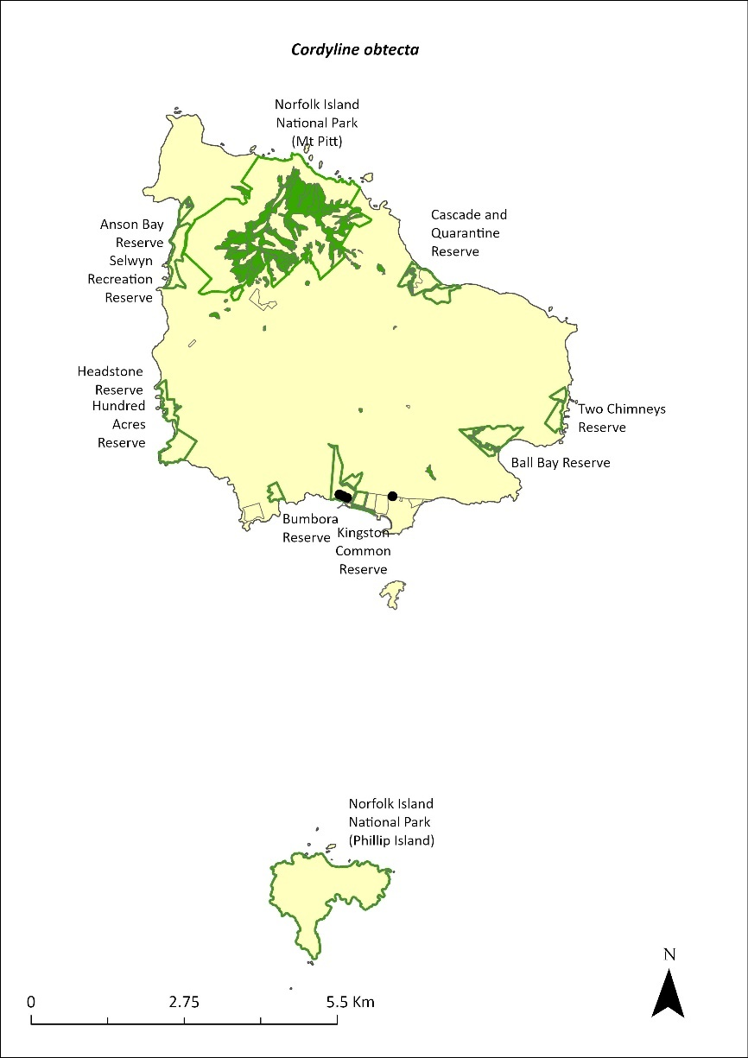
Green outlines indicate reserves within which the species occurs. Green shading shows plant communities within which the species may occur (Christian & Mills 2021). Points show recorded locations (Mills2017c).

Risk assessment
Risk assessment undertaken for Vulnerable trees/shrubs as a grouping. The risk assessment is shown in Table 83.
Table 83 Risk assessment for Vulnerable trees/shrubs as a grouping
Risk | Likelihood of exposure | Consequence | Threat rating
1. Loss and fragmentation of native vegetation through past land clearing | Almost certain (91–100%) | Extreme | Extreme
2. Loss and fragmentation of native vegetation through current or future land clearing | Rare (0–10%) | Negligible | Negligible
3. Degradation of native vegetation through past grazing or loss of nutrients | Almost certain (91–100%) | Extreme | Extreme
4. Degradation of native vegetation through current or future grazing | Possible (26–50%) | Moderate | Medium
6. Predation by rodents | Likely (51–90%) | Moderate | Medium
7. Predation by cats | Rare (0–10%) | Negligible | Negligible
8. Predation or damage by chickens | Rare (0–10%) | Negligible | Negligible
9. Predation by swamphens | Rare (0–10%) | Negligible | Negligible
10. Predation by Argentine ant | Possible (26–50%) | Minor | Low
11. Competition from/change of habitat because of weed invasion | Likely (51–90%) | Minor | Medium
12. Infection by pathogens already present | Possible (26–50%) | Moderate | Medium
13. Impacts of potential new invasive species or pathogens | Unlikely (11–25%) | Minor | Low
14. Changes to vegetation, increased fire risk and/or direct physiological stress as a result of climatic changes | Unlikely (11–25%) | Minor | Low
15. Problems caused by small populations, including lack of genetic diversity | Rare (0–10%) | Major | Low

Management actions
Continue targeted weed control and maintenance. Undertake revegetation/habitat restoration. Continue replanting in public reserves. Exclude or manage cattle grazing in public reserves.

Recovery target
The recovery target is shown in Table 84.
Table 84 Recovery target for Cordyline obtecta
EPBC Act status | Estimated population (2023) | Where known populations occur | 2034 target
Vulnerable | 1863 | >80% in the national park  >15% in public reserves | 3000

Relevant literature
Christian NE & Mills K (2021) Vegetation Mapping of Norfolk Island 2021. Unpublished data.
Invasive Species Council & TierraMar (2021) The Native Plant Communities of Norfolk Island. Invasive Species Council, Katoomba, NSW.
Mills K (2009b) The Vegetation of Phillip Island, Norfolk Island Group. Envirofund 2007/2008. Kevin Mills & Associates, Jamberoo, NSW.
Mills K (2017c) Survey of public reserves on Norfolk Island for threatened plant species: 1. The Kingston Reserves. Prepared for Norfolk Island Regional Council.
Orchard A (ed) (1994) Flora of Australia. Vol. 49. Oceanic Islands 1. Australian Government Publishing Service, Canberra.
TSSC (Threatened Species Scientific Committee) (2003b) Commonwealth Listing Advice for Norfolk Island Flora - 15 Vulnerable Species.

Dendrobium brachypus—Norfolk Island orchid
Family ORCHIDACEAE

Conservation significance
Endemic to Norfolk Island.
EPBC Act Listing Status: Endangered.

Description
An epiphytic orchid with two or three pale cream flowers on a short stem.

Distribution and abundance
There were fewer than 200 mature individuals present on Norfolk Island in 2003 (TSSC 2003c).
More than 90% of the population is in the Mt Pitt section of the national park and in the botanic garden. The distribution is shown in Map 34.
Map 34 Distribution of Dendrobium brachypus
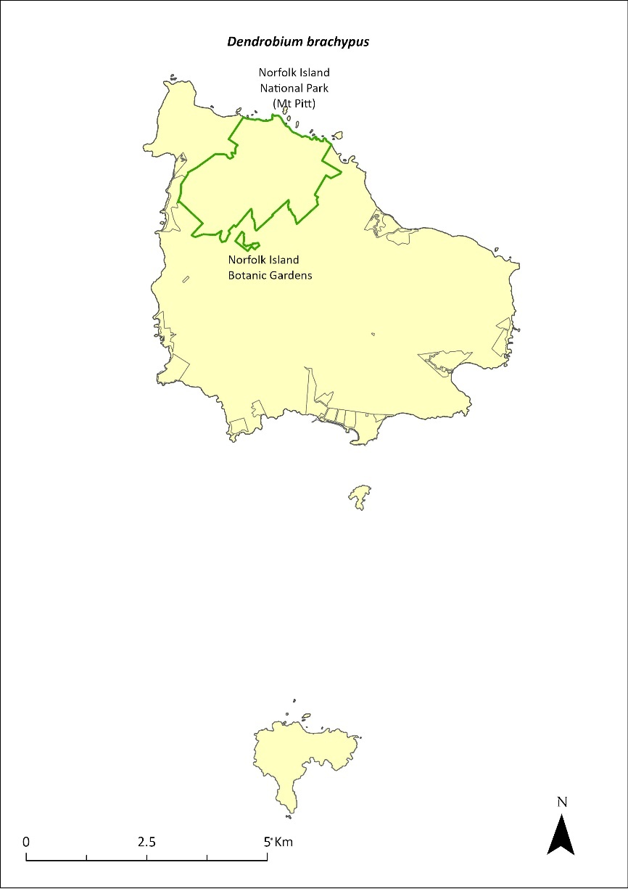
Green outlines indicate reserves within which the species occurs.

Ecology
Little known.

Habitat
Grows on tree branches in forest on the slopes of Mt Pitt.

Threats
Dendrobium brachypus is threatened by small population size and subsequent increased risk of extinction through natural events such as cyclones, slips and drought. Weed invasion and competition affecting host trees and climate change also threaten the species.

Impacts on other species
Grows on branches and stems of other plants but is not parasitic.

Risk assessment
Risk assessment undertaken for all threatened orchids as a grouping. The risk assessment is shown in Table 85.
Table 85 Risk assessment for all threatened orchids as a grouping
Risk | Likelihood of exposure | Consequence | Threat rating
1. Loss and fragmentation of native vegetation through past land clearing | Almost certain (91–100%) | Minor | Medium
2. Loss and fragmentation of native vegetation through current or future land clearing | Rare (0–10%) | Moderate | Negligible
3. Degradation of native vegetation through past grazing or loss of nutrients | Almost certain (91–100%) | Minor | Medium
4. Degradation of native vegetation through current or future grazing | Unlikely (11–25%) | Moderate | Low
6. Predation by rodents | Possible (26–50%) | Extreme | High
7. Predation by cats | Rare (0–10%) | Negligible | Negligible
8. Predation or damage by chickens | Rare (0–10%) | Negligible | Negligible
9. Predation by swamphens | Rare (0–10%) | Negligible | Negligible
10. Predation by Argentine ant | Rare (0–10%) | Negligible | Negligible
11. Competition from/change of habitat because of weed invasion | Possible (26–50%) | Moderate | Medium
12. Infection by pathogens already present | Unlikely (11–25%) | Moderate | Low
13. Impacts of potential new invasive species or pathogens | Unlikely (11–25%) | Moderate | Low
14. Changes to vegetation, increased fire risk and/or direct physiological stress as a result of climatic changes | Likely (51–90%) | Major | High
15. Problems caused by small populations, including lack of genetic diversity | Almost certain (91–100%) | Moderate | High

Management actions
This orchid may require development of species-specific conservation actions, including ex situ conservation. Undertake targeted weed control and maintenance around host trees, and habitat protection and rehabilitation. Undertake research into the ecology of the species.
Monitor/survey likely areas of the national park after storms, rescue any fallen specimens and attempt to cultivate them in the Norfolk Island National Park Nursery (Sykes & Atkinson 1988).

Recovery target
The recovery target is shown in Table 86.
Table 86 Recovery target for Dendrobium brachypus
EPBC Act status | Estimated population (2023) | Where known populations occur | 2034 target
Endangered | 200 | 100% in the national park | No decline

Relevant literature
Orchard A (ed) (1994) Flora of Australia. Vol. 49. Oceanic Islands 1. Australian Government Publishing Service, Canberra.
Sykes W & Atkinson I (1988) Rare and Endangered Plants of Norfolk Island. Unpublished report to the Australian National Parks and Wildlife Service, Norfolk Island.
TSSC (Threatened Species Scientific Committee) (2003c) Commonwealth Listing Advice for Norfolk Island Flora – 16 Endangered Species.

Dysoxylum bijugum—sharkwood
Family MELIACEAE

Conservation significance
Australian distribution is restricted to Norfolk Island but also occurs in New Caledonia and Vanuatu (TSSC 2003b).
EPBC Act Listing Status: Vulnerable.

Description
A tree growing to 7m with yellow flowers and a strong fetid or garlic-like smell when bruised.

Distribution and abundance
The Norfolk Island population of Dysoxylum bijugum consisted of 870 mature individuals in 2003 (TSSC 2003b) with about 90% of the population occurring in the national park. It also occurs in the Mission Road rainforest fragments, at Steeles Point and in Anson Reserve, Selwyn Reserve and Two Chimneys Reserve. There are pockets in the south-east and west of the national park where this species is the dominant tree. In these areas there are many small seedlings. On Phillip Island, this species has been planted in the upper part of Long Valley (Mills 2009b). The 2021 population estimate was 940 individuals and is considered stable.
The distribution is shown in Map 35.

Habitat
Grows in moist upland hardwood forest, pine-hardwood ridge forest and plateau hardwood forest (Invasive Species Council & TierraMar 2021).

Ecology
Little known.

Threats
D. bijugum is threatened by cattle grazing and weed invasion and competition. Phytophthora cinnamomi is potentially a major risk.

Impact on other species
None known.
Map 35 Distribution of Dysoxylum bijugum
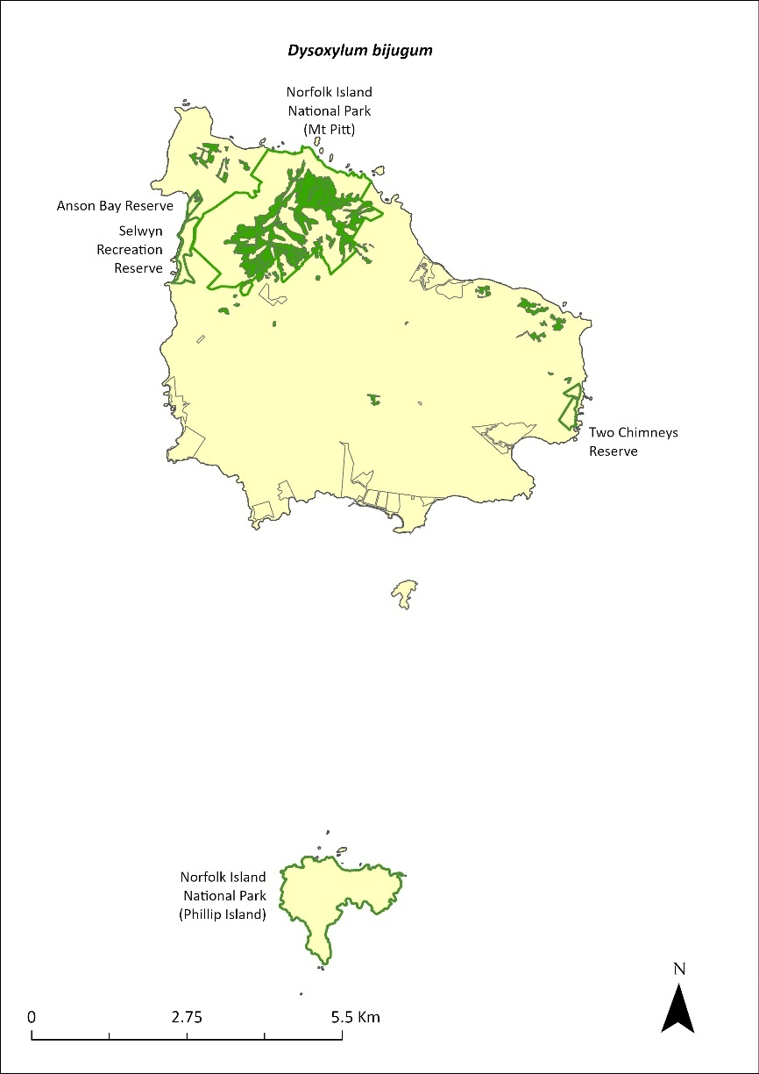
Green outlines indicate reserves within which the species occurs. Green shading shows plant communities within which the species may occur (Christian & Mills 2021).

Risk assessment
Risk assessment undertaken for Vulnerable trees/shrubs as a grouping. The risk assessment is shown in Table 87.
Table 87 Risk assessment for Vulnerable trees/shrubs as a grouping
Risk | Likelihood of exposure | Consequence | Threat rating
1. Loss and fragmentation of native vegetation through past land clearing | Almost certain (91–100%) | Extreme | Extreme
2. Loss and fragmentation of native vegetation through current or future land clearing | Rare (0–10%) | Negligible | Negligible
3. Degradation of native vegetation through past grazing or loss of nutrients | Almost certain (91–100%) | Extreme | Extreme
4. Degradation of native vegetation through current or future grazing | Possible (26–50%) | Moderate | Medium
6. Predation by rodents | Likely (51–90%) | Moderate | Medium
7. Predation by cats | Rare (0–10%) | Negligible | Negligible
8. Predation or damage by chickens | Rare (0–10%) | Negligible | Negligible
9. Predation by swamphens | Rare (0–10%) | Negligible | Negligible
10. Predation by Argentine ant | Possible (26–50%) | Minor | Low
11. Competition from/change of habitat because of weed invasion | Possible (26–50%) | Minor | Low
12. Infection by pathogens already present | Possible (26–50%) | Moderate | Medium
13. Impacts of potential new invasive species or pathogens | Unlikely (11–25%) | Minor | Low
14. Changes to vegetation, increased fire risk and/or direct physiological stress as a result of climatic changes | Possible (26–50%) | Minor | Low
15. Problems caused by small populations, including lack of genetic diversity | Rare (0–10%) | Minor | Negligible

Management actions
Undertake targeted weed control and maintenance. Undertake revegetation/habitat restoration. Exclude or manage cattle grazing. Undertake propagation and planting within suitable areas, including public reserves.

Recovery target
The recovery target is shown in Table 88.
Table 88 Recovery target for Dysoxylum bijugum
EPBC Act status | Estimated population (2023) |  | 2034 target
Vulnerable | 940 | >95% in the national park  1% in the reserves | 2000

Relevant literature
Christian NE & Mills K (2021) Vegetation Mapping of Norfolk Island 2021. Unpublished data.
Invasive Species Council & TierraMar (2021) The Native Plant Communities of Norfolk Island. Invasive Species Council, Katoomba, NSW.
Mills K (2009b) The Vegetation of Phillip Island, Norfolk Island Group. Envirofund 2007/2008. Kevin Mills & Associates, Jamberoo, NSW.
Orchard A (ed) (1994) Flora of Australia. Vol. 49. Oceanic Islands 1. Australian Government Publishing Service, Canberra.
TSSC (Threatened Species Scientific Committee) (2003b) Commonwealth Listing Advice for Norfolk Island Flora - 15 Vulnerable Species.

Elatostema montanum—mountain procris
Family URTICACEAE

Conservation significance
Endemic to Norfolk Island.
EPBC Act Listing Status: Critically Endangered.

Description
A fleshy, succulent-stemmed perennial herb or low shrub growing to 1m tall with a straggling habit.

Distribution and abundance
Gilmour & Helman (1989b) found the entire population of Elatostema montanum within the Mt Pitt section of the Norfolk Island National Park, and the largest known subpopulation declined between 1988 and 1989 (Gilmour & Helman 1989b).
Although not a detailed and comprehensive survey, 76 individuals were located in 2003 in seven severely fragmented subpopulations. No subpopulation contained more than 26 individuals, and only two subpopulations contained more than six individuals (TSSC 2003e).
In a 2012 survey the species was only found at a few rocky sites on the mountains and in valleys in moist locations near watercourses in the national park. It was found at three places along two transects where a total of 11 plants were counted (Mills 2012b).
The 2021 population estimate was 26 individuals.
The distribution is shown in Map 36.

Ecology
Monoecious. The plant propagates through division of the rather succulent stem and spreads as the stems produce roots on contact with the ground (Mills 2012b).

Habitat
This species occurs in damp shade within moist palm valley forest. It is found on cliffs behind shaded streams within the national park and is restricted to very steep rocky bands and cliffs in shaded valley bottoms where there is always adequate moisture (Sykes & Atkinson 1988). This species is affected by the erosion regime of the island—active down-cutting by streams might open new sites while heavy downpours might wipe out existing colonies (Sykes & Atkinson 1988).

Threats
The main threats to the species are weed invasion and competition—especially by weeds such William Taylor (Ageratina riparia) (TSSC 2003e)— and drought/dry conditions due to climate change.

Impact on other species
None known.
Map 36 Distribution of Elatostema montanum
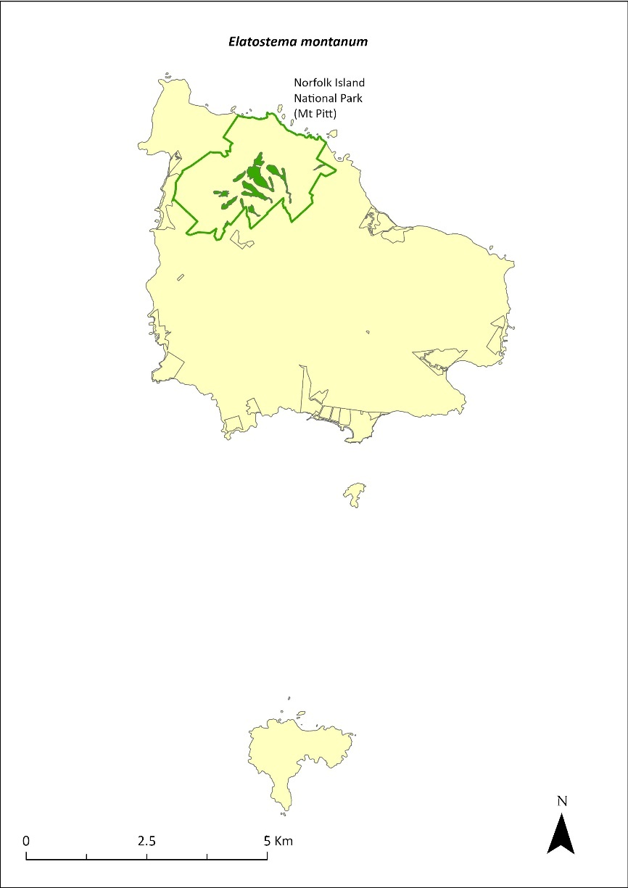
Green outlines indicate reserves within which the species occurs. Green shading shows plant communities within which the species may occur (Christian & Mills 2021).

Risk assessment
Risk assessment undertaken for Critically Endangered herbs/grasses as a grouping. The risk assessment is shown in Table 89.
Table 89 Risk assessment for Critically Endangered herbs/grasses as a grouping
Risk | Likelihood of exposure | Consequence | Threat rating
1. Loss and fragmentation of native vegetation through past land clearing | Almost certain (91–100%) | Extreme | Extreme
2. Loss and fragmentation of native vegetation through current or future land clearing | Rare (0–10%) | Negligible | Negligible
3. Degradation of native vegetation through past grazing or loss of nutrients | Almost certain (91–100%) | Extreme | Extreme
4. Degradation of native vegetation through current or future grazing | Possible (26–50%) | Moderate | Medium
6. Predation by rodents | Rare (0–10%) | Negligible | Negligible
7. Predation by cats | Rare (0–10%) | Negligible | Negligible
8. Predation or damage by chickens | Rare (0–10%) | Negligible | Negligible
9. Predation by swamphens | Rare (0–10%) | Negligible | Negligible
10. Predation by Argentine ant | Rare (0–10%) | Negligible | Negligible
11. Competition from/change of habitat because of weed invasion | Unlikely (11–25%) | Minor | Low
12. Infection by pathogens already present | Rare (0–10%) | Negligible | Negligible
13. Impacts of potential new invasive species or pathogens | Unlikely (11–25%) | Minor | Low
14. Changes to vegetation, increased fire risk and/or direct physiological stress as a result of climatic changes | Almost certain (91–100%) | Major | Extreme
15. Problems caused by small populations, including lack of genetic diversity | Almost certain (91–100%) | Moderate | High

Management actions
Undertake targeted weed control and maintenance around existing plants, ensuring shaded areas are not opened too quickly. Undertake revegetation/habitat restoration. Undertake propagation from cuttings or seed and plantings within suitable areas.

Recovery target
The recovery target is shown in Table 90.
Table 90 Recovery target for Elatostema montanum
EPBC Act status | Estimated population (2023) | Where known populations occur | 2034 target
Critically Endangered | 26 | 100% within the national park | 100

Relevant literature
Christian NE & Mills K (2021) Vegetation Mapping of Norfolk Island 2021. Unpublished data.
Invasive Species Council & TierraMar (2021) The Native Plant Communities of Norfolk Island. Invasive Species Council, Katoomba, NSW.
Gilmour PM & Helman CE (1989b) The Vegetation of Norfolk Island National Park. Report to the Australian National Parks and Wildlife Service, Norfolk Island.
Mills K (2012b) The Flora of Norfolk Island. Report 14. The Endangered Plants in the national park: Field Survey and Review. Kevin Mills & Associates, Jamberoo, NSW.
Sykes W & Atkinson I (1988) Rare and Endangered Plants of Norfolk Island. Unpublished report to the Australian National Parks and Wildlife Service, Norfolk Island.
TSSC (Threatened Species Scientific Committee) (2003e) Commonwealth Listing Advice—Critically Endangered Elatostema montanum (Mountain Procris, a herb).

Euphorbia norfolkiana—Norfolk Island euphorbia
Family EUPHORBIACEAE

Conservation significance
Endemic to Norfolk Island.
EPBC Act Listing Status: Critically Endangered.

Description
A dense low shrub usually growing to 1m but sometimes to 3m tall with olive green flowers.

Distribution and abundance
There were 38 mature individuals of Euphorbia norfolkiana known in 2003 (TSSC 2003a). A 2007 survey found a total of 104 plants on Norfolk Island, of which 42 plants were higher than 1m tall, including 12 plants in Bumbora Reserve and 5 plants in Ball Bay Reserve; most plants were on private land near Bumbora Reserve (Mills 2007d). In 2012 the species was decreasing in abundance, with only one small plant found in Bumbora Reserve, and 13 individuals counted on a transect in the valley east of Cook’s Monument in Norfolk Island National Park (Mills 2012b).
By 2021 the population had increased to 388, including 25 in Bumbora Reserve (planted in 2017) and 29 at Ball Bay Reserve (wild population) (Mills 2017a, b). The species has also been planted on Phillip Island (Mills 2009b).

Ecology
This species can establish on bare, loose soil but may need partial shade for the most effective establishment. Most plants establish below an open cover of pine.

Habitat
Occurs in in coastal pine and white oak forest (Invasive Species Council & TierraMar 2021), in open areas in light shade amidst coastal cliff vegetation, usually below pines.

Threats
Threats to the species include small population size and restricted distribution and subsequent increased risk of extinction through natural events such as cyclones, slips and drought; weed invasion and competition from weeds such as African olive (Olea europaea cuspidata) and kikuyu (Cenchrus clandestinus); and cattle grazing. Phytophthora cinnamomi is potentially a major risk.

Impact on other species
None known.
Map 37 Distribution of Euphorbia norfolkiana
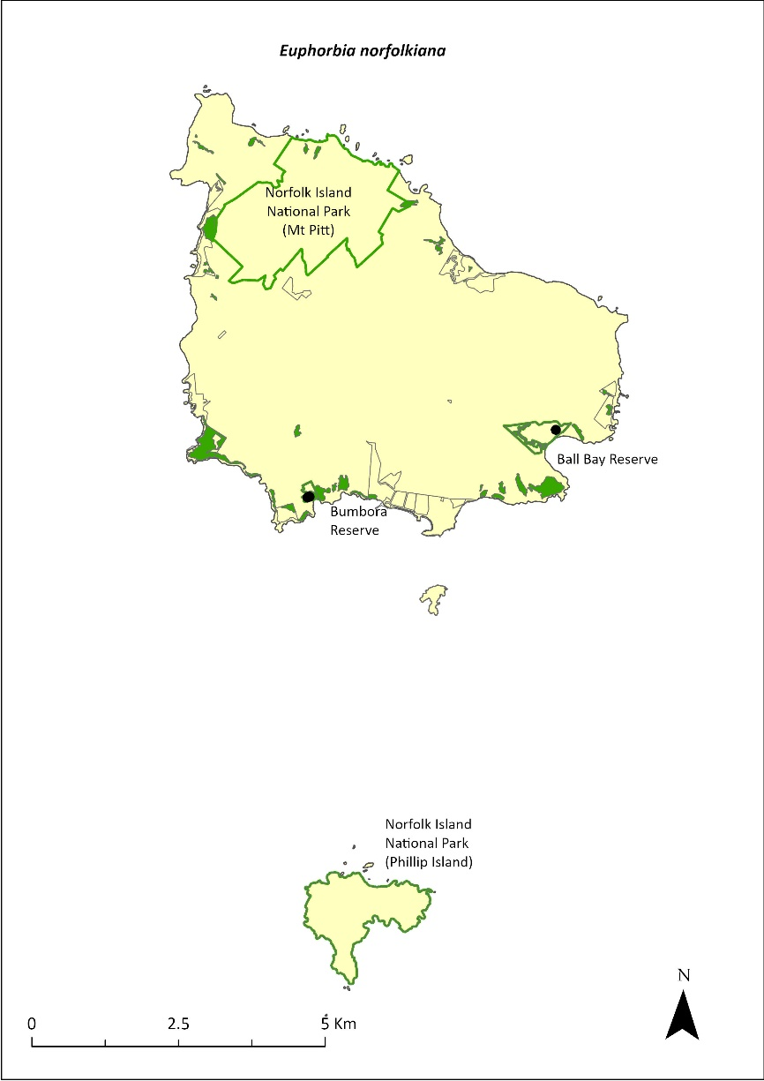
Green outlines indicate reserves within which the species occurs. Green shading shows plant communities within which the species may occur (Christian & Mills 2021). Points show recorded locations (Mills 2017a, b).

Risk assessment
Risk assessment undertaken for Critically Endangered trees/shrubs as a grouping. The risk assessment is shown in Table 91.
Table 91 Risk assessment for Critically Endangered trees/shrubs as a grouping
Risk | Likelihood of exposure | Consequence | Threat rating
1. Loss and fragmentation of native vegetation through past land clearing | Almost certain (91–100%) | Extreme | Extreme
2. Loss and fragmentation of native vegetation through current or future land clearing | Rare (0–10%) | Negligible | Negligible
3. Degradation of native vegetation through past grazing or loss of nutrients | Almost certain (91–100%) | Extreme | Extreme
4. Degradation of native vegetation through current or future grazing | Possible (26–50%) | Moderate | Medium
6. Predation by rodents | Almost certain (91–100%) | Major | Extreme
7. Predation by cats | Rare (0–10%) | Negligible | Negligible
8. Predation or damage by chickens | Likely (51–90%) | Moderate | Medium
9. Predation by swamphens | Rare (0–10%) | Negligible | Negligible
10. Predation by Argentine ant | Possible (26–50%) | Minor | Low
11. Competition from/change of habitat because of weed invasion | Possible (26–50%) | Moderate | Medium
12. Infection by pathogens already present | Possible (26–50%) | Moderate | Medium
13. Impacts of potential new invasive species or pathogens | Unlikely (11–25%) | Minor | Low
14. Changes to vegetation, increased fire risk and/or direct physiological stress as a result of climatic changes | Possible (26–50%) | Major | High
15. Problems caused by small populations, including lack of genetic diversity | Almost certain (91–100%) | Extreme | Extreme

Management actions
Undertake targeted weed control and maintenance around existing plants. Undertake revegetation/habitat restoration. Exclude or manage cattle grazing. Undertake propagation and planting in shaded areas under pines in coastal habitat across all land tenures. Plants should be grown to a reasonable size before being planted out to increase survival rates. Investigate suitable habitat below pines within One Hundred Acres Reserve.
Monitor existing populations and conduct searches in other areas (such as adjacent to Bumbora reserve and along the coast to Beefsteak).

Recovery target
The recovery target is shown in Table 92.
Table 92 Recovery target for Euphorbia norfolkiana
EPBC Act status | Estimated population (2023) | Where known populations occur | 2034 target
Critically Endangered | 388 | >85% within the national park  >10% within public reserves | 1000

Relevant literature
Christian NE & Mills K (2021) Vegetation Mapping of Norfolk Island 2021. Unpublished data.
Invasive Species Council & TierraMar (2021) The Native Plant Communities of Norfolk Island. Invasive Species Council, Katoomba, NSW.
Mills K (2007d) The Flora of Norfolk Island. 5. Field Survey of the Norfolk Island Endemic Shrub Euphorbia norfolkiana (Euphorbiaceae). Kevin Mills & Associates, Jamberoo, NSW.
Mills K (2009b) The Vegetation of Phillip Island, Norfolk Island Group. Envirofund 2007/2008. Kevin Mills & Associates, Jamberoo, NSW.
Mills K (2012b) The Flora of Norfolk Island. Report 14. The Endangered Plants in the national park: Field Survey and Review. Kevin Mills & Associates, Jamberoo, NSW.
Mills K (2017a) Survey of public reserves on Norfolk Island for threatened plant species: 3. Point Ross Reserve and Bumbora Reserve. Prepared for Norfolk Island Regional Council.
Mills K (2017b) Survey of public reserves on Norfolk Island for threatened plant species: 8. Ball Bay Reserve. Prepared for Norfolk Island Regional Council.
Sykes W & Atkinson I (1988) Rare and Endangered Plants of Norfolk Island. Unpublished report to the Australian National Parks and Wildlife Service, Norfolk Island.
TSSC (Threatened Species Scientific Committee) (2003a) Commonwealth Listing Advice for Norfolk Island Flora – 11 Critically Endangered Species.

Euphorbia obliqua—a herb
Family EUPHORBIACEAE

Conservation significance
Australian distribution restricted to Norfolk Island. Also occurs in New Caledonia and Vanuatu.
EPBC Act Listing Status: Vulnerable.

Description
A prostrate perennial herb with stems to 20cm long.

Distribution and abundance
The natural population of Euphorbia obliqua is mostly found outside of the Norfolk Island National Park; there were 530 mature individuals known in 2003 (TSSC 2003b).
The species has been reported from Emily Bay, Kingston, the rocks near the Old Salt House, and The Chord at Duncombe Bay (Orchard 1994). It is common on Nepean Island, where Mills (2009a) found 154 plants, mainly along the southern shoreline. Mills (2017c) counted 814 in Point Hunter Reserve, the major population of the species on Norfolk Island, and 49 in Kingston Recreation Reserve.
The population estimate in 2021 was 814 individuals.
The distribution is shown in Map 38.

Ecology
Little known.

Habitat
Occurs within sandy beach herbland (Invasive Species Council & TierraMar 2021). Found in calcarenite cracks and fissures in coralline and sometimes basaltic rocks by the sea, with a woody rootstock penetrating the fissures.

Threats
E. obliqua is threatened by small population size and subsequent increased risk of extinction through natural events such as cyclones and drought, specific habitat requirements, and weed invasion and competition.

Impact on other species
None known.
Map 38 Distribution of Euphorbia obliqua
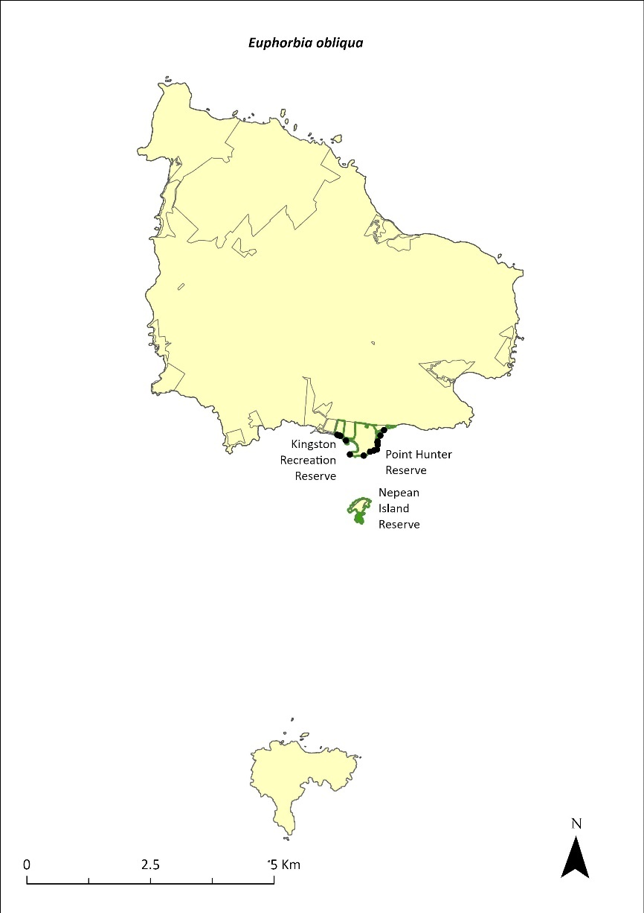
Green outlines indicate reserves within which the species occurs. Green shading shows plant communities within which the species may occur (Mills 2009a). Points show recorded locations (Mills2017c).

Risk assessment
Risk assessment undertaken for Vulnerable herbs/grasses as a grouping. The risk assessment is shown in Table 93.
Table 93 Risk assessment for Vulnerable herbs/grasses as a grouping
Risk | Likelihood of exposure | Consequence | Threat rating
1. Loss and fragmentation of native vegetation through past land clearing | Almost certain (91–100%) | Extreme | Extreme
2. Loss and fragmentation of native vegetation through current or future land clearing | Rare (0–10%) | Negligible | Negligible
3. Degradation of native vegetation through past grazing or loss of nutrients | Almost certain (91–100%) | Extreme | Extreme
4. Degradation of native vegetation through current or future grazing | Possible (26–50%) | Moderate | Medium
6. Predation by rodents | Rare (0–10%) | Negligible | Negligible
7. Predation by cats | Rare (0–10%) | Negligible | Negligible
8. Predation or damage by chickens | Rare (0–10%) | Negligible | Negligible
9. Predation by swamphens | Rare (0–10%) | Negligible | Negligible
10. Predation by Argentine ant | Rare (0–10%) | Negligible | Negligible
11. Competition from/change of habitat because of weed invasion | Unlikely (11–25%) | Minor | Low
12. Infection by pathogens already present | Rare (0–10%) | Negligible | Negligible
13. Impacts of potential new invasive species or pathogens | Unlikely (11–25%) | Minor | Low
14. Changes to vegetation, increased fire risk and/or direct physiological stress as a result of climatic changes | Possible (26–50%) | Moderate | Medium
15. Problems caused by small populations, including lack of genetic diversity | Possible (26–50%) | Moderate | Medium

Management actions
Undertake targeted weed control and maintenance. Undertake revegetation/habitat restoration. Exclude or manage cattle grazing. Monitor existing populations.

Recovery target
The recovery target is shown in Table 94.
Table 94 Recovery target for Euphorbia obliqua
EPBC Act status | Estimated population (2023) | Where known populations occur | 2034 target
Vulnerable | 814 | <95% within the public reserves | 1500

Relevant literature
Invasive Species Council & TierraMar (2021) The Native Plant Communities of Norfolk Island. Invasive Species Council, Katoomba, NSW.
Mills K (2009a) The Flora of Norfolk Island. 9. The Vegetation of Nepean Island (including Errata and Addenda for Papers 1 to 8). Kevin Mills & Associates, Jamberoo, NSW.
Mills K (2017c) Survey of public reserves on Norfolk Island for threatened plant species: 1. The Kingston Reserves. Prepared for Norfolk Island Regional Council.
Orchard A (ed) (1994) Flora of Australia. Vol. 49. Oceanic Islands 1. Australian Government Publishing Service, Canberra.
TSSC (Threatened Species Scientific Committee) (2003b) Commonwealth Listing Advice for Norfolk Island Flora - 15 Vulnerable Species.

Hibiscus insularis—Phillip Island hibiscus
Family MALVACEAE

Conservation significance
Endemic to Phillip Island.
EPBC Act Listing Status: Critically Endangered.

Description
Large shrub growing to 2.5m high. The flowers are solitary and pale yellow with a greenish tinge, have a dark magenta centre, and turn purple as they age.

Distribution and abundance
There were 13 plants in 1939 and only eight surviving in 1963 (Orchard 1994). In 1988, Hibiscus insularis was restricted to one site only, with a major patch and a minor patch on the northern slopes of Phillip Island (Sykes & Atkinson 1988). In 2003 there were fewer than 50 mature plants surviving in the wild (TSSC 2003a). In 2009 there were over 100 plants on Phillip Island, with a large clump in the upper part of Long Valley (Mills 2009b).
Plants are now being cultivated at the Norfolk Island National Park Nursery, and the species has been planted in revegetation programs in public reserves and is grown in many private gardens. The population estimate in 2021 was 350 individuals.
The distribution is shown in Map 39.

Ecology
This species takes 18 years to mature from seed, but plants mature more quickly when propagated from cuttings.
The predatory moths Pectinophora scutigera and Anisoplaca cosmia may reduce reproductive success by destroying seeds (Groeneveld 1989).
H. insularis is pollinated by nectar feeding birds (Groeneveld 1989).

Habitat
Grows on the northern slopes of Phillip Island.

Threats
H. insularis is threatened by small population size and restricted distribution, and subsequent increased risk of extinction through natural events such as cyclones, slips and drought. Existing population has been totally derived from two individuals. Weed invasion and competition (particularly from African olive [Olea europaea cuspidata]) is a significant threat, which may be exacerbated by extended dry periods. Phytophthora cinnamomi is potentially a major risk.
Map 39 Distribution of Hibiscus insularis
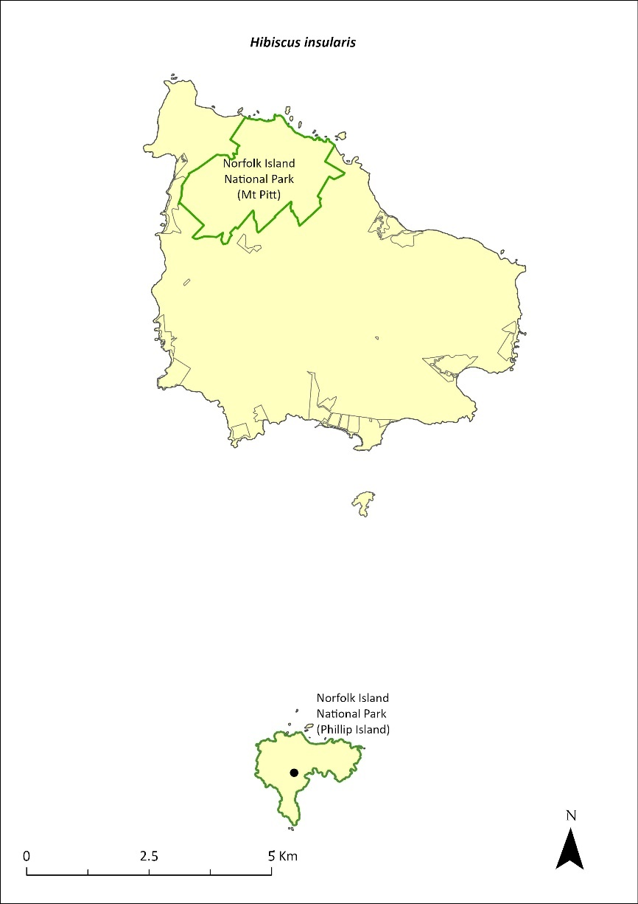
Green outlines indicate reserves within which the species occurs. Points show recorded locations (Mills 2009b).

Impact on other species
None known.

Risk assessment
Risk assessment undertaken for Critically Endangered trees/shrubs as a grouping. The risk assessment is shown in Table 95.
Table 95 Risk assessment for Critically Endangered trees/shrubs as a grouping
Risk | Likelihood of exposure | Consequence | Threat rating
1. Loss and fragmentation of native vegetation through past land clearing | Almost certain (91–100%) | Extreme | Extreme
2. Loss and fragmentation of native vegetation through current or future land clearing | Rare (0–10%) | Negligible | Negligible
3. Degradation of native vegetation through past grazing or loss of nutrients | Almost certain (91–100%) | Extreme | Extreme
4. Degradation of native vegetation through current or future grazing | Possible (26–50%) | Moderate | Medium
6. Predation by rodents | Likely (51–90%) | Moderate | Medium
7. Predation by cats | Rare (0–10%) | Negligible | Negligible
8. Predation or damage by chickens | Likely (51–90%) | Moderate | Medium
9. Predation by swamphens | Rare (0–10%) | Negligible | Negligible
10. Predation by Argentine ant | Possible (26–50%) | Minor | Low
11. Competition from/change of habitat because of weed invasion | Possible (26–50%) | Minor | Low
12. Infection by pathogens already present | Possible (26–50%) | Moderate | Medium
13. Impacts of potential new invasive species or pathogens | Unlikely (11–25%) | Minor | Low
14. Changes to vegetation, increased fire risk and/or direct physiological stress as a result of climatic changes | Possible (26–50%) | Minor | Low
15. Problems caused by small populations, including lack of genetic diversity | Almost certain (91–100%) | Moderate | High

Management actions
Undertake propagation and planting within suitable areas on Phillip Island. Establish native tree shelter belts (such as white oaks) to replace the weed species that currently shelter the main population on Phillip Island. Undertake targeted weed control and ongoing maintenance, while maintaining a strict herbicide ban in the vicinity of the main population.

Recovery target
The recovery target is shown in Table 96.
Table 96 Recovery target for Hibiscus insularis
EPBC Act status | Estimated population (2023) | Where known populations occur | 2034 target
Critically Endangered | 350 | >95% within the national park | 1000

Relevant literature
Groeneveld KM (1989) Conservation biology of the endangered species Hibiscus insularis. Unpublished Report to the Australian National Parks and Wildlife Service.
Mills K (2009b) The Vegetation of Phillip Island, Norfolk Island Group. Envirofund 2007/2008. Kevin Mills & Associates, Jamberoo, NSW.
Orchard A (ed) (1994) Flora of Australia. Vol. 49. Oceanic Islands 1. Australian Government Publishing Service, Canberra.
Sykes W & Atkinson I (1988) Rare and Endangered Plants of Norfolk Island. Unpublished report to the Australian National Parks and Wildlife Service, Norfolk Island.
TSSC (Threatened Species Scientific Committee) (2003a) Commonwealth Listing Advice for Norfolk Island Flora – 11 Critically Endangered Species.

Hypolepis dicksonioides—downy ground fern, brake fern
Family DENNSTAEDTIACEAE

Conservation significance
Australian distribution is restricted to Norfolk and Phillip Islands but also occurs in the Kermadec Islands, New Zealand, Samoa, Society Islands and Marquesas.
EPBC Act Listing Status: Vulnerable.

Description
A terrestrial fern of disturbed sites with fronds growing to 100 cm or longer.
An important colonising fern that does not persist for long periods in the same location (Braggins 1996).

Distribution and abundance
This species occurs on Norfolk and Phillip Islands and has been recorded from Mt Bates (Orchard 1994). In a 1995 survey, it was reported from only one site outside of Phillip Island and was much less common than in 1971 (Brownsey & Chinnock 1987, Braggins 1996).
On Phillip Island, this fern is uncommon but widespread. It is most common in First West End Valley and the valleys across the eastern part of the island (Mills 2009b). Six clumps of the plant were also recorded from Bumbora Reserve (Mills 2017a). The number of mature individuals in 2003 was fewer than 500 (TSSC 2003b).
The distribution is shown in Map 40.

Ecology
Little known.

Habitat
Grows in disturbed sites and open rocky places.

Threats
The main threats to the species are weed invasion and competition, and small population size and subsequent increased risk of extinction through natural events such as cyclones, slips and drought. Drought/dry conditions due to climate change are also a threat.

Impact on other species
None known.
Map 40 Distribution of Hypolepis dicksonioides
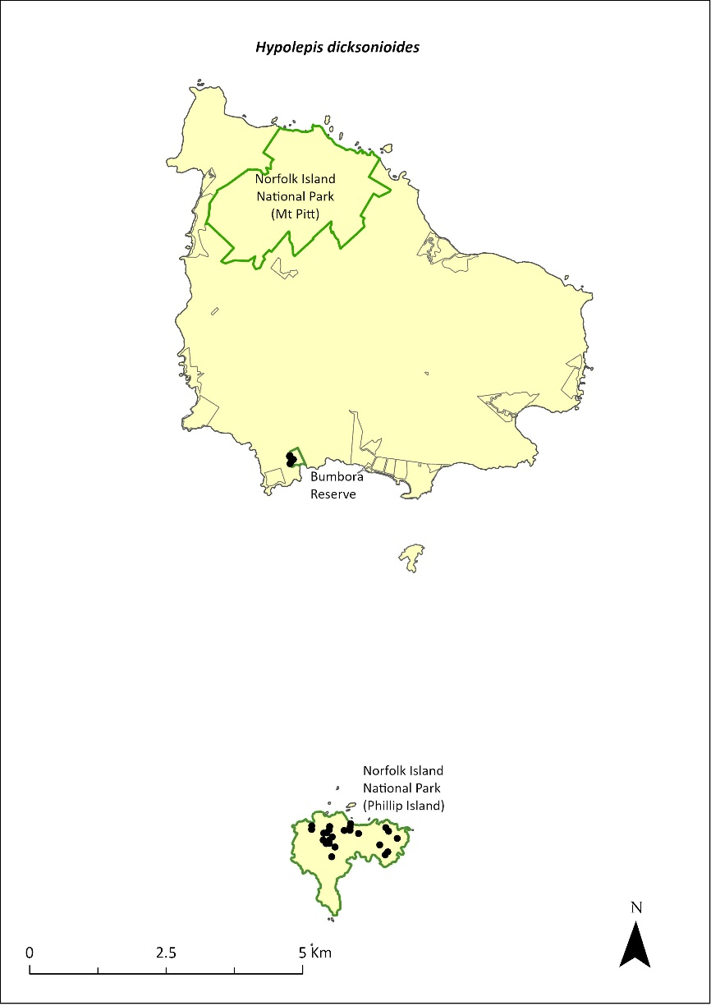
Green outlines indicate reserves within which the species occurs. Points show recorded locations (Mills 2009b and 2017a).

Risk assessment
Risk assessment undertaken for Vulnerable ferns as a grouping. The risk assessment is shown in Table 97.
Table 97 Risk assessment for Vulnerable ferns as a grouping
Risk | Likelihood of exposure | Consequence | Threat rating
1. Loss and fragmentation of native vegetation through past land clearing | Almost certain (91–100%) | Extreme | Extreme
2. Loss and fragmentation of native vegetation through current or future land clearing | Rare (0–10%) | Negligible | Negligible
3. Degradation of native vegetation through past grazing or loss of nutrients | Almost certain (91–100%) | Extreme | Extreme
4. Degradation of native vegetation through current or future grazing | Possible (26–50%) | Moderate | Medium
6. Predation by rodents | Rare (0–10%) | Negligible | Negligible
7. Predation by cats | Rare (0–10%) | Negligible | Negligible
8. Predation or damage by chickens | Rare (0–10%) | Negligible | Negligible
9. Predation by swamphens | Rare (0–10%) | Negligible | Negligible
10. Predation by Argentine ant | Rare (0–10%) | Negligible | Negligible
11. Competition from/change of habitat because of weed invasion | Possible (26–50%) | Moderate | Medium
12. Infection by pathogens already present | Rare (0–10%) | Negligible | Negligible
13. Impacts of potential new invasive species or pathogens | Unlikely (11–25%) | Minor | Low
14. Changes to vegetation, increased fire risk and/or direct physiological stress as a result of climatic changes | Possible (26–50%) | Moderate | Medium
15. Problems caused by small populations, including lack of genetic diversity | Almost certain (91–100%) | Major | Extreme

Management actions
Undertake targeted weed control and maintenance. Undertake revegetation/habitat restoration and propagation and planting within suitable areas.

Recovery target
The recovery target is shown in Table 98.
Table 98 Recovery target for Hypolepis dicksonioides
EPBC Act status | Estimated population (2023) | Where known populations occur | 2034 target
Vulnerable | 506 | 99% within the national park  1% within public reserves | 750

Relevant literature
Braggins JE (1996) Report on the conservation status of the ferns of Norfolk Island. Unpublished report to the Australian Nature Conservation Agency.
Brownsey PJ & Chinnock RJ (1987) A taxonomic revision of the Australian species of Hypolepis. Journal of the Adelaide Botanical Garden 10, 1–30.
Mills K (2009b) The Vegetation of Phillip Island, Norfolk Island Group. Envirofund 2007/2008. Kevin Mills & Associates, Jamberoo, NSW.
Mills K (2017a) Survey of public reserves on Norfolk Island for threatened plant species: 3. Point Ross Reserve and Bumbora Reserve. Prepared for Norfolk Island Regional Council.
Orchard A (ed) (1994) Flora of Australia. Vol. 49. Oceanic Islands 1. Australian Government Publishing Service, Canberra.
TSSC (Threatened Species Scientific Committee) (2003b) Commonwealth Listing Advice for Norfolk Island Flora - 15 Vulnerable Species.

Ileostylus micranthus—mistletoe
Family LORANTHACEAE

Conservation significance
Ileostylus micranthus is best known from New Zealand and was first collected on Norfolk Island in the 1930s. It is presumed to be a recent arrival on Norfolk Island as previous collectors had failed to find it (Orchard 1994).
EPBC Act Listing Status: Vulnerable.

Description
A bushy epiphytic mistletoe with green flowers and yellow fruit.

Distribution and abundance
I. micranthus has been reported from the upper slopes of Mt Pitt and the track leading to Red Road on Mt Bates (Orchard 1994) above the 200-metre contour. On Norfolk Island the number of mature individuals was fewer than 500 in 2003 (TSSC 2003b).
The distribution is shown in Map 41.

Ecology
An epiphytic parasite with a wide range of host plants.

Habitat
Occurs scattered on several host species within the national park, favouring Coprosma pilosa as its host.

Threats
The species is threatened by weed invasion, catastrophic events (such as severe storms), and limited distribution of its host C. pilosa.

Impact on other species
Parasitic on host species and heavy infestations on C. pilosa can kill the host plant.
Map 41 Distribution of Ileostylus micranthus
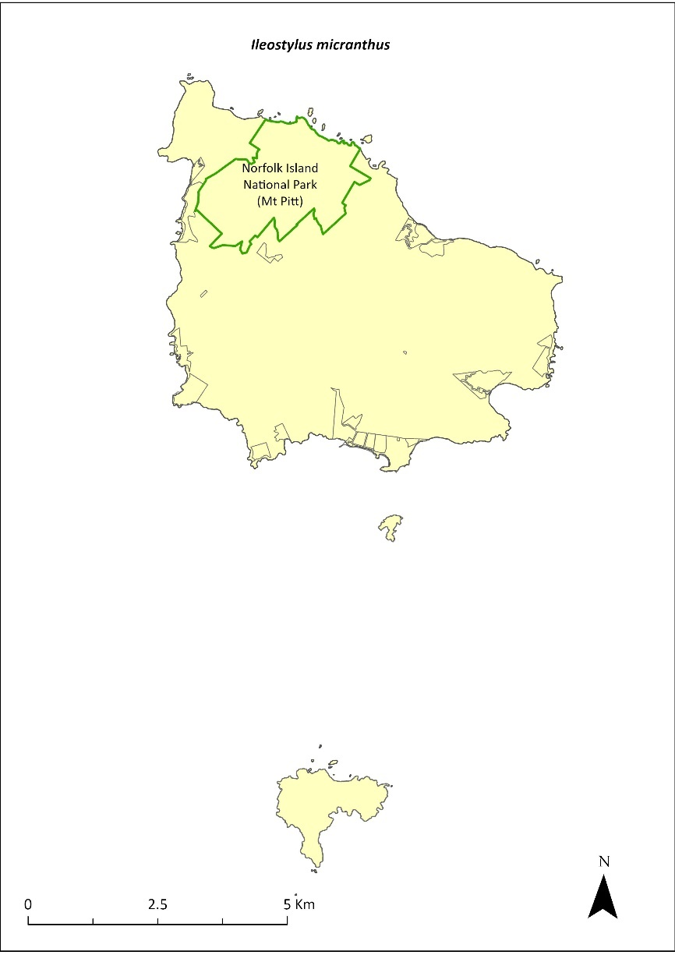
Green outlines indicate reserves within which the species occurs.

Risk assessment
The risk assessment is shown in Table 99.
Table 99 Risk assessment for Ileostylus micranthus
Risk | Likelihood of exposure | Consequence | Threat rating
1. Loss and fragmentation of native vegetation through past land clearing | Almost certain (91–100%) | Extreme | Extreme
2. Loss and fragmentation of native vegetation through current or future land clearing | Rare (0–10%) | Negligible | Negligible
3. Degradation of native vegetation through past grazing or loss of nutrients | Almost certain (91–100%) | Extreme | Extreme
4. Degradation of native vegetation through current or future grazing | Possible (26–50%) | Moderate | Medium
6. Predation by rodents | Unlikely (11–25%) | Minor | Low
7. Predation by cats | Rare (0–10%) | Negligible | Negligible
8. Predation or damage by chickens | Rare (0–10%) | Negligible | Negligible
9. Predation by swamphens | Rare (0–10%) | Negligible | Negligible
10. Predation by Argentine ant | Rare (0–10%) | Negligible | Negligible
11. Competition from/change of habitat because of weed invasion | Unlikely (11–25%) | Moderate | Low
12. Infection by pathogens already present | Rare (0–10%) | Negligible | Negligible
13. Impacts of potential new invasive species or pathogens | Unlikely (11–25%) | Minor | Low
14. Changes to vegetation, increased fire risk and/or direct physiological stress as a result of climatic changes | Unlikely (11–25%) | Minor | Low
15. Problems caused by small populations, including lack of genetic diversity | Possible (26–50%) | Major | High

Management actions
Undertake revegetation/habitat restoration. Undertake targeted weed control and maintenance.

Recovery target
The recovery target is shown in Table 100.
Table 100 Recovery target for Ileostylus micranthus
EPBC Act status | Estimated population (2023) | Where known populations occur | 2034 target
Vulnerable | 500 | 100% within the national park | 750

Relevant literature
Orchard A (ed) (1994) Flora of Australia. Vol. 49. Oceanic Islands 1. Australian Government Publishing Service, Canberra.
TSSC (Threatened Species Scientific Committee) (2003b) Commonwealth Listing Advice for Norfolk Island Flora - 15 Vulnerable Species.

Lastreopsis calantha—shield-fern
Family DRYOPTERIDACEAE

Conservation significance
Endemic to Norfolk Island.
EPBC Act Listing Status: Endangered.
The Australian Plant Census accepts Parapolystichum calanthum as a synonym.

Description
A terrestrial fern with a long creeping rhizome and fronds growing to 30cm, occasionally reaching 50cm long.

Distribution and abundance
Lastreopsis calantha is known to occur mainly in the Norfolk Island National Park, in damp and shady valleys (Sykes & Atkinson 1988).
Braggins (1996) found it at several widely scattered sites, and the species had returned in areas where cattle had been excluded. There were fewer than 200 mature individuals in 2003 (TSSC 2003c). Mills (2012b) found 148 plants along 10 transects, mostly within valleys. The valley to the south-west of Bird Rock in the national park contained the largest population of this fern, with 72 plants.
The distribution is shown in Map 42.

Ecology
Grows in moist shaded areas.

Habitat
Grows in moist upland hardwood forest, mainly in shaded valleys.

Threats
The main threats to the species are cattle grazing, weed invasion and changes to hydrology in the national park.

Impact on other species
None known.
Map 42 Distribution of Lastreopsis calantha
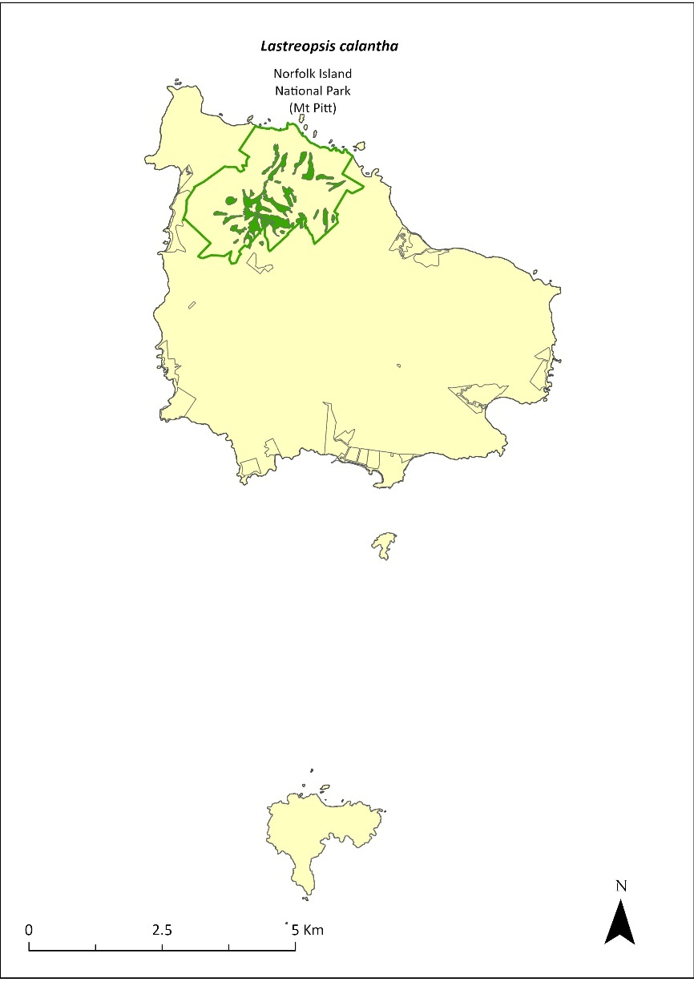
Green outlines indicate reserves within which the species occurs. Green shading shows plant communities within which the species may occur (Christian & Mills 2021).

Risk assessment
Risk assessment undertaken for Endangered ferns as a grouping. The risk assessment is shown in Table 101.
Table 101 Risk assessment for Endangered ferns as a grouping
Risk | Likelihood of exposure | Consequence | Threat rating
1. Loss and fragmentation of native vegetation through past land clearing | Almost certain (91–100%) | Extreme | Extreme
2. Loss and fragmentation of native vegetation through current or future land clearing | Rare (0–10%) | Negligible | Negligible
3. Degradation of native vegetation through past grazing or loss of nutrients | Almost certain (91–100%) | Extreme | Extreme
4. Degradation of native vegetation through current or future grazing | Possible (26–50%) | Moderate | Medium
6. Predation by rodents | Rare (0–10%) | Negligible | Negligible
7. Predation by cats | Rare (0–10%) | Negligible | Negligible
8. Predation or damage by chickens | Rare (0–10%) | Negligible | Negligible
9. Predation by swamphens | Rare (0–10%) | Negligible | Negligible
10. Predation by Argentine ant | Rare (0–10%) | Negligible | Negligible
11. Competition from/change of habitat because of weed invasion | Likely (51–90%) | Moderate | Medium
12. Infection by pathogens already present | Rare (0–10%) | Negligible | Negligible
13. Impacts of potential new invasive species or pathogens | Unlikely (11–25%) | Minor | Low
14. Changes to vegetation, increased fire risk and/or direct physiological stress as a result of climatic changes | Possible (26–50%) | Moderate | Medium
15. Problems caused by small populations, including lack of genetic diversity | Unlikely (11–25%) | Moderate | Low

Management actions
Implement revegetation/habitat restoration. Undertake ongoing targeted weed control and maintenance. Exclude or manage cattle grazing. Monitor to determine population dynamics.

Recovery target
The recovery target is shown in Table 102.
Table 102 Recovery target for Lastreopsis calantha
EPBC Act status | Estimated population (2023) | Where known populations occur | 2034 target
Endangered | 148 | 100% within the national park | 250

Relevant literature
Christian NE & Mills K (2021) Vegetation Mapping of Norfolk Island 2021. Unpublished data.
Braggins JE (1996) Report on the conservation status of the ferns of Norfolk Island. Unpublished report to the Australian Nature Conservation Agency.
Orchard A (ed) (1994) Flora of Australia. Vol. 49. Oceanic Islands 1. Australian Government Publishing Service, Canberra.
Mills K (2012b) The Flora of Norfolk Island. Report 14. The Endangered Plants in the national park: Field Survey and Review. Kevin Mills & Associates, Jamberoo, NSW.
Sykes W & Atkinson I (1988) Rare and Endangered Plants of Norfolk Island. Unpublished report to the Australian National Parks and Wildlife Service, Norfolk Island.
TSSC (Threatened Species Scientific Committee) (2003c) Commonwealth Listing Advice for Norfolk Island Flora – 16 Endangered Species.

Marattia salicina (Ptisana salicina)—king fern, para, potato fern
Family MARATTIACEAE

Conservation significance
Australian distribution restricted to Norfolk Island; it is also found in New Zealand
EPBC Act Listing Status: Endangered
This species is listed under the EPBC Act as Marattia salicina. Now known as Ptisana salicina, Marattia salicina is also listed as a synonym.

Description
Large robust fern with fronds growing to 6m long.

Distribution and abundance
It was reported from several sites within the Norfolk Island National Park with some regeneration in 1996 (Braggins 1996). In 2003 there were fewer than 100 mature individuals, which were all within the Mt Pitt section of the national park (TSSC 2003c). Mills (2012b) recorded 44 plants in six valleys within the national park. The largest number of plants (33) were observed in King Fern Valley, to the east of Mount Pitt Road.
The population estimate in 2021 was 160 individuals.
In New Zealand it was listed as “chronically threatened—Serious Decline” (de Lange et al. 2004).
The distribution is shown in Map 43.

Ecology
Little known.

Habitat
This species grows in valleys on south-east mountain slopes (Orchard 1994).

Threats
Illegal collection from the national park has occurred in the past (Braggins 1996). Climate change/dry conditions are also a threat.

Impact on other species
None known.
Map 43 Distribution of Marattia salicina
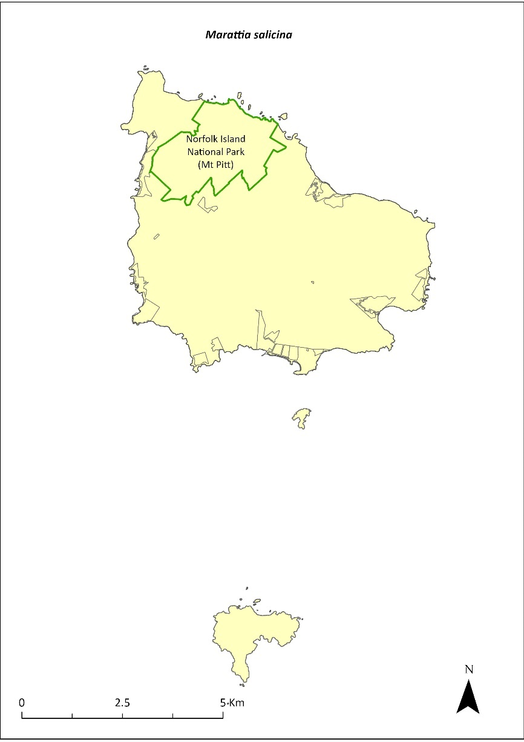
Green outlines indicate reserves within which the species occurs.

Risk assessment
Risk assessment undertaken for Endangered ferns as a grouping. The risk assessment is shown in Table 103.
Table 103 Risk assessment for Endangered ferns as a grouping
Risk | Likelihood of exposure | Consequence | Threat rating
1. Loss and fragmentation of native vegetation through past land clearing | Almost certain (91–100%) | Extreme | Extreme
2. Loss and fragmentation of native vegetation through current or future land clearing | Rare (0–10%) | Negligible | Negligible
3. Degradation of native vegetation through past grazing or loss of nutrients | Almost certain (91–100%) | Extreme | Extreme
4. Degradation of native vegetation through current or future grazing | Possible (26–50%) | Moderate | Medium
6. Predation by rodents | Rare (0–10%) | Negligible | Negligible
7. Predation by cats | Rare (0–10%) | Negligible | Negligible
8. Predation or damage by chickens | Rare (0–10%) | Negligible | Negligible
9. Predation by swamphens | Rare (0–10%) | Negligible | Negligible
10. Predation by Argentine ant | Rare (0–10%) | Negligible | Negligible
11. Competition from/change of habitat because of weed invasion | Likely (51–90%) | Major | High
12. Infection by pathogens already present | Rare (0–10%) | Negligible | Negligible
13. Impacts of potential new invasive species or pathogens | Unlikely (11–25%) | Minor | Low
14. Changes to vegetation, increased fire risk and/or direct physiological stress as a result of climatic changes | Possible (26–50%) | Moderate | Medium
15. Problems caused by small populations, including lack of genetic diversity | Almost certain (91–100%) | Major | Extreme

Management actions
Undertake propagation and revegetation in suitable habitat (including sales to private landholders to reduce pressure on naturally occurring populations). Protect and restore habitat. Investigate sites on public reserves for introduction.

Recovery target
The recovery target is shown in Table 104.
Table 104 Recovery target for Marattia salicina
EPBC Act status | Estimated population (2023) | Where known populations occur | 2034 target
Endangered | 160 | 100% within the national park | 250

Relevant literature
Braggins JE (1996) Report on the conservation status of the ferns of Norfolk Island. Unpublished report to the Australian Nature Conservation Agency.
de Lange PJ, Johnson PN, Norton DA, Hitchmough R, Heenan PB, Courteney SP, Molloy B.P.J, Ogle C.C & Rance BD (2004) Threatened and uncommon plants of New Zealand. New Zealand Journal of Botany 42, 45–76.
Orchard A (ed) (1994) Flora of Australia. Vol. 49. Oceanic Islands 1. Australian Government Publishing Service, Canberra.
Mills K (2012b) The Flora of Norfolk Island. Report 14. The Endangered Plants in the national park: Field Survey and Review. Kevin Mills & Associates, Jamberoo, NSW.
Sykes W & Atkinson I (1988) Rare and Endangered Plants of Norfolk Island. Unpublished report to the Australian National Parks and Wildlife Service, Norfolk Island.
TSSC (Threatened Species Scientific Committee) (2003c) Commonwealth Listing Advice for Norfolk Island Flora – 16 Endangered Species.

Melicope littoralis—shade tree
Family RUTACEAE

Conservation significance
Endemic to Norfolk Island.
EPBC Act Listing Status: Vulnerable.

Description
Tree to 5 m tall, with trifoliolate leaves (having three leaflets), small creamy-white flowers and shiny black seeds.

Distribution and abundance
There were 273 mature individuals in 2003 with most plants occurring in the Mt Pitt section of the national park (Orchard 1994, TSSC 2003b). In 2010 it was considered widespread within the park and the 2021 population estimate was 305.
The distribution is shown in Map 44.

Ecology
Little known.

Habitat
Occurs in moist upland hardwood forest (Invasive Species Council & TierraMar 2021).

Threats
The black rat may contribute to the failed reproduction of this species (Bell 1990). Phytophthora cinnamomi is potentially a major risk.

Impact on other species
None known.
Map 44 Distribution of Melicope littoralis
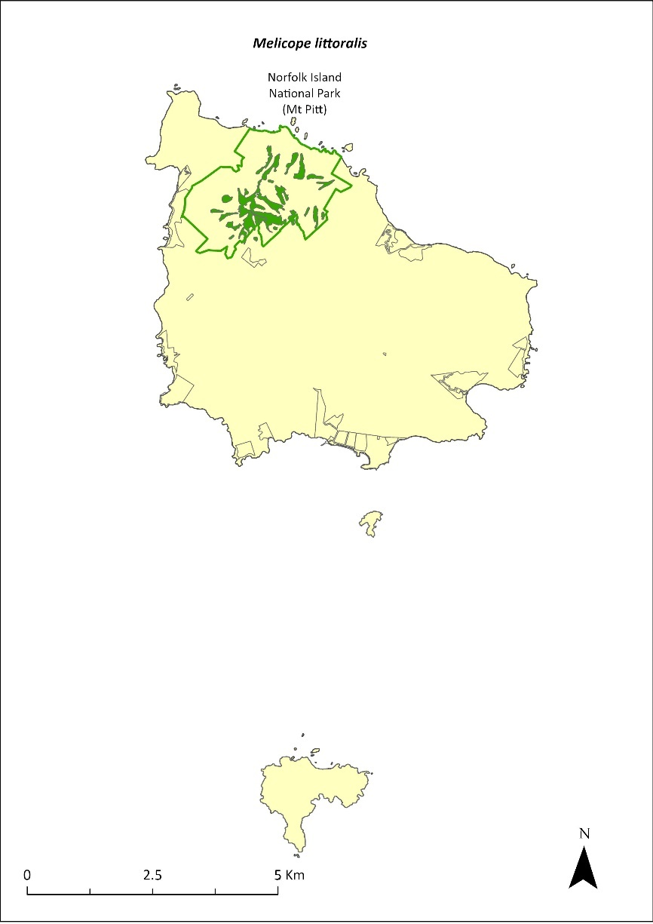
Green outlines indicate reserves within which the species occurs. Green shading shows plant communities within which the species may occur (Christian & Mills 2021).

Risk assessment
Risk assessment undertaken for Vulnerable trees/shrubs as a grouping. The risk assessment is shown in Table 105.
Table 105 Risk assessment for Vulnerable trees/shrubs as a grouping
Risk | Likelihood of exposure | Consequence | Threat rating
1. Loss and fragmentation of native vegetation through past land clearing | Almost certain (91–100%) | Extreme | Extreme
2. Loss and fragmentation of native vegetation through current or future land clearing | Rare (0–10%) | Negligible | Negligible
3. Degradation of native vegetation through past grazing or loss of nutrients | Almost certain (91–100%) | Extreme | Extreme
4. Degradation of native vegetation through current or future grazing | Possible (26–50%) | Moderate | Medium
6. Predation by rodents | Likely (51–90%) | Moderate | Medium
7. Predation by cats | Rare (0–10%) | Negligible | Negligible
8. Predation or damage by chickens | Rare (0–10%) | Negligible | Negligible
9. Predation by swamphens | Rare (0–10%) | Negligible | Negligible
10. Predation by Argentine ant | Possible (26–50%) | Minor | Low
11. Competition from/change of habitat because of weed invasion | Likely (51–90%) | Major | High
12. Infection by pathogens already present | Possible (26–50%) | Moderate | Medium
13. Impacts of potential new invasive species or pathogens | Unlikely (11–25%) | Minor | Low
14. Changes to vegetation, increased fire risk and/or direct physiological stress as a result of climatic changes | Possible (26–50%) | Moderate | Medium
15. Problems caused by small populations, including lack of genetic diversity | Likely (51–90%) | Major | High

Management actions
Undertake rodent control. Carry out targeted weed control and maintenance. Undertake propagation and planting within suitable areas. Undertake revegetation/habitat restoration.

Recovery target
The recovery target is shown in Table 106.
Table 106 Recovery target for Melicope littoralis
EPBC Act status | Estimated population (2023) | Where known populations occur | 2034 target
Vulnerable | 305 | 100% within the national park | 1000

Relevant literature
Bell BD (1990) The status and management of the White-breasted White-eye and other birds of Norfolk Island. Unpublished report to the Australian Nature Conservation Agency.
Christian NE & Mills K (2021) Vegetation Mapping of Norfolk Island 2021. Unpublished data.
Invasive Species Council & TierraMar (2021) The Native Plant Communities of Norfolk Island. Invasive Species Council, Katoomba, NSW.
Orchard A (ed) (1994) Flora of Australia. Vol. 49. Oceanic Islands 1. Australian Government Publishing Service, Canberra.
TSSC (Threatened Species Scientific Committee) (2003b) Commonwealth Listing Advice for Norfolk Island Flora - 15 Vulnerable Species.

Melicytus latifolius—Norfolk Island mahoe
Family VIOLACEAE

Conservation significance
Endemic to Norfolk Island
EPBC Act Listing Status: Critically Endangered

Description
A small tree usually growing to 4m tall but sometimes reaching 9m.

Distribution and abundance
Melicytus latifolius is found in the valleys and on the slopes of the Mt Pitt section of Norfolk Island National Park, together with a few areas outside the park in the Mission Road area (Sykes & Atkinson 1988). 40 plants were identified in 1988, with a high proportion of juveniles and few seedlings or mature trees (Sykes & Atkinson 1988). Historical records suggest this plant has been rare for some time (Gilmour & Helman 1989b).
The last good flowering season was in the late 1990s/early 2000s when a large number of plants were produced in the natural forest and in the nursery plantings (Director of National Parks 2010). There were 17 known mature individuals in 2003 (TSSC 2003a). Surveys in 2012 (Mills 2012b) found a total of 16 plants along five transects, all saplings. More recently, searches have found over 100 new adults in the wild, which have been tagged for monitoring. The population estimate in 2021 was 148.
The distribution is shown in Map 45.

Ecology
Little known.

Habitat
This species requires moist shaded valley sites and broad ridges, and, while it can tolerate dense shade, it sometimes establishes at the edge of canopy gaps (Sykes & Atkinson 1988). It occurs in moist upland hardwood forest and plateau hardwood forest (Invasive Species Council & TierraMar 2021).

Threats
The main threats to the species are weed invasion and competition, particularly by red guava (Psidium cattleyanum) and wild tobacco (Solanum mauritianum). Unpredictable and irregular seed production is also a threat. Phytophthora cinnamomi is potentially a major risk.

Impact on other species
None known.
Map 45 Distribution of Melicytus latifolius
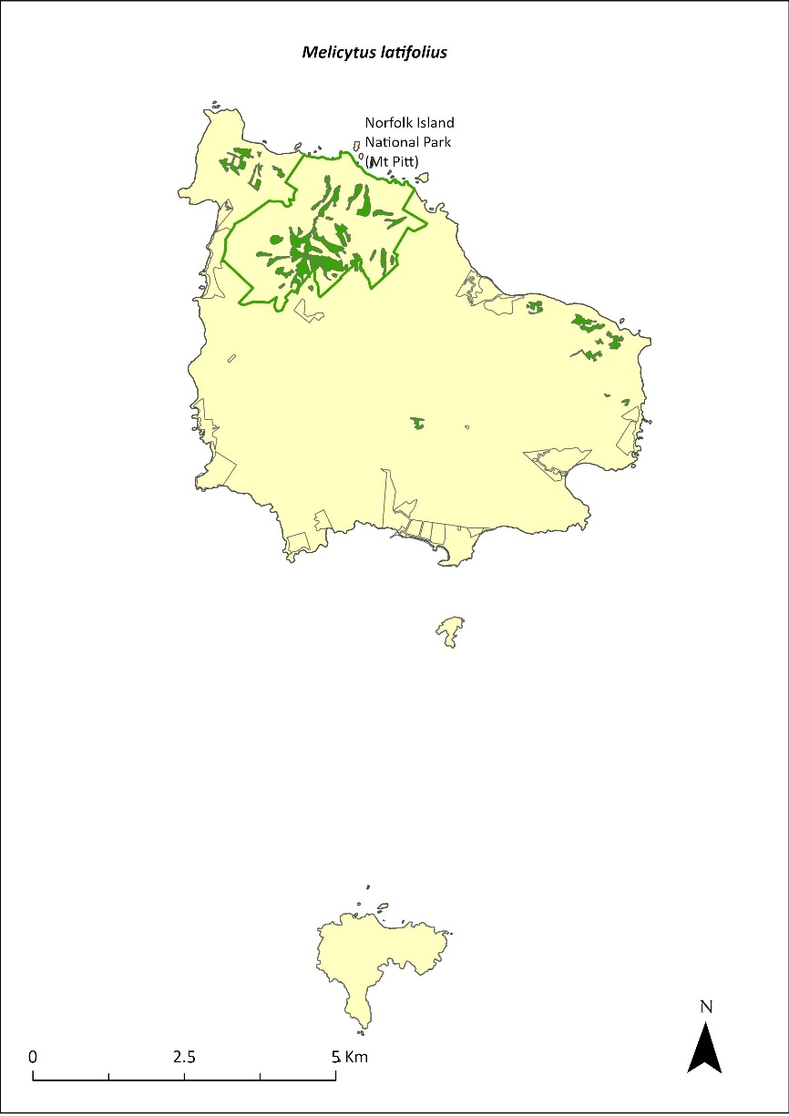
Green outlines indicate reserves within which the species occurs. Green shading shows plant communities within which the species may occur (Christian & Mills 2021).

Risk assessment
Risk assessment undertaken for Critically Endangered trees/shrubs as a grouping. The risk assessment is shown in Table 107.
Table 107 Risk assessment for Critically Endangered trees/shrubs as a grouping
Risk | Likelihood of exposure | Consequence | Threat rating
1. Loss and fragmentation of native vegetation through past land clearing | Almost certain (91–100%) | Extreme | Extreme
2. Loss and fragmentation of native vegetation through current or future land clearing | Rare (0–10%) | Negligible | Negligible
3. Degradation of native vegetation through past grazing or loss of nutrients | Almost certain (91–100%) | Extreme | Extreme
4. Degradation of native vegetation through current or future grazing | Possible (26–50%) | Moderate | Medium
6. Predation by rodents | Possible (26–50%) | Major | High
7. Predation by cats | Rare (0–10%) | Negligible | Negligible
8. Predation or damage by chickens | Likely (51–90%) | Moderate | Medium
9. Predation by swamphens | Rare (0–10%) | Negligible | Negligible
10. Predation by Argentine ant | Possible (26–50%) | Minor | Low
11. Competition from/change of habitat because of weed invasion | Almost certain (91–100%) | Major | Extreme
12. Infection by pathogens already present | Possible (26–50%) | Moderate | Medium
13. Impacts of potential new invasive species or pathogens | Unlikely (11–25%) | Minor | Low
14. Changes to vegetation, increased fire risk and/or direct physiological stress as a result of climatic changes | Possible (26–50%) | Moderate | Medium
15. Problems caused by small populations, including lack of genetic diversity | Almost certain (91–100%) | Major | Extreme

Management actions
Monitor seed production and collect and propagate seed when available. Conduct regular monitoring to determine causes of mortality. Carry out targeted weed control and maintenance and undertake replanting on moist slopes within the national park (Sykes & Atkinson 1988). Continue protection of the Mission Road rainforest remnants. Exclude or manage cattle grazing.

Recovery target
The recovery target is shown in Table 108.
Table 108 Recovery target for Melicytus latifolius
EPBC Act status | Estimated population (2023) | Where known populations occur | 2034 target
Critically Endangered | 148 | >95% within the national park | 500

Relevant literature
Christian NE & Mills K (2021) Vegetation Mapping of Norfolk Island 2021. Unpublished data.
Director of National Parks (2010) Norfolk Island Region Threatened Species Recovery Plan. Department of the Environment, Water, Heritage and the Arts, Canberra.
Gilmour PM & Helman CE (1989b) The Vegetation of Norfolk Island National Park. Report to the Australian National Parks and Wildlife Service, Norfolk Island.
Invasive Species Council & TierraMar (2021) The Native Plant Communities of Norfolk Island. Invasive Species Council, Katoomba, NSW.
Mills K (2012b) The Flora of Norfolk Island. Report 14. The Endangered Plants in the national park: Field Survey and Review. Kevin Mills & Associates, Jamberoo, NSW.
Sykes W & Atkinson I (1988) Rare and Endangered Plants of Norfolk Island. Unpublished report to the Australian National Parks and Wildlife Service, Norfolk Island.
TSSC (Threatened Species Scientific Committee) (2003a) Commonwealth Listing Advice for Norfolk Island Flora – 11 Critically Endangered Species.

Melicytus ramiflorus subsp. oblongifolius—whiteywood
Family VIOLACEAE

Conservation significance
Endemic to Norfolk Island.
EPBC Act Listing Status: Vulnerable.

Description
A slender shrub or tree to 5m tall.

Distribution and abundance
This subspecies has been recorded on the saddle between Mt Pitt and Mt Bates in the Norfolk Island National Park, and north-east of the Kingston Cemetery (Orchard 1994). There were 436 mature individuals recorded in 2003 (TSSC 2003b).
It is relatively widespread in the national park, occurring in viny hardwood forest on the south-western flanks of the mountains (Invasive Species Council & TierraMar 2021). There are also a few individuals within Ball Bay and Hundred Acres Reserves (Mills 2017b).
The population estimate in 2021 was 570.
The distribution is shown in Map 46.

Ecology
Little known.

Habitat
Forest.

Threats
Major threats to the species are cattle grazing, weed invasion and competition, and drought/dry conditions due to climate change. Phytophthora cinnamomi is potentially a major risk.

Impact on other species
None known.
Map 46 Distribution of Melicytus ramiflorus subsp. oblongifolius
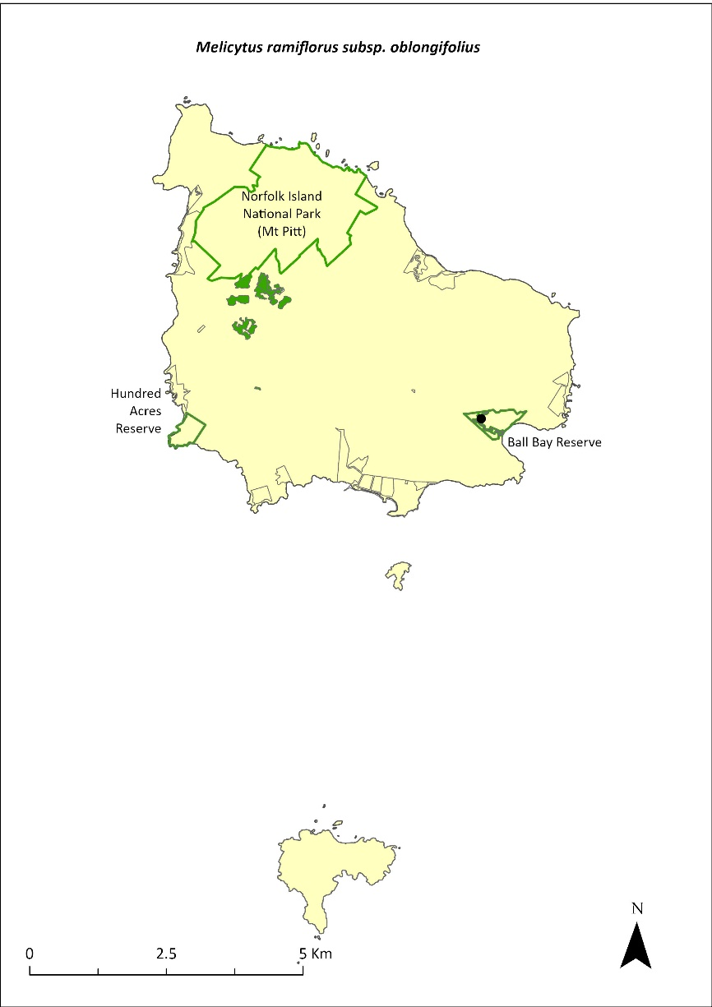
Green outlines indicate reserves within which the species occurs. Green shading shows plant communities within which the species may occur (Christian & Mills 2021). Points show recorded locations (Mills 2017b).

Risk assessment
Risk assessment undertaken for Vulnerable trees/shrubs as a grouping. The risk assessment is shown in Table 109.
Table 109 Risk assessment for Vulnerable trees/shrubs as a grouping
Risk | Likelihood of exposure | Consequence | Threat rating
1. Loss and fragmentation of native vegetation through past land clearing | Almost certain (91–100%) | Extreme | Extreme
2. Loss and fragmentation of native vegetation through current or future land clearing | Rare (0–10%) | Negligible | Negligible
3. Degradation of native vegetation through past grazing or loss of nutrients | Almost certain (91–100%) | Extreme | Extreme
4. Degradation of native vegetation through current or future grazing | Possible (26–50%) | Moderate | Medium
6. Predation by rodents | Likely (51–90%) | Moderate | Medium
7. Predation by cats | Rare (0–10%) | Negligible | Negligible
8. Predation or damage by chickens | Rare (0–10%) | Negligible | Negligible
9. Predation by swamphens | Rare (0–10%) | Negligible | Negligible
10. Predation by Argentine ant | Possible (26–50%) | Minor | Low
11. Competition from/change of habitat because of weed invasion | Almost certain (91–100%) | Moderate | High
12. Infection by pathogens already present | Possible (26–50%) | Moderate | Medium
13. Impacts of potential new invasive species or pathogens | Unlikely (11–25%) | Minor | Low
14. Changes to vegetation, increased fire risk and/or direct physiological stress as a result of climatic changes | Possible (26–50%) | Moderate | Medium
15. Problems caused by small populations, including lack of genetic diversity | Possible (26–50%) | Moderate | Medium

Management actions
Undertake propagation and planting within suitable areas, including public reserves. Implement habitat protection and rehabilitation. Carry out ongoing targeted weed control and maintenance. Exclude or manage cattle grazing.

Recovery target
The recovery target is shown in Table 110.
Table 110 Recovery target for Melicytus ramiflorus subsp. oblongifolius
EPBC Act status | Estimated population (2023) | Where known populations occur | 2034 target
Vulnerable | 570 | 99% within the national park  1% within public reserves | 1000

Relevant literature
Christian NE & Mills K (2021) Vegetation Mapping of Norfolk Island 2021. Unpublished data.
Invasive Species Council & TierraMar (2021) The Native Plant Communities of Norfolk Island. Invasive Species Council, Katoomba, NSW.
Orchard A (ed) (1994) Flora of Australia. Vol. 49. Oceanic Islands 1. Australian Government Publishing Service, Canberra.
Mills K (2017b) Survey of public reserves on Norfolk Island for threatened plant species: 8. Ball Bay Reserve. Prepared for Norfolk Island Regional Council.
TSSC (Threatened Species Scientific Committee) (2003b) Commonwealth Listing Advice for Norfolk Island Flora - 15 Vulnerable Species.

Meryta angustifolia—Narrow-leaved Meryta
Family ARALIACEAE

Conservation significance
Endemic to Norfolk Island.
EPBC Act Listing Status: Vulnerable.

Description
Tree growing to 6m tall with few branches.

Distribution and abundance
There were 479 mature individuals of Meryta angustifolia recorded on Norfolk Island in 2003 (TSSC 2003b). Orchard (1994) reported that the species was widespread within the Norfolk Island National Park (particularly in areas where weed control had been carried out) and recorded it from the northern and southern slopes of Mt Bates, on the saddle between Mt Pitt and Mt Bates, and from outside the national park. Most of the population is within the park but there are some individuals in the Mission Road rainforest remnants.
The population estimate in 2021 was 494.
The distribution is shown in Map 47.

Ecology
Little known.

Habitat
Occurs in moist upland hardwood forest and pine-hardwood ridge forest (Invasive Species Council & TierraMar 2021).

Threats
Threats to the species include cattle grazing, weed invasion, and limited seed production in comparison with M. latifolia. Phytophthora cinnamomi is potentially a major risk.

Impact on other species
None known.
Map 47 Distribution Meryta angustifolia
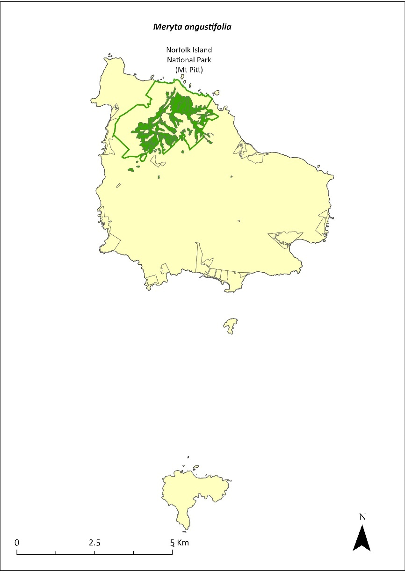
Green outlines indicate reserves within which the species occurs. Green shading shows plant communities within which the species may occur (Christian & Mills 2021).

Risk assessment
Risk assessment undertaken for Vulnerable trees/shrubs as a grouping. The risk assessment is shown in Table 111.
Table 111 Risk assessment for Vulnerable trees/shrubs as a grouping
Risk | Likelihood of exposure | Consequence | Threat rating
1. Loss and fragmentation of native vegetation through past land clearing | Almost certain (91–100%) | Extreme | Extreme
2. Loss and fragmentation of native vegetation through current or future land clearing | Rare (0–10%) | Negligible | Negligible
3. Degradation of native vegetation through past grazing or loss of nutrients | Almost certain (91–100%) | Extreme | Extreme
4. Degradation of native vegetation through current or future grazing | Possible (26–50%) | Moderate | Medium
6. Predation by rodents | Almost certain (91–100%) | Major | Extreme
7. Predation by cats | Rare (0–10%) | Negligible | Negligible
8. Predation or damage by chickens | Rare (0–10%) | Negligible | Negligible
9. Predation by swamphens | Rare (0–10%) | Negligible | Negligible
10. Predation by Argentine ant | Possible (26–50%) | Minor | Low
11. Competition from/change of habitat because of weed invasion | Likely (51–90%) | Moderate | Medium
12. Infection by pathogens already present | Possible (26–50%) | Moderate | Medium
13. Impacts of potential new invasive species or pathogens | Unlikely (11–25%) | Minor | Low
14. Changes to vegetation, increased fire risk and/or direct physiological stress as a result of climatic changes | Possible (26–50%) | Moderate | Medium
15. Problems caused by small populations, including lack of genetic diversity | Possible (26–50%) | Moderate | Medium

Management actions
Undertake propagation and planting within suitable areas, including the public reserves. Implement habitat protection and rehabilitation. Conduct targeted weed control and maintenance. Maintain fencing and current grazing exclusion in Mission Road rainforest remnants.

Recovery target
The recovery target is shown in Table 112.
Table 112 Recovery target for Meryta angustifolia
EPBC Act status | Estimated population (2023) | Where known populations occur | 2034 target
Vulnerable | 494 | >95% within the national park | 1000

Relevant literature
Christian NE & Mills K (2021) Vegetation Mapping of Norfolk Island 2021. Unpublished data.
Invasive Species Council & TierraMar (2021) The Native Plant Communities of Norfolk Island. Invasive Species Council, Katoomba, NSW.
Orchard A (ed) (1994) Flora of Australia. Vol. 49. Oceanic Islands 1. Australian Government Publishing Service, Canberra.
TSSC (Threatened Species Scientific Committee) (2003b) Commonwealth Listing Advice for Norfolk Island Flora - 15 Vulnerable Species.

Meryta latifolia—broad-leaved meryta
Family ARALIACEAE

Conservation significance
Endemic to Norfolk Island.
EPBC Act Listing Status: Critically Endangered.

Description
Very distinctive tree with large, very broad, dark green leaves growing to 6m tall with few branches and producing a large yellow flower spike.

Distribution and abundance
Only 33 plants were found in 1988; 20 of these were in the Mission Road rainforest remnants (Sykes & Atkinson 1988). While the total number of mature individuals of Meryta latifolia in 2003 was 149, the effective reproductive population was determined by the limited number of mature female plants, which was estimated to be approximately 20 (TSSC 2003f). In 2012, 110 plants were counted within the national park, almost all of which were along tracks and on valley floors where they had been planted (Mills 2012b).
The species is now found on Phillip Island where it has been planted in various locations amongst Norfolk Island pine and white oak (Mills 2009b), and it also occurs in public reserves and in many private gardens on Norfolk Island. Propagation and planting have occurred through the Norfolk Island National Park threatened flora program.
The population estimate in 2021 was 395, including 216 in Anson Bay and Selwyn Reserve (Mills 2017d).
The distribution is shown in Map 48.

Ecology
Little known.

Habitat
This species grows on steep slopes, coastal cliffs, and within both shaded and unshaded sites. It is most commonly found at the edges of canopy gaps or along forest margins but can sometimes be found beneath Norfolk Island pines (Araucaria heterophylla; Sykes & Atkinson 1988). It occurs in viny hardwood forest and sheltered coastal forest (Invasive Species Council & TierraMar 2021).
Map 48 Distribution of Meryta latifolia
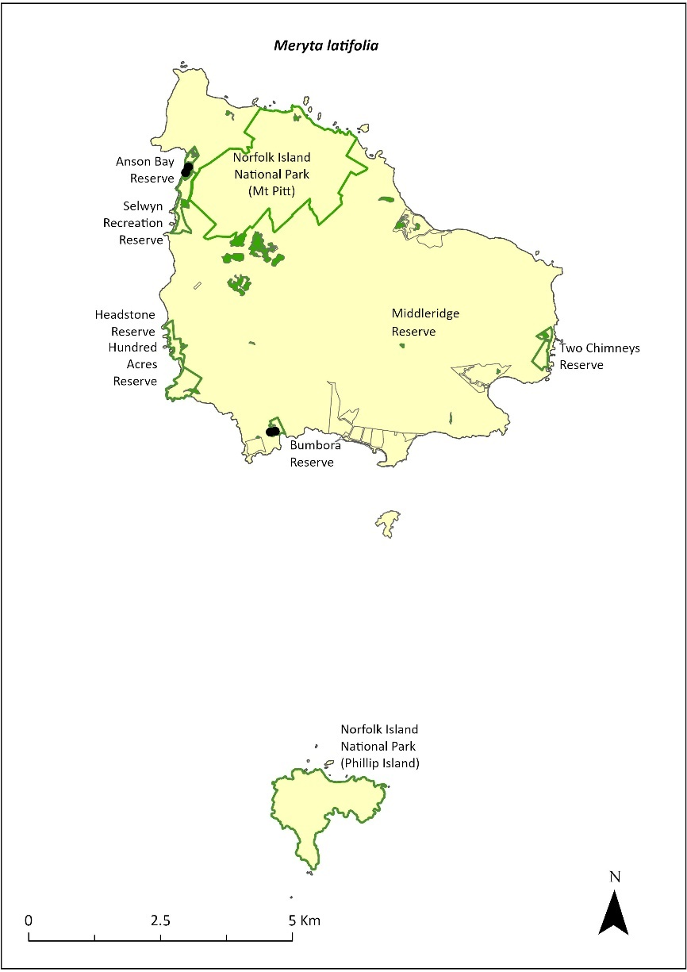
Green outlines indicate reserves within which the species occurs. Green shading shows plant communities within which the species may occur (Christian & Mills 2021). Points show recorded locations (Mills 2017d).

Threats
Threats to the species include weed invasion, predation of seeds by rats, senescence of over-mature plants, sex ratio bias and cattle grazing. The species is adapted to moist forest conditions and is therefore susceptible to climate change (TSSC 2003f). Phytophthora cinnamomi is potentially a major risk.

Impact on other species
None known.

Risk assessment
Risk assessment undertaken for Critically Endangered trees/shrubs as a grouping. The risk assessment is shown in Table 113.
Table 113 Risk assessment for Critically Endangered trees/shrubs as a grouping
Risk | Likelihood of exposure | Consequence | Threat rating
1. Loss and fragmentation of native vegetation through past land clearing | Almost certain (91–100%) | Extreme | Extreme
2. Loss and fragmentation of native vegetation through current or future land clearing | Rare (0–10%) | Negligible | Negligible
3. Degradation of native vegetation through past grazing or loss of nutrients | Almost certain (91–100%) | Extreme | Extreme
4. Degradation of native vegetation through current or future grazing | Possible (26–50%) | Moderate | Medium
6. Predation by rodents | Almost certain (91–100%) | Major | Extreme
7. Predation by cats | Rare (0–10%) | Negligible | Negligible
8. Predation or damage by chickens | Likely (51–90%) | Moderate | Medium
9. Predation by swamphens | Rare (0–10%) | Negligible | Negligible
10. Predation by Argentine ant | Possible (26–50%) | Minor | Low
11. Competition from/change of habitat because of weed invasion | Likely (51–90%) | Moderate | Medium
12. Infection by pathogens already present | Possible (26–50%) | Moderate | Medium
13. Impacts of potential new invasive species or pathogens | Unlikely (11–25%) | Minor | Low
14. Changes to vegetation, increased fire risk and/or direct physiological stress as a result of climatic changes | Possible (26–50%) | Moderate | Medium
15. Problems caused by small populations, including lack of genetic diversity | Almost certain (91–100%) | Major | Extreme

Management action
Continue seed collection, propagation and replanting, including into lowland and coastal areas that are protected from cattle grazing (Sykes & Atkinson 1988). Implement habitat protection and rehabilitation. Undertake ongoing targeted weed control and maintenance. Maintain fencing and current grazing exclusion in Mission Road rainforest remnants and in public reserves. Facilitate additional plantings in private gardens.

Recovery target
The recovery target is shown in Table 114.
Table 114 Recovery target for Meryta latifolia
EPBC Act status | Estimated population (2023) | Where known populations occur | 2034 target
Critically Endangered | 395 | >25% within the national park  >70% within public reserves | 1000

Relevant literature
Christian NE & Mills K (2021) Vegetation Mapping of Norfolk Island 2021. Unpublished data.
Invasive Species Council & TierraMar (2021) The Native Plant Communities of Norfolk Island. Invasive Species Council, Katoomba, NSW.
Mills K (2009b) The Vegetation of Phillip Island, Norfolk Island Group. Envirofund 2007/2008. Kevin Mills & Associates, Jamberoo, NSW.
Mills K (2012b) The Flora of Norfolk Island. Report 14. The Endangered Plants in the national park: Field Survey and Review. Kevin Mills & Associates, Jamberoo, NSW.
Mills K (2017d) Survey of public reserves on Norfolk Island for threatened plant species: 6. Anson Bay Reserve and Selwyn Reserve. Prepared for Norfolk Island Regional Council.
Sykes W & Atkinson I (1988) Rare and Endangered Plants of Norfolk Island. Unpublished report to the Australian National Parks and Wildlife Service, Norfolk Island.
TSSC (Threatened Species Scientific Committee) (2003f) Commonwealth Listing Advice—Critically Endangered Meryta latifolia (Shade Tree).

Muehlenbeckia australis—shrubby creeper, pohuehue
Family POLYGONACEAE

Conservation significance
Restricted to Norfolk Island and New Zealand.
EPBC Act Listing Status: Endangered.

Description
Perennial, much-branched, scrambling creeper that grows to 4 m high.
There may be genetic differences between the Norfolk and the Phillip Island population.

Distribution and abundance
This species occurs from sea level to the summit of Mt Pitt and has been recorded from Mt Pitt, Mt Bates and Steels Point (Orchard 1994). It occurs mostly within the Mt Pitt section of the Norfolk Island National Park, but also occurs on Phillip Island on the cliffs east of Razorback (Mills 2009b).
There were 100 mature individuals of Muehlenbeckia australis recorded in 2003 (TSSC 2003c). In 2012, Mills found 31 plants (most of which were small) along seven transects within the national park. The plants mainly occurred on ridges on the higher mountains. More than half the plants observed (17) were seen along the edge of the Mount Pitt Road (Mills 2012b).
The distribution is shown in Map 49.

Ecology
Little known.

Habitat
Grows in native forests from sea level to the upper slopes of the mountains. Usually seen in light gaps or on the edges of forest.

Threats
Threats include weed invasion and difficulty in propagating from seed.

Impact on other species
None known.
Map 49 Distribution of Muehlenbeckia australis
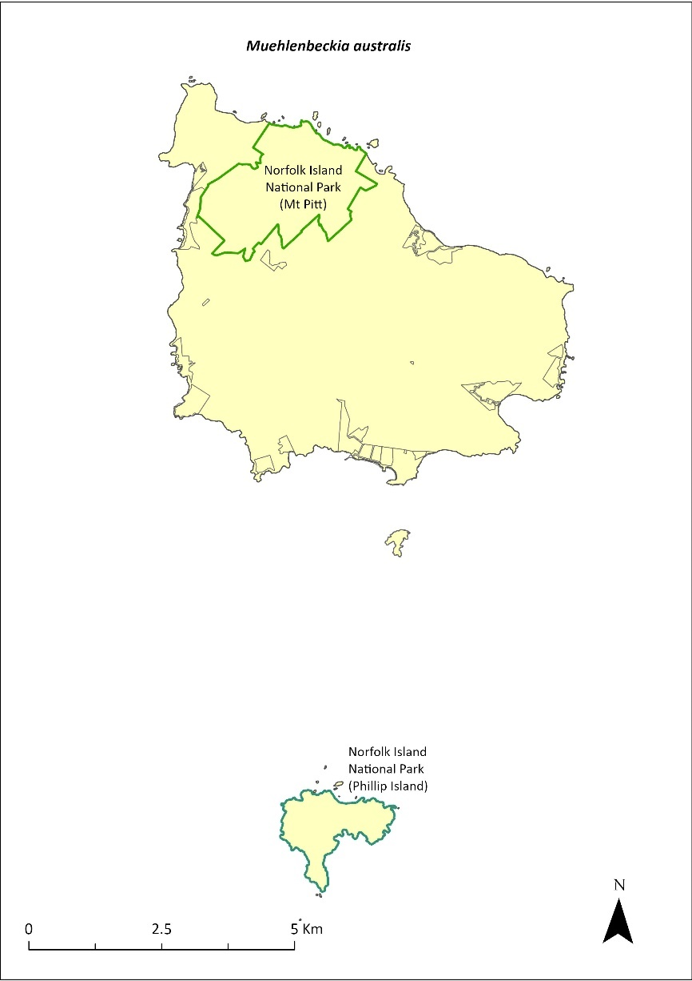
Green outlines indicate reserves within which the species occurs.

Risk assessment
Risk assessment undertaken for Endangered vines/climbers as a grouping. The risk assessment is shown in Table 115.
Table 115 Risk assessment for Endangered vines/climbers as a grouping
Risk | Likelihood of exposure | Consequence | Threat rating
1. Loss and fragmentation of native vegetation through past land clearing | Almost certain (91–100%) | Extreme | Extreme
2. Loss and fragmentation of native vegetation through current or future land clearing | Rare (0–10%) | Negligible | Negligible
3. Degradation of native vegetation through past grazing or loss of nutrients | Almost certain (91–100%) | Extreme | Extreme
4. Degradation of native vegetation through current or future grazing | Possible (26–50%) | Moderate | Medium
6. Predation by rodents | Possible (26–50%) | Minor | Low
7. Predation by cats | Rare (0–10%) | Negligible | Negligible
8. Predation or damage by chickens | Rare (0–10%) | Negligible | Negligible
9. Predation by swamphens | Rare (0–10%) | Negligible | Negligible
10. Predation by Argentine ant | Rare (0–10%) | Negligible | Negligible
11. Competition from/change of habitat because of weed invasion | Likely (51–90%) | Moderate | Medium
12. Infection by pathogens already present | Rare (0–10%) | Negligible | Negligible
13. Impacts of potential new invasive species or pathogens | Unlikely (11–25%) | Minor | Low
14. Changes to vegetation, increased fire risk and/or direct physiological stress as a result of climatic changes | Possible (26–50%) | Moderate | Medium
15. Problems caused by small populations, including lack of genetic diversity | Possible (26–50%) | Moderate | Medium

Management actions
Undertake propagation from cuttings from individuals on Norfolk Island and Phillip Island and replanting into appropriate areas. Conduct research into seed propagation techniques. Implement habitat protection and rehabilitation. Undertake targeted weed control and maintenance. Undertake research into taxonomic differences between the populations from Phillip Island and Norfolk Island and compare with those from New Zealand.

Recovery target
The recovery target is shown in Table 116.
Table 116 Recovery target for Muehlenbeckia australis
EPBC Act status | Estimated population (2023) | Where known populations occur | 2034 target
Endangered | 100 | 100% within the national park | 250

Relevant literature
Mills K (2009b) The Vegetation of Phillip Island, Norfolk Island Group. Envirofund 2007/2008. Kevin Mills & Associates, Jamberoo, NSW.
Mills K (2012b) The Flora of Norfolk Island. Report 14. The Endangered Plants in the national park: Field Survey and Review. Kevin Mills & Associates, Jamberoo, NSW.
Orchard A (ed) (1994) Flora of Australia. Vol. 49. Oceanic Islands 1. Australian Government Publishing Service, Canberra.
TSSC (Threatened Species Scientific Committee) (2003c) Commonwealth Listing Advice for Norfolk Island Flora – 16 Endangered Species.

Myoporum obscurum—popwood
Family MYOPORACEAE

Conservation significance
Endemic to Norfolk Island.
EPBC Act Listing Status: Critically Endangered.

Description
Shrub or small spreading tree growing to 7 m tall with shiny green foliage.

Distribution and abundance
In 1988, the species was found on the northern slopes of the Norfolk Island National Park and on Mt Bates Road, but only four trees were sighted. It was not present on Phillip Island, although it was recorded there in the 1830s (Sykes & Atkinson 1988). A survey in 1989 failed to locate additional individuals again, confirming that this species was very rare in the national park (Gilmour & Helman 1989b). There were only five mature, seed-producing individuals of Myoporum obscurum remaining until replanting began in 1995.
Mills (2012b) found the species during surveys within the park at four sites where six plants were counted. No seedlings were found and only two wild trees were found at two of the sites surveyed. The species has been planted along the tracks in the national park and in gardens on Norfolk Island. The species was recorded within several reserves in 2017 (mostly plantings), including Selwyn, Cascade and Two Chimneys Reserves (Mills 2017d, f, g).
The population had increased to 417 individuals in 2021. Propagation and planting have occurred through the Norfolk Island National Park threatened flora program.
The distribution is shown in Map 50.

Ecology
Little known.

Habitat
This species prefers clearings, canopy gaps or open areas away from the coast (Sykes & Atkinson 1988).

Threats
Threats to the species include weed invasion and competition, and small population size and subsequent increased risk of extinction through natural events such as cyclones, slips and drought. Phytophthora cinnamomi is potentially a major risk.
Map 50 Distribution of Myoporum obscurum
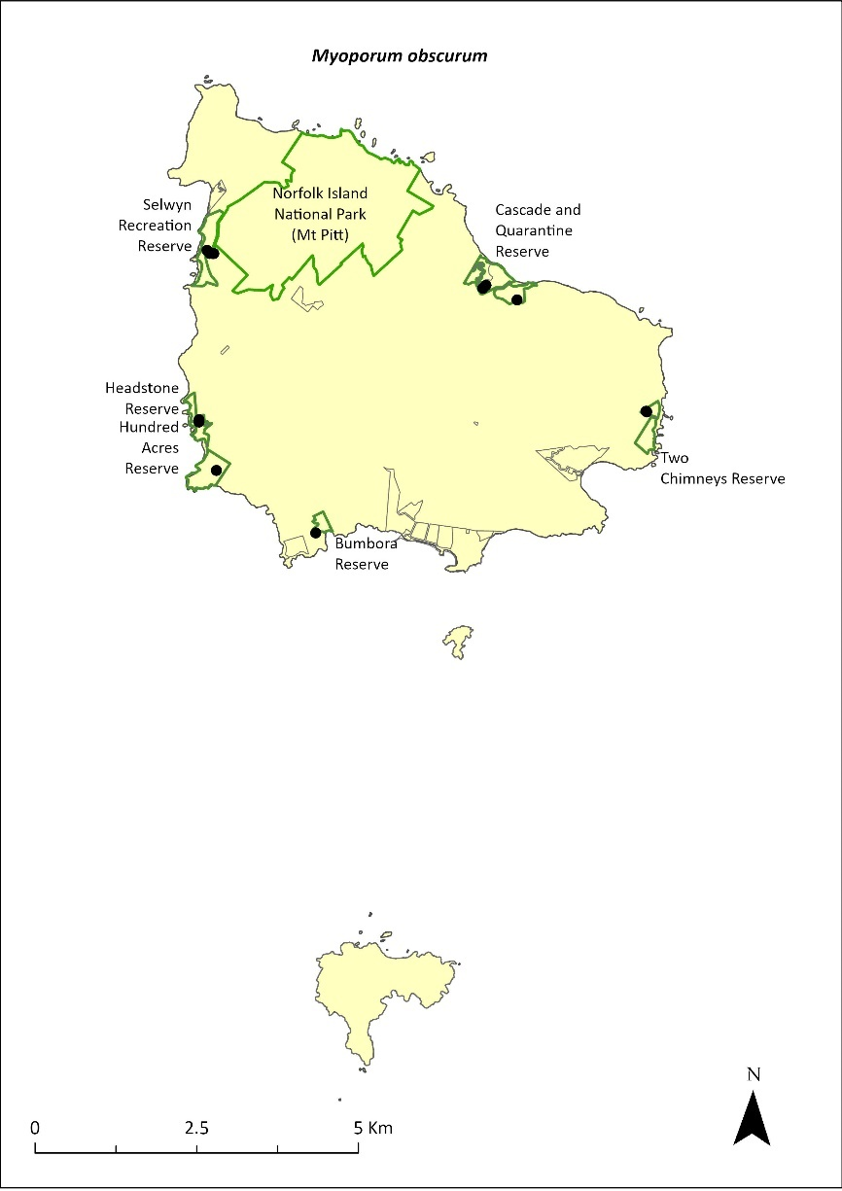
Green outlines indicate reserves within which the species occurs. Points show recorded locations (Mills 2017a, d, e, f, g).

Impact on other species
None known.

Risk assessment
Risk assessment undertaken for Critically Endangered trees/shrubs as a grouping. The risk assessment is shown in Table 117.
Table 117 Risk assessment for Critically Endangered trees/shrubs as a grouping
Risk | Likelihood of exposure | Consequence | Threat rating
1. Loss and fragmentation of native vegetation through past land clearing | Almost certain (91–100%) | Extreme | Extreme
2. Loss and fragmentation of native vegetation through current or future land clearing | Rare (0–10%) | Negligible | Negligible
3. Degradation of native vegetation through past grazing or loss of nutrients | Almost certain (91–100%) | Extreme | Extreme
4. Degradation of native vegetation through current or future grazing | Possible (26–50%) | Moderate | Medium
6. Predation by rodents | Unlikely (11–25%) | Minor | Low
7. Predation by cats | Rare (0–10%) | Negligible | Negligible
8. Predation or damage by chickens | Likely (51–90%) | Moderate | Medium
9. Predation by swamphens | Rare (0–10%) | Negligible | Negligible
10. Predation by Argentine ant | Possible (26–50%) | Minor | Low
11. Competition from/change of habitat because of weed invasion | Likely (51–90%) | Major | High
12. Infection by pathogens already present | Possible (26–50%) | Moderate | Medium
13. Impacts of potential new invasive species or pathogens | Unlikely (11–25%) | Minor | Low
14. Changes to vegetation, increased fire risk and/or direct physiological stress as a result of climatic changes | Possible (26–50%) | Moderate | Medium
15. Problems caused by small populations, including lack of genetic diversity | Almost certain (91–100%) | Major | Extreme

Management actions
Continue propagation and replanting into appropriate areas on Norfolk Island and Phillip Island, as well as the public reserves. Implement habitat protection and rehabilitation. Undertake targeted weed control and maintenance. Monitor plantings to determine survival rates.

Recovery target
The recovery target is shown in Table 118.
Table 118 Recovery target for Myoporum obscurum
EPBC Act status | Estimated population (2023) | Where known populations occur | 2034 target
Critically Endangered | 417 | >90% within the national park  4% within the Reserves | 1000

Relevant literature
Gilmour PM & Helman CE (1989b) The Vegetation of Norfolk Island National Park. Report to the Australian national parks and Wildlife Service, Norfolk Island.
Mills K (2009b) The Vegetation of Phillip Island, Norfolk Island Group. Envirofund 2007/2008. Kevin Mills & Associates, Jamberoo, NSW.
Mills K (2012b) The Flora of Norfolk Island. Report 14. The Endangered Plants in the national park: Field Survey and Review. Kevin Mills & Associates, Jamberoo, NSW.
Orchard A (ed) (1994) Flora of Australia. Vol. 49. Oceanic Islands 1. Australian Government Publishing Service, Canberra.
Mills K (2017a) Survey of public reserves on Norfolk Island for threatened plant species: 3. Point Ross Reserve and Bumbora Reserve. Prepared for Norfolk Island Regional Council.
Mills K (2017d) Survey of public reserves on Norfolk Island for threatened plant species: 6. Anson Bay Reserve and Selwyn Reserve. Prepared for Norfolk Island Regional Council.
Mills K (2017e) Survey of public reserves on Norfolk Island for threatened plant species: 7. Hundred Acres Reserve. Prepared for Norfolk Island Regional Council.
Mills K (2017f) Survey of public reserves on Norfolk Island for threatened plant species: 4. Cascade Reserve including Quarantine Reserve. Prepared for Norfolk Island Regional Council.
Mills K (2017g) Survey of public reserves on Norfolk Island for threatened plant species: 5. Two Chimneys Reserve. Prepared for Norfolk Island Regional Council.
Sykes W & Atkinson I (1988) Rare and Endangered Plants of Norfolk Island. Unpublished report to the Australian National Parks and Wildlife Service, Norfolk Island.
TSSC (Threatened Species Scientific Committee) (2003a) Commonwealth Listing Advice for Norfolk Island Flora – 11 Critically Endangered Species.

Myrsine ralstoniae—beech
Family MYRSINACEAE

Conservation significance
Endemic to Norfolk Island.
EPBC Act Listing Status: Vulnerable.

Description
A small tree growing to 6 m tall with small berries.

Distribution and abundance
Most of the Myrsine ralstoniae population is within the Mt Pitt section of the Norfolk Island National Park. The species is widespread and very common in the national park. Elsewhere, it occurs in most public reserves and in forest remnants on private land (K Mills 2024. pers comm 11 January).
The total number of mature plants present in 2003 was 562 (TSSC 2003b). The population estimate in 2021 was 1789, including 409 in Anson Bay and Selwyn Reserves and 547 in Hundred Acres Reserve (Mills 2017d & e).
The distribution is shown in Map 51.

Ecology
Little known.

Habitat
The species often occurs as an understorey tree in forested areas (Orchard 1994). Occurs in moist upland hardwood forest, pine-hardwood ridge forest, viny hardwood forest, plateau hardwood forest, lowland valley hardwood forest, sheltered coastal forest and coastal pine and white oak forest (Invasive Species Council & TierraMar 2021).

Threats
Threats to the species include weed invasion and competition, cattle grazing and climate change. Phytophthora cinnamomi is potentially a major risk.

Impact on other species
None known.
Map 51 Distribution of Myrsine ralstoniae
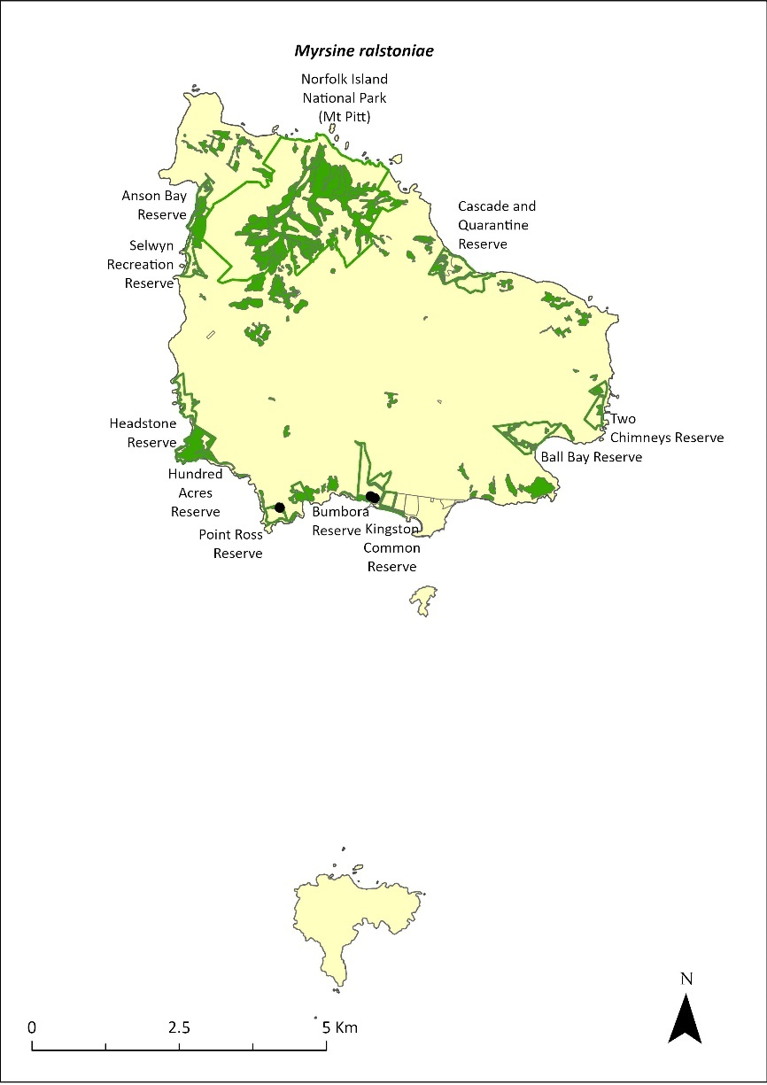
Green outlines indicate reserves within which the species occurs. Green shading shows plant communities within which the species may occur (Christian & Mills 2021). Points show recorded locations (Mills 2017a and c).

Risk assessment
Risk assessment undertaken for Vulnerable trees/shrubs as a grouping. The risk assessment is shown in Table 119.
Table 119 Risk assessment for Vulnerable trees/shrubs as a grouping
Risk | Likelihood of exposure | Consequence | Threat rating
1. Loss and fragmentation of native vegetation through past land clearing | Almost certain (91–100%) | Extreme | Extreme
2. Loss and fragmentation of native vegetation through current or future land clearing | Rare (0–10%) | Negligible | Negligible
3. Degradation of native vegetation through past grazing or loss of nutrients | Almost certain (91–100%) | Extreme | Extreme
4. Degradation of native vegetation through current or future grazing | Possible (26–50%) | Moderate | Medium
6. Predation by rodents | Almost certain (91–100%) | Moderate | High
7. Predation by cats | Rare (0–10%) | Negligible | Negligible
8. Predation or damage by chickens | Rare (0–10%) | Negligible | Negligible
9. Predation by swamphens | Rare (0–10%) | Negligible | Negligible
10. Predation by Argentine ant | Possible (26–50%) | Minor | Low
11. Competition from/change of habitat because of weed invasion | Likely (51–90%) | Minor | Medium
12. Infection by pathogens already present | Possible (26–50%) | Moderate | Medium
13. Impacts of potential new invasive species or pathogens | Unlikely (11–25%) | Minor | Low
14. Changes to vegetation, increased fire risk and/or direct physiological stress as a result of climatic changes | Possible (26–50%) | Minor | Low
15. Problems caused by small populations, including lack of genetic diversity | Unlikely (11–25%) | Minor | Low

Management actions
Undertake seed collection, propagation and replanting. Implement habitat protection and rehabilitation. Undertake targeted weed control and maintenance. Exclude or manage cattle grazing.

Recovery target
The recovery target is shown in Table 120.
Table 120 Recovery target for Myrsine ralstoniae
EPBC Act status | Estimated population (2023) | Where known populations occur | 2034 target
Vulnerable | 1789 | >30% within the national park  >65% within public reserves | 3000

Relevant literature
Christian NE & Mills K (2021) Vegetation Mapping of Norfolk Island 2021. Unpublished data.
Invasive Species Council & TierraMar (2021) The Native Plant Communities of Norfolk Island. Invasive Species Council, Katoomba, NSW.
Mills K (2017d) Survey of public reserves on Norfolk Island for threatened plant species: 6. Anson Bay Reserve and Selwyn Reserve. Prepared for Norfolk Island Regional Council.
Mills K (2017e) Survey of public reserves on Norfolk Island for threatened plant species: 7. Hundred Acres Reserve. Prepared for Norfolk Island Regional Council.
Orchard A (ed) (1994) Flora of Australia. Vol. 49. Oceanic Islands 1. Australian Government Publishing Service, Canberra.
TSSC (Threatened Species Scientific Committee) (2003b) Commonwealth Listing Advice for Norfolk Island Flora - 15 Vulnerable Species.

Pennantia endlicheri—pennantia
Family ICACINACEAE

Conservation significance
Endemic to Norfolk Island.
EPBC Act Listing Status: Endangered

Description
A large shrub or more usually a tree growing to 10 m tall with small white flowers.

Distribution and abundance
It was estimated that a few hundred mature trees and about 3,000 saplings were present in the Mt Pitt section of the Norfolk Island National Park in the early 2000s (Director of National Parks 2010). The species is occasionally found outside of the park (Gardner & de Lange 2002; de Lange & Murray 2003). Some large trees are also known to occur in the Mission Road remnants (Director of National Parks 2010).
The total number of mature plants recorded within the national park in 2003 was 168 (TSSC 2003c). Mills (2012b) found that this species had greatly increased its population in the national park since 2003. A total of 680 plants were counted during the study on nearly all transects and ranged from seedlings to large old trees, indicating this species is increasing in abundance and is secure.
The population estimate in 2021 was 791 individuals. Propagation and planting have occurred through the Norfolk Island National Park threatened flora program.
The distribution is shown in Map 52.

Ecology
Flowers functionally unisexual.

Habitat
This species grows in sheltered moist palm valley forest, moist upland hardwood forest and pine-hardwood ridge forest (Invasive Species Council & TierraMar 2021). Young plants have some shade tolerance such that they are often found in gullies dominated by Norfolk Island palms (Rhopalostylis baueri; Gardner & de Lange 2002).

Threats
Threats to the species include weed invasion and competition and rodents eating seeds. Phytophthora cinnamomi is potentially a major risk.

Impact on other species
None known.
Map 52 Distribution of Pennantia endlicheri
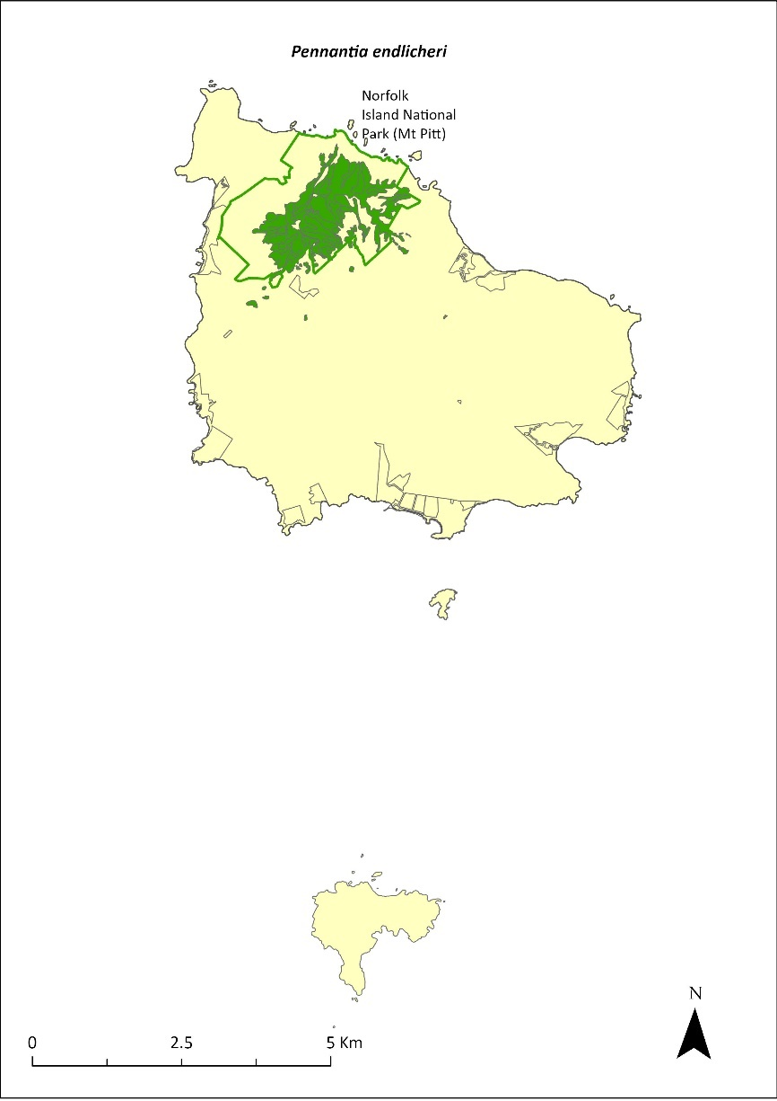
Green outlines indicate reserves within which the species occurs. Green shading shows plant communities within which the species may occur (Christian & Mills 2021).

Risk assessment
Risk assessment undertaken for Endangered trees/shrubs as a grouping. The risk assessment is shown in Table 121.
Table 121 Risk assessment for Endangered trees/shrubs as a grouping
Risk | Likelihood of exposure | Consequence | Threat rating
1. Loss and fragmentation of native vegetation through past land clearing | Almost certain (91–100%) | Extreme | Extreme
2. Loss and fragmentation of native vegetation through current or future land clearing | Rare (0–10%) | Negligible | Negligible
3. Degradation of native vegetation through past grazing or loss of nutrients | Almost certain (91–100%) | Extreme | Extreme
4. Degradation of native vegetation through current or future grazing | Possible (26–50%) | Moderate | Medium
6. Predation by rodents | Almost certain (91–100%) | Moderate | High
7. Predation by cats | Rare (0–10%) | Negligible | Negligible
8. Predation or damage by chickens | Likely (51–90%) | Moderate | Medium
9. Predation by swamphens | Rare (0–10%) | Negligible | Negligible
10. Predation by Argentine ant | Possible (26–50%) | Minor | Low
11. Competition from/change of habitat because of weed invasion | Almost certain (91–100%) | Major | Extreme
12. Infection by pathogens already present | Possible (26–50%) | Moderate | Medium
13. Impacts of potential new invasive species or pathogens | Unlikely (11–25%) | Minor | Low
14. Changes to vegetation, increased fire risk and/or direct physiological stress as a result of climatic changes | Possible (26–50%) | Moderate | Medium
15. Problems caused by small populations, including lack of genetic diversity | Almost certain (91–100%) | Moderate | High

Management actions
Continue propagation and planting in suitable areas. Implement habitat protection and rehabilitation. Undertake ongoing targeted weed control and maintenance and ongoing rodent and chicken control.

Recovery target
The recovery target is shown in Table 122.
Table 122 Recovery target for Pennantia endlicheri
EPBC Act status | Estimated population (2023) | Where known populations occur | 2034 target
Endangered | 791 | >95% within the national park | 1000

Relevant literature
Christian NE & Mills K (2021) Vegetation Mapping of Norfolk Island 2021. Unpublished data.
de Lange PJ & Murray BG (2003) Chromosome numbers of Norfolk Island endemic plants. Australian Journal of Botany 51, 211–215.
Director of National Parks (2010) Norfolk Island Region Threatened Species Recovery Plan. Department of the Environment, Water, Heritage and the Arts, Canberra.
Gardner RO & de Lange PJ (2002) Revision of Pennantia (Icacinaceae), a small isolated genus. Journal of the Royal Society of New Zealand 32, 669–695.
Invasive Species Council & TierraMar (2021) The Native Plant Communities of Norfolk Island. Invasive Species Council, Katoomba, NSW.
Mills K (2012b) The Flora of Norfolk Island. Report 14. The Endangered Plants in the national park: Field Survey and Review. Kevin Mills & Associates, Jamberoo, NSW.
Orchard A (ed) (1994) Flora of Australia. Vol. 49. Oceanic Islands 1. Australian Government Publishing Service, Canberra.
TSSC (Threatened Species Scientific Committee) (2003c) Commonwealth Listing Advice for Norfolk Island Flora – 16 Endangered Species.

Phreatia limenophylax—Norfolk Island phreatia
Family ORCHIDACEAE

Conservation significance
Endemic to Norfolk Island.
EPBC Act Listing Status: Critically Endangered.

Description
A small, tufted, epiphytic orchid growing to 3-6 cm high with a long inflorescence of many tiny greenish-white flowers.

Distribution and abundance
The species has been recorded from Anson Bay (Orchard 1994) but likely only remains within the Mt Pitt section of Norfolk Island National Park. The total number of mature Phreatia limenophylax plants in 2003 was five (TSSC 2003a). The species was not found during a 2007 study of epiphytes on Norfolk Island by Mills (2007e).
The distribution is shown in Map 53.

Ecology
Little known.

Habitat
Grows on the branches of trees in the Mt Pitt section of the national park, within moist palm valley forest.

Threats
Threats to the species include small population size and subsequent increased risk of extinction through natural events such as cyclones, slips and drought, and climate change.

Impact on other species
Grows on the branches of trees.
Map 53 Distribution of Phreatia limenophylax
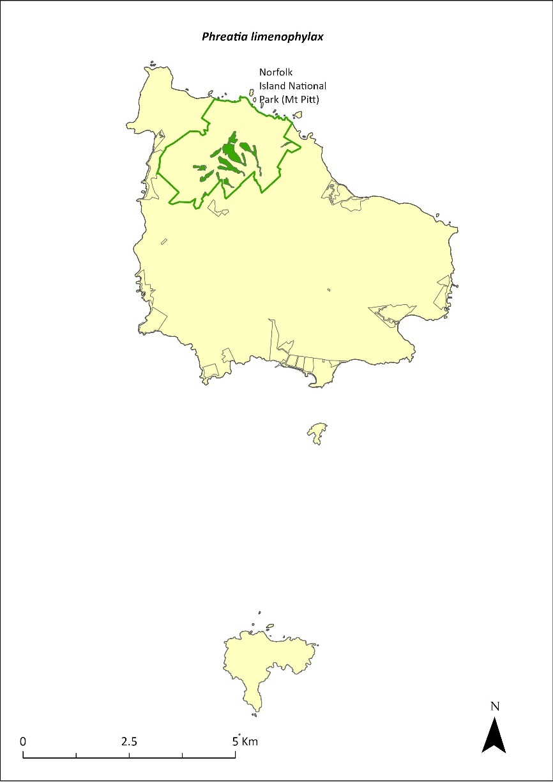
Green outlines indicate reserves within which the species occurs. Green shading shows plant communities within which the species may occur (Christian & Mills 2021).

Risk assessment
Risk assessment undertaken for all threatened orchids as a grouping. The risk assessment is shown in Table 123.
Table 123 Risk assessment for all threatened orchids as a grouping
Risk | Likelihood of exposure | Consequence | Threat rating
1. Loss and fragmentation of native vegetation through past land clearing | Almost certain (91–100%) | Minor | Medium
2. Loss and fragmentation of native vegetation through current or future land clearing | Rare (0–10%) | Moderate | Negligible
3. Degradation of native vegetation through past grazing or loss of nutrients | Almost certain (91–100%) | Minor | Medium
4. Degradation of native vegetation through current or future grazing | Possible (26–50%) | Moderate | Medium
6. Predation by rodents | Rare (0–10%) | Negligible | Negligible
7. Predation by cats | Rare (0–10%) | Negligible | Negligible
8. Predation or damage by chickens | Rare (0–10%) | Negligible | Negligible
9. Predation by swamphens | Rare (0–10%) | Negligible | Negligible
10. Predation by Argentine ant | Rare (0–10%) | Negligible | Negligible
11. Competition from/change of habitat because of weed invasion | Possible (26–50%) | Moderate | Medium
12. Infection by pathogens already present | Unlikely (11–25%) | Moderate | Low
13. Impacts of potential new invasive species or pathogens | Unlikely (11–25%) | Moderate | Low
14. Changes to vegetation, increased fire risk and/or direct physiological stress as a result of climatic changes | Likely (51–90%) | Major | High
15. Problems caused by small populations, including lack of genetic diversity | Almost certain (91–100%) | Moderate | High

Management actions
This orchid may require development of species-specific conservation actions, including ex situ conservation. Undertake surveys in suitable habitat areas to search for additional individuals/populations. Undertake ongoing targeted weed control and maintenance. Implement habitat protection and rehabilitation. Undertake research into the ecology of the species. Monitor/survey likely areas of the national park after storms, rescue any fallen specimens and attempt to cultivate them in the Norfolk Island National Park Nursery (Sykes & Atkinson 1988).

Recovery target
The recovery target is shown in Table 124.
Table 124 Recovery target for Phreatia limenophylax
EPBC Act status | Estimated population (2023) | Where known populations occur | 2034 target
Critically Endangered | 5 | 100% within the national park | Established in a second location

Relevant literature
Christian NE & Mills K (2021) Vegetation Mapping of Norfolk Island 2021. Unpublished data.
Gilmour PM & Helman CE (1989b) The Vegetation of Norfolk Island National Park. Report to the Australian national parks and Wildlife Service, Norfolk Island.
Mills K (2007e) The Flora of Norfolk Island. 2. Epiphytes and Mistletoes. Kevin Mills & Associates, Jamberoo, NSW.
Orchard A (ed) (1994) Flora of Australia. Vol. 49. Oceanic Islands 1. Australian Government Publishing Service, Canberra.
Sykes W & Atkinson I (1988) Rare and Endangered Plants of Norfolk Island. Unpublished report to the Australian National Parks and Wildlife Service, Norfolk Island.
TSSC (Threatened Species Scientific Committee) (2003a) Commonwealth Listing Advice for Norfolk Island Flora – 11 Critically Endangered Species.

Phreatia paleata—White lace orchid
Family ORCHIDACEAE

Conservation significance
Australian distribution restricted to Norfolk Island; also occurs in New Caledonia, New Guinea, Solomon Islands and Vanuatu (Orchard 1994).
EPBC Act Listing Status: Endangered

Description
A tufted epiphytic orchid growing to 30 cm high with 50 or more small white flowers on a drooping stem to 35 cm long.

Distribution and abundance
The population in 2003 consisted of fewer than 200 mature plants (TSSC 2003c).
The study of epiphytes on Norfolk Island by Mills (2007e) recorded 27 plants growing on trees and rocks, all in the national park, particularly at the higher altitudes.
The distribution is shown in Map 54.

Ecology
An epiphyte that grows on several tree species, apparently favouring Dysoxylum bijugum (Mills 2007e).

Habitat
Grows on tree branches in native forest.

Threats
Threats to the species include small population size and subsequent increased risk of extinction through natural events such as cyclones, slips and droughts, and climate change.

Impact on other species
Grows on the branches of other trees.
Map 54 Distribution of Phreatia paleata
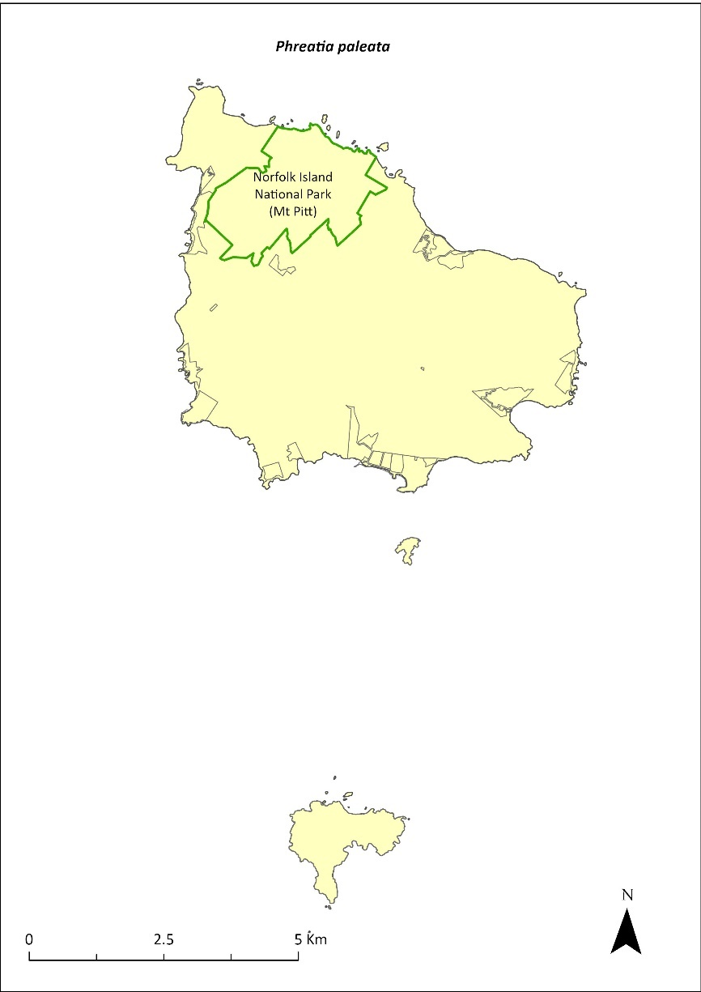
Green outlines indicate reserves within which the species occurs.

Risk assessment
Risk assessment undertaken for all threatened orchids as a grouping. The risk assessment is shown in Table 125.
Table 125 Risk assessment for all threatened orchids as a grouping
Risk | Likelihood of exposure | Consequence | Threat rating
1. Loss and fragmentation of native vegetation through past land clearing | Almost certain (91–100%) | Minor | Medium
2. Loss and fragmentation of native vegetation through current or future land clearing | Rare (0–10%) | Moderate | Negligible
3. Degradation of native vegetation through past grazing or loss of nutrients | Almost certain (91–100%) | Minor | Medium
4. Degradation of native vegetation through current or future grazing | Unlikely (11–25%) | Moderate | Low
6. Predation by rodents | Possible (26–50%) | Extreme | High
7. Predation by cats | Rare (0–10%) | Negligible | Negligible
8. Predation or damage by chickens | Rare (0–10%) | Negligible | Negligible
9. Predation by swamphens | Rare (0–10%) | Negligible | Negligible
10. Predation by Argentine ant | Rare (0–10%) | Negligible | Negligible
11. Competition from/change of habitat because of weed invasion | Possible (26–50%) | Moderate | Medium
12. Infection by pathogens already present | Unlikely (11–25%) | Moderate | Low
13. Impacts of potential new invasive species or pathogens | Unlikely (11–25%) | Moderate | Low
14. Changes to vegetation, increased fire risk and/or direct physiological stress as a result of climatic changes | Likely (51–90%) | Major | High
15. Problems caused by small populations, including lack of genetic diversity | Likely (51–90%) | Moderate | Medium

Management actions
Phreatia paleata may require development of species-specific conservation actions, including ex situ conservation. Undertake surveys in suitable habitat areas to search for additional individuals/populations. Undertake ongoing targeted weed control and maintenance, habitat protection and rehabilitation. Undertake research into the ecology of the species. Monitor likely areas of the national park after storms, rescue any fallen specimens and attempt to cultivate them in the Norfolk Island National Park Nursery (Sykes & Atkinson 1988).

Recovery target
The recovery target is shown in Table 126.
Table 126 Recovery target for Phreatia paleata
EPBC Act status | Estimated population (2023) | Where known populations occur | 2034 target
Endangered | 27 | 100% within the national park | No decline

Relevant literature
Mills K (2007e) The Flora of Norfolk Island. 2. Epiphytes and Mistletoes. Kevin Mills & Associates, Jamberoo, NSW.
Orchard A (ed) (1994) Flora of Australia. Vol. 49. Oceanic Islands 1. Australian Government Publishing Service, Canberra.
Sykes W & Atkinson I (1988) Rare and Endangered Plants of Norfolk Island. Unpublished report to the Australian National Parks and Wildlife Service, Norfolk Island.
TSSC (Threatened Species Scientific Committee) (2003c) Commonwealth Listing Advice for Norfolk Island Flora – 16 Endangered Species.

Pittosporum bracteolatum—oleander
Family PITTOSPORACEAE

Conservation significance
Endemic to Norfolk Island.
EPBC Act Listing Status: Vulnerable.

Description
Tree growing to 7 m tall with small cream flowers and spherical fruit containing numerous seeds in a sticky orange pulp.

Distribution and abundance
Pittosporum bracteolatum is widespread with most of the wild population found in the Mt Pitt section of the Norfolk Island National Park. Elsewhere, it has been found at Mission Road, Steels Point and north-east of Bloody Bridge (Orchard 1994, Cayzer et al. 2000).
The total number of mature plants recorded in 2003 was 921 (TSSC 2003b). This species seeds well and it has been widely planted in the national park and in public reserves. The population estimate in 2021 was 1127 individuals, including 208 in Hundred Acres Reserve (Mills 2017e).
The distribution is shown in Map 55.

Ecology
Little known.

Habitat
Occurs in moist upland hardwood forest, pine-hardwood ridge forest and viny hardwood forest (Invasive Species Council & TierraMar 2021). It is quite common on parkland and forest slopes, particularly the sheltered south-east slopes of Mt Pitt (Cayzer et al. 2000).

Threats
The primary threat to the species is weed invasion and competition including from the introduced P. undulatum. Phytophthora cinnamomi is potentially a major risk.

Impact on other species
None known.
Map 55 Distribution of Pittosporum bracteolatum
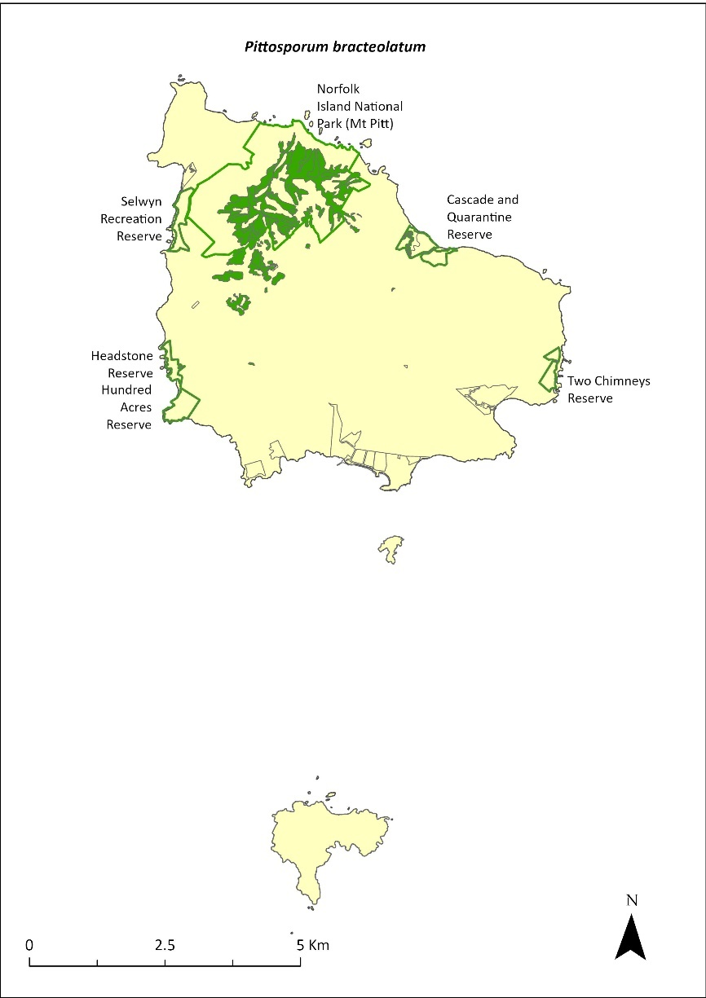
Green outlines indicate reserves within which the species occurs. Green shading shows plant communities within which the species may occur (Christian & Mills 2021).

Risk assessment
Risk assessment undertaken for Vulnerable trees/shrubs as a grouping. The risk assessment is shown in Table 127.
Table 127 Risk assessment for Vulnerable trees/shrubs as a grouping
Risk | Likelihood of exposure | Consequence | Threat rating
1. Loss and fragmentation of native vegetation through past land clearing | Almost certain (91–100%) | Extreme | Extreme
2. Loss and fragmentation of native vegetation through current or future land clearing | Rare (0–10%) | Negligible | Negligible
3. Degradation of native vegetation through past grazing or loss of nutrients | Almost certain (91–100%) | Extreme | Extreme
4. Degradation of native vegetation through current or future grazing | Possible (26–50%) | Moderate | Medium
6. Predation by rodents | Almost certain (91–100%) | Moderate | High
7. Predation by cats | Rare (0–10%) | Negligible | Negligible
8. Predation or damage by chickens | Rare (0–10%) | Negligible | Negligible
9. Predation by swamphens | Rare (0–10%) | Negligible | Negligible
10. Predation by Argentine ant | Possible (26–50%) | Minor | Low
11. Competition from/change of habitat because of weed invasion | Likely (51–90%) | Minor | Medium
12. Infection by pathogens already present | Possible (26–50%) | Moderate | Medium
13. Impacts of potential new invasive species or pathogens | Unlikely (11–25%) | Minor | Low
14. Changes to vegetation, increased fire risk and/or direct physiological stress as a result of climatic changes | Possible (26–50%) | Moderate | Medium
15. Problems caused by small populations, including lack of genetic diversity | Unlikely (11–25%) | Minor | Low

Management actions
Continue propagation and planting in suitable areas. Undertake targeted weed control and maintenance, with a focus on P. undulatum. Implement habitat protection and rehabilitation.

Recovery target
The recovery target is shown in Table 128.
Table 128 Recovery target for Pittosporum bracteolatum
EPBC Act status | Estimated population (2023) | Where known populations occur | 2034 target
Vulnerable | 1349 | >80% within the national park  >15% within the Reserves | 3000

Relevant literature
Cayzer LW, Crisp MD & Telford IRH (2000) A revision of Pittosporum (Pittosporaceae) in Australia. Systematic Journal of Botany 13, 845–902.
Christian NE & Mills K (2021) Vegetation Mapping of Norfolk Island 2021. Unpublished data.
Invasive Species Council & TierraMar (2021) The Native Plant Communities of Norfolk Island. Invasive Species Council, Katoomba, NSW.
Mills K (2017e) Survey of public reserves on Norfolk Island for threatened plant species: 7. Hundred Acres Reserve. Prepared for Norfolk Island Regional Council.
Orchard A (ed) (1994) Flora of Australia. Vol. 49. Oceanic Islands 1. Australian Government Publishing Service, Canberra.
TSSC (Threatened Species Scientific Committee) (2003b) Commonwealth Listing Advice for Norfolk Island Flora - 15 Vulnerable Species.

Planchonella costata—bastard ironwood
Family SAPOTACEAE

Conservation significance
Norfolk Island and New Zealand.
EPBC Act Listing Status: Endangered

Description
A small tree to 15m tall, which produces large (2.5–4 cm) multi-coloured berries and exudes a sticky white latex when wounded.

Distribution and abundance
Planchonella costata has been recorded from the slopes of Mt Pitt in the Norfolk Island National Park (Orchard 1994), in the Mission Road rainforest remnants and the botanic garden, and on private land at Simons Water.
There were 176 mature individuals recorded in the national park in 2003 (TSSC 2003c). Mills (2012b) found 34 plants on six transects within the national park, though the locations where this species is most common (lower altitudes and often on private property) were not surveyed. Mills (2017e) counted one planted individual in Hundred Acres Reserve.
The population estimate in 2021 was 251 individuals. Propagation and planting have occurred through the Norfolk Island National Park threatened flora program.
The distribution is shown in Map 56.

Ecology
Little known.

Habitat
A lowland species that is rare to absent at higher altitudes (K Mills 2024. pers comm 11 January). Grows in most types of forest except extreme/harsh coastal communities (Sykes & Atkinson 1988).

Threats
The primary threat to the species is weed invasion and competition. Phytophthora cinnamomi is potentially a major risk.

Impact on other species
None known.
Map 56 Distribution of Planchonella costata
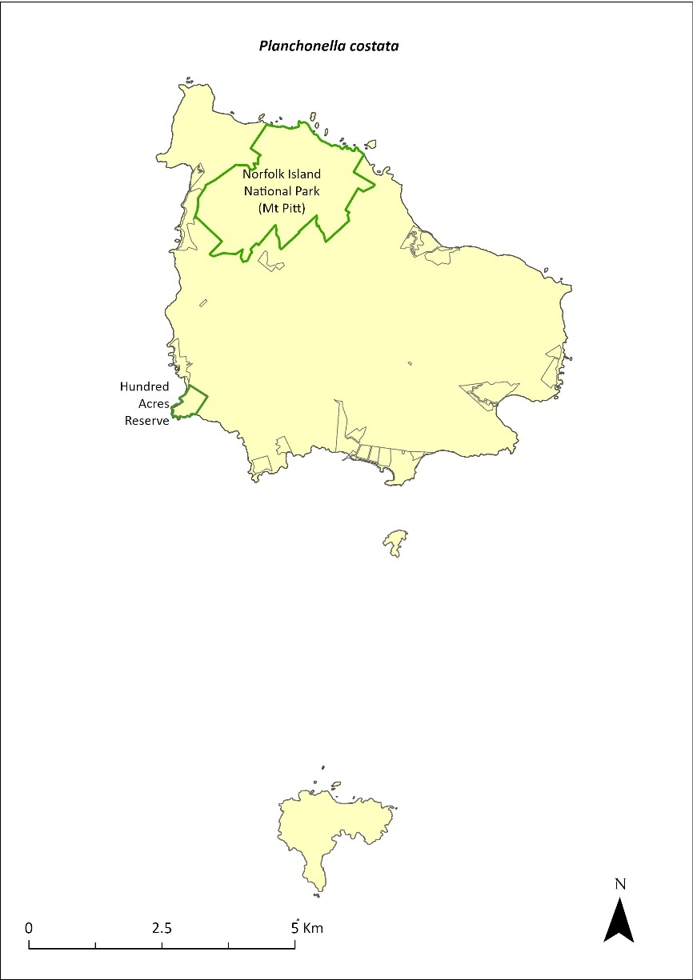
Green outlines indicate reserves within which the species occurs.

Risk assessment
Risk assessment undertaken for Endangered trees/shrubs as a grouping. The risk assessment is shown in Table 129.
Table 129 Risk assessment for Endangered trees/shrubs as a grouping
Risk | Likelihood of exposure | Consequence | Threat rating
1. Loss and fragmentation of native vegetation through past land clearing | Almost certain (91–100%) | Extreme | Extreme
2. Loss and fragmentation of native vegetation through current or future land clearing | Rare (0–10%) | Negligible | Negligible
3. Degradation of native vegetation through past grazing or loss of nutrients | Almost certain (91–100%) | Extreme | Extreme
4. Degradation of native vegetation through current or future grazing | Possible (26–50%) | Moderate | Medium
6. Predation by rodents | Possible (26–50%) | Minor | Low
7. Predation by cats | Rare (0–10%) | Negligible | Negligible
8. Predation or damage by chickens | Likely (51–90%) | Moderate | Medium
9. Predation by swamphens | Rare (0–10%) | Negligible | Negligible
10. Predation by Argentine ant | Possible (26–50%) | Minor | Low
11. Competition from/change of habitat because of weed invasion | Likely (51–90%) | Major | High
12. Infection by pathogens already present | Possible (26–50%) | Moderate | Medium
13. Impacts of potential new invasive species or pathogens | Unlikely (11–25%) | Minor | Low
14. Changes to vegetation, increased fire risk and/or direct physiological stress as a result of climatic changes | Possible (26–50%) | Moderate | Medium
15. Problems caused by small populations, including lack of genetic diversity | Likely (51–90%) | Major | High

Management actions
Continue propagation and planting in suitable areas. Implement habitat protection and rehabilitation. Undertake ongoing targeted weed control and maintenance to promote natural regeneration.

Recovery target
The recovery target is shown in Table 130.
Table 130 Recovery target for Planchonella costata
EPBC Act status | Estimated population (2023) | Where known populations occur | 2034 target
Endangered | 251 | >95% within the national park  <1% within public reserves | 1000

Relevant literature
Mills K (2012b) The Flora of Norfolk Island. Report 14. The Endangered Plants in the national park: Field Survey and Review. Kevin Mills & Associates, Jamberoo, NSW.
Mills K (2017e) Survey of public reserves on Norfolk Island for threatened plant species: 7. Hundred Acres Reserve. Prepared for Norfolk Island Regional Council.
Orchard A (ed) (1994) Flora of Australia. Vol. 49. Oceanic Islands 1. Australian Government Publishing Service, Canberra.
Sykes W & Atkinson I (1988) Rare and Endangered Plants of Norfolk Island. Unpublished report to the Australian National Parks and Wildlife Service, Norfolk Island.
TSSC (Threatened Species Scientific Committee) (2003c) Commonwealth Listing Advice for Norfolk Island Flora – 16 Endangered Species.

Polyphlebium endlicherianum—middle filmy fern
Family HYMENOPHYLLACEAE

Conservation significance
Australian distribution is restricted to Norfolk Island and Queensland. Also known from New Zealand, Fiji and Vanuatu, east to Samoa and Tahiti.
EPBC Act Listing Status: Endangered.
For further information on the species outside of the Norfolk Island Group, see the species profile on SPRAT.

Description
Delicate epiphytic, lithophytic or terrestrial fern with small fronds growing to 10cm long.

Distribution and abundance
There were fewer than 200 mature individuals in the wild recorded on Norfolk Island in the 1990s (Braggins 1996). The species was present in and apparently restricted to the rocky stream banks of Broken Bridge Creek and its tributaries.
Mills (2012b) found the species in 15 colonies in three valleys where it was growing on moist rocks, usually with other small ferns, particularly the large filmy fern Cephalomanes bauerianum. An earlier survey located 36 colonies during a search of the majority of valleys in Norfolk Island National Park (Mills 2007).
In Queensland, the species has been recorded at Kauri Creek, Tinaroo Hills, and Maalan State Forest, Atherton Tableland (Bostock & Spokes 1998).
The distribution within the Norfolk Island Group is shown in Map 57.

Ecology
Epiphytic (grows on, but is not parasitic on, other plants), lithophytic (grows on rocks and cliffs) or terrestrial (grows on the ground) in habit.

Habitat
Grows in moist, humid, shaded forest valleys, often beside waterfalls.

Threats
Threats to the species include drought/dry conditions due to climate change, changes to stream hydrology in the national park, and weed invasion and competition.

Impact on other species
Can grow on branches of other plants.
Map 57 Distribution of Polyphlebium endlicherianum
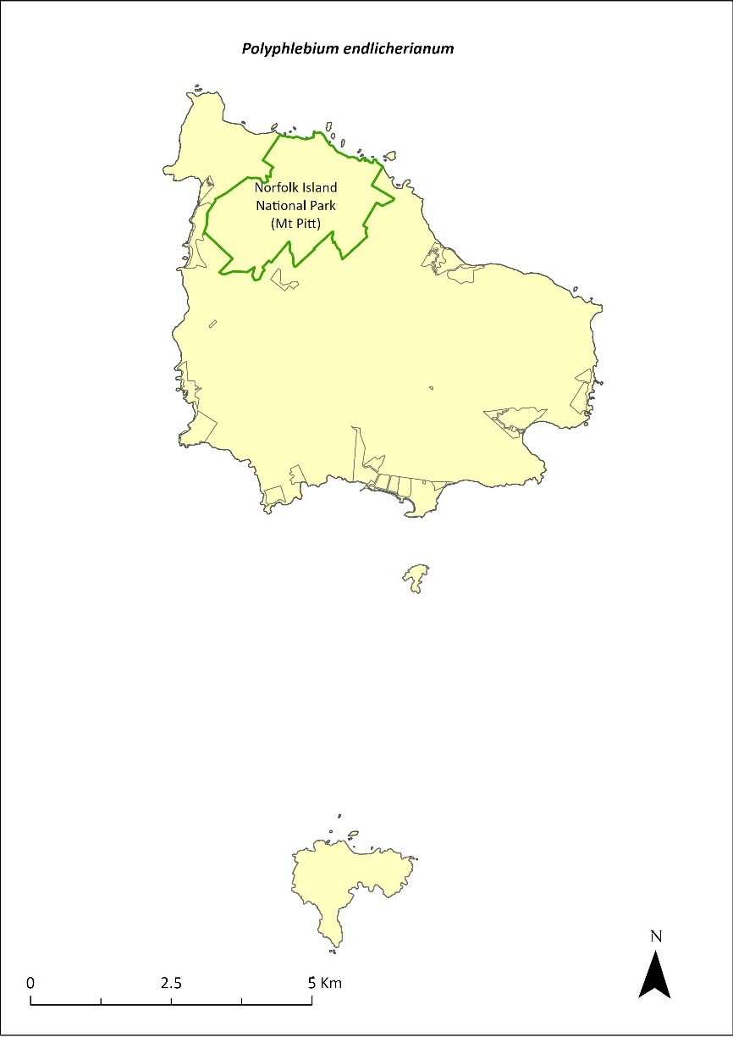
Green outlines indicate reserves within which the species occurs.

Risk assessment
Risk assessment undertaken for Endangered ferns as a grouping. The risk assessment is shown in Table 131.
Table 131 Risk assessment for Endangered ferns as a grouping
Risk | Likelihood of exposure | Consequence | Threat rating
1. Loss and fragmentation of native vegetation through past land clearing | Almost certain (91–100%) | Extreme | Extreme
2. Loss and fragmentation of native vegetation through current or future land clearing | Rare (0–10%) | Negligible | Negligible
3. Degradation of native vegetation through past grazing or loss of nutrients | Almost certain (91–100%) | Extreme | Extreme
4. Degradation of native vegetation through current or future grazing | Possible (26–50%) | Moderate | Medium
6. Predation by rodents | Rare (0–10%) | Negligible | Negligible
7. Predation by cats | Rare (0–10%) | Negligible | Negligible
8. Predation or damage by chickens | Rare (0–10%) | Negligible | Negligible
9. Predation by swamphens | Rare (0–10%) | Negligible | Negligible
10. Predation by Argentine ant | Rare (0–10%) | Negligible | Negligible
11. Competition from/change of habitat because of weed invasion | Possible (26–50%) | Minor | Low
12. Infection by pathogens already present | Rare (0–10%) | Negligible | Negligible
13. Impacts of potential new invasive species or pathogens | Unlikely (11–25%) | Minor | Low
14. Changes to vegetation, increased fire risk and/or direct physiological stress as a result of climatic changes | Likely (51–90%) | Major | High
15. Problems caused by small populations, including lack of genetic diversity | Likely (51–90%) | Moderate | Medium

Management actions
This species may require development of species-specific conservation actions, including ex situ conservation. Undertake targeted weed control and maintenance around existing plants, ensuring shaded areas are not opened too quickly. Undertake revegetation/habitat restoration.
Actions may need to be undertaken in collaboration with Queensland Government as appropriate.

Recovery target
The recovery target is shown in Table 132.
Table 132 Recovery target for Polyphlebium endlicherianum
EPBC Act status | Estimated population (2023) | Where known populations occur | 2034 target
Endangered | 200 | 100% within the national park | 250

Relevant literature
Bostock PD & Spokes TM (1998) Hymenophyllaceae, in PM McCarthy (ed), Flora of Australia 48, ABRS/CSIRO, Canberra. pp. 116–148.
Braggins JE (1996) Report on the conservation status of the ferns of Norfolk Island. Unpublished report to the Australian Nature Conservation Agency.
DCCEEW (2024) Conservation Advice for Polyphlebium endlicherianum (middle filmy fern). Department of Climate Change, Energy, the Environment and Water, Canberra.
Mills K (2007e) The Flora of Norfolk Island. 2. Epiphytes and Mistletoes. Kevin Mills & Associates, Jamberoo, NSW.
Mills K (2012b) The Flora of Norfolk Island. Report 14. The Endangered Plants in the national park: Field Survey and Review. Kevin Mills & Associates, Jamberoo, NSW.
Orchard A (ed) (1994) Flora of Australia. Vol. 49. Oceanic Islands 1. Australian Government Publishing Service, Canberra.

Pteris kingiana—King’s brakefern
Family PTERIDACEAE

Conservation significance
Endemic to Norfolk and Phillip Islands.
EPBC Act Listing Status: Endangered.

Description
A tufted fern with a short erect rhizome and fronds growing to 90 cm long.

Distribution and abundance
Pteris kingiana has been collected from Ball Bay (Orchard 1994) and is known from several scattered sites but never with very many individuals. There were few populations in the Norfolk Island National Park (Braggins 1996).
There were fewer than 200 mature plants recorded in 2003 (TSSC 2003c). Mills (2012b) found 93 plants at two sites within the national park. These populations contained many small plants as well as tall, mature specimens.
Surveys of the public reserves in 2017 (Mills 2017a, b, d, e, f) recorded 7 plants in Point Ross Reserve, 6 plants in Bumbora Reserve, 161 in Cascade Reserve, 45 in Anson Bay Reserve, 28 in Selwyn Reserve, 50 in Hundred Acres Reserve, and 89 in Ball Bay Reserve. The species also occurs on Phillip Island (Mills 2009b).
The population estimate in 2021 was 483.
The distribution is shown in Map 58.

Ecology
Wind dispersed spores. This species grows on shady forest floors, almost always near the coast.

Habitat
The species mainly grows in sheltered coastal forest (Invasive Species Council & TierraMar 2021).

Threats
Threats to the species includes weed invasion and competition, cattle grazing, and clearing of woody weeds without replacing vegetation.

Impact on other species
None known.
Map 58 Distribution of Pteris kingiana
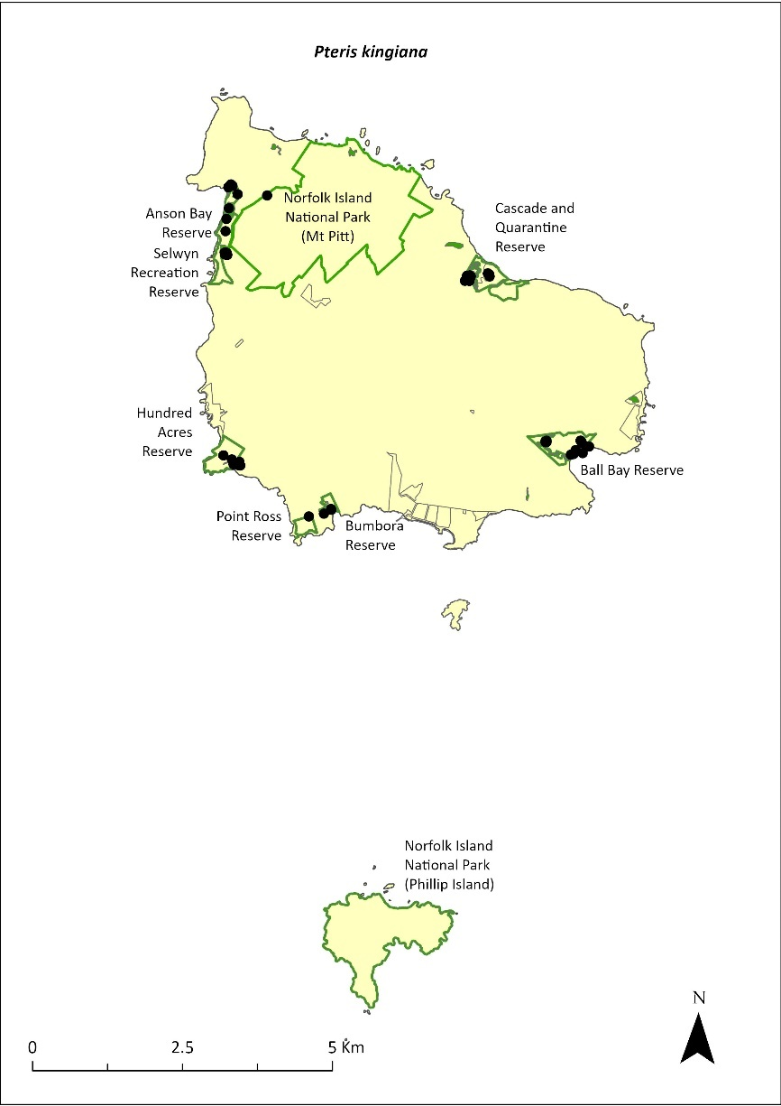
Green outlines indicate reserves within which the species occurs. Green shading shows plant communities within which the species may occur (Christian & Mills 2021). Points show recorded locations (Mills 20017a, b, d, e and f).

Risk assessment
Risk assessment undertaken for Endangered ferns as a grouping. The risk assessment is shown in Table 133.
Table 133 Risk assessment for Endangered ferns as a grouping
Risk | Likelihood of exposure | Consequence | Threat rating
1. Loss and fragmentation of native vegetation through past land clearing | Almost certain (91–100%) | Extreme | Extreme
2. Loss and fragmentation of native vegetation through current or future land clearing | Rare (0–10%) | Negligible | Negligible
3. Degradation of native vegetation through past grazing or loss of nutrients | Almost certain (91–100%) | Extreme | Extreme
4. Degradation of native vegetation through current or future grazing | Possible (26–50%) | Moderate | Medium
6. Predation by rodents | Rare (0–10%) | Negligible | Negligible
7. Predation by cats | Rare (0–10%) | Negligible | Negligible
8. Predation or damage by chickens | Rare (0–10%) | Negligible | Negligible
9. Predation by swamphens | Rare (0–10%) | Negligible | Negligible
10. Predation by Argentine ant | Rare (0–10%) | Negligible | Negligible
11. Competition from/change of habitat because of weed invasion | Likely (51–90%) | Moderate | Medium
12. Infection by pathogens already present | Rare (0–10%) | Negligible | Negligible
13. Impacts of potential new invasive species or pathogens | Unlikely (11–25%) | Minor | Low
14. Changes to vegetation, increased fire risk and/or direct physiological stress as a result of climatic changes | Possible (26–50%) | Moderate | Medium
15. Problems caused by small populations, including lack of genetic diversity | Possible (26–50%) | Moderate | Medium

Management actions
Undertake propagation and replanting into suitable habitat areas. Undertake targeted weed control and maintenance. Implement habitat protection and rehabilitation. Exclude or manage cattle grazing.

Recovery target
The recovery target is shown in Table 134.
Table 134 Recovery target for Pteris kingiana
EPBC Act status | Estimated population (2023) | Where known populations occur | 2034 target
Endangered | 483 | 19% within the national park  81% within public reserves | 500

Relevant literature
Braggins JE (1996) Report on the conservation status of the ferns of Norfolk Island. Unpublished report to the Australian Nature Conservation Agency.
Christian NE & Mills K (2021) Vegetation Mapping of Norfolk Island 2021. Unpublished data.
de Lange PJ & Murray BG (2003) Chromosome numbers of Norfolk Island endemic plants. Australian Journal of Botany 51, 211–215.
Invasive Species Council & TierraMar (2021) The Native Plant Communities of Norfolk Island. Invasive Species Council, Katoomba, NSW.
Mills K (2009b) The Vegetation of Phillip Island, Norfolk Island Group. Envirofund 2007/2008. Kevin Mills & Associates, Jamberoo, NSW.
Mills K (2012b) The Flora of Norfolk Island. Report 14. The Endangered Plants in the national park: Field Survey and Review. Kevin Mills & Associates, Jamberoo, NSW.
Mills K (2017a) Survey of public reserves on Norfolk Island for threatened plant species: 3. Point Ross Reserve and Bumbora Reserve. Prepared for Norfolk Island Regional Council.
Mills K (2017b) Survey of public reserves on Norfolk Island for threatened plant species: 8. Ball Bay Reserve. Prepared for Norfolk Island Regional Council.
Mills K (2017d) Survey of public reserves on Norfolk Island for threatened plant species: 6. Anson Bay Reserve and Selwyn Reserve. Prepared for Norfolk Island Regional Council.
Mills K (2017e) Survey of public reserves on Norfolk Island for threatened plant species: 7. Hundred Acres Reserve. Prepared for Norfolk Island Regional Council.
Mills K (2017f) Survey of public reserves on Norfolk Island for threatened plant species: 4. Cascade Reserve including Quarantine Reserve. Prepared for Norfolk Island Regional Council.
Orchard A (ed) (1994) Flora of Australia. Vol. 49. Oceanic Islands 1. Australian Government Publishing Service, Canberra.
TSSC (Threatened Species Scientific Committee) (2003c) Commonwealth Listing Advice for Norfolk Island Flora - 16 Endangered Species.

Pteris zahlbruckneriana—netted brakefern
Family PTERIDACEAE

Conservation significance
Endemic to Norfolk Island.
EPBC Act Listing Status: Endangered.

Description
Tufted fern with a short erect rhizome and fronds growing to 1 m high.

Distribution and abundance
Pteris zahlbruckneriana occurs in scattered populations in forests at higher elevations in the Norfolk Island National Park.
There were fewer than 200 mature plants recorded in 2003 (TSSC 2003c). Mills (2012b) found 35 individuals across seven valleys of the national park, and noted that this species replaces P. kingiana in the upper parts of the valleys leading to the coast. The species is not common and is known to be less widespread than P. kingiana (de Lange & Murray 2003).
The distribution is shown in Map 59.

Ecology
Wind born spores.

Habitat
This species grows in forest on gully sides and creek banks.

Threats
Threats to the species include weed invasion and competition (particularly by William Taylor [Ageratina riparia] and red guava [Psidium cattleyanum]), climate change, and cattle grazing.

Impact on other species
None known.
Map 59 Distribution of Pteris zahlbruckneriana
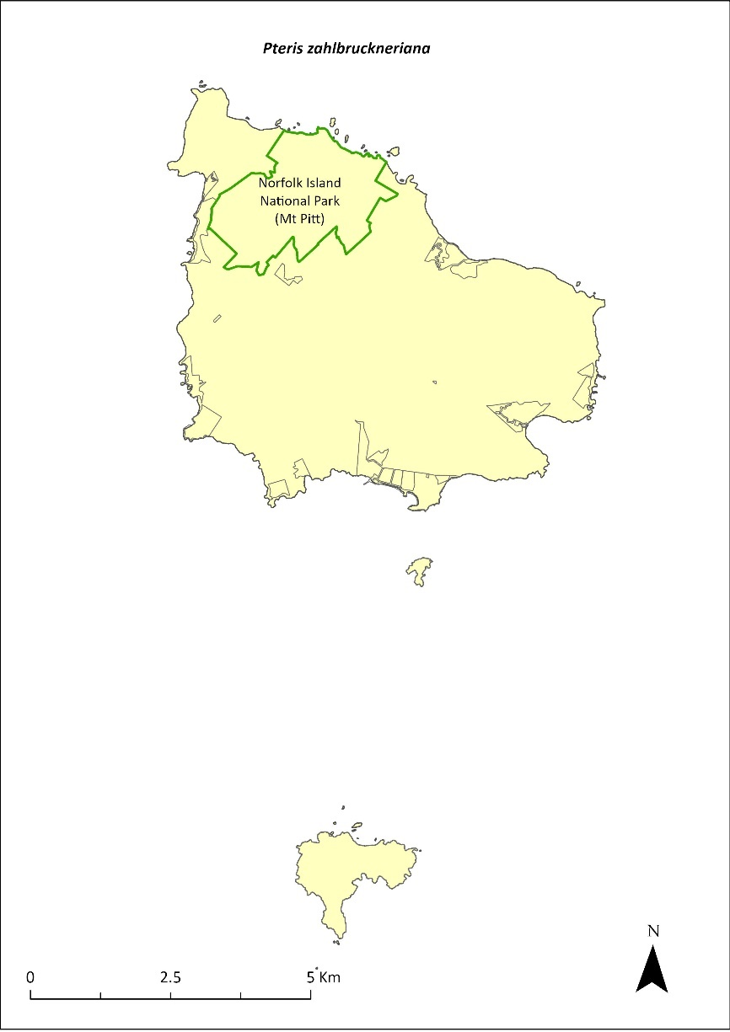
Green outlines indicate reserves within which the species occurs.

Risk assessment
Risk assessment undertaken for Endangered ferns as a grouping. The risk assessment is shown in Table 135.
Table 135 Risk assessment for Endangered ferns as a grouping
Risk | Likelihood of exposure | Consequence | Threat rating
1. Loss and fragmentation of native vegetation through past land clearing | Almost certain (91–100%) | Extreme | Extreme
2. Loss and fragmentation of native vegetation through current or future land clearing | Rare (0–10%) | Negligible | Negligible
3. Degradation of native vegetation through past grazing or loss of nutrients | Almost certain (91–100%) | Extreme | Extreme
4. Degradation of native vegetation through current or future grazing | Possible (26–50%) | Moderate | Medium
6. Predation by rodents | Rare (0–10%) | Negligible | Negligible
7. Predation by cats | Rare (0–10%) | Negligible | Negligible
8. Predation or damage by chickens | Rare (0–10%) | Negligible | Negligible
9. Predation by swamphens | Rare (0–10%) | Negligible | Negligible
10. Predation by Argentine ant | Rare (0–10%) | Negligible | Negligible
11. Competition from/change of habitat because of weed invasion | Likely (51–90%) | Moderate | Medium
12. Infection by pathogens already present | Rare (0–10%) | Negligible | Negligible
13. Impacts of potential new invasive species or pathogens | Unlikely (11–25%) | Minor | Low
14. Changes to vegetation, increased fire risk and/or direct physiological stress as a result of climatic changes | Possible (26–50%) | Moderate | Medium
15. Problems caused by small populations, including lack of genetic diversity | Likely (51–90%) | Moderate | Medium

Management actions
Undertake propagation and replanting into suitable shaded habitat areas. Implement targeted weed control and maintenance. Implement habitat protection and rehabilitation. Exclude or manage cattle grazing.

Recovery target
The recovery target is shown in Table 136.
Table 136 Recovery target for Pteris zahlbruckneriana
EPBC Act status | Estimated population (2023) | Where known populations occur | 2034 target
Endangered | 35 | 100% within the national park | 250

Relevant literature
Braggins JE (1996) Report on the conservation status of the ferns of Norfolk Island. Unpublished report to the Australian Nature Conservation Agency.
de Lange PJ & Murray BG (2003) Chromosome numbers of Norfolk Island endemic plants. Australian Journal of Botany 51, 211–215.
Mills K (2012b) The Flora of Norfolk Island. Report 14. The Endangered Plants in the national park: Field Survey and Review. Kevin Mills & Associates, Jamberoo, NSW.
Orchard A (ed) (1994) Flora of Australia. Vol. 49. Oceanic Islands 1. Australian Government Publishing Service, Canberra.
TSSC (Threatened Species Scientific Committee) (2003c) Commonwealth Listing Advice for Norfolk Island Flora – 16 Endangered Species.

Senecio australis—a daisy
Family ASTERACEAE

Conservation significance
Endemic to the Norfolk Island Group. It has recently arrived in New Zealand, where it is known from three small populations comprising a total of 10 or so plants.
EPBC Act Listing Status: Vulnerable.

Description
An erect annual or short-lived perennial growing to 90 cm tall with yellow daisy flowers.

Distribution and abundance
Senecio australis has been recorded from Barney Duffy, Anson Bay, at The Chord at Duncombe Bay, and from the Stool, Phillip Island (Orchard 1994). There were fewer than 500 mature plants recorded in 2003 (TSSC 2003b).
The species was common around the edges of Phillip Island in September 2008, particularly on the southern cliffs (Mills 2009b). It also occurs on Nepean Island (Mills 2009a). It is quite common in some of the public reserves.
The population estimate in 2021 was 1454, including populations in Two Chimneys Reserve (497; Mills 2017g), Anson and Selwyn Reserves (333; Mills 2017d), Cascade Reserve (67; Mills 2017f), Ball Bay Reserve (64; Mills 2017b), Bumbora Reserve (31; Mills 2017a) and Hundred Acres Reserve (26; Mills 2017e).
The distribution is shown in Map 60.

Ecology
Little known.

Habitat
Occurs within coastal pine and white oak forest, coastal white oak shrubland and coastal grassland (Invasive Species Council & TierraMar 2021).

Threats
The primary threat to the species is weed invasion and competition, particularly by kikuyu (Cenchrus clandestinus).

Impact on other species
None known.
Map 60 Distribution of Senecio australis
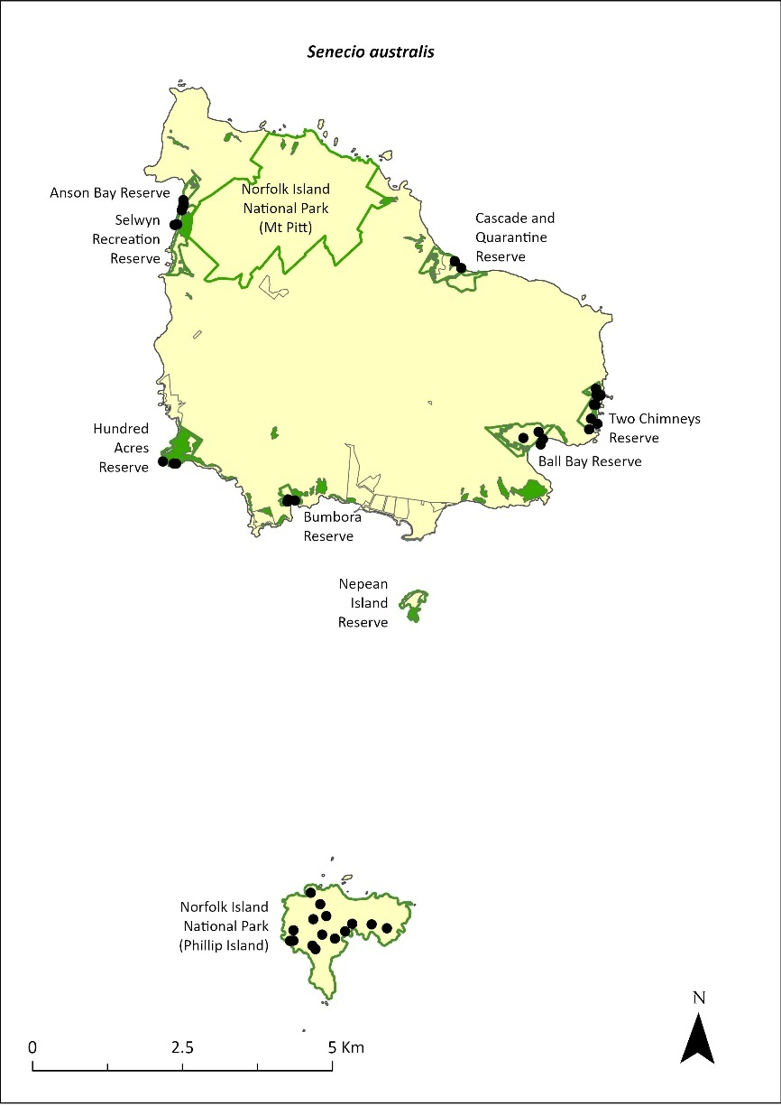
Green outlines indicate reserves within which the species occurs. Green shading shows plant communities within which the species may occur (Christian & Mills 2021, Mills 2009a). Points show recorded locations (Mills 2009b, 2017a, b, d, e, f and g).

Risk assessment
Risk assessment undertaken for Vulnerable herbs/grasses as a grouping. The risk assessment is shown in Table 137.
Table 137 Risk assessment for Vulnerable herbs/grasses as a grouping
Risk | Likelihood of exposure | Consequence | Threat rating
1. Loss and fragmentation of native vegetation through past land clearing | Almost certain (91–100%) | Extreme | Extreme
2. Loss and fragmentation of native vegetation through current or future land clearing | Rare (0–10%) | Negligible | Negligible
3. Degradation of native vegetation through past grazing or loss of nutrients | Almost certain (91–100%) | Extreme | Extreme
4. Degradation of native vegetation through current or future grazing | Possible (26–50%) | Moderate | Medium
6. Predation by rodents | Rare (0–10%) | Negligible | Negligible
7. Predation by cats | Rare (0–10%) | Negligible | Negligible
8. Predation or damage by chickens | Rare (0–10%) | Negligible | Negligible
9. Predation by swamphens | Rare (0–10%) | Negligible | Negligible
10. Predation by Argentine ant | Rare (0–10%) | Negligible | Negligible
11. Competition from/change of habitat because of weed invasion | Likely (51–90%) | Moderate | Medium
12. Infection by pathogens already present | Rare (0–10%) | Negligible | Negligible
13. Impacts of potential new invasive species or pathogens | Unlikely (11–25%) | Minor | Low
14. Changes to vegetation, increased fire risk and/or direct physiological stress as a result of climatic changes | Possible (26–50%) | Moderate | Medium
15. Problems caused by small populations, including lack of genetic diversity | Possible (26–50%) | Moderate | Medium

Management actions
Undertake propagation and replanting into suitable habitat areas. Conduct targeted weed control and maintenance. Implement habitat protection and rehabilitation.

Recovery target
The recovery target is shown in Table 138.
Table 138 Recovery target for Senecio australis
EPBC Act status | Estimated population (2023) | Where known populations occur | 2034 target
Vulnerable | 1454 | 34% within the national park  66% within public reserves | 3000

Relevant literature
Christian NE & Mills K (2021) Vegetation Mapping of Norfolk Island 2021. Unpublished data.
Invasive Species Council & TierraMar (2021) The Native Plant Communities of Norfolk Island. Invasive Species Council, Katoomba, NSW.
Mills K (2009a) The Flora of Norfolk Island. 9. The Vegetation of Nepean Island (including Errata and Addenda for Papers 1 to 8). Kevin Mills & Associates, Jamberoo, NSW.
Mills K (2009b) The Vegetation of Phillip Island, Norfolk Island Group. Envirofund 2007/2008. Kevin Mills & Associates, Jamberoo, NSW.
Mills K (2017a) Survey of public reserves on Norfolk Island for threatened plant species: 3. Point Ross Reserve and Bumbora Reserve. Prepared for Norfolk Island Regional Council.
Mills K (2017b) Survey of public reserves on Norfolk Island for threatened plant species: 8. Ball Bay Reserve. Prepared for Norfolk Island Regional Council.
Mills K (2017d) Survey of public reserves on Norfolk Island for threatened plant species: 6. Anson Bay Reserve and Selwyn Reserve. Prepared for Norfolk Island Regional Council.
Mills K (2017e) Survey of public reserves on Norfolk Island for threatened plant species: 7. Hundred Acres Reserve. Prepared for Norfolk Island Regional Council.
Mills K (2017f) Survey of public reserves on Norfolk Island for threatened plant species: 4. Cascade Reserve including Quarantine Reserve. Prepared for Norfolk Island Regional Council.
Mills K (2017g) Survey of public reserves on Norfolk Island for threatened plant species: 5. Two Chimneys Reserve. Prepared for Norfolk Island Regional Council.
Orchard A (ed) (1994) Flora of Australia. Vol. 49. Oceanic Islands 1. Australian Government Publishing Service, Canberra.
TSSC (Threatened Species Scientific Committee) (2003b) Commonwealth Listing Advice for Norfolk Island Flora - 15 Vulnerable Species.

Senecio evansianus—a daisy
Family ASTERACEAE

Conservation significance
Endemic to Norfolk Island.
EPBC Act Listing Status: Endangered.

Description
A low herb growing between 3 cm and 30 cm tall with small yellow daisy flowers.

Distribution and abundance
Senecio evansianus has been recorded from Rocky Point, Bumbora Reserve above Creswell Bay, Bloody Bridge and east of Bloody Bridge (Orchard 1994).
There were fewer than 200 mature plants recorded in 2003 (TSSC 2003c). The species has not been found within the Norfolk Island National Park (Mills 2012b) and was not recorded during the 2017 surveys of the public reserves (Mills 2017a-g).
A distribution map is unavailable for Senecio evansianus as there is no reliable information on the current distribution of this species.

Ecology
Little known.

Habitat
The species appears to be restricted to well-watered clay soils beneath open stands of Norfolk Island pine (Araucaria heterophylla; Orchard 1994).

Threats
Primary threats to the species include weed invasion and competition, particularly by kikuyu (Cenchrus clandestinus), and climate change.

Impact on other species
None known.

Risk assessment
The risk assessment is shown in Table 139.
Table 139 Risk assessment for Senecio evansianus
Risk | Likelihood of exposure | Consequence | Threat rating
1. Loss and fragmentation of native vegetation through past land clearing | Almost certain (91–100%) | Extreme | Extreme
2. Loss and fragmentation of native vegetation through current or future land clearing | Rare (0–10%) | Negligible | Negligible
3. Degradation of native vegetation through past grazing or loss of nutrients | Almost certain (91–100%) | Extreme | Extreme
4. Degradation of native vegetation through current or future grazing | Possible (26–50%) | Moderate | Medium
6. Predation by rodents | Rare (0–10%) | Negligible | Negligible
7. Predation by cats | Rare (0–10%) | Negligible | Negligible
8. Predation or damage by chickens | Rare (0–10%) | Negligible | Negligible
9. Predation by swamphens | Rare (0–10%) | Negligible | Negligible
10. Predation by Argentine ant | Rare (0–10%) | Negligible | Negligible
11. Competition from/change of habitat because of weed invasion | Likely (51–90%) | Major | High
12. Infection by pathogens already present | Rare (0–10%) | Negligible | Negligible
13. Impacts of potential new invasive species or pathogens | Unlikely (11–25%) | Minor | Low
14. Changes to vegetation, increased fire risk and/or direct physiological stress as a result of climatic changes | Possible (26–50%) | Major | High
15. Problems caused by small populations, including lack of genetic diversity | Almost certain (91–100%) | Extreme | Extreme

Management actions
Conduct surveys to determine current distribution. Undertake propagation and replanting into suitable habitat areas. Conduct targeted weed control and maintenance. Implement habitat protection and rehabilitation. Monitor populations to determine dynamics.

Recovery target
The recovery target is shown in Table 140.
Table 140 Recovery target for Senecio evansianus
EPBC Act status | Estimated population (2023) | Where known populations occur | 2034 target
Endangered | 200 | Unknown | 250

Relevant literature
Mills K (2012b) The Flora of Norfolk Island. Report 14. The Endangered Plants in the national park: Field Survey and Review. Kevin Mills & Associates, Jamberoo, NSW.
Orchard A (ed) (1994) Flora of Australia. Vol. 49. Oceanic Islands 1. Australian Government Publishing Service, Canberra.
Mills K (2017a) Survey of public reserves on Norfolk Island for threatened plant species: 3. Point Ross Reserve and Bumbora Reserve. Prepared for Norfolk Island Regional Council.
Mills K (2017b) Survey of public reserves on Norfolk Island for threatened plant species: 8. Ball Bay Reserve. Prepared for Norfolk Island Regional Council.
Mills K (2017c) Survey of public reserves on Norfolk Island for threatened plant species: 1. The Kingston Reserves. Prepared for Norfolk Island Regional Council.
Mills K (2017d) Survey of public reserves on Norfolk Island for threatened plant species: 6. Anson Bay Reserve and Selwyn Reserve. Prepared for Norfolk Island Regional Council.
Mills K (2017e) Survey of public reserves on Norfolk Island for threatened plant species: 7. Hundred Acres Reserve. Prepared for Norfolk Island Regional Council.
Mills K (2017f) Survey of public reserves on Norfolk Island for threatened plant species: 4. Cascade Reserve including Quarantine Reserve. Prepared for Norfolk Island Regional Council.
Mills K (2017g) Survey of public reserves on Norfolk Island for threatened plant species: 5. Two Chimneys Reserve. Prepared for Norfolk Island Regional Council.
TSSC (Threatened Species Scientific Committee) (2003c) Commonwealth Listing Advice for Norfolk Island Flora – 16 Endangered Species.

Senecio hooglandii—a daisy
Family ASTERACEAE

Conservation significance
Endemic to Norfolk Island Group.
EPBC Act Listing Status: Vulnerable.

Description
An erect herb growing to 60 cm tall with yellow daisy flowers.

Distribution and abundance
Senecio hooglandii has been recorded from near the cemetery on Norfolk Island and on the north side of Phillip Island, though its occurrence on Phillip Island may be due to the widespread broadcasting of seed to revegetate the island following rabbit removal (Orchard 1994).
There were fewer than 550 mature plants recorded in 2003 (TSSC 2003b). The species is moderately common around the cliffs of Phillip Island (Mills 2009b) and also occurs on Nepean Island (Mills 2009a).
The distribution is shown in Map 61.

Ecology
Little known.

Habitat
Little known.

Threats
The primary threat to the species is weed invasion and competition, particularly by kikuyu (Cenchrus clandestinus).

Impact on other species
None known.
Map 61 Distribution of Senecio hooglandii
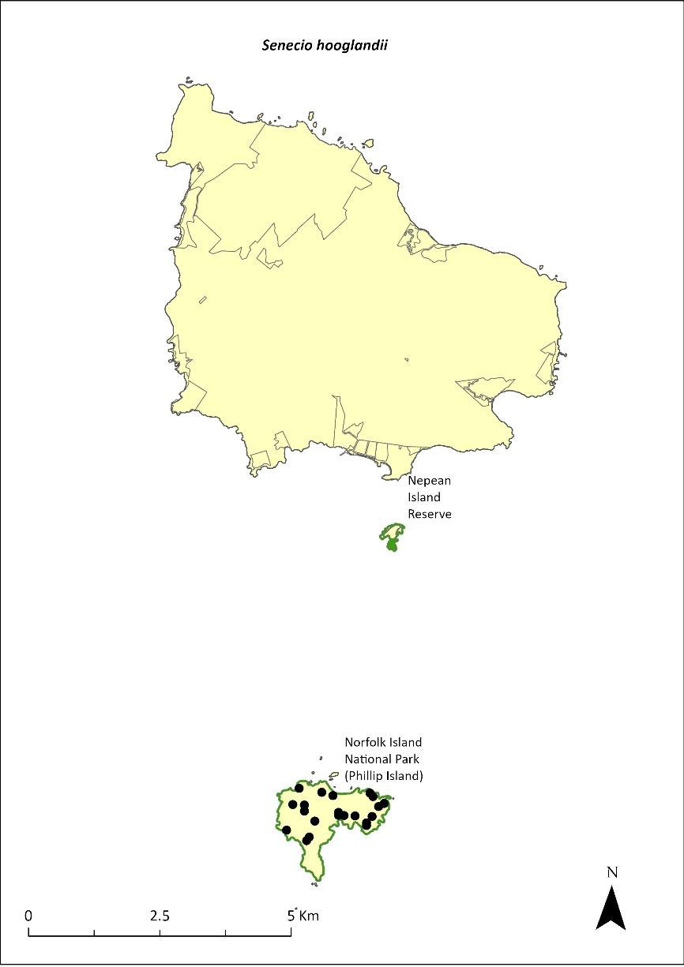
Green outlines indicate reserves within which the species occurs. Green shading shows plant communities within which the species may occur (Mills 2009a). Points show recorded locations (Mills 2009b).

Risk assessment
Risk assessment undertaken for Vulnerable herbs/grasses as a grouping. The risk assessment is shown in Table 141.
Table 141 Risk assessment for Vulnerable herbs/grasses as a grouping
Risk | Likelihood of exposure | Consequence | Threat rating
1. Loss and fragmentation of native vegetation through past land clearing | Almost certain (91–100%) | Extreme | Extreme
2. Loss and fragmentation of native vegetation through current or future land clearing | Rare (0–10%) | Negligible | Negligible
3. Degradation of native vegetation through past grazing or loss of nutrients | Almost certain (91–100%) | Extreme | Extreme
4. Degradation of native vegetation through current or future grazing | Possible (26–50%) | Moderate | Medium
6. Predation by rodents | Unlikely (11–25%) | Major | Medium
7. Predation by cats | Rare (0–10%) | Negligible | Negligible
8. Predation or damage by chickens | Rare (0–10%) | Negligible | Negligible
9. Predation by swamphens | Rare (0–10%) | Negligible | Negligible
10. Predation by Argentine ant | Rare (0–10%) | Negligible | Negligible
11. Competition from/change of habitat because of weed invasion | Almost certain (91–100%) | Moderate | High
12. Infection by pathogens already present | Rare (0–10%) | Negligible | Negligible
13. Impacts of potential new invasive species or pathogens | Unlikely (11–25%) | Minor | Low
14. Changes to vegetation, increased fire risk and/or direct physiological stress as a result of climatic changes | Possible (26–50%) | Moderate | Medium
15. Problems caused by small populations, including lack of genetic diversity | Likely (51–90%) | Moderate | Medium

Management actions
Undertake propagation and replanting into suitable habitat areas. Conduct targeted weed control and maintenance. Implement habitat protection and rehabilitation. Monitor populations to determine dynamics.

Recovery target
The recovery target is shown in Table 142.
Table 142 Recovery target for Senecio hooglandii
EPBC Act status | Estimated population (2023) | Where known populations occur | 2034 target
Vulnerable | 550 | >95% within the national park | 750

Relevant literature
Mills K (2009a) The Flora of Norfolk Island. 9. The Vegetation of Nepean Island (including Errata and Addenda for Papers 1 to 8). Kevin Mills & Associates, Jamberoo, NSW.
Mills K (2009b) The Vegetation of Phillip Island, Norfolk Island Group. Envirofund 2007/2008. Kevin Mills & Associates, Jamberoo, NSW.
Orchard A (ed) (1994) Flora of Australia. Vol. 49. Oceanic Islands 1. Australian Government Publishing Service, Canberra.
TSSC (Threatened Species Scientific Committee) (2003b) Commonwealth Listing Advice for Norfolk Island Flora - 15 Vulnerable Species.

Streblus pendulinus—Siah’s backbone
Family MORACEAE

Conservation significance
Streblus pendulinus is endemic to Norfolk Island.
EPBC Act Listing Status: Endangered.
Approved Conservation Advice: 1/07/2016 (TSSC 2016c).

Description
Tree or shrub growing to 6 m tall with fleshy red fruit and very rough leaves. It exudes a white latex when damaged.

Distribution and abundance
In 1988 Streblus pendulinus was not generally common but was widespread and not considered threatened on Norfolk Island (Sykes & Atkinson 1988). The species has been recorded from Cascade Reserve, Mt Pitt, Mt Pitt Road, and about 3km north-east of the cemetery at Kingston (Orchard 1994). It was listed as Endangered in 2003, when most surviving individuals of the species were inside the Norfolk Island National Park (187 mature individuals; TSSC 2003c), Additional plants have been recorded in the Mission Road rainforest remnants, near Steels Point and in Ball Bay Reserve.
Mills (2012b) found the species on 16 transects within the national park, with 107 plants counted. All age classes were observed, and good regeneration was reported. The species also occurs in Cascade, Ball Bay and Selwyn Reserves, in small numbers (Mills 2017b, d and f).
The population estimate in 2021 was 259.
The distribution is shown in Map 62.

Ecology
Many trees are male and cannot produce seed (Sykes & Atkinson 1988), although male and female flowers can be seen on individual trees (K Mills 2024. pers comm 11 January).

Habitat
Occurs in sheltered coastal forest (Invasive Species Council & TierraMar 2021).

Threats
The main threats to the species are competition from weeds and cattle grazing (TSSC 2016c). Phytophthora cinnamomi is potentially a major risk.
At the time of the previous recovery plan (Director of National Parks 2010), a parasite appeared to be stopping seed setting in many individuals (TSSC 2016c).) Insect larvae (possibly a moth species) appear to feed on the developing fruit and destroy the seeds (K Mills 2024. pers comm 11 January). This requires further investigation.
Map 62 Distribution of Streblus pendulinus
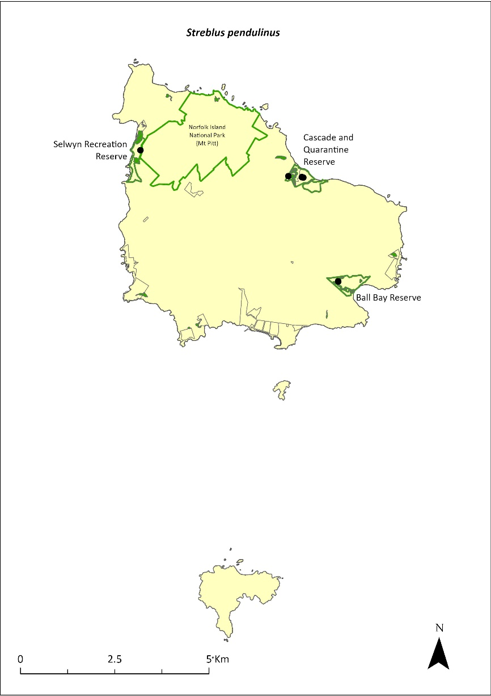
Green outlines indicate reserves within which the species occurs. Green shading shows plant communities within which the species may occur (Christian & Mills 2021). Points show recorded locations (Mills 20017b, d and f).

Impact on other species
None known.

Risk assessment
Risk assessment undertaken for Endangered trees/shrubs as a grouping. The risk assessment is shown in Table 143.
Table 143 Risk assessment for Endangered trees/shrubs as a grouping
Risk | Likelihood of exposure | Consequence | Threat rating
1. Loss and fragmentation of native vegetation through past land clearing | Almost certain (91–100%) | Extreme | Extreme
2. Loss and fragmentation of native vegetation through current or future land clearing | Rare (0–10%) | Negligible | Negligible
3. Degradation of native vegetation through past grazing or loss of nutrients | Almost certain (91–100%) | Extreme | Extreme
4. Degradation of native vegetation through current or future grazing | Possible (26–50%) | Moderate | Medium
6. Predation by rodents | Almost certain (91–100%) | Major | Extreme
7. Predation by cats | Rare (0–10%) | Negligible | Negligible
8. Predation or damage by chickens | Likely (51–90%) | Moderate | Medium
9. Predation by swamphens | Rare (0–10%) | Negligible | Negligible
10. Predation by Argentine ant | Possible (26–50%) | Minor | Low
11. Competition from/change of habitat because of weed invasion | Likely (51–90%) | Moderate | Medium
12. Infection by pathogens already present | Possible (26–50%) | Moderate | Medium
13. Impacts of potential new invasive species or pathogens | Unlikely (11–25%) | Minor | Low
14. Changes to vegetation, increased fire risk and/or direct physiological stress as a result of climatic changes | Possible (26–50%) | Moderate | Medium
15. Problems caused by small populations, including lack of genetic diversity | Possible (26–50%) | Major | High

Management actions
Undertake research to determine the best method of treating the parasite. Implement targeted weed control and maintenance. Implement habitat protection and rehabilitation. Exclude or manage cattle grazing.

Recovery target
The recovery target is shown in Table 144.
Table 144 Recovery target for Streblus pendulinus
EPBC Act status | Estimated population (2023) | Where known populations occur | 2034 target
Endangered | 259 | 95% within the national park  5% within public reserves | 1000

Relevant literature
Christian NE & Mills K (2021) Vegetation Mapping of Norfolk Island 2021. Unpublished data.
Director of National Parks (2010) Norfolk Island Region Threatened Species Recovery Plan. Department of the Environment, Water, Heritage and the Arts, Canberra.
Invasive Species Council & TierraMar (2021) The Native Plant Communities of Norfolk Island. Invasive Species Council, Katoomba, NSW.
Mills K (2012b) The Flora of Norfolk Island. Report 14. The Endangered Plants in the national park: Field Survey and Review. Kevin Mills & Associates, Jamberoo, NSW.
Mills K (2017b) Survey of public reserves on Norfolk Island for threatened plant species: 8. Ball Bay Reserve. Prepared for Norfolk Island Regional Council.
Mills K (2017d) Survey of public reserves on Norfolk Island for threatened plant species: 6. Anson Bay Reserve and Selwyn Reserve. Prepared for Norfolk Island Regional Council.
Mills K (2017f) Survey of public reserves on Norfolk Island for threatened plant species: 4. Cascade Reserve including Quarantine Reserve. Prepared for Norfolk Island Regional Council.
Mills K (2024) Personal communication by email, 11 January 2024, plant ecologist.
Orchard A (ed) (1994) Flora of Australia. Vol. 49. Oceanic Islands 1. Australian Government Publishing Service, Canberra.
Sykes W & Atkinson I (1988) Rare and Endangered Plants of Norfolk Island. Unpublished report to the Australian National Parks and Wildlife Service, Norfolk Island.
TSSC (Threatened Species Scientific Committee) (2003c) Commonwealth Listing Advice for Norfolk Island Flora – 16 Endangered Species.
Threatened Species Scientific Committee (TSCC) (2016c) Conservation Advice Streblus pendulinus Siah’s backbone. Department of the Environment, Canberra.

Taeniophyllum norfolkianum—minute orchid, ribbon-root orchid
Family ORCHIDACEAE

Conservation significance
Taeniophyllum norfolkianum was considered endemic at listing; it has now also been reported from New Zealand (Renner & Beadel 2011).
EPBC Act Listing Status: Vulnerable.

Description
A small epiphytic orchid with tiny greenish yellow flowers.

Distribution and abundance
T. norfolkianum has been recorded from Mt Bates (Orchard 1994), south of Mount Pitt and in the vicinity of Red Road (K Mills 2024. pers comm 11 January). There were fewer than 500 mature plants recorded in 2003 (TSSC 2003b).
The distribution is shown in Map 63.

Ecology
Leafless with photosynthetic roots.

Habitat
Grows on the trunks and underside of branches of the Norfolk Island pine (Araucaria heterophylla).

Threats
The species is threatened by small population size and subsequent increased risk of extinction through natural events such as cyclones, slips and drought, and by climate change.

Impact on other species
Primarily grows on Norfolk Island pines.
Map 63 Distribution of Taeniophyllum norfolkianum
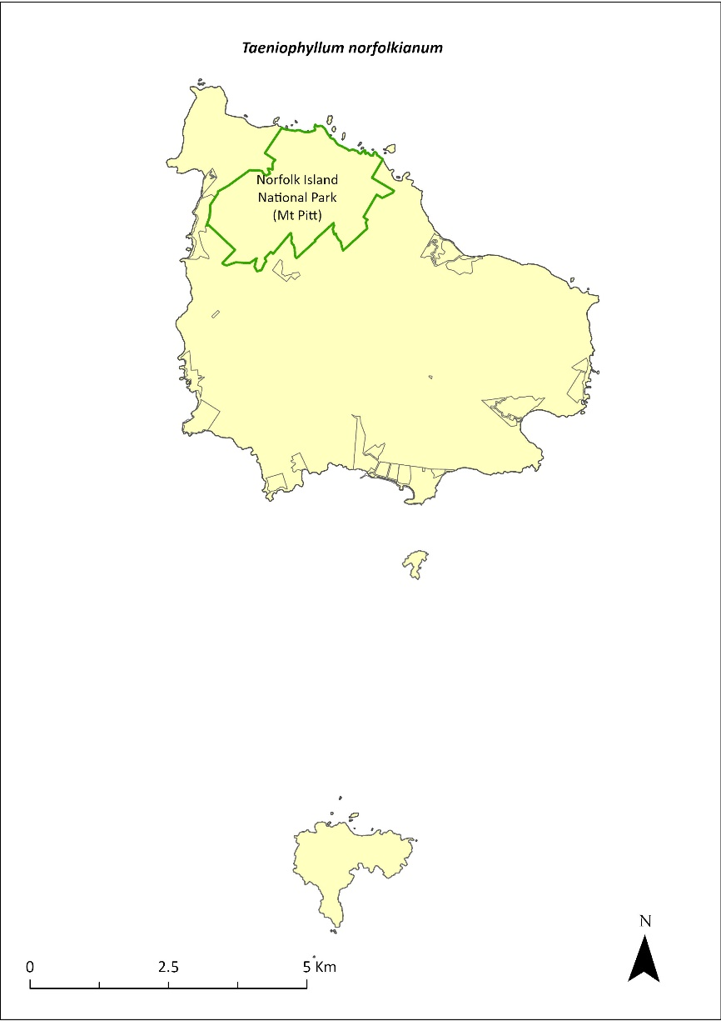
Green outlines indicate reserves within which the species occurs.

Risk assessment
Risk assessment undertaken for all threatened orchids as a grouping. The risk assessment is shown in Table 145.
Table 145 Risk assessment for all threatened orchids as a grouping
Risk | Likelihood of exposure | Consequence | Threat rating
1. Loss and fragmentation of native vegetation through past land clearing | Almost certain (91–100%) | Minor | Medium
2. Loss and fragmentation of native vegetation through current or future land clearing | Rare (0–10%) | Moderate | Negligible
3. Degradation of native vegetation through past grazing or loss of nutrients | Almost certain (91–100%) | Minor | Medium
4. Degradation of native vegetation through current or future grazing | Unlikely (11–25%) | Moderate | Low
6. Predation by rodents | Rare (0–10%) | Negligible | Negligible
7. Predation by cats | Rare (0–10%) | Negligible | Negligible
8. Predation or damage by chickens | Rare (0–10%) | Negligible | Negligible
9. Predation by swamphens | Rare (0–10%) | Negligible | Negligible
10. Predation by Argentine ant | Rare (0–10%) | Negligible | Negligible
11. Competition from/change of habitat because of weed invasion | Possible (26–50%) | Moderate | Medium
12. Infection by pathogens already present | Possible (26–50%) | Moderate | Medium
13. Impacts of potential new invasive species or pathogens | Unlikely (11–25%) | Moderate | Low
14. Changes to vegetation, increased fire risk and/or direct physiological stress as a result of climatic changes | Likely (51–90%) | Major | High
15. Problems caused by small populations, including lack of genetic diversity | Likely (51–90%) | Moderate | Medium

Management actions
This orchid may require development of species-specific conservation actions, including ex situ conservation. Implement targeted weed control and maintenance. Implement habitat protection and rehabilitation. Undertake research into the ecology of the species. Monitor/survey likely areas of the national park after storms, rescue any fallen specimens and attempt to cultivate them in at the Norfolk Island National Park Nursery (Sykes & Atkinson 1988).

Recovery target
The recovery target is shown in Table 146.
Table 146 Recovery target for Taeniophyllum norfolkianum
EPBC Act status | Estimated population (2023) | Where known populations occur | 2034 target
Vulnerable | 500 | 100% within the national park | No decline

Relevant literature
Mills K (2024) Personal communication by email, 11 January 2024, plant ecologist.
Orchard A (ed) (1994) Flora of Australia. Vol. 49. Oceanic Islands 1. Australian Government Publishing Service, Canberra.
Renner MAM & Beadel SM (2011) Taeniophyllum norfolkianum: a second genus of Vandeae (Orchidaceae) indigenous to New Zealand. New Zealand Journal of Botany 49(3), 435-439.
Sykes W & Atkinson I (1988) Rare and Endangered Plants of Norfolk Island. Unpublished report to the Australian National Parks and Wildlife Service, Norfolk Island.
TSSC (Threatened Species Scientific Committee) (2003b) Commonwealth Listing Advice for Norfolk Island Flora - 15 Vulnerable Species.

Tmesipteris norfolkensis—hanging fork-fern
Family PSILOTACEAE

Conservation significance
Endemic to Norfolk Island.
EPBC Act Listing Status: Vulnerable.

Description
A small, pendulous epiphytic fern with branches growing to 25 cm long.

Distribution and abundance
Tmesipteris norfolkensis has been recorded on the south-east slopes of Mount Pitt and between Palm Glen and Red Road (Orchard 1994). It appears to be restricted to moist forests and is most common on the southern side of the mountains rather than the drier northern side (Mills 2007e).
There were fewer than 500 mature plants recorded in 2003 (TSSC 2003b), with most occurring in damp and shady valleys of the Mt Pitt section of the Norfolk Island National Park, where it grows on the lower part of tree fern trunks (Sykes & Atkinson 1988).
The distribution is shown in Map 64.

Ecology
An epiphyte that grows in damp conditions and uses several native hardwoods as hosts but prefers the fibrous base of the tree ferns Sphaeropteris excelsa (under 1 m from the ground) and Alsophila australis norfolkensis.
Most plants grow on the downhill side of the trunks of the tree ferns (Mills 2007e).

Habitat
Grows in damp and shady places and prefers the deep moist valleys of the southern side of the mountains.

Threats
Threats to the species include habitat degradation, catastrophic events such as severe storms, and climate change.

Impact on other species
Grows on tree ferns and on several hardwood tree hosts.
Map 64 Distribution of Tmesipteris norfolkensis
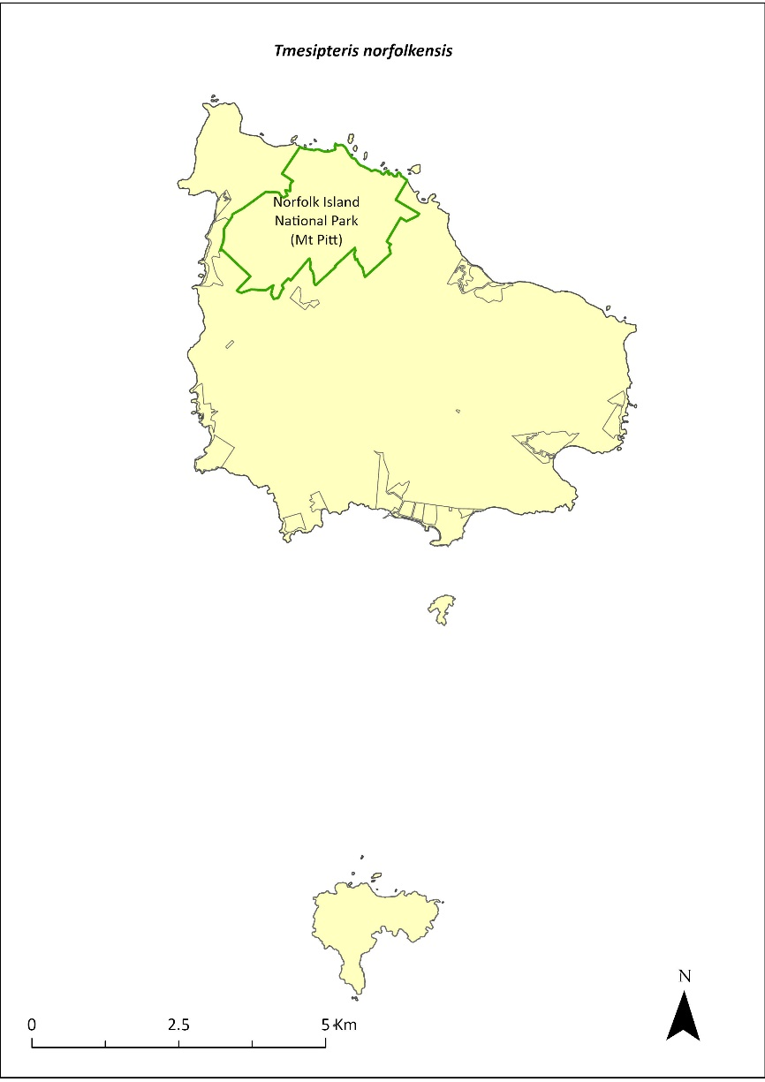
Green outlines indicate reserves within which the species occurs.

Risk assessment
Risk assessment undertaken for Vulnerable ferns as a grouping. The risk assessment is shown in Table 147.
Table 147 Risk assessment for Vulnerable ferns as a grouping
Risk | Likelihood of exposure | Consequence | Threat rating
1. Loss and fragmentation of native vegetation through past land clearing | Almost certain (91–100%) | Extreme | Extreme
2. Loss and fragmentation of native vegetation through current or future land clearing | Rare (0–10%) | Negligible | Negligible
3. Degradation of native vegetation through past grazing or loss of nutrients | Almost certain (91–100%) | Extreme | Extreme
4. Degradation of native vegetation through current or future grazing | Possible (26–50%) | Moderate | Medium
6. Predation by rodents | Rare (0–10%) | Negligible | Negligible
7. Predation by cats | Rare (0–10%) | Negligible | Negligible
8. Predation or damage by chickens | Rare (0–10%) | Negligible | Negligible
9. Predation by swamphens | Rare (0–10%) | Negligible | Negligible
10. Predation by Argentine ant | Rare (0–10%) | Negligible | Negligible
11. Competition from/change of habitat because of weed invasion | Unlikely (11–25%) | Moderate | Low
12. Infection by pathogens already present | Rare (0–10%) | Negligible | Negligible
13. Impacts of potential new invasive species or pathogens | Unlikely (11–25%) | Minor | Low
14. Changes to vegetation, increased fire risk and/or direct physiological stress as a result of climatic changes | Possible (26–50%) | Moderate | Medium
15. Problems caused by small populations, including lack of genetic diversity | Possible (26–50%) | Moderate | Medium

Management action
Implement targeted weed control and maintenance around host trees. Implement habitat protection and rehabilitation. Monitor/survey likely areas of the national park after storms, rescue any fallen specimens and attempt to cultivate them in at the Norfolk Island National Park Nursery (Sykes & Atkinson 1988).

Recovery target
The recovery target is shown in Table 148.
Table 148 Recovery target for Tmesipteris norfolkensis
EPBC Act status | Estimated population (2023) | Where known populations occur | 2034 target
Vulnerable | 500 | 100% within the national park | 1000

Relevant literature
Mills K (2007e) The Flora of Norfolk Island. 2. Epiphytes and Mistletoes. Kevin Mills & Associates, Jamberoo, NSW.
Orchard A (ed) (1994) Flora of Australia. Vol. 49. Oceanic Islands 1. Australian Government Publishing Service, Canberra.
Sykes W & Atkinson I (1988) Rare and Endangered Plants of Norfolk Island. Unpublished report to the Australian National Parks and Wildlife Service, Norfolk Island.
TSSC (Threatened Species Scientific Committee) (2003b) Commonwealth Listing Advice for Norfolk Island Flora - 15 Vulnerable Species.

Ungeria floribunda—bastard oak
Family STERCULIACEAE

Conservation significance
Endemic monotypic genus which could be one of Norfolk Island’s most ancient plants.
EPBC Act Listing Status: Vulnerable.

Description
A tree growing to 15 m tall with deep pink flowers.

Distribution and abundance
Ungeria floribunda is evenly distributed through the Norfolk Island National Park. It occurs on the broad ridges and upper valley sides and is also found on flat sites outside the park in the north-west part of the island. Young trees are associated with secondary forest that has established following removal of the original canopy.
The total number of mature plants recorded in 2003 was 502 (TSSC 2003b).
Regeneration is restricted by predation of seeds by rats (either on the tree or on the ground) and because this species is a periodic regenerator that does not fruit every year (Sykes & Atkinson 1988). It may require 20 years or more to produce viable seed.
U. floribunda propagates well from seed. The species seems to be regenerating well, mainly occurring above 120 metres altitude, although seedling survival appears to be low (K Mills 2024. pers comm 11 January).
The distribution is shown in Map 65.

Ecology
Little known.

Habitat
This species grows in forested areas throughout Norfolk Island, especially in areas of dense canopy above moderate elevations (such as Prince Phillip Drive/Red Road area, including private land; M Christian 2024. pers comm 12 January). Occurs in moist upland hardwood forest and pine-hardwood ridge forest (Invasive Species Council & TierraMar 2021).

Threats
Threats to the species include seed predation by rats, and irregular seed production. Phytophthora cinnamomi is potentially a major risk.

Impact on other species
None known.
Map 65 Distribution of Ungeria floribunda
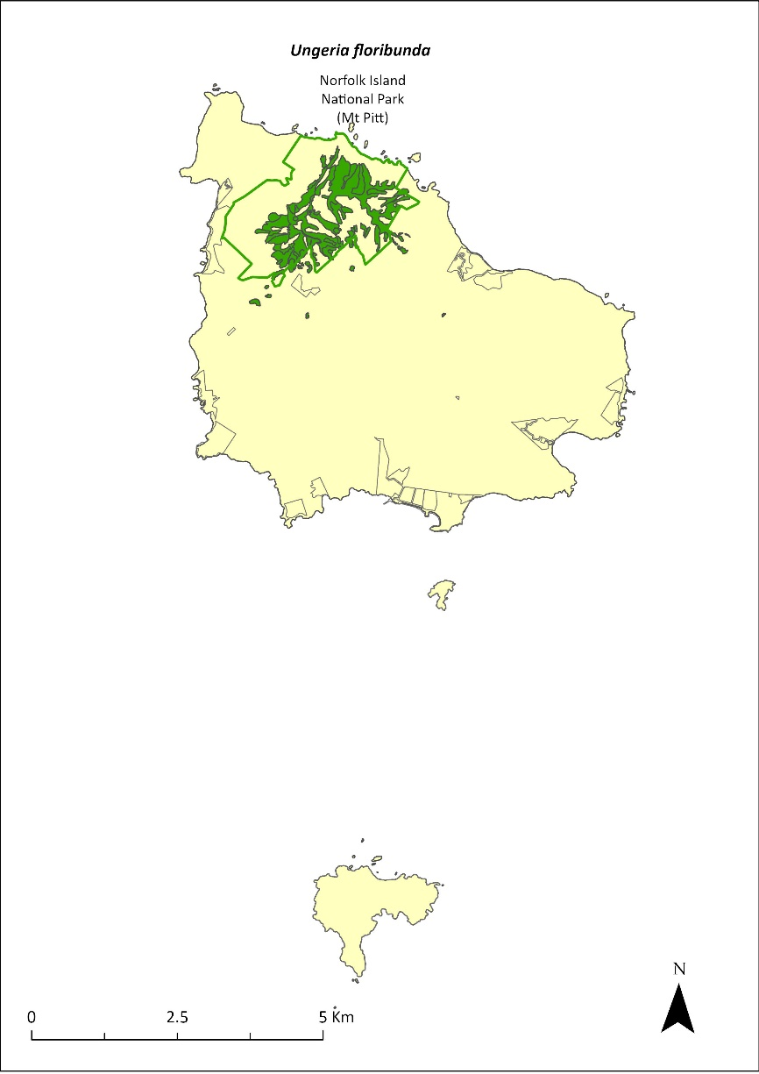
Green outlines indicate reserves within which the species occurs. Green shading shows plant communities within which the species may occur (Christian & Mills 2021).

Risk assessment
Risk assessment undertaken for Vulnerable trees/shrubs as a grouping. The risk assessment is shown in Table 149.
Table 149 Risk assessment for Vulnerable trees/shrubs as a grouping
Risk | Likelihood of exposure | Consequence | Threat rating
1. Loss and fragmentation of native vegetation through past land clearing | Almost certain (91–100%) | Extreme | Extreme
2. Loss and fragmentation of native vegetation through current or future land clearing | Rare (0–10%) | Negligible | Negligible
3. Degradation of native vegetation through past grazing or loss of nutrients | Almost certain (91–100%) | Extreme | Extreme
4. Degradation of native vegetation through current or future grazing | Possible (26–50%) | Moderate | Medium
6. Predation by rodents | Almost certain (91–100%) | Extreme | Extreme
7. Predation by cats | Rare (0–10%) | Negligible | Negligible
8. Predation or damage by chickens | Rare (0–10%) | Negligible | Negligible
9. Predation by swamphens | Rare (0–10%) | Negligible | Negligible
10. Predation by Argentine ant | Possible (26–50%) | Minor | Low
11. Competition from/change of habitat because of weed invasion | Likely (51–90%) | Moderate | Medium
12. Infection by pathogens already present | Possible (26–50%) | Moderate | Medium
13. Impacts of potential new invasive species or pathogens | Unlikely (11–25%) | Minor | Low
14. Changes to vegetation, increased fire risk and/or direct physiological stress as a result of climatic changes | Possible (26–50%) | Moderate | Medium
15. Problems caused by small populations, including lack of genetic diversity | Possible (26–50%) | Moderate | Medium

Management actions
Undertake habitat protection and rehabilitation. Undertake seed propagation (when seed is available) and replanting in suitable habitat. Carry out rodent control. Carry out targeted weed control and maintenance around existing populations.

Recovery target
The recovery target is shown in Table 150.
Table 150 Recovery target for Ungeria floribunda
EPBC Act status | Estimated population (2023) | Where known populations occur | 2034 target
Vulnerable | 502 | >95% within the national park | 1000

Relevant literature
Christian NE & Mills K (2021) Vegetation Mapping of Norfolk Island 2021. Unpublished data.
Christian M (2024) Personal communication by email, 12 January 2024, independent researcher.
Invasive Species Council & TierraMar (2021) The Native Plant Communities of Norfolk Island. Invasive Species Council, Katoomba, NSW.
Mills K (2024) Personal communication by email, 11 January 2024, plant ecologist.
Orchard A (ed) (1994) Flora of Australia. Vol. 49. Oceanic Islands 1. Australian Government Publishing Service, Canberra.
Sykes W & Atkinson I (1988) Rare and Endangered Plants of Norfolk Island. Unpublished report to the Australian National Parks and Wildlife Service, Norfolk Island.
TSSC (Threatened Species Scientific Committee) (2003b) Commonwealth Listing Advice for Norfolk Island Flora - 15 Vulnerable Species.

Wikstroemia australis—kurrajong
Family THYMELAEACEAE

Conservation significance
Endemic to Norfolk Island.
EPBC Act Listing Status: Critically Endangered.

Description
A small tree growing to 4 m or taller, with blackish stems and hard, rough bark.

Distribution and abundance
Wikstroemia australis was once widespread over much of Norfolk Island, but since the 1930s it has been reduced to scattered pockets mostly within the Norfolk Island National Park (Tierney 1989).
In 1988, it was widely distributed on the ridges and upper valley sides of the Mt Pitt section of the national park, but there was a critical lack of juvenile plants (Sykes & Atkinson 1988). The lack of regeneration of young plants was probably caused by competition from weeds, particularly red guava (Psidium cattleyanum), unsuitable soil conditions, dry conditions due to climate change and disease (Sykes & Atkinson 1988).
Tierney (1989) noted that young plants successfully established in gaps along the Bird Rock Track with young plants relatively common close to the track in less weedy areas. However, a survey in 1989 suggested a continued decline, with many diseased plants (Gilmour & Helman 1989b).
The total number of mature plants recorded in 2003 was 155 (TSSC 2003g).
A targeted survey by Mills (2010) found a total of 84 plants, including trees and a reasonable number of seedling. Mills (2012b) counted 12 plants at five locations, but noted that the species was not regenerating well, as most seedlings were not surviving.
The population estimate in 2021 had increased to 629 individuals, through planting and propagation as part of the Norfolk Island National Park threatened flora program.
The distribution is shown in Map 66.

Ecology
This species is possibly short lived and requires high light levels for establishment.

Habitat
Occurs in moist upland hardwood forest and pine-hardwood ridge forest (Invasive Species Council & TierraMar 2021), especially in protected, sunny, moist sites.

Threats
Threats to the species include weed invasion and competition from weeds, particularly red guava. Phytophthora cinnamomi is potentially a major risk. There has been unexplained death of many plants; the cause of this is unknown.
Map 66 Distribution of Wikstroemia australis
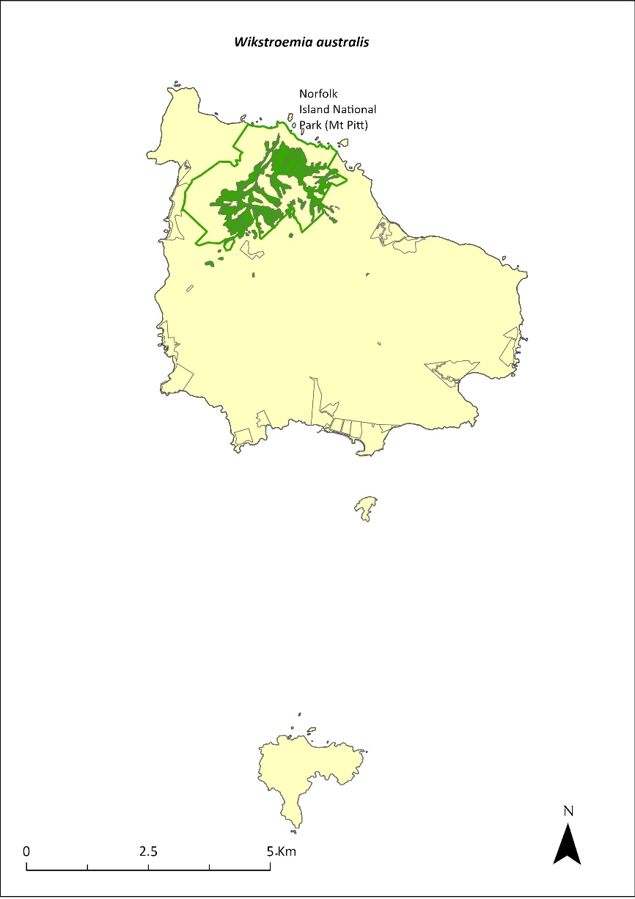
Green outlines indicate reserves within which the species occurs. Green shading shows plant communities within which the species may occur (Christian & Mills 2021).

Impact on other species
None known.

Risk assessment
Risk assessment undertaken for Critically Endangered trees/shrubs as a grouping. The risk assessment is shown in Table 151.
Table 151 Risk assessment for Critically Endangered trees/shrubs as a grouping
Risk | Likelihood of exposure | Consequence | Threat rating
1. Loss and fragmentation of native vegetation through past land clearing | Almost certain (91–100%) | Extreme | Extreme
2. Loss and fragmentation of native vegetation through current or future land clearing | Rare (0–10%) | Negligible | Negligible
3. Degradation of native vegetation through past grazing or loss of nutrients | Almost certain (91–100%) | Extreme | Extreme
4. Degradation of native vegetation through current or future grazing | Possible (26–50%) | Moderate | Medium
6. Predation by rodents | Almost certain (91–100%) | Major | Extreme
7. Predation by cats | Rare (0–10%) | Negligible | Negligible
8. Predation or damage by chickens | Likely (51–90%) | Moderate | Medium
9. Predation by swamphens | Rare (0–10%) | Negligible | Negligible
10. Predation by Argentine ant | Possible (26–50%) | Minor | Low
11. Competition from/change of habitat because of weed invasion | Likely (51–90%) | Minor | Medium
12. Infection by pathogens already present | Possible (26–50%) | Moderate | Medium
13. Impacts of potential new invasive species or pathogens | Unlikely (11–25%) | Minor | Low
14. Changes to vegetation, increased fire risk and/or direct physiological stress as a result of climatic changes | Possible (26–50%) | Moderate | Medium
15. Problems caused by small populations, including lack of genetic diversity | Likely (51–90%) | Moderate | Medium

Management actions
Continue propagation and planting in suitable areas. Undertake habitat protection and rehabilitation. Carry out targeted weed control and maintenance around existing populations to create gaps to allow the penetration of sunlight. Undertake research into the causes of plant death and treatment options.

Recovery target
The recovery target is shown in Table 152.
Table 152 Recovery target for Wikstroemia australis
EPBC Act status | Estimated population (2023) | Where known populations occur | 2034 target
Critically Endangered | 629 | >95% within the national park | 1000

Relevant literature
Christian NE & Mills K (2021) Vegetation Mapping of Norfolk Island 2021. Unpublished data.
Gilmour PM & Helman CE (1989b) The Vegetation of Norfolk Island National Park. Report to the Australian National Parks and Wildlife Service, Norfolk Island.
Invasive Species Council & TierraMar (2021) The Native Plant Communities of Norfolk Island. Invasive Species Council, Katoomba, NSW.
Mills K (2010) The Flora of Norfolk Island. 11. Field Survey and Assessment of the Critically Endangered Endemic Plant Wikstroemia australis (Kurrajong). Kevin Mills & Associates, Jamberoo, NSW.
Mills K (2012b) The Flora of Norfolk Island. Report 14. The Endangered Plants in the national park: Field Survey and Review. Kevin Mills & Associates, Jamberoo, NSW.
Orchard A (ed) (1994) Flora of Australia. Vol. 49. Oceanic Islands 1. Australian Government Publishing Service, Canberra.
Sykes W & Atkinson I (1988) Rare and Endangered Plants of Norfolk Island. Unpublished report to the Australian National Parks and Wildlife Service, Norfolk Island.
TSSC (Threatened Species Scientific Committee) (2003g) Listing Advice—Critically Endangered Wikstroemia australis (Kurrajong).
Tierney JW (1989) Report on investigation into kurrajong (Wikstroemia australis) decline and Phellinus noxius root rot control on Norfolk Island. Unpublished report to the Australian National Parks and Wildlife Service, Norfolk Island.

Zehneria baueriana—native cucumber, giant cucumber
Family CUCURBITACEAE

Conservation significance
In Australia it is restricted to Norfolk Island, but also occurs in New Caledonia.
EPBC Act Listing Status: Endangered.

Description
A large perennial climber with corky rope-like stems and red, fleshy berries.

Distribution and abundance
Zehneria baueriana has been collected from Mt Pitt (Orchard 1994) and recorded in the Mt Pitt and Phillip Island sections of the Norfolk Island National Park and in the Mission Road rainforest remnants. On Phillip Island, it occurs mainly in the highest parts of the Long Valley catchment (Mills 2009b).
There were 77 mature individuals recorded in 2003 (TSSC 2003c). By 2010, the Mission Road rainforest remnants contained the largest clumps of this species, and it was scattered throughout the national park as individuals (Director of National Parks 2010).
Mills (2012b) found the species to be quite common throughout the national park. 180 plants were counted during 2012 making it one of the most common species seen during flora surveys. The survey found a range of plant age classes from small seedlings to plants climbing high into trees, and the species occurred on nearly all transects.
The distribution is shown in Map 67.

Ecology
Occurs in light gaps and is rather transient in its occurrence. Little else is known about the ecology of the species.

Habitat
This species is a locally common climber that primarily grows in gaps in the forest and around the edges, climbing high into trees (Mills 2012b).

Threats
Threats to the species include weed invasion and competition, cattle grazing, and predation of fruit by rodents.

Impact on other species
Climbs on other vegetation.
Map 67 Distribution of Zehneria baueriana
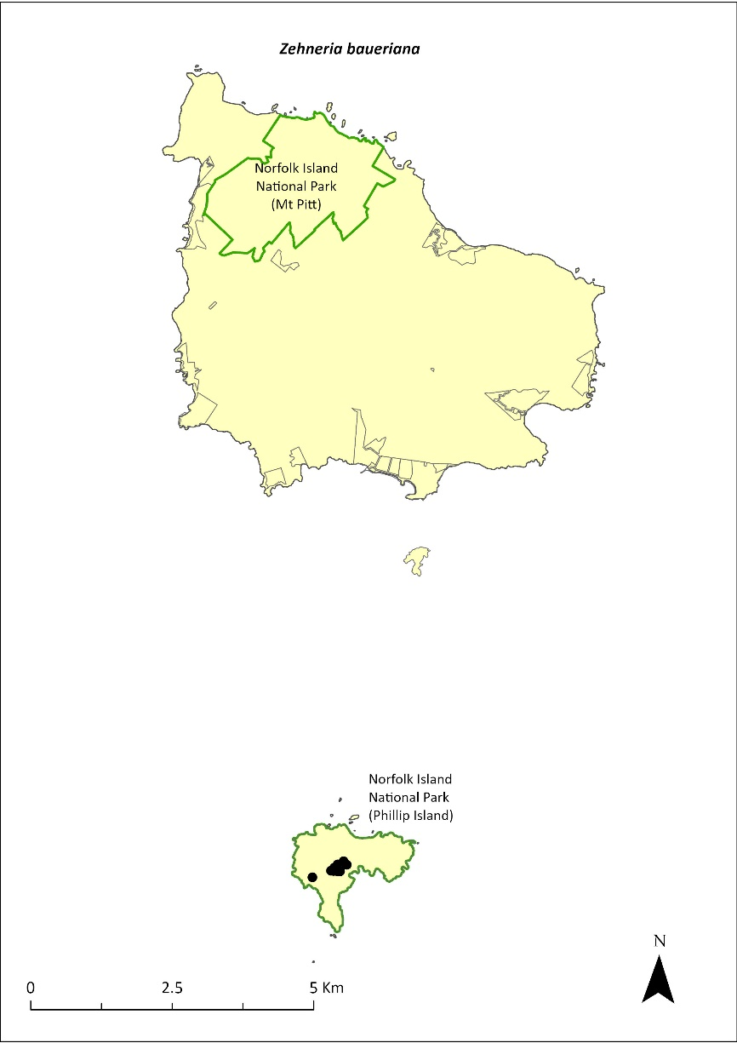
Green outlines indicate reserves within which the species occurs. Points show recorded locations (Mills 2009b).

Risk assessment
Risk assessment undertaken for Endangered vines/climbers as a grouping. The risk assessment is shown in Table 153.
Table 153 Risk assessment for Endangered vines/climbers as a grouping
Risk | Likelihood of exposure | Consequence | Threat rating
1. Loss and fragmentation of native vegetation through past land clearing | Almost certain (91–100%) | Extreme | Extreme
2. Loss and fragmentation of native vegetation through current or future land clearing | Rare (0–10%) | Negligible | Negligible
3. Degradation of native vegetation through past grazing or loss of nutrients | Almost certain (91–100%) | Extreme | Extreme
4. Degradation of native vegetation through current or future grazing | Possible (26–50%) | Moderate | Medium
6. Predation by rodents | Almost certain (91–100%) | Negligible | Negligible
7. Predation by cats | Rare (0–10%) | Negligible | Negligible
8. Predation or damage by chickens | Rare (0–10%) | Negligible | Negligible
9. Predation by swamphens | Rare (0–10%) | Negligible | Negligible
10. Predation by Argentine ant | Rare (0–10%) | Negligible | Negligible
11. Competition from/change of habitat because of weed invasion | Likely (51–90%) | Moderate | Medium
12. Infection by pathogens already present | Rare (0–10%) | Negligible | Negligible
13. Impacts of potential new invasive species or pathogens | Unlikely (11–25%) | Minor | Low
14. Changes to vegetation, increased fire risk and/or direct physiological stress as a result of climatic changes | Possible (26–50%) | Moderate | Medium
15. Problems caused by small populations, including lack of genetic diversity | Possible (26–50%) | Moderate | Medium

Management actions
Conduct targeted weed control and maintenance around existing populations. Implement habitat protection and rehabilitation. Undertake seed propagation (when seed is available) and replanting in suitable habitat. Exclude or manage cattle grazing.

Recovery target
The recovery target is shown in Table 154.
Table 154 Recovery target for Zehneria baueriana
EPBC Act status | Estimated population (2023) | Where known populations occur | 2034 target
Endangered | 180 groups of plants | >95% within the national park | 300 groups of plants

Relevant literature
Director of National Parks (2010) Norfolk Island Region Threatened Species Recovery Plan. Department of the Environment, Water, Heritage and the Arts, Canberra.
Mills K (2009b) The Vegetation of Phillip Island, Norfolk Island Group. Envirofund 2007/2008. Kevin Mills & Associates, Jamberoo, NSW.
Mills K (2012b) The Flora of Norfolk Island. Report 14. The Endangered Plants in the national park: Field Survey and Review. Kevin Mills & Associates, Jamberoo, NSW.
Orchard A (ed) (1994) Flora of Australia. Vol. 49. Oceanic Islands 1. Australian Government Publishing Service, Canberra.
Sykes W & Atkinson I (1988) Rare and Endangered Plants of Norfolk Island. Unpublished report to the Australian National Parks and Wildlife Service, Norfolk Island.
TSSC (Threatened Species Scientific Committee) (2003c) Commonwealth Listing Advice for Norfolk Island Flora - 16 Endangered Species

Part 7—Appendices

Appendix A: Conceptual models
Figure 10 Conceptual model of factors and interactions influencing forest birds on Norfolk Island
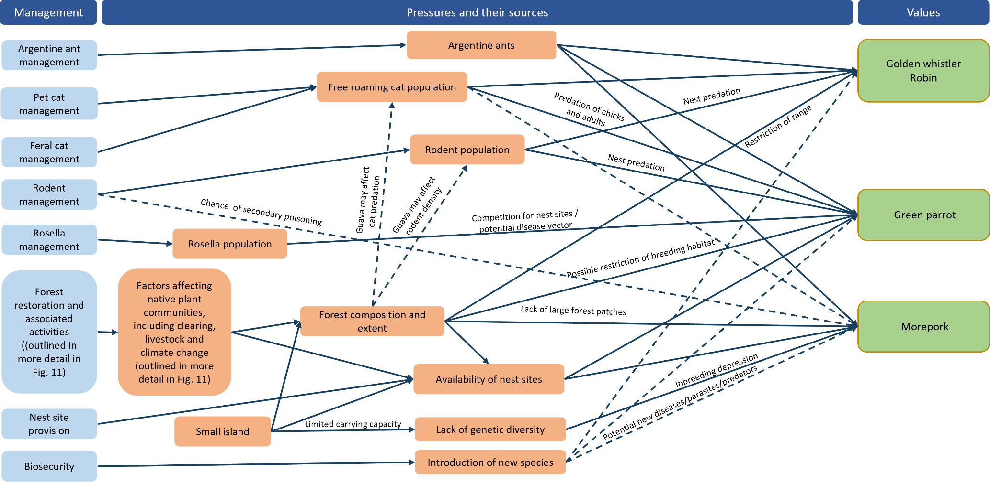
This model outlines the relationship between the four threatened species of forest bird (listed in the right column, in green boxes), the major pressures that are affecting these values and the sources of those pressures (in the middle column, in orange boxes), and the priority management programs that can address pressures (in the left column, in blue boxes). Solid lines represent known or likely influences; dotted lines represent possible or hypothetical influences.
Figure 11 Conceptual model of factors and interactions influencing native plant communities and threatened plant species on Norfolk Island
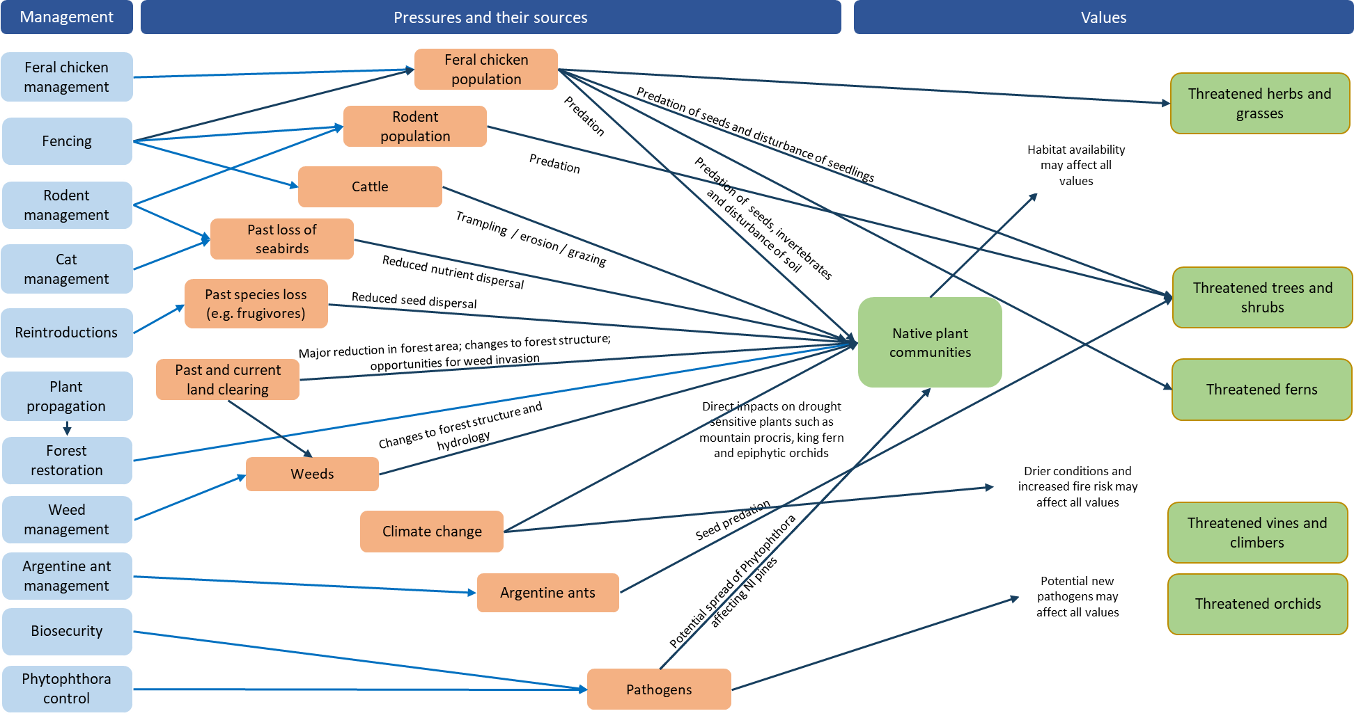
This model outlines the relationship between plant communities and groups of threatened plants (in the right column, in green boxes), the major pressures that are affecting these values and the sources of those pressures (in the middle column in, orange boxes), and the priority management programs that address the cause/source of major pressures (in the left column, in blue boxes). Arrows indicate the direction of the relationships. Solid lines represent known or likely influences; dotted lines represent possible or hypothetical influences. For simplicity, not all arrows have been shown for these interactions: the extent and condition of native plant communities influences habitat availability for all plants; climate change could affect all groups of plants; the introduction of new species could affect any group of plants.
Figure 12 Conceptual model of factors and interactions influencing threatened snails on Norfolk Island
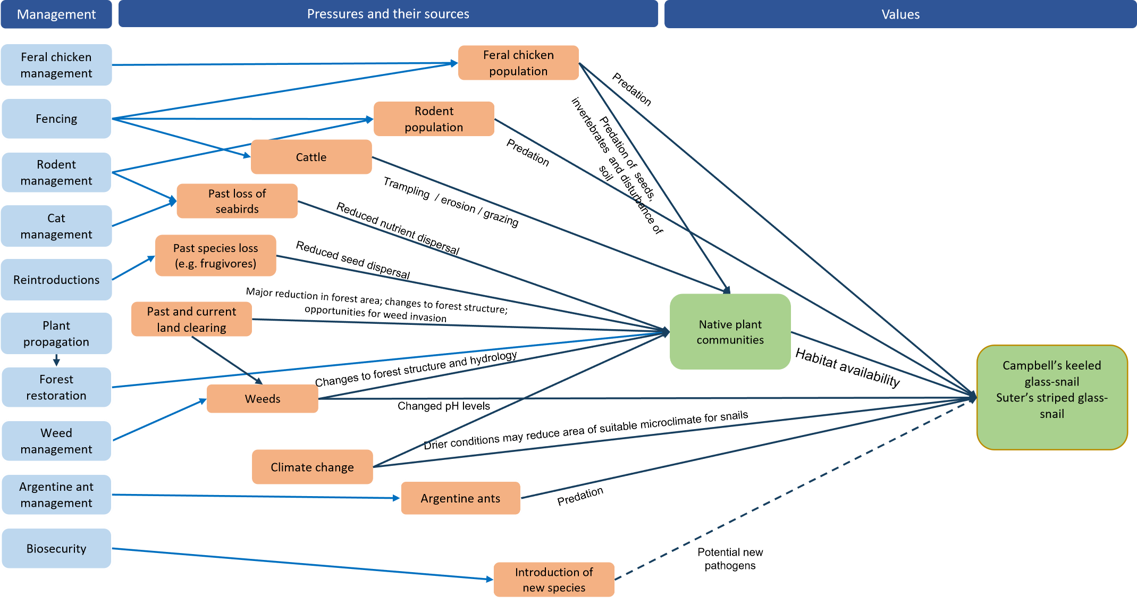
This model outlines the relationship between the two extant threatened species of snail (in the right column, in green boxes), the major pressures that are affecting those species and the sources of those pressures (in the middle column, in orange boxes), and the priority management programs that can address pressures (in the left column, in blue boxes). Solid lines represent known or likely influences; dotted lines represent possible or hypothetical influences.
Figure 13 Conceptual model of factors and interactions influencing native plant communities and threatened plant species on Phillip Island
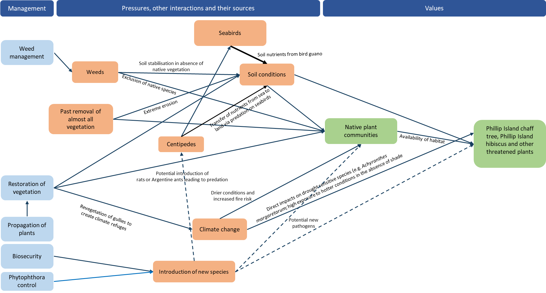
This model outlines the relationship between plant communities and groups of threatened plants (in the right column, in green boxes), the major pressures that are affecting these values and the sources of those pressures (in the middle column, in orange boxes), and the priority management programs that address the cause/source of major pressures (in the left column, in blue boxes). Arrows indicate the direction of the relationships. Solid lines represent known or likely influences; dotted lines represent possible or hypothetical influences.
Figure 14 Conceptual model of factors and interactions influencing threatened animals on Phillip Island
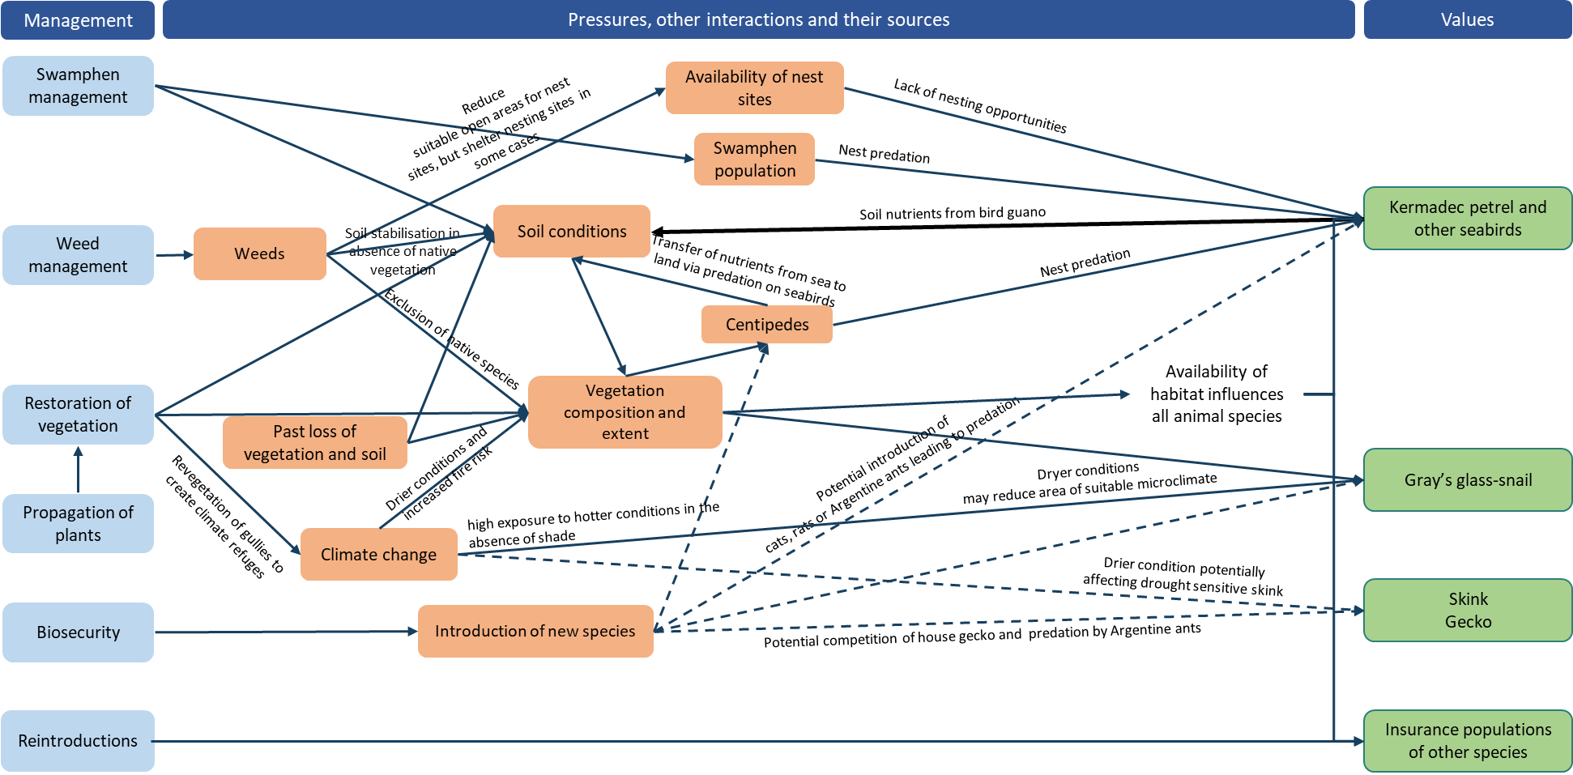
This model outlines the relationship between plant communities and groups of threatened animals (in the right column, in green boxes), the major pressures that are affecting these values and the sources of those pressures (in the middle column, in orange boxes), and the priority management programs that address the cause/source of major pressures (in the left column, in blue boxes). Arrows indicate the direction of the relationships. Solid lines represent known or likely influences; dotted lines represent possible or hypothetical influences.

Glossary
Term |  | Definition
Australian Government |  | The Government of the Commonwealth of Australia
APC |  | The Australian Plant Census
AFD |  | The Australian Faunal Directory
CHL |  | Commonwealth Heritage List
DCCEEW |  | The Department of Climate Change, Energy, the Environment and Water including any such other department or agency that succeeds to the functions of the Department
DITRDCA |  | The Department of Infrastructure, Transport, Regional Development, Communications and the Arts including any such other department or agency that succeeds to the functions of the Department
The Director of National Parks (or Director) |  | The Director is a corporation-sole under the EPBC Act and a corporate Commonwealth entity for the purposes of the Public Governance, Performance and Accountability Act 2013. The corporation is constituted by the person appointed by the Governor-General to the office that is also called the Director of National Parks. The functions of the Director include the administration, management and control of the Norfolk Island National Park and Botanic Garden. The Director of National Parks includes any person to whom the Director has delegated powers and functions under the EPBC Act. The Director is supported by Parks Australia, a division of the Department of Climate Change, Energy, the Environment and Water (DCCEEW).
EPBC Act |  | The Environment Protection and Biodiversity Conservation Act 1999 including Regulations under the Act, and includes reference to any Act amending, repealing or replacing the EPBC Act
EPBC Regulations |  | The Environment Protection and Biodiversity Conservation Regulations 2000 and includes reference to any Regulations amending, repealing or replacing the EPBC Regulations
IUCN |  | The International Union for Conservation of Nature
KAVHA |  | Kingston and Arthur’s Vale Historic Area
Key threatening process |  | A process that threatens or may threaten the survival, abundance or evolutionary development of a native species or ecological community, as identified and listed under the EPBC Act
Minister |  | The Minister administering the EPBC Act
MNES |  | A Matter of National Environmental Significance are matters that are protected under national environmental law and include, for example listed threatened species and communities under the EPBC Act
NINPAC |  | The Norfolk Island National Park Advisory Committee which is responsible for advising the Park Manager on implementation of the Norfolk Island National Park management plan
NIRC |  | The Norfolk Island Regional Council which is responsible for local government functions on Norfolk Island and may deliver some other including state-type functions under agreements with DITRDCA
Norfolk Island Botanic Garden or botanic garden |  | The area declared as a reserve by that name under the National Parks and Wildlife Conservation Act 1975 and continued under the EPBC Act by the Environmental Reform (Consequential Provisions) Act 1999
Norfolk Island Group |  | The group of islands that are included in the plan including Norfolk Island, Phillip Island, Nepean Island, and the surrounding rock stacks
Norfolk Island National Park |  | The areas declared as a national park by that name under the NPWC Act and continued under the EPBC Act by the Environmental Reform (Consequential Provisions) Act 1999
NPWC Act |  | The National Parks and Wildlife Conservation Act 1975 and the Regulations under that Act
Park or national park |  | Norfolk Island National Park
Parks Australia |  | The part of the Department of Climate Change, Energy, the Environment and Water that assists the Director of National Parks in performing the Director’s functions under the EPBC Act
Pressure (or threat) | Event, condition or process that results in degradation of the environment
Recovery plan or plan |  | This Norfolk Island Region Threatened Species Recovery Plan, unless otherwise stated
Territory |  | The Territory of Norfolk Island
Threat abatement plan |  | A statutory document aimed at lessening the impact of a key threatening process, as identified and listed under the EPBC Act
Threatened species |  | A species listed as Vulnerable, Endangered or Critically Endangered under the EPBC Act
Threatening process |  | A process or activity that ‘threatens … the survival, abundance or evolutionary development of a native species or ecological community’ (EPBC Act, p. 273) and which also may threaten the sustainability of resource use
Risk |  | The combined likelihood of exposure to an environmental pressure and the level of harmful consequences

References
Abell RS & Falkland AC (1991) The hydrogeology of Norfolk Island, South Pacific Ocean (Bulletin-Australia, Bureau of Mineral Resources, Geology and Geophysics, 234). Australian Government Public Service, Canberra.
Abell RS & Taylor FJ (1981). Hydrogeological and geophysical investigations on Norfolk Island. Geoscience Australia, Canberra.
Anderson AJ (1996) Discovery of a prehistoric habitation site on Norfolk Island. Journal of the Polynesian Society 105, 479–486.
Anderson AJ, Smith I & White P, 2001. Archaeological fieldwork on Norfolk Island. Records of the Australian Museum, Supplement 27, 11–32.
Anderson JG & Cochrane K (1995) Assessment of Population Numbers of Norfolk’s Threatened Plants (Norfolk Island National Park). Report to the Australian Nature Conservation Agency, Norfolk Island.
Australian Biological Resources Study (ABRS) (2017) Lichens of Norfolk Island, South Pacific Ocean. Accessed 30 January 2024.
Australian Museum (2022) Priceless archaeological artefacts found in Norfolk Island National Park by local citizen scientist. Accessed 31 January 2024.
Bell BD (1990) The status and management of the White-breasted White-eye and other birds of Norfolk Island. Unpublished report to the Australian Nature Conservation Agency.
Benson ML (1980) Dieback of Norfolk Island pine in its natural environment. Australian Forestry 43, 245–252.
Bester A (2003) The breeding, foraging ecology and conservation of the Providence Petrel Pterodroma solandri on Lord Howe Island, Australia. PhD Thesis, Charles Sturt University, Albury, NSW.
Bindoff NL, Cheung WWL, Kairo JG, Arístegui J, Guinder VA, Hallberg R, Hilmi N, Jiao N, Karim MS, Levin L, O’Donoghue S, Purca Cuicapusa SR, Rinkevich B, Suga T, Tagliabue A & Williamson P (2019) Changing Ocean, Marine Ecosystems, and Dependent Communities, in H-O Pörtner, DC Roberts, V Masson-Delmotte, P Zhai, M Tignor, E Poloczanska, K Mintenbeck, A Alegrı́a, M Nicolai, A Okem, J Petzold, B Rama & NM Weyer (eds), IPCC Special Report on the Ocean and Cryosphere in a Changing Climate. Cambridge University Press, Cambridge, UK and New York, NY, USA.
Blakers M, Davies SJJF & Reilly PM (1984) An atlas of Australian birds. Royal Australasian Ornithologists Union, Melbourne University Press, Melbourne.
Borges PA, Gabriel R & Fattorini S (2020) Biodiversity erosion: causes and consequences, in Life on Land. Encyclopedia of the UN Sustainable Development Goals. Springer International Publishing, Cham, Switzerland.
Bostock PD & Spokes TM (1998) Hymenophyllaceae, in PM McCarthy (ed), Flora of Australia 48, ABRS/CSIRO, Canberra. pp. 116–148.
Braggins JE (1996) Report on the conservation status of the ferns of Norfolk Island. Unpublished report to the Australian Nature Conservation Agency.
Brown SM, Macgregor N, Wilson M, Olsen P, Clarke R, Lees C, Weeks A, Heinsohn R, Pryde M, Kavanagh R, Greenwood D, Ward R, Latch P, Christian M, Christian J, Greenup N, Lang S, Quintal R & Christian K (2020) Report on an expert workshop to discuss conservation strategies for the Norfolk Island morepork (Ninox novaeseelandiae undulata) and other Norfolk Island birds. Director of National Parks, Canberra.
Brownsey PJ & Chinnock RJ (1987) A taxonomic revision of the Australian species of Hypolepis. Journal of the Adelaide Botanical Garden 10, 1–30.
Bureau of Meteorology (2019) Temperature and rainfall changes at remote Australian Islands and Antarctic sites. Accessed 30 January 2024.
Bureau of Meteorology (2021) Norfolk Island climate. Accessed 30 January 2024.
Cai WJ (2011) Estuarine and coastal ocean carbon paradox: CO2 sinks or sites of terrestrial carbon incineration? Annual Review of Marine Science 3, 123–145.
Carlile N (2011) Observations of seabirds on Phillip Island 8–12 May 2011. Unpublished report.
Carlile N & O’Dwyer T (2018) NI2016–26 Report to the Director national parks and Manager Norfolk Island National Park. Office of Environment and Heritage NSW.
Carlile N & O’Dwyer T (2022) At-sea movements of the White Tern Gygis alba in waters off Eastern Australia. Marine Ornithology 50, 157–164.
Carlile N & O’Dwyer T (2023) Conservation of the surface-nesting Kermadec Petrel Pterodroma neglecta neglecta in the South Pacific: Clarifying breeding ecology and the threat of avian ground predators. Bird Conservation International 33, e44, 1–9.
Carlile N, O'Dwyer T, Wilson M, Clarke RH, Brown SM, Baker GB & Garnett ST (2021) Western Kermadec petrel Pterodroma neglecta neglecta, in ST Garnett & GB Baker (eds), The Action Plan for Australian Birds 2020. CSIRO Publishing, Melbourne. pp. 169–172.
Carlile N, Priddel D, Lloyd C, Jarman M & Craven P (2015) Seabird islands No. 42 (1): Tollgate Islands, New South Wales. Corella 39(4), 96–99.
Cayzer LW, Crisp MD & Telford IRH (2000) A revision of Pittosporum (Pittosporaceae) in Australia. Systematic Journal of Botany 13, 845–902.
Chapple D, Tingley R, Mitchell N, Macdonald S, Keogh JS, Shea G, Bowles P, Cox N & Woinarski J (2019) The Action Plan for Australian Lizards and Snakes 2017. CSIRO Publishing, Melbourne.
Christian M (2005) Norfolk Island …the birds. Green Eyes Publications, Norfolk Island.
Christian N (1999) A study of the determinants of invasive success and management options for the weed species Psidium cattleianum Sabine var cattleianum (Strawberry guava) in Norfolk Island. Honours thesis, Southern Cross University.
Christian NE & Mills K (2021) Vegetation Mapping of Norfolk Island 2021. Unpublished data.
Clark BL, Carneiro APB, Pearmain EJ et al. (2023) Global assessment of marine plastic exposure risk for oceanic birds. Nature Communications 14, 3665.
Clarke RH, Dutson G, Olsen P & Garnett ST (2021) White-chested White-eye Zosterops albogularis, in ST Garnett & GB Baker (eds), The Action Plan for Australian Birds 2020. CSIRO Publishing, Melbourne. pp. 762–763.
Cogger HG (2004) Draft recovery plan for the threatened lizards Christinus guentheri and Oligosoma lichenigera on Norfolk and Lord Howe Islands. Unpublished draft report to Department of the Environment and Heritage, Canberra.
Cogger HG, Cameron EE & Sadlier RA (1979) The terrestrial reptiles of islands in the Norfolk Island complex. Unpublished report to the Australian National Parks and Wildlife Service, Canberra.
Cogger HG, Cameron EE, Sadlier RA & Eggler P (1993) The Action Plan for Australian Reptiles. Australian Nature Conservation Agency, Canberra.
Cogger HG, Muir G & Shea G (2006) A survey of the terrestrial reptiles of Norfolk Island March 2005: Reports 1–4. Unpublished reports to the Department of the Environment and Heritage, Canberra.
Cole NC, Jones CG & Harris S (2005) The need for enemy-free space: The impact of an invasive gecko on island endemics. Biological Conservation 125(4), 467–474.
Commonwealth of Australia (2005) National Recovery Plan for the Norfolk Island Scarlet Robin Petroica multicolor multicolor and the Norfolk Island Golden Whistler Pachycephala pectoralis xanthroprocta. Department of the Environment and Heritage, Canberra.
Commonwealth of Australia (2009). Threat abatement plan to reduce the impacts of exotic rodents on biodiversity on Australian offshore islands of less than 100 000 ha. Department of the Environment, Water, Heritage and the Arts, Canberra. Accessed 31 January 2024.
Commonwealth of Australia (2015a) Threat abatement plan for predation by feral cats. Department of the Environment, Canberra. Accessed 31 January 2024.
Commonwealth of Australia (2015b) Wildlife Conservation Plan for Migratory Shorebirds. Department of the Environment, Canberra. Accessed 1 February 2024.
Commonwealth of Australia (2018a) Threat abatement plan for the impacts of marine debris on the vertebrate wildlife of Australia's coasts and oceans. Department of the Environment and Energy, Canberra. Accessed 1 February 2024.
Commonwealth of Australia (2018b) Threat abatement plan for the incidental catch (or bycatch) of seabirds during oceanic longline fishing operations. Department of the Environment and Energy, Canberra. Accessed 1 February 2024.
Commonwealth of Australia (2022) Wildlife Conservation Plan for Seabirds. Accessed 30 January 2024.
Connor HE (1990) Elymus (Gramineae) on Norfolk Island. Kew Bulletin 45, 680.
Cowie RH (2001) Decline and homogenization of Pacific faunas: the land snails of American Samoa. Biological Conservation 99, 207–222.
Coyne P, Evans B, Evans O & McCoy H (2015) The Tasman Masked Booby Sula dactylatra tasmani of Nepean and Phillip Islands in the Norfolk Island Group. Corella 39 (3), 60–66.
CSIRO (2020) Norfolk Island Water Resource Assessment. A summary report from the CSIRO Norfolk Island Water Resource Assessment. CSIRO, Australia.
CSIRO, Managers of World Heritage Properties in Australia & Indigenous Reference Group (2021) The implications of climate change for World Heritage Properties in Australia: assessment of impacts and vulnerabilities. Department of Climate Change, Energy, the Environment and Water, Canberra.
Csurhes S & Markula A (2009) Pest animal risk assessment: Asian house gecko Hemidactylus frenatus. Biosecurity Queensland, Queensland Primary Industries and Fisheries, Department of Employment, Economic Development and Innovation, Queensland.
Dann LE, Guja L, Kark S & Dwyer J (2023) Comparative study reveals management of a dominant invasive plant facilitates subtropical forest regeneration. Biological Invasions 26, 299–313.
Dann LE, Scott M, Guja L, Wilson M, Greenup N & Kark S (2021) A guide to propagating Norfolk Island’s native plants and seeds. National Environmental Science Program Threatened Species Recovery Hub, The University of Queensland, Brisbane.
Davidson P, Anderson J & Evans O (1994) Native vegetation within the forestry zone of Norfolk Island National Park. Unpublished Report to the Australian Nature Conservation Agency.
Davis P (2008) Argentine Ants on Norfolk Island—An investigation into their extent and future management options, Report of a visit 4th–10th May 2008. Unpublished report to Administration of Norfolk Island.
Davidson P (2008) Collection of Blood Samples from Providence Petrel Pterodroma solandri on Phillip Island, Norfolk Island Group 12–14 June 2008. Unpublished report.
Dawkins K & Esiobu N (2016) Emerging insights on Brazilian pepper tree (Schinus terebinthifolius) invasion: the potential role of soil microorganisms. Frontiers in plant science 7, 712.
DCCEEW (Department of Climate Change, Energy, the Environment and Water) (n.d.). Australian Heritage Database. Available on the Internet at: https://www.environment.gov.au/heritage/publications/australian-heritage-database
DCCEEW (Department of Climate Change, Energy, the Environment and Water) (2022a) Nature Positive Plan: better for the environment, better for business. Department of Climate Change, Energy, the Environment and Water, Canberra.
DCCEEW (Department of Climate Change, Energy, the Environment and Water) (2022b) Threatened Species Strategy Action Plan 2022–2032. Department of Climate Change, Energy, the Environment and Water, Canberra.
DCCEEW (Department of Climate Change, Energy, the Environment and Water) (2024) Conservation Advice for Polyphlebium endlicherianum (middle filmy fern). Department of Climate Change, Energy, the Environment and Water, Canberra.
Debus SJS (2012) Norfolk Island Boobook chick deaths. Boobook 30, 6.
DECC (Department of Environment and Climate Change) NSW (2007) Lord Howe Island Biodiversity Management Plan. Department of Environment and Climate Change, NSW, Sydney.
DEH (Department of the Environment and Heritage) (2006) Threat abatement plan to reduce the impacts of tramp ants on biodiversity in Australia and its territories. Department of the Environment and Heritage, Canberra.
DEH (Department of the Environment and Heritage) (2003) What the Environment Protection and Biodiversity Conservation Act 1999 (EPBC Act) means for Norfolk Island. Department of the Environment and Heritage, Canberra.
de Lange PJ & Murray BG (2001) A new Achyranthes (Amaranthaceae) from Phillip Island, Norfolk Island Group, South Pacific Ocean. New Zealand Journal of Botany 39, 1–8.
de Lange PJ & Murray BG (2003) Chromosome numbers of Norfolk Island endemic plants. Australian Journal of Botany 51, 211–215.
de Lange PJ, Gardner RO, Sykes WR, Crowcroft GM, Cameron EK, Stalker F, Christian ML, & Braggins JE (2005) Vascular flora of Norfolk Island: some additions and taxonomic notes. New Zealand Journal of Botany 43, 563–596.
de Lange PJ, Johnson PN, Norton DA, Hitchmough R, Heenan PB, Courteney SP, Molloy B.P.J, Ogle C.C & Rance BD (2004) Threatened and uncommon plants of New Zealand. New Zealand Journal of Botany 42, 45–76.
Debus SJS (2012) Norfolk Island Boobook chick deaths. Boobook 30, 6.
DEWHA (Department of the Environment, Water, Heritage and the Arts) (2008a) Approved Conservation Advice for Advena campbellii campbellii. Department of the Environment, Water, Heritage and the Arts, Canberra. Accessed 1 February 2024.
DEWHA (Department of the Environment, Water, Heritage and the Arts) (2008b). Approved Conservation Advice for Mathewsoconcha grayi ms (a snail). Department of the Environment, Water, Heritage and the Arts, Canberra. Accessed 1 February 2024.
DEWHA (Department of the Environment, Water, Heritage and the Arts) (2008c). Approved Conservation Advice for Mathewsoconcha phillipii (Phillip Island Helicarinoid Snail). Department of the Environment, Water, Heritage and the Arts, Canberra. Accessed 1 February 2024.
DEWHA (Department of the Environment, Water, Heritage and the Arts) (2008d). Approved Conservation Advice for Mathewsoconcha suteri (a snail). Department of the Environment, Water, Heritage and the Arts, Canberra. Accessed 1 February 2024.
DEWHA (Department of the Environment, Water, Heritage and the Arts) (2008e). Approved Conservation Advice for Quintalia stoddartii (Stoddart's Helicarionid Land Snail). Department of the Environment, Water, Heritage and the Arts, Canberra. Accessed 1 February 2024.
Di Fonzo MMI, Nicol S, Possingham HP, Flakus S, West JG, Failing L, Long G & Walshe T (2017) Cost-Effective Resource Allocator: A decision support tool for threatened species management. Parks 23(1), 101–113.
Director of National Parks (2008) Norfolk Island National Park and Norfolk Island Botanic Garden Management Plan 2008-2018. Department of the Environment, Water, Heritage and the Arts, Canberra.
Director of National Parks (2010) Norfolk Island Region Threatened Species Recovery Plan. Department of the Environment, Water, Heritage and the Arts, Canberra.
Director of National Parks (2011) Norfolk Island National Park and Botanic Garden Climate Change Strategy 2011-2016. Department of Sustainability, Environment, Water, Population and Communities, Canberra.
Director of National Parks (2018) Temperate East Marine Parks Network Management Plan 2018. Director of National Parks, Canberra.
Director of National Parks (2020) Norfolk Island National Park and Norfolk Island Botanic Garden Management Plan 2020. Director of National Parks, Canberra.
Director of National Parks (2021) Norfolk Island Threatened Species Recovery Plan: Prioritising management activities to conserve threatened species. Unpublished report.
DoEE (Department of the Environment and Energy) (2017) Recovery team governance—Best practice guidelines. Commonwealth of Australia. Accessed 1 February 2024.
Doran GT (1981) There’s a SMART way to write management’s goals and objectives. Management review 70(11), 35–36.
DSEWPaC (Department of Sustainability, Environment, Water, Population and Communities) (2012a) Marine bioregional plan for the North Marine Region. Accessed 1 February 2024.
DSEWPaC (Department of Sustainability, Environment, Water, Population and Communities) (2012b) Marine bioregional plan for the North-west Marine Region. Accessed 1 February 2024.
DSEWPaC (Department of Sustainability, Environment, Water, Population and Communities) (2012c) Marine bioregional plan for the South-west Marine Region. Accessed 1 February 2024.
DSEWPaC (Department of Sustainability, Environment, Water, Population and Communities) (2012d) Marine bioregional plan for the Temperate East Marine Region. Accessed 1 February 2024.
Dunlop M & Brown PR (2008) Implications of Climate Change for Australia’s National Reserve System: A Preliminary Assessment. CSIRO Sustainable Ecosystems, report to the Department of Climate Change and the Department of the Environment, Water, Heritage and the Arts, Canberra.
Dutson G (2013) Population densities and conservation status of Norfolk Island forest birds. Bird Conservation International 23, 271–282.
Edwards ED (1985) Report on the Lepidoptera collected on Norfolk and Phillip Islands. Unpublished Report to the Australian National Parks and Wildlife Service, Canberra.
Elix JA & Streimann H (1985) Lichens and Bryophytes of Norfolk Island. Unpublished report to the Australian National Parks and Wildlife Service, Canberra.
Elix JA, Streimann H & Archer AW (1992) The lichens of Norfolk Island 2: The genera Cladonia, Pertusaria, Pseudocyphellaria and Ramalina. Proceedings of the Linnean Society of New South Wales 113(1), 72–76.
Erwin T, Bathols J, Heady C, Bedin T, Wilson L, Narsey S, Rafter T, Bhend J & Clarke J (2015) CMIP5 Climatologies. v5. Unpublished analysis. CSIRO Data Access Portal. Accessed 30 January 2024.
ESSS (Endangered Species Scientific Subcommittee) (1995) Commonwealth Listing Advice on Incidental catch (or bycatch) of seabirds during oceanic longline fishing operations. Commonwealth of Australia.
Fernández-Palacios JM, Kreft H, Irl SDH, Norder S, Ah-Peng C & Borges PAV (2021) Scientists’ warning–The outstanding biodiversity of islands is in peril. Global ecology and conservation 31, e01847.
Fitzherbert K & Peter J (1988) Status and movement of Australian migratory birds Vol 1. Procellariiformes Part II. Royal Australasian Ornithologists Union, Melbourne.
Frankham R, Bradshaw CJ & Brook BW (2014) Genetics in conservation management: revised recommendations for the 50/500 rules, Red List criteria and population viability analyses. Biological Conservation 170, 56–63.
Fullagar PJ & Disney HJ (1975) The birds of Lord Howe Island: a report on the rare and endangered species. ICBP Bulletin 12, 187–202.
Fullagar PJ (1978) Norfolk Island birds. Unpublished report to RAOU Congress, Norfolk Island.
Gardner RO & de Lange PJ (2002) Revision of Pennantia (Icacinaceae), a small isolated genus. Journal of the Royal Society of New Zealand 32, 669–695.
Garnett ST & Baker GB (2021) The Action Plan for Australian Birds 2020. CSIRO Publishing, Melbourne.
Garnett ST & Crowley GM (2000) The Action Plan for Australian Birds. Environment Australia.
Garnett ST, Szabo J & Dutson G (2011) The Action Plan for Australian Birds 2010. CSIRO Publishing, Melbourne.
Gautschi D, Heinsohn R, Crates R, Macgregor NA, Wilson M & Stojanovic D (2022) Utilization of modified and artificial nests by endemic and introduced parrots on Norfolk Island. Restoration Ecology 30(5), e13586.
Giachino PM (2005) Revision of the Australian Anillina (Coleoptera, Carabidae, Bembidiini) Results of the Zoological Missions to Australia of the Regional Museum of Natural Sciences of Turin. II. Monografie del Museo regionale di Scienze naturali, Torino 42, 137–238.
Gilmour PM & Helman CE (1989a) A Survey of Quality Plant Communities of Norfolk Island Outside the national park. Report to the Australian National Parks and Wildlife Service, Norfolk Island.
Gilmour PM & Helman CE (1989b) The Vegetation of Norfolk Island National Park. Report to the Australian National Parks and Wildlife Service, Norfolk Island.
Gorta S (2023) unpublished data.
Green P (1994) Introduction. Norfolk Island and Lord Howe Island, in A Orchard (ed), Flora of Australia. Vol. 49. Oceanic Islands 1. Australian Government Publishing Service, Canberra. pp. 1–24.
Greene TC (2003) Breeding biology of red-crowned parakeets (Cyanoramphus novaezelandiae novaezelandiae) on Little Barrier Island, Hauraki Gulf, New Zealand. Notornis 50, 83–99.
Groeneveld KM (1989) Conservation biology of the endangered species Hibiscus insularis. Unpublished Report to the Australian National Parks and Wildlife Service.
Hall LS, Krausman PR & Morrison ML (1997) The habitat concept and a plea for standard terminology. Wildlife Society Bulletin 25, 173–182.
Halpin LR, Carlile N, Baker GB & Garnett ST (2021b) White-necked Petrel Pterodroma cervicalis cervicalis, in ST Garnett & GB Baker (eds), The Action Plan for Australian Birds 2020. CSIRO Publishing, Melbourne. pp. 177–179.
Halpin LR, Mott R, Clay TA, Humphries GRW, Chatwin TA, Carlile N & Clarke RH (2022) Predicting the foraging habitats of sympatrically breeding gadfly petrels in the South Pacific Ocean. Frontiers in Marine Science 9, 853104.
Halpin LR, Terrington DI, Jones HP, Mott R, Wong WW, Dow DC, Carlile N & Clarke RH (2021a) Arthropod predation of vertebrates structures trophic dynamics in island ecosystems. The American Naturalist 198(4), 540–550.
Hay JR (1986) Bird Conservation in the Pacific Islands. Study Report 7. International Council for Bird Preservation, Cambridge.
Hayes RA, Crossland MR, Hagman M, Capon RJ & Shine R (2009) Ontogenetic variation in the chemical defenses of cane toads (Bufo marinus): toxin profiles and effects on predators. Journal of chemical ecology 35(4), 391–399.
Heinsohn R (2019) Review of the translocation of Norfolk Island Green Parrots from Norfolk Island to Phillip Island. Report to the Director of National Parks, Canberra.
Hermes N, Evans O & Evans B (1986) Norfolk Island birds: a review 1985. Notornis 33, 141–149.
Heterick BE & Shattuck S (2011) Revision of the ant genus Iridomyrmex (Hymenoptera: Formicidae). Zootaxa 2845, 1–174.
Hicks J & Greenwood D (1989) Rescuing Norfolk Island’s Parrot. Birds International 2, 35–47.
Hicks J & Preece M (1991) Green Parrot. 1991 Recovery Plan. Unpublished report to the Australian National Parks and Wildlife Service.
Hill R (2002) Recovery Plan for the Norfolk Island Green Parrot Cyanoramphus novaeseelandiae cookii. Environment Australia, Canberra.
Hoare M (1969) Norfolk Island—An Outline of its History 1774–1968. University of Queensland Press, St. Lucia, Queensland.
Hoffmann BD (2020) Argentine Ant Eradication Strategy Norfolk Island 2021-2026. CSIRO.
Holloway JD (1977) The Lepidoptera of Norfolk Island: their biogeography and ecology (Series Entomologica 13). W Junk publisher, The Hague.
Hoskin CJ (2011) The invasion and potential impact of the Asian House Gecko (Hemidactylus frenatus) in Australia. Austral Ecology 36(3), 240–251.
Hoye GA, Law BS & Allison FR (2008) East-coast Free-tailed Bat, in R Strahan & S Van Dyck (eds), The Mammals of Australia. 3rd ed. Reed New Holland, Sydney.
Hughes L (2003) Climate change and Australia: trends, projections, and impacts. Austral Ecology 28, 423–443.
Hyder Consulting (2008) The Impacts and Management Implications of Climate Change for the Australian Government’s Protected Areas. Report to the Department of Climate Change and the Department of the Environment, Water, Heritage and the Arts, Canberra.
Hyman I & Köhler F (2020) Report on survey of land snails on Norfolk Island. Australian Museum, Sydney.
Hyman I (2005) Taxonomy, systematic, and evolutionary trends in Helicarionida (Mollusca, Pulmonata). PhD Thesis, University of Sydney.
Hyman IT, Caiza J & Köhler F (2023) Systematic revision of the microcystid land snails endemic to Norfolk Island (Gastropoda: Stylommatophora) based on comparative morpho-anatomy and mitochondrial phylogenetics. Invertebrate Systematics 37(5–6), 334–443.
Invasive Species Compendium (2022a) Norfolk Island. Accessed 30 January 2024.
Invasive Species Compendium (2022b) Rattus rattus (black rat) Data Sheet. Accessed 30 January 2024.
Invasive Species Council & TierraMar (2021) The Native Plant Communities of Norfolk Island. Invasive Species Council, Katoomba, NSW.
Invasive Species Council and Island Conservation (2017) Norfolk Island: Protecting an Ocean Jewel. Recommendations for stronger biosecurity for the Norfolk Island Group. Invasive Species Council and Island Conservation, Fairfield, Victoria.
IPBES (2019) Global assessment report on biodiversity and ecosystem services of the Intergovernmental Science-Policy Platform on Biodiversity and Ecosystem Services. ES Brondizio, J Settele, S Díaz & HT Ngo (eds). IPBES secretariat, Bonn, Germany.
IPCC (2021) Climate Change 2021: The Physical Science Basis (Contribution of Working Group I to the Sixth Assessment Report of the Intergovernmental Panel on Climate Change). V Masson-Delmotte, P Zhai, A Pirani, SL Connors, C Péan, S Berger, N Caud, Y Chen, L Goldfarb, MI Gomis, M Huang, K Leitzell, E Lonnoy, JB R Matthews, TK Maycock, T Waterfield, O Yelekçi, R Yu & B Zhou (eds). Cambridge University Press, Cambridge.
Iredale T (1910) Bird life on the Kermadec Islands. Emu. 10, 2–16.
Iredale T (1945) The land mollusca of Norfolk Island. Australian Zoologist 11, 46–71.
IUCN (2020) IUCN Redlist. Accessed 30 January 2024.
IUCN (2022) Version 2022-1. Accessed 21 December 2022.
Jean Rice Architect, Context Pty Ltd & GML Heritage Pty Ltd (2016) Kingston and Arthur’s Vale Historic Area Heritage Management Plan. Commonwealth of Australia.
Johns PM (1967) A note on the introduced millipedes of New Zealand. New Zealand Entomologist 3(5), 60–62.
Jones JG & McDougall I (1973) Geological history of Norfolk and Philip islands, southwest Pacific Ocean. Journal of the Geological Society of Australia 20(3), 239–254.
Kearney SG, Watson JE, Reside AE, Fisher DO, Maron M, Doherty TS, Legge SM, Woinarski JC, Garnett ST, Wintle BA & Ritchie EG (2023) Threat-abatement framework confirms habitat retention and invasive species management are critical to conserve Australia's threatened species. Biological Conservation 277, 109833.
Kirk DA, Park AC, Smith AC, Howes BJ, Prouse BK, Kyssa NG, Fairhurst EN & Prior KA (2018) Our use, misuse, and abandonment of a concept: Whither habitat? Ecology and Evolution 8(8), 4197–4208.
Koch LE (1984) A new species of Cormocephalus centipede (Chilopoda: Scolopendridae) from Phillip Island in the South Pacific. Journal of Natural History 18(4), 617–621.
Levick S & Johnson S (2023) Norfolk Island landcover mapping from airborne LiDAR. v2. Data collection. CSIRO Data Access Portal. Accessed 30 January 2024.
Lindsey TR (1986) The Seabirds of Australia: the national photographic index of Australian Wildlife. Angus and Robertson, North Ryde, NSW.
Lombal AJ, Wenner TJ, Carlile N, Austin JJ, Woehler E, Priddel D & Burridge CP (2016) Population genetic and behavioral variation of the two remaining colonies of Providence petrel (Pterodroma solandri). Conservation Genetics 18, 117–129.
Lowe S, Browne M, Boudjelas S & De Poorter M (2000) 100 of the world's worst invasive alien species: a selection from the global invasive species database (Vol. 12). Invasive Species Specialist Group, Auckland.
Macgregor NA, Wilson M, Brown SM, Goumas M, Heinsohn R, Clarke RH, Ortiz-Catedral L, Greenup N, Christian M, Greenwood D, Ward R & Garnett ST (2021) Norfolk Island Green Parrot Cyanoramphus novaezelandiae cookii, in ST Garnett & GB Baker (eds) The Action Plan for Australian Birds 2020. CSIRO Publishing, Melbourne. pp. 432–435.
Major R (1989) Reproductive output and recruitment of the Norfolk Island Scarlet Robin (Petroica multicolor multicolor) Phase II. Report to the Australian National Parks and Wildlife Service, Canberra.
Martoni F, Achari S, Blacket MJ, Brohier ND, Constable F, Dugdale T, Ekanayake P, Kant P, Kelly G, Kinoti C, Li T, Lovelock D, Mann R, Nogarotto E, Sawbridge T, Smith R, Wainer J & Rodoni B (2023) Plant pest and disease survey on Norfolk Island. Department of Energy, Environment and Climate Change (Victoria), report to the Department of Infrastructure, Transport, Regional Development, Communications and the Arts, Canberra.
Maynard GV, Lepschi BJ & Malfroy SF (2018) Norfolk Island quarantine survey 2012–2014—a comprehensive assessment of an isolated subtropical island. Proceedings of the Linnean Society of New South Wales 140, 7–243.
McCormack RB & Coughran J (2009) Norfolk Island Freshwater Aquatic Survey 2009 (Internal Project Report, The Australian Crayfish Project). Australian Aquatic Biological Pty Ltd, Karua, NSW.
McJannet D, Marano J, Petheram C, Tavener N & Greenwood D (2023) Quantifying rainfall and cloud water interception in upland forests of Norfolk Island. Hydrological Processes 37(7), e14945.
Medway DG (2002) History and causes of the extirpation of the Providence petrel (Pterodrma solandri) on Norfolk Island. Notornis 49 (4), 246–258.
Melville R (1969) The endemics of Phillip Island. Biological Conservation 1(2), 170–172.
Merton DV (1970) Kermadec Island expedition reports: a general account of bird life. Notornis 17, 147–199.
Mills K (2007a) The Flora of Norfolk Island. 1. The Indigenous Flora. Kevin Mills & Associates, Jamberoo, NSW.
Mills K (2007b) The Flora of Norfolk Island. 8. Indigenous Plant Species Recorded in Public Reserves on Norfolk Island. Kevin Mills & Associates, Jamberoo, NSW.
Mills K (2007c) The Flora of Norfolk Island. 3. The Coastal Species. Kevin Mills & Associates, Jamberoo, NSW.
Mills K (2007d) The Flora of Norfolk Island. 5. Field Survey of the Norfolk Island Endemic Shrub Euphorbia norfolkiana (Euphorbiaceae). Kevin Mills & Associates, Jamberoo, NSW.
Mills K (2007e) The Flora of Norfolk Island. 2. Epiphytes and Mistletoes. Kevin Mills & Associates, Jamberoo, NSW.
Mills K (2007f) The Flora of Norfolk Island. 7. Endemic and Threatened Species. Kevin Mills & Associates, Jamberoo, NSW.
Mills K (2009a) The Flora of Norfolk Island. 9. The Vegetation of Nepean Island (including Errata and Addenda for Papers 1 to 8). Kevin Mills & Associates, Jamberoo, NSW.
Mills K (2009b) The Vegetation of Phillip Island, Norfolk Island Group. Envirofund 2007/2008. Kevin Mills & Associates, Jamberoo, NSW.
Mills K (2010) The Flora of Norfolk Island. 11. Field Survey and Assessment of the Critically Endangered Endemic Plant Wikstroemia australis (Kurrajong). Kevin Mills & Associates, Jamberoo, NSW.
Mills K (2012a) The Flora of Norfolk Island. Report 16. The Wetland Plants. Kevin Mills & Associates, Jamberoo, NSW.
Mills K (2012b) The Flora of Norfolk Island. Report 14. The Endangered Plants in the national park: Field Survey and Review. Kevin Mills & Associates, Jamberoo, NSW.
Mills K (2017a) Survey of public reserves on Norfolk Island for threatened plant species: 3. Point Ross Reserve and Bumbora Reserve. Prepared for Norfolk Island Regional Council.
Mills K (2017b) Survey of public reserves on Norfolk Island for threatened plant species: 8. Ball Bay Reserve. Prepared for Norfolk Island Regional Council.
Mills K (2017c) Survey of public reserves on Norfolk Island for threatened plant species: 1. The Kingston Reserves. Prepared for Norfolk Island Regional Council.
Mills K (2017d) Survey of public reserves on Norfolk Island for threatened plant species: 6. Anson Bay Reserve and Selwyn Reserve. Prepared for Norfolk Island Regional Council.
Mills K (2017e) Survey of public reserves on Norfolk Island for threatened plant species: 7. Hundred Acres Reserve. Prepared for Norfolk Island Regional Council.
Mills K (2017f) Survey of public reserves on Norfolk Island for threatened plant species: 4. Cascade Reserve including Quarantine Reserve. Prepared for Norfolk Island Regional Council.
Mills K (2017g) Survey of public reserves on Norfolk Island for threatened plant species: 5. Two Chimneys Reserve. Prepared for Norfolk Island Regional Council.
Moore BP (1985) The Carabidae of Norfolk Island, in GE Ball (ed), Taxonomy, phylogeny and zoogeography of beetles and ants. W Junk publisher, Doordrecht, Netherlands. pp. 236–256.
Mosley JG (2001) Island on the Brink—A Conservation Strategy for Norfolk Island. Norfolk Island Conservation Society, Norfolk Island.
Mound LA & Wells A (2015) Endemics and adventives: Thysanoptera (Insecta) biodiversity of Norfolk, a tiny Pacific Island. Zootaxia 3964 (2), 183–210.
Munstermann MJ, Heim NA, McCauley DJ, Payne JL, Upham NS, Wang SC & Knope ML (2022) A global ecological signal of extinction risk in terrestrial vertebrates. Conservation Biology 36(3), e13852.
Nance AH, Mitchell WF, Clarke RH, Wilson M, Brown SM, Macgregor NA, Dutson G & Garnett ST (2021c) Slender-billed White-eye Zosterops tenuirostris, in ST Garnett & GB Baker (eds) The Action Plan for Australian Birds 2020. CSIRO Publishing, Melbourne. pp. 763–765.
Nance AH, Mitchell WF, Clarke RH, Wilson M, Brown SM, Macgregor NA, Dutson G & Garnett ST (2021b) Norfolk Island Robin Petroica multicolor, in ST Garnett & GB Baker (eds) The Action Plan for Australian Birds 2020. CSIRO Publishing, Melbourne. pp. 741–744.
Nance AH, Mitchell WF, Wilson M, Brown SM, Clarke RH, Macgregor NA, Ward R & Garnett ST (2021a) Norfolk Island Golden Whistler Pachycephala pectoralis xanthoprocta, in ST Garnett & GB Baker (eds) The Action Plan for Australian Birds 2020. CSIRO Publishing, Melbourne. pp. 709–710.
Nance AH, Mitchell WF, Dawlings F, Cook CN & Clarke RH, (2023) Rodent predation and specialised avian habitat requirements drive extinction risk for endemic island songbirds in the south-west Pacific. Emu - Austral Ornithology 123(3), 217–231.
Naumann ID (1984) Review of Norfolk and Phillip Island Hymenoptera (excluding Formicidae). Unpublished report to the Australian National Parks and Wildlife Service.
Neuweger D, White P & Ponder WF (2001) Land snails from Norfolk Island sites. Records of the Australian Museum, Supplement 27, 115–122.
NIP&FS (Norfolk Island Parks and Forestry Service) (2003) Nepean Island Plan of Management Part B Section 8.
NIRC (Norfolk Island Regional Council) (2003) Norfolk Island Heritage Act 2002 Heritage Register. Norfolk Island Regional Council, Norfolk Island.
NIRC (Norfolk Island Regional Council) (2016) (as amended). Norfolk Island Plan 2002. Latest amendment approved 21 March 2016. Norfolk Island Regional Council, Norfolk Island.
NIRC (Norfolk Island Regional Council) (2016) Norfolk Island Community Strategic Plan 2016–2026: Our Plan for the Future. Norfolk Island Regional Council, Norfolk Island.
NIRC (Norfolk Island Regional Council) (2017) Norfolk Island Heritage and Culture Strategy 2017–2020. Norfolk Island Regional Council, Norfolk Island.
NIRC (Norfolk Island Regional Council) (2018b) Norfolk Island Regional Council Asset Management Policy. Norfolk Island Regional Council, Norfolk Island.
NIRC (Norfolk Island Regional Council) (2018a) The Norfolk Island Environment Strategy 2018-2023. Norfolk Island Regional Council, Norfolk Island.
NIRC (Norfolk Island Regional Council) (2020a) Plan of Management Anson Bay Reserve. Norfolk Island Regional Council, Norfolk Island.
NIRC (Norfolk Island Regional Council) (2020b) Plan of Management Ball Bay Reserve. Norfolk Island Regional Council, Norfolk Island.
NIRC (Norfolk Island Regional Council) (2020c) Plan of Management Bumbora Reserve. Norfolk Island Regional Council, Norfolk Island.
NIRC (Norfolk Island Regional Council) (2020d) Plan of Management Cascade Reserve. Norfolk Island Regional Council, Norfolk Island.
NIRC (Norfolk Island Regional Council) (2020e) Plan of Management Cemetery Reserve. Norfolk Island Regional Council, Norfolk Island.
NIRC (Norfolk Island Regional Council) (2020f) Plan of Management Government House Reserve. Norfolk Island Regional Council, Norfolk Island.
NIRC (Norfolk Island Regional Council) (2020g) Plan of Management Headstone Reserve. Norfolk Island Regional Council, Norfolk Island.
NIRC (Norfolk Island Regional Council) (2020h) Plan of Management Hundred Acres Reserve. Norfolk Island Regional Council, Norfolk Island.
NIRC (Norfolk Island Regional Council) (2020i) Plan of Management Kingston Common Reserve. Norfolk Island Regional Council, Norfolk Island.
NIRC (Norfolk Island Regional Council) (2020j) Plan of Management Kingston Recreation Reserve. Norfolk Island Regional Council, Norfolk Island.
NIRC (Norfolk Island Regional Council) (2020k) Plan of Management Middleridge Reserve. Norfolk Island Regional Council, Norfolk Island.
NIRC (Norfolk Island Regional Council) (2020l) Plan of Management Nepean Reserve. Norfolk Island Regional Council, Norfolk Island.
NIRC (Norfolk Island Regional Council) (2020m) Plan of Management Point Hunter Reserve. Norfolk Island Regional Council, Norfolk Island.
NIRC (Norfolk Island Regional Council) (2020n) Plan of Management Point Ross Reserve. Norfolk Island Regional Council, Norfolk Island.
NIRC (Norfolk Island Regional Council) (2020o) Plan of Management Selwyn Reserve. Norfolk Island Regional Council, Norfolk Island.
NIRC (Norfolk Island Regional Council) (2020p) Plan of Management Stock Reserve. Norfolk Island Regional Council, Norfolk Island.
NIRC (Norfolk Island Regional Council) (2020q) Plan of Management Two Chimneys Reserve. Norfolk Island Regional Council, Norfolk Island.
NIRC (Norfolk Island Regional Council) (2020r) Plan of Management War Memorial Reserve. Norfolk Island Regional Council, Norfolk Island.
NIRC (Norfolk Island Regional Council) (2021) Norfolk Island Regional Council Pest Management Plan (NIRCPMP) 2021-2026. Norfolk Island Regional Council, Norfolk Island.
Norfolk Island Conservation Society (1988) A conservation strategy for Norfolk Island. Unpublished report, Norfolk Island Conservation Society.
O'Dowd DJ, Green PT & Lake PS (2003) Invasional ‘meltdown’ on an oceanic island. Ecology Letters 6(9), 812–817.
O’Dwyer T, Carlile N, O’Neill L & Halpin LR (2023) Changing fortunes of the Black-winged Petrel Pterodroma nigripennis following the Lord Howe Island Rodent Eradication Project - interactions with other recovering species. Bird Conservation International 33: e18.
Oliver EC, Burrows MT, Donat MG, Sen Gupta A, Alexander LV, Perkins-Kirkpatrick SE, Benthuysen JA, Hobday AJ, Holbrook NJ, Moore PJ, Thomsen MS, Wernberg T & Smale TA (2019) Projected marine heatwaves in the 21st century and the potential for ecological impact. Frontiers in Marine Science 6, 734.
Olsen P (1996) Re-establishment of an endangered subspecies: the Norfolk Island Boobook. Bird Conservation International 6, 63–70.
Olsen P (1997) Recovery Plan for the Norfolk Island Boobook Owl Ninox novaeseelandiae undulata. Environment Australia, Canberra.
Olsen PD (1986) Status and conservation of the Norfolk Island Boobook Owl Ninox novaeseelandiae undulata. Unpublished report to the Australian National Parks and Wildlife Service.
Olsen PD, Mooney NJ & Olsen J (1989) Status and conservation of the Norfolk Island Boobook Ninox novaeseelandiae undulata, in BU Meyburg & RD Chancellor (eds) Raptors in the Modern World. WWGBP, Berlin. pp. 123–129.
O'Neill L (2006) The breeding and feeding ecology of the Sooty Tern Sterna fuscata on Lord Howe Island. PhD Thesis, Charles Sturt University, Albury, NSW.
Orchard A (ed) (1994) Flora of Australia. Vol. 49. Oceanic Islands 1. Australian Government Publishing Service, Canberra.
Ortiz-Catedral L (2013) The Population and Status of Green Parrot (Tasman Parakeet) Cyanoramphus cookii on Norfolk Island. Unpublished report to the Director of National Parks.
Ortiz-Catedral L, Kearvell JC, Hauber ME & Brunton DH (2009) Breeding biology of the critically endangered Malherbe’s parakeet on Maud Island, New Zealand, following the release of captive-bred individuals. Australian Journal of Zoology 57, 433–439.
Ortiz-Catedral L, Nias R, Fitzsimons J, Vine S & Christian M (2018) Back from the brink–again: the decline and recovery of the Norfolk Island green parrot, in S Garnett, P Latch, D Lindenmayer & J Woinarski (eds) Recovering Australian Threatened Species: A Book of Hope. CSIRO Publishing, Australia.
Petheram C, Taylor A, Hughes J, Philip S, Tavener N, Greenwood D, Taylor N, Wilson PR, Raiber M, Turnadge C, Yang A, Seo L, Davies P, Vanderzalm J, Davis A, Crane P, Gallant J, Ahmed W, Rogers L, Ticehurst C, Marvanek S, Christoph G, Bui E, Grice T, Crosbie R, Metcalfe S, Fitzpatrick R, Schepen A, Levick S, Nobbs C, Cahill K & Vaze J (2020) Norfolk Island Water Resource Assessment. A report to the Australian Government from the CSIRO Norfolk Island Water Resource Assessment team. CSIRO, Australia.
PIER (Pacific Islands at Risk) (2002) Schinus terebinthifolius Risk Assessment. Accessed 30 January 2024.
Pierce R (2002) Pacific rats: their impact on two small seabird species in the Hen and Chicken Islands, New Zealand, in CR Veitch & MN Clout (eds) Turning the tide: the eradication of invasive species. Occasional Paper of the IUCN Species Survival Commission No. 27. IUCN, Gland, Switzerland.
Ponder WF (1997) Conservation status, threats and habitat requirements of Australian terrestrial and freshwater mollusca. Memoirs of the Museum of Victoria 56, 421–430.
Priddel D, Carlile N, Evans O, Evans B & McCoy H (2010) A review of the seabirds of Phillip Island in the Norfolk Island Group. Notornis 57, 113–127.
Rasheed AA, Hambley K, Chan G, de la Rosa CA, Larison B & Blumstein DT (2018) Persistence of antipredator behavior in an island population of California quail. Ethology 124(3),155–160.
Reid AM, Smith K and Beatson M (2018) Revision of the genus Lamprima Latreille, 1804 (Coleoptera: Lucanidae). Zootaxa 4446, 151–202.
Renner MAM & Beadel SM (2011) Taeniophyllum norfolkianum: a second genus of Vandeae (Orchidaceae) indigenous to New Zealand. New Zealand Journal of Botany 49(3), 435–439.
Rentz DDF (1988) The orthopteroid insects of Norfolk Island with descriptions of some related species from Lord Howe Island, South Pacific. Invertebrate Systematics 2, 1013–1077.
Robinson D (1988) Ecology and Management of the Scarlet Robin, White-breasted White-eye, and Long-billed White-eye of Norfolk Island. Consultants’ report to the Australian National Parks and Wildlife Service, Canberra.
Robinson D (1997) An evaluation of the status of the Norfolk Island Robin following rat-control and weed-control works in the Norfolk Island National Park. Report to Environment Australia, Canberra.
Rodda G, Fritts T, Campbell EW III, Dean-Bradley K, Perry G & Qualls C (2002) Practical concerns in the eradication of island snakes, in CR Veitch & MN Clout (eds), Turning the tide: the eradication of invasive species. Occasional Paper of the IUCN Species Survival Commission No. 27. IUCN, Gland, Switzerland. pp. 260–265.
Schodde R, Fullagar P & Hermes N (1983) A review of Norfolk Island birds past and present (Special Publication No. 8). Australian National Parks and Wildlife Service, Canberra.
Shine R (2010) The ecological impact of invasive cane toads (Bufo marinus) in Australia. The Quarterly Review of Biology 85(3), 253–291.
Simmonds SA (2019) Habitat use by Tasman Parakeets (Cyanoramphus cookii) and Crimson Rosellas (Platycercus elegans) on Norfolk Island, South Pacific. MSc Thesis, Massey University, Auckland.
Skirrow MJ (2019) Estimating the population size of two critically endangered South Pacific parakeets: the Tasman Parakeet and Malherbe's Parakeet. MSc Thesis, Massey University, Auckland.
Smith BJ (1992) Non-marine Mollusca, in WWK Houston (ed) Zoological Catalogue of Australia Volume 8. Australian Government Publishing Service, Canberra.
Smith I, Clark G & White P (2001) Mammalian and reptilian fauna from Emily and Cemetery Bays Norfolk Island. Records of the Australian Museum, Supplement 27, 75–79.
Smithers CN & Disney HJ (1969) The distribution of terrestrial and freshwater birds on Norfolk Island. Australian Zoologist 15, 127–140.
Smithers CN (1998) A species list and bibliography of the insects recorded from Norfolk Island. Technical Reports of the Australian Museum 13, 1–55.
Smithers CN, Peters JV & Thornton IWB (1999) The Psocoptera (Insecta) of Norfolk and Philip Islands: occurrence, status, and zoogeography. Proceedings of the Linnean Society of New South Wales 121, 101–111.
Sperring F, Webster W, Isaac B, Clarke R, Gautschi D, Heinsohn R, Olsen P, Weeks A, Macgregor N, Wilson M & Greenup N (2021b) Ecology, genetics, and conservation management of the Norfolk Island morepork and green parrot. Interim report to the NESP Threatened Species Recovery Hub, Brisbane.
Sperring VF, Brown SM, Macgregor NA, Olsen P, Clarke RH, Wilson M, Greenup N, Weeks A, Ward R, Greenwood D, Christian M & Garnett ST (2021a) Norfolk Island Morepork Ninox novaeseelandiae undulata, in ST Garnett & GB Baker (eds), The Action Plan for Australian Birds 2020. CSIRO Publishing, Melbourne. pp. 360–363.
Standards Reference Group SERA (2017) National Standards for the Practice of Ecological Restoration in Australia. Second Edition. Society for Ecological Restoration Australasia. Accessed 30 January 2024.
Starr F, Starr K & Loope L (2003) Olea europaea subsp. cuspidata African olive. Report by Biological Sciences Resources Division, United States Geological Survey, Maui, Hawaii.
Stephens CG & Hutton JT (1954) A soil and land-use study of the Australian Territory of Norfolk Island, South Pacific Ocean. CSIRO, Melbourne.
Suarez AV, Holway DA & Case TJ (2001) Patterns of spread in biological invasions dominated by long-distance jump dispersal: insights from Argentine ants. Proceedings of the National Academy of Sciences 98 (3), 1095–1100.
Sykes W & Atkinson I (1988) Rare and Endangered Plants of Norfolk Island. Unpublished report to the Australian National Parks and Wildlife Service.
Tarburton MK (1981) Seabirds nesting on Norfolk Island. Notornis 28, 209–211.
Taylor RW & Brown DR (1985) Hymenoptera: Formicoidea, in DW Walton (ed), Zoological Catalogue of Australia Volume 2. Australian Government Publishing Service, Canberra.
Tennyson AJD, Taylor GA & Scofield RP (1989) Another visit to Macauley Island. Ornithological Society of New Zealand News 52, 4–5. Supplement to Notornis 36.
Tershy BR, Shen KW, Newton KM, Holmes ND & Croll DA (2015) The importance of islands for the protection of biological and linguistic diversity. BioScience 65(6), 592–597.
Tierney JW (1989) Report on investigation into kurrajong (Wikstroemia australis) decline and Phellinus noxius root rot control on Norfolk Island. Unpublished report to the Australian National Parks and Wildlife Service.
TSSC (Threatened Species Scientific Committee) (2003a) Listing Advice—11 Critically Endangered Norfolk Island Flora Species. Accessed 30 January 2024.
TSSC (Threatened Species Scientific Committee) (2003b) Listing Advice—15 Vulnerable Norfolk Island Flora Species. Accessed 30 January 2024.
TSSC (Threatened Species Scientific Committee) (2003c) Listing Advice—16 Endangered Norfolk Island Flora Species. Accessed 30 January 2024.
TSSC (Threatened Species Scientific Committee) (2003d) Listing Advice—Critically Endangered Achyranthes arborescens (Chaff Tree, Soft-wood). Accessed 29 January 2024.
TSSC (Threatened Species Scientific Committee) (2003e) Listing Advice—Critically Endangered Elatostema montanum (Mountain Procris, a herb). Accessed 29 January 2024.
TSSC (Threatened Species Scientific Committee) (2003f) Listing Advice—Critically Endangered Meryta latifolia (Shade Tree). Accessed 29 January 2024.
TSSC (Threatened Species Scientific Committee) (2003g) Listing Advice—Critically Endangered Wikstroemia australis (Kurrajong). Accessed 29 January 2024.
TSSC (Threatened Species Scientific Committee) (2003h) Commonwealth Listing Advice for Injury and fatality to vertebrate marine life caused by ingestion of, or entanglement in, harmful marine debris. Commonwealth of Australia
TSSC (Threatened Species Scientific Committee) (2009a) Commonwealth Listing Advice on Advena campbellii campbellii. Department of the Environment, Water, Heritage and the Arts. Accessed 29 January 2024.
TSSC (Threatened Species Scientific Committee) (2009b) Commonwealth Listing Advice on Mathewsoconcha grayi ms. Department of the Environment, Water, Heritage and the Arts, Canberra.
TSSC (Threatened Species Scientific Committee) (2009c) Commonwealth Listing Advice on Mathewsoconcha phillipii. Department of the Environment, Water, Heritage and the Arts, Canberra.
TSSC (Threatened Species Scientific Committee) (2009d) Commonwealth Listing Advice on Mathewsoconcha suteri. Department of the Environment, Water, Heritage and the Arts, Canberra.
TSSC (Threatened Species Scientific Committee) (2009e) Commonwealth Listing Advice on Quintalia stoddartii. Department of the Environment, Water, Heritage and the Arts, Canberra.
TSSC (Threatened Species Scientific Committee) (2016a) Conservation Advice Cyanoramphus cookii Norfolk Island green parrot. Department of the Environment, Canberra.
TSSC (Threatened Species Scientific Committee) (2016b). Conservation Advice Ninox novaeseelandiae undulata Norfolk Island boobook owl. Department of the Environment, Canberra.
TSSC (Threatened Species Scientific Committee) (2016c) Conservation Advice Streblus pendulinus Siah’s backbone. Department of the Environment, Canberra.
Turner JS, Smithers CN & Hoogland RD (1968) The Conservation of Norfolk Island. Australian Conservation Foundation, Melbourne.
Tweed J (2023) Phillip Island Survey March 2023. Unpublished data.
Varman RVJ (2015) Norfolk Island Snail Species Collections made between January and March 2015. Unpublished report.
Varman RVJ (2016) Norfolk Island Snail Species Collections made between January and March 2016. Unpublished report.
Varman RVJP (1991) Conchological Survey 1983-90: Manuscript of Land Mollusca Fossiliferous and Present Day. Unpublished manuscript.
Waldmann A (2016) Foraging ecology of the world's only population of the critically endangered Tasman parakeet (Cyanoramphus cookii) on Norfolk Island. MSc Thesis, Massey University, Auckland.
Watkins Consulting (1999) Australian Coastal Vulnerability Assessment Case Studies: Norfolk Island. Climate Change Program, Commonwealth Coastal Action Plan. Report prepared for Environment Australia and The Administration of Norfolk Island.
Weir TA (1985) Coleoptera. Report to Australian National Parks and Wildlife Service, Canberra.
Wilson L (2002) Norfolk Island rat and cat control evaluation. New Zealand Department of Conservation. Unpublished report to Environment Australia.
Wilson M (2016) Owl Survey Report, December 2016. Director of National Parks, Canberra.
Yong C, Ward M, Watson JEM, Reside AE, van Leeuwen S, Legge S, Geary WL, Lintermans M, Kennard MJ, Stuart S & Carwardine J (2023) The costs of managing key threats to Australia’s biodiversity. Journal of Applied Ecology 60, 898–910.
Ziesing P (1997) Norfolk Island Weed Control Manual. Environment Australia, Norfolk Island.
Zimmer H, Clements M, Cooper E, Jones D, Makinson R, Nargar K & Stevenson K (2023) Collateral damage: epiphytic orchids at risk from myrtle rust. Australian journal of botany 71, 523–536.

Other sources
Carlile N (2024) Personal communication by email, 12 January 2024, NSW Department of Planning and Environment.
Christian M (2024) Personal communication by email, 12 January 2024, independent researcher.
Christian J (2024) Personal communication by email, 11 January 2024, Parks Australia (Norfolk Island National Park).
Gautschi D (2024) Personal communication by email, 12 January 2024, Australian National University.
Gorta S (2024) Personal communication by email, 11 January 2024, University of New South Wales.
Mills K (2024) Personal communication by email, 11 January 2024, plant ecologist.
Ortiz-Catedral L (2024) Personal communication by email, 11 January 2024, World Parrot Trust & New Zealand Parrot Trust.
Tweed J (2024) Personal communication by email, 17 January 2024, University of Queensland.
Ward R (2024) Personal communication by email, 11 January 2024, Norfolk Island.
Wilson M (2024) Personal communication by email, 12 January 2024, Parks Australia (Norfolk Island National Park).

