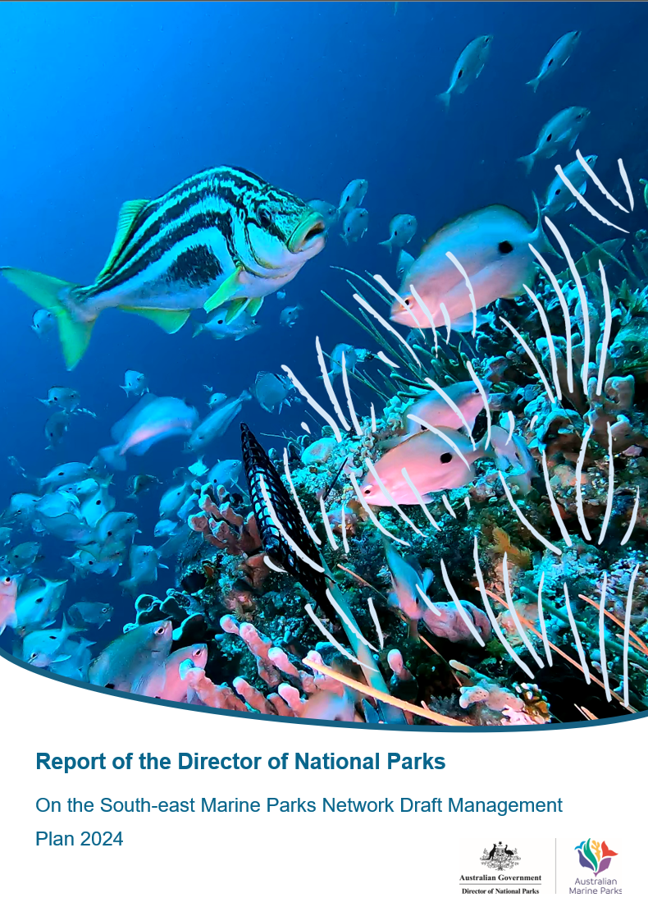

Contents

Acronyms 2

1. Executive Summary 3

2. Introduction 5

3. The management plan 6

4. Consultation 7

4.1First consultation period: Notice of Intent to prepare a management plan 7

4.2 Second consultation period: draft management plan 8

5. Summary of submissions and comments 9

6. Comments on the draft plan 11

6.1 General comments 11

6.2 Comments about Chapter 1 of the draft plan - Introduction 14

6.3 Comments about Chapter 2 of the draft plan – The South-east Marine Parks Network 15

6.4 Comments about Chapter 3 of the draft plan – Approach to Management 16

6.5 Comments about Chapter 4 of the draft plan – Zoning and Activity prescriptions 19

6.5.1 Comments about the zoning design proposed in the draft plan 19

6.5.2 Comments about proposed activity prescriptions 26

6.6 Comments about Schedule 1 30

6.7 Comments about Schedule 2 31

6.8 Comments about Schedule 4 32

7. Comments received outside of the statutory consultation process 33

8. Comments that were out of scope for this consultation 34

Cover page image:   
Striped trumpeter and butterfly perch in Tasman Fracture Marine Park (Institute for Marine and Antarctic Studies)

# Acronyms

ABARES – Australian Bureau of Agricultural and Resource Economics

BIA – Biologically Important Areas

DNP – Director of National Parks

EPBC Act - *Environment Protection and Biodiversity Conservation Act*

IUCN – International Union for the Conservation of Nature

IUCN Ia – Sanctuary Zone (pink)

IUCN II – National Park Zone (green)

IUCN IV – Habitat Protection Zone (yellow) and Recreational Use Zone (orange)

IUCN VI – Multiple Use Zone (light blue) and Special Purpose Zone (dark blue)

KNVs – Key Natural Values

NOPSEMA – National Offshore Petroleum Safety and Environmental Management Authority

NRSMPA – National Representative System of Marine Protected Areas

# Executive Summary

The Director of National Parks (Director) undertook public consultation on the draft South-east Marine Parks Network Management Plan 2024 (the draft plan) from 11 October to 14 November 2024.

A total of 18,400 campaign submissions[1] and 90 unique submissions were received from individuals and organisations. The submissions covered a wide range of subjects and were generally supportive of the changes made from the previous expired plan. Six submissions were received outside the statutory requirements and are considered separately in in this report.

The Director has considered the comments received and provided their views in this report. The Director recommends that the draft plan should be finalised with modest amendments. These include changes to the zoning design of the following marine parks: Beagle, Flinders, Freycinet and Zeehan as outlined in Table 1.1.

The changes are recommended in consideration of the representations by First Nations groups, commercial fishing peak bodies, recreational fishing groups and individuals, environmental NGOs, researchers and local individuals and organisations.

The Director believes that these zoning changes would broadly retain the significant conservation outcomes sought by the consultation draft, while reducing impacts on commercial and recreational fishers. With these changes, the proportion of highly protected areas within the South-east Network would increase by approximately one per cent compared to the consultation draft.

The Director has also recommended changes to the body of the management plan to better feature First Nations-related views and content. These revisions respond to extensive feedback from Traditional Owners, including a South-east Saltwater Council representing multiple representative bodies from the region. The Director believes these changes will help set the foundation to strengthen relationships and develop a genuine partnership between Parks Australia and South-east Traditional Owners over the life of the management plan.

The Director believes it is important that a statement authored by the South-east Saltwater Council is presented within the final management plan. The statement sets out the views and aspirations of the Council. Understanding their position is an important first step in in developing a partnership. The statement does not constitute their endorsement of the management plan, nor does it reflect commitments by the Director.

The Director did not support or act upon many comments made in submissions received, when these were considered impractical or unfeasible at present; inconsistent with the Government’s policy and approach; or were out of scope of the statutory review. Sections 6, 7 and 8 of this report also highlight those instances when comments received were not addressed.

The Director believes that the recommended final management plan strikes an appropriate balance between the diverse views on how the South-east Network should be managed. The management plan is based on scientific evidence and extensive stakeholder consultation. Compared to the expired management plan, it represents an increase in the level of protection afforded to the South-east Marine Parks at a time when climate change impacts and other pressures are subjecting the region’s environment to increasing pressure, while continuing to support industries and local communities to sustainably utilise selected areas of the network.

The recommended final plan includes structural and editorial changes, which were made primarily in response to comments received, to aid clarity and readability.

**Table 1.1 Summary of changes to the draft South-east Marine Parks Network zoning design following public consultation.**

|  |  |  |
| --- | --- | --- |
| **Park** | **Zoning change** | **Rationale** |
| Beagle | Reduce the size of the proposed National Park Zone from 561 km2 to 479 km2. | In response to concerns about impacts on existing commercial fishing activities, primarily for the Commonwealth Gillnet, Hook and Trap sector. Key conservation features will still be protected by the National Park Zone. |
| Flinders | Move the proposed Habitat Protection Zone westwards close to the 4000m depth contour and reduce the size from 11,278 km2 to 10,892 km2. | In response to a request to improve viability of operations for the Commonwealth Eastern Tuna and Billfish Fishery. The change slightly reduces the area open to pelagic fishing activities and continues to limit the Habitat Protection Zone to abyssal habitats only (already abundantly represented in high protection in this marine park and across the South-east Network). |
| Freycinet | Reduce the proposed in-shore National Park Zone from 100 km2 to 32 km2.  Re-zone the rest of the proposed inshore National Park Zone to Habitat Protection Zone of 68 km2. | In response to concerns about loss of fishing grounds. The change reduces by two-thirds the area that will be closed to recreational fishers, while retaining full protection for the unique ecosystem features of Joe’s Reef. Surrounding benthic habitats remain protected through IUCN IV Habitat Protection Zoning, which allows recreational fishing and selected commercial fishing methods. |
| Zeehan | Expand the proposed National Park Zone from 11,506 km2 to 18,663 km2. | Reflects confirmation that none of the newly granted exploration permits from the 2021 Acreage Release, announced in July 2024, overlap the Zeehan Marine Park.  Solidifies the policy approach for ‘no new oil and gas’ activities under this management plan, by constraining all future activity to two small IUCN VI blue zones in Zeehan Marine Park where existing rights are held. |

# Introduction

Under the *Environment Protection and Biodiversity Conservation Act 1999* (EPBC Act), the Director is required to provide a public comment period of at least 30 days on a draft plan before it is finalised and tabled in parliament.

Public consultation on the draft plan was open from 11 October to 14 November 2024.[2],[3]

This report has been prepared in accordance with section 370(2) of the EPBC Act for consideration by the Minister for the Environment, in relation to the draft plan.

This report incorporates any comments, views and recommendations received from the public consultation that were given to the Minister but have not been given effect to in the plan. This will allow the plan to be tabled in Parliament in compliance with section 371(3) of the EPBC Act.

This report:

* summarises the comments received in response to an invitation issued by the Director under section 368(5) of the EPBC Act, on the draft plan
* includes the Director’s views on the comments
* must be provided to the Minister for the Environment to inform the Minister’s approval of the South-east Marine Parks Network Management Plan 2025
* pending approval of the South-east Marine Parks Network Management Plan 2025, must be tabled in Parliament at the same time as the new plan, consistent with section 371 of the EPBC Act.

The report is structured to reflect the format used to elicit feedback through the Have Your Say platform, where input was sought for comments that were:

* general
* related to specific parts of the draft plan
* related to specific marine parks in the South-east Network.

# The management plan

The mandatory content for Commonwealth reserve management plans is set out in section 367 of the EPBC Act. In accordance with the section, management plans for marine parks must provide for the protection and conservation of each park and may divide the park into zones. In particular, the management plan must:

* assign each park to an IUCN category
* state how each park, or each zone of the park, is to be managed
* state how the natural features of the park are to be protected and conserved
* specify any limitation or prohibition on the exercise of a power, or performance of a function, under an Act or in relation to the park
* specify any mining operation, major excavation or other work that may be carried out in the park, and the conditions under which it may be carried on
* specify any other operation or activity that may be carried on in the park
* indicate generally the activities that are to be prohibited or regulated in the park, and the means for prohibiting or regulating them
* indicate how the plan takes account of Australia’s international obligations
* be consistent with National and Commonwealth Heritage place principles.

The management plan has been prepared to meet these requirements by including a description of each park and a summary of the values of each park. The plan also sets out management programs, activities and prescriptions that will be in place over the life of the plan.

In accordance with section 368 of the EPBC Act, the management plan for the marine parks of the South-east Network has been prepared taking account of:

* the report prepared for the proclamation of the marine parks
* the proclamation and associated purposes governing the use of the marine parks
* the interest of owners, leaseholders, Traditional Owners, First Nations people, and holders of usage rights within the marine parks
* the protection, conservation and management of biodiversity and heritage within marine parks
* the protection of marine parks against damage
* Australia’s obligations under international agreements relevant to the protection and conservation of biodiversity and heritage
* comments received on the Notice of Intent to prepare a draft plan between 20 March and 22 May 2023
* comments received on the draft plan between 11 October and 14 November 2024.

# Consultation

## First consultation period: Notice of Intent to prepare a management plan

The South-east Marine Parks Network Management Plan 2013-2023 expired on 30 June 2023.

On 20 March 2023, in accordance with section 368(2) of the EPBC Act, a Notice was published in the Australian Government Gazette, newspapers circulating nationally and in each relevant state (The Australian, Adelaide Advertiser, the Hobart Mercury, Sydney Morning Herald) and placed on the Department of Climate Change, Energy, the Environment and Water (the department) website, inviting comments on the proposal to prepare a draft plan for the South-east Marine Parks Network. An email inviting comment on the proposal to prepare a draft plan was also sent to all individuals and organisations that had expressed interest in the South-east Review process.

Consultation on the Notice of Intent closed on 22 May 2023, with a total of 13,569 submissions received. Of these, 40 were unique submissions from organisations, representative bodies, businesses and individuals and 13,529 were submissions from the general public using standardised words or a template (from two different campaigns). The submissions using standard words expressed views about conservation.

Key comments raised during the first round of consultation included:

* the need for higher protection across the South-east Network, but particularly through new highly protected zones on the shelf
* the need for stronger representation of First Nations rights and interests in the new management plan, and commitments to work in partnership and with the full engagement of First Nations people
* concerns about the impacts of zoning changes on marine park users (particularly commercial and recreational fishers) and the cumulative impact of any potential changes in addition to other impacts in the region (e.g. from offshore windfarms)
* the impacts of climate change in the region, and the extent to which marine parks are an appropriate tool to address climate-associated pressures
* calls for more restrictions on extractive activities, particularly oil and gas exploration and production, and associated seismic testing
* clearly articulated positions on new activities in the network that weren’t considered in the 2013 management plan (e.g. offshore wind and aquaculture)
* importance of consistency in management arrangements between adjacent Australian and state parks
* importance of flexible / adaptive management approaches, including greater articulation of objectives and strategies at the park scale.

Those submissions received through the ‘Notice of Intent’ consultation period were published and remain available online. Together with the results from scientific research conducted over the course of the previous management plan, and consultation with First Nations and stakeholder representatives, the submissions informed the preparation of the draft plan that was released for public comment on 11 October 2024.

Following the first consultation period, Parks Australia undertook extensive and targeted engagement with a diverse range of individuals and organisations to further inform the preparation of the draft management plan. Targeted consultation included discussions with those who did provide a submission, to ensure their comments were fully understood. Parks Australia also sought to meet with organisations that had not provided a submission but are known to have an interest in the South-east Marine Parks. This engagement was designed to supplement legislative consultation requirements under the EPBC Act.

## Second consultation period: draft management plan

In accordance with section 368(5) of the EPBC Act, public comments were invited on the draft management plan between 11 October and 14 November 2024.

Invitations to comment on the draft plan were published in the Australian Government Gazette, newspapers circulating nationally and in each relevant state (The Australian, Adelaide Advertiser, the Hobart Mercury, and Sydney Morning Herald) and placed on the department’s and Parks Australia’s websites.

Personalised letters on behalf of the Director inviting comment, along with information materials, were sent to relevant native title representative bodies, representatives of native title claimants, and Aboriginal community organisations in the vicinity of the marine parks. Though not legally required for this process, this was consistent with comparable consultation requirements set out in the Future Acts Regime in the *Native Title Act 1993.*

An email inviting comment on the draft plan was sent to individuals and organisations who made submissions during the ‘Notice of Intent’ consultation, individuals and organisations who had expressed interest in the South-east review, and any previous and current South-east Marine Parks authorisation-holders.

Invitations directed people to make submission via the department’s Have Your Say platform at the following web address: consult.dcceew.gov.au/se-marine-parks-network-mgt-plan.

A copy of the draft plan was made available on the Parks Australia website.

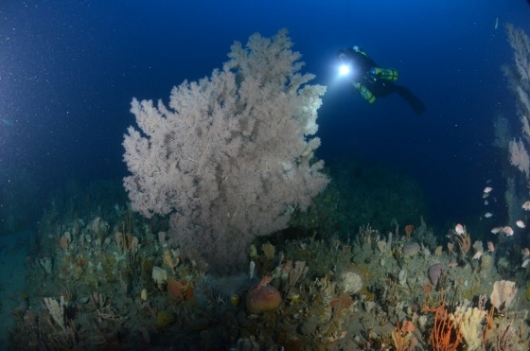

*Image: Joe’s Reef, Freycinet Marine Park (James Parkinson)*

# Summary of submissions and comments

This report includes a summary of the public comments made on the draft plan and the Director’s views on those comments. Personal details or commercial-in-confidence information are not reported here. Submissions will be published online, when the author has provided their permission to do so.

During the statutory consultation, 90 unique submissions and 18,400 campaign submissions were received. The campaign submissions included 14,774 using standard text provided by the campaign organisations; and 3626 that presented some variation in text but were broadly consistent with the standard text.

Tables 5.1 to 5.3 provide a breakdown of the submissions.

Unique submissions came from individuals and from a range of organisations, including research groups, conservation organisations, seafood industry representative bodies, commercial fishing companies, recreational fishers, First Nations groups, and small businesses from Victoria, South Australia and Tasmania as well as from other parts of Australia.

In accordance with section 370(2) of the EBPC Act, all comments received through the statutory public consultation period have been considered in this report. This includes unique comments made in campaign submissions (i.e. comments additional to template content).

Six submissions—from conservation, recreational diving and commercial fishing sectors, and from First Nations groups—were received either via email (i.e. not through the prescribed platform) or after the consultation closed at 11:30 pm on 14 November 2024. These six submissions are considered ‘non-statutory’ and the Director is not required to consider these comments under the statutory process, but has chosen to incorporate them into this report under a separate section.

Submissions can be viewed on the department’s Have Your Say platform, subject to the respondent having provided permission: consult.dcceew.gov.au/se-marine-parks-network-mgt-plan. Those submissions marked private or for which permission to publish was not explicitly granted, were considered in preparing this report but have not been published online.

Comments about document edits and structure to improve clarity and readability have in most cases being taken on board but are not reported here.

**Table 5.1 Number of campaign, unique and total submissions received**

|  |  |
| --- | --- |
| **Submission type** | **Number of submissions** |
| Unique | 90 |
| Campaign | 18,400 |
| Total | 18,490 |

**Table 5.2 Summary of unique submissions by sector**

|  |  |
| --- | --- |
| **Sector** | **Number of submissions** |
| Conservation | 21 |
| General public | 16 |
| Recreational use (including fishing) | 14 |
| Commercial fishing | 9 |
| Research | 7 |
| Commercial tourism | 6 |
| First Nations interests | 5 |
| Aquaculture | 2 |
| Commercial media | 1 |
| State government agency | 1 |
| Other | 8 |
| Total | 90 |

**Table 5.3 Breakdown of campaign submissions**

|  |  |  |  |
| --- | --- | --- | --- |
| **Campaign text** | **Submissions with standard text** | **Submissions with personal comments** | **Total** |
| Save Our Marine Life | 2345 | 509 | 2854 |
| Australian Marine Conservation Society | 9536 | 3117 | 12,652 |
| Environment Tasmania | 1360 | 0 | 1360 |
| Victorian National Parks Association | 592 | 0 | 592 |
| International Fund for Animal Welfare | 942 | 0 | 942 |
| **Total campaign submissions** | **14,776** | **3626** | **18,400** |

# Comments on the draft plan

## General comments

This section summarises the general comments received in relation to the draft plan. Comments that relate to specific sections of the draft plan are addressed in sections 6.2 – 6.8.

**General support** was expressed in relation to:

* the intent to strengthen protection of the South-east Marine Parks Network, both through the zoning changes (see below section 6.5.1) as well as through restrictions on or exclusion of intensive industrial activities (see section 6.5.2)
* the benefits that marine parks provide to the environment, tourism and fishing
* the level of engagement with marine parks users during the preparation of the draft plan including efforts made to reduce impacts on the commercial fishing industry.

**Neutral comments** or observations were expressed in relation to:

* the need for dedicated, sustained and adaptable funding to ensure effective plan implementation
* the consultation fatigue being experienced by the commercial fishing industry, from concurrent Government consultation processes.

General **concerns** of the draft plan included:

* comments about missed opportunities for further conservation gains (including for specific areas, see section 6.5)
* a concern that the zoning upgrades did not go far enough to meet the CAR (comprehensive, adequate and representative) principles for marine protected area design
* concerns that marine parks are ineffective at addressing environmental pressures, particularly climate change, and associated challenges
* opposition to reducing the level of protection in some marine parks, particularly at Murray and Flinders Marine Parks (see section 6.5 of this report*)*
* concerns that changes would contribute to the increasing spatial squeeze pressure experienced in the South-east region by the commercial fishing industry and lead to direct social, economic and wellbeing impacts to many fishers
* claims that recreational fishers in Tasmania had not been adequately consulted about the plan and that they were significantly impacted by many of the proposed zoning changes, but particularly at Freycinet Marine Park
* claims that Parks Australia has been disproportionately influenced by conservation stakeholders in preparing the draft management plan
* comments that effective implementation of the plan will require dedicated, sustained and adaptable funding
* suggestions that the plan should do more to address climate change pressures and possible responses
* that the plan does not adequately explain its ecosystem-based approach to management
* the document’s technicality and complexity were criticised by some; including that management plans should use Plain English principles, accessible visuals and an easy-to-read Executive Summary, to better engage a broad public audience and facilitate feedback.

Extensive comments were provided by organisations and individuals representing **Traditional Owners** of Sea Country in the South-east marine region:

* the South-east Saltwater Council—a newly formed alliance of multiple First Nations representative organisations from the South-east region—submitted a First Nations-authored statement for inclusion at the beginning of the management plan
* concerns that First Nations engagement in the development of the draft plan was inadequate and should have been conducted as a comprehensive co-design process
* disappointment about the poor engagement from government with Traditional Owners of the South-east Sea Country, dating from when the marine parks were proclaimed in 2007 and through the implementation of the first management plan
* concerns that the First Nations content in the management plan, along with its placement, is tokenistic
* statements that rights and authority over Sea Country in Australian Marine Parks has never been ceded, with calls for this to be formally acknowledged
* advice that Traditional Owners have an interest in all aspects of management, not just cultural values or cultural heritage
* statements that Traditional Owners are partners, not stakeholders, and should be fully included in planning, decision-making and management
* recommendations that co-design should be the standard for all future documents, including management plans
* support for local and regional Aboriginal employment opportunities and community asset benefit sharing models
* criticism of advisory bodies and structures, emphasising that more is required for sovereign First Nations peoples to manage Sea Country than an advisory board
* opposition to the current approach to mapping and zoning of Sea Country, arguing that dividing zones for protection or exclusion is inconsistent with Aboriginal ways of caring for Country and sustaining the future.

|  |
| --- |
| **6.1.a Director of National Parks response**  *The Director notes the diversity of views, recommendations and concerns that exist in relation to marine parks. It is the Director’s view that the recommended final plan strikes an appropriate balance across the multiple objectives in managing the Australian Marine Parks of the South-east region.*  *The Director also notes comments—both positive and negative—on the consultation process for the review of the plan, and perceptions of greater influence by some sectors. These comments are welcome, as the Director is committed to regular reviews and continuous improvement of processes and mechanisms, informed by stakeholder feedback.*  *The Director asserts that all sectors were given fair and equal opportunity to be engaged in the preparation of the draft plan, both through formal statutory consultation, and informal targeted engagement. The Director acknowledges the consultation fatigue conveyed by the commercial fishing sector. The Director also acknowledges comments received in relation to the need for sustained funding to support plan implementation.*  *The Director acknowledges submissions received from First Nations representatives and has made the following changes to the recommended final management plan in response to this feedback:*   * *the First* *Nations-authored statement,**“Not without us, if it’s about us”, written by the South-east Saltwater* *Council has been included in the front of the plan. The Director’s Foreword has been updated to include a response to this statement* * *the* *Director’s Foreword and the Acknowledgement of Country have been amended to better reflect the Director’s commitment to work in partnership with Traditional Owners of Sea Country* * *the section “Partnerships with First Nations people” has been moved to the Introduction and has been* *edited to include reference to partnership mechanisms. Revised Indigenous Engagement principles, now termed Partnership Principles, have also been brought forward and edited.*   *In response to feedback on the plan’s technicality and complexity, and on the need to explain some approaches like ecosystem-based management, the Director has introduced a new action in the Communication and Engagement Program (see also section 6.4 below):*   * *“Develop clear* *and concise materials that enhance the accessibility of management arrangements in the South-east”.* |

## Comments about Chapter 1 of the draft plan - Introduction

Regarding this chapter, submissions requested that **further information** be included in relation to:

* Australia’s obligations under international law
* the purpose of Australian Marine Parks.

Regarding the **vision and objectives** of the draft plan:

* several submissions expressed support
* some submissions expressed disagreement and concern about:
  + the dual objectives of marine parks - they should be for conservation only and not for sustainable use
  + the anthropocentric nature of the vision, which does not acknowledge the intrinsic rights of nature
  + the vision and objectives being limited to the network of existing parks, rather than applying to the entire South-east marine region.

In relation to the **rationale for changes** from the previous management plan, submissions requested further information be included about:

* changes in zoning design including why some areas have not been afforded higher protection
* the zoning changes in Murray and Flinders Marine Parks
* the zoning protection upgrades across the South-east Network
* how the ‘comprehensive, adequate and representative’ principles for marine protected areas design have been met.

|  |
| --- |
| **6.2.a Director of National Parks response**  *The Director notes that international conventions and obligations that are relevant to the plan are outlined in Schedule 2.*  *The Director has made amendments to the first paragraph of section 1.4 in the management plan to better describe Australian Marine Parks, including how they are designated and managed.*  *The Director considers that the articulation of the management vision and objectives is appropriate and consistent with the requirements of the EPBC Act and the proclamations for each of the marine parks.*  *The Director has amended section 1.6 in the management plan to better explain the zoning design process and the justification for zoning changes, including the changes in Flinders and Murray Marine Parks.*  *As a general response, the zoning design in the draft management plan sought to balance the needs for stronger protection for unique and vulnerable habitats, particularly those associated with the continental shelf and upper slope environments with the needs of marine users.* |

## Comments about Chapter 2 of the draft plan – The South-east Marine Parks Network

In relation to the **description of the broader South-east marine region**:

* one comment disputed the accuracy of statements about the proximity of the offshore wind declared areas to areas of high population and high electricity demand
* one comment considered the statements about the importance of gas to Australia’s Net Zero emission transition to be contradictory to the plan’s proposed policy position on oil and gas.

The **definition of cultural values** was strongly rejected by submissions provided by First Nations organisations:

* concerns were expressed that the definition in the draft plan failed to acknowledge First Nations as the original custodians of Australia’s Sea Country and their ancient connections, by combining First Nations cultural values with those of other groups. An alternative definition was provided to ensure the values of Traditional Owners are distinctly recognised and not conflated with other cultural interests
* the point was also made that Traditional Owners’ concerns are not limited to cultural heritage; they have vested interests in all values and areas of activity in their Sea Country.

Regarding the **social and economic benefits** of marine parks, submissions included:

* a suggestion to order the social and economic benefits alphabetically to avoid perception of different relative priority
* concerns that wording about recreational use of offshore areas shows a lack of understanding of the recreational fishing sector
* a suggestion to include wording to acknowledge that the recreational fishing sector has a low impact on ecosystem health.

On the draft plan’s **description of pressures** in the South-east Network submissions requested:

* more context about the sustainability credentials of Australian fisheries, including an explanation that all commercial fisheries undergo Ecologically Sustainable Development risk assessments and address and mitigate risks to ecosystems associated with bycatch, by continuous improvement to gear and practice to minimise impacts to the environment and non-target species.

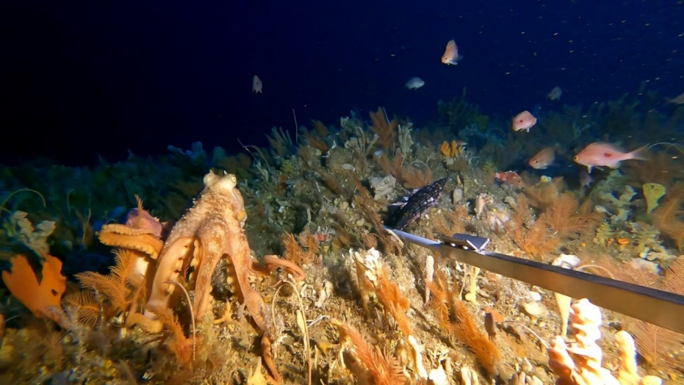

*Image: Octopus in Tasman Fracture Marine Park (IMAS)*

|  |
| --- |
| **6.3.a Director of National Parks response**  *The Director notes comments about the contextual description of the South-east region but recommends no changes. The statements in section 2.1 of the management plan provide context about the South-east region and the Director has worked with the relevant Commonwealth agencies to ensure content is accurate.*  *The Director has updated the definition of cultural values in response to feedback received, replacing the category of “cultural values” with “First Nations values.” The articulation of First Nations values provided by the South-east Saltwater Council has also been added.*  *Non-First Nations cultural heritage values, e.g. historic shipwrecks, are encompassed by the category “Other Protected Matters.”*  *To avoid the perception that social and economic benefits are listed in order of importance, the Director has amended this section to list the benefits alphabetically.*  *The Director has also amended text on recreational use to better describe the current and potential future recreational use of the marine parks.*  *The Director has included additional information in section 2.4.2 of the management plan around robust management and regulatory framework in place for commercial fishing in Australia.* |

## Comments about Chapter 3 of the draft plan – Approach to Management

The following comments were raised in relation to the **approach to management** of the marine parks:

* support for the emphasis on assessment of cumulative ecological risks (as well as acute) and on the ongoing application of an adaptive management practice
* suggestions that Parks Australia should partner with other agencies to manage risks and pressures occurring from outside marine park boundaries
* support for the involvement of other regulatory agencies that provide independent oversight of related functions, including the National Offshore Petroleum Safety and Environmental Management Authority (NOPSEMA) and the Australian Fisheries Management Authority (AFMA)
* suggestions that Parks Australia should work with commercial fishers and recreational fishers to obtain their insights and ongoing marine park data relating to fish populations and movements, to inform science and adaptive management
* statements that Parks Australia should only partner with conservation and research groups and should not partner with any industry, commercial or extractive use sectors
* statements that partnerships require empowerment of all partners in strategy and implementation
* *also see feedback relating to partnerships with Traditional Owners considered in section 6.1 of this report.*

Regarding the **First Nations Connections and Partnerships Program**, feedback:

* called for genuine commitments to working in partnership with Traditional Owners in the future management of the marine parks
* supported mechanisms such as a South-East Saltwater Council and a National Cultural Authority to serve as engagement platforms in marine park management, with an expectation that Parks Australia will appropriately resource these mechanisms
* recommended a commitment to co-designing a Sea Country Strategy and/or individual plans for marine parks
* called for greater recognition and integration of First Nations values, perspectives and knowledge.

Regarding the **Protection and Resilience Program**, submissions:

* suggested that Parks Australia should introduce pollution control and monitoring, regular water quality checks and pollution control measures
* expressed concern that the plan does not provide consideration of how a robust compliance and enforcement program will be carried out
* suggested adding provision to track Australia’s compliance with international conventions.

Regarding the **Science and Management Effectiveness Program**, submissions:

* requested more detail to understand how a comprehensive research program will be established to support effective management
* expressed concern about the lack of research available on contemporary recreational fishing use in the South-east region
* asserted that research to determine recreational fishers’ values, catch effort within parks, the scale, type and impact of fishing activity has not been adequately prioritised over the life of the last management plan, including during the evaluation and review phase
* suggested establishing a program to monitor the effectiveness of National Park Zones
* stated that Traditional Knowledge is science and should be fully integrated into the protection of Sea Country.

Relevant to the **Communication and Engagement Program**, submissions:

* recommended expanding on community education efforts by exploring partnerships with local diving operator and community groups
* suggested enhancing community and visitor engagement and education, including through partnerships with other organisations, increased funding, and a variety of media forms
* suggested including actions to inspire residents and visitors, and to demonstrate the benefits of no-take zones to local fishers and businesses. This would support local economic resilience while fostering broad community support for high marine park protection.

In relation to **monitoring and evaluation** of the plan implementation, submissions:

* generally supported the articulation of adaptive management in the management plan
* called for an adequately resourced monitoring, evaluation, reporting and improvement framework and a commitment to undertaking periodic monitoring
* requested more information on:
  + what adaptive management will look like under this plan and how it will be implemented
  + specific reporting timelines rather than vague terms like ‘periodically’
* called for the establishment of a robust, climate-responsive monitoring program for sensitive areas, including: regular population assessment, impact analysis of allowed activities, adaptive management reviews.

|  |
| --- |
| **6.4.a Director of National Parks response**  *The Director welcomes the support for key elements of the management approach, including adaptive management and partnerships. The Director notes and recognises that partnerships—with First Nations people, other government agencies, marine parks users, community and researchers—are important mechanisms for achieving management outcomes and notes the approach is well embedded in the way Australian Marine Parks have been managed for over a decade.*  *To address feedback from First Nations representatives, the Director has:*   * *amended the goal of the First Nations Connections and Partnerships Program to read (text inserted is underlined):* ***‘****Respect and support the ongoing cultural responsibilities and connections of First Nations people to care for and manage Sea Country in marine parks’* * *added the following new actions to the First Nations Connections and Partnerships Program:*   + *‘Ensure* *dedicated resources are allocated to support First Nations engagement in the management of South-east marine parks’*   + *‘Co-design a* *Sea Country Strategy with Traditional Owners to identify priorities for First Nations-led projects and actions’*   + *‘Develop and* *implement a process with Traditional Owners to dual or rename parks in advance of the next Management Plan’* * *amended the following actions to the First Nations Connections and Partnerships Program:*   + *‘Engage with* *Traditional Owners through culturally appropriate and culturally safe mechanisms, including the South-east Saltwater Council’* * *added the following new actions to the Science and Management Effectiveness Program:*   + *‘Continue* *to explore opportunities to better weave Indigenous knowledge systems and Western science, ensuring all perspectives are valued and inform adaptive management’.*   *The Director notes and appreciates the suggestions made in relation to establishment of a National Cultural Authority, to serve as engagement platform for marine park management. The Director will explore opportunities to support such a platform in the future.*  *In relation to comments pertaining to environmental protection, pollution and monitoring, the Director notes that these matters are covered in multiple parts of the management plan, particularly under zoning and activity prescriptions. Further consideration of the need for specific water quality monitoring programs in the South-east Network will be given as part of Parks Australia’s science strategy and the monitoring and effectiveness framework.*  *The Director notes that the Australian Government has well established mechanisms to track compliance with international obligations. For example, the Director contributes to regular international reporting coordinated across government, against commitments under a number of conventions, e.g. Convention on Biological Diversity.*  *The Director notes that work to establish a program for assessing the effectiveness of Marine National Park zones is underway. The Director considers that the level of detail on the Science and Management Effectiveness Program is adequate for the purposes of this plan, noting that consideration of priorities for research is informed by an estate-wide Parks Australia science strategy and associated governance and processes.*  *In response to comments pertaining to the level of knowledge about recreational fishing in the marine parks, the Director has added the following action to the Science and Management Effectiveness Program:*   * *‘In* *partnership with relevant recreational fishing organisations, identify priorities to better understand recreational fishing effort, benefits and impacts in the South-east Network’.*   *The Director considers that the content regarding monitoring and evaluation of the implementation of the plan, is appropriate, with further details being included in Parks Australia’s management effectiveness monitoring and reporting framework, currently under development.*  *The Director notes the comments regarding the communication and engagement program and the calls for further action and effort into community partnerships. No changes were made to this program, as the comments are considered consistent with the partnership approach embedded in marine parks management and the actions already included in the program (Table 3.1 in the Plan).* |

## Comments about Chapter 4 of the draft plan – Zoning and Activity prescriptions

### Comments about the zoning design proposed in the draft plan

Several of the unique submissions and all campaign submissions expressed **support for the increased protection** proposed in the draft Plan, including:

* the creation of 11 new highly protected areas, particularly areas of high-conservation value shelf and slope environments
* the increase in bioregion representation
* the zoning at the recently expanded Macquarie Island Marine Park.

All campaign and multiple unique submissions did **call for greater protection**, including:

* more high protection (IUCN II and Ia) across the Network, including for the purpose to better meet the principles of the NRSMPA/CAR
* that partial protection (anything above an IUCN II) is ineffective and perceived to be comparable to open areas outside of marine parks in relation to conservation benefits
* more high protection needed to improve climate change resilience in the South-east region
* to ensure connectivity (particularly between high protection zones) is adequately addressed in the zoning design
* opposing the zoning changes in Murray and Flinders Marine Parks that open up new areas to some commercial fishing methods; these submissions also claimed that the plan does not provide sufficient justification for these zoning changes
* a recommendation for greater consideration of priorities and needs for threatened species when designing marine parks zoning, in addition to consideration of external threats and making use of ecological risk assessments.

Conversely, multiple unique submissions expressed **opposition to increased protection**, including:

* claims of lack of evidence to support proposed protection upgrades
* concerns about zoning changes that impact on commercial fishers, and that this will have flow on impacts to small businesses, including fishing cooperatives, individual livelihoods and communities
* there were suggestions that, where impacts on existing commercial fishers are too significant, a new zoning category that only allows one type of commercial fishing gear, should be considered; there were related comments that some commercial gear types are very low impact, such as octopus pots, and should remain to be allowed in some zone types
* concerns associated with ‘spatial squeeze’ experienced by the commercial fishing industry, with parallel government processes reducing available fishing grounds e.g. offshore wind, oil and gas activities, aquaculture, and marine parks
* concerns were expressed that the impacts of this squeeze are not being considered holistically, and it may result in unforeseen impacts (such as condensing fishing effort to other locations)
* concerns that the ‘spatial squeeze’ is resulting in poor mental health outcomes amongst workers in the industry
* concerns about zoning changes that impact on recreational fishers
* claims that recreational fishers have a relatively small impact on the seafloor and fish abundance and that many recreational fishers, particularly game fishers who tend to operate in offshore areas, where the parks are, practice catch and release
* concerns about zoning changes that impact on the oil and gas and energy exploration industry sector.

A suggestion was provided to change **terminology** from ‘Sanctuary Zone’ to ‘Strict Nature Reserve’ to align internationally and avoid possible confusion with the ‘Australian Whale Sanctuary’.

|  |
| --- |
| **6.5.1.a Director of National Parks response**  *Zoning design for the draft plan was guided by the latest available science, considered in the broad context of the principles of the NRSMPA, and informed by extensive consultation. The design sought to minimise impacts on existing users as much as possible.*  *‘No-take’ areas (IUCN Ia and II) will always remain important for marine protected areas as they provide the highest level of protection. Partially protected areas—which exclude some types of activity —combined with effective management, have been shown to provide conservation benefits compared to open environments, while reducing impacts on users.*  *Consistent with long-standing government policy, zoning of Australian Marine Parks reflects a multiple use approach to management of protected areas, which allows a range of commercial extractive and non-extractive activities based on zone type. Allowable activities are subject to sectoral management regimes, to assessment processes and are authorised when impacts on park values are low or manageable. This approach recognises that many of Australia’s existing and emerging offshore industries are of high social and economic importance.*  *The Director notes the concerns related to the impacts of additional high protection zones. The Director notes and appreciates the concerns raised, particularly by the commercial and recreational fishing industry, about proposed changes which increase protection and the potential for flow-on impacts. The Director is aware that the South-east marine region is the most heavily used marine region in Australia. Competition for resources is growing, with the expansion of new industries such as offshore wind generation. Balancing access needs to marine areas is not easy. The footprint of existing commercial fishers was considered in designing the zoning changes across the Network, for the purpose of minimising impacts on fishers. This was not always possible and as a result, commercial fishers directly affected by changes to the final management plan may be eligible for direct financial assistance through a Fishing Business Assistance grants program. Importantly, the comments received did inform specific zoning decisions, which are further described in the following section. The Director considers that the resulting zoning design appropriately balances conservation with sustainable use.*  *Finally, the language and terminology used to describe the Australian Marine Parks zoning are consistent with state agencies and across other Australian Marine Parks. Both Marine Sanctuary Zone and Strict Nature Reserve refer to IUCN Category Ia.* |

Many submissions included comments specific to **individual marine parks**. All parks were commented upon except for the Nelson and South Tasman Rise Marine Parks. Comments on individual marine parks are listed below in alphabetical order:

**Apollo Marine Park:**

* calls to establish a new highly protected zone adjacent to Victoria’s 12 Apostles Marine Park to improve the connectivity of the NRSMPA, establish high protection in the Central Bass Strait and Central Victorian bioregions, pygmy blue whale feeding grounds, wedge-tailed shearwaters foraging areas, and diverse shelf habitats of the Otway bioregion.

**Beagle Marine Park:**

* calls to establish a new high protection area in western Beagle Marine Park to protect Southern Right Whale feeding grounds, create connectivity with Wilson’s Promontory Marine National Park managed by the Victorian government, improve the representativeness of the park and support protection of known shipwrecks
* suggestions to extend the newly proposed National Park Zone further south to improve connectivity with the Kent Group Marine Reserve managed by the Tasmanian government
* calls to remove the proposed National Park Zone to avoid impacts on Commonwealth shark fishery, and Tasmanian fisheries, including octopus.

**Boags Marine Park:**

* calls to establish a new highly protected zone across tidal sand waves and sand banks and the South-east region’s shallowest depth habitats, which would improve the comprehensiveness, adequacy and representativeness of the park
* claims that potential changes to Boags would not impact on Tasmanian fishers
* opposition to any potential changes to Boags that would impact on the operations of Tasmanian Octopus fishers or recreational fishers.

**East Gippsland Marine Park:**

* calls to create a new highly protected area in the North-east of East Gippsland Marine Park to provide protection for the upwelling East of Eden key ecological feature, biologically important areas for specific species, and improve the comprehensiveness, adequacy and representativeness of the park.

**Flinders Marine Park:**

* calls to extend the proposed National Park Zone westwards and eastwards across the upper slope and shelf to create a continuous depth transect and protect canyon habitats
* opposition to the proposed Habitat Protection Zone (IV) over area that was previously National Park Zone (II) and had been closed to commercial fishing for 17 years
* additional concerns over the precedence this could set within Australia and potential impacts on Australia’s international reputation
* concern from Traditional Owners that the new Habitat Protection Zone (IV) reduces protection for culturally significant species and increases potential bycatch
* comments opposing the national park zone upgrade over the continental shelf, due to concerns about impacts on recreational fishing
  + suggestion that a Habitat Protection Zone or Recreational Use Zone would provide similar conservation outcomes
* comments opposing the national park zone upgrade over the continental shelf, due to concerns about impacts on commercial fishing
* a call for increasing the proposed Habitat Protection Zone to ensure commercial fishing activities can be carried out without accidental non-compliance (e.g. gear drifting)
  + suggestion to shift the western boundary further to the west to about the 4000 m depth contour.

**Franklin Marine Park:**

* calls to establish a new highly protected zone in the southern part of Franklin marine park to provide the first high protection of shelf habitats in the Franklin bioregion
* support for the proposed national park zone in Franklin and the protection it offers to feeding grounds for the endangered Shy Albatross
* opposition to the proposed national park zone due to concerns about impacts on existing fisheries operators
* opposition to the proposed national park zone due to concerns about impacts on recreational fishing.

**Freycinet Marine Park:**

* calls to extend the proposed National Park Zone east to enhance protection over shelf break reefs and improve connectivity with the existing National Park Zone, while improving the representativeness of protection
* support for the inshore zoning upgrade over Joe’s reef
* opposition to the inshore upgrade over Joe’s Reef due to impacts on local recreational fishers and suggestion that a Habitat Protection Zone or Recreational Use Zone would provide the same or similar conservation outcomes
* opposition to the inshore upgrade over Joe’s Reef due to impacts on commercial fishers, and that this area is of importance to rock lobster and giant crab.

**Huon Marine Park:**

* calls to extend the proposed National Park Zone to Sidmouth Rock on its southern edge, and also northward across the upper slope to Pedra Branca in Tasmanian state waters in the north-east corner of the park to provide high protection over the diverse shelf habitats of the Bruny bioregion
* calls for the proposed National Park Zone to be a Habitat Protection Zone (IUCN IV), to support the recreational fishing, particularly for tuna and other pelagic species.

**Macquarie Island Marine Park:**

* a call for allowing transit through Macquarie Island Marine Park sanctuary zone due to concerns about potential impacts on a low number of commercial tourism operators
* support the finalised zoning at Macquarie Island Marine Park.

**Murray Marine Park:**

* support for the proposed zoning design, and the benefits it will provide to low impact purse seine fishing
* calls to establish a highly protected zone in the northern section of Murray Marine Park adjacent to Encounter Marine Park in South Australian waters to increase connectivity and effectiveness of the state marine park and improve the representativeness of protection
* calls to extend the proposed National Park Zones further onto the shelf to maximise the inclusion of shelf break habitats and provide a continuous depth habitat and provide improved conservation benefits
* calls to establish a highly protected area over the Murray Canyon
* opposition to the proposed zoning arrangements rezoning Special Purpose Zone (VI) to Habitat Protection Zone (IV), as recreational fishing and some pelagic commercial fishing methods would be allowed when previously excluded
* concern from Traditional Owners that the new zoning arrangement reduces protection for culturally significant species and Sea Country
* a claim that proposed zoning arrangements are confusing and overly complex
  + suggestion that the entire north-west corner of the park be zoned as Multiple Use Zone (VI) to reduce confusion and improve compliance.

**Tasman Fracture Marine Park:**

* calls to extend the proposed National Park Zone to maximise protection for the West Tasmanian Canyons and Tasmanian Seamounts, a key ecological feature in the region and improve the representativeness of protection
* calls to extend the full width of the proposed National Park Zone southward to connect to the new southern National Park Zone to create a continuous transect across depths
* recommendations to amend existing zoning under the former management plan, by changing the National Park Zone (IUCN II) that is circular in shape around Mewstone Island, to a Habitat Protection Zone (IUCN IV) to improve compliance and access by recreational fishers. An alternative zoning arrangement was provided
* concerns about impacts on Tasmanian rock lobster and giant crab fishing in the vicinity of the 200m depth contour, and that this area is important for quality size catch, with evidence referenced of healthy rock lobster egg production and biomass in the region. Tasmanian operators did not report concern for deeper water changes at Tasman Fracture.

**Zeehan Marine Park:**

* calls to extend the proposed Special Purpose Zone east to replace the proposed Multiple Use Zone, in order to improve protection of Key Natural Values found in this park (including the West Tasmanian Canyons key ecological feature and core foraging habitats for endangered shy albatross)
* opposition to zoning upgrades over Zeehan Marine Park due to concerns about impacts on game fishing and lack of rationale for the removal of recreational fishing access from Special Purpose Zones, compared to the 2013 management plan
* support for the position of no new oil and gas activities in the Network.

|  |
| --- |
| **6.5.1.b Director of National Parks response**  *The Director acknowledges the submissions calling for additional Marine National Park zones (for* ***Apollo, Beagle, Boags, East Gippsland, Franklin*** *and* ***Murray Marine Parks****) and for extensions to proposed Marine National Park zones (for* ***Beagle, Flinders, Freycinet, Huon, Murray, Tasman Fracture*** *and* ***Zeehan****):*   * *the Director’s view is that the recommended new and extended Marine National Park zones would result in additional significant impacts on marine parks users and should not be pursued through this review. The recommendations will be used to guide future survey work, to ensure that a better understanding of values and pressures is available to inform future reviews of management arrangements.*   *The Director notes the opposition to the proposed rezoning—from Marine National Park to Habitat Protection—in the offshore part of* ***Flinders Marine Park****:*   * *the Director is of the view that the proposed rezoning over an environment—the abyssal plain—amply represented in highly protected zoning throughout the Network and in this marine park, is consistent with the dual sustainable use and conservation objectives of the network. Partially protected areas—such as Habitat Protection Zones— combined with effective management, have been shown to provide conservation benefits compared to open environments, while reducing impacts on users[4].*   *The Director notes the support and opposition received in relation to the proposed rezoning—from a mix of Special Purpose Zone and Multiple Use Zone to Habitat Protection Zone—in* ***Murray Marine Park****:*   * *in the* *small area that was previously Multiple Use Zone, this change would restrict commercial fishing gear types that interact with the seafloor, while still allowing pelagic methods to continue* * *in the area that was previously Special Purpose Zone, this change would allow pelagic fishing methods to be undertaken in an area where they weren’t allowed under the previous management plan* * *this change reflects a balanced approach to zoning. Two new green zones will be established to protect important canyon ecosystems in Murray Marine Park, and the new fishing area further offshore will support the fishing industry adapt to the changes.*   *The Director acknowledges the submissions opposing the proposed Marine National Parks zoning based on concerns about impacts on commercial fishing (for* ***Beagle, Boags, Flinders, Franklin*** *and* ***Freycinet****):*   * *in general, the Director notes the extensive consultation with commercial fishing industry representatives to ensure impacts on the sector were understood and minimised. The Director worked with the Australian Bureau of Agricultural and Resource Economics (ABARES) and relevant fisheries management agencies to ensure up to date and accurate data on commercial catch distribution was used to inform the zoning design. The Director recognises that some commercial fishers may be affected by new Marine National Park zones. Further information about the availability of an assistance program for eligible fishers to assist them adjust their operations, will be forthcoming as soon as practicable* * *the Director recommends a change to the proposed Marine National Park zone in* ***Beagle*** *Marine Park to reduce the impacts on the Commonwealth South-east Scalefish and Shark Fishery. The change would remove the north-east corner of the green zone, resulting in a 25% reduction in displaced average annual catch. The key values targeted by the proposed zone would continue to be protected (highly diverse temperate sponge communities, Port Jackson shark aggregations and reefs of likely cultural significance)* * *the Director also recommends a repositioning of the proposed offshore Habitat Protection zoning in* ***Flinders Marine Park****, that will result in a small reduction in size of the zoning, while supporting operational efficiency for the pelagic tuna fishery* * *the Director confirms that the draft plan did not propose changes to* ***Boags Marine Park****.*   *The Director acknowledges the submissions opposing the proposed Marine National Parks zoning based on concerns about impacts on recreational fishers (for* ***Boags****,* ***Flinders, Franklin, Freycinet, Huon*** *and* ***Zeehan****):*   * *the Director has considered these concerns and is recommending limiting the Marine National Park zoning over Joe’s Reef in the* ***Freycinet Marine Park****, to a smaller area to the south-west corner of the original proposal. The Director considers that the habitats and communities associated with Joe’s Reef are unique and fragile and are deserving of higher protection. The remainder of the proposed Marine National Park zone in Freycinet will be rezoned as Habitat Protection, which allows recreational fishing and commercial pelagic fishing.* * *the Director confirms that the draft plan did not propose changes to* ***Boags Marine Park*** * *the Director acknowledges feedback on the change in management rules for recreational fishing in Special Purpose Zones, from the 2013 management plan to the draft plan. The draft plan proposed converting most Special Purpose Zones to National Park Zones (IUCN II) or Habitat Protection Zones (IUCN IV), with only one relatively small area remaining within* ***Zeehan Marine Park****. This area will maintain existing protection from commercial fishing, while providing for existing oil and gas activities. Given this area is deep and remote and unlikely to be of importance to recreational fishing except for a small minority, the Director considers it appropriate to limit recreational fishing in the Zeehan Marine Park Special Purpose Zone* * *the Director does not believe changes are required for Flinders and Huon.*   *The Director* *acknowledges concerns about the existing marine National Park Zone in* ***Tasman Fracture Marine Park****, in relation to impacts on recreational fishers and Tasmanian rock lobster and giant crab fishers:*   * *the Director considers that insufficient evidence was provided to warrant a change to this zone in support of improved recreational fishing access* * *the Director observes that the 200m depth contour is largely within the existing National Park Zone of Tasman Fracture Marine Park, which has prohibited fishing access since 2007. On the balance of comments received, it was considered that change to the existing National Park Zone of Tasman Fracture Marine Park is not warranted.*   *The Director acknowledges the concerns on impacts on commercial tourism from the Sanctuary Zone (IUCN Category Ia) in the* ***Macquarie Island Marine Park****. The statutory process to expand Macquarie Island Marine Park in 2023 was informed by extensive consultation, including on management arrangements. The Director also notes the widespread support for the finalised zoning of this park.* |

### 6.5.2 Comments about proposed activity prescriptions

The following general comments were received on the **proposed activity prescriptions**:

* marine parks should be free from all industrial and commercial activities
* generally supportive of the tightened rules on industrial activities
* the activity rules are more complex and allow more activities in marine parks, compared to the previous management plan.

Comments on **general use, access and waste management** (Section 4.3.1 of the draft plan) included:

* concerned that drones are allowed in sanctuary zones due to potential impacts on marine life and migratory birds
* concerned that disposal of domestic and industrial waste has no specific compliance requirements.

Comments on prescriptions specific to **commercial fishing** activities (Section 4.3.2 of the draft plan) included:

* commercial fishing should not be allowed anywhere in marine parks
* concerned about the impact of commercial fishing on marine park values
* low-impact commercial fishing activities should be allowed everywhere in marine parks
* opposition to any restriction to commercial fishing since fisheries are already tightly controlled under state and commonwealth fisheries management authorities
* support for the plan addressing inconsistencies in how commercial fishing activities are managed across the Australian Marine Parks network.

Comments on prescriptions specific to **recreational use activities**, including recreational fishing (section 4.3.6 of the draft plan) included:

* calls for low-impact recreational fishing activities to be allowed in all marine parks.

Comments on prescriptions specific to **offshore wind energy operations**, (section 4.3.7 of the draft plan) included:

* support for the policy position that Offshore wind energy operations are not allowed anywhere in the South-east Network
* recommendations that transmission cables be prohibited anywhere in marine parks.

Comments on prescriptions specific to **mining operations** including exploration (section 4.3.8 of the draft plan) included:

* calls for a complete ban on oil and gas operations including operations under existing oil and gas titles
  + calls for a total ban on seismic blasting due to the impacts on cetaceans and other marine life
* support for the proposed policy position that oil and gas activities under new titles may not be conducted in the Network
* calls for prohibiting pipelines everywhere in the network
* calls for prohibiting pipelines in National Park Zones
* opposition to proposed restrictions on new oil and gas activities, including exploration activities, because of requirements for Net Zero transition
* recommendation that the ability to obtain a Special Prospecting Authority overlapping with marine parks be retained, as exploration activities and geoscience surveys may need to be undertaken in the vicinity of, but outside existing title areas
* comments that, where conservation values of a Multiple Use Zone (VI) can be maintained, marine reserves should continue to allow for sustainable resource use, as Australia’s future energy security is contingent on continued gas exploration and development.

Comments on prescriptions specific to **offshore geological storage of carbon dioxide** (section 4.3.9 of the draft plan) included:

* calls for prohibiting pipelines everywhere in the Network
* opposition to restrictions on offshore geological storage of carbon dioxide
* a comment that underground geological storage of carbon dioxide outside a marine park may result in storage of the carbon dioxide within a marine park boundary due to migration of the fluid through the storage formation, including over geological timeframes
* concern that the government policy position regarding carbon capture and sequestration, sends mixed messages to the global investment community
* concerns that exploration activity in Australia has already declined to historically low levels amid increased regulatory uncertainty and delays.

Comments on prescriptions specific to the **approach to decision-making** (part 4.4 of the draft plan) included:

* a call for a prescription that, where the Director determines that there are risks, impacts or benefits to First Nations people by a proposed activity, the Director must consult with and obtain the Free, Prior and Informed Consent (FPIC) of affected First Nations people
* recommendation to include clear definition and guidance in the plan for terms such as ‘as low as reasonably practicable’ and ‘acceptable’
* a request to expand on assessment considerations, to require the Director to consider all impacts and risks of a proposed activity, not just impacts and risks to marine park values and representativeness
* recommendation about incorporating the economic value of ecosystem services and eco-tourism into decision-making
* a call that the final plan should provide for allowing activities in the Network, including commercial harvest of invasive species in a highly protected IUCN II or Ia zone e.g. commercial harvest of Centrostephanus spp.

|  |
| --- |
| **6.5.2.a Director of National Parks response**  *The Director welcomes the broad support for tightened rules on industrial activities. The Director notes that regulation of activities within marine parks is a primary means to reduce overall pressure on the marine parks’ values, and that there is increasing scientific evidence that decreasing pressure increases the ecological resilience.*  *General use, access and waste* management - *The Director notes comments on general access, and that the management plan does not allow drones in sanctuary zones (Ia).*  *The disposal of waste is also subject to several restrictions and requirements under the management plan. Waste from the normal operation of vessels must be compliant with requirements under MARPOL, the International Maritime Organization convention covering prevention of pollution of the marine environment by ships from operational or accidental causes.*  *Commercial fishing - The Director notes the comments on the impacts on commercial fishing and has not made any further changes beyond those described in section 6.5 above (regarding the final zoning design of several marine parks).*  *Recreational use (including recreational fishing) - The Director notes the comments on recreational fishing and the benefits of recreational activities. Due to the remoteness of many of the parks, recreational use is lower compared with near shore areas (it represents about 3% of the recreational fishing effort in Tasmania, according to the 2022 Recreational Fishing Survey). The Director sees benefits in better understanding the values, effort and impacts of recreational use, including fishing, in the Australian Marine Park and, as flagged in section 6.4 above, has added an action in the final plan to work with sector representatives to identify priorities and explore collaborations.*  *Offshore wind and energy - The Director acknowledges the support for the government’s current policy position of avoid overlap between offshore wind farm development areas and Australian Marine Parks. The Director notes the construction, operation and decommissioning of transmission cables must be carried out in line with certain rules and requirements under the management plan.*  *Mining operations - The Director notes the varied comments on oil and gas activities, as well as comments raised around Australia’s transition to Net Zero emissions and future energy security. The position on oil and gas in the draft plan was informed by extensive consultation, including the relevant Commonwealth agencies, and ensures complementarity with other Australian Government policies.*  *The Director notes existing mining activities would continue to be allowed – subject to relevant regulatory requirements for offshore mining activities – only in those parts of Zeehan Marine Park where existing titles occur. The plan won’t provide for seismic testing via Special Prospecting Authorities outside of those existing title areas.*  *Offshore geological storage of carbon dioxide - The Director notes the various comments on carbon capture and sequestration. The permanent storage of carbon dioxide under the seabed, and associated geological surveys, will not be allowed anywhere in the network. The position in the draft plan was informed by extensive consultation with relevant Commonwealth agencies, ensuring complementarity with other Australian Government policies.*  *The Director notes the construction and operation of pipelines will be subject to assessment and other carbon management technologies would be considered on a case-by-case basis under the ‘other activities’ of the management plan.*  *Making decisions about activities- The Director has worked closely with Traditional Owners to finalise the development of the management plan, making changes to position Traditional Owners as partners and not stakeholders. A commitment to improved consultation processes is reflected in the updated DNP Foreword and the inclusion of Partnership Principles, which replace the previous Indigenous Engagement Principles. Further detail can be found in section 6.2 of this report.*  *Assessment thresholds ‘as low as reasonably practicable’ and ‘acceptable’ can vary greatly depending on the individual marine park and its environmental context. The Director has added a note in prescription 4.4.1.2 committing to “develop and maintain publicly available resource to support the interpretation of these decision-making prescriptions”. Guidance is currently available for these terms in the Parks Australia Authorisations Policy.*  *The Director notes the comment on expanding considerations of impacts and risks within the Director’s assessment. The Director considers that no changes are required as it is consistent across the Australian Marine Parks estate and provides high levels of protection and a balanced approach.*  *The Director will not make any changes to the Plan to incorporate the economic value of ecosystem services and eco-tourism into decision-making. The Director already incorporates economic value into the assessments process through the dual objective of enabling sustainable use and protection of marine park values. Assigning a monetary value to ecosystem services and eco-tourism would complicate the assessment process and risk making it slower and more costly for park users.*  *Authorisation of activities - The Director has made a small amendment to specify risks as well as impacts in prescription 4.5.1.2(d) as suggested in the comment. The Director notes that prescription 4.5.1.2 provides for activities to be authorised that would otherwise be not allowed, if there is a threat or emergency to Australia as a whole. Consequently, an activity that may otherwise be ‘unacceptable’ may be ‘acceptable ‘in these circumstances due to other benefits i.e. human safety or national security.*  *The Director has made a small amendment to section 4.3.14 in the management plan to demonstrate that new activities and authorisations could include activities whose details are not known at the time of the plans publication such as actions required to restore habitats and support climate adaptation.* |

## Comments about Schedule 1

The following comments were received regarding **Key Natural Values of the South-east Network**:

* support for the inclusion of table S1.2 in the plan
* a request for further detail on how updates on natural values criteria and new values will be added
* recommendation for an additional section on poorly understood elements such as deep-sea skates, so that it is clear these will be addressed over the life of the plan
* that table S1.2 outlines 14 Key Natural Values while p.21 of the plan states there are 13 Key Natural Values
* concerns that some natural values in the parks are not mentioned in table S1.2 e.g. Macquarie Island.

One submission made extensive comments relevant to seabirds information included in the **overview of marine parks** section of the Schedule (Section 1.3):

* more complete seabird values should be identified in each marine park summary table, and should be based on a consistent approach to the identification of relevant seabirds from all available studies e.g. include tracking studies and at-sea surveys
* there are inconsistencies of reference to data sources between tables
* in many cases, species known to occur within a certain marine park, are omitted, despite published studies
* EPBC-listed migratory species should be included, in addition to tables describing Key Ecological Features and Biologically Important Areas
* Information in the table for Macquarie Island Marine Park relies solely on tracking studies and overlooks at-sea surveys
* seabird tracking studies have been overlooked for 12 of the 13 marine parks
* no seabirds-related values are described for South Tasman Rise and Nelson Marine Parks
* unclear how ‘biologically important feeding areas’ were identified in the summary tables
* existing Biologically Important Areas (BIA) for marine species is out of date and are being reviewed
* sought additional information around the values protected by Nelson and Murray Marine Parks.

|  |
| --- |
| **6.6.a Director of National Parks response**  *Key Natural Values - The Director acknowledges comments requesting more detail about marine park values and how this information will be updated over time. The description of natural values in the plan is necessarily high level since the understanding of marine species is constantly improving, enabling better descriptions of natural values over time. To ensure management keeps pace with improving data and knowledge, natural values information will be periodically reviewed and updated within the life of the Plan via the Australian Marine Parks webpage.*  *Both the table S1.2 and p. 21 state that there are 13 Key Natural Values in the network.*  *All Key Natural Values (KNVs) in the Network are outlined in table S1.2. Macquarie Island Marine Park is not currently listed as a KNV due to the limited data and relevant expertise available during the initial KNV assessment process for the South-east. This will be addressed in future iterations, though the Director notes that KNVs are only one aspect of the natural values considered in guiding management decisions.*  *Biologically important areas - The Director is aware that the biologically important areas for marine protected species are currently being reviewed and datasets may change as they are updated over the life of the plan. Biologically important areas were a part of the suite of scientific research and findings that informed the design of the South-east Marine Parks Network when it was proclaimed in 2007. The understanding of the natural values continues to evolve: to ensure management keeps pace with improving data and knowledge, natural values information will be periodically reviewed and updated within the life of the Plan via the Australian Marine Parks webpage.*  *The process to establish the Network in 2007, including Nelson Marine Park and Murray Marine Park, ensured the parks were representative of ecosystems in the South-east marine region. The Director notes the new offshore National Park Zones in Murray and Nelson formalise a long history of almost no extractive use in these areas.*  *Key ecological features – The Director considers these are sufficiently described under S2.3.1.* |

## Comments about Schedule 2

The following comments were received regarding **the legislative and policy context** within which the management plan is prepared and implemented:

* the following additional plans should be cited in the final management plan:
  + Threat Abatement Plan for the impacts of marine debris on the vertebrate wildlife of Australia's coasts and oceans
  + Threat Abatement Plan for the accidental catch (or bycatch) of seabirds during oceanic longline fishing operations
  + National Recovery Plan for albatrosses and petrels; Wildlife Conservation Plan for Seabirds
  + Wildlife Conservation Plan for Seabirds (2022)
* a recommendation to expand on how international agreements apply to the South-east Marine Parks, so that legal obligations arising from these agreements and conventions are clear (for example, the Convention on Biological Diversity, the Convention on Migratory Species and the Agreement on the Conservation of Albatrosses and Petrels).

|  |
| --- |
| **6.7.a Director of National Parks response**  *The Director added content to Schedule 2 of the recommended final plan regarding the interactions between the management plan and other plans and instruments that may apply to matters within a marine park. These include* *Threat Abatements Plans; however, individual plans and instruments are not referenced given they may be reviewed during the lifetime of the management plan, and that new relevant plans and other instruments may also be made during the life of the management plan.*  *The Director notes that links to international agreements and obligations under those agreements are often complex, detailed and subject to updates over time. The management plan broadly describes a range of relevant agreements but does not list every obligation in detail.* |

## Comments about Schedule 4

A comment was received on the Schedule 4 (**Supporting Information**):

* the supporting information is heavily biased toward increasing protection.

|  |
| --- |
| **6.8.a Director of National Parks response**  *The Director notes comments received in relation to supporting information. Most of the publications listed are scientific publications on the natural values within the marine parks and adjacent region where relevant. The Director notes that the draft plan was also informed by comments received during the first statutory consultation, by discussions at the South-east Marine Parks Advisory Committee, and by non-statutory and extensive consultation with marine users and sectoral management agencies. The most recent ABARES fishery status reports (2024) has been added to the list of supporting information as an important point-in-time consideration in the preparation of this management plan (it had originally been omitted given the publication is updated annually).* |

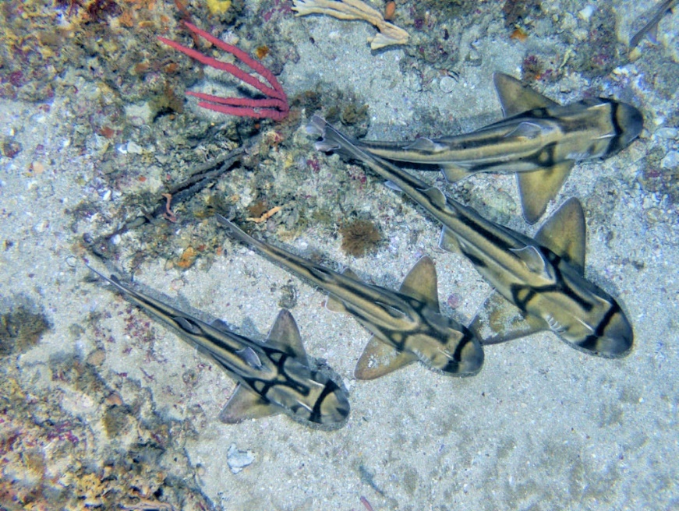

*Image: Port Jackson sharks in Beagle Marine Park (IMAS)*

# Comments received outside of the statutory consultation process

As per the invitation to provide comment on the draft plan, submissions were required to be provided by 11:30PM (AEDT) on the 14th of November 2024, via the Department’s consultation hub website: https://consult.dcceew.gov.au/se-marine-parks-network-mgt-plan.

Six submissions were received outside of this process. All 6 were provided by email and 4 of these were provided after the consultation period closed on 14th November 2024.

The submissions largely provided comments already reflected in other submissions and have thus been captured elsewhere in this report. For example:

* supporting high-level protection for all marine parks on Palawa Country—Zeehan, Franklin, Boags, Tasman Fracture, Huon, Freycinet, Flinders and Beagle
* a call to use the same definitions of values used in the management plans for the North, North-west, Coral Sea, and Temperate East, and South-west Networks
* concern about the financial impacts of proposed zoning changes on Gummy shark fishermen, and flow on impacts to regional businesses, including fishing cooperatives.

However, comments not raised in other submissions included:

* recognition that a key pressure is the ongoing dispossession of Palawa people by governments
* a recommendation for the use of the Protected Seascape Zone (IUCN Category V), with all marine parks on Palawa Country to include Protected Landscape/Seascape Zones, as a means of explicitly recognising rights to Sea Country
* support for renaming or dual naming for marine parks on Palawa Country, noting the current marine park names all have linkages to the colonisation of Australia.

|  |
| --- |
| **7.a Director of National Parks response**  *The First Nations feedback largely aligns with other submissions and is addressed in section 6.2 of this Report. Renaming or dual naming of marine parks is covered in section 6.4, the definition of cultural values in section 6.3, while section 6.5 addresses comments on the proposed zoning design.*  *The suggestion to introduce a Protected Seascape Zone (IUCN Category V) is a new recommendation not reflected in other submissions. The application of the full suite of zoning categories included in Schedule 8 of the EPBC Regulations is available to the Director. Future reviews of management plans will seek to explore opportunities for the application of IUCN Category V where appropriate.*  *The feedback in relation to gummy shark fishers, and flow on impacts to regional businesses like fishing cooperatives, had been expressed in in other submissions and addressed in Section 6.5 of this report.* |

# Comments that were out of scope for this consultation

The Director received comments in submissions that were beyond the scope of the consultation on the draft plan. These comments are summarised below, and no Director of National Parks response is provided:

* comments relating to expanding the boundaries of existing marine parks or creating new marine parks
* suggestions to expand the scope of the Australian Marine Park Advisory Committees to include the entire marine region, not just marine park networks
* comments seeking to broaden the management and monitoring framework contemplated in the draft plan to encompass the South-east marine region not just the South-east Network
* concern around inadequate protection in state waters
* broader criticism of the Australian Government, legislation, and the EPBC Act as institutions that perpetuate colonial structures of power and decision-making, including the principle of terra nullius
* advocation for enforceable agreements to ensure the full protection of Sea Country, including areas within and beyond the South-east Network
* calls for systemic changes across Government to enable the genuine application of Indigenous Cultural and Intellectual Property and FPIC
* comments in relation to the effectiveness of commercial fisheries management in Australia
* criticism of the Government’s calculation of 30 by 30 target, and that zone types which allow extractive activities should not qualify as marine parks in line with international guidance.

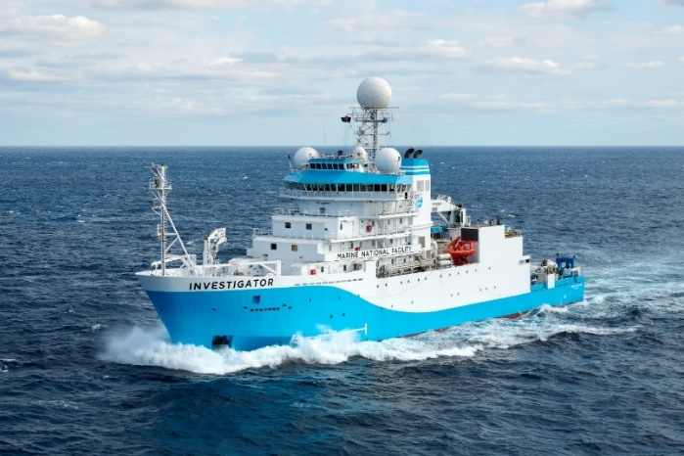

*Image: CSIRO Research vessel investigator (CSIRO)*



1. ‘Campaign submissions’ herein refers to submissions generated by individuals through a third-party website and generally provided the same or similar comments
2. The notice inviting comments on the draft plan is published on the Australian Government Gazette: [https://www.legislation.gov.au/C2024G00602/](https://www.legislation.gov.au/C2024G00602/asmade/text).
3. The draft plan was released on 11 October 2024 and is available on the Parks Australia website: https://australianmarineparks.gov.au/
4. Phillips GAC, Krueck N, Ogier E, Barrett N, Dutton I, Hartmann K. Assessing the multiple benefits of partially protected marine protected areas in Australia: A systematic review protocol. PLoS One. 2023 Apr 20;18(4):e0284711. doi: 10.1371/journal.pone.0284711. PMID: 37079655; PMCID: PMC10118075.: