**EXPLANATORY STATEMENT**

Issued by the authority of the Minister for Defence Industry and Capability Delivery

*Defence Act 1903*

***Defence (RAAF Base Williamtown Defence Aviation Area) Declaration 2024***

**Purpose**

The purpose of the *Defence (RAAF Base Williamtown Defence Aviation Area) Declaration 2024* is to declare the areas of land, sea and airspace in the vicinity of RAAF Base Williamtown, in New South Wales, as a defence aviation area. Subsection 117AC(1) of the *Defence Act 1903* (the Act) empowers the Minister to declare, by legislative instrument, an area of land, sea or airspace in or adjacent to Australia to be a defence aviation area.

Defence airfields, air weapons ranges and low flying training areas play a significant role in the Defence strategy for Australia. They are essential for maintaining Defence’s high training standards, operational capability and ability to respond in emergencies. Safe aircraft operations at military and joint-user airfields are not only concerned with defence aviation, but are also essential for the safety of the local community.

Part IXD of the Act provides for the declaration and regulation of defence aviation areas, in order to support the safe operation of Defence aviation. Defence aviation areas are regulated areas in which activities dangerous to aviation are controlled. Within these areas, proposals to construct permanent and temporary structures above specified heights, as well as gas plumes from exhaust stacks and other objects hazardous to aircraft or aviation-related communications, navigation or surveillance must be referred to Defence for approval before construction commences.

The declaration will provide clear guidance to developers, landowners, occupiers and other interested parties about the height restrictions that apply to new buildings, structures and objects, requiring Defence approval before construction or movement.

**Background**

Defence assesses development proposals for aviation impacts across 14 Defence aerodromes where defence aviation areas are in force.

In the absence of the declaration, development of land surrounding RAAF Base Williamtown is governed by the *Environmental Planning and Assessment Act 1979* (NSW). Under that Act, Local Environmental Plans (LEPs) are used as a framework to guide development decisions by local governments. As such, local governments are responsible for decisions to approve or refuse development that may be dangerous to aviation. This declaration defers the decision to the Minister, which ensures a consistent approach to development assessments across all Defence aerodromes where a declaration exists.

Defence is required to negotiate with state government and local councils to ensure the declaration plan is represented within the affected planning schemes.

**Legislative authority**

The declaration is made under section 117AC of the Act. The Minister must not declare a defence aviation area unless the Minister is satisfied that it is necessary for the defence of Australia for any of the matters mentioned in paragraphs 117AD(a) to (c) to apply in relation to the area; and, in particular, the matters are necessary for the purpose of preventing or reducing hazards to aircraft or aviation-related communications, navigation and surveillance.

The matters include:

* the regulation or prohibition of the construction or use of buildings, structures or objects within defence aviation areas;
* the regulation or prohibition of the bringing of hazardous objects into, or having objects within, defence aviation areas;
* the removal (in whole or in part), marking, lighting, screening, modification or relocation of buildings, structures or objects (including trees or other natural obstacles) within defence aviation areas.

Subsection 117AC(3) provides that, without limiting section 117AD, a declaration of an area may also specify height restrictions that apply in relation to buildings, structures and objects (including trees and other natural obstacles) within the area.

**Commencement**

The instrument commences on the day after its registration on the Federal Register of Legislation.

**Consultation**

Public Consultation occurred between 30 October 2023 and 19 January 2024 and included:

1. local Government stakeholders (Port Stephens Council, Dungog Shire, Newcastle Council, Maitland City Council);
2. airspace stakeholders (Civil Aviation Safety Authority, Airservices Australia);
3. institutional stakeholders (NSW Department of Planning & Environment, Transport for NSW, Port of Newcastle, NSW National Parks & Wildlife, Urban Development Institute of Australia); and
4. general public and public interest groups.

**Impact Analysis**

The Office of Impact Analysis advised that no Impact Analysis was required as this declaration is unlikely to have more than a minor regulatory impact (OIA24-07999).

**Details / Operation**

Details of the declaration are set out in Attachment A.

The Declaration is a disallowable legislative instrument for the purposes of the *Legislation Act 2003*.

**Human Rights Statement**

The declaration is compatible with the human rights and freedoms recognised or declared under section 3 of the *Human Rights (Parliamentary Scrutiny) Act 2011*. A Statement of Compatibility with Human Rights is at Attachment B.

**ATTACHMENT A**

**Defence (RAAF Base Williamtown Defence Aviation Area) Declaration 2024**

**Section 1 – Name**

This section provides that the title of the instrument is the *Defence (RAAF Base Williamtown Defence Aviation Area) Declaration 2024.*

**Section 2 – Commencement**

This section provides that the instrument commences on the day after it is registered on the Federal Register of Legislation.

**Section 3** – **Authority**

This section provides that this instrument is made under subsection 117AC(1) of the Act.

**Section 4 – Declaration of Defence Aviation Area – RAAF Base Williamtown**

Subsection 4(1) declares RAAF Base Williamtown as a defence aviation area.

Subsection 4(2) provides that the RAAF Base Williamtown Defence Aviation Area is the areas of land, sea and airspace in the vicinity of RAAF Base Williamtown in New South Wales that are depicted on the plan set out in Schedule 1 to the instrument.

Subsection 4(3) makes it clear that areas depicted by white space on the plan set out in Schedule 1 are not included in the RAAF Base Williamtown Defence Aviation Area.

The note provides that defence aviation area is defined in section 4 of the Act.

**Section 5 – Specification of Height Restrictions**

Subsection 5(1) provides that for the purposes of subsection 117AC(3), height restrictions apply in relation to buildings, structures and objects (including trees and other natural obstacles) within the RAAF Base Williamtown Defence Aviation Area.

Subsection 5(2) provides that the height restrictions described in the legend to the plan set out in Schedule 1 apply in the corresponding area depicted on the plan.

**Schedule 1 – Plan­­­­­­­**

Schedule 1 contains the plan depicting the area of land, sea and airspace that is the RAAF Base Williamtown Defence Aviation Area. The declared defence aviation area is the area identified by the legend to the plan and includes various height restrictions that apply.

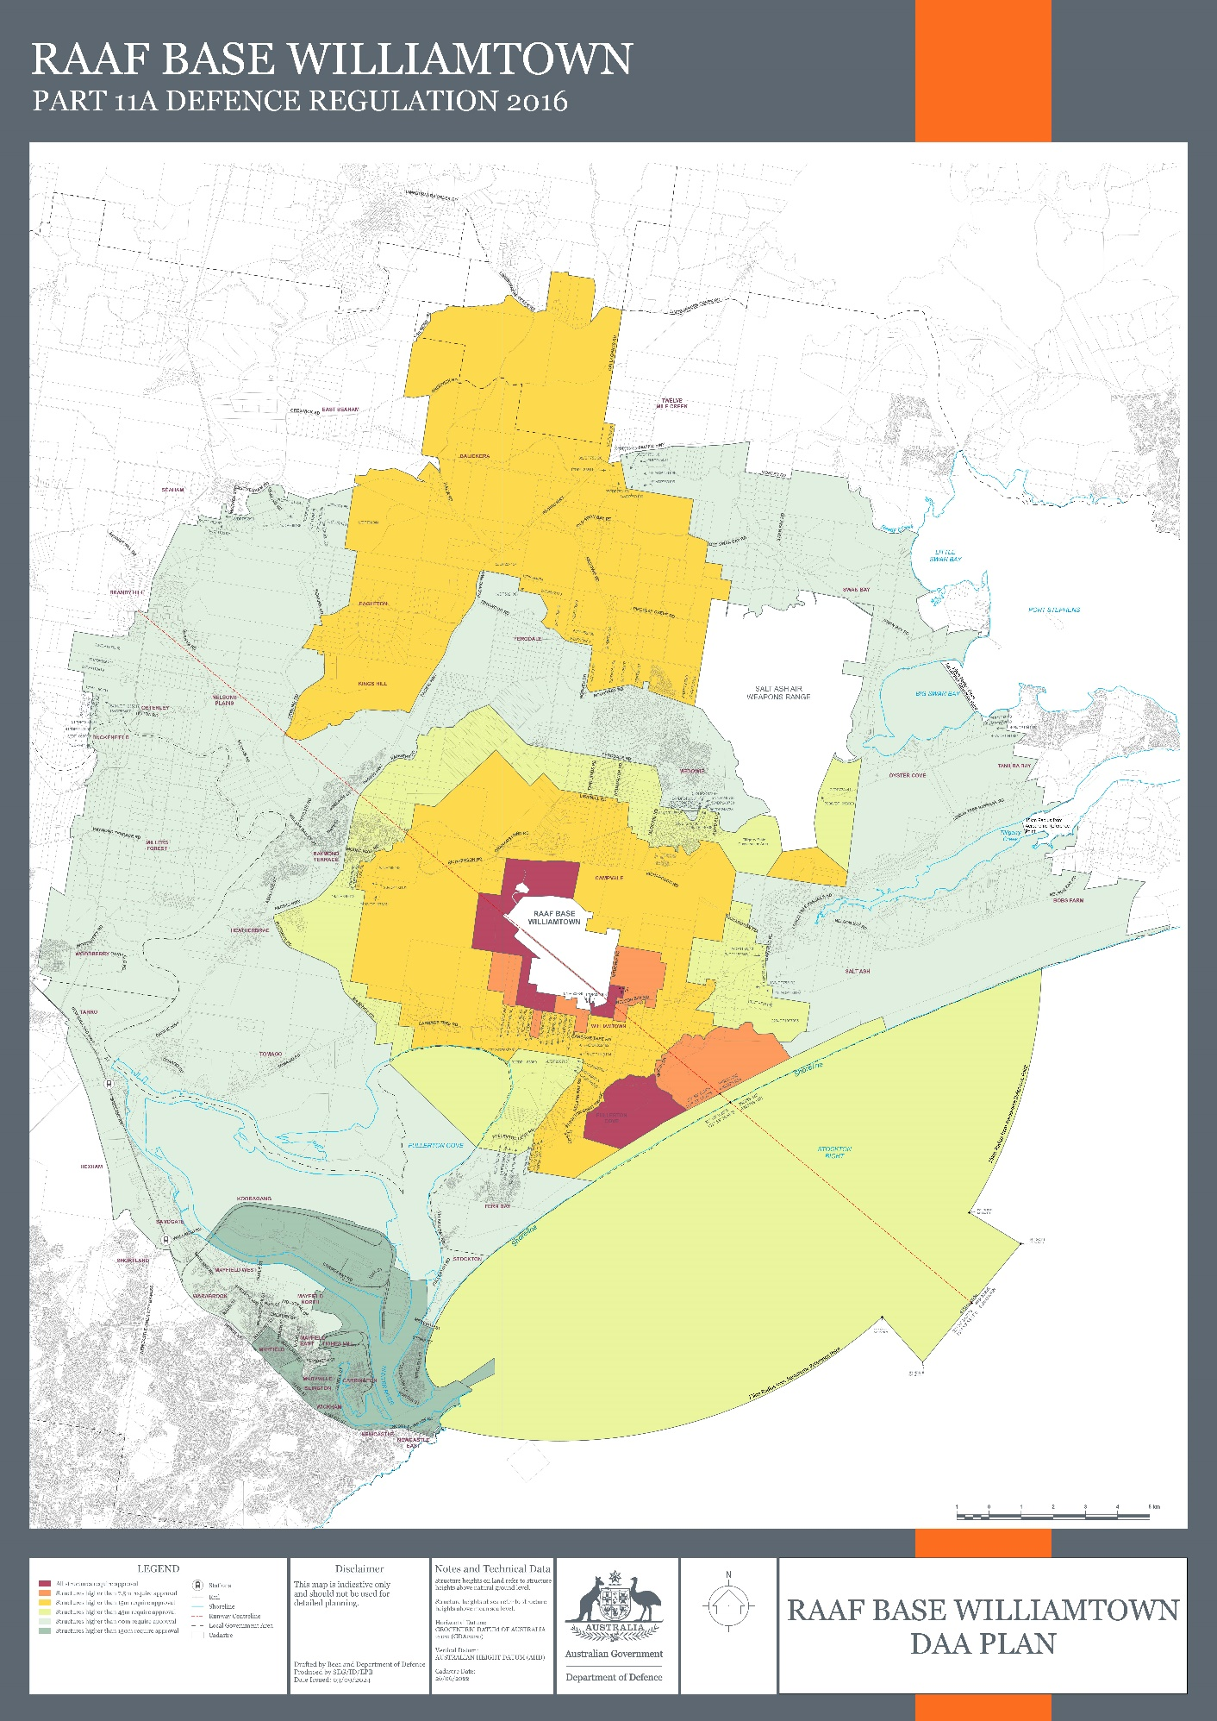

**ATTACHMENT B**

## Statement of Compatibility with Human Rights

*Prepared in accordance with Part 3 of the Human Rights (Parliamentary Scrutiny) Act 2011*

***Defence (RAAF Base Williamtown Defence Aviation Area) Declaration 2024***

The *Defence (RAAF Base Williamtown Defence Aviation Area) Declaration 2024* is compatible with the human rights and freedoms recognised or declared in the international instruments listed in section 3 of the *Human Rights (Parliamentary Scrutiny) Act 2011*.

### Overview of the Legislative Instrument

The instrument declares the areas of land, sea and airspace surrounding RAAF Base Williamtown to be a defence aviation area, and specifies height restrictions that apply to buildings, structures and objects within that area. The declaration means that the provisions of Part IXD of the *Defence Act 1903* and Part 11A of the Defence Regulation 2016 apply within the area.

### Human rights implications

This instrument does not engage any of the applicable rights or freedoms.

### Conclusion

The instrument is compatible with human rights as it does not raise any human rights issues.