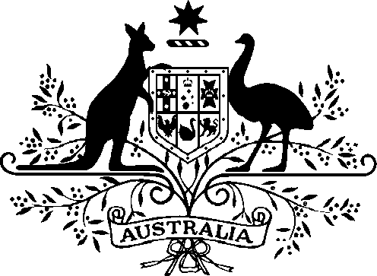

*Acts Interpretation (Ministerial Acting Arrangements for the Resources Portfolio) Authorisation (No. 1) 2025*

I, the Hon Madeleine King MP, Minister for Resources and Minister for Northern Australia, acting in accordance with sections 19 and 34AAB of the *Acts Interpretation Act 1901*, and all other powers thereunto enabling, as the case requires, hereby authorise the Hon Amanda Rishworth MP, Minister for Social Services, to exercise, on my behalf, all my powers and functions, including powers and functions conferred on me by any law of the Commonwealth.

This instrument commences on Wednesday, 15 January 2025 and is repealed at the end of Thursday, 30 January 2025.

Dated 17 December 2024

Signed

Madeleine King

Minister for Resources

Minister for Northern Australia