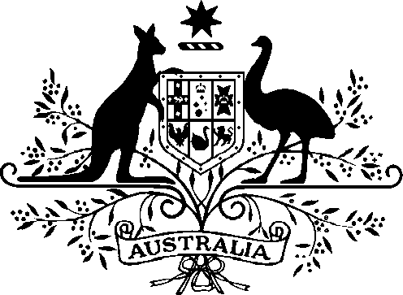

*Acts Interpretation (Ministerial Acting Arrangements for the Industry and Science Portfolio) Authorisation (No. 2) 2024*

I, the Hon Ed Husic MP, Minister for Industry and Science, acting in accordance with sections 19 and 34AAB of the *Acts Interpretation Act 1901*, and all other powers thereunto enabling, as the case requires, hereby authorise the Hon Tanya Plibersek MP, Minister for the Environment and Water, to exercise, on my behalf, all my powers and functions, including powers and functions conferred on me by any law of the Commonwealth.

This instrument commences on Saturday, 21 December 2024 and is repealed at the end of Tuesday, 7 January 2025.

Dated 29 November 2024

Signed

Ed Husic

Minister for Industry and Science