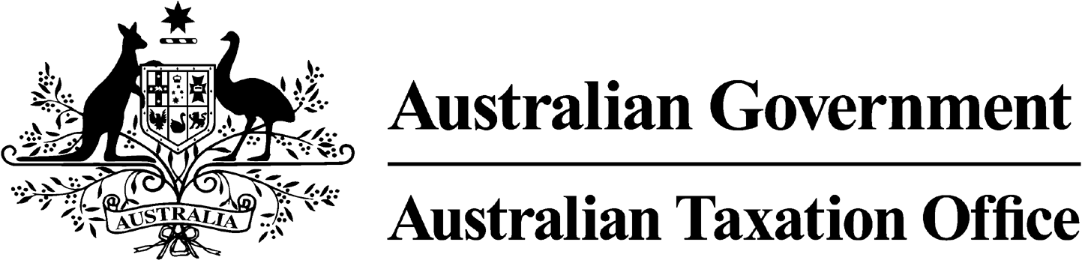

**NOTICE OF CONFIRMATION OF DISQUALIFICATION – AARON COUSINS – 31 October 2024**

*Superannuation Industry (Supervision) Act 1993*

To:

AARON COUSINS

PEARCEDALE VIC 3912

I, Andrew Orme, a delegate of the Commissioner of Taxation, give you notice as required by subsection 344(6) of the *Superannuation Industry (Supervision) Act 1993* (SISA), that I have made a decision under subsection 344(4) of the SISA to confirm the disqualification notice issued to you on 12 September 2024.

The disqualification takes effect on the day on which it is made.

Dated: 31 October 2024

**Andrew Orme**

Deputy Commissioner of Taxation

Per Brenden Morley

Note 1:

Under subsection 126A(7) of the SISA, details of this disqualification notice will be published as a *Notifiable Instrument* in the Federal Register of Legislation.

Note 2:

Under section 126K of the SISA, it is an offence for a disqualified person, who knows that he or she is a disqualified person, to be, or act as a:

* trustee, investment manager or custodian of a superannuation entity
* responsible officer or a body corporate that is a trustee, investment manager or custodian, of a superannuation entity

The maximum penalty for committing this offence is two years jail.