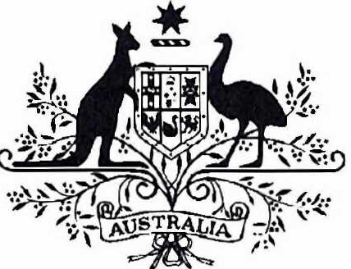

Acts Interpretation (Ministerial Acting Arrangements for Special Minister of State and Trade and Tourism Portfolios) Authorisation (No. 1) 2024

I, **Senator the Hon Don Farrell, Special Minister of State** and **Minister for Trade and Tourism,** acting in accordance with sections 19 and 34AAB of the *Acts Interpretation Act 1901,* and all other powers thereunto enabling, as the case requires, hereby authorise the Hon Madeleine King, Minister for Resources and Minister for Northern Territory, to exercise, on my behalf, all my powers and functions, including powers and functions conferred on me by any law of the Commonwealth.

This instrument commences on 4 July 2024 and ceases to have effect at the end of 2 August 2024.

**Dated 3 July 2024**

**Don Farrell**

Special Minister of State Minister for Trade and Tourism

Note: The name of this instrument was amended on registration as the instrument as lodged did not have a unique name (see subsection 10(2), *Legislation Rule 2016*).