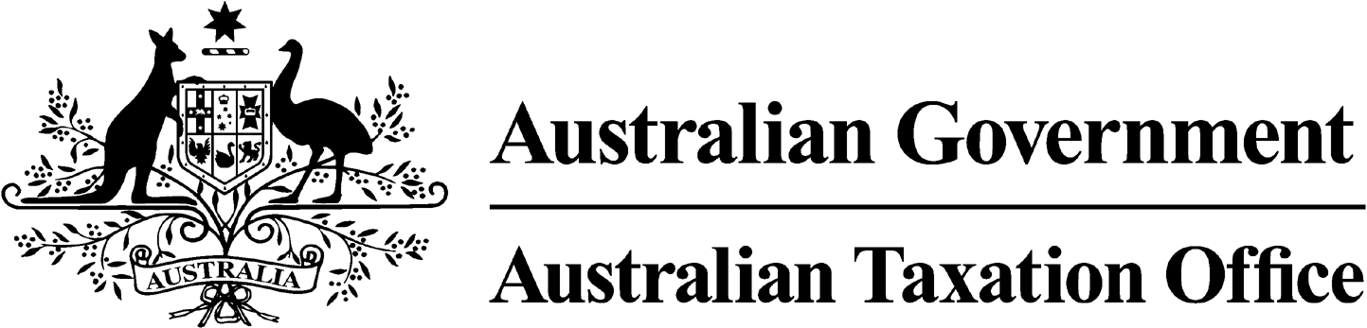
NOTICE OF REVOCATION OF DISQUALIFICATION - Tracey Sully- 16 July 2024
Superannuation Industry (Supervision) Act 1993
To:

Tracey Sully

Merrimac QLD 4226
I, Emma Rosenzweig, a delegate of the Commissioner of Taxation, give you notice as required by subsection 126A(6) of the Superannuation Industry (Supervision) Act 1993 (SISA), that I have made a decision under subsection 126A(5) of the SISA to revoke the disqualification notice issued to you on 6 March 2024.

The revocation of the disqualification order takes effect on the day on which this notice is made.

Dated: 16 July 2024

Emma Rosenzweig
Deputy Commissioner of Taxation

Per Karla Bauer

Note 1:
Under subsection 126A(7) of the SISA, details of this disqualification notice will be published as a Notifiable Instrument in the Federal Register of Legislation.

