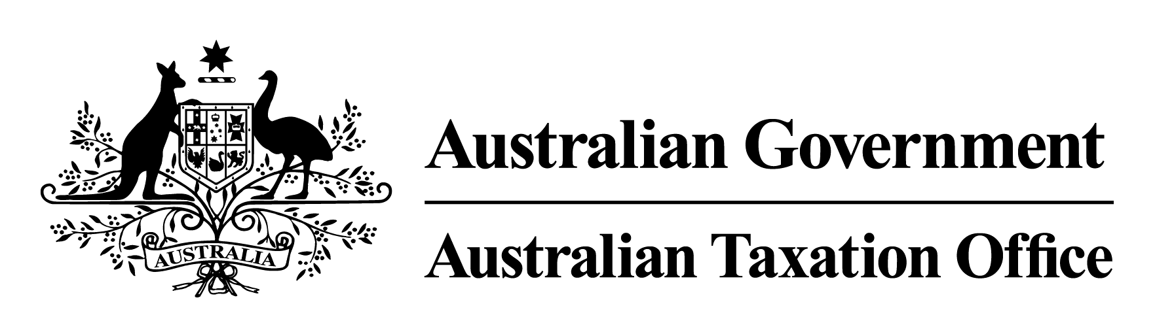

**Notice of Rulings and Withdrawal of Rulings 3 July 2024**

The Commissioner of Taxation, Rob Heferen, gives notice by notifiable instrument under subsection 358-5(4) of Schedule 1 to the *Taxation Administration Act 1953* of the following public rulings, , and under subsection 358-20(1) of Schedule 1 to the *Taxation Administration Act 1953* of the withdrawal of the following public ruling, copies of which can be obtained from [ato.gov.au/law](http://ato.gov.au/law)

|  |  |  |
| --- | --- | --- |
| NOTICE OF RULINGS | | |
| Ruling number | Subject | Brief description |
| TD 2024/4 | Income tax: hybrid mismatch rules – application of certain aspects of the ‘liable entity’ and ‘hybrid payer’ definitions | This Determination sets out our view on 2 separate but related issues, whether:   * hypothetical income or profits within the tax base of a country can be used to identify a ‘liable entity’ or entities in the country for the purposes of section 832-325 of the *Income Tax Assessment Act 1997*, and * a ’non-including country’ for the purpose of subsection 832-320(3) of the ‘hybrid payer’ definition can be a jurisdiction other than the country where the payee of the relevant payment is located or resides.   This Determination applies both before and after its date of issue. |
| CR 2024/36 | National Australia Bank Limited – NAB Capital Notes 8 | This Ruling sets out the income tax consequences for entities who subscribed for and acquired National Australia Bank Capital Notes 8 issued by National Australia Bank Limited.  This Ruling applies from 1 July 2023 to 30 June 2035. |
| CR 2024/37 | Calima Energy Limited – return of capital | This Ruling sets out the income tax consequences for shareholders of Calima Energy Limited who received a return of capital payment of 12.63 cents per ordinary Calima share on 21 June 2024.  This Ruling applies to shareholders specified in the Ruling from 1 July 2023 to 30 June 2024. |
| CR 2024/38 | Best & Less Holdings Group Pty Limited – employee share scheme – disposal of shares | This Ruling sets out the income tax consequences for employees of Best & Less Group Holdings Pty Limited and its subsidiaries who participated in the Best & Less Group Holdings Limited Tax Exempt Share Plan who were subject to an off-market takeover by BBRC Admin 1 Pty Ltd.  This Ruling applies to shareholders specified in the Ruling from 1 July 2021 to 30 June 2024. |
| CR 2024/39 | EROAD Australia Pty Ltd – Fuel Tax Credits Solution | This Ruling sets out when the FTC Report generated from EROAD Australia Pty Ltd’s Fuel Tax Credits Solution can be used as a record (but not the only record) for fuel tax credit record-keeping purposes.  This Ruling applies to taxable fuel acquired on or after 1 July 2024 to 30 June 2026. |
| PR 2024/11 | Utmost Executive Investment Bond | This Ruling sets out the income tax consequences for specified entities in connection with an Executive Investment Bond issued by Utmost International Isle of Man Limited and subject to the Executive Investment Bond Policy Terms.  This Ruling applies to entities specified in the Ruling from 1 July 2024. |

|  |  |  |
| --- | --- | --- |
| NOTICE OF ERRATUM | | |
| Ruling number | Subject | Brief description |
| TD 2023/3 | Income tax: what are the reasonable travel and overtime meal allowance expenses amounts for the 2023–24 income year? | This Erratum amends incorrect paragraph references in Taxation Determination TD 2023/3.  This Erratum applies from 28 June 2023. |

|  |  |  |
| --- | --- | --- |
| NOTICE OF WITHDRAWAL | | |
| Ruling number | Subject | Brief description |
| TD 2018/11 | Income tax: what are the reasonable travel and overtime meal allowance expense amounts for the 2018–19 income year? | TD 2018/11 is withdrawn as its period of effect has ceased. |