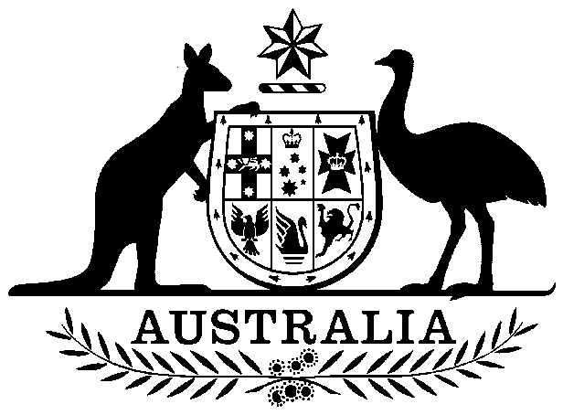

COMMONWEALTH OF AUSTRALIA

##### **Environment Protection and Biodiversity Conservation Act 1999**

###### DECLARATION OF AN APPROVED WILDLIFE TRADE OPERATION – VICTORIAN EEL FISHERY, JUNE 2024

I, BELINDA JAGO, Branch Head, Ocean and Wildlife Branch, as Delegate of the Minister for the Environment and Water, have considered in accordance with section 303FN of the *Environment Protection and* *Biodiversity Conservation Act 1999* (EPBC Act) the application from the Victorian Fisheries Authority and advice on the ecological sustainability of the operation. I am satisfied on those matters specified in section 303FN of the EPBC Act. I hereby declare the operations for the harvesting of specimens that are or are derived from fish or invertebrates, taken in the Victorian Eel Fishery as defined in the management regime in force under the:

* *Fisheries Act 1995* (Vic)
* [Fisheries Regulation 2019](https://www.legislation.vic.gov.au/in-force/statutory-rules/fisheries-regulations-2019/002) (Vic)
* [Victorian Eel Fishery Management Plan 2017](https://vfa.vic.gov.au/__data/assets/word_doc/0011/342767/Victorian-Eel-Fishery-Management-Plan-2017-with-VFA-cover_SIGNED.docx),

but not including:

1. specimens that belong to taxa listed under section 209 of the EPBC Act (Australia’s List of Migratory Species), or
2. specimens that belong to taxa listed under section 248 of the EPBC Act (Australia’s List of Marine Species), or
3. specimens that belong to eligible listed threatened species, as defined under section 303BC of the EPBC Act, or
4. specimens that belong to taxa listed under section 303CA of the EPBC Act (Australia’s CITES List)

to be an approved wildlife trade operation, in accordance with subsection 303FN(2) and paragraph 303FN(10)(d), for the purposes of the EPBC Act.

Unless amended or revoked, this declaration:

1. is valid until 20 June 2027 and
2. is subject to the conditions applied under section 303FT specified in Schedule 1.

Dated this 21st day of June 2024

Belinda Jago

………….…….…………………………………

Delegate of the Minister for the Environment and Water

Notes: Under the Administrative Appeals Tribunal Act 1975, a person whose interests are affected by this decision may apply for a statement of reasons and for independent review of the decision. An application for a statement of reasons may be made in writing to the Department of Climate Change, Energy, the Environment and Water within 28 days of the date of the declaration. An application for independent review may be made to the Administrative Appeals Tribunal on payment of the relevant fee within 28 days of the date of the declaration, or if reasons are sought, within 28 days of receipt of reasons. Further information may be obtained from the Director, Sustainable Fisheries Section, Department of Climate Change, Energy, the Environment and Water, Email: [sustainablefisheries@dcceew.gov.au](mailto:sustainablefisheries@environment.gov.au).

Schedule 1

Declaration of the harvest operations of the Victorian Eel Fishery as an approved Wildlife Trade Operation, June 2024

**ADDITIONAL PROVISIONS (section 303FT)**

Relating to the harvesting of fish specimens that are, or are derived from, fish or invertebrates, other than specimens of species listed under Part 13 and Part 13A of the *Environment Protection and Biodiversity Conservation Act 1999* (EPBC Act), taken in the Victorian Eel Fishery:

**Condition 1:**

Operation of the Victorian Eel Fishery must be carried out in accordance with the *Fisheries Act 1995* (Vic), the Fisheries Regulations 2019 (Vic), and the Victorian Eel Fishery Management Plan 2017.

**Condition 2**:

The Victorian Fisheries Authority must inform the Department of Climate Change, Energy, the Environment and Water of any intended material changes to the Victorian Eel Fishery management arrangements that may affect the assessment against which *Environment Protection and Biodiversity Conservation Act 1999* decisions are made.

**Condition 3:**

The Victorian Fisheries Authority must inform the Department of Climate Change, Energy, the Environment and Water of any intended changes to fisheries legislation that may affect the legislative instruments relevant to this approval.

**Condition 4:**

The Victorian Fisheries Authority must produce and provide reports on the Victorian Eel Fishery, including progress against all Part 13A conditions, to the Department of Climate Change, Energy, the Environment and Water by 20 June annually, with the first annual report due by 20 June 2025.

These reports must be completed as per Appendix B of the *Guidelines for the Ecologically Sustainable Management of Fisheries – 2nd Edition*.

**Condition 5:**

By 12 December 2025, the Victorian Fisheries Authority must conduct stock assessments for the two target species. Such assessments may involve attempts to standardise Catch Per Unit Effort, applying other stock assessment methods appropriate to the biological stocks, and/or undertaking research into the health of eel populations in areas closed to fishing.

**Condition 6:**

By 20 June 2026, the Victorian Fisheries Authority must complete and make publicly available a harvest strategy for the fishery, and provide it to the Department of Climate Change, Energy, the Environment and Water. This harvest strategy must clearly outline biologically relevant reference points, performance measures and triggers for management action.

**Condition 7:**

By 12 December 2025, the Victorian Fisheries Authority must complete and make publicly available a detailed bycatch risk assessment for the fishery.

**Condition 8:**

1. By 13 December 2024, the Victorian Fisheries Authority must develop and implement an interim bycatch reduction plan. Implementation of this plan must include the adoption and enforcement of appropriate bycatch reduction measures on all licenced eel fishers, until such time as the detailed bycatch risk assessment is completed. A copy of the plan and the interim bycatch reduction implementation measures must be provided to the Department of Climate Change, Energy, the Environment and Water.
2. By 31 August 2025, the Victorian Fisheries Authority must provide an update on the implementation and effectiveness of the interim bycatch reduction measures to the Department of Climate Change, Energy, the Environment and Water.
3. By 30 November 2026, the Victorian Fisheries Authority must develop and implement risk mitigation measures for all risks identified as being moderate or higher in the bycatch risk assessment and demonstrate that all reasonable steps have been taken to reduce, and where possible avoid bycatch of air-breathing vertebrates and species protected under the Environment Protection and Biodiversity Conservation Act 1999.

**Condition 9:**

By 20 June 2025, the Victorian Fisheries Authority must implement an independent monitoring and validation program in the fishery to provide information on catch composition, bycatch and protected species interactions.

This may involve the expansion of Fishery Officer inspections, surveys, electronic monitoring or other means. The information collected and spatial/temporal coverage must be sufficient to assess the accuracy of reported catch, bycatch and protected species interaction data collected via logbooks.

Bycatch and protected species interactions, particularly mortalities, must be reported to the species level wherever possible.

**Condition 10:**

Export of glass eels harvested in the Victorian Eel Fishery is limited to 50kg per year until robust data is presented to the satisfaction of the Department of Climate Change, Energy, the Environment and Water, demonstrating commercial scale glass eel harvest and export will be sustainable.

1. The Victorian Fisheries Authority must inform the Department of Climate Change, Energy, the Environment and Water, of any future glass eel fishery trials (beyond the scale of the current market assessment trial) to be undertaken under the current wildlife trade operation. Comprehensive plans for future trials must be provided to the Department of Climate Change, Energy, Environment and Water at least 6 months before commencement of any trial, for review and endorsement by the department.