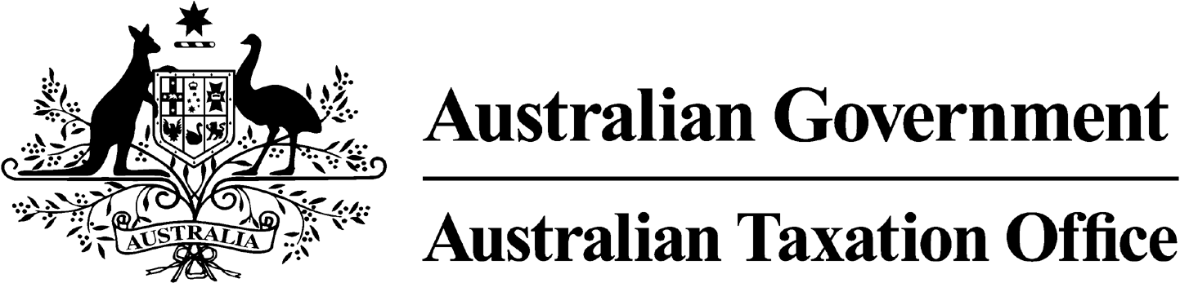

**NOTICE OF REVOCATION OF DISQUALIFICATION – ROBIN BARROW -**

23 February 2024

*Superannuation Industry (Supervision) Act 1993*

To:

ROBIN BARROW

PORT DOUGLAS QLD 4877

I, Andrew Orme, a delegate of the Commissioner of Taxation, give you notice as required by subsection 126A(6) of the *Superannuation Industry (Supervision) Act 1993* (SISA), that I have made a decision under subsection 126A(5) of the SISA to revoke the disqualification notice issued to you on 12 September 2023.

I have revoked the decision to disqualify you under subsection 126A(1) of the SISA as I am satisfied that the contraventions have been appropriately addressed and you do not represent a future compliance risk.

The revocation of the disqualification order takes effect on the day on which this notice is made.

Dated: 23 February 2024

**Andrew Orme**

Deputy Commissioner of Taxation

Per Michelle Gainford

Note 1:

Under subsection 126A(7) of the SISA, details of this disqualification notice will be published as a *Notifiable Instrument* in the Federal Register of Legislation.