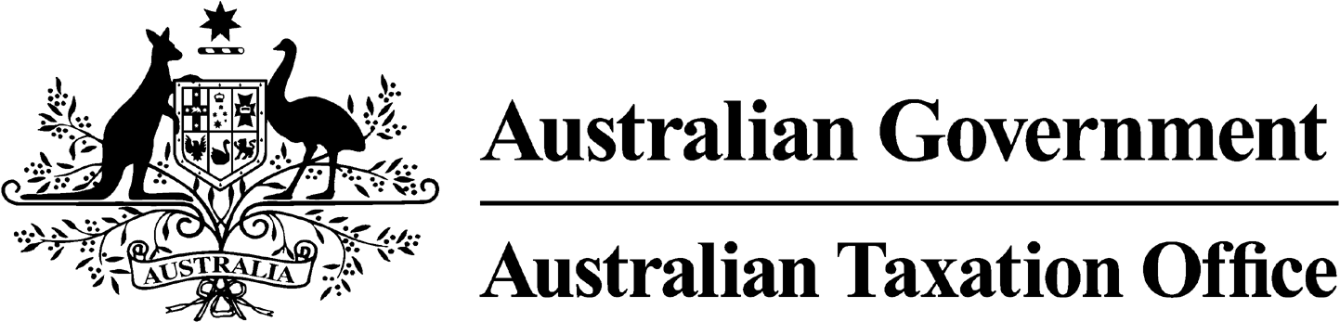

**NOTICE OF DISQUALIFICATION – Kay Saunders – 20 December 2023**

*Superannuation Industry (Supervision) Act 1993*

To:Kay Saunders

YARRAWONGA VIC 3730

I, Andrew Orme, a delegate of the Commissioner of Taxation, give you notice as required by subsection 126A(6) of the *Superannuation Industry (Supervision) Act 1993* (SISA), that I have disqualified you under subsection 126A(2) of the SISA.

I’ve disqualified you as I am satisfied that the corporate trustee of one or more superannuation entities has contravened the SISA on one or more occasions, and at the time of the contraventions you were a responsible officer of the corporate trustee and the number of the contraventions provides grounds for disqualifying you.

The disqualification takes effect on the day on which it is made.

Dated: 20 December 2023

**Andrew Orme**

Deputy Commissioner of Taxation

Per Pauline Cotter

Note 1:

Under subsection 126A(7) of the SISA, details of this disqualification notice will be published as a *Notifiable Instrument* in the Federal Register of Legislation.

Note 2:

Under section 126K of the SISA, it is an offence for a disqualified person, who knows that he or she is a disqualified person, to be, or act as a:

* trustee, investment manager or custodian of a superannuation entity
* responsible officer or a body corporate that is a trustee, investment manager or custodian, of a superannuation entity

The maximum penalty for committing this offence is two years jail.

Note 3:

Under subsection 126A(5) of the SISA, we may revoke this disqualification on our own initiative or on your written application.

.