Explanatory Statement

Issued by the authority of the Minister for Climate Change and Energy

Offshore Electricity Infrastructure Act 2021

Offshore Electricity Infrastructure Amendment (Overlapping Applications) Regulations 2024

Legislative Authority
The Offshore Electricity Infrastructure Act 2021 (OEI Act) establishes a legal framework to enable the construction, installation, commissioning, operation, maintenance, and decommissioning of offshore electricity infrastructure (OEI) in the Commonwealth offshore area.
Section 305 of the OEI Act provides that the Governor General may make regulations on matters required or permitted by the Act to be prescribed by the regulations or necessary or convenient to be prescribed for carrying out or giving effect to the Act.
Sections 29 and 32 of the OEI Act provide for regulations to prescribe for a licensing scheme, including for the process for applying for and offering feasibility licences.
Under paragraph 33(1)(f) of the OEI Act, the Minister may grant a feasibility licence in respect of an area to an eligible person if any other requirements prescribed by the licensing scheme are met including subsection 33(4), requirements of the licence area.

Purpose
The purpose of the Offshore Electricity Infrastructure Amendment (Overlapping Applications) Regulations 2024 (Amendment Regulations) is to amend the Offshore Electricity Infrastructure Regulations 2022 (Principal Regulations) by prescribing requirements to deal with overlapping feasibility applications which are not of equal merit and to ensure that a feasibility licence can only be issued for an area that has been applied for by an applicant, for the purposes of the licensing scheme under section 29 of the OEI Act.
An objective of the Amendment Regulations is to address the interpretation of the licensing scheme adopted by the Federal Court in its decision in Seadragon Offshore Wind Pty Ltd v Minister for Climate Change and Energy [2024] FCA 1290 (the Seadragon case).
Background
The OEI framework
The OEI Act and the Principal Regulations provides a regulatory framework for offshore renewable energy infrastructure and offshore electricity transmission infrastructure.
Section 33 of the OEI Act sets out the requirements for the granting of a feasibility licence including that a licence must not include any part of a licence area of any other feasibility licence (or commercial licence).
The licensing scheme is currently prescribed in the Principal Regulations, and only explicitly manages groups of overlapping feasibility licence applications that are of equal merit.
Section 11 of the Principal Regulations sets out arrangements for the Minister to determine that a group of 2 or more feasibility licence applications form an overlapping application group if:
- the Minister considers all the applications in the group to be of equal merit; and
- each application in the group overlaps at least one other application in the group; and
- the licence areas proposed by all the applications in the group together form a continuous area; and
- the Minister is satisfied that, if not for the overlap(s), a feasibility licence could be offered in response to each of the applications in the group.
In the Seadragon case, the Court determined that the OEI licensing scheme does not regulate overlapping feasibility licence applications of unequal merit. The Court also determined that the Minister’s power to grant a feasibility licence is not confined to the area described in the feasibility application. Rather, in circumstances where the Minister is satisfied that an applicant meets the merit criteria required to be granted a feasibility licence, the Minister has a discretionary power to grant a feasibility licence over an area, which includes a reduced area as compared to the area that an applicant applied for.
The Amendment Regulations are intended to address these matters raised by the Court in that decision by:
- setting out the licence area description requirements that are to be included in a feasibility licence application (consistent with those previously described in the Registrar’s approved form);
- limiting the Minister’s power to grant a feasibility licence to the area described in a feasibility licence application, or revised as part of the overlapping application group process;
- if an overlapping application group is formed under section 11 of the Principal Regulations, limiting the Minister’s power to offer or grant a licence to a particular licence application which overlap with an overlapping application group, but is not included in that group only because it is of lower merit; and
- if there are a group of overlapping applications, but an overlapping application group is not formed, permitting the Minister to offer or grant a licence to the applicant of highest merit and limiting the Minister’s power to offer or grant licences to applications of lower merit.
The Amendment Regulations will apply to applications made under the licensing scheme on or after the day that these Regulations are registered.
Impact and Effect
The OEI industry is important for addressing climate change, as well as economic growth and job creation (including in regional areas). The Amendment Regulations will clarify elements of the licensing scheme relating to the treatment of overlapping feasibility licence applications where one or more applications in the group are of unequal merit.
Clarity in the operation of the licensing scheme is important for the community, industry, the Registrar, and the Commonwealth. The Amendment Regulations seek to clarify elements of the licensing scheme with respect to applications for feasibility licences that overlap.
Consultation
The Offshore Infrastructure Registrar was consulted on and is supportive of the Amendment Regulations. The Amendment Regulations may affect eligible persons considering applying for feasibility application licences in the future. However, that group of people cannot easily be discerned until applications are received. The Amendment Regulations reflect current government policy and seek to facilitate a clearer and more certain licensing process for industry.
Details/ Operation
The Amendment Regulations are a legislative instrument for the purposes of the Legislation Act 2003.
Details of the Amendment Regulations are set out in Attachment A.
Regulatory Impact
A Regulatory Impact Statement (RIS) was prepared for the OEI Act and was included in the Explanatory Memorandum for the OEI Act. The Office of Impact Assessment has advised that no further RIS is required for the Amendment Regulations.
Other
The Amendment Regulations are compatible with the human rights and freedoms recognised or declared under section 3 of the Human Rights (Parliamentary Scrutiny) Act 2011. A full statement of compatibility is set out in Attachment B.
The Amendment Regulations are a legislative instrument for the purposes of the Legislation Act 2003.

Attachment A

Details of the Offshore Electricity Infrastructure Amendment (Overlapping Application) Regulations 2024
Section 1 – Name
This section provides that the name of the instrument is the Offshore Electricity Infrastructure Amendment (Overlapping Application) Regulations 2024 (Amendment Regulations).
Section 2 – Commencement
This section provides for the Amendment Regulations to commence the day after they are registered.
Section 3 – Authority
This section provides that the Amendment Regulations are made under the Offshore Electricity Infrastructure Act 2021 (OEI Act).
Section 4 – Schedules
This section provides that each instrument that is specified in a Schedule to the Amendment Regulations is amended or repealed as set out in the applicable items in the Schedule concerned, and any other item in a Schedule has effect according to its terms.

SCHEDULE 1 – GENERAL AMENDMENTS

Item 1 – After paragraph 10(2)(b)
This item inserts a new paragraph (ba) after paragraph 10(2)(b) in the Principal Regulations that requires a feasibility licence application to describe the area proposed to be covered by a feasibility licence. An application can satisfy that requirement:
- by providing, in a manner consistent with Geocentric Datum of Australia 1994 (that is, GDA94 geocentric data set, as defined in Gazette No. 35 of 6 September 1995), a detailed map of the area, specifying the geographical coordinates of the area and including shapefiles; or
- by describing the area as otherwise provided by the approved form.
This provision, when read together with item 4, operates to ensure that a feasibility licence can only be offered and granted for the area that an applicant has applied for (including where an application is revised and resubmitted under section 12).

Item 2 – After section 11 – new section 11A
This item inserts a new section 11A in the Principal Regulations. This new section deals with overlapping applications of unequal merit.
Subsection 11A(1) limits the application of the provision to:
  - applications made in response to an invitation by the Minister under section 9 of the Principal Regulations for a feasibility licence, and
  - where one or more applications overlap in a given area.
Subsection 11A(2) sets out the way the Minister is to treat an application that overlaps with others, but is not included as part of an overlapping application group because that application (particular application) is of lower merit relative to other applications which the Minister has determined to form part of an overlapping application group. Specifically, it provides that the Minister is not to offer or grant a particular application a feasibility licence if:
- the Minister makes a determination to form an overlapping application group under subsection 11(2) of the Regulations, and the particular application is not included in that group (paragraph 11A(2)(a)). This means that the Minister is satisfied that all applications that form the group are of equal merit; while the particular application is of lower merit, having regard to the factors set out in subsection 11(3) of the Regulations; and
- the only reason the particular application is not included in the overlapping application group is because it is of lower merit to the other applications that form that group (paragraph 11A(2)(b)).
Subsection 11A(3) sets out the way the Minister is to treat an application when:
- it overlaps with at least one other application, and
- the Minister does not make a determination to form an overlapping application group because one application that overlaps is of higher merit to all other applications that overlap.
In that case, the Minister is able to offer and grant a feasibility licence to the overlapping application of highest merit, and not offer or grant a feasibility licence to any application that is of lower merit.
This supports the principle of the licensing scheme to award licences to those of highest merit where possible.
Subsection 11A(4) clarifies the operation of new section 11A in respect of the broader licensing scheme. It provides that the Minister may offer or grant a feasibility licence if an application is not included in an overlapping application group for reasons other than those mentioned in paragraph 11A(2)(b) or subsection 11A(3).
The Minister may also have regard to any other matters the Minister considers relevant, including any of the matters provided in section 26 of the Principal Regulations.
Explanatory notes to subsection 11A(4) provide two examples to illustrate how new section 11A is intended to operate in a feasibility licence application process.
Example 1: Two geographically dispersed overlapping groups
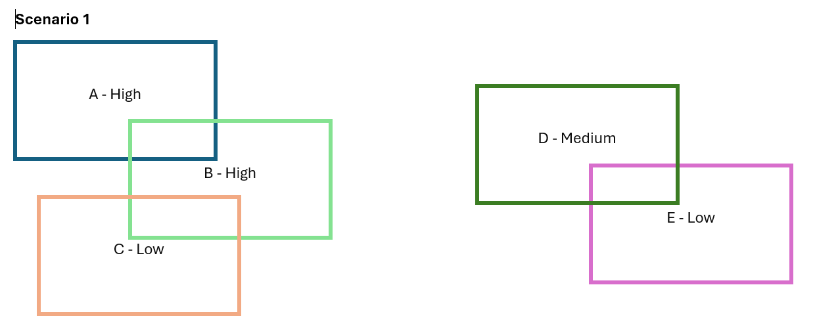
In this example, all applications are in the same declared area and satisfy the criteria in paragraphs 11(2)(b) to (d) of the Principal Regulations but have been rated at varying levels of merit.
In one part of the declared area, Application A overlaps with Application B and Application B overlaps with Application C. Applications A & B are of higher merit than Application C and can form an overlapping group of equal merit in accordance with subsection 11(2) of the Principal Regulations.
Subsection 11A(2) of the Principal Regulations requires that the Minister not offer or grant a licence to Application C as it is of lower merit relative to Applications A & B.
In a separate spatial area of the same declared area, Applications D & E overlap but do not overlap with Applications A, B & C. Application E is of lower merit relative to Application D. As Applications D & E are not of equal merit, the requirements of subsection 11(2) of the Principal Regulations are not satisfied, and the Minister cannot include Applications D and E in an overlapping application group.
Subsection 11A(2) does not limit the Minister’s ability to grant a feasibility licence to Application D. Subsection 11(3) then operates to prevent the Minister from granting a licence to Application E as it is of lower merit than Application D.

Example 2: Continuous overlapping groups
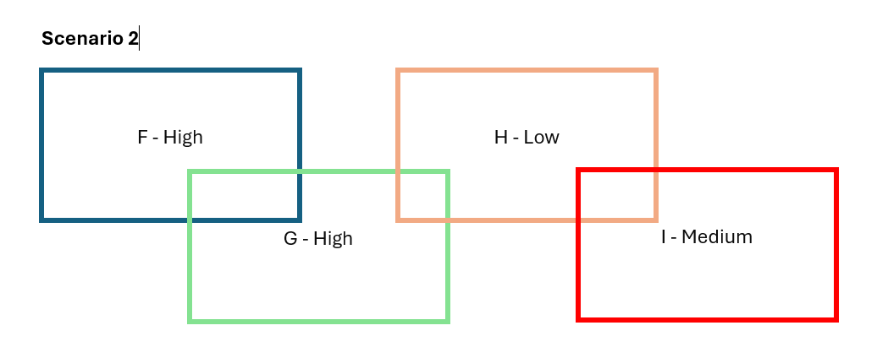
In this example Application F overlaps with Application G, Application G also overlaps with application H, and Application H also overlaps with Application I to form a continuous overlapping group. Applications F & G are rated of higher merit relative to Applications H & I. Given Applications F & G satisfy the requirements of subsection 11(2) of the Principal Regulations, they can form an overlapping group in accordance with subsection 11(2) of the Principal Regulations.
Application H is of lower merit than Application I. The Minister must not offer or grant a licence in respect of Application H. Subsection 11A(3) does not prevent the Minister from offering or granting a licence to Application I because paragraph 11A(2)(b) is not satisfied in respect of Application I.

New section 11A is intended to respond to the Seadragon case which identified that the regulatory scheme did not regulate applications of unequal merit. It does so by providing for how these kinds of applications are to be treated under the licensing scheme.
Item 3 – Paragraph 27(3)(b)
This item inserts “(see also subsection (4) for feasibility licences)” after “for the licence” in paragraph 27(3)(b) of the Principal Regulations. Section 27 of the Principal Regulations sets out the process for a Minister to offer a licence with subsection 27(2) setting out the requirements of an offer.
This amendment relates to the amendment described below in item 4, which limits the scope of the Minister’s power with regard to the area for which the Minister is able to offer and grant a feasibility licence.

Item 4 - At the end of section 27
This item inserts a new subsection at the end of section 27 of the Principal Regulations. Subsection 27(4) provides that an offer of a feasibility licence is limited to an area that is either:
- the same area described in the feasibility licence application (as required by the new paragraph 10(2)(ba) of the Regulations described at item 1 above); or
- in the event that a feasibility licence application overlaps, and an overlapping application group is formed, the area that has been revised and resubmitted under section 12 in accordance with the requirements of section 13—the area described in the revised and resubmitted application.
The effect of subsection 27(4) is to limit the scope of the Minister’s discretion in respect to the offering or a granting a licence to the area that an applicant applies for.
This provision, when read together with item 1 above, is intended to respond to the Court’s determination in the Seadragon case that, in circumstances where the Minister is satisfied that an applicant meets the merit criteria required to be granted a feasibility licence, the Minister has the discretion to offer and grant a feasibility licence in respect of an area different from that which the applicant has applied for during the application process.
The provision makes clear that, under the licensing scheme, the Minister is not permitted to offer or grant a feasibility licence in respect of an area other than the area that was specified in an application made under section 10 of the Principal Regulations (or, if an application revised and resubmitted under section 12 of the Regulations, the area specified in the revised application).
Item 5 – At the end of Part 14
This item inserts a new section 165 in the Principal Regulations that provides for the amendments set out in Schedule 1 to Amendment Regulations to apply in relation to an application made on or after the commencement of that Schedule.

ATTACHMENT B

Statement of Compatibility with Human Rights

Prepared in accordance with Part 3 of the Human Rights (Parliamentary Scrutiny) Act 2011
Offshore Electricity Infrastructure Amendment (Overlapping Applications) Regulations 2024
This Legislative Instrument is compatible with the human rights and freedoms recognised or declared in the international instruments listed in section 3 of the Human Rights (Parliamentary Scrutiny) Act 2011.

Overview of the Legislative Instrument

The Offshore Electricity Infrastructure Amendment (Overlapping Applications) Regulations 2024 (Amendment Regulations) amend the Offshore Electricity Infrastructure Regulations 2022 (Principal Regulations) for the purposes of the licensing scheme under section 29 and 32 of the Offshore Electricity Infrastructure Act 2021 (OEI Act).
These amendments give effect to elements of the offshore electricity infrastructure (OEI) framework, including for the process for applying for and offering feasibility licences in respect to applications for feasibility licences that overlap. These matters are crucial to ensure the OEI licensing scheme operates as intended and provide regulatory certainty for offshore renewable energy industry.

Human rights implications

This Legislative Instrument does not engage any of the applicable rights or freedoms.

Conclusion

The Offshore Electricity Infrastructure Amendment (Overlapping Applications) Regulations 2024 is compatible with human rights as it does not raise any human rights issues.

The Hon. Chris Bowen MP
Minister for Climate Change and Energy

Office of Impact Assessment reference number 06632.

