Explanatory Statement

Issued by the authority of the Minister for the Environment and Water

Environment Protection and Biodiversity Conservation Act 1999

Environment Protection and Biodiversity Conservation (Heard Island and McDonald Islands Marine Reserve) Amendment Proclamation 2024

Legislative Authority

The Environment Protection and Biodiversity Conservation Act 1999 (EPBC Act) seeks, among other things, to: provide for the protection of the environment; promote the conservation of biodiversity; enhance protection and management of important natural and cultural places; and promote ecologically sustainable development through the conservation and ecologically sustainable use of natural resources. Commonwealth reserves contribute to these objectives.

Subsection 344(1) of the EPBC Act provides that the Governor-General may, by Proclamation, declare as a Commonwealth reserve an area of land; an area of sea; or an area of a described land or sea.

Subsection 346(1) of the EPBC Act provides that a Proclamation must give the reserve a name, state the purposes for which the reserve is declared, state the depth of any land or seabed included in the reserve and assign the reserve to an International Union for Conservation of Nature (IUCN) category prescribed in the Environment Protection and Biodiversity Conservation Regulations 2000. Subsection 346(2) of the EPBC Act provides that a Proclamation may also divide a reserve into zones and assign each zone to an IUCN category.

Subsection 350(1) of the EPBC Act provides that the Governor-General may revoke or amend a Proclamation by another Proclamation.

Purpose

The purpose of the Environment Protection and Biodiversity Conservation (Heard Island and McDonald Islands Marine Reserve) Amendment Proclamation 2024 (Amendment Proclamation) is to amend the Environment Protection and Biodiversity Conservation (Heard Island and McDonald Islands Marine Reserve) Proclamation 2002 (Principal Proclamation), which declares the Heard Island and McDonald Islands Marine Reserve (the Reserve). The Amendment Proclamation extends the boundaries of the Reserve to add an area of sea with two additional categories of IUCN zoning (IUCN II National Park Zone and IUCN IV Habitat/species management area) to the existing Reserve (IUCN 1a Strict Nature Reserve).

Background

The Reserve was first established in the Principal Proclamation made by the Governor-General and published in the Gazette on 16 October 2002 under subsection 344(1) of the EPBC Act.

Conservation zones were established by Proclamation under section 390D of the EPBC Act published in the Gazette on 16 October 2002 to protect these areas while they were being assessed to determine whether they should be included in the Reserve. The Principal Proclamation was amended by a Proclamation under the EPBC Act on 28 March 2014 to add recommended areas within these conservation zones to the Reserve. The conservation zones were then removed.

The Amendment Proclamation adds nearly 310,000 km² to the approximately 71,000 km² proclaimed in 2014. This expansion adds additional protections for unique and important sub-Antarctic marine habitats in the face of climate change impacts and other emerging pressures.

The waters surrounding Heard Island and McDonald Islands also provide fishing grounds for the Heard Island and McDonald Islands Fishery, which targets Patagonian Toothfish and Mackerel Icefish. This fishery is internationally certified for sustainability, with low bycatch and strong mitigation measures to prevent mortality of seabirds. Commercial fishing activities will only be able to continue in the Habitat/species management area (IUCN Category IV) of the expanded marine reserve if such activities are covered by the necessary authorisations under relevant legislation (including an approval under section 359B of the EPBC Act).

Impact and Effect

For the purposes of paragraph 346(1)(b) of the EPBC Act, the expanded marine reserve will provide for:
- the protection and conservation of biodiversity and other natural, cultural and heritage values; and
- ecologically sustainable use that supports positive social and economic outcomes.

Consultation

The Director of National Parks has delegated their powers and functions in relation to the Heard Island and McDonald Islands Marine Reserve to Head of Division (Environment Protection and Biodiversity Conservation Heard Island and McDonald Island Marine Reserve (Director of National Parks) Delegation 2022).

Statutory and non-statutory consultation occurred on a Proclamation proposal to expand the Heard Island and McDonald Islands Marine Reserve. Statutory consultation opened on 5 July 2024 and closed 5 September 2024. This consultation period is required to be undertaken as set out in the EPBC Act. Members of the public and all interested stakeholders were invited to provide comments on a Proclamation proposal during this statutory consultation period. Prior to public consultation opening in July 2024, the Head of Division consulted with relevant Commonwealth agencies and stakeholders including commercial fishing operators and conservation groups. These preliminary consultations helped inform development of a draft proposal to amend the Reserve.

There are no Native Title consultation requirements for these islands. However, future statutory consultation and targeted consultation on the management plan will be undertaken to ensure that First Nations interests, including management of habitats and species of cultural significance, are considered in development of the management plan.

The Department of Climate Change, Energy, the Environment and Water (DCCEEW) consulted with stakeholders outside of the statutory process. Between the period October 2023 and June 2024, Senior Executives of the Australian Antarctic Division and Parks Australia met with the independent authors of the Australian Marine Conservation Society commissioned scientific report as well as representatives of member organisations of the Save Our Marine Life alliance, including the Australian Marine Conservation Society, Pew Charitable Trusts and the World Wildlife Fund on multiple occasions.

Between the period October 2023 and September 2024, Senior Executives of Australian Antarctic Division and Parks Australia met, virtually and in person, with the two fishing companies that operate in the Heard Island and McDonald Islands Fishery and are the holders of the Statutory Fishing Rights in the relevant fishery (i.e., Austral Fisheries and Australian Longline). They also met several times with the Minister for the Environment and Water to discuss their proposed design for the marine reserve. Through this engagement, the two fishing companies sought clarification on the implications of the proposed reserve design.

The Department of Industry Science and Resources was consulted during the Proclamation proposal drafting process to confirm there are no mining or exploration leases or licenses in the Heard Island and McDonald Islands region.

The Department of Agriculture, Fisheries and Forestry (DAFF) was consulted throughout the proposal drafting process. The DAFF Australian Bureau of Agricultural and Resource Economics and Sciences division was also engaged to undertake analysis of economic impacts in relation to the proposal.

Geoscience Australia was consulted during drafting of the proposal and also reviewed the Amendment Proclamation to ensure the accuracy of the Geographic Coordinates.

Discussions were held with officials from the Department of Prime Minister and Cabinet throughout the design and consultation process.

The Australian Fisheries Management Authority provided the Australian Antarctic Division with information on historical catch and effort in the Heard Island and McDonald Islands Fishery and general context about the sustainability and management of the fishery.

Consultation also occurred with internal DCCEEW line areas, including Parks Australia Division, the Convention for the Conservation of Antarctic Marine Living Resources team, and the Heritage, Reef and Ocean Division.

A review of publicly available science undertaken by DCCEEW confirmed there was an opportunity to strengthen protection of conservation values in the region by expanding the reserve. The review summary, titled Conservation values in the marine environment surrounding Heard Island and McDonald Islands, was published as part of public consultation alongside the proposal to expand the Reserve.

Consistent with subsections 351(2) and (3) of the EPBC Act, the Head of Division published the Proposed Proclamation to amend the Heard Island and McDonald Islands Marine Reserve Proclamation 2002 (as amended) in the Gazette between 5 July and 5 September 2024. The notice invited public comment and a total of 19,926 submissions were received. Most of the submissions supported expanding the Heard Island and McDonald Islands Marine Reserve and contained comments requesting changes to zoning or adding new areas to the proposal.

The Head of Division considered these submissions and prepared a report including the Head of Division’s views. Subsection 351(1) of the EPBC Act provides that the Minister must consider this report before the Governor-General makes a Proclamation. On 3 October 2024, the Minister for the Environment and Water noted the report summarising comments received on the Proclamation proposal from public consultation and approved the final recommended design for the reserve.

The Amendment Proclamation will commence on 24 January 2025.

The Office of Impact Analysis (OIA) advised that the Amendment Proclamation appears unlikely to have more than a minor impact and an Impact Analysis was not required to be prepared (OIA24-07508).

Details/ Operation

Details of the Amendment Proclamation are in Attachment A.

Details of the IUCN categories relevant to the Amendment Proclamation are set out in Attachment B.

A map of the extended Reserve is included at Attachment C.

Other

The Amendment Proclamation is a legislative instrument for the purposes of the Legislation Act 2003 (Legislation Act). In accordance with item 15 of section 10 of the Legislation (Exemptions and Other Matters) Regulations 2015 (LEOM Regulation), for paragraph 44(2)(b) of the Legislation Act, section 42 of the Legislation Act (disallowance of legislative instruments) does not apply to the Amendment Proclamation. Section 344 provides for the Governor-General to declare areas as Commonwealth reserves by Proclamation, and section 350 provides for the revocation or amendment of Proclamations under section 344. Proclamations are necessary for the management of Commonwealth reserves and subjecting them to the disallowance process may disrupt this. They are therefore not appropriate for the disallowance process. As the Amendment Proclamation is not subject to disallowance, a Statement of Compatibility with Human Rights is not required in accordance with paragraph 15J(2)(f) of the Legislation Act and subsection 9(1) of the Human Rights (Parliamentary Scrutiny) Act 2011.
The Amendment Proclamation is made under subsection 350(1) of the EPBC Act. Section 48A of the Legislation Act has the effect that, because the Amendment Proclamation only amends the Principal Proclamation, it will be automatically repealed on commencement. Once repealed, the sunsetting regime in Part 4 of the Legislation Act has no practical effect on the Amendment Proclamation.
However, the amendments made to the Principal Proclamation will be enduring, because section 344 of the EPBC Act is specified in item 24 of section 12 of the LEOM Regulation as a particular instrument that is not subject to sunsetting for the purposes of paragraph 54(2)(b) of the Legislation Act. The Principal Proclamation is exempt from sunsetting to ensure that there is ongoing protection of Commonwealth reserves, this includes the protection of unique marine and terrestrial areas of high conservation value within the Heard Island and McDonald Islands Marine Reserve.

Attachment A

Details of the Environment Protection and Biodiversity Conservation (Heard Island and McDonald Islands Marine Reserve) Amendment Proclamation 2024

Section 1 - Name

This section provides that the name of the instrument is the Environment Protection and Biodiversity Conservation (Heard Island and McDonald Islands Marine Reserve) Amendment Proclamation 2024 (Amendment Proclamation).

Section 2 – Commencement

This section provides for the commencement of provisions of the Amendment Proclamation.

Table item 1 provides that the whole of the Amendment Proclamation commences on 24 January 2025.

Section 3 – Authority
This section provides that the Amendment Proclamation is made under subsection 350(1) of the Environment Protection and Biodiversity Conservation Act 1999 (EPBC Act).
Section 4 – Schedules
This section provides that each instrument that is specified in a Schedule to the Amendment Proclamation is amended or repealed as set out in the applicable items in the Schedule concerned, and any other item in a Schedule to the Amendment Proclamation has effect according to its terms.
SCHEDULE 1 – aMENDMENTS

This schedule incorporates amendments to the Environment Protection and Biodiversity Conservation (Heard Island and McDonald Islands Marine Reserve) Proclamation 2002 (Principal Proclamation).

Item 1 – Paragraph (a)

This item states the purpose of the Heard Island and McDonald Island Marine Reserve.

This item replaces paragraph (a) of the Principal Proclamation with:

(a) declare the area specified in clause 3 of Schedule 1 to be a Commonwealth reserve for the purposes of:
(i) the protection and conservation of biodiversity and other natural, cultural and heritage values; and
(ii) ecologically sustainable use that supports positive social and economic outcomes.

Item 2 – Paragraph (c)

This item clarifies depth of the land and seabed included in the reserve.

This item omits the term “and seabed” from paragraph (c) of the Principal Proclamation.

Item 3 – After paragraph (c)

This item states the depth of the seabed that is under the sea included in the reserve.

This item inserts a new paragraph (ca) to specify that the seabed to a depth of 1000 metres that is under the sea included within the declared area is within the reserve.

Item 4 – Paragraph (d)

This item assigns the overall reserve to International Union of Conservation of Nature (IUCN) category, as defined in Schedule 8 of Environment Protection and Biodiversity Conservation Regulations 2000.

This item divides the reserve into nine zoned areas and assigns each zoned area to an IUCN category.

This item replaces paragraph (d) of the Principal Proclamation and includes:

(d) assign the reserve to the IUCN category IV (habitat/species management area); and
(e) divide the reserve into the zones identified in Schedule 1; and
(f) assign each zone to an IUCN category specified for the zone in Schedule 1.

Item 5 – Paragraph (d)

This item defines the definitions, geographic coordinate standard, the area of the reserve and the reserve zoned areas.

This item repeals Schedule 1 to the Principal Proclamation and substitutes the following new Schedule 1 -Heard Island and McDonald Island Marine Reserve

In new Schedule 1, the following new clauses are incorporated into the Principal Proclamation:

Clauses 1 – Definitions

In this clause, a note is provided that a number of expressions used in new Schedule 1 are defined in the EPBC Act, including the following:
- exclusive economic zone;
- IUCN category;
- Territorial sea
This clause also defines the term Australia-France maritime delimitation line, which means the line commencing at the point identifier HMI-CS-1 in the table in Part 1 of Schedule 3 to the Seas and Submerged Lands (Limits of Continental Shelf) Proclamation 2012 and running progressive as described in that table to point identifier HMI-CS-8.
Clause 2 – Geographic coordinates standard
This clause provides that the Geographic coordinates in this Schedule are determined by reference to the International Terrestrial Reference Frame (2000), as defined by the International Earth Rotation and Systems Service at epoch 1 January 2000.
The International Terrestrial Reference Frame (2000) is incorporated as it is in force in 2000. The standard can be accessed freely by the public at the following website: https://www.iers.org/IERS/EN/Publications/TechnicalNotes/tn31.html-1.htm?nn=94912.
Clause 3 – Area of reserve
This clause provides that the Heard Island and McDonald Islands Marine Reserve consists of an area in the Southern Ocean that is enclosed by the boundary of the outer limit of Australia’s exclusive economic zone adjacent to Heard Island and McDonald Islands and the Australia-France maritime delimitation line adjacent to Heard Island and McDonald Islands. The Reserve also includes the land that forms part of Heard Island and McDonald Islands and the zones described in items 5 to 13 of new Schedule 1.
Clause 4 – Area of reserve
This clause provides that:
- the Heard Island and McDonald Islands Marine Reserve is divided into the zones described in clauses 5 to 13;
- the zones described in clauses 5 to 8 are assigned to IUCN category Ia (strict nature reserve);
- the zones described in clauses 9 to 12 are assigned to IUCN category II (national park)
- the zone described in clause 13 is assigned to IUN category IV (habitat/species management area).
Clause 5 – Zone 1 of reserve – strict nature reserve
This clause provides that Zone 1 of the reserve (also identified as HIMISAN01) consists of an area bounded by the line commencing at the point described in item 1 of the table in clause 5 and running progressively as described in that table.
Clause 6 – Zone 2 of reserve – strict nature reserve
This clause provides that Zone 2 of the reserve (also identified as HIMISAN02) consists of an area bounded by the line commencing at the point described in item 1 of the table in clause 6 and running progressively as described in that table.
Clause 7 – Zone 3 of reserve – strict nature reserve
This clause provides that Zone 3 of the reserve (also identified as HIMISAN03) consists of an area bounded by the line commencing at the point described in item 1 of the table in clause 7 and running progressively as described in that table.

Clause 8 – Zone 4 of reserve – strict nature reserve
This clause provides that Zone 4 of the reserve (also identified as HIMISAN04) consists of an area bounded by the line commencing at the point described in item 1 of the table in clause 8 and running progressively as described in that table.
Clause 9 – Zone 5 of reserve – national park
This clause provides that Zone 5 of the reserve (also identified as HIMINP05) consists of an area bounded by the line commencing at the point described in item 1 of the table in clause 9 and running progressively as described in that table.
Clause 10 – Zone 6 of reserve – national park
This clause provides that Zone 6 of the reserve (also identified as HIMINP06) consists of an area bounded by the line commencing at the point described in item 1 of the table in clause 10 and running progressively as described in that table.
Clause 11 – Zone 7 of reserve – national park
This clause provides that Zone 7 of the reserve (also identified as HIMINP07) consists of an area bounded by the line commencing at the point described in item 1 of the table in clause 11 and running progressively as described in that table.
Clause 12 – Zone 8 of reserve – national park
This clause provides that Zone 8 of the reserve (also identified as HIMINP08) consists of an area bounded by the line commencing at the point described in item 1 of the table in clause 12 and running progressively as described in that table.
Clause 13 – Zone 9 of reserve – habitat/species management area
This clause provides that Zone 9 of the reserve (also identified as HIMIHP09) consists of an area bounded by the line commencing at the point described in item 1 of the table in clause 13 and running progressively as described in that table.

Attachment B

Details of the IUCN categories relevant to the Amendment Proclamation

International Union for the Conservation of Nature (IUCN) categories are an internationally defined set of management categories used for consistency in comparing protected areas across Australia and internationally.

In accordance with paragraph 346(1)(e) of the Environment Protection and Biodiversity Conservation Act 1999 (EPBC Act), a Proclamation declaring an area to be a Commonwealth reserve must assign the reserve an IUCN category that is prescribed in Division 10.6 of the Environment Protection and Biodiversity Conservation Regulations 2000 (EPBC Regulations). In addition, subsection 346(2) of the EPBC Act allows a Proclamation to divide a reserve into zones and assign each zone to an IUCN category.

The Environment Protection and Biodiversity Conservation (Heard Island and McDonald Islands Marine Reserve) Amendment Proclamation 2024 assigns the reserve to IUCN category IV and divides the reserve into zones of IUCN categories Ia, II and IV.

In accordance with section 348 of the EPBC Act, the Australian reserve management principles for each IUCN category are contained in Schedule 8 of the EPBC Regulations. Management of the Commonwealth reserves will be consistent with those principles. The management principles for the relevant IUCN categories are as follows:

Category Ia: Strict nature reserve:

- The reserve or zone should be managed primarily for scientific research or environmental monitoring based on the following principles.
- Habitats, ecosystems and native species should be conserved in as undisturbed a state as possible.
- Genetic resources should be maintained in a dynamic and evolutionary state.
- Established ecological processes should be maintained.
- Structural landscape features or rock exposures should be safeguarded.
- Examples of the natural environment should be secured for scientific studies, environmental monitoring and education, including baseline areas from which all avoidable access is excluded.
- Disturbance should be minimised by careful planning and execution of research and other approved activities.
- Public access should be limited to the extent it is consistent with these principles.

Category II: National park:

- The reserve or zone should be protected and managed to conserve its natural condition according to the following principles.
- Natural and scenic areas of national and international significance should be protected for spiritual, scientific, educational, recreational or tourist purposes.
- Representative examples of physiographic regions, biotic communities, genetic resources, and native species should be perpetuated in as natural a state as possible to provide ecological stability and diversity.
- Visitor use should be managed for inspirational, educational, cultural and recreational purposes at a level that will maintain the reserve or zone in a natural or near natural state.
- Management should seek to ensure that exploitation or occupation inconsistent with these principles does not occur.
- Respect should be maintained for the ecological, geomorphologic, sacred and aesthetic attributes for which the reserve or zone was assigned to this category.
- The needs of indigenous people should be taken into account, including subsistence resource use, to the extent that they do not conflict with these principles.
- The aspirations of traditional owners of land within the reserve or zone, their continuing land management practices, the protection and maintenance of cultural heritage and the benefit the traditional owners derive from enterprises, established in the reserve or zone, consistent with these principles should be recognised and taken into account.

Category IV: Habitat/species management area:

- The reserve or zone should be managed primarily, including (if necessary) through active intervention, to ensure the maintenance of habitats or to meet the requirements of collections or specific species based on the following principles.
- Habitat conditions necessary to protect significant species, groups or collections of species, biotic communities or physical features of the environment should be secured and maintained, if necessary through specific human manipulation.
- Scientific research and environmental monitoring that contribute to reserve management should be facilitated as primary activities associated with sustainable resource management.
- The reserve or zone may be developed for public education and appreciation of the characteristics of habitats, species or collections and of the work of wildlife management.
- Management should seek to ensure that exploitation or occupation inconsistent with these principles does not occur.
- People with rights or interests in the reserve or zone should be entitled to benefits derived from activities in the reserve or zone that are consistent with these principles.
- If the reserve or zone is declared for the purpose of a botanic garden, it should also be managed for the increase of knowledge, appreciation and enjoyment of Australia's plant heritage by establishing, as an integrated resource, a collection of living and herbarium specimens of Australian and related plants for study, interpretation, conservation and display.

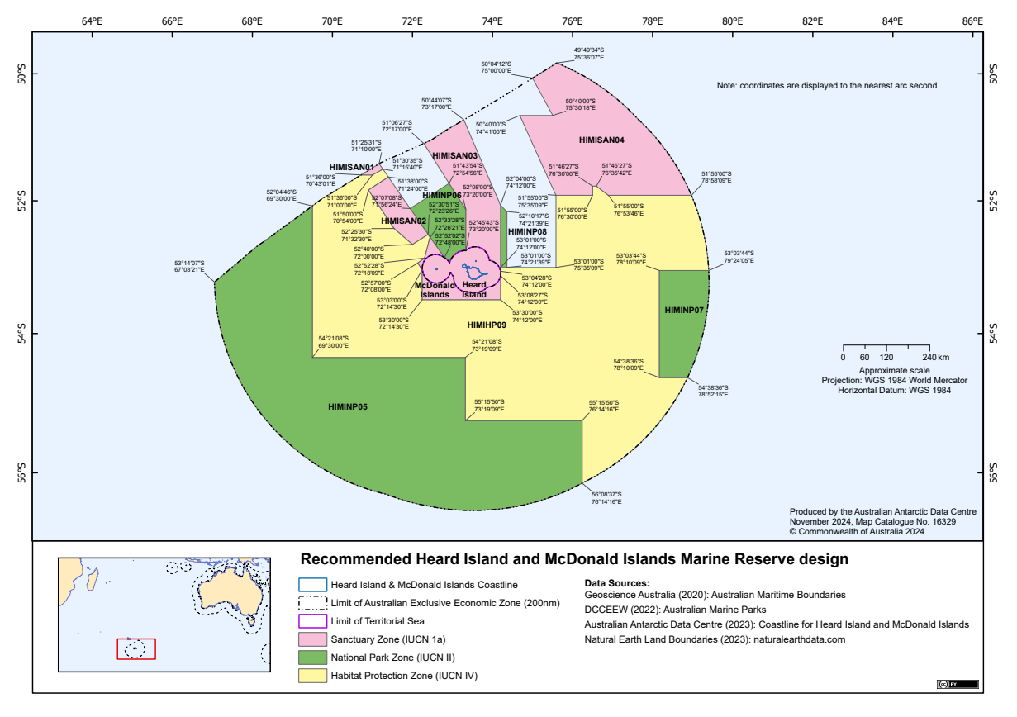
Attachment C

