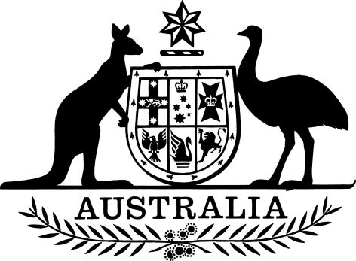

Autonomous Sanctions (Designated Persons and Entities and Declared Persons – Thematic Sanctions) Amendment (No. 5) Instrument 2024
I, PENNY WONG, Minister for Foreign Affairs, make the following instrument.
Dated thirtieth September 2024
PENNY WONG
Minister for Foreign Affairs

Contents
1 Name 1
2 Commencement 1
3 Authority 1
4 Schedules 1
Schedule 1—Amendments 2
Autonomous Sanctions (Designated Persons and Entities and Declared Persons – Thematic Sanctions) Instrument 2022 2

1 Name
This instrument is the Autonomous Sanctions (Designated Persons and Entities and Declared Persons – Thematic Sanctions) Amendment (No. 5) Instrument 2024.

2 Commencement
(1) Each provision of this instrument specified in column 1 of the table commences, or is taken to have commenced, in accordance with column 2 of the table. Any other statement in column 2 has effect according to its terms.

Commencement information
Column 1 | Column 2 | Column 3
Provisions | Commencement | Date/Details
1. The whole of this instrument | The day after this instrument is registered.
Note: This table relates only to the provisions of this instrument as originally made. It will not be amended to deal with any later amendments of this instrument.
(2) Any information in column 3 of the table is not part of this instrument. Information may be inserted in this column, or information in it may be edited, in any published version of this instrument.

3 Authority
This instrument is made under subregulation 6A(2) of the Autonomous Sanctions Regulations 2011.

4 Schedules
Each instrument that is specified in a Schedule to this instrument is amended or repealed as set out in the applicable items in the Schedule concerned, and any other item in a Schedule to this instrument has effect according to its terms.

Schedule 1—Amendments

Autonomous Sanctions (Designated Persons and Entities and Declared Persons – Thematic Sanctions) Instrument 2022
1 Clause 1 of Schedule 3 (at the end of the table)
Add:

3 | Name of individual | Maksim Viktorovich YAKUBETS
 | Also known as | Aqua
 | Date of birth | 20 May 1987
 | Citizenship | Russian
 | Instrument of first designation and declaration | Autonomous Sanctions (Designated Persons and Entities and Declared Persons – Thematic Sanctions) Amendment (No. 5) Instrument 2024
 | Additional information | Founder and leader of Evil Corp
4 | Name of individual | Igor Olegovich TURASHEV
 | Also known as | Enki; Nintutu
 | Date of birth | 15 June 1981
 | Citizenship | Russian
 | Instrument of first designation and declaration | Autonomous Sanctions (Designated Persons and Entities and Declared Persons – Thematic Sanctions) Amendment (No. 5) Instrument 2024
 | Additional information | Senior administrator of Evil Corp and DoppelPaymer
5 | Name of individual | Aleksandr Viktorovich RYZHENKOV
 | Also known as | Beverley
 | Date of birth | 26 May 1993
 | Citizenship | Russian
 | Instrument of first designation and declaration | Autonomous Sanctions (Designated Persons and Entities and Declared Persons – Thematic Sanctions) Amendment (No. 5) Instrument 2024
 | Additional information | Second-in-command of Evil Corp and Lockbit affiliate

