

Explosives Regulations 2024

I, the Honourable Frances Adamson AC, Administrator of the Commonwealth of Australia, acting with the advice of the Federal Executive Council, make the following regulations.

Dated 29 August 2024

Frances Adamson AC

Administrator

By Her Excellency’s Command

Richard Marles

Minister for Defence

Contents

Part 1—Preliminary 1

1 Name 1

2 Commencement 1

3 Authority 1

4 Schedule 3 1

5 Definitions 1

6 References in AE Code to Competent Authority 4

7 Commonwealth explosives area 4

Part 2—Handling of explosives 5

Division 1—Preliminary 5

8 Purpose of this Part 5

9 This Part not to apply in certain circumstances 5

Division 2—General rules relating to the transport of explosives 7

10 Transport of unauthorised Commonwealth explosives prohibited 7

11 Transport of certain authorised Commonwealth explosives prohibited 7

12 Application of AE Code 7

13 Persons around vehicles during loading and unloading of explosives 8

14 Smoking and other fire hazards around vehicles prohibited 8

15 Sections 12 and 13 do not apply in certain circumstances 8

Division 3—Transport of explosives under approved security plans 10

16 Approved security plan required for regulated Commonwealth agencies 10

17 Compliance with approved security plans 10

Division 4—Exemptions relating to transport of explosives 12

18 Applying for exemptions 12

19 Competent Authority may grant exemptions 12

20 AAT review of decisions 13

21 Carriage of exemptions in vehicles 14

Division 5—Containers previously containing Commonwealth explosives 15

22 Certification that containers are free from explosives 15

Part 3—Control of Commonwealth explosives areas 16

Division 1—Preliminary 16

23 Purpose of this Part 16

Division 2—Prohibited activities 17

24 Entry into a Commonwealth explosives area 17

25 Hindrance, obstruction and failure to comply with directions 17

26 Parking, stopping and mooring 17

27 Maximum speed limits 17

28 Smoking and other fire hazards 17

29 Persons under the influence of alcohol or drugs 18

Part 4—Other matters 19

Division 1—Competent Authority 19

30 Appointment and powers of Competent Authority 19

31 Delegation by Competent Authority 19

Division 2—Compliance auditors 20

32 Appointment of compliance auditors 20

33 Compliance audits 20

34 Identity cards for compliance auditors 21

Division 3—Area managers 22

35 Area manager 22

36 Consent to enter area 22

37 Signs relating to entering Commonwealth explosives areas 22

38 Determinations and signs for vehicles or vessels 22

39 Determinations and signs in relation to fire hazard areas 23

40 Directions 23

41 Removal of persons, vehicles etc. 23

Division 4—Committees of Advice 24

42 Committees of advice 24

Division 5—Orders 25

43 List of authorised Commonwealth explosives 25

44 Circumstances requiring special provision 25

Part 5—Application, saving and transitional provisions 26

Division 1—Amendments made by the Customs and Other Legislation Amendment (Australian Border Force) Regulation 2015 26

45 Amendments made by the *Customs and Other Legislation Amendment (Australian Border Force) Regulation 2015* 26

Division 2—Transitional provisions relating to the commencement of this instrument 27

46 Definitions 27

47 Things done under the old area regulations and the old transport regulations 27

48 Audits 27

49 Review by the Administrative Appeals Tribunal of exemption decisions of the Competent Authority 27

Schedule 1—Modifications of the AE Code in relation to Commonwealth explosives 28

Schedule 2—Commonwealth explosives areas 30

Part 1—Hut Forest Road, South Kiah 30

1.1 Land acquired by the Commonwealth 30

1.2 Plan 31

1.3 Land over which Commonwealth has rights 32

1.4 Plan 33

Part 2—Twofold Bay, Eden 34

2.1 Land over which Commonwealth has rights 34

2.2 Plan 35

Schedule 3—Repeals 36

Explosives Areas Regulations 2003 36

Explosives Transport Regulations 2002 36

Part 1—Preliminary

1 Name

This instrument is the *Explosives Regulations 2024*.

2 Commencement

(1) Each provision of this instrument specified in column 1 of the table commences, or is taken to have commenced, in accordance with column 2 of the table. Any other statement in column 2 has effect according to its terms.

| Commencement information | | |
| --- | --- | --- |
| Column 1 | Column 2 | Column 3 |
| Provisions | Commencement | Date/Details |
| 1. The whole of this instrument | The day after the end of the period of 28 days beginning on the day this instrument is registered. | 27 September 2024 |

Note: This table relates only to the provisions of this instrument as originally made. It will not be amended to deal with any later amendments of this instrument.

(2) Any information in column 3 of the table is not part of this instrument. Information may be inserted in this column, or information in it may be edited, in any published version of this instrument.

3 Authority

This instrument is made under the *Explosives Act 1961*.

4 Schedule 3

Each instrument that is specified in Schedule 3 to this instrument is amended or repealed as set out in the applicable items in that Schedule, and any other item in that Schedule has effect according to its terms.

5 Definitions

Note: The following expressions used in this instrument are defined in the Act:

(a) explosives;

(b) handling;

(c) vessel.

In this instrument:

***Act*** means the *Explosives Act 1961*.

***AE Code*** (short for Australian Explosives Code)means the third edition of the *Australian Code for the Transport of Explosives by Road and Rail* endorsed by the Workplace Relations Ministers’ Council on 3 April 2009.

Note: The AE Code can be viewed on the Safe Work Australia website (https://www.safeworkaustralia.gov.au).

***approved security plan*** for a regulated Commonwealth agency means a security plan approved by the Competent Authority under subsection 16(2), for the regulated Commonwealth agency.

***authorised Commonwealth explosive*** means a Commonwealth explosive, or a kind of Commonwealth explosive, specified in an order made under subsection 43(1).

***Commonwealth explosives*** means explosives to which Part II of the Act applies.

Note: See sections 5 and 9 of the Act.

***Commonwealth explosives area*** has the meaning given by section 13 of the Act.

Note: See also section 7 of this instrument.

***Commonwealth land*** has the meaning given by section 13 of the Act.

***Commonwealth public official*** has the meaning given by the *Criminal Code*.

***Competent Authority*** means the person appointed under section 30 as the Competent Authority.

Note: See also section 6 on references in the AE Code to Competent Authority.

***compliance auditor*** means a person appointed under section 32 to be a compliance auditor for the purposes of this instrument.

***fire hazard area*** means an area of a Commonwealth explosives area to which a determination under section 39 applies.

***involved***: a person who is ***involved*** in the transport of Commonwealth explosives or authorised Commonwealth explosives includes:

(a) a person who does one or more of the following:

(i) packs, or marks packages containing, Commonwealth explosives for transport by road or rail;

(ii) marks or placards freight containers and vehicles in which Commonwealth explosives are transported by road or rail;

(iii) consigns Commonwealth explosives for transport by road or rail, including preparing any documents and giving notices or other information required by or under the AE Code for the consignment of such explosives;

(iv) loads Commonwealth explosives onto a vehicle for transport by road or rail, including securing the explosives on the vehicle and doing anything to comply with any requirement of the AE Code limiting the quantity of such explosives that may be carried on the vehicle;

(v) unloads Commonwealth explosives that have been transported by road or rail;

(vi)undertakes a task that is required, in accordance with an approved security plan, to be undertaken for the security of Commonwealth explosives to which the security plan relates;

(vii) drives a road vehicle carrying Commonwealth explosives or acts as an attendant (within the meaning of the AE Code) for the transport of those explosives;

(viii) drives a rail vehicle carrying Commonwealth explosives or a train of which a rail vehicle carrying such explosives forms part;

(ix) undertakes maintenance on vehicles that are used to transport Commonwealth explosives by road or rail;

(x)undertakes a task in relation to the segregation of Commonwealth explosives from other Commonwealth explosives or other explosives including, if more than 2 rail vehicles are used to transport the explosives, a task in relation to the separation of the rail vehicles;

(xi)in the event of an emergency of a kind referred to in the AE Code involving Commonwealth explosives—anything that is required to be done by the AE Code in such an emergency;

(xii)provides training relating to Commonwealth explosives to drivers of vehicles transporting the explosives; and

(b) the owner (within the meaning of the AE Code) of a road vehicle that is being used to transport Commonwealth explosives; and

(c) a prime contractor (within the meaning of the AE Code) having responsibility for the transport of Commonwealth explosives by road or rail; and

(d) a rail operator (within the meaning of the AE Code) having responsibility for:

(i) the transport of Commonwealth explosives by rail; or

(ii) the condition of a rail vehicle transporting those explosives; and

(e) a person who:

(i) is, within the meaning of the AE Code, a supervisor or a person in charge; and

(ii) supervises, or is in charge of, an activity, or part of an activity, covered by this definition; and

(f) a Commonwealth public official, not covered by another paragraph of this definition, whose functions or duties include responsibility for the transport of Commonwealth explosives by road or rail.

***net explosive quantity*** means the actual quantity, expressed by mass, of explosive substance in an article, package or container.

***rail vehicle*** means a unit of rail rolling stock used for transporting goods on a railway.

***regulated Commonwealth agency*** means:

(a) the Australian Defence Force; or

(b) the Australian Federal Police; or

(c) the Department administered by the Minister administering Part XII of the *Customs Act 1901*; or

(d) the Department.

***road vehicle*** means a vehicle of a kind used for transporting goods on a road and includes a combination road vehicle (within the meaning of the AE Code).

***unauthorised Commonwealth explosive*** means a Commonwealth explosive, or a kind of Commonwealth explosive, that is not specified in an order made under subsection 43(1).

***vehicle*** means a road vehicle or a rail vehicle.

6 References in AE Code to Competent Authority

For the purposes of this instrument, a reference in the AE Code to the Competent Authority is to be read, in relation to any matter concerning Commonwealth explosives, as if it were a reference to the Competent Authority appointed under section 30.

7 Commonwealth explosives area

For the purposes of the definition of ***Commonwealth explosives area*** in section 13 of the Act, each area of Commonwealth land mentioned in Schedule 2 of this instrument is declared to be a Commonwealth explosives area.

Part 2—Handling of explosives

Division 1—Preliminary

8 Purpose of this Part

This Part is made for the purposes of section 10 of the Act.

9 This Part not to apply in certain circumstances

(1) This Part does not apply to:

(a) the packaging and marking, by the Australian Defence Force or the Department, of a Commonwealth explosive that has been recovered in an explosive ordnance disposal operation conducted by the Australian Defence Force or the Department; or

(b) a person who is involved in the transport of Commonwealth explosives during:

(i) an approved special activity carried on by the Australian Defence Force; or

(ii) any training or other activity carried on for that approved special activity; or

(c) the transport of an explosives demolition kit by the Australian Defence Force or the Australian Federal Police for the demolition of explosives; or

(d) a person who is involved in the transport of Commonwealth explosives during:

(i) an authorised covert operation carried on by the Australian Federal Police; or

(ii) any training or other activity carried on for that operation; or

(e) a person who is involved in the transport of Commonwealth explosives during:

(i) an operation carried on by that part of the Australian Federal Police known as the AFP special operations team; or

(ii) any training or other activity carried on by that team for that operation; or

(f) explosives subject to customs control under the *Customs Act 1901*, other than any of those explosives for which a permission to move under section 71E of that Act has been given; or

(g) a person who is involved in the transport of Commonwealth explosives that have been detected and seized by a Commonwealth public official in circumstances in which it is reasonable to believe that there is a threat to national security or public safety; or

(h) the transport of Commonwealth explosives on a light vehicle by a Commonwealth public official if:

(i) the explosives are authorised explosives within the meaning of the AE Code; and

(ii) the explosives do not include detonators; and

(iii) the net explosive quantity of the explosives is one kilogram or less.

(2) The Chief of the Defence Force, or a service chief, may, in writing, authorise a person for the purposes of this subsection, if the person is:

(a) an officer of the Navy who holds the rank of Lieutenant Commander or a higher rank; or

(b) an officer of the Army who holds the rank of Major or a higher rank; or

(c) an officer of the Air Force who holds the rank of Squadron Leader or a higher rank.

(3) An authorised officer may, in writing, for the purposes of this subsection, approve an activity, if the activity is:

(a) for the purposes of, or a purpose related to, the defence of the Commonwealth; or

(b) for any utilisation of the Australian Defence Force under Part IIIAAA of the *Defence Act 1903*.

(4) In this section:

***approved special activity*** means an activity approved under subsection (3).

***authorised covert operation*** means an operation within the functions of the Australian Federal Police that is authorised as a covert operation by a member of the Australian Federal Police at or above the rank of sergeant.

***authorised officer*** means an officer authorised under subsection (2).

***light vehicle*** means a road vehicle that has a maximum laden mass, as specified by the manufacturer, of 4.5 tonnes or less.

Division 2—General rules relating to the transport of explosives

10 Transport of unauthorised Commonwealth explosives prohibited

A person must not transport unauthorised Commonwealth explosives, or permit unauthorised Commonwealth explosives to be transported, by road or rail.

Note: Penalties for a failure to comply with this section are set by section 20 of the Act.

11 Transport of certain authorised Commonwealth explosives prohibited

(1) A person contravenes this subsection if:

(a) the person transports, by road or rail, authorised Commonwealth explosives; and

(b) the explosives are:

(i) not stable; or

(ii) of a kind that are classified in the AE Code as in class 1.1A; or

(iii) not capable of passing the tests, or meeting the criteria, applicable to the explosives set out or referred to in the United Nations manual called *Manual of Tests and Criteria ‑ Eighth Revised Edition* (ISBN: 9789210019033), published in October 2023, part of the periodical Recommendations on the Transport of Dangerous Goods: Tests and Criteria; and

(c) either:

(i) the person does not have written permission under subsection (2) to transport the explosives; or

(ii) if the person has written permission under subsection (2) to transport the explosives—the person does not comply with a condition of the permission.

Note 1: The *Manual of Tests and Criteria ‑ Eight Revised Edition* could in 2024 be viewed on the United Nations iLibrary website (https://www.un‑ilibrary.org).

Note 2: Penalties for a failure to comply with this subsection are set by section 20 of the Act.

(2) The Competent Authority may, for the purposes of subparagraph (1)(c)(ii), grant written permission, subject to any conditions specified in the permission, to a person to transport, by road or rail, authorised Commonwealth explosives.

12 Application of AE Code

(1) A person who is involved in the transport of authorised Commonwealth explosives must comply with any requirement of the AE Code, as modified by Schedule 1 of this instrument, that is applicable to the person.

Note: Penalties for a failure to comply with this subsection are set by section 20 of the Act.

(2) However, if there is an inconsistency between a requirement of the AE Code, as it applies to the person, and a requirement of this instrument, or of an order made under paragraph 44(1)(a) or (b), as it applies to the person, the requirement of this instrument, or of the order, prevails to the extent of the inconsistency.

13 Persons around vehicles during loading and unloading of explosives

(1) A person (other than a person mentioned in subsection (2)) must not be in, on or in the vicinity of a vehicle if:

(a) authorised Commonwealth explosives are being loaded onto, or unloaded from, the vehicle; and

(b) the person does not have the consent of the person in charge of the vehicle.

Note 1: The AE Code includes provisions about persons riding in vehicles that are carrying explosives.

Note 2: Penalties for a failure to comply with this subsection are set by section 20 of the Act.

(2) For the purposes of subsection (1), the persons are as follows:

(a) the driver of the vehicle;

(b) a person involved in loading or unloading the vehicle;

(c) a member of a fire brigade established by or under a law of a State or Territory;

(d) a member or special member of the Australian Federal Police;

(e) an officer of the Police of a State or Territory.

14 Smoking and other fire hazards around vehicles prohibited

(1) A person contravenes this subsection if:

(a) the person is within 6 metres of a vehicle on which authorised Commonwealth explosives are loaded; and

(b) the person:

(i) smokes; or

(ii) is in possession of, creates or uses any fire or naked light.

(2) A person contravenes this subsection if:

(a) the person is in the vicinity of a vehicle on which authorised Commonwealth explosives are loaded; and

(b) the person engages in conduct that is likely to result in a fire or explosion affecting the explosives on the vehicle.

Note 1: See the provisions of the AE Code about smoking and other fire hazards near vehicles that are carrying explosives.

Note 2: Penalties for a failure to comply with subsections (1) and (2) of this section are set by section 20 of the Act.

15 Sections 12 and 13 do not apply in certain circumstances

(1) Sections 12 and 13 do not apply to:

(a) a person who is involved in the transport of authorisedCommonwealth explosives in a place:

(i) that is occupied or controlled by the Defence Force or a part of the Defence Force; or

(ii) that was declared, under repealed regulation 49 of the *Defence Force Regulations 1952*, to be a defence practice area; or

(iii) that is declared, under regulations made for the purposes of the *Defence Act 1903*, to be a defence area; or

(iv) where Commonwealth explosives are manufactured or tested; or

(b) the transport, between a place that is occupied or controlled by a part of the Defence Force and a nearby place where a particular training exercise is being, or is to be, carried out by that part of the Defence Force, on a vehicle forming part of the equipment of that part of the Defence Force, of authorised Commonwealth explosives to be used for the purposes of that training exercise.

Note 1: In relation to subparagraph (1)(a)(ii): Part XI of the *Defence Force Regulations 1952* continues to apply in relation to a defence practice area that was, immediately before the repeal of those regulations, declared under subregulation 49(1) of those regulations (see subsection 87(3) of the *Defence Regulation 2016*).

Note 2: There are also exemptions included in the AE Code (see Chapter 1 of the AE Code).

(2) In this section:

***Defence Force*** means:

(a) the Australian Defence Force; or

(b) the naval, military or air forces of another country that are in the Commonwealth or a Territory, with the approval of the Commonwealth for the purposes of, or a purpose related to, the defence of the Commonwealth.

Division 3—Transport of explosives under approved security plans

16 Approved security plan required for regulated Commonwealth agencies

(1) A regulated Commonwealth agency that transports, or will transport, Commonwealth explosives by road or rail must ensure that an approved security plan for the regulated Commonwealth agency:

(a) is in place; and

(b) covers the transport of the Commonwealth explosives.

Note: Penalties for a failure to comply with this subsection are set by section 20 of the Act.

(2) The Competent Authority may approve a security plan for a regulated Commonwealth agency if the security plan:

(a) covers the arrangements and procedures for the transport of Commonwealth explosives by road or rail by or for the agency; and

(b) includes the following:

(i) a description of the measures for preventing the theft of Commonwealth explosives being transported by road or rail and for preventing unauthorised people from having access to those explosives;

(ii) a statement setting out the vehicle design requirements for vehicles used to transport Commonwealth explosives, and the load securing requirements for securing and protecting those explosives;

(iii) a description of the arrangements for emergency communications in the event of an emergency involving those explosives;

(iv) a statement setting out the requirements for training for persons involved in the transport of Commonwealth explosives by road or rail;

(v) a statement setting out the requirements for ensuring that vehicles transporting Commonwealth explosives travel by the safest practicable route, including the procedures for planning transport routes;

(vi) a statement setting out the requirements for consultation with State and Territory bodies concerned with the transport of explosives by road or rail;

(vii) any other matter the Competent Authority considers necessary for the transport.

17 Compliance with approved security plans

(1) A person who transports authorised Commonwealth explosives for a regulated Commonwealth agency must comply with any requirement of an approved security plan for the regulated Commonwealth agency that:

(a) is applicable to the person; and

(b) the agency has expressly made known to the person.

Note: Penalties for a failure to comply with this subsection are set by section 20 of the Act.

(2) However, if there is an inconsistency between a requirement of an approved security plan, as it applies to the person, and a requirement of this instrument, or of an order made under paragraph 44(1)(a) or (b), as it applies to the person, the requirement of this instrument, or of the order, prevails to the extent of the inconsistency.

Division 4—Exemptions relating to transport of explosives

18 Applying for exemptions

(1) A person (the ***applicant***) may apply to the Competent Authority for an exemption from compliance with a provision of this instrument.

(2) An application for an exemption must:

(a) be in writing; and

(b) state the applicant’s name and address; and

(c) specify the provision, or each provision, of this instrument, and, if applicable, of the AE Code, to which the application relates; and

(d) state whether the exemption is to apply only to a specified person or to every person included in a class of persons who might otherwise be bound to comply with the provision or provisions; and

(e) specify the Commonwealth explosives to which the application relates; and

(f) state the reasons why the applicant thinks that the exemption is necessary; and

(g) set out details of how the applicant proposes to ensure that the explosives will be handled in a way that:

(i) reduces as far as practicable the risks of personal injury, property damage and environmental harm arising from the transport of Commonwealth explosives by road or rail, and the risk of that transport endangering public safety; and

(ii) ensures the security of the explosives; and

(h) if the application relates to a vehicle, equipment, packaging or other thing—describe the thing; and

(i) state the period for which the exemption is sought; and

(j) state the geographical area within which the exemption is to apply.

(3) If the Competent Authority reasonably needs more information or another document to allow the Competent Authority to consider the application, the Competent Authority may, in writing, request the applicant to give the Competent Authority the information, the document or a copy of the document, specified in the request.

(4) If the Competent Authority asks for information or a document under subsection (3), the Competent Authority may choose to not consider the application further until the applicant gives to the Competent Authority the information, the document or a copy.

19 Competent Authority may grant exemptions

(1) The Competent Authority may, on application, grant an exemption from compliance with a provision of this instrument.

(2) An exemption granted under subsection (1) must be in writing.

(3) In deciding whether to grant the exemption, the Competent Authority must have regard to whether the explosives proposed to be covered by the exemption will be handled in a way that:

(a) reduces as far as practicable:

(i) the risks of personal injury, property damage and environmental harm arising from the transport of the explosives by road or rail; and

(ii) the risk of that transport endangering public safety; and

(b) ensures the security of the explosives.

(4) An exemption may be granted subject to the applicant, specified person or each person in the class, complying with any conditions that the Competent Authority considers necessary to:

(a) reduce as far as practicable:

(i) the risks of personal injury, property damage and environmental harm arising from the transport of the explosives to which the exemption relates by road or rail; and

(ii) the risk of that transport endangering public safety; and

(b) ensure the security of the explosives.

(5) After making a decision on an application for an exemption, the Competent Authority must notify the applicant in writing as soon as practicable of the decision.

(6) If the decision is to grant the exemption, the notice must:

(a) state the provision that is, or provisions that are, the subject of the exemption; and

(b) specify the person, or describe the class of persons, to whom the exemption applies; and

(c) specify the Commonwealth explosives to which the exemption relates; and

(d) state the period (which must be no longer than 12 months) for which the exemption is to remain in force; and

(e) state any conditions considered necessary under subsection (4) to which the exemption is subject; and

(f) specify the geographical area to which the exemption applies.

(7) Unless sooner revoked, the exemption remains in force for the period specified in the notice.

(8) The Competent Authority must retain a copy of each exemption granted for 2 years after the day it was given.

Note: Penalties for a failure to comply with this subsection are set by section 20 of the Act.

20 AAT review of decisions

Applications may be made to the Administrative Appeals Tribunal for review of decisions of the Competent Authority under section 19 to:

(a) refuse to grant an exemption; or

(b) grant an exemption on terms not sought by the applicant; or

(c) impose a particular condition on an exemption.

21 Carriage of exemptions in vehicles

Sections 8.2.8 and 8.2.9 of Chapter 8 of the AE Code apply in relation to an exemption granted under section 19 as if a reference to transport documentation in those sections were a reference to the exemption.

Division 5—Containers previously containing Commonwealth explosives

22 Certification that containers are free from explosives

(1) If:

(a) a consignor consigns a container that previously contained Commonwealth explosives; and

(b) the container is free from explosives;

the consignor must certify that the container is free from explosives.

(2) If the consignor certifies a container as free from explosives, the consignor must remove from the container, deface or cover, any label or marking that specifies a classification code or United Nations number.

(3) If a container or package that has contained Commonwealth explosives, or purports to have contained Commonwealth explosives, has not been certified in accordance with subsection (1), a person must not cause any label affixed to, or marking on, the container or package specifying a classification code or United Nations number to be defaced or obscured.

(4) If a container or package that has contained Commonwealth explosives, or purports to have contained Commonwealth explosives, has not been certified as free from explosives in accordance with subsection (1), a person must handle the package or container as if it contains explosives.

Note: Penalties for a failure to comply with subsection (1), (2), (3) or (4) of this section are set by section 20 of the Act.

(5) In this section:

***classification code*** has the meaning given by the AE Code.

***consignor*** has the meaning given by the AE Code.

***United Nations number*** has the meaning given by the AE Code.

Part 3—Control of Commonwealth explosives areas

Division 1—Preliminary

23 Purpose of this Part

This Part is made for the purposes of section 14 of the Act.

Division 2—Prohibited activities

24 Entry into a Commonwealth explosives area

(1) A person must not enter or remain within a Commonwealth explosives area.

(2) Subsection (1) does not apply if the person is:

(a) the area manager for the Commonwealth explosives area, appointed under section 35; or

(b) acting in accordance with written consent provided by the area manager for the area under section 36.

Note 1: A defendant bears an evidential burden in relation to the matter in subsection (2) (see subsection 13.3(3) of the Criminal Code).

Note 2: Penalties for a failure to comply with this section are set by section 20 of the Act.

25 Hindrance, obstruction and failure to comply with directions

(1) A person in a Commonwealth explosives area must not:

(a) hinder or obstruct the area manager of a Commonwealth explosives area in the exercise of the area manager’s powers or functions; or

(b) fail to comply with a direction under section 40.

Note: Penalties for a failure to comply with this subsection are set by section 20 of the Act.

(2) Paragraph (1)(b) does not apply if the person has a reasonable excuse.

Note: A defendant bears an evidential burden in relation to the matter in this subsection (see subsection 13.3(3) of the Criminal Code).

26 Parking, stopping and mooring

A person in a Commonwealth explosives area must not park or stop a vehicle, or moor or stop a vessel:

(a) in contravention of a sign erected by the area manager; or

(b) in a way that would unreasonably obstruct the passage of other vehicles or vessels.

Note: Penalties for a failure to comply with this section are set by section 20 of the Act.

27 Maximum speed limits

A person in a Commonwealth explosives area must not drive or ride a vehicle, or operate a vessel, on a part of a Commonwealth explosives area at more than the maximum speed permitted for the vehicle or vessel in that part of the area, as indicated by any sign erected by the area manager.

Note: Penalties for a failure to comply with this section are set by section 20 of the Act.

28 Smoking and other fire hazards

A person contravenes this section if:

(a) the person is in a Commonwealth explosives area; and

(b) the person is either:

(i) within 6 metres of explosives; or

(ii) in a fire hazard area; and

(c) the person:

(i) smokes; or

(ii) is in possession of, creates or uses any fire or naked light; or

(iii) engages in conduct that is likely to result in a fire or an explosion.

Note: Penalties for a failure to comply with this section are set by section 20 of the Act.

29 Persons under the influence of alcohol or drugs

A person must not be under the influence of alcohol or a drug in or near a part of a Commonwealth explosives area in which explosives are being handled.

Note: Penalties for a failure to comply with this section are set by section 20 of the Act.

Part 4—Other matters

Division 1—Competent Authority

30 Appointment and powers of Competent Authority

(1) The Minister may, in writing, appoint as the Competent Authority for the purposes of this instrument:

(a) an SES employee, or acting SES employee, in the Department; or

(b) an officer of the Navy who holds the rank of Commodore or a higher rank; or

(c) an officer of the Army who holds the rank of Brigadier or a higher rank; or

(d) an officer of the Air Force who holds the rank of Air Commodore or a higher rank.

(2) The Competent Authority may exercise all the powers of a compliance auditor.

(3) An appointment under subsection (1) may be made subject to conditions stated in the instrument of appointment.

31 Delegation by Competent Authority

(1) The Competent Authority may, in writing, delegate to a person referred to in subsection (2) all or any of the duties, functions and powers (however described) of the Competent Authority under this instrument other than:

(a) the power to appoint a person to be a compliance auditor under section 32; and

(b) the power to grant exemptions under section 19; and

(c) the power to make an order under section 43.

(2) For the purposes of subsection (1), the persons are as follows:

(a) an APS employee in the Department who is:

(i) classified as Executive Level 2, or equivalent, or higher; or

(ii) acting in a position usually occupied by an APS employee who is so classified;

(b) an officer of the Navy who holds the rank of Captain or a higher rank;

(c) an officer of the Army who holds the rank of Colonel or a higher rank;

(d) an officer of the Air Force who holds the rank of Group Captain or a higher rank.

Division 2—Compliance auditors

32 Appointment of compliance auditors

(1) The Competent Authority may, in writing, appoint as a compliance auditor a person who:

(a) is experienced and trained in the safe handling of explosives; and

(b) has practical knowledge of Commonwealth explosives and of the legislation relating to the transport of such explosives by road or rail.

(2) An appointment may be made subject to conditions stated in the instrument of appointment.

33 Compliance audits

(1) For the purposes of finding out if the appropriate legislation is being complied with, a compliance auditor may:

(a) enter premises connected with, or used for the purposes of, activities carried on in relation to, or in relation to any matter incidental to, the transport of Commonwealth explosives by road or rail, or where any documents relating to those activities are kept; and

(b) conduct an audit by way of an examination or review of any aspect of those activities.

(2) However, a compliance auditor is not authorised to enter premises unless:

(a) the auditor produces the auditor’s identity card for inspection by the occupier of the premises; and

(b) the occupier of the premises has consented to the entry.

(3) In conducting the audit, the compliance auditor may exercise the following powers:

(a) the power to inspect the premises or anything found there that is connected with, or has been, is being or is likely to be used for the purposes of, the transport of Commonwealth explosives by road or rail;

(b) the power to take copies of or extracts from any documents inspected under paragraph (a);

(c) the power to take measurements of anything in or on the premises concerning the explosives;

(d) the power to make sketches or take photographs of anything in or on the premises concerning the explosives.

(4) Nothing in this section authorises a compliance auditor:

(a) to use force to any extent for the purpose of conducting the audit; or

(b) to conduct the audit against the expressed wishes of the occupier.

(5) A compliance auditor must, within 14 days after completing an audit, give to the Competent Authority a written report of the audit setting out the results of the audit.

(6) In this section:

***appropriate legislation*** means Part 2 of this instrument or orders made under paragraph 44(1)(a) or (b).

***occupier***, in relation to a vehicle, means the person in charge or apparently in charge of the vehicle.

***premises*** includes any place, whether enclosed, built on or not, any vehicle and any part of premises.

Note: Penalties for a failure to comply with subsection (2), (4) or (5) of this section are set by section 20 of the Act.

34 Identity cards for compliance auditors

(1) The Competent Authority must issue to a compliance auditor an identity card that:

(a) shows a recent photograph of the compliance auditor; and

(b) includes:

(i) the signature of the compliance auditor; and

(ii) the name and office of the compliance auditor; and

(iii) the date that the card expires.

(2) A person who ceases to be a compliance auditor must, as soon as practicable, return the person’s identity card to the Competent Authority.

Note: Penalties for a failure to comply with subsection (1) or (2) of this section are set by section 20 of the Act.

Division 3—Area managers

35 Area manager

(1) The Competent Authority must, in writing, appoint an area manager for each Commonwealth explosives area.

(2) The area manager of a Commonwealth explosives area:

(a) is responsible for the management and control of the area; and

(b) may carry out the area manager’s duties under this Division with any assistance the area manager thinks necessary.

(3) An appointment may be made subject to conditions specified in the instrument of appointment.

36 Consent to enter area

(1) An area manager for a Commonwealth explosives area may, for the purposes of paragraph 24(2)(b), give written consent to a person to enter the area.

(2) Consent may be given subject to conditions specified in the instrument of consent.

(3) Without limiting subsection (2), conditions may include requiring the person to observe signs displayed in the area indicating times during which persons with consent may or may not access the area.

37 Signs relating to entering Commonwealth explosives areas

The area manager may erect a sign in a Commonwealth explosives area, including to indicate any restrictions that apply in relation to entering the area.

38 Determinations and signs for vehicles or vessels

(1) The area manager of a Commonwealth explosives area may, in writing, determine:

(a) places in the area where a person is, or is not, permitted to park or stop a vehicle or a class of vehicles or to moor or stop a vessel or a class of vessels; and

(b) the conditions under which a person is, or is not, permitted to park or stop a vehicle or a class of vehicles, or to moor or stop a vessel or a class of vessels, in those places; and

(c) the maximum speed for a vehicle or vessel, or a class of vehicles or vessels, in all or part of the area.

(2) The area manager must erect prominently displayed signs in relation to any determinations made under subsection (1).

39 Determinations and signs in relation to fire hazard areas

(1) The area manager may, in writing, determine an area of a Commonwealth explosives area as a fire hazard area.

(2) The area manager must erect prominently displayed signs in relation to any determinations made under subsection (1).

40 Directions

(1) The area manager for a Commonwealth explosives area may give directions to a person in the area to ensure:

(a) the safety of any person in or near the area; or

(b) protection from damage of any property in or near the area.

(2) The area manager for a Commonwealth explosives area may give directions to a person about handling explosives in or near the area if:

(a) the explosives have spilled from their container; or

(b) the explosives are in a damaged container.

41 Removal of persons, vehicles etc.

(1) The area manager of a Commonwealth explosives area may remove from the area:

(a) a person who has entered the area without consent and any vehicle or vessel used by the person; or

(b) a person who the area manager reasonably believes has endangered or may endanger the safety of persons, or has damaged or may damage property, in or near the area.

(2) The area manager of a Commonwealth explosives area may move a vehicle or vessel to another place in the area if:

(a) the person in control of the vehicle or vessel refuses or fails to comply with a direction under section 40 to remove the vehicle or vessel from the place where it is parked, moored or stopped; or

(b) for a parked vehicle or moored vessel:

(i) the area manager cannot communicate with the driver or master after taking reasonable steps to do so; and

(ii) had the area manager been able to communicate with the driver or master, the area manager would have given the driver or master a direction under section 40 to move the vehicle or vessel.

Division 4—Committees of Advice

42 Committees of advice

The Minister may, in writing, establish a committee or committees, consisting of persons appointed by the Minister, to advise the Minister on matters relating to explosives and the handling of explosives.

Division 5—Orders

43 List of authorised Commonwealth explosives

(1) The Competent Authority must specify, by order, Commonwealth explosives, or kinds of Commonwealth explosives, for the purposes of this subsection.

Note: Orders are legislative instruments (see subsection 16(1) of the Act).

(2) For the purposes of section 17 of the Act, an order made under subsection (1) of this section takes effect at the start of the day after the day the instrument is registered.

44 Circumstances requiring special provision

(1) If the Minister is satisfied that there are circumstances requiring special provision to be made under this section, the Minister may make provision, by order:

(a) in relation to, or in relation to any matter incidental to, the handling of Commonwealth explosives; and

(b) in relation to safety measures to be observed at, in or on a place, vehicle, aircraft or vessel at, in, on or in the vicinity of which there are Commonwealth explosives; and

(c) for safety measures to be observed in or near a Commonwealth explosives area.

Note 1: Penalties for a failure to comply with an order are set by section 20 of the Act.

Note 2: Orders are legislative instruments (see subsection 16(1) of the Act).

(2) For the purposes of section 17 of the Act, an order made under subsection (1) of this section takes effect at the start of the day after the day the instrument is registered.

(3) If there is an inconsistency between a provision of this instrument and a provision of an order made by the Minister under this section, the order prevails to the extent of the inconsistency.

(4) An order ceases to have effect at the earliest of the following:

(a) the end of 12 months after the day on which the order takes effect;

(b) the end of any shorter period that is specified in the order;

(c) the order is revoked.

Part 5—Application, saving and transitional provisions

Division 1—Amendments made by the Customs and Other Legislation Amendment (Australian Border Force) Regulation 2015

45 Amendments made by the *Customs and Other Legislation Amendment (Australian Border Force) Regulation 2015*

An approved security plan of the Australian Customs and Border Protection Service that was in force under regulation 26 of the *Explosives Transport Regulations 2002* immediately before 1 July 2015 continues in force on and after that day as if it were an approved security plan of the Department administered by the Minister administering Part XII of the *Customs Act 1901*.

Division 2—Transitional provisions relating to the commencement of this instrument

46 Definitions

In this Division:

***old area regulations*** means the *Explosives Areas Regulations 2003*, as in force immediately before the commencement of this section.

***old transport regulations*** means the *Explosives Transport Regulations 2002*, as in force immediately before the commencement of this section.

47 Things done under the old area regulations and the old transport regulations

(1) If:

(a) a thing was done for a particular purpose under the old area regulations or the old transport regulations; and

(b) the thing could be done for that purpose under this instrument;

the thing has effect for the purposes of this instrument as if it had been done for that purpose under this instrument.

(2) Without limiting subsection (1), a reference in that subsection to a thing being done includes a reference to an application, appointment, determination, direction, exemption, notice or order being given or made.

48 Audits

Despite the repeal of the old transport regulations, regulation 13 of the old transport regulations continues to apply, after the commencement of this section, in relation to an audit that was commenced but not concluded at that commencement as if that repeal had not happened.

49 Review by the Administrative Appeals Tribunal of exemption decisions of the Competent Authority

(1) This section applies if:

(a) the Competent Authority makes a decision under regulation 16 of the old transport regulations before the commencement of this section; and

(b) immediately before that commencement, an application has not been made under regulation 19 of the old transport regulations for review by the Administrative Appeals Tribunal of that decision; and

(c) immediately before that commencement, the time for a person to make such an application has not ended (including any extensions of that time under section 29 of the *Administrative Appeals Tribunal Act 1975*).

(2) Despite the repeal of regulation 19 of the old transport regulations, that regulation, as in force immediately before the commencement of this section, continues to apply in relation to the Competent Authority’s decision as if that repeal had not happened.

Schedule 1—Modifications of the AE Code in relation to Commonwealth explosives

Note: See section 12.

1 After section 3.6(3)

*insert*

(4) However, a Class label for Commonwealth explosives that:

(a) are included in Division 1.4, 1.5 or 1.6; and

(b) were manufactured before 9 May2002;

may also display the symbol depicting an exploding bomb that is displayed on the label for explosives included in Division 1.1, 1.2 or 1.3, as shown in Figure 3.1.

2 Section 6.2(5)

*substitute*

(5) The above requirements do not apply to Commonwealth explosives when transported in or on a Commonwealth vehicle, within the meaning of the *Commonwealth Vehicles (Registration and Exemption from Taxation) Act 1997*, that displays registration plates issued for the Australian Defence Force.

(6) The above requirements do not apply to Commonwealth explosives that are being transported in or on a vehicle forming part of the naval, military or air forces of another country that are in the Commonwealth or a Territory with the approval of the Commonwealth for the purposes of, or a purpose related to, the defence of the Commonwealth.

(7) Despite anything else in this Chapter, a load of Commonwealth explosives may be transported in or on a vehicle that is approved for that purpose by the Competent Authority if it is impracticable to transport the load in an enclosed vehicle body that meets the applicable requirements of this Chapter because of the size or shape of the load or the way in which the vehicle is to be loaded or unloaded.

3 Table 7.2, including the notes

*substitute*

**TABLE 7.2**

Permitted mixed transport for Commonwealth Explosives

|  |  |  |  |  |  |  |  |  |  |  |  |  |  |  |
| --- | --- | --- | --- | --- | --- | --- | --- | --- | --- | --- | --- | --- | --- | --- |
| Compatibility Group | | | | | | | | | | | | | | |
| Compatibility Group |  | A(a) | B(b)(c)(j) | C(j) | D(j) | E(j) | F(j) | G(j) | H | J | K(g) | L(h) | N(j) | S(i)(j) |
| A(a) | (a) |  |  |  |  |  |  |  |  |  |  |  |  |
| B(b)(c)(j) |  | X | X(b)(c) | X(b)(c) | X(b)(c) | X(b)(c) | X(b)(c) |  |  |  |  |  | X |
| C(j) |  | X(b)(c) | X | X | X | X(d) | X(f)(e) |  |  |  |  | X(d)(e) | X |
| D(j) |  | X(b)(c) | X | X | X | X(d) | X(f)(e) |  |  |  |  | X(d)(e) | X |
| E(j) |  | X(b)(c) | X | X | X | X(d) | X(e) |  |  |  |  | X(d)(e) | X |
| F(j) |  | X(b)(c) | X(d) | X(d) | X(d) | X | X(d) |  |  |  |  | X(d) | X |
| G(j) |  | X(b)(c) | X(f)(e) | X(f)(e) | X(e) | X(d) | X |  |  |  |  | X(e) | X |
| H |  |  |  |  |  |  |  | X |  |  |  |  | X |
| J |  |  |  |  |  |  |  |  | X |  |  |  | X |
| K(g) |  |  |  |  |  |  |  |  |  | X(g) |  |  |  |
| L(h) |  |  |  |  |  |  |  |  |  |  | (h) |  |  |
| N(j) |  |  | X(d)(e) | X(d)(e) | X(d)(e) | X(d) | X(e) |  |  |  |  | X | X |
| S(i)(j) |  | X | X | X | X | X | X | X | X |  |  | X | X |

‘X’ indicates that explosives of the corresponding compatibility groups may be transported in the same compartment, carry box, freight container or vehicle (see section 7.3.2(3)).

***Notes:***

*(a) Substances that are included in compatibility group A must not form mixed loads with substances or articles that are included in another compatibility group and may be transported only with the written approval of the Competent Authority and in accordance with any conditions specified in the approval.*

*(b) Articles that are included in compatibility group B must not be transported in or on the same vehicle on which there are explosives that are included in another compatibility group, but fuzes that are included in compatibility group B may be carried with the articles to which the fuzes are designed to be attached. In this case, the NEQ of the fuzes is to be aggregated with that of the articles and the combined load is to be treated as a load of explosives that are included in compatibility group F.*

*(c) Detonators that are included in compatibility group B and packed in a manner approved by a Competent Authority as being effective to prevent propagation may be mixed in transport with explosives that are included in compatibility group C, D, E or F or with articles included in compatibility group G that are not liable to give rise to loose explosive powder. The combined load is to be treated as a load of explosives that are included in compatibility group F.*

*(d) Articles that are included in compatibility group F may be mixed in transport with articles that are included in compatibility group C, D, E or N or with articles included in compatibility group G that are not liable to give rise to loose explosive powder. The combined load is to be treated as a load of explosives that are included in compatibility group F.*

*(e) Articles that are included in compatibility group C, D, E or N and articles included in compatibility group G that are not liable to give rise to loose explosive powder may be mixed in transport. However, when articles that are included in compatibility group C, D or E are mixed with articles that are included in compatibility group N, the articles that are included in compatibility group N should be treated as articles that are included in compatibility group D.*

*(f) Substances included in compatibility group C, D or G that are packaged so as not to give rise to loose powder, and that are less sensitive to mechanical stimuli than dry RDX, may be mixed in transport. The combined load is to be treated as a single group.*

*(g) Articles that are included in compatibility group K must not be transported in or on the same vehicle as explosives that are included in any other compatibility group.*

*(h) Substances and articles that are included in compatibility group L may only be transported in or on the same vehicle as other articles and substances of the same kind and must not be mixed with other substances or articles.*

*(i) Inert items, and substances and articles that are included in compatibility group S, may be transported on the same vehicle as substances and articles that are included in another compatibility group, except compatibility group A, K or L.*

*(j) Articles of HD 1.4 may be mixed in transport with articles of compatibility group B, C, D, E, F, G, N or S.*

Schedule 2—Commonwealth explosives areas

Note: See section 7.

Part 1—Hut Forest Road, South Kiah

1.1 Land acquired by the Commonwealth

| Item | Descriptor | Description |
| --- | --- | --- |
| 1 | Area | 151.8 ha |
| 2 | Parish | Wonboyn |
| 3 | County | Auckland |
| 4 | State | New South Wales |
| 5 | Location | About 15 km south of Eden, about 1.9 km east of the junction of the Princes Highway and Edrom Road |
| 6 | Boundaries | As shown on the plan in section 1.2 of this Schedule, between Permanent Survey Marks 124670 and 124671 |

1.2 Plan

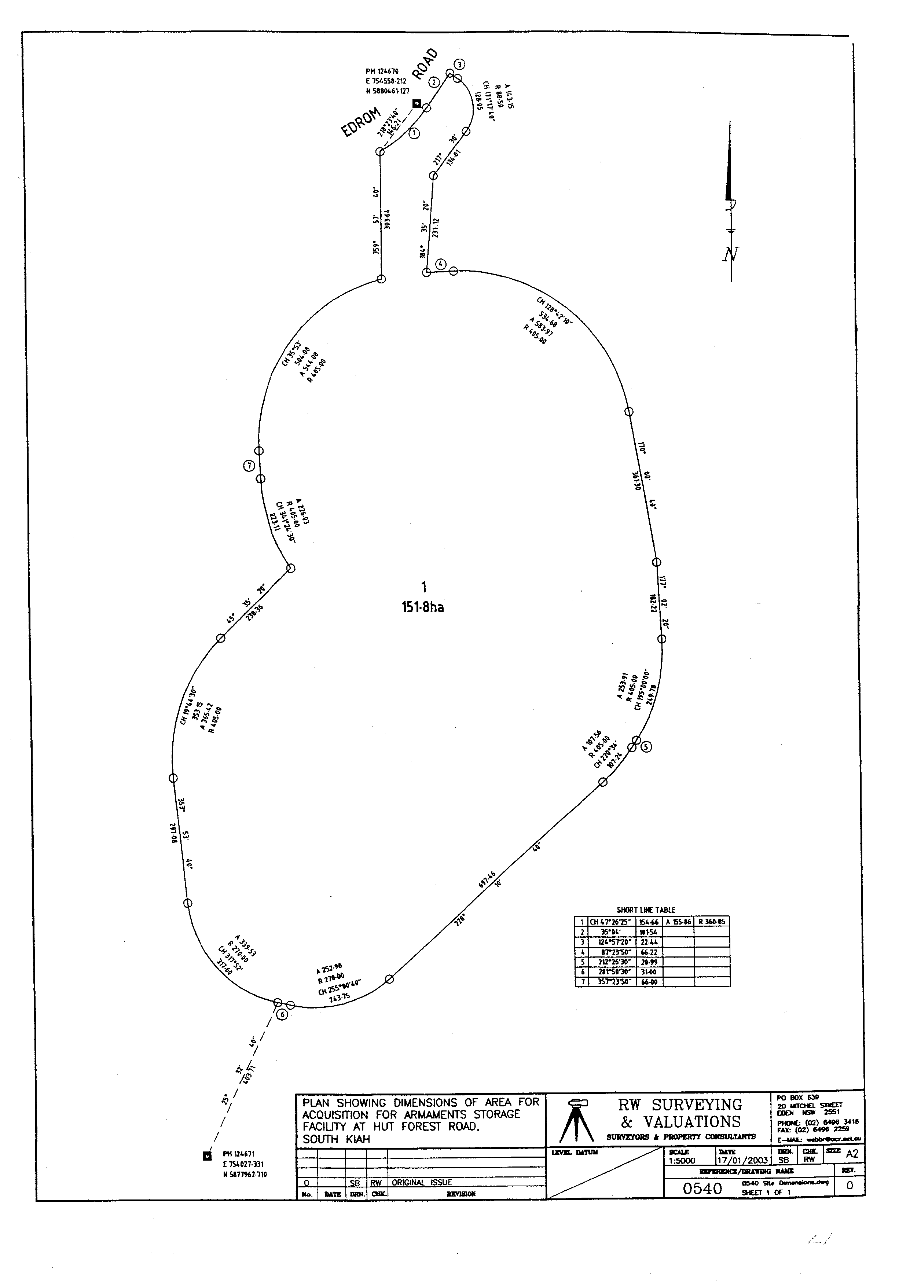

1.3 Land over which Commonwealth has rights

| Item | Descriptor | Description |
| --- | --- | --- |
| 1 | Area | 555.84 ha |
| 2 | Parish | Wonboyn |
| 3 | County | Auckland |
| 4 | State | New South Wales |
| 5 | Location | About 15 km south of Eden, about 1.9 km east of the junction of the Princes Highway and Edrom Road, surrounding the land mentioned in section 1.1 of this Schedule |
| 6 | Boundaries | As shown on the plan in section 1.4 of this Schedule, between Permanent Survey Marks 124670 and 124671 |

1.4 Plan

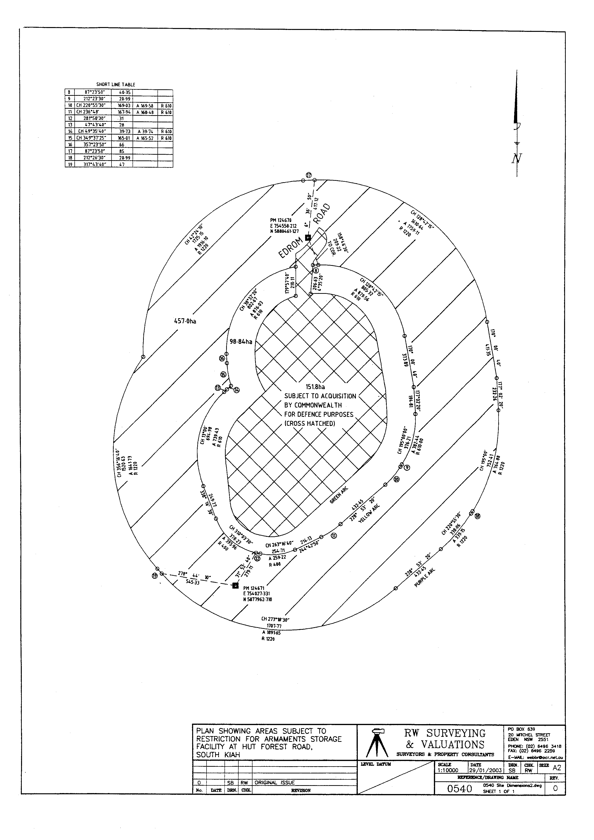

Part 2—Twofold Bay, Eden

2.1 Land over which Commonwealth has rights

| Item | Descriptor | Description |
| --- | --- | --- |
| 1 | Area | 598.285 ha |
| 2 | Parish | Kiah |
| 3 | County | Auckland |
| 4 | State | New South Wales |
| 5 | Location | About 5 km south of Eden |
| 6 | Boundaries | As shown on the plan in section 2.2 of this Schedule, being the land within a 1 380 m radius of the centre point of the wharf |

2.2 Plan

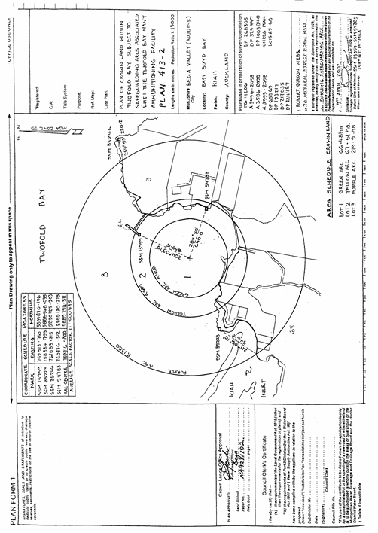

Schedule 3—Repeals

Explosives Areas Regulations 2003

1 The whole of the instrument

Repeal the instrument.

Explosives Transport Regulations 2002

2 The whole of the instrument

Repeal the instrument.