

Native Title (Recognition as Representative Body – Northern Land Council) Instrument 2024
I, Linda Burney MP, Minister for Indigenous Australians, make the following instrument.

Dated 12 June 2024
LINDA BURNEY MP
Minister for Indigenous Australians

Contents
1 Name 1
2 Commencement 1
3 Authority 1
4 Definitions 1
5 Schedules 1
6 Recognised Representative Aboriginal/Torres Strait Islander Body 2
7 Period of recognition 2
Schedule 1—Description of area (Northern Northern Territory) 3
Description of area 3
Map of area 4
Schedule 2— Repeals 5
Native Title (Recognition as Representative Body – Northern Land Council) Instrument 2018 5

1 Name
This instrument is the Native Title (Recognition as Representative Body – Northern Land Council) Instrument 2024.

2 Commencement
(1) Each provision of this instrument specified in column 1 of the table commences, or is taken to have commenced, in accordance with column 2 of the table. Any other statement in column 2 has effect according to its terms.

Commencement information
Column 1 | Column 2 | Column 3
Provisions | Commencement | Date/Details
1. The whole of this instrument | 1 July 2024
Note: This table relates only to the provisions of this instrument as originally made. It will not be amended to deal with any later amendments of this instrument.
(2) Any information in column 3 of the table is not part of this instrument. Information may be inserted in this column, or information in it may be edited, in any published version of this instrument.

3 Authority
This instrument is made under subsection 203AD(1) of the Native Title Act 1993.

4 Definitions
In this instrument:
Act means the Native Title Act 1993.
Representative Body means a representative Aboriginal/Torres Strait Islander body recognised under section 203AD of the Act.
Northern Land Council means the Northern Land Council as established under section 21 of the Aboriginal Land Rights (Northern Territory) Act 1976.

5 Schedules
Each instrument that is specified in a Schedule to this instrument is amended or repealed as set out in the applicable items in the Schedule concerned, and any other item in a Schedule to this instrument has effect according to its terms.
6 Recognised Representative Aboriginal/Torres Strait Islander Body
For subsection 203AD(1) of the Act, the Northern Land Council is recognised as the Representative Body for the area described in Schedule 1.
7 Period of recognition
For subsection 203AD(2) of the Act, this recognition as a Representative Body takes effect on 1 July 2024 and ceases to have effect at the end of 30 June 2030.

Schedule 1—Description of area (Northern Northern Territory)

1 The Northern Northern Territory area is, firstly, all the area of land and waters bounded by a line commencing at the intersection of the Northern Territory border, the Western Australia State border and the coastline of mainland Australia, and then proceeding south along the western border of the Northern Territory to its intersection with the Central Land Council boundary line, vide Aboriginal Land Rights (Northern Territory) Act 1976, published in the Australian Government Gazette No. S6, 26 January 1977, as amended by notice published in the Australian Government Gazette No. G34, 30 August 1977, then generally south-easterly along the aforesaid boundary to its intersection with the Northern Territory’s eastern border, then north along the eastern border of the Northern Territory to the intersection of the Northern Territory border, the Queensland State border, the coastline of mainland Australia, then generally north along the Northern Territory and Queensland adjacent area boundary as defined in Schedule 2 of the Petroleum (Submerged Land) Act 1967 to its intersection with the outer limit of the Exclusive Economic Zone of Australia (EEZ), then generally westerly along that outer limit to its intersection with the Northern Territory and Western Australia adjacent area boundary as defined in Schedule 2 of the Petroleum (Submerged Land) Act 1967, and then generally south by that adjacent area boundary to the point where the line began.

Secondly, all the area of land and waters bounded by a line commencing at the western intersection of the EEZ of Australia and the Western Australia and Territory of Ashmore and Cartier Islands adjacent area boundary as defined in Schedule 2 of the Petroleum (Submerged Land) Act 1967, and then proceeding generally easterly along that adjacent area boundary to the eastern intersection of the aforesaid boundary to the EEZ of Australia, and then generally westerly along the outer limit of the EEZ to the point where the line began.

2 In this Schedule:
exclusive economic zone means the exclusive economic zone within the meaning of the Seas and Submerged Lands Act 1973.

Northern Northern Territory

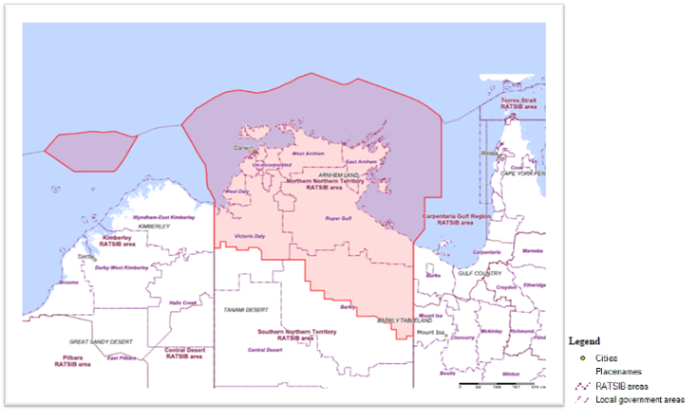
Alt text: Map and Legend showing description of Northern Northern Territory area

Schedule 2—Repeals

Native Title (Recognition as Representative Body – Northern Land Council) Instrument 2018
1 The whole of the instrument

Repeal the instrument.

