**EXPLANATORY STATEMENT**

Issued by authority of the Assistant Treasurer and Minister for Financial Services

*Competition and Consumer Act 2010*

*Consumer Goods (Toppling Furniture) Information Standard 2024*

**Authority**

The Assistant Treasurer and Minister for Financial Services (the **Minister**) has made the *Consumer Goods (Toppling Furniture) Information Standard 2024* (**the instrument**) pursuant to subsection 134(1) of the Australian Consumer Law (the **ACL**), which is Schedule 2 of the *Competition and Consumer Act 2010*(Cth) (the **CCA**).

**Purpose and operation of the instrument**

There have been at least 28 deaths associated with toppling furniture reported in Australia between 2000 and 2022. Additionally, toppling furniture incidents result in approximately 900 injuries that require medical treatment each year.

The most common cause of toppling furniture related fatalities are head and crush related injuries and asphyxiation. Of the 28 fatalities attributed to toppling furniture between 2000 and 2022, 17 involved children aged 4 years and under, with another 4 fatalities involving older Australians (60 years of age or older).

The cost of toppling furniture related deaths and injuries is estimated to be at least $8 million dollars per year but the true cost to families and communities is incalculable.

The purpose of the instrument is to reduce the risk of death and injury associated with toppling furniture including by requiring:

* permanent labels to be affixed to toppling furniture made available for sale which warn consumers as to the risks associated with toppling furniture and provide information as to how such furniture can be used safely, and
* the display of point of sale warnings, both instore and online, to raise awareness about the risks of toppling furniture.

A provision-by-provision description of the instrument is set out in the notes at **Attachment A**.

Pursuant to paragraph 131E(1)(i) of the CCA, the instrument is a legislative instrument for the purposes of the *Legislation Act 2003*.

By operation of subsections 44(1) and 54(1) of the *Legislation Act 2003*, the instrument is not subject to disallowance or sunsetting because its enabling legislation, the ACL (at Schedule 2 of the CCA), facilitates the operation of an intergovernmental scheme involving the Commonwealth and all the States and Territories (the *Intergovernmental Agreement for the Australian Consumer Law*), and the ACL authorises the making of the instrument for the purposes of that scheme. Item 16 in the table at section 12 of the *Legislation (Exemptions and Other Matters) Regulation 2015* also provides that the instrument is not subject to the sunsetting provisions of the *Legislation Act 2003*.

**Consultation**

Before the instrument was made, the Minister was satisfied that consultation was undertaken to the extent appropriate and reasonably practicable, in accordance with section 17 of the *Legislation Act 2003*.

The ACCC published, on its website, the *Toppling Furniture and Televisions Issues Paper* for public consultation from 2 - 30 August 2021. Thirty submissions were received responding to questions posed in the Issues Paper about toppling furniture in Australia, perceived safety risks, the regulatory environment, international standards, consumer information and product design. Stakeholder feedback broadly supported some form of regulation for toppling furniture and confirmed that there were existing safeguards, including requirements for mechanical stability and consumer information for televisions.

The ACCC published, on its website, the *Toppling Furniture Consultation Regulatory Impact Statement* from 13 May - 13 June 2022, inviting stakeholder feedback on policy options to improve the safety of storage furniture. Televisions were not within the scope of the regulatory options proposed.

In response, the ACCC received 31 submissions from a range of stakeholders including advocacy groups, state regulators, industry associations, manufacturers (large and small), medical practitioners, an overseas regulator, and members of the public.

Stakeholders unanimously agreed that educating consumers about the risks associated with toppling furniture would be beneficial. Consequently, the ACCC recommended that the Commonwealth Minister exercise his power under subsection 134(1) of the ACL to make an information standard in relation to toppling furniture to mitigate the identified risks.

The ACCC notified the World Trade Organization (WTO) of a draft version of the instrument on 25 July 2023 under the WTO Agreement on Technical Barriers to Trade. One submission was received from an industry participant outside of the WTO consultation period. The submission provided feedback about the scope and labelling requirements of the draft instrument. The issues raised by the submission were of a kind previously considered by the ACCC in the course of the two prior consultation processes. The ACCC did not receive any submissions from Member nations or industry associations.

In accordance with clause 34 of the *Intergovernmental Agreement for the Australian Consumer Law* the Minister is required to consult with relevant state and territory Ministers before making a mandatory information standard (such as the instrument). 5 jurisdictions (including 3 states) voted in favour of the proposed instrument following a period of formal consultation. The remaining 3 jurisdictions did not participate in the vote.

**Regulatory impact assessment**

A Regulation Impact Analysis has been undertaken by the ACCC and assessed by the Office of Impact Analysis as consistent with the six principles for Australian Government policy makers as specified in the Australian Government Guide to Regulatory Impact Analysis (OBPR21-01088).

**Documents incorporated by reference**

The instrument does not incorporate any documents by reference.

**Attachment A**

**Notes to the *Consumer Goods (Toppling Furniture) Information Standard 2024***

**Part 1 - Preliminary**

Section 1 – Name

This section provides for the instrument to be cited as the *Consumer Goods (Toppling Furniture) Information Standard 2024.*

Section 2 – Commencement

This section provides for the instrument to commence at the start of the day after the end of the period of 12 months beginning on the day this instrument is registered on the Federal Register of Legislation.

The Federal Register of Legislation may be accessed free of charge at www.legislation.gov.au.

Section 3 – Authority

This section provides that the instrument is made under subsection 134(1) of the ACL.

Section 4 – Definitions

This section defines a number of key terms used throughout the instrument.

A number of other expressions used in the instrument are defined in the CCA.

The definitions given to category 1, category 2 and category 3 furniture reference the common names of particular items of furniture. Where an item of furniture may be commonly known by a number of names, for example, a sideboard may also be referred to as a credenza, the definition of the relevant category of furniture should be interpreted to include that item of furniture regardless that it may be referred to by another common name not referenced in the definition.

Category 1 and category 3 furniture are defined as certain furniture 686mm or greater in height. That height aligns with the height specified in *ASTM F2057 – 23 Standard Safety Specification for Clothing Storage Units* (ASTM F2057). ASTM F2057 is a standard safety specification developed by American based standards body ASTM International and is intended to reduce injuries and death from hazards associated with the toppling over of furniture such as clothing storage units, chests of drawers and dressers. ASTM F02057 applies to furniture 27 inches or greater in height, which equates to 686mm.

An ‘electronic platform’ is defined to mean a service that enables a business to supply, or offer to supply, goods or services over the internet whether by a website, an online marketplace or other means. An electronic platform will include a website operated by a particular furniture retailer to supply, or offer to supply, that retailer’s furniture. An electronic platform will also include websites or online market places operated by third parties such as Amazon or eBay, by which a number of furniture retailers may supply, or offer to supply, their furniture. A website or other online service that does no more than carry or display advertisements for goods or services (but does not otherwise enable a business to supply, or offer to supply, those goods or services) will not be an electronic platform for the purposes of the instrument.

Section 5 – Meaning of *toppling furniture*

This section defines ‘toppling furniture’ to mean an item of category 1, category 2, or category 3 furniture.

To ensure that ‘built-in’ items of furniture are not captured by the definition of toppling furniture, furniture items that are designed to be affixed to a wall or other structure and which cannot be properly used unless so affixed, are excluded from the definition of toppling furniture. For example, in-built wardrobes and kitchen cabinets which are affixed to a wall or other structure, and which cannot be used properly unless so affixed, do not fall within the definition of toppling furniture for the purposes of the instrument.

However, where an item of furniture is designed such that it can be affixed to a wall or other structure (with, for example, an anchoring device) but that item of furniture can be used properly withoutaffixing the furniture to a wall or structure, it will be captured by the definition of toppling furniture.

By way of example, a bookcase that is category 1 furniture for the purposes of the instrument may come with pre-drilled holes and anchor devices by which the bookcase can be affixed to a wall. But if the bookcase can be properly used without being affixed to a wall by use of the anchor devices (because, for example, the bookcase remains upright without use of the anchor devices) it will be captured by the definition of toppling furniture.

Section 6 – Application

This section provides that the instrument applies to items of toppling furniture that are consumer goods. The ACL defines consumer goods as, ‘goods that are intended to be used, or are of a kind likely to be used for personal, domestic or household consumption […]’.

Paragraph 6(2)(a) provides that the instrument does not apply to an item of toppling furniture that has been acquired by a consumer (within the meaning given by section 3 of the ACL) and is subsequently being supplied or offered for supply. Paragraph 6(2)(b) provides that the instrument does not apply to a second-hand item of toppling furniture. This is to ensure that an item of toppling furniture that was initially acquired other than for personal, domestic or household use (for example, for commercial use) and that is subsequently being supplied or offered for supply for personal, domestic or household use, is not subject to the operation of the instrument.

**Part 2 – Requirements**

Part 2 of the instrument requires clear graphic and plain English warnings and safety information to be provided in connection with the supply of toppling furniture. Warnings required to be provided in accordance with Part 2 of the instrument include internationally recognised safety alert symbols and pictograms depicting a child standing or climbing on the toppling furniture, with a cross or strikethrough

Compliant (but not to scale) examples of the symbols and pictograms referenced in the instrument are set out below.

Further information about internationally recognised alert symbols can be found in voluntary industry standard *ISO 3864-2:2016 Graphical symbols—Safety colours and safety signs—Part 2: Design principles for product safety labels.*

Internationally recognised safety alert symbol

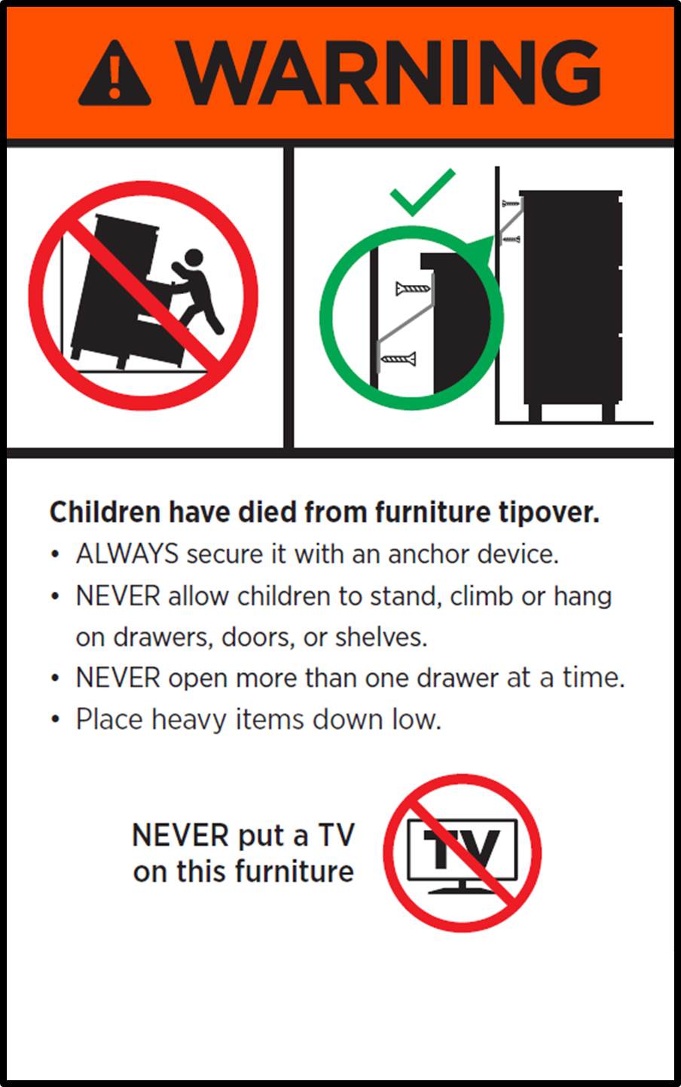

A pictogram that shows a child standing or climbing on the consumer good with a strikethrough

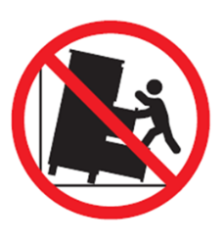

**Division 1 – Warnings and point of sale**

Section 7 – Display and supply of toppling furniture online

Subsection 7(1) provides that a person who carries on a business that supplies toppling furniture and uses an electronic platform to offer to supply toppling furniture to consumers, must cause a warning about the risk of tip overs and the importance of anchoring to be included in the description of the toppling furniture provided by the electronic platform.

The matters to be included in such warnings are set out in subsection 7(3) and, depending on whether the relevant toppling furniture is category 1, category 2 or category 3 furniture, subsection 7(4), 7(5) or 7(6).

The obligations set out in section 7 do not apply in circumstances where a website or other online service displays or carries advertisements for toppling furniture because advertisements will not, typically, constitute an offer to supply.

Section 8 – Display and supply of toppling furniture in stores

Subsection 8(1) provides that persons who conduct a business that supplies toppling furniture at retail premises (regardless that that person may also conduct a business supplying toppling furniture by use of an electronic platform) must cause a clearly visible, prominent and legible warning about the risk of tip overs and the importance of anchoring to be displayed on or near relevant toppling furniture. The note to subsection 8(1) clarifies that a relevant warning can take the form of a hang or swing tag attached to the toppling furniture, a placard placed near or on top of the toppling furniture or a removable sticker affixed to the toppling furniture.

The matters to be included in such warnings are set out in subsection 8(3) and, depending on whether the relevant toppling furniture is category 1, category 2 or category 3 furniture, subsection 8(4), 8(5) or 8(6).

The following is an example of a (not to scale) hang tag that is compliant with the requirements of subsections 8(3) and 8(4) (in relation to category 1 furniture) The hang tag is also compliant in respect of subsections 9(3) and 9(6) (in relation to category 3 furniture). The inclusion of pictograms that show toppling furniture anchored to a wall with a green tick is not required, but is recommended.

*Category 1 & 3*

A hangtag containing text and pictograms warning about the risk of toppling furniture


The following is an example of a (not to scale) hang tag that is compliant with the requirements of subsections 8(3) and 8(5) (in relation to category 2 furniture).The inclusion of a pictogram that shows the toppling furniture anchored to a wall with a green tick is not required, but is recommended.

*Category 2*

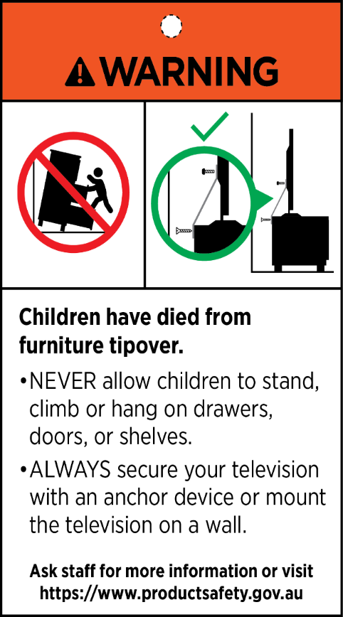

**Division 2 – Warnings and safety information on furniture**

Section 9 – Warnings and safety information to be affixed on toppling furniture

Subsections 9(1) and 9(2) provide that persons who supply toppling furniture must cause a clearly visible, prominent and legible warning about the risk of tip overs and the importance of anchoring to be displayed on toppling furniture. The warning must be included on an affixed permanent and durable label that will last the lifetime of the product (assuming normal use) and in a location where it will be visible when the toppling furniture is empty. The note to subsection 9(2) clarifies, by way of example, that a warning label affixed to the inside of an item of toppling furniture’s door or drawer will be visible when that piece of furniture is empty.

The matters to be included in such warnings are set out in subsection 9(3) and, depending on whether the relevant toppling furniture is category 1, category 2 or category 3 furniture, subsection 9(4), 9(5) or 9(6).

The following is an example of a (not to scale) warning label that is compliant with the requirements of subsections 9(3) and 9(4) (in relation to category 1 furniture). The label is also compliant in respect of subsections 9(3) and 9(6) (in relation to category 3 furniture). The inclusion of a pictogram that shows the toppling furniture anchored to a wall with a green tick is not required, but is recommended.

*Category 1 & 3*

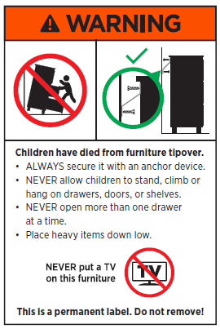

The following is an example of a (not to scale) warning label that is compliant with the requirements of subsections 9(3) and 9(5) (in relation to category 2 furniture). The inclusion of a pictogram that shows the toppling furniture anchored to a wall with a green tick is not required, but is recommended.

*Category 2*

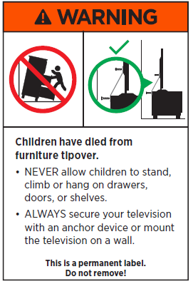

Section 10 – Warnings and safety information to be provided with instructions

Subsection 10(1) provides that persons who supply toppling furniture must cause a warning about the risk of tip overs and the importance of anchoring to be included in the instructions (including assembly instructions) supplied with the toppling furniture (if any).

The matters to be included in such warnings are set out in subsection 10(3) and, depending on whether the relevant toppling furniture is category 1, category 2 or category 3 furniture, subsection 10(4), 10(5) or 10(6).