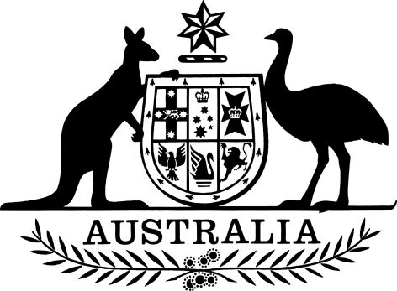

PB 47 of 2024

National Health (Pharmaceutical Benefits Scheme - Exempt items - Section 84AH) Amendment Determination 2024 (No. 1)
I, Nikolai Tsyganov, Assistant Secretary, Pricing and PBS Policy Branch, Technology Assessment and Access Division, Department of Health and Aged Care, delegate of the Minister for Health and Aged Care, make the following determination.
Dated 29 April 2024
NIKOLAI TSYGANOV
Assistant Secretary
Pricing and PBS Policy Branch
Technology Assessment and Access Division
Department of Health and Aged Care

Contents
1 Name 1
2 Commencement 1
3 Authority 1
4 Schedules 1
Schedule — Amendments 2
National Health (Pharmaceutical Benefits Scheme–Exempt items – Section 84AH) Determination 2017 (PB 81 of 2017) 2

1 Name
This instrument is the National Health (Pharmaceutical Benefits Scheme-Exempt items - Section 84AH) Amendment Determination 2024 (No. 1).
This instrument may also be cited as PB 47 of 2024.

2 Commencement
(1) Each provision of this instrument specified in column 1 of the table commences, or is taken to have commenced, in accordance with column 2 of the table. Any other statement in column 2 has effect according to its terms.

Commencement information
Column 1 | Column 2 | Column 3
Provisions | Commencement | Date/Details
1. The whole of this instrument | 1 May 2024.
Note: This table relates only to the provisions of this instrument as originally made. It will not be amended to deal with any later amendments of this instrument.
(2) Any information in column 3 of the table is not part of this instrument. Information may be inserted in this column, or information in it may be edited, in any published version of this instrument.

3 Authority
This instrument is made under section 84AH of the National Health Act 1953.

4 Schedules
Each instrument that is specified in a Schedule to this instrument is amended or repealed as set out in the applicable items in the Schedule concerned, and any other item in a Schedule to this instrument has effect according to its terms.

Schedule — Amendments

National Health (Pharmaceutical Benefits Scheme–Exempt items – Section 84AH) Determination 2017 (PB 81 of 2017)

- In the Schedule, after the entry for Ondansetron Syrup, 4 mg (as hydrochloride dihydrate) per 5 mL, 50mL
Insert:

Oxybutynin | Transdermal patches 36 mg, 8 | Transdermal

