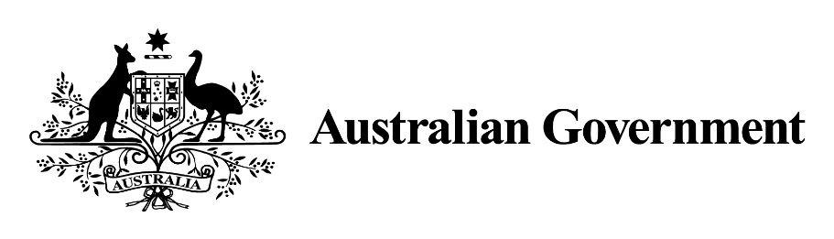

Marine Safety (Domestic Commercial Vessel) National Law (Meaning of Corresponding State-Territory law) Declaration 2024

*Marine Safety (Domestic Commercial Vessel) National Law Act 2012*

I, **CATHERINE KING**, Minister for Infrastructure, Transport, Regional Development and Local Government make the following Declaration.

Dated 13 Feb 24

**CATHERINE KING**  
Minister for Infrastructure, Transport, Regional Development and Local Government

1 Name of Declaration

This Declaration is the *Marine Safety (Domestic Commercial Vessel) National Law (Meaning of Corresponding State-Territory law) Declaration 2024.*

2 Commencement

This instrument commences on 1 March 2024.

3 Authority

This instrument is made under subsection 12(1) of the *Marine Safety (Domestic Commercial Vessel) National Law Act 2012.*

4 Definitions

In this instrument:

***Act*** means the *Marine Safety (Domestic Commercial Vessel) National Law Act 2012.*

5 Schedules

Each instrument that is specified in a Schedule to this instrument is amended or repealed as set out in the applicable items in the Schedule concerned, and any other item in a Schedule to this instrument has effect according to its terms.

6 Declaration

For subsection 12(1) of the Act, each law mentioned in the following table is declared to correspond to the Act.

|  |  |  |
| --- | --- | --- |
| **State and Territory laws** | | |
| **Item** | **State or Territory** | **Law** |
| 1 | New South Wales | The *Marine Safety Amendment (Domestic Commercial Vessel National Law Application) Act 2012* |
| 2 | Victoria | The *Marine (Domestic Commercial Vessel National Law Application) Act 2013* |
| 3 | South Australia | The *Marine Safety (Domestic Commercial Vessel) National Law (Application) Act 2013* |
| 4 | Tasmania | The *Marine Safety (Domestic Commercial Vessel National Law Application) Act 2013* |
| 5 | Northern Territory | The *Marine Safety (Domestic Commercial Vessel) (National Uniform Legislation) Act 2013* |
| 6 | Queensland | The *Transport Operations (Marine Safety—Domestic Commercial Vessel National Law Application) Act 2016* |
| 7 | Western Australia | The *Marine Safety (Domestic Commercial Vessel National Law Application) Act 2023* |

Schedule 1—Repeals

Marine Safety (Domestic Commercial Vessel) National Law (Meaning of Corresponding State-Territory law) Declaration 2023

1 The whole of the instrument

Repeal the instrument