

Security of Critical Infrastructure (Naval shipbuilding precinct) Amendment (LIN 24/006) Rules 2024
I, Clare O’Neil, Minister for Home Affairs and Minister for Cyber Security, make this instrument under section 61 of the Security of Critical Infrastructure Act 2018.
Dated 06 February 2024

Clare O’Neil
Minister for Home Affairs
Minister for Cyber Security

Contents
1 Name 1
2 Commencement 1
3 Authority 1
4 Schedules 1
Schedule 1—Amendments 2
Security of Critical Infrastructure (Naval shipbuilding precinct) Rules (LIN 23/007) 2023. 2

1 Name
This instrument is the Security of Critical Infrastructure (Naval shipbuilding precinct) Amendment (LIN 24/006) Rules 2024.

2 Commencement
This instrument commences on the day after it is registered.

3 Authority
This instrument is made under section 61 of the Security of Critical Infrastructure Act 2018.

4 Schedules
Each instrument that is specified in a Schedule to this instrument is amended or repealed as set out in the applicable items in the Schedule concerned, and any other item in a Schedule to this instrument has effect according to its terms.

Schedule 1—Amendments

Security of Critical Infrastructure (Naval shipbuilding precinct) Rules (LIN 23/007) 2023
1 Section 4
Repeal the section, substitute:

4 Critical infrastructure asset
(1) For paragraph 9(1)(f) of the Act, an asset is a critical infrastructure asset if it is:
(a) within an area identified for the purposes of this section on the map in Schedule 1; and
(b) used for the primary purposes of naval shipbuilding or sustainment.

Note: The map in Schedule 1 depicts the Osborne Naval Shipyard precinct on Lefevre Peninsula, South Australia.
(2) For subsection 12L(23) of the Act, the responsible entity for a critical infrastructure asset mentioned in subsection (1) is:
(a) the entity that has been granted exclusive control and use of the asset or the area where the asset is located, under a licence or other contractual arrangement, for such time as the licence or other contractual arrangement remains in force; or
(b) in all other circumstances—Australian Naval Infrastructure Pty Ltd (ABN 45 051 762 639).

2 Schedule 1
Repeal the Schedule; substitute:
Schedule 1—Naval shipbuilding precinct
- Osborne Naval Shipyard
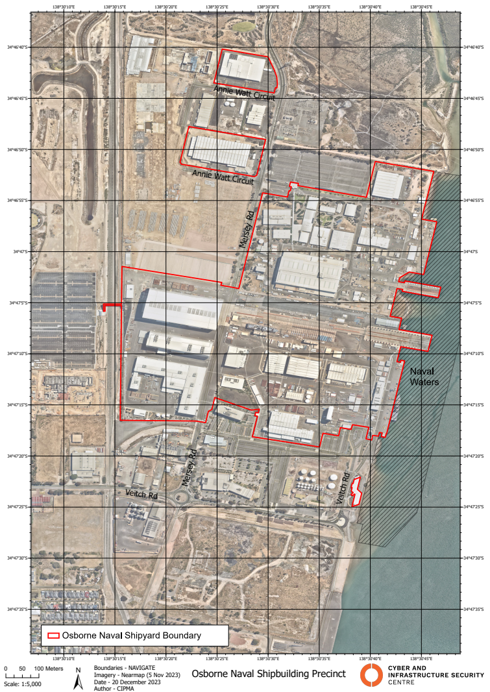
An area within the Osborne Naval Shipyard boundary lines on the following map constitutes an area identified for the purposes of section 4.

