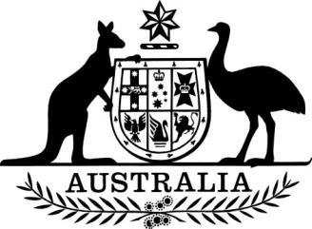

Australian Competition and Consumer Commission (Acting Chairperson) Appointment (No. 4) 2023

I, Jim Chalmers, Treasurer, under paragraph 11(2)(a) of the *Competition and Consumer Act 2010*, appoint Catriona Lowe as the acting Chairperson of the Australian Competition and Consumer Commission, on a full-time basis, for the period beginning on 1 December 2023 until 13 December 2023.

Dated 16 November 2023

Dr Jim Chalmers Treasurer