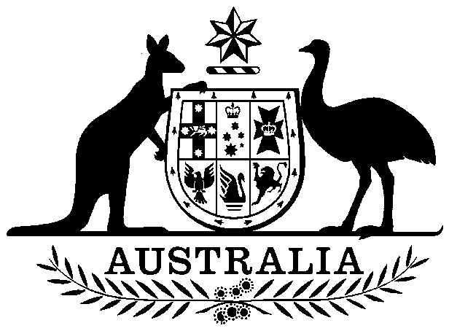

COMMONWEALTH OF AUSTRALIA

##### Environment Protection and Biodiversity Conservation Act 1999

###### DECLARATION OF AN APPROVED WILDLIFE TRADE OPERATION

###### (SMALL- SCALE) MARK’S PRODUCTS AND SERVICES – HARVEST OF NATURALLY FALLEN (MOULTED) BIRD FEATHERS (2023-2026)

I, Belinda Jago, Branch Head, Oceans and Wildlife Branch, as Delegate of the Minister for the Environment and Water, under the *Environment Protection and Biodiversity Conservation Act 1999*, am satisfied that the operation to export naturally fallen (moulted) feathers from Australian native birds from Mark’s Products and Services, is a small-scale operation as defined by regulation 9A.20(2) under subsection 303FN(10)(b). I declare under subsection 303FN(2) that Mark’s Products and Services is an approved small-scale wildlife trade operation.

This declaration has effect subject to the following conditions applied under section 303FT:

1. The operation must be carried out in accordance with the *Wildlife Trade Operation (small-scale) Mark’s Products and Services – harvest of naturally fallen (moulted) bird feathers 2023-2026* submitted on 29 May 2023.
2. All bird feathers referred to in the Wildlife Trade Operation (small-scale) must be obtained from appropriately licensed suppliers.
3. Feathers sourced from additional suppliers or species not currently listed in the approved Wildlife Trade Operation may only be exported with the prior approval of the Department of Climate Change, Energy, the Environment and Water.
4. The declaration is valid for three years from the day after its publication on the Federal Register of Legislation.
5. Mark’s Products and Services must maintain accurate records and provide an annual report to the Department of Climate Change, Energy, the Environment and Water by   
   30 May each year. Annual reports must include:

* The number of feathers sourced from each species by supplier in the previous 12 months.
* The number of feathers from each species exported in the previous 12 months.

Dated this 29 day of June 2023

Belinda Jago

………….…….……………………….........

**Delegate of the Minister for the Environment and Water**

A person whose interests are affected by this declaration may, within 28 days, make an application in writing to the Department of Climate Change, Energy, the Environment and Water for the reasons for the decision.

An application for independent review of the decision (under section 303GJ(1) of the *Environment Protection and Biodiversity Conservation Act 1999*) may be made to the Administrative Appeals Tribunal (AAT), on payment of the relevant fee (currently $1,826 or reduced fee where applicable due to financial hardship) by the applicant, either within 28 days of receipt of the reasons for the decision, or within 28 days of this declaration if reasons for the decision are not sought. Applications should be made to the Deputy Registrar, AAT in your Capital City. Please visit the AAT’s website at [Administrative Appeals Tribunal | Administrative Appeals Tribunal (aat.gov.au)](https://www.aat.gov.au/) for further information.

You may make an application under the *Freedom of Information Act 1982* (Cth) to access documents relevant to this decision. For further information, please visit <https://www.dcceew.gov.au/about/reporting/freedom-of-information>. Further enquiries should be directed to the Director, Wildlife Trade Assessments Section, Department of Climate Change, Energy, the Environment and Water by email: [wta@dcceew.gov.au](mailto:wta@dcceew.gov.au) or telephone: 1800 075 065.