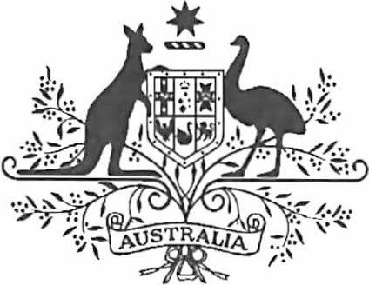

Acts Interpretation (Ministerial Acting Arrangements for the Foreign Affairs and Trade Portfolio) Authorisation (No. 1) 2022

I, SENATOR THE HON PENNY WONG, Minister for Foreign Affairs, acting in accordance with sections 19 and 34AAB of the Acts Interpretation Act 1901, and all other powers thereunto enabling, as the case requires, hereby authorise THE HON MARK DREYFUS KC MP, Attorney-General, Cabinet Secretary, to exercise, on my behalf, all my powers and functions, including powers and functions conferred on me by any law of the Commonwealth.

This instrument commences on 27 December 2022 and ceases to have effect on 16 January
2023.

Dated 19 December 2022

Senator the Hon Penny Wong
Minister for Foreign Affairs
Note: The name of this instrument was amended on registration as the instrument as lodged did not have a unique name (see subsection 10(2), Legislation Rule 2016).

