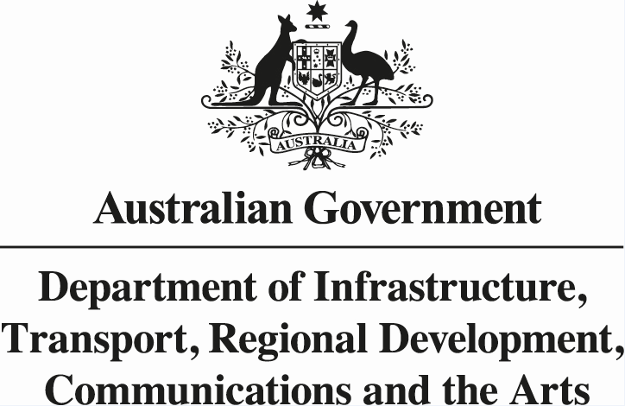

**Declaration of a Distanced Investment Fund**

**SAPR 64/2023**

**_______________________________________________________**

I Jim Betts, Secretary of the Commonwealth Department of Infrastructure, Transport Regional Development, Communications and the Arts, acting pursuant to Regulation 4.03 of the *Airports (Ownership – Interests In shares) Regulations 1996,* DECLARE that the following fund managed by Dexus Capital Funds Management Limited is a Distanced Investment Fund:

* Dexus Core Infrastructure Fund

Dated this 1st day of June 2023

…………………………………………………………………

Jim Betts

Secretary, Department of Infrastructure, Transport, Regional Development, Communications and the Arts