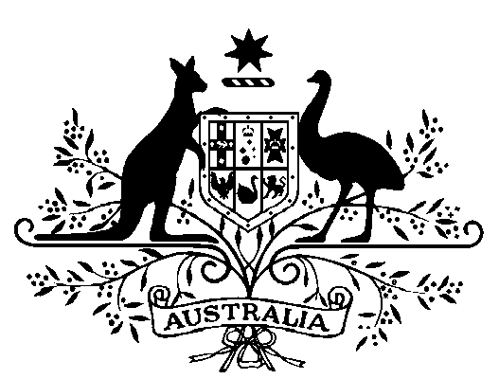

COMMONWEALTH OF AUSTRALIA
Public Service Act 1999

Appointment of the Secretary of the Department of Health

I, General the Honourable David Hurley AC DSC (Retd), Governor-General of the Commonwealth of Australia, acting with the advice of the Federal Executive Council and under subsection 58(1) of the Public Service Act 1999, appoint Professor Brendan Murphy as the Secretary of the Department of Health for a period of five years commencing on 29 February 2020.

Dated 6 February 2020

[SIGNED]
David Hurley
Governor-General

By His Excellency’s Command

[SIGNED]
Scott Morrison
Prime Minister

