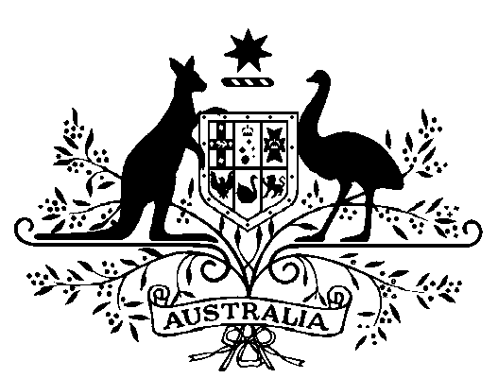

**COMMONWEALTH OF AUSTRALIA**

*Public Service Act 1999*

Appointment of the Secretary of the Department of   
Agriculture, Water and the Environment

I, General the Honourable David Hurley AC DSC (Retd), Governor-General of the Commonwealth of Australia, acting with the advice of the Federal Executive Council and under subsection 58(1) of the *Public Service Act 1999*, hereby appoint Mr Andrew Metcalfe AO as the Secretary of the Department of Agriculture, Water and the Environment for a period of five years commencing on 1 February 2020.

Dated 5 December 2019

[SIGNED]

David Hurley  
Governor-General

By His Excellency’s Command

[SIGNED]

Scott Morrison  
Prime Minister