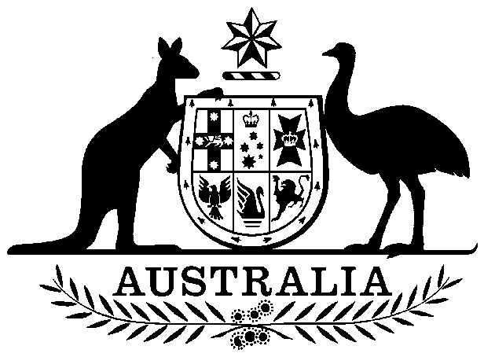

**COMMONWEALTH OF AUSTRALIA**

*Environment Protection and Biodiversity Conservation Act 1999*

**DECLARATION OF AN APPROVED WILDLIFE TRADE OPERATION – MANAGEMENT PLAN FOR THE COMMERCIAL HARVEST AND EXPORT OF WALLABY FROM TASMANIA (2023-2026)**

I, TANYA PLIBERSEK, Minister for the Environment and Water:

(a) having noted that two public comments were received in response to an invitation under section 303FR(1) of the *Environment Protection and Biodiversity Conservation Act 1999* (Cth)   
(EPBC Act); and

(b) being satisfied as to those matters set out in section 303FN of the EPBC Act,

Declare that the *Management Plan* *for the commercial harvest and export of wallaby from Tasmania   
(2023-2026)* is an **approved wildlife trade operation (small-scale)** for the purposes of section 303FN of the EPBC Act. Unless amended or revoked, this declaration has effect subject to the following conditions applied under section 303FT:

1. The operation must be carried out in accordance with the wildlife trade operation (small-scale), *Management Plan for the commercial harvest and export of wallaby from Tasmania (2023-2026)*.
2. The small-scale wildlife trade operation relates to the processing of meat, skin and fur (fibre) derived only from *Macropus rufogriseus* (Bennett’s wallaby) and *Thylogale billardierii* (known as Rufous-Bellied Pademelon, Tasmanian Pademelon and rufus wallaby).
3. The annual harvest quota for the purposes of export by Lenah Game Meats must not exceed 200,000 wallabies. Additional taxa can be exported only after approval from the Department of Climate Change, Energy, the Environment and Water.
4. The declaration is valid for three years from the day after its publication on the Federal Register of Legislation.
5. An annual report must be submitted to the Department of Climate Change, Energy, the Environment and Water by 31 March each year. The annual report will cover the preceding calendar year and should include as a minimum:

* population density estimates for each species;
* quotas calculated as a proportion of population density estimates for each species; and
* the number of wallabies harvested for each species.

Dated this …23rd… day of …April… 2023

…………Tanya Plibersek…………….

Minister for the Environment and Water