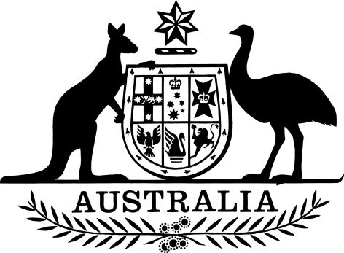

Higher Education Support Amendment (Maximum Payments for Other Grants) Determination 2023
I, Jason Clare, Minister for Education, make the following determination.
Dated 12 December 2023
Jason Clare
Minister for Education

Contents
1 Name 1
2 Commencement 1
3 Authority 1
4 Schedules 1
Schedule 1—Amendments 2
Higher Education Support (Maximum Payments for Other Grants) Determination 2020 2

1 Name
This instrument is the Higher Education Support Amendment (Maximum Payments for Other Grants) Determination 2023.

2 Commencement
This instrument commences the day after this instrument is registered.

3 Authority
This instrument is made under section 41-45 of the Higher Education Support Act 2003.

4 Schedules
Each instrument that is specified in a Schedule to this instrument is amended or repealed as set out in the applicable items in the Schedule concerned, and any other item in a Schedule to this instrument has effect according to its terms.

Schedule 1—Amendments

Higher Education Support (Maximum Payments for Other Grants) Determination 2020
1 Paragraph 6(d)
Omit “$2,412,000,000; and”, substitute “$2,464,000,000;”.
2 Paragraph 6(e)
Omit “$2,241,533,000.”, substitute “$2,635,000,000; and”.
3 After paragraph 6(e)
Insert:
(f) for the year 2025—$2,689,000,000.

