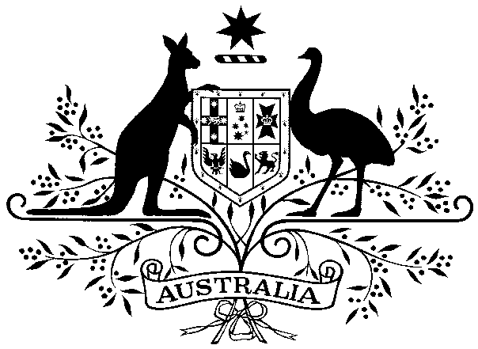

Vehicle Standard (Australian Design Rule) Amendment Instrument 2023 (No. 1)
I, CAROL BROWN, Assistant Minister for Infrastructure and Transport, make the following determination under section 12 of the Road Vehicle Standards Act 2018.

Dated 23 October 2023

[SIGNED]

Carol Brown

Assistant Minister for Infrastructure and Transport

CONTENTS

1. legislative provisions 3
2. SCHEDULES 3
Schedule 1 3
Schedule 2 3

- legislative provisions
  - Name of Legislative Instrument
    - This instrument is the Vehicle Standard (Australian Design Rule) Amendment Instrument 2023 (No. 1).
  - Commencement
    - This instrument commences on the day after it is registered.
- Schedules
  - Each instrument that is specified in a schedule to this instrument is amended as set out in the applicable items in the schedule concerned, any other item in a schedule to this instrument has effect according to its terms.
  - The changes specified in Schedule 1 amend Vehicle Standard (Australian Design Rule 42/04 – General Safety Requirements) 2005.
  - The changes specified in Schedule 2 amend Vehicle Standard (Australian Design Rule 42/05 – General Safety Requirements) 2018.
Schedule 1
Vehicle Standard (Australian Design Rule 42/04 – General Safety Requirements) 2005
- Section 20. WARNING DEVICES – AUDIBLE
Insert a new clause 20.3.1. to read:
“20.3.1 For vehicles of category MD3 and MD4, and those of category ME, NB and NC, equipped with audible reverse warning devices, approvals to the technical requirements of United Nations Regulation No. 165 – UNIFORM PROVISIONS CONCERNING THE APPROVAL OF AUDIBLE REVERSE WARNING DEVICES AND OF MOTOR VEHICLES WITH REGARD TO THEIR AUDIBLE REVERSE WARNING SIGNAL, incorporating the 00 series of amendments will meet the requirements of clause 20.3.”

Schedule 2
Vehicle Standard (Australian Design Rule 42/05 – General Safety Requirements) 2018
- Section 23. AUDIBLE DEVICES
Insert a new clause 23.2.2. to read:
“23.2.2 For vehicles of category MD3 and MD4, and those of category ME, NB and NC, equipped with audible reverse warning devices, approvals to the technical requirements of United Nations Regulation No. 165 – UNIFORM PROVISIONS CONCERNING THE APPROVAL OF AUDIBLE REVERSE WARNING DEVICES AND OF MOTOR VEHICLES WITH REGARD TO THEIR AUDIBLE REVERSE WARNING SIGNAL, incorporating the 00 series of amendments will meet the requirements of clause 23.2.”

