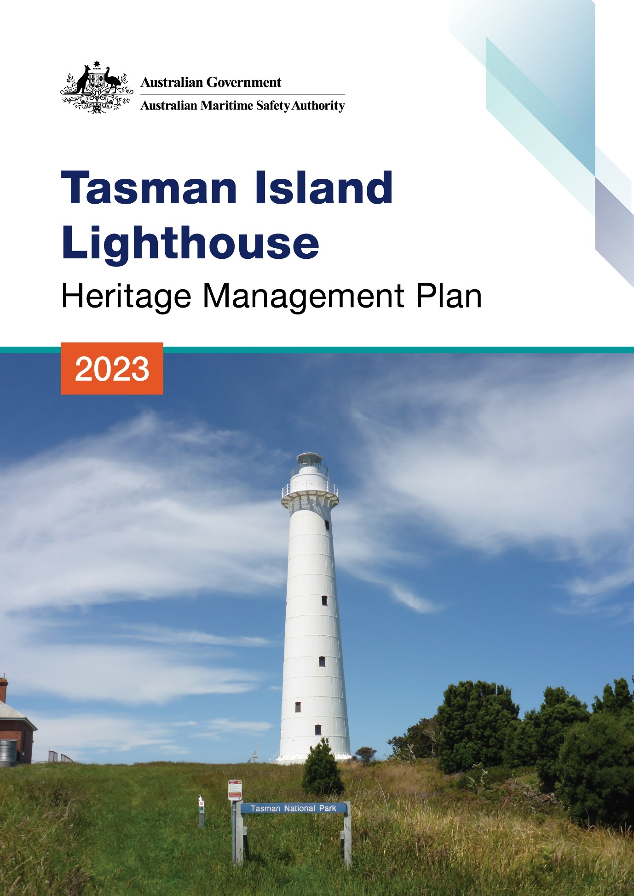

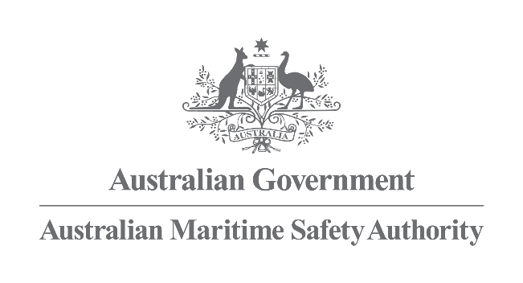

Tasman Island Lighthouse
Heritage Management Plan
2023

The Australian Maritime Safety Authority makes this heritage management plan under section 341S of the Environment Protection and Biodiversity Conservation Act 1999 (Cth) for Tasman Island Lighthouse.
5th September 2023
Mick Kinley
Chief Executive Officer
Copyright
© Australian Maritime Safety Authority

The Australian Maritime Safety Authority encourages the dissemination and exchange of information provided in this publication.

Except as otherwise specified, all material presented in this publication is provided under Creative Commons Attribution 4.0 International licence. This excludes:
- the Commonwealth Coat of Arms
- this department's logo
- content supplied by third parties.

The Creative Commons Attribution 4.0 International Licence is a standard form licence agreement that allows you to copy, distribute, transmit and adapt this publication provided that you attribute the work. The details of the version 4.0 of the licence are available on the Creative Commons website, as is the full legal code for that licence.

Third Party Copyright
Some material in this document, made available under the Creative Commons Licence framework, may be derived from material supplied by third parties. The Australian Maritime Safety Authority has made all reasonable efforts to identify content supplied by third parties using the following format ‘© [name of third party]’ or ‘Source: [name of third party]’. Permission may need to be obtained from third parties to re-use their material.

Acknowledgements
The Australian Maritime Safety Authority acknowledges Traditional Owners and other Aboriginal peoples of the region, their rich culture and spiritual connection to Country and Sea
Contact
Comments or questions regarding this document should be addressed to:
The Australian Maritime Safety Authority,
Manager Asset Management and Preparedness,
PO Box 10790,
Adelaide Street, Brisbane QLD 4000

Phone: (02) 6279 5000 (switchboard)
Email: Heritage@amsa.gov.au
Website: www.amsa.gov.au

Attribution
AMSA’s preference is that you attribute this publication (and any material sourced from it) using the following wording:
Source: Australian Maritime Safety Authority Tasman Island Lighthouse Heritage Management Plan – 2023
Front cover image
Figure 1. Tasman Island Lighthouse (© AMSA, 2021)
More information
For enquiries regarding copyright including requests to use material in a way that is beyond the scope of the terms of use that apply to it, please contact us through our website: www.amsa.gov.au
Table of contents

Executive summary

- Introduction
  - Background and purpose
  - Heritage management plan objectives
  - Methodology
  - Status
  - Authorship
  - Acknowledgements
  - Language
  - Previous reports
  - Sources of information and images

- Tasman Island Lightstation site
  - Location
  - Setting and landscape
  - Lease and management
  - Access
  - Listings

- History
  - General history of lighthouses in Australia
  - The Commonwealth Lighthouse Service
  - Tasmanian Lighthouse Administration
  - Tasman Island: a history
  - Planning a lighthouse
  - Lighthouse keeping
  - Chronology of major events
  - Changes and conservation over time
  - Summary of current and former uses
  - Summary of past and present community associations
  - Unresolved questions or historical conflicts
  - Recommendations for further research

- Fabric
  - Fabric register
  - Related objects and associated AMSA artefacts
  - Comparative analysis

- Heritage significance
  - Commonwealth heritage listing – Tasman Island Lighthouse
  - TAS State heritage register – Tasman Island Lighthouse
  - Condition and integrity of the Commonwealth heritage values
  - Gain or loss of heritage values.

- Opportunities and constraints
  - Implications arising from significance
  - Framework: sensitivity to change
  - Statutory and legislative requirements
  - Operational requirements and occupier needs
  - Proposals for change
  - Potential pressures
  - Process for decision-making

- Conservation management principles and policies

- Policy implementation plan
  - Plan and schedule
  - Monitoring and reporting
Appendices
Appendix 1. Glossary of heritage conservation terms
Appendix 2. Glossary of historic lighthouse terms relevant to Tasman Island Lighthouse
Appendix 3. Table demonstrating compliance with the EPBC Regulations
Appendix 4. Tasman Island current light details
End notes
Reference list
List of figures

Figure 1. Tasman Island Lighthouse (© AMSA, 2021)

Figure 2. Planning process applied for heritage management (Source: Australia ICOMOS, 1999)

Figure 3. Location of Tasman Island (Imagery ©TerraMetrics, Map data: @2022 Google)

Figure 4. Tasman Island and lightstation (Data SIO, NOAA, U.S. Navy, NGA, GEBCO. Image @2022 TerraMetrics)

Figure 5. View of Tasman Island from the air (© AMSA, 2019)

Figure 6. Tasman Island Lighthouse map of lease (Source: Esri, DigitalGlobe, GeoEye, Earthstar Geographics, CNES/Airbus DS, USDA, USGS, AeroGRID, IGN, and the GIS User Community

Figure 7. View of helipad at Tasman Island Lighthouse (© AMSA, 2019)

Figure 8. Incandescent oil vapour lamp by Chance Brothers (Source: AMSA)

Figure 9. Dioptric lens on display at Narooma (Source: AMSA)

Figure 10. Dalén's system - sunvalve, mixer and flasher (Source: AMSA)

Figure 11. Marine Board of Hobart, Tasman Island Lighthouse, Huckson & Hutchison, 1904. NAA: A9568, 5/13/4. Image courtesy of the National Archives of Australia (© Commonwealth of Australia, National Archives of Australia)

Figure 12. Tasman Island Lightstation before removal of original lantern house, 1910. Image courtesy of the NAA: A1861, 1958 (© Commonwealth of Australia, National Archives of Australia)

Figure 13. Tasman Island Lighthouse landing, showing the method used to unload supplies and personnel destined for the lighthouse. Image courtesy of NAA: A1200, L11284. (© Commonwealth of Australia, National Archives of Australia)

Figure 14. Lighthouse landing and incline tramway, Tasman Island, off the south-east corner of Tasmania. Image courtesy of NAA: A1200, L11285. (© Commonwealth of Australia, National Archives of Australia)

Figure 15. Oil Store, lighthouse and lightkeepers' quarters no. 3 (obscured). (© Brett
Hall, 2019)

Figure 16. Tasman Landing and Anchor Rock, (© Brett Hall, 2019)

Figure 17. Winch shed at Tasman Island, reclad by Parks & Wildlife Service Tasmania (© Brett Hall, 2019)

Figure 18. Tasman Island Lighthouse, first lit 1906 (© AMSA, 2021)

Figure 21. Currie Harbour Lighthouse, first lit 1879 (© AMSA, 2009)

Acronym List
List of acronyms utilised throughout this heritage management plan:
Acronym | Definition
AGA | Gas Accumulator Company
AMSA | Australian Maritime Safety Authority
AMSG | Australian Maritime Systems Group
AtoN | Aid to Navigation
BBT | Barbier, Benard, et Turenne
CHL | Commonwealth Heritage List
DCCEEW | Department of Climate Change, Energy, the Environment and Water
EPBC Act | Environment Protection and Biodiversity Conservation Act 1999 (Cth)
EPBC Regulations | Environment Protection and Biodiversity Conservation Regulations 2000 (Cth)
HMP | Heritage Management Plan
IALA | International Association of Marine Aids to Navigation and Lighthouse Authorities
LED | Light emitting diode
NAA | National Archives of Australia
NES | National Environmental Significance
NLA | National Library of Australia
RMS | Record Management System
RNE | Register for the National Estate (non-statutory archive)
TAS PWS | Tasmanian Parks and Wildlife Service
THR | Tasmanian Heritage Register

Executive summary

Built in 1906, Tasman Island Lighthouse is a historic structure recognised by both State and Commonwealth governments. Registered on the Commonwealth Heritage List in 2004, the lighthouse is recognised as the last lighthouse to be built by the Tasmanian State Government before the Lighthouse Service was handed over to the Commonwealth in 1915. The lighthouse is also recognised for its place within a relatively intact early twentieth century lightstation complex, and its aesthetic value as one of the highest lighthouse towers in Australia.

Tasman Island Lighthouse is also listed on the Tasmanian State Heritage Register for its contribution to the development of navigational aids along the Tasmanian east coast, its pre-fabricated cast iron tower, and its standing as a remote lightstation. It is also recognised for its early twentieth century Federation-era characteristics, its notability as a landmark within the Sydney-to-Hobart Yacht Race, and the lightstation’s overall intactness.

The lightstation is situated on Tasman Island within the Tasman Sea, approximately 16.7 kilometres south-east of Port Arthur. The tower, three keepers’ cottages and service buildings are the only intact structures that remain onsite. The tower was originally fitted with a 1st Order Chance Bros. & Co lens fuelled by vapour kerosene and an 85mm burner with six-wick emergency lamp. The tower is now fitted with a Vega VRB beacon, operating on an automated mechanism as part of AMSA’s network of aids to navigation (AtoNs). The original lantern house was removed in 1976 and replaced with a NAL-1 lantern room following automation.

The equipment on site is serviced by AMSA’s maintenance contractor, who visits at least once per year. AMSA officers visit on an ad hoc basis for auditing, project and community liaison purposes. Tasmanian Parks and Wildlife (TAS PWS) maintain all other structures outside of the AMSA lease, including the lightkeepers’ quarters and oil store.

This heritage management plan is concerned primarily with the lighthouse under the AMSA lease, but also addresses the management of this surrounding land. The plan is intended to guide our decisions and actions in accordance with the Environment Protection and Biodiversity Conservation Act 1999 (Cth) (EPBC Act), and the Environment Protection and Biodiversity Conservation Regulations 2000 (Cth) (EPBC Regulations).

Well built and generally well-maintained, the lighthouse is in relatively good, stable condition. The policies and management guidelines set out in this heritage management plan strive to ensure that Commonwealth heritage values of Tasman Island Lighthouse are recognised, maintained and preserved for future generations.


- Introduction

  - Background and purpose
The Australian Maritime Safety Authority (AMSA) is the Commonwealth agency responsible for coastal aids to navigation. AMSA’s network includes Tasman Island Lighthouse, built between 1904-1905 and first lit in 1906.
Section 341S of the Environment Protection and Biodiversity Conservation Act 1999 (Cth) (EPBC Act) requires AMSA to prepare a management plan for Tasman Island Lighthouse that addresses the matters prescribed in Schedules 7A and 7B of the Environment Protection and Biodiversity Conservation Regulations 2000 (Cth) (EPBC Regulations). The principal features of this management plan are:
- a description of the place, its heritage values, their condition and the method used to assess its significance
- an administrative management framework
- a description of any proposals for change
- an array of conservation policies that protect and manage the place
- an implementation plan
- ways the policies will be monitored and how the management plan will be reviewed.

AMSA has prepared this heritage management plan to guide the future conservation of the place. This plan provides the framework and basis for the conservation and best practice management of Tasman Island Lighthouse in recognition of its heritage values. The policies in this plan indicate the objectives for identification, protection, conservation and presentation of the commonwealth heritage values of the place. Figure 2 shows the basic planning process applied.
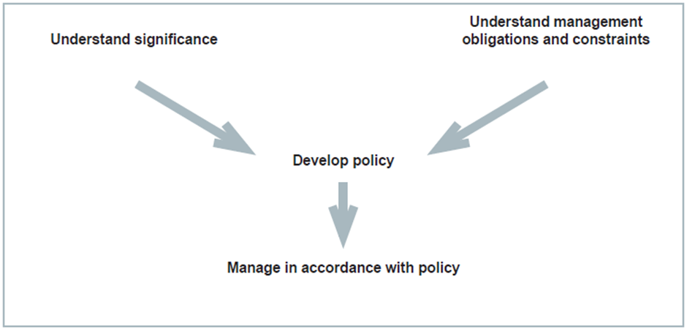
Figure 2. Planning process applied for heritage management (Source: Australia ICOMOS, 1999)

  - Heritage management plan objectives
The objectives of this heritage management plan are to:
- protect, conserve and manage the Commonwealth heritage values of the Tasman Island Lighthouse.
- interpret and promote the Commonwealth heritage values of the Tasman Island Lighthouse.
- manage use of the lighthouse
- use best practice standards, including ongoing technical and community input, and apply best available knowledge and expertise when considering actions likely to have a substantial impact on Commonwealth heritage values.

In undertaking these objectives, this plan aims to:
- provide for the protection and conservation of the heritage values of the place while minimising any impacts on the environment by applying the relevant environmental management requirements in a manner consistent with Commonwealth heritage management principles
- take into account the significance of the region as a cultural landscape occupied by Aboriginal people over many thousands of years
- recognise that the site has been occupied by lease holders since the early twentieth century
- encourage site use that is compatible with the historical fabric, infrastructure and general environment
- record and document maintenance works, and changes to the fabric in the Tasman Island Lighthouse fabric register.

The organisational planning cycle and associated budgeting process is used to confirm requirements, allocate funding and manage delivery of maintenance activities. Detailed planning for the AtoN network is managed through our internal planning processes.
An interactive map showing many of AMSA’s heritage sites, including Tasman Island, can be found at AMSA Heritage Lighthouses Interactive MapP0FP0FPP.
  - Methodology
The methodology used in the preparation of this plan is consistent with the recommendations of The Burra Charter and with the requirements of Chapter 5, Part 15 Division 1A of the EPBC Act. In particular, the plan details:
- the history of the site based on information sourced from archival research, expert knowledge, and documentary resources.
- the description of the site based on information sourced from site inspection reports and fabric registers.
- the Commonwealth heritage criteria satisfied by Tasman Island Lighthouse as set out by schedule 7A of the EPBC Regulations.

The criterion set out at Schedule 7A (h) (i-xiii) informed the development of the required policies for the management of the Tasman Island Lighthouse, in conjunction with input from the Department of Climate Change, Energy, the Environment and Water (DCCEEW) on best practice management.
Consultation
In preparation of the plan, AMSA sought engagement with the Tasmanian Parks and Wildlife Service (TAS PWS) and the Friends of Tasman Island (Wildcare Inc. branch). Tas PWS and the Friends of Tasman Island provided information on the history and management of the larger lightstation, details on the fauna and flora of the island, and photographs of the lightstation.
AMSA also sought engagement with the Tasmanian Aboriginal Corporation (TAC) and the Parrdarrama Pungenna Aboriginal Corporation (PPAC). AMSA is yet to receive a response and future versions of this plan will provide an update on this consultation process.
The draft management plan was advertised in accordance with the EPBC Act and EPBC Regulations. On 4 May 2022 a notice was placed in The Australian newspaper publication which invited the general public to review the draft plan on AMSA’s website and provide feedback. Public consultation closed on 1 June 2022 and submissions were considered by AMSA’s Heritage Team.
A developed draft was submitted to the Federal Minister through the Heritage Branch of the Department of Climate Change, Energy, the Environment and Water (DCCEEW), and in that process the Minister’s delegate sought advice from the Australian Heritage Council. The plan was endorsed on 18 July 2023.
  - Status
This plan has been adopted by AMSA in accordance with Schedule 7A (Management plans for Commonwealth Heritage places) and Schedule 7B (Commonwealth Heritage management principles) of the EPBC Regulations to guide the management of the place and for inclusion in the Federal Register of Legislative Instruments.
  - Authorship
This plan has been prepared by AMSA. At the initial time of publication, the Australian Maritime Systems Group (AMSG) was the contract maintenance provider for the Commonwealth Government’s AtoN network including Tasman Island Lighthouse.
  - Acknowledgements
AMSA acknowledges the assistance of the TAS PWS, the Friends of Tasman Island, Tony Brown, former Aboriginal Curator at the Tasmanian Museum and Art Gallery, and Brett Hall for the use of their photos.
  - Language
For clarity and consistency, some words in this plan such as restoration, reconstruction and preservation, are used with the meanings defined in the Burra Charter. (See Appendix 1 Glossary of heritage conservation terms). Also see ‘Appendix 2 Glossary of lighthouse terminology relevant to Tasman Island Lighthouse’ which sets out the technical terminology used in this plan.
  - Previous reports
- A Heritage Lighthouse Report was generated by Peter Marquis-Kyle in 2006 for AMSA.
- A Heritage Asset Condition Report (3rd Revision) was generated by AMSG in 2021 for AMSA.

  - Sources of information and images
This plan has used a number of sources of information. This includes the National Archives of Australia (NAA), the National Library of Australia (NLA) and AMSA’s heritage collection.
Friends of Tasman Island also provided a number of photographs for inclusion in the plan.


- Tasman Island Lightstation site
  - Location
Tasman Island Lighthouse is located off the south-east coast of Tasmania on Tasman Island, a 280-metre high plateau landmass within the Tasman Sea. Situated just south of Cape Pillar and the Tasman Peninsular, the island is approximately 16.7 kilometres south-east of Port Arthur and 67.7 kilometres south-east of the city of Hobart. The lighthouse is located along the eastern side of the island.
Coordinates: 43˚ 14.3722’ S, 148˚ 00.3046’ E
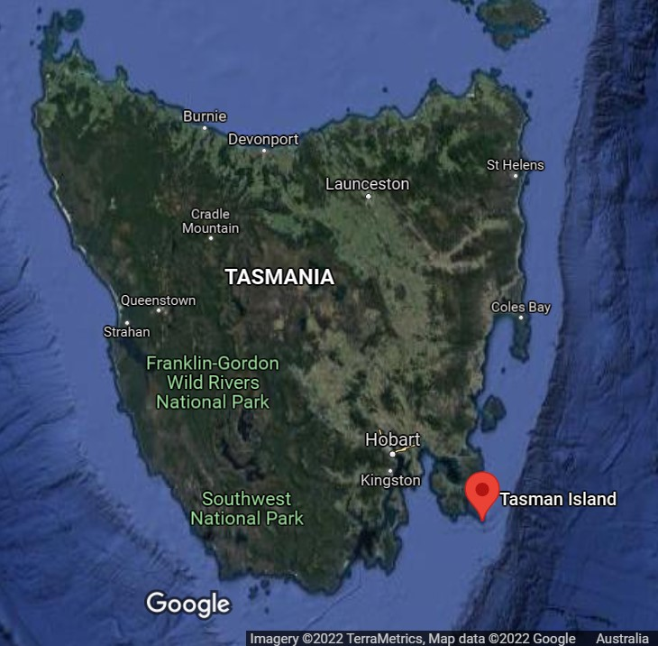
Figure 3. Location of Tasman Island (Imagery © TerraMetrics, Map data: @2022 Google)

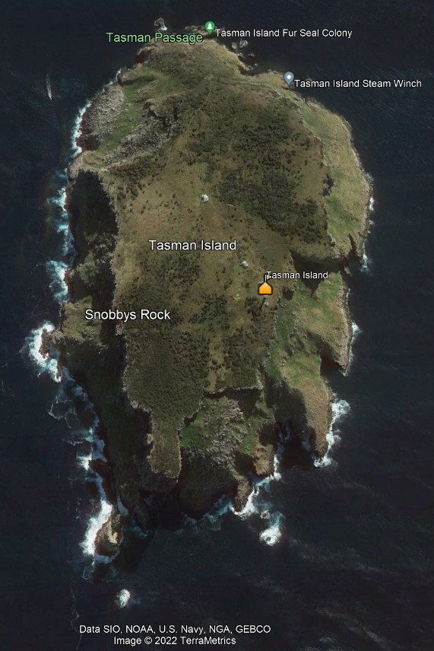
Figure 4. Tasman Island and lightstation (Data SIO, NOAA, U.S. Navy, NGA, GEBCO. Image @2022 TerraMetrics)
  - Setting and landscape
Tasman Island stands as an impressive display of dolerite rock formation with a flat plateau approximately 1.2 square kilometres in size. With its highest point registering at 300 metres above sea level, the island holds an average height of 280 metres above sea level. During the period of its staffed history, the island was noted to have fertile soil, and the forestry on the island was cleared for grazing and firewood.
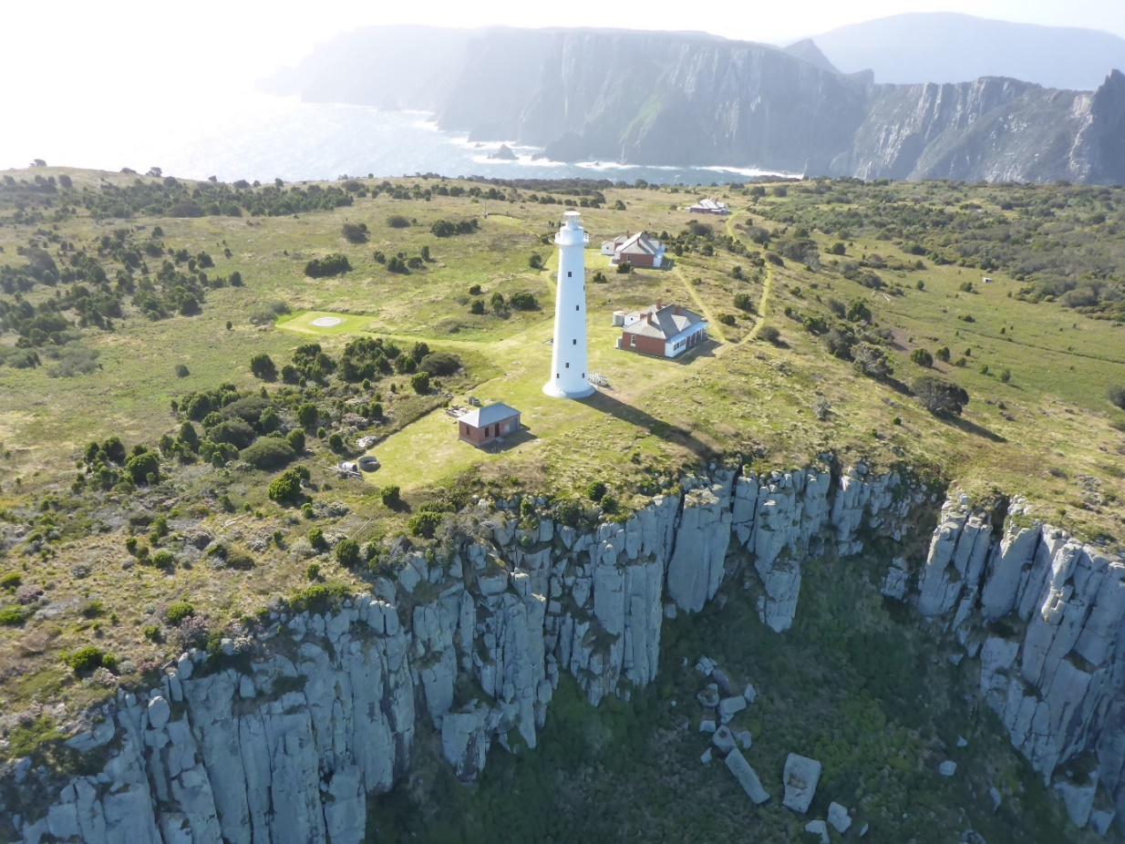
Figure 5. View of Tasman Island from the air (© AMSA, 2019)
Fauna and flora
Once covered in thick forestry, the island is now relatively bare after decades of deforestation efforts for cattle grazing. Floral genus that remain on the island include:
- heathy scrub
- sheoak woodland
- sedgeland
- coastal mosaic
- Cape Pillar sheoak
The island is recognised as an important bird area and houses the largest fairy prion colony in Tasmania. Ground nesting birds such as the Short-tailed shearwater, Sooty shearwater and Fairy prion which were predated by feral cats until a successful eradication programme funded by the Pennicott Foundation in 2011.
Former keepers have noted that there has been an increase in the number of land birds on Tasman Island with the increase of vegetation since de-staffing of the station, there include:
- White belied Sea eagle
- Lewins Rail
- Yellow-tailed black cockatoo
- Beautiful Firetail
- New Holland Honeyeater
- Satin Flycatcher
- Silvereye
- Swamp Harrier
Reptiles recorded on the island include:
- Metallic skink
- White’s skink
- Oscillated skink
- Sheoak skink
- Tasmanian Tree skink
The cricket Tasmanoplectron isolatum has only been recorded on Tasman Island.
An Australian and New Zealand fur seal colony can be found at the island’s northern end, and humpback whales have been recorded migrating in the vicinity of the island. Friends of Tasman Island—a volunteer branch of Wildcare Inc.—assists with the conservation and preservation of the island’s cultural and environmental values.
  - Lease and ownership
AMSA leases the Tasman Island Lighthouse from the Minister administering the National Parks and Reserves Management Act 2002 (Tas) (formerly the National Parks and Wildlife Act 1970 (TAS).
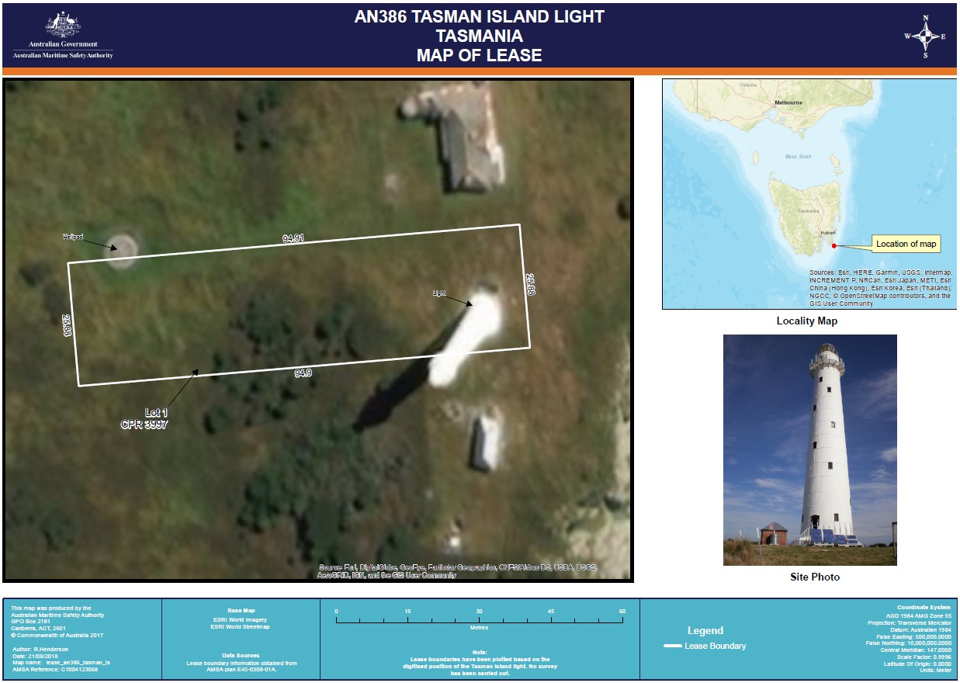
Figure 6. Tasman Island Lighthouse map of lease (Source: Esri, DigitalGlobe, GeoEye, Earthstar Geographics, CNES/Airbus DS, USDA, USGS, AeroGRID, IGN, and the GIS User Community
The AMSA lease consists of one lot, approximately 2,456 metres-squared in size. The current lease commenced on 1 May 1998 for a period of 25 years.
  - Access
Due to the island’s sheer dolerite cliffs, access to the lighthouse is only achievable by authorised helicopter. Access inside the lighthouse is restricted to authorised personnel only.
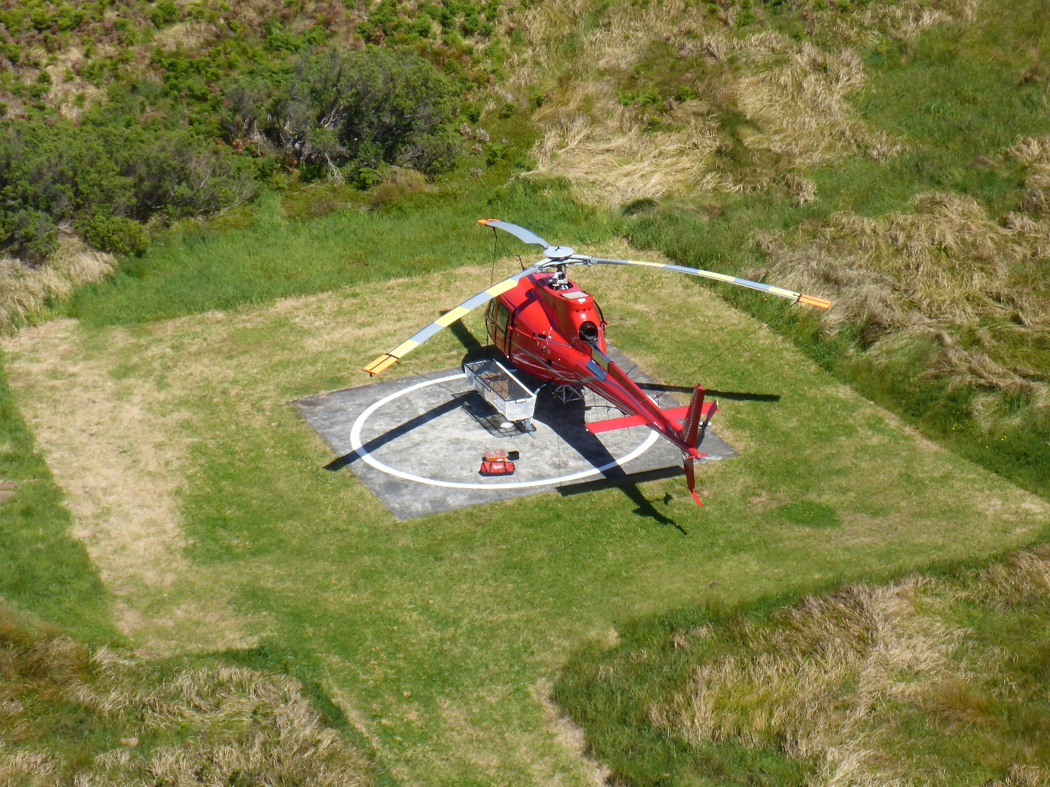
Figure 7. View of helipad at Tasman Island Lighthouse (© AMSA, 2019)
  - Listings
Tasman Island Lighthouse is included on the following heritage registers:
Listing | ID
Commonwealth Heritage List | 105566
Register of the National Estate | 102872
Tasmanian Heritage Register | 5623


- History
3.1 General history of lighthouses in Australia
The first lighthouse to be constructed on Australian soil was Macquarie Lighthouse, located at the entrance to Port Jackson, NSW. First lit in 1818, the cost of the lighthouse was recovered through the introduction of a levy on shipping. This was instigated by Governor Lachlan Macquarie, who ordered and named the light.
The following century oversaw the construction of hundreds of lighthouses around the country. Constructing and maintaining a lighthouse were costly ventures that often required the financial support of multiple colonies. However, they were deemed necessary aids in assisting the safety of mariners at sea. Lighthouses were firstly managed by the colony they lay within, with each colony developing their own style of lighthouse and operational system. Following Federation in 1901, which saw the various colonies unite under one Commonwealth government, lighthouse management was transferred from state hands to the Commonwealth Lighthouse Service.

Lamps and optics: an overview
Lighthouse technology has altered drastically over the centuries. Eighteenth century lighthouses were lit using parabolic mirrors and oil lamps. Documentation of early examples of parabolic mirrors in the United Kingdom, circa 1760, were documented as consisting of wood and lined with pieces of looking glass or plates of tin. As described by Searle, ‘When light hits a shiny surface, it is reflected at an angle equal to that at which it hit. When a light source is placed in the focal point of a parabolic reflector, the light rays are reflected parallel to one another, producing a concentrated beam’.
In 1822, Augustin Fresnel invented the dioptric glass lens. By crafting concentric annular rings with a convex lens, Fresnel had discovered a method of reducing the amount of light absorbed by a lens. The Dioptric System was adopted quickly with the Cordouran Lighthouse (France), which was fitted with the first dioptric lens in 1823. The majority of heritage-listed lighthouses in Australia housed dioptric lenses made by others such as Chance Brothers (United Kingdom), Henry-LePaute (France), Barbier, Bernard & Turenne (BBT, France) and Svenska Aktiebolaget Gasaccumulator (AGA of Sweden). These lenses were made in a range of standard sizes, called orders—see Appendix 2. Glossary of lighthouse Terms relevant to Tasman Island Lighthouse.
Early Australian lighthouses were originally fuelled by whale oil and burned in Argand lamps, and multiple wicks were required in order to create a large flame that could be observed from seaward. By the 1850s, whale oil had been replaced by colza oil, which was in turn replaced by kerosene, a mineral oil.
In 1900, incandescent burners were introduced. This saw the burning of fuel inside an incandescent mantle, which produced a brighter light with less fuel within a smaller volume. Light keepers were required to maintain pressure to the burner by manually pumping a handle as can be seen in Figure 8.
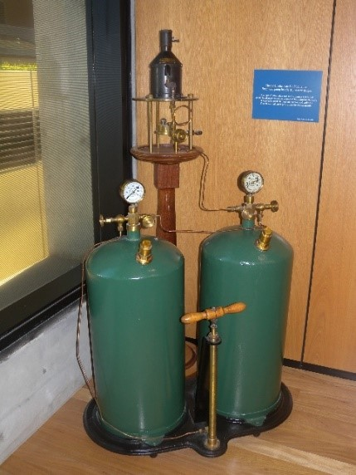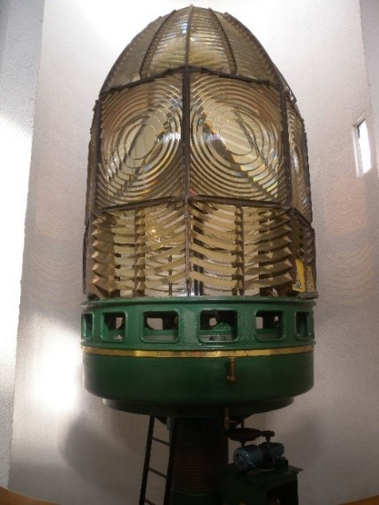
Figure 8. Incandescent oil vapour lamp by Chance Brothers (Source: AMSA)
Figure 9. Dioptric lens on display at Narooma (Source: AMSA)
In 1912 Swedish engineer Gustaf Dalén was awarded the Nobel Prize in physics for a series of inventions relating to acetylene-powered navigation lights. Dalén’s system included the sun valve, the mixer, the flasher, and the cylinder containing compressed acetylene. Due to their efficiency and reliability, Dalén’s inventions led to the gradual de-staffing of lighthouses. Acetylene was quickly adopted by the Commonwealth Lighthouse Service from 1915 onwards.
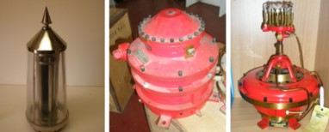
Figure 10. Dalén's system - sunvalve, mixer and flasher (Source: AMSA)
Large dioptric lenses, such as that shown in Figure 8, gradually decreased in popularity due to cost and the move towards unmanned automatic lighthouses. By the early 1900s, Australia had stopped ordering these lenses with the last installed at Eclipse Island in Western Australia in 1927. Smaller Fresnel lenses continued to be produced and installed until the 1970s when plastic lanterns, still utilising Fresnel’s technology, were favoured instead. Acetylene remained in use until it was finally phased out in the 1990s.
In the current day, Australian lighthouses are lit and extinguished automatically using mains power, diesel generators, and solar-voltaic systems.
  - The Commonwealth Lighthouse Service
When the Australian colonies federated in 1901, they decided that the new Commonwealth government would be responsible for coastal lighthouses—that is, major lights used by vessels travelling from port to port—but not the minor lights used for navigation within harbours and rivers. There was a delay before this new arrangement came into effect. Existing lights continued to be operated by the states.
Since 1915, various Commonwealth departments have managed lighthouses. AMSA, established under the Australian Maritime Safety Authority Act 1990 (Cth), is now responsible for operating Commonwealth lighthouses and other aids to navigation, along with its other functions.
  - Tasmanian Lighthouse Administration
The table below details the authority of Tasmanian lighthouse management from 1915 to the present.
Time Period | Administration
1915–1927:  1927–1963:  1963–1972:  1972–1982:  1982–1983:  1983–1985  1985–1987:  1987–1990:  1991– | Lighthouse District No. 3 (Victoria, New South Wales, Tasmania), Hobart Headquarters.  Deputy Director of Lighthouses and Navigation, Tasmania.  Department of Shipping and Transport, Regional Controller, Tasmania.  Department of Transport [III], Regional Controller, Tasmania.  Department of Transport and Construction. Victoria-Tasmania Region, Transport Division (Tasmania)  Department of Transport [IV] Victoria–Tasmania Region, Hobart Office.  Department of Transport [IV] Tasmanian Region.  Department of Transport and Communications, Tasmanian Region.  Australian Maritime Safety Authority.

  - Tasman Island: a history
Aboriginal history
The following was provided by Tony Brown, former Aboriginal Curator at the Tasmanian Museum and Art Gallery.
Aboriginal use of Tasmanian off shore islands is well enough documented and the attraction of Tasman Island was undoubtedly its rich food resources of muttonbirds (shearwaters), little penguins and fur seals.
Memos between the Marine Board of Hobart and the Tasmanian Museum in 1913 detail the discovery by one of the light house keepers of ‘a very ancient’ Aboriginal skull recovered from a penguin rookery on the top of the island. In 1922 an early historian mentions that ‘numbers of Aboriginal stone implements are to be found on the island,’ and anecdotal evidence by former lighthouse keepers and their families confirm the existence of artefacts.
While only a short distance from the coast, Tasman Island and its plateau appear to be inaccessible. Visitors to the island today must go either by helicopter or effect a difficult landing by boat or canoe under calm conditions. Tasmanian Aborigines, using their unique bark canoes, would most likely have approached the island from Crescent Bay, a distance of 11 kilometres. Prior to European occupation the only natural practical route from sea level to the plateau surface of the island would have been by way of a steep ramp on the north western side, known by lighthouse families as the ‘zig-zag’ track.
Although there has been no Aboriginal heritage assessment undertaken, the island is the site of the first record of Aboriginal seal hunting in southeast Tasmania. In 1982 a number of stone tools were found with the skeletal remains of a seal on the plateau of the island, in the vicinity of the ‘zig-zag’ track. (Stephen Harris, ‘A Seal Hunter’s Site on Tasman Island’, Australian Archaeology 1984:19)
There is no doubt that for hundreds, and possibly thousands of years, Tasmanian Aborigines travelled to Tasman Island. As with visitors today, the likelihood of bad weather blowing and making a return to the mainland impractical was an omnipresent hazard.
Aboriginal Heritage Tasmania advised that although no Aboriginal heritage sites registered in the Aboriginal Heritage Register (AHR) are recorded within the lease footprint of the lighthouse, there are two Aboriginal heritage sites recorded elsewhere on Tasman Island.
Early European history
Tasmania was first sighted by European explorers in 1642 when Dutchman Abel Tasman sailed past the Tasmanian mainland and named it Anthoonji van Diemenslandt, after the Governor of the Dutch East Indies. A large part of the south-east coast of Tasmania was charted on this expedition, and ‘Tasmans Eÿl’, known today as Tasman Island, was recorded by cartographer Joan Blaeu and reproduced in a map by Melchisedech Thevenot in 1663.
Tasman Island was also included in the 1837 map of Tasmania by John Dower. Surveyor, James Erksine Calder remarked that is was a wild and desolate looking spot, and ‘if accessible at all, only at one point.’ Due to its extreme height and formation, very few, if any, European settlers travelled to Tasman Island prior to the discussions of a lighthouse in the 1880s.
  - Planning a lighthouse
Why Tasman Island?
A meeting of the Consolidated Marine Board in August 1885 discussed the possibility of a lighthouse in the vicinity of Cape Pillar. For some time the masters of the Union Steam Company’s vessels had advocated for the erection of a light as the narrow passage of water beside the cape oversaw frequent traffic.
The necessity of such a light either on Cape Pillar or Tasman's Island has been felt absolutely essential for many years by seafaring people, and those commercially engaged in the mercantile marine; but it was not until the Russian war scare of last year that any practical proposals emanated from the Government in respect to its erection.
After discounting the cape itself and nearby Hippolyte Rocks, a site inspection was made on Tasman Island but the cost of construction was considered excessive. It was also noted that the expense of maintaining a lighthouse on the island would be double that of other locations. The difficulty of establishing telegraphic communication to Tasman Island was also seen as an obstacle.
However by 1886, despite the disadvantages identified, the Consolidated Marine Board of Tasmania made the suggestion that plans and specifications should be prepared for the Tasman Island Lighthouse. By November of that same year, the Board had put out a tender for clearing a line of trees and erecting a 20-foot high cairn on the top of Tasman Island.
Momentum towards constructing the light was short-lived, as by April 1887, the Marine Board passed a motion 'That the resolution for the erection of a light on Tasman's Island be rescinded'. Their justification was that as the site was so high, the lighthouse would frequently be obscured by clouds. Several captains under the Union Steam Navigation Company had since come forward and proclaimed the light was unnecessary and that the need of a light on the south-west coast was considered greater. The Tasman Island Lighthouse was deferred in favour of building Maatsuyker Island Lighthouse, which was constructed in 1891.
By 1897, there was again agitation for a lighthouse on Tasman Island, as the number of steamers trading from Hobart to New Zealand had increased and nearby mainland cities had grown. By the early 1900s, the River Derwent had become a busy thoroughfare and ships reported several close encounters with land and delays due to the fog around the Cape Pillar region. In 1903, the Consolidated Marine Board recommended to the Tasmanian Government the necessity for a light was by then an urgent matter. The Premier agreed that the state would pay the interest on the cost of construction of the light until the lighthouses were eventually taken over by the Federal Government.
Design
At a meeting of the Hobart Marine Board on 2 February 1904 it was announced that a lighthouse was to be built on Tasman Island.
In January 1904, the Hobart Marine Board visited Tasman Island for the purpose of selecting a site for the new lighthouse in the vicinity of Cape Pillar. The lighthouse committee recommended, based on the reports of the lighthouse inspector, the board's architects, and the Harbourmaster that the lighthouse be erected on the south-eastern part of Tasman Island.

8th April 1904
Sirs,
At a special meeting of the Board held on Wednesday last, it was decided that the site for the proposed lighthouse on Tasman Island be the one marked “A”, that is,- the Southern of the two sites shown on the plans left here by you. The light is to be a quick flashing white light visible ½ of a second once every 5 seconds and the tower is to be of iron and 85 feet high.
The quarters are to be of brick with hollow walls and iron roofs. The tower and apparatus will be ordered by the Board from England, but the tenders to be called for erection of the quarters and other work on the Island will include the erection of the tower under the personal supervision of the Lighthouse Inspector. The contractor will take delivery of the tower on the Hobart Wharf. The recommendations contained in your report of the 29th March and Mr. H. R. Hutchison’s of the same date were accepted by the Board. Please prepare plans and specifications for the whole of the work and submit same to the Board. The landing stage, crane, the haulage and tramlines and everything connected therewith shall be the property of the Board without any extra payment. All of such work shall be of a good and permanent character and shall stand part of the contract. Any sheds etc. erected by the contractor shall also become the property of the Board without any extra payment.
I am, Sirs,
Your obedient servant,
Master Warden.

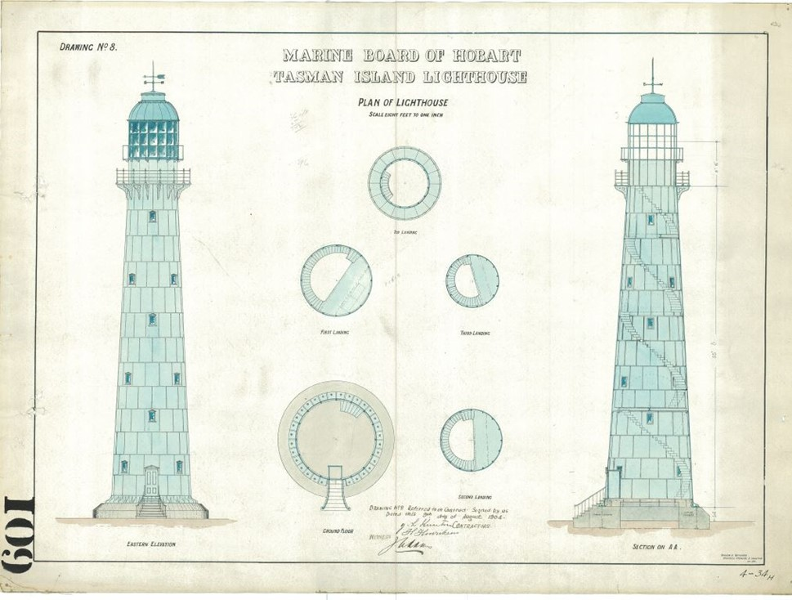
Figure 11. Marine Board of Hobart, Tasman Island Lighthouse, Huckson & Hutchison, 1904. NAA: A9568, 5/13/4. Image courtesy of the National Archives of Australia (© Commonwealth of Australia, National Archives of Australia)
The Marine Board's engineer, Mr J. R. Meech, told the members of the Consolidated Board that: 'due to the extreme difficulties of getting building materials to the Island , the lighthouse tower would have to be made of iron, and taken to the island in segments, and then put together’.
Marine Board architects, Huckson and Hutchison, forwarded plans and specifications for the Tasman Island Lightstation to the Hobart Marine Board in June 1904. As per Mr Meech's instructions, it was to be a cast iron tower on cement foundations and fitted with an incandescent light.

Construction
Following completion of Huckson and Hutchison’s design, the board called for tenders and instructed the Master Warden to order the tower and lens from Chance Bros in Birmingham, England.
A tender of £10,487 and 10 shillings was awarded to Henrickson and Knutson for the erection of the lighthouse with an undertaking to complete the works in 18 months from the date of announcement being 18 August 1904.
Mr F. Reynolds was appointed Clerk of Works at Tasman Island to oversee the erection of the lighthouse. Following the arrival of the pre-fabricated tower and Chance Bros & Co. 1st Order lens from England, work commenced in October 1904 and it proved no easy feat. Due to the extreme height of the island and its formation, a landing, haulage system and a steam crane with a 60-foot radius, purchased second-hand after the construction of Hobart’s General Post Office, was erected on the island beforehand. Building materials were brought to Tasman Island via steamer from Hobart and then hauled up the cliffs to site. The cast iron plates, estimated to have weighed 13cwt (660 kg) each took roughly eight hours to scale the cliffs and reach the site. Once all parts had successfully made it to the site, the plates were bolted together and the lens fitted.
Equipment when built
Once completed, Tasman Island Lighthouse stood as a 29-metre tall cast iron tower, fitted with a 1st Order lens with an intensity registering at 275,500 candlepower. The light source operated with vapour kerosene and an 85mm burner with a six-wick emergency lamp. The tower was accompanied by brick keepers’ cottages. The head keeper’s quarters, a seven-room building, cost around £2,000, and the two six-room assistant cottages were £1,500 each to construct.
The lighthouse was officially opened on Monday 2 April 1906. The Master Warden, J.E. Risby, and members of the Marine Board made the journey to the lightstation for a short ceremony, followed by lunch with the keepers and their families. Afterwards, the official party left on board the SS Mahinapua, and observed the light, which was lit for the first time by the Superintendant’s wife.
  - Lighthouse keeping
The first Superintendent stationed at the lighthouse was Mr George Johnson, accompanied by his family, his assistants J. McGuire and E. Davis, and their families. The keepers and their families tended to crops and livestock, including sheep, chickens, cows, draught horses, and pigs, which afforded them wool, meat, and dairy products. Devoid of native animals, feral cats were prominent on the island and keepers were forced to keep their chickens in fully enclosed runs.
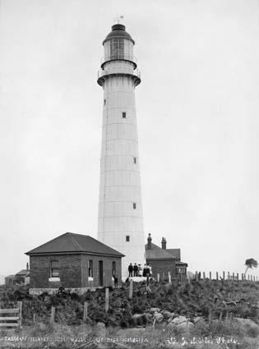
Figure 12. Tasman Island Lightstation before removal of original lantern house, 1910. Image courtesy of the NAA: A1861, 1958 (© Commonwealth of Australia, National Archives of Australia)

Light keeping on island lightstations was already an extremely isolated livelihood, and Tasman Island’s colossal height and the inability to make telegraphic connections isolated inhabitants even further. Originally forced to rely on signal flags for communication, pigeon post was eventually introduced on the island after successful trials at the nearby Maatsuyker Island Lighthouse. The pigeons at Tasman, however, were unreliable to say the least. Due to the number of birds of prey lurking off the coast of Cape Pillar, and the extremely comfortable lifestyle the pigeons were given at the station, most were reluctant to fly far from the Island and those that did rarely reached their intended destination.
Access to the island in the early days was either by ‘the Zig-zag’, a perilous access path down the sheer cliff-face, or via hoist in a basket up to the landing on a ledge 80 feet above sea level by steam crane. From there, an engine-driven tramline carried goods or people up the remainder of the cliff before they had to be transferred onto a horse-drawn tramway.
In March 1927, a new crane was being installed on the cliff edge approximately 100 metres above sea level when a beam suddenly gave away. Two riggers who had been working at the top of the crane were thrown down the cliff. William Groombridge was thrown onto the rocks below and swept out to sea while the second man, Orlando Patterson, was knocked unconscious and miraculously saved after his leg became entwined in some wire, holding him above the water. After a failed attempt to send for help via pigeon post, the lightkeepers were finally able to attract a passing ship the following day using distress signals. The message was successfully relayed to Hobart and the steamer Cartela was dispatched to the island with a doctor on board. The unconscious Patterson was hoisted down the cliffs to the awaiting steamer.
This event is considered the turning point that triggered investigation into the reliability of pigeon post at isolated sites. Finally in October 1930, a radio was installed at Tasman Island Lighthouse.
With the crane lost, access to the island was by a temporary structure built on the rocks below until a flying fox was constructed in 1929. Suspended from an overhead wire, the flying fox stretched from the landing platform to an off-shore rock known as Anchor Rock, approximately 80 feet above sea level. This remained in operation until the station was closed in 1977.
In addition to the station’s perilous location and isolating conditions, the weather endured on Tasman Island could be catastrophic. High wind levels battered the station, causing the tower to sway and mantles within the lantern to split, extinguishing the light on many occasions. Crops were ruined by strong gales and some unfortunate livestock were blown over the cliff side. On 28 April 1906, the keepers’ woodshed and cottage fences were blown away by the winds, and in 1928, the two-roomed relief quarters was lifted 3ft from its foundations. The tower was also flooded twice in the first year of its operation as disastrous storms hit the island.
An account of life on the island was published in The Argus in 1919, revealing much about the keeper’s relationship with the weather:
One thing ever with them, and in their ears night and day, is the sound of the surf at the foot of the cliffs. It varies from a mournful minor melody on summer days when the sea is calm, except for the swell which never ceases to rise and shatter itself against the black rocks, to a crashing roar which fills the air and seems to shake the solid rock in times of storm. So habituated is it possible to become to this ‘background’ of never-ceasing sound, that some of those who are used to it cannot sleep when they first go to inland places. The silence of the night seems oppressive and unnatural, and they lie awake listening in vain for the wild lullaby of the breaker.
The station remained staffed until 1977 when on 20 May, the last inhabitants of Tasman Island—David Ingram, his family and Lyndon Webb—departed.
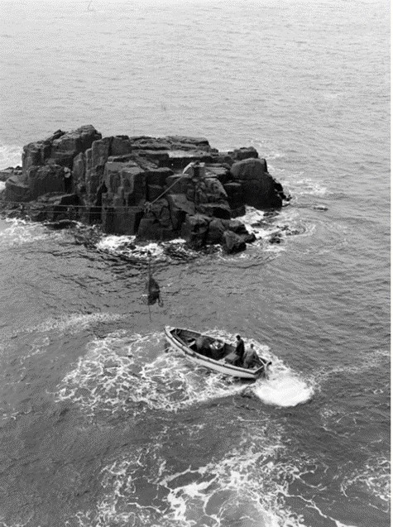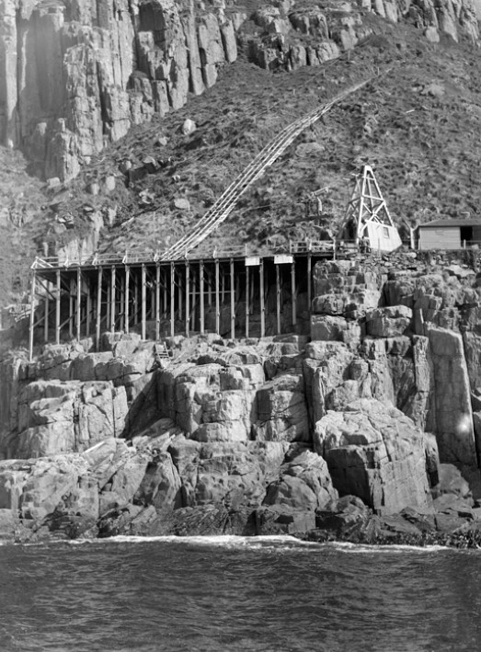
Figure 13. (Left) Tasman Island Lighthouse landing, showing the method used to unload supplies and personnel destined for the lighthouse, 1948. Image courtesy of NAA: A1200, L11284. (© Commonwealth of Australia, National Archives of Australia)
Figure 14. (Right) Lighthouse landing and incline tramway, Tasman Island, off the south-east corner of Tasmania, 1948. Image courtesy of NAA: A1200, L11285. (© Commonwealth of Australia, National Archives of Australia)
Second World War
Throughout the duration of the Second World War, Royal Australian Navy personnel were stationed on Tasman Island. Tasked with managing radio transmissions and signals, the personnel were noted to maintain good relations with the lightkeepers. Radio communications during this time was restricted, and instead ‘silent’ codes, such as semaphore, International Flag Code and Morse, were practiced.
Lighthouse keepers were forbidden from enlisting due to their essential service to the country. During a supply ship visit, a ceremony took place wherein the keepers were brought on board, and the ship’s captain appointed them as Special Commonwealth Peace Officers.
  - Chronology of major events
The following table outlines the major events to have occurred over the course of Tasman Island’s Lighthouse history.

Date | Event
2 Apr 1906 | Light first lit. Ceremony held with lightkeepers, Master Warden, and members of the Marine Board.
28 Apr 1906 | Keepers’ woodshed and cottages’ fences blown away by strong winds.
Oct–Nov 1906 | Lighthouse tower flooded twice due to intense storms.
20 Mar 1907 | Mantles in the lighthouse split due to the tower vibrating in the strong winds — substituted with a wick-burner.
Oct 1911 | Commander C.R.W. Brewis visits Tasman Island to inspect and report on the lighthouse prior to the Commonwealth takeover.
1912–13 | Pigeon Post service started as means of communication at lighthouse.
7–8 Nov 1915 | SS Nord observed by keepers foundering in nearby waters — lightstation pigeons sent to Hobart.
1915 | Lighthouse Service passed into the control of the Commonwealth.
1916 | New station horse hoisted up flying fox.
1919 | Strong winds destroy five mantles within lantern and mercury from bath is spilt on lantern room floor. The fowl house was destroyed, and one cottage’s verandah was blown away.
1920 | Daughter to keeper Mr L.B. Jonston and his wife, Stella, born at the station.
1921 | Lightkeeping families struck down by influenza.
Jan 1922 | Storm hits island — lantern glazing cracked, and two mantles split.
Apr 1922 | Storm hits island — six mantles split.
Mar 1927 | Fatal accident at the Tasman Island Lighthouse — cliff-side crane collapses taking Mr. William George Groombridge with it over the cliff. Joseph Orlando Patterson was saved.
Oct 1930 | Radio installed at Tasman Island replacing pigeon post.
1936 | Severe rockfall on lighthouse side of landing — no damage observed to structures.
Circa 1939-1945 | Royal Australian Navy personnel stationed at Tasman Island to control radio transmissions during Second World War.
1950 | Lightkeeper’s son badly scalded by boiling water — winched down the cliffs in basket to an awaiting rescue ship.
1967 | Black Tuesday bushfires — smoke and cinders blown across from Cape Pillar to Tasman Island resulting in the stables being burnt down.
1975 | Lighthouse converted to solar power.
20 May 1977 | Station is de-staffed. Lightkeepers and their families depart.
21 Oct 1980 | Tasman Island Lighthouse listed on the Register of the National Estate.
1997 | Tasman Island Lightstation listed on the Tasmanian Heritage Register.
22 Jun 2004 | Tasman Island Lighthouse listed on the Commonwealth Heritage List.
Apr 2007 | First public tours of lighthouse carried out inconjunction with the Rotary Club of Tasman Peninsula.
Jun 2016 | Original steam crane, which had been stored on the bank adjacent to the landing since 1927, is washed away in storm.

  - Changes and conservation over time
Tasman Island Lighthouse has undergone a number of changes since its construction, most notably the removal of its original lantern house in 1976. The magnificent 1st Order Chance Brothers Fresnel lens is now on display at the Australian National Maritime Museum in Sydney.
This section details historical recommendations for change, alterations to the light over time, and recent conservation works carried out on the tower.
The Brewis Report
Commander CRW Brewis, retired naval surveyor, was commissioned in 1911 by the Commonwealth Government to report on the condition of existing lights and to recommend any additional ones. Brewis visited every lighthouse in Australia between June and December 1912, and produced a series of reports published in their final form in March 1913. These reports were the basis for future decisions made in relation to the individual lighthouses.
Recommendations made by Brewis for Tasman Island Lighthouse included the installation of a fog signal, the construction of a new crane, the installation of an acetylene Morse lamp, and the establishment of telephone communication.
TASMAN ISLAND LIGHT.
(30 miles from Derwent Light.)
Lat. 43º 14’ S., Long. 148º 2’ E., Chart No, 1079.- Established in the year 1906. Situated at the
entrance to Storm Bay.
Character.- One white, flashing every five seconds, dioptric, 1st Order, 275,500 c.p. Illuminant,
vaporized kerosene.
Iron tower, 85 feet. Height of focal plane, 907 feet above high water. Visible, in clear weather, 36
nautical miles.
Condition and State of Efficiency.- The tower, optical apparatus, and quarters are modern, and in
good condition. The steam crane at the landing was old when erected, and is now admittedly dangerous.
Arrangements are being made by the Hobart Marine Board to have the crane replaced by a new one as soon
as possible.
Three lightkeepers are stationed here.
Communication.- Quarterly by steamer carrying stores by contract.
Mail service every three weeks by fishing vessel.
An acetylene Morse Lamp is required to facilitate communication with passing vessels – necessary
in case of emergency. Telephone communication is required.
Fogs.- During the summer months occasional bush fires cause fogs of great density.
RECOMMENDED.-
- A fog signal be established. Fog rockets, one report every five minutes. From the
position of the light, over 900 feet, the rockets will explode at an elevation of about
1,200 feet.
- Landing Stores.- A new crane be provided.
- Communication.- Acetylene Morse Lamp be provided.
- Telephone communication be established, connected with the main telegraph system.
(Provided for by clause 9 of the Light-houses Act 1911.)
A preliminary survey was made in 1910 for a proposed telephone route from Oakwood to Tasman
Island, distance 12 ¾ miles. From Oakwood to Tasman’s Peninsula there are no difficulties in the way of
erecting an ordinary telephone line, but a suspension wire about 1,350 yards long would be required from
Cape Pillar to the island.
No steps have been taken by the Marine Board to carry out the work.

Despite Commander Brewis’s recommendations, the fog signal was never installed. The steam crane, which was first used in the construction of Hobart GPO, was second hand when installed on Tasman Island and wasn’t dismantled for replacement until 1927. The crane lay on the bank adjacent to the landing until 2016, when a storm finally washed it into the sea.
Alteration to the light
The following table details alterations made to the light at Tasman Island over the course of its history.
Date | Alteration
May 1929 | Intensity of light increased to 400,000 cd.
1976 | Original lens and lantern house removed and replaced with AGA PRB21 array and NAL-1 lantern room respectively.  Wind generator used to power lighthouse.
28 Mar 1991 | Solar conversion of lighthouse occurs.
Apr 1996 | Vega VRB25 array installed.

Recent conservation works
The following table details the recent conservation works to have been undertaken by AMSA.
Date | Works Completed
c. 1990s | Removal of tower entry door and replacement with replica.

  - Summary of current and former uses
From its construction in 1906, Tasman Island Lighthouse has been used as a marine AtoN for mariners at sea. Its AtoN capability remains its primary use.
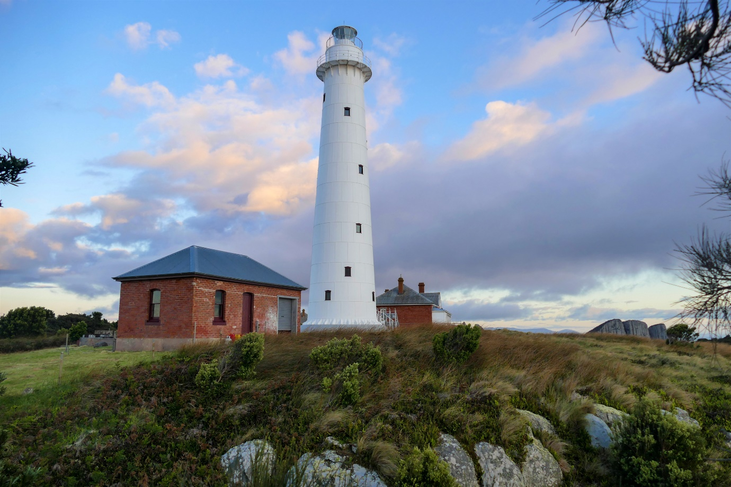
Figure 15. Oil store, lighthouse and lightkeepers' quarters no. 3 (obscured). (© Brett Hall, 2019)
Due to conservation efforts by Wildcare group Friends of Tasman Island, in partnership with the Tasmanian Park and Wildlife Service, the lightstation’s remaining buildings are being restored. The following was written by a representative of the group:
Apart from the lighthouse, existing buildings on Tasman Island include three substantial brick lightkeepers’ quarters and an oil store. A timber building, the oldest structure on the island, built in 1904 as the Clerk of Works office and subsequently used as relief keepers’ quarters, now lies in ruins. Other ruins still visible include the foundations of the horse stables, haulage & landing.

- Lightkeepers Quarters No 3 – Assistant’s quarters
The Assistant Lightkeepers’ Quarters 2 & 3 are both built to the same plan.
A substantial brick building adjacent to the lighthouse. It is now used as accommodation for volunteers, wildlife observers and Parks’ personnel. Restoration is ongoing, the most recent work being the restoration of the sunroom & front verandah.

- Lightkeepers Quarters No 2 – Assistant’s quarters
The Assistant Lightkeepers’ Quarters 2 & 3 are both built to the same plan.
A substantial brick building. Restoration is ongoing, the most recent work being the restoration of the sunroom & front verandah.

- Lightkeepers Quarters No 1 – Superintendent’s (Head Keeper’s) quarters
This substantial brick building is in need of considerable restoration. Work is ongoing.

- Oil Store
A brick building with corrugated iron roof. Restoration completed in 2008 and now used as workshop and storage.

- Haulage
Overgrown & in ruins

- Landing
This substantial structure, about 25 metres above sea level, has suffered from the ravages of time. Substantial storm damage was sustained in 2016 and the landing has now been partially restored by Parks & Wildlife Service Tasmania, together with contractor AJR Construct.

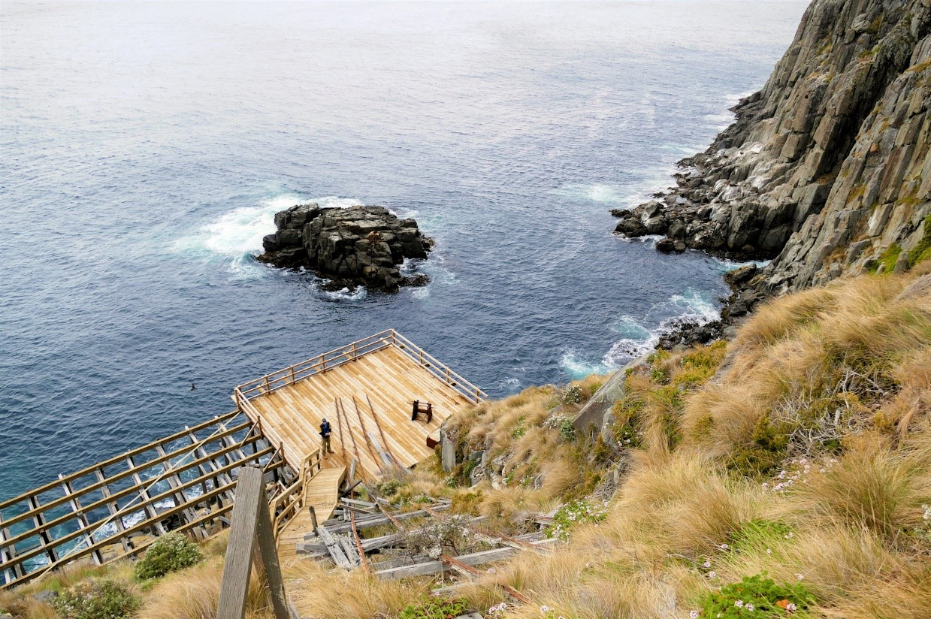
Figure 16. Tasman Landing and Anchor Rock (© Brett Hall, 2019)

  - Summary of past and present community associations
Aboriginal associations
Further consultation with Traditional Custodians will be undertaken for a greater understanding of the past and present associations held across the region.
Local, national and international associations
The island and lightstation maintain strong familial associations due to the lighthouse’s extensive history as a staffed site. Tasman Island is considered a significant site of Tasmanian and Australian history.
The site is maintained by Friends of Tasman Island, a branch of Wildcare Inc., in partnership with Parks and Wildlife Tasmania. AMSA consulted with the group regarding their associations with and work on the island. The following was written by a representative of the group:
After the lighthouse was automated in 1977 and keepers withdrawn, Tasman Island subsequently became part of the Tasman National Park, managed by the Tasmanian Parks and Wildlife Service. Volunteers from Wildcare Friends of Tasman Island, formed in 2005, work in partnership with Parks and Wildlife Service Tasmania—their aim to restore the island’s cultural and natural heritage. Their first working bee, held on the island in 2006, celebrated the 100th anniversary of the lighthouse. Since that time, working bees have been held two or three times a year, with volunteers completing an impressive range of restoration, conservation and maintenance work.
Wildcare Friends of Tasman Island volunteers have carried out many hundreds of hours of work each year towards the preservation and restoration of the natural and cultural heritage of Tasman Island. Their dedication will ensure that this dramatic island’s history will not be forgotten.
Wildcare Friends of Tasman Island hold the remaining pieces of the original Tasman Island Lighthouse lantern room, and hope to put it on display one day.
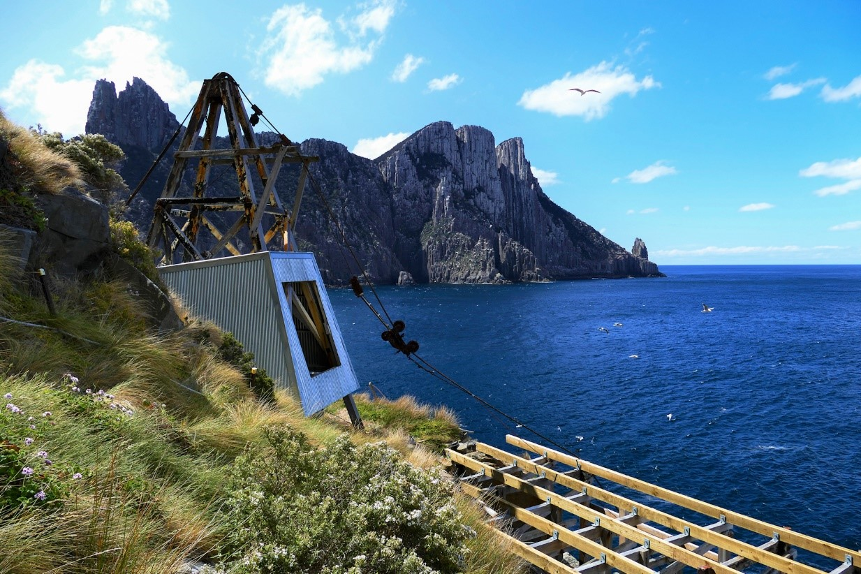
Figure 17. Winch shed at Tasman Island, reclad by Parks & Wildlife Service Tasmania (© Brett Hall, 2019)
  - Unresolved questions or historical conflicts
There are small inconsistencies between differing accounts of the lighthouse’s history, such as the intensity of the light. K. Stanley determines in their book Guiding Lights: Tasmania’s lighthouses and lighthousemen that the Tasman Island light registered an intensity of 400,000 cd. upon its installation in 1906. However, Gary Searle found that the light initially registered an intensity of 275,500 cd. in 1906 before increasing to 400,000 cd. in 1929.
Any further inconsistencies brought to light will be included in future versions of this plan.
  - Recommendations for further research
Archaeological investigation of the site may reveal further information on prehistoric and historic uses of Tasman Island to broaden understandings of the site’s intrinsic value.


- Fabric
  - Fabric register
The cultural significance of the lighthouse resides in its fabric, and also in its intangible aspects, such as the meanings people ascribe to it, and the connections to other places and things. The survival of its cultural value depends on a well-informed understanding of what is significant, and on clear thinking about the consequences of change. The Burra Charter sets out good practice for conserving cultural significance.
Criterion listed under ‘Heritage Significance’ refer to the criterion satisfied within the specific Commonwealth heritage listing (see section 5.1).
(All images in sub-section 4.1 and 4.2 – © AMSA)
Lighthouse feature: 1976 GRP lantern on top of 1906 Chance Brothers lantern base.
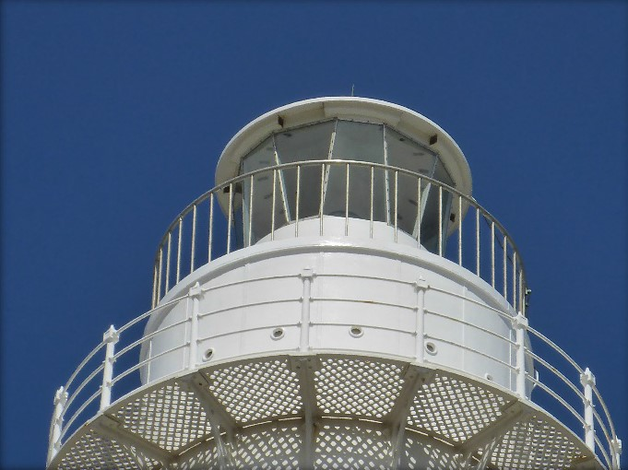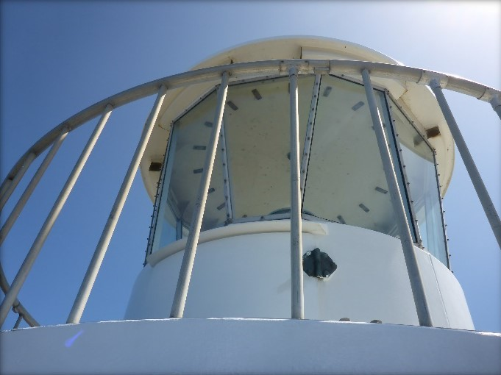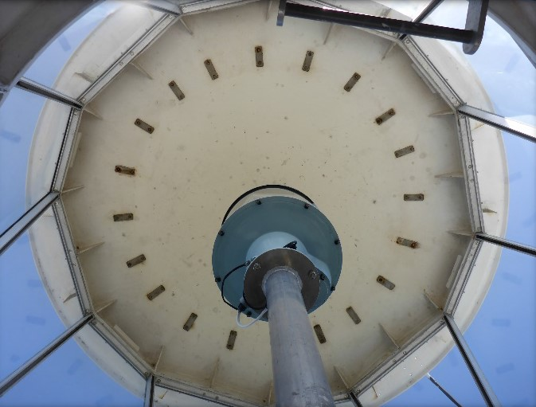
© AMSA, 2019
Description and condition
NAL-1 conical roof of glass reinforced plastic. Single copper lightning conductor spike on top, connected with a cable running down outside of tower.
Finish | painted externally
Condition | intact and sound
Integrity | high
Significance | low
Maintenance | keep in service, prepare and repaint at normal intervals
Rectification works | none

Heritage significance: Low

Lighthouse feature: 1976 Lantern glazing
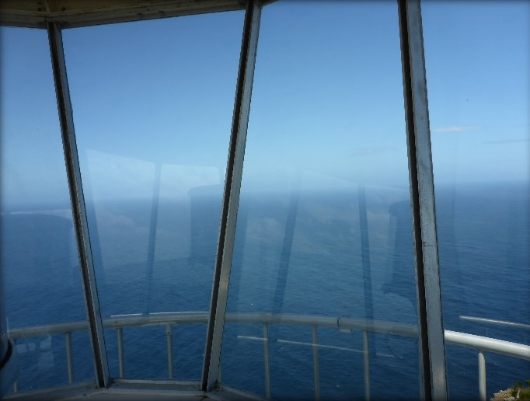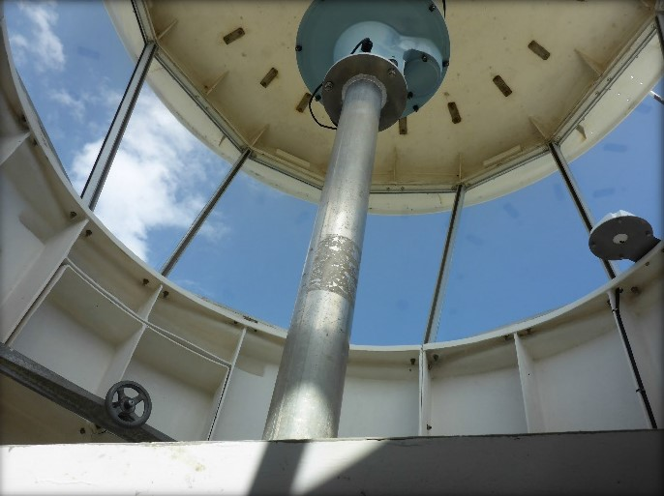
© AMSA, 2019
Description and condition
Flat, trapezoidal glass panes. Aluminium astragals and cover strips.
Finish | unpainted
Condition | intact and sound
Integrity | high
Significance | low
Maintenance | keep in service, reglaze as necessary
Rectification works | none

Heritage significance: Low

Lighthouse feature: 1976 lantern base
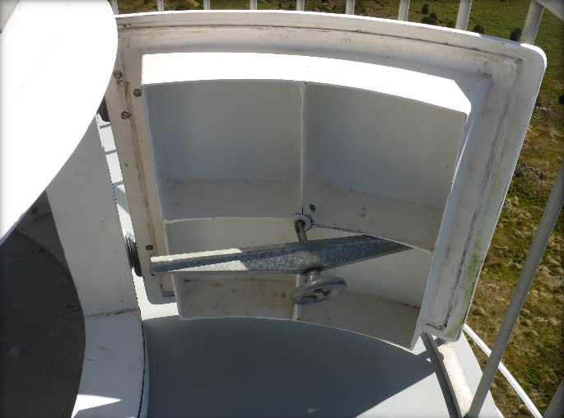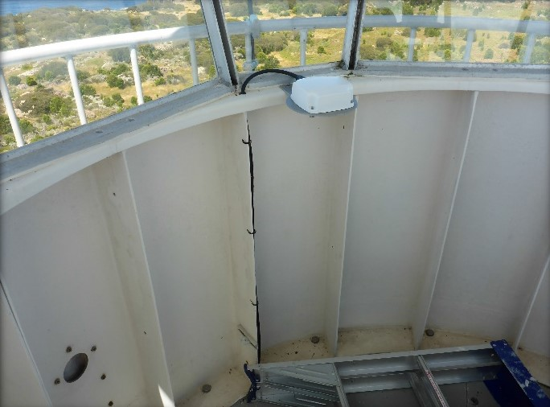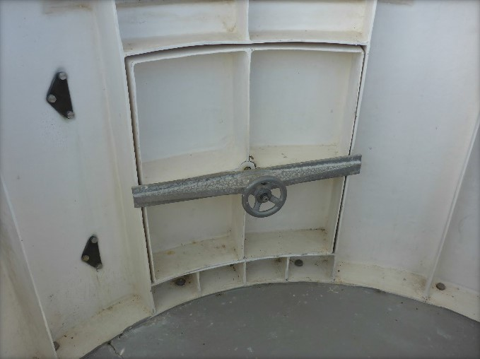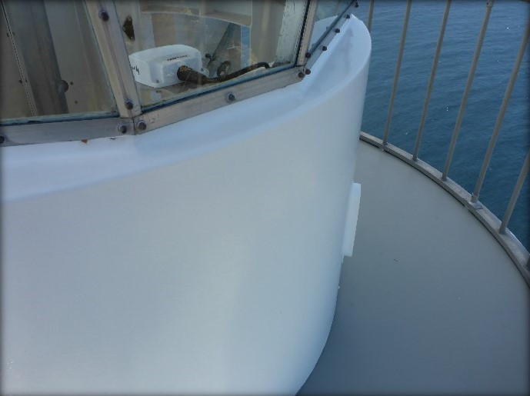
© AMSA, 2019
Description and condition
GRP cylindrical base made of panels bolted together; vertical ribs and flanges where segments are connected; horizontal flange at bottom; horizontal sill at top.
- Ventilators – GRP chambers bolted onto the outside of the wall panels.
- Balcony door – GRP, internally ribbed, on bronze hinges, locked by internal cast aluminium strong-back with cast aluminium hand wheel on stainless steel stud.
Finish | painted externally
Condition | intact and sound
Integrity | high
Significance | low
Maintenance | keep in service, prepare and repaint at normal intervals
Rectification works | none

Heritage significance: Low

Lighthouse feature: 1976 lantern floor
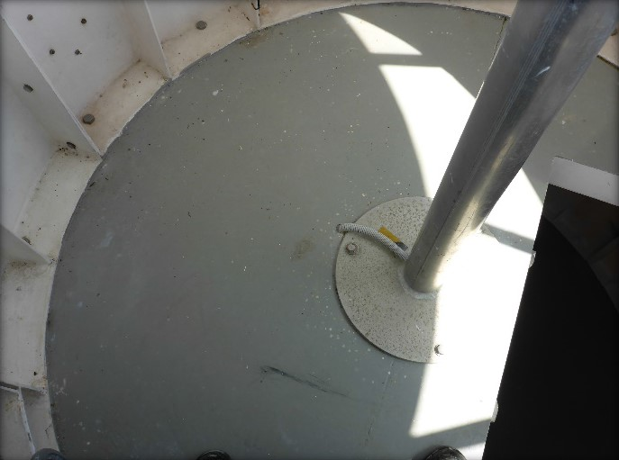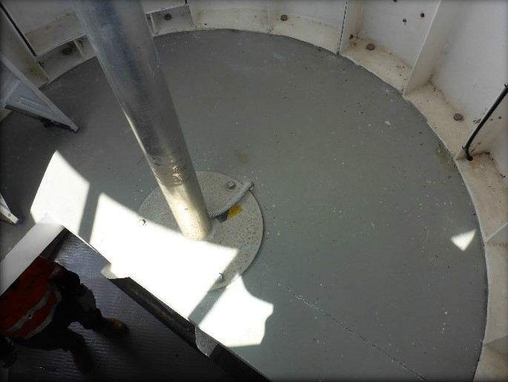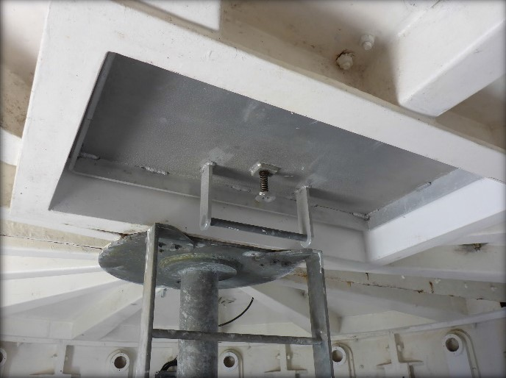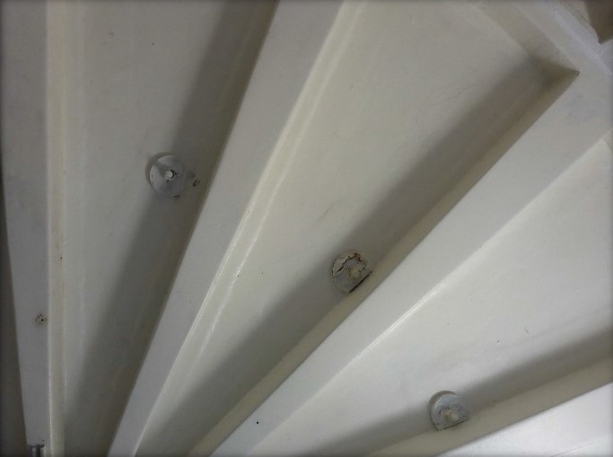
© AMSA, 2019
Description and condition
GRP floor made in two halves with integral box beams underneath; halves bolted together and fixed to the top of the old lantern base; continuous with upper balcony floor. Access hatch is rectangular, with welded aluminium door.
Finish | painted on top, unpainted on bottom
Condition | intact and sound
Integrity | high
Significance | low
Maintenance | keep in service, prepare and repaint at normal intervals
Rectification works | none

Heritage significance: Low

Lighthouse feature: 1906 lantern base
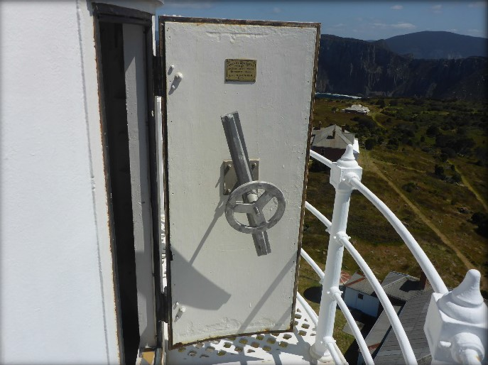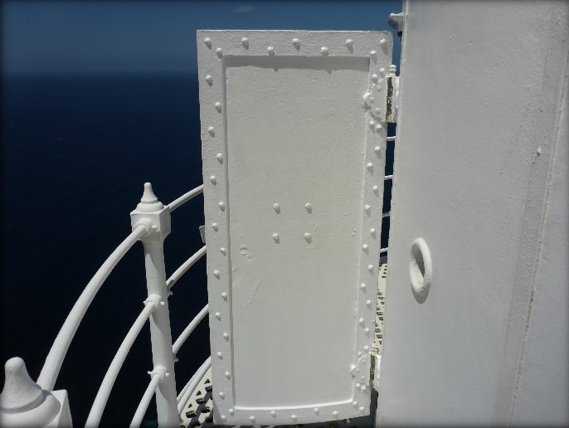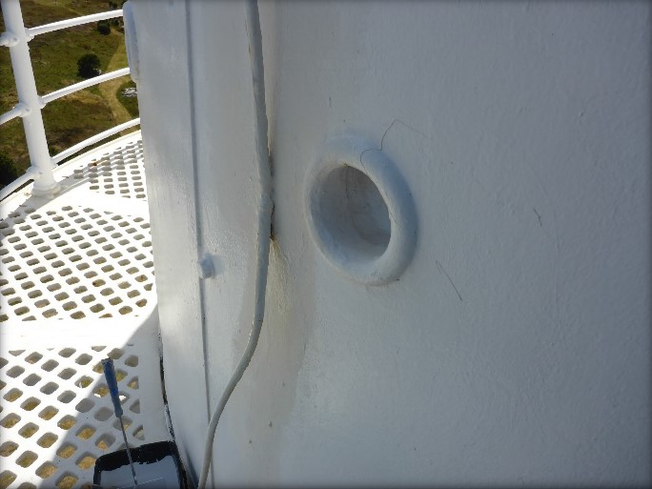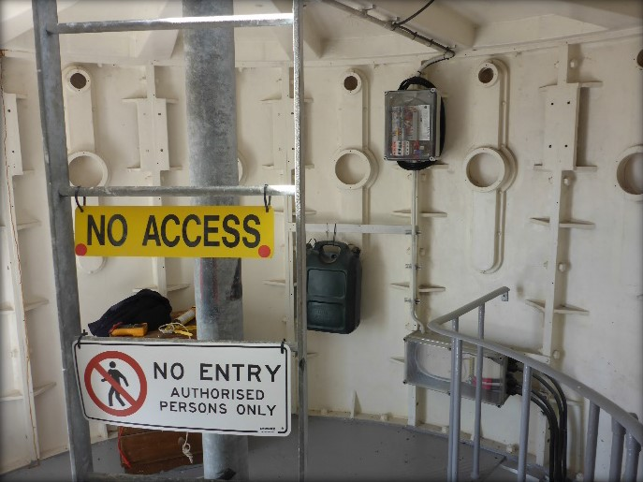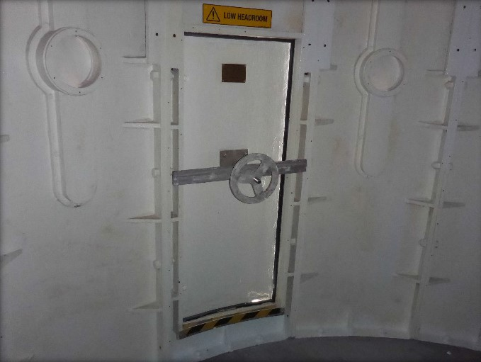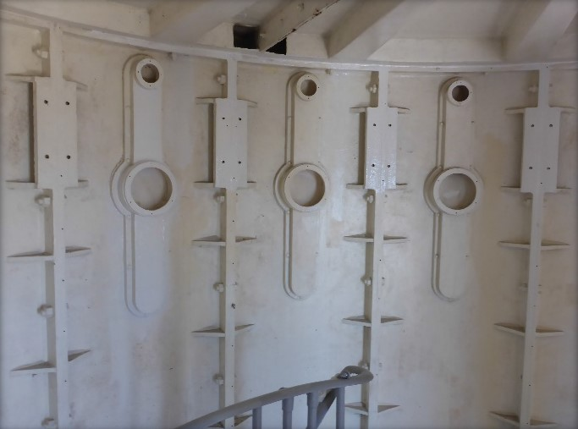
© AMSA, 2019
Description and condition
1906 Chance Bros, cylindrical in form. Curved panels of cast iron bolted together with flanged joints.
- Internal lining – none (removed).
- Central support – galvanised steel tube with welded plates top and bottom, to support the centre of the upper lantern floor and the beacon pedestal.
- Ladder – fixed galvanised steel ladder to upper lantern room.
- Ventilators – round air inlets cast as part of wall panels; cast iron air trunks bolted on inside, from which the original brass regulators have been removed.
- Doors – Chance Bros iron door from which the inner lining, frame and lock have been removed; the lock replaced by cast aluminium strong-back, cast aluminium hand-wheel and stainless steel stud; original bronze hinges. Reproduction Chance Brothers makers plate fitted to internal surface of door in 2012.
Finish | painted
Condition | sound
Integrity | high
Significance | high
Maintenance | keep in service, prepare and repaint at normal intervals
Rectification works | none

Heritage significance: High
The 1906 lantern base is an original part of one of the last lighthouses to have been built by the state of Tasmania (criterion a).
The 1906 lantern base is an original part of a relatively intact twentieth century lighthouse complex (criterion d).
The 1906 lantern base contributes to the aesthetic value of the lighthouse within its setting (criterion e).

Lighthouse feature: 1906 lantern floor
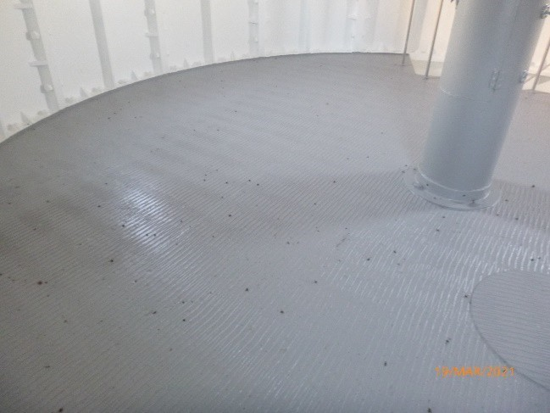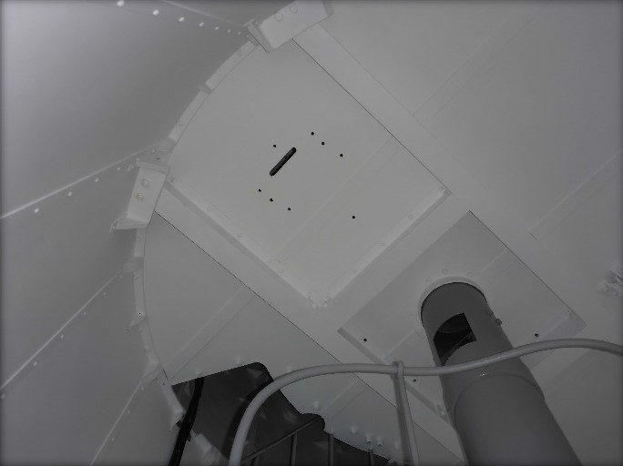
© AMSA, 2021
Description and condition
Ferrous metal checker plate on rolled steel joints supported on brackets built into tower wall panels.
Finish | painted
Condition | intact and sound
Integrity | high
Significance | high
Maintenance | keep in service, prepare and repaint at normal intervals
Rectification works | none

Heritage significance: High
The 1906 lantern floor is an original part of one of the last lighthouses to have been built by the State of Tasmania (criterion a).
The 1906 lantern floor is an original part of a relatively intact twentieth century lighthouse complex (criterion d).

Lighthouse feature: Beacon
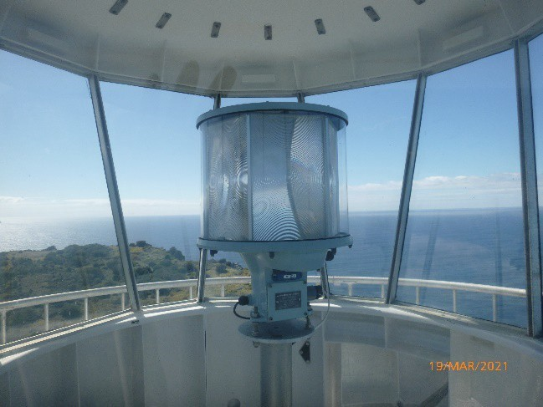
© AMSA, 2021
Description and condition
Vega VRB-25 self-contained rotating beacon.
Condition | intact and sound
Integrity | high
Significance | low
Maintenance | keep in service
Rectification works | none

Heritage significance: Low

Lighthouse feature: Pedestal
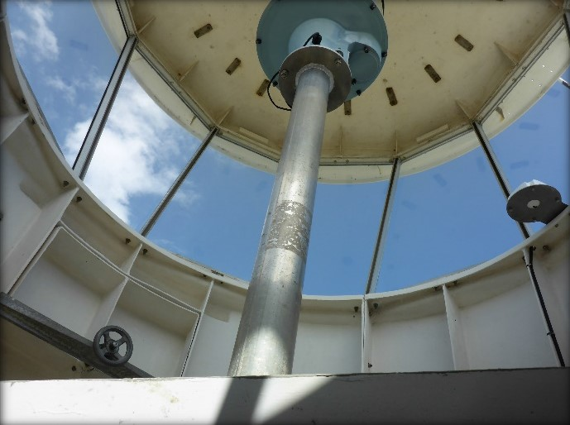
© AMSA, 2019
Description and condition
Aluminium tube welded to circular aluminium plates top and bottom.
Finish | unpainted
Condition | intact and sound
Integrity | high
Significance | low
Maintenance | keep in service
Rectification works | none

Heritage significance: Low

Lighthouse feature: 1976 Balcony floor – upper
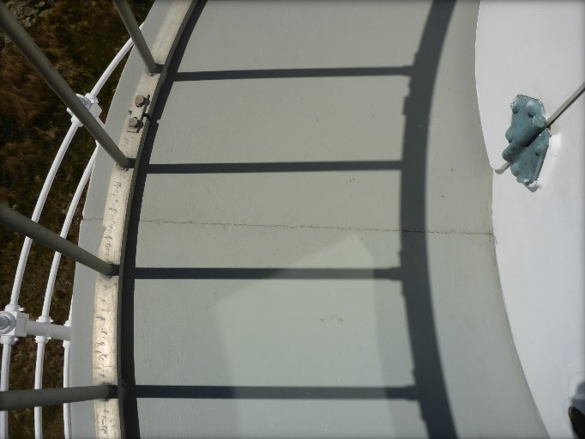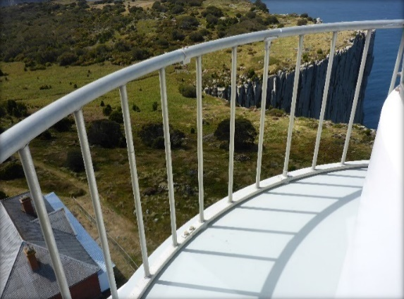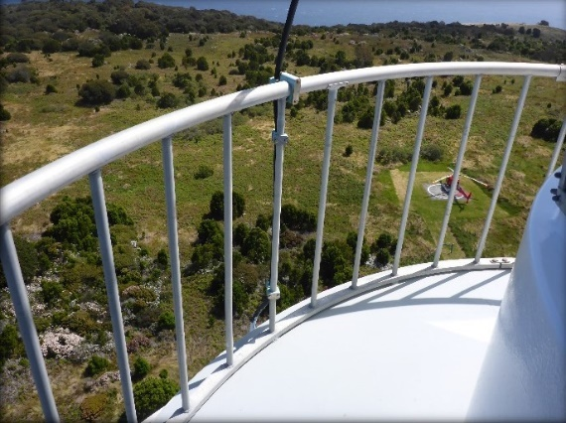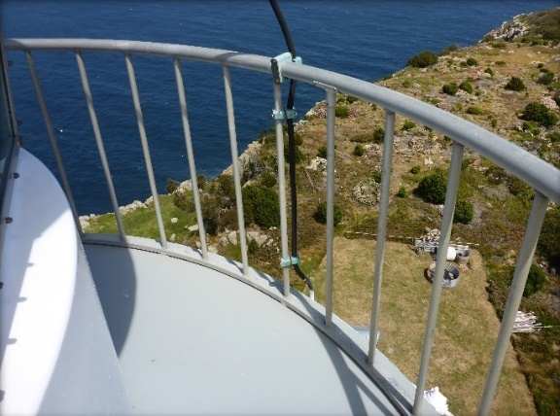
© AMSA, 2019
Description and condition
1976 GRP floor continuous with 1976 lantern floor.
Finish | painted
Condition | intact and sound
Integrity | high
Significance | low
Maintenance | keep in service, prepare and repaint at normal intervals
Rectification works | none

Heritage significance: Low

Lighthouse feature: 1976 Balcony balustrade – upper
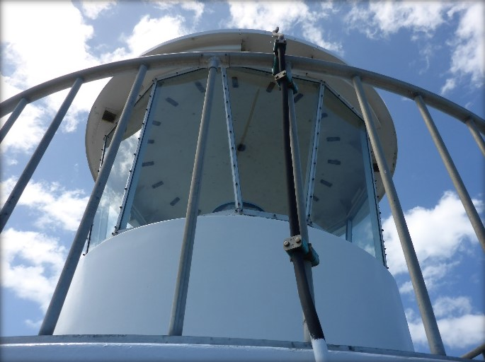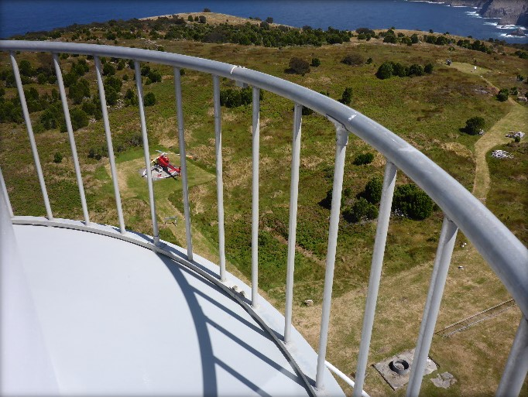
© AMSA, 2019
Description and condition
1976 welded aluminium structure with tubular hand rail and balusters and rectangular bar bottom rail.
Finish | unpainted
Condition | intact and sound
Integrity | high
Significance | low
Maintenance | keep in service
Rectification works | none

Heritage significance: Low

Lighthouse feature: 1906 Balcony floor – lower
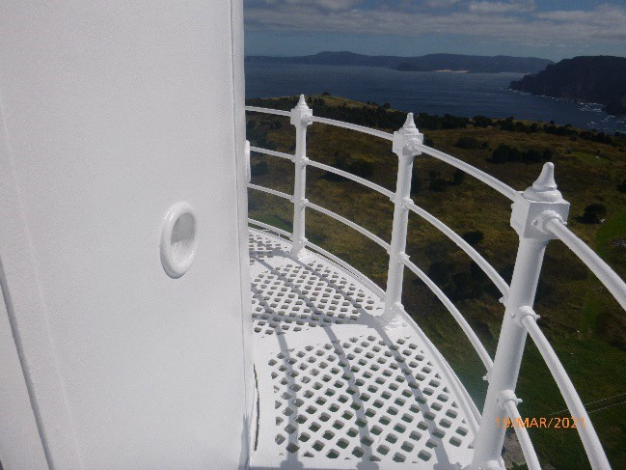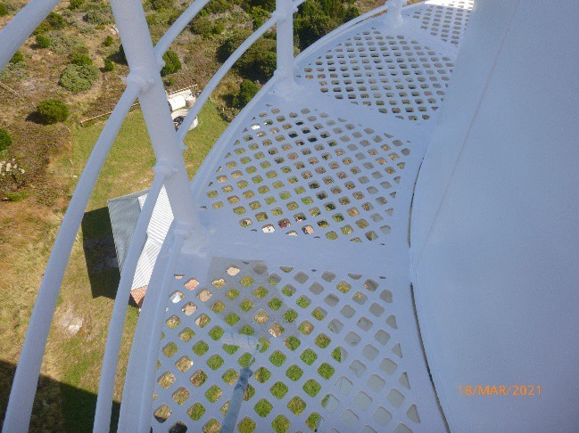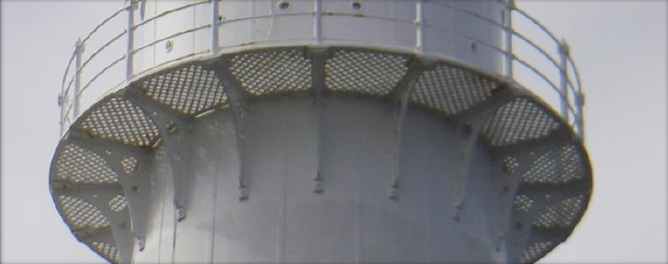
© AMSA, 2021
Description and condition
1906 Chance Bros cast iron floor panels and supporting brackets.
- Floor panels – segments of open lattice with solid edges.
- Brackets – angle brackets with perforated webs, bolted to tower wall panels below the balcony.
Finish | painted
Condition | intact and sound
Integrity | high
Significance | high
Maintenance | keep in service, prepare and repaint at normal intervals
Rectification works | none

Heritage significance: High
The 1906 balcony floor (lower) is an original part of one of the last lighthouses to have been built by the state of Tasmania (criterion a).
The 1906 balcony floor (lower) is an original part of a relatively intact twentieth century lighthouse complex (criterion d).
The 1906 balcony floor (lower) contributes to the aesthetic value of the lighthouse within its setting (criterion e).

Lighthouse feature: 1906 Balcony balustrade – lower
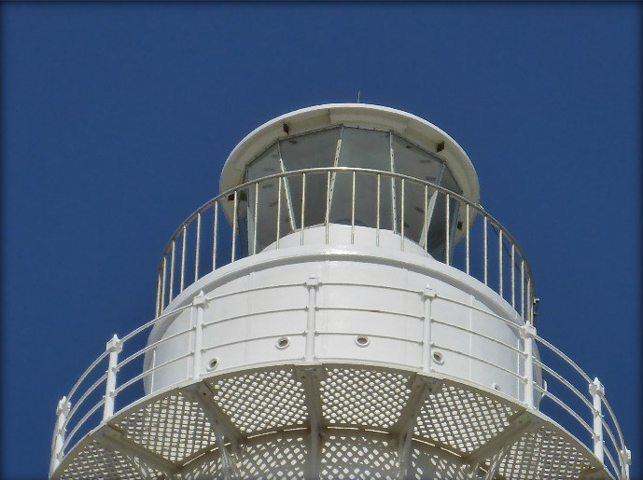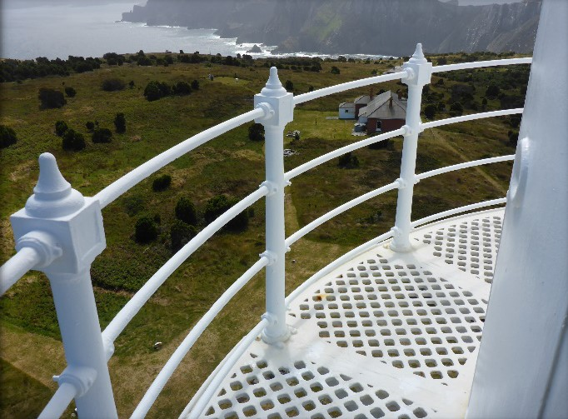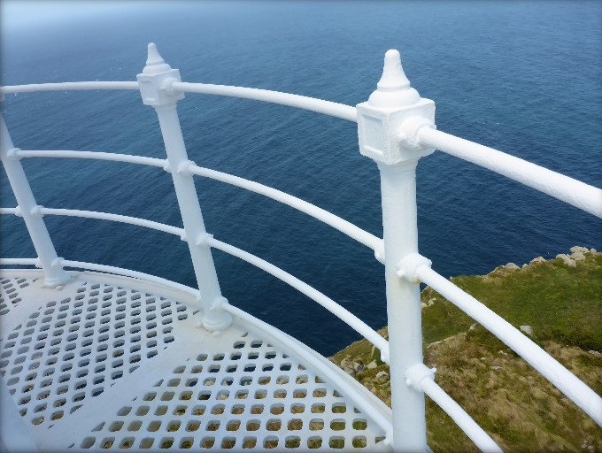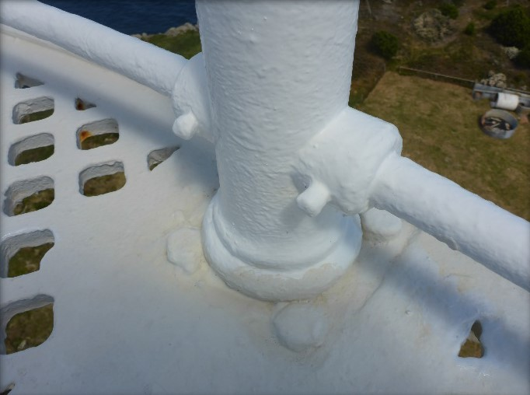
© AMSA, 2019
Description and condition
1906 Chance Bros cast iron stanchions with finial at the top and base plate at the bottom, bolted to balcony floor. Four round section solid wrought iron rails.
Finish | painted
Condition | intact and sound
Integrity | high
Significance | high
Maintenance | keep in service, prepare and repaint at normal intervals
Rectification works | none

Heritage significance: High
The 1906 balcony balustrades (lower) are original parts of one of the last lighthouses to have been built by the state of Tasmania (criterion a).
The 1906 balcony balustrades (lower) are original parts of a relatively intact twentieth century lighthouse complex (criterion d).
The 1906 balcony balustrades (lower) contribute to the aesthetic value of the lighthouse within its setting (criterion e).

Lighthouse feature: Walls
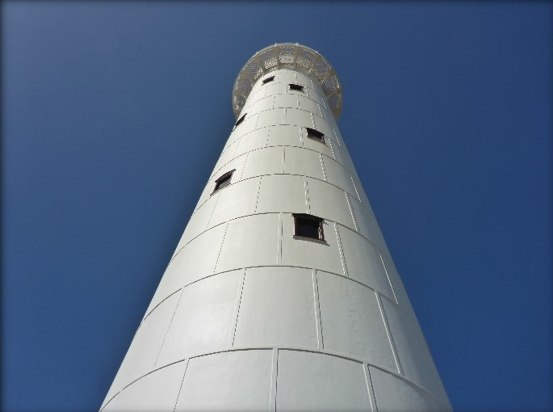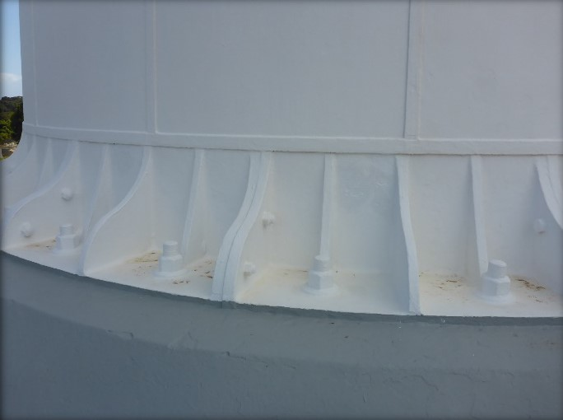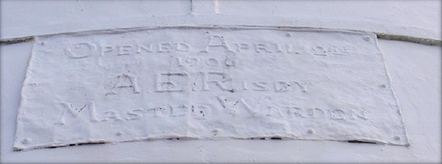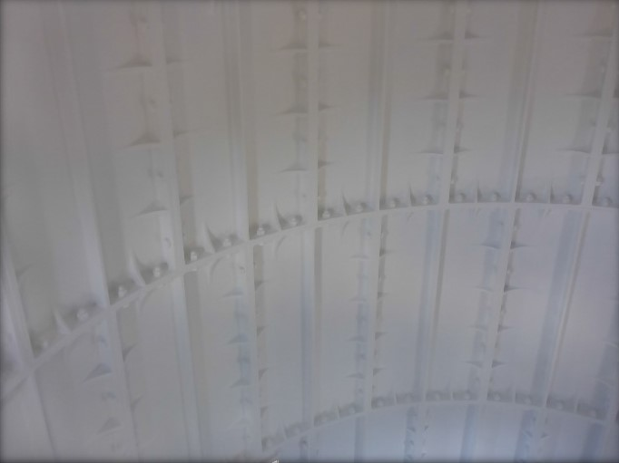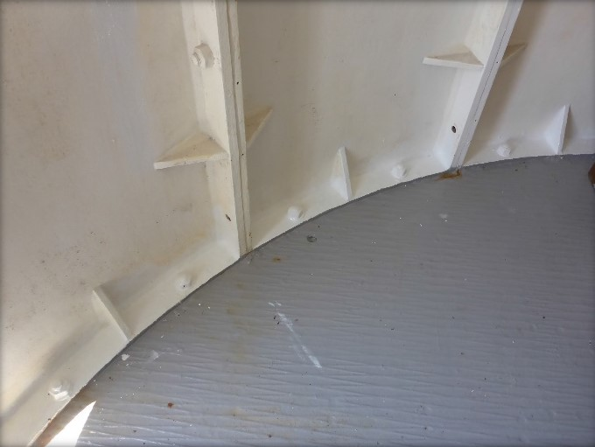
© AMSA, 2019
Description and condition
1906 Chance Bros tower of conical form, made of curved cast iron panels bolted together with flanged joints. 14 courses, including the base.
- Plaque – 1906 copper repoussé plaque above door.
Finish | painted
Condition | intact and sound
Integrity | high
Significance | high
Maintenance | keep in service, prepare and repaint at normal intervals
Rectification works | none

Heritage significance: High
The tower walls are an original part of one of the last lighthouses to have been built by the state of Tasmania (criterion a).
The tower walls are an original part of a relatively intact twentieth century lighthouse complex (criterion d).
The tower walls contribute to the aesthetic value of the lighthouse within its setting (criterion e).

Lighthouse feature: Service room
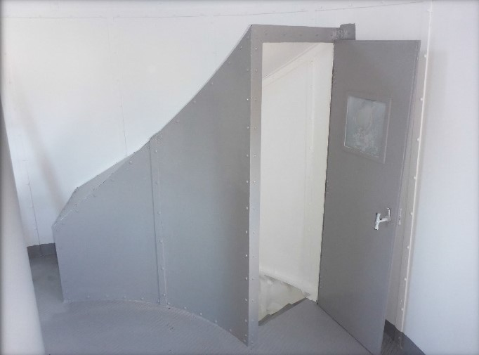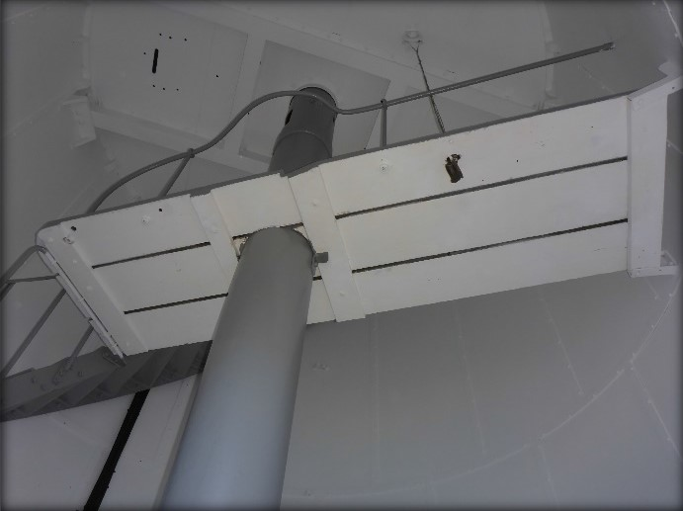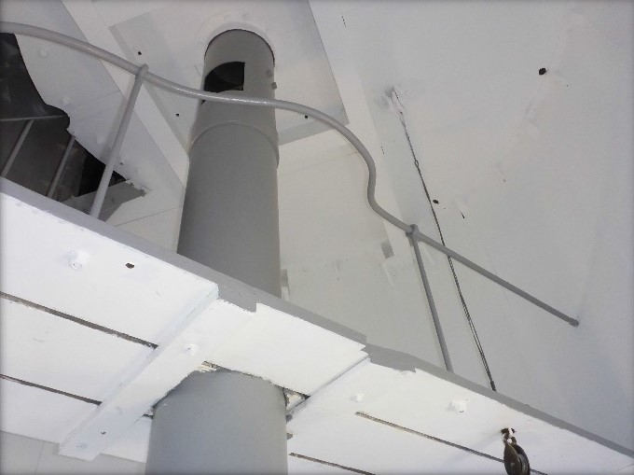
© AMSA, 2019
Description and condition
The upper chamber of the tower (between the third floor and the 1906 lantern floor) is internally lined with curved iron plates and iron cover strips, screwed to the outer skin.
- Air lock – iron plate enclosure and door, enclosing the stair from the chamber below.
- Access platform – platform to give access to the top of the weight tube. Timber plank floor attached by wrought iron brackets to the tower wall and the stair. Wrought iron hand rail.
Finish | painted
Condition | intact and sound
Integrity | high
Significance | high
Maintenance | keep in service, prepare and repaint at normal intervals
Rectification works | none

Heritage significance: High
The service room is an original part of one of the last lighthouses to have been built by the state of Tasmania (criterion a).
The service room is an original part of a relatively intact twentieth century lighthouse complex (criterion d).

Lighthouse feature: Windows
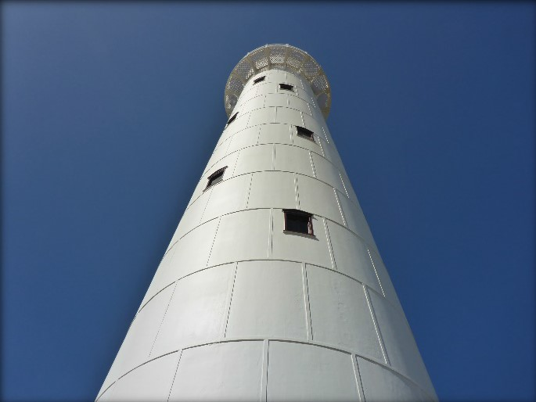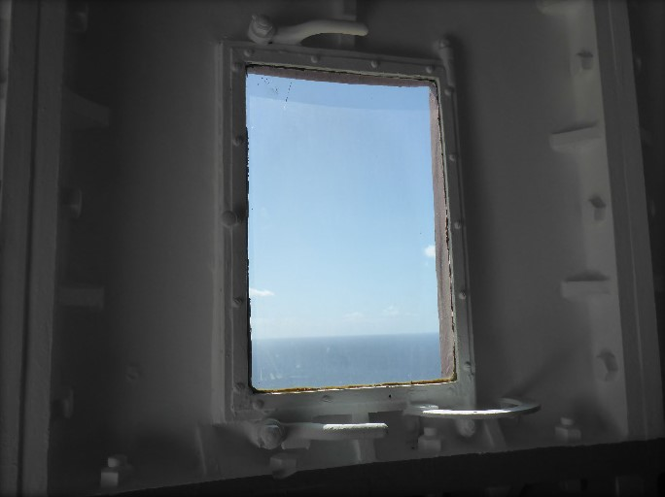
© AMSA, 2019
Description and condition
1906 Chance Bros cast iron casement sashes glazed with clear glass, in frames integral with the cast iron tower wall panels.
- Architrave – cast iron pedimented architrave on the outside.
Finish | frames and sashes: painted  glass: clear
Condition | intact and sound
Integrity | high
Significance | high
Maintenance | keep in service, prepare and repaint at normal intervals
Rectification works | none
Heritage significance: High
The windows are original parts of one of the last lighthouses to have been built by the state of Tasmania (criterion a).
The windows are original parts of a relatively intact twentieth century lighthouse complex (criterion d).
The windows contribute to the aesthetic value of the lighthouse within its setting (criterion e).

Lighthouse feature: Door
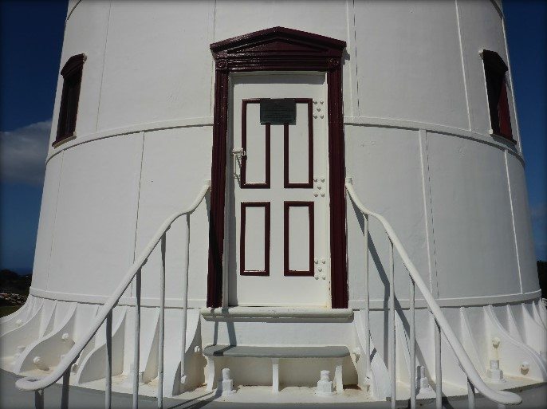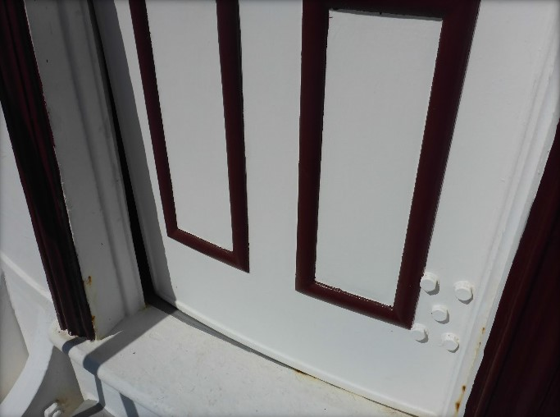
© AMSA, 2019
Description and condition
Recent glass reinforced plastic replica of original cast iron door leaf with simulated bolection moulds.
- Architrave – the outside of the door opening has Chance Bros cast iron door case with moulded architraves and pediment.
- Hardware – three hinges bolted on inside, recent D pull on outside, recent padbolt with CLS padlock.
Finish | painted
Condition | door is warped below lock, otherwise intact and sound
Integrity | medium
Significance | high
Maintenance | keep in service, prepare and maintain at normal intervals
Rectification works | none

Heritage significance: High
The door contributes to the aesthetic value of the lighthouse within its setting (criterion e).

Lighthouse feature: Intermediate floors
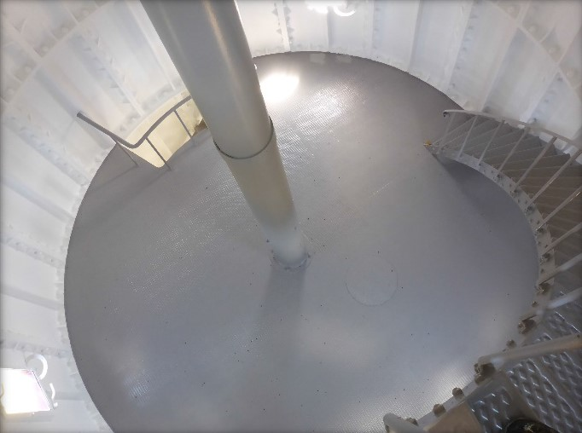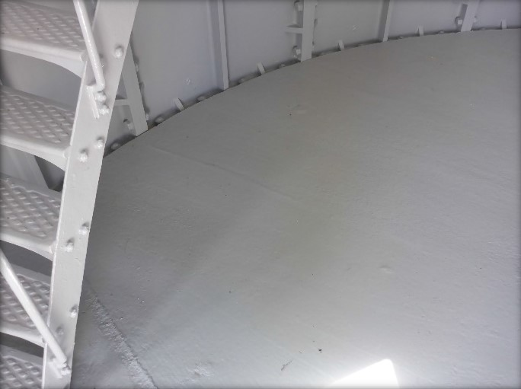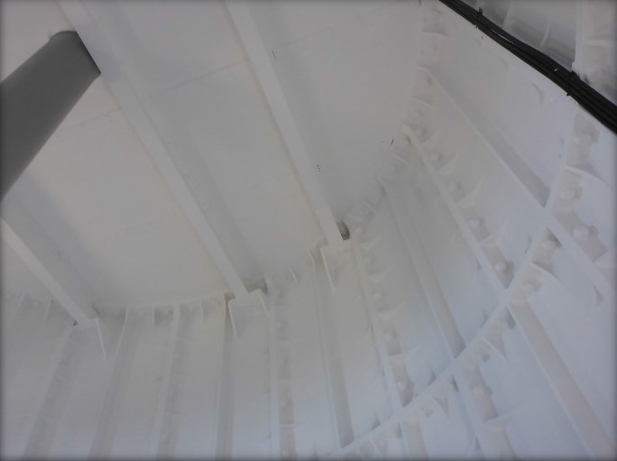
© AMSA, 2019
Description and condition
Three 1906 Chance Bros floors of iron checker plate on hot rolled iron girders. Joints between floor plates are butted, with cover plates underneath screwed to floor plates.
Finish | Painted
Condition | intact and sound
Integrity | High
Significance | High
Maintenance | keep in service, prepare and repaint at normal intervals
Rectification works | None

Heritage significance: High
The intermediate floors are original parts of one of the last lighthouses to have been built by the state of Tasmania (criterion a).
The intermediate floors are original parts of a relatively intact twentieth century lighthouse complex (criterion d).

Lighthouse feature: Stairs
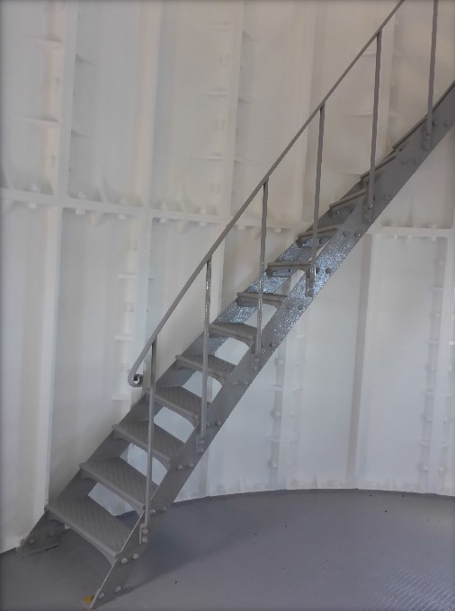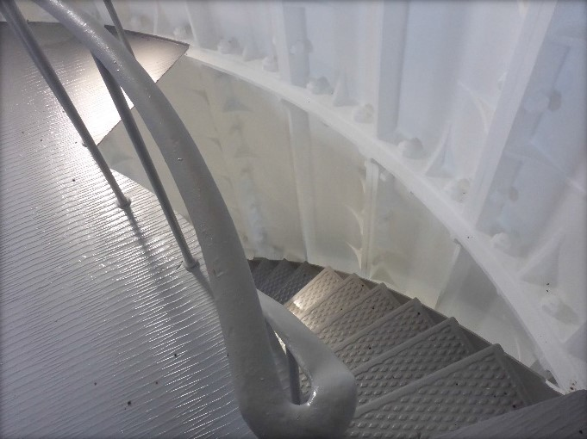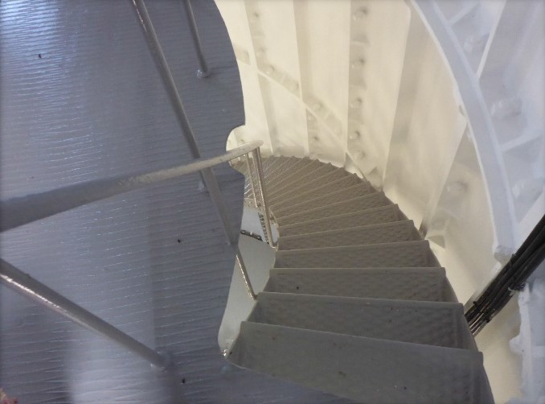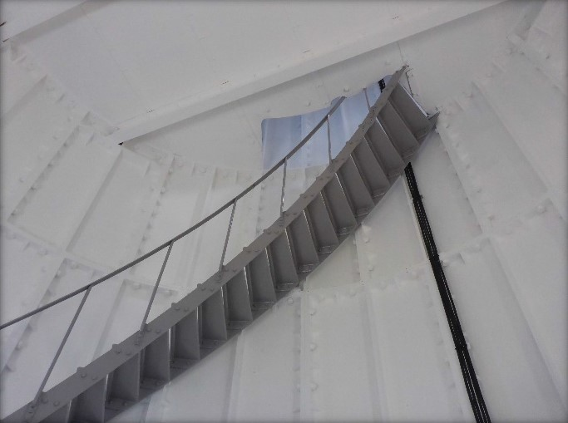
© AMSA, 2019
Description and condition
1906 Chance Bros geometric stair. Cast iron treads bolted to iron plate strings. Wrought iron handrail and stanchions.
Finish | painted
Condition | intact and sound
Integrity | high
Significance | high
Maintenance | keep in service, prepare and repaint at normal intervals
Rectifications works | none

Heritage significance: High
The stairs are an original part of one of the last lighthouses to have been built by the state of Tasmania (criterion a).
The stairs are an original part of a relatively intact twentieth century lighthouse complex (criterion d).

Lighthouse feature: Weight tube
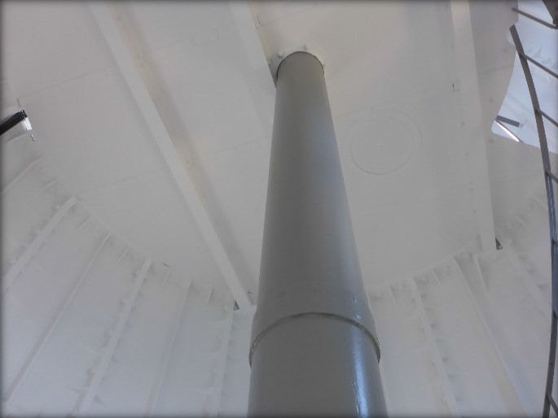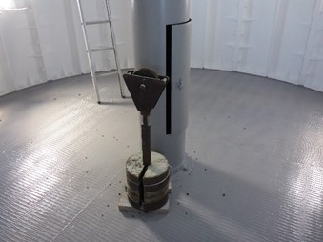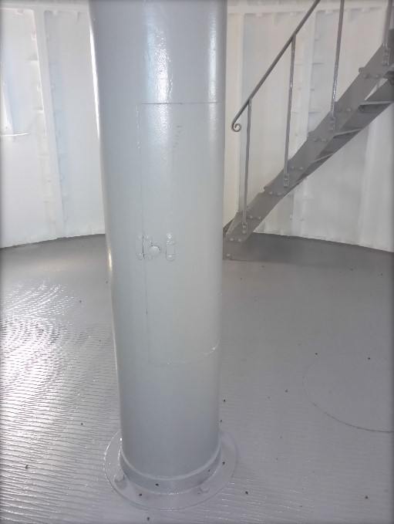
© AMSA, 2019
Description and condition
1906 riveted iron plate tube, in the centre of the tower, between the lantern floor and the first floor above ground.
Finish | painted
Condition | intact and sound
Integrity | high
Significance | high
Maintenance | preserve, prepare and repaint at normal intervals
Rectification works | none

Heritage significance: High
The weight tube is an original part of one of the last lighthouses to have been built by the state of Tasmania (criterion a).
The weight tube is an original part of a relatively intact twentieth century lighthouse complex (criterion d).

Lighthouse feature: Ground floor
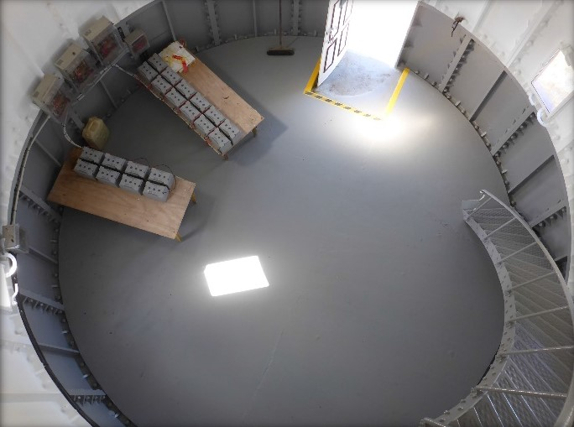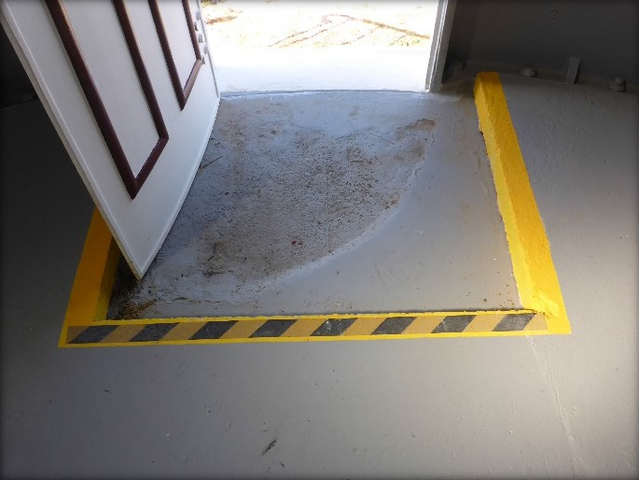
© AMSA, 2019
Description and condition
1906 reinforced concrete slab, with recent concrete topping. Recess around entry door.
Finish | bare concrete
Condition | sound
Integrity | high
Significance | high
Maintenance | keep in service
Rectification works | none

Heritage significance: High
The ground floor is an original part of one of the last lighthouses to have been built by the state of Tasmania (criterion a).
The ground floor is an original part of a relatively intact twentieth century lighthouse complex (criterion d).

Lighthouse feature: External stair
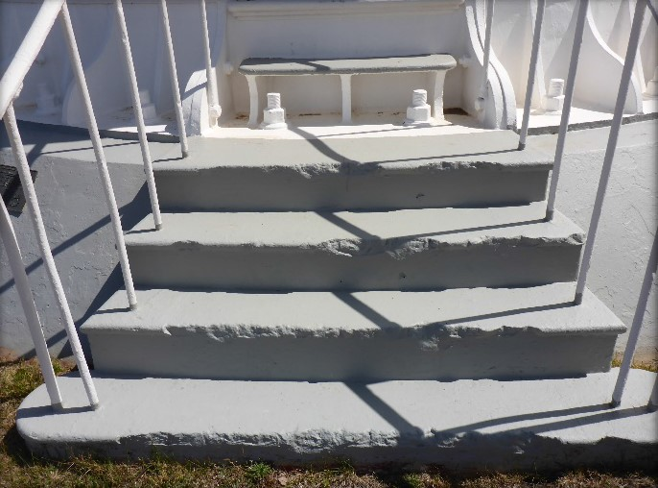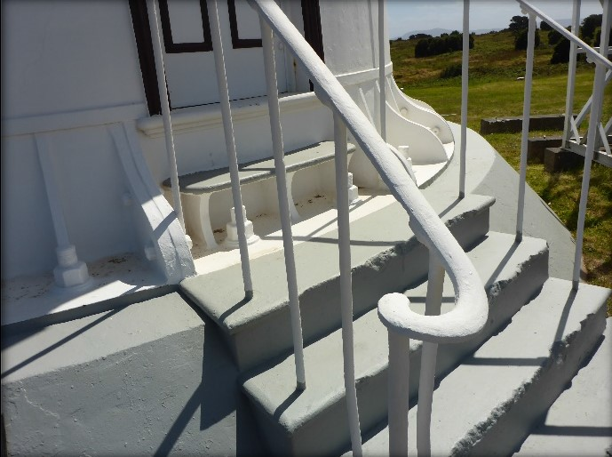
© AMSA, 2019
Description and condition
1906 concrete treads cast as part of the tower base. Wrought iron handrail and balusters. Uppermost step and threshold of cast iron, part of the base course of the tower.
Finish | painted
Condition | intact and sound
Integrity | high
Significance | high
Maintenance | keep in service, prepare and repaint at normal intervals
Rectification works | none

Heritage significance: High
The external stair is an original part of one of the last lighthouses to have been built by the state of Tasmania (criterion a).
The external stair is an original part of a relatively intact twentieth century lighthouse complex (criterion d).

Lighthouse feature: Helipad

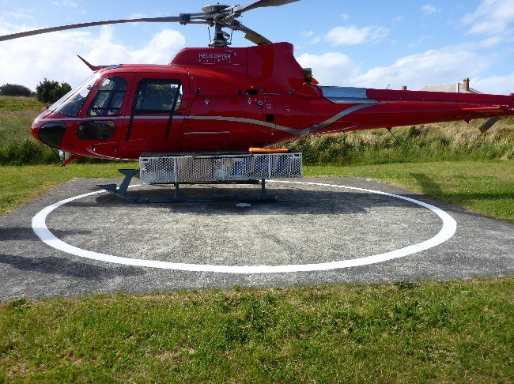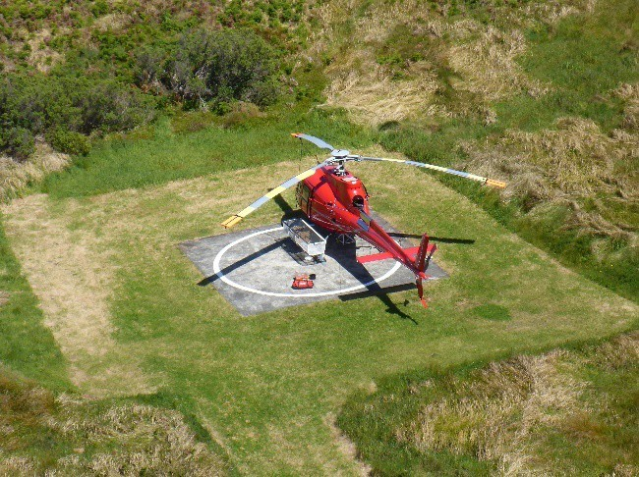
© AMSA, 2021
Description and condition
Concrete slab on ground.
Finish | bare concrete, with white painted circle
Condition | intact and sound
Integrity | high
Significance | low
Maintenance | keep in service
Rectification works | none

Heritage significance: Low

Lighthouse feature: Solar panels
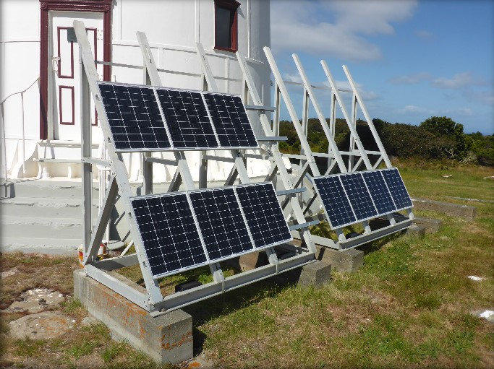
© AMSA, 2019
Description and condition
Array of 10 solar panels mounted on the ground near the tower base. Support frame of aluminium channel members welded and bolted together, on concrete footings.
Condition | sound
Integrity | high
Significance | low
Maintenance | keep in service
Rectification works | not assessed

Heritage significance: Low

  - Related object and associated AMSA artefacts
There are currently no AMSA-listed artefacts stored on this site.
  - Comparative analysis
Of all the lighthouses built in Tasmania, the only two constructed of pre-fabricated cast iron were Tasman Island Lighthouse and Currie Harbour Lighthouse located on King Island within Bass Strait. Built in 1879, Currie Harbour Lighthouse arrived from England in 312 pieces of pre-fabricated cast iron that were then assembled on-site. Both lighthouses sport open lattice balconies supported on angle brackets. Unlike Tasman Island, Currie Island retained its original Chance Bros. lantern house.
Currie Harbour Lighthouse was decommissioned as a Commonwealth light and extinguished in 1989. However, in 1995, the light was re-ignited and is now maintained by the King Island Council.
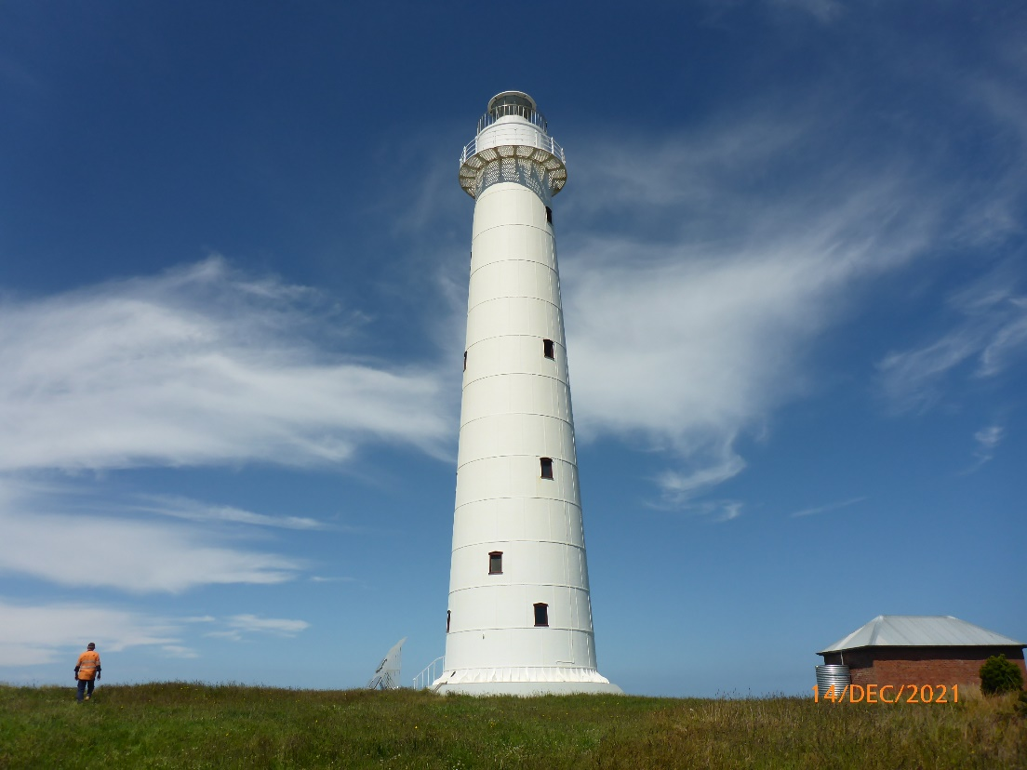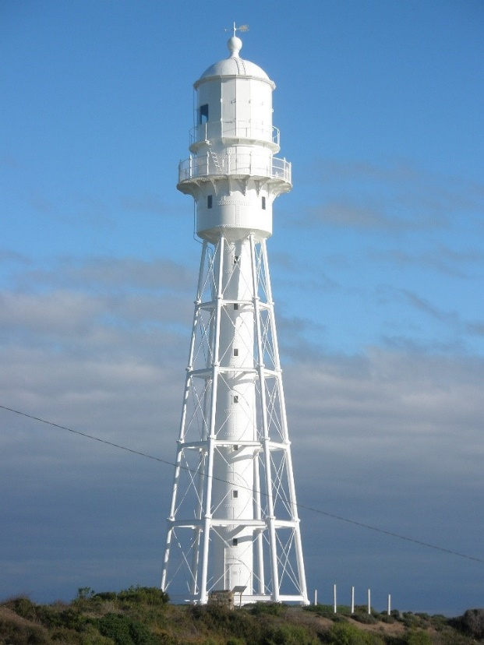
Figure 18. Tasman Island Lighthouse, first lit 1906 (© AMSA, 2021)
Figure 19. Currie Harbour Lighthouse, first lit 1879 (©AMSA, 2009)


- Heritage significance
  - Commonwealth Heritage listing – Tasman Island Lighthouse
The following information is taken directly from the Commonwealth Heritage listing for Tasman Island Lighthouse (Place ID: 105566).
Commonwealth heritage list – statement of significance
The Tasman Island Lighthouse, built in 1906, is significant as one of the last lighthouses to be constructed in Tasmania before the Commonwealth assumed responsibility for coastal lights. It is one of the most isolated lighthouses in Australia, and its exposed location on Tasman Island illustrates the hardships that would have been experienced by former lighthouse keepers. (Criterion A.4) (Australian Historic Themes 3.8.1 Shipping to and from Australian ports; 3.8.2 Safeguarding Australian products for long journeys and 3.16.1 Dealing with hazards and disasters)
The Tasman Island Lighthouse is part of a relatively intact early twentieth century complex of lighthouse, service buildings and haulage system, which contributes to its significance. (Criterion D2)
The Tasman Island Lighthouse is one of the highest lighthouses in Australia, and its location in a dramatic and isolated landscape creates a strong aesthetic appeal. (Criterion E.1)
Commonwealth heritage values – criteria
There are nine criteria for inclusion in the Commonwealth Heritage List—meeting any one of these is sufficient for listing a place. These criteria are similar to those used in other Commonwealth, state and local heritage legislation, although thresholds differ. In the following sections, Tasman Island Lighthouse is discussed in relation to each of the criteria as based on the site’s current Commonwealth Heritage Listing (Place ID: 105566)
Criterion | Relevant Attributes Identified | Explanation
Criterion A) Processes | The whole lighthouse including base, tower of bolted steel plates, interior and exterior, plus landscape setting. | The Tasman Island Lighthouse, built in 1906, is significant as one of the last lighthouses to be constructed in Tasmania before the Commonwealth assumed responsibility for coastal lights. It is one of the most isolated lighthouses in Australia, and its exposed location on Tasman Island illustrates the hardships that would have been experienced by former lighthouse keepers.

Criterion D) Typicality  This criterion is satisfied by places that have significant heritage values because of [their] importance in demonstrating the principal characteristics of a class of Australia’s natural or cultural history. | The whole lighthouse plus its original clockwork mirrors, its association with service buildings and haulage system within the landscape setting. | The Tasman Island Lighthouse is part of a relatively intact early twentieth century complex of lighthouses, service buildings and haulage system, which contributes to its significance.
Criterion E) Aesthetic characteristics  This criterion is satisfied by places that have significant heritage value because of [their] importance in exhibiting particular aesthetic characteristic value by a community or cultural group. | Its visual prominence on its cliff-top landscape setting. | The Tasman Island Lighthouse is one of the highest lighthouses in Australia, and its location in a dramatic and isolated landscape creates a strong aesthetic appeal.

  - TAS State Heritage Register – Tasman Island Lighthouse
The following information is taken directly from the Tasmanian State Heritage register listing of Tasman Island Light Station (Place ID: 5623).
TAS State heritage listing– statement of significance
The Tasman Island Light Station is of historic cultural significance for its association with the development of navigational aids along the east coast of Tasmania and the economic development of the region. It demonstrates the remote and self-contained nature of many light stations and the difficulties and isolation experienced by light house keepers and their families in maintaining these essential navigational aids.
The Tasman Island Lighthouse is significant as one of the last lighthouses to be constructed before the Commonwealth assumed responsibility for coastal lights in 1915 and is the highest operating lighthouses and most isolated light station in Australia. Its location in a dramatic and remote landscape, and lack of subsequent development, creates a strong aesthetic appeal. Its exposed location illustrates the hardships that would have been experienced by former lighthouse keepers.
The Tasman Island Station is a relatively intact early twentieth century complex of lighthouse, staff accommodation, service buildings and haulage system. Its high degree of integrity contributes to its significance. It was the last manned light station to be constructed in Tasmania.

TAS State heritage listing – criteria
The following information is taken directly from the Tasmanian State Heritage register listing of Tasman Island Light Station (Place ID: 5623). The Heritage Council may enter a place in the Heritage Register if it meets one or more of the following criteria from the Historic Cultural Heritage Act 1995 (TAS).
Criterion | Evidence/Explanation
Criterion A) The place is important to the course or pattern of Tasmania’s history. | Tasman Light Station is significant for its association with the development of navigational aids along the east coast of Tasmania and the economic development of the region. It is the last manned light station built in Tasmania and heralds the transition towards automated light stations. The Tasman Island Lighthouse is significant as one of the last lighthouses to be constructed before the Commonwealth assumed responsibility for coastal lights in 1915.
Criterion B) The place possesses uncommon or rare aspects of Tasmania’s history. | Tasman Island Lighthouse is the only example of this type of prefabricated cast iron light station tower construction in Tasmania.
Criterion C) The place has the potential to yield information that will contribute to an understanding of Tasmania’s history. | Tasman Light Station including the remains of the haulage way, flying fox and timber buildings and the surrounds of extant buildings, including the lighthouse have the ability to yield information which will contribute to our understanding of life and work on a remote light house station in the twentieth century.
Criterion D) The place is important in demonstrating the principal characteristics of a class of place in Tasmania’s history. | Tasman Light Station is of historic heritage significance because it represents the principal characteristics of an early twentieth century Federation-era cast iron lighthouse and associated keepers quarters from the same era. The Light station, as one of the most isolated light stations in Australia, demonstrates the remote and self-contained nature of such infrastructure and the difficulties and isolation experienced by light keepers and their families.
Criterion F) The place has a strong or special association with a particular community or cultural group for social or spiritual reasons. | The lighthouse is a prominent landmark for mariners making the final turning point for the Sydney to Hobart Yacht Race.
Criterion H) The place is important in exhibiting particular aesthetic characteristics. | The light station, with its cast iron tower, brick residences, remains of the flying fox and haulage system, has an unusually high level of intactness. This intactness, combined with the dramatic nature of the island’s topography and lack of subsequent development, creates a strong aesthetic appeal.

These heritage values, identified and explained in the Commonwealth Heritage List and the State Heritage Register, will form the basis of the management of Tasman Island Lighthouse. In the event of necessary works, all criteria will be consulted to inform best practice management of the values associated with the lightstation. (See ‘Section 7. Conservation management policies’ for further information on strategies to conserve heritage values of the Tasman Island Lighthouse)
  - Condition and integrity of the Commonwealth heritage values
A heritage monitoring program was implemented in 2016. Each site is visited and reviewed every two years where the heritage fabric and values of the site are evaluated. Assessment of the condition and integrity of lighthouses’ values are derived from the latest available Heritage Asset Condition Report produced by AMSA’s maintenance contractor.
‘Condition’ is measured on a Good – Fair – Poor scale and incorporates the current condition of the specific value. Integrity is measured on a High – Medium – Low scale which incorporates the value’s intactness.
The values are deemed to be in good condition and maintain high-medium integrity. The removal of the original lantern house and installation of a NAL-1 lantern room in 1976 infringed on the characteristics of the tower (Criterion D).
Criteria | Attributes | Condition | Integrity
Criterion A) Processes | The whole lighthouse including base, tower of bolted steel plates, interior and exterior, plus landscape setting.  The Tasman Island Lighthouse, built in 1906, is significant as one of the last lighthouses to be constructed in Tasmania before the Commonwealth assumed responsibility for coastal lights. It is one of the most isolated lighthouses in Australia, and its exposed location on Tasman Island illustrates the hardships that would have been experienced by former lighthouse keepers. | Good | Medium
Criterion D) Characteristic values | The whole lighthouse plus its original clockwork mirrors, its association with service buildings and haulage system within the landscape setting.  The Tasman Island Lighthouse is part of a relatively intact early twentieth century complex of lighthouses, service buildings and haulage system, which contributes to its significance. | Good | Medium
Criterion E) Aesthetic characteristics | Its visual prominence on its cliff-top landscape setting.  The Tasman Island Lighthouse is one of the highest lighthouses in Australia, and its location in a dramatic and isolated landscape creates a strong aesthetic appeal. | Good | High

  - Gain or loss of heritage values
Evidence for the potential gain or loss of heritage values will be documented within this section of future versions of this heritage management plan.


- Opportunities and constraints
  - Implications arising from significance
The Commonwealth statement of significance (section 5.1 above) demonstrates that Tasman Island Lighthouse is a place of considerable heritage value due to its standing as one of the last state-built towers in Tasmania, its 20th century lightstation characteristics, and its aesthetic prominence on the island.
The implication arising from this assessment is that key aspects of the place should be conserved to retain this significance. The key features requiring conservation include:
- continued use of the lighthouse as an AtoN
- architectural quality of the building
- interior spaces and features, which are notable for their design, details and/or their original lighthouse function. These include:
- 1906 lantern base and floor
- service room
- weight tube
- intermediate floors
- ground floor
- spiral staircase
- external spaces and features, which are notable for their design, details, and/or their original lighthouse function. These include:
- external stair
- 1906 balcony
- tower walls
- windows and doors.

Referral and approvals of action
The EPBC Act requires approval from the Minister for the Environment for all actions likely to have a significant impact on matters of National Environmental Significance (NES).
The Act provides that actions taken:
- on Commonwealth land which are likely to have a significant impact on the environment will require the approval of the Minister.

- outside Commonwealth land which are likely to have a significant impact on the environment on Commonwealth land, will require the approval by the Minister.

- by the Australian Government or its agencies, which are likely to have a significant impact on the environment anywhere, will require approval by the Minister.

The definition of ‘environment’ in the EPBC Act and EPBC Regulations includes the cultural heritage values of places.
Heritage strategy
If an Australian Government agency owns or controls one or more places with Commonwealth heritage values, it must prepare a heritage strategy within two years from the first time they own or control a heritage place (section 341ZA).
A heritage strategy is a written document that integrates heritage conservation and management within an agency’s overall property planning and management framework. Its purpose is to help an agency manage and report on the steps it has taken to protect and conserve the commonwealth heritage values of the properties under its ownership or control.
The heritage strategy for AMSA’s AtoN assets was completed and approved by the Commonwealth Minister for the Environment in 2018 and reviewed in 2022. The latest version of the Strategy is available online.P37F
Heritage Asset Condition Report

A heritage asset condition report is a written document that details the heritage fabric of a site with an in-depth description of each architectural and structural element. The document includes: a brief history of the site, the Commonwealth Heritage statement of significance and value criteria, a heritage significance rating for each individual element, and a catalogue of artefacts on-site. The document is also accompanied by up-to-date photos of each structural element. This document operates as a tool for heritage monitoring, and is reviewed and updated biennially.

Natural and Aboriginal heritage values
AMSA understands that Tasman Island as a whole has noted Aboriginal cultural heritage, and natural values. Although these values lie outside of the Commonwealth heritage listing curtilage and AMSA’s lease, the potential remains for future works at the lighthouse to impact these values. At the time this plan was written, no plans have been made for future works at Tasman Island Lighthouse. In the event major works at the lighthouse are to be carried out, AMSA will seek to minimise impacts to the surrounding area by:
- Utilising specific access tracks to ensure no damage to surrounding vegetation,
- Ensuring project footprint is limited to the AMSA lease. In any instance that work is required outside of this footprint, approvals will be sought from the appropriate stakeholders,
- Consulting with the Department of Primary Industries, Parks, Water and Environment (Aboriginal Heritage Tasmania) and TAS PWS in the event heritage artefacts/sites are uncovered or suspected during works,
- Implementing an appropriate discovery plan in the instance Aboriginal cultural heritage is suspected and/or found.

  - Framework: sensitivity to change
Owing to the site’s desired historic importance, characteristics and aesthetic qualities, Tasman Island Lighthouse is of high significance. Therefore, work actioned by AMSA on the lighthouse’s fabric harnesses the potential to reduce or eradicate the significance of the site’s heritage values.
Conservation works, including restoration and reconstruction, or adaption works of the absolute minimum so as to continue the lighthouse’s usefulness as an AtoN are the only works that should be actioned by AMSA on Tasman Island Lighthouse. Some exceptions are made for health and safety requirements, however any and all work carried out must be conducted in line with heritage considerations and requirements of the EPBC Act.
The table below demonstrates the level of sensitivity attributed to the various elements of the fabric register in the face of change. These are measured on a High-Moderate-Low spectrum depending on the action’s possible threat to the site’s heritage values.
High sensitivity
High sensitivity to change includes instances where a change would pose a major threat to the heritage value of a specific fabric, or the lightstation as a whole. A major threat is one that would lead to substantial or total loss of the heritage value.

Moderate sensitivity
Moderate sensitivity to change includes instances where a change would pose a moderate threat to the heritage value of a specific fabric, or the heritage significance of a specific fabric in another part of the building. A moderate threat is one that would diminish the heritage value, or diminish the ability of an observer to appreciate the value.
Low sensitivity
Low sensitivity to change includes instances where a change would pose little to no threat to the heritage value of a specific fabric, or to the heritage significance in another part of the building.

Component | Level of sensitivity | Nature of change impacting heritage values
Tasman Island Lighthouse structure including helipad and solar panels | High | - Changes to façade materials and design.  - Reduction of all round visibility of structure and its setting on Tasman Island.  - Removal of 1906 copper repossé plaque above entrance door.
 | Low | - Repainting of structure in like colours.  - Removal of asbestos and lead paint or other toxic materials.  - Repairs to helipad.  - Removal or replacement of solar panels.
Ground floor and external stair | High | - Changes to façade materials and design.
 | Low | - Repainting of ground floor and external stairs in like colours.  - Removal, replacement or adjustment of batteries and battery racks in ground floor.
Internal stairs and weight tube | High | - Removal of 1906 geometric stairs.  - Removal of 1906 weight tube.
 | Low | - Repainting of stairs and weight tube in like colours.  - Corrosion repairs to stairs and weight tube.
Intermediate floors | High | - Removal of intermediate floors.
 | Low | - Repainting of intermediate floors.  - Corrosion repairs to intermediate floors.
Service room | High | - Removal of airlock.  - Removal of access platform.
 | Low | - Repainting of service room including air lock and access platform.
1906 balcony | High | - Changes to façade materials and design.  - Removal of 1906 balcony or balustrades.
 | Low | - Repainting of 1906 balcony and balustrades.  - Corrosion repairs to balcony and balustrades.
1976 balcony | Low | - Replacement or adjustment of 1976 balcony and balustrades.  - Repainting of balcony floor.
1906 lantern base | High | - Changes in façade materials and design.
 | Low | - Replacement of Chance Bros. maker’s plate replica in like-materials.  - Reinstatement of brass regulators.  - Repainting of lantern base and floor.
1976 lantern base | Low | - Alterations to GRP hut.  - Replacement of lantern glazing.  - Resealing of lantern glazing.
Lens and pedestal | Low | - Replacement, removal or alterations to Vega VRB beacon and pedestal.  - Upgrades to light.  - Changing of the light’s character.
Doors and windows | High | - Changes to façade design of front door.  - Removal of original front door architraves.  - Removal of original cast iron window sashes, or external cast iron architraves.
 | Low | - Reparations to warped front door.  - Replacement of broken window glass.  - Repainting of door and window architraves in like colours.

  - Statutory and legislative requirements
The following table lists the Acts and codes relevant to the management of Tasman Island Lighthouse.
Act or code | Description
Environment Protection and Biodiversity Conservation Act 1999 (Cth) | The Environment Protection & Biodiversity Conservation Act 1999 (Cth) requires agencies to prepare management plans that satisfy the obligations included in Schedule 7A and 7B of the EPBC Regulations.
Environment Protection and Biodiversity Conservation Regulations 2000 (Cth)  Schedule 7B | The Commonwealth Department of Climate Change, Energy, the Environment and Water determined these principles as essential for guidance in managing heritage properties.  - The objective in managing Commonwealth Heritage places is to identify, protect, conserve, present and transmit, to all generations, their Commonwealth Heritage values.  - The management of Commonwealth Heritage places should use the best available knowledge, skills and standards for those places, and include ongoing technical and community input to decisions and actions that may have a significant impact on their Commonwealth Heritage values.  - The management of Commonwealth Heritage places should respect all heritage values of the place and seek to integrate, where appropriate, any Commonwealth, state, territory and local government responsibilities for those places.  - The management of Commonwealth Heritage places should ensure that their use and presentation is consistent with the conservation of their Commonwealth Heritage values.  - The management of Commonwealth Heritage places should make timely and appropriate provision for community involvement, especially by people who:  - have a particular interest in, or associations with, the place; and  - may be affected by the management of the place.  - Indigenous people are the primary source of information on the value of their heritage and that the active participation of indigenous people in identification, assessment and management is integral to the effective protection of indigenous heritage values.  - The management of Commonwealth Heritage places should provide for regular monitoring, review and reporting on the conservation of Commonwealth Heritage values.
AMSA Heritage Strategy 2022 | As the custodian of many iconic sites, the Australian Maritime Safety Authority (AMSA) has long recognised the importance of preserving their cultural heritage.  This Heritage Strategy is in response to section 341ZA of the EPBC Act (1999) which obliges AMSA to prepare and maintain a heritage strategy, along with obliging AMSA to:  - Assist in identification, assessment and monitoring of places of heritage value in its care;  - Prepare and maintain a register of its places of heritage value;  - Protect the heritage value of places when they are sold or leased;  - Provide this heritage strategy, and any subsequent major updates, to the relevant minister.  The strategy derives from the AMSA Corporate Plan and achievements are reported through the AMSA Annual Report. The 2020-21 AMSA Annual report can be found online.
Navigation Act 2012 (Cth) | Part 5 of the Act outlines AMSA’s power to establish, maintain and inspect marine aids to navigation (such as Tasman Island Lighthouse).  - AMSA may:  - establish and maintain aids to navigation; and  - add to, alter or remove any aid to navigation that is owned or controlled by AMSA; and  - vary the character of any aid to navigation that is owned or controlled by AMSA.  - AMSA, or person authorised in writing by AMSA may, at any reasonable time of the day or night:  - inspect any aid to navigation plan  - Plan or any lamp or light which, in the opinion of AMSA or the authorised person, may affect the safety or convenience of navigation, whether the aid to navigation of the lamp or light is the property of:  - a state or territory; or  - an agency of a state or territory; or  - any other person; and  - enter any property, whether public or private, for the purposes of an inspection under paragraph (a); and  - transport, or cause to be transported, any goods through any property, whether public or private, for any purpose in connection with:  - the maintenance of an aid to navigation that is owned or controlled by AMSA; or  - the establishment of any aid to navigation by AMSA.
Australian Heritage Council Act 2003 (Cth) | This Act establishes the Australian Heritage Council, whose functions are:  - to make assessments under Division 1A and 3A of Part 15 of the EPBC Act 1999  - to advise the Minister on conserving and protecting places included, or being considered for inclusion, in the National Heritage List or Commonwealth Heritage List  - to nominate places for inclusion in the National Heritage List or Commonwealth Heritage List  - to promote the identification, assessment, conservation and monitoring of heritage  - to keep the Register of the National Estate  - to organise and engage in research and investigations necessary for the performance of its functions  - to provide advice directly to any person or body or agency either of its own initiative or at the request of the Minister; and  - to make reports as outlined in the Act.
TAS Historic Cultural Heritage Act 1995 (TAS) | This Act establishes the Tasmanian Heritage Council.  7 General functions and powers of Heritage Council  (1) The functions of the Heritage council are –  - to advise the Minister on matters relating to Tasmania's historic cultural heritage and the measures necessary to conserve that heritage for the benefit of the present community and future generations; and  - to work within the planning system to achieve the proper protection of Tasmania's historic cultural heritage; and  - to co-operate and collaborate with Federal, State and local authorities in the conservation of places of historic cultural heritage significance; and  - to encourage and assist in the proper management of places of historic cultural heritage significance; and  - to encourage public interest in, and understanding of, issues relevant to the conservation of Tasmania's historic cultural heritage; and  - to encourage and provide public education in respect of Tasmania's historic cultural heritage; and  - to assist in the promotion of tourism in respect of places of historic cultural heritage significance; and  - to keep proper records, and encourage others to keep proper records, of places of historic cultural heritage significance; and  - to perform any other function the Minister determines.  - The Heritage Council may do anything necessary or convenient to perform its functions.
Building Code of Australia/National Construction Code | The Code is the definitive regulatory resource for building construction, providing a nationally accepted and uniform approach to technical requirements for the building industry. It specifies matters relating to building work in order to achieve a range of health and safety objectives, including fire safety.  As far as possible, Commonwealth agencies aim to achieve compliance with the Code, although this may not be entirely possible because of the nature of and constraints provided by existing circumstances, such as an existing building.
Work Health and Safety Act 2011 (Cth) | The objectives of this Act include:  - The main object of this Act is to provide for a balanced and nationally consistent framework to secure the health and safety of workers and workplaces by:  - protecting workers and other persons against harm to their health, safety and welfare through the elimination or minimisation of risks arising from work; and  - providing for fair and effective workplace representation, consultation, co-operation and issue resolution in relation to work health and safety; and  - encouraging unions and employer organisations to take a constructive role in promoting improvements in work health and safety practices, and assisting persons conducting businesses or undertakings and workers to achieve a healthier and safer working environment; and  - promoting the provision of advice, information, education and training in relation to work health and safety; and  - securing compliance with this Act through effective and appropriate compliance and enforcement measures; and  - ensuring appropriate scrutiny and review of actions taken by persons exercising powers and performing functions under this Act; and  - providing a framework for continuous improvement and progressively higher standards of work health and safety; and  - maintaining and strengthening the national harmonisation of laws relating to work health and safety and to facilitate a consistent national approach to work health and safety in this jurisdiction.  - In furthering subsection (1)(a), regard must be had to the principle that workers and other persons should be given the highest level of protection against harm to their health, safety and welfare from hazards and risks arising from work as is reasonably practicable.  [Quoted from Division 2 of Act]  This has implications for Tasman Island Lighthouse in Australia as it is related to AMSA staff, contractors and visitors.

  - Operational requirements and occupier needs
As a working AtoN, the operational needs of Tasman Island Lighthouse are primarily concerned with navigational requirements. Below are the operational details and requirements of the Tasman Island light as outlined by AMSA.
Navigation requirement for AMSA’s AtoN site
The following table is taken from AMSA’s Asset Management Strategy for the Tasman Island light.
1 | Objective/rationale | An AtoN is required on Tasman Island to warn of the island itself, the unmarked Cape Pillar to the north at 1.1 miles and the unmarked navigational hazard of Cheverton Rock and Hippolyte Rocks to the north at 7.2 miles.  The AtoN is required as a navigational mark for vessels transiting around the south-eastern section of Tasmania and as a landfall for Port Arthur 5.7 miles to the north west, and Hobart to the west and north.
2 | Required type(s) of AtoN | A fixed structure is required to act as a day mark.  A distinctive light is required for use at night.
3 | Priority/significance | An AtoN at this site is important for the navigation of commercial ships.
4 | Required measure of performance | The service performance of the AtoN must comply with the IALA Availability Target Category 2 (99%).
5 | Primary and secondary means (if any) of identification | The day mark must be conspicuous. The existing 29-metre high white round metal tower at an elevation of 276 metres meets this requirement.  The light must comply with the requirements of rhythmic characters of light as per the IALA NAVGUIDE. The light must have distinct characteristics that are easy to recognise and identify. The present flashing white light every 7.5 seconds meets this requirement.
6 | Visual range | During daytime, the AtoN structure should be visible from at least five nautical miles.  At night, the white light must have a nominal range of at least 18 nautical miles. It can, however, be frequently obscured by cloud and fog.
7 | Radar conspicuousness | As the island itself will provide a good radar echo, no additional radar enhancement is required for this site.

AMSA’s goals
AMSA is responsible, under the Navigation Act, for maintaining a network of marine AtoN around Australia’s coastline that assist mariners to make safe and efficient passages. AMSA’s present network of approximately 500 marine AtoN includes traditional lighthouses such as Tasman Island Lighthouse, beacons, buoys, racons, automatic identification system stations, metocean sensors including broadcasting tide gauges, current meter, directional wave rider buoys and a weather station.

Technological developments in the area of vessel traffic management have also contributed to increasing navigation safety and helped promote marine environment protection. AMSA aims to meet international standards for the reliability of lighthouses set by the International Association of Marine Aids to Navigation and Lighthouse Authorities (IALA).

At the time of preparing this management plan, the primary goal for Tasman Island Lighthouse is to continue its utilisation as an AtoN (for as long as necessary), while upkeeping the appropriate maintenance to conserve and preserve the heritage values of the lighthouse.
Lighthouse performance standards
AMSA aims to meet international standards for the reliability of lighthouses set by IALA. Tasman Island’s light is designated as an IALA Availability Category 2 AtoN (within a scale of Category 1 to Category 3, Category 1 aids are most critical). Category 2 aids have an availability target of 99.0 per cent.
Access to the lighthouse
One practical effect of this performance standard is that the operational equipment and structure of the light need to be kept in good repair by regular maintenance. Routine maintenance is carried out by AMSA’s maintenance contractor, and emergency repairs are scheduled in the event equipment fails in service. The contractor needs reliable access to the site for this work, and AMSA officers require access for occasional inspections of the site, including to audit the contractor’s performance.
  - Proposals for change
Preventative maintenance works are carried out on the lighthouse to maintain its status as a working marine AtoN, and to assist in the site’s conservation.
A list of scheduled preventative maintenance work is identified within the latest available site inspection report. The information provided below was taken from this report.
Maintenance | Estimated date of work
Structure paint | 2024
Lantern room paint | 2027

  - Potential pressures
A significant pressure that harnesses the potential to effect the Commonwealth heritage values of the place would be the obligation to remove or replace original fabric materials from the lighthouse owing to unavoidable and irreversible deterioration.
At the time of preparing this management plan, no plans have been made to modify/remove heritage fabric. In the event plans are made to modify or remove heritage fabric, work will be conducted in line with the heritage considerations and requirements of the EPBC Act.

  - Processes for decision-making
Processes for decision-making are required in the event of an incident that impacts the heritage values of the site. The following incidents are included due to their likelihood of occurrence at Tasman Island Lighthouse.
Incident | Procedure
Major project/maintenance works proposed | - Prepare Heritage Impact Statement on proposed modifications.  - Submit scope of works and Heritage Impact Statement to the DCCEEW and the Tasmanian Heritage Council for review.
Damage to lighthouse’s fabric (heritage significance) | - AMSA or selected contractors assess extent of damage.  - Seek heritage advice on restoration of heritage fabric impacted.  - Identify possible loss of heritage value (at both state and Commonwealth level).  - Seek the appropriate approvals for restoration of heritage fabric impacted.  - Implement best-practice management of restoration work, in keeping with the original character of the place.  - In the case of a loss of heritage value, prepare report for submission.  - Update record-keeping of incident and make available to relevant personnel.
Damage to lighthouse’s fabric (no heritage significance) | - AMSA or selected contractors to assess extent of damage.  - Identify possible impact on heritage fabric in any work carried out to restore fabric.  - Implement best-practice management of restoration work.  - Update record-keeping of incident and make available to relevant personnel.
Light upgrade | - Assess possible loss of heritage value in the event of an upgrade.  - If necessary, seek expert heritage advice on process of upgrade.  - If necessary, seek heritage approvals for the upgrade of light.  - Implement best-practice management of light upgrade work.  - Update record-keeping and make available to relevant personnel.
Minor modifications to lighthouse (such as adding of attachment) | - Assess possible obstruction to light.  - If necessary, seek heritage approvals.  - Monitor and update record-keeping.
Unforeseen discovery of Aboriginal artefacts on-site. | - Immediate stop-work. Create temporary 'buffer' zone and allow no entry in zone until artefacts have been assessed by appropriate personnel.  - Notify TAS PWS, and Aboriginal Heritage Tasmania as soon as possible.  - Delay work on site until artefacts have been appropriately assessed, and/or extracted and further investigations carried out in surrounding area.  - Update record-keeping of unforeseen discovery and make available to relevant personnel.
Divestment of lighthouse from AMSA | - Transfer control of heritage assets to the Minister administering the National Parks and Reserves Management 2002 (TAS) in line with section 341ZE of the EPBC Act.  - Terminate lease of site.  - Transfer relevant records and historical information held by AMSA to the Minister administering the National Parks and Reserves Management Act 2002 (TAS).

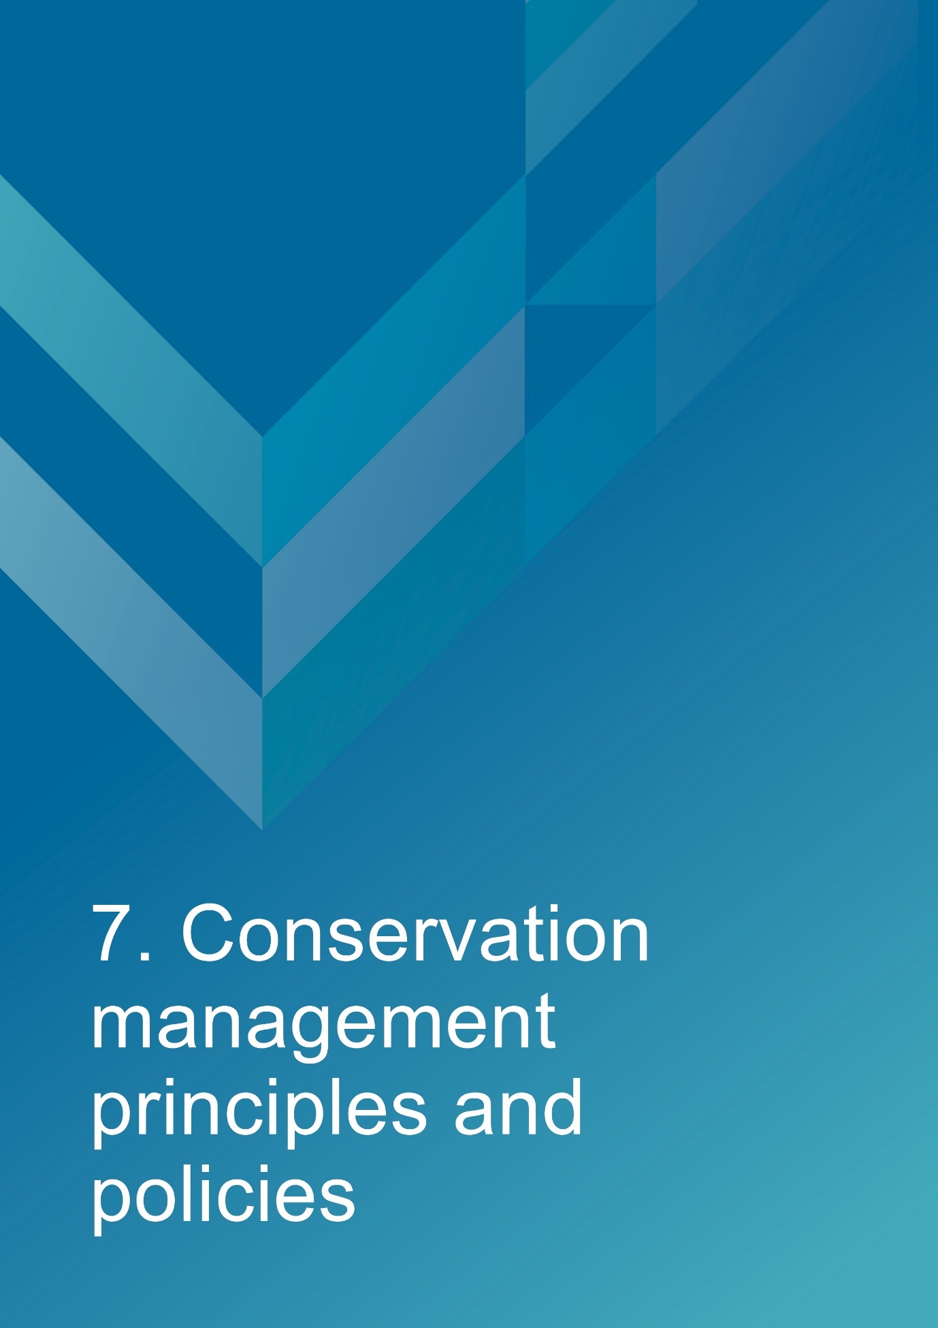
- Conservation management principles and policies
Policies
Fabric and setting
Policy 1 – Protect and conserve the significant external and internal fabric of the lighthouse, including existing buildings, layout and setting.
AMSA’s main purpose is to facilitate the ongoing operation of the site as a marine AtoN while preserving the site’s heritage values. As part of a heritage monitoring program, Heritage Asset Condition Reports are produced for each site every two years to evaluate the condition of the heritage fabric and values. Routine servicing is also carried out by maintenance contractors. Regular written reports from these visits will be sent to AMSA Asset Management and Preparedness for review and any work requirements identified will be scheduled accordingly. Should for some unforeseen reason the site no longer be viable as a marine AtoN, ownership will be passed to the appropriate state or federal authority in line with section 341ZE of the EPBC Act to ensure preservation of the heritage assets.
Implementation strategy:
- AtoN Maintenance contractor will continue scheduled periodic maintenance of the lighthouse and marine aid to navigation every 12 months to ensure condition is monitored for early warning of deterioration. Schedule must be approved by AMSA Asset Management and Preparedness.
- AMSA Asset Management and Preparedness to arrange for maintenance to be carried out on the lighthouse as required while continuing to operate as an AMSA marine aid to navigation.
- AMSA Asset Management and Preparedness to arrange for the replacement and upgrading of marine aids to navigation equipment in the lighthouse as required to meet AMSA’s service commitment, in a manner that preserves the original fabric of the lighthouse.
- AMSA Asset Management and Preparedness to maintain information on the heritage fabric of the lighthouse including any and all actions, treatments and inspection outcomes within the heritage fabric register. See section 4.1 for fabric register.
- AMSA Asset Management and Preparedness to conserve all the fabric elements identified as significant in the heritage asset condition report.
- AMSA Asset Management and Preparedness to seek expert materials conservation advice when considering repair, restoration and reconstruction of historic fabric. The relevant local, state and federal heritage approvals must be sought prior to repair, restoration and reconstruction.
- AMSA Asset Management and Preparedness to assess any development proposals to surrounding area for possible impacts on the heritage values of Tasman Island Lighthouse, and liaise with the appropriate state or federal heritage authorities.
- AMSA AtoN Heritage Coordinator to conserve the distinctive character of the lightstation by collecting photographic evidence and historical documentation of the original fabric.
- AtoN Maintenance Contractor to continue scheduled heritage monitoring visits to Tasman Island and review Heritage Asset Condition Reports.
Uses
Policy 2 – Install and operate equipment in the lighthouse, so that it continues to function as an effective marine aid to navigation, in such a way as to impose the least possible harm to the significant fabric.
Tasman Island Lighthouse’s use as a working marine AtoN is of high priority. Carrying out maintenance, including upgrades to navigational equipment, is necessary to its function and continued marine safety along the TAS coast. In the event of the installation and/or upgrade to AtoN equipment, proper precaution will be taken to ensure the least possible harm is done to significant fabric.
Implementation strategy:
- AtoN Maintenance Contractor to monitor Tasman Island’s AtoN equipment every 12 months and propose maintenance in the instance of necessary installation or removal. Proposed maintenance is to be approved by AMSA Asset Management and Preparedness.
- AtoN Maintenance Contractor and AMSA Asset Management and Preparedness to outline all possible risks to significant fabric, external and internal, associated with the installation, removal and operation of equipment.
- AMSA Asset Management and Preparedness to ensure works carried out are those that ensure the least possible harm to significant fabric.
- AMSA Asset Management and Preparedness to seek expert heritage conservation advice on best practice management of the site during installation, removal and operation of equipment.

Policy 3 – Monitor possible impacts to the site resulting from tourism and control appropriate access to the lighthouse for contractors and visitors.
Although Tasman Island Lighthouse is not currently open to the general public, and its location on the Island does not allow for easy public access, a helicopter service charters flights to the island for tourism purposes. Access inside the lighthouse is restricted to authorised personnel, such as contractors and AMSA employees. AMSA personnel and contractors require easy access inside the lighthouse precinct and tower for periodical site visits to carry out inspections and routine maintenance.
Implementation strategy:
- AtoN Maintenance Contractor to ensure control on access to all buildings within the AMSA lease area is maintained by periodically inspecting restricted access areas during maintenance visits every 12 months.
- AMSA Asset Management and Preparedness to ensure access to the lighthouse complies with workplace health and safety measures.
- AMSA Asset Management and Preparedness to ensure contractors are made aware of the heritage values of the lighthouse.
- AMSA Asset Management and Preparedness to ensure access to the site is available for Traditional Custodians to maintain cultural traditions.

Interpretation
Policy 4 – Accurate and relevant interpretation of the history and significance of the place should be made available to site users/visitors and for offsite external research.
AMSA will continue to make information available through the maintenance of site interpretive signage and its website.
Implementation strategy:
- All relevant information concerning the history and significance of the place will be checked for accuracy and updated appropriately.
- Information will be presented primarily as online resources accessible to relevant personnel and the general public. On-site interpretative signage will be installed where possible.
- This information will be maintained and updated in accordance with changes to the history and significance of the place.

Management
Policy 5 – AMSA will continue to conserve the lighthouse in accordance with Commonwealth and Tasmanian State heritage listing requirements.
For works requiring heritage approval, AMSA will obtain permission from any relevant state or federal authorities. Continuous and as needed conservation works will be undertaken as required.
Implementation strategy:
- AMSA Asset Management and Preparedness to liaise with the relevant federal and state agencies when proposing work on the site.
- AMSA Asset Management and Preparedness to consult with TAS PWS when proposing work on site.
- Approval in writing must be granted for any proposals for development.

Policy 6 – The cultural significance of the lightstation will be the basis for deciding how to manage it.

The heritage values or cultural significance of the place must be conserved. This heritage management plan includes relevant background information to support this policy (see Section 3 History).
Implementation strategy:
- Conserve the lighthouse to protect its heritage values (cultural significance).
- When possible, strive to maintain the original fabric of the lighthouse.
- Use the Burra Charter as the primary guide for treatment of fabric.
- Engage appropriately qualified heritage consultants when making decisions regarding impact on heritage values.
- Assess impacts on the heritage values of the place when considering proposed alterations or adaptations.

Policy 7 – Monitor, review and report the Commonwealth heritage values of the Lighthouse every five years or sooner if major changes to the lightstation occur.

The Commonwealth heritage values of the lighthouse are to be monitored and reported on a regular basis. A Heritage Asset Condition Report is updated for Tasman Island Lighthouse every two years which records historical information, condition, and maintenance requirements for fabric within the lighthouse to ensure a gain and/or loss of heritage value is identified.

Implementation strategy:

- AMSA Asset Management and Preparedness to regularly monitor the lighthouse for possible impacts on the identified Commonwealth heritage values.
- AMSA Asset Management and Preparedness to review the current Commonwealth heritage values at least once every five years and assess any gain or loss of values. This review must be undertaken in the event of any major alterations to the lightstation.
- AMSA Asset Management and Preparedness to report any changes to the Commonwealth heritage values of the lightstation to the DCCEEW (Heritage Branch).
- AMSA Asset Management and Preparedness to update AMSA’s heritage strategy and this plan to reflect any changes identified.
- AtoN Maintenance Contractor to review and update Heritage Asset Condition Report biennially.

Policy 8 – Maintain historical, management and maintenance records within AMSA and make available these records.
As part of the proper process for managing change in significant places, the Burra Charter points out the importance of making records before any change, and advocates placing records in a permanent archive, and making them available where this is appropriate. AMSA’s collection of records, which include documents pertaining to heritage intervention, management and maintenance, are subject to this process. Heritage Asset Condition Reports are routinely generated for each lighthouse and stored in AMSA’s recordkeeping system. AMSA will continue to practice such processes via their Records Management Systems (RMS).
Implementation strategy:
- AMSA to maintain, review and update records through existing AMSA RMS as required.
- AMSA to ensure records are made available to the relevant personnel and parties as required.

Policy 9 – Develop and provide appropriate training and resources to all relevant AMSA staff, contractors and licensees.
In order to ensure best practice management of AMSA-operated lighthouses, all staff, contractors and licensees are required to have access to the appropriate training and resources in order to provide best practice conservation of the site.
Implementation strategy:
- Provide staff, contractors and licensees access to up-to-date versions of the AMSA heritage strategy, heritage management plans and fabric registers.
- When funds are made available, AMSA Asset Management and Preparedness staff and contractors will undertake a relevant training to ensure comprehension of the Commonwealth heritage and EPBC Act statutory requirements.
- AMSA representatives will attend Commonwealth-run heritage workshops, programs and conferences for up-to-date information on statutory requirements and best-practice management of sites of national and state heritage significance.

Policy 10 – Use contractors and service providers with appropriate experience.
AMSA is to ensure parties carrying out work have appropriate knowledge and use effective methods to ensure conservation of the lighthouse.
Implementation strategy:
- AMSA Asset Management and Preparedness to engage staff and contractors with the relevant experience and expertise concerning conservation of the lighthouse.
- Develop and provide the appropriate training on heritage conservation matters for AMSA Asset Management and Preparedness staff and other relevant parties who hold responsibility for heritage management.

Policy 11 – Seek heritage advice and apply best heritage practice.
AMSA will continue to use in-house heritage expertise, external consultancy, or a combination of both as required in order to successfully apply best heritage practice. Should in-house heritage expertise be limited in responding to a requirement, external heritage expertise will be engaged to address the issue.
Implementation strategy:
- Apply in-house heritage expertise when required.

- Use tools such as the Burra Charter and Working Together: Managing Commonwealth Heritage Places (Commonwealth of Australia, 2019) to measure the likely impact of proposals.
- Seek external heritage expertise in the event of limited in-house capability.

Policy 12 – Appropriate protocol in the event of unforeseen discoveries or disturbances of heritage within the AMSA site.
AMSA’s scope of work rarely involves excavation. Should such work need to be undertaken, AMSA will implement a suitable discovery plan and seek advice from suitably qualified personnel as required. In the event of any unforeseen discovery or disturbance of heritage-related items on the AMSA site, notification to the appropriate organisation will occur in accordance with the conditions of the discovery plan. This plan will also be updated accordingly.
Note: In most cases, AMSA’s leases are limited to the immediate vicinity of the lighthouse and therefore this scenario is not anticipated as a likely occurrence.
Implementation strategy:
- Consult Aboriginal Heritage Tasmania and TAS PWS in the event Aboriginal heritage is suspected/found.
- Seek appropriate heritage advice and apply best practice in the event of unforeseen discoveries/disturbances.

Policy 13 – Make this Heritage Management Plan available to all persons involved in decision-making on the management of the lighthouse and its setting.
The plan will be made available to all personnel intrinsic to management of the lighthouse and its setting, for example AMSA maintenance contractors, TAS PWS as land manager, staff and other relevant parties.
Implementation strategy:
- Provide links to this plan via the AMSA website.
- Provide copies to all relevant personnel and parties.

Future Developments
Policy 14 – Adaptation of the place using methods or processes that minimise impact on heritage values and significance in accordance with The Burra Charter principles.
It is likely that over time the lighthouse will house new equipment as technology changes. The Burra Charter principles will be used as the basis for decision-making.
Implementation strategy:
- Assess the likely impacts of changes on the heritage values and significance of the place.
- Preserve the original fabric of the place and do only what is necessary for the continued use and care of the place.
- Engage expert heritage advice and use The Burra Charter in adapting the place.

Policy 15 – When required, engage with adjacent landowners to maintain an appropriate setting for the lighthouse in its visual and natural context.
Any changes to the surrounding land or AMSA leased area, requires careful consideration. AMSA will liaise with all adjacent landowners in the event of any proposed changes that may affect the setting and attempt to influence a positive outcome.
Implementation strategy:
- AMSA Asset Management and Preparedness to engage with adjacent landowners and TAS PWS through consultation when changes are proposed regarding the wider visual and natural context.

Policy 16 – In the event of adaptive re-use or divestment, which would no longer place the lighthouse under AMSA control, AMSA will strive to ensure the Commonwealth and TAS State heritage values of the site are recognised and preserved.

In the event Tasman Island Lighthouse is no longer identified as a working AtoN, AMSA will withdraw its standing as lessee and hand over all authority to the lessor. This process must be conducted in line with section 341ZE of the EPBC Act.

Implementation strategy:
- AMSA will negotiate with lessor to have site lease terminated.
- All available heritage information within AMSA’s collection, including this Heritage Management Plan, will be shared with the relevant parties to ensure the Commonwealth and State heritage values of the site are recognised and preserved.

Community Involvement
Policy 17 – Consult with Traditional Custodians and community groups in the preparation of the management plan.
AMSA will give Traditional Custodians and community groups, as well as the general public, an opportunity to review and comment on this management plan through a public consultation process.
Implementation strategy:
- Undertake community consultation when preparing the heritage management plan in accordance with EPBC Regulations.
- Seek advice from all relevant Traditional Custodians and refer to ‘Engage Early – Guidance for proponents on best practice Indigenous engagement for environmental assessments under the Environment Protection and Biodiversity Conservation Act 1999 (EPBC Act)’ to guide consultations.
Policy 18 – Manage and record sensitive information appropriately.

Sensitive information may be passed onto AMSA during consultation with stakeholders and the general public. This information will be handled in-line with AMSA’s privacy policy.

Implementation strategy:

- AMSA will record, store and manage sensitive information in-line with its privacy policy.
- No sensitive information will be included in draft or published heritage management plans.

Review
Policy 19 – Review this plan within 5 years of its adoption or sooner if major changes are needed.
This plan will be reviewed every five years. This review should:
- assess the content of the plan.
- determine its effectiveness in protecting the identified heritage values.
- provide any necessary recommendations for updating or re-writing of the plan. If major changes occur at the site in the interim, this plan will be reviewed and updated earlier than the specified five years.

Implementation strategy:
- AMSA Asset Management and Preparedness to review this heritage management plan at least five years after its adoption.

- AMSA Asset Management and Preparedness to review and update this heritage management plan in the event of a major change to the lightstation.

- AMSA Asset Management and Preparedness to summarise changes implemented within updated plan.

- AMSA Asset Management and Preparedness to submit revised plan for approval.


- Policy implementation plan
  - Plan and schedule
Key Issue | Management action/task | Policies | Responsibility | Priority | Timeframe
Conservation and preservation | Conserve the lighthouse. | 1, 2, 3, 5, 6, 10, 11, 14 | AMSA, Asset Management and Preparedness | High | On-going
 | Review the heritage management plan every five years. | 18 | AMSA, AtoN Heritage Coordinator | Medium | 2028 (5 years (minimum)
 | Make this plan available to all relevant personnel. | 7, 13 | AMSA, AtoN Heritage Coordinator | High | Ongoing
Liaison dealings | If applicable, ensure communication is maintained with adjacent landowners. | 15 | AMSA, Asset Management and Preparedness | Medium | As required
 | Consult with Traditional Custodians and community stakeholders in preparing the management plan. | 17 | AMSA, AtoN Heritage Coordinator | Medium | As required
Heritage values | Review the Commonwealth heritage values every five years. | 7 | AMSA, AtoN Heritage Coordinator | High | 2028
 | Consider heritage values when proposing new planning and/or developments. | 5, 6, 7, 14 | AMSA, AtoN Heritage Coordinator and Project Managers | High | Ongoing
 | Ensure process of re-use or divestment of the site recognises and preserves heritage values. | 16 | AMSA, AtoN Heritage Coordinator | High | As required
 | Conduct heritage monitoring site visit and review Heritage Asset Condition Report every two years. | 1, 7 | AMSA, AtoN Heritage Coordinator | High | Once every two years (Ongoing)
Staff and community awareness | Develop and provide relevant training and awareness for management personnel (contractors and site-users). | 9 | AMSA, Asset Management and Preparedness | High | As required
 | Ensure the availability of accurate and relevant information on the history and significance of the lightstation for site-users and visitors. | 4 | AMSA, AtoN Heritage Coordinator | Medium | Ongoing
Record-keeping/access | Maintain adequate record-keeping of historical, management and maintenance documents. Make these records available. | 8 | AMSA, Asset Management and Preparedness | High | Ongoing
Expert heritage advice | Ensure knowledge and advice of heritage experts is used. | 10, 11 | AMSA, Asset Management and Preparedness | Medium | As required
Lighthouse maintenance | Schedule periodic maintenance. | 1 | AMSA, Asset Management and Preparedness | High | Ongoing (reoccurring once every 12 months)
 | The implementation of unforeseen discovery or disturbance processes in the event of an accidental discovery. | 12 | AMSA, Asset Management and Preparedness | Medium | As required
Lightstation access | Secure appropriate access to lightstation for contractors and visitors. | 3 | AMSA, Asset Management and Preparedness | Medium | As required

  - Monitoring and reporting
As stipulated by Schedule 7A of the EPBC Regulations, the outlined implementation plan and associated policies listed above are required to be monitored and updated accordingly. The below review process timetable will be adhered to over the next five years:
Timeframe | Review step | Responsibility
2026 | Plan’s half-life internal review:  - Assess strengths and weaknesses of existing plan  - Address any known impact to the lighthouse’s heritage values | AMSA, Asset Management and Preparedness
2028 | Plan’s full-life review:  - Consult with internal and external stakeholders on existing plan  - Prepare updated draft plan and consult with the Heritage Branch  - Submit reviewed plan to the Minister | AMSA, Asset Management and Preparedness

Other key actions in monitoring and reporting include:
- ensuring the implementation plan and policies are readily available for all relevant personnel
- delegating AMSA staff to periodically check the implementation plan is up-to-date and being utilised appropriately by the relevant personnel
- ensuring the timeframes outlined within the plan are followed
- delegating AMSA Response staff to review this plan and the associated policies at least every five years and determine whether its contents are relevant and effective in terms of continuing to conserve the place.


Appendix 1. Glossary of heritage conservation terms
The Burra Charter, from its first version (1979) and its current version (2013), defined a set of terms that have since been widely adopted in Australian heritage conservation practice.
Where the following terms are used in this heritage management plan, the particular meanings defined in the charter are intended. The definitions are quoted from Article 1 of the Burra Charter.
Adaptation means modifying a place to suit the existing use or a proposed use.
Associations means the special connections that exist between people and a place.
Compatible use means a use which respects the cultural significance of a place. Such a use involves no, or minimal, impact on cultural significance.
Conservation means all the processes of looking after a place to retain its cultural significance.
Cultural significance means aesthetic, historic, scientific, social or spiritual value for past, present or future generations. Cultural significance is embodied in the place itself, its fabric, setting, use, associations, meanings, records, related places and related objects. Places may have a range of values for different individuals or groups.
Fabric means all the physical material of the place including components, fixtures, contents, and objects.
Interpretation means all the ways of presenting the cultural significance of a place.
Maintenance means the continuous protective care of a place and its setting. Maintenance is to be distinguished from repair which involves restoration or reconstruction.
Meanings denote what a place signifies, indicates, evokes or expresses to.
Place means a geographically defined area. It may include elements, objects, spaces and view. Place may have tangible and intangible dimensions.
Preservation means maintaining a place in its existing state and retarding deterioration.
Reconstruction means returning a place to a known earlier state and is distinguished from restoration by the introduction of new material.
Related object means an object that contributes to the cultural significance of a place but is not at the place.
Related place means a place that contributes to the cultural significance of another place.
Restoration means returning a place to a known earlier state by removing accretions or by reassembling existing elements without the introduction of new material.
Setting means the immediate and extended environment of a place that is part of or contributes to its cultural significance and distinctive character.
Use means the functions of a place, including the activities and traditional and customary practices that may occur at the place or are dependent on the place.

Appendix 2. Glossary of historic lighthouse terms relevant to Tasman Island Lighthouse
A
Apron paving – the concrete paving surrounding the base of the lighthouse tower.
Architrave – the moulded frame around a doorway or window.
Astragal – the bars which support the glazing of a lantern. They may also support the roof. Simply a framing member between the glazing bars in the lantern glazing. In its true meaning an astragal is a moulding that has a rounded profile. In lanterns this is almost never the case.

B
Balcony – a walk way around the outside of the lantern, used for maintenance and (formerly, when lighthouses were manned) for observing ships. Principal parts are the balcony floor and the balcony balustrade. (Synonym: gallery deck).
Balcony floor – floor of the balcony. Tasman Island’s upper balcony floor is a 1976 GRP floor continuous with 1976 lantern floor. The lower balcony floor is of 1906 Chance Bros. open lattice.
Balcony balustrade – a handrail together with its supports. The supports are called balusters. Simply a railing or wall on the outer perimeter of the balcony, to prevent people from falling off the balcony. Generally made of metal stanchions and rails—Tasman Island’s upper balcony balustrades are of 1976 welded aluminium. The lower balcony balustrades are of 1906 Chance Bros cast iron stanchions.
Balcony door – door in the lantern base to give access to the balcony. In AMSA lanterns two doors are sometimes fitted but only one is operational. (Synonym: parapet hatch, service room door).

C
Cast iron – a mixture of iron and carbon with a relatively high carbon content and a low melting point, produced directly from a blast furnace.
Chance Bros – English manufacturer of optical apparatus, lanterns, cast iron stairs, cast iron towers, and other lighthouse components. The Chance family established a glass-making business in Smethwick, England in 1824 and is often described as ‘near Birmingham’. The business was absorbed into the Pilkington group of companies in 1951 and now ceases to exist.
Character – pattern of flashes of light emitted by a lighthouse, designed to identify that particular lighthouse.
Copper – a red malleable metal of low resistivity.

H
Haulage – a structure utilised to transport goods and people up the island.

I
Intermediate floors – levels found mid-way up a building. Tasman Island has three 1906 Chance Bros floors of iron checker plate.
Iron – there were two common types of iron used in lighthouse construction: wrought and cast. Older lights will almost certainly contain these iron types. Wrought iron has been worked by hand and is an iron alloy with a very low carbon content in contrast to steel, it also has fibrous inclusions. Cast iron is iron which has been heated until it liquefies, and is then poured into a mould to solidify.

L
Lantern – the glazed enclosure, usually of cylindrical or polygonal shape, at the top of a lighthouse, which surrounds and protects the optical apparatus. It contains the optical apparatus, made up of the lantern roof, lantern glazing and lantern base sections.
Lantern floor – the level in a lighthouse at which the lantern is installed, and by which access may be gained to the optical system and to the inside and outside of the lantern glazing. The lantern floor is generally at or near the same level as the catwalk and can be made from steel, concrete, or timber.
Lantern glazing – the middle section of the lantern, circular or polygonal in plan, between the lantern roof above and the lantern base below, made up of glass panes held in a framework of glazing bars. On the landward side there may be blank panels in place of glass, or other opaque construction. Types of lantern glazing include: flat and curved trapezoidal panes and curved diamond/triangular panes. Tasman Island’s lantern glazings are flat, trapezoidal glass panes.
Lantern roof – the roof of the lantern. Usually made of copper sheeting over a framework of rafters.
Lens assembly – a transparent optically refracting element of glass. The surface is usually spherical in form.
Light source – electric bulbs now illuminate most lighthouses.
Lighthouse – the principal structure of a lightstation, generally made up of a lantern, balcony and tower.
Lightstation – a precinct containing a lighthouse structure and other related buildings, for example. Keepers’ cottages, store room and signal house.

O
Oil store – building originally used to store fuel of the lighthouse, typically found on lightstations.
Order – a shorthand expression of the size of an optical apparatus or lantern. At the time the system of orders was established, when kerosene burners were used, longer range lights needed larger burners, and larger burners needed lens assemblies of longer focal length to ensure a sharply defined beam. Thus in turn the lantern rooms were required to be larger to house these lens assemblies. AMSA historic lantern rooms range from 1st to 4th order.

P
Pedestal – part of the optical apparatus, consisting of a metal column or base standing on the balcony floor inside the lantern and supporting the lens assembly and light source. Some later Chance documentation (such as their tariffs 1908) also refer to the lantern base as a pedestal.

R
Repoussé – (of metalwork) hammered into relief from the reverse side.

T
Tower – structure to support the lantern at a sufficient height above the ground. The most common types are the masonry tower, timber-framed tower, cast iron tower and lattice tower.

Appendix 3. Table demonstrating compliance with the EPBC Regulations
Environment Protection and Biodiversity Conservation Regulations 2000 (Cth) Schedule 7A – Management Plans for Commonwealth Heritage Places
Legislation | Satisfied within
A management plan must:
(a) Establish objectives for the identification, protection, conservation, presentation and transmission of the Commonwealth Heritage values of the place | Section 1 – Introduction
(b) Provide a management framework that  includes reference to any statutory  requirements and agency mechanisms for  the protection of the Commonwealth  heritage values of the place | Section 1 – Introduction
(c) Provide a comprehensive description of the place, including information about its  location, physical features, condition,  historical context and current uses | Section 2 – Tasman Island Lightstation site  Section 3 – History  Section 4 – Fabric
(d) Provide a description of the  Commonwealth heritage values and any  other heritage values of the place | Section 5 – Heritage significance
(e) Describe the condition of the  Commonwealth heritage values of the  place | Section 5 – Heritage significance
(f) Describe the method used to assess the  Commonwealth heritage values of the  place | Section 5 – Heritage significance
(g) Describe the current management  requirements and goals including  proposals for change and any potential  pressures on the Commonwealth heritage  values of the place, and | Section 6 – Opportunities and constraints
(h) Have policies to manage the
Commonwealth heritage values of a place,
and include in those policies, guidance in
relation to the following:
i. The management and conservation processes to be used | Section 7 – Conservation management principles and policies (Policy 1, 2, 3, 5, 6, 10, 11, 14)
ii. The access and security  arrangements, including access to  the area for indigenous people to  maintain cultural traditions | Section 7 – Conservation management principles and policies (Policy 3)
iii. The stakeholder and community  consultation and liaison  arrangements | Section 7 – Conservation management principles and policies (Policy 15, 17)
iv. The policies and protocols to  ensure that indigenous people  participate in the management  process | Section 7 – Conservation management principles and policies (Policy 17)
v. The protocols for the management  of sensitive information; | Section 7 – Conservation management principles and policies (Policy 18)
vi. The planning and management of  works, development, adaptive reuse  and property divestment  proposals | Section 7 – Conservation management principles and policies (Policy 16)
vii. How unforeseen discoveries or  disturbances of heritage are to be  managed | Section 7 – Conservation management principles and policies (Policy 12)
viii. How, and under what  circumstances, heritage advice is  to be obtained | Section 7 – Conservation management principles and policies (Policy 10, 11)
ix. How the condition of  Commonwealth heritage values is  to be monitored and reported | Section 7- Conservation management principles and policies (Policy 5, 6, 7, 14)
x. How records of intervention and  maintenance of a heritage places  register are kept | Section 7 – Conservation management principles and policies (Policy 7, 13)
xi. The research, training and  resources needed to improve  management | Section 7 – Conservation management principles and policies (Policy 9)
xii. How heritage values are to be  interpreted and promoted, and | Section 7 – Conservation management principles and policies (Policy 4)
(i) Include an implementation plan | Section 8 – Policy implementation plan
(j) Show how the implementation of policies  will be monitored; and | Section 8 – Policy implementation plan
(k) Show how the management plan will be  reviewed. | Section 7 – Conservation management principles and policies (Policy 19)  Section 8 – Policy implementation plan

Appendix 4. Tasman Island current light details
IALA AVAILABILITY
CATEGORY: 2

PERFORMANCE
CRITERIA
(AVAILABILITY): 99%

POSITION: Latitude: 43˚ 14.3722’ S
Longitude: 148˚ 00.3046’ E
Datum: WGS 84

BA LIST OF LIGHTS: K 3614

DAYMARK: White cast iron tower and white lantern room.

HEIGHT OF DAYMARK: 29 metres

COLOUR OF LIGHT: White

CHARACTER: Flashing 7.5 seconds
Flash: 0.1 seconds
Eclipse: 7.4 seconds

COLOUR OF LIGHT: White

LANTERN: NAL-1

BEACON: VRB-25
ELEVATION: 276 m

RANGE: Nominal: 18 nautical miles
Geographical: 38.3 nautical miles

Reference List
The Argus. “Lighthouses: Lonely life and service.” December 30, 1916. https://trove.nla.gov.au/newspaper/article/1621153

The Argus. “Life in a lighthouse.” November 29, 1919. https://trove.nla.gov.au/newspaper/article/4645827

Australia ICOMOS. The Burra Charter: The Australia ICOMOS Charter for Places of Cultural Significance. Australia ICOMOS, 2013.

Australian Heritage Database: Commonwealth Heritage List. “Tasman Island Lighthouse, Port Arthur, TAS, Australia.” Accessed May 2020, https://www.environment.gov.au/cgi-bin/ahdb/search.pl?mode=place_detail;search=state%3DTAS%3Blist_code%3DCHL%3Blegal_status%3D35%3Bkeyword_PD%3D0%3Bkeyword_SS%3D0%3Bkeyword_PH%3D0;place_id=105566

Australian Heritage Database: Register of the National Estate. “Tasman Island Lighthouse (Commonwealth), Port Arthur, TAS, Australia.” Accessed May 2020. https://www.environment.gov.au/cgi-bin/ahdb/search.pl?mode=place_detail;search=place_name%3DTasman%2520Island%3Blist_code%3DRNE%3Bkeyword_PD%3Don%3Bkeyword_SS%3Don%3Bkeyword_PH%3Don%3Blatitude_1dir%3DS%3Blongitude_1dir%3DE%3Blongitude_2dir%3DE%3Blatitude_2dir%3DS%3Bin_region%3Dpart;place_id=102872

Australian Maritime Safety Authority. AMSA Heritage strategy 2022-2025, (2022). https://www.amsa.gov.au/amsa-heritage-strategy-2022-2025

Australian Maritime Safety Authority. “AMSA Interactive heritage lighthouse map.” Accessed May 2020. https://www.operations.amsa.gov.au/lighthouses/?_ga=2.236400321.1108408984.1535497123-1996646104.1535497123

Australian Maritime Safety Authority. Annual Report 2021-22. Australian Maritime Safety Authority, 2022. https://www.amsa.gov.au/about/corporate-publications/annual-report-2021-22

Australian Maritime Systems Group. Tasman Island Lighthouse: Heritage Asset Condition Report, 3rd Revision. Australian Maritime Systems Group, 2021.

Brewis, C.R.W. Preliminary report on the lighting of the coast of Tasmania and the islands in Bass Strait, with recommendations as to existing lights and additional lights. Melbourne: Government printer, 1912.

Calder, James Erksine. Ramblings on Betsy’s Island, Tasman Peninsula and Forestier’s Peninsula in February 1848. Adelaide: Sullivan’s Cove, 1985.

Commonwealth of Australia. Engage Early—Guidance for proponents on best practice Indigenous engagement for environmental assessments under the Environment Protection and Biodiversity Conservation Act 1999 (EPBC Act). Commonwealth of Australia, 2016.

Commonwealth of Australia. Working Together Managing Commonwealth Heritage Places: a guide for Commonwealth agencies. Commonwealth of Australia, 2019.

Daily Telegraph (Launceston). “Consolidated marine board.” April 29, 1887. https://trove.nla.gov.au/newspaper/article/149488889

Daily Telegraph (Launceston). “At the Capital.” July 4, 1903. https://trove.nla.gov.au/newspaper/article/153950655

Dower, John. Van Dieman’s Land. Orr and Smith, 1837.

The Evening. “Lighthouse lad’s basket rescue.” March 10, 1950. https://trove.nla.gov.au/newspaper/article/212226767

Examiner (Launceston). “South marine board: the lighthouses.” June 25, 1902. https://trove.nla.gov.au/newspaper/article/35491623

Examiner (Launceston). “Four new lights for the Tasmanian coast: work in progress.” September 9, 1904. https://trove.nla.gov.au/newspaper/article/35819888

Examiner (Launceston). “Lighthouse death: Man’s terrible fall.” March 14, 1927. https://trove.nla.gov.au/newspaper/article/51411729

Langlois, J. Thevenot's Relations de divers voyages curieux. Paris: De l'imprimerie de Iaqves Langlois, 1663.

Lighthouses of Australia INC. “Tasman Island Lighthouse.” Accessed May 2020. https://lighthouses.org.au/tas/tasman-island-lighthouse/

Marquis-Kyle, Peter. Heritage Lighthouse Report: Tasman Island. Australian Maritime Systems Group, 2006.

The Mercury. “Marine board.” July 4, 1885. https://trove.nla.gov.au/newspaper/article/9107460

The Mercury. “Marine board tenders: Tasman Island.” November 25, 1886. https://trove.nla.gov.au/newspaper/article/9128682

The Mercury. “Hobart marine board.’” July 1, 1903. https://trove.nla.gov.au/newspaper/article/12275110

The Mercury. “Hobart marine board.” February 3, 1904. https://trove.nla.gov.au/newspaper/article/9677025

The Mercury. “Tasman Island Lighthouse: In full working order.” April 3, 1906. https://trove.nla.gov.au/newspaper/article/12771295

The Mercury. “Tasman Island pigeon post.” November 13, 1912. https://trove.nla.gov.au/newspaper/article/10259996

The Mercury. “S.S. NORD lost: Strikes a rock and flounders.” November 10, 1915. https://trove.nla.gov.au/newspaper/article/10435531

National Archives of Australia. Department of Foreign Affairs and Trade, Central Office; A1200, Black and white photographic negatives and prints, 1945-1971; L11284, Lighthouses and beacons - Tasman Island lighthouse landing, showing the method used to unload supplies and personnel destined for the lighthouse. A cable is anchored to an offshore rock and a pulley on a flying fox is used to ferry goods ashore from boats, 1948-1948.

National Archives of Australia. Department of Foreign Affairs and Trade, Central Office; A1200, Black and white photogenic negatives and prints, 1945-1971; L11285, Lighthouses and beacons - Lighthouse landing and incline tramway, Tasman Island, off the south-east corner of Tasmania [photographic image], 1948-1948.

The North Western Advocate and the Emu Bay Times. “Tasman Island Lighthouse.” August 18, 1904. https://trove.nla.gov.au/newspaper/article/64670857

Searle, Garry. First Order: Australia’s Highway of Lighthouses. SA: Seaside Lights, 2013.

Stanley, Kathleen. Guiding Lights: Tasmania’s lighthouses and lighthousemen. Hobart: St. David’s Park Publishing, 1991.

The Sydney Morning Herald. “Lighthouse radio.” October 10, 1930. https://trove.nla.gov.au/newspaper/article/16721286

Tasmanian Heritage Council. Tasmanian Heritage Register: Tasman Light Station. State Government of Tasmania. https://heritage.tas.gov.au/heritage-listed-places/search-the-register#SearchSpatiallyUsingLISTmap%C2%A0

Tasmanian News. “A cruise for a lighthouse site: the Marine Board on a tour of inspection.” September 22, 1886. https://trove.nla.gov.au/newspaper/article/169160247

Tomlinson, Charles. Cyclopaedia of Useful Arts, mechanical and chemical, manufactures, mining and engineering, Vol II. London & New York: ca. 1866.

Wildcare Tasmania. ‘Friends of Tasman Island.’ Accessed May 2020 https://wildcaretas.org.au/branches/friends-of-tasman-island/

Endnotes

“AMSA Interactive heritage lighthouse map,” Australian Maritime Safety Authority, accessed May 2020, https://www.operations.amsa.gov.au/lighthouses/?_ga=2.236400321.1108408984.1535497123-1996646104.1535497123
Australia ICOMOS, The Burra Charter: The Australia ICOMOS Charter for Places of Cultural Significance (Australia ICOMOS, 2013).
Peter Marquis-Kyle, Heritage Lighthouse Report: Tasman Island (Australian Maritime Systems Group, 2006).
Australian Maritime Systems Group, Tasman Island Lighthouse: Heritage Asset Condition Report, 3rd Revision (Australian Maritime Safety Authority, 2021).
“Friends of Tasman Island,” Wildcare Tasmania, accessed May 2020, https://wildcaretas.org.au/branches/friends-of-tasman-island/
“Tasman Island Lighthouse, Port Arthur, TAS, Australia,” Australian Heritage Database, Commonwealth Heritage List, accessed May 2020, https://www.environment.gov.au/cgi-bin/ahdb/search.pl?mode=place_detail;search=state%3DTAS%3Blist_code%3DCHL%3Blegal_status%3D35%3Bkeyword_PD%3D0%3Bkeyword_SS%3D0%3Bkeyword_PH%3D0;place_id=105566
“Tasman Island Lighthouse (Commonwealth), Port Arthur, TAS, Australia,” Australian Heritage Database, Register of the National Estate, accessed May 2020, https://www.environment.gov.au/cgi-bin/ahdb/search.pl?mode=place_detail;search=place_name%3DTasman%2520Island%3Blist_code%3DRNE%3Bkeyword_PD%3Don%3Bkeyword_SS%3Don%3Bkeyword_PH%3Don%3Blatitude_1dir%3DS%3Blongitude_1dir%3DE%3Blongitude_2dir%3DE%3Blatitude_2dir%3DS%3Bin_region%3Dpart;place_id=102872
Tasmanian Heritage Council, Tasmanian Heritage Register: Tasman Light Station(State Government of Tasmania, , https://heritage.tas.gov.au/heritage-listed-places/search-the-register#SearchSpatiallyUsingLISTmap%C2%A0
Gary Searle, First Order: Australia’s Highway of Lighthouses, (SA: Seaside Lights, 2013), 34.
Melchisedech Thevenot, Hollandia Nova detecta, Terre Australe decouuerte l'an 1644, in J. Langlois’s Thevenot's Relations de divers voyages curieux (Paris: De l'imprimerie de Iaqves Langlois, 1663).
John Dower, Van Dieman’s Land, (Orr and Smith, 1837).
James Erksine Calder, Ramblings on Betsy’s Island, Tasman Peninsula and Forestier’s Peninsula in February 1848, Adelaide: Sullivan’s Cove, 1985).
Kathleen Stanley, Guiding Lights: Tasmania’s lighthouses and lighthousemen, (Hobart: St. David’s Park Publishing, 1991), 144.
“A cruise for a lighthouse site: the Marine Board on a tour of inspection,” Tasmanian News, September 22, 1886, https://trove.nla.gov.au/newspaper/article/169160247
“Marine board,” The Mercury, July 4, 1885, https://trove.nla.gov.au/newspaper/article/9107460
“Marine board tenders: Tasman Island,” The Mercury, November 25, 1886, https://trove.nla.gov.au/newspaper/article/9128682
“Consolidated marine board,” Daily Telegraph (Launceston), April 29, 1887, https://trove.nla.gov.au/newspaper/article/149488889
“South marine board: the lighthouses,” Examiner, June 25, 1902, https://trove.nla.gov.au/newspaper/article/35491623 ; “Hobart marine board,” The Mercury, July 1, 1903, https://trove.nla.gov.au/newspaper/article/12275110
“Hobart marine board,” The Mercury, February 3, 1904, https://trove.nla.gov.au/newspaper/article/9677025
Marine Board, 8 April 1904, Marine Board Notification, Australian Maritime Safety Authority archives.
“At the Capital,” Daily Telegraph, July 4, 1903, https://trove.nla.gov.au/newspaper/article/153950655
“Four new lights for the Tasmanian coast: work in progress,” Examiner, September 9, 1904, https://trove.nla.gov.au/newspaper/article/35819888
“Tasman Island Lighthouse,” The North Western Advocate and the Emu Bay Times,’ August 18, 1904, https://trove.nla.gov.au/newspaper/article/64670857
Searle, First Order, 363; “Tasman Island Lighthouse,” Lighthouses of Australia INC, accessed May 2020, https://lighthouses.org.au/tas/tasman-island-lighthouse/
Stanley, Guiding Lights, 145
Stanley, Guiding Lights, 146; “Tasman Island Lighthouse: In full working order,” The Mercury, April 3, 1906, https://trove.nla.gov.au/newspaper/article/12771295
Stanley, Guiding Lights, 145.
Searle, First Order, 364.
Searle, First Order, 368.
Stanley, Guiding Lights, 146; “Life in a lighthouse,” The Argus, November 29, 1919, https://trove.nla.gov.au/newspaper/article/4645827
“Lighthouses: Lonely life and service,” The Argus, December 30, 1916, https://trove.nla.gov.au/newspaper/article/1621153
Stanley, Guiding Lights, 158.
Stanley, Guiding Lights, 158; “Tasman Island Lighthouse,” Lighthouses of Australia INC, accessed May 2020, https://lighthouses.org.au/tas/tasman-island-lighthouse/
Stanley, Guiding Lights, 146.
Stanley, Guiding Lights, 146.
Stanley, Guiding Lights, 147.
C.R.W. Brewis, Preliminary report on the lighting of the coast of Tasmania and the islands in Bass Strait, with recommendations as to existing lights and additional lights, (Melbourne: Government printer, 1912) 8.
”Tasman Island pigeon post,” The Mercury, November 13, 1912, https://trove.nla.gov.au/newspaper/article/10259996
Stanley, Guiding Lights, 149; “S.S. NORD lost: Strikes a rock and flounders,” The Mercury, November 10, 1915, https://trove.nla.gov.au/newspaper/article/10435531
Stanley, Guiding Lights, 150.
Stanley, Guiding Lights, 151.
Stanley, Guiding Lights, 151.
Stanley, Guiding Lights, 152.
Stanley, Guiding Lights, 153.
Stanley, Guiding Lights, 153.
“Lighthouse death: Man’s terrible fall,” Examiner, March 14, 1927, https://trove.nla.gov.au/newspaper/article/51411729 ; Searle, First Order, 368.
Stanley, Guiding Lights, 154; Searle, First Order, 368; “Lighthouse radio,” The Sydney Morning Herald, October 10, 1930, https://trove.nla.gov.au/newspaper/article/16721286
Stanley, Guiding Lights, 158.
Stanley, Guiding Lights, 158.
“Lighthouse lad’s basket rescue,” The Evening, March 10, 1950, https://trove.nla.gov.au/newspaper/article/212226767
Stanley, Guiding Lights, 159
Brewis, Preliminary report on the lighting of the coast of Tasmania and the islands in Bass Strait, 8.
Erika Shankley, Friends of Tasman Island.
Erika Shankley, Friends of Tasman Island.
Searle, First Order, 369; Stanley, Guiding Lights, 144.
“Tasman Island Lighthouse, Port Arthur, TAS, Australia.”
Tasmanian Heritage Council, Tasmanian Heritage Register: Tasman Light Station
AMSA, AMSA Heritage strategy 2022-2025, (2022), https://www.amsa.gov.au/amsa-heritage-strategy-2022-2025
AMSA, Annual Report 2021-22, https://www.amsa.gov.au/about/corporate-publications/annual-report-2021-22
‘Engage Early – Guidance for proponents on best practice Indigenous engagement for Environment Protection and Biodiversity Conservation Act 1999 (EPBC Act), Commonwealth of Australia (2016).

