

Military Rehabilitation and Compensation (Subsection 204A(2) Amount) Instrument 2023

The Military Rehabilitation and Compensation Commission makes the following instrument.

Dated 5 September 2023

The Seal of the Military Rehabilitation and Compensation Commission was affixed hereto in the presence of:

|  |  |  |
| --- | --- | --- |
| ~~Alison Frame~~ | Kate Pope | Glen Ferrarotto |
|  | PSM |  |
| Chair | Acting Chair | Acting Member |
| ~~Gwen Cherne~~ | ~~Rear Admiral Sarah Sharkey~~ | Greg Vines |
|  | AM CSC RAN |
| Member | Member | Acting Member |
|  |  |  |
|  |  |  |

Major General Wade Stothart

DSC AM CSC

Member

1 Name

This instrument is the *Military Rehabilitation and Compensation (Subsection 204A(2) Amount) Instrument 2023*.

2 Commencement

This instrument commences the day after the instrument is registered.

3 Authority

This instrument is made under subsection 204A(2) of the *Military Rehabilitation and Compensation Act 2004*.

4 Definitions

Note A number of expressions used in this instrument are defined in the Act, including the following:

(a) Commission;

(b) compensation;

(c) Special Rate Disability Pension.

In this instrument:

***Act*** means the *Military Rehabilitation and Compensation Act 2004*.

5 Schedules

Each instrument that is specified in a Schedule to this instrument is amended or repealed as set out in the applicable items in the Schedule concerned, and any other item in a Schedule to this instrument has effect according to its terms.

6 Working out amount of compensation that should not have been paid

For subsection 204A(2) of the Act, the following steps are specified for working out the portion of the lump sum paid to a person under section 138 of the Act:

Step 1: Calculate the entitled amount for the person using the formula in section 7.

Step 2: Subtract the entitled amount from the lump sum paid to the person under section 138 of the Act.

Note The portion of the lump sum worked out using these steps is taken to be an amount of compensation that should not have been paid to the person (see subsection 204A(2) of the Act).

7 Formula for calculating entitled amount

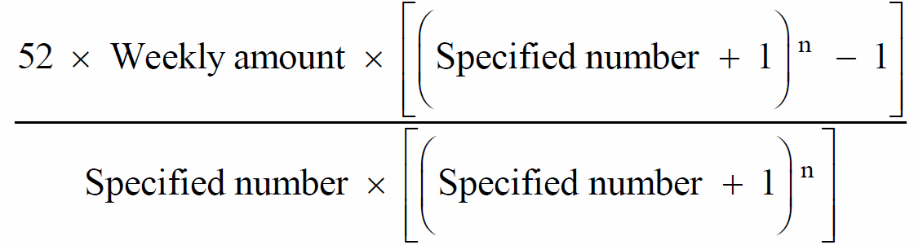

Where:

***n*** means the number worked out using the formula:

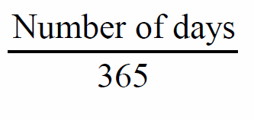

***number of days*** means the total amount of days in the period:

(a) beginning on the day after the day on which the person advised the Commission of his or her choice under paragraph 138(1)(d) of the Act; and

(b) ending on the day before the day the Special Rate Disability Pension is payable to the person.

Note In some cases a person’s Special Rate Disability Pension amount will be nil.

***Specified number***means the number used as the specified number by the Commission to determine the amount of the person’s lump sum under subsection 138(3) of the Act.

***Weekly amount*** means the amount of compensation payable to the person under section 118 of the Act for the week in which the person advised the Commission of his or her choice under paragraph 138(1)(d) of the Act.

Schedule 1—Repeals

Military Rehabilitation and Compensation Act (Section 204A(2) amount) Instrument 2013

1 The whole of the instrument

Repeal the instrument.