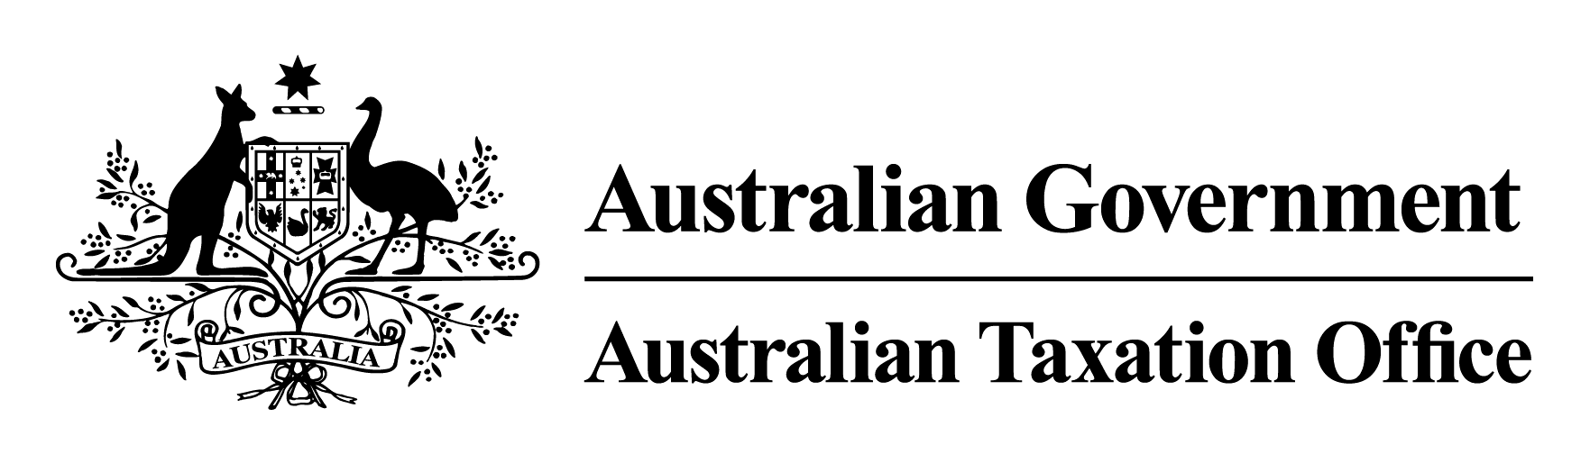

Taxation Administration (Exemption from Providing Payment Summaries to Passbook Account Holders) Legislative Instrument 2023
I, Ben Kelly, Deputy Commissioner of Taxation, make the following legislative instrument.
Dated 28/02/2023
Ben Kelly
Deputy Commissioner of Taxation

Contents
1 Name 1
2 Commencement 1
3 Authority 1
4 Definitions 1
5 Schedules 1
6 Exemption 2
Schedule 1—Repeals 3
Notice of exemption from providing payment summaries to passbook account holders (30/11/2012) (F2012L02333) 3

1 Name
This instrument is the Taxation Administration (Exemption from Providing Payment Summaries to Passbook Account Holders) Legislative Instrument 2023.

2 Commencement
(1) Each provision of this instrument specified in column 1 of the table commences, or is taken to have commenced, in accordance with column 2 of the table. Any other statement in column 2 has effect according to its terms.

Commencement information
Column 1 | Column 2 | Column 3
Provisions | Commencement | Date/Details
1. The whole of this instrument | The day after this instrument is registered.
Note: This table relates only to the provisions of this instrument as originally made. It will not be amended to deal with any later amendments of this instrument.
(2) Any information in column 3 of the table is not part of this instrument. Information may be inserted in this column, or information in it may be edited, in any published version of this instrument.

3 Authority
This instrument is made under section 16-180 of Schedule 1 to the Act.

4 Definitions
In this instrument:
Act means the Taxation Administration Act 1953.
passbook account provider means an entity that provides a passbook account (such as a bank, financial institution, building society or credit union).
passbook account means a type of account provided by a passbook account provider, where the account holder is given a physical document known as a passbook, in which account transactions and information (such as deposits, withdrawals, interest and balances) are recorded.

5 Schedules
Each instrument that is specified in a Schedule to this instrument is amended or repealed as set out in the applicable items in the Schedule concerned, and any other item in a Schedule to this instrument has effect according to its terms.

6 Exemption
(1) A passbook account provider is exempt from the requirement in section 16-155 of Schedule 1 to the Act to give a payment summary for a financial year to a passbook account holder if:
(a) the payment summary is in respect of a passbook account;
(b) at any time during that financial year, the passbook account was open or in use; and
(c) the payment summary is in respect of a payment to the passbook account from which:
(i) an amount must be withheld under Subdivision 12-E (Payments where TFN or ABN not quoted); or
(ii) an amount must be withheld under Subdivision 12-F (Dividend, interest and royalty payments).
(2) Subsection (1) does not apply if the passbook account holder requests a payment summary.

Schedule 1—Repeals

Notice of exemption from providing payment summaries to passbook account holders (30/11/2012) (F2012L02333)
1 The whole of the instrument
Repeal the instrument

