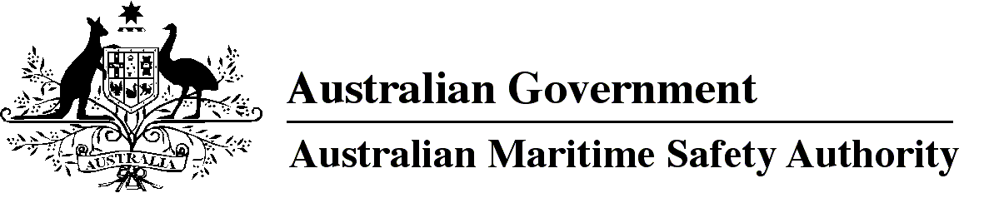
AMSA MO 2023/1
Marine Order 98 (Harmful anti-fouling systems) 2023
I, Michael Kinley, Chief Executive Officer of the Australian Maritime Safety Authority, make this Marine Order under section 24 of the Protection of the Sea (Harmful Anti-fouling Systems) Act 2006.
6 February 2023
Michael Kinley
Chief Executive Officer

Division 1 Preliminary 3
1 Name of Marine Order 3
1A Commencement 3
1B Repeal of Marine Order 98 (Marine pollution — anti-fouling systems) 2013 3
2 Purpose 3
3 Power 3
4 Definitions 3
5 Application 4
Division 2 Matters for AFS Act 4
6 Anti-fouling certificates 4
7 Cancellation of anti-fouling certificates — service of notices 4
8 Notices of happenings 4
9 Anti-fouling declarations 4

Division 1 Preliminary
1 Name of Marine Order
This Marine Order is Marine Order 98 (Harmful anti-fouling systems) 2023.
1A Commencement
This Marine Order commences on 1 March 2023.
1B Repeal of Marine Order 98 (Marine pollution — anti-fouling systems) 2013
Marine Order 98 (Marine pollution — anti-fouling systems) 2013 is repealed.
2 Purpose
This Marine Order prescribes matters for the Protection of the Sea (Harmful Anti-fouling Systems) Act 2006 (AFS Act) and gives effect to survey requirements under the International Convention on the Control of Harmful Anti-fouling Systems on Ships (Convention).
3 Power
(1) The following provisions of the AFS Act provide for this Marine Order to be made:
(a) paragraph 25(a) which provides for regulations to be made prescribing matters required or permitted by the Act to be prescribed;
(b) paragraph 25(b) which provides for regulations to be made prescribing matters necessary or convenient to be prescribed for carrying out or giving effect to the Act;
(c) paragraph 25(c) which provides for regulations to be made prescribing matters to give effect to the Convention, other than provisions of the Convention to which effect is given by the Act.
(2) Section 24 of the AFS Act provides that AMSA may make Marine Orders about matters on which regulations may be made.
4 Definitions
In this Marine Order:
AMSA has the same meaning as Authority in the AFS Act.
Note 1 Some terms used in this Marine Order are defined in Marine Order 1 (Administration) 2013, including:
- AFS Act
- IMO
Note 2 Other terms used in this Marine Order are defined in the AFS Act, including:
- anti-fouling certificate
- Australian ship
- Convention
- foreign ship
- master
- owner
- ship
Note 3 Information on obtaining copies of any document mentioned in this Marine Order, including IMO Resolutions, is available from the AMSA website Marine Orders link at http://www.amsa.gov.au.
5 Application
This Marine Order applies to an Australian ship.
Note Parts 1, 2, 4 and 5 of the AFS Act apply to foreign ships. See the AFS Act for the obligations, responsibilities and inspection powers that affect foreign ships.
Division 2 Matters for AFS Act
6 Anti-fouling certificates
(1) For subsection 10(1) of the AFS Act, an anti-fouling certificate for an Australian ship must be in the form of the International Anti-Fouling System Certificate attached to the Convention.
Note This form is available on the AMSA website at: http://www.amsa.gov.au.
(2) For subsection 10(2) of the AFS Act, an endorsement of an anti-fouling certificate for an Australian ship must be in accordance with the ‘Endorsement of the Records’ section of the International Anti-fouling System Certificate attached to the Convention.
(3) A survey mentioned in section 10 of the AFS Act must be carried out in accordance with the 2022 Guidelines for survey and certification of anti-fouling systems on ships adopted by IMO Resolution MEPC.358(78), as if those Guidelines were mandatory.
7 Cancellation of anti-fouling certificates — service of notices
For paragraphs 12(3)(b) and 12(5)(c) of the AFS Act, notice must be served by email, fax or post.
8 Notices of happenings
For paragraph 14(1)(c) of the AFS Act, notice of a happening must be given to AMSA on the approved form.
Note 1 The approved form is available on the AMSA website at: http://www.amsa.gov.au.
Note 2 Section 14 of the AFS Act provides that the master and owner of a ship each commit an offence if notice is not given within 7 days after the happening of an event that may affect the ship’s compliance with anti-fouling requirements.
9 Anti-fouling declarations
For the definition of anti-fouling declaration in subsection 15(5) of the AFS Act, the declaration must be in the form of the Declaration on Anti-Fouling System attached to the Convention.
Note This form is available on the AMSA website at: http://www.amsa.gov.au.

Note
1. All legislative instruments and compilations of legislative instruments are registered on the Federal Register of Legislation under the Legislation Act 2003. See https://www.legislation.gov.au.

