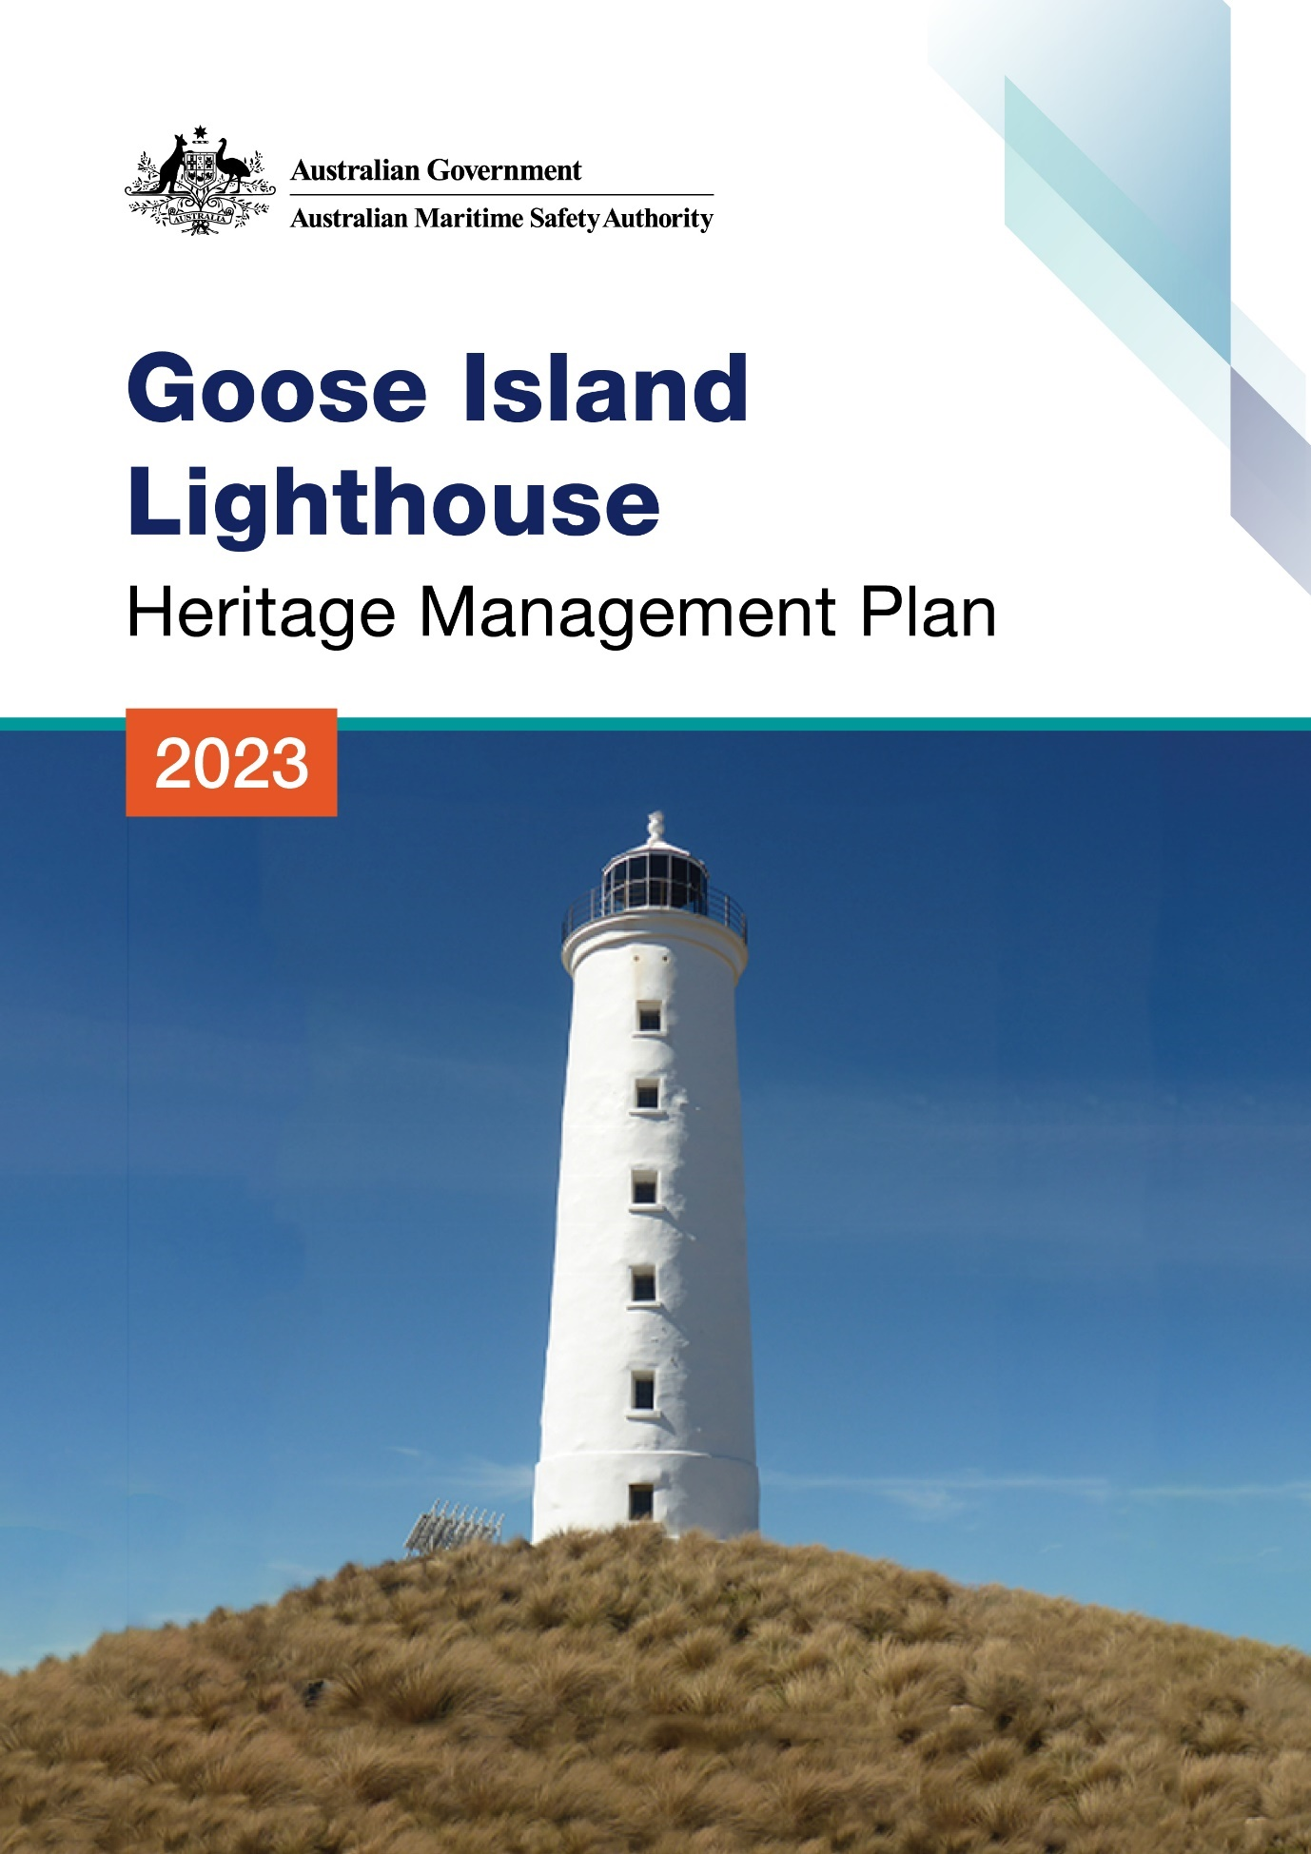

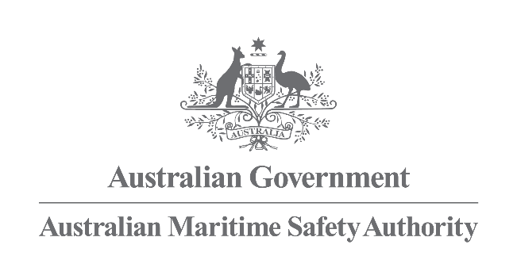

Goose Island Lighthouse
Heritage Management Plan
2023
The Australian Maritime Safety Authority makes this heritage management plan under section 341S of the Environment Protection and Biodiversity Conservation Act 1999 (Cth) for Goose Island Lighthouse.
25 January 2023
Mick Kinley
Chief Executive Officer
Copyright
© Australian Maritime Safety Authority

The Australian Maritime Safety Authority encourages the dissemination and exchange of information provided in this publication.

Except as otherwise specified, all material presented in this publication is provided under Creative Commons Attribution 4.0 International licence. This excludes:
- the Commonwealth Coat of Arms
- this department's logo
- content supplied by third parties.

The Creative Commons Attribution 4.0 International Licence is a standard form licence agreement that allows you to copy, distribute, transmit and adapt this publication provided that you attribute the work. The details of the version 4.0 of the licence are available on the Creative Commons website, as is the full legal code for that licence.

Third Party Copyright
Some material in this document, made available under the Creative Commons Licence framework, may be derived from material supplied by third parties. The Australian Maritime Safety Authority has made all reasonable efforts to identify content supplied by third parties using the following format ‘© [name of third party]’ or ‘Source: [name of third party]’. Permission may need to be obtained from third parties to re-use their material.

Acknowledgements
The Australian Maritime Safety Authority acknowledges the Traditional Custodians of country throughout Australia and their connections to land, sea and community.
Contact
Comments or questions regarding this document should be addressed to:
The Australian Maritime Safety Authority,
Manager Asset Management and Preparedness,
PO Box 10790,
Adelaide Street, Brisbane QLD 4000

Phone: (02) 6279 5000 (switchboard)
Email: Heritage@amsa.gov.au
Website: www.amsa.gov.au

Attribution
AMSA’s preference is that you attribute this publication (and any material sourced from it) using the following wording:
Source: Australian Maritime Safety Authority Goose Island Lighthouse Heritage Management Plan – 2023
Front cover image - Figure 1. Cover photo of Goose Island Lighthouse (Source: AMSA, 2018)
More information
For enquiries regarding copyright including requests to use material in a way that is beyond the scope of the terms of use that apply to it, please contact us through our website: www.amsa.gov.au
Table of Contents

Executive summary
- Introduction
  - Background and purpose
  - Heritage management plan objectives
  - Methodology
  - Status
  - Authorship
  - Acknowledgements
  - Language
  - Previous reports
  - Sources of information and images

- Goose Island Lightstation site
  - Location
  - Setting and landscape
  - Lease
  - Access
  - Listings

- History
  - General history of lighthouses in Australia
  - The Commonwealth Lighthouse Service
  - Tasmanian Lighthouse Service Administration
  - Goose Island: A history
  - Planning a lighthouse
  - Lightkeeping on Goose Island
  - Chronology of major events
  - Changes and conservation over time
  - Summary of current and former uses
  - Summary of past and present community associations
  - Unresolved questions or historical conflicts
  - Recommendations for further research

- Fabric
  - Fabric register
  - Related object and associated AMSA artefact
  - Comparative analysis

- Heritage Significance
  - Commonwealth heritage list – Goose Island Lighthouse
  - TAS State heritage register – Goose Island Lighthouse
  - Condition and integrity of Commonwealth heritage values
  - Gain or loss of heritage values

- Opportunities and constraints
  - Implications arising from significance
  - Framework: sensitivity to change
  - Statutory and legislative requirements
  - Operational requirements
  - Occupier needs
  - Proposals for change
  - Potential pressures
  - Process for decision-making

- Conservation management principles and policies

- Policy implementation plan
  - Plan and schedule
  - Monitoring and reporting

Appendices
Appendix 1. Glossary of heritage conservation terms
Appendix 2. Glossary of historic lighthouse terms relevant to Goose Island
Appendix 3. Table demonstrating compliance with the EPBC Regulations
Appendix 4. Goose Island current light details

Endnotes

Reference list

List of Figures
Figure 1. Cover photo of Goose Island (Source: AMSA, 2018)
Figure 2. Planning process applied for heritage management (Source: Australia ICOMOS, 1999)
Figure 3. Location of Goose Island within Bass Strait (Imagery: ©2021 TerraMetrics, Map data ©2021 Google)
Figure 4. Location of lighthouse on Goose Island (Imagery: ©2021 CNES/Airbus, Maxar Technologies, Map data: ©2021 Google)
Figure 5. View of Goose Island Lighthouse and surrounds (Source: AMSA, 2018)
Figure 6. Goose Island Lightstation 2018 Map of Lease (Goose Island Lightstation Map of Lease (Esri, DigitalGlobe, GeoEye, Earthstar Geographics, CNES/Airbus DS, USDA, USGS, AeroGRID, IGN, and the GIS User Community)
Figure 7. View of path from lighthouse tower to helipad (Source: AMSA, 2018)
Figure 8. Incandescent oil vapour lamp by Chance Brothers (Source: AMSA)
Figure 9. Dioptric lens on display at Narooma (Source: AMSA)
Figure 10. Dalén’s system – sun valve, mixer and flasher (Source: AMSA)
Figure 11. Drawings and floor plans of five Tasmanian lighthouses built in 1840s. From left to right: Low Head, South Bruny, Deal Island, Swan Island, and Goose Island (1848). Image courtesy of the National Archives of Australia. (© Commonwealth of Australia, National Archives of Australia)
Figure 12. Goose Island jetty and tramway (1917). Image courtesy of the National Archives of Australia. (© Commonwealth of Australia, National Archives of Australia)
Figure 13. Goose Island tramway, 1990. Image courtesy of the National Archives of Australia: P2812, 18 (© Commonwealth of Australia, National Archives of Australia)
Figure 14. Blueprints for conversion of Goose Island to Acetylene operation, 1931. Image courtesy of the National Archives of Australia: A10182, CN 01 130 (© Commonwealth of Australia, National Archives of Australia)
Figure 15. Swan Island Lighthouse, TAS. First lit 1845 (Source: AMSA, 2021)
Figure 16. Goose Island Lighthouse, TAS. First lit 1846 (Source: AMSA, 2020)

Acronym List
List of acronyms utilised throughout this heritage management plan:
Acronym | Definition
AGA | Gas Accumulator Company
AMSA | Australian Maritime Safety Authority
AMSG | Australian Maritime Systems Group
AtoN | Aid to Navigation
BBT | Barbier, Benard, et Turenne
CHL | Commonwealth Heritage List
DCCEEW | Department of Climate Change, Energy, the Environment and Water
EPBC Act | Environment Protection and Biodiversity Conservation Act 1999 (Cth)
EPBC Regulations | Environment Protection and Biodiversity Conservation Regulations 2000 (Cth)
HMP | Heritage Management Plan
IALA | International Association of Marine Aids to Navigation and Lighthouse Authorities
LED | Light emitting diode
NAA | National Archives of Australia
NES | National Environmental Significance
NLA | National Library of Australia
RMS | Record Management System
RNE | Register for the National Estate (non-statutory archive)
TAS PWS | Tasmanian Parks and Wildlife Service
THR | Tasmanian Heritage Register

Executive summary
Goose Island Lighthouse was placed on the Commonwealth Heritage List in 2004. The lighthouse has contributed to the establishment of marine Aids to Navigation (AtoNs) within Bass Strait. It is known for its significance as one of five pre-1850 lighthouses in Tasmania and its aesthetic characteristics as a remote coastal landmark.
Goose Island Lighthouse is listed on the Tasmanian Heritage Register for its contribution to the development of early 19th century AtoNs. It is also recognised for its rarity as the third oldest Australian lighthouse still in existence, its potential to yield knowledge, demonstration of class characteristics and aesthetic value.
Built in 1841-1846, the lighthouse is located on Goose Island, a landmass within the Furneaux Group Islands situated within Bass Strait. The lighthouse was originally accompanied by keepers’ cottages, and a jetty and tramway before their demolition following the de-staffing of the site in 1931. The only structures left on Goose Island are the tower, store shed and helipad, which are incorporated in the AMSA lease. The larger part of the island is managed by Tasmanian Parks and Wildlife Service (TPWS).
Originally fitted with a fixed W Wilkins Co single-lamp and catadioptric lens, the lighthouse tower now operates via a Vega VRB-25 self-contained rotating beacon on an automated mechanism as part of our network of AtoNs. The equipment is serviced by AMSA’s maintenance contractor who visits at least once each year. AMSA officers visit on an ad hoc basis for auditing, project and community liaison purposes.
This heritage management plan concerns the lighthouse tower and store shed, however it also considers the management of the surrounding precinct and land which is managed by the Tasmanian Parks and Wildlife Service (TAS PWS). This plan is intended to guide decisions and actions of AMSA who continue to operate the lighthouse. AMSA has prepared this plan to integrate the heritage values of the lighthouse in accordance with the Environment Protection and Biodiversity Conservation Act 1999 Cth (EPBC Act), and the Environment Protection and Biodiversity Conservation Regulations 2000 Cth (EPBC Regulations).
Well-built and generally well-maintained, the lighthouse is in relatively good, stable condition. The policies and management guidelines set out in this heritage management plan strive to ensure the Commonwealth and State heritage values of Goose Island Lighthouse are recognised, maintained and preserved for future generations.


- Introduction
  - Background and purpose
The Australian Maritime Safety Authority (AMSA) is the Commonwealth agency responsible for coastal aids to navigation (AtoN). AMSA’s network includes the Goose Island Lighthouse built in 1841-1846.
Section 341S of the Environment Protection and Biodiversity Conservation Act 1999 (Cth) (EPBC Act) requires AMSA to prepare a management plan for Goose Island Lighthouse that addresses the matters prescribed in Schedules 7A and 7B of the Environment Protection and Biodiversity Conservation Regulations 2000 (Cth) (EPBC Regulations). The principal features of this management plan are:
- a description of the place, its heritage values, their condition and the method used to assess its significance
- an administrative management framework
- a description of any proposals for change
- an array of conservation policies that protect and manage the place
- an implementation plan
- ways the policies will be monitored and the management plan reviewed.

AMSA has prepared this heritage management plan to guide the future conservation of the place. This plan provides the framework and basis for the conservation and best practice management of Goose Island Lighthouse in recognition of its heritage values. The policies in this plan indicate the objectives for identification, protection, conservation and presentation of the Commonwealth heritage values of the place. Figure 2 shows the basic planning process applied. 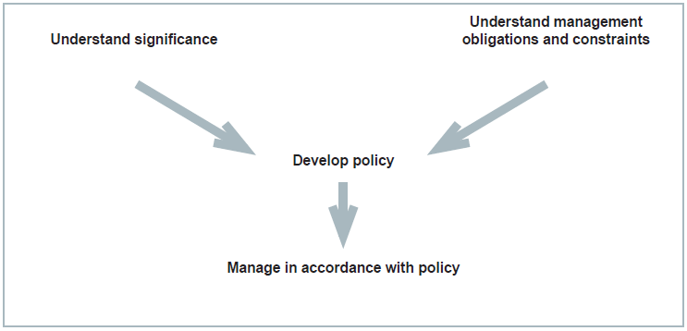
Figure 2. Planning process applied for heritage management (Source: Australia ICOMOS, 1999)

  - Heritage management plan objectives
The objectives of this heritage management plan are to:
- protect, conserve and manage the Commonwealth heritage values of Goose Island Lighthouse
- interpret and promote the Commonwealth heritage values of the Goose Island Lighthouse
- manage use of the lightstation
- use best practice standards, including ongoing technical and community input, and apply best available knowledge and expertise when considering actions likely to have a substantial impact on Commonwealth heritage values.
In undertaking these objectives, this plan aims to:
- Provide for the protection and conservation of the heritage values of the place while minimising any impacts on the environment by applying the relevant environmental management requirements in a manner consistent with Commonwealth heritage management principles.
- Take into account the significance of Goose Island as a cultural landscape occupied by Aboriginal people over many thousands of years.
- Recognise that the site has been occupied by lease holders since the early 20th century.
- Encourage site use that is compatible with the historical fabric, infrastructure and general environment.
- Record and document maintenance works, and changes to the fabric, in the Goose Island Lighthouse fabric register (see Section 4. Fabric Register).
The organisational planning cycle and associated budgeting process is used to confirm requirements, allocate funding, and manage delivery of maintenance activities. Detailed planning for the aids to navigation network is managed through our internal planning processes.
An interactive map showing many of AMSA’s heritage sites, including Goose Island Lighthouse, can be found on AMSA’s Interactive Lighthouse Map.
1.3 Methodology
The methodology used in the preparation of this plan is consistent with the recommendations of The Burra Charter and with the requirements of Chapter 5, Part 15 Division 1A of the EPBC Act. In particular, the plan:
- details a history of the site based on information sourced from archival research, expert knowledge, and documentary resources,
- provides a description of the site based on information sourced from site inspection reports and fabric registers, and;
- details the Commonwealth heritage criteria satisfied by Goose Island Lighthouse as set out by schedule 7A of the EPBC Regulations.

The criterion set out at Schedule 7A (h) (i-xiii) informed the development of the required policies for the management of Goose Island Lighthouse, in conjunction with input from the Department of Climate Change, Energy, the Environment and Water (DCCEEW) on best practice management.

Consultation
In preparation of the plan, AMSA sought engagement with the Aboriginal Land Council of Tasmania (ALCT) under direction from the Office of Aboriginal Affairs (Tas). AMSA also consulted with Aboriginal Heritage Tasmania (Department of Primary Industries, Parks, Water and Environment, Tas) and were provided with information on Aboriginal heritage in the vicinity of the lighthouse. This information was included in the plan.
AMSA consulted with Tasmania Parks and Wildlife (TAS PWS) who provided valuable historical information and feedback on land management. This information was included within the plan.
The draft management plan was advertised in accordance with the EPBC Act and EPBC Regulations. On 7 March 2022 a notice was placed in The Australian newspaper publication which invited the general public to review the draft plan on AMSA’s website and provide feedback. Public consultation closed on 1 April 2022 and submissions were considered by AMSA’s Heritage Team.
A developed draft was submitted to the Federal Minister through the Heritage Branch of the Department of Climate Change, Energy, the Environment and Water (DCCEEW), and in that process the Minister’s delegate sought advice from the Australian Heritage Council. The plan was endorsed on 24 October 2022.
No updates or amendments have been made in this version of the plan.
1.4 Status
This plan has been adopted by AMSA in accordance with Schedule 7A (Management plans for Commonwealth Heritage places) and Schedule 7B (Commonwealth Heritage management principles) of the EPBC Regulations to guide the management of the place and for inclusion in the Federal Register of Legislative Instruments.
1.5 Authorship
This plan has been prepared by AMSA. At the initial time of publication, the Australian Maritime Systems Group (AMSG) was the contract maintenance provider for the Commonwealth Government’s AtoN network including Goose Island Lighthouse.
1.6 Acknowledgements
AMSA acknowledges the professional assistance of TAS PWS, the Aboriginal Land Council of Tasmania, and Aboriginal Heritage Tasmania.
AMSA acknowledges the professional assistance of Dr. Robin Sim, Archaeologist.
1.7 Language
For clarity and consistency, some words in this plan such as restoration, reconstruction, and preservation, are used with the meanings defined in the Burra Charter. See Appendix 1 Glossary of heritage conservation terms.
Also see Appendix 2 Glossary of historic lighthouse terms relevant to Goose Island Lighthouse, which sets out the technical terminology used in this plan.
1.8 Previous reports
- A Heritage Lighthouse Report was produced by Mr Peter Marquis-Kyle for AMSA in 2007.
- A Heritage Asset Condition Report was produced by AMSG in 2016 (reviewed and updated 2019).
1.9 Sources of information and images
This plan has used a number of sources of information. This includes the National Archives of Australia (NAA), National Library of Australia (NLA) and AMSA’s heritage collection.


- Goose Island Lightstation site
  - Location
The Goose Islands, comprised of Little Goose Island and Goose Island, form part of the Badger Group Islands located within the Furneaux Group Islands. Situated within Bass Strait, the Goose Islands are found to the north of the Australian state of Tasmania. Goose Island Lighthouse is located on the southern tip of the main Goose Island, an unpopulated granite landmass approximately 109 Ha in size.

Lighthouse coordinates: 40º 18.7032’S, 147º 48. 0810’E

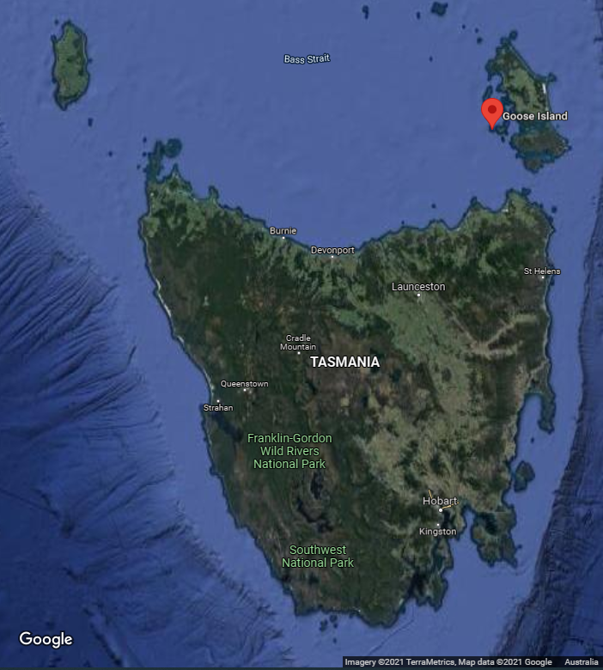
Figure 3. Location of Goose Island within Bass Strait (Imagery: ©2021 TerraMetrics, Map data ©2021 Google)
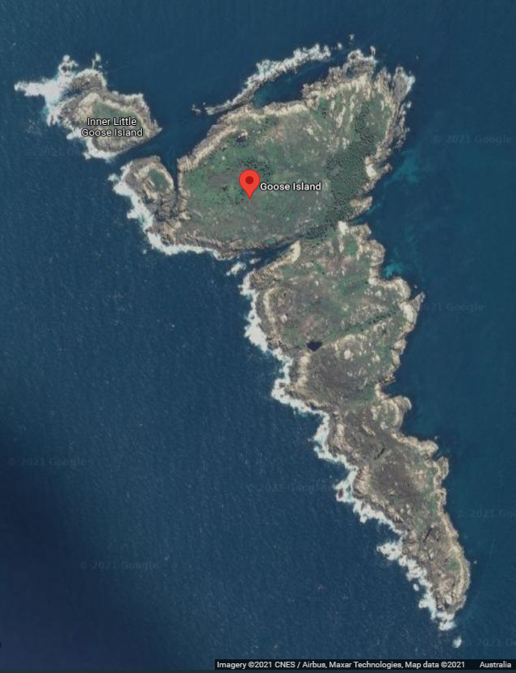
Figure 4. Location of lighthouse on Goose Island (Imagery: ©2021 CNES/Airbus, Maxar Technologies, Map data: ©2021 Google)
  - Setting and landscape
Goose Island, a low-lying elongated island, is approximately 2.5km in length and, at its widest point, approximately 1km in width. Owing to its granite foundation, Goose Island possesses limited vegetation. A large sheep population was kept on the island during the period the lighthouse was staffed, which may have contributed to the limited vegetation growth.
Apart from the lighthouse tower, oil storeroom and helipad, the Island bears no other structure – with exception to some structural remains of the demolished lightkeepers’ cottages, tramway and small lighthouse graveyard.
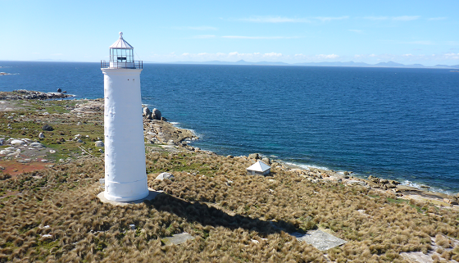
Figure 5. View of Goose Island Lighthouse and surrounds (Source: AMSA, 2018)

Fauna and flora
Goose Island contains a select abundance of fauna and flora owing to its isolated position in Bass Strait. Coastal birds colonies, particularly little penguin and short-tailed shearwater, have been recorded on the island.

Within the larger setting of the Furneaux Group Islands, white-bellied sea-eagles, terns, and hooded plover ‘hot spots’ have been identified. The Furneaux Group Islands have also been identified as containing a small number of rare faunal species:
- Tornatellinops jacksonensis (snail)
- Parvotettix rangaensis (Ranga cave cricket)
- Platyzosteria insulae (Fisher Island cockroach)
At the time this plan was written, a Biosecurity Plan for the Furneaux Group Islands was being developed. Their findings will be included in an updated version of this plan.

  - Lease

AMSA leases the Goose Island Lighthouse and helipad from the Minister administering the National Parks and Wildlife Act 1970 (TAS), and this lease is managed by the Tasmanian Parks and Wildlife Service (TAS PWS).

The AMSA lease consists of one parcel of land:
- Lot 1: Lighthouse tower (1,024m²)
The current lease commenced on 1 May 1998 and includes the option to renew for an additional 25 years.
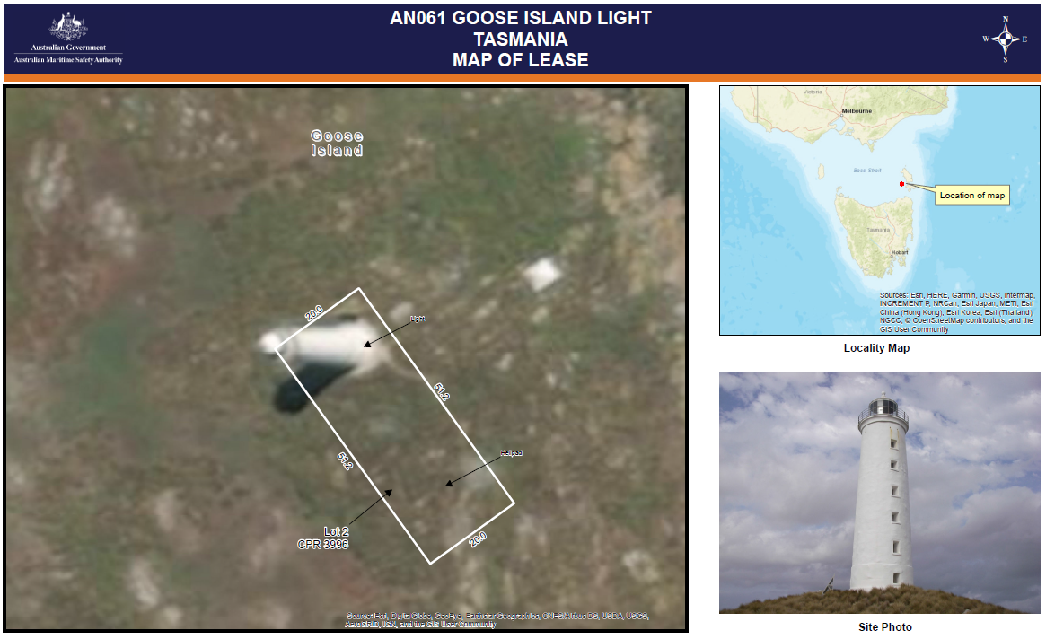
Figure 6. Goose Island Lightstation 2018 Map of Lease (Esri, DigitalGlobe, GeoEye, Earthstar Geographics, CNES/Airbus DS, USDA, USGS, AeroGRID, IGN, and the GIS User Community)
Goose Island Lighthouse and its accompanying store shed are the only remaining structure from the original lightstation. The land surrounding AMSA’s lease is managed by the Minister administering the National Parks and Wildlife Act 1970 (TAS).
  - Access
Goose Island can be accessed by helicopter and boat – boat landing is enabled on the sandy beaches of its north eastern coastline. Visitors are required to walk the distance to the lighthouse (minimal path visibility). Access inside the lighthouse is restricted to authorised personnel only.
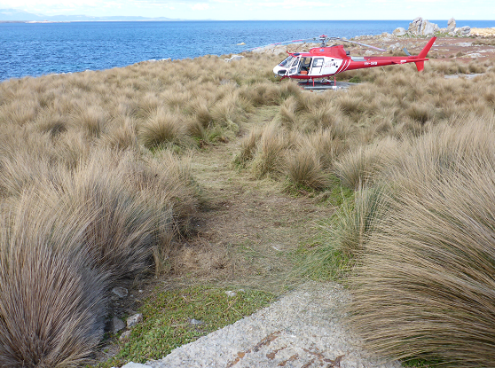
Figure 7. View of path from lighthouse tower to helipad (Source: AMSA, 2018)
Tourism
Due to the extreme isolation of the lighthouse and the island, no current tourism operations exist.
  - Listings
The table below details the various heritage listings of the Goose Island Lightstation.

Register | ID
Commonwealth Heritage List | 105564
Register for the National Estate (non-statutory) | 102869
Tasmanian Heritage Register | 10684


- History

  - General history of lighthouses in Australia
The first lighthouse to be constructed on Australian soil was Macquarie Lighthouse, located at the entrance to Port Jackson, NSW. First lit in 1818, the cost of the lighthouse was recovered through the introduction of a levy on shipping. This was instigated by Governor Lachlan Macquarie, who ordered and named the light.
The following century oversaw the construction of hundreds of lighthouses around the country. Constructing and maintaining a lighthouse were costly ventures that often required the financial support of multiple colonies. However, they were deemed necessary aids in assisting the safety of mariners at sea. Lighthouses were firstly managed by the colony they lay within, with each colony developing their own style of lighthouse and operational system. Following Federation in 1901, which saw the various colonies unite under one Commonwealth government, lighthouse management was transferred from state hands to the Commonwealth Lighthouse Service.

Lamps and optics: an overview
Lighthouse technology has altered drastically over the centuries. Eighteenth century lighthouses were lit using parabolic mirrors and oil lamps. Documentation of early examples of parabolic mirrors in the United Kingdom, circa 1760, were documented as consisting of wood and lined with pieces of looking glass or plates of tin. As described by Searle, ’When light hits a shiny surface, it is reflected at an angle equal to that at which it hit. With a light source is placed in the focal point of a parabolic reflector, the light rays are reflected parallel to one another, producing a concentrated beam’.
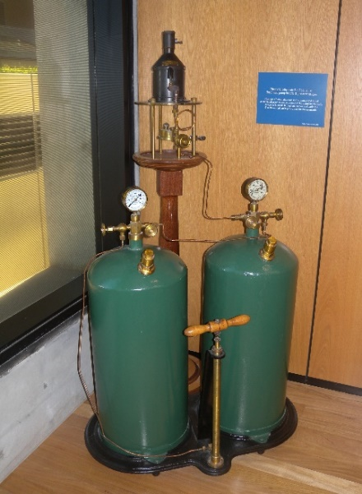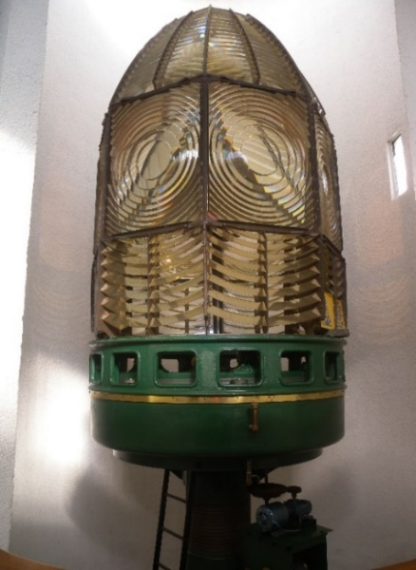
Figure 8. Incandescent oil vapour lamp by Chance Brothers (Source: AMSA)
Figure 9. Dioptric lens on display at Narooma (Source: AMSA)
In 1822, Augustin Fresnel invented the dioptric glass lens. By crafting concentric annular rings with a convex lens, Fresnel had discovered a method of reducing the amount of light absorbed by a lens. The Dioptric System was adopted quickly with Cordouran Lighthouse (France), which was fitted with the first dioptric lens in 1823. The majority of heritage-listed lighthouses in Australia house dioptric lenses made by others such as Chance Brothers (United Kingdom), Henry-LePaute (France), Barbier, Bernard & Turenne (BBT, France) and Svenska Aktiebolaget Gasaccumulator (AGA of Sweden). These lenses were made in a range of standard sizes, called orders—see ‘Appendix 2. Glossary of lighthouse Terms relevant to Goose Island Lighthouse’.
Early Australian lighthouses were originally fuelled by whale oil and burned in Argand lamps, and multiple wicks were required in order to create a large flame that could be observed from sea. By the 1850s, whale oil had been replaced by colza oil, which was in turn replaced by kerosene, a mineral oil.
In 1900, incandescent burners were introduced. This saw the burning of fuel inside an incandescent mantle, which produced a brighter light with less fuel within a smaller volume. Light keepers were required to maintain pressure to the burner by manually pumping a handle as can be seen in Figure 8.
In 1912, Swedish engineer Gustaf Dalén, was awarded the Nobel Prize in physics for a series of inventions relating to acetylene-powered navigation lights. Dalén’s system included the sun valve, the mixer, the flasher, and the cylinder containing compressed acetylene. Due to their efficiency and reliability, Dalén’s inventions led to the gradual de-staffing of lighthouses. Acetylene was quickly adopted by the Commonwealth Lighthouse Service from 1915 onwards.
Large dioptric lenses, such as that shown in Figure 9, gradually decreased in popularity due to cost and the move towards de-staffed automatic lighthouses. By the early 1900s, Australia had stopped ordering these lenses with the last installed at Eclipse Island in Western Australia in 1927. Smaller Fresnel lenses continued to be produced and installed until the 1970s when plastic lanterns, still utilising Fresnel’s technology, were favoured instead. Acetylene remained in use until it was finally phased out in the 1990s.
In the current day, Australian lighthouses are lit and extinguished automatically using mains power, diesel generators, and solar-voltaic systems.
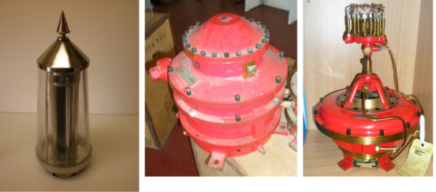
Figure 10. Dalén's system - sunvalve, mixer, and flasher (Source: AMSA)
  - The Commonwealth Lighthouse Service
When the Australian colonies federated in 1901, they decided that the new Commonwealth government would be responsible for coastal lighthouses—that is, major lights used by vessels travelling from port to port—but not the minor lights used for navigation within harbours and rivers. There was a delay before this new arrangement came into effect. Existing lights continued to be operated by the states.
Since 1915, various Commonwealth departments have managed lighthouses. AMSA, established under the Australian Maritime Safety Authority Act 1990 (Cth), is now responsible for operating Commonwealth lighthouses and other aids to navigation, along with its other functions.

  - Tasmanian Lighthouse Service Administration
The following table outlines a chronology of Goose Island Lighthouse’s management following federal acquisition.

Time Period | Administration
1915-1927:  1927-1963:  1963-1972:  1972-1982:  1982-1983:  1983-1985:  1985-1987:  1987-1990:  1991- | Lighthouse District No. 3 (Victoria, New South Wales, Tasmania), Hobart Headquarters.  Deputy Director of Lighthouses and Navigation, Tasmania.  Department of Shipping and Transport, Regional Controller, Tasmania.  Department of Transport [III], Regional Controller, Tasmania.  Department of Transport and Construction. Victoria-Tasmania Region, Transport Division (Tasmania).  Department of Transport [IV] Victoria-Tasmania Region, Hobart Office.  Department of Transport [IV], Tasmanian Region.  Department of Transport and Communications, Tasmanian Region.  Australian Maritime Safety Authority.

  - Goose Island: A history
Aboriginal history
Surveys of the Outer Furneaux Islands were carried out in 1989-1990 and a total of 64 prehistoric Aboriginal sites were recorded, all containing stone artefacts. Sites recorded on Swan Island were identified as being open sites consisting of stone artefacts of quartz, quartzite and exotic. Seven unretouched flake and flaked pieces, and three retouched implements were identified within Swan Island’s artefact scatters and are estimated to date from the late Pleistocene landbridge phase. These investigations demonstrated that the eastern Bassian region was occupied during the prehistoric period.

Aboriginal Heritage Tasmania (Department of Primary Industries, Parks, Water and Environment, TAS) detailed that four Aboriginal heritage sites are recorded within the Aboriginal Heritage Register, and these sites are located 1-2 kilometres north-west of Goose Island Lighthouse.
The full extent of past and present Aboriginal cultural associations with Goose Island requires further consultation and research. New information will be included in later versions of this plan.

Early European history

In 1798, the passage of water separating Tasmania from the mainland was charted by British explorer George Bass, and British navigator and cartographer Matthew Flinders. Named ‘Bass Strait’, this passage was traversed by countless ships that had previously been forced to journey around the south coast of Tasmania.
Little is known about post-European settlement activity on Goose Island following the colonial inhabitation of the Bass Strait. New information will be included in later versions of this plan.
  - Planning a lighthouse
Why Goose Island?

In 1841, suggestions were made to improve shipping safety in the Bass Strait vicinity. Sir John Franklin, Lieutenant-Governor of Van Diemen’s Land (Tasmania), recommended to Sir George Gipps, Governor of New South Wales, that two lighthouses be constructed within Banks Strait – a passage between the Furneaux Group Islands and Tasmania’s north-eastern coastline. The Banks Strait was regularly navigated by vessels travelling from Melbourne (VIC), Hobart and Launceston (TAS). Of these proposed lightstation sites was Goose Island, chosen for its position along the Banks Strait shipping route.

Construction
Construction of Goose Island Lighthouse commenced in January 1841. Supervised by ex-convict Charles Watson, construction was carried out by convict labour. The workmen were housed in basic huts onsite while food, water and fuel were shipped to the island sporadically.
Construction of the tower was completed by March 1843. However, the W Wilkins Co lantern ordered from England failed to arrive when expected. Whilst waiting for its arrival, Watson and his team moved onto construction of Swan Island Lighthouse, also located in Bass Strait, which was completed in October 1845. Eventually, the lantern destined for Goose Island arrived the same month Swan Island was completed. The lantern was successfully installed and the Goose Island light was first exhibited on 1 February 1846.
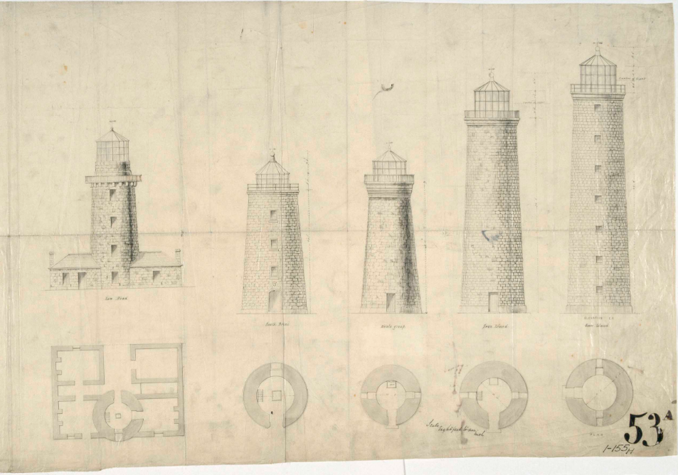
Figure 11. Drawings and floor plans of five Tasmanian lighthouses built in 1840s. From left to right: Low Head, South Bruny, Deal Island, Swan Island, and Goose Island (1848). Courtesy of the National Archives of Australia. (© Commonwealth of Australia, National Archives of Australia)

Equipment when built

Following completion, Goose Island Lighthouse stood as a 21.5 metre circular granite rubble tower. It housed a W Wilkins Co single-lamp, catadioptric lens - one of the earliest uses of this technology in Australia. The light was fixed and the upper and lower sections of the lens sytems were silvered mirrors. The tower was originally painted red and white, red for the upper half and white for the lower half, which was the typical colour scheme for early Tasmanian lighthouses.

3.6 Lightkeeping on Goose Island
Initially, the light was maintained by a superintendent accompanied by convict assistants. These convicts were assigned to the Island for a pre-determined period of time before obtaining a ‘Ticket of Leave’. Replacement convicts were sent in each time such a ticket was awarded.

Owing to its isolated position, life on Goose Island was as tedious as it was dangerous.
Whilst activity on the island was restricted to lightkeeping duties with little interaction with the outside world, one incident of an unusual nature broke the monotony of life at the lightstation. In March 1857, the lightstation was ransacked by pirates:

The cutter Lucy reports that Goose Island Lighthouse was plundered by four bushrangers, on the 31st March, in a square-sterned boat; left the island steering north-west, supposed bound for the Promontory. Those marauders are supposed to be George Lawrence, James Smith, Dennis Callahan and John Cosgrove, who absconded from Hobart Town about the 2nd March.

The lightstation was later staffed by free men who were often accompanied by their families. However, the isolation often proved tragic for its inhabitants. By the early 1900’s, some supplies for Goose Island would arrive via mail steamer. These steamers were not required to dock at the Island, but rather sit in the surrounding waters and wait for the lightkeepers to row out to meet them and collect mail and provisions.

On the 22nd of March 1922, two lightkeepers made the journey to the steamer Calliboi despite the adverse weather conditions.
They had been expecting the vital delivery of a baby bottle on board the steamer to replace one broken at the lighthouse. Unfortunately, due to the strong westerly wind, both men were drowned in the Strait upon attempting to return to Goose Island. Their bodies and the boat were later located washed up on two separate islands within Flinders Group. The men were transported back to the lighthouse where they were buried in a cemetery onsite.

These incidents at Goose Island reinforced the reality of dangers associated with isolated lighthouse keeping in the 19th and 20th centuries.
The last keeper of Goose Island Lighthouse was RE Bridgen who, in 1931 following the light’s upgrade to a 5th Order AGA revolving lens, was transferred to Swan Island Lighthouse. It is believed that the cottages and jetty were demolished shortly afterwards.

  - Chronology of major events
The table below details the major events to have occurred at Goose Island Lightstation site and environs.

Date | Event
1841-1846 | Lightstation constructed.
31 Mar 1857 | Goose Island ‘invaded’ by four bushrangers that had absconded from Hobart Town. Lighthouse plundered.
1877 | Captain Napper, superintendent of Goose Island Lighthouse reported to be deceased and buried on Goose Island after adverse weather forbid removal of his body from the island.
22 Nov 1863 | Schooner Native Youth wrecked on Goose Island while delivering stores to the lighthouse.
20 Oct 1877 | Brigantine Grances Gertrude wrecked while retrieving the body of lighthouse superintendent Captain Richard Napper.
1892 | 100ft jetty and tramway installed on island.  Workmen were briefly stranded on Goose Island following the work as no telegraphic communication existed between the nearby Islands and no passing ship would take notice of their signals.
23 Aug 1906 | Earth tremor experienced at Goose Island Lightstation.
22 Mar 1922 | Two lightkeepers perish after rowing out to meet the steamer Calliboi to receive provisions.
28 Nov 1931 | Lighthouse de-staffed. Cottages and jetty demolished shortly afterwards.
May 1939 | Mechanic injured while repairing the tower’s lantern. Sailed to Hobart on the steamer Cape York to receive treatment.
24 Nov 1958 | Motor vessel Merilyn wrecked when it went ashore during a heavy fog.
31 Mar 1978 | Goose Island Lighthouse added to Register of the National Estate.
22 June 2006 | Goose Island Lighthouse added to Commonwealth Heritage List.

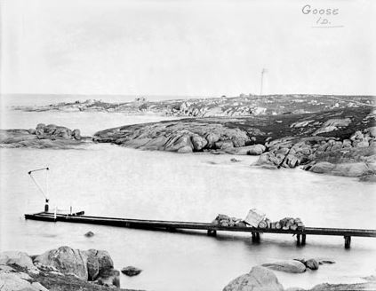
Figure 12. Goose Island jetty and tramway (1917). Courtesy of the National Archives of Australia. (© Commonwealth of Australia, National Archives of Australia)
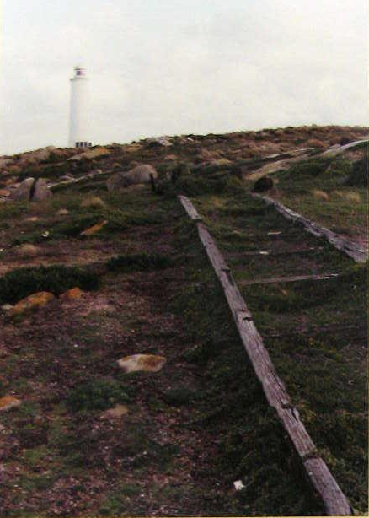
Figure 13. Goose Island tramway, 1990. Image courtesy of the National Archives of Australia: P2812, 18 (© Commonwealth of Australia, National Archives of Australia)
  - Changes and conservation over time
Due to developments in lighthouse fabric and technology, a number of alterations were carried out on the Goose Island Lighthouse throughout its lifetime.

The Brewis report
Commander CRW Brewis, retired naval surveyor, was commissioned in 1911 by the Commonwealth Government to report on the condition of existing lights and to recommend any additional ones. Brewis visited every lighthouse in Australia between June and December 1912 and produced a series of reports published in their final form in March 1913. These reports were the basis for future decisions made in relation to the individual lighthouses.
The recommendations made by Brewis concerning Goose Island included altering the light’s character, increasing the light’s power, and adding an acetylene Morse lamp.
Goose Island Light.
(30 miles from Swan Island.)
Lat. 40º 19’ S., Long. 147º 48’ E., Chart No. 1906.- Established in the year 1846.
Character.- One white, fixed dioptric, 1st Order, 20,000 c.p. Visible between the bearings of S.28ºE.,
through north, to N. 50º W. Frequently obscured by intervening island. Otherwise visible in clear
weather, 16 nautical miles.
Stone tower, 74 feet. Height of focal plane, 100 feet above high water.
Condition and Sate of Efficiency.- The light-house tower and apparatus are in good condition
The dwellings are old, but in fair order.
Three light-keepers are stationed here.
Communication.- Quarterly by steamer, carrying stores by contract.
An acetylene Morse lamp is required to facilitate communication with passing vessels – necessary in case of emergency.
RECOMMENDED.-
- The light be given a distinctive character, by inserting a revolving cylinder, actuated by
clockwork mechanism (to be wound every sixteen hours), thus converting the light from fixed to flashing. Light characteristic – one flash of one second duration every six
seconds.
- The power of the light be increased from 20,000 to 100,000 c.p., and economy effected
in the consumption of oil by installing an 85 mm. incandescent mantle; illuminant, vapourized kerosene.
- Acetylene Morse lamp be provided.

Alterations to the light
Owing to changes in lighthouse technology over the 19th, 20th and 21st centuries, the Goose Island light underwent a number of alterations following its construction in 1846. (See appendix 4. for Goose Island’s current light details)

Date | Alterations
1870 | Silvered mirrors replaced (ex. Swan Island).
7 Oct 1924 | Intensity increased to 20,000 cd.
28 Nov 1931 | 1st Order lens replaced by 5th Order lens – a 187.5mm four panel with Dalén PR50 pedestal with Acetylene operation.  Intensity increased to 35,000 cd.
12 April 1985 | Lighthouse converts from Acetylene to electric (wind power).  Dunlite type BP, 12V 2kW wind generator installed on a 6-metre tower.  Sealed beam array on AGA PRB 24/4 gearless revolving mercury pedestal installed.  Intensity increased to 65,000 cd.
12 Apr 1990 | Lighthouse undergoes solar conversion.
28 Feb 2006 | Vega VRB-25 12V, 75W C8 Halogen light installed at lighthouse.  Intensity increased to 85,336 cd.
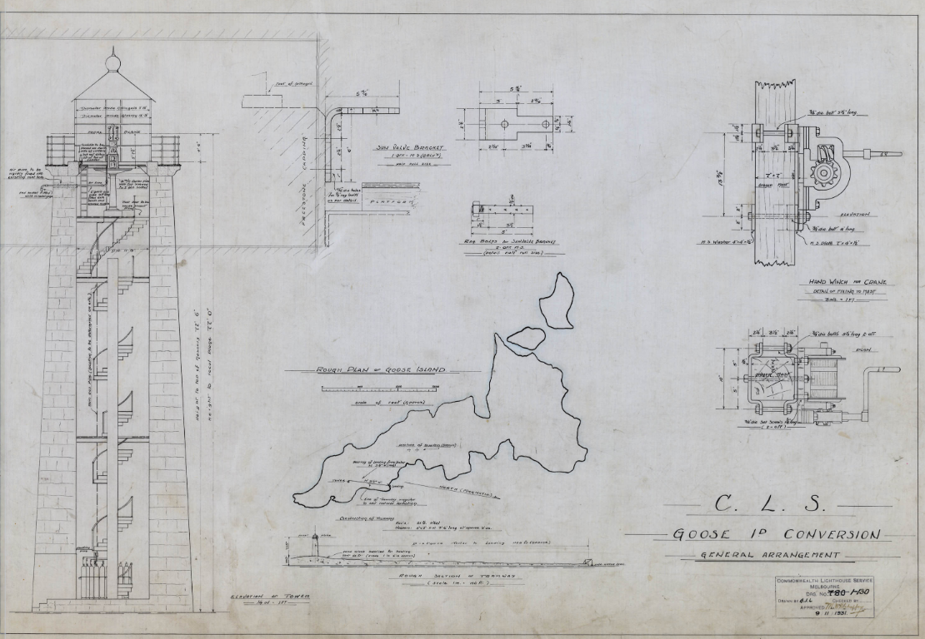Figure 14. Blueprints for conversion of Goose Island to Acetylene operation, 1931. Image courtesy of the National Archives of Australia: A10182, CN 01 130 (© Commonwealth of Australia, National Archives of Australia)

Conservation works
The following table lists the rectification works undertaken to maintain the lighthouse.

Date | Works Completed
1892 | Timber staircase replaced with cast iron staircase inside tower.
1985 | Original copper cupola of the lantern replaced by a fibreglass replica.
2012 | Stainless steel corrugated roofing sheets installed on lantern roof.
2015 | Structure repaint and corrosion-repair work.

  - Summary of current and former uses
From its construction in 1846, the Goose Island Lighthouse has been used as a marine AtoN for mariners at sea. Its AtoN capabilities remain its primary use.

In conjunction with its AtoN capabilities, the island was occupied for over 80 years which saw it become home to many convict workers, livestock and later, light keeping families. The installation of the 5th Order AGA light source oversaw the de-staffing of the light and the demolition of much of the lightstation. On 23 November 1931, the Circular Head Chronicle reported that the Lady Loch had been deployed to Goose Island to “assist with alterations to lighthouse at that island”. Remnants of these building foundations lie beside the tower and are classified as being of historical and archaeological significance.

  - Summary of past and present community associations

Aboriginal associations
Further consultation with Traditional Stakeholders is required for a greater understanding of the past and present associations held across the region.
AMSA will continue to work with stakeholders and the general public to establish the past and present significance of Swan Island, and associations with the lighthouse. This will be carried out in the form of consultation engagement, and future versions of this plan will be updated to reflect further information.

Local, national and international associations
As one of the oldest lighthouse towers to have remained active, Goose Island Lighthouse maintains significant national ties to both historic and current day navigational safety. Convict and lightkeeping families’ presence on the island has generated genealogical interest in the region both locally, nationally and internationally.

  - Unresolved questions or historical conflicts
Little is known about the European history of Goose Island prior to the construction of the lighthouse in 1846. The island’s isolated location suggests it was left untouched until 1841 when construction commenced.

  - Recommendations for further research
Research on past lighthouse keepers of Goose Island may be beneficial in determining the full extent of the social value placed on the site.


- Fabric
  - Fabric register
The cultural significance of the lighthouse resides in its fabric, and also in its intangible aspects – such as the meanings people ascribe to it, and the connections to other places and things. The survival of its cultural value depends on a well-informed understanding of what is significant, and on clear thinking about the consequences of change. The Burra Charter sets out good practice for conserving cultural significance.
Criterion listed under ‘Heritage Significance’ refer to the criterion satisfied within the specific Commonwealth heritage listing (see section 5.1).
(All images in sub-sections 4.1 and 4.2 - Source: AMSA)
Lighthouse feature: Lantern roof
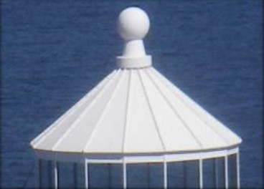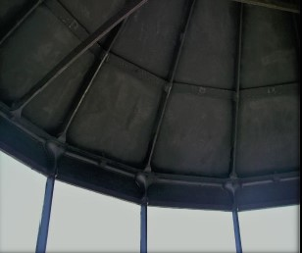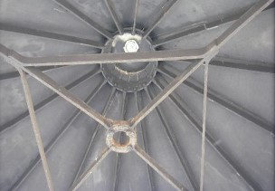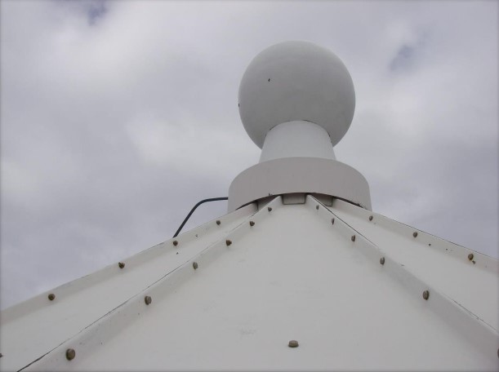
© AMSA 2019
Description and condition
Recent 16-sided pyramidal roof of glass-reinforced-plastic panels on 1846 cast metal ribs and top ring.
- Ribs – cast metal ribs
- Inner skin – none
- Ventilator – recent GRP replica of ball type ventilator, without ventilation holes
- Wind vane – none
- Lightning conductor – single spike on top of ventilator
- Gutter – none
Finish: | painted
Condition: | intact and sound
Integrity: | high
Significance: | original fabric: high  other parts: low
Maintenance: | keep in service  prepare and repaint at normal intervals
Rectification works: | none

Heritage significance: High
The lantern roof is an essential part of the lighthouse (with the cast metal ribs and top ring being an original feature). The lantern roof retains significance due to the lighthouse being one of only five extant pre-1850 lighthouses in Tasmania (criterion b).
The lantern roof contributes to the aesthetic value of the lighthouse (criterion e).

Lighthouse feature: Lantern glazing
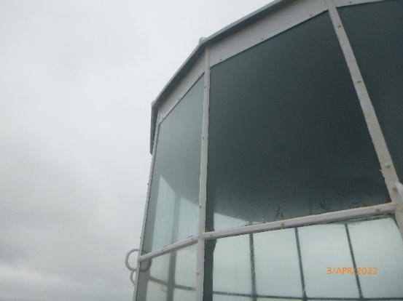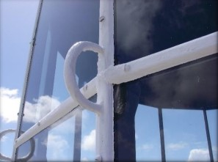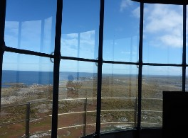© AMSA 2022

Description and condition
Polygonal in form, with 16 sides. The vertical astragals extend from a base ring at lantern floor level up to the lantern roof – there is no separate lantern base.
- Panes – flat rectangular glass. Two tiers of glass, with tier of blank panels below (forming the lantern base).
- Astragals – vertical astragals of moulded profile with thickenings at intersections with horizontal astragals and at top and bottom. Horizontal astragals of similar moulded section.
- Handholds – one on each vertical astragal, fixed to cover strips.
Finish: | bottom tier: blanking panels  astragals and glazing strips: painted
Condition: | intact and sound
Integrity: | high
Significance: | high
Maintenance: | keep in service, reglaze as necessary  prepare and repaint at normal intervals
Rectification works: | none

Heritage significance: High
The lantern glazing is an essential part of the lighthouse. It maintains significance due to the lighthouse being one of only five extant pre-1850 lighthouses in Tasmania (criterion b).
The lantern glazing contributes to the aesthetic value of the lighthouse (criterion e).

Lighthouse feature: Lantern base
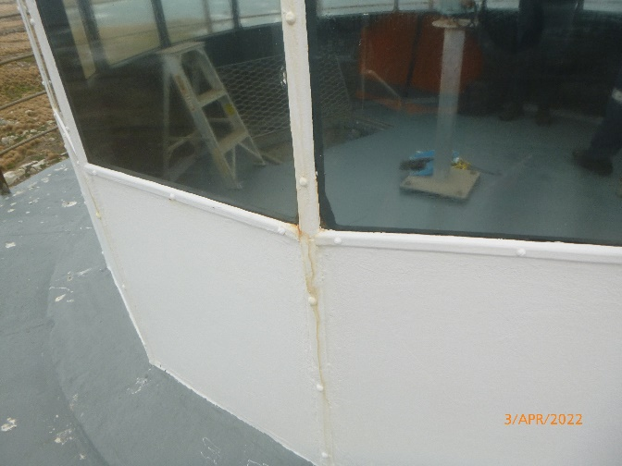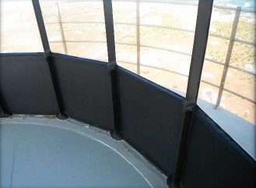
© AMSA 2022
Description and condition
Formed by the bottom tier of the lantern glazing which has been re-fitted with blank panels (originally fully glazed).
- Vents – recent cast cowls fitted over round vent holes in blank panels
- Door – two doors set into the lowest tier of the lantern

Finish: | painted
Condition: | intact and sound
Integrity: | high
Significance: | blank panels and vents: low  other parts: high
Maintenance: | keep in service  prepare and repaint at normal intervals
Rectification works: | none

Heritage Significance: High
The lantern base is an essential part of the lighthouse. It maintains significance due to the lighthouse being one of only five extant pre-1850 lighthouses in Tasmania (criterion b).

Lighthouse fabric: 1846 Lantern base
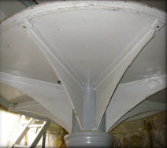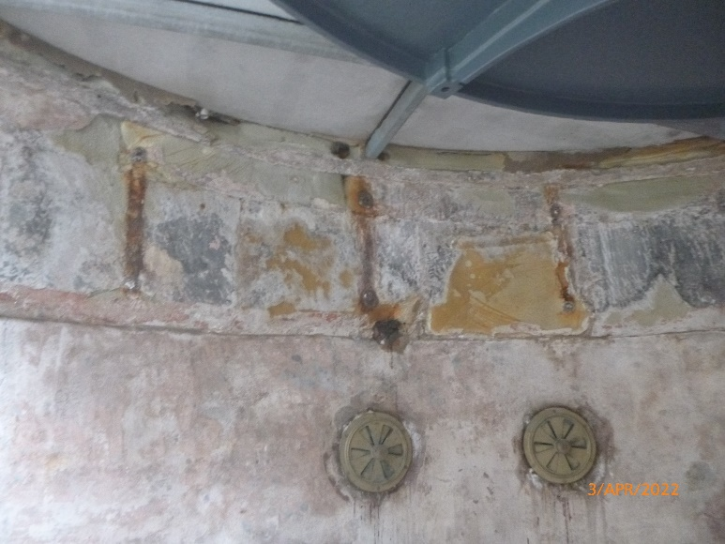© AMSA 2022
Description and condition
Original lantern base was formed within the top of the existing masonry tower walls. The earlier cast iron pedestal for the Fresnel lens is still located on this level, but not in service. Fixing positions of the original internal catwalk brackets into the masonry walls are visible.
- Vents – original round vent openings still exist through masonry walls at this level. They are fit with circular brass regulators.
- Door – there was no door in the original lantern base and the balcony was accessed through the existing doors in the lantern glazing from the internal catwalk.

Finish: | masonry wall: bare render  pedestal: painted
Condition: | There is fretting of the top course of sandstone masonry on the internal face, otherwise sound.
Integrity: | medium
Significance: | high
Maintenance: | keep in service  prepare and repaint at normal intervals
Rectification works: | none

Heritage significance: High
The lantern base is an original part of the lighthouse. It maintains significance due to the lighthouse being one of only five extant pre-1850 lighthouses in Tasmania (criterion b).

Lighthouse feature: Lantern floor
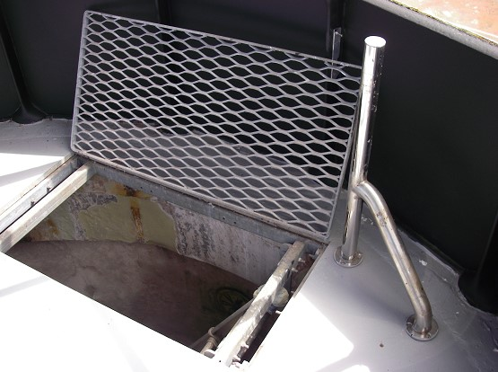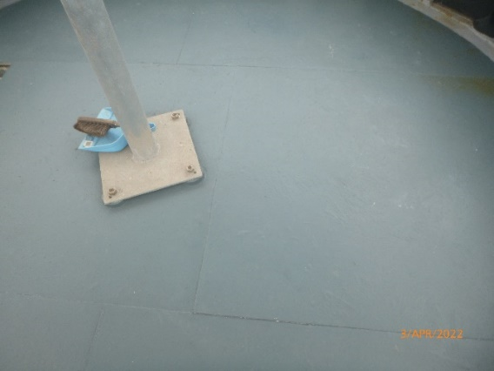
© AMSA 2022
Description and condition
Recent floor of compressed fibre-cement sheet on frame of galvanised steel rectangular hollow sections (RHS) sections bolted together. The frame sits on the top of the tower wall around the edge.
- Access opening – rectangular, with expanded metal mesh cover.
Finish: | painted
Condition: | intact and sound
Integrity: | high
Significance: | high
Maintenance: | keep in service  prepare and repaint at normal intervals
Rectification works: | none

Heritage significance: High
The lantern floor is an essential part of the lighthouse – it maintains its significance due to the lighthouse being one of only five extant pre-1850 lighthouses in Tasmania (criterion b).

Lighthouse feature: Beacon
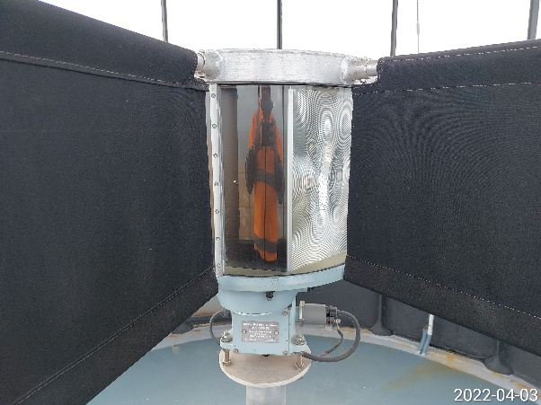© AMSA 2022
Description and condition
Vega VRB-25 self-contained rotating beacon. Fitted with four fixed masks to stop parasitic flashes, suspended from an aluminium framework on top of the beacon.
Condition: | intact and sound
Integrity: | not assessed
Significance: | low
Maintenance: | keep in service
Rectification works: | none

Heritage significance: Low

Lighthouse feature: Pedestal
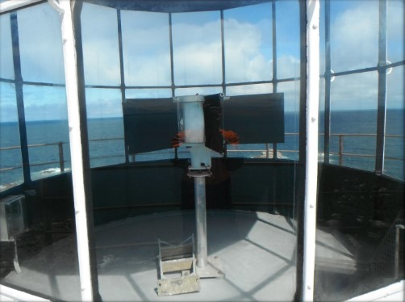© AMSA 2019
Description and condition
Welded aluminium post, with flat plates welded top and bottom.
Finish: | bare aluminium
Condition: | intact and sound
Integrity: | high
Significance: | low
Maintenance: | keep in service
Rectification works: | none

Heritage significance: Low
Lighthouse feature: Balcony floor
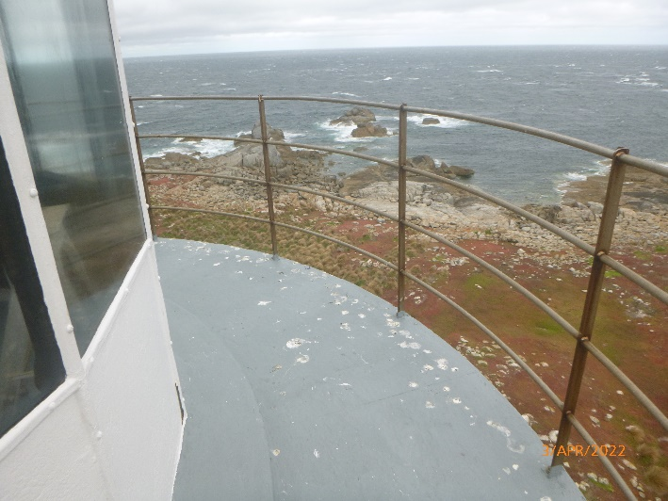© AMSA 2022
Description and condition
1846 slate slab floor supported on the tower wall and cornice.
Finish: | Painted
Condition: | intact and sound
Integrity: | high
Significance: | high
Maintenance: | keep in service, maintain joint seals  prepare and repaint at normal intervals
Rectification works: | none

Heritage significance: High
The balcony floor is an essential part of the lighthouse – it maintains its significance due to the lighthouse being one of five extant pre-1850 lighthouses in Tasmania (criterion b)

Lighthouse feature: Balcony balustrade
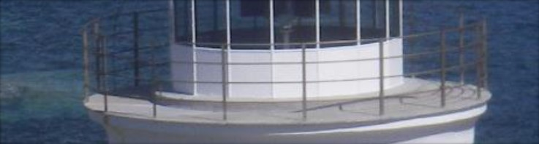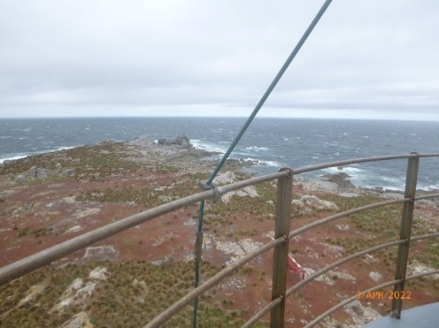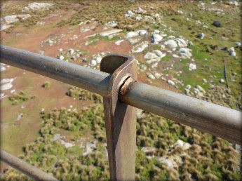© AMSA 2022
Description and condition
Recent balustrade of welded stainless steel, with angle section stanchions bolted to the balcony floor at the bottom, with four round tubular rails.
Finish: | bare metal
Condition: | intact and sound
Integrity: | high
Significance: | low
Maintenance: | keep in service
Rectification works: | none

Heritage significance: Low

Lighthouse feature: Walls
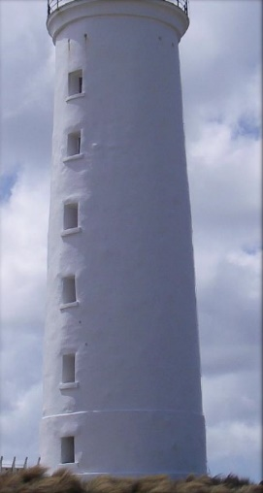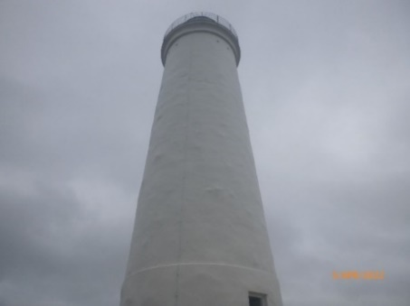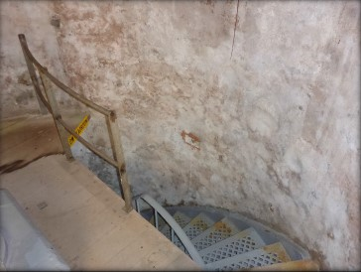© AMSA 2022
Description and condition
1846 stone walls, probably originally with exposed rock faced stone in courses with finely dressed freestone cornice courses at the top. It has render and stucco coatings inside and out, probably a later modification. Internal projecting ledges indicate probable earlier locations of intermediate floors, since removed.
Finish: | painted
Condition: | intact and sound
Integrity: | high
Significance: | high
Maintenance: | keep in service  prepare and paint at normal intervals  monitor condition of pointing and stonework
Rectification works: | none

Heritage significance: High
The tower walls are both an original and essential part of the lighthouse – they maintain significance due to the lighthouse being one of only five extant pre-1850 lighthouses in Tasmania (criterion b).
The tower walls contribute to the aesthetic value of the lighthouse (criterion e).

Lighthouse feature: Windows
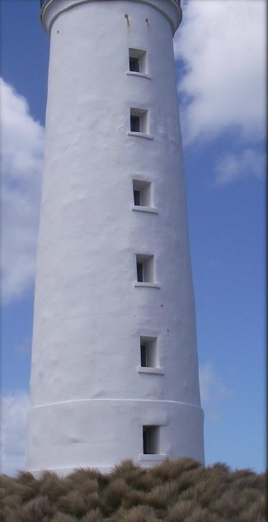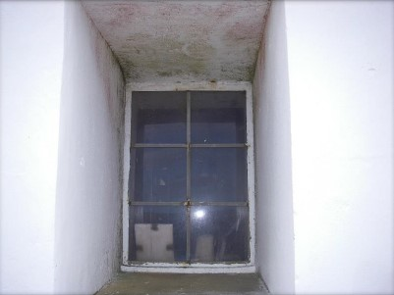© AMSA 2019
Description and condition
Six original window openings with fixed glazing in stainless steel sashes and frames.
Finish: | frames and sashes: bare metal  glass: clear
Condition: | intact and sound
Integrity: | high
Significance: | window openings: high  glazing, sashes and frames: low
Maintenance: | keep in service  replace broken panes as required
Rectification works: | none

Heritage significance: High
The window openings are both essential and original to the lighthouse – they maintain significance due to the lighthouse being one of only five extant pre-1850 lighthouses in Tasmania (criterion b).

Lighthouse feature: Door
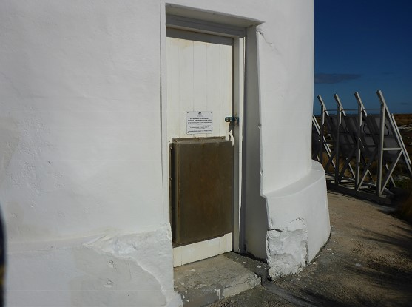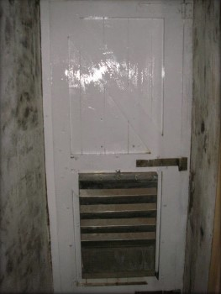© AMSA 2019
Description and condition
1846 door opening. Later timber framed and sheeted door with stainless steel vent cover, hung in timber door frame. Secured with hasp and staple and CLS padlock.
Finish: | painted
Condition: | sound
Integrity: | high
Significance: | high
Maintenance: | keep in service  prepare and repaint at normal intervals
Rectification works: | none

Heritage significance: High
The tower door is an essential part of the lighthouse – the original door opening maintains significance due to the lighthouse being one of only five extant pre-1850 lighthouses in Tasmania (criterion b).

Lighthouse feature: Intermediate floors
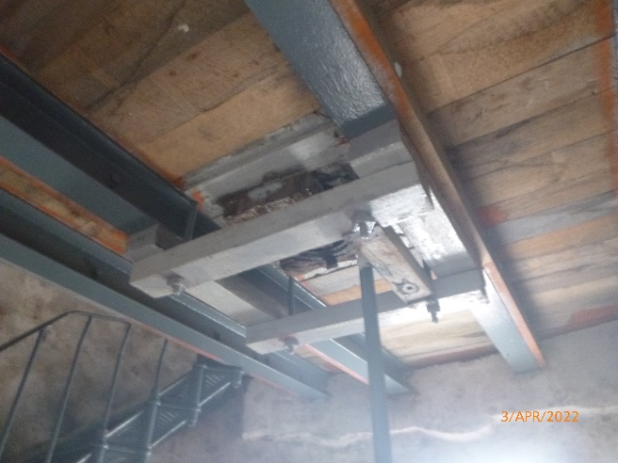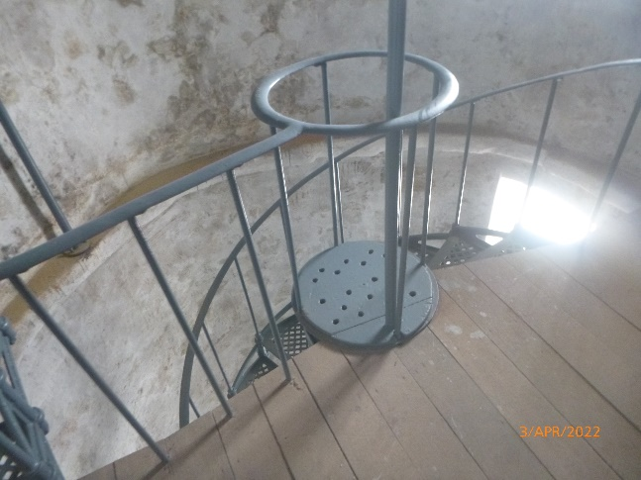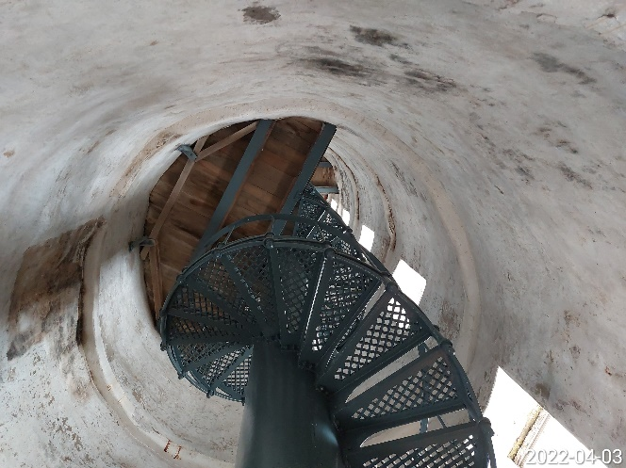© AMSA 2022
Description and condition
Three intermediate landings, of timber boards on rolled iron beams built into the tower walls. (Original intermediate floors at lower levels have been removed when the cast iron stair was installed, but their positions are marked by projecting ledges inside the tower walls).
Finish: | painted
Condition: | corrosion on beam ends  otherwise intact and sound
Integrity: | medium
Significance: | high
Maintenance: | keep in service  treat corrosion  prepare and repaint at normal intervals
Rectification works: | none

Heritage significance: High
The intermediate floors are an essential part to the lighthouse – they maintain their significance due to the lighthouse being one of only five extant, pre-1850 lighthouses in Tasmania (criterion b).

Lighthouse feature: Stairs
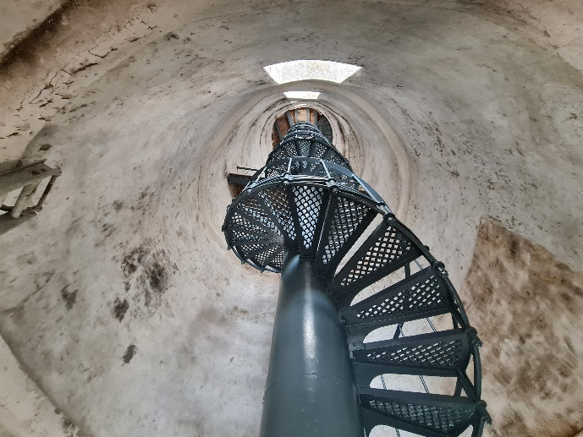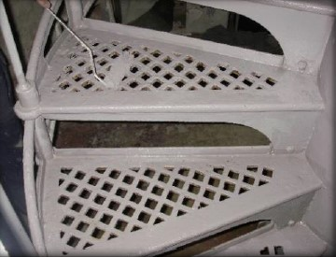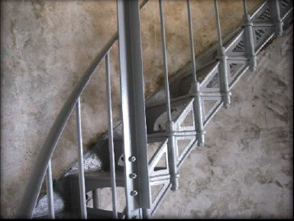© AMSA 2022
Description and condition
Cast iron spiral stair integrated with central weight tube/column, rising from the ground floor to a floor two storeys below the lantern floor. The stair structure is free-standing, independent of the stone tower. Cast iron treads/riser units with lattice treads are bolted to one another and to the weight tube, the connecting bolts extend vertically as balusters supporting a wrought iron handrail on the outside of the flight. A separate flight of stairs, with a wrought iron outer string, leads from the lower intermediate floor to the one below the lantern floor.
Finish: | painted
Condition: | intact and sound
Integrity: | high
Significance: | high
Maintenance: | keep in service  prepare and repaint at normal intervals
Rectification works: | none

Heritage significance: High
The tower stairs are an essential part to the lighthouse – they maintain their significance due to the lighthouse being one of only five extant, pre-1850 lighthouses in Tasmania (criterion b).

Lighthouse feature: Ground floor
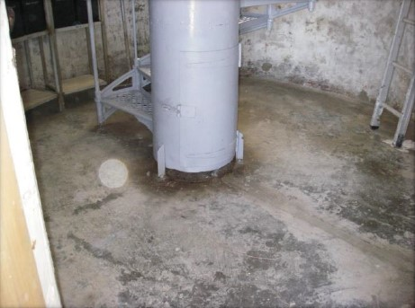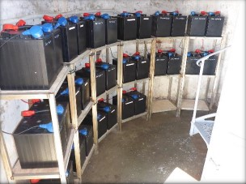
© AMSA 2022
Description and condition
Concrete floor slab.
- Equipment – batteries on racks mounted against the tower walls at ground floor level, control equipment wall- mounted.
Finish: | bare
Condition: | intact and sound
Integrity: | high
Significance: | high
Maintenance: | keep in service  clean at normal intervals
Rectification works: | none

Heritage significance: High
The ground floor is an essential part to the lighthouse – it maintains its significance due to the lighthouse being one of only five extant, pre-1850 lighthouses in Tasmania (criterion b).

Lighthouse feature: Solar array
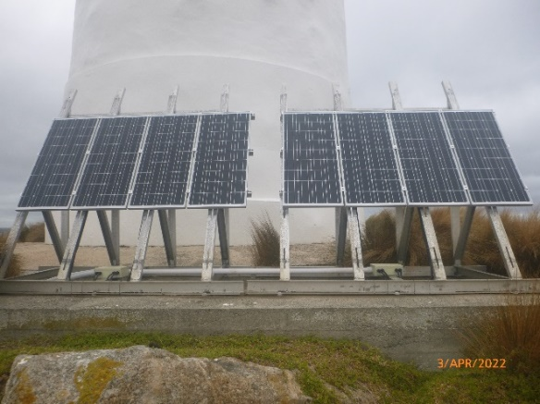© AMSA 2022
Description and condition
Solar panels mounted on aluminium stands affixed to concrete foundation at the base of the tower.
Condition: | not assessed
Integrity: | not assessed
Significance: | low
Maintenance: | not assessed
Rectification works: | none

Heritage significance: Low

Lighthouse feature: Tower apron
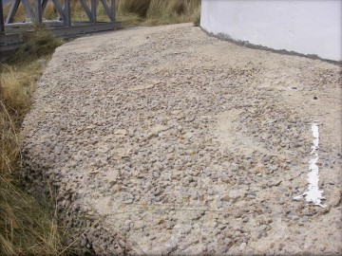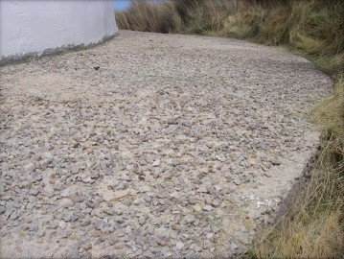© AMSA 2019
Description and condition
Later concrete apron slab of unknown date placed around the base of the tower.
Finish: | bare un-compacted concrete surface
Condition: | numerous settlement cracks appearing on concrete slab
Integrity: | medium
Significance: | low
Maintenance: | monitor condition
Rectification works: | none

Heritage significance: Low
Lighthouse feature: Store shed
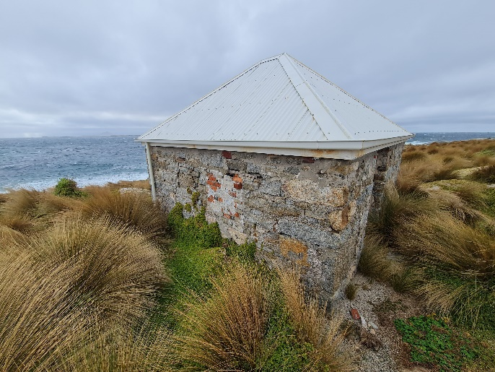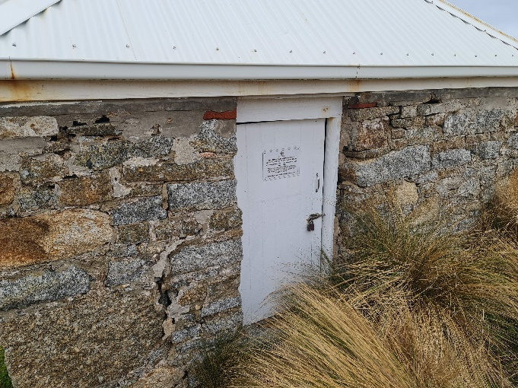© AMSA 2022
Description and condition
Early free standing building with rubble stone walls and hipped roof clad with recent (2012) corrugated stainless steel roofing sheet.
Stainless steel guttering and downpipe.
Condition: | Sound. Some movement is showing by the cracks in the un-coursed rubble stonework. This movement in the wall has been visible for a length of time and the walls are in a stable condition.  The red clay bricks used to in-fill the old window and door are eroding and a few of the clay bricks in the window have fallen out of place.  The door frame has also moved causing the door to not fit properly.
Integrity: | medium
Significance: | high
Maintenance: | monitor condition  prepare and repaint parts as required
Rectification works: | none

Heritage significance: High
The store shed is an essential part of the lightstation – it maintains its significance due to the lightstation being one of only five extant pre-1850 lightstations in Tasmania (criterion b).
The store shed contribute to the aesthetic of the lightstation (criterion e).

Lighthouse feature: Helipad slab
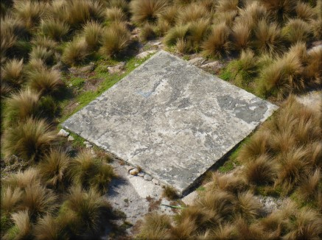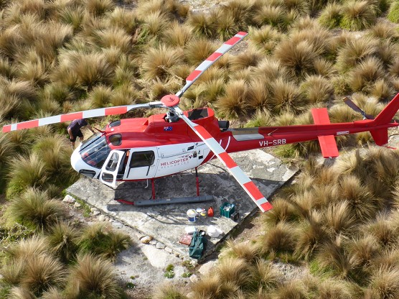© AMSA 2019
Description and condition
Concrete slab near lighthouse tower.
Condition: | sound
Integrity: | high
Significance: | low
Maintenance: | keep in service
Rectification works: | none

Heritage significance: Low

  - Related object or associated AMSA artefact
There are no AMSA registered artefacts at the Goose Island Lighthouse.

  - Comparative analysis
Exhibiting similar stylistic features, both the Swan Island Lighthouse, first lit 1845, and Goose Island Lighthouse were built by ex-convict Charles Watson and his team of prisoners. Both masonry towers were constructed of cement rendered rubble stone and fitted with a catadioptric lens with silvered mirrors. In 1872, Swan Island’s mirrors were removed and fitted in the Goose Island lantern room. Located on isolated islands, the two towers are situated approximately 54.5 km apart in Bass Strait and are considered to be the two major coastal lights operating north-east of Tasmania.
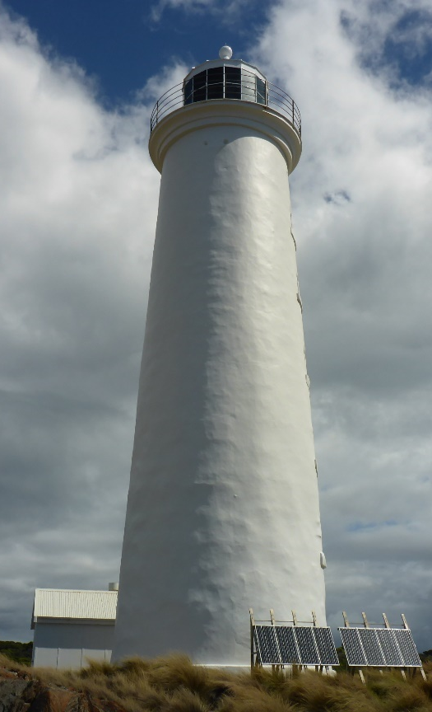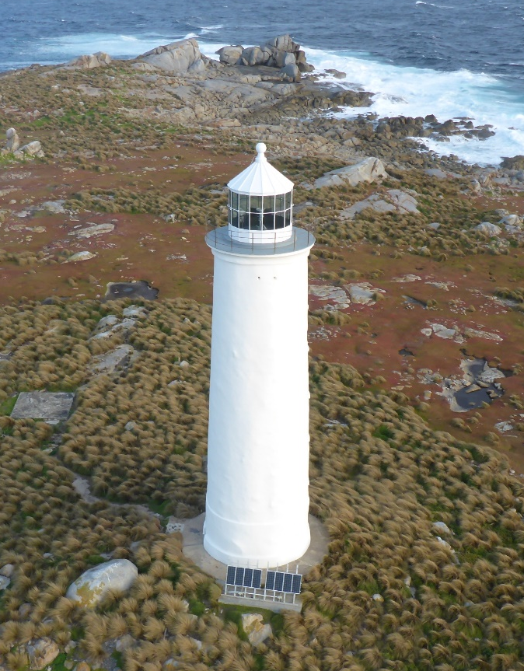
Figure 15. Swan Island Lighthouse, TAS. First lit 1845 (Source: AMSA, 2021)
Figure 16. Goose Island Lighthouse, TAS. First lit 1846 (Source: AMSA, 2020)


- Heritage Significance
  - Commonwealth heritage list – Goose Island Lighthouse
The following information is taken from the Goose Island Lighthouse listing on the Australian Heritage Database (Place ID: 105564)

Commonwealth heritage list – statement of significance

The Goose Island Lighthouse, built in 1841-1846, is significant as an integral part of Bass Strait's mid-nineteenth century lighthouse network, and was constructed at a time when shipping was increasing between Melbourne, Hobart and Launceston. It was built using convict labour, which demonstrates the continuing role of convicts in the construction of government facilities in Tasmania during the 1840s. (Criterion A) (Australian Historic Themes 3.8.1 Shipping to and from Australian ports; 3.8.2 Safeguarding Australian products for long journeys and 3.16.1 Dealing with hazards and disasters)

The Goose Island Lighthouse is significant as one of five extant pre-1850 lighthouses in Tasmania. It is an important rural coastal landmark. (Criteria B and E).

Commonwealth heritage values – criteria
There are nine criteria for inclusion in the Commonwealth Heritage List – meeting any one of these is sufficient for listing a place. These criteria are similar to those used in other commonwealth, state and local heritage legislation, although thresholds differ. In the following sections, the Goose Island Lighthouse is discussed in relation to each of the criteria as based on the current Commonwealth Heritage Listing Place ID 105564.

Criterion | Relevant Attributes Identified | Explanation
Criterion B – Rarity  This criterion is satisfied by places that have significant heritage value because of [their] possession of uncommon, rare or endangered aspects of Australia’s natural or cultural history. | The whole of the lighthouse tower, including its construction materials and details, as well as its landscape setting. | The Goose Island Lighthouse is significant as one of five extant pre-1850 lighthouses in Tasmania.
Criterion E – Aesthetic characteristics  This criterion is satisfied by places that have significant heritage value because of [their] importance in exhibiting particular aesthetic characteristics values by a community or cultural group. | The prominence of the lighthouse tower in its landscape setting. | The Goose Island Lighthouse is an important rural coastal landmark.

  - TAS State heritage register – Goose Island Lighthouse
The following information is taken directly from Goose Island Lighthouse’s listings on the Tasmanian State heritage register (THR ID: 10684).
TAS State Register – statement of significance
Goose Island is of historic cultural heritage significance as an important site in the nineteenth century development of maritime navigational aids through Bass Strait and along the Tasmanian coast. With a growing population, the expansion of ports such as Melbourne, Hobart and Launceston and emerging international trade patterns, the colony required safe and efficient waterways.
Similar to other early lightstations, Goose Island was constructed using convict labour. Goose Island also demonstrates the evolution of light-keeping technology, the station being one of the first to use catadioptric technology in the Australian colonies. Goose Island Lighthouse is one of five pre-1850 lighthouses still in use in the state, and is the third oldest lighthouse in the country still in operation.
It has significant archaeological potential being occupied for almost a century and because of its remote location, has undergone relatively little development. The site has the potential to yield information to better understand the development of navigational aids and domestic life in an isolated environment.
Goose Island Lighthouse is a fine example of a nineteenth century lightstation, forming part of a wider network of stations around the coastline of Tasmania.
TAS State Register – criteria
The Heritage Council may enter a place in the Heritage Register if it meets one or more of the following criteria from the Historic Cultural Heritage Act (1995).
Criterion | Explanation and evidence
- The place is important to the course or pattern of Tasmania’s history. | The lighthouse and related structures are important for their association with the early nineteenth century development of these aids most of which were constructed by convict labour. Goose Island Lighthouse was constructed at a time when shipping between Melbourne, Hobart and Launceston was increasing, and it contributed significantly to the Bass Strait network of lighthouses, including that of Deal Island. Goose Island Lighthouse is also of historic heritage significance as one of the earliest uses of the catadioptric technology in Australia.
- The place possesses uncommon or rare aspects of Tasmania’s history. | The Goose Island Lightstation is of historic heritage significance as one of five extant pre-1850 lighthouses in Tasmania. It is the third oldest lighthouse in Australia still in existence and is still operating.
- The place has the potential to yield information that will contribute to an understanding of Tasmania’s history. | The buildings, outbuilding, surface and subsurface deposits, of the Goose Island Lighthouse and associated features, which are below or adjacent to the structures are artefacts in the archaeological sense of being the tangible products of human behaviour. As such, they have the potential to yield information that will contribute to a greater understanding of Tasmania’s history. This site has the potential to explore sequences of construction and building methods during the 19th century, changes in building fashions and technology, social and economic situations of past occupiers/owners, and reflections or expressions of 19th century ideology and family life. Such tangible evidence supports and contributes to our existing knowledge. The potential information from this site may also contribute to wider research frameworks within or outside Australia. The cemetery on Goose Island has research value as an index to the community’s social and religious history, and for its layer of biographical information. Information yielded may include local and regional burial practices, aspects of a community’s religious affiliations, economic and population statistics, changes in health and lifestyle or values and tastes.
- The place is important in demonstrating the principal characteristics of a class of place in Tasmania’s history. | Goose Island Lighthouse, built in 1846, together with the surrounding ruins of the settlement, is of historic heritage significance because it represents the principal characters of a mid-nineteenth century light station complex.
- The place is important in exhibiting particular aesthetic characteristics. | Goose Island Lighthouse is located in one of Tasmania’s most isolated waterways. The dramatic nature of the topography, lack of development and isolated setting collectively create a strong visual and aesthetic appeal.

These heritage values, identified and explained in the Commonwealth heritage list and the State heritage register, will form the basis of the management of Goose Island Lighthouse. In the event of necessary works, all criteria will be consulted to inform best practice management of the values associated with the lightstation. (See Section 7. Conservation management policies for further information on strategies to conserve heritage values of Goose Island Lighthouse).

  - Condition and integrity of the Commonwealth heritage values
A heritage monitoring program was implemented in 2016. Each site is visited and reviewed every two years where the heritage fabric and values of the site are evaluated. Assessment of the condition and integrity of the lighthouse’s values are derived from the latest available Heritage Asset Condition Report produced by AMSA’s maintenance contractor.
‘Condition’ is measured on a Good – Fair – Poor scale and incorporates the current condition of the specific value. Integrity is measured on a High – Medium – Low scale which incorporates the value’s intactness.
As a whole, Goose Island Lighthouse’s identified values demonstrate good condition and high integrity. The lighthouse tower’s prominence within its landscape setting is undisputed and retains much of its original fabric.
Criteria | Values (including attributes) | Condition | Integrity
Criterion B – Rarity | The Goose Island Lighthouse is significant as one of five extant pre-1850 lighthouses in Tasmania.  The whole of the lighthouse tower, including its construction materials and details, as well as its landscape setting. | Good | High
Criterion E – Aesthetics | The Goose Island Lighthouse is an important rural coastal landmark.  The prominence of the lighthouse tower in its landscape setting. | Good | High

  - Gain or loss of heritage values
Evidence for the potential gain or loss of heritage values will be documented within this section of future versions of this heritage management plan.


- Opportunities and constraints

  - Implications arising from significance
The Commonwealth statement of significance (section 5.1 above) demonstrates Goose Island Lighthouse is a place of considerable heritage value due to its contribution to the development of coastal navigation of Bass Strait, and its assistance during a period of increased shipping between Melbourne, Hobart and Launceston.
The implication arising from this assessment is that key aspects of the place should be conserved to retain this significance. The key features requiring conservation include:
- continued use of the lighthouse as an AtoN
- architectural quality of the building
- interior spaces and features, which are notable for their design and/or their original lighthouse function. These include:
- intermediate floors
- ground floor
- spiral staircase
- lantern room and base
- Fresnel lens pedestal
- external spaces and features, which are notable for their design, details, and/or their original lighthouse function. These include:
- lantern roof
- balcony
- tower walls and windows
- store shed
Referral and approvals of action
The EPBC Act requires approval from the Minister for the Environment, for all actions likely to have a significant impact on matters of National Environmental Significance (NES).
The Act provides that actions:
- taken on Commonwealth land which are likely to have a significant impact on the environment will require the approval of the Minister.

- taken outside Commonwealth land which are likely to have a significant impact on the environment on Commonwealth land, will require the approval by the Minister.

- taken by the Australian Government or its agencies which are likely to have a significant impact on the environment anywhere will require approval by the Minister.
The definition of ‘environment’ in the EPBC Act and EPBC Regulations includes the cultural heritage values of places.
Heritage strategy
If an Australian Government agency owns or controls one or more places with Commonwealth heritage values, it must prepare a heritage strategy within two years from the first time they own or control a heritage place (section 341ZA).
A heritage strategy is a written document that integrates heritage conservation and management within an agency’s overall property planning and management framework. Its purpose is to help an agency manage and report on the steps it has taken to protect and conserve the Commonwealth heritage values of the properties under its ownership or control.
The heritage strategy for AMSA’s AtoN assets was completed and approved by the Commonwealth Minister for the Environment in 2018 and reviewed in 2022. The latest version of the Strategy is available online.P37F
Heritage asset condition report
A heritage asset condition report is a written document that details the heritage fabric of a site with an in-depth description of each architectural and structural element. The document includes: a brief history of the site, the Commonwealth Heritage statement of significance and value criteria, a heritage significance rating for each individual element, and a catalogue of artefacts on-site. The document is also accompanied by up-to-date photos of each structural element. This document operates as a tool for heritage monitoring, and is reviewed and updated biennially.
Aboriginal heritage significance
Goose Island as a whole is notable for its Aboriginal heritage significance and natural values. Although these values lie outside of the Commonwealth heritage listing curtilage and AMSA’s lease, the potential remains for future works at the lighthouse to impact these values. At the time this plan was written, no plans have been made for future works at Goose Island Lighthouse. In the event major works at the lighthouse are to be carried out, AMSA will seek to minimise impacts to the surrounding area by:
- Utilising specific access tracks to ensure no damage to surrounding vegetation,
- Ensuring project footprint is limited to the AMSA lease. In any instance that work is required outside of this footprint, approvals will be sought from the appropriate stakeholders including TAS PWS, Aboriginal Land Council of Tasmania, and the Office of Aboriginal Affairs (Tas),
- Implementing an appropriate discovery plan in the instance Aboriginal cultural heritage is suspected and/or found.

  - Framework: sensitivity to change
Owing to the site’s rarity and aesthetic qualities, Goose Island Lighthouse is of high significance. Therefore, work actioned by AMSA on the lighthouse’s fabric harnesses the potential to reduce or eradicate the significance of the site’s heritage values.
Conservation works, including restoration and reconstruction, or adaption works of the absolute minimum so as to continue the lightstation's usefulness as an AtoN are the only works that should be actioned by AMSA on Goose Island Lighthouse. Some exceptions are made for health and safety requirements, however any and all work carried out must be conducted in line with heritage considerations and requirements of the EPBC Act.
The table below demonstrates the level of sensitivity attributed to the various elements of the fabric register in the face of change. These are measured on a High-Moderate-Low spectrum depending on the action’s possible threat to the site’s heritage values.
High sensitivity
High sensitivity to change includes instances wherein a change would pose a major threat to the heritage value of a specific fabric, or the lightstation as a whole. A major threat is one that would lead to substantial or total loss of the heritage value.

Moderate sensitivity
Moderate sensitivity to change includes instances wherein a change would pose a moderate threat to the heritage value of a specific fabric, or would pose a threat to the heritage significance of a specific fabric in another part of the building. A moderate threat is one that would diminish the heritage value, or diminish the ability of an observer to appreciate the value.
Low sensitivity
Low sensitivity to change includes instances wherein a change would pose little to no threat to the heritage value of a specific fabric, and would pose little to no threat to heritage significance in another part of the building.

Component | Level of sensitivity | Nature of change impacting heritage values
Goose Island Lighthouse structure, including store shed | High | - Changes to façade materials and design.  - Reduction of all-round visibility of the structure and its setting on Goose Island.
Goose Island Lighthouse structure, including store shed | Low | - Repainting of structure in like colours.  - Removal of asbestos and lead paint or other toxic materials.  - Repairs to apron paving.
Ground floor | High | - Changes to façade materials and designs.
Ground floor | Low | - Movement, removal or replacement of battery racks.
Intermediate floors | High | - Removal of timber intermediate floors.
Intermediate floors | Low | - Corrosion repairs to steel beams.
Stairs | High | - Removal of late 19th century spiral staircase.
Stairs | Low | - Corrosion repairs to staircase.
Balcony | High | - Changes to façade materials and design.
Balcony | Low | - Repainting of balcony in like colours.
Lantern room and base | High | - Changes to façade materials and design.
Lantern room and base | Low | - Replacement of glazing.  - Resealing of glazing.  - Repainting of lantern room and base in like colours.
Lens assembly and pedestal | High | - Removal of Fresnel lens pedestal.
Lens assembly and pedestal | Low | - Replacement of the VRB beacon.  - Replacement of aluminium post.
Windows and doors | High | - Alteration to original/early window and door openings.
Windows and doors | Low | - Replacement of window glazing, sashes and frames.  - Replacement of doors.

  - Statutory and legislative requirements
The table below lists the relevant Acts and codes relevant to the conservation of Goose Island Lighthouse.
Act or Code | Description
Environment Protection and Biodiversity Conservation Act 1999 (Cth) | The Environment Protection & Biodiversity Conservation Act 1999 (Cth) requires agencies to prepare management plans that satisfy the obligations included in Schedule 7A and 7B of the EPBC Regulations .
Environment Protection and Biodiversity Conservation Regulations 2000 (Cth) | The DCCEEW has determined these principles to guide for excellence in managing heritage properties.  - The objection in managing Commonwealth Heritage places to identify, protect, conserve, present and transmit, to all generations, their Commonwealth Heritage values.  - The management of Commonwealth Heritage places should use the best available knowledge, skills and standards for those places, and include ongoing technical and community input to decisions and actions that may have a significant impact on Commonwealth Heritage values.  - The management of Commonwealth Heritage places should respect all heritage values of the place and seek to integrate, where appropriate, any Commonwealth, state and territory and local government responsibilities for those places.  - The management of Commonwealth Heritage places should ensure that their use and provision for community involvement, especially by people who:  - Have a particular interest in, or associations with, the place; and  - May be affected by the management of the place  - Indigenous people are the primary source of information on the value of their heritage and the active participation of Indigenous people in identification, assessment and management is integral to the effective protection of Indigenous heritage values.
AMSA Heritage Strategy 2022 | As the custodian of many iconic sites, the Australian Maritime Safety Authority (AMSA) has long recognised the importance of preserving their cultural heritage.  This Heritage Strategy is in response to section 341ZA of the EPBC Act (1999) which obliges AMSA to prepare and maintain a heritage strategy, along with obliging AMSA to:  - Assist in identification, assessment and monitoring of places of heritage value in its care;  - Prepare and maintain a register of its places of heritage value;  - Protect the heritage value of places when they are sold or leased;  - Provide this heritage strategy, and any subsequent major updates, to the relevant minister.  The strategy derives from the AMSA Corporate Plan and achievements are reported through the AMSA Annual Report. The 2020-21 AMSA Annual report can be found online.
Navigation Act 2012 (Cth) | Part 5 of the Act outlines AMSA’s power to establish, maintain and inspect marine aids to navigation (such as Goose Island Lighthouse).  - AMSA may:  - Establish and maintain aids to navigation; and  - Add to, alter or remove any aid to navigation that is owned or controlled by AMSA; and  - Vary the character of any aid to navigation that is owned or controlled by AMSA.  - AMSA, or person authorised in writing by AMSA may, at any reasonable time of the day or night:  - Inspect any aid to navigation or any lamp or light which, in the opinion of AMSA or the authorised person, may affect the safety or convenience of navigation, whether the aid to navigation of the lamp or light is the property of:  - A state or territory; or  - An agency of a state or territory; or  - Any other person; and  - Enter any property, whether public or private, for the purposes of an inspection under paragraph (a); and  - Transport, or cause to be transported, any good through any property, whether public or private, for any purpose in connection with:  - The maintenance of an aid to navigation that is owned or controlled by AMSA; or  - The establishment of any aid to navigation by AMSA.
Australian Heritage Council Act 2003 (Cth) | This Act establishes the Australian Heritage Council, whose functions are:  - to make assessments under Division 1A and 3A of Part 15 of the EPBC Act 1999;  - to advise the Minister on conserving and protecting places included, or being considered for inclusion, in the National Heritage List or Commonwealth Heritage List;  - to nominate places for inclusion in the National Heritage List or Commonwealth Heritage List;  - to promote the identification, assessment, conservation and monitoring of heritage;  - to keep the Register of the National Estate;  - to organise and engage in research and investigations necessary for the performance of its functions;  - to provide advice directly to any person or body or agency either if its own initiative of at the request of the Minister; and  - to make reports as outlined in the Act.
TAS Historic Cultural Heritage Act 1995 (Tas) | This Act establishes the Tasmanian Heritage Council.  - General functions and powers of Heritage Council  - The functions of the Heritage council are –  - to advise the Minister on matters relating to Tasmania's historic cultural heritage and the measures necessary to conserve that heritage for the benefit of the present community and future generations; and  - to work within the planning system to achieve the proper protection of Tasmania's historic cultural heritage; and  - to co-operate and collaborate with Federal, state and local authorities in the conservation of places of historic cultural heritage significance; and  - to encourage and assist in the proper management of places of historic cultural heritage significance; and  - to encourage public interest in, and understanding of, issues relevant to the conservation of Tasmania's historic cultural heritage; and  - to encourage and provide public education in respect of Tasmania's historic cultural heritage; and  - to assist in the promotion of tourism in respect of places of historic cultural heritage significance; and  - to keep proper records, and encourage others to keep proper records, of places of historic cultural heritage significance; and  - to perform any other function the minister determines.  - The Heritage Council may do anything necessary or convenient to perform its functions.
National Parks and State Reserve Management 2002 (Tas) | Schedule 1, Section 8: Historic site  The following objectives:  - to conserve sites or areas of historic cultural significance;  - to conserve natural biological diversity;  - to conserve geological diversity;  - to preserve the quality of water and protect catchments;  - to encourage education based on the purposes of reservation and the natural or cultural values of the historic site, or both;  - to encourage research, particularly that which furthers the purposes of reservation;  - to protect the historic site against, and rehabilitate the historic site following, adverse impacts such as those of fire, introduced species, diseases and soil erosion on the historic site’s natural and cultural values and on assets within and adjacent to the historic site;  - to encourage tourism, recreational use and enjoyment consistent with the conservation of the historic site’s natural and cultural values;  - to encourage cooperative management programs with Aboriginal people in areas of significance to them in a manner consistent with the purposes of reservation and the other management objectives.
Building Code of Australia/National Construction Code | The Code is the definitive regulatory resource for building construction, providing a nationally accepted and uniform approach to technical requirements for the building industry. It specifies matters relating to building work in order to achieve a range of health and safety objectives, including fire safety.  As far as possible, Commonwealth agencies aim to achieve compliance with the Code, although this may not be entirely possible because of the nature of and constraints provided by existing circumstances, such as an existing building.
Work Health and Safety Act 2011 (Cth) | The objectives of this Act include:  - The main object of this Act is to provide for a balanced and nationally consistent framework to secure the health and safety of workers and workplaces by:  - protecting workers and other persons against harm to their health, safety and welfare through the elimination or minimisation of risks arising from work; and  - providing for fair and effective workplace representation, consultation, co‑operation and issue resolution in relation to work health and safety; and  - encouraging unions and employer organisations to take a constructive role in promoting improvements in work health and safety practices, and assisting persons conducting businesses or undertakings and workers to achieve a healthier and safer working environment; and  - promoting the provision of advice, information, education and training in relation to work health and safety; and  - securing compliance with this Act through effective and appropriate compliance and enforcement measures; and  - ensuring appropriate scrutiny and review of actions taken by persons exercising powers and performing functions under this Act; and  - providing a framework for continuous improvement and progressively higher standards of work health and safety; and  - maintaining and strengthening the national harmonisation of laws relating to work health and safety and to facilitate a consistent national approach to work health and safety in this jurisdiction.  - In furthering subsection (1)(a), regard must be had to the principle that workers and other persons should be given the highest level of protection against harm to their health, safety and welfare from hazards and risks arising from work as is reasonably practicable.  [Quoted from Division 2 of Act]  This has implications for Goose Island Lighthouse of Australia as it is related to AMSA staff, contractors and visitors.

  - Operational requirements
As a working AtoN, the operational needs of Goose Island Lighthouse are primarily concerned with navigational requirements. Below are the operational details and requirements of Goose Island Lighthouse as outlined by AMSA.
Navigation requirement for AMSA’s AtoN site
The following table is taken from AMSA’s Asset Management Strategy for the Goose Island light.
1 | Objective/rationale | An AtoN is required at the South end of Goose Island to mark the island itself on the Western side of the Furneaux Group in the Bass Strait.  It is a navigation mark for vessels transiting the 1.6 mile wide channel between Goose and Badger Islands; the Franklin Sound to the East; and the Banks Strait to the South.  It also warns of the smaller Chappell Islands 6 miles to the South East.
2 | Required type(s) of AtoN | A fixed structure is required to act as a day mark.  A distinctive light is required for use at night.
3 | Priority/significance | An AtoN at this site is important for the navigation of commercial ships.
4 | Required measure of performance | The service performance of the AtoN must comply with the IALA Availability Target Category 2 (99%).
5 | Primary and secondary means (if any) of identification | The day mark must be conspicuous. The existing 30 m white masonry tower and lantern at an elevation of 36 m meets this requirement.  The light must comply with the requirements of rhythmic characters of light as per the IALA NAVGUIDE. The light must have distinct characteristics that are easy to recognise and identify. The present flashing (2) white light every 10 seconds meets this requirement.
6 | Visual range | During daytime, the AtoN structure should be visible from at least 5 nautical miles.  At night, the white light must have a nominal range of at least 18 nautical miles.
7 | Radar conspicuousness | As the island itself will give a good radar echo, no additional radar enhancement is required for this site.

  - Occupier needs
AMSA’s goals
AMSA is responsible, under the Navigation Act, for maintaining a network of marine AtoN around Australia’s coastline that assist mariners to make safe and efficient passages. AMSA’s present network of approximately 500 marine AtoN includes traditional lighthouses such as Goose Island Lighthouse, beacons, buoys, racons, automatic identification system stations, metocean sensors including broadcasting tide gauges, current meter, directional wave rider buoys and a weather station.

Technological developments in the area of vessel traffic management have also contributed to increasing navigation safety and helped promote marine environment protection. AMSA aims to meet international standards for the reliability of lighthouses set by the International Association of Marine Aids to Navigation and Lighthouse Authorities (IALA).

At the time of preparing this management plan, the major goal for Goose Island Lighthouse primarily encompassed continuing its utilisation as an AtoN (for as long as necessary), while upkeeping the appropriate maintenance to conserve and preserve the heritage values of the lightstation.

Lighthouse performance standards
AMSA aims to meet international standards for the reliability of lighthouses set by IALA. Goose Island light is designated as an IALA Availability Category 2 AtoN (within a scale of Category 1 to Category 3, Category 1 aids are most critical). Category 2 aids have an availability target of 99.0 per cent.

Access to the lighthouse
One practical effect of this performance standard is that the operational equipment and structure of the light need to be kept in good repair by regular preventative maintenance and equipment that fails in service is repaired quickly. Routine maintenance and emergency repairs are carried out by AMSA’s maintenance contractor. The contractor needs reliable access to the site for this work, and AMSA officers need access for occasional inspections of the site including auditing the contractor’s performance.

  - Proposals for change
Preventative maintenance works are carried out on the lighthouse to maintain its status as a working marine AtoN, and to assist in the site’s conservation.
A list of scheduled preventative maintenance work is identified within the latest available site inspection report. The information provided below was taken from this report:
Maintenance description | Estimated maintenance date
Goose Island lantern change | 2022
Goose Island lantern room paint | 2025
Goose Island reseal glazing | 2025
Goose Island structure paint | 2029

  - Potential pressures
A significant pressure that harnesses the potential to effect the Commonwealth heritage values of the place would be the obligation to remove or replace original fabric materials from the lighthouse owing to unavoidable and irreversible deterioration. At the time of preparing this management plan, no plans have been made to remove original fabric material. In the event plans are made to modify or remove original fabric, work will be conducted in line with the heritage considerations and requirements of the EPBC Act.
  - Processes for decision-making
Processes for decision-making are required in the event of an incident that impacts the heritage values of the site. The following incidents are included due to their likelihood of occurrence at Goose Island Lighthouse.
Incident | Procedure
Major project/maintenance works proposed | - Prepare Heritage Impact Statement on proposed modifications.  - Submit scope of works and Heritage Impact Statement to the DCCEEW and the Tasmanian Heritage Council for review.
Damage to lighthouse’s fabric (heritage significance) | - AMSA or selected contractors assess extent of damage.  - Seek heritage advice on restoration of heritage fabric impacted.  - Identify possible loss of heritage value (at both state and Commonwealth level).  - Seek the appropriate approvals for restoration of heritage fabric impacted.  - Implement best practice management of restoration work in keeping with the original character of the place.  - In the case of a loss of heritage value, prepare report for submission.  - Update record-keeping of incident and make available to relevant personnel.
Damage to lighthouse’s fabric (no heritage significance) | - AMSA or selected contractors to assess extent of damage.  - Identify possible impact on heritage fabric in any work carried out to restore fabric.  - Implement best practice management of restoration work.  - Update record-keeping of incident and make available to relevant personnel.
Light upgrade | - Assess possible loss of heritage value in the event of an upgrade.  - If necessary, seek expert heritage advice on process of upgrade.  - If necessary, seek heritage approvals for the upgrade of light.  - Implement best practice management of light upgrade work.  - Update record-keeping and make available to relevant personnel.
Modification to lighthouse such as adding of attachment | - Assess possible obstruction to light.  - Seek heritage approvals for attachment to tower.  - Monitor attachment and update record-keeping.
Unforeseen discovery of Aboriginal artefacts on-site. | - Immediate stop-work. Create temporary 'buffer' zone and allow no entry in zone until artefacts have been assessed by appropriate personnel.  - Notify Aboriginal Land Council of Tasmania, TPWS, and Aboriginal Heritage Tasmania as soon as possible.  - Delay work on site until artefacts have been appropriately assessed, and/or extracted and further investigations carried out in surrounding area.  - Update record-keeping of unforeseen discovery and make available to relevant personnel.
Divestment of lighthouse from AMSA | - Transfer ownership or control of heritage assets to the Minister administering the National Parks and Wildlife Act 1970 (Tas).  - Terminate lease of site.  - Transfer relevant records and historical information held by AMSA to the Minister administering the National Parks and Wildlife Act 1970 (Tas).

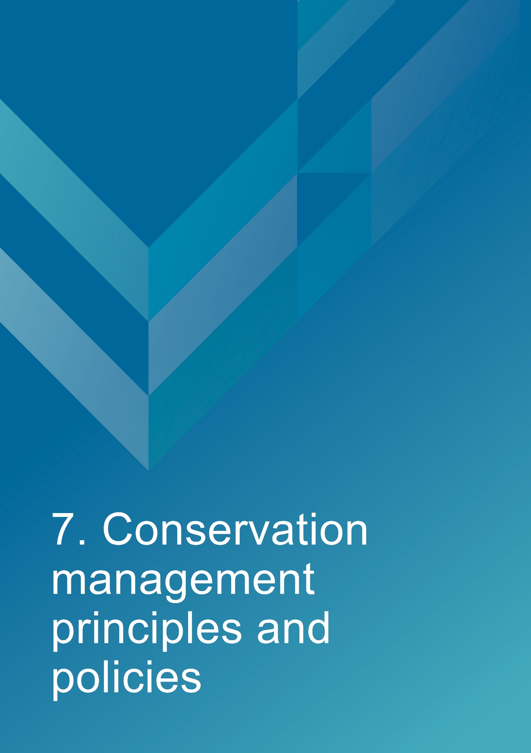
- Conservation management principles and policies
Policies
Note: The management of sensitive information is not relevant to AMSA’s heritage strategy and therefore bears no relevance in this management plan.
Fabric and setting
Policy 1 – Protect and conserve the significant external and internal fabric of the lightstation, including existing buildings, layout and setting.
AMSA’s main purpose is to facilitate the ongoing operation of the site as a marine AtoN while preserving the site’s heritage values. As part of a heritage monitoring program, Heritage Asset Condition Reports are produced for each site every two years to evaluate the condition of the heritage fabric and values. Routine servicing is also carried out by maintenance contractors. Regular written reports from these visits will be sent to AMSA Asset Management and Preparedness for review and any work requirements identified will be scheduled accordingly. Should for some unforeseen reason the site no longer be viable as a marine AtoN, ownership will be passed to an appropriate state of federal authority to ensure preservation of the heritage assets.
Implementation strategy:
- AtoN Maintenance contractor will continue scheduled periodic maintenance of the lighthouse and marine aids to navigation every 12 months to ensure condition is monitored for early warning of deterioration. Schedule must be approved by AMSA Asset Management and Preparedness.
- AMSA Asset Management and Preparedness to arrange for maintenance to be carried out on the lighthouse as required while continuing to operate as an AMSA marine aids to navigation.
- AMSA Asset Management and Preparedness to arrange for the replacement and upgrading of marine aids to navigation equipment in the lighthouse as required to meet AMSA’s service commitment, in a manner that preserves the original fabric of the lighthouse.
- AMSA Asset Management and Preparedness to maintain information on the heritage fabric of the lighthouse including any and all actions, treatments and inspection outcomes within the heritage fabric register. See section 4.1 for fabric register.
- AMSA Asset Management and Preparedness to conserve all the fabric elements identified as significant in the heritage asset condition report.
- AMSA Asset Management and Preparedness to seek expert materials conservation advice when considering repair, restoration and reconstruction of historic fabric. The relevant local, state and federal heritage approvals must be sought prior to repair, restoration and reconstruction.
- AMSA Asset Management and Preparedness to assess any development proposals to surrounding area for possible impacts on the heritage values of Goose Island Lighthouse, and liaise with the appropriate state or federal heritage authorities.
- AMSA AtoN Heritage Coordinator to conserve the distinctive character of the lightstation by collecting photographic evidence and historical documentation of the original fabric.
- AtoN Maintenance Contractor to continue scheduled heritage monitoring visits to Goose Island and update Heritage Asset Condition Reports.
Uses
Policy 2 – Install and operate equipment in the lighthouse, so that it continues to function as an effective marine aid to navigation, in such a way as to impose the least possible harm to the significant fabric.
Goose Island Lighthouse’s use as a working marine AtoN is of high priority. Carrying out maintenance, including upgrades to navigational equipment, is necessary to its function and continued marine safety along the TAS coast. In the event of the installation and/or upgrade to AtoN equipment, proper precaution will be taken to ensure the least possible harm is done to significant fabric.
Implementation strategy:
- AtoN Maintenance Contractor to monitor Goose Island’s AtoN equipment every 12 months and propose maintenance in the instance of necessary installation or removal. Proposed maintenance is to be approved by AMSA Asset Management and Preparedness.

- AtoN Maintenance Contractor and AMSA Asset Management and Preparedness to outline all possible risks to significant fabric, external and internal, associated with the installation, removal and operation of equipment.

- AMSA Asset Management and Preparedness to ensure works carried out are those that ensure the least possible harm to significant fabric.

- AMSA Asset Management and Preparedness to seek expert heritage conservation advice on best practice management of the site during installation, removal and operation of equipment.

Policy 3 – Monitor possible impacts to the site resulting from tourism, and control appropriate access to the lighthouse for contractors and visitors.
Goose Island Lighthouse is not currently open to the general public, and its location on the Island does not allow for easy public access. Access inside the lighthouse is restricted to authorised personnel, such as contractors and AMSA employees. In the event Goose Island were to be opened to tour groups, AMSA personnel and contractors would require easy access inside the lighthouse precinct and tower for periodical site visits to carry out inspections and routine maintenance.
Implementation strategy:
- AtoN Maintenance contractor to ensure control on access to all buildings within AMSA’s lease area is maintained by periodically inspecting buildings during maintenance visits every 12 months.

- AtoN Maintenance contractor to inspect lighthouse for signs of wear and tear attributed to visitor intake during yearly maintenance visit, and note changes in Heritage Asset Condition Report.

- AMSA Asset Management and Preparedness to ensure access to the lightstation complies with workplace health and safety measures.

- AMSA Asset Management and Preparedness to ensure contractors are made aware of the heritage values of the lighthouse.

- AMSA Asset Management and Preparedness to ensure access to site is available for Traditional Stakeholders to maintain cultural traditions.

Interpretation
Policy 4 – Accurate and relevant interpretation of the history and significance of the place should be made available to site users/visitors and for offsite external research.
AMSA will continue to make information available through the maintenance of site interpretive signage and its website.
Implementation strategy:
- All relevant information concerning the history and significance of the place will be checked for accuracy and updated appropriately.

- Information will be presented primarily as online resources accessible to relevant personnel and the general public. On-site interpretative signage will be installed where possible.

- This information will be maintained and updated in accordance with changes to the history and significance of the place.

- The location of the former Keeper’s Cottage, jetty and tramway are outside of AMSA’s lease area and are therefore not managed under this plan. However, as they contribute to the general historical development of the lighthouse and its context, their history and significance will be included and updated in any interpretive resources.

Management
Policy 5 – AMSA will continue to conserve the lighthouse in accordance with Commonwealth and Tasmanian State heritage listing requirements.
For works requiring heritage approval, AMSA will obtain permission from any relevant state or federal authorities. Continuous and as needed conservation works will be undertaken as required.
Implementation strategy:
- Liaise with the relevant federal and state agencies when proposing work on the site.

- Consult with TAS PWS when proposing work on site.

- Approval in writing must be granted for any proposals for development.

Policy 6 – The cultural significance of the lightstation will be the basis for deciding how to manage it.

The heritage values or cultural significance of the place must be conserved. This heritage management plan includes relevant background information to support this policy (see Section 3 History).
Implementation strategy:
- Conserve the lightstation to protect its heritage values (cultural significance).

- When possible, strive to maintain the original fabric of the lightstation.

- Use the Burra Charter as the primary guide for treatment of fabric.

- Engage appropriately qualified heritage consultants when making decisions regarding impact on heritage values.

- Assess impacts on the heritage values of the place when considering proposed alterations or adaptations.

Policy 7 – Monitor, review and report the Commonwealth heritage values of the Lightstation every five years or sooner if major changes to the lightstation occur.

The Commonwealth heritage values of the lighthouse are to be monitored and reported on a regular basis. A Heritage Asset Condition Report is updated for Goose Island Lighthouse every two years which records historical information, condition, and maintenance requirements for fabric within the lighthouse to ensure a gain and/or loss of heritage value is identified.

Implementation strategy:

- AMSA Asset Management and Preparedness to regularly monitor the lightstation for possible impacts on the identified Commonwealth heritage values.

- AMSA Asset Management and Preparedness to review the current Commonwealth heritage values at least once every five years and assess any gain or loss of values. This review must be undertaken in the event of any major alterations to the lightstation.

- AMSA Asset Management and Preparedness to report any changes to the Commonwealth heritage values of the lightstation to the DCCEEW (Heritage Branch).

- AMSA Asset Management and Preparedness to update AMSA’s heritage strategy and this plan to reflect any changes identified.

- AtoN Maintenance Contractor to review and update Heritage Asset Condition Report biennially.

Policy 8 – Maintain historical, management and maintenance records within AMSA and make available these records.
As part of the proper process for managing change in significant places, the Burra Charter points out the importance of making records before any change, and advocates placing records in a permanent archive, and making them available where this is appropriate. AMSA’s collection of records, which include documents pertaining to heritage intervention, management and maintenance, are subject to this process. Heritage Asset Condition Reports are routinely generated for each lighthouse and stored in AMSA’s recordkeeping system. AMSA will continue to practice such processes via their Records Management Systems (RMS).
Implementation strategy:
- AMSA to maintain, review and update records through existing AMSA RMS as required.

- AMSA to ensure records are made available to the relevant personnel and parties as required.

Policy 9 – Develop and provide appropriate training and resources to all relevant AMSA staff, contractors and licencees.
In order to ensure best practice management of AMSA-operated lighthouses, all staff, contractors and licencees are required to have access to the appropriate training and resources in order to provide best practice conservation of the site.
Implementation strategy:
- Provide staff, contractors and licencees access to up-to-date versions of the AMSA heritage strategy, heritage management plans and fabric registers.

- When funds are made available, AMSA Asset Management and Preparedness staff will undertake relevant training to ensure comprehension of the Commonwealth heritage and EPBC Act statutory requirements.

- Contractors engaged with heritage sites will undertake appropriate training to ensure comprehension of the Commonwealth heritage and EPBC Act statutory requirements.

- AMSA representatives will attend Commonwealth-run heritage workshops, programs and conferences for up-to-date information on statutory requirements and best-practice management of sites of national and state heritage significance.

- All current and incoming tour guides operating within AMSA lighthouses will be required to take the lighthouse tour guide safety induction e-learning module once every two years to stay informed on heritage values, visitor safety and duty-of-care for the site’s heritage values.

Policy 10 – Use contractors and service providers with appropriate experience.
AMSA is to ensure parties carrying out work have appropriate knowledge and use effective methods to ensure conservation of the lighthouse.
Implementation strategy:
- Engage staff and contractors with the relevant experience and expertise concerning conservation of the lightstation.
- Develop and provide the appropriate training on heritage conservation matters for AMSA Asset Management and Preparedness staff and other relevant parties who hold responsibility for heritage management.

Policy 11 – Seek heritage advice and apply best heritage practice.
AMSA will continue to use in-house heritage expertise, external consultancy, or a combination of both as required in order to successfully apply best heritage practice. Should in-house heritage expertise be limited in responding to a requirement, external heritage expertise will be engaged to address the issue.
Implementation strategy:
- Apply in-house heritage expertise when required.

- Use tools such as the Burra Charter and Working Together: Managing Commonwealth Heritage Places (Commonwealth of Australia, 2019) to measure the likely impact of proposals.

- Seek external heritage expertise in the event of limited in-house capability.

Policy 12 – Appropriate protocol in the event of unforeseen discoveries or disturbances of heritage within the AMSA site.
AMSA’s scope of work rarely involves excavation. Should such work need be undertaken, AMSA will implement a suitable discovery plan and seek advice from suitably qualified personnel as required. In the event of any unforeseen discovery or disturbance of heritage-related items on the AMSA site, notification to the appropriate organisation will occur in accordance with the conditions of the discovery plan. This plan will also be updated accordingly.
Note: In most cases, AMSA’s leases are limited to the immediate vicinity of the lighthouse and therefore this scenario is not anticipated as a likely occurrence.
Implementation strategy:
- Consult with the Aboriginal Land Council of Tasmania, Aboriginal Heritage Tasmania, and TAS PWS in the event Aboriginal heritage is suspected.

- Seek appropriate heritage advice and apply best practice in the event of unforeseen discoveries/disturbances.

Policy 13 – Make this Heritage Management Plan available to all persons involved in decision-making on the management of the lighthouse and its setting.
The plan will be made available to all personnel intrinsic to management of the lighthouse and its setting, for example AMSA maintenance contractors, TAS PWS as land manager, staff and other relevant parties.
Implementation strategy:
- Provide links to this plan via the AMSA website.

- Provide copies to all relevant personnel and parties.

Future Developments
Policy 14 – Adaptation of the place using methods or processes that minimise impact on heritage values and significance in accordance with The Burra Charter principles.
It is likely that over time the lighthouse will house new equipment as technology changes. The Burra Charter principles will be used as the basis for decision-making.
Implementation strategy:
- Assess the likely impacts of changes on the heritage values and significance of the place.

- Preserve the original fabric of the place and do only what is necessary for the continued use and care of the place.

- Engage expert heritage advice and use The Burra Charter in adapting the place.

Policy 15 – When required, engage with adjacent landowners to maintain an appropriate setting for the lighthouse in its visual and natural context.
Any changes to the surrounding land or AMSA leased area, requires careful consideration. AMSA will liaise with all adjacent landowners in the event of any proposed changes that may affect the setting and attempt to influence a positive outcome.
Implementation strategy:
- AMSA Asset Management and Preparedness to engage with adjacent landowners and TAS PWS through consultation when changes are proposed regarding the wider visual and natural context.

Policy 16 – In the event of adaptive re-use or divestment, which would no longer place the lighthouse under AMSA control, AMSA will strive to ensure the Commonwealth and TAS State heritage values of the site are recognised and preserved.

In the event Goose Island Lighthouse is no longer identified as a working AtoN, AMSA will withdraw its standing as lessee and hand over all authority to the lessor. This process must be conducted in line with section 341ZE of the EPBC Act.

Implementation strategy:
- AMSA will negotiate with lessor to have site lease terminated.

- All available heritage information within AMSA’s collection, including this Heritage Management Plan, will be shared with the relevant parties to ensure the Commonwealth and State heritage values of the site are recognised and preserved.

Community Involvement
Policy 17 – Consult with Traditional Stakeholders and wider community in the preparation of the management plan.
AMSA will give Traditional Stakeholders and wider community, as well as the general public, an opportunity to review and comment on this management plan through a public consultation process.
Implementation strategy:
- Undertake community consultation when preparing the heritage management plan in accordance with EPBC Regulations.

- Seek advice from Traditional Stakeholders and refer to ‘Engage Early – Guidance for proponents on best practice Indigenous engagement for environmental assessments under the Environment Protection and Biodiversity Conservation Act 1999 (EPBC Act)’ to guide consultations.

Review
Policy 18 – Review this plan within 5 years of its adoption or sooner if major changes are needed.
This plan will be reviewed every five years. This review should:
- assess the content of the plan.
- determine its effectiveness in protecting the identified heritage values.
- provide any necessary recommendations for updating or re-writing of the plan. If major changes occur at the site in the interim, this plan will be reviewed and updated earlier than the specified five years.

Implementation strategy:
- AMSA Asset Management and Preparedness to review this heritage management plan at least five years after its adoption.

- AMSA Asset Management and Preparedness to review and update this heritage management plan in the event of a major change to the lightstation.

- AMSA Asset Management and Preparedness to summarise changes implemented within updated plan.

- AMSA Asset Management and Preparedness to submit revised plan for approval.


- Policy implementation plan

  - Plan and schedule
Key Issue | Management action/task | Policies | Responsibility | Priority | Timeframe
Conservation and preservation | Conserve the lightstation. | 1, 2, 3, 5, 6, 10, 11, 14 | AMSA, Asset Management and Preparedness | High | On-going
Conservation and preservation | Review the heritage management plan every five years. | 18 | AMSA, AtoN Heritage Coordinator | Medium | 2028 (5 years from registration)
Conservation and preservation | Make this plan available to all relevant personnel. | 7, 13 | AMSA, AtoN Heritage Coordinator | High | Ongoing
Liaison dealings | If applicable, ensure communication is maintained with adjacent landowners. | 15 | AMSA, Asset Management and Preparedness | Medium | As required
Liaison dealings | Consult with Traditional Stakeholders and wider community in preparing the management plan. | 17 | AMSA, AtoN Heritage Coordinator | Medium | As required
Heritage values | Review the Commonwealth heritage values every five years. | 7 | AMSA, AtoN Heritage Coordinator | High | 2028
Heritage values | Consider heritage values when proposing new planning and/or developments. | 5, 6, 7, 14 | AMSA, AtoN Heritage Coordinator and Project Managers | High | Ongoing
Heritage values | Ensure process of re-use or divestment of the site recognises and preserves heritage values. | 16 | AMSA, AtoN Heritage Coordinator | High | As required

Key Issue | Management action/task | Policies | Responsibility | Priority | Timeframe
 | Conduct heritage monitoring site visit and review Heritage Asset Condition Report every two years. | 1, 7 | AMSA, AtoN Heritage Coordinator | High | Once every two years (ongoing)
Staff and community awareness | Develop and provide relevant training and awareness for management personnel (contractors and site-users). | 9 | AMSA, Asset Management and Preparedness | High | On-going
Staff and community awareness | Ensure the availability of accurate and relevant information on the history and significance of the lightstation for site-users and visitors. | 4 | AMSA, AtoN Heritage Coordinator | Medium | Ongoing
Record-keeping/access | Maintain adequate record-keeping of historical, management and maintenance documents. Make these records available. | 8 | AMSA, Asset Management and Preparedness | High | Ongoing
Expert heritage advice | Ensure knowledge and advice of heritage experts is used. | 10, 11 | AMSA, Asset Management and Preparedness | Medium | As required
Lighthouse maintenance | Schedule periodic maintenance. | 1 | AMSA, Asset Management and Preparedness | High | Ongoing (reoccurring once every 12 months)
Lighthouse maintenance | The implementation of unforeseen discovery or disturbance processes in the event of an accidental discovery. | 12 | AMSA, Asset Management and Preparedness | Medium | As required
Key Issue | Management action/task | Policies | Responsibility | Priority | Timeframe
Lightstation access | Secure appropriate access to lightstation for contractor and visitors. | 3 | AMSA, Asset Management and Preparedness | Medium | As required

  - Monitoring and reporting
As stipulated by Schedule 7A of the EPBC Regulations, the outlined implementation plan and associated policies listed above are required to be monitored and updated accordingly. The below review process timetable will be adhered to over the next five years:
Timeframe | Review step | Responsibility
2026 | Plan’s half-life internal review:  - Assess strengths and weaknesses of existing plan  - Address any known impact to the lighthouse’s heritage values | AMSA, Asset Management and Preparedness
2028 | Plan’s full-life review:  - Consult with internal and external stakeholders on existing plan  - Prepare updated draft plan and consult with the Heritage Branch  - Submit reviewed plan to the Minister | AMSA, Asset Management and Preparedness

Other key actions in monitoring and reporting include:
- ensuring the implementation plan and policies are readily available for all relevant personnel
- delegating AMSA staff to periodically check the implementation plan is up-to-date and being utilised appropriately by the relevant personnel
- ensuring the timeframes outlined within the plan are followed
- delegating AMSA Response staff to review this plan and the associated policies at least every five years and determine whether its contents are relevant and effective in terms of continuing to conserve the place.


Appendix 1. Glossary of heritage conservation terms
The Burra Charter, from its first (1979) version and its current (2013) version, defined a set of terms that have since been widely adopted in Australian heritage conservation practice.
Where the following terms are used in their heritage management plan, the particular meanings defined in the charter are intended. The definitions are quoted from Article 1 of The Burra Charter.
Adaptation means modifying a place to suit the existing use or a proposed use.
Associations mean the special connections that exist between people and a place.
Compatible use means a use which respects the cultural significance of a place. Such a use involves no, or minimal, impact on cultural significance.
Conservation means all the processes of looking after a place to retain its cultural significance.
Cultural significance means aesthetic, historic, scientific, social or spiritual value for past, present or future generations. Cultural significance is embodied in the place itself, its fabric, setting, use, associations, meanings, records, related places and related objects. Places may have a range of values for different individuals or groups.
Fabric means all the physical material of the place including components, fixtures, contents, and objects.
Interpretation means all the ways of presenting the cultural significance of a place.
Maintenance means the continuous protective care of a place and its setting. Maintenance is to be distinguished from repair which involves restoration or reconstruction.
Meanings denote what a place signifies, indicates, evokes or expresses to.
Place means a geographically defined area. It may include elements, objects, spaces and view. Place may have tangible and intangible dimensions.
Preservation means maintaining a place in its existing state and retarding deterioration.
Reconstruction means returning a place to a known earlier state and is distinguished from restoration by the introduction of new material.
Related object means an object that contributes to the cultural significance of a place but is not at the place.
Related place means a place that contributes to the cultural significance of another place.
Restoration means returning a place to a known earlier state by removing accretions or by reassembling existing elements without the introduction of new material.
Setting means the immediate and extended environment of a place that is part of or contributes to its cultural significance and distinctive character.
Use means the functions of a place, including the activities and traditional and customary practices that may occur at the place or at dependant on the place.
Appendix 2. Glossary of historic lighthouse terms relevant to Goose Island Lighthouse
A
Apron paving – concrete paving surround the base of the lighthouse tower.
Astragal – bars which support the glazing of a lantern. They may also support the roof. Simply a framing member between the glazing bars in the lantern glazing. In its true meaning an astragal is a moulding that has a rounded profile. In lanterns this is almost never the case.

B
Balcony – walk way around the outside of the lantern, used for maintenance and (formerly, when lighthouses were staffed) for observing ships. Principal parts are the balcony floor and the balcony balustrade.
Balcony floor – floor of the balcony. The Goose Island Lighthouse tower’s balcony floor is constructed of 1846 slate slab floor (supported on the tower wall and cornice).
Balcony balustrade – handrail together with its supports. The supports are called balusters. Simply a railing or wall on the outer perimeter of the balcony, to prevent people from falling off the balcony. Generally made of metal stanchions and rails – Goose Island’s is constructed of welded stainless steel (with angle section stanchions bolted to the balcony floor at the bottom, with four round tubular rails).
Balcony door – door in the lantern base to give access to the balcony. In AMSA lanterns two doors are sometimes fitted but only one is operational. (Synonym: parapet hatch, service room door).
Brass – an alloy of copper and zinc, commonly used for corrosion-resistant fixings and plumbing fittings.
Bronze – an alloy of copper and tin.

C
Cast iron – mixture of iron and carbon with a relatively high carbon content and a low melting point, produced directly from a blast furnace.
Chance Bros – English manufacturer of optical apparatus, lanterns, cast iron stairs, cast iron towers, and other lighthouse components. The Chance family established a glass-making business in Smethwick, England in 1824 and is often described as ‘near Birmingham’. The business was absorbed into the Pilkington group of companies in 1951 and now ceases to exist.
Character – pattern of flashes of light emitted by a lighthouse, designed to identify that particular lighthouse.
Copper – red malleable metal of low resistivity.
G
Glazing – middle section of the lantern, circular or polygonal in plan, between the lantern roof above and the lantern base below, made up of glass panes held in a framework of glazing bars and astragals.

I
Intermediate floors – levels found mid-way up a building. Goose Island retains three intermediate landings (timber boards on rolled iron beams built into the tower walls).
Internal catwalk – open landing inside the tower complete with handrail.
Iron – there were two common types of iron used in lighthouse construction; wrought and cast. Older lights will almost certainly contain these iron types. Wrought iron has been worked by hand and is an iron alloy with a very low carbon content in contrast to steel, it also has fibrous inclusions. Cast iron is iron which has been heated until it liquefies, and is then poured into a mould to solidify.

L
Lantern – glazed enclosure, usually of cylindrical or polygonal shape, at the top of a lighthouse, which surrounds and protects the optical apparatus. It contains the optical apparatus, made up of the lantern roof, lantern glazing and lantern base sections.
Lantern floor – level in a lighthouse at which the lantern is installed, and by which access may be gained to the optical system and to the inside and outside of the lantern glazing. The lantern floor is generally at or near the same level as the catwalk and can be made from steel, concrete, or timber.
Lantern glazing – middle section of the lantern, circular or polygonal in plan, between the lantern roof above and the lantern base below, made up of glass panes held in a framework of glazing bars. On the landward side there may be blank panels in place of glass, or other opaque construction. Types of lantern glazing include: flat & curved trapezoidal panes and curved diamond/triangular panes. Goose Island houses polygonal, flat rectangular panes.
Lantern roof – roof of the lantern. Usually made of copper sheeting over a framework of rafters.
Lens assembly – transparent optically refracting element of glass. The surface is usually spherical in form.
Light source – electric bulbs now illuminate most lighthouses.
Lighthouse – principal structure of a lightstation, generally made up of a lantern, balcony and tower.
Lightstation – precinct containing a lighthouse structure and other related buildings, for example. Keepers’ cottages, store room, signal house.

O
Order – a shorthand expression of the size of an optical apparatus or lantern. At the time the system of orders was established, when kerosene burners were used, longer range lights needed larger burners, and larger burners needed lens assemblies of longer focal length to ensure a sharply defined beam. Thus in turn the lantern rooms were required to be larger to house these lens assemblies. AMSA historic lantern rooms range from 1st to 4th order.

P
Pedestal – part of the optical apparatus, consisting of a metal column or base standing on the balcony floor inside the lantern and supporting the lens assembly and light source. Some later Chance documentation (such as their tariffs 1908) also refer to the lantern base as a pedestal.

T
Tower – structure to support the lantern at a sufficient height above the ground. The most common types are the masonry tower, timber-framed tower, cast iron tower, and lattice tower.

Appendix 3. Table demonstrating compliance with the EPBC Regulations
Environment Protection and Biodiversity Conservation Regulations 2000 (Cth) Schedule 7A – Management Plans for Commonwealth Heritage Places
Legislation | Satisfied within
A management plan must:
(a) Establish objectives for the identification, protection, conservation, presentation and transmission of the Commonwealth Heritage values of the place; and | Section 1 – Introduction
(b) Provide a management framework that  includes reference to any statutory  requirements and agency mechanisms for  the protection of the Commonwealth  heritage values of the place; and | Section 1 – Introduction
(c) Provide a comprehensive description of the  place, including information about its  location, physical features, condition,  historical context and current uses; and | Section 2 – Goose Island Lightstation site  Section 3 - History  Section 4 - Fabric
(d) Provide a description of the  Commonwealth heritage values and any  other heritage values of the place; and | Section 5 – Heritage significance
(e) Describe the condition of the  Commonwealth heritage values of the  place; and | Section 5 – Heritage significance
(f) Describe the method used to assess the  Commonwealth heritage values of the  place; and | Section 5 – Heritage significance
(g) Describe the current management  requirements and goals including  proposals for change and any potential  pressures on the Commonwealth heritage  values of the place; and | Section 6 – Opportunities and constraints
(h) Have policies to manage the
Commonwealth heritage values of a place,
and include in those policies, guidance in
relation to the following:
i. The management and conservation processes to be used; | Section 7 – Conservation management principles and policies (Policy 1, 2, 3, 5, 6, 10, 11, 14)
ii. The access and security  arrangements, including access to  the area for Indigenous people to  maintain cultural traditions; | Section 7 – Conservation management principles and policies (Policy 3)
iii. The stakeholder and community  consultation and liaison  arrangements; | Section 7 – Conservation management principles and policies (Policy 15, 17)
iv. The policies and protocols to  ensure that Indigenous people  participate in the management  process; | Section 7- Conservation management principles and policies (Policy 17)
v. The protocols for the management  of sensitive information; | Not Applicable
vi. The planning and management of  works, development, adaptive reuse  and property divestment  proposals; | Section 7 – Conservation management principles and policies (Policy 16)
vii. How unforeseen discoveries or  disturbances of heritage are to be  managed; | Section 7 – Conservation management principles and policies (Policy 12)
viii. How, and under what  circumstances, heritage advice is  to be obtained; | Section 7 – Conservation management principles and policies (Policy 10, 11)
ix. How the condition of  Commonwealth heritage values is  to be monitored and reported; | Section 7- Conservation management principles and policies (Policy 5, 6, 7, 14)
x. How records of intervention and  maintenance of a heritage places  register are kept; | Section 7 – Conservation management principles and policies (Policy 7, 13)
xi. The research, training and  resources needed to improve  management; | Section 7 – Conservation management principles and policies (Policy 9)
xii. How heritage values are to be  interpreted and promoted; and | Section 7 – Conservation management principles and policies (Policy 4)
(i) Include an implementation plan; and | Section 8 – Policy implementation plan
(j) Show how the implementation of policies  will be monitored; and | Section 8 – Policy implementation plan
(k) Show how the management plan will be  reviewed. | Section 7 – Conservation management principles and policies (Policy 18)  Section 8 – Policy implementation plan

Appendix 4. Goose Island current light details

IALA AVAIL CATEGORY: | 2
POSITION: | Latitude: 40º 18.7032’S  Longitude: 147º 48.0810’E
CHARTS: | AUS 179, 356, 797
DAYMARK: | White masonry tower and lantern, 30 metres high.
CHARACTER: | Flashing: 2 (in): 10.00 sec  Flash: 0.065 sec  Short Eclipse: 3.27 sec  Long Eclipse: 6.60 sec
COLOUR OF LIGHT: | White
ARC OF VISIBILITY:  True bearings from seaward | 319º - 161º (202º)  Partially obscured elsewhere.
BEACON: | Vega VRB-25
LENS SPEED: | 3 RPM
LIGHT SOURCE: | Lamp: 12v, 75w C8 Halogen LP PR30s  Lampchanger: VLC-153  Flasher: Calc-20B  Daylight Control Switch: Vega PE Cell
POWER SOURCE: | Solar Panels: 8 x CNPV-105M  (inclined 60º to horizontal)  Battery: 12V, 2640 Ah (8 x 330Ah modules)  32 x Sonnenschein A406 6V, 165Ah
STRUCTURE: | White masonry tower, 25 m to lantern.
INTENSITY: | 85,336 cd.
ELEVATION: | 36 metres
RANGE: | Nominal: 18 nautical miles  Geographical: 16.7 nautical miles

Reference List
AMSA, AMSA Heritage strategy, (2022). https://www.amsa.gov.au/amsa-heritage-strategy-2022-2025

AMSA, Annual Report 2020-21, https://www.amsa.gov.au/about/corporate-publications/annual-report-2020-21

AMSA, Interactive heritage lighthouse map, Google, 2019, https://www.operations.amsa.gov.au/lighthouses/?_ga=2.236400321.1108408984.1535497123-1996646104.1535497123

Australia ICOMOS. The Burra Charter: The Australia ICOMOS Charter for Places of Cultural Significance. 2013.
Australian Maritime Systems Group. Goose Island Lighthouse Heritage Asset Condition Report. 2019.

Australian heritage database. Goose Island Lighthouse, Whitemark, TAS Australia. Department of the Environment and Energy. https://www.environment.gov.au/cgi-bin/ahdb/search.pl?mode=place_detail;search=state%3DTAS%3Blist_code%3DCHL%3Blegal_status%3D35%3Bkeyword_PD%3D0%3Bkeyword_SS%3D0%3Bkeyword_PH%3D0;place_id=105564
Australian heritage database. Goose Island Lighthouse, Whitemark, TAS , Australia. Department of the Environment and Energy. https://www.environment.gov.au/cgi-bin/ahdb/search.pl?mode=place_detail;search=place_name%3Dgoose%2520island%3Bkeyword_PD%3Don%3Bkeyword_SS%3Don%3Bkeyword_PH%3Don%3Blatitude_1dir%3DS%3Blongitude_1dir%3DE%3Blongitude_2dir%3DE%3Blatitude_2dir%3DS%3Bin_region%3Dpart;place_id=102869
Brewis, C R W. Preliminary report on the lighting of the coast of Tasmania and the islands in Bass Strait: Recommendations as to existing lights and additional lights. Department of Trade and Customs, 1912.
Bryant, S., and Jean Jackson. Tasmania’s threatened fauna handbook: what, where and how to protect Tasmania’s threatened animals. TPWS, 1999. https://dpipwe.tas.gov.au/Documents/threatfauna.pdf
Engage Early - Guidance for proponents on best practice Indigenous engagement for environmental assessments under the Environment Protection and Biodiversity Conservation Act 1999 (EPBC Act). Commonwealth of Australia, 2016.

Marquis-Kyle, P. Goose Island Lighthouse: Heritage Lighthouse Report. AMSG, 2007.

Reid, G. From Dusk till Dawn: A history of Australian lighthouses. Aus: Macmillan Co., 1988.

Serle, G. First Order: Australia’s Highway of Lighthouses. Glenelg, SA: Seaside Lights, 2013.

Sim, Robin. The Archaeology of Isolation? Prehistoric occupation in the Furneaux Group of Islands, Bass Strait, Tasmania. PhD Thesis, ANU, 1998.
Tasmanian heritage register. Goose Island Historic Precinct. Heritage Tasmania. https://heritage.tas.gov.au/heritage-listed-places/search-the-register#SearchSpatiallyUsingLISTmap%C2%A0

Tomlinson, C. Tomlinson’s Cyclopaedia of Useful Arts. 1854.

Working Together Managing Commonwealth Heritage Places: a guide for Commonwealth agencies. Commonwealth of Australia, 2019.
‘Flinders Island’. Launceston Examiner. Jul 9, 1892, https://trove.nla.gov.au/newspaper/article/39468577
‘Goose Island’. The Shipping Gazette and Sydney General Trade List. Mar 14, 1846, https://trove.nla.gov.au/newspaper/article/161166667
‘Goose Island Tragedy’. Advocate. Sept 20, 1922, https://trove.nla.gov.au/newspaper/article/66733112
‘Goose Island Tragedy’. Examiner. Oct 3, 1922, https://trove.nla.gov.au/newspaper/article/86418265
‘The Goose Island Tragedy: finding of a body’. Daily Telegraph. Jun 3, 1922, https://trove.nla.gov.au/newspaper/article/153326182
‘Lost Lighthouse Keepers: Compensation claims’. Advocate. Jun 17, 1922, https://trove.nla.gov.au/newspaper/article/66597732
‘Mechanic injured’. The Mercury. May 29, 1939, https://trove.nla.gov.au/newspaper/article/25610515
‘The new lighthouses’. The Cornwall Chronicle. Jan 23, 1841, https://trove.nla.gov.au/newspaper/article/66020129
‘Shipping’. Circular Head Chronicle. Nov 25, 1931, https://trove.nla.gov.au/newspaper/article/173043737
‘Shipping Intelligence’. The Mercury. Nov 3, 1877, https://trove.nla.gov.au/newspaper/article/8957173
‘Tasmania, Hobart: an earth tremor’. Daily Telegraph. Sept 3, 1906, https://trove.nla.gov.au/newspaper/article/151581706
‘Tragedy at Goose Island Lighthouse’. The Mercury. Mar 29, 1922, https://trove.nla.gov.au/newspaper/article/23557796

Endnotes

AMSA Interactive heritage lighthouse map, Google, (2019), https://www.operations.amsa.gov.au/lighthouses/
Australia ICOMOS, Burra Charter, (2013).
Marquis-Kyle, Peter, Goose Island Lighthouse, Heritage Lighthouse Report, AMSG, (2007).
AMSG, Goose Island Lighthouse Heritage Asset Condition Report, (2019).
Bryant, S., and Jean Jackson, Tasmania’s threatened fauna handbook: what, where and how to protect Tasmania’s threatened animals, TPWS, (1999), pg. 17, https://dpipwe.tas.gov.au/Documents/threatfauna.pdf
Bryant, S., and Jean Jackson, Tasmania’s threatened fauna handbook, (1999), pg. 229, 234-235, 405, 408, 413-414, https://dpipwe.tas.gov.au/Documents/threatfauna.pdf
Australian heritage database, Goose Island Lighthouse, Whitemark, TAS Australia, Department of the Environment and Energy, https://www.environment.gov.au/cgi-bin/ahdb/search.pl?mode=place_detail;search=state%3DTAS%3Blist_code%3DCHL%3Blegal_status%3D35%3Bkeyword_PD%3D0%3Bkeyword_SS%3D0%3Bkeyword_PH%3D0;place_id=105564
Australian heritage database, Goose Island Lighthouse, Whitemark, TAS , Australia, Department of the Environment and Energy, https://www.environment.gov.au/cgi-bin/ahdb/search.pl?mode=place_detail;search=place_name%3Dgoose%2520island%3Bkeyword_PD%3Don%3Bkeyword_SS%3Don%3Bkeyword_PH%3Don%3Blatitude_1dir%3DS%3Blongitude_1dir%3DE%3Blongitude_2dir%3DE%3Blatitude_2dir%3DS%3Bin_region%3Dpart;place_id=102869
Tasmanian heritage register, Goose Island Historic Precinct, Heritage Tasmania, https://heritage.tas.gov.au/heritage-listed-places/search-the-register#SearchSpatiallyUsingLISTmap%C2%A0
Garry Searle, First Order: Australia’s Highway of Lighthouses, (SA: Seaside Lights, 2013), 34.
Sim, R. The Archaeology of Isolation? Prehistoric Occupation in the Furneaux Group of Islands, Bass Strait, Tasmania, PhD, ANU (1998), pg. 45-58.
Iain Davidson and David Roberts, ’14 000BP – On being along: the isolation of Tasmania,’ Turning Points in Australian History, Martin Crotty and David Roberts (eds), Sydney: UNSW Press, 2009, pg. 2
‘The new lighthouses,’ The Cornwall Chronicle, Jan 23, 1841, https://trove.nla.gov.au/newspaper/article/66020129
Searle, G., First Order, (2013), pg. 49.
Searle, G., First Order, (2013), pg. 49.
NAA: A9568, 5/9/3
Searle, G., First Order, (2013), pg. 49; ‘Goose Island,’ The Shipping Gazette and Sydney General Trade List, Mar 14, 1846, https://trove.nla.gov.au/newspaper/article/161166667
Searle, G., First Order, (2013), pg. 50.
Searle, G., First Order, (2013), pg. 51.
‘Lost Lighthouse Keepers: Compensation claims,’ Advocate, Jun 17, 1922, https://trove.nla.gov.au/newspaper/article/66597732; ‘Goose Island Tragedy,’ Advocate, Sept 20, 1922, https://trove.nla.gov.au/newspaper/article/66733112; ‘Goose Island Tragedy,’ Examiner,’ Oct 3, 1922, https://trove.nla.gov.au/newspaper/article/86418265; ‘The Goose Island Tragedy: finding of a body,’ Daily Telegraph, Jun 3, 1922, https://trove.nla.gov.au/newspaper/article/153326182
Searle, G., First Order, (2013), pg. 53.
Searle, G., First Order, (2013), pg. 51.
‘Shipping Intelligence,’ The Mercury, Nov 3, 1877, https://trove.nla.gov.au/newspaper/article/8957173
‘Flinders Island,’ Launceston Examiner, Jul 9, 1892, https://trove.nla.gov.au/newspaper/article/39468577
‘Tasmania, Hobart: an earth tremor,’ Daily Telegraph, Sept 3, 1906, https://trove.nla.gov.au/newspaper/article/151581706
‘Tragedy at Goose Island Lighthouse,’ The Mercury, Mar 29, 1922, https://trove.nla.gov.au/newspaper/article/23557796
Searle, G., First Order, (2013), pg. 53.
‘Mechanic injured,’ The Mercury, May 29, 1939, https://trove.nla.gov.au/newspaper/article/25610515
Brewis, C R W., Preliminary report on the lighting of the coast of Tasmania and the islands in Bass Strait: Recommendations as to existing lights and additional lights, Department of Trade and Customs, (1912), pg. 10.
‘Shipping,’ Circular Head Chronicle, Nov 25, 1931, https://trove.nla.gov.au/newspaper/article/173043737
Australia ICOMOS, Burra Charter, (2013).
AMSA, AMSA Heritage strategy, (2022), https://www.amsa.gov.au/amsa-heritage-strategy-2022-2025
AMSA, Annual Report 2020-21, https://www.amsa.gov.au/about/corporate-publications/annual-report-2020-21
‘Engage Early – Guidance for proponents on best practice Indigenous engagement for Environment Protection and Biodiversity Conservation Act 1999 (EPBC Act), Commonwealth of Australia (2016).
Australia ICOMOS, Burra Charter, (2013).

