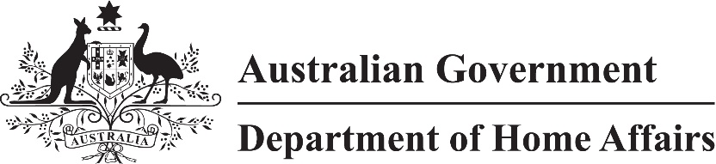
LIN 22/031
Migration (Daily maintenance amount for persons in detention) Determination (LIN 22/031) 2022
I, Roderick Thiele, delegate of the Minister, make this instrument under subsection 262(2) of the Migration Act 1958 (the Act).
Dated 29 June 2022
Roderick Thiele
A/g Senior Executive Service One
ABF Workforce Capability Branch
Department of Home Affairs

1 Name
This instrument is the Migration (Daily maintenance amount for persons in detention) Determination (LIN 22/031) 2022.

2 Commencement
This instrument commences on 1 July 2022.

3 Daily maintenance rate
For subsection 262(2) of the Act:
(a) the daily amount is $490.69; and
(b) the following detention centres established under subsection 273(1) of the Act are specified:
(i) North West Point (Christmas Island) Immigration Detention Centre;
(ii) Perth Immigration Detention Centre;
(iii) Villawood Immigration Detention Centre;
(iv) Yongah Hill Immigration Detention Centre; and
(c) each place approved by the Minister in writing under subparagraph (b)(v) of the definition of immigration detention in subsection 5(1) of the Act is specified; and
(d) the period after 30 June 2022 and before 1 July 2024 is specified.

