
Commonwealth of Australia
Environment Protection and Biodiversity Conservation Act 1999
Section 285
Environment Protection and Biodiversity Conservation (Wildlife Conservation Plan for Seabirds) Instrument 2022
I, Sussan Ley, Minister for the Environment, pursuant to section 285 of the Environment Protection and Biodiversity Conservation Act 1999 (Cth), hereby jointly make a wildlife conservation plan with the Western Australia Minister for Environment, the Hon Reece Whitby MLA, the South Australia Minister for Environment and Water, the Hon David Speirs MP, the Queensland Minister for the Environment and the Great Barrier Reef, the Hon Meaghan Scanlon MP and the New South Wales Minister for Energy and Environment, the Hon Matthew Kean MP, for the following 76 listed migratory and marine species, entitled “Wildlife Conservation Plan for Seabirds”.
Listed migratory and marine species | Wildlife conservation plan
Anous minutus | Department of Agriculture, Water and the
Anous stolidus | Environment (2020) Wildlife Conservation Plan
Aptenodytes patagonicus | for Seabirds. Commonwealth of Australia
Ardenna carneipes
Ardenna grisea
Ardenna pacifica
Ardenna tenuirostris
Bulweria bulwerii
Calonectris leucomelas
Chlidonias hybridus
Chlidonias leucopterus
Daption capense
Eudyptes chrysocome
Eudyptes chrysolophus
Eudyptula minor
Fregata ariel
Fregata minor
Fregetta tropica
Garrodia nereis
Gelochelidon nilotica
Gygis alba
Haliaeetus leucogaster
Haliastur indus
Hydrobates matsudairae
Hydrobates monorhis
Hydroprogne caspia
Larus dominicanus
Larus novaehollandiae
Larus pacificus
Lugensa brevirostris
Morus serrator
Oceanites oceanicus
Onychoprion anaethetus
Pachyptila belcheri
Pachyptila crassirostris
Pachyptila desolata

Pachyptila salvini
Pachyptila turtur
Pachyptila vittata
Pandion haliaetus
Pelagodroma marina
Pelecanoides georgicus
Pelecanoides urinatrix
Pelecanus conspicillatus
Phaethon lepturus
Phaethon rubricauda
Phalacrocorax fuscescens
Procelsterna cerulea
Pseudobulweria rostrata
Pterodroma cervicalis
Pterodroma inexpectata
Pterodroma lessonii
Pterodroma macroptera
Pterodroma nigripennis
Pterodroma solandri
Puffinus assimilis
Puffinus bulleri
Puffinus gavia
Puffinus huttoni
Pygoscelis papua
Stercorarius longicaudus
Stercorarius maccormicki
Stercorarius parasiticus
Stercorarius pomarinus
Sterna bengalensis
Sterna dougallii
Sterna fuscata
Sterna hirundo
Sterna paradisaea
Sterna striata
Sterna sumatrana
Sternula albifrons
Sula dactylatra
Sula leucogaster
Sula sula
Thalasseus bergii

The wildlife conservation plan specified in the above paragraph will come into force on the day after the plan is registered on the Federal Register of Legislation.

Dated this 28th day of March 2022
Sussan Ley
Sussan Ley
Minister for the Environment (Commonwealth)

Dated this 10 day of November 2021
Matthew Kean
Matthew Kean
Minister for Energy and Environment (New South Wales)
Dated this 25 day of May 2021
David Speirs
David Speirs
Minister for Environment and Water (South Australia)
Dated this 8 day of March 2022
Meaghan Scanlon
Meaghan Scanlon
Minister for the Environment and Great Barrier Reef (Queensland)

Dated this 2 of February 2022
Reece Whitby
Reece Whitby
Minister for Environment (Western Australia)

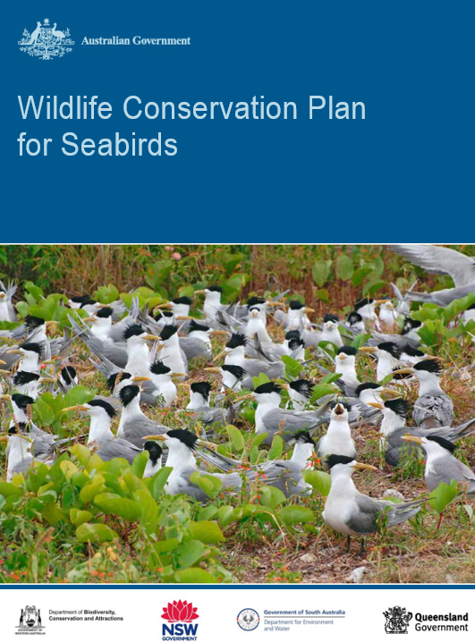

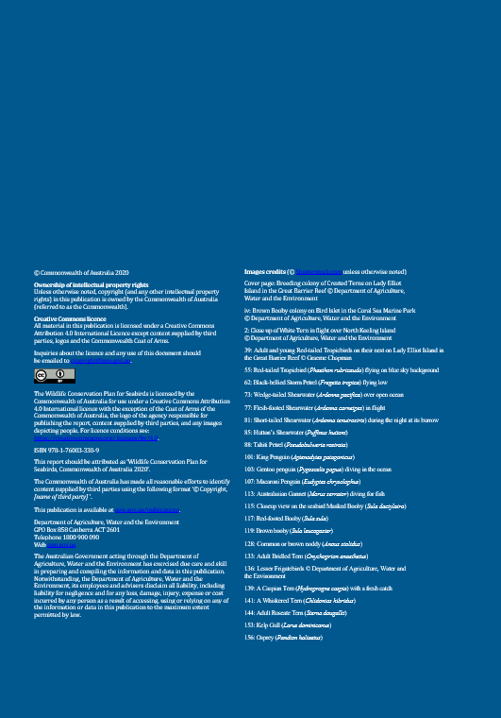

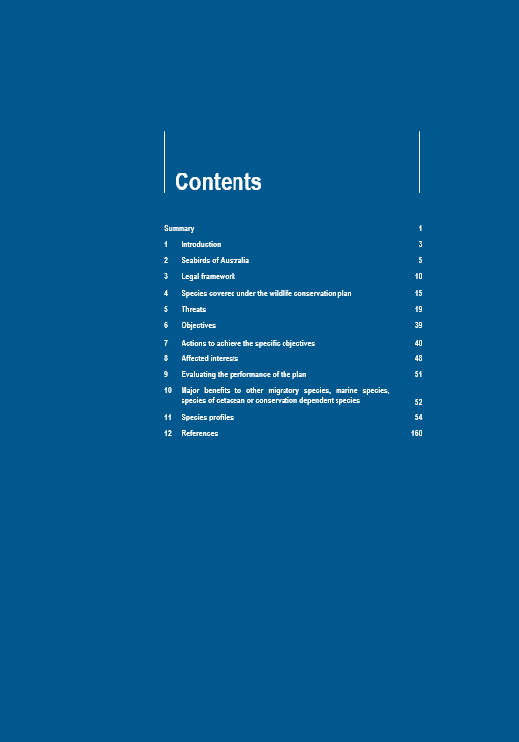

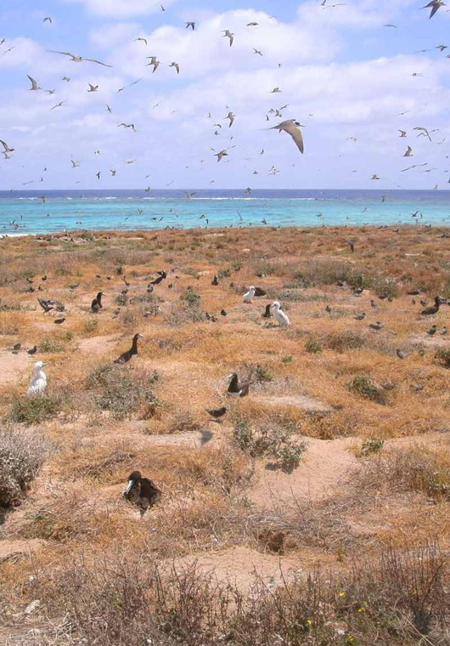


There are over 100 species of seabird that occur naturally or regularly visit Australia
during the course of their lifecycle. Australia’s coastal and oceanic habitats, particularly
offshore islands and surrounding waters are critically important areas for seabirds
during the breeding and non-breeding season as places to breed, rest and feed.
For long-distance migratory species, these habitats also provide resources so birds
can build enough energy reserves to travel the long distance to complete their
annual migration.
Commonwealth listed marine and migratory seabird species that inhabit Australia receive national protection as a matter of national environmental significance under the Environment Protection and Biodiversity Conservation Act 1999 (EPBC Act). Under the EPBC Act, wildlife conservation plans can be prepared to provide for research and management actions necessary to support the survival of listed marine and migratory species. This mechanism also supports Australia’s domestic obligations under our current bilateral migratory bird agreements with the Governments of Japan, China and the Republic of Korea, as well as multi-lateral environment agreements including the Convention on Migratory Species (CMS) and Convention on Biological Diversity (CBD).
The Australian Government Department of Agriculture, Water and the Environment has prepared a Wildlife Conservation Plan for Seabirds in consultation with Commonwealth agencies, state and territory governments, local government, natural resource
management bodies, industry, research institutions, non-government organisations and other relevant stakeholders. The Plan aims to provide a national framework for the research and management of listed marine and migratory seabirds and to outline national activities to support the conservation of listed seabirds in Australia and beyond. The Plan includes a summary of Australia’s commitments under international conventions and agreements, and the identification of important habitats within Australia. This Plan can be used as an over-arching framework to develop sub-national or regional plans and should be used to ensure seabird conservation, research and management are integrated and remain focused on the long-term survival of seabirds and their habitats.
This is the first wildlife conservation plan developed under the EPBC Act for seabirds and the Department encourages the implementation of actions identified in the plan in partnership with all relevant stakeholders. The Plan will be in place for a period of ten years and will be reviewed in 2025. It is available for download from the Department’s website at http://www.environment.gov.au/biodiversity.
Wildlife Conservation Plan for Seabirds 1

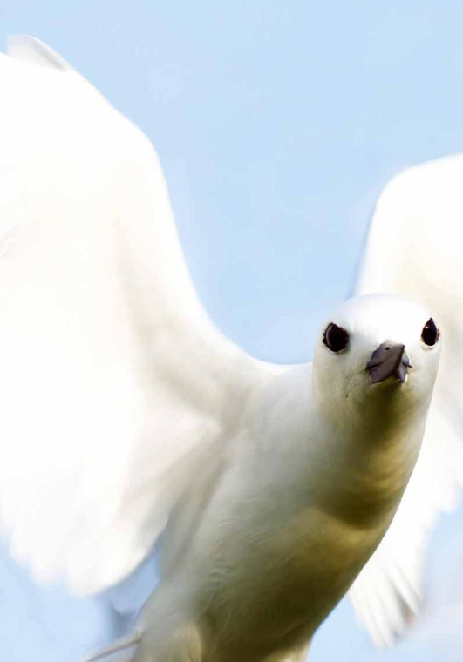


The seabird diversity of Australia, its islands and external territories is remarkable. The majority of species feed in coastal or oceanic waters and many migrate beyond Australian jurisdiction to complete their lifecycle. For these species, efforts to conserve seabirds in one country can only be effective with the cooperation and complementary actions of all countries in which they occur, including the high seas. Globally, there is a growing urgency to conserve seabirds and minimise the threats to the habitats critical to their survival in the face of ever-increasing human impacts across the world (Croxall et al. 2012).
Responsibility for the conservation and management of seabirds in Australia lies jointly with the Commonwealth and, state and territory governments. Australia has statutory obligations to conserve EPBC Act listed seabird species within its jurisdiction and internationally through agreements such as the Convention on Migratory Species (CMS), the Agreement of the Conservation of Albatross and Petrels (ACAP) and the bilateral migratory bird agreements (JAMBA, CAMBA and ROKAMBA). Most Australian seabird breeding colonies are on islands within state or territory waters and are managed accordingly by the relevant authority. Greater coordination amongst government agencies, research institutions, conservation organisations, industry groups and community organisations will significantly improve the knowledge base and capacity for the management of seabirds in Australia.
Governments, industry and conservation groups including the Australian Antarctic Division, Parks Australia, the Great Barrier Reef Marine Park Authority, CSIRO, Indigenous Land and Sea Rangers, BirdLife Australia and the Australasian Seabird Group, have undertaken some major projects relating to seabirds and their habitats. Population monitoring, island colony counts and research programs which have been operational for many years, have been successful due to the large number of scientists and volunteers that have contributed to these projects. There are a number of projects aimed at the conservation of marine and migratory listed seabirds in Australia which are primarily funded by the Australian Government, state and territory agencies, industry groups and philanthropic organisations.
Through the variety of research and volunteer programs that have been carried out, there is a strong baseline of information on seabirds throughout Australia. However, much remains unknown and it is important to sustain research and expand monitoring activities in order to detect significant changes in seabird populations. Whilst there is a strong network between many of the conservation groups who have an interest in seabirds, there may be many projects that would benefit from a coordinated system of communication and information exchange.
Wildlife Conservation Plan for Seabirds 3

Introduction
This Plan seeks to facilitate a nationally coordinated effort to protect and conserve EPBC Act listed seabirds and provides an over-arching framework for their research and management. This Plan encourages a cross-sectorial effort to address threats to seabirds and their habitats. A prioritised research program, nationally coordinated monitoring program and the implementation of on-ground actions to alleviate threats are critical areas for immediate focus. The Plan also contains a compilation of seabird species accounts covering life history, distribution, population size and trends, conservation concerns, and recommended management actions. These profiles can be used by agencies, land managers and on-ground environmental organisations to inform species specific management priorities. Additional information on each of these species can be found on the Department’s SPRAT profiles, including information on the listing status of the species under relevant state or territory legislation (see http://www.environment.gov.au/cgi-bin/sprat/public/sprat.pl).
4 Wildlife Conservation Plan for Seabirds


Seabirds are a taxonomically varied group of nearly 350 bird species (around
3.5 per cent of all birds) that depend on the marine environment for at least part of their life cycle (BirdLife International 2019). By convention, seabirds are defined as species in the families Phaethontidae (Tropicbirds), Hydrobatidae (Northern Storm-petrels), Oceanitidae (Austral Storm-petrels), Diomedeidae (Albatrosses), Procellariidae (Shearwaters and petrels), Spheniscidae (Penguins), Fregatidae (Frigatebirds), Sulidae (Gannets and boobies), Pelecanidae (Pelicans), Stercorariidae (Skuas) and Laridae (Gulls and terns). While seabirds vary greatly in their lifestyle and habitats, behaviour and physiology, they often exhibit striking convergent evolution, as the same environmental challenges and feeding niches have resulted in similar adaptations.
In general, seabirds are long lived, have delayed breeding and have fewer young than other birds do. Most species nest in colonies, which can vary in size from a few dozen birds to millions. Many species undertake long migrations, crossing the equator or circumnavigating the Earth in some cases. They feed both at the ocean's surface and below it, and even feed on each other. Seabirds can be oceanic, coastal, or in some cases spend a part of the year away from the sea entirely.
Adaptation to the marine environment
Seabirds have evolved numerous adaptations to living on and feeding in the marine environment. The evolution of wing morphology of an individual species or family has been shaped by its ecological niche. Longer wings and low wing loading are typical of more oceanic species, while diving species have shorter wings (Gaston 2004). Species such as the Wandering Albatross (Diomedea exulans), which forage over large areas of ocean, have a reduced capacity for powered flight and are dependent on a type of gliding called dynamic soaring (where the wind deflected by waves provides lift) as well as slope soaring (Pennycuick 1982). Seabirds also almost always have webbed feet, to aid movement on the surface as well as assisting diving in some species.
The Procellariiformes are unusual among birds in having a strong sense of smell, which is used to find widely distributed food in a vast ocean (Lequette et al. 1989) and possibly to locate their colonies. Salt glands are used by seabirds to deal with the salt they ingest by drinking and feeding (particularly on crustaceans), and to help them osmoregulate (Harrison 1990). The excretions from these glands (which are positioned in the head of the birds, emerging from the nasal cavity) are almost pure sodium chloride.

Wildlife Conservation Plan for Seabirds 5

Seabirds of Australia
Diet and foraging behaviour
Seabirds have evolved to exploit different food resources in the world's oceans, and to a great extent, their physiology and behaviour have been shaped by their diet (Springer et al 2018). These evolutionary forces have often caused species in different families and even orders to evolve similar strategies and adaptations to the same problems, leading to remarkable convergent evolution, such as that between Northern Hemisphere auks and Southern Hemisphere penguins.
There are four basic feeding strategies, or ecological guilds, for feeding at sea: surface feeding, pursuit diving, plunge diving and kleptoparasitism; within these guilds there are multiple variations on the theme.
Many seabirds feed on the ocean's surface, as the action of marine currents often concentrates food such as krill, forage fish, squid or other prey items within reach of a dipped head. Surface feeders that swim often have unique bills adapted for their specific prey. Prions have special bills with filters called lamellae to filter out plankton from water (Brooke 2004), and many albatrosses and petrels have hooked bills to snatch fast-moving prey. Gulls have more generalised bills that reflect their more opportunistic lifestyle.
Pursuit diving exerts greater pressures (both evolutionary and physiological) on seabirds. Propulsion underwater can be provided by wings (as used by penguins, diving petrels and some other species of petrel) or feet (as used by cormorants). Many shearwaters are intermediate between the two, having longer wings than typical wing-propelled divers but heavier wing loadings than the other surface-feeding procellariids, leaving them capable of diving to considerable depths while still being efficient long-distance travellers (Shaffer et al. 2006). This is the dominant guild in polar and subpolar environments, as it is energetically inefficient in warmer waters. With their poor flying ability, many wing-propelled pursuit divers are more limited in their foraging range than other guilds, especially during the breeding season when young need regular feeding.
Gannets, boobies, tropicbirds and some terns engage in plunge diving, taking fast moving prey by diving into the water from flight. Plunge diving allows birds to use the energy from the momentum of the dive to combat natural buoyancy (caused by air trapped in plumage) (Ropert-Coudert et al. 2004), and thus uses less energy than the dedicated pursuit divers, allowing them to utilise more widely distributed food resources, for example, less productive tropical areas. Some plunge divers (as well as some surface feeders) are dependent on dolphins and tuna to push shoaling fish up towards the surface (Au et al. 1986).
Kleptoparasites are seabirds that steal food of other seabirds. Most famously, frigatebirds and skuas engage in this behaviour, although gulls, terns and other species will steal food opportunistically (Schreiber and Burger 2002). The nocturnal nesting behaviour of some seabirds has been interpreted as arising due to pressure from this aerial piracy (Gaston and Dechesne 1986). Kleptoparasitism is not thought to play a significant part of the diet of any species but is a supplement to food obtained by hunting (Schreiber and Burger 2002). A study of Great Frigatebirds stealing from Masked Boobies estimated that the frigatebirds could at most obtain 40 per cent of the food they needed, and on average obtained only 5 per cent (Vickery and Brooke 1994).
6 Wildlife Conservation Plan for Seabirds

Seabirds of Australia
Life history
Seabirds' life histories are largely different from those of land birds. In general, they are K-selected, that is, population numbers fluctuate at or near the carrying capacity of the environment in which they inhabit. K-selected species generally have a longer lifespan (up to 60 years), delay breeding for longer (for up to 10 years) and invest more effort into fewer young (Robertson 1993; Schreiber and Burger 2002). Most seabird species will only have one clutch a year, unless they lose the first, and many species (like the procellariids and sulids), only one egg a year (Schreiber and Burger 2002; Brooke 2004).
Care of young is protracted, extending for as long as six months, among the longest for birds. For example, frigatebirds have long periods of parental care with each chick fledging after four to six months and continued parental investment for up to 14 months (Metz and Schreiber 2002). Due to the extended period of care, breeding occurs every two years rather than annually for some species. This life-history strategy has likely evolved both in response to the challenges of living at sea (collecting widely scattered prey items), the frequency of breeding failures due to unfavourable marine conditions, and the relative lack of predation compared to that of land-living birds (Schreiber and Burger 2002).
Because of the greater investment in raising the young and because foraging for food may occur far from the nest site, both parents participate in caring for the young, and pairs are typically at least seasonally monogamous. Many species, such as gulls, shearwaters and penguins, retain the same mate for several seasons, and many petrel species can mate for life (Brooke 2004). Albatrosses and procellariids, which can mate for life, take many years to form a pair bond before they breed (Pickering and Berrow 2001; Brooke 2004).
Breeding
Seabird breeding colonies are highly variable. Individual nesting sites can be widely spaced, as in an albatross colony, or densely packed as with a tern colony. In most seabird colonies, several different species will nest on the same site, often exhibiting some niche separation. Seabirds can nest in trees or shrubs (if any are available), on the ground (with or without nests), on cliffs, in burrows under the ground and in rocky crevices. Competition can be strong both within species and between species, with aggressive species such as Sooty Terns pushing less-dominant species out of the most desirable nesting spaces (Schreiber et al. 2002). The Great-winged Petrel (Pterodroma macroptera) nests during the winter to avoid competition with the more aggressive species like the Flesh-footed Shearwater (Ardenna carneipes) in south-west Western Australia. When the seasons overlap, Flesh-footed Shearwaters will share burrows with young Great-winged Petrels in order to use their burrows for summer nesting (Serventy et al. 1971).
Many seabirds show remarkable site fidelity, returning to the same burrow, nest or site for many years, and they will defend that site from rivals with great vigour (Schreiber and Burger 2002). This behaviour increases breeding success, provides a place for returning mates to reunite, and reduces the costs of prospecting for a new site (Bried et al. 2003). Young adults breeding for the first time usually return to their natal colony, and often nest close to where they hatched. This tendency, known as philopatry, is so strong that a study of Laysan Albatrosses (Phoebastria immutabilis) found that the average distance between hatching site and the site where a bird established its own territory was 22 m (Fisher 1976). For some species, once these sites are lost, there are limited options for these species to “find” alternative locations and habitat. Given the gaps in seabird ecology, loss of these sites may pose a risk to certain seabird populations.
Wildlife Conservation Plan for Seabirds 7
Seabirds of Australia
Colonies are usually situated on islands, cliffs or headlands, which land mammals have difficulty accessing (Moors and Atkinson 1984). This is thought to provide protection to seabirds, which are often very clumsy on land. Colonies of breeding seabirds will also take advantage of artificial structures, breakwaters and offshore platforms. Breeding in colonies often arises in types of birds that do not defend feeding territories; this may be a reason why it arises more frequently in seabirds (Schreiber and Burger 2002). There are other possible advantages: colonies may act as information centres, where seabirds returning to the sea to forage can find out where prey is by studying returning individuals of the same species. There are disadvantages to colonial life, particularly the spread of disease and ectoparasites. Colonies also attract the attention of predators, principally other birds, and many species attend their colonies nocturnally to avoid predation (Keitt et al. 2004).
Migration
Like many birds, seabirds often migrate after the breeding season. Of these, the migration taken by the Arctic Tern (Sterna paradisaea) is the farthest of any
bird, crossing the equator in order to spend the Austral summer in Antarctica
(Egevang et al. 2010; Fijim et al. 2013). Other species also undertake trans-equatorial trips, both from the north to the south, and from south to north. The Sooty Shearwater (Ardenna grisea) undertakes an annual migration cycle that rivals that of the Arctic Tern; birds that nest in New Zealand and Chile spend the northern summer feeding in the North Pacific Ocean off Japan, Alaska and California, an annual round trip of 64,000 km (Shaffer et al. 2006).
Other species migrate shorter distances away from the breeding sites, their distribution at sea determined by the availability of food. If oceanic conditions are unsuitable, seabirds will immigrate to more productive areas, sometimes permanently if the bird is young (Oro et al. 2004). After fledging, juvenile birds often disperse further than adults, and to different areas, so are commonly sighted far from a species' normal range. Some species, such as some of the storm petrels, diving petrels and cormorants, rarely disperse at all, staying near their breeding colonies year-round.
Biologically important areas for seabirds in Australia
Australian Marine Parks (Commonwealth reserves proclaimed under the EPBC Act in 2007 and 2013) are located in Commonwealth waters that start at the outer edge of state and territory waters, generally three nautical miles (approximately 5.5 kilometres) from the shore, and extend to the outer boundary of Australia’s Exclusive Economic Zone (EEZ), 200 nautical miles (approximately 370 kilometres) from the shore. These marine parks have been established for the protection and conservation of biodiversity and other natural, cultural and heritage values of the parks. They contain biologically important areas for a range of protected seabird species, and management of these parks can contribute to the protection of these species, or the ecological processes that support them.

8 Wildlife Conservation Plan for Seabirds

Seabirds of Australia
Biologically important areas (BIAs) are areas that are particularly important for the conservation of the protected species and where aggregations of individuals display biologically important behaviour such as breeding, foraging, resting or migration.
BIAs were originally identified for some (but not all) seabirds through a rigorous and robust process as part of the Commonwealth Bioregional Planning Process and are referenced in Commonwealth Marine Bioregional Plans. The selection of BIAs for species was informed by the availability of scientific information, the conservation status of listed species and the importance of the region for the species. They represent areas where a specific behaviour is known to occur. The absence of an identified BIA does not mean that an area is not important habitat, just that it was not known at the time of assessment. This is because BIA maps reflect the best available information at the time of publication.
Specifically, BIAs are based on the following:
- Behaviour (feeding, nesting, migration) occurs in the area;
- Certainty of occurrence (only areas of ‘known’ or ‘likely’ occurrence are considered);
- The level to which species use the BIA;
- The season(s) during which species use the BIA; and
- Source(s) of the information upon which the BIA is based.
Biologically important areas have been identified for a number of listed seabirds that occur in Commonwealth marine areas. Behaviours used to define biologically important areas for seabirds include breeding areas with a foraging buffer, and roosting habitats.
The BIA maps are a dynamic tool which allow for up-to-date information to be stored and referenced in a geospatial environment, building on information used to inform the wildlife conservation plan.
The range of species for which biologically important areas are identified will continue to expand as reliable spatial and scientific information becomes available. Biologically important areas are included in the Department’s Conservation Values Atlas (www.environment.gov.au/cva).
Wildlife Conservation Plan for Seabirds 9


Marine species
Under the United Nations Convention on the Law of the Sea, Australia has rights and responsibilities over 16 million square kilometres of ocean – more than twice the area of the Australian continent. Within this area live thousands of marine species, some of which are unique to Australia and all of which contribute to making Australia the most biodiverse rich country in our region.
The Australian Government uses the EPBC Act to protect and manage threatened, migratory and marine species in the marine environment. Marine species are listed under the EBPC Act and includes sea snakes, seals, crocodiles, Dugong (Dugong dugon), marine turtles and all birds that occur naturally in Commonwealth marine areas.
Once listed as a marine species under the EPBC Act, it becomes an offence to kill, injure, take, trade, keep or move of any listed marine species in or on a Commonwealth area.
The marine species list established under the EPBC Act is available at: http://www.environment.gov.au/marine/marine-species/marine-species-list.
Migratory species
The EPBC Act is the Australian Government’s key piece of environmental legislation. Under the EPBC Act, actions that have, or are likely to have, a significant impact on nationally protected matters require approval from the Australian Government Minister for the Environment. One of these matters protected by the Act is migratory species; specifically those migratory species listed under the Convention on the Conservation of Migratory Species of Wild Animals (also known as the CMS or the Bonn Convention; www.cms.int/) and bilateral migratory bird agreements with Japan (JAMBA), China (CAMBA) and the Republic of Korea (ROKAMBA).
Australia’s list of migratory species is established under Section 209 of the EPBC Act and is available at: http://www.environment.gov.au/biodiversity/migratory-species.
Section 211(A to E) of the EPBC Act prohibits the killing, injuring, taking, trading, keeping or moving of any migratory species in or on a Commonwealth area, although certain exemptions are allowed for in Section 212. For places outside of Commonwealth areas, the EPBC Act prevents actions (Section 140) or approvals under Strategic Assessments (Section 146L) that are inconsistent with Australia’s migratory species’ obligations under the CMS, JAMBA, CAMBA or ROKAMBA.

10 Wildlife Conservation Plan for Seabirds

Legal framework
Under the CMS, species are listed on Appendix I or Appendix II (or both), with Appendix I species recognised as endangered. Parties to the Convention that are Range States of a migratory species commit to prohibiting the taking of animals listed in Appendix I, and endeavour:
- to conserve and, where feasible and appropriate, restore those habitats of the species which are of importance in removing the species from danger of extinction;
- to prevent, remove, compensate for or minimize, as appropriate, the adverse effects of activities or obstacles that seriously impede or prevent the migration of the species; and
- to the extent feasible and appropriate, prevent, reduce or control factors that are endangering or are likely to further endanger the species, including strictly controlling the introduction of, or controlling or eliminating, already introduced exotic species.
Appendix II species are those that have an unfavourable conservation status and which require international agreements for their conservation and management, as well as those that would significantly benefit from the international cooperation that could be achieved by an international agreement.
Migratory species included in either Appendix can also benefit from the development of Concerted Actions. These range from field research and conservation projects to the establishment of technical and institutional frameworks for action. International Single Species Action Plans are an important instrument to promote and coordinate activities that seek to protect and restore habitat, mitigate obstacles to migration and other factors that might endanger species.
Signatories to JAMBA, CAMBA and ROKAMBA are committed to taking appropriate measures to preserve and enhance the environment of migratory birds, in particular, by seeking means to prevent damage to such birds and their environment.
These agreements also commit the governments to exchange research data and publications, to encourage formulation of joint research programs, and to encourage the conservation of migratory birds.
Actions that have or are likely to have, a significant impact on a listed migratory species (or other protected matter) must be referred to the Department for a decision on whether further assessment and approval is needed under the EPBC Act before an action can be undertaken.
An action is likely to have a significant impact on a migratory species if there is a real chance or possibility that it will:
- substantially modify (including by fragmenting, altering fire regimes, altering nutrient cycles or altering hydrological cycles), destroy or isolate an area of important habitat for migratory species;
- result in an invasive species that is harmful to the migratory species becoming established in an area of important habitat for the migratory species; or
- seriously disrupt the lifecycle (breeding, feeding, migration or resting behaviour) of an ecologically significant proportion of the population of a migratory species.
Further information of significant impact criteria can be found in the EPBC Act Policy Statement 1.1 Significant Impact Guidelines – Matters of National Environmental Significance.
Wildlife Conservation Plan for Seabirds 11

Legal framework
Agreement on the Conservation of Albatross and Petrels
The Agreement on the Conservation of Albatrosses and Petrels (ACAP) is a legally binding international treaty which entered into force on 1 February 2004. It was established in order to halt the alarming decline of seabird populations in the Southern Hemisphere, particularly albatrosses and petrels. Albatrosses and petrels are threatened by introduced species on their breeding islands, pollution, and being taken as bycatch in commercial and artisanal fisheries using a range of different gear. The agreement requires that measures be taken by signatory governments to reduce bycatch; protect breeding colonies; and control and remove introduced species from breeding sites, especially on islands.
Currently, ACAP protects all the world's albatross species, seven Southern Hemisphere petrel and two shearwater species. The agreement demonstrates an increasing international commitment to protect albatrosses and petrels.
ACAP helps countries to implement species action plans, control the expansion of non-native predators, introduce measures to reduce bycatch of seabirds, and support research in the effective conservation of albatrosses and petrels. The agreement has published ACAP Species Assessments, booklets, mitigation factsheets, and a number of ACAP Conservation Guidelines, including for biosecurity; eradication of introduced mammals; translocation; and census and survey methods. One of the agreement's main activities is to provide expert advice on seabird bycatch mitigation to fisheries managers, both in domestic and high seas fisheries. Further information about ACAP can be found here: https://www.acap.aq/.
While the CMS, ACAP, JAMBA, CAMBA and ROKAMBA provide mechanisms for pursuing conservation outcomes for migratory birds, they do not encompass all seabirds and are binding on a limited number of countries. As Australia became increasingly concerned about the conservation status of species, additional mechanisms have been developed for multilateral cooperation on biodiversity conservation globally and throughout the region.
Convention on the Conservation of Antarctic Marine Living Resources
The Convention on the Conservation of Antarctic Marine Living Resources (CCAMLR) is an international treaty that was adopted at the Conference on the Conservation of Antarctic Marine Living Resources which met at Canberra, Australia, 7–20 May 1980. The convention’s objective is the conservation of Antarctic marine living resources where conservation includes sustainable harvesting.
The treaty is a multilateral response to concerns that unregulated increases in krill catches in the Southern Ocean could be detrimental for Antarctic marine ecosystems particularly for seabirds, seals, whales and fish that depend on krill for food. It takes whole ecosystem and precautionary approaches to management.
Whilst this wildlife conservation plan does not include Australian Antarctic Territory restricted species, CCAMLR is still a relevant legal framework related to the
conservation of seabirds in the Southern Ocean.
12 Wildlife Conservation Plan for Seabirds
Legal framework
CCAMLR applies to all Antarctic populations of finfish, molluscs, crustacean and seabirds found south of the Antarctic Convergence, however, there are some species which do move beyond the Convergence to Australian waters which may rely on Antarctic resources, additionally there are some complementary CCAMLR measures around international actions to reduce the incidental mortality of seabirds arising from fishing. Further information on the Convention is available here: https://www.ccamlr.org/en.
Convention on Biological Diversity
The Convention on Biological Diversity (CBD) was inspired by the world community's growing commitment to sustainable development. It represents a step forward in the conservation of biological diversity, the sustainable use of its components, and the fair and equitable sharing of benefits arising from the use of genetic resources.
Australia is one of 196 Parties to CBD who are committed to implementing provisions of the Convention through National Biodiversity Strategies and Action Plans (NBSAP). NBSAPs are the principal instruments for implementing the Convention at the national level (Article 6). The Convention requires countries to prepare a national biodiversity strategy (or equivalent instrument) and to ensure that this strategy is mainstreamed into the planning and activities of all those sectors whose activities can have an impact (positive and negative) on biodiversity. Further information on Australia’s biodiversity strategy is available here: http://www.environment.gov.au/biodiversity/conservation/strategy.
Ramsar Convention on Wetlands
Australia is a signatory to the Convention on Wetlands of International Importance (see www.ramsar.org). The Ramsar Convention, as it is commonly known, is an intergovernmental treaty dedicated to the conservation and ‘wise use’ of wetlands.
The Ramsar Convention focuses on conservation of important habitats rather than species. Parties are committed to identifying wetlands that qualify as internationally significant against a set of criteria, nominating these wetlands to the List of Wetlands of International Importance (the Ramsar List) and ensuring the maintenance of the ecological character of each listed Ramsar site.
As at June 2020, Australia has 66 Wetlands of International Importance that cover a total of approximately 8.1 million hectares. Many of Australia’s Ramsar sites were nominated and listed using waterbird-based criteria, and in some of these cases seabirds are a major component of the waterbird numbers (e.g. Ramsar sites in the Coral Sea Marine Park, Ashmore Reef Marine Park and Pulu Keeling National Park). Some Ramsar sites that may not have been specifically listed for their waterbird-related values however contain critical components that are used by waterbirds. This includes use as migratory and localised feeding or roosting areas.
Wildlife Conservation Plan for Seabirds 13

Legal framework
East Asian—Australasian Flyway Partnership
The Partnership for the Conservation of Migratory Waterbirds and the Sustainable Use of their Habitats in the East Asian–Australasian Flyway (East Asian— Australasian Flyway Partnership (EAAFP)) was launched on 6 November 2006. A Ramsar regional initiative, the partnership is an informal and voluntary collaboration of effort focusing on protecting migratory waterbirds, their habitat and the livelihoods of people dependant on them.
The EAAF is one of nine major migratory waterbird flyways around the globe. It extends from within the Arctic Circle in Russia and Alaska, southwards through East and South-east Asia, to Australia and New Zealand in the south, encompassing 22 countries. Migratory waterbirds share this flyway with 45 per cent of the world’s human population. The EAAF is home to over 50 million migratory waterbirds—including shorebirds, Anatidae (ducks, geese and swans), seabirds and cranes—from 207 species, including 33 globally threatened and 13 near threatened species.
Flyway partners include countries, intergovernmental agencies, international non-government organisations and the international business sector. A cornerstone of the partnership is the establishment of a network of internationally important sites for migratory waterbirds throughout the EAAF. The partnership operates via working groups and task forces, including the Seabird Working Group. More information about the Partnership is available at: www.eaaflyway.net.
14 Wildlife Conservation Plan for Seabirds
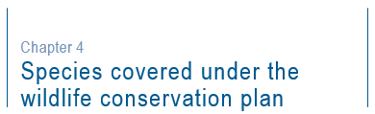
The Plan includes 73 species of seabird that occur or regularly visit Australia and its EEZ. The Plan does not include Australian Antarctic Territory restricted species, vagrant seabirds, ACAP-listed albatrosses and petrels or those species that are listed as threatened under the EPBC Act. Threatened species receive separate, approved conservation advice and, in some cases, a recovery plan which sets out what should be done to stop the decline and support the recovery of the species.
Based on expert opinion, three raptor species – White-bellied Sea-eagle (Haliaeetus leucogaster), Brahminy Kite (Haliastur indus) and Osprey (Pandion haliaetus) have also been included in this Plan as they all rely on the marine environment to complete their lifecycle and would all benefit from a national framework to coordinate research and management actions.
If, during the life of this Plan, a seabird species listed in Table 1 becomes a listed threatened species under the EPBC Act, the plan will cease to apply to that species. In the situation where a threatened seabird species is delisted, it will be eligible to be included in this plan as long as the species is also listed as migratory, and/or marine under the EPBC Act. If any seabird species that is currently considered a vagrant were to be recorded on a regular basis, monitoring programmes for the species should be supported to determine whether inclusion under the EPBC Act is appropriate.
Additional information on each of these species can be found on the Department’s SPRAT profiles, including information on the listing status of the species under relevant state or territory legislation (see http://www.environment.gov.au/cgi-bin/sprat/public/sprat.pl).

Wildlife Conservation Plan for Seabirds 15

Species covered under the wildlife conservation plan

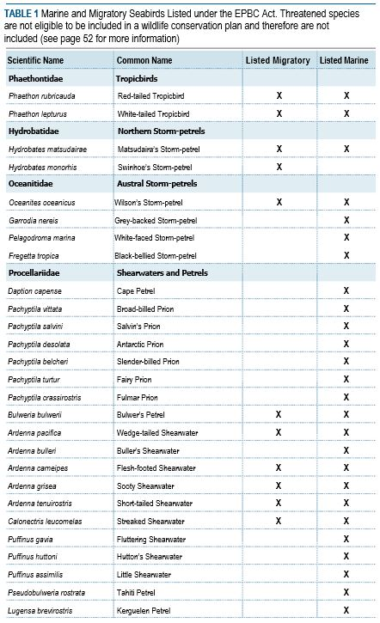

continued ...
16 Wildlife Conservation Plan for Seabirds

Species covered under the wildlife conservation plan

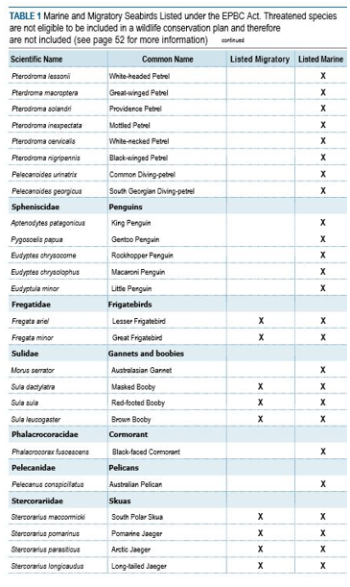continued ...

Wildlife Conservation Plan for Seabirds 17

Species covered under the wildlife conservation plan

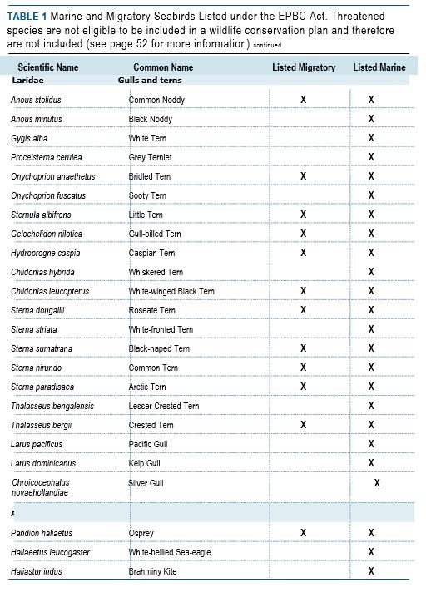
18 Wildlife Conservation Plan for Seabirds


In Australia, threats to seabird populations can generally be attributed to one of four broad categories: biological, climate, resource use or chemical. Key threats to the survival of Australian seabirds are identified in this section. The list is not exhaustive but identifies the main threats that are likely to affect seabird populations adversely.
Habitat loss
Coastal development
Development pressures affect many species as human populations grow and we expand our coastal and urban footprint. Coastal development such as housing estates, roads, ports, windfarms and industrial areas can reduce or eliminate areas for seabirds to breed and forage. Tourism or industry developments on offshore islands can also lead to a reduction of the area available for nesting seabirds like terns and shearwaters. Secondary impacts of coastal and urban development can include increased disturbance, roaming domestic pets, light pollution and energy infrastructure (covered below).
The settlement of offshore islands, such as the Cocos (Keeling) Islands, has led to a decline in the distribution of breeding seabirds. Before human occupation of the islands in the 19th century, seabirds bred on all Cocos (Keeling) atolls. Now the only significant seabird breeding colonies are restricted to Pulu Keeling National Park. The site regularly supports more than 30,000 pairs of Red-footed Booby; 15,000 Common Noddy and 3,000 Great and Lesser Frigatebirds.
Loss of areas that support large numbers of seabirds can cause disproportionate declines in seabird populations, as displaced birds are unable to find suitable replacement habitat. Similarly, incremental loss of smaller areas affects the broader conservation of habitat availability. In Australia, loss of important habitat reduces availability of foraging and roosting areas, affecting the ability of birds to build up energy stores necessary for successful migration and breeding. Some areas are also important year-round for juvenile birds, with loss of these habitats affecting future breeding populations of these species.

Wildlife Conservation Plan for Seabirds 19

Threats
Habitat may be lost due to a variety of activities that make the habitat unavailable to seabirds. These may include direct loss through clearing, inundation, infilling or draining (for example, for buildings or marine services such as harbours, marinas, ports or oil terminals) or indirect loss through changes to hydrology, water quality or vegetation structural changes near breeding and roosting areas (for example increased vegetation cover or encroachment of buildings).
When assessing a development proposal, all direct and indirect impacts that have, will have, or are likely to occur on a protected matter as a result of the action must be considered.
Habitat modification
Seabirds are sensitive to subtle changes to their habitat. In particular, many have specialised feeding techniques making them susceptible to slight changes in prey availability or to their foraging environments. An activity that reduces the ability of seabirds to use an area for breeding, roosting or foraging, or reduces the availability of food, degrades habitat may have adverse impacts on the population. These impacts include (among others):
- alteration of nesting trees, ground substrate or burrows, sand spits used for roosting or inshore feeding areas such as seagrass beds, estuaries and coastal wetlands;
- substantial loss of marine or estuarine vegetation which is likely to alter the dynamic equilibrium of sediment banks and mudflats;
- invasion of coastal weeds;
- livestock (i.e. trampling burrows) and fire management at nesting areas, including on islands;
- water pollution and changes to the water regime, including the construction of dams and water management;
- artificial changes to hydrological regimes that affect the productivity of the feeding environment (for example, changes in water depth); and
- exposure of acid sulphate soils changing the chemical balance of the area.
20 Wildlife Conservation Plan for Seabirds
Threats
Climate variability and change
Climate change
Most extreme climatic events are beyond our immediate control, but it is important to monitor their effects on seabirds, particularly in the long term, in order to understand the background of natural influences against which to judge anthropogenic influences (Ross et al. 1996). The implications of extreme climatic events for Australian and Southern Hemisphere seabirds have been described by Chambers et al. (2011, 2013, 2014) and by Rodriguez et al. (2019) for petrels and shearwaters.
Climate change is a threat that impacts many marine organisms including seabirds. The 'Loss of climatic habitat caused by anthropogenic emissions of greenhouse gases' has been declared a Key Threatening Process under the EPBC Act. The threat is described as reductions in the bioclimatic range within which a species or ecological community exists due to emissions induced by human activities of greenhouse gases. The listing of this threat recognises that it is occurring at a continental scale. Components of the process include: temperature rise; changes in rainfall patterns; changes to the El Niño Southern Oscillation; and sea level rise. Consequences to seabirds could include negative impacts from an increase in extreme weather events, reduced or changed prey abundance and distribution, and decrease in nesting habitat.
Changes to marine ecosystems have been linked to strengthening warm currents and ocean warming (Ridgway 2007; Steinacher et al. 2010; Wu et al. 2012). In Australia, marine productivity has decreased as a result of the strengthening East Australian Current and warming waters (Ridgway 2007, Wu et al. 2012) which is likely to affect seabirds (e.g. foraging impacts and distribution changes (Carroll et al. 2016; Gorta et al. 2019)). For example, high seabird diversity in the Tasman Sea is subject to increasing rates of ocean warming and decreases in productivity which is likely to adversely impact species in that region (Mott and Clarke 2018).
Several seabird species have been identified as being at high risk from exposure to climate change and sensitive to climate change (Garnett and Franklin 2014). These species include: White-bellied Storm-petrel (Tasman Sea), Wedge-tailed Shearwater, Little Shearwater (Tasman Sea), Soft-plumaged Petrel, White-necked Petrel, Kermadec Petrel and Masked Booby (Tasman Sea). Many other seabirds listed by Garnett and Franklin (2014) are sensitive to climate change and their exposure to climate change varies. Understanding the impacts of climate change on these species, and the management response, will vary. The impact of climate change on Australian’s seabirds requires further research that will inform actions that inform adaptation and resilience.
Projected sea level rises are likely to adversely affect beach-nesting seabirds such as terns and noddies in the short term, followed by ground nesting seabirds like gulls, boobies and burrowing species such as penguins, shearwaters and petrels on low lying coastal areas, islands and cays.
A reduction in the emissions of greenhouse gases requires an internationally coordinated effort. Australia is a signatory to relevant international agreements, and has made a commitment to limit, and reduce, greenhouse gas emissions. In addition, the states and territories are pursuing additional opportunities to abate greenhouse gas emissions in a cost-effective and environmentally sensitive manner.
Wildlife Conservation Plan for Seabirds 21

Threats
El Niño Southern Oscillation
Long-term climatic cycles caused by El Niño Southern Oscillation (ENSO) events can have profound effects on seabird colonies and breeding success (Schreiber and Burger 2002; Surman and Nicholson 2009; Chambers et al. 2013). For example, northward irruption of Southern Ocean species and subsequent mortalities are a feature of strong ENSO events. Oceanographic parameters play an important role in determining the distribution of many pelagic seabird species. The position of the front of the East Australian Current, the Subantarctic Convergence and the Leeuwin Current are all major cyclical features affecting marine productivity and seabird distributions in Australia.
Generally, effects of ENSO events on seabirds are seen first in the central Pacific where they develop and are the most severe, but parallel oceanographic and atmospheric changes occur in the Atlantic and Indian Oceans (Schreiber and Burger 2002). For example, during ENSO events, when the flow of the Leeuwin Current flow is weaker and the Southern Oscillation Index is low, reproductive effort and output was severely reduced for Lesser Noddy (Anous tenuirostris) and Common Noddy (A. stolidus) breeding at the Houtman Abrolhos, Western Australia (Surman and Nicholson 2009). The conditions appeared to result in low prey availability, which delayed the commencement of seabird breeding by up to two months and caused breeding failures (Surman and Nicholson 2009).
La Niña events can also impact seabirds. Cannell et al. (2012) observed negative impacts on breeding success and fledging mass of Little Penguin (Eudyptula minor) in Western Australia.
Storms and cyclones
Small populations such as those of White-tailed Tropicbird (Phaethon lepturus), Kermadec Petrel (Pterodroma neglecta) and Little Tern (Sternula albifrons) are vulnerable to stochastic events such as storms and cyclones. Storms and cyclones have the potential to have serious effects on the arrival points, nesting substrate, vegetation and wildlife on remote seabird breeding islands, in addition to impacting seabirds directly at sea. Such natural factors can place additional pressures on seabird populations already adversely affected by anthropogenic influences. However, stochastic events such as storms and cyclones are beyond the control of management authorities and have not been addressed for the species in this Plan.
Geological processes
Volcanism
Active volcanoes generally occur close to the major tectonic plate boundaries. They are rare in Australia because there are no plate boundaries on this continent. However, there are two active volcanoes located 4,000 kilometres south west of Perth in the Australian Antarctic Territory on Heard Island and the nearby McDonald Islands.
Mawson Peak, on Heard Island has erupted several times in the last decade and remains active. The volcano on McDonald Island, after being dormant for 75,000 years, became active in 1992 and has erupted several times since, the most recent in 2005. It is estimated that volcanic activity displaced more than 1 million pairs of Macaroni Penguins (Eudyptes chrysolophus) on McDonald Island after the 1992 eruptions, though satellite images show unidentified penguins that may be recolonising the area (Crossin et al. 2013).
22 Wildlife Conservation Plan for Seabirds
Threats
The other active volcanoes nearest Australia are in Papua New Guinea, New Zealand, South Pacific, Indonesia and the Philippines. Gas-rich sticky magmas dominate the Asia Pacific, making composite volcanoes and calderas the most common varieties in the region. These types of volcanoes threaten lives, property, agricultural lands and livelihoods throughout south-east Asia and the Australian region. While volcanoes can impact seabird colonies from time-to-time by removing suitable nesting habitat, they can also create new habitat which is colonised over time as conditions change and improve.
Earthquake, tsunami and landslips
Earthquakes are the vibrations caused by rocks breaking under stress. The underground surface along which the rock breaks and moves is called a fault plane. Apart from causing shaking, earthquakes of magnitude 4.0 or greater can also trigger landslides, which can cause casualties. The larger the magnitude of the earthquake, the bigger the area over which landslides may occur. Undersea earthquakes can cause a tsunami, or a series of waves which can cross an ocean and cause extensive damage to coastal regions and nearshore seabird populations (Viera et al. 2006; Reynolds et al. 2015).
In areas underlain by water-saturated sediments, large earthquakes, usually magnitude 6.0 or greater, may cause liquefaction. The shaking causes the wet sediment to become quicksand and flow. Subsidence from this can cause buildings to topple, and the
sediment might erupt at the surface from craters and fountains.
Landslips caused by earthquakes or heavy rainfall, can impact habitat used by seabirds. For example, in 2016, a landslip caused by a 7.5 magnitude earthquake in New Zealand significantly impacted the breeding colony of the globally endangered Hutton’s Shearwater (Puffinus huttoni). Hutton’s Shearwaters are small seabirds endemic to New Zealand that breed only in the Seaward Kaikōura Ranges. They breed at two sites about 8 kilometres inland – Kowhai Stream and Shearwater Stream - at altitudes between 1200-1800 metres. They make burrows in loose soil amongst tussocks, where they spend nearly six months raising their chicks. After the earthquake struck, it was thought that up to 25 per cent of the population may have been crushed by the landslide. Surveys following the earthquake suggested that an estimated 20–30 per cent loss of breeding burrows had occurred but adults had returned to breed.
Invasive species
Invasive species are one of the primary threats to seabirds around the globe (Baker et al. 2002; Jones et al. 2008; Croxall et al. 2012). Mammals such as cats (Felis catus), rodents (Rattus spp.), European Red Fox, dogs (Canis familiaris) and pigs (Sus scrofa) predate adults, chicks and eggs and have caused localised extinctions. Goats (Capra hircus), cattle (Bos spp.) and rabbits (Oryctolagus cuniculus) alter breeding areas making them unsuitable for breeding or reducing breeding success. On Bird Island, Seychelles, the invasion of Yellow Crazy Ants (Anoplolepis gracilipes) led to an estimated 60,000 pairs of Sooty Tern (Onchoprion fuscatus), which nest in colonies on the ground, being displaced from their nesting sites and also caused the death of White Tern (Gygis alba) chicks (Feare 1999). Yellow Crazy Ants may also take over nesting sites of known tree-hollow nesting birds and the constant acid spraying behaviour of crazy ants causes injuries to seabird chicks. The Yellow Crazy Ant has been identified as a threat to breeding seabirds and other biological assets on Christmas Island. Control efforts are underway to reduce the impacts on wildlife including baiting and biological control.
The solution seems simple – eradication of invasive species – but the implementation of such programs is logistically difficult and expensive.
Wildlife Conservation Plan for Seabirds 23
Threats
One of Australia’s most successful programs to eradicate invasive species from an island was the Macquarie Island Pest Eradication Project. Since its discovery, a number of invasive invertebrates, mammal and bird species had been introduced to Macquarie Island. Some have had serious impacts on the island's native flora and fauna. Horses (Equus caballus), donkeys (E. asinus), pigs, cattle, goats, dogs and sheep (Ovis aries) were the first to be removed or die out naturally, and between 1989 and 2000, Weka (Gallirallus australis) and cats were eradicated. A major project to remove the last remaining mammal species - rabbits, Black Rats (Rattus rattus) and House Mice (Mus musculus) was undertaken between 2007 and 2014 thanks to a joint commitment of $24.7 million by the Australian and Tasmanian Governments to fund the eradication project. Aerial baiting of the entire island was completed in July 2011, followed by intensive monitoring by hunters and highly trained detection dogs, to detect and dispatch any surviving individuals. In April 2014, after nearly three years of monitoring with no sign of surviving individual rabbits, rats or mice, the project was declared a success. With the removal of rabbits and the resulting intensive grazing pressure, the island's vegetation is rapidly rebounding. Seabirds, which had suffered predation of eggs and chicks by rats, are also returning in numerous areas.
Another conservation success due to an island eradication program is the recovery of the threatened Gould’s Petrel (Pterodroma leucoptera) on NSW’s Cabbage Tree Island. In 1989 it was the sole Australian breeding site with just 250 breeding pairs. Adults were being killed by native Pied Currawongs (Strepera graculina) because rabbits had eaten out the understorey. Chicks were also becoming entangled in the sticky fruits of Pisonia trees (Pisonia umbellifera). Since eradication of rabbits, the removal of Pisonia trees, and establishment of additional breeding populations on other islands, numbers are continuing to grow.
Australian seabird islands facing invasive species issues include Ashmore Reef, Norfolk Island, Christmas Island and Cocos (Keeling) Island. These important seabird islands may benefit from pest eradication programs, provided the impacts of these invasive species and role with ecosystems is understood.
Control of pest plants on offshore islands can be challenging, particularly where freshwater is scarce, and carting of water (required for mixing herbicide) to islands is problematic. Integrated methods of spraying, burning and revegetating have proved effective on some New South Wales islands. Research and field trials into more effective control methods for weeds that impact seabird islands are a worthwhile priority, particularly species like Tree Mallow (Malva arborea) which require seasonal slashing.
Some weed species may provide important habitat, or be stabilising beaches, dunes or sand islands, and weed control around seabird colonies must be carefully planned. Species such as Little Penguin burrow under woody weeds, such as Boxthorn, and weed removal can alter burrow conditions like humidity or temperature. Removal of native vegetation and weeds may result in erosion that impacts available habitat, or in some cases, total loss of sand spits islands.
24 Wildlife Conservation Plan for Seabirds
Threats
Native wildlife
The influence of native species on the breeding success of seabirds should not be over-looked. Prior to the Macquarie Island Pest Eradication Project, it was believed that the population of Brown Skuas (Stercorarius antarcticus) on the island were being kept artificially high as a result of the availability of introduced rabbits as prey (Ross et al. 1996). Following the eradication of introduced rabbits, there was increased predation pressure by Brown Skua on native seabird colonies (i.e. prey switching from rabbits to seabirds).
Silver Gulls (Chroicocephalus novaehollandiae) can pose a threat to seabirds, particularly around tourist developments and human refuse (Smith 1991, 1992; Egan and Smith 1994). Kelp and Silver Gulls are known to raid tern colonies for eggs and young chicks and in large numbers have the ability to inflict a heavy toll on nesting seabirds (Serventy et al 1971; Ross et al. 1996). Increased abundance of gull species has been related to poor management of waste disposal (Coulson and Coulson 1983) and poor feed management at aquaculture facilities (Harrison 2010). Maintaining and improving good management practices at waste and aquaculture facilities may be important in reducing predation impacts to seabird colonies.
Long-nosed Fur Seals (Arctocephalus forsteri) are known to predate Little Penguins in South Australian and western Victoria. Numbers of fur seal are recovering from severe harvesting in the 1800s (Shaughnessy et al. 2015). The increasing trend in South Australia is likely to continue into the foreseeable future, primarily by expansion in colonies on Kangaroo Island and by establishment of new colonies (Shaughnessy et al. 2015). Long-nosed Fur Seals will eat Little Penguins whereas Australian Fur Seals (A. pusillus) do not (Hume et al. 2004, Page et al. 2005) and Australian Sea Lions do so very rarely (McIntosh et al. 2006). In studies of the occurrence of Little Penguin remains in scats and regurgitates of Long-nosed Fur Seal, the occurrence is around 30 per cent in South Australia and western Victoria (Bool et al. 2007, Page et al. 2005). Predation of Little Penguins by Long-nosed Fur Seals has been identified as a plausible cause of penguin decline in some colonies.
Fisheries interactions and by-catch
From time-to-time seabirds may interact with fishing boats that use certain fishing gears, particularly trawl, longline, purse seine and gillnet gear (Clay et al. 2019). Incidental mortality (bycatch) in fisheries remains one of the greatest threats to seabirds globally (Clay et al. 2019). Birds are attracted to fishing vessels as a source of food, particularly when bait, by-catch and fisheries waste and offal is being thrown back into the ocean.
An ‘interaction’ is any physical contact a person, boat or fishing gear has with a protected species that causes the animal stress, injury or death (AFMA 2019). Interactions with seabirds in trawl fisheries occur when birds foraging on discards or offal are injured or killed on collision with net monitoring and warp cables, dragged underwater and drowned when their wings become entangled around the warp, or become entangled in nets. Birds can also get caught on the hooks of longlines when the gear is being deployed or retrieved and the birds are chasing the bait.
Wildlife Conservation Plan for Seabirds 25
Threats
In Australia, the Australian Fisheries Management Authority (AFMA) collects data on interactions with protected seabirds through its monitoring programs. All fishers are required to report any interactions they have with seabirds through their logbooks. AFMA officers can also travel as observers on Australian fishing boats to collect biological data and make environmental observations which contributes to the monitoring of fishing interactions with protected species. Electronic monitoring of fishing activities, including interactions with seabirds, through the mounting of electronic monitoring systems on fishing vessels, is also being used in
Commonwealth fisheries.
AFMA and industry work in partnership to minimise and avoid interactions with protected seabirds. For example, fishery operations in Commonwealth longline fisheries are guided by the Australian Government’s Threat Abatement Plan for the incidental catch (or bycatch) of seabirds during oceanic longline fishing operations (2018). This threat abatement plan was developed to address the key threatening process of ‘the incidental catch (or bycatch) of seabirds during oceanic longline fishing operations’. The key threatening process was listed in July 2000 under the EPBC Act. This threat abatement plan is considered to be a feasible, effective and efficient approach to abating the threat to Australia’s biodiversity from the incidental catch (or bycatch) of seabirds during oceanic longline fishing operations. The threat abatement plan binds the Commonwealth and its agencies to respond to the impact of oceanic longline fishing on seabirds, and identifies the research, management and other actions needed to reduce the impacts of the key threatening process to an acceptable level.
The Australian Government has also developed a National Plan of Action for Minimising the Incidental Catch of Seabirds in Australian Capture Fisheries (NPOA–Seabirds). NPOA–Seabirds is a voluntary measure that has been developed to provide a comprehensive and nationally consistent approach to reducing the impact of fishing on seabirds. It draws together existing regulatory and voluntary management arrangements into one document and provides additional guidance for future management decisions around seabird mitigation measures.
The plan provides guidance on best practice mitigation, monitoring and reporting of seabird interactions. It aims to reduce duplication, target responses to areas identified as having the strongest need, and assist fisheries managers and industry towards more uniform, efficient and cost-effective seabird bycatch management.
AFMA also uses seabird management plans to reduce fishing interactions with protected seabirds. Seabird management plans are tailored to individual fishing boats and identify the main threats posed to seabirds by that boat. It also sets out the mitigation measures the concession holder has agreed to implement to reduce the risk of seabird interactions.
Mitigation measures are another way to reduce interactions between fisheries and seabirds. A range of measures is available that can minimise bycatch, and improvements and novel approaches are still being researched. Although some approaches are widely advocated, none is 100 per cent effective in isolation. There is extensive variation in operational and gear characteristics among fisheries, and they may overlap with different assemblages of seabirds which vary in susceptibility to capture. Consequently, mitigation needs to be tailored carefully, and if introduced in combination with close monitoring of compliance has been very effective (Phillips et al. 2016).
Further information on mitigation devices can be reviewed here: https://www.afma.gov.au/sustainability-environment/bycatch-discarding/ bycatch-reduction-devices.
26 Wildlife Conservation Plan for Seabirds
Threats
Prey depletion
Long-term demographic studies show that seabird populations may suffer from competition with fisheries (Bertrand et al 2012; Grémillet et al. 2018). Tuna fisheries are thought to have reduced prey availably for a number of procellariforms as many species rely on tuna to herd shoals of small fish to the surface where they become available for surface-feeding birds (Au et al. 1986; Furness 2003; Brooke 2004). Harvesting of marine resources can affect marine ecosystems and predator-prey interactions by the removal or redistribution of biomass central to pelagic food webs. In particular, fisheries targeting forage fish and euphausiids may be in competition with seabirds for food resources. Understanding this process is critical for the implementation of a whole of ecosystem approach to fisheries management.
Resource extraction
The effects of terrestrial mining can be profound and have direct consequences on seabirds and their habitats, or indirect impacts via disturbance or pollution. Guano mining in the 19th and 20th Centuries led to the human colonisation of many seabird breeding islands for so called ‘white gold’. Important island habitats were severely modified to fuel the demand for the highly effective fertilizer. Colonisation also spread invasive species which helped accelerate seabird declines on some islands. Even today, some historical guano mines have yet to recover from mining activities and will take hundreds of years to recover fully, if at all.
Whilst the impacts of tailings storage facilities mainly affect waterfowl and passerines, better knowledge of tailings dam ecology is required to develop site-specific monitoring and mitigation to better understand risks posed to wildlife, including seabirds (Smith et al. 2008). Solar-powered floating deterrent beacons with sonic guns have been trialled at ponds to deter species such as gulls and terns and some shorebirds (Read 1999). The Australian Government recommends monitoring of wildlife impacts and reducing the risks associated with the storage of water on tailings storage facilities, which could involve perimeter fencing, minimising the area of ponded water, netting or intermittent noise to distract birds (Commonwealth of Australia 2016).
The recently discovered breeding sites of Tahiti Petrel (Pseudobulweria rostrata) in New Caledonia are all in areas threatened by nickel mining (Spaggiari and Baré 2004, Delelis et al. 2007, Le Breton 2008), with mining activities predicted to have severe negative impacts on breeding success and potential adult mortality through ingestion of harmful materials. Threats such as these need to be minimised to avoid accelerating population declines.
Seabirds are known to aggregate around oil and gas platforms in above average numbers due to night lighting, flaring, food concentrations and other visual cues (Wiese et al. 2001). Bird mortality has been documented due to collision with the structure, oiling and incineration by the flares (Wiese et al. 2001). Implementing a comprehensive monitoring program of impacts of these offshore platforms should include nature, timing and extent of bird mortality caused by these structures. This information can then be used to better inform regulators responsible for exploration and extraction proposals.
Proposals for oil and mineral exploration and exploitation should be adequately assessed and, as appropriate, conditions imposed to ensure there are no adverse effects on seabirds or their habitats.
Wildlife Conservation Plan for Seabirds 27
Threats
Renewable energy
Marine renewable energy developments (MREDs) are becoming an increasing feature of the marine environment. MREDs are just one of several infrastructure developments in the marine environment that have the potential to impact seabirds. Globally, there is potential for generating energy from the marine environment in the form of extensive wind, wave and tidal-stream resources. However, the potential effects of MREDs on seabirds are not yet fully understood. Seabirds may be directly affected through collision with infrastructure or indirectly affected by displacement from foraging areas. A key question is how MREDs may affect seabird foraging success through changes in foraging behaviour and will be key to understanding whether large-scale installations could have impacts at a population level.
A key research area needed to address this issue is to better understand seabird distribution and foraging behaviour. This information will improve our understanding and be able to better predict adverse impacts in seabird populations.
Terrestrial windfarms in Tasmania have been reported to kill seabirds including diving-petrels, shearwaters, prions, storm-petrels and gannets from bird strikes (Hull et al. 2013). Species with large wingspans and relatively slow wingbeats are known to be susceptible to striking terrestrial windfarms, suggesting White-bellied Sea-Eagles, albatrosses and larger petrels may be at risk if offshore windfarms are constructed. Floating solar fields or deployment of solar fields over marine saltfield ponds and wastewater ponds may limit foraging opportunities for seabirds, conversely these may increase undesired roosting activity, fouling panels that may need mitigation.
Anthropogenic disturbance
Disturbance can be defined as any activity that changes the behaviour or physiology of one or more individuals within a colony (Gӧtmark 1999; Carney and Sydeman 1999; Nisbert 2000). Disturbance of seabirds causing adverse impacts can be classified in two broad categories: recreational disturbance and investigator disturbance (see reviews Gӧtmark 1999; Carney and Sydeman 1999; Nisbert 2000; Carey 2009). Recreational disturbance can be as simple as walking a dog on a beach close to nesting colonies of terns, causing them to flush off their nests. Investigator or researcher disturbance are activities affecting individual birds or nests such as marking nests, trapping, banding and handling of adults and their young.
Studies of breeding seabirds including gulls, shearwaters, penguins, boobies, gannets and cormorants have demonstrated that excessive disturbance can reduce reproductive success, reduce chick growth, disrupt feeding ecology and change physiological parameters (Gӧtmark 1999; Carney and Sydeman 1999; Nisbert 2000; Carey 2009). Efforts to reduce disturbance from recreational activities and researchers should be managed accordingly particularly when threatened species are involved or the breeding colony is small. For example, guidelines for visitors to seabird colonies in the Great Barrier Reef (GBRMPA 1997) and Macquarie Island (Tasmanian Parks and Wildlife Service 2018) have been developed to support tourist operations and researchers undertaking necessary biological investigations. GBRMPA have also developed guidelines for managing research in the Great Barrier Reef Marine Park (GBRMPA 2019).
28 Wildlife Conservation Plan for Seabirds
Threats
Hunting
Historically, a number of seabird colonies were exploited for their eggs, chicks and adults. In northern Australia fleets of Malayan trepang fisherman took large numbers of boobies and frigatebirds as fresh meat (Serventy et al. 1971) in places such as Ashmore Reef, but this has since largely ceased with the establishment of a marine park at Ashmore Reef in 1983. Historically, Cocos (Keeling) Islanders took large numbers of seabirds at North Keeling, particularly Red-footed Booby (Sula sula) prior to establishment of Pulu Keeling National Park in 1995. Protection of migratory species under the EPBC Act has made it an offence to kill many of the birds that the Cocos-Malay community had traditionally harvested with illegal poaching of seabirds both in the park and around the southern atoll an ongoing problem. In 1998 the Australian Federal Police implemented a gun control program under the National Firearms Program Implementation Act 1998 for registered firearms in the territory. This has helped to reduce the level of poaching of protected seabirds.
In Tasmania, Little Penguin, Black-faced Cormorant (Phalacrocorax fuscescens) and Short-tailed Shearwaters (Ardenna tenuirostris) have previously been used illegally by crayfishers as bait for their pots (Serventy et al. 1971). Historic impacts also extended to Australasian Gannets (Morus serrator) breeding on Cat Island with the species eventually expatriated in the 1980s (Serventy et al. 1971). Cat Island had been the largest gannet colony in Australia before its demise. The practice of egg collection or “egging” still occurs in some parts of northern Australia by Indigenous communities and Norfolk Island but is not considered a widespread threat to any seabird population.
The Native Title Act 1993 identifies activities such as hunting and fishing as potential native title rights and interests and permits Native Title holders to hunt certain species for the purposes of satisfying their personal, domestic or non-commercial communal needs. In Tasmania, there is an annual take of Short-tailed Shearwater chicks which is regulated by the Tasmanian Government. There are three separately managed harvests namely:
- Indigenous commercial harvest – undertaken on three islands; Trefoil Island off Tasmania’s north west coast in western Bass Strait; Great Dog (or Big Dog) Island and Babel Island, both in the Furneaux Island Group in Eastern Bass Strait. This harvest is licensed by the Tasmanian Government, but it does not undertake any monitoring on these sites or require harvesters to report numbers harvested. This industry is entirely self-managed with the community undertaking monitoring – no quotas are set by the Tasmaninan Government. However, the industry has been shown to self-manage, for example the community shut down harvest in 2014 due to low chick numbers. Season duration is restricted by the Tasmanian Government.
- Indigenous cultural harvest – undertaken under permit on a couple of small sites including (in recent years) South Arm and Cape Queen Elizabeth on Bruny Island, both in southern Tasmania and at Seymour on Tasmania’s east coast. The Tasmanian Government monitors the South Arm colony, the number of harvesters is restricted, and daily bag limits apply. There is also a small unreported cultural harvest on indigenous-owned islands.
- Recreational harvest – undertaken under license between 38 and 44 of Tasmania’s known 209 colonies (Skira et.al. 1996) and open to anyone eligible for purchasing a recreational license. Harvest areas include King Island and the Hunter Island Group both in western Bass Strait; the Furneaux Island Group in eastern Bass Strait and Tasmania’s West Coast, near Strahan. The season generally runs for 16 days with a daily bag limit of 25 birds (15 on the west coast).
Sooty Shearwaters (Ardenna grisea) and Grey-faced Petrels (Pterodroma gouldi) in New Zealand are subject to an annual harvest for their oil, feathers and meat (Rodriguez et al. 2019).
Wildlife Conservation Plan for Seabirds 29

Threats
Transport
Shipping
Ships may directly affect seabirds through their activities close to colonies or roost sites. For example, the bright deck lights of some ships may disturb and disorientate roosting seabirds as well as cause collision with birds (discussed further in Light Pollution below). Indirect influences relate to pollution from ships such as oil spills and garbage.
The use of boats or other watercraft close to breeding islands and roost site requires regular monitoring and assessment. Boat strike causing mortality of Little Penguins has been recorded in inshore coastal environments (Cannell et al. 2016).
Aircraft
The passage of aircraft, particularly those flying low over breeding islands, may adversely affect colonies through excessive disturbance. This has been documented in Australia, mainly in the Great Barrier Reef. Hicks et al. (1987) found that Sooty Terns and Common Noddies breeding on Michaelmas Cay took flight in reaction to the landing and departure of seaplanes within 400 m. On Lady Elliot Island in the southern Great Barrier Reef, small commercial aircraft regularly land on an airstrip which bisects the island. The airstrip is several meters from breeding colonies of Crested (Thalasseus bergii) and Bridled Terns (O. anaethetus) and Common Noddies. Apart from the occasional bird strike, no studies have been made on the potential impact on breeding success or displacement. Helicopters are used in the Great Barrier Reef to transport tourists to some resort islands. Frequency, approach and overflight height are all potential issues that impact nesting seabirds. Some species may be more sensitive to aircraft, whereas at sites regularly exposed to aircraft, the disturbance may be less severe due to habituation (Giese 1998; Giese and Riddle 1999).
In some areas, local no-fly guidelines have been implemented around nesting areas for White-bellied Sea Eagles to reduce the potential impacts of aircraft on individuals.
Drones
Drones are being increasingly used in innovative ways to enhance environmental research and conservation (Hodgson et al. 2018). Despite their widespread use for wildlife studies, there are few scientifically justified guidelines that provide minimum distances at which wildlife can be approached to minimize visual and auditory disturbance. Determining these distances is essential to ensuring that behavioural and survey data have no observer bias, and once understood, should form the basis of requirements for animal ethics and scientific permit approvals.
Drone disturbance may be species-specific, and it is possible that different avian taxa exhibit different behavioural disturbance thresholds. For example, Bevan et al. (2018) observed a colony of Crested Terns resting on a sand-bank displayed disturbance behaviours (e.g. flight response) when a drone was flown below 60 m altitude. At Raine Island National Park (RINP), Queensland, preliminary data suggests that other avian species are even more sensitive to drone disturbance than Crested Terns (Queensland Parks and Wildlife Service 2017). Official guidance for drone use within RINP indicates that drone altitudes of 80 and 120 m, respectively, are required to avoid disturbing Brown Booby (Sula leucogaster) and Common Noddy. These requirements suggest that drone disturbance may be species-specific, and that different avian taxa exhibit different behavioural disturbance threshold altitudes. Such thresholds for target species should be determined prior to initiating drone-based biological studies and monitoring.
30 Wildlife Conservation Plan for Seabirds
Threats
Pollution
Marine debris
Marine debris can affect seabirds either through ingestion or entanglement. Most of the marine debris affecting seabirds is derived from consumer waste. Many species ingest considerable quantities of plastic and other marine debris, which has a wide range of lethal or sub-lethal effects. The debris can cause physical damage, or perforation, mechanical blockage or impairment of the digestive system, resulting in starvation. Chicks appear to be at greater risk than adults because of their high rates of ingestion and low frequency of regurgitated casting of indigestible material. When the plastics are regurgitated to chicks, the physical impaction and internal ulceration are likely to lower survival. In addition, the chick receives less food, lowering its nutrient intake and increasing its chances of starvation (Fry et al. 1987; Sileo et al. 1990). For example, as part of the ongoing marine debris surveys in Gulf St Vincent, South Australia, opportunistic necropsy was undertaken on 23 carcasses of Short-tailed Shearwaters that had died and washed up on Goolwa and Waitpinga beaches. These deaths were part of a large-scale mortality of hundreds of these birds across southern Australia, probably due to poor body condition after their seasonal migration from the northern hemisphere. In the study, 70 per cent of the birds had plastic fragments in their gut, which can be passed on to their young by the regurgitation of food (see Carey 2011).
Some seabirds are also killed after becoming entangled in marine debris (Nel and Nel 1999). Such entanglement can constrict growth and circulation, leading to asphyxiation. Entanglement may also increase the bird's drag coefficient through the water, causing the animal to die due to reduced ability to catch prey or avoid predators. The rate of this source of mortality remains completely unknown for Australian species.
Injury and Fatality Caused by the Ingestion and Entanglement of Marine Life in Marine Debris has been listed a Key Threatening Process under the EPBC Act. It was considered that 20 listed threatened species are adversely affected by marine debris.
The problems of plastic ingestion and entanglement may affect many Australian breeding petrels and has been reviewed in Baker et al. (2002) and Rodriguez et al. (2019). While it is likely that many seabirds ingest plastic debris without it being observed or documented, and birds may become entangled in marine debris from time to time, there is currently no evidence to suggest that ingestion or entanglement are posing a significant threat to any Australian seabird species at the population level.
Light pollution
In response to concerns about light pollution, the Australian Government developed National Light Pollution Guidelines for Wildlife Including Marine Turtles, Seabirds and Migratory Shorebirds (Commonwealth of Australia 2020) aimed to raise awareness of the potential impacts of artificial light on wildlife and provide a framework for assessing and managing these impacts around susceptible listed wildlife.
Artificial light associated with the urbanisation of coastal areas has been linked to increased seabird mortality (Gineste et al. 2016) and today, 56 petrel species worldwide are known to be impacted by artificial lighting (Rodriguez et al. 2017a,b,c).
All species of seabird are vulnerable to impacts from lighting. Problematic sources of artificial light include coastal residential and hotel developments, street lighting, vehicle lights, sporting facility floodlights, vessel searchlights, cruise ships, fishing vessels, research vessels, gas flares, security lighting, navigation aids and lighthouses (Montevecchi 2006, Rodriguez et al. 2012, 2017a, Raine et al. 2007, Ainley et al. 2001, Troy et al. 2011, Merkel & Johannsen 2011, Black 2005, Deppe et al. 2017).
Wildlife Conservation Plan for Seabirds 31

Threats
High rates of “fallout”, or the collision of birds with structures, has been reported in seabirds nesting adjacent to urban or developed areas (Montevecchi 2006, Rodriguez et al. 2017a, Podolsky et al. 1998). Light sourced impacts have also been reported from offshore oil platforms, including gas flares (Bourne 1979, Wiese et al. 2001, Burke et al. 2005).
Adult seabirds are less impacted by artificial lighting than fledglings.
Many procellariforms species (i.e. shearwaters, storm petrels, gadfly petrels) are vulnerable to artificial lighting during nocturnal activities which make up part of the annual breeding cycle. Adult procellariforms are vulnerable when returning to and leaving the nesting colony. They may leave or enter to re-establish their pair bonds with breeding partners, repair nesting burrows, defend nesting sites or to forage. A recent study showed artificial light disrupts adult nest attendance and thus affects weight gain in chicks (Cianchetti-Benedetti et al 2018).
Fledglings are more vulnerable to artificial light than adults due to the naivety of their first flight, the immature development of ganglions in the eye at fledging and the potential connection between light and food (see Montevecchi 2006 and Mitkus et al 2018). Emergence during darkness, believed to be a predator-avoidance strategy (Watanuki 1986) may increase vulnerability to impacts from artificial lighting (Reed et al. 1985). Artificial lights are thought to override the sea-finding cues provided by the moon and star light at the horizon (Telfer et al. 1987) and fledglings can be attracted back to onshore lights after reaching the sea (Rodriguez et al 2014, Podolsky et al 1998). It is possible that fledglings that survive their offshore migration cannot imprint upon their natal colony, preventing them from returning to nest when they mature (Raine et al. 2007). The consequences of exposure to artificial light on the viability of a breeding population of seabirds is unknown (Greisheimer and Holmes 2011).
Chronic pollution
Chemical contamination has been clearly implicated in the decline of a number of seabirds. Its relevance to the conservation of albatrosses and petrels has been reviewed by Baker et al. (2002) and includes deleterious effects through diminished reproductive success caused by eggshell thinning, embryo viability and offspring deformities. Elevated levels of chemicals and heavy metals can be found in the plasma of adults, chicks and eggs of seabirds from every continent and virtually all islands across the globe. Organochlorines and heavy metals degrade very slowly in the environment, are retained by organisms and passed along the food chain, becoming increasingly concentrated. Tributyltin (TBT), whilst its use as an antifoulant has been widely reduced, can accumulate in sediments which can then be released upon disturbance. Consequently, top order predators, such as seabirds and coastal raptors, may accumulate high levels of chemicals in tissues, a problem which is exacerbated because these birds are long-lived and highly mobile species (Falkenberg et al. 1994).
Copley (1996) reported that nutrient enrichment or coastal eutrophication was the marine pollution issue with highest priority in South Australia, particularly with regards to inshore habitat loss of seagrass off the Adelaide metropolitan area and related impacts upon fish and coastal erosion. Flow-on effects of these impacts to seabird populations are not usually obvious but are nonetheless likely to occur (Copley 1996).
32 Wildlife Conservation Plan for Seabirds
Threats
Turbidity is implicated in coastal and deepwater seagrass habitat loss (Westphalen et al. 2006; Tanner 2006). The implications of turbidity related impacts from other activities such as dredging on seabirds is unclear. Turbidity may impact upon seabird feeding, for species which may need clear water to view prey (i.e. terns). For example, increased turbidity from European Carp in Murray Mouth lakes appeared to interfere with Australian Fairy Tern feeding (Copley 1996).
Pesticides accumulate in seabirds and species which had been tested in South Australia have had elevated organochlorine levels (Silver Gulls, Little Penguins, Australian Pelican, White-bellied Sea-eagle) (Falkenberg et al. 1994). There have been concerns over organochlorine pesticide contamination and reproductive failure in Osprey (Pandion haliaetus) and White-bellied Sea Eagle (Falkenberg et al. 1994). Pesticide levels were also of concern for several prey species commonly found in the diet of White-bellied Sea Eagle, such as Feral Pigeon and Silver Gull. DDT was also found at high concentration in pelican eggs. Concentrations found were well above those known to cause
reproductive failure in falcons (Falco spp.). Dieldrin was present in most samples, but at low concentrations (Falkenberg et al. 1994).
Agricultural land runoff containing pesticides may inhibit zooplankton grazing which can then result in algal blooms (Hallegraeff 1995). Harmful algal blooms can affect seabirds that feed on filter-feeding fish and shellfish. Harmful algal blooms can affect a range of marine species including seabirds, including reduced feeding activity, inability to lay eggs, loss of motor coordination and death, and impacts to seabird population recruitment (Shumway et al 2003). Systematic monitoring of blooms and impacts on marine species is needed to determine long-term impacts.
Hormones and endocrine disruptors which may be present in pesticides, agricultural runoff, antifouling and municipal and industrial effluent are known to impact on some fish species and other wildlife (Environment Canada 1999, ORD & USEPA 1998, Colborn et al. 1993). More recently concerns have been raised over Endocrine Disrupting Chemicals (EDCs) contained in Pharmaceuticals and Personal Care Products (PPCPs) which may enter aquatic environments in sewerage or reclaimed water (Ying et al. 2004). At certain concentrations chemicals such as estradiol, nonylphenol, bisphenol A, polychlorinated biphenyls (PCBs) and some pesticides can cause disruption to endocrine systems and can affect hormonal control of development in aquatic wildlife. Whilst poorly documented in Australia, one impact is the feminisation of fish by wastewater effluent from sewage treatment (Ying et al. 2004).
Marine pollution is becoming increasingly apparent in the Southern Hemisphere and impacts on Australian seabirds are likely to increase in the future. Internationally, only a few studies of any seabird species have been undertaken to identify whether marine contaminants (e.g. organochlorines and dichloro-diphenyl-trichloroethane (DDT) affect seabird survival, in particular aspects of their breeding biology (Croxall 1998; Ludwig et al. 1998).
Wildlife Conservation Plan for Seabirds 33
Threats
Acute pollution
Bulk fuel and oil spills also have the potential to affect high numbers of seabirds. Birds coming into contact with oil can become physically smothered, or suffer
oiled plumage, which leads to reduced insulation and increased heat loss, loss of waterproofing, reduced ability to forage efficiently, usually resulting in emaciation and death. Birds may also ingest oil, leading to potential toxicity. Since seabirds spend much of their time on the sea surface, they are particularly vulnerable to the hazards of oil or fuel spills and are difficult to rehabilitate. Shipping discharge of oil and other pollutants is regulated by the International Convention for the Prevention of Pollution from Ships (1973) and its Protocol (1978) - MARPOL 73/78. The Australian Maritime Safety Authority (AMSA) administers MARPOL in Australian waters under the Commonwealth Protection of the Sea (Prevention of Pollution from Ships) Act 1983.
Response to marine oil spills is managed by AMSA, in conjunction with the states and the Northern Territory, through the Intergovernmental Agreement on the National Plan to Combat Pollution of the Sea by Oil and Other Noxious and Hazardous Substances. The Plan sets out the role and responsibilities for government and industry in the event of an oil spill. The Plan identifies the potential effects on wildlife and the operations and procedures that should be put into place in the event of an oil spill. However, if the incident occurs in remote areas, there may be little that can be done when large numbers of birds are affected.
For offshore petroleum activities in Commonwealth waters, the titleholder is responsible for managing oil spill response (being accountable under the OPGGS Act and Environment Regulations). For oil pollution response in State and Territory waters, whether the incident occurs in the State/Territory waters or oil pollution migrates into State/Territory waters, the State/Territory authorities manage the response and provide direction to the responsible party (titleholder) to respond, which includes response to oiled wildlife.
In Port Bonython, South Australia an oil spill occurred on 30 August 1992 from the fuel tanker Era during berthing operations in upper Spencer Gulf. An estimated 300 000 litres (296 tonnes) of heavy bunker oil was released in sensitive mangrove and seagrass communities of upper Spencer Gulf. An estimated 23 hectares of mangroves subsequently died or totally defoliated in heavily oiled areas. There was a significant loss of birdlife. About 500 birds were affected, of which 300 required treatment. Species affected were mostly: cormorants, pelicans, terns, grebes, herons and ducks.
Two other ship-based events in Australasia (MV Iron Baron, Tasmania in 1995 (Giese et al. 2000, Goldsworthy et al. 2000a, b), and MV Rena in New Zealand in 2011 (Sievwright 2014, Chilvers et al. 2015) impacted numerous seabirds. When the Montara well spill (August 2009) in the Timor Sea released crude oil and gas condensate, 16 individual seabirds (noddies, shearwater, frigatebird and booby) were collected (Watson et al. 2009; Gagnon and Rawson 2010).
Heavy metals
The bio-accumulation of heavy metals in seabirds in the Australian region is complex as natural levels of some metals may be relatively high particularly in some fish species (Denton and Breck 1981; Lyle 1984). A study of levels of lead, mercury and cadmium in tropical terns in Australia (Burger and Gochfeld 1991) showed that levels of lead and mercury were highest in Black Noddy and cadmium levels were highest for Common Noddy and Sooty Tern and lowest for Black Noddy. The data indicates that levels of these heavy metals in tropical terns in Australia are similar to, or higher than, those reported from birds in temperate areas subject to industrial pollution.
34 Wildlife Conservation Plan for Seabirds
Threats
Heavy metal pollution has been an issue in the Adelaide metropolitan area and outside the upper Spencer Gulf (EPA 2004). Heavy metal contamination is known in marine mammals in South Australia’s gulfs, particularly cadmium which is assumed to be related to emissions from the Port Pirie smelter (Kemper et al. 1994). However, there is limited research on effects on seabirds in South Australia.
Wildlife exposure to metal contaminants may correlate with local anthropogenic emissions. Mott et al. (2017) investigated the feather mercury concentrations of adult and juvenile Lesser Frigatebirds (Fregata ariel) and Great Frigatebirds (F. minor) breeding in the eastern Indian Ocean. Low mercury concentration in juveniles relative to adults, higher mercury concentration in adult females than adult males, and a trend for Lesser Frigatebirds to have higher mercury concentration than Great Frigatebirds implicated non-breeding ground exposure as the major influence on mercury burden. The authors noted that aspects of the frigatebird foraging ecology were consistent with high exposure occurring in inshore waters of the non-breeding range, particularly in the South China Sea.
Seabirds (Fairy Prions, Pachyptila turtur) off Tasmania are known to have significantly higher cadmium levels in areas close to the source of cadmium pollution (Kemper, et al. 1994). Lavers and Bond (2013) detailed contaminant loads in Short-tailed Shearwaters, and recent studies in Tasmania and Western Australia in Little Penguins (Einoder et al. 2018; Dunlop et al unpublished data) showed high metal levels in penguin feathers from historical industrial discharges in estuarine environments.
In Western Australia, a study on Caspian Terns showed that most breeding adults had elevated levels of mercury in their tail feathers (mean 2.27 mg/kg) (Dunlop and McNeill 2017). Two of the sampled Caspian Terns had feather mercury levels above the threshold considered capable of producing deleterious effects (5 mg/kg, Burger & Gochfeld 2004); four individuals registered above 4 mg/kg (Dunlop and McNeill 2017). One bird with a feather mercury of 5.8 mg/kg was observed dying on the Peel Inlet three months after sampling, with symptoms consistent with nervous disintegration caused by mercury intoxication (Burger & Gochfeld 2004; Dunlop and McNeill 2017). These observations indicate that the Caspian Terns foraging in the southern metropolitan coastal waters of Perth may well be subject to an elevated level of mercury exposure (Dunlop and McNeill 2017). High mercury exposure would appear to be related to the increased eutrophication in these aquatic ecosystems.
The release of mercury from permafrost regions in the Arctic are likely to impact Arctic breeding seabirds that migrate to Australia. The extent to which the bio-accumulation of heavy metals reflects anthropogenic or geological sources and the role of the food chain requires further investigation in other species that breed in and migrate to Australia.
Aquaculture
The use of coastal land and nearshore waters for various types of aquaculture may have adverse consequences for a number of species. Few major problems have yet been experienced in Australia, but in South-East Asia, where aquaculture is a major industry, species such as cormorants become regarded as pest and integrated land-use planning is essential (White 1984).
In Australia, the largest aquaculture industries are present in Tasmania and South Australia. The tuna aquaculture venture using cages off Port Lincoln in South Australia has been attributed to increases in the number of Silver Gulls through the provision of food (Ross et al. 1996). Bacteriological discharges from aquaculture facilities may cause adverse problems if concentrations of pathogens are too high. Deaths of seabirds from sewage discharge have been documented in North America (Ankerberg 1984).
Wildlife Conservation Plan for Seabirds 35
Threats
The spread of the herpes virus in wild stocks of pilchards, causing mortality impacted
Little Penguins in southern Australia (Murray et al. 2003; Chiaradia et al. 2010).
The herpes virus is thought to have originated in feed used in aquaculture
(Gaughan et al. 2000).
Low levels of entanglement of seabirds and bird strikes (primarily gulls and cormorants)
occasionally resulting in low numbers of mortalities are known from Tasmania.
Current and proposed moves to offshore locations off southeast Tasmania may see
an increased level of interaction with Southern Ocean species such as albatrosses
and petrels.
The Australian Government has developed industry guidance for offshore aquaculture (DEH 2006), which provides specific guidance to the marine-based aquaculture industry to assist proponents to decide whether or not actions which they propose to take require assessment and approval under the EPBC Act.
Disease
Throughout their lifecycle, seabirds can contract a range of diseases such as
Newcastle disease (caused by avian paramyxovirus), avian influenza, avian cholera, and avian pox (Morgan et al. 1981; Weimerskirch 2004; Grimaldi et al. 2011;
Uhart et al. 2018). Infectious diseases have the potential to cause rapid decreases in seabird populations and pose a potentially major conservation problem for small or already declining populations.
Because seabirds spend large amounts of time at sea, the impact of diseases on seabirds is perhaps more difficult to detect than in terrestrial environments. Fortunately, in Australia no major disease outbreak causing mass mortality has been reported. Elsewhere, the global spread of avian cholera has been partly held responsible for the decline of Indian Yellow-nosed Albatross (Thalassarche carteri) and could be threatening other seabirds on Amsterdam Island in the Southern Ocean (Weimerskirch 2004).
Malaria-like blood parasites have been detected in some Little Penguin populations in Western Australia (Cannell 2013) and South Australia (Colombelli-Négrel, 2016), and noted worldwide in penguin populations (Grilo et al 2016). In Little Penguin colonies monitored across the Gulf St Vincent, South Australia, blood parasites (Haemoproteus and Plasmodium spp.) were identified in 86 per cent of the individuals sampled and individuals with multiple infections had longer bills than those with single infection or non-infected individuals. A South Australian penguin monitoring program recorded Little Penguin mortality from multiple organ failure directly related to blood parasites (Tomo and Kemper 2016). There is a need to identify parasite infections, viruses and vectors across colonies to better assess their impact on population trends.
In Australia, the National Avian Influenza Wild Bird (NAIWB) Steering Group was established in January 2006 to facilitate collaboration between State and Territory programs and non-government organisations undertaking surveillance for avian influenza. Primary Industry agencies agreed to strengthen national surveillance for avian influenza in both poultry and wild birds.
Activities under the NAIWB Surveillance Program are conducted Australia- wide. The Program has two main components: Targeted surveillance: pathogen-specific, risk-based surveillance via convenience sampling of apparently healthy, live and hunter-killed wild birds; and General (passive) surveillance: investigation of significant, unexplained morbidity / mortality events in wild birds, including captive and wild birds within zoo grounds. During 2017, targeted surveillance activities included testing of samples for avian paramyxoviruses (APMVs), predominantly targeting APMV-1.
36 Wildlife Conservation Plan for Seabirds
Threats
Results from the NAIWB Surveillance Program are used to inform policy development and planning by Australian government and state/territory government agencies and contribute to Australia’s National Animal Health Information System (NAHIS). The data also informs Australia’s international reporting; and summary data are provided to industry at regular intervals through each sampling year.
Threat prioritisation
Each of the threats outlined above has been assessed to determine the risk posed to seabird populations (Table 3) using a risk matrix (Table 2). This identifies the threats that are likely to have greater impacts on seabird populations and therefore actions to mitigate these threats can be prioritised accordingly. The risk matrix considers the likelihood of an incident occurring and the consequences of that incident. Threats may act differently on different species and populations at different times of year, but the precautionary principle dictates that the threat category is determined by the group at highest risk. Population-wide threats are generally considered to present a higher risk.
The risk matrix uses a qualitative assessment drawing on peer reviewed literature and expert opinion. In some cases, the consequences of the threat are unknown. In these cases, the precautionary principle has been applied. Levels of risk and the associated priority for action are defined as follows:
- Very High – immediate mitigation action required
- High – mitigation action and an adaptive management plan required, the precautionary principle should be applied
- Moderate – obtain additional information and develop mitigation action if required
- Low – monitor the threat occurrence and reassess threat level if likelihood or consequences change

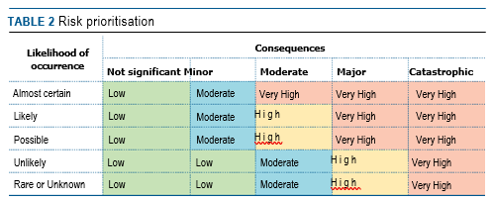

Wildlife Conservation Plan for Seabirds 37

Threats
Categories for likelihood are defined as follows:
- Almost certain – expected to occur every year
- Likely – expected to occur at least once every five years
- Possible – might occur at some time
- Unlikely – such events are known to have occurred on a worldwide basis but only a few times
- Rare or Unknown – may occur only in exceptional circumstances; OR it is currently unknown how often the incident will occur
Categories for consequences are defined as follows:
- Not significant – no long-term effect on individuals or populations
- Minor – individuals are adversely affected but no effect at population level
- Moderate – population recovery stalls or reduces
- Major – population decreases
- Catastrophic – population extinction
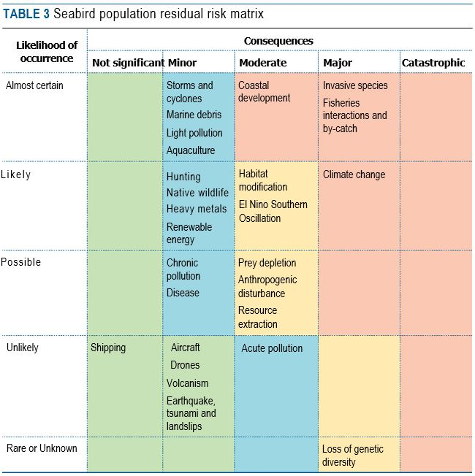

38 Wildlife Conservation Plan for Seabirds


1 International cooperation and collaboration continue to support the survival of seabirds and their habitats outside Australian jurisdiction.
2 Seabirds and their habitats are identified, protected and managed in Australia.
3 The long-term survival of seabirds and their habitats is achieved through supporting
priority research programs, coordinated monitoring, on-ground management
and conservation.
4 Increase the awareness of the importance of conserving seabirds and their
habitats through community education and capacity building to support monitoring
and on-ground management.
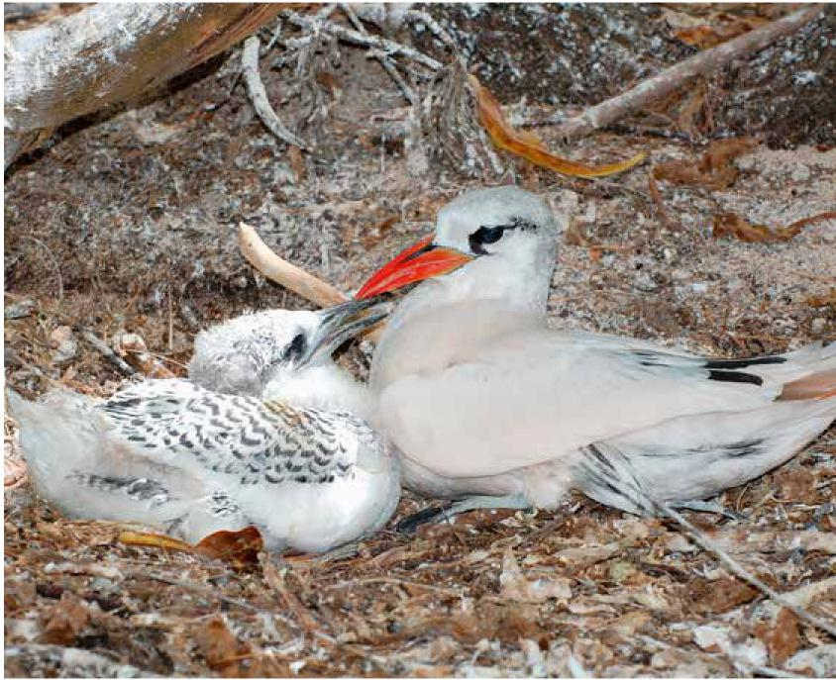

Wildlife Conservation Plan for Seabirds 39



Actions identified for the protection, conservation and management of the species covered by this plan are described below. Some of the objectives are long-term (>10 years) and may not be fully achieved during the lifetime of this wildlife conservation plan but actions identified will make incremental steps towards the successful progress towards of achieving desired objectives.

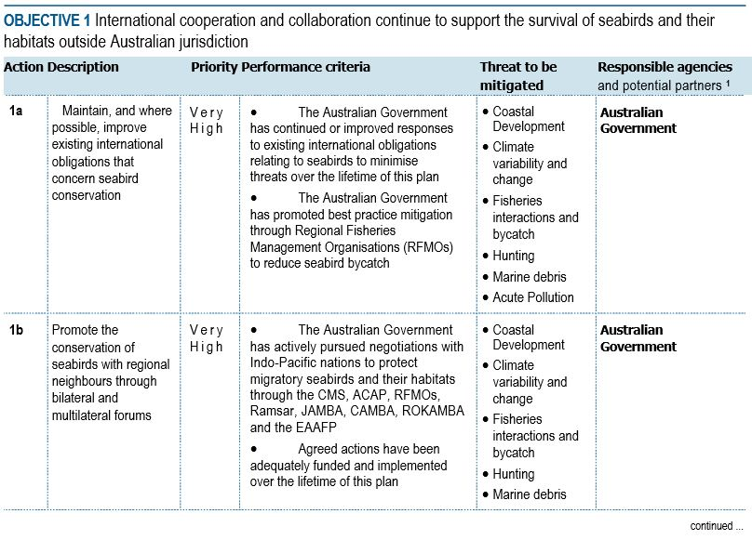

40 Wildlife Conservation Plan for Seabirds
Actions to achieve the specific objectives
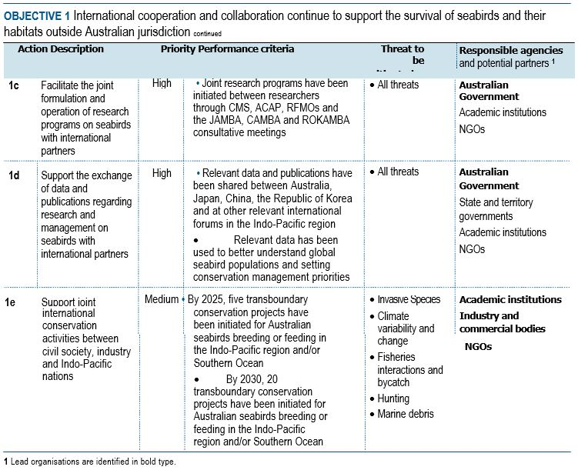
Wildlife Conservation Plan for Seabirds 41

Actions to achieve the specific objectives
42 Wildlife Conservation Plan for Seabirds
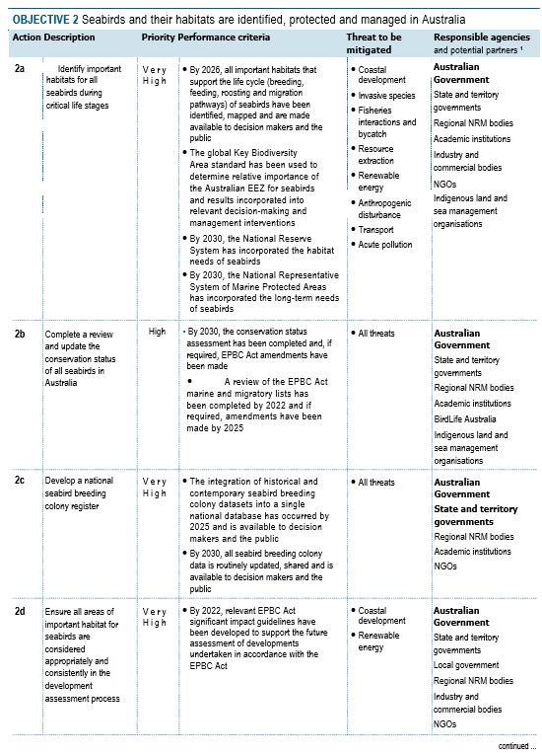

Actions to achieve the specific objective
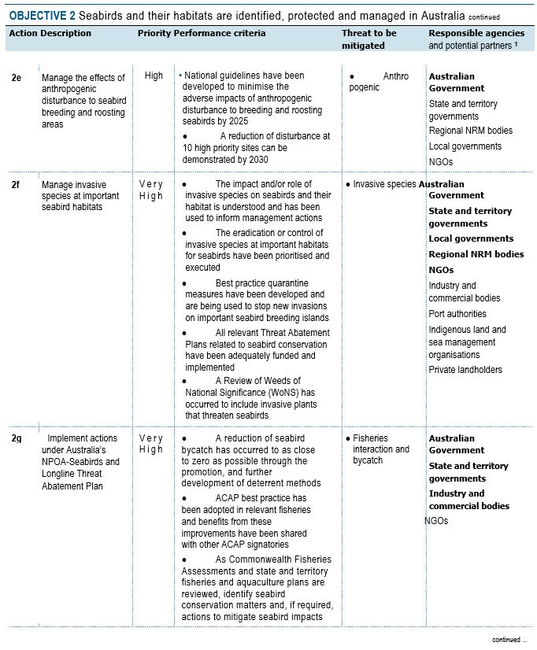
Wildlife Conservation Plan for Seabirds 43

Actions to achieve the specific objective
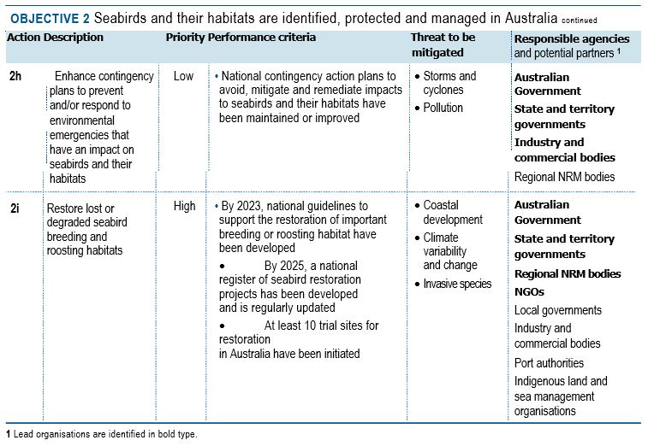

44 Wildlife Conservation Plan for Seabirds

Actions to achieve the specific objectives
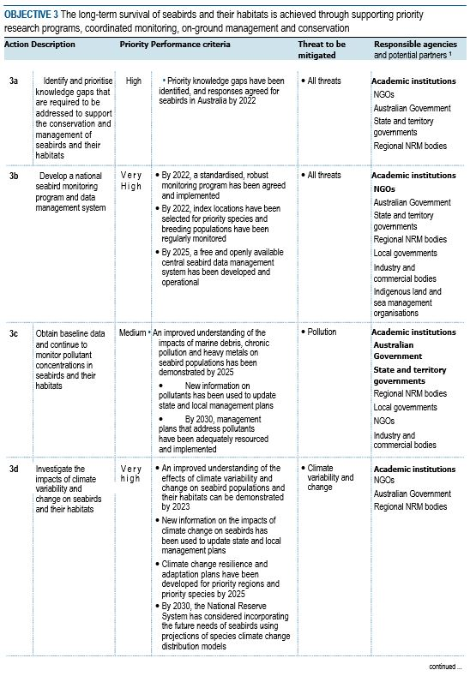
Wildlife Conservation Plan for Seabirds 45

Actions to achieve the specific objectives
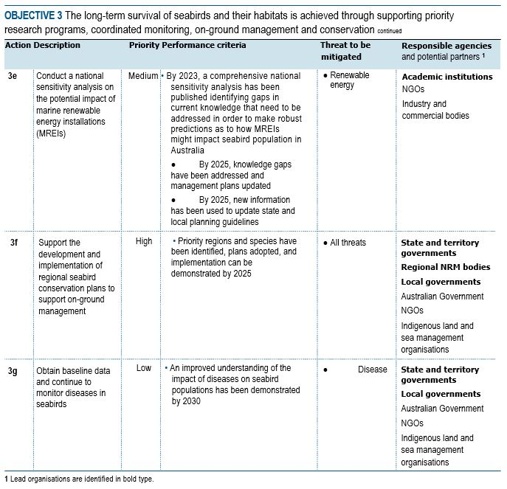

46 Wildlife Conservation Plan for Seabirds

Actions to achieve the specific objective

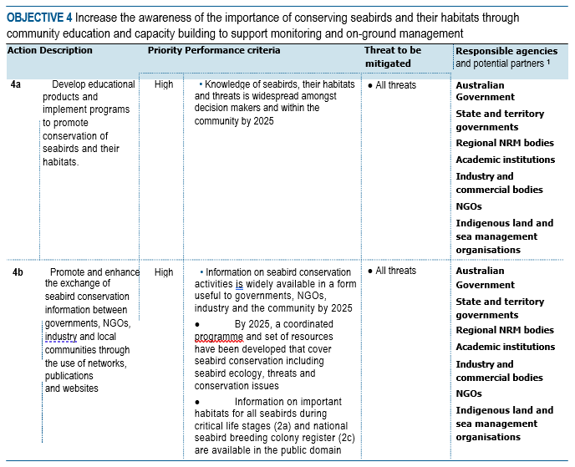

Wildlife Conservation Plan for Seabirds 47


Organisations likely to be affected by the actions proposed in this plan include: international multilateral and bilateral agreements; government agencies (Commonwealth, state and territory, local), particularly those involved with coastal and island environments and conservation programs; Indigenous land and sea management groups (including ranger programmes); researchers; bird watching groups; conservation groups; wildlife interest groups; 4WD and fishing groups; environmental consulting companies; tourism operators; industry and commercial bodies; and, proponents of coastal and island development in the vicinity of important habitat. This list however should not be considered exhaustive, as there may be other interest groups that would like to be included in the future or need to be considered when specialised tasks are required.
The following table lists some of the interest groups, how they could contribute to the success of the plan and the potential benefits/impacts that may emerge from the Plan’s implementation:

48 Wildlife Conservation Plan for Seabirds

Affected interests
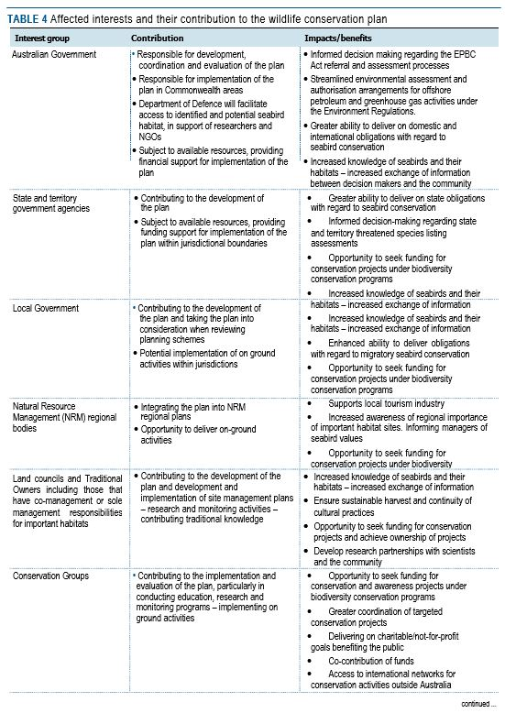

Wildlife Conservation Plan for Seabirds 49

Affected interests

50 Wildlife Conservation Plan for Seabirds


This plan must be formally reviewed no later than five years from when it was endorsed and made publicly available. The review will determine the performance of the plan; whether the plan continues unchanged; whether the plan is varied to remove completed actions and include new conservation priorities; or whether a wildlife conservation plan is no longer necessary for the species.
The review will be coordinated by the Department of Agriculture, Water and the Environment in association with relevant state and territory agencies, and key stakeholder groups including scientific research organisations.

Wildlife Conservation Plan for Seabirds 51

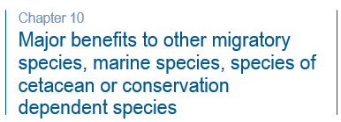
There are 37 seabirds that are currently listed threatened under the EPBC Act.
To promote the recovery of listed threatened species, conservation advices and
where required, recovery plans, are made or adopted in accordance with Part 13 of the EPBC Act. Conservation advices provide guidance at the time of listing on known threats and priority recovery actions that can be undertaken at a local and regional level. Recovery plans describe key threats and identify specific recovery actions that can be undertaken to enable recovery activities to occur within a planned and logical national framework. The implementation of this Plan will benefit a number of threatened species and their habitats. Below is a table of threatened seabirds in Australia, and links to their approved conservation advice and/or recovery plans.
While the Wildlife Conservation Plan for Seabirds focuses on identifying and developing effective management strategies for important habitats, there are also major conservation benefits for those species that share habitats with seabirds. There are a number of major benefits to species other than seabirds that may result from implementation of this Plan. For example, Hooded Plover (Thinornis cucullatus cucullatus) listed as vulnerable under the EPBC Act, shares similar habitat requirements with listed seabirds, as do nesting marine turtles in Western Australia, Northern Territory, Queensland and Commonwealth marine areas, and may all benefit from habitat management actions. While coastal and freshwater or coastal wetlands serve as nurseries for many prey species of fish and aquatic invertebrates.
There are at least 18 species of resident shorebirds including the Banded Stilt (Cladorhynchus leucocephalus), Hooded Plover (Thinornis cucullatus) and Australian Pied Oystercatcher (Haematopus longirostris) that share many habitat requirements and would also gain major benefits from the Plan’s implementation.

52 Wildlife Conservation Plan for Seabirds

Major benefits to other migratory species, marine species, species of cetacean or conservation dependent species
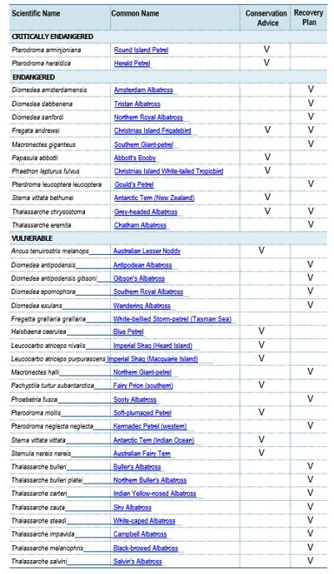
Wildlife Conservation Plan for Seabirds 53

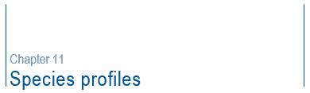Red-tailed Tropicbird (Phaethon rubricauda)
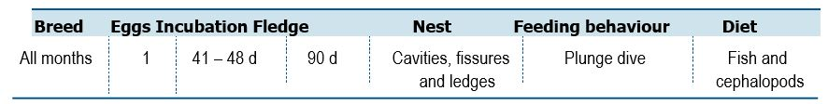
Life History and Distribution
The Red-tailed Tropicbird (Phaethon rubricauda) is a medium sized, oceanic, Indo-Pacific Ocean seabird. Adults are mainly white with bright red bill and very long central rectrices. Sexes are similar with no seasonal plumage changes. At sea, the species is solitary, flying mostly well above the waves with regular, mechanical wing-beats alternating with horizontal glides. The species breeds in tropical and subtropical zones on volcanic and other islands, stacks, atolls, cays away from mainland areas. Nests are located in rugged terrain, on coastal cliffs and slopes but also on cays, at the base of trees with dense leaf canopy that reaches the ground, and coral atolls. Most food is captured by deep plunging vertically into the water. Their diet mainly consists of fish and cephalopods. Movements away from the breeding site are not well known but adults and juveniles appear to disperse widely.
Population Estimates and Trends
The global population is estimated at >32,000 individuals (del Hoyo et al. 1992). The Australian population is poorly known owing to the numerous breeding sites and protracted and asynchronous breeding season making an accurate census difficult. The largest population breeds on Christmas Island (>2,000 pairs) with additional key breeding locations on Cocos (Keeling) Group, islands of Ashmore Reef Marine Park, Lord Howe Island, Norfolk Island, Coral Sea Marine Park and two known islands and cays in the Great Barrier Reef Marine Park. The Herald Cays (Coral Sea Marine Park) support a population in excess of 500 breeding pairs and is the most important breeding site for this species in Eastern Australia (Baker 2008). The population of Red-tailed Tropicbirds on Raine Island, Queensland has increased on average, by approximately 1.4 per cent per year since 1980 (GBRMPA 2019). The national population is suspected to be stable in the absence of evidence for any declines or substantial threats.
54 Wildlife Conservation Plan for Seabirds

Species profiles
Conservation Concerns and Actions
Invasive species, particularly rats and cats, have caused significant losses in Red-tailed Tropicbird colonies. The species has been shown to benefit from eradications that have been carried out to date. An increased frequency and intensity of tropical storm and cyclones may reduce breeding success. Sea level rise has the potential to eliminate breeding habitat on low lying islands and cays.
Recommended Management Actions
- Determine Red-tailed Tropicbird breeding population numbers and trends
- Manage human disturbance at breeding localities, particularly when adults are incubating eggs
- Control, or eradicate invasive species at breeding localities
- Implement best practice quarantine measures at breeding colonies to reduce the risk of any invasive species (re)establishing on islands
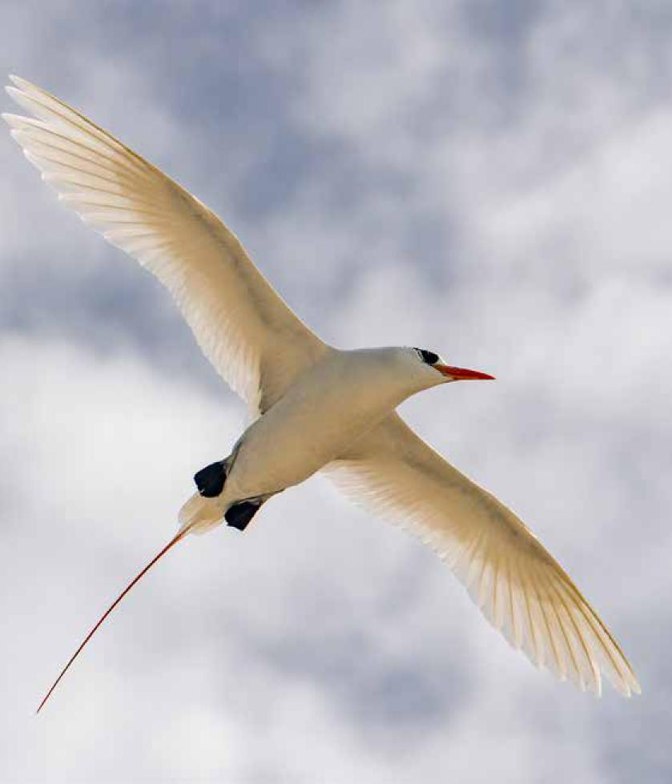

Wildlife Conservation Plan for Seabirds 55

Species profiles
White-tailed Tropicbird (Phaethon lepturus)

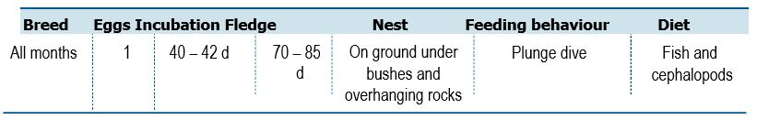

Life History and Distribution
The White-tailed Tropicbird (Phaethon lepturus) is a distinctive, medium sized white seabird with black diagonal bar on the inner upperwing, black based outer primaries and long white central tail feathers and yellow bill. It is much smaller than the Red-tailed Tropicbird. The species is pantropical, breeding at many locations, though usually in low numbers. Two subspecies occur in Australia, subspecies fulvus is listed endangered under the EPBC Act. The species is most common off North West Australia and a rare visitor to the Coral Sea and east coast. The species is primarily oceanic in tropical waters, rarely inshore, and only is near land when breeding. Nests are located on islands and atolls utilising a variety of habitats from closed canopy rainforest to bare sandy ground and rugged rocky terrain. The species feeds mainly on fish and cephalopods, captured by deep plunge diving. Patterns of movement away from the breeding sites is not well known.
Population Estimates and Trends
The global population is estimated at >50,000 individuals (del Hoyo et al. 1992). The Australian population is poorly known owing to the numerous breeding sites and protracted and asynchronous breeding season making an accurate census difficult. The largest population breeds on Christmas Island (6,000–12,000 pairs; subspecies fulvus) and is believed to be in decline with additional breeding locations on Cocos (Keeling) Group and islands of Ashmore Reef Marine Park (subspecies lepturus).
Conservation Concerns and Actions
Cyclones and tropical storms have been known to cause high levels of mortality of both chicks and brooding adults. Habitat affected by the storms may also render nesting sites temporarily unusable. The species readily adapts to artificial nesting sites and studies show that it can increase nesting success when compared to natural nests. Invasive species, particular rats and cats, have caused significant losses in White-tailed Tropicbird colonies. Invasive plants can render nest sites unsuitable. Tropicbirds are vulnerable to oil pollution at sea.
Recommended Management Actions
- Determine White-tailed Tropicbird breeding population numbers and trends
- Trial artificial nesting shelters to improve nesting success in disturbed habitats
- Control, or eradicate invasive species at breeding localities
- Implement best practice quarantine measures at breeding colonies to reduce the risk of any invasive species (re)establishing on islands
56 Wildlife Conservation Plan for Seabirds

Species profiles
Matsudaira’s Storm-petrel (Hydrobates matsudairae)

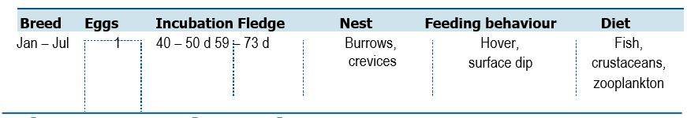

Life History and Distribution
The Matsudaira’s Storm-petrel (Hyrobates matsudairae) is a dark-brown storm-petrel with long angular wings. Tail is long and forked. The species occupies a small
breeding range in southern Japan, probably only two islands. It is known to breed on Minami-Iwo-Jima, and perhaps on Kita-Iwo-Jima. It has also been recorded around Ogasawara Islands and it is assumed to breed there but required confirmation. The species is a colonial breeder, nesting in burrows on high ground. Breeding is thought to begin in January, with most young fledging by June. After the breeding season, birds move south to the Timor Sea, north-west Australia and into the northern Indian Ocean. During the non-breeding season Matsudaira’s Storm-petrel remains in oceanic waters far from the coast.
Population Estimates and Trends
No quantitative data are available on the species population, although it is reported to be locally common in its breeding range and its abundance in the Indian Ocean has led to the suggestion that the global population is at least 20,000 individuals. The population trend is difficult to determine because of uncertainty over the main threats to the species. The species has been assessed as globally vulnerable under IUCN criteria on the basis that it occupies a small range when breeding and is susceptible to stochastic events and human impacts.
Conservation Concerns and Actions
Black Rats (Rattus rattus) became established on Kita-Iwo-Jima apparently following the Second World War and are considered to have caused local extirpations. There does not appear to be any recent breeding records from the island. Rats pose a threat to birds attempting to recolonise the island. A greater threat would be the introduction of rats to the only known breeding island, Minami-Iwo-Jima. Storm-petrels are known to be vulnerable to oil pollution at sea and marine debris.
Recommended Management Actions
- Gain an improved understanding of at sea distribution in north west Australia
- Exchange information on successful Rattus spp. eradiation techniques with Japanese authorities
- Facilitate the collaboration between Australian and Japanese researchers to survey and monitor known colonies, study ecological requirements, search for undocumented breeding colonies in suitable habitat

Wildlife Conservation Plan for Seabirds 57

Species profiles
Swinhoe’s Storm-petrel (Hydrobates monorhis)

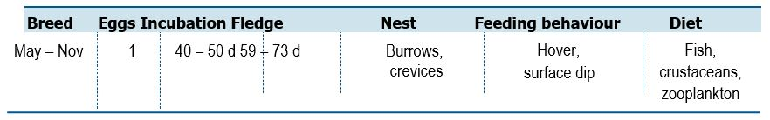
Life History and Distribution
Swinhoe’s Storm-petrel (Hydrobates monorhis) is a small dark brown seabird that has a fluttering flight. The species can be found over oceanic and inshore waters. The species breeds on islands in the north-west Pacific Ocean off Russia, Japan, the Republic of Korea and China. Breeding starts in April forming loose colonies close to the sea in rock crevices and lays a single egg. The species is strictly nocturnal at the breeding sites to avoid predation by gulls and skuas. Outside the breeding season the species migrates into the Indian Ocean and Arabian Sea.
Population Estimates and Trends
Based on estimates of Brooke (2004) and Sato et al. (2010) the global estimate of the species is estimated between 65,000 – 260,000 mature individuals. Birds Korea (2010) estimated that 100,000 pairs nest on Gugeul Islet, Republic of Korea which if accurate, suggests that one island holds a significant proportion of the global population. Little is known about the Chinese breeding population. The Australian population is poorly known owing to the oceanic nature of the species.
The species is listed as globally near threatened based on IUCN criteria, on the basis that its population is expected to undergo a moderately rapid decline over the next three generations, owing to the impacts of introduced species and anthropogenic disturbance.
Conservation Concerns and Actions
Swinhoe’s Storm-petrel is threatened by a number of invasive species, including Brown Rats (Rattus norvegicus) and Oriental Chaff Flower (Achyranthes japonica) in Japan and the Republic of Korea. The seeds of the invasive plant represent an entrapment risk, particularly for adults. There has been a decrease in the population of Swinhoe’s Strom-petrels in Japan. Colonies have been adversely affected by mining activities and anthropogenic disturbance. The breeding population on Verkhovsky Island, Russia is likely threatened by recreational users in summer months.
Recommended Management Actions
- Gain an improved understanding of at sea distribution in north west Australia
- Exchange information on successful Rattus spp. eradiation techniques with Korean and Japanese authorities
- Facilitate the collaboration between Australian, Korean and Japanese researchers to survey and monitor known colonies, study ecological requirements, search for undocumented breeding colonies in suitable habitat
58 Wildlife Conservation Plan for Seabirds

Species profiles
Wildlife Conservation Plan for Seabirds 59

Wilson’s Storm-petrel (Oceanites oceanicus)
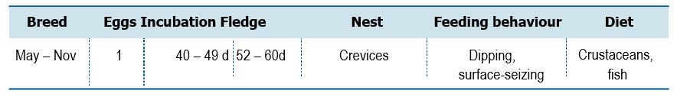

Life History and Distribution
Wilson’s Storm-petrel (Oceanites oceanicus) is a small blackish storm-petrel with proportionately short rounded wings, square tail and long thin legs. In flight, feet usually project well beyond the tail. This species has an extremely large range, but most often seen over continental shelf waters. The breeding range of Wilson’s Storm-petrels includes subantarctic islands from Cape Horn (Chile) east to the Kerguelen Islands (French Southern Territories), Macquarie Island, Heard Island and coastal Antarctica. The species undergoes a trans-equatorial migration, spending the nonbreeding season in the north Atlantic and north Indian Oceans. A number of individuals also migrate into the North Pacific Ocean. The species breeds in rocky crevices, on cliffs and amongst boulder scree. It feeds in cold waters with a diet comprised of planktonic crustaceans (especially krill) and fish.
Population Estimates and Trends
Brooke (2004) estimated the global breeding population to number 4–10 million breeding pairs. The Australian population is poorly known owing to their small size and their cryptic nature on land. A couple of pairs of Wilson’s Storm-petrel were detected in 1993 at Bishop and Clerk Island (Brothers and Ledingham 2008) and are also likely to be breeding on Macquarie Island (Tasmanian Parks and Wildlife Service unpublished data). In the absence of reliable population data, their current population trend is unknown.
Conservation Concerns and Actions
The species is vulnerable from invasive species. On the Kerguelen and Crozet Islands, rats are reported to take chicks and eggs, causing nest failure. Cats may take adults in addition to chicks. Storm-petrels are known to be vulnerable to oil pollution at sea and marine debris.
Recommended Management Actions
- Gain an improved understanding of at sea distribution in Australia
Species profiles
Grey-backed Storm-petrel (Garrodia nereis)
60 Wildlife Conservation Plan for Seabirds
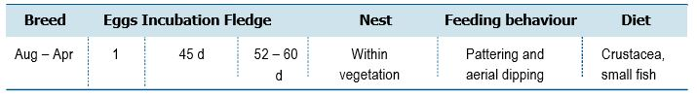
Life History and Distribution
The Grey-backed Storm-petrel (Garrodia nereis) is the smallest storm-petrel in the Southern Ocean. At sea, the species appears as a tiny, fast flying storm-petrel with a small and slender body and square cut tail. The species has a circumpolar distribution in the subantarctic, breeding on islands from the Falkland Islands (Islas Malvinas) in the south-west Atlantic Ocean east to the Chatham Islands, New Zealand. The species breeds on Macquarie Island and is considered a non-breeding bird at Heard Island. Grey-backed Storm-petrels winter off the southern coast of Argentina and Australia. Its diet comprises mainly of immature barnacles and other crustaceans, but also small squid and occasionally small fish. It catches prey mostly by pattering over the surface whilst in flight, but also by dipping and shallow plunging. It has been seen to attend trawlers and occasionally follows ships. Its breeding season starts in October or November, with individuals forming loose colonies creating burrows in vegetation or nesting in crevices in rocks.
Population Estimates and Trends
The population is not well known however, Brooke (2004) estimated the global population to potentially number over 200,000 individuals. The Australian population is unknown. The population is suspected to be in decreasing owing to predation by invasive species.
Conservation Concerns and Actions
Grey-backed Storm-petrels are at risk of predation by invasive species such as rats. Tussock grassland on some breeding islands have been modified by grazing by invasive species and fire. A number of individuals are killed each year due to light-induced collisions with boats. Storm-petrels are known to be vulnerable to oil pollution at sea and marine debris.
Recommended Management Actions
- Gain an improved understanding of the at sea distribution in Southern Ocean
- Confirm breeding on Macquarie Island
- Mitigate against impacts of light pollution by boats at sea

Species profiles
White-faced Storm-petrel (Pelagodroma marina)
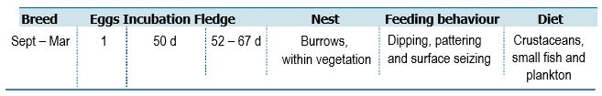

Life History and Distribution
The White-faced Storm-petrel (Pelagodroma marina) is a medium sized, distinctively patterned storm-petrel, common over inshore and oceanic waters around southern Australia. The species has an extremely large range and breeds on remote islands in the North and South Atlantic Ocean and on the coast of southern Australia and New Zealand. Outside the breeding season the Australian population range as far as the northern Indian Ocean and the north-west coast of South America. The species can normally be found over oceanic waters except when close to breeding colonies. The species feeds mostly on planktonic crustaceans and small fish. It feeds mainly of the wing by pattering and dipping. The species rarely follows ships but is known to follow cetaceans. White-faced Storm-petrels generally breed in colonies during spring and summer, forming burrows in flat areas with low herbaceous vegetation but also in rocky areas and on slops. The species is migratory, moving from temperate breeding areas to tropical and subtropical waters.
Population Estimates and Trends
Brooke (2004) estimated the global population to number at least 4 million individuals. The European population is estimated at 77,000–111,000 pairs and is estimated to have decreased by less than 25 per cent in 46 years (three generations). In NSW the species may have declined by as much as 85 per cent since the 1970s but precise data from initial surveys is lacking (N. Carlile pers. comm). The Australian population is unknown. The population is suspected to be in decreasing owing to predation by invasive species.
Conservation Concerns and Actions
The species is threatened by invasive species such as rabbits, rats, mice and cats. Expanding Silver Gull (Chroicocephalus novaehollandiae) breeding colonies have been attributed to the decrease of some White-faced Storm-petrel colonies following shifts in the vegetation community composition and erosion. Spiny woody weed infestations (i.e. Boxthorn Lycium chinense) may impact on nest sites, restricted access and cause impalement (Sir Joseph Banks Group, SA). Fires can adversely affect vegetation on breeding islands.
Recommended Management Actions
- Survey and quantify breeding colonies in Australia.
- Regularly monitor breeding colonies and reproductive success, particularly in the presence of Silver Gull breeding colonies
- Control, or eradicate invasive species from known (and former) breeding islands
- Establish new breeding colonies
- Mitigate against impacts of light pollution around breeding colonies
- Gain an improved understanding of the at sea distribution in Southern Ocean
Wildlife Conservation Plan for Seabirds 61

Species profiles
Black-bellied Storm-petrel (Fregetta tropica)
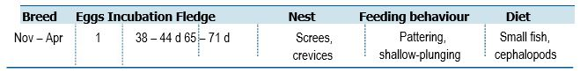

Life History and Distribution
The Black-bellied Storm-petrel (Fregetta tropica) is a medium sized storm-petrel with conspicuous white sides to the abdomen, central underwings, flanks and rump. The species breeds on subantarctic islands and migrates to subtropical and tropical zones of the Atlantic, Indian and Pacific Oceans, regularly occurring north to the Equator. Its breeding season begins in November, when it forms loose colonies on bare rocky slopes, in vegetation or peat of offshore islands or stacks. The species may be associated with cool water currents where it feeds on squid and small fish.
Population Estimates and Trends
Brooke (2004) estimated the global population to number 500,000 individuals. The Australian population is unknown.
Conservation Concerns and Actions
Black-bellied Storm-petrels are at risk of predation by invasive species such as rats.
A number of individuals are killed each year due to light-induced collisions with boats.
Storm-petrels are known to be vulnerable to oil pollution and marine debris.
Recommended Management Actions
- Determine the relationship between breeding distribution and existing and projected marine productivity for Australian taxa
- Manage key sites to retain their value under projected climate change scenarios
- Gain an improved understanding of the at sea distribution in Southern Ocean
- Mitigate against impacts of light pollution by boats at sea
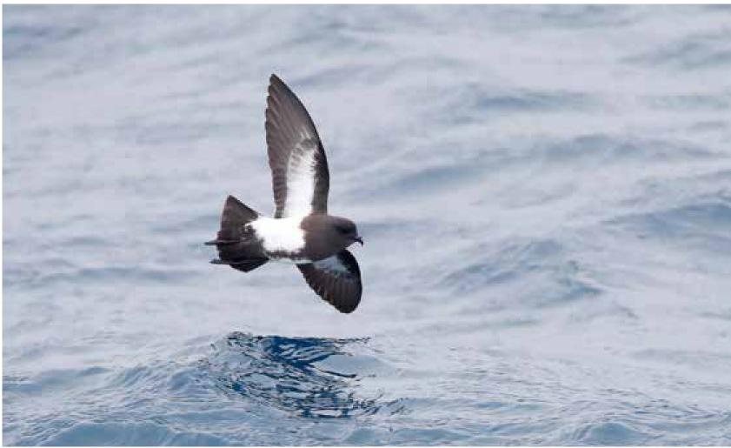
62 Wildlife Conservation Plan for Seabirds

Species profiles
Cape Petrel (Daption capense)
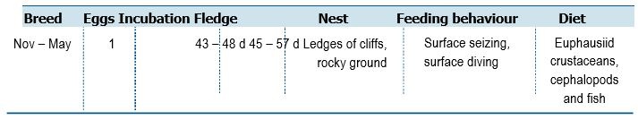

Life History and Distribution
The Cape Petrel (Daption capense) is a distinctive, medium-sized, stockily built petrel with strikingly chequered and patterned black and white upperparts. The species has an extremely large range covering the entire Southern Ocean. The Cape Petrel is oceanic, occurring mainly over cold waters beyond the continental shelf but can be found over inshore waters during the breeding season. The main breeding grounds are on Antarctic and sub-Antarctic islands, including Auckland, Chatham and Campbell Islands. The breeding season starts in November with colonies of variable sizes being formed on cliffs or steep rocky slopes. It nests in shallow crevices, in scrape on rocky ledges, on stable beds of gravel or among boulders. During the breeding season, Cape Petrels feed predominately around Antarctica and the sub-Antarctic islands. Its diet comprises mainly of krill, but also fish, squid, offal, carrion and refuse from ships, acquiring food by hydroplaning, dipping whilst on the wing and surface diving. Cape Petrels are known to associate with whales and other seabirds and congregate in large flocks around trawlers.
Population Estimates and Trends
The global population is thought to exceed 2 million individuals (Brooke 2004). In the 1980s, the New Zealand breeding population was estimated to be between 5,000–10,000 pairs (Robertson and Bell 1984). There is a small breeding population at Macquarie Island, likely to be increasing at Macquarie Island after the successful Macquarie Island Pest Eradication Project (DPIPWE pers. comm). In 2003/04, breeding estimates from Heard Island are between 1,000–2,500 pairs (E. Woehler pers. comm). The population is suspected to be stable in the absence of evidence for any decreases or substantial threats.
Conservation Concerns and Actions
Cape Petrels are known to be adversely impacted by invasive species on breeding islands. Ingestion of marine debris may impact some individuals.
Recommended Management Actions
- Gain an improved understanding of the at sea distribution in the Southern Ocean
- Quantify the breeding population on Heard Island
- Work with range states to control, or eradicate invasive species on breeding islands
- Implement best practice quarantine measures at breeding colonies to reduce the risk of any invasive species (re)establishing on islands

Wildlife Conservation Plan for Seabirds 63
Species profiles
Broad-billed Prion (Pachyptila vittata)
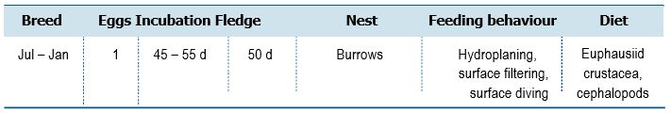
Life History and Distribution
The Broad-billed Prion (Pachyptila vittata) is the largest prion with a large, broad, glossy iron grey bill, high forehead, sombre facial pattern and prominent blue-grey collar impart appearance of large dark head compared to other prions. The species has an extremely large range extending from the Southern Ocean to the South Atlantic Ocean. The species breeds on Gough Island and Tristan da Cunha in the south Atlantic Ocean and on the Chatham Islands, New Zealand. Breeding starts in July or August and individuals are strongly colonial, nesting in burrows which are sometimes occupied by more than one pair. Broad-billed Prions breed on a variety of substrates and areas including, coastal slopes, flat lava fields, offshore islets and cliffs, dry rocky soil, caves and scree. Adults are thought to remain in waters adjacent to breeding colonies, however, young birds seem to occur farther north to Australia and South Africa. The diet of this species is comprised mostly of crustaceans (especially copepods), squid and some fish. The species apparently takes more crustaceans in summer and small squid in winter. Prey is obtained usually by hydroplaning and by filtering or surface seizing.
Population Estimates and Trends
The global population has been estimated to exceed 15 million individuals (Brooke 2004). The population is suspected to be decreasing owing to predation from invasive species.
Conservation Concerns and Actions
The main threats faced by the Broad-billed Prion come from introduced
predators. House Mice (Mus musculus) on Gough Island are adversely impacting reproductive success and causing very rapid population decreases (Cuthbert et al. 2013, Dilley et al. 2015). Estimates of breeding success were only 6 per cent from the 2009-10 and 2010-11 breeding seasons (Cuthbert et al. 2013), and chick mortality in 2014 was 100 per cent (Dilley et al. 2015). The population by 2000-01 had already been estimated to have reduced by more than 80 per cent since the 1960s (Carboneras et al. 2018). In New Zealand, rapid decreases and local extirpations have occurred following the introduction of other invasive predators to breeding islands, including rats and stoats in Dusky Sound, Fiordland, cats (Felis catus) on Herekopare Island and Weka (Gallirallus australis) on Jacky Lee Island (Miskelly 2013). Severe weather events also pose a threat. A severe storm in 2010 caused considerable mortality on breeding islands around Stewart Island, New Zealand (Miskelly 2013), and predicted increases in the frequency and intensity of storms may impact part of the population sufficiently to impact the global abundance of the species.
Recommended Management Actions
- Work with range states to control, or eradicate invasive species on breeding islands
64 Wildlife Conservation Plan for Seabirds

Species profiles
Salvin’s Prion (Pachyptila salvini)

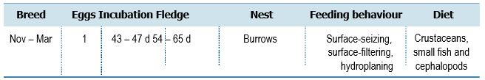

Life History and Distribution
Salvin’s Prion (Pachyptila salvini) is a medium sized prion of the Indian Ocean. The species is very similar to Antarctic Prion (P. desolata) in shape, size, appearance and habits making the two species difficult to separate at sea. The species has an extremely large range which extends from South Africa to Australian and New Zealand. This species normally occurs offshore and can be found in areas of upwelling outside the breeding season. The species breeds on the Prince Edwards Islands (South Africa), Crozet Islands, Amsterdam Islands and St Paul Island (French Southern Territories). Breeding starts in October in huge colonies up to and above one million individuals. It nests in burrows, usually on islands, inland on highland plateau or on slopes with grass or shrubs. It can also be found in caves or crevices (del Hoyo et al. 1992). Its diet is comprised mostly of crustaceans, especially krill, but also fish and squid, all of which it catches either by hydroplaning, surface-seizing or filtering.
Population Estimates and Trends
Brooke (2004) estimated the global population to exceed 12 million individuals. The population is suspected to be stable in the absence of evidence from any decreases or substantial threats.
Conservation Concerns and Actions
Black Rats (Rattus rattus) have had a considerable impact on colonies in the past, causing them to shift to locations above the tree-line, and are likely to still be causing decreases within the very large breeding colonies. Cats also have some effect and are present on Cochons Island but are too large to enter burrows although it is thought that predation of adults occurs along with that of near-fledged chicks (del Hoyo et al. 2019).
Recommended Management Actions
- Gain an improved understanding of the at sea distribution in the Southern Ocean
- Work with range states to control, or eradicate invasive species on breeding islands

Wildlife Conservation Plan for Seabirds 65

Species profiles
Antarctic Prion (Pachyptila desolata)
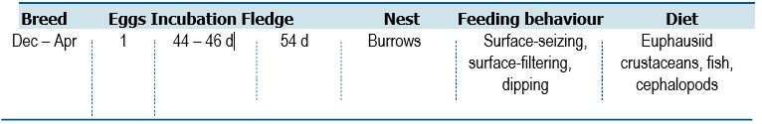

Life History and Distribution
The Antarctic Prion (Pachyptila desolata) is an abundant, medium sized prion of Antarctic and subantarctic waters, ranging into subtropical waters. The species is very similar to Salvin’s Prion (P. salvini) from which it is difficult to distinguish at sea. The species has an extremely large range and occurs in the Indian, Southern and Atlantic Oceans. The Antarctic Prion breeds on islands in the southern oceans, including the Crozet Islands and Kerguelen Island (French Southern Territories), Macquarie Island and Heard Island (Australia), the Auckland Islands (New Zealand), South Georgia (Georgias del Sur), the South Sandwich Islands (Islas Sandwich del Sur), Scott Island and the Scotia Archipelago. All birds leave the colonies after breeding, dispersing from pack ice in Antarctica to as far north as Peru, and also occurring off South Africa and Australia. This species breeds on slopes under grass tussocks, in rock crevices or scree, or on cliffs. Its prey is mostly crustaceans (especially krill, copepods and amphipods), but also small quantities of fish and squid (del Hoyo et al. 1992).
Population Estimates and Trends
Brooke (2004) estimated the global population to number 50 million individuals. The breeding population on Macquarie and Heard Islands has not been quantified for some time. On Macquarie Island, abundance was estimated at approx. 49,000 pairs from surveys conducted between 1975 and 1982 (Brothers 1984, Tasmanian Parks and Wildlife Service 2006). Results are pending from the most recent island population census undertaken in 2018 (University of Queensland and Tasmanian Parks and Wildlife Service unpublished data). On Heard Island the population was estimated at 100,000 pairs in 2003/04 (Woehler 2006, 2010). The population is suspected to be in decreasing at some (non-Australian) sites as a result of predation by invasive species, however, is likely to be increasing at Macquarie Island after the successful eradication of introduced rodent predators during the Macquarie Island Pest Eradication Project (DPIPWE pers. comm.).
Conservation Concerns and Actions
This species is decreasing at some sites due to a number of invasive species.
The Antarctic Prion appeared to be unable to successfully nest in the presence of Brown Rats on South Georgia, and possibly in other parts of the range (Marchant and Higgins 1990). Feral pigs and cats are known to kill large numbers on the Auckland Islands. The population on Macquarie Islands is expected to increase as a result of eradication efforts of invasive species.
Recommended Management Actions
- Quantify the breeding population on Heard Island
- Consolidate current population data from Macquarie Island
- Regularly monitor breeding populations at index locations
- Determine non-breeding areas and migration routes
- Work with range states to control, or eradicate invasive species on breeding islands
- Implement best practice quarantine measures at breeding colonies to reduce the risk of any invasive species (re)establishing on islands
66 Wildlife Conservation Plan for Seabirds

Species profiles

Slender-billed Prion (Pachyptila belcheri)

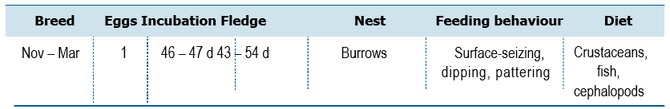
Life History and Distribution
The Slender-billed Prion (Pachyptila belcheri) is a small, pale prion of Antarctic and subantarctic waters. It can be distinguished from other prions by the small head, slender body and slender bluish bill, mostly white lores and broad white supercilium giving a striking pale-face appearance. The species has an extremely large range. The Slender-billed Prion breeds in the Crozet Islands and the Kerguelen Islands (French Southern Territories), the Falkland Islands (Islas Malvinas) and Noir Island, Chile. The species possibly breeds on Macquarie Island. Outside the breeding season it can be found over much of the Southern Ocean, including the coasts of South Africa, Australia and South America as far north as Uruguay and southern Peru. The species can usually be found over oceanic waters but will feed inshore or in shallow offshore waters during the breeding season. It feeds mostly on crustaceans with a high dependence on amphipods but can also take small fish and squid. It catches prey mainly by surface-seizing, dipping and pattering at night. Breeding starts in October in loose colonies in coastal areas with soft or stony soil and low vegetation. It nests in burrows in soft soil or under rocks (del Hoyo et al. 1992).
Population Estimates and Trends
Brooke (2004) estimated the global population to number at least 7 million individuals. The Australian population is unknown. The population is suspected to be stable in the absence of evidence for any decreases or substantial threats.
Conservation Concerns and Actions
The largest colony of Slender-billed Prion, on New Island in the Falklands, has suffered predation from cats (Felis catus) and rats, but appears naturally resilient to this pressure (Hilton and Cuthbert 2017) and eradications have further nullified any population impacts (del Hoyo et al. 2019). Cat predation is however ongoing on Iles Kerguelen, and may be having impacts here alongside predation from skuas on non-breeding birds (del Hoyo et al. 2019).
Recommended Management Actions
- Gain an improved understanding of the at sea distribution in the Southern Ocean
- Determine breeding status on Macquarie Island
- Work with range states to control, or eradicate invasive species on breeding islands
- Implement best practice quarantine measures at breeding colonies to reduce the risk of any invasive species (re)establishing on islands
Wildlife Conservation Plan for Seabirds 67

Species profiles
Fairy Prion (Pachyptila turtur)
68 Wildlife Conservation Plan for Seabirds
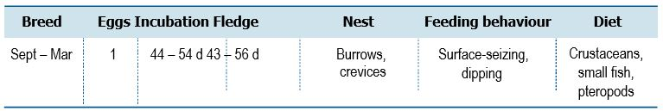
Life History and Distribution
The Fairy Prion (Pachyptila turtur) is small, circumpolar prion frequenting subantarctic and subtropical waters. The species has a rounded crown, rounded wings and a fairly long wedge-shaped tail. At sea it may be confused with Fulmar Prion (P. crassirostris). Two subspecies breed in Australia, turtur and subantarctica. The subspecies subantarctica has previously been detected breeding on two rock stacks off Macquarie Island in 1979 (Brothers 1984) and Bishop and Clerk Island in 1993 (Brothers and Ledingham 2008) and is listed as vulnerable under the EPBC Act. Fairy Prions can be found breeding on the Chatham Islands, Snares Islands and Antipodes Islands of New Zealand, islands around Tasmania, including the Bass Strait Islands of Australia, the Crozet Islands (French Southern Territories) in the south Indian Ocean and the Falkland Islands (Islas Malvinas) and South Georgia (Georgia del Sur) in the South Atlantic (del Hoyo et al. 1992). The breeding season starts in September and the species is highly colonial, creating burrows in coastal sites on oceanic islands (del Hoyo et al. 1992). The species occurs mainly offshore but may move inshore during stormy weather. Its diet is comprised mostly of crustaceans (especially krill), but occasionally includes some fish and squid. It feeds mainly by surface-seizing and dipping but can also
catch prey by surface-plunging or pattering. It often associates with other prions and storm-petrels when feeding around boats.
Population Estimates and Trends
Brooke (2004) estimated the global population to number around 5 million individuals. The Australian breeding population and trends are unknown. The subspecies subantarctica is thought to number as few as 50 pairs (Brothers 1984) but is expected to increase with the successful eradication of Black Rats (Rattus rattus) from
Macquarie Island where it may recolonise the main island. The population status of P. turtur at breeding locations around Tasmania (e.g. Port Davey islands, Maatsuyker Island group, Tasman Island, and islands in Bass Strait including Albatross Island and Black Pyramid) is unknown. The global population of P. turtur is suspected to be stable in the absence of evidence of any population decreases or substantial threats.

Species profiles

Conservation Concerns and Actions
Although the Fairy Prion is not thought to be experiencing any significant threats across the majority of its range, the population in the Kerguelen Islands suffers ongoing predation from cats. The removal of cats from Tasman Island in Tasmania in 2010/11 has resulted in a population increase on that island (Tasmanian Parks and Wildlife Service, unpublished data). Procellariiform seabirds are have the highest incidence of marine debris ingestion so may be susceptible to plastic ingestion.
Recommended Management Actions
- Survey and regularly monitor breeding populations at index locations
- Determine breeding parameters for this species in Australia
- Determine non-breeding areas and migration routes
- Work with range states to control, or eradicate invasive species on breeding islands
- Implement best practice quarantine measures at breeding colonies to reduce the risk of any invasive species (re)establishing on islands
Wildlife Conservation Plan for Seabirds 69
Species profiles
Fulmar Prion (Pachyptila crassirostris)

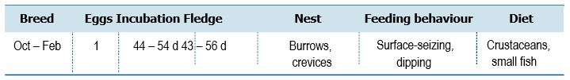
Life History and Distribution
The Fulmar Prion (Pachyptila crassirostris) is a relatively rare prion similar in size and
appearance to the more abundant Fairy Prion (P. turtur). The Fulmar Prion is oceanic
and stays over the southern oceans close to colonies. When breeding, birds come ashore
and nest on Heard Island (Australia; subspecies eatoni) in the south Indian Ocean,
and the Auckland Islands, Chatham Islands, Bounty Island and Snares Island off the
coast of New Zealand (subspecies crassirostris). Breeding occurs in colonies starting
in October, nesting on coastal cliffs and boulder slopes in rock crevices and cracks
(del Hoyo et al. 1992). Little else is known about the breeding ecology of the species.
Its diet comprises mostly of crustaceans but fish, squid and molluscs are also taken.
Population Estimates and Trends
The global population is estimated to be between 150,000–300,000 individuals (Brooke 2004). The population on Heard Island is estimated to be at least 10,000 breeding pairs (Woehler 2006, 2010). The population is suspected to be stable in the absence of evidence of any decrease or substantial threats.
Conservation Concerns and Actions
On Auckland Island, predation by Cats (Felis catus), dogs (Canis familiaris) and pigs (Sus domesticus) is thought to be impacting the breeding population, and on other islands the presence of invasive species may be prohibiting establishment (or re-establishment). Information is poor on the degree to which the species is affected and there is some concern that impacts in some colonies may be severe. The introduction of predators to Heard Island is a plausible threat (Garnett et al 2011).
Recommended Management Actions
- Regularly monitor breeding populations at index locations
- Study the breeding biology of the species
- Work with range states to control, or eradicate invasive species on breeding islands
- Implement best practice quarantine measures at breeding colonies to reduce the risk of any invasive species (re)establishing on islands
70 Wildlife Conservation Plan for Seabirds

Species profiles
Bulwer’s Petrel (Bulweria bulwerii)
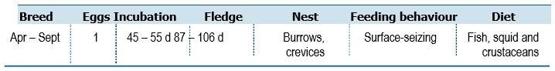

Life History and Distribution
Bulwer’s Petrel (Bulweria bulwerii) is a small all-dark petrel similar in size to small gadfly petrels (Pterodroma spp.) and prions (Pachyptila spp.) with strikingly long wings and long wedge-shaped tail. The species is pantropical, being found in all three oceans outside the breeding season. Breeding sites include the eastern Atlantic from the Azores, Portugal to Cape Verde, and the Pacific from eastern China and the Bonin Islands (Japan), east to the Hawaiian Islands (USA), and the Marquesas Islands (French Polynesia) (del Hoyo et al. 1992). The breeding season begins in April or May, with individuals forming colonies in a wide variety of habitats on offshore islands. Nests are usually in burrows, crevices, cracks or caves, under debris or vegetation cover (del Hoyo et al. 1992). After breeding, Bulwer’s Petrel migrate away from colonies but movements are not well understood. Birds are seen off north-west Australia between September and April and are thought to be on migration into the Indian Ocean. The diet comprises mainly of fish and squid, with minor proportions of crustaceans and sea-striders, feeding largely at night by surface-seizing.
Population Estimates and Trends
Brooke (2004) estimated the global population to number between 500,000–1 million individuals. The Australian population is unknown but observations have increased off north-west Australia, Christmas Island and the islands of Ashmore Reef in recent decades. The population is suspected to be stable in the absence of evidence of any decreases or substantial threats.
Conservation Concerns and Actions
Predation by cats (Felis catus) and Black Rats (Rattus rattus) occurs over portions of the breeding range (Cabral et al. 2005, Matias et al. 2009). Feral cats are considered a major driver of the present distribution of the species, on the Azores where breeding areas are restricted to steep cliffs. Black Rats are present on many of the islands on which the species breeds or would be likely to breed, and, along with cats, is thought to be one of the main determinants of the current breeding distribution. The species may be at risk of incidental capture in longline fisheries, but as yet, no significant effects of bycatch on adult mortality have been documented (Waugh et al. 2012). Due to the species foraging habit and wide range overlapping with commercial fishing areas, it is thought to suffer a heightened risk of mortality from oil spills and other marine pollution. Light pollution at night may be an important cause of mortality in some areas, and tourism and recreational developments may reduce available habitat in breeding colonies (del Hoyo et al. 2019).
Recommended Management Actions
- Determine non-breeding areas and migration routes
- Work with range states to control, or eradicate invasive species on breeding islands
Wildlife Conservation Plan for Seabirds 71

Species profiles
Wedge-tailed Shearwater (Ardenna pacifica)

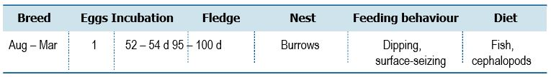

Life History and Distribution
The Wedge-tailed Shearwater (Ardenna pacifica) is a large, lightly built polymorphic shearwater found in the subtropical and tropical Pacific and Indian Oceans between latitudes 35°N and 35°S. The species closely resembles Buller’s Shearwater (A. bulleri) in size and shape. The species occurs in a wide variety of marine habitats, from well inshore to shelf-edge and oceanic waters. Numerous breeding colonies occur on offshore islands along the Western Australian coast, New South Wales and on islands and cays in the Great Barrier Reef, particularly the Capricorn – Bunker Group. Large numbers breed on islands in the Coral Sea Marine Park. The species also breeds on Cocos (Keeling), West Island of Ashmore Marine Park, Lord Howe and Norfolk Islands. It feeds mostly on fish, with some cephalopods and crustaceans. It catches prey mainly on the wing by dipping but also by surface-seizing or pursuit-plunging. Usually solitary or in small parties at sea, but often in large feeding flocks with other species, particularly Sooty Tern (Onychoprion fuscata) and Common Noddy (Anous stolidus). The species will congregate around schooling fish and will often attend trawlers and smaller fishing boats.
Population Estimates and Trends
Brooke (2004) estimated the global population to number >5,200,000 individuals. Australia hosts a large proportion of the global population with approximately 1.1 million pairs breeding in Western Australia (Burbidge et al. 1996) and 560,000 breeding pairs in the Capricorn – Bunker Group, where 95 per cent of the Queensland population occur (Dyer et al 2005). Monitoring data by QPWS&P at Capricornia Cays indicate that there has been almost 40 per cent decline in Wedge-tailed Shearwater population of a 15 year period. Total estimates for North West Island, Heron Island Mast Head and Lady Musgrave in across the 1996-2000 period was 528,909 pairs. Populations of Wedge-tailed Shearwater had declined to 338,836 pairs by 2012–2015 survey period (Hemson 2015). There is no indication that the Capricorn Cays Wedge-tailed Shearwater population has begun to recover. The global population is suspected to be in decreasing but no trend data are available.
72 Wildlife Conservation Plan for Seabirds

Species profiles
Conservation Concerns and Actions
Competition with commercial fisheries potential poses a threat to the species. Over-exploitation of tuna stocks is reducing prey availability (Brooke 2004) as the shearwaters rely on tuna to herd shoals of small fish to the surface where they become available for surface-feeding (Ratcliffe 1999). Human disturbance by visitors to islands where the species breeds have been found to negatively affect breeding success (Benoit and Bretagnolle 2002). Brown Rats (Rattus norvegicus) have in some cases caused local extirpations. Following the eradication of rats from several islands, the species has returned, and is again successfully breeding in these areas (Smith et al. 2006). Small amounts of plastic have been found in Wedge-tailed Shearwater chicks (Verlis et al. 2013). Increased sea surface temperatures have been demonstrated to reduce the provisioning rate, and above a particular temperature threshold reproductive success is nil (Chambers et al. 2011).
Recommended Management Actions
- Investigate the locations and characteristics of key feeding sites during breeding and the means to retain their value under climate change
- Manage key sites to retain their value under projected climate change scenarios
- Regularly monitor breeding populations at index locations
- Determine non-breeding areas and migration routes
- Quantify impacts of fisheries interactions and human disturbance
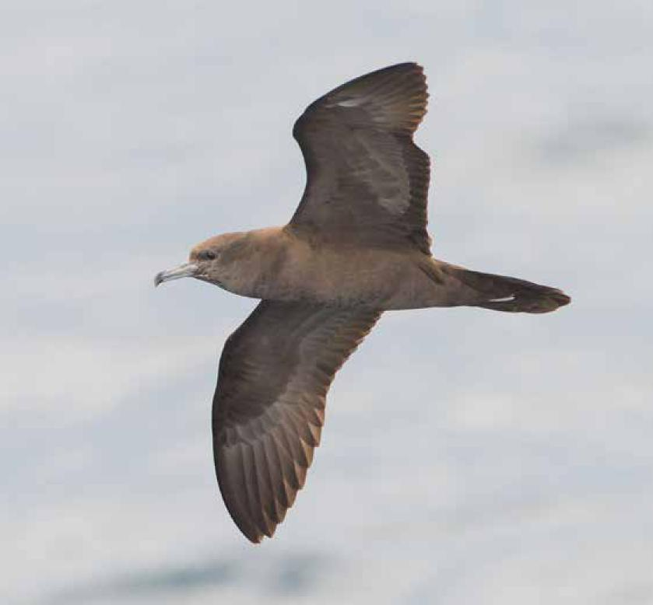

Wildlife Conservation Plan for Seabirds 73

Species profiles

Buller’s Shearwater (Ardenna bulleri)

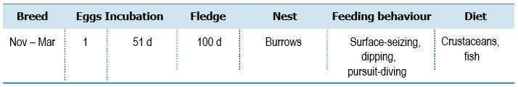

Life History and Distribution
Buller’s Shearwater (Ardenna bulleri) is a large, lightly built shearwater closely resembling Wedge-tailed Shearwater (A. pacifica) in size and shape. The species is widespread in the subtropical south west Pacific Ocean and migrates in the non-breeding season to the northern Pacific Ocean, from Japan to North America. The main non-breeding moult zone appears to be the Emperor Seamounts, a chain of underwater volcanos northwest of Hawaii (BirdLife International 2019). The species occupies a range of marine habitats from inshore to shelf-edge and oceanic zones. The species is a breeding endemic to New Zealand, occupying a variety of habitats on the Poor Knights Islands (Aorangi and Tawhiti Rahi). It nests in burrows or on rock-crevices and ledges, often under dense vegetation. It feeds on krill, small fish, salps and jellyfish (Marchant and Higgins 1990, Heather and Robertson 1997).
Population Estimates and Trends
The total population has been estimated at 2.5 million birds (Marchant and Higgins 1990), although this is now regarded as too high (Waugh et al. 2013; BirdLife International 2019). Between 1938 and 1981, the population on Aorangi increased from approximately 200 to 200,000 pairs (Harper 1983, Heather and Robertson 1997). However, surveys in 2011-13 suggested that there are around 100,000 burrows, similar to estimates in 1960s (Waugh et al. 2013). The species is listed as vulnerable by the IUCN Red List.
Conservation Concerns and Actions
This species is at risk from fisheries by-catch throughout its range. It was previously caught in north Pacific drift-nets (Gould et al. 1998), and is still potentially at risk from set-nets. It may be caught on longlines, in trawling operations and on hand and reel lines, but by-catch levels have not been quantified and documented evidence is scarce (Taylor 2000, Tennyson et al. 2012). Climate change is anticipated to have a significant effect on this species due to its limited breeding range, and its observed sensitivity to climatic fluctuations and apparent lower productivity during La Niña years. Domestic Pigs (Sus domesticus) were previously present on Aorangi Island, but eradicated in the 1930s, when the island was declared a Reserve; vegetation and soil conditions there have subsequently improved (Heather and Robertson 1997).
Recommended Management Actions
- Gain an improved understanding of the at sea distribution in Australia
- Determine non-breeding areas and migration routes
- Assess the impact of trawl fisheries bycatch and maintain mitigation strategies
74 Wildlife Conservation Plan for Seabirds

Species profiles
Flesh-footed Shearwater (Ardenna carneipes)

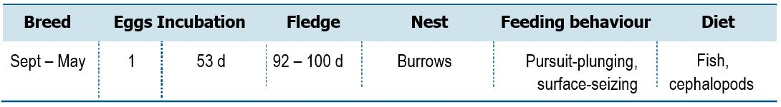
Life History and Distribution
The Flesh-footed Shearwater (Ardenna carneipes) is a large, bulky all-dark shearwater, superficially like Black Petrel (Procellaria parkinsoni). The bill is more robust than other Ardenna spp., and more bulky than other dark shearwater species. The Flesh-footed Shearwater mainly occurs in the subtropics over continental shelves and slopes, and occasionally in inshore waters. Individuals pass through the tropics and over deeper waters when on migration to the North Pacific and Indian Oceans (Brooke 2004). The species breeds on St Paul Island (French Southern Territories), Lord Howe and Phillip Island, islands off south-west mainland Australia, South Australia (at two colonies), and islands off North and South Islands (New Zealand). Pairs breed on islands in burrows on sloping ground in coastal forest, scrubland, or grassland (Powell et al. 2007). Nests consist of enlarged chambers at the end of burrows (1-3 metres in length), with the entrance often covered by plant material (Waugh et al. 2014). In the non-breeding season, it ranges north through the western Pacific Ocean to the seas off Japan, Russia and the Korean Peninsula, with small numbers reaching North America, and north through the Indian Ocean and west to the southern tip of Africa (del Hoyo et al. 1992, Rayner et al. 2011, Reid et al. 2013a, Bond and Lavers 2015).
Population Estimates and Trends
Brooke (2004) estimated the global population to number >650,000 individuals, but this has recently been revised downward following the identification of errors in the historical literature, and recent population surveys. Overall, the current global population is smaller than previously thought, comprising only around 74,000 breeding pairs (Lavers 2015). In Australia, the population on Lord Howe Island had been estimated at between 20,000-40,000 breeding pairs in 1978 (Fullagar and Disney 1981) and 17,462 breeding pairs in 2003 (Priddel et al. 2003). In 2009, the population was estimated at 16,267 pairs (95%-confidence interval 11,649–21,250), representing a decrease in the number of pairs of 6.8 per cent since 2003, equalling a decline of approximately 1.3 per cent per annum (Reid et al. 2013b). Recent estimates suggest the population is 22,654 breeding pairs (95%-confidence interval: 8,159–37,909) (Lavers et al. 2018).
In New Zealand, Robertson and Bell (1984) estimated the breeding population at 50,000-100,000 pairs in 1983, while Taylor (2000) considered the population to be at 25,000-50,000 pairs. Recent surveys suggest the population is closer to 10,000-15,000 pairs (Baker et al. 2010, Waugh et al. 2013). Despite the historical records and the current lack of data across all populations to assess the global population, there is enough evidence to suggest that the population has been affected by the fisheries operating in Australia (Tuck et al. 2003, Baker and Wise 2005, Tuck and Wilcox 2008, Richard and Abraham 2013) and the population on Lord Howe and Lady Alice Island (New Zealand) is decreasing (Tuck et al. 2003, Reid et al. 2013b, Waugh et al. 2013, Barbraud et al. 2014).
Wildlife Conservation Plan for Seabirds 75

Species profiles
Conservation Concerns and Actions
Records of bycatch in the Australian Eastern Tuna and Billfish Fishery (ETBF) have been high; 0.38 birds caught per 1,000 hooks and an estimated 8,972–18,490 individuals killed in the period 1998-2002 (Baker and Wise 2005), sufficient to decrease the population. Considerable levels of bycatch from gill-nets, purse-seines, longlines and inshore trawl have been recorded across the range (Japan, Australia, Russia and New Zealand) affecting the majority of the population.
Some mitigation methods have been put in place to reduce incidental capture, however the species is repeatedly found to be amongst the seabirds at greatest risk. In Baker and Wise’s (2005) findings, 91 per cent of all birds taken were Flesh-footed Shearwaters. Mortality in the ETBF has evidently decreased in recent years, but this is thought to be largely due to the fishery shifting northward in 2006/07 due to a change in the targeted fish species (Reid et al. 2013b). Consequently, high mortality rates in the ETBF may occur again in future years if the fishery returns south. Data on Flesh-footed Shearwater bycatch in the West and South Coast Purse Seine Managed Fisheries in Western Australia (six vessels operated in 2010) suggest up to six adult birds are killed per day per boat (DEF 2005) with more than 512 birds entangled in one season (Dunlop 2007).
From 1992 to 1996, estimates of seabird bycatch rates on Japanese long-line vessels fishing within the southern Australian EEZ varied between 0.1 and 0.3 birds per 1,000 hooks, with Flesh-footed Shearwaters accounting for around 10 per cent of the observed bycatch (Tuck et al. 2003). An additional 677 Flesh-footed Shearwaters are reportedly taken each year in the Japanese neon flying squid driftnet fishery (Ogi 2008) and 116 in the land-based salmon gillnet fishery (DeGange and Day 1991).
The incidence of plastic ingestion by chicks over the past decade is high with 90 per cent of sampled fledglings having ingested plastic (Lavers and Bond 2016). Data from New Zealand indicates around 44 per cent of adult birds contain plastic (Robertson et al. 2004). Heavy metal contamination (silver, aluminium, copper, mercury, arsenic and cadmium) have been detected in multiple populations and may be co-pollutants linked to plastic consumption (Bond and Lavers 2011, Lavers et al. 2014, Lewis 2016).
Introduced Black Rats (Rattus rattus) and Brown Rats (R. norvegicus) are present
in parts of the breeding range (Taylor 2000, Gaze 2000, Priddel et al. 2006). On Breaksea
Island, adults compete with introduced rabbits for burrows (Lavers 2015).
Several roads pass through or run adjacent to breeding colonies on Lord Howe Island, and mortalities are frequently reported along the roadsides (Hutton 2003, DECC 2008). The density of carcasses adjacent to roads was 25 times greater than elsewhere in the colony, and an estimated 125 birds were killed on roads during the 2008/2009 breeding season (Reid 2010, Reid et al. 2013b). These rates are sufficient to drive a slow population decrease (Reid et al. 2013b).
Areas of Flesh-footed Shearwater habitat have been cleared for residential developments up to the recent past. As a result, the extent of suitable habitat on Lord Howe Island was reduced (down 35 per cent from 37.8 ha in 1978 to 24.3 ha in 2002, Priddel et al. 2006), but recent restrictions have halted further conversion, despite an apparent continued decrease in burrow density (Reid et al. 2013a).
76 Wildlife Conservation Plan for Seabirds
Species profiles
Recommended Management Actions
- Maintain bycatch mitigation strategies in the ETBF
- Assess the impact of bycatch from gill-nets, purse-seines, longlines and inshore trawl across the range (Japan, Australia, Russia and New Zealand)
- Investigate potential impacts of the WA fisheries and apply appropriate mitigation techniques if required
- Regularly monitor breeding populations at index locations
- Determine non-breeding areas, migration routes and at sea distribution
- Measure contaminant levels in all relevant life stages
- Work with range states to control, or eradicate invasive species on breeding islands
- Implement best practice quarantine measures at breeding colonies to reduce the risk of any invasive species (re)establishing on islands
- Develop mitigation measure to reduce roadkill on Lord Howe Island
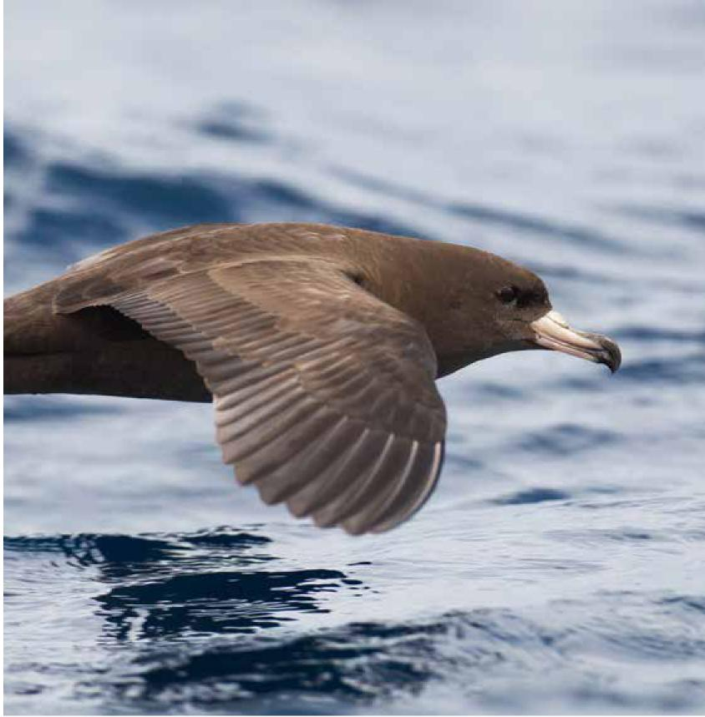

Wildlife Conservation Plan for Seabirds 77

Species profiles
Sooty Shearwater (Ardenna grisea)

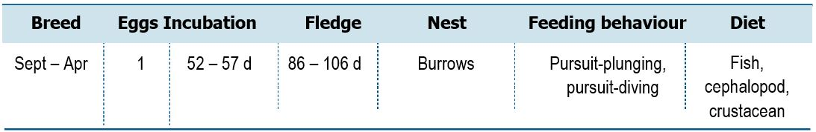
Life History and Distribution
The Sooty Shearwater (Ardenna grisea) is a large solid-bodied shearwater,
closely resembling the slightly smaller Short-tailed Shearwater (A. tenuirostris). Sooty Shearwaters are entirely dark brown-grey with a broad pale streak down the centre of the underwing. The species is abundant in the Southern Ocean during summer months, particularly around New Zealand. The species nests on islands and headlands in large colonies on islands off New Zealand, Australia and Chile, and the Falkland Islands (Islas Malvinas). In Australia, there are colonies on 17 islands, all of which contain fewer than 1,000 pairs. Burrows are dug under tussock grass, low scrub and on the Snares Islands under Olearia forest. Birds typically do not return to their natal colonies until the age of four years. They feed on fish, crustacea and cephalopods, which are caught while diving. Short (1-3 days) and long (5-15 days) provisioning trips are made by parents; longer trips allow foraging along the Antarctic Polar Front, reducing competition close to breeding grounds and allowing vast colonies to persist (Weimerskirch
1998). The species migrates to the Northern Hemisphere during the Austral winter (Shaffer et al. 2006, Hedd et al. 2012), and in the California Current, Sooty Shearwater numbers have decreased by 90 per cent in the last 20 years (Veit et al. 1996). It remains uncertain whether this has resulted from population decrease or distributional shifts (Spear and Ainley 1999), given there is no evidence from colonies of a decrease of 90 per cent.
Population Estimates and Trends
The global population is estimated at 4.4 million pairs, roughly equating to 19–23.6 million individuals (Newman et al. 2009, Waugh et al. 2013). In southern Chile, some colonies number up to 200,000 pairs, with the largest colony of up to 4 million individuals on Isla Guafo (Reyes-Arriagada et al. 2007). In the Falklands (Islas Malvinas), 10,000-20,000 pairs have been recorded. New Zealand supports more than 180 colonies. In 1970-1971, the colonies on the Snares Islands were estimated to support 2,750,000 breeding pairs (del Hoyo et al. 1992, Heather and Robertson 1997).
Although this is an extremely numerous species, there are persistent signs of a current decrease (Brooke 2004). In New Zealand, the number of burrows in the largest colony on the Snares Islands decreased by 37 per cent between 1969-1971 and 1996-2000, and burrow occupancy may also have decreased, indicating that an overall population decrease may have occurred (Warham and Wilson 1982, Scofield and Christie 2002, Scott et al. 2008). Some colonies on mainland New Zealand have decreased, and several colonies on offshore islands, especially in northern New Zealand, have not responded to predator control (Gaze 2000, Jones 2000, Waugh et al. 2013). However, other colonies in southern New Zealand have responded to sustained pest management with increasing shearwater numbers (Newman et al. 2009). Population estimates and trends at Australian colonies are unknown (Garnett et al. 2011).
78 Wildlife Conservation Plan for Seabirds

Species profiles
Conservation Concerns and Actions
The species is at risk from incidental capture in longline, trawl and gill-net fisheries and suffers the additional effects of depletion of prey stocks (Uhlmann 2003). A large number of deaths occur as a result of interaction with fisheries both during the breeding season and the winter migration to the Northern Hemisphere (Uhlmann 2003). The species is also subject to a legal cultural harvest in New Zealand. Harvesting of young birds ('muttonbirding') currently accounts for the take of around a quarter of a million birds annually (del Hoyo et al. 1992, Heather and Robertson 1997, Newman et al. 2008, 2009), but is unlikely to account for the scale of the observed decrease.
Past investigation into the biological impact of climatic trends led to predictions of large-scale shifts in foraging distribution during the boreal summer and/or dramatic reductions in abundance and survival rate (Ainley et al. 1995, Veit et al. 1996, 1997, Spear and Ainley 1999, Wahl and Tweit 2000, Oedekoven et al. 2001, Hyrenbach and Veit 2003). Climate change is already affecting the foraging distribution of this species along the Californian coast (Veit et al. 1997). Evidence shows that birds are still visiting many of the same foraging areas, but are taking new routes to avoid altered current systems (Veit et al. 1996, 1997). Decreases at monitored breeding sites appear to be linked to changed patterns in large scale oceanic cycles which reduce prey availability (Clucas 2011).
Brown Rat (Rattus norvegicus) and Black Rat (R. rattus) are present on some islands on which the species breeds, and although egg and chick predation by rats has been demonstrated, the extent of impact is unknown (Jones et al. 2008).
Recommended Management Actions
- Regularly monitor breeding populations at index locations
- Determine non-breeding areas and migration routes
- Maintain bycatch mitigation strategies in relevant fishery operations
- Assess the impact of bycatch from gill-nets, longlines and trawl fisheries across the range and apply appropriate mitigation techniques
- Measure contaminant levels in all relevant life stages
- Work with range states to control, or eradicate invasive species on breeding islands
- Implement best practice quarantine measures at breeding colonies to reduce the risk of any invasive species (re)establishing on islands
Wildlife Conservation Plan for Seabirds 79
Species profiles
Short-tailed Shearwater (Ardenna tenuirostris)

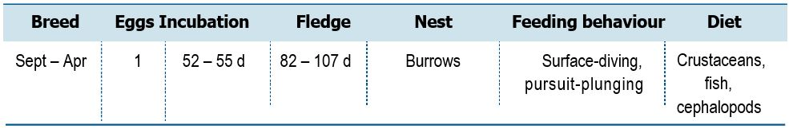
Life History and Distribuion
The Short-tailed Shearwater (Ardenna tenuirostris) is a medium sized all brown-grey shearwater, very similar to the larger Sooty Shearwater (A. grisea). The Short-tailed Shearwater undergoes a trans-equatorial migration, wintering north of Japan and the Bering Sea near the Aleutian Islands (USA) (Carey et al. 2014). The return migration pathway incorporates the central Pacific Ocean, with some individuals moving south along the western coast of North America. This species breeds on Tasmanian offshore islands and off the coast of southern Australia, with the bulk of the population in the south-east. Breeding occurs mainly on coastal islands, typically in areas of grassland or other vegetation, but sometimes cliffs or bare ground (del Hoyo et al. 1992). While breeding, the species alternates short foraging trips to local waters with long foraging trips (up to 17 days) to the Polar Frontal Zone. Short trips allow greater chick provisioning, longer trips allow foraging at the Antarctic Polar Front, reducing competition close to the breeding grounds. Diet includes fish (particularly mycotphids), crustaceans and squid (Weimerskirch and Cherel 1998). Feeding occurs in very large flocks and it regularly feeds in association with other shearwaters, petrels, gannets and terns.
Population Estimates and Trends
Skira (1996) estimated the global population to number 23 million individuals. The population trend is thought to be increasing in North America (BirdLife International 2019), however, the global population is suspected to be decreasing owing to ecosystem changes resulting from climate change (Brooke 2004). National trends are unknown, however the species is monitored at some locations in Tasmania, Victoria and NSW.
Conservation Concerns and Actions
Previously, the species suffered substantial mortality from entanglement in gill nets set for salmon in the Northern Pacific, particularly off Japan with an estimated 40,000 birds captured per annum (DeGange and Day 1991, Uhlmann 2003). Between 1952 and 2001, bycatch by North Pacific driftnet fisheries accounted for the mortality of an estimated 4,600,000–21,200,000 Short-tailed Shearwaters (Uhlmann et al. 2005).
In Tasmania, the species is taken annually under licence as part of an indigenous commercial harvest and a non-indigenous recreational harvest during a declared open season, and permits are also issued for a small indigenous cultural harvest. Bag limits apply to recreational harvesters and cultural harvesters and the commercial harvest is self-managed. Only chicks are taken on a limited number of colonies and the season is restricted.
80 Wildlife Conservation Plan for Seabirds

Species profiles
Light pollution represents a potential threat to this species in parts of the range. A number much higher than anticipated, of (predominantly juvenile) shearwaters were found dead or injured as a result of being attracted to lights and grounded. Over a 15-year period of patrols on Phillip Island, Victoria (1999-2013), 8,871 fledglings were found grounded, 39 per cent of which were dead or dying. The incidence levels far exceed those of other shearwater spp., however fewer than 1 per cent of fledglings produced annually are thought to be affected by mortality from attraction to artificial light (Rodriguez et al. 2014).
Wrecks (mass-mortality events) have been reported, e.g. at Bering Sea 1997 (Hyrenbach et al. 2001) and in Australia 2013 (Peter and Dooley 2014) and are potentially linked to ecosystem changes caused by climate change and salmon productivity (Brooke 2004; Springer at al. 2018). Recent studies indicate that both young and adults suffer from the ingestion of marine plastic debris, with potentially adverse effects (Carey 2011).
Recommended Management Actions
- Update population estimates for this species in Tasmania and Australia
- Regularly monitor breeding populations at index locations
- Determine non-breeding areas and migration routes
- Maintain bycatch mitigation strategies in relevant fishery operations
- Implement measures to reduce the impact of light pollution near breeding colonies
- Measure contaminant levels in all relevant life stages
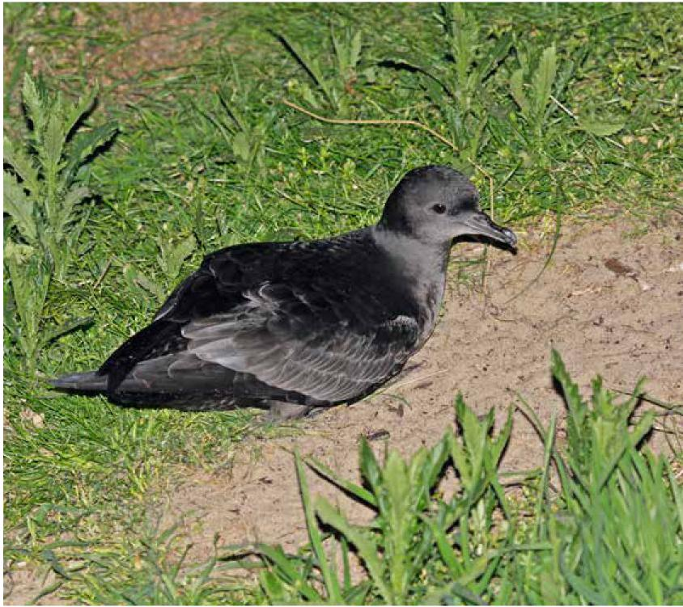

Wildlife Conservation Plan for Seabirds 81

Species profiles
Streaked Shearwater (Calonectris leucomelas)
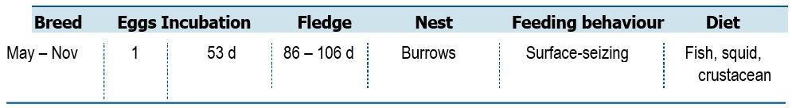
Life History and Distribution
The Streaked Shearwater (Calonectris leucomelas) is a very large shearwater, with a long slender bill, long slender neck and body tapering to long wedge-shaped tail. Wings are long and broad and the species has a diagnostic white face, finely streaked black.
This species is found in the western Pacific, breeding on the coast and on offshore islands of Japan, Russia, China and Korean Peninsula. Breeding begins in March at colonies on offshore islands, occupying burrows in forested hills. It undergoes trans-equatorial migration traveling south during winter, to the coasts of Vietnam, New Guinea, the Philippines, Australia, southern India and Sri Lanka (del Hoyo et al. 1992,
Praveen et al. 2013). It feeds mainly on fish and squid which it catches by surface-seizing and shallow plunges. It often associates with other seabirds and will follow fishing boats.
Population Estimates and Trends
The global population has been estimated to number 3 million individuals
(Brooke 2004). In Japan, where the majority of the species breeds, there are 11 islands that are each thought to be inhabited by more than 10,000 breeding pairs (Oka 2004). According to locals, the species appears to have been decreasing rapidly on Mikura-Jima, but quantitative data are not available (BirdLife International 2019). The prevalence of threats from introduced predators suggests that the species is in overall decrease; however, further data are required from throughout the species range to assess the current population trend.
Conservation Concerns and Actions
Introduced mammals poses the greatest threat to the population, with cats (Felis catus), Norway Rats (Rattus norvegicus) and Black Rats (R. rattus) being present on islands throughout the species range. Rats have invaded at least three of the Japanese breeding islands, with current impacts largely unknown, but likely to affect fledgling success and egg predation (Lee 2010). Climate change is affecting foraging distribution and hence energetic budgets of adults. It is further predicted that whole colonies may be affected in the future as prey populations shift distribution in response to climate change. In addition to these threats, the species is also susceptible to fisheries bycatch (Birds Korea 2010; Croxall et al 2012), but the impact has not been quantified.
Recommended Management Actions
- Determine non-breeding areas and migration routes
- Work with range states to control, or eradicate invasive species on breeding islands
- Quantify impact of fisheries interactions on the population and apply appropriate mitigation techniques
82 Wildlife Conservation Plan for Seabirds
Species profiles
Fluttering Shearwater (Puffinus gavia)
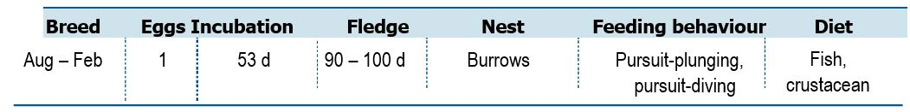
Life History and Distribution

The Fluttering Shearwater (Puffinus gavia) is a small slender-billed shearwater with dark brown upperparts and white underparts. The species is similar in size, shape and appearance to Hutton’s Shearwater (P. huttoni). This species is a common and widespread species endemic to New Zealand. This species breeds on small, vegetated islands and rock stacks. It nests in colonies in burrows under grass, scrub or coastal forest, but occasionally breeds in rocky cavities (Marchant and Higgins 1990).
The largest colonies are found in the Three Kings group, Moturoa group, Motuharakeke (Cavalli Islands), north-west Chickens, Bream Islands, Mokohinau group, Channel Island, Mercury group, Ruamahuanui (Aldermen group) and Trio Islands, as well as on several other islands in the Cook Strait. The breeding biology of the species is poorly known but laying of eggs is believed to begin in early September, chicks fledge from late January (Powlesland and Rickard 1992). Fledglings, and possibly some adults, move towards the east and south of Australia in February, but most remain near to breeding colonies throughout the year (Marchant and Higgins 1990, Powlesland and Rickard 1992). Birds feed mostly on fish and some coastal krill (Marchant and Higgins 1990).
Population Estimates and Trends
Brooke (2004) estimated the global population to number at least 100,000 individuals. The population is suspected to be in decline owing to predation by invasive species.
Conservation Concerns and Actions
Historically, the species has been extirpated from several breeding locations by introduced feral cats (Felis catus), Black Rats (Rattus rattus) and Brown Rats (R. norvegicus). Invasive rats have now been successfully removed from considerable parts of the breeding range, yet they are still present at some sites and likely to have a negative impact on breeding success. At present, the species survives mostly on islands free of introduced mammals, but some persist in coexistence with populations of Polynesian Rat (R. exulans) and Black Rat (Saddle Island). These populations are relatively small, and the rats may be having a significant effect on breeding success. There is a future risk of re-invasion on currently predator-free islands. Other potential threats include overharvesting of inshore prey stocks, bycatch in fisheries. Fluttering Shearwaters are frequently trapped in fishing gear in inshore waters, with unknown impacts on the global population.
Recommended Management Actions
- Gain an improved understanding of the at sea distribution in Australia
- Determine non-breeding areas and migration routes
Wildlife Conservation Plan for Seabirds 83

Species profiles
Hutton’s Shearwater (Puffinus huttoni)
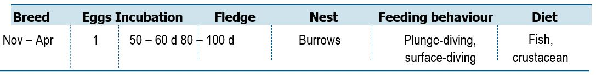
Life History and Distribution

Hutton’s Shearwater (Puffinus huttoni) is a small black and white shearwater very similar in appearance to the slightly smaller, shorter-billed Fluttering Shearwater (P. gavia). The species breeds in the Seaward Kaikoura Range, north-east South Island, New Zealand. The population comprises two main colonies (Kowhai Valley and Shearwater Stream), sited 10-18 km inland. The species digs its burrows on gentle to steep mountain slopes at 1,200-1,800 m, under tussock grass or low alpine scrubland (Marchant and Higgins 1990). First breeding is thought to occur at 4-6 years of age. The species feeds mostly on small fish and krill (Heather and Robertson 1997). Birds gather food for chicks as far south as the Otago Peninsula and often fish around Banks Peninsula bays (Harrow 2009). Kapiti Island and Cook Strait are common feeding areas in the north, with foraging individuals also recorded near the Chatham Islands (Harrow 2009). Frequently diving to feed to 25 m, they have been recorded as deep as 36.6 m (Harrow 2009). Levels of burrow occupancy in both original colonies in 2006/2007 was found to be similar to the 1990s. In contrast, breeding success in both main colonies was thought to be due to poor feeding conditions at sea, rather than increases in stoat predation, as no evidence pointed to the latter (Sommer et al. 2009). Annual adult survival, breeding success and burrow occupancy averaged 93 per cent, 47 per cent and 71 per cent, respectively (Sommer et al. 2009). Low levels of breeding success, particularly at Shearwater Stream colony, point to the possibility of the colony levels being maintained by immigration from the more successful Kowhai Valley colony (Sommer et al. 2009). In the non-breeding season, birds migrate to waters off Australia, particularly southern, western and north-western Australia (Heather and Robertson 1997).
Population Estimates and Trends
The total population is estimated to number between 300,000-350,000 individuals (Brooke 2004) and an estimated 106,000 breeding pairs (Cuthbert and Davis (2002). Although this species is believed to have a stable population, it suffered a historical decrease in range and population size. It qualifies as endangered under IUCN criteria because breeding is now restricted to just two colonies, which remain vulnerable to feral pigs that occur in adjoining areas of the Kaikoura Mountains. The proportion of birds using Australian waters during the non-breeding season is unknown.
Conservation Concerns and Actions
Numbers and distribution within the Kaikoura Ranges have decreased, with 8 of 10 known colonies having been extirpated this century (Cuthbert 1999). Six out of eight colonies discovered in the high Kaikoura Mountains were likely extirpated by feral pigs, which remain a potential threat to the remaining two colonies (Harrow 2009). Since the rapid extirpation of colonies was detected, a third population on the Kaikoura peninsula has been established through translocation of chicks (Anon 2007, Ombler 2010).
84 Wildlife Conservation Plan for Seabirds

Species profiles
Introduced stoats (Mustela erminea) are known to prey on burrowing seabirds (Moors and Atkinson 1984, Lyver 2002), and their continued presence in both
remaining colonies is of major concern for the future survival of the species
(Sherley 1992). Initially, stoats were thought to be the primary cause of the species decline (Sherley 1992, Heather and Robertson 1997); however, longer-term research has shown that only a small proportion of adults are taken, and the impact on breeding success could be insignificant (Cuthbert 1999, Cuthbert and Davis 2002). Predation and disturbance by feral pigs and cats are considered a major potential threat but are normally absent from the breeding range (Cuthbert 1999, Taylor 2000, Cuthbert 2002). Habitat degradation and predation by feral pigs (Sus scrofa), along with heavy browsing by a range of introduced herbivores may have been the cause of the complete destruction of some sub-colonies, contributing considerably to habitat loss and range contraction (Sommer et al. 2009).
Incidental capture in set-nets and inshore long-liners is also a concern, with up to 80 individuals being caught in a single net (West and Imber 1985, Darby and Dawson 2000, Harrow 2009). In addition, long-term over-harvesting of some inshore fish species could compromise prey availability to Hutton’s Shearwaters with adverse impacts (Taylor 2000). Modelling has demonstrated that colonies are most vulnerable to the loss of breeding adults; therefore, maintaining high survivorship is paramount (Cuthbert et al. 2001).
Climate change poses a potential threat to the species. Breeding at high altitude makes the species susceptible to detrimental effects of abnormal amounts or timing of snowfall; heavy snowfall can crush burrows, and late snow cover can delay or prevent breeding (Taylor 2000).
Recommended Management Actions
- Gain an improved understanding of the at sea distribution in Australia
- Determine non-breeding areas and migration routes
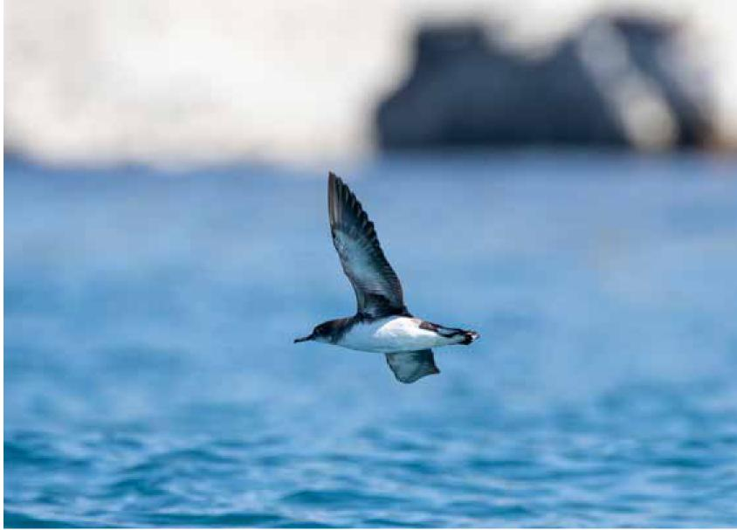

Wildlife Conservation Plan for Seabirds 85

Species profiles
Little Shearwater (Puffinus assimilis)

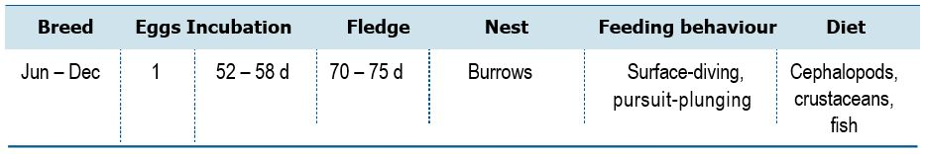
Life History and Distribution
The Little Shearwater (Puffinus assimilis) is the smallest shearwater resembling other members of the ‘fluttering’ group. The species has a compact structure with a shorter, more slender bill and shorter broader wings with rounder tips. The species has a very large range, occurring in subantarctic, subtropical and occasionally tropical waters. Two subspecies breed in Australia, subspecies assimilis breeds on Norfolk and Lord Howe Island groups and subspecies tunneyi on offshore islands off south-west Western Australia. The species breeds colonially under forest or tussocks. The species also occurs on several New Zealand islands and islands in the Atlantic Ocean. At sea the species is usually solitary or in small groups. They feed by plunge-diving or surface-seizing on cephalopods, crustaceans and small fish.
Population Estimates and Trends
Brooke (2004) estimated the global population at 200,000 mature individuals. The subspecies tunneyi occurs on 65 offshore islands in Western Australia with an estimated minimum number of breeding pairs between 27,000–61,500 (Burbidge et al. 1996). Subspecies assimilis is endemic to the Lord Howe and Norfolk Island groups. The population of Roach Island (Lord Howe) is estimated at 1,050 pairs with a further 85 pairs on Lord Howe Island (Priddel et al. 2003; Carlile et al. 2013). The population in the Norfolk Island group is estimated at 100–1000 pairs (Schodde et al. 1983; Priddel et al. 2010). Australian trend estimates are unknown.
Conservation Concerns and Actions
Predation by introduced rats and feral cats (Felis catus) represents the greatest current and future threat, due to their presence across large portions of the species breeding range in New Zealand and Australia. Little Shearwaters appear to have been greatly reduced in number on Lord Howe and Norfolk Islands. Rat predation affects different subspecies differently, and there is a risk that some subspecies (Puffinus assimilis assimilis in particular) may continue to decline in the future. The continued presence of predators on many islands is likely a contributory factor to preventing recolonisations.
Recommended Management Actions
- Minimise effects of climate change
- Examine the relationship between foraging and breeding succuss, population density and productivity and surrounding sea including tracking to determine use of marine habitat in space and time
- Manage key sites to retain their value under climate change
- Regularly monitor breeding populations at index locations
- Determine non-breeding areas and migration routes
- Measure contaminant levels in all relevant life stages
- Work with range states to control, or eradicate invasive species on breeding islands
- Implement best practice quarantine measures at breeding colonies to reduce the risk of any invasive species (re)establishing on islands
- Establish new breeding colonies within former range
86 Wildlife Conservation Plan for Seabirds
Species profiles
Tahiti Petrel (Pseudobulweria rostrata)

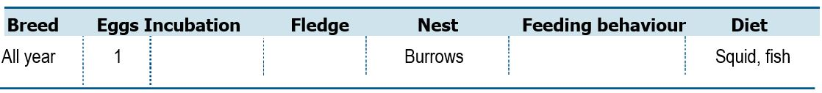
Life History and Distribution
The Tahiti Petrel (Pseudobulweria rostrata) is a medium-sized dark-brown and white petrel with a sharply demarcated dark hood. The species is found over warm, tropical and subtropical water in the Pacific Ocean. The species breeds in the Marquesas, Society and Gambier Islands, French Polynesia, Fiji, American Samoa and New Caledonia (to France). It used to breed in Vanuatu (BirdLife International 2019) and may breed on Rarotonga, Cook Islands (Pratt et al. 1987), as well as on other islands. Two subspecies are distinguished: trouessarti in New Caledonia and rostrata in French Polynesia, the subspecific status of birds from other archipelagos remaining unclear, although Brooke (2004) assigned them to rostrata. This distinction is poorly supported by morphological (Villard et al. 2006) and genetic (Gangloff et al. 2012) data, and detailed analyses of vocalization differences between the two subspecies are missing. The Tahiti Petrel occurs predominantly off southeast Queensland and Northeast NSW in spring through to early autumn with numbers peaking with the arrival of juveniles in December. In some years, small numbers of these petrels remain off the eastern Australian coast. Of interest is the occurrence of this species off the northwest coast. It is not known where these petrels have originated from Pacific Island population; an unknown population breeding in Indonesia; or an unknown population breeding in the Indian Ocean. The species generally nests at high altitudes within forest or scrub on mountain steep slopes or rims and craters of volcanic islands, but also on low coralline or rocky hill islets and backshore. Eggs are laid in burrows or cavities located underneath large rocks, within cliffs or rocky boulders, or among large tree root systems. Birds generally nest in loose and small colonies. Breeding appears to occur throughout the year, although at least on Tahiti, there appears to be a peak between March and July (Villard et al. 2006). In the non-breeding season, the species disperses widely, and birds have been recorded as far east as the coast of Central America (Ballance et al. 2002), particularly Peru, Mexico (Onley and Scofield 2007) and Costa Rica (BirdLife International 2019).
Population Estimates and Trends
The global population is estimated to be between 20,000–30,000 individuals. There are no recent data, however the species is thought to be decreasing, mainly due to nest predation by introduced predators and open cast mining activities. Marine surveys in the eastern tropical Pacific from 1988-2000 estimated a 35 per cent reduction between the periods 1988-1990 and 1998-2000 (Balance et al. 2002).
Conservation Concerns and Actions
Predation and disturbance from non-native species represent the most serious threat to the species. Feral cats (Felis catus) have been identified as the greatest threat to the Tahiti Petrel, with predation impacting both chicks and adults. Petrel remains have been identified in 1-8 per cent of all cat scats (n=4,166) in large parts of the species range (Palmas et al. 2017). Rats (Rattus spp.), dogs (Canis familiaris) and pigs (Sus scrofa) are likely contributing to declines in reproductive success (BirdLife International 2019), with both dogs and pigs observed to dig out adults and chicks from their burrows (Villard et al. 2006). On Grand Terre (New Caledonia), the Marquesas and Society Islands, rat predation is an observed, but unquantified problem. In colonies where the soil is deep enough for Wedge-tailed Shearwaters (Ardenna pacifica) to nest, there can be intense competition for burrows (Villard et al. 2006).
Wildlife Conservation Plan for Seabirds 87

Species profiles
Newly discovered sites in New Caledonia are all in areas threatened by nickel mining (Spaggiari and Baré 2004, Delelis et al. 2007, Le Breton 2008), with mining activities predicted to have negative impacts on breeding success. Adults and fledglings in particular, suffer from attraction to artificial lights and subsequently becoming grounded and sometimes run over by vehicles. Light pollution threatens birds mainly in the urban areas around Papeete, Tahiti (BirdLife International 2019), and around Nouméa, rural villages and active mining sites in New Caledonia. Collision with electric powerlines in the mountains of French Polynesia is thought to be responsible for a small proportion of adult mortality (BirdLife International 2019). The species is occasionally hunted by local people for their white feathers, which are used in fishing lures (Holyoak and Thibault 1984).
Recommended Management Actions
- Investigate the dispersal of Tahiti Petrels between and the South Pacific Ocean breeding island and Australia
- Investigate the providence of the Tahiti Petrels that occur of the northwest coast of Western Australia in the Indian Ocean
- Gain an improved understanding of the at sea distribution in Australia
- Determine non-breeding areas and migration routes
- Work with range states to control, or eradicate invasive species on breeding islands
- Work with range states to manage the impact of extractive industries on breeding islands
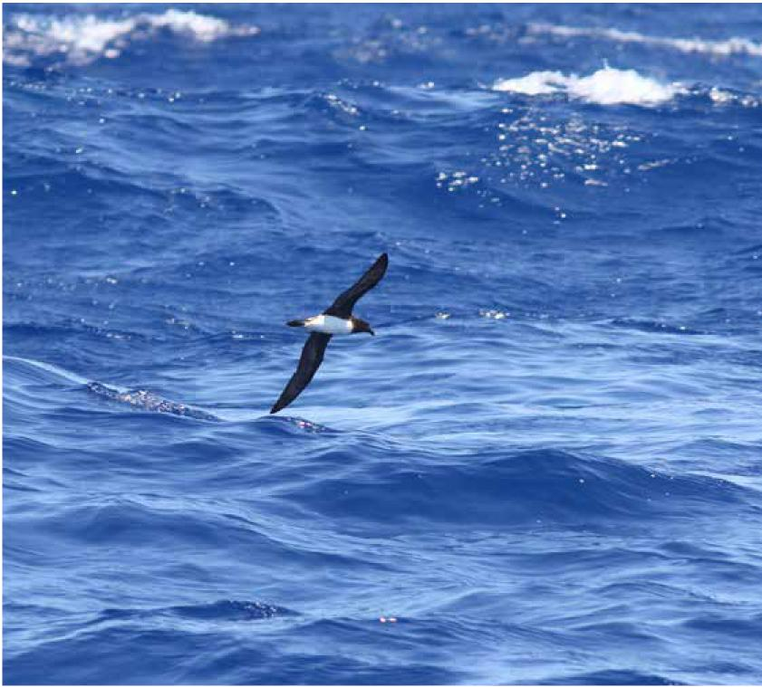

88 Wildlife Conservation Plan for Seabirds

Species profiles
Kerguelen Petrel (Lugensa brevirostris)
Wildlife Conservation Plan for Seabirds 89
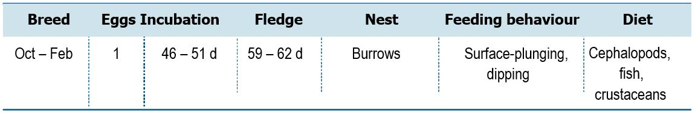
Life History and Distribution
The Kerguelen Petrel (Lugensa brevirostris also known as Aphrodroma brevirostris) is a medium-sized all-dark petrel of the Southern Ocean, similar in size to Soft-plumaged Petrel (Pterodroma mollis). The species has a very large circumpolar range in subantarctic and Antarctic waters. Kerguelen Petrel breeding colonies are present on Gough Island (St Helena to UK) in the Atlantic Ocean, and Marion Island and Prince Edward Island (South Africa), and Crozet Islands and Kerguelen Island (French Southern Territories) in the Indian Ocean. Its breeding season starts in August, forming loose colonies near the sea on marshy ground, and also higher up on volcanic ridges up to 450 m Above Sea Level (ASL). It nests in deep burrows dug in soft, wet soil (del Hoyo et al. 1992). Outside the breeding season its range is circumpolar, frequenting Australian waters south to the ice pack (del Hoyo et al. 1992). It feeds mostly on squid, but also krill and fish. Squid are captured by surface-seizing at night, but dipping is also seen.
Population Estimates and Trends
Brooke (2004) estimated that the global population numbers around 1 million individuals. The population is suspected to be decreasing, as invasive House Mice (Mus musculus) may be affecting breeding success.
Conservation Concerns and Actions
On Gough Island, one of the locations where this species is known to breed, mice are responsible for reduced breeding success of burrowing petrel species (Cuthbert et al. 2013). While the effects on this species specifically have not been investigated it is also likely to be negatively affected.
Recommended Management Actions
- Gain an improved understanding of the at sea distribution in Australia
- Determine non-breeding areas and migration routes
- Work with range states to control, or eradicate invasive species on breeding islands

Species profiles
White-headed Petrel (Pterodroma lessonii)
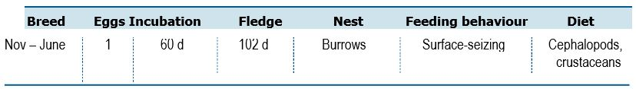
Life History and Distribution
The White-headed Petrel (Pterodroma lessonii) is a large, solidly built all grey-white petrel. At sea the prominent black patch underscoring eye on an otherwise largely white head is diagnostic. The White-headed Petrel is oceanic, rarely approaching land except near colonies, but has been recorded inshore during stormy weather. This species has a circumpolar range and is found throughout the Southern Ocean. It breeds on Macquarie Island, the Auckland Islands and Antipodes Islands (New Zealand), Crozet and Kerguelen Islands (French Southern Territories) and possibly on the Prince Edward Islands (South Africa) (del Hoyo et al. 1992). Breeding starts in October in loose colonies, nesting in burrows dug in soft soil or scree near the coast or inland up to 300 m Above Sea Level (ASL) (del Hoyo et al. 1992). The distribution extends farther north in the non-breeding season. Birds feed mostly on squid and crustaceans, which are caught mostly at night by surface-seizing and dipping.
Population Estimates and Trends
Brooke (2004) estimated the global population to number around 600,000 individuals. In 1975-79, the breeding population on Macquarie Island was estimated to be around 16,000 breeding pairs (Brothers 1984). The most recent island population census was undertaken in 2018, with results pending (University of Queensland and Tasmanian Parks and Wildlife Service unpublished data). The global population is thought to be decreasing owing to predation by invasive species at some sites. Trends in Australia are unknown.
Conservation Concerns and Actions
The primary threats to this species come from invasive predators. Extinction of the species on Auckland Island, New Zealand is attributed to the impact of introduced pigs and cats (Taylor 2013), and despite large numbers breeding birds adjacent to the main island the continued presence of both pigs and cats prevents any recolonisation effort. Cats, Black Rats, European Rabbits and Weka are thought to have caused decreases on Macquarie Island before their eradication (Taylor 2013). The breeding population on Macquarie Island is expected to increase following the removal of invasive species.
Recommended Management Actions
- Consolidate current population data on Macquarie Island
- Regularly monitor breeding populations at index locations
- Determine non-breeding areas and migration routes
- Work with range states to control, or eradicate invasive species on breeding islands
- Implement best practice quarantine measures at breeding colonies to reduce the risk of any invasive species (re)establishing on islands
90 Wildlife Conservation Plan for Seabirds
Species profiles
Great-winged Petrel (Pterodroma macroptera)

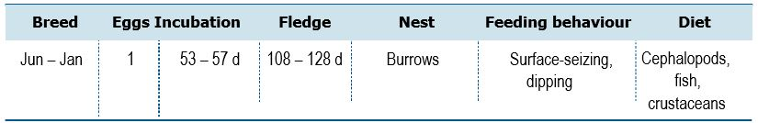
Life History and Distribution
The Great-winged Petrel (Pterodroma macroptera) is a large, long winged gadfly petrel with all-dark plumage and black bill, that is very similar to Grey-faced (P. gouldi) and Providence (P. solandri) Petrels. Until recently Grey-faced Petrel and Great-winged Petrel were considered conspecific, it was not until 2014 that these two species were considered as different species (Wood et. al. 2016). The species has a widespread, but sparse distribution. It breeds in the Southern Hemisphere with colonies on Tristan da Cunha and Gough Island (St Helena to UK), the Crozet Islands and Kerguelen Islands (French Southern Territories), the Prince Edward Islands (South Africa), and on the coasts of south-western Australia. Breeding occurs in the winter, arriving at colonies in April. It nests either solitary or in small colonies on oceanic islands on ridges, slopes or flat ground. Breeding usually occurs below 400 m Above Sea Level (ASL) but has been recorded as high as 1,400 m ASL on Tristan da Cunha. It nests in burrows or above ground in rock crevices, among tree roots or under scrub (del Hoyo et al. 1992). Outside the breeding season, it disperses widely in subtropical parts of the Atlantic, Indian and Pacific Oceans (del Hoyo et al. 1992). It feeds mostly on squid, with some fish and crustaceans, most of which it obtains by dipping and surface-seizing. It feeds mainly at night and may locate some cephalopods by their bioluminescence. It can occasionally be seen following cetaceans and will associate with other petrels and shearwaters. Occasionally follows vessels.
Population Estimates and Trends
Brooke (2004) estimated the global population to exceed 1,500,000 individuals. The Australian breeding population is restricted to 17 offshore islands in south-west Western Australia. The minimum estimated number of breeding pairs is 36,000–84,000 (Burbidge et al. 1996). Trends in Australia are unknown. The global population is suspected to be decreasing owing to predation by invasive species.
Conservation Concerns and Actions
This species has experienced decreases due to invasive predatory mammals. Cats caused a decrease in the species on Marion Island before their eradication in 1991 (Cooper et al. 1995). Despite cat eradication, subsequent recovery on Marion has been slower than expected, possibly due to breeding success remaining unexpectedly low. This has been attributed to the observed predation by House Mice (Mus musculus) (Dilley et al. 2018).
Recommended Management Actions
- Quantify the breeding population in Western Australia
- Regularly monitor breeding populations at index locations
- Determine non-breeding areas and migration routes
- Work with range states to control, or eradicate invasive species on breeding islands
- Implement best practice quarantine measures at breeding colonies to reduce the risk of any invasive species (re)establishing on islands
Wildlife Conservation Plan for Seabirds 91

Species profiles
Providence Petrel (Pterodroma solandri)
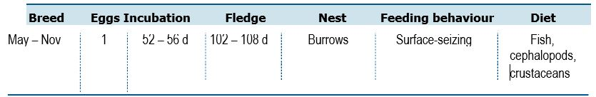
Life History and Distribution
The Providence Petrel (Pterodroma solandri) is a large, heavy built gadfly petrel with a stout bill. Plumage is mainly dark grey-brown with grey mantle, brown head with scaly white-face. The species resembles other large dark gadfly petrels, especially Great-winged (P. macroptera) and dark morphs of Kermadec Petrel (P. neglecta). The species has a large distribution from the south-west Pacific Ocean to the North Pacific and Bering Sea. Breeding is restricted to Lord Howe Island and Phillip Island (Norfolk Island group). It was exterminated on Norfolk Island itself between 1790 and 1800, where it was once considered numerous. An estimated one million adults and young were harvested for food from 1790-1793 and numbers dropped to 15,000 by 1796, with complete extermination by 1800 (Priddel et al. 2010). It nests in burrows or under rock cavities and occasionally between tree buttresses from sea level to 900 m (Bester et al. 2002, Bester 2003). On Lord Howe, it breeds in forest, as once did the population of Norfolk Island, so the Phillip Island population is atypical, burrows being in eroded cliffs of soft volcanic tuff (Priddel et al. 2010). The species is a winter breeder, with birds from Phillip Island breeding at the same time as Lord Howe Island (Priddel et al. 2010). Adults arrive at Phillip from mid-April (Priddel et al. 2010), a single egg is laid mid- to late May (Bester et al. 2007), hatching starts mid-July (Bester et al. 2007), and chicks are near-fledged by early November (Priddel et al. 2010). Adults land during daylight, often about 1530 h (Priddel et al. 2010). The adults feed predominantly on squid and fish with crustaceans less important. The most important prey item is bioluminescent fish from the genus Electrona (Bester 2003).
Population Estimates and Trends
During the 2002 breeding season the Lord Howe Island population was estimated at just over 32,000 breeding pairs (Bester 2003). Current estimates for the Phillip Island population are 10-100 pairs (Priddel et al. 2010) with 250 burrows counted in 2011 (N. Carlile unpub. data cited by BirdLife International 2019). Surveys have determined that the distribution is likely to have increased since the eradication of pigs on Lord Howe Island and it appears to be establishing itself in the lower elevations south of Mt Lidgbird (Bester 2003). This species qualifies as vulnerable under IUCN criteria because it has a very small range, being confined to one very small island and one tiny islet, and it is therefore susceptible to stochastic events and human impacts.
92 Wildlife Conservation Plan for Seabirds
Species profiles
Conservation Concerns and Actions
Invasive and introduced species have also been a problem in the past, however, wild pigs, cats and goats have been successfully eradicated from Lord Howe Island (Parks Australia 2010). Rat predation accounts for a small proportion of breeding failures each year (Bester et al. 2007). Eradication of rodents on Lord Howe Island was implemented in June and July 2019 with the final biosecurity check for the success planned for August 2021 (Lord Howe Island Board). The introduced Masked Owl may switch to preying on petrels with the removal of rats, potentially causing problematic declines (Bester et al. 2007), and the plans for its eradication (Milledge et al. 2010) are proceeding following significant population reduction during the rodent eradication baiting phase.
The native Lord Howe Woodhen (Hypotaenidia sylvestris) is known to prey on eggs and young chicks and is known to be a significant source of nesting mortality (Bester et al. 2007). Wedge-tailed Shearwaters are also problematic, known to evict smaller petrels from burrows, they have been seen to kill chicks in the small population on Phillip Island (Pridel et al. 2010).
This species is at risk from flooding due to heavy rains and the flooding of burrows represented the main cause of breeding failure on Lord Howe Island in the 2000 and 2001 breeding seasons (Bester et al. 2007). Although flooding is unlikely to kill adult birds, it kills eggs and chicks through chilling and can weaken burrows, causing them to collapse (Bester et al. 2007).
The Providence Petrel is at risk from drowning due to entrapment in fishing gear, however, this is not thought to be a significant source of mortality (Bester et al. 2007). Hunting is known to have severely affected the Norfolk Island population in the past, causing its extirpation (Medway 2002), and it is thought to be unlikely to return. Plastic ingestion may also represent a minor threat, with plastic found in the stomachs of over 10 per cent of the birds sampled (Bester et al. 2010), however, this is not known to have any adverse consequences to the population.
Recommended Management Actions
- Quantify the breeding population on Lord Howe and Phillip Islands
- Regularly monitor breeding populations at index locations
- Determine non-breeding areas and migration routes
- Eradicate invasive species on breeding islands
- Implement best practice quarantine measures at breeding colonies to reduce the risk of any invasive species (re)establishing on islands
- Measure contaminant levels in all relevant life stages
- Maintain bycatch mitigation strategies in relevant fishery operations
- Restore Phillip Island and facilitate colony expansion
- Re-establish the Norfolk Island colony
Wildlife Conservation Plan for Seabirds 93
Species profiles
Mottled Petrel (Pterodroma inexpectata)
94 Wildlife Conservation Plan for Seabirds
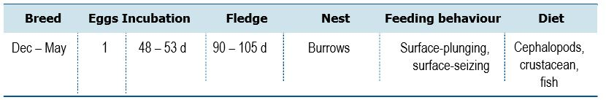
Life History and Distribution
The Mottled Petrel (Pterodroma inexpectata) is a medium sized gadfly-petrel, similar in size and structure to Soft-plumaged Petrel (P. mollis). The species is virtually unmistakeable because of the combination of frosty grey upperparts with dark M-mark across the upperwings. Underparts are white with a large grey belly patch and mainly white underwing marked with a broad black diagonal bar across the secondary coverts. The species is an endemic breeding seabird to New Zealand. It breeds on islands off Fiordland, the Solander Islands, Foveaux Strait islands, islands around Stewart Island (including Titi Islands, Codfish, Big South Cape Islands, and islets in Port Pegasus) and the Snares Islands (Marchant and Higgins 1990, Heather and Robertson 1997). It once bred throughout the North and South Islands, and possibly the Chatham, Bounty, Antipodes and Auckland Islands (Marchant and Higgins 1990, Heather and Robertson 1997). The species forages widely in Australian waters and the Southern Ocean. It migrates to the north Pacific Oceans far as the northern Gulf of Alaska and the southern half of the Bering Sea (Ainley and Manolis 1979, Marchant and Higgins 1990, Heather and Robertson 1997, Ogi et al. 1999).
Population Estimates and Trends
Brooke (2004) estimated that the population was likely greater than 1,500,000 individuals. There are an estimated >10,000 pairs on each of Big South Cape and Main Islands (Heather and Robertson 1997), and the Codfish Island population was estimated at 300,000–400,000 pairs in 1996 (Taylor 2000).
Conservation Concerns and Actions
This species seems to be vulnerable to changing ocean temperatures, with relatively high numbers observed beachwashed during the El Nino event in 1997 in both New Zealand and Alaska (Taylor 2004). Invasive species also represent a threat; the Weka (Gallirallus australis), has been introduced to several colonies, and has caused losses on Codfish Island (Taylor 2000). Black Rat (Rattus rattus) is present on Big South Cape Island, and may have an adverse effect on breeding success.
Recommended Management Actions
- Gain an improved understanding of the at sea distribution in Australia

Species profiles
White-necked Petrel (Pterodroma cervicalis)
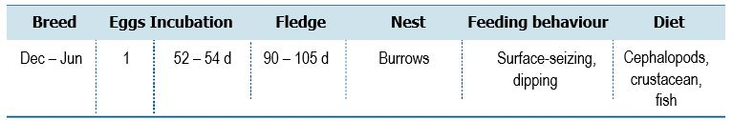
Wildlife Conservation Plan for Seabirds 95

Life History and Distribution
The White-necked Petrel (Pterodroma cervicalis) is a large grey-white petrel with a distinctive white hindneck collar and a black cap that extends below the eyes. The species breeds on Macauley Island in the Kermadec Islands, New Zealand, with a second small colony on Phillip Island, off Norfolk Island (Priddel et al. 2010). It formally bred on Raoul Island, also in the Kermadec Islands, early in the 20th century (Taylor 2000). Two birds were found on Raoul Island in 2005 and 2006 covered in seed-burrs, possibly prospecting (Gaskin 2011). The rare sub-species occulta breeds in small numbers on Vanua Lava, Vanuatu (Totterman 2009). On Phillip Island (subspecies occulta), it is a summer breeder. Birds come ashore as early as 11 November, but lay eggs in January (Priddel et al. 2010). Birds nesting on Phillip Island differ from the population on Macauley by nesting among boulders and in crevices in rocky habitat with sparse understorey, below a canopy of mature White Oaks (Lagunaria patersonia) that provide concealment from avian predators (Priddel et al. 2010). It has also been known to nest in artificial cavities. On Phillip Island, the only known nests are at the top of Long Valley, but other areas have potential nest sites (Priddel et al. 2010). It migrates to the tropical and sub-tropical north Pacific Ocean (Spear et al. 1992) with recent sightings in Hawaiian waters (BirdLife International 2019). It feeds mainly on squid (Heather and Robertson 1997).
Population Estimates and Trends
The global population is estimated at 150,000 individuals (BirdLife International 2019). The Macauley Island population was estimated to be around 50,000 pairs in 1988 and possibly increasing (Veitch et al. 2004). The population on Phillip Island is estimated at 10–100 pairs (Priddel et al. 2010). In 2018, 35 active burrows were found where it is thought the species is expanding (N. Carlile pers. comm). This species qualifies as Vulnerable under IUCN criteria because it has a very small range, on two or three very small islands, and it is therefore susceptible to stochastic events and human impacts.
Conservation Concerns and Actions
The primary threat faced by this species is invasive mammals. Rabbit overgrazing led to considerable erosion on Phillip Island, and their eradication appeared to enable White-necked Petrel to recolonise the suitable areas of the island. Domestic Pigs contributed considerably to the degradation of Phillip Island and may have previously impacted the species on Norfolk Island.

Species profiles
Cats are likely to have been responsible, along with Brown Rat, for the extirpation of the species on Raoul Island. Both are still present on Vanua Lava and pose an existential threat to the species there. Goats dramatically altered the vegetation on Macauley Island prior to their eradication but no clear population impacts were recorded. Polynesian Rats (Rattus exulans) are present in some parts of the range but have not been demonstrated to impact the population. People on Vanua Lava previously harvested chicks from burrows near Mount Suretamatai (del Hoyo et al. 2019) however, this affected a minority of the population and is thought unlikely to return.
Recommended Management Actions
- Minimise effects of climate change
- Examine the relationship between foraging and breeding succusses, population density and productivity and surrounding sea including tracking to determine use of marine habitat in space and time
- Manage key sites to retain their value under climate change
- Quantify the breeding population on Phillip Island
- Regularly monitor breeding populations at index locations
- Determine non-breeding areas and migration routes
- Eradicate invasive species on breeding islands
- Implement best practice quarantine measures at breeding colonies to reduce the risk of any invasive species (re)establishing on islands
- Measure contaminant levels in all relevant life stages
- Restore Phillip Island and facilitate colony expansion
- Re-establish the Norfolk Island breeding colony
96 Wildlife Conservation Plan for Seabirds
Species profiles
Black-winged Petrel (Pterodroma nigripennis)

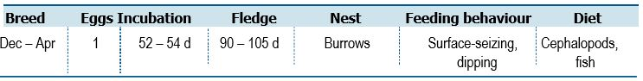

Life History and Distribution
The Black-winged Petrel (Pterodroma nigripennis) is a small compact gadfly petrel with a grey and white plumage, almost complete grey collar. The Black-winged Petrel breeds in the south-west Pacific, in Lord Howe Island (Australia), New Caledonia, the Chatham Islands (New Zealand) and Austral Islands (French Polynesia). It breeds in colonies, usually making burrows on high ground inland amongst scrub or tussock grass (del Hoyo et al. 1992). Outside the breeding season it migrates to the north and east Pacific, being common in the north-west Pacific in July–November, and particularly abundant between the Hawaiian Islands (U.S.A.) and Peru. Little is known about its diet, but it is known to include cephalopods and prawns which it catches mainly by surface-seizing and dipping, but also pattering. It has often been recorded feeding in association with other shearwaters and petrels.
Population Estimates and Trends
Brooke (2004) estimated the global population to number 8 –10 million individuals. In recent decades the species seems to have expanded westwards. Attempts to colonise Norfolk Island have been unsuccessful due to cat predation. On Lord Howe Island, the population is approximately 500–600 pairs and on Phillip Island, (Norfolk Island group) the population in 2017 was estimated at 15,000- 18,000 pairs (N. Carlile pers. comm). Australian trends are unknown but are thought to be increasing.
Conservation Concerns and Actions
Cats predate Black-winged Petrels on Norfold Island (Priddel et al. 2010).
Polynesian Rats may be keeping populations low on islands where they are still present but have been eradicated from the islands where the vast majority of birds breed (Greene et al. 2014). Rabbits may have been a problem in the past on Phillip Island, Australia, but have since been eradicated and the population is increasing. Volcanoes represent a genuine threat to this species, with Macauley Island, containing 2-3 million breeding pairs, on the edge of an active submarine caldera and Curtis Island, containing 300,000 breeding pairs, is an active volcano.
Recommended Management Actions
- Quantify the breeding population on Lord Howe and Phillip Island
- Regularly monitor breeding populations at index locations
- Determine non-breeding areas and migration routes
- Eradicate invasive species on breeding islands
- Implement best practice quarantine measures at breeding colonies to reduce the risk of any invasive species (re)establishing on islands
- Restore Phillip Island and facilitate colony expansion
- Establish a Norfolk Island breeding colony
Wildlife Conservation Plan for Seabirds 97

Species profiles
Common Diving-petrel (Pelecanoides urinatrix)
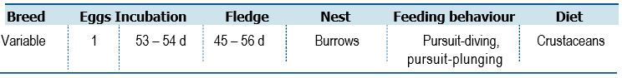
Life History and Distribution
The Common Diving-petrel (Pelecanoides urinatrix) is a small stocky diving-petrel with a ‘neckless’ and short-tailed appearance resembling Northern Hemisphere auks (Alcidae). Very similar in appearance to South Georgian Diving-petrels (P. georgicus) and are largely indistinguishable at sea. The Common Diving-petrel has discrete ranges surrounding oceanic islands in the south Atlantic at South Georgia (Georgias del Sur), the Falkland Islands (Islas Malvinas), Tristan da Cunha and Gough Island (St Helena to UK), in the south Indian Ocean, south and east of New Zealand (e.g. Antipodes Islands), New Zealand's north island, Victoria and Tasmania. Very little is known of their range when not breeding, but they are thought to be fairly sedentary, remaining in coastal waters adjacent to colonies (del Hoyo et al. 1992). Its breeding season is variable according to locality, forming colonies with up to 1,500 individuals in burrows on steep slopes and also on flat ground of oceanic islands. It nests in burrows with an end chamber. Its diet comprises mainly of planktonic crustaceans, which are caught under water in pursuit-diving either from the surface or after plunging.
Population Estimates and Trends
Brooke (2004) estimated the global population to exceed 16 million individuals. Two subspecies breed in Australia, P. u. exsul is restricted to Heard and Macquarie Islands and has an estimated population of 1,000–10,000 individuals on Heard Island (Woehler et al. 1991) and 20 pairs on Macquarie Island in 1979 (Brothers 1984). Subspecies P. u. urinatrix breeds on islands of south-east Australia, Tasmania, New Zealand. Common Diving-petrel occurs on 53 offshore islands in Tasmania with an estimated 127,000–184,000 pairs (Brothers et al. 1996; Brothers et al. 2001). No populations estimates are available for Victoria, and the Australian trend is unknown.
Conservation Concerns and Actions
Rats are present in multiple colonies where this species breeds and could be suppressing breeding success. Eradicating invasive species on offshore islands should be a priority as well as maintaining strict quarantine controls on all known breeding islands.
Recommended Management Actions
- Regularly monitor breeding populations at index locations
- Determine non-breeding areas and migration routes
- Measure contaminant levels in all relevant life stages
- Work with range states to control, or eradicate invasive species on breeding islands
- Implement best practice quarantine measures at breeding colonies to reduce the risk of any invasive species (re)establishing on islands
98 Wildlife Conservation Plan for Seabirds

Species profiles
South Georgian Diving-petrel (Pelecanoides georgicus)

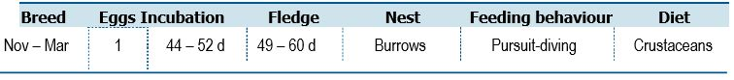
Life History and Distribution
The South Georgian Diving-petrel (Pelecanoides georgicus) is a small stocky petrel similar in appearance to the Common Diving-petrel (P. urinatrix). The South Georgia Diving-Petrel has a circumpolar distribution, breeding on South Georgia (Georgias del Sur) in the south Atlantic and on the Prince Edward Islands (South Africa), Crozet and Kerguelen Islands (French Overseas Territories) and Macquarie and Heard Islands in the Southern Ocean. In New Zealand, it breeds on Codfish Island (del Hoyo et al. 1992). It breeds between October and February in colonies on oceanic islands amongst scree or volcanic ash above the tree line, or under sand dunes in areas of relatively flat ground. It nests in burrows with an end chamber. Little is known about its movements but it is presumably sedentary (del Hoyo et al. 1992). It feeds mainly on planktonic crustaceans, particularly krill, but will also feed on some small fish and young cephalopods. Prey are caught under water in a pursuit-dive or by surface-seizing.
Population Estimates and Trends
Brooke (2004) estimated the global population to number around 15 million individuals. The population on Heard Island was estimated at 10,000–100,000 individuals in 2003/04 (Woehler 2010), with 3–4 pairs found breeding on Bishop and Clerk Islands near Macquarie Island in 1993 (Brothers and Ledingham 2008). Trends are unknown.
Conservation Concerns and Actions
Invasive species remains the most pressing threat to the species. All known Australian breeding colonies are free from predators. Maintaining strict quarantine provisions at Heard, Macquarie, Bishop and Clerk Islands is essential. Habitat erosion after a severe weather event in 2003 has led to significant decrease in the species' colony on Codfish Island, New Zealand (Taylor 2013), habitat degradation is also occurring due to the expansion of forest habitat into the dune region and choking of burrows by the roots of invasive grass species (Taylor 2013).
Recommended Management Actions
- Regularly monitor breeding populations at index locations
- Determine non-breeding areas and migration routes
- Measure contaminant levels in all relevant life stages
- Work with range states to control, or eradicate invasive species on breeding islands
- Implement best practice quarantine measures at breeding colonies to reduce the risk of any invasive species (re)establishing on islands
Wildlife Conservation Plan for Seabirds 99

Species profiles
King Penguin (Aptenodytes patagonicus)
100 Wildlife Conservation Plan for Seabirds
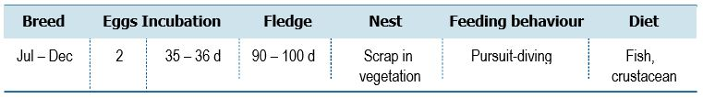

Life History and Distribution
The King Penguin (Aptenodytes patagonicus) is a large penguin with striking orange and black head markings as an adult. Adults are up to 95 cm tall and achieve a weight of approximately 13.5 kg. The King Penguin is the second largest penguin species, following the Emperor Penguin (A. forsteri). Females are slightly smaller than males, but identical in appearance and juveniles are similar, with less pronounced colouration (Marchant and Higgins 1990). The King Penguin breeds on sub-Antarctic islands in the South Atlantic, southern Indian Ocean and the Australian sector of the Southern Ocean (Marchant and Higgins 1990). The species’ pelagic (oceanic) distribution is poorly known. The species utilises beaches, valleys and moraines free of snow and ice and with easy access to sea (generally within several hundred to 1000 m to the sea) (Woehler 2002, pers. comm.). The King Penguin feeds mostly on small fish of the family Myctophidae (lanternfishes) with some small cephalopods consumed in winter at Marion Island, Iles Crozet and Macquarie Island. Birds recorded foraging around South Georgia mostly fed on large cephalopods (Kondakovia longmania and Moroteuthis spp.). There is evidence of prey-switching during different seasons, which may be in response to seasonal changes in prey abundance (Marchant & Higgins 1990). Given the long breeding cycle, breeding pairs typically breed two in every three years if successful.
Population Estimates and Trends
Due to the long breeding cycle of King Penguins, breeding is asynchronous within a colony and proportion of birds present do not breed. Consequently, it can be difficult to accurately estimate the total number of breeding pairs in a colony. Given these caveats, the total population of the King Penguin was estimated to be approximately 1.64 million pairs in the late 1990s (Ellis et al. 1998). The largest breeding aggregations have been recorded at Iles Crozet (700,000 pairs in 1992) (Woehler and Croxall 1997), Iles Kerguelen (240,000–280,000 pairs in 1987), Prince Edward Island (228,000 pairs in 1979) (Marchant and Higgins 1990) and South Georgia (400,000 pairs in mid-1990s) (Woehler and Croxall 1997). However, while some populations subsequently showed population increases (e.g. South Georgia increased by 11 per cent per annum since 1985-86; Woehler and Croxall 1997, Woehler et al. 2001), recent surveys have shown dramatic decreases at some sites. e.g. 88 per cent decrease from c. 500,000 pairs to 60,000 pairs at Ile aux Cochons, Iles Crozet over past 50 years (Weimershirch et al. 2018). Numbers at the Prince Edward Islands were estimated to be 65,000 breeding pairs at Marion Island and 2,000 pairs at Prince Edward Island in 2008 (Crawford et al. 2009), far below the estimates from 1979.

Species profiles
The Macquarie Island breeding aggregation increased at a rate of 9.7 per cent per annum between 1930–80, reaching 130,000 pairs by the mid-1990s (Marchant and Higgins 1990; Woehler and Croxall 1997), however this population increase has not continued (Tasmanian Parks and Wildlife Service unpublished data). At Macquarie Island, the number of chicks is estimated annually as a proxy for population trend estimates and, from 2007–2019, chick numbers in August ranged from 33,000–80,000 chicks per annum (Tasmanian Parks and Wildlife Service unpublished data). On Heard Island, where the species was believed to have been extirpated in the nineteenth century, the aggregation increased at rate of 15.1 per cent per annum from 1963–80 and >20 per cent per annum between 1980–1993, to reach a total size of 16,345 pairs at that time (Marchant and Higgins 1990; Woehler and Croxall 1997).
Conservation Concerns and Actions
The King Penguin was formerly hunted for oil and the species was extirpated in the nineteenth century from several breeding locations, including Heard Island. However, the species has since re-established. The main threat for this species in recent years is climate change with warming oceans resulting in a decline in breeding success and adult survival (Le Bohec et al 2008). The species may be affected by current human activities near occupied scientific winter bases (Marchant and Higgins 1990). Marine pollution (e.g. oil spills, and ingestion of plastics) kills some birds, but this has not been quantified (Ellis et al. 1998). Eggs and small chicks may be lost during storms or other natural events. Skuas and sheathbills (Chionis spp.) take eggs and small chicks. Older chicks may die from starvation or be killed by giant-petrels (Marchant and Higgins 1990). Potential developing threats include competition with commercial fisheries for food, ocean warming and introduced disease (Ellis et al. 1998).
Recommended Management Actions
- Quantify the breeding population on Heard Island
- Regularly monitor breeding populations at index locations
- Implement best practice quarantine measures at breeding colonies to reduce the risk of any invasive species (re)establishing on islands
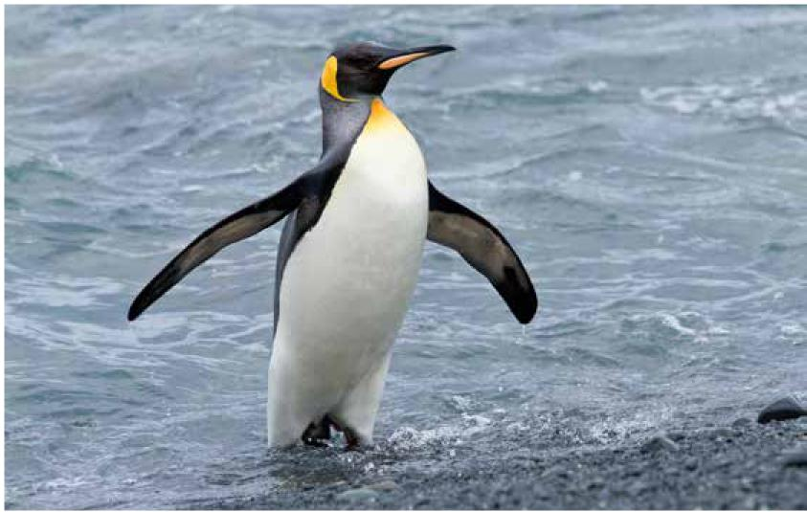

Wildlife Conservation Plan for Seabirds 101

Species profiles
Gentoo Penguin (Pygoscelis papua)
102 Wildlife Conservation Plan for Seabirds
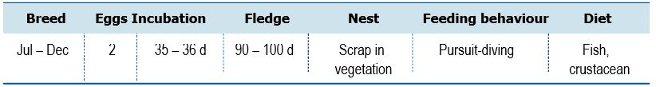
Life History and Distribution
The Gentoo Penguin (Pygoscelis papua) is unmistakable and cannot be confused with other species in its normal range. The species is a tall black and white penguin of subantarctic and Antarctic regions with a bright orange bill and feet. Gentoo Penguins are defined morphologically as a single species with a northern and southern subspecies. A recent phylogenetic tree based on mitochondrial DNA showed a deep division between populations in the Indian and Atlantic oceans, with at least three distinct clades, two in the respective sub-Antarctic and Antarctic zones of the Atlantic Ocean, and a deeply divergent and unnamed third clade in the subantarctic Indian Ocean (de Dinechin et al. 2012). Breeding colonies are present on Macquarie and Heard Islands (Woehler 1993, 2006). The species nests on flat beaches or among tussock grasses in South Georgia and the Falkland Islands and in grasses at Marion Island. Further south, on the Antarctic Peninsula, nests are typically on low lying gravel beaches and dry moraines. Colonies are typically much smaller than those of other Pygoscelis species, with the largest including only 6,000 breeding pairs (Lynch et al. 2008). It feeds opportunistically and preys predominantly on crustaceans, fish and squid. It preferably forages inshore, close to the breeding colony. Winter habitats are less well studied, but available data suggest that it prefers coastal areas, while movements are more local relative to its congeners (Tanton et al. 2004, Hinke et al. 2017). Gentoo Penguins remain close to colonies throughout the year, with colonies occupied year-round. In the non-breeding season, colonies are used as roosts during periods of poor weather.
Population Estimates and Trends
The global population is estimated at 774,000 mature individuals (Lynch 2013). Population trends are difficult to establish because of large year-to-year fluctuations in the size of the breeding population. The three most important locations, containing 80 per cent of the global population, are the Falkland Islands (Malvinas): 132,000 breeding pairs at about 84 breeding sites (Baylis et al. 2013), South Georgia: 98,867 pairs (South Georgia & the South Sandwich Islands) (Trathan et al. 1996) and the Antarctic Peninsula (incl. South Shetland Island): 94,751 pairs (Lynch et al. unpublished cited in BirdLife International 2019). About 16,000 pairs were breeding on Heard Island in 1987-88 (Woehler 1991, 2006). On Macquarie Island, there were approximately 2,500–2,600 breeding pairs in 2017 (Tasmanian Parks and Wildlife Service unpublished data). Current population trends show a 50 per cent decline in the number of breeding pairs on Macquarie Island since 1984 (Robertson 1986), or 2 per cent per annum.

Species profiles
Conservation Concerns and Actions
There are no major land-based threats to Gentoo Penguins on either Heard or Macquarie Islands, although it is possible that Brown Skua and overwintering giant petrels have increased their predation pressure on Gentoo Penguin breeding populations after the removal of alternate non-native prey (rabbits and rodents) on Macquarie Island. Terrestrial protections for Gentoo Penguins include the protection of breeding habitat and the minimization of colony disturbance during the breeding season. In the Antarctic, visitor site guidelines already specify minimum approach distances of 5 m and set off-limit areas.
Interactions with fisheries may pose a threat to the species through incidental capture in fishing nets and resource competition (Ellis et al. 1998). The species appears to be actively feeding on discards from trawling fleets, making it susceptible to bycatch, which potentially could be causing slow decreases in populations whose foraging range overlaps with fisheries (Crawford et al. 2017). Increasing oil exploration around the Falkland Islands is a growing concern for the species (Lynch 2013) and pollution from oil spills represents a threat on local scales. Historically, egg collection was widespread on the Falkland Islands (Clausen and Pütz 2002), and some legal egg collection still continues (Otley et al. 2004) and is strictly regulated; hence it is believed not to contribute to a decrease in the species. It is currently unknown what impact warming oceans will have on Gentoo Penguin populations.
Recommended Management Actions
- Quantify the breeding population on Heard Island
- Investigate the cause of the population decline observed on Macquarie Island
- Regularly monitor breeding populations at index locations
- Implement best practice quarantine measures at breeding colonies to reduce the risk of any invasive species (re)establishing on islands
- Maintain bycatch mitigation strategies in relevant fishery operations
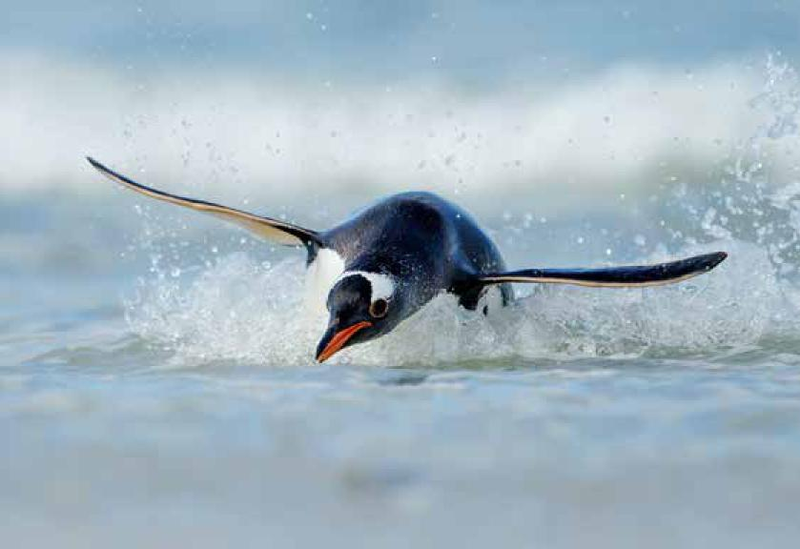

Wildlife Conservation Plan for Seabirds 103

Species profiles
Rockhopper Penguin (Eudyptes chrysocome)
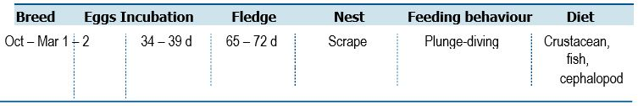
Life History and Distribution
The Rockhopper Penguin (Eudyptes chrysocome) is the smallest of the crested penguin group but larger than Little Penguin (Eudyptula minor). The southern Rockhopper Penguin differ from their northern counterparts in having a narrower supercilium and shorter plumes, which reach just over the black throat. The species breeds on islands located in the South Atlantic, Indian and Pacific Oceans, ranging from 46º S in the South Atlantic and South Indian Oceans to Macquarie Island at 54ºS in the Southern Ocean, and a number of offshore islands in southern Argentina and Chile. This species returns to its breeding colonies in October, which range from sea-level sites to cliff-tops, and sometimes inland. Two eggs are laid and incubated during November and December for 32-34 days. In February, the chicks fledge and depart the colony (BirdLife International 2019). At most breeding sites, only one chick fledges, but there is some evidence that it is not unusual for Rockhopper Penguins in the Falkland Islands (Malvinas) to raise two chicks (Clausen and Pütz 2002; Poisbleau et al. 2008). At the Falkland Islands (Islas Malvinas), hybridization occurs with Macaroni (White and Clausen 2002) and northern Rockhopper Penguins (Crofts and Robson 2016). Rockhopper Penguins prey on a variety of fish, crustaceans and cephalopods (Williams 1995), but there is individual dietary specialization during part of their annual cycle (Dehnhard et al. 2016).
Population Estimates and Trends
Several populations have experienced major long-term population crashes. Approximately 1.5 million pairs are estimated to have been lost from Campbell Island (94 per cent of the original total) between 1942 and 1986 (Cunningham and Moors 1994), with a further 21.8 per cent decrease between 1986 and 2012 (Morrison et al. 2015). In the Falkland Islands (Malvinas), the population decreased by around 1.2 million pairs between 1932 and 2000 (20 per cent of the original total) (Pütz et al. 2003). At Staten Island, the numbers of Rockhopper Penguins decreased by 24 per cent between the censuses of 1998 and 2010 (Raya Rey et al. 2014). Between 1987/88 and 2012/13, numbers at Marion Island decreased by about 52 per cent, from 138,000 pairs to 65,000 pairs, equivalent to 72 per cent in three generations (Dyer and Crawford 2015). The long-term trends remain unknown for the Kerguelen and Crozet populations. Several other populations at the Auckland Islands and Antipodes Islands appear to have suffered severe declines of more than 40 per cent between the 1970s and the 1990s (Cooper 1992, Hiscock and Chilvers 2013).
Due to the difficulty in surveying this species (i.e. a high proportion of nests are cryptic in boulder fields and dense vegetation), population estimates, and trends are difficult to accurately obtain. In 1990, the population was estimated at 100,000–300,000 pairs on Macquarie Island and, in 1993, 166 pairs on Bishop and Clerk Islets (Brothers and Ledingham 2008). On Heard Island the estimate is 10,000 pairs and at least 10 pairs on McDonald Island (Woehler 1991, 1993; Ellis et al. 1998; Woehler 2006). Numbers on Macquarie Island were estimated at 32–43,000 pairs in 2006–2007 and work to develop and test survey methods to accurately estimate population trends on the island continues.
104 Wildlife Conservation Plan for Seabirds
Species profiles
No recent data from Bishop and Clerk Islets, Heard or McDonald Islands (Woehler 2006) but Heard Island population is believed to have decreased, based on disappearance of surface colonies between 1940s–1950 and early 2000s (E. Woehler pers. comm). Globally, this species has been classified as vulnerable under IUCN criteria owing to rapid population decreases, which, although they have been ongoing for perhaps a century, appear to have worsened in recent years.
Conservation Concerns and Actions
Climate change appears to be a factor driving population decreases. Survival of adult Rockhopper Penguins appears to be sensitive to sea surface temperatures, with highest survival probabilities under moderately-cold to long-term average temperature, and reduced survival probabilities under increasingly cold or warm ocean temperatures (Raya Rey et al. 2007, Dehnhard et al. 2013). Rockhopper Penguins at the Falkland Islands (Islas Malvinas) delayed breeding under warmer environmental conditions and laid lower mass eggs, with potential impacts on breeding success (Dehnhard et al. 2015a, b). Temperature extremes have caused collapse in accessible food resources in the past, and these are part of an ongoing trend in more frequent unusual oceanographic conditions recurring in the area (Dehnhard et al. 2013).
Penguins and their habitats may also be threatened by increased frequency of storm events at breeding sites (Wolfaardt et al. 2012). Severe mortality was recorded in moulting birds found unusually far from colonies in 2016, which appeared to be related to a set of poorly understood oceanographic conditions, leading to lowered primary productivity near breeding sites immediately before moult (Morgenthaler et al. 2018). Climate change may also lead to top-down changes in food web structure, causing increased inter-specific competition and secondary predation, e.g. competition and predation by the rapidly increasing pinniped (fur seal and sea lion) populations (Barlowet al. 2002, Raya Rey et al. 2012, Morrison et al. 2017). Overwintering conditions are thought to influence the proportions of birds skipping breeding at Marion Island (Crawford et al. 2006) and potentially elsewhere.
The number of Rockhopper Penguins returning to Marion Island to breed decreased by about 20 per cent between 1994/95 and 2007/08 and was significantly correlated with breeding success (Crawford et al. 2008). Another potential threat stems from interaction with fisheries; levels of bycatch mortality appear to be insignificant, but resource competition and indirect changes to the food web through modification of ecosystems may have more extensive impacts (Crawford et al. 2017). Land-based human threats at breeding sites, such as tourism, research and land management, are considered low, and although it may vary on local scales, disturbance from such activities is currently deemed not significant at an overall population level at the Falkland Islands (Islas Malvinas) (Crofts 2014). Tourism is strictly regulated with visits only to a small percentage of the global population.
Recommended Management Actions
- Develop robust survey methods to quantify the breeding population on Macquarie, Heard and McDonald Islands
- Regularly monitor breeding populations at index locations
- Implement best practice quarantine measures at breeding colonies to reduce the risk of any invasive species (re)establishing on islands
- Maintain bycatch mitigation strategies in relevant fishery operations
Wildlife Conservation Plan for Seabirds 105
Species profiles
Macaroni Penguin (Eudyptes chrysolophus)
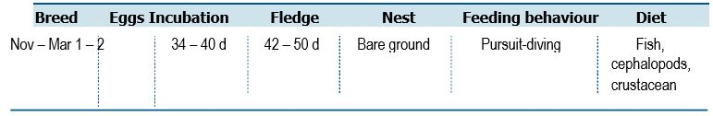
Life History and Distribution
The Macaroni Penguin (Eudyptes chrysolophus) is a medium sized penguin with a large red-brown bill. The species is larger than other Eudyptes penguins, except for the Royal Penguin (E. schlegeli). The species breeds at southern Chile, the Falkland Islands (Malvinas), South Georgia (Georgia del Sur) and the South Sandwich Islands (Islas Sandwich del Sur), the South Orkney and South Shetland Islands, Bouvet Island (to Norway), Prince Edward and Marion Islands (South Africa), Crozet Islands, Kerguelen Islands (French Southern Territories), Heard and McDonald Islands and very locally on the northern Antarctic Peninsula. Macaroni Penguins nest on level to steep ground, often walking hundreds of metres across steep scree slopes to nest-sites. The breeding cycle is characterized by a high level of synchrony with a laying period protracted over a period of less than 2 weeks. Breeding areas usually have little or no vegetation due to erosion by birds. Macaroni Penguins are oceanic foragers, searching for prey at moderate depths, usually less than 50 m but they can dive more than 100 m. They feed mainly on small krill (Marchant and Higgins 1990); at South Georgia they feed extensively on Antarctic krill (Euphausia superba), while at Crozet and Kerguelen they have a more diverse diet, feeding on small euphausiids, amphipods (e.g. Themisto gaudichaudii) and small amounts of myctophid fish. Their diets show a shift after incubation, with an increase in fish. During their winter dispersal, they rely mostly on crustaceans (Bost et al. 2009).
Population Estimates and Trends
The global population is estimated at 6.3 million pairs in at least 258 colonies
at 55 breeding sites (Crossin et al. 2013), with major populations on Crozet
(2,200,000 pairs, including 1 million on Ilots des Pingouins), Kerguelen
(1.8 million pairs), Heard Island (1 million pairs), South Georgia (1 million pairs)
and Marion Island (290,000 pairs). Volcanic activity displaced a colony of 1 million
pairs on McDonald Island, though satellite images show unidentified penguins may be
recolonising the affected area (Crossin et al. 2013). Surveys on Heard Island suggest
a decrease owing to losses in some smaller colonies. The population at Marion has
decreased by over 30 per cent from 434,000 pairs in 1994-1995 to 290,000 pairs in
2008-2009 (Crawford et al. 2009), and 267,000 pairs in 2012-2013 (Dyer and Crawford
2015). At Kerguelen populations increased by 1.06 per cent per annum between
1962 and 2014, and have been stable since.
106 Wildlife Conservation Plan for Seabirds
Species profiles
Conservation Concerns and Actions
Climate change is an important candidate for explaining recent decreases at some breeding sites. Large-scale environmental changes, particularly those related to sea surface temperatures could be contributing to habitat loss, indirect ecosystem effects, direct species mortality and reduced reproductive success, but the nature and level of impacts remain unclear as there may be divergent responses in different populations; climate was found to be have potentially positive effects in the short to medium term for the population studied at Bird Island, South Georgia, whereas changes to predation dynamics appear to be the main factor driving decreases (Horswill et al. 2014, 2016).
Commercial fisheries could represent a potential threat through incidental capture and resource competition. Long-line fisheries at winter feeding grounds have inflicted limited bycatch mortality on Macaroni Penguins (Dyer and Crawford 2015) and harvesting of Antarctic krill (Euphausia superba) could reduce food availability if management does not adequately allow for the dietary needs of the species.
Invasive mammals including cats, mice and rabbits are present on a number of subantarctic islands but their current impact on the species is thought to be negligible (Crossin et al. 2013). Breeding colonies on Marion Island have decreased following outbreaks of avian cholera and other unknown diseases (Cooper et al. 2009, Grimaldi et al. 2011).
Human impacts potentially also include disturbance from tourists, scientists and construction of new infrastructure. Protection of habitat on land and at sea remains important, with the designation of appropriate protection for transit, foraging and rafting areas at sea.
Recommended Management Actions
- Quantify the breeding population on Heard and McDonald Islands
- Regularly monitor breeding populations at index locations
- Implement best practice quarantine measures at breeding colonies to reduce the risk of any invasive species (re)establishing on islands
- Maintain bycatch mitigation strategies in relevant fishery operations
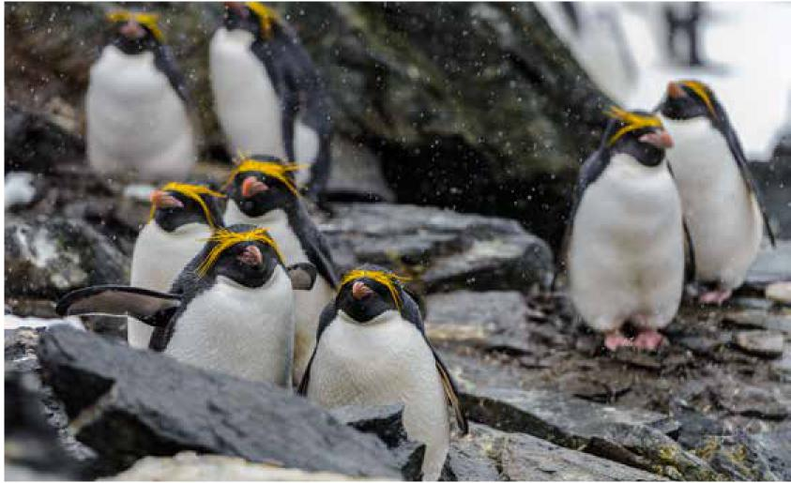

Wildlife Conservation Plan for Seabirds 107

Species profiles
Little Penguin (Eudyptula minor)
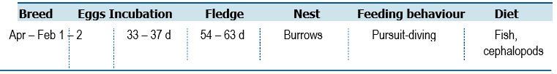
Life History and Distribution
The Little Penguin (Eudyptula minor) is the smallest penguin species and is endemic to Australia and New Zealand. In Australia, the species occurs from Western Australia (Carnac Island) to New South Wales (Broughton Island) and Tasmania. The distribution is not continuous, with sections of the southern coast of Australia without occurrence of breeding colonies. In New Zealand, Little Penguins occur from the Chatham Islands to mainland New Zealand, including Stewart Island. The Little Penguin breeds during the austral autumn to summer months and are the only truly nocturnal penguin species on land; adults always arrive after dusk and leave before dawn (Klomp and Wooller 1991, Chiaradia et al. 2007, Rodriguez et al. 2016). Little Penguins typically lay two eggs per clutch (Dann 2013). This species is a generalist feeder, with large variability in diet amongst colonies and even between years at the same colony (Klomp and Wooller 1988; Gales and Pemberton 1990, Cullen et al. 1992, Fraser and Lalas 2004, Chiaradia et al. 2010, 2012). They feed mainly on clupeids, such as anchovy Engraulis austalis and sardines Sardinops sagax, when feeding chicks, but they may also feed on krill Nyctiphanes australis and several species of cephalopods at all stages of breeding (Gales and Pemberton 1990, Cullen et al. 1992, Chiaradia et al. 2012). When foraging, some individuals can take advantage of man-made features, like ship channels to aid in their foraging (Preston et al. 2008).
Population Estimates and Trends
The global population size has been quantified for most sites, with current population estimated of 469,760 breeding adults. This is substantially fewer than the previous Red List assessments that estimated the total population as under 1 million individuals but was based on non-quantified data. Based on limited data for a low number of colonies, there is an apparent increase of 18 per cent in population size when historic and recent data are compared. However, this increase must be interpreted with caution as it is very likely to be related to improved population survey effort rather than an actual increase in population. For sites with current population estimates, 60 per cent of the sites have an “unknown” trend due to data deficiency. Nevertheless, for the sites where data were available, 51 per cent of sites were stable, 29 per cent deteriorating and 20 per cent improving. Fifteen sites are suspected extinct.
108 Wildlife Conservation Plan for Seabirds
Species profiles
Conservation Concerns and Actions
Principal threats to Little Penguins are introduced predators, bycatch, habitat loss through coastal development, oil pollution, mortality through roadkill and collisions with watercraft, and human disturbance at breeding colonies (Stevenson and Woehler 2007; Chiaradia 2013, Dann 2013, Cannell et al. 2016). Additionally, the impact of changing oceanic conditions appears to impact food availability and reproductive success (Voice et al. 2006, Wu et al. 2012). Introduced predators impact colonies throughout the range to varying extents, with substantial mortality occurring particularly from domestic dogs (Canis familiaris) but impacts were also noted from pigs (Sus scrofa), cats (Felis catus) and Weka (Gallirallus australis) in New Zealand. Invasive grasses and weeds are another threat as they can inhibit access to breeding sites as well as cause the loss of breeding sites. The species is assessed as being moderately at risk from bycatch in gillnets, although qualitative data are lacking (Crawford et al. 2017). As such, recreational gillnets in some parts of the range appear to have the potential to cause considerable mortality (Stevenson and Woehler 2007; Crawford et al. 2017).
An additional challenge for this species is in the fast-changing marine and terrestrial environment, particularly the rapidly warming sea of southern Australia (Voice et al. 2006, Wu et al. 2012). In southwestern Australia, the sea surface temperatures have been associated with poorer breeding including lower fledging success, fewer chicks per pair and a lower mean mass of chicks at fledging (Cannell et al. 2012). Little Penguins have been also shown to catch fewer prey in warmer conditions (Carroll et al. 2016). Oceanographic change may lead to a mismatch between plankton and the small pelagic fish that are also penguin prey (Hinder et al. 2013). Increasing terrestrial temperatures are also responsible for Little Penguin mortality due to hyperthermia (Cannell et al. 2011, Chambers et al 2013).
Recommended Management Actions
- Regularly monitor breeding populations at index locations
- Measure contaminant levels in all relevant life stages
- Control, or eradicate invasive species at breeding colonies
- Implement best practice quarantine measures at breeding colonies to reduce the risk of any invasive species (re)establishing on islands
- Maintain bycatch mitigation strategies in relevant fishery operations
Wildlife Conservation Plan for Seabirds 109
Species profiles
Lesser Frigatebird (Fregata ariel)
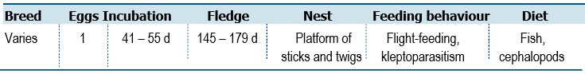
Life History and Distribution
The Lesser Frigatebird (Fregata ariel) is the smallest frigatebird with black and white marking that vary with age and sex. The species has a typical frigatebird structure with long pointed wings, long bill with hooked tip and a very long, deeply forked tail. Lesser Frigatebirds are found throughout tropical waters in the Indian, west and central Pacific Oceans. The Lesser Frigatebird breeds on small, remote tropical and sub-tropical islands, in mangroves or bushes, and even on bare ground. Outside the breeding season it is sedentary, with immature and non-breeding individuals dispersing throughout tropical seas, especially of the Indian and Pacific Oceans (del Hoyo et al. 1992). It feeds mainly on fish (especially flying-fish) and squid, but also on seabird eggs and chicks, carrion and fish scraps (del Hoyo et al. 1992).
Population Estimates and Trends
Del Hoyo et al. (1992) estimate that the population is likely several hundred thousand individuals. The global population estimate is between 100,000–500,000 individuals (BirdLife International 2019). It has been suggested that the frigatebird roost at Weipa, Queensland should be recognised as nationally or internationally significant for one or both species of frigatebirds (Gould 2008). Likewise, survey data suggests Ashmore Reef Marine Park comprises significant numbers and is believed to account for ≥1% of the global population (Cannell and Surman 2020). Baker and Holdsworth (2013) reported that from a regional perspective, the Herald Cays (Coral Sea Marine Park) contain a significant proportion of the region’s breeding populations of Lesser Frigatebirds. Up to 2012, there were 20-year and 10-year data sets available for North East Cay (Herald Cays) and South West Cay (Herald Cays) (Coral Sea Marine Park), respectively. Over the 20-year period (1992-2012), the number of frigatebirds (Great and Lesser Frigatebirds) declined at an annual rate of 7.7 per cent.
Conservation Concerns and Actions
Climatic events associated with ENSO (El Niño Southern Oscillation) can cause synchronised breeding failure, as observed in the central Pacific (del Hoyo et al. 2019). Human disturbance at breeding localities has the potential to lower reproductive success.
Recommended Management Actions
- Quantify the breeding population in Australia
- Regularly monitor breeding populations at index locations
- Investigate the importance of the Weipa Lesser Frigatebird roost
- Determine non-breeding areas and migration routes
- Control, or eradicate invasive species on breeding islands
- Implement best practice quarantine measures at breeding colonies to reduce the risk of any invasive species (re)establishing on islands
- Quantify and manage the potential impacts of fisheries interactions and human disturbance
110 Wildlife Conservation Plan for Seabirds

Species profiles
Great Frigatebird (Fregata minor)
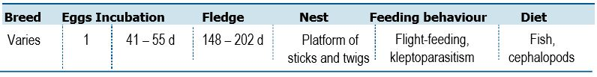

Life History and Distribution
The Great Frigatebird (Fregata minor) is a very large black, or black and white seabird larger than most seabirds in the tropics. Major breeding populations are found in tropical waters of the Pacific and Indian Oceans. The Great Frigatebird breeds on small, remote tropical and sub-tropical islands, in mangroves or bushes and occasionally on bare ground (del Hoyo et al. 1992). The species has a protracted breeding cycle, averaging 16 months, to raise a single chick (Nelson 1976). Successful breeders from one year rarely if ever attempt to breed in the following year. Juveniles remain dependent until well into their second year, overlapping the subsequent nesting cycle (James and McAllan 2014). Fish, squid and chicks of other bird species (e.g. Sooty Terns) have all been identified as prey (Weimerskirch et al. 2004). It is frequently observed attempting to steal food from other bird species (Vickery and Brooke 1994). However, this behaviour represents a minor source of energy intake (Vickery and Brooke 1994; Weimerskirch et al. 2004).
Population Estimates and Trends
The global population estimate is 500,000–1,000,000 individuals (BirdLife International 2019). Christmas Island provides breeding habitat for an estimated 3,500 pairs (James and McAllan 2014). Other important populations include those at North Keeling Island, the islands of Ashmore Reef Marine Park (50 pairs; Cannell and Surman 2020), Adele Island, WA and in several Coral Sea Marine Park islands and cays. Baker and Holdsworth (2013) reported that from a regional perspective, the Herald Cays (Coral Sea Marine Park) contain a significant proportion of the region’s breeding populations, particularly for the Great Frigatebird. As at 2012, there were 20-year and 10-year data sets available for North East Cay (Herald Cays) and South West Cay (Herald Cays), respectively. Over the 20-year period (1992-2012), the number of frigatebirds (Great and Lesser Frigatebirds) declined at an annual rate of 7.7 per cent.
Conservation Concerns and Actions
Suspected increases in the frequency of ENSO (El Niño Southern Oscillation) events with climate change (Timmermann et al. 1999) may pose a threat to the survival and breeding success of Great Frigatebirds of unknown severity (Anderson 1989, Weimerskirch et al. 2010). Human disturbance has minor effects on the species; boats approaching the beach trigger flushing of nesting and roosting individuals (Borsa and Boiteux 2007 in Borsa et al. 2010).
Recommended Management Actions
- Quantify the breeding population in Australia
- Regularly monitor breeding populations at index locations
- Determine non-breeding areas and migration routes
- Eradicate invasive species on breeding islands
- Implement best practice quarantine measures at breeding colonies to reduce the risk of any invasive species (re)establishing on islands
- Quantify and manage the potential impacts of fisheries interactions and human disturbance
Wildlife Conservation Plan for Seabirds 111

Species profiles
Australasian Gannet (Morus serrator)

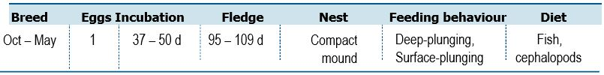
Life History and Distribution
The Australasian Gannet (Morus serrator) is a large, conspicuous, predominantly white seabird. Generally, Australasian Gannets are unmistakeable from other seabirds except other sulids with a long neck, slender wings, spear-like bill and pointed tail. The species is confined to waters around Australia and New Zealand, mainly in the temperate zone. Breeding colonies are found off the coast of Victoria, Tasmania and New Zealand. One small colony is also found farther north at Norfolk Island. Breeding is highly seasonal (October to May), nesting on the ground in small but dense colonies. Adults tend to stay within the vicinity of the colony after breeding, with young birds dispersing (del Hoyo et al. 1992). Birds winter in adjacent waters and up the east and west coasts of Australia as far north as the Tropic of Capricorn (del Hoyo et al. 1992). Their diet is comprised mainly of pelagic fish, especially pilchard, anchovies and jack mackerel, but also squid and garfish. Prey is caught mainly by plunge-diving, but the species is also seen regularly attending trawlers.
Population Estimates and Trends
A global population estimate has not been quantified (BirdLife International 2019). The population is suspected to be increasing following a reduction in human persecution and the establishment of new colonies in Victoria and Tasmania in recent years. Numbers of Australasian Gannet have been increasing since 1950, although some colonies have disappeared, and others have decreased in population (Bunce et al. 2002). Between 1980 and 2000, the population in Australian waters increased from approximately 6,600 to 20,000 breeding pairs (Bunce et al. 2002). The most recent comprehensive New Zealand census was in 1981, yielding an estimate of 46,600 pairs, estimated to have increased to around 55,000 pairs in 2006 (Wodzicki et al 1984; Bunce et al. 2002).
Colony location is related to sea surface temperature, which in turn influences the presence of fish. Many colonies have limited space and birds seek new locations once the nest sites in a colony are full. In Tasmania, there are colonies at Eddystone Rock and Pedra Branca off the south coast, and Black Pyramid Rock off the northwest coast. The colony on Black Pyramid increased from 500 pairs in 1961 to 12,300 pairs in 1998 (Bunce et al. 2002). Eddystone Rock increased from 20 pairs in 1947 to 189 pairs in 1998, and Pedra Branca grew from 1,000 pairs in 1939 to 3,300 pairs by 1995, but both these sites have little or no room for expansion (Bunce et al. 2002). Conversely, the colony at Cat Island, Furneaux Group decreased from an estimated 5,000 –10,000 pairs in 1908 to nil in the 1980s due to human persecution (Serventy et al. 1971; BirdLife International 2019), and a fire that destroyed the colony in 1984 (Brothers et al. 2001). More recently, small numbers of pre-fledged chicks have been observed at a number of known roost sites on Tasmanian offshore islands, including Bass Pyramid, Judgement Rocks and Wright Rocks in eastern Bass Strait and Hippolyte Rock in the south-east.
112 Wildlife Conservation Plan for Seabirds

Species profiles
Conservation Concerns and Actions
Bycatch is a concern for all gannet species and Australasian Gannets interact with fisheries throughout their inshore foraging range with considerable potential for impacts from longline and set-net fisheries (del Hoyo et al. 2019). In New Zealand, Australasian Gannets have been assessed as being at relatively low risk from commercial fisheries with an estimated annual mortality of 62 individuals (95% confidence interval 7-222) (Richard and Abraham 2013). In New Zealand, the greatest mortality was observed in set-net fisheries (Richard and Abraham 2013).
Recommended Management Actions
- Quantify the breeding population in Australia
- Regularly monitor breeding populations at index locations
- Determine non-breeding areas and migration routes
- Maintain bycatch mitigation strategies in relevant fishery operations
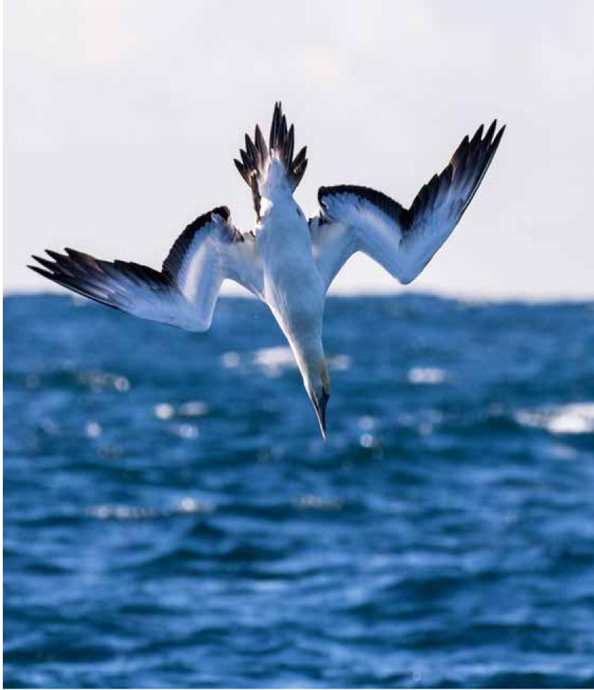

Wildlife Conservation Plan for Seabirds 113

Species profiles
Masked Booby (Sula dactylatra)
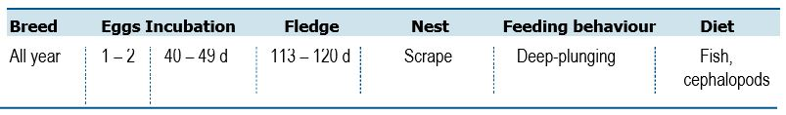
Life History and Distribution
The Masked Booby (Sula dactylatra) is the largest booby. It displays typical sulid characteristics of a streamlined body, long narrow wings, long neck, pointed bill and tail. Masked Boobies tend to be more solitary that Australasian Gannets (Morus serrator) sometimes in loose congregations, particularly when returning to breeding islands. This species ranges widely in tropical waters, being found in every ocean except the eastern Atlantic Ocean, northern Indian Ocean and the central-eastern Pacific Ocean (del Hoyo et al. 1992). Its breeding season depends on locality, forming small to medium-sized colonies of variable densities on rocky islands offshore. Nests are preferably built on cliff ledges, but a variety of other sites are used (del Hoyo et al. 1992). In Australia, breeding is largely confined to islands and cays in the Great Barrier Reef and Coral Sea Marine Park with other colonies occurring on Lord Howe and Norfolk Islands. Masked Boobies banded at Lord Howe Island have been found on two occasions on North East Herald Cay (Coral Sea Marine Park) suggesting that Lord Howe Island birds may regularly disperse into the Coral Sea before returning to breed at their natal colonies (Baker et al. 2008). Small colonies also occur on the islands of Ashmore Reef Marine Park, Lacepede, Bedout and Adele Islands, Western Australia. There is some conjecture on the subspecies of Masked Booby breeding within Ashmore Reef Marine Park. At sea, the species can normally be found over pelagic waters, preferring deeper waters than other boobies. It feeds on large species of shoaling fish, especially flying fish, but will also take large squid.
Population Estimates and Trends
The global population size has not been quantified, but this species is described as 'fairly common' (Stotz et al. 1996). The population on the Lord Howe Island group, including Balls Pyramid was estimated in 2011 at 2,670 pairs (N. Carlile pers. comm). In the Coral Sea Marine Park, the largest colonies (>300 pairs) recorded were in the Cato Island and Saumarez Reef cays. The Australian population estimate and trends remain unknown.
Conservation Concerns and Actions
Masked Boobies are sensitive to human disturbance, with visitors passing within 10-20 m causing birds to leave their nest (Borsa et al. 2010); however, this is not believed to be significantly affecting the population. Invasive species, primarily Black Rats Rattus rattus, also pose a threat in some parts of the booby's range, namely Clipperton Island, following the eradication of feral cats Felis catus (Pitman et al. 2005). Collection of eggs and hunting of adults from breeding colonies (del Hoyo et al. 2019) is thought to be causing slow and significant declines outside of Australia.
114 Wildlife Conservation Plan for Seabirds
Species profiles
Recommended Management Actions
- Determine the subspecies status breeding within the Ashmore Reef Marine Park
- Investigate the location and characteristic of key feeding sites and the means to retain their value under climate change
- Manage key sites to retain their value under projected climate change scenarios
- Quantify the breeding population in Australia
- Regularly monitor breeding populations at index locations
- Determine non-breeding areas and migration routes
- Quantify and manage the potential impacts of fisheries interactions and human disturbance
- Control, or eradicate invasive species on breeding islands
- Implement best practice quarantine measures at breeding colonies to reduce the risk of any invasive species (re)establishing on islands
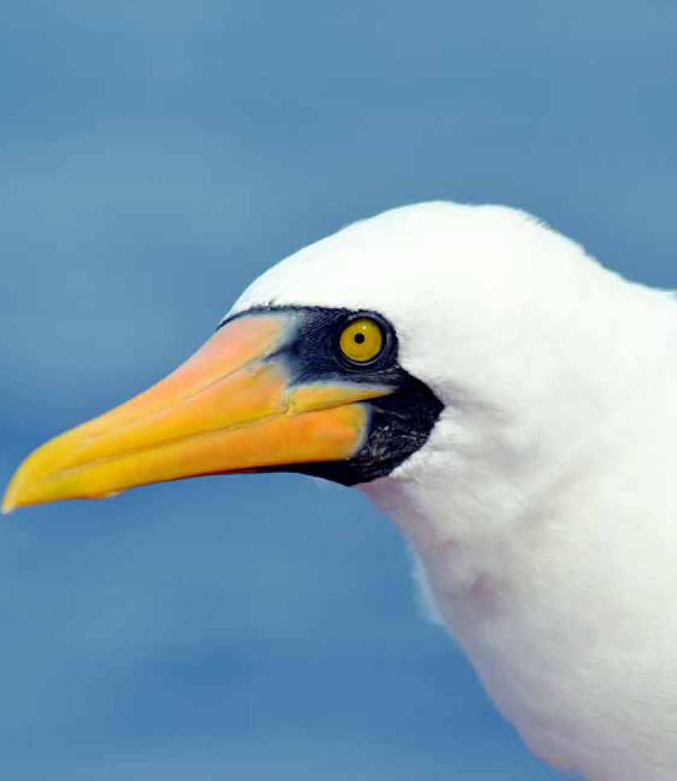

Wildlife Conservation Plan for Seabirds 115

Species profiles
Red-footed Booby (Sula sula)
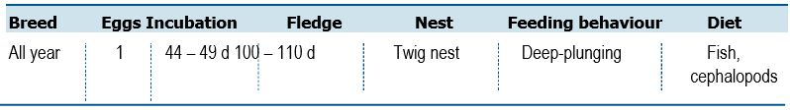
Life History and Distribution
The Red-footed Booby (Sula sula) is the smallest and lightest booby with a typical sulid silhouette in flight. This species is found in tropical islands in most oceans, excluding the eastern Atlantic. It winters at sea in the same area, ranging north of the Tropic of Cancer and south of the Tropic of Capricorn (del Hoyo et al. 1992). This species is largely pelagic occurring farther from land than other booby species. It feeds mainly on flying-fish and squid. Prey is caught by plunge-diving, but flying fish are also taken in flight, especially when chased by underwater predators. It often rests on boats using them as vantage points. Breeding is not seasonal in most of its range and egg and chicks have been recorded in all months. Individuals form large colonies, nesting and roosting mainly in trees or on islets with abundant vegetation (del Hoyo et al. 1992).
Population Estimates and Trends
The global population is estimated to number >1,000,000 individuals (del Hoyo et al. 1992). Globally, the population is suspected to be decreasing owing to habitat loss, predation by invasive species and unsustainable levels of exploitation. Indonesian populations are under threat from human activity, including hunting and habitat loss, and the Red-footed Booby has long been extinct as a breeding species in western Indonesia (de Korte and Silvius 1994; de Jong 2011). The most important breeding population in Australia occurs in Pulu Keeling National Park which regularly supports more than 30,000 pairs. Christmas Island has an estimated 12,000 pairs and the species is also present on the islands of Ashmore Reef Marine Park (248 pairs). Several colonies occur on islands and cays in the Great Barrier Reef and Coral Sea Marine Park. Baker and Holdsworth (2013) reported that from a regional perspective, the Herald Cays (Coral Sea Marine Park) contain a significant proportion of the region’s breeding population of Red-footed Booby. As of 2012, there were 20-year and 10-year data sets available for North East Cay (Herald Cays) and South West Cay (Herald Cays), respectively and the Red-footed Booby population increased by an annual rate of 3.8 per cent. The total Australian population and trends are unknown.
116 Wildlife Conservation Plan for Seabirds
Species profiles
Conservation Concerns and Actions
Clearance of nesting trees for fuel wood or land conversion has occurred on many islands throughout the range, reducing nesting sites available to the species (del Hoyo et al. 2019), but this does not appear to have had much impact on populations of this widespread species. Large numbers of birds of all ages have been harvested by Cocos-Malay people on Cocos (Keeling) Islands over the last century, and this has impacted this population. Protection of the population on North Keeling Island in more recent years has resulted in a much larger and more stable population, although it is still vulnerable to cyclones. An unquantified level of hunting is likely to take place in numerous south-east Asian and small Pacific colonies. However, this does not seem to be significantly affecting the population nesting there (Baker et al. 2004).
Recommended Management Actions
- Quantify the breeding population in Australia
- Regularly monitor breeding populations at index locations
- Determine non-breeding areas and migration routes
- Quantify and manage the potential impacts of fisheries interactions and human disturbance
- Control, or eradicate invasive species on breeding islands
- Implement best practice quarantine measures at breeding colonies to reduce the risk of any invasive species (re)establishing on islands
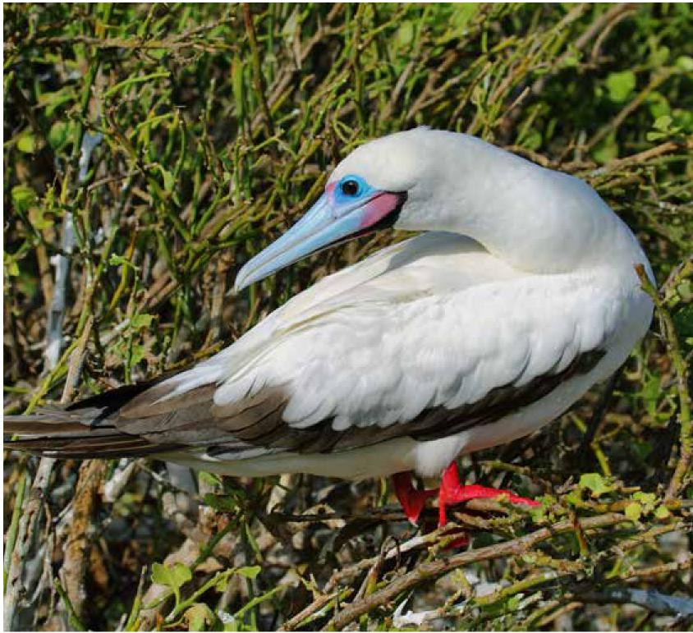

Wildlife Conservation Plan for Seabirds 117

Species profiles
Brown Booby (Sula leucogaster)
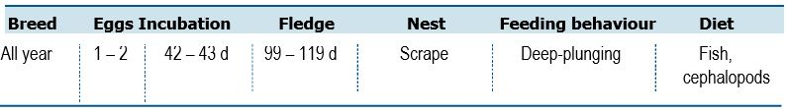
Life History and Distribution
The Brown Booby (Sula leucogaster) is a medium sized, sleek looking dark-coloured booby with sharply demarcated brown and white underparts. The Brown Booby can be found throughout the pantropical oceans with few exceptions. Breeding sites include the Caribbean, the Atlantic coasts of Brazil and Africa, oceanic islands off Madagascar, the Red Sea, northern Australia, many oceanic islands in the western and central Pacific, as well as off the coast of Mexico and Peru. Breeding is seasonal in some areas, but elsewhere it breeds opportunistically or more or less continuously. Nests are built on the ground in the midst of vegetation on rocky islands or coral atolls. Individuals form colonies that are usually smaller than those of other Sula species (del Hoyo et al. 1992). This species is strictly marine, generally feeding on inshore waters. Its diet is comprised mainly of flying-fish and squid, but also some halfbeak, mullet and anchovy. Prey is usually caught by plunge-diving and it can also snatch prey off the surface of water. Kleptoparasitism has been observed, mostly by females.
Population Estimates and Trends
The global population is estimated to number > 200,000 individuals (del Hoyo et al. 1992). Globally, the population is suspected to be in decline owing to disturbance and unsustainable levels of exploitation. Numerus breeding locations occur on offshore islands in the Great Barrier Reef, Coral Sea Marine Park and north-west WA. Survey data suggests Ashmore Reef Marine Park accounts for ≥1 per cent of the global population (Cannell and Surman 2020). Several thousand pairs also breed on Christmas (5,000 pairs) and Cocos (Keeling) Islands. The total Australian population and trends are unknown.
Conservation Concerns and Actions
Brown Boobies are hunted for food and bait in some areas of their range (del Hoyo et al. 2019); however, this is thought to have negligible effects on their population. They are highly sensitive to human disturbance, with the presence of humans 10–20 m from the nest enough to cause the birds to leave (Borsa et al. 2010). Verlis et al. (2014) found that most Brown Booby nests surveyed contain at least one item of marine debris. Further, Lavers et al. (2013) found that around 30 per cent of the debris poses some entanglement risk to the birds. This is currently unlikely to represent a significant source of injury and mortality (Lavers et al. 2013) but is likely to increase due to the long term persistence of marine debris. In the past, organochemical pollution has caused a significant reduction in reproductive success due to the thinning of eggshells, often caused by DDT use in agricultural areas as well as, in one case, mosquito control for a tourist development. Currently, eggshell thickness varies in relation to individual characteristics and/or feeding sources, as opposed to actual exposure and, where records are available, eggshell thickness has recovered to pre-DDT conditions (Mellink et al. 2009). Introduced rats are also thought to impact on the species through reduction of reproductive success on islands (Pitman et al. 2005; del Hoyo et al. 2019).
118 Wildlife Conservation Plan for Seabirds
Species profiles
Recommended Management Actions
- Quantify the breeding population in Australia
- Regularly monitor breeding populations at index locations
- Determine non-breeding areas and migration routes
- Measure contaminant levels in all relevant life stages
- Quantify and manage the potential impacts of fisheries interactions and human disturbance
- Control, or eradicate invasive species on breeding islands
- Implement best practice quarantine measures at breeding colonies to reduce the risk of any invasive species (re)establishing on islands
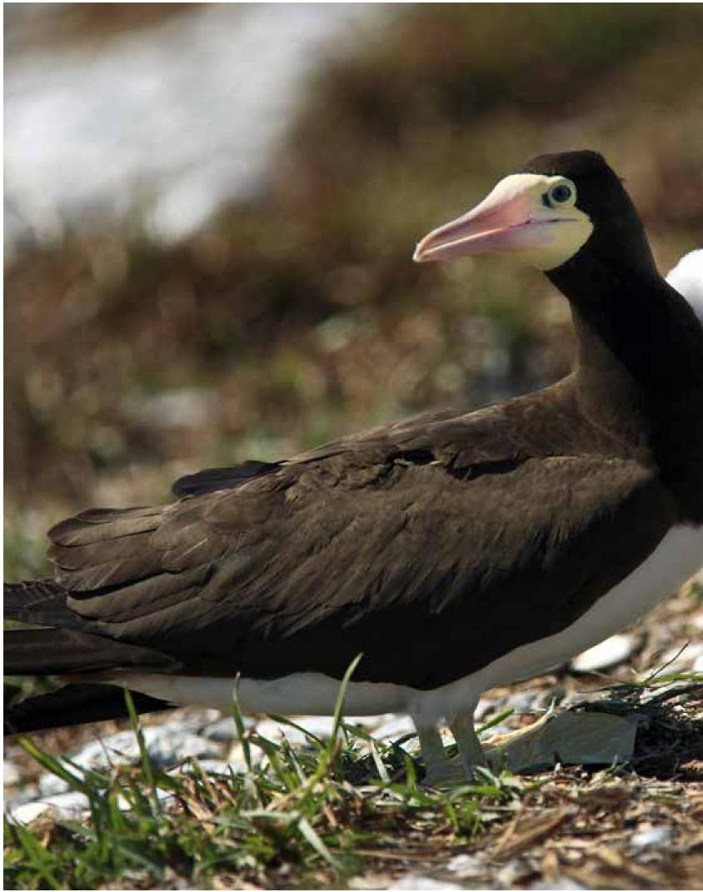

Wildlife Conservation Plan for Seabirds 119

Species profiles
Black-faced Cormorant (Phalacrocorax fuscescens)
120 Wildlife Conservation Plan for Seabirds
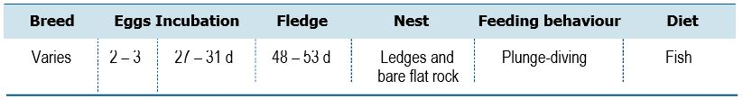

Life History and Distribution
The Black-faced Cormorant (Phalacrocorax fuscescens) is a moderately large black and white cormorant endemic to southern Australia. This species is found along the coast of Tasmania and Victoria with two independent populations one on the coast of southern Western Australia, the other on the coasts of South Australia (del Hoyo et al. 1992). Breeding usually occurs on rocky islands, but also on stacks, slopes and sea cliffs in colonies of up to 2,500 individuals (del Hoyo et al. 1992). It feeds in coastal waters, sometimes in sheltered places such as bays and islets and can be found entering rivers along the coast.
Population Estimates and Trends
The total population estimate is uncertain but is thought to be several 10,000s of birds (del Hoyo et al. 1992). The population trend is difficult to determine because of uncertainty over the extent of threats to the species. Population at the large Port Adelaide colony saw increases since colonisation after breakwater construction from 250-300 nests in 1967, 2,000 nests in 1987, 6,000 nests early 1990s but have declined to approx. 2,300 individuals (1,150 nests) in recent counts 2018.
Conservation Concerns and Actions
The species is occasionally persecuted by fishermen who perceive it as a threat to their livelihoods, but the incidence has not been quantified. Among the few colonies that have been monitored in recent years, no resulting declines have been observed due to human disturbance. Oil spills and marine debris (entanglement) pose risks to individuals. In South Australia, Spencer Gulf colonies breed in summer, storm activity regularly impacts nests at the large winter nesting colony at Port Adelaide, Silver Gull egg and chick depredation also impacts breeding success.
Recommended Management Actions
- Quantify the breeding population in Australia
- Regularly monitor breeding populations at index locations
- Measure contaminant levels in all relevant life stages
- Quantify and manage the potential impacts of fisheries interactions and human disturbance

Species profiles
Australian Pelican (Pelecanus conspicillatus)
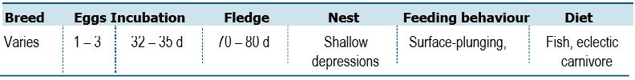

Life History and Distribution
The Australian Pelican (Pelecanus conspicillatus) is a large waterbird, widespread on inland and coastal waters of Australia and Papua New Guinea, also in Fiji, parts of Indonesia. It is a predominantly white bird with black wings and a pink bill. It eats fish but will also consume birds and scavenges for scraps if the opportunity arises. Australian Pelicans occur primarily in large expanses of open water without dense aquatic vegetation. The habitats that can support them include large lakes, reservoirs, billabongs and rivers, as well as estuaries, swamps, temporarily flooded areas in arid zones, drainage channels in farmland, salt evaporation ponds and coastal lagoons. They do seem to prefer areas where disturbance is relatively low while breeding. The Australian Pelican begins breeding at two or three years of age. The breeding season varies, occurring in winter in tropical areas (north of 26°S) and spring in parts of southern Australia. Breeding may occur any time after rainfall in inland areas. The nest is a shallow depression in earth or sand, sometimes with some grass lining. They may roost on mudflats, sandbars, beaches, reefs, jetties and pilings. Australian Pelicans feed by plunge-diving while swimming on the surface of the water. They work in groups to drive fish to shallower water, where they stick their sensitive bills in to snatch their prey. Some feeding grounds in large bodies of water have included up to 1,900 individual birds.
Population Estimates and Trends
The global population size has not been quantified. The Australian population
estimate and trends remain unknown. The population is suspected to be fluctuating owing to fluctuations in wetland habitats. The breeding status of Australian Pelicans in Victoria appears to be in decline, with the numbers of both breeding birds and sites being used less now than previously (O’Brien et al. 2010). Only two Victorian locations (Gippsland Lakes and Mud Islands) that have been recently used for breeding. Reasons for this shift are not understood there appears to have been a shift in breeding from French Island in Western Port to Mud Islands in Port Phillip Bay.
Conservation Concerns and Actions
Pelicans occasionally become entangled in discarded fishing line. Australian Pelicans are vulnerable to disturbance at all Victorian breeding sites (O’Brien et al. 2010). Human disturbance can cause nesting adults to leave their nest, exposing their eggs and young to predators and harsh weather. It is possible that, in the future, the effects of climate change could have an adverse impact on food sources and breeding habitat.
Recommended Management Actions
- Quantify the breeding population in Australia
- Regularly monitor breeding populations at index locations
- Measure contaminant levels in all relevant life stages
- Quantify and manage the potential impacts of fisheries interactions and human disturbance
Wildlife Conservation Plan for Seabirds 121

Species profiles
Brown Skua (Catharacta antarctica)

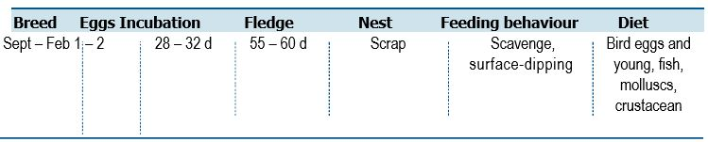
Life History and Distribution
The Brown Skua (Stercocorarius antarcticus, also known as Catharacta antarctica) is a large, thickset gull-like seabird with rather broad pointed wings, short, slightly wedge-sharped tail. The species is found on the Antarctic Peninsula and on the subantarctic islands of the Atlantic, Indian and Pacific Oceans including Australia’s Heard and Macquarie Island, wintering near nesting islands (del Hoyo et al. 1996). Breeding begins in September to November depending on location. Birds are loosely colonial but highly territorial, nesting on grass, gravel or bare rock (del Hoyo et al. 1996). The species is highly predatory, feeding mainly on other birds but will also scavenge around fishing boats and ships and feed at sea.
Population Estimates and Trends
The total population has been estimated to be 13,000-14,000 pairs (del Hoyo et al. 1996) and is assumed to equate to 26,000-28,000 mature individuals.
The Australian population estimate is unknown. On Macquarie Island, approximately 30 per cent of the island was surveyed in 1974, 1983, 1997, 2004 and then annually from 2008–2017. The number of breeding pairs peaked in the mid-2000s prior to the eradication of rabbits and rodents, which was likely due to the availability of these non-native prey species. After the pest eradication baiting program, the number of breeding pairs declined by approximately 50 per cent and breeding success by 60 per cent. This was due to a combination of reduced prey availability and incidental mortality from the baiting program. Since then the number of breeding pairs and breeding success has remained relatively stable (Tasmanian Department of Primary Industries, Parks Water and Environment pers. comm.).
Conservation Concerns and Actions
In the absence of any major threats, the species is suspected to be stable. It is possible that, in the future, the effects of climate change could have an adverse impact on food sources and breeding habitat on the Antarctic Peninsula and subantarctic islands.
Recommended Management Actions
- Quantify the breeding population at Heard Island
- Regularly monitor breeding populations at index locations
122 Wildlife Conservation Plan for Seabirds
Species profiles
South Polar Skua (Catharacta maccormicki)
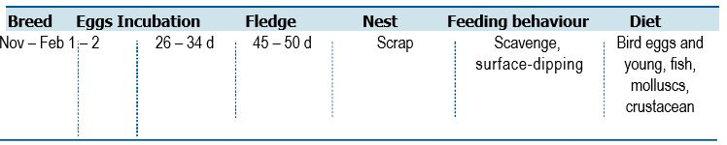
Life History and Distribution
The South Polar Skua (Stercocorarius maccormicki, also known as Catharacta maccormicki) is very similar in size and shape to the Brown Skua (S. antarctica) but appears smaller and slimmer, with slightly finer head, bill and tarsi when directly compared. The body is pale golden brown in colour. The species breeds around the Antarctic coastline including the Antarctic Peninsula, and in the Ross Sea area on relatively snow-free areas (del Hoyo et al. 1996). It is usually reliant on fish (Pietz 1987), with predation on penguins being of variable importance (del Hoyo et al. 1996). It can, however, subsist exclusively on penguins where a breeding colony is associated to a penguin colony (Trillmich 1978, Young and Miller 1999). The species undergoes a transequatorial migration, wintering as far north as Alaska (USA) and Greenland.
Population Estimates and Trends
The population is estimated to be between 6,000 -15,000 mature individuals (BirdLife International 2019). The population is suspected to be stable in the absence of evidence for any decreases or substantial threats. The Australian population and trends are unknown.
Conservation Concerns and Actions
At present there are no factors thought to pose a threat to this species. It is possible that, in the future, the effects of climate change could have adverse impacts on food sources and breeding habitat on the Antarctic Peninsula and Antarctic coastline.
Recommended Management Actions
- Quantify the breeding population in Australia
- Regularly monitor breeding populations at index locations
Wildlife Conservation Plan for Seabirds 123
Species profiles
Pomarine Jaeger (Stercorarius pomarinus)
124 Wildlife Conservation Plan for Seabirds

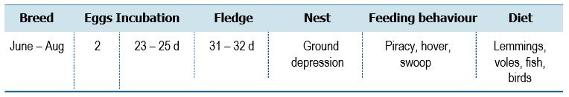
Life History and Distribution
The Pomarine Jaeger (Stercorarius pomarinus) is the largest jaeger, thickset with heavy bill, thick neck, deep chest and barrel-shaped body. The species is smaller and slimmer than Brown Skua (S. antarctica) and South Polar Skua (S. maccormicki) but larger than Arctic Jaeger (S. parasiticus). This species breeds in the far north of Eurasia and North America. Breeding begins in June at scattered sites across the tundra where lemming concentrations are high. Individuals are highly territorial. The species performs a transequatorial migration, mostly wintering between the Tropic of Cancer and Tropic of Capricorn and along the coastlines of Australia and Argentina (del Hoyo et al. 1996; Reid et al. 2002). The species remains somewhat coastal, especially in upwelling regions of the tropics and subtropics (BirdLife International 2019). Whilst breeding, it specialises in catching lemmings, which frequently constitute over 90 per cent of its diet. It also feeds on young shorebirds and gamebirds, bird eggs and carrion. In winter, it takes fish, sometimes by kleptoparasitism, small seabirds, and carrion.
Population Estimates and Trends
A very preliminary estimate of the global population size is approximately
400,000 mature individuals, although further validation of this estimate is needed (BirdLife International 2019). The population is suspected to be stable in the absence of evidence for any decreases or substantial threats. The Australian population and trends are unknown.
Conservation Concerns and Actions
The productivity of this species is thought to fluctuate in accordance with changes in the population of lemmings, a key prey item during the breeding season (Maher 1974). As a result of this, it is expected that future changes to lemming populations driven by climate change may have impacts on the breeding success of the Pomarine Jaeger, with some decreases already identified (Gilg et al. 2009). The future impact on populations is unknown, but it has the potential to have a significant negative effect on productivity, that if continued over several years could begin to drive a decrease in population level. In Australia, there are no factors thought to pose a genuine threat to this species.
Recommended Management Actions
- Gain an improved understanding of the at sea distribution in Australia
- Determine non-breeding areas and migration routes

Species profiles
Arctic Jaeger (Stercorarius parasiticus)
Wildlife Conservation Plan for Seabirds 125
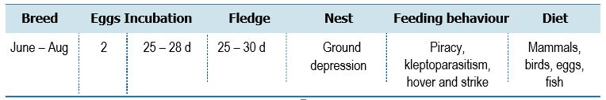

Life History and Distribution
The Arctic Jaeger (Stercorarius parasiticus) is a medium sized jaeger with an elegant appearance, and a fast falcon-like flight. Its size, shape and proportions are intermediate between Pomarine (S. pomarinus) and Long-tailed Jaegers (S. longicaudus). This species breeds on the northernmost coasts of Eurasia and North America and preforms a transequatorial migration, wintering on the southern tips of South America (as far north as Peru and Argentina), Africa (as far north as South Africa and Angola), and on the coasts of Australia and New Zealand (del Hoyo et al. 1996). This species is predominately coastal but will migrate over land. Most or all of its food is obtained by kleptoparasitism when nesting near other seabird colonies. Otherwise, its diet can include rodents, adult and fledgling passerines, shorebird chicks, bird eggs, insects and berries.
Breeding begins in May or June, occurring later in the north then the south. It is either colonial at seabird sites or widely scattered across the tundra, where it is territorial (del Hoyo et al. 1996).
Population Estimates and Trends
A very preliminary estimate of the global population size is approximately 400,000–560,000 mature individuals (BirdLife International 2019). The population is suspected to be stable in the absence of evidence for any declines or substantial threats. The Australian population and trends are unknown.
Conservation Concerns and Actions
Arctic Jaegers have been classified as highly sensitive to changes in sandeel (Ammodytes spp.) populations (ICES 2017), with decreases in sandeel stocks causing decreases in the northernmost Scottish populations. Localised persecution of this species occurs on Iceland, the Faroes, Northern Scotland and across Scandinavia (del Hoyo et al. 2019), in order to alleviate stresses to other seabirds and due to the species’ aggressive behaviour towards humans during the breeding season. However, the level of persecution remains low and has decreased in more recent years owing to the increased legal protection for this species. In Australia, there are no factors thought to pose a genuine threat to this species.
Recommended Management Actions
- Gain an improved understanding of the at sea distribution in Australia
- Determine non-breeding areas and migration routes

Species profiles
Long-tailed Jaeger (Stercorarius longicaudus)
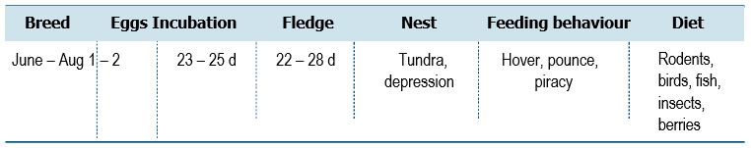
Life History and Distribution
The Long-tailed Jaeger (Stercorarius longicaudus) is the smallest and most lightly built jaeger, with a short stout bill, small head, slim body and prominent chest. The species is more elegant and tern-like than Arctic Jaeger (S. parasiticus). In breeding plumage, adults have a diagnostic long, fine central tail-streamers that project beyond the rest of the tail. This species breeds in the high Arctic of Eurasia and North America and has a circumpolar winter distribution in the Southern Oceans (del Hoyo et al. 1996). Breeding begins in June, with birds widely scattered over the Arctic and subarctic or montane tundra, up to 1,300 m Above Sea Level in Scandinavia. This species is marine and highly oceanic, rarely occurring within sight of land except when breeding. It feeds mainly on lemmings during the summer, but will also take shrews, many insects, berries and small birds when rodents are scarce. Its winter diet is largely unknown, but probably includes marine insects and fish, with some scavenging and kleptoparasitism.
Population Estimates and Trends
A very preliminary estimate of the global population size is approximately 250,000–800,000 mature individuals (BirdLife International 2019). The population is suspected to be stable in the absence of evidence for any decreases or substantial threats. The Australian population and trends are unknown.
Conservation Concerns and Actions
Long-tailed Jaegers face few threats as adult birds but are susceptible to crashes in breeding success. Productivity is thought to fluctuate in accordance with changes in the population of lemmings, a key prey item during the breeding season (del Hoyo et al. 2019). This species does however seem to have a large number of adults which do not breed in any particular year, which may result in a buffering of the populations reproductive success in the face of adult numbers declining due to low food availability (Barraquand et al. 2014). Extended periods of lemming failure, however, are likely to begin to cause significant declines in the breeding population (Barraquand et al. 2014). In Australia, there are no factors thought to pose a genuine threat to this species.
Recommended Management Actions
- Gain an improved understanding of the at sea distribution in Australia
- Determine non-breeding areas and migration routes
126 Wildlife Conservation Plan for Seabirds

Species profiles
Common Noddy (Anous stolidus)
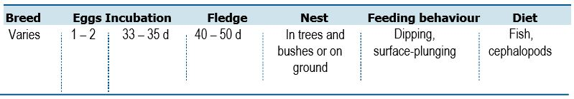
Life History and Distribution
The Common Noddy (Anous stolidus), also known as Brown Noddy, is the largest noddy, bigger and bulkier than Black Noddy (A. minutus) and Lesser Noddy (A. tenuirostris). The Common Noddy is a slender dark-brown seabird, with long rather stout bill, about the same length as head and appearing decurved over whole length. The Common Noddy is a tropical seabird with a worldwide distribution, ranging from the Pacific Ocean, including colonies off the Pacific coast of north-west South and Central America, the Indian Ocean including south-east Asia and in the Atlantic Ocean including a colony off the coast of Cameroon. Some colonies are also present in the sub-tropics with individuals from these colonies wintering in the tropics (del Hoyo et al. 1996). The species occurs around isolated, bare or vegetated, inshore or oceanic islands or coral reefs with rocky cliffs or offshore stacks (del Hoyo et al. 1996) and coral or sand beaches (Higgins and Davies 1996). It forages in the inshore waters surrounding such islands, often along the line of breakers or in lagoons (Higgins and Davies 1996), and disperses up to 180 km out into the oceanic zone to forage (Surman and Wooller 2003) and up to 950 km when not breeding (Surman et al. 2018). Out at sea it often rests on buoys, flotsam, ships and on the open water (del Hoyo et al. 1996). Although its migratory movements are poorly known and the species is present all year round at most tropical colonies, it is seasonally absent from subtropical colonies and is known to disperse to the open ocean after breeding (del Hoyo et al. 1996). The timing of breeding varies throughout the species range (del Hoyo et al. 1996). It may breed colonially in groups numbering up to 100,000 or more pairs (Higgins and Davies 1996) although it also nests almost solitarily depending on the availability of nesting sites (del Hoyo et al. 1996). Even when not breeding the species remains gregarious and can occur in huge flocks in some areas, although it is more usually observed in smaller flocks of 50-100 individuals (Higgins and Davies 1996). The nest may be a simple layer of debris or a more elaborate construction of seaweed and sticks (del Hoyo et al. 1996), and may be placed in a number of sites including flat shingle beaches, bare ground, cliff ledges, offshore stacks, low bushes and tall trees (del Hoyo et al. 1996). It nests in colonies that can be very dense or more open depending on the availability of nesting sites (del Hoyo et al. 1996). Its diet consists predominantly of small fish as well as squid, pelagic molluscs, medusae and insects (del Hoyo et al. 1996; Higgins and Davies 1996; Surman and Wooller 2003).
Population Estimates and Trends
The global population is estimated to number between 180,000–1,100,000 individuals (Delany and Scott 2006; BirdLife International 2019). The global population is suspected to be stable in the absence of evidence for any decreases or substantial threats. Significant populations occur in Western Australia (130,136–151,636 pairs; Burbidge et al. 1996) and the Great Barrier Reef, Queensland (King 1996) but the total Australian population is unknown, and trends are not available. A 2019 survey of Ashmore Reef Marine Park found Common Noddies to be the second most abundant bird species at Ashmore with over 40,000 recorded (Cannell and Surman 2020).
Wildlife Conservation Plan for Seabirds 127

Species profiles
Conservation Concerns and Actions
Invasive species have caused declines in Common Noddy population throughout its range. Egg and chick harvesting have occurred in certain parts of the range but is not considered a threat in Australia. Human disturbance at breeding locations is thought to displace some birds. At present there are no factors thought to pose a genuine threat to this species. It is possible that, in the future, the effects of climate change could have an adverse impact on food sources and breeding habitat.
Recommended Management Actions
- Quantify the breeding population in Australia
- Regularly monitor breeding populations at index locations
- Determine non-breeding areas and migration routes
- Measure contaminant levels in all relevant life stages
- Quantify and manage the potential impacts of fisheries interactions and human disturbance
- Control, or eradicate invasive species on breeding islands
- Implement best practice quarantine measures at breeding colonies to reduce the risk of any invasive species (re)establishing on islands
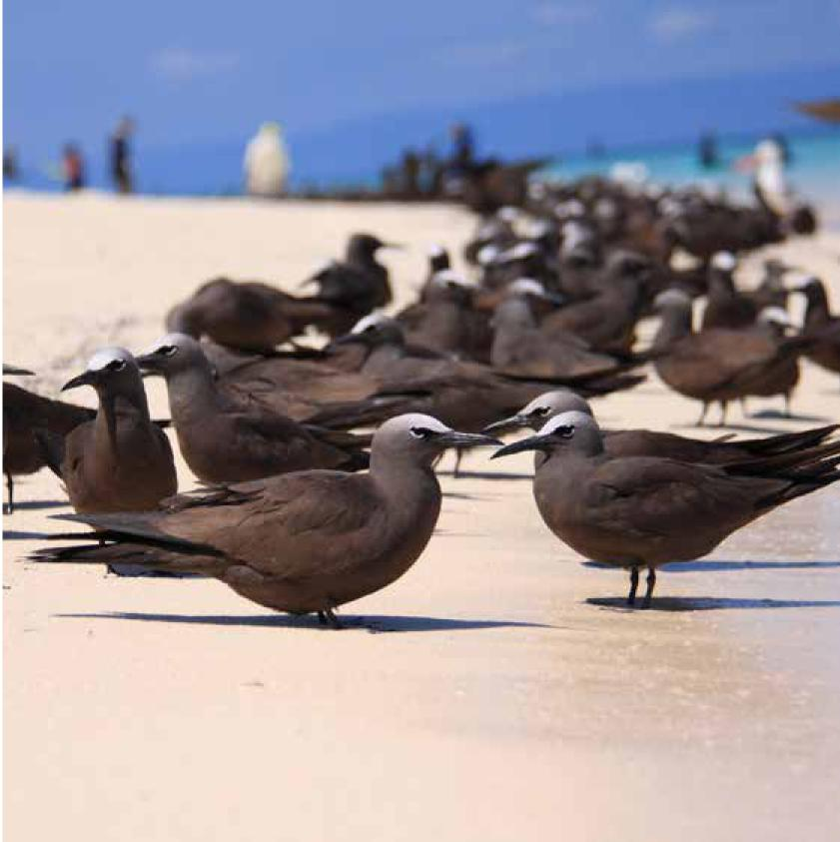

128 Wildlife Conservation Plan for Seabirds

Species profiles
Black Noddy (Anous minutus)

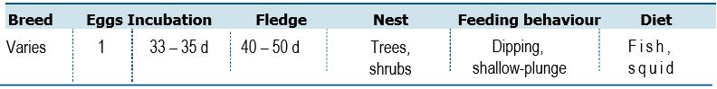
Life History and Distribution
The Black Noddy (Anous minutus) is a medium sized slender sooty-black noddy with a long straight slender bill, long narrow wings and shallow forked tail. The Black Noddy has a worldwide distribution in tropical and subtropical seas, with colonies widespread in the western and central Pacific Ocean and more scattered across the Caribbean, central Atlantic and in the northeast Indian Ocean (del Hoyo et al. 1996). This species inhabits tropical and subtropical islands. Its breeding season varies depending upon locality, with variable colony sizes and nest sites (del Hoyo et al. 1996). It feeds on small fish and squid, with prey species and proportion of each depending on locality. It often feeds by hover-dipping and contact-dipping. Kleptoparasitism has been observed, and it will associate with other seabirds over schools of predatory fish.
Population Estimates and Trends
BirdLife International (2019) estimates the population at between 1,146,000–2,061,000 individuals. The global population is suspected to be stable in the absence of evidence for any decreases or substantial threats. In Australia the bulk of the population occurs in Queensland, with the Capricorina–Bunker Group containing approximately 97% of the Black Noddies on the Great Barrier Reef (Hulsman et al 1997). Dyer et al. (2005) estimated 302,000 active nests between 1997–2000 for nine of the 16 islands in the group. As of 2012, there were 20-year and 10-year data sets available for North East Cay (Herald Cays) and South West Cay (Herald Cays) in the Coral Sea Marine Park, respectively (Baker and Holsworth 2013). Over the 20-year period (1992-2012), the Black Noddy population declined at an annual rate of 3.8 per cent (Baker and Holsworth 2013).
Conservation Concerns and Actions
Increased sea surface temperature has been demonstrated to reduce the provisioning rate at studied colonies in the Great Barrier Reef, and above a particular threshold of temperature reproductive success is nil (Chambers et al. 2011). At present this impact appears restricted to a minority of the breeding population, and colonies have become established at new locations which may be related to adaption to climate impacts. It is possible that, in the future, the effects of climate change could have an adverse impact on food sources and breeding habitat. Invasive species have contributed to the decline of the species throughout its range (Priddel et al. 2010; BirdLife International 2019)
Recommended Management Actions
- Quantify the breeding population in Australia
- Regularly monitor breeding populations at index locations
- Control, or eradicate invasive species on breeding islands
- Implement best practice quarantine measures at breeding colonies to reduce the risk of any invasive species (re)establishing on islands
Wildlife Conservation Plan for Seabirds 129

Species profiles
White Tern (Gygis alba)
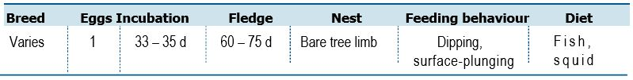
Life History and Distribution
The White Tern (Gygis alba) is unmistakable, because it is a wholly white tern.
The species has a delicate appearance, large rounded head, slightly upturned bill, short legs and long slender wings with long, slightly forked tail. The White Tern has a distribution across the tropics of the world, being found year-round on islands in the south Atlantic Ocean, the Indian Ocean, and the western and central Pacific. It is also a seasonal visitor to islands in the south-central and eastern Pacific off the coast of Mexico (del Hoyo et al. 1996). Its breeding season varies locally. It nests on coral islands, usually with vegetation, nesting in trees and bushes, on rocky slopes and cliffs, and also on artificial substrates. It lays a single egg on a bare branch, usually within a slight depression at a fork or on the midrib of a palm frond or banana leaf. It is resident year-round on some islands but is a seasonal visitor on others where its non-breeding movements are not known (del Hoyo et al. 1996). This species feeds mainly upon small fish but will also take squid and crustaceans.
Population Estimates and Trends
Delany and Scott (2006) estimated the population at 150,000–1,100,000 individuals. The overall population trend is stable, although some populations have unknown trends (Delany and Scott 2006; BirdLife International 2019). In Australia, the species breeds on Lord Howe, Norfolk, Christmas and Cocos (Keeling) Islands. Carlile and Priddel (2015) suggested the Lord Howe Island population has been growing at 12 per cent per annuum since 1971. Current population on the island is 600 pairs (N. Carlile pers. comm). Australian population estimates and trends are unknown.
Conservation Concerns and Actions
The White Tern is at risk from the impacts of invasive species (Pitman et al. 2005). Rats and Cats (Felis catus) have been observed to predate White Terns and they likely predate both chicks and nesting adults (BirdLife International 2019). Pied Currawong (Strepera graculina) and Masked Owls (Tyto novaehollandiae) are known predators of White Terns on Lord Howe Island (Carlile and Priddel 2015). Barn Owls (Tyto alba) represent a significant predation pressure on Aride Island, Seychelles, but is currently subject to a control program (del Hoyo et al. 2019). It is possible that, in the future, the effects of climate change could have an adverse impact on food sources and breeding habitat.
Recommended Management Actions
- Quantify the breeding population in Australia
- Regularly monitor breeding populations at index locations
- Control, or eradicate invasive species on breeding islands
- Implement best practice quarantine measures at breeding colonies to reduce the risk of any invasive species (re)establishing on islands
130 Wildlife Conservation Plan for Seabirds

Species profiles
Grey Ternlet (Procelsterna cerulea)
Wildlife Conservation Plan for Seabirds 131
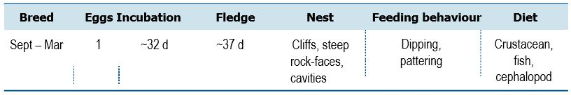
Life History and Distribution
Grey Ternlet (Procelsterna cerulea) and Grey Noddy (P. albivitta) (del Hoyo and Collar 2014) were previously lumped as P. cerulea following Sibley and Monroe (1990, 1993). Cibois et al. (2016) found that Procelsterna sits within Anous, which is accepted and results in P. albivitta changing name to Grey Noddy Anous albivattus and P. cerulea changing name to Blue Noddy A. cerulea (del Hoyo et al. 2019). Grey Noddy breeds on Lord Howe and Norfolk Islands and on Kermadec Island, New Zealand. The species is a small delicate tern, with a slender black bill and moderately forked tail. Grey Noddies are distinctive with blue-grey above, grey-white head. The species is distributed across the Pacific Ocean and breeds on isolated tropical and subtropical islands, islets or rock stacks. Breeding can be continual in places and occurs in loose colonies (del Hoyo et al. 1996) but is poorly known. This species takes very small fish (average length 17 mm), squid, crustaceans and pelagic sea striders with proportions varying seasonally and geographically. It feeds on the wing by dipping or pattering.
Population Estimates and Trends
The combined populations of Anous ceruleus and A. albivittus are estimated to number 27,000–120,000 individuals, but the total for A. albivittus is unknown. The global population trend is stable, although some populations have unknown trends (Delany and Scott 2006). Australian population estimates and trends are unknown.
Conservation Concerns and Actions
Globally, the species is threatened by invasive species. Rodents on Lord Howe Island restrict breeding and rodent free islands have over 80 per cent breeding success (N. Carlile pers. comm). On Easter Island, the population is thought to be threatened by cat predation (Marin and Caceres 2010). It is possible that, in the future, the effects of climate change could have an adverse impact on food sources and breeding habitat.
Recommended Management Actions
- Quantify the breeding population in Australia
- Regularly monitor breeding populations at index locations
- Control, or eradicate invasive species on breeding islands
- Implement best practice quarantine measures at breeding colonies to reduce the risk of any invasive species (re)establishing on islands

Species profiles
Bridled Tern (Onychoprion anaethetus)
132 Wildlife Conservation Plan for Seabirds
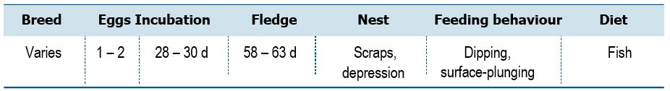

Life History and Distribution
The Bridled Tern (Onychoprion anaethetus) is a medium-sized tropical tern, with a stout bill about the same length as head, long slender wings and a long deeply forked tail. The species is slightly smaller and slimmer than Sooty Tern (O. fuscata). The Bridled Tern breeds off the Pacific and Atlantic coast of Central America including the Caribbean, off small areas of western Africa, around Arabia and eastern Africa down to South Africa, off the coast of India, and in much of south-east Asia and Australasia excluding southern Australia and New Zealand (del Hoyo et al. 1996). It breeds on the periphery of vegetated coastal and continental (Haney et al. 1999) coral, rock or rubble islands and beaches (Higgins and Davies 1996, del Hoyo et al. 1996, Haney et al. 1999), volcanic stacks and exposed reefs (Haney et al. 1999). The nest is a scrape or depression in shingle or sand (Higgins and Davies 1996) that may be freshly excavated or re-used from a previous season (Higgins and Davies 1996). Nests are placed in a variety of concealed locations (Higgins and Davies 1996, del Hoyo et al. 1996). The species is not strictly colonial but solitary pairs usually congregate in suitable habitats (Haney et al. 1999) with neighbouring nests spaced according to nest-site availability (usually 1-5 m apart, minimum 30 cm) (del Hoyo et al. 1996). Most populations are migratory and dispersive and abandon their breeding sites at the end of the breeding season to overwinter at sea (Haney et al. 1999). Migratory movements have been documented from Houtman Abrolhos to the Celebes Sea, 3,800 km north (Surman et al. 2018) and some populations in the Indian Ocean seem entirely sedentary or only partially migratory (Haney et al. 1999). The timing of breeding varies geographically, most populations breeding annually in suitable habitat (Haney et al. 1999).
Population Estimates and Trends
The global population is estimated to number between 610,000–1,500,000 individuals (Delany and Scott 2006). The overall population trend is uncertain, as some populations are decreasing, while others are increasing or have unknown trends (Delany and Scott 2006). The species is common in WA (22,000–48,121 pairs; Burbidge et al. 1996) and Queensland (King 1996). The species is known to breed on islands of Ashmore Reef Marine Park. In 2019, surveys reported 400 adults across islands and cays of Ashmore Reef Marine Park (Cannell and Surman 2020).

Species profiles
Conservation Concerns and Actions
The Bridled Tern is known to have abandoned breeding colonies when subject to high levels of human disturbance, although at sites exposed to long-term visitation it may become habituated to continuous and predictable human presence and activity (Haney et al. 1999). Measures to reduce human disturbance of nesting colonies include the erection of barriers and signs, the provision of walkways, and the supervision and education of visitors (Haney et al. 1999). Eggs are harvested for subsistence in the Bahamas and the West Indies, and eggs and chicks are harvested on some islands in the Pacific by local residents and coastal shipping crews (Haney et al. 1999). Neither of these are considered to represent a significant threat to the population but no assessment has been made. It is possible that, in the future, the effects of climate change could have an adverse impact on food sources and breeding habitat.
Recommended Management Actions
- Quantify the breeding population in Australia
- Regularly monitor breeding populations at index locations
- Determine non-breeding areas and migration routes
- Quantify and manage the potential impacts of human disturbance
- Control, or eradicate invasive species on breeding islands
- Implement best practice quarantine measures at breeding colonies to reduce the risk of any invasive species (re)establishing on islands
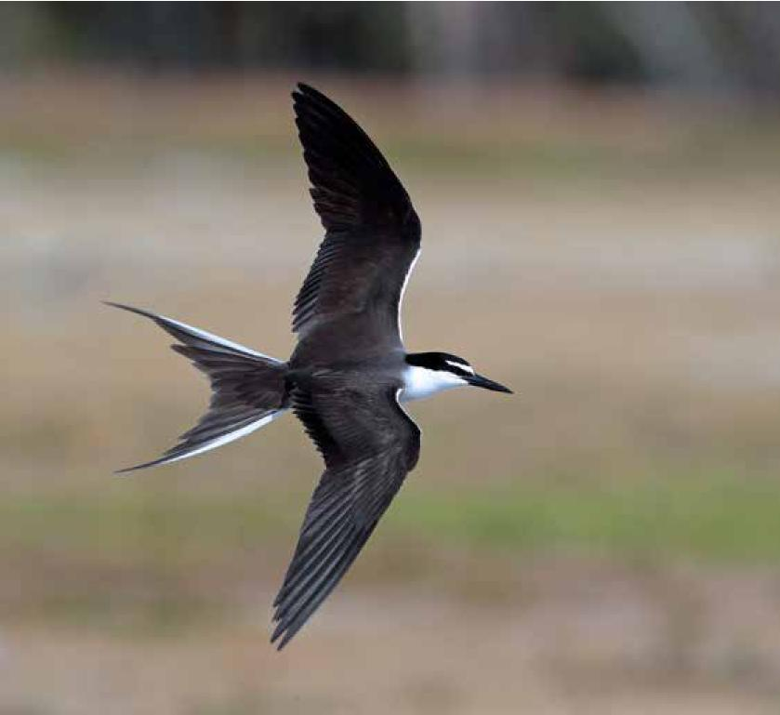

Wildlife Conservation Plan for Seabirds 133

Species profiles
Sooty Tern (Onychoprion fuscatus)
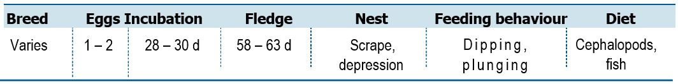
Life History and Distribution
The Sooty Tern (Onychoprion fuscatus) is a medium-sized tropical tern, slightly larger than Bridled Tern and larger than the noddies (Anous spp.). The species has an extremely large range through most of the tropical oceans (del Hoyo et al. 1996). It breeds on flat, open, sparsely or heavily vegetated, oceanic or barrier islands of sand, coral or rock in productive tropical and subtropical offshore waters rich in plankton, fish and squid (del Hoyo et al. 1996; Surman and Wooller 2003). It is absent from cold current areas and generally avoids islands with terrestrial predators (del Hoyo et al. 1996). Outside of the breeding season, the species is highly oceanic, but generally avoids cold current areas (del Hoyo et al. 1996). Its diet consists predominantly of fish and squid (Surman and Wooller 2003), but it also occasionally takes crustaceans, insects and offal (del Hoyo et al. 1996). The species is reliant upon prey driven to the surface by predatory fish (e.g. tuna), especially when breeding (Higgins and Davies 1996).
Population Estimates and Trends
The global population is estimated to number 21,000,000-22,000,000 individuals (Delany and Scott 2006). The overall population trend is uncertain, as some populations are decreasing, while others are increasing or have unknown trends (Delany and Scott 2006). Large populations occur in Western Australia (293,000–388,000 pairs; Burbidge et al. 1996), Queensland (King 1996) and the Coral Sea Marine Park. A 2019 survey of Ashmore Reef Marine Park found Sooty Terns to be the most abundant bird species at Ashmore with over 77,000 recorded (Cannell and Surman 2020).
Conservation Concerns and Actions
Colonies have declined in line with observed increases in sea temperatures in Australia, in contrast to the fortunes of Bridled Tern, which have formed new colonies further south (Dunlop and Surman 2012). Variations in sea surface temperature have been shown to negatively influence the species’ foraging success at breeding colonies, hence lowering reproductive success (Erwin and Congdon 2007). Previously, in some parts of its range, persistent large-scale egg-collecting has encouraged the species to move to suboptimal nesting sites, resulting in higher mortality and reduced reproductive success (van Halewyn and Norton 1984). Invasive species are threatening some populations.
Recommended Management Actions
- Quantify the breeding population in Australia
- Regularly monitor breeding populations at index locations
- Determine non-breeding areas and migration routes
- Quantify and manage the potential impacts of human disturbance
- Control, or eradicate invasive species on breeding islands
- Implement best practice quarantine measures at breeding colonies to reduce the risk of any invasive species (re)establishing on islands
134 Wildlife Conservation Plan for Seabirds

Species profiles
Little Tern (Sternula albifrons)
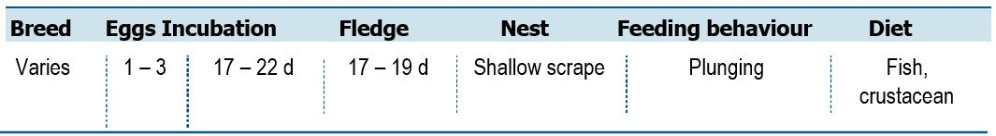
Life History and Distribution
The Little Tern (Sternula albifrons) is the smallest tern in the Australian region. The species is very similar in size and shape to Fairy Tern (S. nereis) and much smaller and slimmer than commic terns and Black-naped Tern (Sterna sumatrana). Adults in breeding plumage can be easily identified by diagnostic patterns of head and bill. This species breeds through much of Europe, scattered along the coast and inland in parts of Africa, in much of western, central and the east and south of Asia, and in parts of Australasia. Migratory individuals expand the range to include most of the coast of Africa, the Arabian Peninsula, the western coast of India and most of the waters of south-east Asia and Australasia.
Little Terns favour sheltered coastal environments, including lagoons, estuaries, river mouths and deltas, lakes, bays, harbours and inlets, especially those with exposed sandbanks or sandpits. The species breeds on barren or sparsely vegetated beaches, islands and spits of sand, shingle, shell fragments, pebbles, rocks or coral fragments on seashores or in estuaries, saltmarshes, saltpans, offshore coral reefs, rivers, lakes and reservoirs (Flint et al. 1984, de Silva 1991, del Hoyo et al. 1996). It may also nest on dry mudflats in grassy areas but shows a preference for islets surrounded by saline or freshwater, where small fish can be caught without the need for extensive foraging flights (de Silva 1991, del Hoyo et al. 1996, Snow and Perrins 1998).
The nest is a bare scrape positioned on the ground in less than 15 per cent vegetation cover on beaches of sand, pebbles, shingle, shell fragments, coral fragments or rock above the high tide-line and often only a few metres away from shallow clear water (Flint et al. 1984, Richards 1990, del Hoyo et al. 1996, Snow and Perrins 1998). In more marshy habitats (e.g. coastal saltmarshes), the species may build a nest of shells or vegetation (del Hoyo et al. 1996). The species nests in small loose colonies, with neighbouring nests usually placed more than 2 m apart (del Hoyo et al. 1996). Its diet consists predominantly of small fish and crustaceans 3-6 cm long as well as insects, annelid worms and molluscs (del Hoyo et al. 1996).
Population Estimates and Trends
The global population is estimated to number 190,000–410,000 individuals (Delany and Scott 2006). The overall population trend is decreasing, although some populations have unknown or increasing trends (Delany and Scott 2006). Australian population estimates and trends are unknown.
Wildlife Conservation Plan for Seabirds 135
Species profiles
Conservation Concerns and Actions
The species is listed threatened in Victoria and New South Wales. Habitat loss, fragmentation and degradation through the development of foreshore poses a significant threat to the Little Tern, with relative sea level rises predicted due to climate change also threatening beach nesting habitats. Human disturbance at colonies will result in colony abandonment and catastrophic breeding failure. There is also potentially a risk from the spread of the invasive weed Sea Spurge (Euphorbia paralias); however, this does not seem to be significant at present. The Red Fox (Vulpes vulpes) acts as the main cause of breeding failure in New South Wales (NSW National Parks and Wildlife Service 2003). In some parts of the range, birds are also vulnerable to nest predation by Silver Gulls (Chroicocephalus novaehollandiae); this is typically following human disturbance that facilitates Sliver Gull attacks.
Recommended Management Actions
- Support recovery actions in Victoria and New South Wales
- Quantify the breeding population in Australia
- Regularly monitor breeding populations at index locations
- Determine non-breeding areas and migration routes
- Quantify and manage the potential impacts of human disturbance
- Monitor and manage, if required, the impact of Silver Gulls and other species (e.g. Corvids) on breeding colonies
- Trail artificial nesting sites and social attraction techniques to establish new colonies
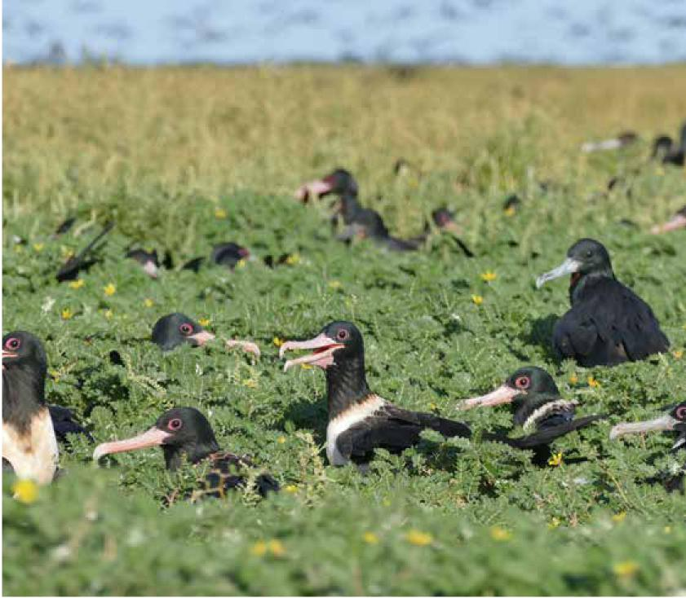

136 Wildlife Conservation Plan for Seabirds

Species profiles
Gull-billed Tern (Gelochelidon nilotica)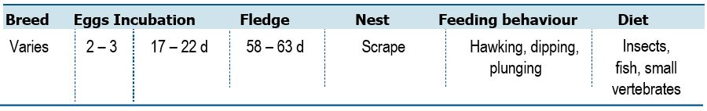
Life History and Distribution
The Gull-billed Tern (Gelochelidon nilotica) and Australian Gull-billed Tern (G. macrotarsa) (del Hoyo and Collar 2014) were previously placed in the genus Sterna and lumped as S. nilotica following Sibley and Monroe (1990, 1993). Only the Gull-billed Tern is listed under the EPBC Act as a listed migratory and marine species. The Gull-billed Tern is a large gull-like tern with a diagnostic short thick gull-like bill, heavy rounded head and short thick neck. The species breeds at scattered sites in North and South America, Europe, Africa and Asia. It breeds in a variety of locations with bare or sparsely vegetated islands, banks, flats, or spits of dry mud and sand including barrier beaches (shoals), dunes, saltmarshes, saltpans, freshwater lagoons, estuaries, deltas, inland lakes, rivers, marshes and swamps (del Hoyo et al. 1996, Higgins and Davies 1996, Snow and Perrins 1998). During this season, it may also feed on emerging insects over lakes, agricultural fields, grasslands and even over semi-desert regions (del Hoyo et al. 1996). On passage the species typically forages over saltpans, coastal lagoons, mudflats, marshes and wet fields, overwintering on estuaries, saltpans, lagoons and saltmarshes, or in more inland sites such as large rivers, lakes, rice-fields, sewage ponds, reservoirs, saltpans and irrigation canals (del Hoyo et al. 1996, Higgins and Davies 1996, Snow and Perrins 1998). It is an opportunistic feeder and is largely insectivorous taking adult and larval terrestrial and aquatic insects as well as spiders, earthworms, small reptiles, frogs, small fish (6-9 cm long) (Richards 1990, del Hoyo et al. 1996).
Population Estimates and Trends
The global population of Gull-billed Tern and Australian Gull-billed Tern combined is estimated to number between 150,000–420,000 individuals (Delany and Scott 2006), but the global population of G. nilotica has not been estimated separately following the taxonomic split. The Australian population estimate and trends are unknown. While recorded observer effort has been inconsistent over the years, there is considerable annual variation in Gull-billed Tern numbers in Victoria, probably with lowest numbers in wet years when there is extensive inland habitat, with more birds coming to Victoria in drought years (Victorian SAC pers. comm. 2020).
Conservation Concerns and Actions
This species has been identified as particularly susceptible to abandonment of breeding sites due to human disturbance (Molina et al. 2014), although early dispersal from breeding sites appears to be a behavioural trait of the species that may mitigate the impact of disturbance. It is possible that, in the future, the effects of climate change could have an adverse impact on food sources and breeding habitat.
Recommended Management Actions
- Quantify the non-breeding population in Australia
- Determine non-breeding areas and migration routes
- Quantify and manage the potential impacts of human disturbance
Wildlife Conservation Plan for Seabirds 137

Species profiles
Caspian Tern (Hydroprogne caspia)
138 Wildlife Conservation Plan for Seabirds

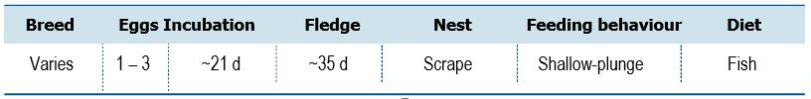
Life History and Distribution
The Caspian Tern (Hydroprogne caspia) is a large gull-like tern with a deep dagger-shaped red bill; it is the largest tern in the world. Its hoarse heron-like croaking call is distinctive. This species has a cosmopolitan but scattered distribution. Their breeding habitat is large lakes and ocean coasts in North America (including the Great Lakes), and locally in Europe (mainly around the Baltic Sea and Black Sea), Asia, Africa, and Australasia. North American birds migrate to southern coasts, the West Indies and northernmost South America. European and Asian birds winter in the tropics. African and Australasian birds are resident or disperse over short distances (del Hoyo et al. 1996).
The species shows a preference for nesting on sandy, shell-strewn or shingle beaches, sand-dunes, flat rock-surfaces, sheltered reefs or islands with sparse vegetation and flat or gently sloping margins surrounded by clear, shallow, undisturbed waters (Flint et al. 1984, Higgins and Davies 1996, del Hoyo et al. 1996, Snow and Perrins 1998). The species nests in large colonies or as single pairs or small groups amidst colonies of other species, neighbouring nests placed between 0.7 and 4 m apart (del Hoyo et al. 1996). The species may forage up to 60 km from the site of the breeding colony (del Hoyo et al. 1996). It also forms winter roosts on sandbars, mudflats and banks of shell (del Hoyo et al. 1996). Its diet consists predominantly of fish and minor amounts of the eggs and young of other birds, carrion, aquatic invertebrates (e.g. crayfish), flying insects and earthworms (Flint et al. 1984, Urban et al. 1986, del Hoyo et al. 1996, Shuford and Craig 2002).
Population Estimates and Trends
The global population is estimated to number between 250,000–470,000 individuals (Wetlands International 2015). The overall population trend is increasing, although some populations are decreasing, stable, or have unknown trends (Delany & Scott 2006). This species has undergone a large and statistically significant increase over the last 40 years in North America (266 per cent increase over 40 years, equating to a 38.3 per cent increase per decade; Butcher and Niven 2007). Australian population estimates and trends are unknown.

Species profiles
Conservation Concerns and Actions
Human disturbance represents a threat to this species. Caspian Tern colonies are especially vulnerable to disturbance during the early courtship and incubation stages, during which human visitation results in the flushing of the whole colony, potentially leading to nest or colony abandonment (Cuthbert and Wires 1999; Shuford and Craig 2002). The effect of disturbance during research activities has been well quantified, with activities such as banding and cannon-netting representing a large proportion of the reproductive failure in colonies studied (Shuford and Craig 2002). Disturbance due to recreational activities are less well quantified but likely also significant (Shuford and Craig 2002). Much of the loss of reproductive success due to human disturbance occurs through gull predation of chicks during the few seconds of panic flight in which the eggs and chicks of a nest are left exposed (Shuford and Craig 2002). Historically, exploitation has resulted in large population decreases through the collection of eggs and adults for food and feathers (Shuford and Craig 2002).
Recommended Management Actions
- Quantify the breeding population in Australia
- Regularly monitor breeding populations at index locations
- Determine non-breeding areas and migration routes
- Quantify and manage the potential impacts of human disturbance
- Monitor and manage, if required, the impact of Silver Gulls and other species on breeding colonies
- Trail artificial nesting sites and social attraction techniques to establish new colonies
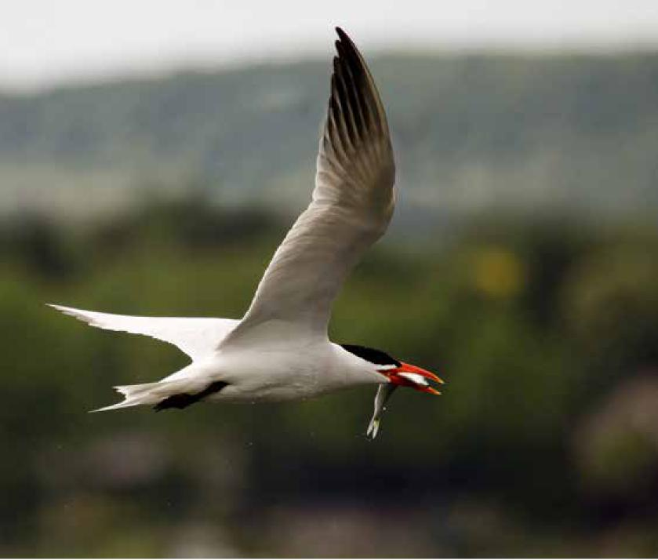

Wildlife Conservation Plan for Seabirds 139

Species profiles
Whiskered Tern (Chlidonias hybrida)
140 Wildlife Conservation Plan for Seabirds
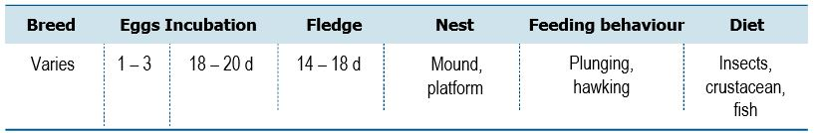
Life History and Distribution
The Whiskered Tern (Chlidonias hybrida) is a large marsh tern with a more dagger-shaped bill than congeners. This species is slightly bigger and bulkier than the White-winged Tern (C. leucopterus), with slightly longer and more uniformed broad wings and a slightly deeper fork-tail. The species utilises a variety of wetland habitats but shows a preference for freshwater marshlands with scattered pools, particularly where the surrounding vegetation is grazed by cattle or horses (Richards 1990). It frequents inland lakes, rivers, marshes, artificial fish-ponds and drainage-ponds (del Hoyo et al. 1996), swamps, river pools, reservoirs, large dams, sewage-ponds, flooded saltmarshes (Higgins and Davies 1996, del Hoyo et al. 1996) and rice-fields (del Hoyo et al. 1996). In Australia the species also occurs along the coast on estuaries, coastal lagoons, creeks in mangrove swamps (Snow and Perrins 1998) and tidal mudflats (del Hoyo et al. 1996). When breeding the nest is a heap of aquatic vegetation (Richards 1990, del Hoyo et al. 1996) or dry grass (del Hoyo et al. 1996), placed either on floating and emergent vegetation over water 60-80 cm deep or resting on the bottom of very shallow water (del Hoyo et al. 1996). The species nests in colonies, neighbouring pairs spaced between 1 and 5 m apart (del Hoyo et al. 1996), and may forage up to 9 km away from breeding sites (more usually within 1 km) (del Hoyo et al. 1996). Its diet consists of terrestrial and aquatic insects (del Hoyo et al. 1996) (e.g. Dytiscidae, adult and larval Odonata, Orthoptera, flying ants (del Hoyo et al. 1996) and mosquitoes (Richards 1990)), spiders, frogs, tadpoles, small crabs (del Hoyo et al. 1996), shrimps (Richards 1990) and small fish (del Hoyo et al. 1996).
Population Estimates and Trends
The global population is estimated to number 300,000-1,500,000 individuals (Delany and Scott 2006). The overall population trend is fluctuating, although some populations are stable and others have unknown trends (Delany and Scott 2006). The Australian population estimate and trends are unknown.

Species profiles
Conservation Concerns and Actions
The species suffers from the loss of natural wetlands to land reclamation, dry seasons and an increase in drainage schemes (Hagemeijer and Blair 1997), as well as the canalization of rivers (Tucker and Heath 1994). Human activities near breeding colonies can result in disturbance and the loss of nesting sites (Tucker and Heath 1994) and many nests are lost to adverse weather. Whiskered Terns are affected by water quality and pollution from insecticides and eutrophication (Martí and Moral 2004). The intensification of fisheries and bycatch in fishing nets are issues in part of its range (Golemansky 2011).
Recommended Management Actions
- Quantify the breeding population in Australia
- Regularly monitor breeding populations at index locations
- Determine non-breeding areas and migration routes
- Manage freshwater wetland habitats to support the lifecycle of the species
- Quantify and manage the potential impacts of human disturbance
- Measure contaminant levels in all relevant life stages
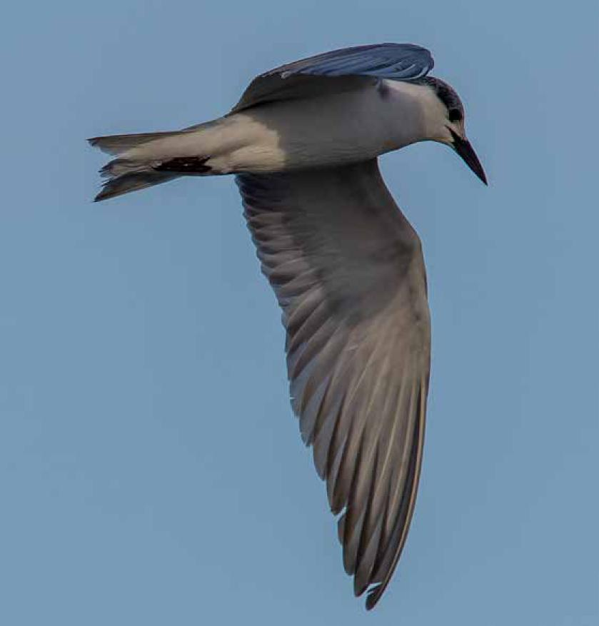

Wildlife Conservation Plan for Seabirds 141

Species profiles
White-winged Black Tern (Chlidonias
leucopterus)

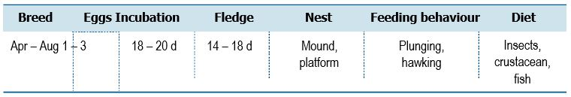

Life History and Distribution
The White-winged Black Tern (Chlidonias leucopterus) is the smallest Chlidonias species, slightly smaller, slimmer and more compact than Whiskered Tern (C. hybrida). In breeding plumage, the adults are strikingly black and white, with diagnostic white forewing-coverts. The species breeds in Europe, Russia and China from April to August in small colonies of between 3 and 100 pairs (mostly 20-40 pairs) that may contain other species (del Hoyo et al. 1996). The species breeds inland on freshwater lakes (del Hoyo et al. 1996, Snow and Perrins 1998), swampy standing water, rivers (Snow and Perrins 1998) and shallow naturally flooded grassland (Richards 1990, Snow and Perrins 1998) with areas of open water bordered by stands of reeds, sedge and other aquatic vegetation (Snow and Perrins 1998). It generally avoids fish-ponds, rice-fields and ornamental waters (Richards 1990) but may feed over wet fields, dry farmland and steppe grassland (del Hoyo et al. 1996). Throughout the year the species feeds in flocks (Snow and Perrins 1998) and migrates and overwinters in large flocks (del Hoyo et al. 1996) of up to tens of thousands of individuals (Snow and Perrins 1998).
Population Estimates and Trends
The global population is estimated to number 3,100,000-4,000,000 individuals (Delany and Scott 2006). The overall population trend is stable, although some populations have unknown trends (Delany and Scott 2006). The Australian population estimate and trends are unknown.
Conservation Concerns and Actions
The main threats to this species are within its European range and have been identified as habitat destruction and water regulation in wetlands. In the west of its European range the reclamation of wetlands is causing declines and in Russia and the Ukraine dry breeding seasons and an increasing number of drainage schemes pose a threat (Hagemeijer and Blair 1997). It is also susceptible to avian influenza so may be threatened by future outbreaks of the virus (Melville and Shortridge 2006).
Recommended Management Actions
- Quantify the non-breeding population in Australia
- Determine non-breeding areas and migration routes
- Manage freshwater wetland habitats to support the lifecycle of the species
- Quantify and manage the potential impacts of human disturbance
- Measure contaminant levels in all relevant life stages
142 Wildlife Conservation Plan for Seabirds

Species profiles
Roseate Tern (Sterna dougallii)
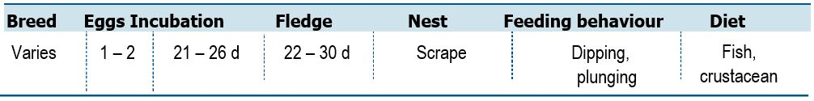
Life History and Distribution
The Roseate Tern (Sterna dougallii) is a slender medium-sized tern with a very long, slender drooping bill. The species is slightly bigger than Black-naped Tern (S. sumatrana) and smaller, slimmer than Common Tern (S. hirundo) and White-fronted Tern (S. striata). The species has an almost cosmopolitan distribution. In Australia the species can be found in subtropical and tropical waters from south-west WA to south-east Qld. The species nests on sand-dunes, sand-spits, shingle beaches, reefs (Snow and Perrins 1998), saltmarshes and rocky, sandy or coral islands and cays (del Hoyo et al. 1996), showing a preference for densely vegetated sites in temperate regions but sparsely vegetated sites in the tropics (del Hoyo et al. 1996). It also shows a preference for nest sites close to clear, shallow, sandy fishing grounds (Snow and Perrins 1998) in tidal bays and sheltered inshore waters (Snow and Perrins 1998). Throughout the year the species often rests and forages in sheltered estuaries, creeks (Urban et al. 1986), inshore waters and up to several kilometres offshore (del Hoyo et al. 1996), moving to warm tropical coasts after breeding (Snow and Perrins 1998). The species breeds in large, dense single- or mixed-species colonies that may contain several thousands of pairs (del Hoyo et al. 1996). It remains gregarious throughout the year, roosting in large groups (Urban et al. 1986, Snow and Perrins 1998) and feeding singly, in small loose groups (Snow and Perrins 1998) or in flocks of many hundreds of individuals (Urban et al. 1986, Snow and Perrins 1998). It is regularly found in mixed species flocks with Lesser Noddy (Anous tenuirostris) and White Tern (Gygis alba) (Ramos 2000). Its diet consists predominantly of small pelagic fish (Urban et al. 1986, del Hoyo et al. 1996; Surman and Wooller 2003).
Population Estimates and Trends
The global population is estimated to number 200,000–220,000 individuals (Delany and Scott 2006). The overall population trend is uncertain, as some populations are decreasing, while others are increasing or stable (Delany and Scott
2006). The Australian population has been estimated to be at least 15,000 pairs (Milton et al. 1996). Recent Australian population estimates and trends are unknown.
Conservation Concerns and Actions
Predators of eggs and chicks include the White-bellied Sea-Eagle (Haliaeetus leucogaster), Silver Gulls (Chroicocephalus novaehollandiae) and lizards (Higgins & Davies 1996; Hulsman et al. 1999). Ruddy Turnstones (Arenaria interpres) and large skinks (Egernis kingii) are also suspected predators in some locations (Hatch & Szczys 2000). The Black Rat (Rattus rattus) is a suspected introduced predator; after a rat baiting program on Wreck Island (Great Barrier Reef) the production of young increased (Burbidge & Fuller 1998; Hulsman et al. 1999).
Wildlife Conservation Plan for Seabirds 143

Species profiles
Crushing of chicks and eggs and disruption of breeding due to human activity is likely to be an issue in areas with moderate visitation (Stokes et al. 1996). Storm surges, combined with high tides, can lead to total loss of eggs and young (Stokes et al. 1996); therefore rising sea-levels may threaten breeding populations in the long-term.
Recommended Management Actions
- Quantify the breeding population in Australia
- Regularly monitor breeding populations at index locations
- Determine non-breeding areas and migration routes
- Quantify and manage the potential impacts of human disturbance
- Control, or eradicate invasive species on breeding islands
- Implement best practice quarantine measures at breeding colonies to reduce the risk of any invasive species (re)establishing on islands
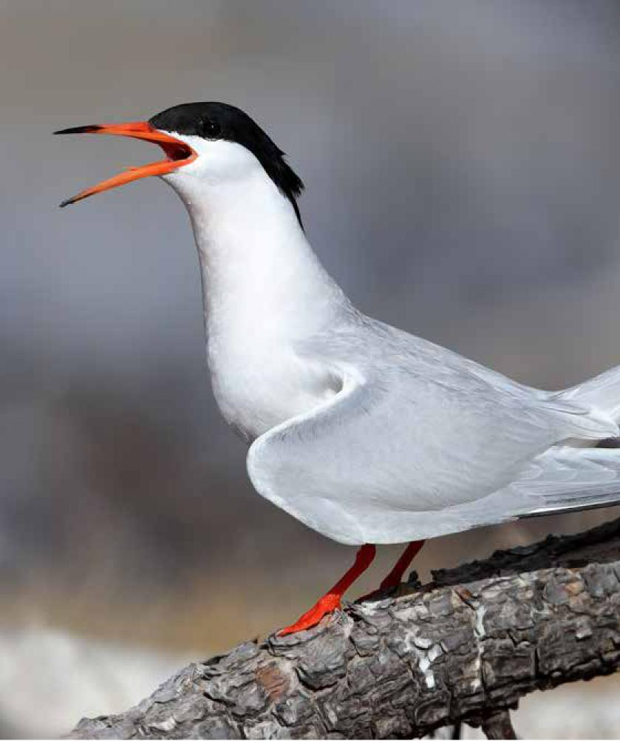

144 Wildlife Conservation Plan for Seabirds

Species profiles
White-fronted Tern (Sterna striata)
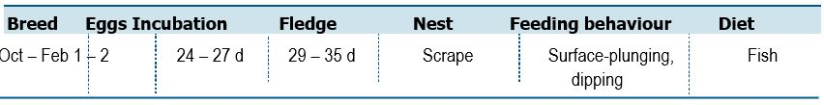
Life History and Distribution
The White-fronted Tern (Sterna striata) is a medium sized ‘commic’ tern with a long straight slender bill and a very long, deeply forked tail. It is the largest and bulkiest commic tern, proportionally similar to Common Tern (S. hirundo). The species is endemic to Australasia, breeding on the North and South Island of New Zealand, Stewart Island, the Chatham, Auckland and Snares Islands off the coast of New Zealand, and Flinders and Cape Barren Island off the north-east of Tasmania. It is also a winter visitor to Australia, from south Queensland to Tasmania and west to South Australia.
This species can be found in coastal areas, nesting on rocky or sandy beaches and shingle islands in rivers, also on coastal cliffs and deserted barges, often close to the surf. It feeds along the shore and in bays, and over oceanic waters in winter. It feeds almost exclusively on fish, but will also take shrimp, feeding in the surf zone or several kilometres out to sea. It often feeds in flocks by plunge-diving from 7-10 m with or without hovering, and by contact-dipping. Nesting takes place from October to December with most colonies containing 100-500 pairs, although solitary pairs are recorded at the edges of the range (del Hoyo et al. 1996).
Population Estimates and Trends
In New Zealand, S. s. striata has been considered to have a population size of
5,000-20,000 mature individuals, and S. s. aucklandoruna was considered to have a population size of 1,000-5,000 mature individuals (Robertson et al. 2017). In Australia, (S. s. incerta) the breeding population is considered to be 120 mature individuals (Garnett et al. 2011), however, there have been no surveys since 1986 when 13 breeding locations were known (Garnett et al. 2011). Based on the subpopulation trends and subpopulation sizes from Garnett et al. (2011) and Robertson et al. (2017), the species may be decreasing. The overall decrease depends on the population size, but would fall in the range 5.2–29.1 per cent over 3 generations (30.3 years) and is considered Near Threatened by BirdLife International (BirdLife International 2019).
Conservation Concerns and Actions
The species habit of nesting in densely packed colonies leaves it at considerable risk of predation by invasive predators (Mills 2013). It is also vulnerable to predation by native species, with an entire colony at Kaikoura (New Zealand) abandoned following chick predation by a single Northern Giant Petrel (Macronectes halli) (Mills 2013). There is also potentially a risk from the spread of the invasive weed Sea Spurge (Euphorbia paralias); however, this does not seem to be significant at present. It is possible that, in the future, the effects of climate change could have an adverse impact on food sources and breeding habitat.
Recommended Management Actions
- Quantify the breeding population in Australia
- Regularly monitor breeding populations at index locations
- Determine non-breeding areas and migration routes
- Control, or eradicate invasive species on breeding islands
- Implement best practice quarantine measures at breeding colonies to reduce the risk of any invasive species (re)establishing on islands
Wildlife Conservation Plan for Seabirds 145

Species profiles
Black-naped Tern (Sterna sumatrana)
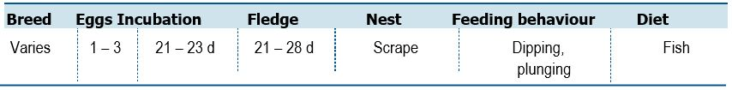
Life History and Distribution
The Black-naped Tern (Sterna sumatrana) is a small slender tropical tern with a long slender bill, long narrow wings and a long deeply forked tail. Adults are pale grey above, with a white head, neck and underparts and a diagnostic narrow black band from eye to nape. This species ranges in tropical and subtropical areas of the Indian Ocean and western Pacific Ocean. In the western Indian Ocean it breeds on the Aldabra and Amirante Islands, Seychelles, Chagos Islands (British Indian Ocean Territory) and the Maldives and can be found on the eastern African coast. Its range in the eastern Indian Ocean and Pacific encompasses the Andaman Islands, India, east to southern Japan and China, south through Indonesia, Malaysia, the Philippines and New Guinea to north-east Australia and some islands in the western-central Pacific (del Hoyo et al. 1996). This species frequents small offshore islands, reeds, sand spits and rocky cays, feeding in atoll lagoons and close inshore over breakers, but sometimes also at sea. It feeds mainly on small fish and will almost always forage singly by shallow plunge-diving or surface-diving. Its breeding season varies depending on locality, usually forming small colonies of 5 to 20 pairs, but sometimes up to 200 pairs. Colonies are often monospecific and formed on unlined depression in the sand or in gravel pockets on coral banks close to the high tide line (del Hoyo et al. 1996).
Population Estimates and Trends
The global population size has not been quantified. The population trend is difficult to determine because of uncertainty over the extent of threats to the species (del Hoyo et al. 1996). Significant breeding populations occur in the Great Barrier Reef and Coral Sea Marine Park islands. The Australian population estimate and trends are unknown.
Conservation Concerns and Actions
This species is extremely sensitive to disturbance, with relatively little disturbance needed to cause nest desertion (Department of the Environment 2019); however, most breeding locations are in remote locations, so this represents a relatively small threat to the species. Is prone to predation by invasive rats, which cause considerable losses due to chick and egg predation, and can lead to breeding failure (Department of the Environment 2019). It is possible that, in the future, climate change could have an adverse impact on food sources and breeding habitat.
Recommended Management Actions
- Quantify the breeding population in Australia
- Regularly monitor breeding populations at index locations
- Determine non-breeding areas and migration routes
- Control, or eradicate invasive species on breeding islands
- Implement best practice quarantine measures at breeding colonies to reduce the risk of any invasive species (re)establishing on islands
146 Wildlife Conservation Plan for Seabirds

Species profiles
Common Tern (Sterna hirundo)
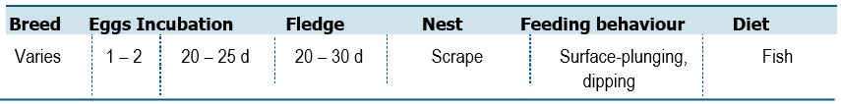
Life History and Distribution
The Common Tern (Sterna hirundo) is a medium sized, slender tern with a long slender bill, long narrow wings and long deeply forked tail. This species has a circumpolar distribution and can be found breeding in most of Europe, Asia and North America, except the in the extreme north. It winters further south, being found along the coast and inland of South America down to the Falkland Islands (Islas Malvinas), along the coast of Africa (excluding northern Africa), along parts of the Arabian Peninsula, the coast of India and throughout much of south-east Asia and Australasia (del Hoyo et al. 1996). It breeds between April and June in solitary pairs or colonially in groups of up to several thousand pairs (del Hoyo et al. 1996). Palearctic breeders migrate south after breeding between August and October, returning to the breeding grounds in March or April (del Hoyo et al. 1996). The species winters on sheltered coastal waters, estuaries and along large rivers, occupying harbours, jetties, piers, beaches and coastal wetlands including lagoons, rivers, lakes, swamps and saltworks, mangroves and saltmarshes (del Hoyo et al. 1996, Higgins and Davies 1996). During this season, it roosts on unvegetated sandy beaches, shores of estuaries or lagoons, sandbars and rocky shores (Higgins and Davies 1996). The species is opportunistic, its diet consisting predominantly of small fish and occasionally planktonic crustaceans and insects (del Hoyo et al. 1996).
Population Estimates and Trends
The global population is estimated to number 1,600,000-3,600,000 individuals (Delany and Scott 2006). The overall population trend is unclear. Some populations may be stable, while others have unknown trends (Delany and Scott 2006).
The Australian population estimate and trends are unknown.
Conservation Concerns and Actions
During the breeding season, the species is vulnerable to human disturbance at nesting colonies (Buckley and Buckley 1984, Blokpoel and Scharf 1991). The flooding of nest sites as a result of naturally fluctuating water levels can also result in complete breeding failure of the effected colony (Buckley and Buckley 1984, Hyde 1997, del Hoyo et al. 2019). Previously, this species has experienced significant declines due to egg collection and hunting (del Hoyo et al. 2019). Although in most places populations have recovered, hunting remains a significant problem in some areas, including parts of West Africa (del Hoyo et al. 2019).
Recommended Management Actions
- Quantify the non-breeding population in Australia
- Determine non-breeding areas and migration routes
- Quantify and manage the potential impacts of human disturbance
Wildlife Conservation Plan for Seabirds 147

Species profiles
Arctic Tern (Sterna paradisaea)
148 Wildlife Conservation Plan for Seabirds
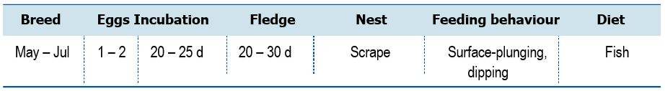
Life History and Distribution
The Arctic Tern (Sterna paradisaea) is a medium sized tern with a short slender bill, compact oval body when perched, a deeply forked tail and short legs. The species is similar in size and shape to Common Tern (S. hirundo), White-fronted Tern (S. striata) and Antarctic Tern (S. vittata). This species has a circumpolar range, breeding in the Arctic and subarctic regions of Europe, Asia and North America as far south as Brittany (France) and Massachusetts (U.S.A.). It is a transequatorial migrant and can be found wintering throughout the Southern Ocean to the edge of the Antarctic ice and the southern tips of South America and Africa (del Hoyo et al. 1996). It breeds between May and July (although the exact timing varies with temperature and food availability) in solitary pairs or colonies of a few to several hundred pairs (usually 2-25) (del Hoyo et al. 1996), and remains gregarious throughout the year especially when roosting, foraging and on passage (Higgins and Davies 1996, Snow and Perrins 1998). The species generally feeds within 3 km of breeding colonies but may occasionally forage up to 50 km away (del Hoyo et al. 1996). On its wintering grounds in Antarctica, it may also forage in association with Antarctic Minke Whale (Balaenoptera bonaerensis) in the open ocean north of the pack-ice zone (Higgins and Davies 1996). Its diet consists predominantly of fish as well as crustaceans (especially planktonic species).
Population Estimates and Trends
The global population is estimated to number >2,000,000 individuals (Delany and Scott 2006). The overall population trend is decreasing (Delany and Scott 2006). In Europe, the population size is estimated to be decreasing by less than 25 per cent in 40.2 years (three generations) (BirdLife International 2019). The Australian population estimate and trends are unknown.
Conservation Concerns and Actions
Arctic Tern breeding colonies are threatened by invasive species, human disturbance and egg collection (Birdlife International 2019). It is possible that, in the future, the effects of climate change could have an adverse impact on food sources and breeding habitat.
Recommended Management Actions
- Quantify the non-breeding population in Australia
- Determine non-breeding areas and migration routes

Species profiles
Lesser Crested Tern (Thalasseus bengalensis)
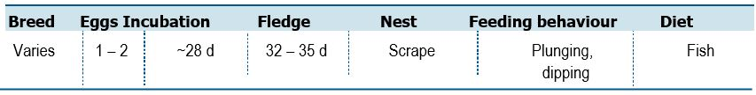
Life History and Distribution
The Lesser Crested Tern (Thalasseus bengalensis) is a large tern very similar in shape and proportions to Crested Tern (T. bergii). Lesser Crested Terns have a diagnostic long bright-orange bill. The species breeds in subtropical coastal parts of the world mainly from the Red Sea across the Indian Ocean to the western Pacific, and Australia, with a significant population on the southern coast of the Mediterranean, on two islands off the coast of Libya. Outside the breeding season it ranges on the north African coast (both Mediterranean and Atlantic), on much of the Indian Ocean nearby continents, and in the western Pacific north of Australia up to New Guinea and Vietnam. Details of this species movements are poorly known. The species inhabits tropical and subtropical (del Hoyo et al. 1996) sandy and coral coasts and estuaries (Urban et al. 1986), breeding on low-lying offshore islands, foraging in the surf and over offshore waters (del Hoyo et al. 1996). Thenest is a shallow scrape (del Hoyo et al. 1996) on ridges or bare areas surrounded by vegetation (del Hoyo et al. 1996) on flat sandy beaches (Snow and Perrins 1998), low-lying sandy islands, coral flats, small coral islets and sandbanks (del Hoyo et al. 1996). Its diet consists predominantly of small pelagic fish (Urban et al. 1986, del Hoyo et al. 1996) and shrimps (del Hoyo et al. 1996).
Population Estimates and Trends
The global population estimate is estimated to number 225,000 pairs, more than half occur in Australia (BirdLife International 2019). An estimated 10,000 pairs occur in the South Pacific and 8,000 in Indonesia. The overall population trend is stable, although some populations have unknown trends (Delany and Scott 2006).
Conservation Concerns and Actions
Globally, the species does not seem to be facing any significant threats, however, some colonies are vulnerable to invasive species and human disturbance. At present there are no factors thought to pose a genuine threat to this species. It is possible that, in the future, the effects of climate change could have an adverse impact on food sources and breeding habitat.
Recommended Management Actions
- Quantify the breeding population in Australia
- Regularly monitor breeding populations at index locations
- Determine non-breeding areas and migration routes
- Control, or eradicate invasive species on breeding islands
- Implement best practice quarantine measures at breeding colonies to reduce the risk of any invasive species (re)establishing on islands
Wildlife Conservation Plan for Seabirds 149

Species profiles
Crested Tern (Thalasseus bergii)
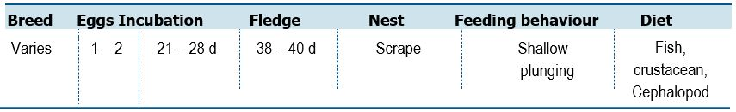
Life History and Distribution
The Crested Tern (Thalasseus bergii) is a large slender tern with long narrow strongly angled wings, long deeply forked tail and a long decurved bill and long legs. At all ages the combination of large size, shaggy crest and yellow bill make the species diagnostic. The species can be found on islands and coastlines of tropical and subtropical areas, ranging from the Atlantic Coast of South Africa, south around the Cape and continuing along the coast of Africa and Asia almost without break to south-east Asia and Australia. It can also be found on Madagascar, islands of the western Indian Ocean and islands of the western and central Pacific Ocean. Outside the breeding season it can be found at sea throughout this range, with the exception of the central Indian Ocean (del Hoyo et al. 1996).
Many populations remain sedentary in their breeding areas or disperse locally
(del Hoyo et al. 1996), although some are more migratory (Urban et al. 1986).
The species breeds in large dense colonies, or in small groups of fewer than 10 pairs
amidst colonies of other species (e.g. Silver Gull Chroicocephalus novaehollandiae)
(del Hoyo et al. 1996). The nest is a shallow scrape in bare sand, rock or coral (del Hoyo et
al. 1996) in flat open sites (Urban et al. 1986) on offshore islands (Urban et al. 1986,
del Hoyo et al. 1996), low-lying coral reefs, sandy or rocky coastal islets, coastal
spits, lagoon mudflats (del Hoyo et al. 1996) or islets in saltpans and sewage works
(Urban et al. 1986, del Hoyo et al. 1996).
Population Estimates and Trends
The global population is estimated to number 150,000–1,100,000 individuals (Delany and Scott 2006). The overall population trend is stable, although some populations have unknown trends (Delany and Scott 2006). Significant breeding populations occur in the Great Barrier Reef and Coral Sea Marine Park islands. The Australian population estimate and trends are unknown.
Conservation Concerns and Actions
The species is vulnerable to human disturbance, which may cause the flushing of adult birds allowing increased egg predation by gulls (del Hoyo et al. 2019) and colony abandonment. It is possible that, in the future, the effects of climate change could have an adverse impact on food sources and breeding habitat. There is also potentially a risk from the spread of the invasive weed Sea Spurge (Euphorbia paralias); however, this does not seem to be significant at present.
Recommended Management Actions
- Quantify the breeding population in Australia
- Regularly monitor breeding populations at index locations
- Determine non-breeding areas and migration routes
- Control, or eradicate invasive species on breeding islands
- Implement best practice quarantine measures at breeding colonies to reduce the risk of any invasive species (re)establishing on islands
150 Wildlife Conservation Plan for Seabirds

Species profiles
Pacific Gull (Larus pacificus)
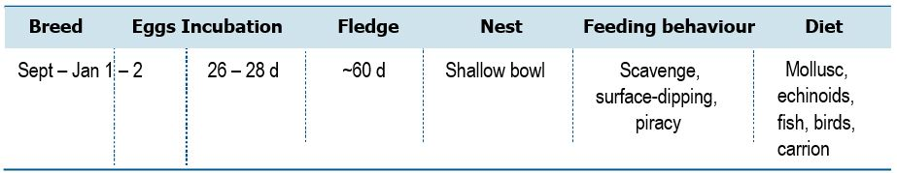
Life History and Distribution
The Pacific Gull (Larus pacificus) is the largest gull in Australia. The species is a powerful, deep-chested and thickset black-backed gull. At all times the species is easily identified by its deep massive bill, with prominent gonys and pear-shaped nostrils. It is bigger and bulkier than Kelp Gull (L. dominicanus). This species is endemic to Australia. The subspecies pacificus breeds in Tasmania, on many Bass Strait islands and westward along the Victorian coast from Wilson's Promontory to the South Australian border. The subspecies georgii is found on the coasts of south-western Western Australia and western South Australia. Its range has expanded in recent years northwards along the Western Australian coast (del Hoyo et al. 2019). Breeding occurs between September and January, either in small and open colonies or solitary (del Hoyo et al. 1996; Widdup 2013). Most nest sites are protected, however, by their inaccessibility, and the species has proved adaptable in exploiting new food sources provided by urbanisation (Garnett and Crowley 2000). It has a diverse diet including fish, squid, intertidal molluscs,
echinoderms and crabs, fish offal, carrion and refuse.
Population Estimates and Trends
Delany and Scott (2006) estimate the population to be 11,000 individuals.
The population is suspected to be stable in the absence of evidence for any decreases or substantial threats (Wakefield et al. 2019). The Australian population estimate requires verification. Trends are unknown, however, increasing in south east Tasmania based on winter surveys 1980–2019 (E. Woehler pers. comm).
Conservation Concerns and Actions
As with other coastal species, Pacific Gulls are prone to disturbance while breeding and feeding. Some populations have begun contracting (del Hoyo et al. 2019). Frequently observed at garbage facilities feeding. It is possible that, in the future, the effects of climate change could have an adverse impact on food sources and breeding habitat (Woehler et al. 2014).
Recommended Management Actions
- Quantify the breeding population in Australia
- Regularly monitor breeding populations at index locations
- Quantify and manage the potential impacts of human disturbance
- Manage human garbage disposal sustainably
- Measure contaminant levels in all relevant life stages
Wildlife Conservation Plan for Seabirds 151

Species profiles
Kelp Gull (Larus dominicanus)

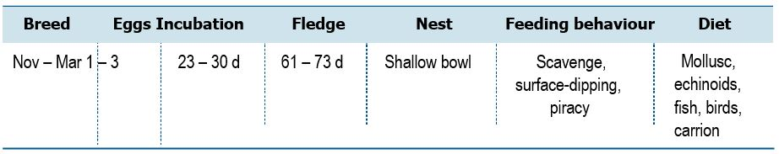

Life History and Distribution
The Kelp Gull (Larus dominicanus) is a large, black-backed gull similar in appearance to Pacific Gull (L. pacificus). The Kelp Gull breeds on coasts and islands through much of the Southern Hemisphere. It is found on a number of subantarctic islands, on the Antarctic Peninsula, on the southern coast of Australia and all of New Zealand, on the southern coast of Africa and Madagascar, and on the coast of South America as far north as Ecuador and southern Brazil (Basset et al. 1988; del Hoyo et al. 1996). It inhabits sheltered coastal harbours, bays, inlets, estuaries, beaches and rocky shores, usually foraging within 10 km of the shore but also following fishing boats beyond the continental shelf (Higgins and Davies 1996, del Hoyo et al. 1996). It may forage and roost in near-coastal inland habitats including lagoons, lakes, swampy basins, rivers, streams, reservoirs, pastures, cultivated land, tussock grassland, scrubland and cleared areas in pine plantations (Higgins and Davies 1996, del Hoyo et al. 1996, Hockey et al. 2005). Although this species is largely sedentary some southern populations migrate north after the breeding season (del Hoyo et al. 1996). The species breeds between late-September and January in colonies of up to several hundred pairs (occasionally nesting solitarily and remains gregarious outside of the breeding season (del Hoyo et al. 1996, Hockey et al. 2005).
Population Estimates and Trends
The population is estimated to number 3,300,000–4,300,000 individuals
(BirdLife International 2019). The overall population trend is increasing, although some populations have unknown trends (Delany and Scott 2006). The Australian population estimate and trends are unknown. Presently increasing in south east Tasmania based on winter surveys 1980–2019 (E. Woehler pers. comm).
Conservation Concerns and Actions
The Kelp Gull rapidly expanded its range in South Africa and in South America. The increased abundance is attributed to availability of food discards from trawlers and at fish processing factories and at waste disposal sites. In South Africa Kelp Gulls are aggressive predators of other seabirds on offshore islands. The species is potentially threatened by marine pollution (Parsons and Underhill 2005) and is susceptible to avian cholera (Hockey et al. 2005, Leotta et al. 2006) and avian botulism (Blaker 1967, Hockey et al. 2005) so may be threatened by future outbreaks of these diseases. The species also suffers mortality from interactions with trawler warp cables (Argentina) (Gonzalez-Zevallos et al. 2007). However, none of these threats are thought to pose a genuine threat to the population at present. Birds are frequently observed feeding at garbage facilities.
152 Wildlife Conservation Plan for Seabirds

Species profiles
Recommended Management Actions
- Quantify the breeding population in Australia
- Regularly monitor breeding populations at index locations
- Quantify and manage the potential impacts of human disturbance
- Manage human garbage disposal sustainably
- Measure contaminant levels in all relevant life stages
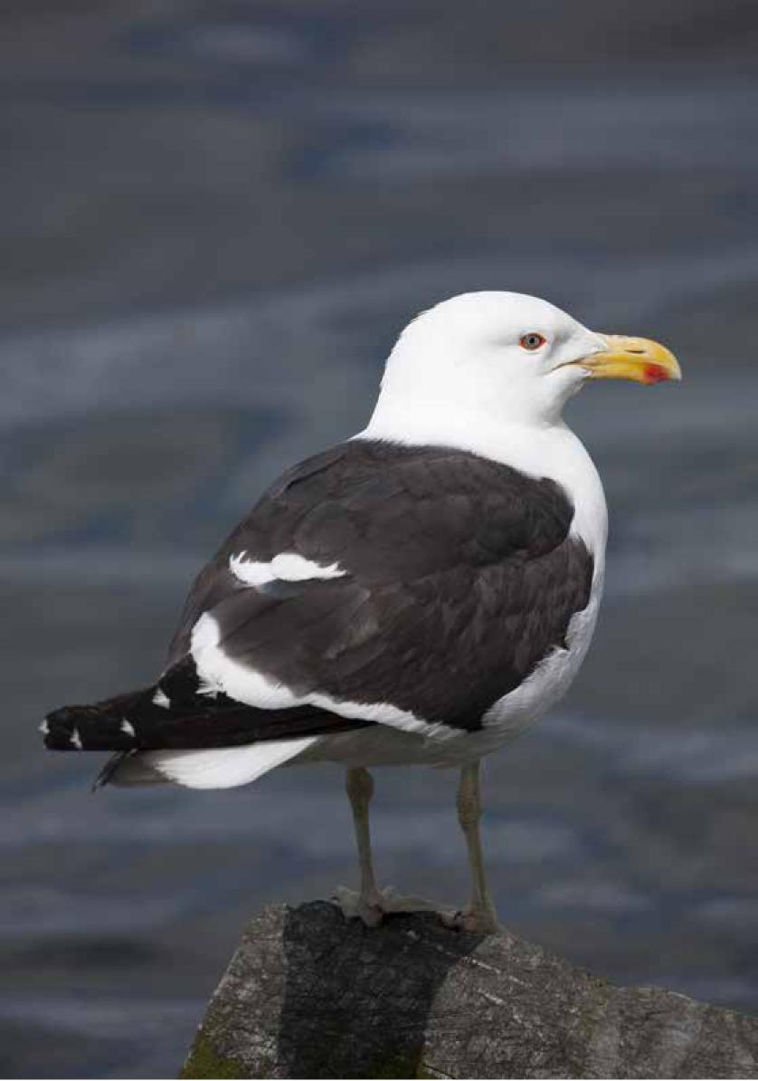

Wildlife Conservation Plan for Seabirds 153

Species profiles
Silver Gull (Chroicocephalus novaehollandiae)

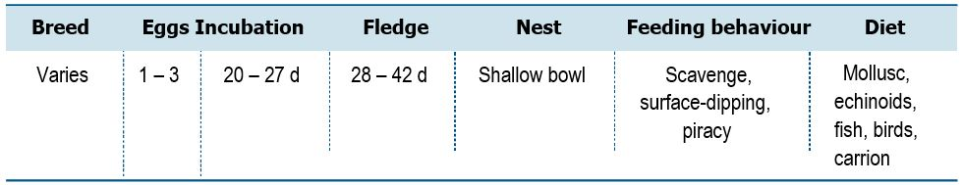

Life History and Distribution
The Silver Gull (Chroicocephalus novaehollandiae) is a familiar small gull of Australian coasts and inland areas. Adults are readily identified by the bright red bill and legs and distinctive pattern of the underwing. This species can be found at both coastal and inland locations in a variety of habitats including artificial habitats such as rubbish dumps. It has a very varied, opportunistic diet including fish, marine and terrestrial invertebrates, seeds, insects and bird eggs. Kleptoparasitism has been observed. It breeds on small islands and points, mainly offshore, but also on freshwater and brackish lakes, and on causeways in salt-pans. The breeding season covers all months, with the exact timing varying depending on locality and age. It is colonial and occasionally solitary, with smaller colonies in the tropics (3-25 pairs) up to 10,000 pairs in southern Australia (del Hoyo et al. 1996; Carlile et al. 2017). Colony size depends on food availability. Individuals may wander widely outside the breeding season (del Hoyo et al. 1996).
Population Estimates and Trends
The species is thought to be abundant across its range. Presently increasing in south east Tasmania based on winter surveys 1980–2019 (E. Woehler pers. comm). The overall population trend is increasing, although some subpopulations have unknown trends (Delany and Scott 2006).
Conservation Concerns and Actions
Frequently observed at garbage facilities feeding on human waste. At present there are no factors thought to pose a genuine threat to this species. It is possible that, in the future, the effects of climate change could have an adverse impact on food sources and breeding habitat (Woehler et al. 2014). Human disturbance at colonies and interactions with aquaculture has local effects.
Recommended Management Actions
- Quantify the breeding population in Australia
- Regularly monitor breeding populations at index locations
- Quantify and manage the potential impacts of human disturbance
- Manage human garbage disposal sustainably
- Measure contaminant levels in all relevant life stages
154 Wildlife Conservation Plan for Seabirds

Species profiles
Osprey (Pandion haliaetus)
Wildlife Conservation Plan for Seabirds 155
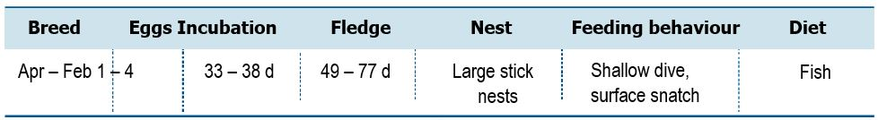
Life History and Distribution
The Osprey (Pandion haliaetus, also known as Pandion cristatus) is a familiar coastal raptor, particularly in northern Australia. Ospreys occur in littoral and coastal habitats and terrestrial wetlands of tropical and temperate Australia and offshore islands. They are mostly found in coastal areas but occasionally travel inland along major rivers, particularly in northern Australia (Johnstone & Storr 1998; Marchant & Higgins 1993; Olsen 1995). They require extensive areas of open fresh, brackish or saline water for foraging (Marchant and Higgins 1993). They frequent a variety of wetland habitats including inshore waters, reefs, bays, coastal cliffs, beaches, estuaries, mangrove swamps, broad rivers, reservoirs and large lakes and waterholes (Marchant and Higgins 1993). They exhibit a preference for coastal cliffs and elevated islands in some parts of their range (Boekel 1976; Domm 1977), but may also occur on low sandy, muddy or rocky shores and over coral cays (Marchant and Higgins 1993). The Osprey breeds from April to February in Australia. Breeding seasons of individual pairs vary according to latitude, with breeding commencing progressively later on a cline from north to south (Marchant and Higgins 1933). Ospreys mainly feed on fish, especially mullet where available.
Population Estimates and Trends
The global population size of the Osprey is not precisely known but is estimated to number less than 212,000 pairs (Ferguson-Lees and Christie 2001; Poole et al. 1989; Rich et al. 2004). Global trends have not been quantified. The Osprey is considered to be moderately common in Australia (Olsen 1998). The species is most abundant in northern Australia, where high population densities occur in remote areas (Garnett 1993; Johnstone and Storr 1998). The species is rare to uncommon in southern Western Australia (Johnstone and Storr 1998) and occurs in low numbers in South Australia (~52 pairs in 2005, Dennis 2007), and NSW (~100 pairs in 1996, Clancy 2006).

Species profiles
Conservation Concerns and Actions
The main threat to the Osprey in Australia is loss, degradation or alteration of habitat for urban or tourism development in coastal areas (Clancy 1989, 1991; Dennis 2007a; Olsen 1998). In the Chain of Bays region of the Eyre Peninsula, South Australia, where Ospreys nest on the ground due to the lack of trees, human disturbance is an increasing threat (Department of the Environment 2019b).
Other less pervasive threats include ingestion of prey items containing pollutants such as pesticides, heavy metals or fishing tackle; competition for food with commercial and recreational fisheries; reduced water quality at foraging grounds caused by discharge of effluent or runoff; disturbance or persecution by humans; and accidental mortality arising from collisions with powerlines (Department of the Environment 2019b).
Poisoning by organochlorine pesticides and persecution by humans are considered the likely causes of a post-settlement decline in Osprey numbers in south-eastern Australia (Clancy 1991, 2005a; Garnett 1993; Olsen 1995). Falkenberg et al. (1994) reported low levels of organochlorine pesticides in Ospreys in South Australia soon after regulations were introduced. Recent studies suggest that Ospreys in north-eastern NSW are not significantly affected by pesticides (Clancy 2005b, 2006).
Recommended Management Actions
- Ensure the continued availability of nest sites (large dead trees or artificial structures) with an appropriate buffer zone.
- Quantify the breeding population in Australia
- Regularly monitor breeding populations at index locations
- Quantify and manage the potential impacts of human disturbance
- Measure contaminant levels in all relevant life stages
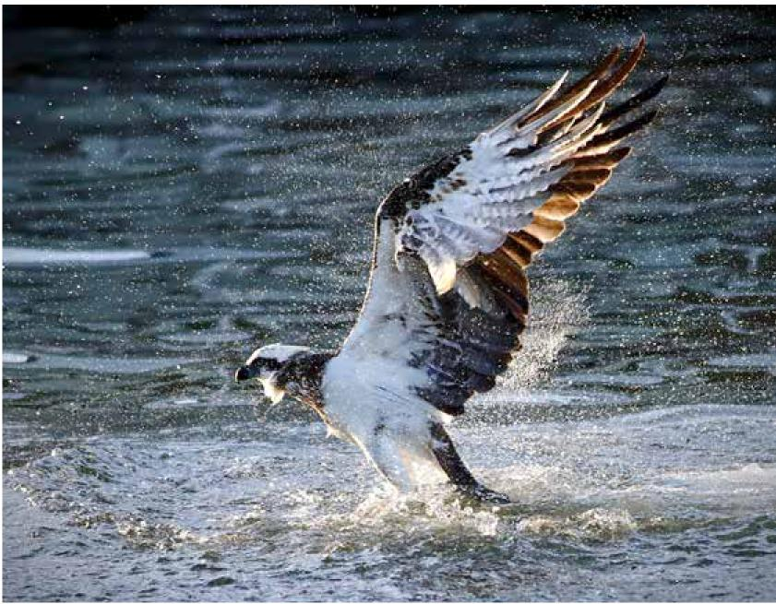

156 Wildlife Conservation Plan for Seabirds

Species profiles
White-bellied Sea-eagle (Haliaeetus leucogaster)

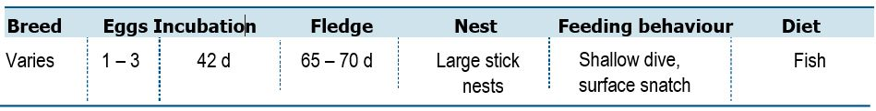
Life History and Distribution
The White-bellied Sea-Eagle (Haliaeetus leucogaster) is a large raptor that has long, broad wings and a short, wedge-shaped tail. Females weigh between 2.8 and 4.2 kg, and are larger than the males, which weigh between 2.5 and 3.7 kg (Marchant and Higgins 1993). The plumage of adult birds is predominantly white and grey. The head, breast and belly, and the feathering on the legs, are white. The White-bellied Sea-Eagle is distributed along the coastline (including offshore islands) of mainland Australia and Tasmania. It also extends inland along some of the larger waterways, especially in eastern Australia. The inland limits of the species are most restricted in south-central and south-western Australia, where it is confined to a narrow band along the coast (Barrett et al. 2003; Bilney and Emison 1983; Blakers et al. 1984; Marchant and Higgins 1993). Recent analysis indicates that the distribution of the sea-eagle may shift in response to climatic conditions, with an apparent decreased occupancy of inland sites (and increased occupancy of coastal sites) during drought conditions (Shephard et al. 2005a). The White-bellied Sea-Eagle breeds in solitary and monogamous pairs that mate for life. However, if one member of the pair dies, it is quickly replaced (Marchant and Higgins 1993). The breeding season extends from June to January (or sometimes February) in southern Australia, but begins one or two months earlier in northern Australia, for example, eggs are laid from June to September (or sometimes later) in southern Australia, and from May to August in northern Australia (Bilney & Emison 1983; Marchant and Higgins 1993). The nest is a large structure composed of sticks and lined with leaves, grass or seaweed (Marchant and Higgins 1993). Nests may be built in a variety of sites including tall trees (especially Eucalyptus species), bushes, mangroves, cliffs, rocky outcrops, caves, crevices, on the ground or even on artificial structures (Abbott 1982; Bilney and Emison 1983; Cupper and Cupper 1981; Emison and Bilney 1982; Marchant and Higgins 1993). Pairs usually return to the same breeding territory each year, and often the same nest, although territories tend to contain one or two additional, less developed nests (Marchant and Higgins 1993). Breeding pairs tend to be widely dispersed and are generally separated by distances of several kilometres or more (Marchant and Higgins 1993), though on offshore islands pairs may be located quite close together. The White-bellied Sea-Eagle feeds opportunistically on a variety of fish, birds, reptiles, mammals and crustaceans, and on carrion and offal (del Hoyo et al. 1994; Ferguson-Lees and Christie 2001; Marchant and Higgins 1993; Rose 2001).
Population Estimates and Trends
The population size in south-eastern Australia alone is estimated to number
410–430 pairs, based on the most recent estimates for Victoria (100 pairs), Tasmania (200–220 pairs) (Olsen 1995) and South Australia (55 pairs, figure based on a total of 55 occupied territories) (Dennis & Lashmar 1996). Declines in local populations have been recorded in NSW (Bell 1983; Lindsey 1986; Marchant and Higgins 1993), Victoria (Bilney and Emison 1983; Quinn 1969), Tasmania and South Australia (Dennis and Lashmar 1996). The sea-eagle was formerly 'found in good numbers along the Murray River' (Hobbs 1961) but is now rarely recorded in the Sunraysia district or in the adjacent districts of south-western NSW (Hayward and MacFarlane 1971; Lindsey 1986).
Wildlife Conservation Plan for Seabirds 157

Species profiles
In South Australia, where a statewide survey has been conducted, it is estimated that the population may have declined by more than 40%, based on a comparison between contemporary and historical records (Dennis and Lashmar 1996). Conversely, populations in the northern and remote tropical regions of Australia appear to be stable (Dennis and Lashmar 1996; Hollands 2003). A national population estimate and trends have not been determined.
Conservation Concerns and Actions
Declines in White-bellied Sea-Eagle populations are related in no small part to anthropogenic encroachment, in all its forms, during critical phases of the breeding cycle (Dennis et al. 2012). The main threats to the White-bellied Sea-Eagle are the loss of habitat due to land development, and the disturbance of nesting pairs by human activity (Bilney and Emison 1983; Dennis and Lashmar 1996). Land clearance reduces the amount of suitable habitat available to the sea-eagle, and this can force birds to nest in sub-optimal habitats where their breeding success is greatly reduced (Emison and Bilney 1982; Bilney and Emison 1983). The intensity and spread of coastal development are, presumably, likely to increase in future, as is the resultant pressure on White-bellied Sea-Eagle habitat and, subsequently, the sea-eagle itself.
The White-bellied Sea-Eagle is sensitive to disturbance when nesting, especially during the early stages of the breeding season, and may desert nests and young if confronted by humans or exposed to human activity (Hollands 2003; Stokes 1996). The disturbance of nesting pairs by human activity can thus lower breeding success, and has been associated with some local population declines, for example, abandoned territories on the Eyre Peninsula and far west coast of South Australia were located in areas that had been developed for tourism or that contained recreational sites accessible by vehicles (Dennis and Lashmar 1996). Abandonment of nesting sites on Kangaroo Island also followed developments in the areas (Dennis and Baxter 2006). The frequency and intensity of disturbance is likely to increase in future as human populations continue to expand and increase in density.
Potential threats to the White-bellied Sea-Eagle include poisoning, shooting, competition with Wedge-tailed Eagles, and the deterioration of inland water resources. Collision with wind turbines have also been identified as a known threat to the White-bellied Sea-Eagle. Raptors are thought to be at higher risk of collision due to their tendency to make flights in the swept area. Intensive monitoring of White–bellied Sea-Eagles and other raptor species need to be undertaken nationally in order to ascertain base levels of environmental contaminants in Australian avifauna.
Recommended Management Actions
- Quantify the breeding population in Australia
- Regularly monitor breeding populations at index locations
- Complete of a population viability assessment once the necessary information becomes available
- Quantify and manage the potential impacts of human disturbance
- Measure contaminant levels in all relevant life stages
158 Wildlife Conservation Plan for Seabirds
Species profiles
Brahminy Kite (Haliastur indus)

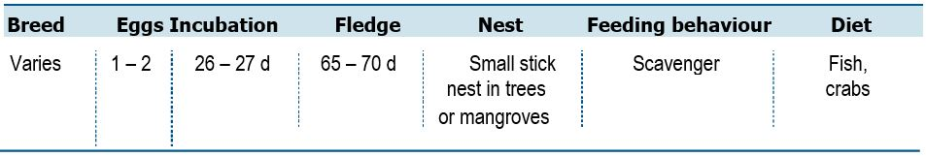
Life History and Distribution
The Brahminy Kite (Haliastur indus) is a medium-sized bird of prey in the family Accipitridae, which also includes many other diurnal raptors, such as eagles, buzzards, and harriers. They are found in the Indian subcontinent, South-east Asia, and Australia as far south as New South Wales. They are found mainly on the coast and in inland wetlands, where they feed on dead fish and other prey. Adults have a reddish-brown body plumage contrasting with their white head and breast which make them easy to distinguish from other birds of prey. The breeding season in South Asia is from December to April (del Hoyo et al. 2019). In southern and eastern Australia, it is August to October, and April to June in the north and west (Beruldsen 2003). The nests are constructed of small branches and sticks with a bowl inside and lined with leaves, and are located in various trees, often mangroves (Beruldsen 2003). They show considerable site fidelity nesting in the same area year after year. A clutch of two dull-white or bluish-white oval eggs are laid in a small stick nest in trees or mangroves. Both parents take part in nest building and feeding, but likely only the female incubates.
The incubation period is about 26 to 27 days (Ali and Ripley 1978). It is primarily a scavenger, feeding mainly on dead fish and crabs, especially in wetlands and marshland, but occasionally hunts live prey such as hares and bats (del Hoyo et al. 2019). They may also indulge in kleptoparasitism and attempt to steal prey from other birds (Kalsi and Rahul 1992). Brahminy Kites have even been recorded taking advantage of Irrawaddy Dolphins herding fish to the surface, in the Mekong River (Ryan 2012).
Population Estimates and Trends
The global population is estimated to number >100,000 individuals (Ferguson-Lees et al. 2001). The population is declining, especially in South-East Asia, owing to loss of habitat, persecution, over-use of pesticides and, possibly, increased human hygiene resulting in reduction of available scraps (Ferguson-Lees and Christie 2001). The Australian population estimate and trends are unknown.
Conservation Concerns and Actions
The main threats to the Brahminy Kite is the loss of habitat due to coastal development, and the disturbance of nesting pairs by human activity (Ferguson-Lees et al. 2001). Potential threats to the Brahminy Kite include poisoning, shooting, competition with White-bellied Sea-Eagle. Collision with wind turbines have also been identified as a potential threat to the Brahminy Kite. Raptors are thought to be at higher risk of collision due to their tendency to make flights in the swept area.
Recommended Management Actions
- Quantify the breeding population in Australia
- Regularly monitor breeding populations at index locations
- Quantify and manage the potential impacts of human disturbance
- Measure contaminant levels in all relevant life stages
Wildlife Conservation Plan for Seabirds 159


Abbott, I. (1982) Birds recorded on 22 tropical islands of Western Australia. Corella. 6: 119-122.
Ainley, D. G. and Manolis, B. (1979) Occurrence and distribution of the Mottled Petrel. Western Birds 10: 113-123.
Ainley, D.G., Podolsky, R., Nur, N., Deforest, L. and Spencer, G.A. (2001) Status and population trends of the Newell’s shearwater on Kauai: a model for threatened petrels on urbanized tropical oceanic islands. Studies in Avian Biology 22:108–123.
Ainley, D., Veit, R., Allen, S., Spear, L., and Pyle, P. (1995) Variations in marine bird communities of the California Current, 1986–1994. California Cooperative Oceanic Fisheries Investigations Reports 36: 72-77.
Ali, S. and Ripley, S.D. (1978) Handbook of the Birds of India and Pakistan. (2nd ed). Oxford University Press, UK.
Anderson, D.J. (1989) Differential responses of boobies and other seabirds in the Galapagos to the 1986-87 El Niño -- Southern Oscillation event. Marine Ecology Progress Series 52: 209-216.
Ankerberg, C.W. (1984) Pelican deaths in the vicinity of a sewage lift station: a bacteriological investigation. Microbios Letter 101: 33–42.
Anon. (2007) New shearwater colony for Kaikoura. Forest and Bird: 10.
Au, D. W. K. and Pitman, R. L. (1986). Seabird interactions with Dolphins and Tuna in the Eastern Tropical Pacific. Condor. 88 (3): 304–31
Australian Fisheries Management Authority (2019) Seabirds. Downloaded from https://www.afma.gov.au/environment-and-research/protected-species-management/ protected-species/seabirds on 16/05/2019.
Baker, B. and Holsworth, M. (2013) Seabird monitoring study at Coringa
Herald National Nature Reserve 2012. Report prepared for the Department of Sustainability, Environment, Water, Populations and Communities. Retrieved from: https://www.latitude42.com.au/wp-content/uploads/2018/04/Coral-Sea-Seabird-Monitoring-Report-2012.pdf
Baker, B., Holdsworth, M., Finley, L. and Double, M. (2008) Seabird monitoring study at Coringa Herald National Nature Reserve. Report prepared for Department of the Environment, Water, Heritage & the Arts. Retrieved from Parks Australia: https://parksaustralia.gov.au/marine/pub/scientific-publications/archive/ coringa-herald-2007.pdf

160 Wildlife Conservation Plan for Seabirds

References
Baker, G.B., Cunningham, R.B. and Murray, W. (2004) Are red-footed boobies Sula sula at risk from harvesting by humans on Cocos (Keeling) Islands, Indian Ocean? Biological Conservation 119: 271–278.
Baker, G.B., Gales, R., Hamilton, S. and Wilkinson, V. (2002) Albatrosses and petrels in Australia: a review of their conservation and management. Emu 102: 71–97.
Baker, B., Hedley, G. and Cunningham, R. (2010) Data collection of demographic, distributional, and trophic information on the Flesh-footed Shearwater to allow estimation of effects of fishing on population viability: 2009-10 field season. Latitude42 Environmental Consultants, Hobart.
Baker, G.B. and Wise, B.S. (2005) The impact of pelagic longline fishing on the Flesh-footed Shearwater Puffinus carneipes in Eastern Australia. Biological Conservation 126: 306-316.
Ballance, L.T., Pitman, R.L., Spear, L.B. and Fiedler, P.C. (2002) Investigations into temporal patterns in distribution, abundance, and habitat relationships within seabird communities of the eastern tropical Pacific. NOAA Administrative Report LJ-02-17 (79 pp.): Available from: Southwest Fisheries Science Center, 8604 La Jolla Shores Drive, La Jolla, CA 92037, and at http://swfsc.nmfs.noaa.gov/IDCPA/TunaDol_rep/
Barbraud, C., Booth, A., Taylor, G.A., Waugh, S.M. (2014) Survivorship in Flesh-footed Shearwater Puffinus carneipes at two sites in northern New Zealand. Marine Ornithology 42: 91-97.
Barlow, K.E., Boyd, I.L., Croxall, J.P., Reid, K., Staniland, I.J. and Brierley, A.S. (2002) Are penguins and seals in competition for Antarctic krill at South Georgia? Marine Biology 140: 205-213.
Barraquand, F., Høye, T.T., Henden, J.A., Yoccoz, N.G., Gilg, O., Schmidt, N.M., Sittler, B. and Ims, R.A. (2014) Demographic responses of a site-faithful and territorial predator to its fluctuating prey: long-tailed skuas and arctic lemmings. Journal of Animal Ecology 83: 375-387.
Barrett, G., Silcocks, A., Barry, S., Cunningham, R. and Poulter, R. (2003) The New Atlas of Australian Birds. Birds Australia, Melbourne, Victoria.
Bassett, J., Johnstone, G.W. and Woehler E.J. (1988) Kelp Gulls Larus dominicanus in the Antarctic Pack Ice and at Australian Antarctic Stations. Emu 88: 258–259.
Baylis, A.M.M., Crofts, S. and Wolfaardt, A.C. (2013) Population trends of Gentoo Penguins Pygoscelis papua breeding at the Falkland Islands. Marine Ornithology 41: 1–5.
Bell, H.L. (1983) Forty years of change in the avifauna of a Sydney suburb. Australian Birds. 18: 1-6.
Benoit, M. P. and Bretagnolle, V. (2002) Seabirds of the southern Lagoon of New Caledonia; distribution, abundance and threats. Waterbirds 25: 202-213.
Bertrand, S., Joo, R., Smet, C.A., Tremblay, Y., Barbraud, C. and Weimerskirch, H. (2012) Local depletion by a fishery can affect seabird foraging. Journal of Applied Ecology 49: 1168–1177.
Beruldsen, G (2003) Australian Birds: Their Nests and Eggs. Kenmore Hills, Queensland.
Bester, A. (2003) The breeding, foraging and conservation of the Providence Petrel Pterodroma solandri breeding on Lord Howe Island, Australia. PhD thesis. Charles Sturt University, Albury.
Wildlife Conservation Plan for Seabirds 161
References
Bester, A., Klomp, N., Priddel, D. and Carlile, N. (2002) Chick-provisioning behaviour of the Providence petrel, Pterodroma solandri. Emu 102: 297-303.
Bester, A.J., Priddel, D. and Klomp, N.I. (2010) Diet and foraging behaviour of the Providence petrel Pterodroma solandri. Marine Ornithology 39: 163-172.
Bester, A. J., Priddel, D., Klomp, N. I., Carlile, N. and O’Neill, L.E. (2007) Reproductive success of the Providence Petrel Pterodroma solandri on Lord Howe Island, Australia. Marine Ornithology 35: 21-28.
Bevan, E., Whiting, S., Tucker, T., Guinea, M., Raith, A. and Douglas, R. (2018) Measuring behavioural responses of sea turtles, saltwater crocodiles, and crested terns to drone disturbance to define ethical operating thresholds. PLoS ONE 13: e0194460.
Bilney, R.J. and Emison, W.B. (1983) Breeding of the White-bellied Sea-eagle in the Gippsland Lakes Region of Victoria, Australia. Australian Bird Watcher. 10: 61-68.
BirdLife International (2019) IUCN Red List for birds. Downloaded from http://www.birdlife.org on 19/03/2019.
Birds Korea (2010) The Birds Korea blueprint 2010 for the conservation of the avian biodiversity of the South Korean part of the Yellow Sea. Birds Korea, Seoul.
Black, A. (2005) Light induced seabird mortality on vessels operating in the Southern Ocean: incidents and mitigation measures. Antarctic Science 17:67–68.
Blaker, D. (1967) An outbreak of Botulinus poisoning among waterbirds. Ostrich 38: 144-147.
Blakers, M., Davies, S.J.J.F. and Reilly, P.N. (1984) The Atlas of Australian Birds. Melbourne, Victoria: Melbourne University Press.
Blokpoel, H. and Scharf, W.C. (1991) Status and conservation of seabirds nesting in
the Great Lakes of North America. In: Croxall. J. P. (ed.), Seabird Status and Conservation:
A Supplement, pp. 17-41. International Council for Bird Preservation.
Boersma (eds), Penguins: Natural History and Conservation, pp. 185-208. University of Washington Press, Seattle.
Bond, A.L. and Lavers, J.L. (2011) Trace element concentrations in feathers of Flesh-footed Shearwaters (Puffinus carneipes) from across their breeding range. Archives of Environmental Contamination and Toxicology 61: 318-326.
Bond, A.L. and Lavers, J.L. (2015) Flesh-footed Shearwaters (Puffinus carneipes) in the north-eastern Pacific Ocean: a summary and synthesis of records from Canada and Alaska. Canadian Field-Naturalist 129: 263-267.
Borsa, P., Pandolfi, M., Andréfouët, S. and Bretagnolle, V. (2010) Breeding avifauna of the Chesterfield Islands, Coral Sea: current population sizes, trends, and threats. Pacific Science 64: 297-314.
Bost, C. A., Thiebot, J. B., Pinaud, D., Cherel, Y. and Trathan, P.N. (2009) Where do penguins go during the inter-breeding period? Using geolocation to track the winter dispersion of the Macaroni Penguin. Biology Letters 5: 473-476.
Bourne, W. R. P. (1979) Birds and gas flares. Marine Pollution Bulletin 10: 124–125.
Bried, J. L.; Pontier, D.; Jouventin, P. (2003). Mate fidelity in monogamous birds: a re-examination of the Procellariiformes. Animal Behaviour 65: 235–246.
Brooke, M. (2004). Albatrosses and Petrels Across The World. Oxford University Press, Oxford, UK.
162 Wildlife Conservation Plan for Seabirds
References
Brothers, N.P. (1984) Breeding, distribution and status of burrow-nesting petrels at Macquarie Island. Australian Wildlife Research 11: 113–131.
Brothers, N.P and Ledingham, R (2008) The avifauna of Bishop and Clerk Islets and its relationship to nearby Macquarie Island. Papers and Proceedings of the Royal Society of Tasmania. 142: 117–121.
Brothers, N, Pemberton, D., Pryor, H. and Halley, V. (2001). Tasmania’s offshore islands: seabirds and other natural features. Tasmanian Museum and Art Gallery, Hobart.
Brothers, N.P., Pemberton, D., Gales, R. and Skira, I. (1996) The Status of Seabirds in Tasmania. In Ross, G.J.B., Weaver, K. and Greig, J.C. (eds) (1996) The Status of Australia’s Seabirds: Proceedings of the National Seabird Workshop, Canberra, 1–2 November 1993. Biodiversity Group, Environment Australia: Canberra.
Buckley, P.A. and Buckley, F.G. (1984) Seabirds of the north and middle Atlantic coasts of the United States: their status and conservation. In: Croxall, J.P., Evans, P.G.H., Schreiber, R.W. (ed.), Status and conservation of the world’s seabirds, pp. 101-133. International Council for Bird Preservation, Cambridge, U.K.
Bunce, A. Norman, F. Brothers, N. Gales, R. (2002). Long-term trends in the Australasian gannet (Morus serrator) population in Australia: the effect of climate change and commercial fisheries. Marine Biology. 141: 263–69.
Burbidge, A.A. and Fuller, P.J. (1998) Montebello Islands, Pilbara Region, Western Australia. Corella. 22: 118-122.
Burbidge, A.A., Johnstone, R.E. and Fuller, P.J. (1996) The Status of Western Australian seabirds. In Ross, G.J.B., Weaver, K. and Greig, J.C. (eds) (1996) The Status of Australia’s Seabirds: Proceedings of the National Seabird Workshop, Canberra, 1–2 November 1993. Biodiversity Group, Environment Australia: Canberra.
Burger, J. and Gochfeld, M. (1991) Lead, mercury, and cadmium in feathers of tropical terns in Puerto Rico and Australia. Archives of Environmental Contamination and Toxicology 21: 311–315.
Burger, J. and Gochfeld, M. (2004) Marine birds as sentinels of environmental pollution. EcoHealth 1: 263-274.
Burke, C. M., G. K. Davoren, W. A. Montevecchi, and F. K. Wiese. (2005) Seasonal and spatial trends of marine birds along offshore support vessel transects and at oil platforms on the Grand Banks. Pages 587–614 in S. L. Armsworthy, P. J. Cranford, and K. Lee (eds.), Offshore oil and gas environmental effects monitoring: approaches and technologies. Battelle Press, Columbus, Ohio.
Butcher, G. and Niven, D. (2007) Combining data from the Christmas Bird Count and the Breeding Bird Survey to determine the continental status and trends of North America Birds. National Audubon Society, New York, NY.
Cabral, M.J., Almeida, J., Almeida, P.R., Dellinger, T., Ferrand de Almeida, N., Oliveira, M. E., Palmeirim, J.M., Queiroz, A.I., Rogado, L. and Santos-Reis, M. (eds). (2005) Livro Vermelho dos Vertebrados de Portugal. Instituto da Conservação da Natureza, Lisboa.
Cannell, B.L., Campbell, K., Fitzgerald, L., Lewis, J.A., Baran, I.J. and Stephens, N.S. (2016) Anthropogenic trauma is the most prevalent cause of mortality in Little Penguins, Eudyptula minor, in Perth, Western Australia. Emu 116: 52–61.
Wildlife Conservation Plan for Seabirds 163
References
Cannell, B.L., Chambers, L.E., Wooller, R.D. and Bradley, J.S. (2012) Poorer breeding by little penguins near Perth, Western Australia is correlated with above average sea surface temperatures and a stronger Leeuwin Current. Marine and Freshwater Research, 63: 914-925.
Cannell, B.L., Krasnec, K.V., Campbell, K., Jones, H.I., Miller, R.D. and Stephens, N. (2013) The pathology and pathogenicity of a novel Haemoproteus spp. infection in wild Little Penguins (Eudyptula minor). Veterinary Parasitology 197: 74-84
Cannell, B.L., Pollock, K., Bradley, S., Wooller, R., Sherwin, W. and Sinclair, J. (2011) Augmenting mark-recapture with beach counts to estimate the abundance of little penguins on Penguin Island, Western Australia. Wildlife Research 38: 491-500.
Cannell, B. and Surman, C. (2020) Seabirds and shorebirds, in Keesing, J.K., Webber, B.L. and Hardiman, L. (Eds). Ashmore Reef Marine Park Environmental Assessment. Report to Parks Australia. CSIRO, Crawley, Australia.
Carlile, N. and Priddel, D. (2015) Establishment and growth of the White Tern Gygis alba population on Lord Howe Island, Australia. Marine Ornithology 43: 113–118.
Carlile, N., Priddel, D. and Bower, H. (2013) Seabird Island No. 256: Roach Island, Lord Howe Island Group, New South Wales Corella 37: 88-89.
Carey, M.J. (2009) The effects of investigator disturbance on procellariiform seabirds: A review. New Zealand Journal of Zoology 36: 367-377.
Carey, M.J. (2011) Intergenerational transfer of plastic debris by Short-tailed Shearwaters (Ardenna tenuirostris). Emu 111: 229-234.
Carey, M.J., Phillips, R.A., Silk, J.R.D. and Shaffer, S.A. (2014) Trans-equatorial migration of Short-tailed Shearwaters revealed by geolocators. Emu 114: 352–359.
Carlile, N., Lloyd, C., Morris, R., Battam, H., Smith, L. (2017) Seabird Islands: Big Island, Five Islands Group, New South Wales. Corella 41: 57–62.
Carney, K.M. and Sydeman, W.J. (1999) A review of human disturbance effects on nesting colonial waterbirds. Waterbirds 22: 68-79.
Carroll, G., Everett, J. D., Harcourt, R., Slip, D., and Jonsen, I. (2016) High sea surface temperatures driven by a strengthening current reduce foraging success by penguins. Scientific Reports 6: 22236.
Chambers, L.E., Altwegg, R., Barbraud, C., Barnard, P., Beaumont, L., Crawford, R.J.M., Durant, J.M., Hughes, L., Keatley, M.R., Low, M., Morellato, L.P.C., Poloczanska, E., Ruoppolo, V., Vanstreels, R.E.T., Woehler, E.J., Wolfaardt, A. (2013) Changes in Southern Hemisphere phenology. PLOS One 8(10): e75514
Chambers, L.E., Dann, P., Cannell, B. and Woehler, E.J. (2014) Climate as a driver of phenological change in southern seabirds. International Journal of Biometeorology 58: 603–612.
Chambers, L.E., Devney, C.A., Congdon, B.C., Dunlop, N., Woehler, E.J., Dann, P. (2011) Observed and predicted effects of climate on Australian seabirds. Emu 111: 235–251.
Chiaradia, A. (2013) The smallest penguin faces big challenges. In Penguins: Their World, their Ways, ed. T. Roy (Clayton, MO: CSIRO Publishing).
Chiaradia, A., Forero, M.G., Hobson, K.A. and Cullen, J.M. (2010) Changes in diet and trophic position of a top predator 10 years after a mass mortality of a key prey. ICES Journal of Marine Science 67: 1710–1720.
164 Wildlife Conservation Plan for Seabirds
References
Chiaradia, A., Forero, M.G., Hobson, K.A., Swearer, S.E., Hume, F., Renwick, L. and Dann,
P. (2012) Diet segregation between two colonies of little penguins Eudyptula minor
in southeast Australia. Austral Ecology 37: 610–619.
Chiaradia, A., Y. Ropert-Coudert, A. Kato, T. Mattern and J. Yorke. (2007) Diving behaviour of Little Penguins from four colonies across their whole distribution range: bathymetry affecting diving effort and fledging success. Marine Biology 151: 1535–1542.
Chilvers, B.L., Morgan, K.M., Finlayson, G. and Sievwright, K.A. (2015) Diving behaviour of wildlife impacted by an oil spill: A clean-up and rehabilitation success? Marine Pollution Bulletin 100: 128–133.
Cianchette-Benedetti, M., Becciu, P., Massa, B. and Dell’Omo, G. (2018) Conflicts between touristic recreational activities and breeding shearwaters: short-term effect of artificial light and sound on chick weight. European Journal of Wildlife Research 64: 19
Cibois, A., Thibault, J.-C., Rocamora, G. & Pasquet, E. 2016. Molecular phylogeny and systematics of Blue and Grey Noddies (Procelsterna). Ibis 158: 433-438.
Clancy, G.P. (1989) A survey of breeding Osprey Pandion haliaetus in north-eastern coastal New South Wales, 1980 to 1982. Corella. 13: 9-14.
Clancy, G.P. (1991) The Biology and Management of the Osprey (Pandion haliaetus cristatus) in NSW. Hurstville: New South Wales National Parks and Wildlife Service.
Clancy, G.P. (2005a) The diet of the Osprey (Pandion haliaetus) on the north coast of New South Wales. Emu. 105: 87-91.
Clancy, G.P. (2005b) Feeding behaviour of the Osprey Pandion haliaetus on the north coast of New South Wales. Corella 29: 91-96.
Clancy, G.P. (2006) The breeding biology of the Osprey Pandion haliaetus on the north coast of New South Wales. Corella. 30: 1-8.
Clarke, R.H., Carter, M., Swann, G. and Thomson, J. (2011) The status of breeding seabirds and herons at Ashmore Reef, off the Kimberly coast, Australia. Journal of the Royal Society of Western Australia 94: 171–182.
Clausen, A.P. and Huin, N. (2003) Status and numerical trends of king, gentoo, and rockhopper penguins breeding in the Falkland Islands. Waterbirds 26: 389-402.
Clausen, A. and Pütz, K. (2002) Recent trends in diet composition and productivity of gentoo, Magellanic and rockhopper penguins in the Falkland Islands. Aquatic Conservation: Marine and Freshwater Ecosystems 12: 51-61.
Clay, T.A. Small, C., Tuck, G.N., Pardo, D., Carneiro, A.P.B., Wood, A.G., Croxall, J.P., Crossin, G.T. and Phillips, R.A. (2019) A comprehensive large-scale assessment of fisheries bycatch risk to threatened seabird populations. Journal of Applied Ecology 56: 1882–1893.
Clucas R. (2011) Long-term population trends of Sooty Shearwater (Puffinus griseus) revealed by hunt success. Ecological Applications 21: 1308-1326.
Colombelli-Négrel, D. (2016) Penguin monitoring and conservation activities in the Gulf St Vincent, July 2015–June 2016. Report to Adelaide and Mount Lofty Ranges NRM Board, School of Biological Sciences, Flinders University.
Commonwealth of Australia (2016) Tailings Management Leading Practice Sustainable Development Program for the Mining Industry, Department of Foreign Affairs and Trade, September 2016.
Commonwealth of Australia (2020) National Light Pollution Guidelines for Wildlife Including Marine Turtles, Seabirds and Migratory Shorebirds. Department of the Environment and Energy, Canberra.
Wildlife Conservation Plan for Seabirds 165
References
Cooper, W. (1992) Rockhopper penguins at the Auckland Islands. Notornis 39: 66-67.
Cooper, J., Crawford, R.J.M., De Villiers, M.S., Dyer, B.M., Hofmeyr, G.J.G. and Jonker,
A. (2009) Disease outbreaks among penguins at sub-Antarctic Marion Island:
A conservation concern. Marine Ornithology 37: 193–196.
Cooper, J., Marais, A.v.N., Bloomer, J.P. and Bester, M.N. (1995) A success story: breeding of burrowing petrels (Procellariidae) before and after the extinction of feral cats Felis catus at subantarctic Marion Island. Marine Ornithology 23: 33-37.
Coulson, G.M. and Coulson, R.I. (1983) ‘The significance of rubbish tips as an additional food source for the Kelp Gull and the Pacific Gull in Tasmania’, Other Degree thesis, University of Tasmania.
Crawford, R.J.M., Makhado, A.B., Upfold, L. and Dyer, B.M. (2008) Mass on arrival of Rockhopper Penguins at Marion Island correlated with breeding success. African Journal of Marine Science 30.
Crawford, R.J.M., Dyer, B.M., Cooper, J. and Underhill, L.G. (2006) Breeding numbers and success of Eudyptes penguins at Marion Island, and the influence of mass and time of arrival of adults. CCAMLR Science 13: 175–190.
Crawford, R.J.M., Whittington, P.A., Upfold, L., Ryan, P.G., Petersen, S.L., Dyer, B.M. and Cooper, J. (2009) Recent trends in numbers of four species of penguins at the Prince Edward Islands. African Journal of Marine Science 31: 419-426.
Crawford, R., Ellenberg, U., Frere, E., Hagen, C., Baird, K., Brewin, P., Crofts, S., Glass, J., Mattern, T. and Pompert, J. (2017) Tangled and drowned: A global review of penguin bycatch in fisheries. Endangered Species Research 34: 373–396.
Crofts, S. (2014) Action Plan for the southern rockhopper penguin Eudyptes chrysocome chrysocome at the Falkland Islands: Review of potential threats, progress of work and prioritised action for 2014–2020. A report to Falklands Islands Government. Falklands Conservation, Stanley.
Crofts, S. and Robson, B. (2016) First record of hybridisation between Northern Eudyptes moseleyi and Southern Rockhopper Penguins E. c. chrysocome. Seabird 28: 37-42.
Crossin, G. T., Trathan, P. and Crawford, R. J. M. (2013) Macaroni Penguin (Eudyptes chrysolophus) and Royal Penguin (Eudyptes schlegeli). In: P. G. Borboroglu and P. D. Boersma (eds), Penguins: Natural History and Conservation, pp. 185-208. University of Washington Press, Seattle.
Croxall, J.P. (1998) Research and Conservation: a future for albatrosses? In Albatross Biology and Conservation. (Eds G. Robertson, and R. Gales.) pp 269-290. Surrey Beatty and Sons: Chipping Norton.
Croxall, J.P., Butchart, S.H.M., Lascelles, B., Stattersfield, A.J., Sullivan, B., Symes, A. and Taylor, P. (2012) Seabird conservation status, threats and priority actions: a global assessment. Bird Conservation International 22: 1–34
Cullen, J.M., Montague T.L. and Hull, C. (1992) Food of little penguins Eudyptula minor in Victoria: comparison of three localities between 1985 and 1988. Emu 91: 318–341.
Cunningham, D.M. and Moors, P.J. (1994) The decline of Rockhopper Penguins Eudyptes chrysocome at Campbell Island, Southern Ocean and the influence of rising sea temperatures. Emu 94: 27-36.
Cupper, J. and Cupper, L. (1981) Hawks in Focus: A study of Australia’s Birds of Prey. Jaclin Enterprises, Mildura, Victoria.
Cuthbert, F. and Wires, L. (1999) Caspian Tern (Sterna caspia). The Birds of North America Online, 403: 1-20. Accessed on 4 June 2019.
166 Wildlife Conservation Plan for Seabirds
References
Cuthbert, R. (2002) The role of introduced mammals and inverse density-dependent
predation in the conservation of Hutton’s shearwater. Biological Conservation
108: 69-78.
Cuthbert, R.J. (1999) The breeding ecology and conservation of Hutton’s Shearwater (Puffinus huttoni). Ph.D thesis. University of Otago, Dunedin.
Cuthbert, R. and Davis, L.S. (2002) Adult survival and productivity of Hutton’s shearwaters. Ibis 144: 423-432.
Cuthbert, R., Fletcher, D. and Davis, L.S. (2001) A sensitivity analysis of Hutton’s shearwater: prioritizing conservation research and management. Biological Conservation 100: 163-172.
Cuthbert, R. J., Low, H., Lurling, J., Parker, G., Rexer-Huber, K., Sommer, E., Visser, P.
and Ryan, P.G. (2013) Low burrow occupancy and breeding success of burrowing petrels
at Gough Island: a consequence of mouse predation. Bird Conservation International
23: 113-124.
Dann, P. (2013) Little Penguin (Eudyptyla minor). In: P. G. Borboroglu and P. D.
Boersma (eds), Penguins: Natural History and Conservation, pp. 305-324 University of Washington Press, Seattle.
Darby J.T. and Dawson S.M. (2000) Bycatch of yellow-eyed penguins (Megadyptes
antipodes) in gillnets in New Zealand waters 1979–1997. Biological Conservation 93: 327332.
de Dinechin, M., Dobson, F.S., Zehtindjiev, P., Metcheva, R.,Couchoux, C., Martin, A., Quillfeldt, P. and Jouventin, P. (2012) The biogeography of Gentoo Penguins (Pygoscelis papua). Canadian Journal of Zoology 90: 352-360.
de Jong, G.D.C. (2011) Current status of seabird colony on Suanggi Island, Banda Sea. Kukila 15: 93–99.
de Korte, J. and Silvius, M.J. (1994) Pelecaniformes in Indonesia: Status, recent changes and management. In Nettlesship, D.N., Burger, J. and Gochfeld, M. (eds.) Seabirds on Islands: Threats, Case Studies and Action Plans. Conservation Series, Number 1, pp. 77-93. BirdLife International, Cambridge, UK.
de Silva, R.I. (1991) Status and conservation of the breeding seabirds of Sri Lanka. In: Croxall. J.P. (ed.), Seabird Status and Conservation: A Supplement, pp. 205-211. International Council for Bird Preservation, Cambridge, UK.
DECC. (2008) Lord Howe Island biodiversity management plan. Department of Environment and Climate Change, Sydney.
DEF (2005) Application to Department of Environment and Heritage on the West Coast Purse Seine managed fishery and South Coast Purse Seine managed fishery.
Department of Fisheries, Perth.
del Hoyo, J., Collar, N.J., Christie, D.A., Elliott, A. and Fishpool, L.D.C. (2014) HBW and BirdLife International Illustrated Checklist of the Birds of the World. Volume 1: Non-passerines. Lynx Editions BirdLife International, Barcelona, Spain and Cambridge, UK.
del Hoyo, J., Elliot, A. and Sargatal, J. (1992) Handbook of the Birds of the World, Vol. 1: Ostrich to Ducks. Lynx Editions, Barcelona, Spain.
del Hoyo, J., Elliott, A. and Sargatal, J. (1994) Handbook of Birds of the World. In: Volume 2: New World Vultures to Guineafowl. Barcelona: Lynx Edicions.
del Hoyo, J., Elliott, A., and Sargatal, J. (1996) Handbook of the Birds of the World, vol. 3: Hoatzin to Auks. Lynx Edicions, Barcelona, Spain.
Wildlife Conservation Plan for Seabirds 167
References
del Hoyo, J., Elliott, A., Sargatal, J., Christie, D.A. & de Juana, E. (eds.). (2019)
Handbook of the Birds of the World Alive. Lynx Edicions, Barcelona, (retrieved from https://www.hbw.com between 14 January and 22 May 2019).
DeGange, A.R. and Day, R.H. (1991) Mortality of seabirds in the Japanese land-based gillney fishery for salmon. Condor 93: 251-258.
Dehnhard, N., Eens, M., Demongin, L., Quillfeldt, P. and Poisbleau, M. (2015a)
Individual consistency and phenotypic plasticity in rockhopper penguins: female but not male body mass links environmental conditions to reproductive investment. PLoS ONE 10: e0128776.
Dehnhard, N., Eens, M., Demongin, L., Quillfeldt, P., Suri, D. and Poisbleau, M. (2015b) Limited individual phenotypic plasticity in the timing of and investment into egg laying in Southern Rockhopper Penguins under climate change. Marine Ecology Progress Series 524: 269-281.
Dehnhard, N., Eens, M., Sturaro, N., Lepoint, G., Demongin, L., Quillfeldt, P. and Poisbleau, M. (2016) Is individual consistency in body mass and reproductive decisions linked to individual specialisation in foraging behaviour in a long-lived seabird? Ecology & Evolution 6: 4488-4501.
Dehnhard, N., Poisbleau, M., Demongin, L., Ludynia, K., Lecoq, M., Masello J.F. and Quillfeldt, P. (2013) Survival of rockhopper penguins in times of global climate change. Aquatic Conservation: Marine and Freshwater Ecosystems 23: 777–789.
Delany, S. and Scott, D. (2006) Waterbird population estimates. Wetlands International, Wageningen, Netherlands.
Delelis, N.; Chartendrault, V.; Barré, N. 2007. Oiseaux menacés du massif de
Koniambo. Etat des populations, recommandation d’atténuation et de compensation. IAC/SCO report for KNS.
Dennis, T.E. (2007). Distribution and status of the Osprey (Pandion haliaetus) in South Australia. Emu. 107: 294-299.
Dennis, T.E and Baxter, C.I. (2006) The Status of the White-bellied Sea-eagle and Osprey on Kangaroo Island in 2005. South Australian Ornithologist. 35: 47-51.
Dennis, T.E. and Lashmar, A.F.C. (1996) Distribution and abundance of White-bellied Sea-Eagles in South Australia. Corella. 20: 93-102.
Denton, G.R.W. and Breck, W.G. (1981) Mercury in tropical marine organisms from north Queensland. Marine Pollution Bulletin 12: 116–121.
Department of the Environment (2019a). Sterna sumatrana in Species Profile and Threats Database, Department of the Environment, Canberra. Available from: http://www.environment.gov.au/sprat. Accessed Tue, 4 Jun 2019
Department of the Environment (2019b). Pandion cristatus in Species Profile and Threats Database, Department of the Environment, Canberra. Available from: http://www.environment.gov.au/sprat. Accessed Wed, 5 Jun 2019
Deppe, L., Rowley, O., Rowe, L.K., Shi, N., McArthur, N., Gooday, O. and Goldstien, S.J. (2017) Investigation of fallout events in Hutton’s shearwaters (Puffinus huttoni) associated with artificial lighting. Notornis 64: 181-191.
Dilley, B.J., Davies, D., Bond, A.L., and Ryan, P. (2015) Effects of mouse predation on burrowing petrel chicks at Gough Island. Antarctic Science 27: 543-553.
Dilley, B.J., Schoombie, S., Stevens, K., Davies, D., Perold, V., Osborne, A., Schoombie, J., Brink, C.W., Carpenter-Kling, T. and Ryan, P. (2018) Mouse predation affects breeding success of burrow-nesting petrels at sub-Antarctic Marion Island. Antarctic Science 30: 93-104.
168 Wildlife Conservation Plan for Seabirds
References
Domm, S. (1977) Seabirds and waders of the Lizard Island area. Sunbird. 8: 1-8.
Dunlop, J.N. (2007) Protected species bycatch in Zone 1 of the South Coast Purse Seine Fishery 2010/11. Department of Environment and Conservation, Perth.
Dunlop, J.N. and McNeill, S. (2017) Local movements, foraging patterns, and heavy metals exposure in Caspian Terns Hydroprogne caspia breeding on Penguin Island, Western Australia. Marine Ornithology 45: 115–120.
Dunlop, J.N. and Surman, C.A. (2012) The role of foraging ecology in the contrasting responses of two dark terns to a changing ocean climate. Marine Ornithology 40: 105-110.
Dyer, B.M. and Crawford, R.J.M. (2015) The Eskom Red Data Book of Birds of South Africa, Lesotho and Swaziland. BirdLife South Africa: 152–154.
Dyer, P.K., O’Neill, P. and Hulsman, K. (2005) Breeding numbers and population trends of Wedge-tailed Shearwater (Puffinus pacificus) and Black Noddy (Anous minutus) in the Capricorina Cays, southern Great Barrier Reef. Emu 105: 249–257.
Egan, K. and Smith, G.C. (1994) Little Terns in Botany Bay. Corella 18: 47.
Egevang, C., Stenhouse I.J., Phillips R.A., Petersen A., Fox, J.W and Silk, J.R.D. (2010) Tracking of Arctic Terns Sterna paradisaea reveals longest animal migration. Proceedings of the National Academy of Sciences of the United States of America 107: 2078 – 2081.
Einoder, L.D., MacLeod, C.K. and Coughanowr, C. (2018) Metal and isotope analysis of bird feathers in a contaminated estuary reveals bioaccumulation, biomagnification, and potential toxic effects. Archives of Environmental Contamination and Toxicology. 75: 96-110.
Ellis, S., Croxall, J.P. and Cooper, J. (1998) Penguin conservation assessment and management plan: report from the workshop held 8-9 September 1996, Cape Town, South Africa. IUCN/SSC, Apple Valley, USA.
Emison, W.B. and Bilney, R.J. (1982) Nesting habitat and nest site characteristics of the White-bellied Sea-Eagle in the Gippsland Lakes region of Victoria, Australia. Raptor Research. 16:54-58.
Erwin, C.A. and Congdon, B.C. (2007) Day-to-day variation in sea-surface temperature reduces sooty tern Sterna fuscata foraging success on the Great Barrier Reef, Australia. Marine Ecology Progress Series 331: 255-266.
Falkenberg, I.D., Dennis, T.E. and Williams, B.D. (1994) Organochlorine pesticide contamination in three species of raptor and their prey in South Australia. WildlifeResearch. 21: 163-173.
Ferguson-Lees, J. and Christie, D.A. (2001) Raptors of the World. Houghton Mifflin Company, New York.
Fijn, R.C.; Hiemstra, D.; Phillips, R.A.; van der Winden, J. (2013). Arctic Terns Sterna paradisaea from the Netherlands migrate record distances across three oceans to Wilkes Land, East Antarctica. Ardea. 101: 3–12.
Fisher, H. I. (1976). Some dynamics of a breeding colony of Laysan Albatrosses. Wilson Bulletin. 88: 121–142.
Flint, V.E., Boehme, R.L., Kostin, Y.V. and Kuznetsov, A.A. (1984) A field guide to birds of the USSR. Princeton University Press, Princeton, New Jersey.
Wildlife Conservation Plan for Seabirds 169

References
Fraser, M.M. and Lalas, C. (2004) Seasonal variation in the diet of blue penguins Eudyptula minor at Oamaru, New Zealand. Notornis 51: 7–15.
Friel, D., Karimirad, M., Whittaker, T., Doran, W. J., and Howlin, E. (2019) A review of floating photovoltaic design concepts and installed variations. In 4th International Conference on Offshore Renewable Energy. CORE2019 proceedings, Glasgow: ASRANet Ltd, UK, 30 Aug 2019 ASRANet Ltd. Published in: 4th International Conference on Offshore Renewable Energy. CORE2019 proceedings, Glasgow: ASRANet Ltd,UK, 30 Aug 2019
Fry, D.M., Fefer, S. I. and Sileo, L. (1987) Ingestion of plastic debris by Laysan Albatrosses
and Wedge-tailed Shearwaters in the Hawaiian Islands. Marine Pollution Bulletin
18: 339–343.
Fullagar, P.J. and Disney, H.J. (1981) Studies on the Fleshy-footed Shearwaters, Puffinus carneipes. Occasional Reports of the Australian Museum 1: 31-32.
Furness, R.W. (2003) Impacts of fisheries on seabird communities.
Scientia Marina 67: 33 – 45.
Gagnon, M.M. and Rawson, C. (2010) Montara Well Release: Report on necropsies from birds collected in the Timor Sea. Curtin University, Perth, Western Australia. pp 20.
Gales, R. P. and Pemberton, D. (1990) Breeding season and double brooding of the little penguin Eudyptula minor in New Zealand. Australian Journal of Wildlife Research 17: 231–259.
Gangloff, B., Shirihai, H., Watling, D., Cruaud, C., Couloux, A., Tillier, A., Pasquet, E. and Bretagnolle, V. (2012) The complete phylogeny of Pseudobulweria, the most endangered seabird genus: systematics, species status and conservation implications. Conservation Genetics 13: 39-52.
Garnett, S., ed. (1993) Threatened and Extinct Birds of Australia. RAOU Report 82. Melbourne: Royal Australasian Ornithologists Union, and Canberra: Australian National Parks and Wildlife Service.
Garnett, S.T. and Crowley, G.M. (2000) The Action Plan for Australian Birds 2000. Environment Australia, Canberra.
Garnett, S.T. and Franking. D.C. (Eds) (2014) Climate change adaptation plan for Australian birds. CSIRO Publishing, Melbourne.
Garnett. S.T., Szabo, J.K. and Dutson, G. (2011) The Action Plan for Australian Birds 2010. CSIRO Publishing, Collingwood, Australia.
Gaskin, C.P. (2011) Seabirds of the Kermadec region: their natural history and conservation. Department of Conservation, Wellington: 71pp.
Gaston, Anthony J. (2004). Seabirds: A Natural History New Haven: Yale University Press
Gaston, A. J. and Dechesne, S. B. C. (1996). Rhinoceros Auklet (Cerorhinca monocerata).
In The Birds of North America, No. 212 (A. Poole and F. Gill, eds.). The Academy of Natural
Sciences, Philadelphia, PA, and The American Ornithologists’ Union, Washington, D.C.
Gaughan, D.J., Mitchell, R.W. and Blight, S.J. (2000) Impact of mortality, possibly due to herpesvirus, on pilchard Sardinops sagax stocks along the south coast of Western Australia in 1998–99. Marine Freshwater Research 51: 601–612.
Gaze, P. (2000) The response of a colony of Sooty Shearwater (Puffinus griseus) and Flesh-footed Shearwater (P. carneipes) to the cessation of harvesting and the eradication of Norway rats (Rattus norvegicus). New Zealand Journal of Zoology 27: 375-379.
Giese, M. (1998) Guidelines for people approaching breeding groups of Adelie penguins (Pygoscelis adeliae). Polar Record 34: 287–292.
170 Wildlife Conservation Plan for Seabirds
References
Giese, M., Goldsworthy, S.D., Gales, R., Brothers, N. and Hamill, J. (2000) Effects of the Iron Baron oil spill on little penguins (Eudyptula minor). III. Breeding success of rehabilitated oiled birds. Wildlife Research. 27: 583-91.
Giese, M. and Riddle, M. (1999) Disturbance of emperor penguin Aptenodytes forsteri chicks by helicopters. Polar Biology 22: 366–371.
Gilg, O., Sittler, B. and Hanski, I. (2009) Climate change and cyclic predator-prey population dynamics in the high Arctic. Global Change Biology 15: 2634-2652.
Gineste B, Souquet M, Couzi F-X, Giloux Y, Philippe J-S, Hoarau C, Tourmetz J, Potin G, Le Corre M. (2016) Tropical shearwater population stability at Reunion Island, despite light pollution. Journal of Ornithology 158: 385–394.
Goldsworthy, S.D., Gales, R.P., Giese, M. and Brothers, N. (2000a) Effects of the Iron Baron oil spill on little penguins (Eudyptula minor). I. Estimates of mortality. Wildlife Research. 27: 559-71
Goldsworthy, S.D., Giese, M., Gales, R.P., Brothers, N. and Hamill, J. (2000b) Effects of the Iron Baron oil spill on little penguins (Eudyptula minor). II. Post-release survival of rehabilitated oiled birds. Wildlife Research 27: 573-82.
Golemanski, V. (2011) Red Data Book of Bulgaria. IBER–BAS, Sofia.
Gonzalez-Zevallos, D., Yario, P. and Caille, G. (2007) Seabird mortality at trawler warp cables and a proposed mitigation measure: A case of study in Golfo San Jorge, Patagonia, Argentina. Biological Conservation 136: 108-116.
Gorta, S.B., Smith, J.A., Everett, J.D., Kingsford, R.T., Cornwell, W.K., Suthers, I.M., Epstein, H., McGovern, R., McLachlan, G., Roderick, M. and Smith, L. (2019) Pelagic citizen science data reveal declines of seabirds off south-eastern Australia. Biological Conservation, 235: 226-235.
Götmark. F. (1992) The effects of investigator disturbance on nesting birds. In: Power DM ed. Current Ornithology, Volume 9. New York, Plenum Press. Pp. 63-104.
Gould, S. (2008) Frigatebirds at Weipa: A significant Australian mainland roost for two protected migratory bird species. Final Report.
Gould, P., Ostrom, P. and Walker, W. (1998) Foods of Buller’s Shearwaters (Puffinus bulleri) associated with driftnet fisheries in the central North Pacific Ocean. Notornis 45: 81-93.
Great Barrier Reef Marine Park Authority (1997) Guidelines for Managing Visitation to Seabird Breeding Islands. Great Barrier Reef Marine Park Authority, Townsville, Australia.
Great Barrier Reef Marine Park Authority (2019) Guidelines for Managing Research in the Great Barrier Reef Marine Park. Great Barrier Reef Marine Park Authority, Townsville, Australia.
Great Barrier Reef Marine Park Authority (2019) Great Barrier Reef Outlook Report 2019. Great Barrier Reef Marine Park Authority, Townsville, Australia.
Greene, T.C., Scofield, R., Dilks, P.J., Griffiths, R. and Barkla, J.W. (2014) Additional notes on the birds and vegetation of the Southern Kermadec Islands, 2002 and 2006. Notornis 61: 1-9.
Grémillet, D., Ponchon, A., Paleczny, M., Palomares, M.L., Karpouzi, V., Pauly, D. (2018) Persisting worldwide seabird-fishery competition despite seabird community decline. Current Biology. 28: 4009-13.
Wildlife Conservation Plan for Seabirds 171
References
Griesemer, A.M. and N.D. Holmes. (2011) Newell’s shearwater population modelling
for Habitat Conservation Plan and Recovery Planning. Technical Report No. 176.
The Hawai`i-Pacific Islands Cooperative Ecosystem Studies Unit and Pacific Cooperative
Studies Unit, University of Hawai`i, Honolulu, Hawai`i. 68 pp.
Grilo, M., Vanstreels, R., Wallace, R., Garcia, P., Braga, E., Chitty, J., Catão-Dias, J., Madeira
de Carvalho, L. (2016) Malaria in penguins–current perceptions. Avian Pathology
45: 1-51.
Grimaldi, W., Jabour, J. and Woehler, E.J. (2011) Considerations for minimising the spread of infectious disease in Antarctic seabirds and seals. Polar Record 47: 56-66.
Hagemeijer, E.J.M. and Blair, M.J. (1997) The EBCC atlas of European breeding birds: their distribution and abundance. T. and A. D. Poyser, London.
Hallegraeff, G.M. (1995) Marine phytoplankton communities in the Australian region: current status and the future threats, in State of the Marine Environment report for Australia: The Marine Environment - Technical Annex: 1, Zann, L.P. ed Great Barrier Reef Marine Park Authority, Qld & Ocean Rescue 2000 Program, Department of the Environment, Sport and Territories, Canberra, 1995.
Haney, J.C., Lee, D.S. and Morris, R.D. (1999) Bridled Tern, Sterna anaethetus. (Charadriiformes: Laridae). In: Poole, A.; Gill (ed.), The Birds of North America, The Birds of North America, Inc., Philadelphia, PA.
Harper, P. C. (1983) Biology of the Buller’s Shearwater (Puffinus bulleri) at the Poor Knights Islands, New Zealand. Notornis 30: 299-318.
Harrison, C. S. (1990) Seabirds of Hawaii, Natural History and Conservation Ithica: Cornell University Press.
Harrison, S.J. (2010) Interactions between Silver Gulls (Larus novaehollandiae) and Southern Bluefin Tuna (Thunnus maccoyii) aquaculture in the Port Lincoln area, Flinders University, School of Biological Sciences. https://theses.flinders.edu.au/view/36b5ef6d-a491-468a-8e9b-7510cdf8908e/1
Harrow, G. (2009) Another chance for Hutton’s Shearwater. Southern Bird: 6.
Hatch, J.J. and Szczys, P. (2000). Lack of evidence for female-female pairs among Roseate Terns Sterna dougallii in Western Australia contrasts with North Atlantic. Emu. 100: 152-155.
Hayward, J.L. and MacFarlane, N. (1971) Bird predators and a mouse plague. Australian Bird Watcher 4: 62-66.
Heather, B.D. and Robertson, H.A. (1997) The Field Guide to the Birds of New Zealand. Oxford University Press, Oxford, UK.
Hedd A, Montevecchi WA, Otley H, Phillips RA, and Fifield DA. (2012) Transequatorial migration and habitat use by Sooty Shearwaters Puffinus griseus from the South Atlantic during the nonbreeding season. Marine Ecology Progress Series 449: 277–290.
Hemson, G. (2015) A common species decline? Wedge-tailed shearwater in the Great Barrier Reef. An unpublished report for the Queensland Parks and Wildlife; Rockhampton.
Hicks, J.T., King, B.R. and Chaloupka, M.Y. (1987) Seaplane and vessel disturbance of nesting seabird colonies on Michaelmas Cay. Queensland National Parks and Wildlife Service Management Report, No. 1. 8 pp.
Higgins, P.J. and S.J.J.F. Davies (eds) (1996) Handbook of Australian, New Zealand and Antarctic Birds. Volume 3: Snipe to Pigeons. Oxford University Press, Melbourne.
172 Wildlife Conservation Plan for Seabirds
References
Hilton, G. M. and Cuthbert, R. J. (2010) The catastrophic impact of invasive mammalian
predators on birds of the UK Overseas Territories: a review and synthesis.
Ibis 152: 443-458.
Hinder, S.L., Gravenor, M.B., Edwards, M., Ostle, C., Bodger, O.G., Lee, P.L.M., Walne, A.W. and Hays, G.C. (2013) Multi-decadal range changes vs. thermal adaptation for north east Atlantic oceanic copepods in the face of climate change. Global Change Biology 20: 140–146.
Hinke, J.T., Cossio, A.M., Goebel, M.E., Reiss, C.S., Trivelpiece, W.Z. and Watters, G.M. (2017) Identifying risk: Concurrent overlap of the Antarctic krill fishery with krill-dependent predators in the South Atlantic. PLoS One 12(1): e0170132.
Hiscock, J.A. and Chilvers, B.L. (2014) Declining eastern Rockhopper (Eudyptes filholi)
and Erect-crested (E. sclateri) Penguins on the Antipodes Islands, New Zealand.
New Zealand Journal of Ecology 38:
Hobbs, J.N. (1961) The birds of south-west New South Wales. Emu. 61: 21-55.
Hockey, P.A.R., Dean, W.R.J. and Ryan, P.G. (2005) Roberts Birds of Southern Africa. Trustees of the John Voelcker Bird Book Fund, Cape Town, South Africa.
Hodgson, J.C., Mott, R., Baylis, S.M., Pham, T.T., Wotherspoon, S., Kilpatrick, A.D., Segaran, R.R., Reid I., Terauds, A. and Koh, L.P. (2018) Drones count wildlife more accurately and precisely than humans. Methods in Ecology and Evolution 9: 1160–1167.
Hollands, D. (2003) Eagles, Hawks and Falcons of Australia. Second Edition. Melbourne: Bloomings Books.
Holyoak, D.T. and Thibault, J. -C. (1984) Contribution à l’étude des oiseaux de Polynésie
orientale. Memoires du Museum National d’Histoire Naturelle - Serie A: Zoologie
127: 1-209.
Horswill, C., Matthiopoulos, J., Green, J. A., Meredith, M. P., Forcada, J., Peat, H., Preston, M., Trathan, P.N. and Ratcliffe, N. (2014) Survival in macaroni penguins and the relative importance of different drivers: individual traits, predation pressure and environmental variability. Journal of Animal Ecology 83: 1057–1067.
Horswill, C., Ratcliffe, N., Green, J.A., Phillips, R.A., Trathan, P.N., and Matthiopoulos, J. (2016) Unravelling the relative roles of top-down and bottom-up forces driving population change in an oceanic predator. Ecology 97: 1919–1928.
Hull, C.L., Stark, E.M., Peruzzo, S. and Sims, C.C. (2013) Avian collisions at two wind farms in Tasmania, Australia: taxonomic and ecological characteristics of colliders versus non-colliders. New Zealand Journal of Zoology 40:47-62.
Hulsman, K., O’Neill, P., Stokes, T., and Warnett, M. (1997). Threats, status, trends and management of seabirds on the Great Barrier Reef. ‘The Great Barrier Reef, Science, Use and Management: A National Conference: proceedings’. Great Barrier Reef Marine Park Authority: Townsville.
Hulsman, K., Walker, T.A. and Limpus, C.J. (1999) Wreck Island, Great Barrier Reef, Queensland. Corella. 23: 88-90.
Hutton, I. (2003) Management for birds on Lord Howe Island. Department of Environment and Conservation, Sydney.
Hyde, D.A. (1997) Special animal abstract for Sterna hirundo (common tern). Michigan Natural Features Inventory, Lansing, MI.
Hyrenbach, K.D., Baduini, C.L. and Hunt Jr, G.L. (2001) Line transect estimates of Short-tailed Shearwater Puffinus tenuirostris mortality in the south-eastern Bering Sea, 1997–1999. Marine Ornithology 29: 11–18
Wildlife Conservation Plan for Seabirds 173
References
Hyrenbach, K.D. and Veit, R.R. (2003) Ocean warming and seabird communities of the southern Californian current system (1987–98): response at multiple temporal scales. Deep-sea Research. Part II, Topical Studies in Oceanography 50: 2537–2565.
ICES (2017) Report of the Benchmark on Sandeel. Bergen, Norway.
James, D.J. and McAllan, I.A.W. (2014) The birds of Christmas Island, Indian Ocean: A review. Australian Field Ornithology 31: Supplement 1–175.
Johnstone, R.E. and Storr, G.M. (1998) Handbook of Western Australian Birds. Vol. 1: Non-passerines (Emu to Dollarbird). West Australian Museum, Perth, Western Australia.
Jones, H.P., Tershy, B.R, Zavaleta, E.S., Croll, D.A., Keitt, B.S., Finkelstein, M.E. and Howald, G.R. (2008) Severity of the effects of invasive rats on seabirds: a global review. Conservation Biology 22: 16–26.
Kalsi, R.S. and Kaul, R. (1992) Kleptoparasitism by Brahminy Kite on Purple Herons. Newsletter for Birdwatchers 32: 8.
Keitt, B. S.; Tershy, B. R.; Croll, D. A. (2004). Nocturnal behavior reduces predation pressure on Black-vented Shearwaters Puffinus opisthomelas. Marine Ornithology. 32: 173–178.
King, B. (1996) The status of seabirds in Queensland. In Ross, G.J.B., Weaver, K. and Greig, J.C. (eds) (1996) The Status of Australia’s Seabirds: Proceedings of the National Seabird Workshop, Canberra, 1–2 November 1993. Biodiversity Group, Environment Australia: Canberra.
Klomp, N. I. and R. D. Wooller. (1988) Diet of little penguin, Eudyptula minor, from Penguin Island, Western Australia. Australian Journal of Marine and Freshwater Research 39: 633–639.
Klomp, N. I. and R. D. Wooller. (1991) Patterns of arrival and departure by breeding little penguins at Penguin Island, Western Australia. Emu 91: 32–35.
Lavers, J.L. (2015) Population status and threats to Flesh-footed Shearwaters (Puffinus carneipes) in South and Western Australia. ICES Journal of Marine Science 72: 316-327.
Lavers, J.L. and Bond, A.L. (2013) Contaminants in indigenous harvests of apex predators: the Tasmanian Short-tailed Shearwater as a case study. Ecotoxicologyand Environmental Safety 95: 78-82.
Lavers, J.L. and Bond, A.L. (2016) Selectivity of Flesh-footed Shearwaters for plastic colour: evidence for differential provisioning in adults and fledglings. Marine Environmental Research 113: 1-6.
Lavers, J.L., Bond, A.L. and and Hutton, I. (2014) Plastic ingestion by Flesh-footed Shearwaters (Puffinus carneipes): Implications for chick body condition and the accumulation of plastic-derived chemicals. Environmental Pollution 187: 124-129.
Lavers, J.L., Hutton, I. and Bond, A.L. (2019) Changes in technology and imperfect detection of nest contents impedes reliable estimates of population trends in burrowing seabirds. Global Ecology and Conservation 17: e00579.
Lavers, J.L., Hodgson, J.C. and Clarke, R.H. (2013) Prevalence and composition of marine debris in Brown Booby (Sula leucogaster) nests at Ashmore Reef. Marine Pollution Bulletin 77: 320-324.
174 Wildlife Conservation Plan for Seabirds
References
Le Breton, J. (2008) Inventaire complémentaire des sites de nidification du Pétrel de Tahiti Pseudobulweria rostrata trouessarti sur le massif de Poum. Biological report for SLN: 22 pp. + appendices.
Le Bohec, C., Durant, J.M., Gauthier-Clerc, M., Stenseth, N.C., Park, Y-H., Pradel, R., Grémillet, D., Gendner, J-P., and Le Maho, Y. (2008) King penguin population threatened by Southern Ocean warming. Proceedings of the National Academy of Sciences of the United States of America. 105: 2493–2497.
Lee K.-G. (2010) The status of seabirds on Sasu and Chilbal islands, and the management of invasive species. The Birds Korea Blueprint 2010 for the conservation of the avian biodiversity of the South Korean part of the Yellow Sea, Birds Korea, Busan.
Lequette, B.; Verheyden, C.; Jowentin, P. (1989). Olfaction in Subantarctic seabirds: Its phylogenetic and ecological significance. The Condor. 91 (3): 732–735.
Leotta, G.A., Chinen, I., Vigo, G.B., Pecoraro, M. and Rivas, M. (2006) Outbreaks of avian cholera in Hope Bay, Antarctica. Journal of Wildlife Diseases 24: 259-270.
Lewis, P. (2016) Persistent Organic Pollutant (POP) concentrations and plastic loads in Australian Flesh-footed (Ardenna carneipes) and Wedge-tailed Shearwaters (A. pacificus). Honours thesis, RMIT University, Melbourne.
Lindsey, T.R. (1986) New South Wales Bird Report for 1984. Australian Birds 20: 97-132.
Ludwig, J.P., Summer, C.L., Auman, H.J., Gauguer, G., Bromley, D., Giesy, J.P., Rolland, R., and Colborn, T. (1998) The roles of organochlorine contaminants and fisheries bycatch in recent population changes of Black-footed and Laysan Albatrosses in the North Pacific Ocean. In Albatross Biology and Conservation. (Eds G. Robertson, and R. Gales.) pp 225-238. Surrey Beatty and Sons: Chipping Norton.
Lyle, J.M. (1984) Mercury concentrations in four carcharhinid and three hammerhead sharks from coastal waters on the Northern Territory. Australian Journal of Marine and Freshwater Research 35: 441–451.
Lynch, H.L. (2013) The Gentoo Penguin (Pygoscelis papua). In: Garcia Borboroglu, P.G.; Boersma P.D. (ed.), Biology and Conservation of the World’s penguins, University of Washington Press, Seattle U.S.A.
Lynch, H. J., Naveen, R. and Fagan, W.F. (2008) Censuses of penguins, Blue-eyed Shags and Southern Giant Petrel populations on the Antarctic Peninsula, 2001-2007. Marine Ornithology 36: 83-97.
Lyver, P.O.B. (2002) Identifying mammalian predators of Sooty Shearwaters from bite marks: a tool for focusing wildlife protection. Mammal Review 30: 31-44.
Maher W. J. (1974) Etiology of Pomarine, Parasitic, and Long-Tailed Jaegers in Northern Alaska. Pacific Coast Avifauna 37: 1-148.
Marchant, S. and Higgins, P.J. (eds). (1990). The Handbook of Australian, New Zealand and Antarctic Birds. Volume 1. Oxford University Press: Melbourne.
Marchant, S. and Higgins, P.J. (eds.) (1993). Handbook of Australian, New Zealand and Antarctic Birds. Volume 2 - Raptors to Lapwings. Oxford University Press: Melbourne.
Marin, M. and Cáceres, P. (2010) Sobre las aves de Isla de Pascua. El Boletin del Museo Nacional de Historia Natural, Chile 59: 75-95.
Wildlife Conservation Plan for Seabirds 175
References
Martí, R. and del Moral, J.C. (2004) Atlas de las aves reproductoras de España. Parques Nacionales.
Matias, R., Rebelo, R., Granadeiro, J.P. and Catry, P. (2009) Predation by Madeiran Wall Lizards Teira dugessii on Cory’s shearwater Calonectris diomedea hatchlings at Selvagem Grande, North Atlantic. Waterbirds 32: 600-603.
Medway, D.G. (2002) History and causes of the extirpation of the Providence petrel (Pterodroma solandri) on Norfolk Island. Notornis 49: 246-258.
Mellink, E., Riojas-López, M.E. and Luévano-Esparza, J. (2009) Organochlorine content and shell thickness in brown booby (Sula leucogaster) eggs in the Gulf of California and the southern Pacific coast of Mexico. Environmental Pollution 157: 2184-2188.
Melville, D.S. and Shortridge, K.F. (2006) Migratory waterbirds and avian influenza in the East Asian-Australasian Flyway with particular reference to the 2003-2004 H5N1 outbreak. In: G. Boere, C. Galbraith and D. Stroud (eds), Waterbirds around the world, pp. 432-438. The Stationery Office, Edinburgh, U.K.
Merkel, F.R. and Johansen, K.L. (2011) Light-induced bird strikes on vessels in Southwest Greenland. Marine Pollution Bulletin 62: 2330–2336.
Metz, V. G. and Schreiber, E. A. (2002) Great Frigatebird (Fregata minor) In The Birds of North America, No 681, (Poole, A. and Gill, F., eds) The Birds of North America Inc.: Philadelphia.
Milledge, D.R. (2010) Research to inform the eradication of the introduced Masked Owl population on Lord Howe Island, Final Report, Stages 1 and 2. Landmark Ecological Services Pty Ltd.
Mills, J.A. (2013) White-fronted tern. In: Miskelly, C.M. (ed.) New Zealand Birds Online. Available at: www.nzbirdsonline.org.nz.
Milton, D.A., Smith, G.C. and Blaber, S.J.M. (1996) Variable success in breeding of the Roseate Tern Stern dougallii on the northern Great Barrier Reef. Emu. 96: 123-131.
Miskelly, C.M. (2013) Broad-billed Prion. Available at: www.nzbirdsonline.org.nz.
Mitkus, M., Nevitt, G.A. and Kelber, A. (2018) Development of the Visual System in a Burrow-Nesting Seabird: Leach’s Storm Petrel. Brain Behaviour Evolution 91: 4–16.
Molina, K.C., Parnell, J.F. and Erwin, R.M. (2014) Gull-billed Tern (Gelochelidon nilotica). In: P. G. Rodewald (ed.), The Birds of North America, Cornell Lab of Ornithology, Ithaca, NY.
Montevecchi, W.A. (2006) Influences of Artificial Light on Marine Birds in: Ecological consequences of artificial night lighting. edited by Catherine Rich and Travis Longcore. Island Press, Washington
Moors, P. J. and Atkinson, I. A. E. (1984). Predation on seabirds by introduced animals, and factors affecting its severity. In Status and Conservation of the World’s Seabirds. Cambridge: ICBP.
Morgan, I., Westbury, H., Caple, I. and Campbell, J.C. (1981) A survey of virus infection in sub-Antarctic penguins on Macquarie Island, Southern Ocean. Australian Veterinary Journal 57: 333–335
Morgenthaler, A., Frere, E., Rey, A.R., Torlaschi, C., Cedrola, P., Tiberi, E., Lopez, R., Mendieta, E., Carranza, M.L., Acardi, S., Collm, N., Gandini, P. and Millones, A. (2018) Unusual number of Southern Rockhopper Penguins, Eudyptes chrysocome, molting and dying along the Southern Patagonian coast of Argentina: pre-molting dispersion event related to adverse oceanographic conditions? Polar Biology 41: 1041-1047.
176 Wildlife Conservation Plan for Seabirds
References
Morrison, K., Amstrong, D.P., Battley, P.F., Jamieson, S.E. and Thompson, D.R. (2017) Predation by New Zealand sea lions and Brown Skuas is causing the continued decline of an Eastern Rockhopper Penguin colony on Campbell Island. Polar Biology 40: 735-751.
Mott, R. and Clarke, R.H. (2018) Systematic review of geographic biases in the collection of at-sea distribution data for seabirds. Emu 118: 235–246.
Mott, R., Herrod, A. and Clarke, R.H. (2017) Post-breeding dispersal of frigatebirds increases their exposure to mercury. Marine Pollution Bulletin 119: 204–210.
Murray, A.G., O’Callaghan, M. and Jones, B. (2003) A model of spatially evolving herpesvirus epidemics causing mass mortality in Australian pilchard Sardinops sagax. Diseases of Aquatic Organisms 54: 1–14.
Nel, D.C. and Nel, J.L. (1990) Marine debris and fishing gear associated with seabirds at sub-Antarctic Marion Island, 1996/97 and 1997/98: in relation to longline fishing activity. CCAMLR Science 6: 85–96.
Nelson, J.B. (1976) The breeding biology of frigatebirds: A comparative review. Living Bird 14: 113–156.
Newman, J., Scott, D., Bragg, C., McKechnie, S., Moller, H. and Fletcher, D. (2009) Estimating regional population size and annual harvest intensity of the sooty shearwater in New Zealand. New Zealand Journal of Zoology 36: 307–323.
Newman, J., Scott, D., Moller, H. and Fletcher, D. (2008) A population and harvest intensity estimate for sooty shearwater, Puffinus griseus, on Taukihepa (Big South Cape) Island, New Zealand. Papers and Proceedings of the Royal Society of Tasmania 142: 177–184.
Nisbet, I.C.T. (2000) Disturbance, habituation, and management of waterbird colonies. Waterbirds 23: 312-332.
NSW National Parks and Wildlife Service (2003) Little Tern (Sterna albifrons) Recovery Plan. Office of Environment and Heritage, Sydney
O’Brien, M.B., Corrick, A.H. and Lacey, G. (2010) Breeding Sites of the Australian Pelican Pelecanus conspicillatus in Victoria. Australian Field Ornithology 27: 19–30.
Oedekoven, C., Ainley, D.G. and Spear, L.B. (2001) Variable responses of seabirds to change in marine climate: California Current, 1985-1994. Marine Ecology Progress Series 212: 265-281.
Ogi, H. (2008) International and national problems in fisheries seabird by-catch. Journal of Disaster Research 3: 187-195.
Ogi, H., Newcomer, M.W., Fujimura, H. and Shiratori, S. (1999) Seasonal distribution of the Mottled Petrel in in the Northwestern North Pacific. Bulletin of the Faculty of Fisheries 50: 45-59.
Oka, N. (2004) The distribution of Streaked Shearwater colonies, with special
attention to population size, area of sea where located and surface water temperature. Journal of the Yamashina Institute for Ornithology 35: 164-188.
Olsen, P. (1995) Australian Birds of Prey. University of NSW Press, Sydney.
Olsen, P.D. (1998) Australia’s raptors: diurnal birds of prey and owls. In: Birds Australia Conservation Statement 2. Supplement to Wingspan. 8(3).
Ombler, K. (2010) Shearwaters find a new home. Forest and Bird: 56.
Onley, D. and Scofield, P. (2007) Field guide to the albatrosses, petrels and shearwaters of the world. Christopher Helm, London.
Wildlife Conservation Plan for Seabirds 177
References
Oro, D., Cam, E., Pradel, R. and Martinetz-Abrain, A. (2004). Influence of food availability on demography and local population dynamics in a long-lived seabird. Proceedings of the Royal Society B. 271 (1537): 387–396.
Otley, H.M., Clausen, A. P., Christie, D.J. and Pütz, K. (2004) Aspects of the breeding biology of the Gentoo Penguin Pygoscelis papua at Volunteer Beach, Falkland Islands, 2001/02. Marine Ornithology 32: 167-171.
Palmas, P., Jourdan, H., Rigault, F., Debar, L., De Meringo, H., Bourguet, E., Mathivet, M., Lee, M., Adjouhgniope, R., Papillon, Y., Bonnaud, E. and Vidal, E. (2017) Feral cats threaten the outstanding endemic fauna of the New Caledonia biodiversity hotspot. Biological Conservation 214: 250-259.
Parks Australia (2010) Norfolk Island Region Threatened Species Recovery Plan. Department of the Environment, Water, Heritage and Arts, Canberra.
Parsons, N.J. and Underhill, L.G. (2005) Oiled and injured African penguins Spheniscus demersus and other seabirds admitted for rehabilitation in the Western Cape, South Africa, 2001 and 2002. African Journal of Marine Science 27: 289-296
Pennycuick, C. J. (1982). The flight of petrels and albatrosses (Procellariiformes), observed in South Georgia and its vicinity. Philosophical Transactions of the Royal Society B. 300 (1098): 75–106.
Peter, J. and Dooley, S. (2014) The fatal shore. Australian Birdlife 3: 24-27.
Phillips, R.A., Gales, R., Baker, G.B., Double, M.C., Favero, M., Quintana, F., Tasker, M.L., Weimersksirch, H., Uhart, M. and Wolfaardt, A. (2016) The conservation status and priorities for albatrosses and large petrels. Biological Conservation 201: 169–183.
Pickering, S. P. C. & Berrow, S. D. (2001). Courtship behaviour of the Wandering Albatross Diomedea exulans at Bird Island, South Georgia. Marine Ornithology. 29: 29–37.
Pietz, P.J. (1987) Feeding and nesting ecology of sympatric south polar and brown skuas. Auk 104: 617-627.
Pitman, R.L., Balance, LT., Bost, C. (2005) Clipperton Island: Pig sty, rat hole and booby prize. Marine Ornithology 33: 193-194.
Podolsky, R., Ainley, D., Spencer, G., Deforest, L. and Nur, N. (1998) Mortality of Newell’s shearwaters caused by collisions with urban structures on Kauai. Colonial Waterbirds 21: 20–34.
Poisbleau, M., Demongin, L., Strange, I.J., Otley, H. and Quillfeldt, P. (2008) Aspects of the breeding biology of the Southern Rockhopper Penguin Eudyptes c. chrysocome and new consideration on the intrinsic capacity of the A-egg. Polar Biology 31: 925-932.
Poole, A.F. (1989) Ospreys. Cambridge University Press, Sydney.
Powell, C.D.L., Wooller, R.D. and Bradley, J.S. (2007) Breeding biology of the Flesh-footed Shearwater (Puffinus carneipes) on Woody Island, Western Australia. Emu 107: 275-283.
Powlesland, R.G. and Rickard, C.R. (1992). Seabirds found dead on New Zealand beaches in 1988, and a review of Puffinus species recoveries, 1943 to 1988. Notornis 39: 27-46.
Pratt, H.D., Bruner, P.L. and Berrett, D.G. (1987) A field guide to the birds of Hawaii and the tropical Pacific. Princeton University Press, Princeton.
Praveen, J., Jayapal, R. and Pittie, A. (2013) Notes on Indian rarities–1: Seabirds. Indian BIRDS 8(5): 113-125.
Preston, T.J., Ropert-Coudert, Y., Kato, A., Chiaradia, A., Kirkwood, R., Dann, P. and Reina, R.D. (2008) Foraging behaviour of little penguins Eudyptula minor in an artificially modified environment. Endangered Species Research 4: 95–103.
178 Wildlife Conservation Plan for Seabirds
References
Priddel, D., Carlile, N., Evans, O., Evans, B. and McCoy, H. (2010) A review of the seabirds of Phillip Island in the Norfolk Island Group. Notornis 57: 113–127.
Priddel, D., Carlile, N., Fullagar, P., Hutton, I. and O’Neill, L. (2006) Decline in the distribution and abundance of Flesh-footed Shearwaters (Puffinus carneipes) on Lord Howe Island, Australia. Biological Conservation 128: 412-424.
Priddel, D., Hutton, I., Carlile, N. and Bester, A. (2003) Little Shearwaters Puffinus assimilis assimilis breeding on Lord Howe Island. Emu 103: 67–70.
Quinn, D.J. (1969) The White-breasted Sea-Eagle in Western Port, Victoria. Australian Bird Watcher 3: 162-165.
Pütz, K., Clausen, A.P., Huin, N. and Croxall, J.P. (2003) Re-evaluation of historical Rockhopper Penguin population data in the Falkland Islands. Waterbirds 26: 169-175.
Raine, H., Borg, J.J., Raine, A., Bariner, S. and Cardona, M.B. (2007) Light Pollution and Its Effect on Yelkouan Shearwaters in Malta; Causes and Solutions. Malta: Life Project Yelkouan Shearwater. BirdLife Malta.
Ramos, J.A. (2000) Azores Bullfinch Pyrrhula murina. Bulletin of the African Bird Club 7: 31-33.
Ratcliffe, N. (1999) Seabirds on Ascension Island. World Birdwatch 21: 16-18.
Raya Rey, A., Rosciano, N., Liljestrhöm, M., Saenz Samaniego, R. and Schiavini, A. (2014) Species-specific population trends detected for penguins, gulls and cormorants over 20 years in sub-Antarctic Fuegian Archipelago. Polar Biology 37: 1343-1360.
Raya Rey, A., Sáenz Samaniergo, R. and Petracci P.F. (2012) New records of South American sea lion Otaria flavescens predation on southern rockhopper penguins Eudyptes chrysocome at Staten Island, Argentina. Polar Biology 35: 319-322.
Raya Rey, A., Trathan, P., Pütz, K. and Schiavini, A. (2007) Effect of oceanographic conditions on the winter movements of rockhopper penguins Eudyptes chrysocome chrysocome from Staten Island, Argentina. Marine Ecology Progress Series 330: 285-295.
Rayner M.J., Hauber M.E., Steeves, T.E., Lawrence, H.A., Thompson, D.R., Sagar, P.M., Bury, S.J., Landers, T.J., Phillips, R.A., Ranjard, L. and Shaffer, S.A. (2011) Contemporary and historic separation of transhemispheric migration between two genetically distinct seabird populations. Nature Communications 2.
Read, J.L. (1999) A strategy for minimizing waterfowl deaths on toxic waterbodies. Journal of Applied Ecology 36: 345–350.
Reed, J.R., Sincock, J.L. and Hailman, J.P. (1985) Light attraction in endangered procellariform birds: reduction by shielding upward radiation. Auk 102: 377-383.
Reid, T. (2010) Modelling the foraging ecology of the Flesh-footed Shearwater Puffinus carneipes in relation to fisheries and oceanography. PhD thesis, University of Tasmania, Hobart.
Reid T.A., Hindell M.A., Eades D.W., and Newman M. (2002). ‘Seabird Atlas of South-eastern Australian Waters.’ (Birds Australia: Melbourne.)
Reid, T., Hindell, M., Lavers, J.L. and Wilcox, C. (2013b) Re-examining mortality sources and population trends in a declining seabird: using Bayesian methods to incorporate existing information and new data. PLoS ONE 8: e58230.
Reid, T., Tuck, G.N., Hindell, M.A., Thalmann, S., Phillips, R.A. and Wilcox, C. (2013a) Nonbreeding distribution of Flesh-footed Shearwaters and the potential for overlap with North Pacific fisheries. Biological Conservation 166: 3-10.
Wildlife Conservation Plan for Seabirds 179
References
Reynolds, M.H., Courtot, K.N., Berkowitz, P., Storlazzi, C.D., Moore, J. and Flint, E. (2015) Will the effects of sea-level rise create ecological traps for Pacific island seabirds? PLoS ONE 10(9), e0136773.
Rich, T.D., Beardmore, C.J., Berlanga, H., Blancher, P.J., Bradstreet, M.S.W., Butcher, G.S., Demarest, D.W., Dunn, E.H., Hunter, W.C., Iñigo-Elias, E.E., Kennedy, J.A., Martell, A.M., Panjabi, A.O., Pashley, D.N., Rosenberg, K.V., Rustay, C.M., Wendt, J.S. and Will, T.C. (2004) Partners in Flight North American Landbird Conservation Plan. Ithaca, New York: Cornell Lab of Ornithology.
Richard, Y. and Abraham E. (2013) Risk of commercial fisheries to New Zealand seabird populations, New Zealand Aquatic Environment and Biodiversity Report No. 109, Ministry of Primary Industries.
Richards, A. (1990) Seabirds of the northern hemisphere. Dragon’s World Ltd, Limpsfield, U.K.
Ridgway, K.R. (2007) Long-term trend and decadal variability of the southward penetration of the East Australian Current. Geophysical Research Letters 34: L13613.
Robertson, C. (1986) Population size and breeding success of Gentoo Penguin, Pygoscelis papua at Macquarie Island. Australian Wildlife Research 13: 583–587.
Robertson, C.J.R. (1993) Survival and longevity of the Northern Royal Albatross Diomedea epomophora sanfordi at Taiaroa Head 1937–93. Emu 93: 269–276.
Robertson, C.J.R. and Bell, B.D. (1984) Seabird status and conservation in the
New Zealand region, in Status and conservation of the world’s seabirds, J.P. Croxall,
P.G.H. Evans, and R.W. Schreiber (Eds). ICBP Technical Publication No. 2. 573-586.
Robertson, H.A., Baird, K., Dowding, J.E., Elliott, G.P., Hitchmough, R.A., Miskelly, C.M., McArthur, N., O’Donnell, C.F.J., Sagar, P.M., Scofield, R.P. and Taylor, G.A. (2017) Conservation status of New Zealand birds, 2016. New Zealand Threat Classification Series 19. Department of Conservation, Wellington.
Rodriguez, A., Arcos, J.M., Bretagnolle, V., Dias, M.P., Holmes, N.D., Louzao, M., Provencher, J., Raine, A.F., Ramirez, F., Rodriguez, B., Ronconi, R.A., Taylor, R.S., Bonnaud, E., Borrelle, S., Cortés, V., Descamps, S., Friesen, V.L., Genovart, M., Hedd, A., Hodum, P., Humphries, G., Le Corre, M., Lebarbenchon, C., Martin, R., Melvin, E.F., Montevecchi, W.A., Pinet, P., Pollet, I.L., Ramos, R., Russell, J.C., Ryan, P.G., Sanz-Aguilar, A., Spatz, D., Travers, M., Votier, S.C., Wanless, R., Woehler, E., Chiaradia, C. (2019) Future directions in conservation research on petrels and shearwaters. Frontiers in Marine Science 6: 94
Rodriguez, A., Burgan, G., Dann, P., Jessop, R., Negro, J.J. and Chiaradia, A. (2014) Fatal attraction of short-tailed shearwaters to artificial lights. PLoS ONE 9: e110114
Rodriguez, A., Chiaradia, A., Wasiak, P., Renwick, L. and Dann, P. (2016) Waddling on the Dark Side: Ambient Light Affects Attendance Behavior of Little Penguins. Journal of Biological Rhythms 31: 194–204.
Rodriguez, A., Holmes, N.D., Ryan, P.G., Wilson, K-J., Faulquier, L., Murillo, Y., Raine, A.F., J. Penniman, V. Neves, B. Rodriguez, J. J. Negro, A. Chiaradia, P. Dann, T. Anderson, B. Metzger, M. Shirai, L. Deppe, J. Wheeler, P. Hodum, C. Gouveia, V. Carmo, G. P. Carreira, L. Delgado-Alburqueque, C. Guerra-Correa, F.-X. Couzi, M. Travers and M. Le Corre (2017a). A global review of seabird mortality caused by land-based artificial lights. Conservation Biology 31: 986–1001.
Rodrıguez, A, Moffet J, Revoltos A, Wasiak P, McIntosh RR, Sutherland DR, Renwick L, Dann P, Chiaradia A. (2017b) Light pollution and seabird fledglings: targeting efforts in rescue programs. Journal of Wildlife Management 81:734–741.
180 Wildlife Conservation Plan for Seabirds
References
Rodriguez, A., P. Dann and A. Chiaradia (2017c). Reducing light-induced mortality of seabirds: High pressure sodium lights decrease the fatal attraction of shearwaters. Journal for Nature Conservation 39: 68-72.
Rodriguez, A., Rodriguez, B. and Lucas, M.P. (2012) Trends in numbers of petrels attracted to artificial lights suggest population declines in Tenerife, Canary Islands. Ibis 154: 167-172.
Ropert-Coudert, Y.; Grémillet, D.; Ryan, P.; Kato, A.; Naito, Y.; Le Maho, Y. (2004). Between air and water: the plunge dive of the Cape Gannet Morus capensis. Ibis. 146 (2): 281–290.
Rose, A.B. (2001). Supplementary records of the food of some terrestrial non-passerines in New South Wales. Australian Bird Watcher 19: 60-68.
Ross, G.J.B., Weaver, K. and Greig, J.C. (eds) (1996) The Status of Australia’s Seabirds: Proceedings of the National Seabird Workshop, Canberra, 1–2 November 1993. Biodiversity Group, Environment Australia: Canberra.
Ryan, G.E. (2012) Brahminy Kites Haliastur indus fishing with Irrawaddy dolphins Orcaella brevirostris in the Mekong River. Forktail 28: 161.
Sato, F., Karino, K., Oshiro, A., Sugawa, H. and Hirai, M. (2010) Breeding of Swinhoe’s
Storm-petrel Oceanodroma monorhis in the Kutsujima Islands, Kyoto, Japan.
Marine Ornithology 38: 133-136.
Schodde, R., Fullagar, P. and Hermes, N. (1983). A Review of Norfolk Island Birds: Past and Present. Australian National Parks and Wildlife Service Special Publication No. 8.
Schreiber, E. A. and Burger, J. (2001) Biology of Marine Birds, Boca Raton: CRC Press
Schreiber, E. A., Feare, C. J., Harrington, B. A., Murray, B. G., Jr., Robertson, W. B., Jr., Robertson, M. J. and Woolfenden, G. E. (2002). Sooty Tern (Sterna fuscata). In The Birds of North America, No. 665 (A. Poole and F. Gill, eds.). The Birds of North America, Inc., Philadelphia, PA.
Scofield, R. P. and Christie, D. (2002) Beach patrol records indicate a substantial decline in sooty shearwater (Puffinus griseus) numbers. Notornis 49: 158-165.
Scott, D., Scofield, R.P., Hunter, C. and Fletcher, D. (2008) Decline of sooty shearwater
Puffinus griseus, on the Snares New Zealand. Papers and Proceedings of the
Royal Society of Tasmania 142: 185–196.
Serventy, D.L., Serventy, V. and Warham, J. (1971) The Handbook of Australian Seabirds. A.H. & A.W. Reed Ltd, Sydney.
Sibley, C.G. and Monroe, B.L. (1990) Distribution and taxonomy of birds of the world. New Haven, USA: Yale University Press.
Sibley, C.G. and Monroe, B.L. (1993) A supplement to ‘Distribution and taxonomy of birds of the world’. New Haven, USA: Yale University Press.
Sievwright, K.A. (2014) Post-release survival and productivity of oiled little blue penguins (Eudyptula minor) rehabilitated after the 2011 C/V Rena oil spill. MSc thesis in Conservation Biology at Massey University, New Zealand.
Sileo, L., Sievert, P.R. and Samuel, M.D. (1990) Causes of mortality of albatross chicks at Midway Atoll. Journal of Wildlife Disease 26: 329–338
Queensland Parks and Wildlife Service (2017) Standard operating procedure for drone use: Raine Island National Park (Scientific). June 2017. Report No.
Wildlife Conservation Plan for Seabirds 181

References
Shaffer, S. A. Tremblay, Y.; Weimerskirch, H.; Scott, D.; Thompson, D. R.; Sagar, P. M.; Moller, H.; Taylor, G. A.; Foley, D. G.; Block, B. A.; Costa, D. P. (2006). Migratory shearwaters integrate oceanic resources across the Pacific Ocean in an endless summer.
Proceedings of the National Academy of Sciences. 103: 12799–12802.
Shephard, J.M., Catterall, C.P. and Hughes, J.M. (2005). Long-term variation in the distribution of the White-bellied Sea-Eagle (Haliaeetus leucogaster) across Australia. Austral Ecology. 30: 131-145.
Sherley, G. (1992) Monitoring Hutton’s Shearwater 1986-1989. Notornis 39: 249-261.
Shuford, W.D. and Craig, D.P. (2002) Status Assessment and Conservation Recommendations for the Caspian Tern (Sterna caspia) in North America. U.S. Department of the Interior, Fish and Wildlife Service, Portland, OR.
Shumway, S.E., Steven M. Allen, S.M., and Dee Boersma, P. (2003) Marine birds and harmful algal blooms: sporadic victims or under-reported events? Harmful Algae 2: 1-17.
Skira, I.J., Brothers, N.P., and Pemberton, D. (1996) Distribution, Abundance and conservation of Short-tailed shearwaters Puffinus tenuirostris in Tasmania, Australia. Marine Ornithology. 24: 1–14.
Smith, G.C. (1991) Kleptoparasitic Silver Gulls Larus novaehollandiae on the northern GBR. Corella 15: 41–44.
Smith, G.C. (1992) Silver Gulls and emerging problems from increasing abundance. Corella 16: 39–46.
Smith, D.G., Shiinoki, E.K. and VanderWerf, E.A. (2006) Recovery of native species following rat eradication on Mokoli‘i Island, O‘ahu, Hawai‘i. Pacific Science 60: 299-303.
Smith, G. B., Donato, D. B., Gillespie, C. G., Griffiths S.R, and Rowntree J. (2008) Ecology of a hypersaline gold mining tailings facility in the Eastern Goldfields of Western Australia: a case study. International Journal of Mining Reclamation and Environment 22: 154-173.
Snow, D.W. and Perrins, C.M. (1998) The Birds of the Western Palearctic, Volume 1: Non-Passerines. Oxford University Press, Oxford.
Sommer, E., Bell, M., Bradfield, P., Dunlop, K., Gaze, P., Harrow, G., McGahan, P., Morriset, M., Walford, M. and Cuthbert, R. (2009) Population trends, breeding success and predation rates of Hutton’s Shearwater (Puffinus huttoni): a 20 year assessment. Notornis 56: 144-153.
Spaggiari J. and Barré N. (2004) Inventaire complémentaire des sites de nidification du Pétrel de Tahiti Pseudobulweria rostrata trouessarti sur le massif du Koniambo. IAC/SCO report for KNS, 28 p.
Spear L.B. and Ainley D.G. (1999) Migration routes of sooty shearwaters in the Pacific Ocean. Condor 101: 205-218.
Spear, L.B., Howell, S.N.G. and Ainley, D.G. (1992) Notes on the at-sea identification of some Pacific gadfly petrels (genus: Pterodroma). Colonial Waterbirds 15: 202-218.
Springer, A.M., van Vliet, G.B., Bool, N., Crowley, M., Fullagar, P., Lea, M-A., Monash, R., Price, C., Vertigan, C and Woehler, E.J. (2018) Transhemispheric ecosystem disservices of pink salmon in a Pacific Ocean macrosystem. Proceedings of the National Academy of Sciences of the United States of America 115: E5038-E5045.
Steinacher, M., Joos, F., Frölicher, T.L., Bopp, L., Cadule, P., Cocco, V., Doney, S.C., Gehlen, M., Lindsay, K., Moore, J.K. and Schneider, B. (2010) Projected 21st century decrease in marine productivity: a multi-model analysis. Biogeosciences 7: 979-1005.
182 Wildlife Conservation Plan for Seabirds
References
Stevenson, C. and Woehler E.J. (2007) Population decreases in Little Penguins Eudyptula minorin southeastern Tasmania, Australia, over the past 45 years. Marine Ornithology 35: 61–66.
Stokes, T. (1996) Helicopter effects upon nesting White-bellied Sea-Eagles and upon smaller birds at an isolated protected location (Eshelby Island, Great Barrier Reef, Australia). Corella. 20: 25-28.
Stokes, T., Hulsman, K., Ogilvie, P. and O’Neill, P. (1996) Management of human visitation to seabird islands of the Great Barrier Reef Marine Park region. Corella. 20: 1-13.
Stotz, D.F., Fitzpatrick, J.W., Parker, T.A. and Moskovits, D.K. (1996) Neotropical Birds: Ecology and Conservation. University of Chicago Press, Chicago.
Suman, C.A. and Nicholson, L.W. (2009) The good, the bad and the ugly: ENSO-driven oceanographic variability and its influence on seabird diet and reproductive performance at the Houtman Abrolhos. Eastern Indian Ocean. Marine Ornithology 37: 129–138.
Surman, C.A., Nicholson, L.W. and Phillips, R.A. (2018) Distribution and patterns
of migration of a tropical seabird community in the Eastern Indian Ocean. Journal of
Ornithology 159: 867–877.
Surman, C.A. and Wooller R.D. (2003) Comparative foraging ecology of five sympatric
terns at a sub-tropical island in the eastern Indian Ocean. Journal of Zoology
259: 219–230.
Tanton, J.L., Reid, K., Croxall, J.P. and Trathan, P.N. (2004) Winter distribution and behaviour of Gentoo Penguins Pygoscelis papua at South Georgia. Polar Biology 27: 299-303.
Tasmanian Parks and Wildlife Service (2006) Macquarie Island Nature Reserve and World Heritage Area Management Plan. Tasmanian Parks and Wildlife Service, Hobart
Tasmanian Parks and Wildlife Service (2018) Guidelines for Tourist Visits to Macquarie Island Nature Reserve and World Heritage Area. Tasmanian Parks and Wildlife Service, Hobart
Taylor, G.A. (2000). The action plan for seabird conservation in New Zealand. Part A: Threatened seabirds. Department of Conservation: Wellington, New Zealand.
Taylor, G.A. (2004) Beach Patrol Scheme: Seabirds found dead on New Zealand beaches, 1997–1999. Notornis 51: 176-191.
Taylor, G.A. (2013). South Georgian diving petrel. Available at:
www.nzbirdsonline.org.nz.
Taylor, G.A. (2013) White-headed Petrel. Available at: www.nzbirdsonline.org.nz.
Telfer, T.C., Sincock, J.L., Byrd, G.V. and Reed, J.R. (1987) Attraction of Hawaiian seabirds to lights: conservation efforts and effects of moon phase. Wildlife Society Bulletin 15: 406–413.
Tennyson, A., S. Hunter, C. M. Miskelly, S. Baylis, S. M. Waugh, S. Bartle, B. Gartrell, and K. Morgan. (2012) Causes of seabird mortality in the Bay of Plenty, Oct-Nov 2011. In Ornithological Society of New Zealand conference. Tauranga.
Timmermann, A., Oberhuber, J., Bacher, A., Esch, M., Latif, M. and Roeckner, E. (1999) Increased El Niño frequency in a climate model forced by future greenhouse warming. Nature 398: 694-696.
Wildlife Conservation Plan for Seabirds 183

References
Tomo, I. and Kemper, C. (2016) Monitoring Little Penguin mortalities in Gulf St Vincent. Final report prepared by the South Australian Museum for Adelaide and Mt Lofty Ranges Natural Resources Management Board.
Totterman, S. (2009) Vanuatu Petrel (Pterodroma occulta) discovered breeding on Vanua Lava, Banks Islands, Vanuatu. Notornis 56(2): 57-62.
Trathan, P.N., Daunt, F.H.J. and Murphy, E.J. (1996) South Georgia: An Ecological Atlas. British Antarctic Survey, Cambridge, UK.
Trillmich, F. (1978) Feeding Territories and Breeding Success Of South Polar Skuas. Auk 95: 23-33.
Troy, J.R., Holmes, N.D. and Green, M.C. (2011) Modelling artificial light viewed by fledgling seabirds. Ecosphere 2: 109.
Tuck, G.N., Polacheck, T. and Bulman, C. M. (2003) Spatio-temporal trends of longline fishing effort in the Southern Ocean and implications for seabird bycatch. Biological Conservation 114: 1-27.
Tuck, G.N. and Wilcox, C. (2008) Assessing the potential impacts of fishing on the Lord Howe Island population of Flesh-footed Shearwaters. Australian Fisheries Management Authority and CSIRO Marine and Atmospheric Research, Hobart: 89 pp.
Tucker, G.M. and Heath, M.F. (1994) Birds in Europe: their conservation status. BirdLife International, Cambridge, U.K.
Uhart, M.M., Gallo, L. and Quintana, F. (2018) Review of diseases (pathogen isolation,
direct recovery and antibodies) in albatrosses and large petrels worldwide.
Bird Conservation International. 28: 169-96.
Uhlmann, S. (2003) Fisheries bycatch mortalities of sooty shearwaters (Puffinus griseus) and short-tailed shearwaters (P. tenuirostris). DOC Science Internal Series 92, Department of Conservation, New Zealand.
Uhlmann, S., Fletcher, D. and Moller, H. (2005) Estimating incidental takes of shearwaters in driftnet fisheries: lessons for the conservation of seabirds. Biological Conservation 123: 151-163.
Urban, E.K., Fry, C.H. and Keith, S. (1986) The Birds of Africa, Volume II. Academic Press, London.
van Halewyn, R. and Norton, R.L. (1984) The status and conservation of seabirds in the Caribbean. In: Croxall. J. P. (ed.), Seabird Status and Conservation: A Supplement, pp. 169-222. International Council for Bird Preservation, Cambridge, U.K.
Veit, R.R., McGowan, J.A., Ainley, D.G., Wahls, T.R. and Pyle, P. (1997) Apex marine predator declines ninety percent in association with changing oceanic climate. Global Change Biology 3: 23-28.
Veit, R.R., Pyle, P. and McGowan, J.A. (1996) Ocean warming and long-term change in pelagic bird abundance within the California Current System. Marine Ecology Progress Series 139: 11–18.
Veitch, C.R., Miskelly, C.M., Harper, G.A., Taylor, G. and Tennyson, A.J.D. (2004) Birds of the Kermadec Islands, south-west Pacific. Notornis 51: 61-90.
Verlis, K.M., Campbell, M.L. and Wilson, S.P. (2013) Ingestion of marine debris plastic by the Wedge-tailed Shearwater Ardenna pacifica in the Great Barrier Reef, Australia. Marine Pollution Bulletin 72: 244-249.
184 Wildlife Conservation Plan for Seabirds
References
Verlis, K.M., Campbell, M.L. and Wilson, S.P. (2014) Marine debris is selected as nesting material by the Brown Booby (Sula leucogaster) within the Swain Reefs, Great Barrier Reef, Australia. Marine Pollution Bulletin 87: 180-190.
Vickery, J. & Brooke, M. (1994). The Kleptoparasitic Interactions between Great Frigatebirds and Masked Boobies on Henderson Island, South Pacific. Condor 96: 331–340.
Viera, V., Le Bohec, C., Cote, S.D. and Groscolas, R. (2006) Massive breeding failures following a tsunami in a colonial seabird. Polar Biology 29: 713–716
Villard, P., Dano, S. and Bretagnolle, V. (2006) Morphometrics and the breeding biology of the Tahiti Petrel Pseudobuleria rostrata. Ibis 148: 285-291.
Voice, M., Harvey, N. and Walsh, K. (2006) Vulnerability to Climate Change of Australia’s Coastal Zone: Analysis of gaps in methods, data and system thresholds. Fisheries Report to the Australian Greenhouse Office, Canberra, Australia.
Wahl, T.R. and Tweit, B. (2000) Seabird abundances off Washington, 1972–1998. Western Seabirds 31: 69–88.
Wakefield, W.C., Wakefield, E. and Ratkowsky, D.A. (2019) Are Kelp Gulls Larus
dominicanus replacing Pacific Gulls L. pacificus in Tasmania? Australian Field Ornithology 36: 47-55.
Watanuki, Y. (1986) Moonlight avoidance behavior in leach’s storm-petrels as a defense against slaty-backed gulls. Auk 103: 14-22.
Watson, J.E., Joseph, L.N. and Watson, A.W. (2009) A rapid assessment of the impacts of the Montara oil leak on birds, cetaceans and marine reptiles. Spatial Ecology Laboratory, University of Queensland, Brisbane, Australia.
Warham, J. and Wilson, G.J. (1982) The size of the Sooty Shearwater population at the Snares Islands, New Zealand. Notornis 29: 23-30.
Waugh, S.M., Filippi, D.P., Kirb y, D.S., Abraham, E. and Walker, N. (2012) Ecological Risk Assessment for seabird interactions in Western and Central Pacific longline fisheries. Marine Policy 36: 933-946.
Waugh, S.M., Hutzler, I., Crotty, E. and Blyth, R. (2014) Do Flesh-footed Shearwaters (Puffinus carneipes) use leaves as home insulation? Notornis 61: 205-207.
Waugh, S. M., Tennyson, A., Taylor, G., and Wilson, K.J. (2013) Population sizes of shearwaters (Puffinus spp.) breeding in New Zealand, with recommendations for monitoring. Tuhinga 24: 159–204.
Weimerskirch, H. (1998) How can a pelagic seabird provision its chick when relying on a distant food resource? Cyclic attendance at the colony, foraging decision and body condition in Sooty Shearwaters. Journal of Animal Ecology 67: 99–109.
Weimerskirch, H. (2004) Diseases threaten Southern Ocean albatrosses. Polar Biology 27: 374–379.
Weimerskirch, H., Le Bouard, F., Ryan, P.G. and Bost, C.A. (2018) Massive decline of the world’s largest king penguin colony at Ile aux Cochons, Crozet. Antarctic Science. 30: 236–242.
Weimerskirch, H. and Cherel, Y. (1998) Feeding ecology of short-tailed shearwaters: breeding in Tasmania and foraging in Antarctica? Marine Ecology Progress Series 167: 261-234.
Wildlife Conservation Plan for Seabirds 185
References
Weimerskirch, H., Le Corre, M., Jaquemet, S., Potier, M. and Marsac, F. (2004) Foraging strategy of a top predator in tropical waters: Great Frigatebirds in the Mozambique Channel. Marine Ecology Progress Series 275: 297-308.
Weimerskirch, H., Le Corre, M., Tew Kai, E. and Marsac, F. (2010) Foraging movements of great frigatebirds from Aldabra Island: Relationship with environmental variables and interactions with fisheries. Progress In Oceanography 86: 204-213.
West, J. and Imber, M.J. (1985) Some foods of Hutton’s shearwater Puffinus huttoni. Notornis 37: 333-336.
Widdup, L. (2013) Reproductive success and chick growth of Pacific Gulls Larus pacificus in the Furneaux Group, Australia. Marine Ornithology 41: 187–194.
Wiese, F.K., Montevecchi, W.A., Davoren, G.K., Huettmann, F., Diamond, A.W. and Linke, J. (2001) Seabirds at risk around offshore oil platforms in the North-west Atlantic. Marine Pollution Bulletin 42: 1285–1290.
Williams, T.D. (1995) The penguins Spheniscidae. Oxford University Press, Oxford.
White, A. (1984) Vulnerable marine resources, coastal reserves, and pollution: a South East Asian perspective. National Parks, Conservation and Development. The Role of Protected Areas in Sustaining Society. Proceedings of the World Congress on National Parks, Bali, Indonesia, 11–12 October 1982.
White, R.W. and Clausen, A. P. (2002) Rockhopper Eudyptes chrysocome x Macaroni E. chrysolophus Penguin Hybrids apparently breeding in the Falkland Islands. Marine Ornithology 30: 40–42.
Wodzicki, K., Robertson, C.J.R., Thompson, H.R. and Alderton, C.J.T. (1984) The distribution and numbers of gannets (Sula serrator) in New Zealand. Notornis 31: 232–261
Woehler, E.J. (1991) The status and conservation of seabirds of Heard Island and
the McDonald Islands. In ‘Seabird Status and Conservation. ICBP Technical Publication
No. 11 (Ed. JP Croxall) pp 263–277. ICBP, Cambridge, UK.
Woehler, E.J. (1993) The distribution and abundance of Antarctic and Subantarctic penguins. Scientific Commission on Antarctic Research, Cambridge, U.K.
Woehler, E.J. (2006) Status and conservation of the seabirds of Heard Island and the McDonald Islands. In Heard Island: Southern Ocean Sentinel (eds K. Green and E.J. Woehler) pp. 128–165. Surrey Beatty & Sons, Chipping Norton, NSW.
Woehler, E.J. (2010) Status and conservation of the seabirds of Heard Island.
In State of Australia’s Birds 2010: Islands and Birds. Wingspan Supplement 20: 8–9.
Woehler, E.J., Hodges, C.L. and Watts, D.J. (1990) An atlas of the pelagic distribution
and abundance of seabirds in the southern Indian Ocean 1981 to 1990.
ANARE Research Notes 77.
Woehler, E., Patterson, T.A., Bravington, M.V., Hobday, A.J. and Chambers, L.E. (2014) Climate and competition in abundance trends in native and invasive Tasmanian gulls. Marine Ecology Progress Series 511: 249–263.
Wodzicki, K.A. Robertson, C.J.R. Thompson, H.R. Alderton, C.J.T. (1984). The distribution and number of gannets (Sula serrator) in New Zealand. Notornis. 31 (3): 232–61.
186 Wildlife Conservation Plan for Seabirds
References

Wolfaardt, A.C., Crofts, S. and Baylis, A.M.M. (2012) Effects of a storm on colonies of seabirds breeding at the Falkland Islands. Marine Ornithology 40: 129–133.
Wood, J.R., Lawrence, H.A., Scofield, R. P., Taylor, G.A., Lyver, P., Gleeson, D.M. (2016) Morphological, behavioural, and genetic evidence supports reinstatement of full species status for the grey-faced petrel, (Procellariiformes: Procellariidae). Zoological Journal of the Linnean Society
Wu, L., Cai, W., Zhang, L., Nakamura, H., Timmermann, A., Joyce, T., McPhaden, M.J., Alexander, M., Qiu, B., Visbeck, M., Chang, P. and Giese, B. (2012) Enhanced warming over the global subtropical western boundary currents. Nature Climate Change 2: 161-166.
Young, E.C. and Millar, C.D. (1999) Skua (Catharacta sp.) foraging behavior at the Cape Crozier Adélie Penguin (Pygoscelis adeliae) colony, Ross Island, Antarctica, and implications for breeding. Notornis 46: 287–297.
Wildlife Conservation Plan for Seabirds 187

