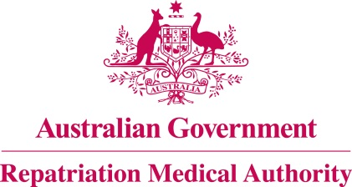

Amendment Statement of Principles

concerning

ACUTE LYMPHOBLASTIC LEUKAEMIA/LYMPHOBLASTIC LYMPHOMA
(Reasonable Hypothesis)

(No. 59 of 2022)
The Repatriation Medical Authority determines the following Amendment Statement of Principles under subsections 196B(2) and (8) of the Veterans' Entitlements Act 1986.

Dated 29 April 2022

The Common Seal of the
Repatriation Medical Authority
was affixed to this instrument
at the direction of:

Professor Terence Campbell AM
Chairperson

Contents
1 Name 3
2 Commencement 3
3 Authority 3
4 Amendment 3

- Name
This is the Amendment Statement of Principles concerning acute lymphoblastic leukaemia/lymphoblastic lymphoma (Reasonable Hypothesis) (No. 59 of 2022).
- Commencement
This instrument commences on 30 May 2022.
- Authority
This instrument is made under subsections 196B(2) and (8) of the Veterans' Entitlements Act 1986.
- Amendment
The Statement of Principles concerning acute lymphoblastic leukaemia/lymphoblastic lymphoma (Reasonable Hypothesis) (No. 33 of 2021) (Federal Register of Legislation No. F2021L00215) is amended in the following manner:

Section | Amendment
Schedule 1 – Dictionary | Insert the following definition of "8-hour time-weighted average " in alphabetical order:  8-hour time-weighted average means the averaging of different exposure levels to benzene during an average exposure period equivalent to 8 hours.
Schedule 1 – Dictionary | Insert the following note to the definition of " being exposed to benzene as specified":  Note: 8-hour time-weighted average is also defined in the Schedule 1 - Dictionary.

